Product Definition, Scope, Roles & Principles

Product Definition, Scope, Roles & Principles
Revision: 2 Last modified: 2026-06-26T12:00:00Z
Document role. This is document 00 of the HelixVPN master technical specification set under docs/research/mvp/final/. It establishes the invariants every later document inherits: what the product is and is not, who uses it, the three-role topology, the licensing/hosting stance, the per-phase scope boundary, the seven non-negotiable principles, the Mullvad-parity acceptance matrix, and — crucially — the eight open architectural decisions (D1–D8) (D1–D7 technical + D8 licensing, §7.2) that downstream documents (01-transport, 02-control-plane, 03-client-core, …) must resolve. Where a decision is still open this document gives options plus a recommendation (§11.4.6 no-guessing, §11.4.66 decision discipline); it never silently picks a camp.
Evidence base. Cross-document synthesis of the 16 source research docs in docs/research/mvp/ (eleven independent LLM analyses 00,01_DSK,02_QWN, 03_ZAI,05_YBO,06_GRK,07_GMI,08_CPL,09_GCT,10_KMI,11_MST plus the five refined 04_VPN_CLD docs). Citations are inline by id, e.g. [04_ARCH §1] = 04_VPN_CLD/HelixVPN-Architecture-Refined.md §1, [05_YBO] = the operator mandate brief, [research-masque] = the MASQUE research note.
Status of this document: SPEC-ONLY. It describes what to build and why; it does not build it. Two-to-three refinement passes follow.

Table of contents
- 1. Executive product definition
- 2. What HelixVPN is — and is explicitly NOT
- 3. The three roles: Connector ⇄ Gateway ⇄ Client
- 4. "Two-way" and "multi-network" — precise meaning
- 5. Personas and the three app classes
- 6. Prior art and positioning
- 7. Hosting model, licensing & commercial stance
- 8. The seven non-negotiable principles
- 9. Mullvad feature-parity matrix (acceptance checklist)
- 10. Scope per phase (in / out)
- 11. Open architectural decisions D1–D8 (options + recommendation)
- 12. Glossary of normative terms
- 13. Cross-document contracts this document fixes
- Sources verified

1. Executive product definition
HelixVPN is a self-hostable overlay network with a privacy-VPN front end.
The one-sentence pitch [04_ARCH §1]:
Cloudflare Tunnel + WARP, rebuilt as Tailscale-style coordination, with Mullvad's obfuscation stack, fully self-hostable, on one shared codebase.
Decomposed, that pitch names four lineages, each of which HelixVPN deliberately unifies:
Lineage borrowed from | What HelixVPN takes | Source
Cloudflare Tunnel + WARP | the connector dials out model (no inbound port-forward) and MASQUE/QUIC transport | [00], [04_ARCH §0/§3.3]
Tailscale / Headscale | the coordination & desired-state "network map" model (push-don't-poll, ACL-compiled topology) | [04_ARCH §4.4], plurality of analyses
Mullvad | the obfuscation + privacy bar (QUIC/MASQUE, Shadowsocks, UoT, LWO, DAITA, multi-hop, kill-switch, no-logging, anonymous accounts) | [04_ARCH §6], [02_QWN], [11_MST]
NetBird | the closest OSS shape (WireGuard + management/signal server, self-hosted) as an architectural sanity check | [04_ARCH §1.3]
The founding constraint that gave rise to the project [05_YBO], [00]: a remote user must obtain full, policy-scoped access to one or many internal / home / lab networks without any inbound port-forward on those networks. Internal hosts dial outbound to a public gateway (a reverse tunnel); the gateway relays and routes. The headline differentiator over every incumbent is 1 user → N joined private networks — a multi-network, bidirectional, policy-routed gateway — which no self-hostable product ships today [04_ARCH §1.3].
Reconciled (§11.4.35, 2026-06-26) — UNVERIFIED (§11.4.99). "no self-hostable product ships [a 1→N multi-network policy-routed gateway] today" is a competitive-market claim, not an architectural fact of HelixVPN. It is plausible from the prior-art map (§6) but MUST be re-verified against current product feature sets in the §11.4.99 latest-source pass before any external-facing use. This matches the marker already carried by v01-product/product-vision-and-positioning.md §2.2/§8 (R-V4). The architectural fact — that HelixVPN's design delivers 1→N policy-routed networks — is cited and is not UNVERIFIED.
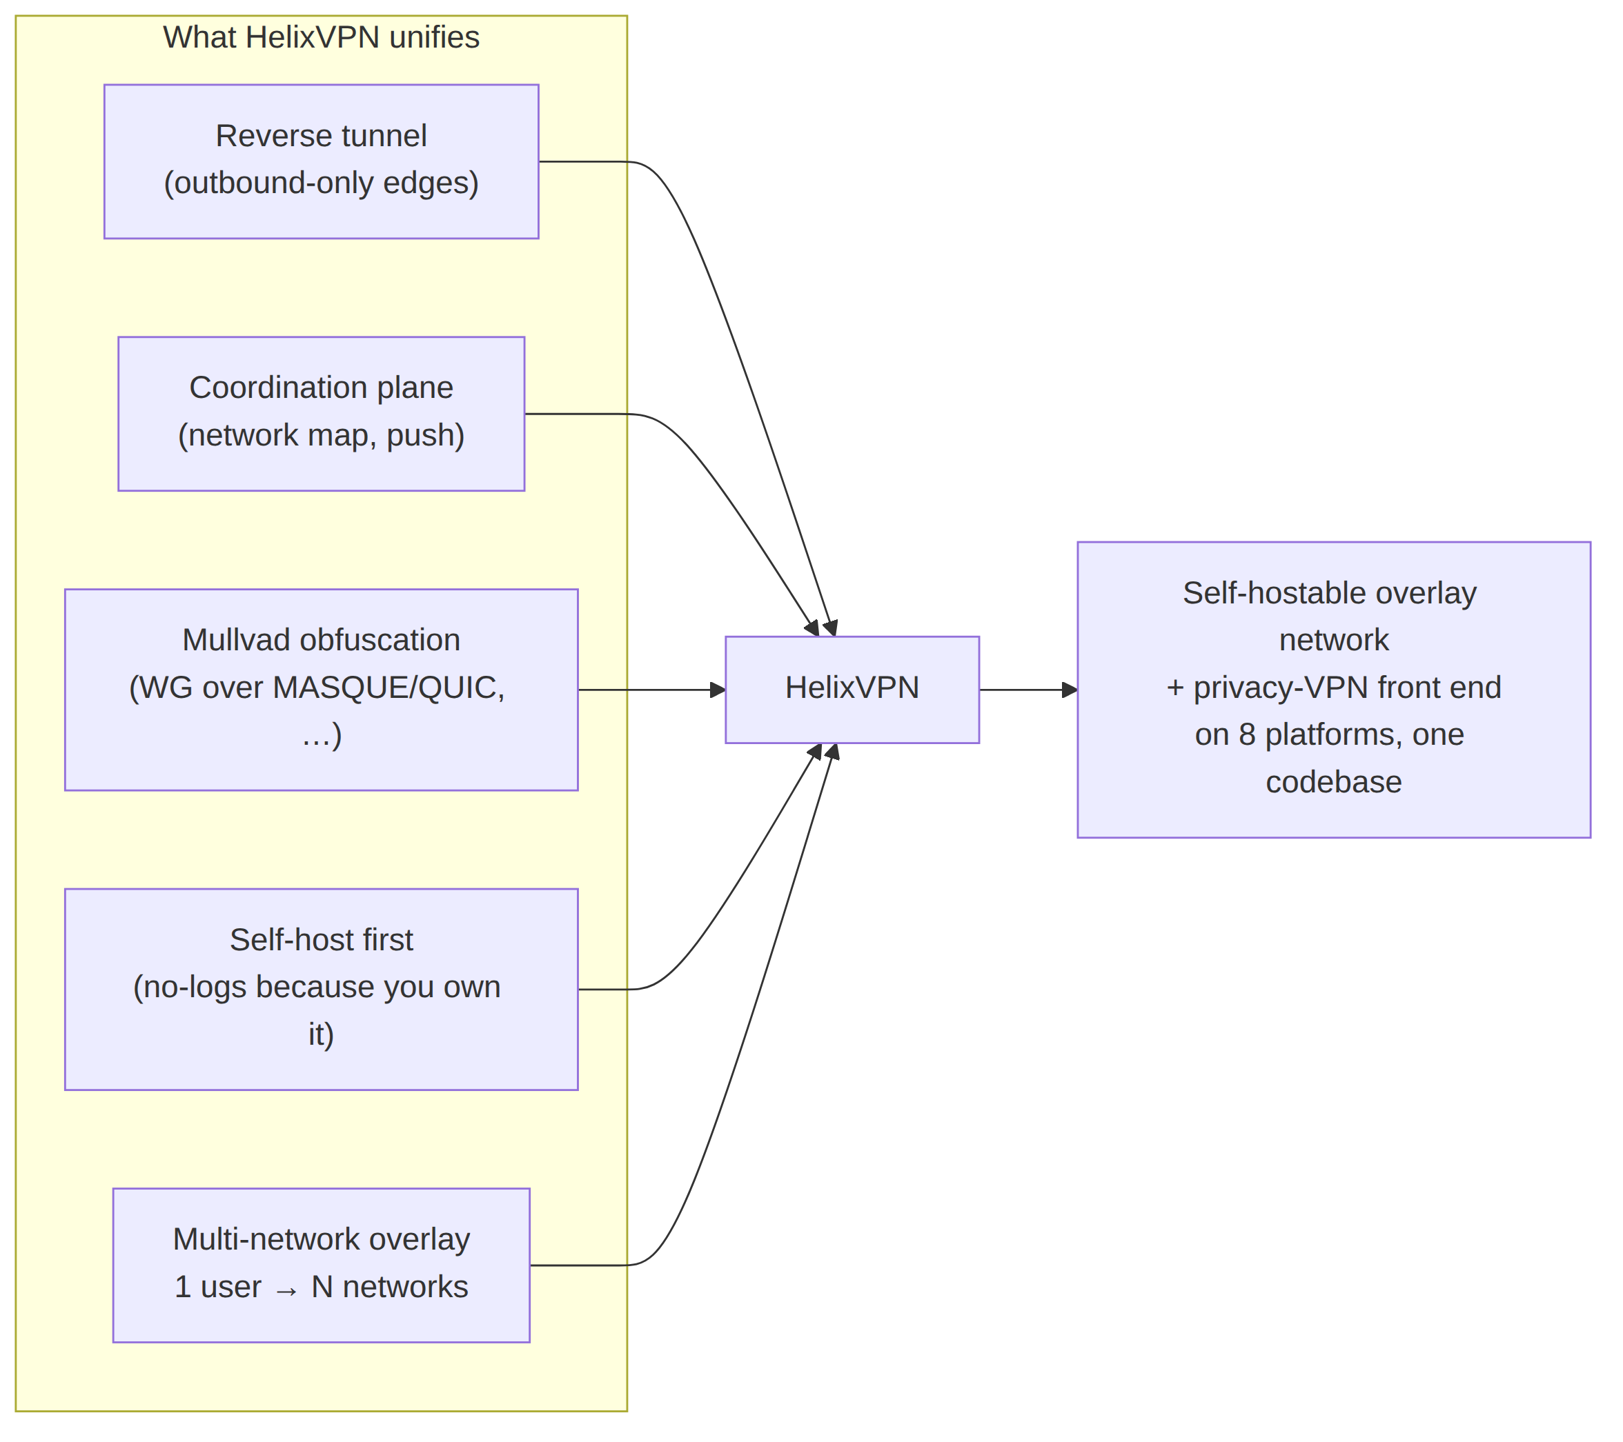

2. What HelixVPN is — and is explicitly NOT
Pinning the negative space is as load-bearing as the positive definition: it keeps every downstream document from drifting into adjacent products.

2.1 HelixVPN IS
- A WireGuard-cryptographic-core overlay where obfuscation/transport is a pluggable layer underneath WireGuard, never a crypto fork [04_ARCH §2/§3].
- A three-role system — Connector, Gateway, Client — with a strict control-plane / data-plane split [04_ARCH §1.1/§2].
- Self-hostable by one person (single rootless-Podman pod), with the same images scaling to an HA multi-region fleet [04_ARCH §2 principle 6, §10].
- A cross-platform app suite on a shared codebase, targeting iOS, Android, Aurora OS, HarmonyOS NEXT, Windows, Linux, macOS, and Web [05_YBO].
- An event-driven, push-based control plane: state changes propagate as events; agents reconcile to a declared desired-state [04_ARCH §4.3/§4.4].
- A no-logging-by-construction privacy product: only aggregate counters and ephemeral presence persist; no durable connection / traffic / packet table ever exists — CI-enforced [04_ARCH §4.5/§7].

2.2 HelixVPN is NOT
NOT | Why it is excluded | Where the boundary is enforced
NOT a forked or re-rolled WireGuard crypto. | The crypto core is the audited WireGuard Noise IK construction. We change only how the encrypted datagrams look on the wire. | Transport spec 01; CI lint forbids touching WG crypto primitives.
NOT a separate "QUIC protocol" alongside WG. | Mullvad's QUIC mode is WireGuard tunneled over MASQUE/HTTP-3, not a different protocol [04_ARCH §0], [research-masque]. | D1 below; transport spec 01.
NOT a full system VPN in a browser. | Browsers cannot open a TUN device. The Web build is Console (management) + an optional in-page WASM MASQUE proxy that proxies the browser's own traffic only [04_ARCH §5.7]. | Client/app spec 03/05; §10 scope below.
NOT a logging / lawful-intercept / DLP appliance. | No-logging is an architectural build property, not a toggle. Control actions are audited; traffic never is. | Data-model spec 02; CI schema-lint.
NOT a generic SDN / service-mesh / L7 API gateway. | HelixVPN operates at L3 (IP overlay) with L4 port policy. It is not Envoy/Istio and does not terminate application TLS for inspection. | Policy spec; §2.1 scope.
NOT a consumer "free VPN" ad-funded service. | The default deployment is self-hosted; a managed offering is an optional later SKU, not the product's reason to exist. | §7 below.
NOT dependent on inbound port-forwarding on any joined network. | The reverse-tunnel insight from the original brief is foundational. | Principle 3 (§8); Connector spec.
§11.4.6 honesty marker. Two product claims have hard physical limits and MUST be stated to users without hand-waving [04_ARCH §5.7]: (a) "fully responsive web app" ≠ system VPN — it is the Console + a browser-scoped proxy; (b) iOS Network Extension ~15 MB working-set ceiling is a measured historical constraint that shapes the core-language decision (D2) and is verified on-device in Phase 0 gate G3, never assumed.

3. The three roles: Connector ⇄ Gateway ⇄ Client
The entire system is three roles and three control relationships [04_ARCH §1.1], [05_YBO], consensus across all 10 analyses.
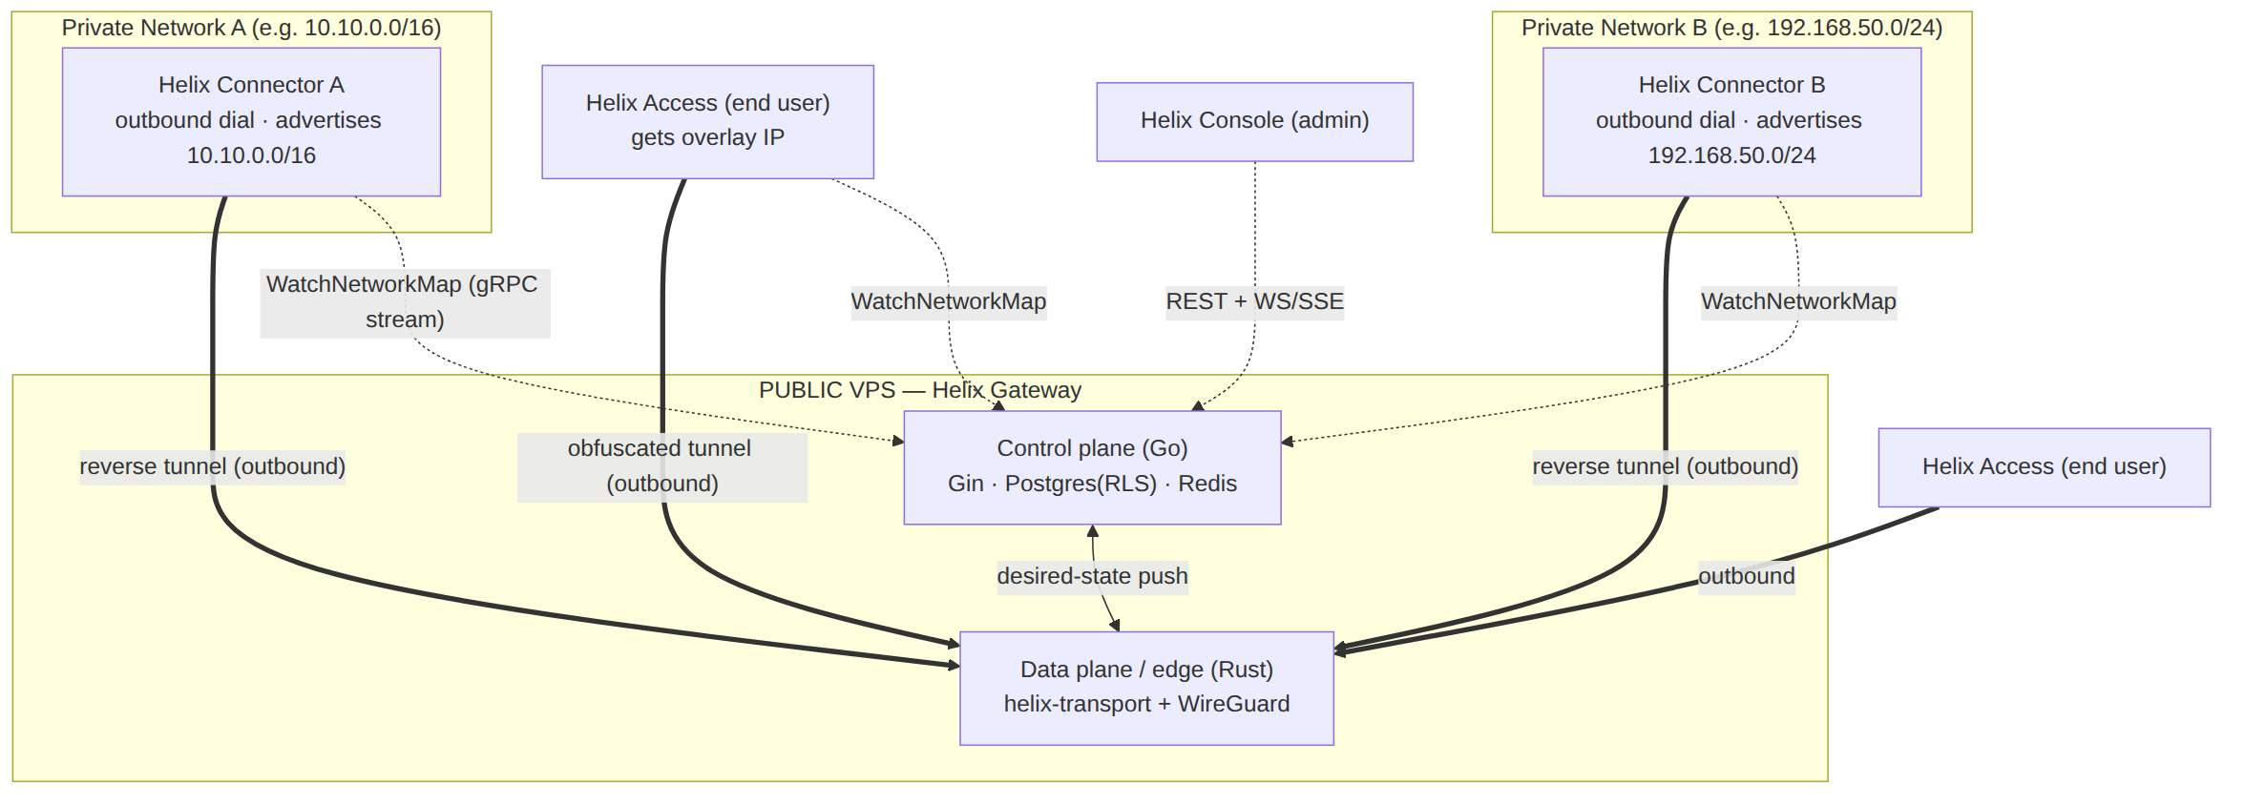

3.1 Connector (network-side agent)
- A first-party agent installed on a host inside each private network.
- Dials outbound to the Gateway — no inbound port-forward, ever [05_YBO].
- Authenticates (device cert + enrollment token), then advertises the CIDRs that network exposes (route.advertised).
- Routes Gateway-bound traffic into its LAN and LAN responses back out.
- Runs headless (daemon) with an optional slim config UI; on appliance hardware it can run on Android/embedded [04_ARCH §1.2/§5.4].
- Shares the same Rust core as the Client, in advertise/route mode rather than capture-this-device's-traffic mode [04_ARCH §5.4].

3.2 Gateway (public VPS — the rendezvous hub)
- The only role with a public address. Two strictly separated planes:
  - Control plane (Go/Gin/Postgres/Redis) — source of truth for identity, devices, networks, routes, policy; distributes desired-state in real time; never sits in the packet path (principle 1).
  - Data plane / edge (Rust + kernel WireGuard) — terminates obfuscated transports, unwraps to WireGuard, applies the per-peer verdict map, routes between users and the networks they are authorized to reach.
- Authenticates connectors and clients, holds the routing/policy table, relays/routes traffic [04_ARCH §1.1/§4].

3.3 Client (end user — Mullvad-style)
- The Access app. Dials into the Gateway, receives an overlay IP, and reaches the subset of joined networks its policy allows.
- Can also use the Gateway as a plain privacy exit (full-tunnel to the internet) — the Mullvad use case [04_ARCH §1.1].
- Drives the same Rust core as the Connector (capture mode) + a per-platform tunnel shim.

3.4 The control relationships (one sentence each)
Relationship | Channel | Direction | Purpose
Connector → Gateway control | gRPC WatchNetworkMap (server-stream over HTTP/2 or HTTP/3) | Connector dials out | receive snapshot+deltas; advertise prefixes
Client → Gateway control | gRPC WatchNetworkMap | Client dials out | receive policy-filtered peer/route map
Console → Gateway control | REST (Gin) + WS/SSE | admin dials out | CRUD + live updates
Connector/Client → Gateway data | obfuscated transport → WireGuard | edge dials out | the encrypted packet path (fail-static)

4. "Two-way" and "multi-network" — precise meaning
The operator brief uses two phrases that the original Home_VPN.md did not fully deliver [04_ARCH §0], [05_YBO]. Their exact engineering meaning:

4.1 "Two-way VPN"
Both halves dial outbound and the Gateway routes between them. It does not mean a single point-to-point tunnel:
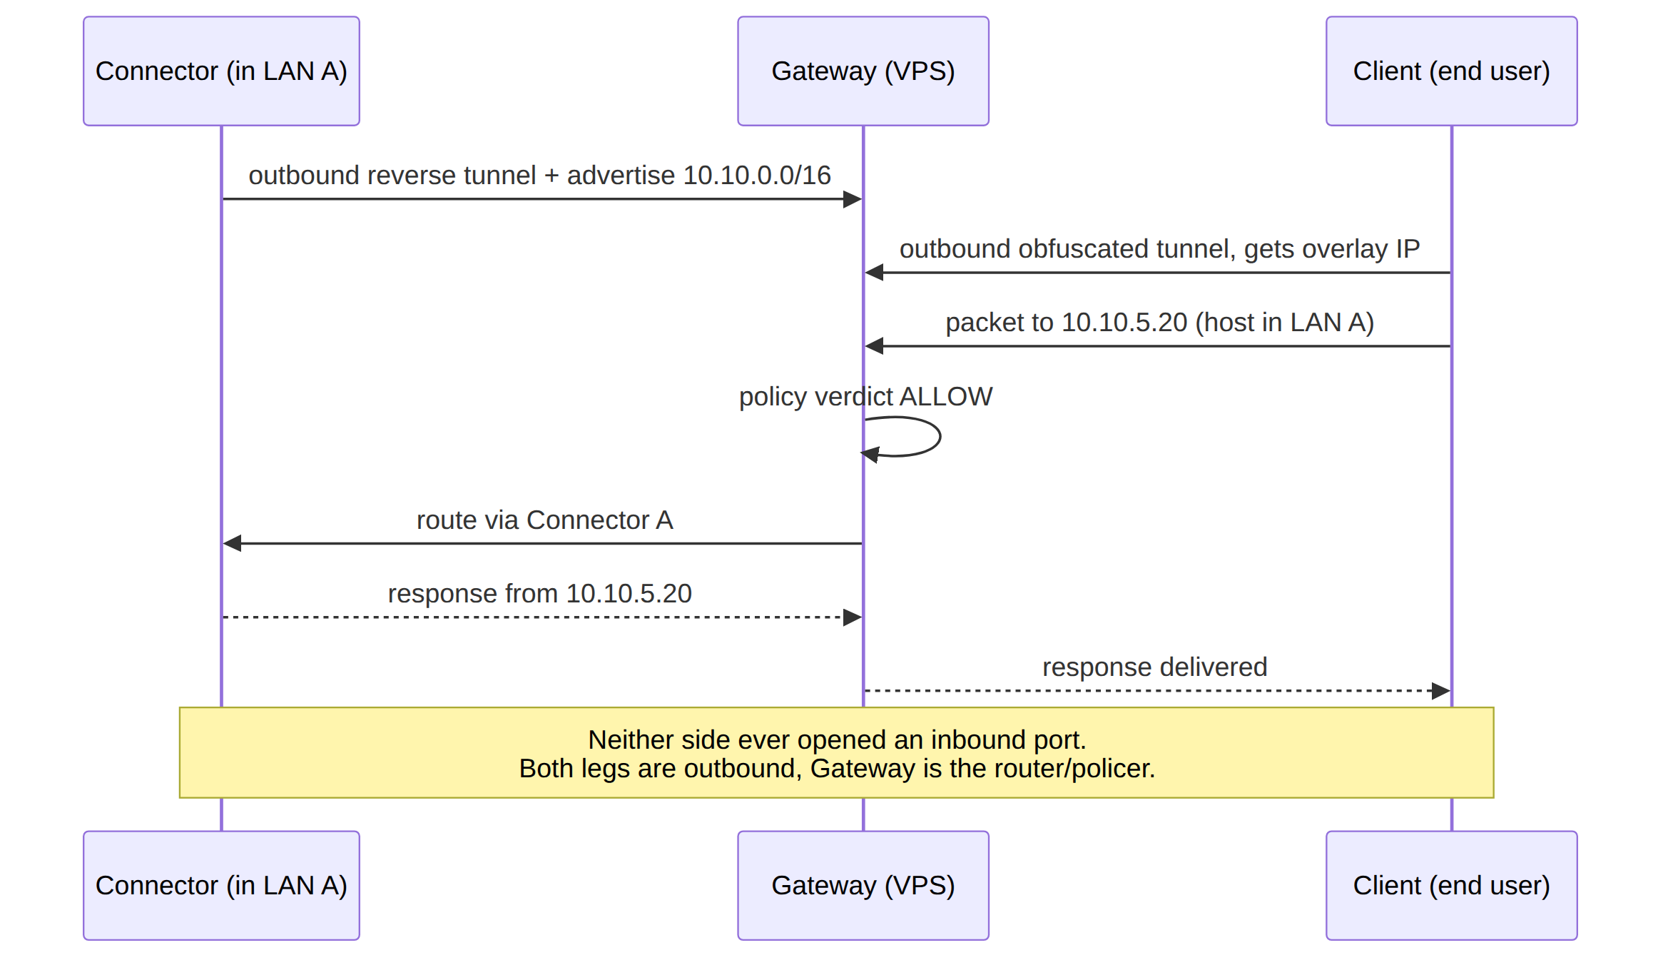
The "two ways" are the network-side leg (Connector → Gateway) and the user-side leg (Client → Gateway). The Gateway stitches and polices between them. This is the core correction over the original one-way "reverse tunnel for my home" model [04_ARCH §0/§1.1].

4.2 "Multi-network"
1 user → N joined private networks, each policy-scoped. Multiple Connectors each advertise their own CIDRs; the Gateway compiles them into one policed overlay; a single user reaches the subset of those networks its ACL grants. This implies three first-class problems the spec set MUST solve [04_ARCH §3.4]:
- Overlapping RFC1918 ranges. Two connectors can both expose 192.168.1.0/24. The overlay must present each as a distinct address space so they never collide — this is D4 (§11), a v1 must-decide.
- Per-user ACL routing. Default-deny; group:contractors → net:warehouse:554/tcp compiles to per-peer AllowedIPs + an nftables/eBPF verdict map.
- Split horizon. Connectors cannot reach each other, and clients cannot reach networks they are not granted, unless policy says so. Microsegmentation is the default [04_ARCH §3.4].

5. Personas and the three app classes
One design system, one Dart UI core, one generated API client across all three apps. Access + Connector additionally share one Rust VPN/transport core [04_ARCH §1.2/§5].
App class | Persona | Primary jobs | Platforms | Cores used
Helix Access | End user ("I want into my lab / a privacy exit") | connect, pick exit/network, toggle obfuscation, kill-switch, split-tunnel | iOS, Android, Aurora, HarmonyOS, Windows, Linux, macOS (Web = limited) | helix-ui + helix-core + tunnel shim
Helix Connector | Network operator ("expose my LAN safely") | onboard a network, advertise CIDRs, set local ACLs, run headless | Linux/Windows/macOS daemon + optional UI; Android/embedded for appliances | helix-core (advertise/route mode) + optional helix-ui
Helix Console | Admin ("manage tenants/users/devices/policy") | tenants, users, devices, networks, routes, policies, audit, billing-optional | Web (responsive) + Desktop (same Flutter build) | helix-ui (admin flavor) + API client only — no core, no tunnel

5.1 Persona detail
- End user (Access). Wants the Mullvad experience: one big connect button, automatic obfuscation, kill-switch, no account email required (anonymous device token). Memory- and battery-sensitive (mobile) [04_ARCH §1.2/§5.6].
- Network operator (Connector). Wants "install one agent inside the LAN, it dials out, done." Cares about which prefixes are advertised, local ACLs, and not opening a router port [05_YBO], [04_ARCH §1.1].
- Admin (Console). Wants tenant/user/device/policy CRUD, a live topology view, an audit trail of control actions, and (optionally) multi-tenant billing. Runs in a browser or as a desktop app — no tunnel involved [04_ARCH §1.2/§5.4].

5.2 The single-tree flavoring contract
All three apps build from one Flutter tree via a flavor entrypoint runHelixApp(flavor, home, capabilities) [04_UI], where flavor ∈ {Access, Connector, Console}; Console is the only build that omits core_ffi (no Rust tunnel core). This contract is fixed here and detailed in client doc 03/05.

6. Prior art and positioning
System | Self-host | Obfuscation | Multi-network overlay | 1st-party cross-platform apps | What HelixVPN borrows
Mullvad | ✗ (service) | ✅ best-in-class (QUIC/MASQUE, Shadowsocks, UoT, LWO, DAITA) | ✗ (privacy exit only) | ✅ | the obfuscation + privacy bar
Tailscale | partial (Headscale) | ✗ | ✅ (mesh + subnet routers) | ✅ | the coordination / network-map model
NetBird | ✅ | limited | ✅ | ✅ | closest OSS shape (WG + mgmt/signal)
Cloudflare Tunnel + WARP | ✗ | MASQUE | ✅ | ✅ | connector-dials-out + MASQUE
Twingate / Zscaler | ✗ | n/a | ✅ ZTNA | ✅ | the ZTNA policy model
HelixVPN | ✅ | ✅ full Mullvad-parity stack | ✅ | ✅ on 8 platforms, one codebase | the self-hosted union of all of the above
Differentiators to lead with [04_ARCH §1.3]: (1) self-hosted and Mullvad-grade obfuscation including MASQUE/QUIC; (2) genuine 8-platform reach including Aurora + HarmonyOS that no incumbent ships; (3) one shared Rust+Flutter codebase; (4) event-driven real-time control plane.

7. Hosting model, licensing & commercial stance

7.1 Hosting model — settled
Self-hosted / home-lab first; the same code can serve managed later [04_ARCH §2 principle 6, §13], consensus. Rationale: a privacy product's no-logs claim is credible because you own the box, not because a vendor promises it [SYNTHESIS §2]. Two deployment shapes, one image set:
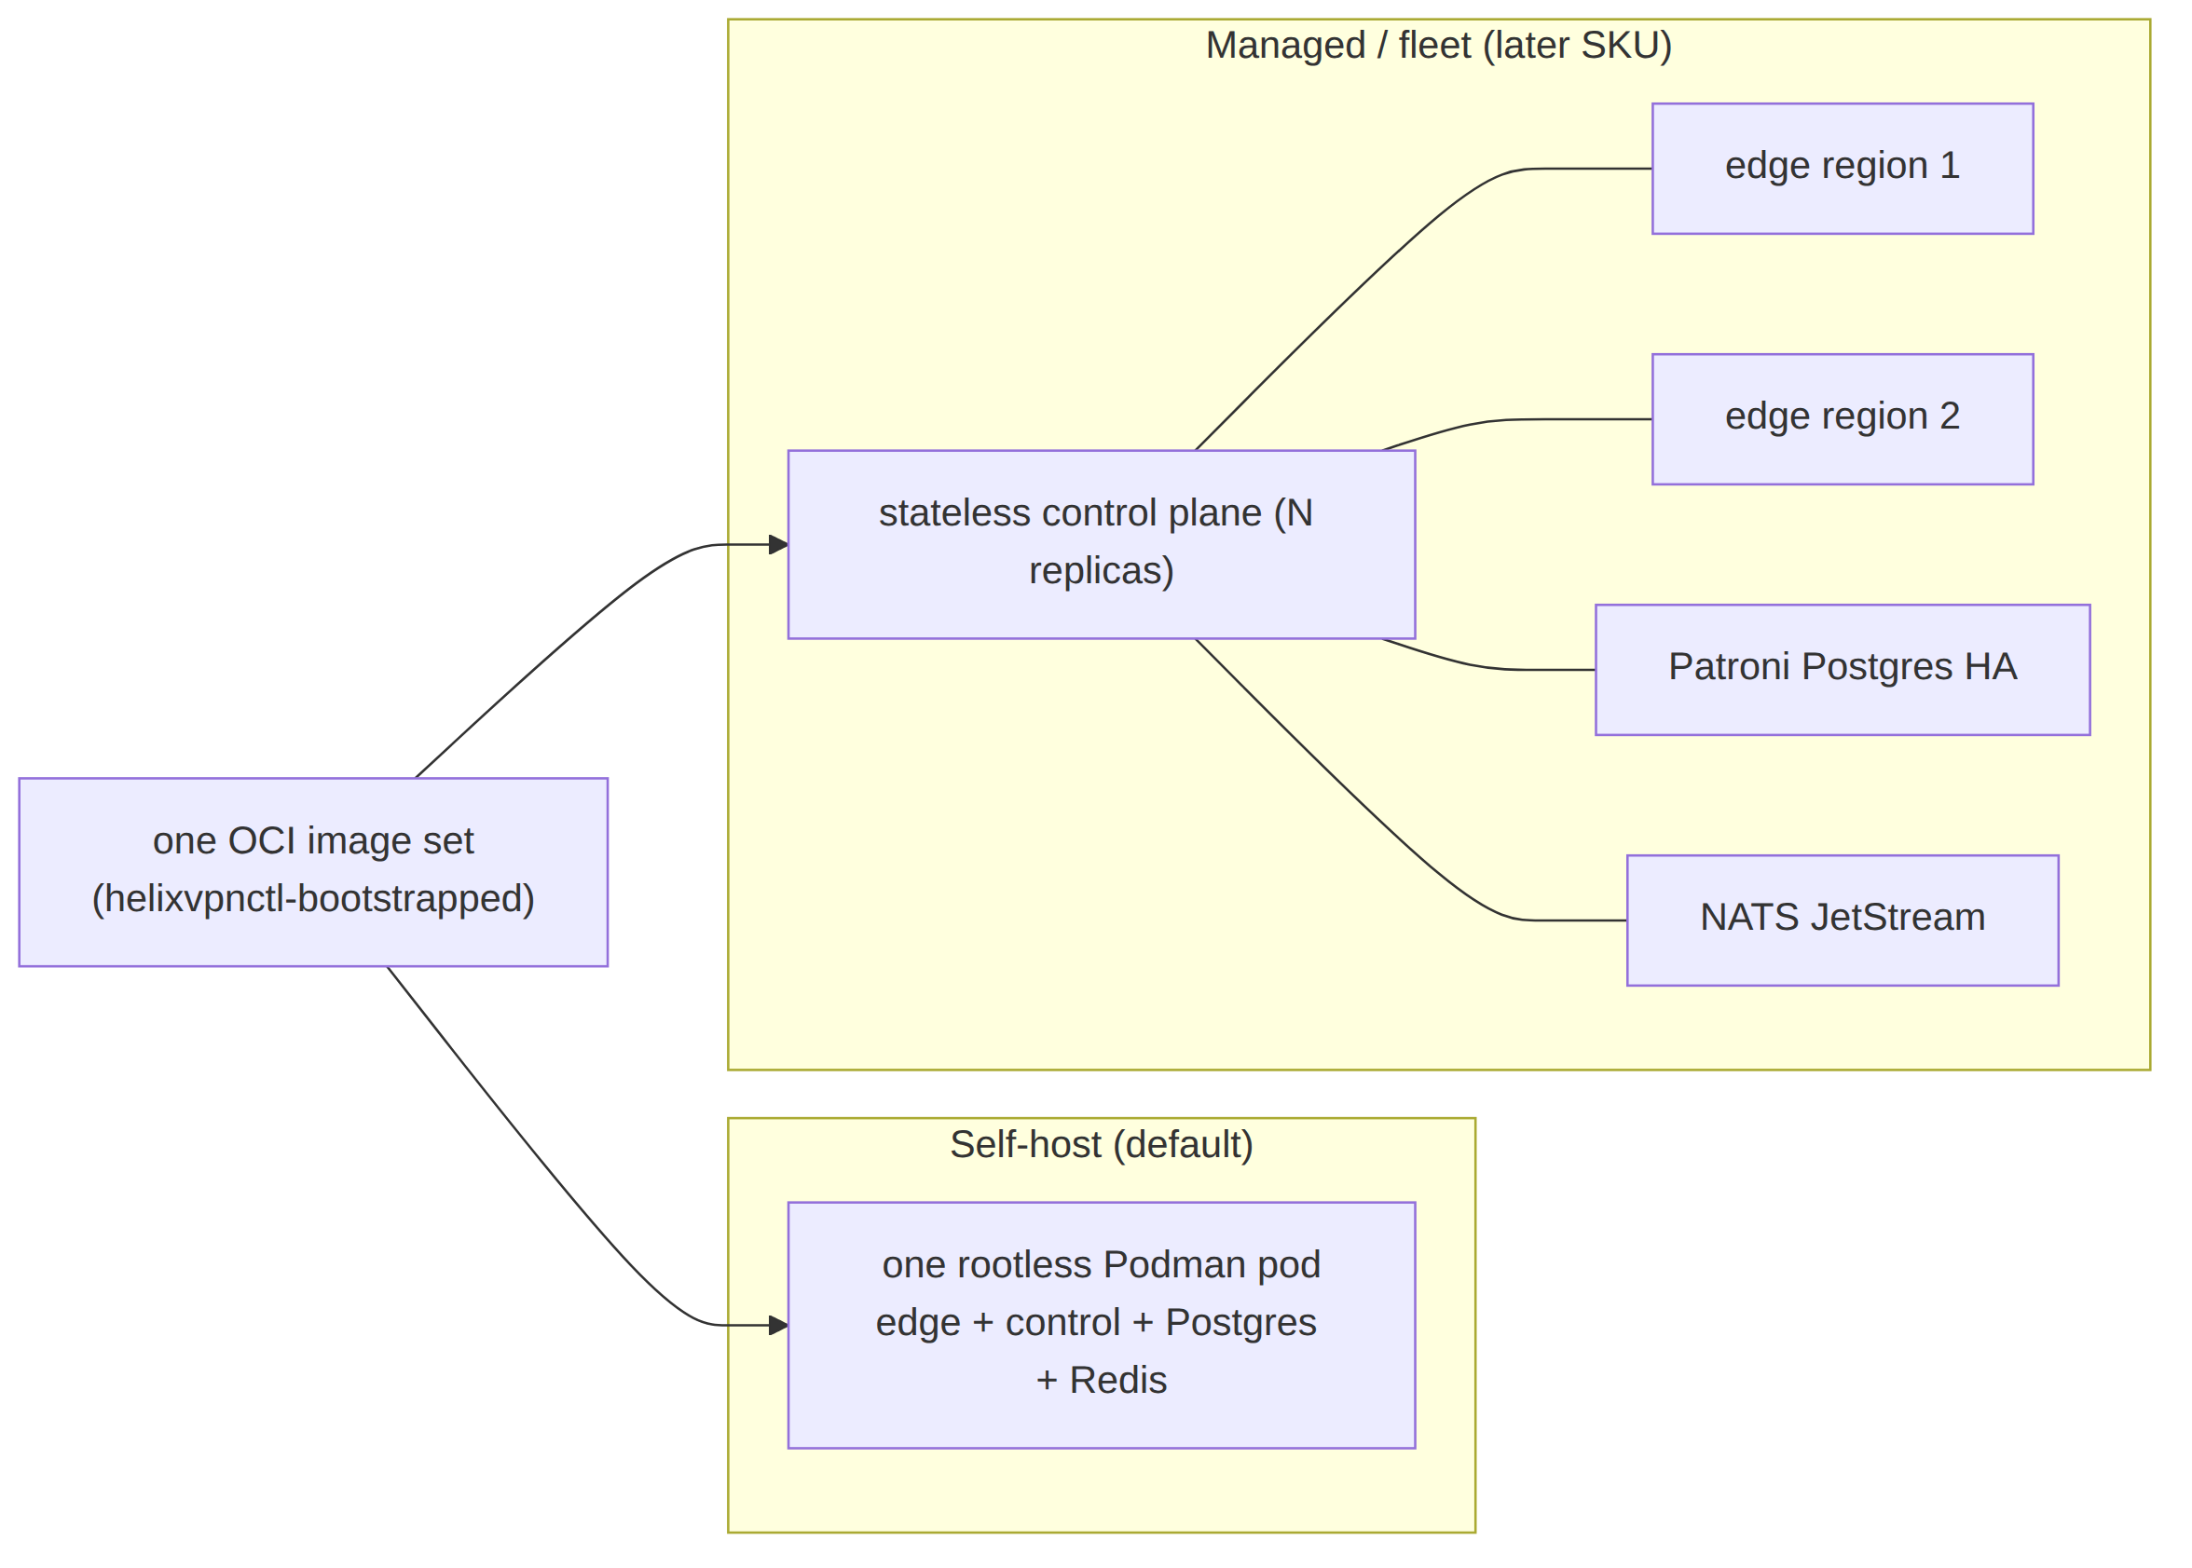

7.2 Licensing (D8) — OPEN DECISION, recommendation given
Reconciled (§11.4.35, 2026-06-26): the licensing decision is D8 in the decision register (§11). SPECIFICATION.md §9 and the decision-register already number it D8, and v01-product/product-vision-and-positioning.md §3.1 cites "[00 §7.2]" as D8's source — this section is therefore the canonical definition of D8 and it is summarised in §11.1.
The licensing model is not yet settled [04_ARCH §13] ("decide the licensing … before public release"). Because it materially shapes the repository split (§11.4.28/.74 decoupled reusable components → own vasic-digital repos), it is surfaced here as decision D8, not a default.
Option | Description | Pros | Cons
L-A: AGPLv3 (copyleft) | strong network-copyleft; managed competitors must open their changes | maximal community-protection; aligns with WireGuard/Mullvad ethos | scares some enterprise self-hosters; complicates a future closed managed SKU
L-B: Source-available (e.g. BSL → Apache after N years) | source visible, commercial-use clause, time-delayed OSS | protects a future managed business; still auditable (privacy claim) | not OSI-"open"; community friction
L-C: Apache-2.0 / MIT (permissive) core + commercial Console/managed add-ons | open core, paid edges | broadest adoption; clean for the reusable Rust/Flutter cores reused by other Helix projects | a competitor can run a managed clone with no give-back
Recommendation: L-C (open-permissive reusable cores + L-B source-available for the managed/multi-tenant Console layer). Rationale: the three reuse pillars — helix-core (Rust), helix-ui (Flutter), helix-proto — are designed to be reused by other Helix-ecosystem projects [04_ARCH §11], [SYNTHESIS §6] and therefore want a permissive license; the commercial surface (multi-tenant billing, fleet orchestration) is exactly the BSL-protectable layer. This split also satisfies §11.4.28 (owned submodules are decoupled, reusable, project-not-aware) — a permissive core is the most reusable. This decision is OWNER-GATED (§11.4.66) before public release; until resolved, all repos carry an explicit LICENSE.PENDING marker, never an assumed license (§11.4.6).

7.3 No-logging as a hosting invariant
Independent of hosting shape, no durable connection/traffic/packet table may exist (§8 principle 7). For the managed SKU this is the contractual no-logs promise; for self-host it is self-evident. Either way it is CI-enforced (schema-lint), not a runtime toggle [04_ARCH §4.5/§7].

8. The seven non-negotiable principles
Verbatim from [04_ARCH §2], each with its engineering rationale and the downstream document that enforces it. These are invariants: a later document may add constraints but may not weaken any of these (mirrors the constitution inheritance rule §11.4.35).

P1 — Control plane and data plane are strictly separated
The Go control services never sit in the packet path. If the control plane is down, existing tunnels keep forwarding (fail-static). Rationale: a coordination outage must never become a connectivity outage; it also keeps the GC'd Go runtime off the hot path. Enforced by: control-plane spec 02 (Go emits desired-state only); edge spec (Rust forwards from a cached verdict map). Anti-pattern forbidden: any synchronous Go call on a per-packet basis.

P2 — WireGuard is the cryptographic core; transports are pluggable
Obfuscation is a swappable layer under WireGuard, never a fork of the crypto [04_ARCH §2/§3]. Rationale: the audited Noise IK / Curve25519 / ChaCha20-Poly1305 construction is the trust anchor; censorship resistance is a wire-shape problem solved beneath it (this is literally Mullvad's model, and why "QUIC" = WG-over-MASQUE, not a new protocol) [research-masque]. Enforced by: transport spec 01 (the Transport trait — see D1) + CI lint forbidding edits to WG crypto.

P3 — Outbound-only from edges
Connectors and Clients always dial the Gateway. No private network ever needs an inbound hole [05_YBO]. Rationale: the founding constraint; it is what makes "expose my LAN without touching my router" true and removes the largest attack surface (a public inbound port). Enforced by: Connector/Client spec; the Gateway is the only role that listens publicly.

P4 — Push, don't poll
State changes propagate over persistent channels as events; agents reconcile to a declared desired-state ("network map"), Tailscale-MapResponse-style [04_ARCH §4.4]. Rationale: polling/cron-restart loops (the original doc's model) cannot meet the p99 < 1 s convergence target and waste battery/CPU. Enforced by: control-plane spec 02 (WatchNetworkMap server-stream + Redis Streams event bus — see D3) + reconciler in helix-core.

P5 — One core per concern, reused everywhere
Rust transport/VPN core shared by Client, Connector, and Gateway edge; Go domain libraries shared across control services; Dart UI core shared across all three apps [04_ARCH §2/§5.5]. Rationale: the obfuscation code that wraps on the client is the same code that unwraps on the edge — one implementation, three consumers — eliminating drift and triplicated bugs. Enforced by: repo layout (§13); three reuse pillars (Rust core / Flutter UI / schema-generated clients).

P6 — Self-hostable by one person, scalable to many gateways
A single rootless-podman deploy for a homelab; the same images scale to an HA, multi-region fleet [04_ARCH §2/§10]. Rationale: the homelab user and the managed operator must not need different codebases; growth is a deployment topology change, not a rewrite. Enforced by: deploy spec (Podman quadlets, §11.4.76 containers submodule, §11.4.161 rootless).

P7 — No-logging by construction
The data plane keeps only counters and ephemeral routing state; no connection/content logs. Privacy is a build property, not a config toggle [04_ARCH §2/§7]. Rationale: a no-logs claim you can grep the schema for is stronger than a policy promise. Enforced by: data-model spec 02 (no connections/traffic/ packet durable table; live presence lives in TTL'd Redis) + CI schema-lint fails the build if such a table appears [04_ARCH §4.5]. This composes with the constitution anti-bluff covenant (§11.4 / §11.4.69 captured-evidence).
Representative CI guard (illustrative skeleton, not the product) — the mechanical teeth of P7:
// tools/schemalint/nolog.go — fails the build on a durable traffic table.
var forbiddenDurableTables = []string{"connections", "traffic", "packets", "sessions_log", "flows"}
func LintNoDurableTraffic(schema *pg.Schema) []Violation {
var v []Violation
for _, t := range schema.Tables {
for _, banned := range forbiddenDurableTables {
if strings.EqualFold(t.Name, banned) && t.IsDurable() {
v = append(v, Violation{Table: t.Name,
Rule: "P7-no-logging", Msg: "durable traffic/connection table forbidden"})
}
}
}
return v
}

9. Mullvad feature-parity matrix (acceptance checklist)
This table is the acceptance checklist for "all Mullvad power features" [04_ARCH §6], [05_YBO]. Every row maps to a concrete component in a later document; nothing is aspirational. The "Phase" column ties each feature to the scope table in §10.
# | Mullvad feature | What it does | HelixVPN implementation | Phase | Spec doc
F1 | WireGuard-only crypto | modern audited tunnel | helix-core WG (kernel fast path, boringtun fallback) | P0/P1 | 01,03
F2 | QUIC obfuscation (MASQUE / RFC 9298) | WG-over-HTTP/3, looks like web | helix-transport CONNECT-UDP via quinn+h3; edge terminates :443/udp | P0/P1 | 01 (D1)
F3 | MASQUE CONNECT-IP (RFC 9484) | native IP-over-HTTP/3 datapath | quinn+h3 CONNECT-IP path (advanced, no inner WG) | P2 | 01
F4 | Shadowsocks obfuscation | WG-in-Shadowsocks | helix-transport Shadowsocks wrap (shadowsocks-rust core) | P2 | 01
F5 | UDP-over-TCP | WG when UDP fully blocked | helix-transport UoT | P2 | 01
F6 | LWO (lightweight obfs) | cheap WG signature evasion | helix-transport LWO (XOR/padding) | P1 | 01
F7 | Automatic obfuscation | try methods until one works | client escalation ladder, driven by handshake-failure events | P1 | 01,03
F8 | Custom WG port / 443 / 53 | port-based evasion | edge multi-listener + port-hopping | P1 | 01
F9 | DAITA (anti traffic-analysis) | constant packet size + cover traffic | optional shaping layer above WG (maybenot-style state machine) | P2 | 01
F10 | Multi-hop | entry/exit separation | nested WG, control-plane orchestrated | P2 | 01,02
F11 | Kill-switch | no leaks if tunnel drops | OS firewall rules driven by helix-core state machine | P1 | 03
F12 | Split tunneling | per-app / per-route bypass | per-route AllowedIPs + per-app rules (Android/desktop) | P1 | 03
F13 | DNS leak protection | force tunnel DNS | core sets tunnel DNS; blocks plaintext :53 off-tunnel | P1 | 03
F14 | No-logging | no connection logs | architectural: ephemeral Redis presence, no durable table | P1 | 02
F15 | Anonymous account (no email) | anonymous identity | optional anonymous device-token enrollment alongside OIDC | P1 | 02
F16 | Post-quantum handshake | PQ-safe key exchange | WG PQ pre-shared layer / ML-KEM (FIPS-203) in pki + core; hybrid never PQ-only | P2 | 01,02
F17 | Per-device management | see/revoke devices | registry + Console; device.revoked → instant edge enforcement (<1s) | P1 | 02
HelixVPN-beyond-Mullvad rows (the differentiators, not present in Mullvad):
# | Feature | Implementation | Phase
X1 | Multi-network overlay (1 user → N nets) | Connectors advertise CIDRs; Gateway compiles policed overlay | P1
X2 | Outbound-only network onboarding | Connector reverse tunnel | P1
X3 | Self-hostable Mullvad-class stack | rootless Podman pod + helixvpnctl | P1
X4 | Direct P2P + NAT traversal + DERP-style relay | STUN-like discovery, hole punching, helix-relay fallback | P2
X5 | 8-platform reach incl. Aurora + HarmonyOS NEXT | Flutter forks + native tunnel shims | P1/P3

10. Scope per phase (in / out)
The phase spine is the CLD roadmap [04_P0],[04_P1],[04_P2],[04_ARCH §12], [SYNTHESIS §4]. Each phase's scope is a binding boundary: a feature listed OUT for a phase MUST NOT be built in that phase (it becomes a tracked workable item per §11.4.93). The phase→task→subtask decomposition lives in the later phase documents; this section fixes only the boundary.

10.1 Phase 0 — Spike (~3–4 weeks, throwaway bodies on production interfaces)
Goal: de-risk the make-or-break unknowns before committing to the MVP shape. Surviving artifacts are interfaces, not implementations: the Transport trait, the helix-wg boringtun wrapper, the orchestrator + status enum, the FFI surface [04_P0].
IN scope (P0) | OUT of scope (P0)
Exit gates G1–G6 (below) | any production-quality code; any persistence beyond a static map
Plain-UDP WG client→gw→connector LAN datapath | Console / Access / Connector product UIs
MASQUE/QUIC through a simulated DPI UDP block | Postgres data model, RLS, multi-tenancy
iOS NEPacketTunnelProvider Rust core under memory ceiling (G3 — make-or-break) | obfuscation transports beyond plain-UDP + one MASQUE spike
Go-vs-Rust edge benchmark (G4 decides D5) | HA, multi-region, P2P, multi-hop, DAITA, PQ
flutter_rust_bridge FFI drives core from Dart (G5) | Aurora / HarmonyOS / Windows / macOS shims
Push-based reconcile from a static map (G6) | event bus, policy compiler, real coordinator
Exit gates [04_P0]: G1 plain-UDP WG client→gw→connector LAN (≥80% bare-link throughput); G2 MASQUE/QUIC through a DPI UDP block (≥50% of plain); G3 iOS NE Rust core under memory ceiling with ≥30% headroom (make-or-break); G4 Go-vs-Rust edge benchmark → decides D5; G5 flutter_rust_bridge FFI drives core from Dart; G6 push-based reconcile from a static map. Test rig: Linux netns + nftables DPI sim + tc netem.

10.2 Phase 1 — MVP (self-hostable)
Goal: a genuinely self-hostable product meeting the MVP Definition-of-Done.
IN scope (P1) | OUT of scope (P1 → P2/P3)
Go modular monolith: identity / registry / ipam / pki / policy / coordinator / events / telemetry / api / store | full transport set (Shadowsocks, UoT, hardened LWO ladder) → P2
Postgres + RLS data model (no connection/traffic tables — CI-lint enforced) | DAITA, multi-hop, direct P2P + NAT traversal, post-quantum → P2
protobuf Coordinator over Connect, server-streaming WatchNetworkMap (snapshot+deltas, peers pre-policy-filtered, need-to-know) | Windows (wireguard-nt+service) + macOS NE desktop apps → P2
coordinator (in-mem topology graph, minimal deltas, p99 < 1 s) | HA + multi-region (stateless coordinators, Patroni PG, NATS) → P2
Redis Streams event backbone | GitOps/policy-as-code → P2
identity (OIDC + anonymous device tokens) + enrollment (device-gen WG keypair, private key never leaves) + short-lived mTLS device cert + revoke < 1 s | HarmonyOS NEXT + Aurora OS builds → P3
policy compiler (Tailscale-ACL-flavored, default-deny, fail-closed → AllowedIPs + nftables/eBPF verdict maps) | WASM browser MASQUE proxy → P3
Gin REST + WS/SSE; helixvpnctl (Cobra) + Podman quadlets | billing-optional multi-tenant; third-party audit + reproducible builds → P3
Auto obfuscation ladder: plain / LWO / QUIC-MASQUE
Access app on iOS + Android + Linux; Connector daemon; Console (web)
MVP Definition-of-Done — 8 acceptance criteria [04_P1] (each requires captured runtime evidence per §11.4.69; none may be a metadata-only PASS):
- self-host from zero on a clean VPS via helixvpnctl init;
- enroll a Connector and a Client;
- reach an authorized LAN host and deny an unauthorized one;
- auto-escalate to MASQUE when plain WG is blocked;
- policy edit reflected in < 1 s with no restart;
- device revoke enforced in < 1 s;
- kill-switch + DNS-leak protection verified (no leak on tunnel drop);
- no durable connection log (schema-lint + runtime check) and all three apps drive the system.

10.3 Phase 2 — Parity + Reach
IN: full transport set (+Shadowsocks, UDP-over-TCP, hardened LWO, auto-ladder with per-network memory + regional priors); DAITA via maybenot; direct P2P + NAT traversal (STUN-like discovery, hole punching, DERP-style helix-relay fallback); multi-hop nested WG; post-quantum handshake (ML-KEM/FIPS-203 PSK, hybrid-never-PQ-only; Rosenpass as an alternative); desktop apps (Windows wireguard-nt+service, macOS NE); policy-as-code/GitOps; HA + multi-region (stateless coordinators, Patroni PG, NATS JetStream) [04_P2]. OUT: HarmonyOS/Aurora/WASM (→P3); managed billing (→P3).

10.4 Phase 3 — Extended reach
IN: HarmonyOS NEXT + Aurora OS builds (real native tunnel-shim work — the biggest platform risk), WASM browser MASQUE proxy, billing-optional multi-tenant, third-party audit + reproducible builds [04_ARCH §12], [SYNTHESIS §4]. OUT (explicitly deferred / non-goals): lawful-intercept, L7 inspection, ad-funded free tier — these remain product non-goals (§2.2), not "later phases".
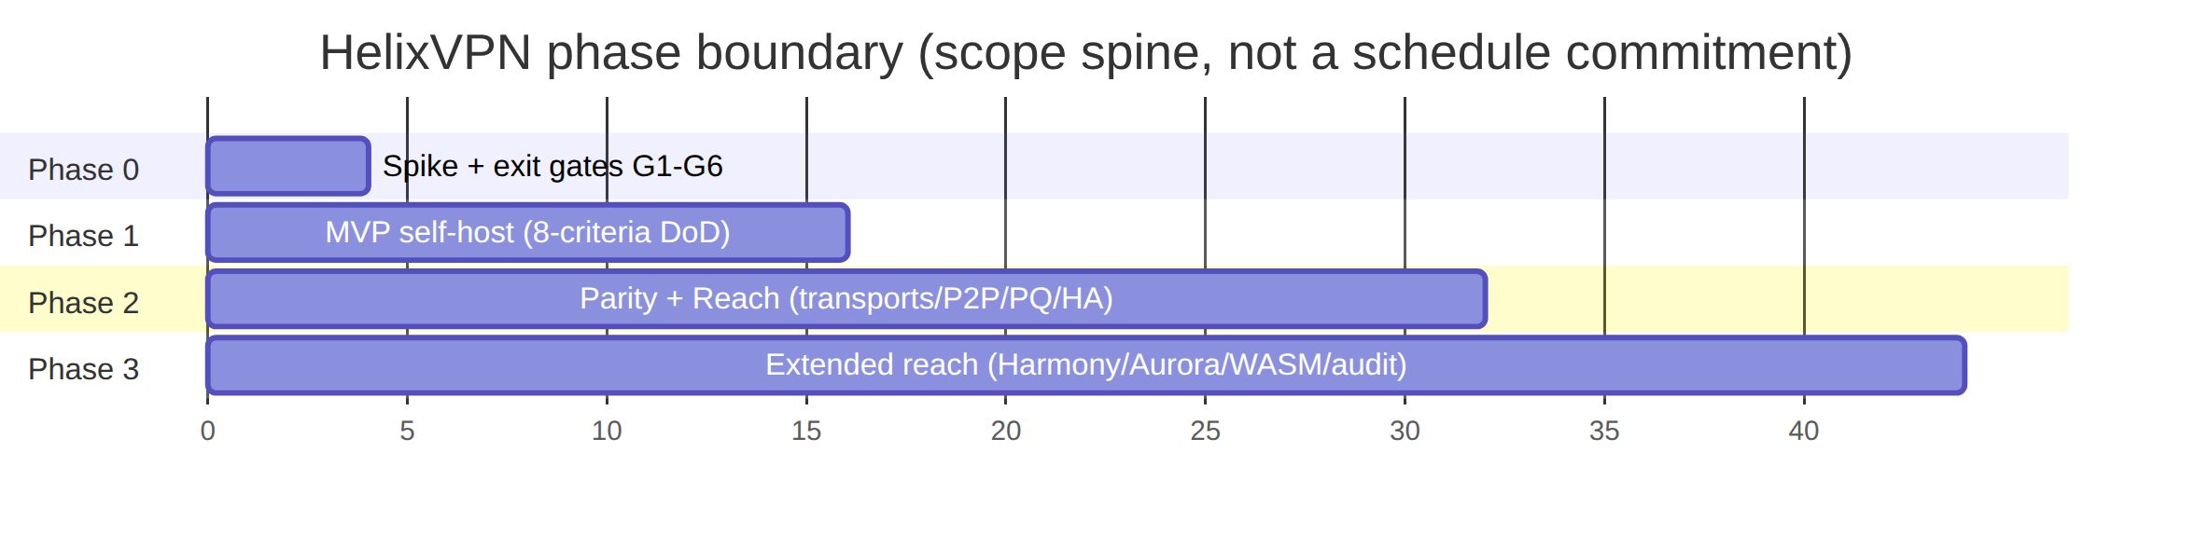

11. Open architectural decisions D1–D8 (options + recommendation)
These are the decisions where the refined 04_VPN_CLD docs pivoted to one camp while the broader 10-LLM consensus diverged [SYNTHESIS §3]. Per §11.4.6 / §11.4.66 each is presented as options + a recommendation, never silently resolved. Each Dn is OWNER-CONFIRMABLE; the recommendation is what the spec set proceeds on unless overridden, and each names the resolution gate (the moment evidence forces the choice).

D1 — Primary obfuscating transport
 | Camp A | Camp B
Option | MASQUE/QUIC = WG-over-HTTP-3 (RFC 9298/9297/9221) — Mullvad's actual mechanism [04_ARCH §3.3],[04_P0],[research-masque] | Hysteria2 + Salamander (QUIC+obfs, turnkey) primary, WG fallback (plurality of the 10 analyses)
For | true Mullvad parity; single Rust impl shared client↔edge (P5); "QUIC ≠ separate protocol, it IS WG-over-MASQUE" [04_ARCH §0] | ships faster (turnkey lib); battle-tested censorship circumvention
Against | more implementation surface (quinn+h3+MASQUE layer) | a different protocol, not WG-over-the-wire → not true parity; second crypto stack to trust
Recommendation: D1 = MASQUE/QUIC (Camp A) as the parity transport, with the escalation ladder (F7) able to also carry a Hysteria2-style mode as one rung. Rationale: P2 (WG core, pluggable transports) makes MASQUE the correct parity answer, and one Rust helix-transport crate serves client+edge (P5). Hysteria2's "ships faster" advantage is captured by adding it as a ladder rung, not as the architectural core. Resolution gate: Phase-0 G2 (MASQUE through a DPI block ≥50% of plain) — if G2 fails, re-open D1 with G2 evidence.

D2 — Shared client-core language
 | Camp A | Camp B
Option | Rust core + Flutter UI (plurality: 04_*,02_QWN,03_ZAI,08_CPL,10_KMI,11_MST) | Go core + Flutter UI (reuses Hysteria2's Go) (01_DSK,07_GMI)
For | wins on iOS NE memory ceiling (~15 MB) + WASM target; no GC on hot path; matches Mullvad/WARP precedent | simpler; reuses Hysteria2 Go directly; faster initial velocity
Against | steeper FFI surface (flutter_rust_bridge + UniFFI) | GC + runtime risk under the iOS NE memory ceiling; weaker WASM story
Recommendation: D2 = Rust core (Camp A). The iOS NE ~15 MB ceiling is the single hardest constraint [04_ARCH §5.7]; a GC'd Go data plane is risky there, and Rust is the only choice that also reaches WASM cleanly. Resolution gate: Phase-0 G3 (iOS NE Rust core ≥30% memory headroom — make-or-break). G3 is the literal decider; if Rust cannot fit, D2 and the whole client strategy re-open.

D3 — Event bus
 | Camp A | Camp B
Option | Redis Streams (MVP) → NATS JetStream (scale) (04_P1,02_QWN,11_MST) | NATS JetStream from start (01_DSK,10_KMI)
For | honors the mandated stack [05_YBO]; one fewer moving part for self-host; bus taxonomy is transport-agnostic so the swap is a transport change | durable subjects + multi-region fan-out from day one; no later migration
Against | a later swap for fleet scale | extra infra a single-node self-hoster does not need
Recommendation: D3 = Redis Streams for MVP, NATS JetStream in Phase 2. The mandated stack [05_YBO] names Redis; the event taxonomy is bus-agnostic (events:devices, events:routes, …) so Phase-2 fleet scale is a transport swap, not a redesign [04_ARCH §4.3]. Resolution gate: Phase-2 HA/multi-region work — the bus interface is fixed in 02 so the swap is mechanical.

D4 — IP-subnet collision across N joined RFC1918 networks
 | Camp A | Camp B
Option | IPv6 ULA /48 per tenant + Tailscale 4via6 mapping of advertised IPv4 LANs [04_ARCH §3.4] | CGNAT 100.64.0.0/10, 1:1 per network (07_GMI,10_KMI)
For | clean, collision-proof; native v6 overlay; Tailscale-proven | simpler mental model; no v6 dependency on legacy clients
Against | requires v6 overlay plumbing everywhere | 100.64/10 space exhaustion with many large networks; NAT bookkeeping
Recommendation: D4 = ULA /48 per tenant + 4via6 (Camp A), with per-network NAT into the connector as the documented fallback for overlapping ranges [04_ARCH §3.4]. Only 07_GMI/10_KMI/CLD actually solved this; it is a v1 must-decide (overlapping 192.168.1.0/24s are the default real-world case). Resolution gate: Phase-1 IPAM design in 02 — the overlay-addressing scheme is frozen before the registry/ipam service is built.

D5 — Gateway edge language (MASQUE termination)
 | Camp A | Camp B
Option | Rust (quinn+h3, shares helix-transport byte-for-byte) [04_P0 G4] | Go (quic-go+masque-go, turnkey)
For | obfuscation logic shared byte-for-byte client↔edge (P5); off the GC hot path | mature turnkey libs; same language as control plane
Against | one more Rust surface on the server | a second MASQUE impl to keep in sync with the Rust client → drift risk (violates P5)
Recommendation: D5 = Rust edge (Camp A), pending the G4 benchmark. P5 (one core, three consumers) strongly favors Rust so the wrap/unwrap code is identical on both ends. Resolution gate: Phase-0 G4 (Go-vs-Rust edge benchmark) is the explicit decider — if Go wins decisively on throughput/CPU and a shared-MASQUE drift mitigation is acceptable, D5 flips with G4 evidence.

D6 — Transport topology (symmetric vs asymmetric per-leg)
 | Camp A | Camp B
Option | single protocol end-to-end | asymmetric per-leg: Hysteria2/QUIC user↔gateway, WireGuard gateway↔networks (11_MST — distinctive)
For | one transport to reason about/operate | best-fit-per-leg: heavy obfuscation only where censorship lives (user↔gw); plain efficient WG on the trusted gw↔connector leg
Against | obfuscation overhead on legs that don't need it | two transport regimes to operate + a translation point at the gateway
Recommendation: D6 = asymmetric per-leg as the operating model, expressed through the same helix-transport crate (Camp B mechanics, Camp A codebase). MST's best-fit-per-leg insight is elegant [11_MST] and falls out naturally: the gateway↔connector leg defaults to plain WG/UDP (P3 outbound, trusted), the user↔gateway leg runs the obfuscation ladder. This is not a second codebase — it is the same pluggable-transport crate (P2/P5) configured per-leg. Resolution gate: Phase-1 coordinator WatchNetworkMap design — per-leg transport policy is part of the pushed desired-state.

D7 — MVP ambition
 | Camp A | Camp B
Option | lean tunnel-first (CLI between 2 hosts → API → apps) (02_QWN,01_DSK,04_P0) | full ecosystem / "Connectivity-OS" from v1 (10_KMI,03_ZAI)
For | de-risks the hard parts first; ships something usable fast; matches the Phase-0/Phase-1 split | a grander v1 story
Against | less impressive initial surface | enormous scope risk; violates §11.4.4 / iteration discipline
Recommendation: D7 = lean Phase-0 spike then the 8-criteria MVP (Camp A). This is already the §10 phase spine; the "Connectivity-OS" ambition is the sum of the phases, reached incrementally, not a v1 boulder. Resolution gate: none — this is settled as the document set's organizing principle; recorded here so the ambition is not silently re-inflated.

D8 — Licensing model
The licensing decision is defined in full in §7.2 (options L-A/L-B/L-C + recommendation); it is registered here as D8 so the decision set is complete and greppable.
 | Summary
Options | L-A AGPLv3 · L-B source-available (BSL→Apache) · L-C permissive (Apache-2.0/MIT) reusable cores + source-available managed Console (§7.2)
Recommendation | L-C — permissive reusable cores (helix-core/helix-ui/helix-proto, §11.4.28/.74) + source-available (BSL-class) for the commercial multi-tenant/managed layer
Against | a competitor could run a managed clone of the permissive core with no give-back (mitigated by the source-available managed layer)
Resolution gate: OWNER-GATED (§11.4.66) before public release; until resolved every repo carries an explicit LICENSE.PENDING marker, never an assumed license (§11.4.6).

11.1 Decision summary
ID | Decision | Recommendation | Resolution gate
D1 | primary obfuscating transport | MASQUE/QUIC (Hysteria2 as a ladder rung) | Phase-0 G2
D2 | shared client-core language | Rust core + Flutter UI | Phase-0 G3 (make-or-break)
D3 | event bus | Redis Streams MVP → NATS Phase 2 | Phase-2 HA work
D4 | IP-subnet collision | ULA /48 + 4via6 (NAT fallback) | Phase-1 IPAM design
D5 | gateway edge language | Rust (quinn+h3) | Phase-0 G4 benchmark
D6 | transport topology | asymmetric per-leg via one crate | Phase-1 coordinator design
D7 | MVP ambition | lean spike → 8-criteria MVP | settled
D8 | licensing model (§7.2) | L-C (permissive reusable cores + source-available managed layer) | OWNER-GATED before public release

12. Glossary of normative terms
Term | Meaning in this spec set
Connector | network-side agent inside a private network; dials outbound; advertises CIDRs.
Gateway | the public VPS; control plane (Go) + data plane/edge (Rust).
Client | end-user Access app; receives an overlay IP.
Overlay IP | the stable address a node holds in the HelixVPN overlay (see D4).
Network map | the per-agent, policy-filtered desired-state pushed by the coordinator (WatchNetworkMap).
Edge | the Rust data-plane component of the Gateway terminating obfuscated transports.
Transport | a pluggable obfuscation layer under WireGuard (plain UDP, MASQUE, Shadowsocks, UoT, LWO).
Fail-static | if the control plane is down, existing tunnels keep forwarding (P1).
No-logging-by-construction | no durable connection/traffic/packet table exists; CI-enforced (P7).
Tenant | an isolated organization boundary (Postgres RLS); a self-hoster running networks for multiple clients has multiple tenants.
Phase boundary | the binding in/out scope per §10; a feature OUT for a phase is a tracked workable item, not built early.

13. Cross-document contracts this document fixes
The following invariants are fixed here and inherited (never weakened, per §11.4.35) by every later document:
- Three roles, two planes, fail-static (§3, P1) → 02 control plane, edge spec.
- WG crypto core + pluggable transport (P2, D1) → 01 transport spec.
- Rust core + Flutter UI + schema-generated clients (P5, D2) → 03 client spec, 04 UI/proto.
- Push-based WatchNetworkMap, p99 < 1 s (P4, D3, D6) → 02.
- No durable traffic table; control-only audit (P7, F14) → 02 data model + CI schema-lint.
- 8-criteria MVP DoD + phase boundaries (§10) → phase docs; each becomes §11.4.93 workable items.
- Mullvad-parity matrix as the acceptance checklist (§9) → every feature doc traces a row.
- Open decisions D1–D8 carry recommendations + resolution gates (§11; D8 = licensing, defined in §7.2) → each gate is a Phase-0/1/2 task or OWNER-GATED; re-opening requires new evidence (§11.4.6/.7).

13.1 Helix-ecosystem submodule wiring (must be designed in, not retrofitted)
The source research predates the now-incorporated submodules/ [SYNTHESIS §8]. This document records the binding so later docs cannot omit it:
Submodule | Role in HelixVPN | Constitution anchor
containers (vasic-digital) | the mandated container orchestration layer for deploy + on-demand integration-test infra | §11.4.76, §11.4.161
helix_qa + challenges | anti-bluff QA / Challenge layer for the 8-criteria DoD + parity matrix | §11.4.27, §11.4.5/.69/.107
docs_chain | mechanizes spec-doc + workable-items sync (this doc set) | §11.4.106
security | security tooling (P7, §7 hardening) | §7
vision_engine | video-evidence QA for UI/connection-state flows | §11.4.107/.158
llm_* / panoptic | mark not-applicable unless a concrete need arises (no speculative wiring) | §11.4.6

Sources verified
- 04_VPN_CLD/HelixVPN-Architecture-Refined.md §0–§14 ([04_ARCH]) — primary product/architecture source.
- 04_VPN_CLD/HelixVPN-Phase0-Spike.md ([04_P0]), HelixVPN-Phase1-MVP.md ([04_P1]), HelixVPN-Phase2-Parity.md ([04_P2]), HelixVPN-helix-ui-Flutter.md ([04_UI]).
- 05_VPN_YBO.md ([05_YBO]) — operator mandate brief (stack + platform + two-way/multi-network requirements).
- 00_VPN_Initial_Res.md, 01_VPN_DSK.md, 02_VPN_QWN.md, 03_VPN_ZAI.md, 06_VPN_GRK.md, 07_VPN_GMI.md, 08_VPN_CPL.md, 09_VPN_GCT.md, 10_VPN_KMI.md, 11_VPN_MST.md — the 10 independent analyses cross-referenced for D1–D7 camps.
- v09-research/_SYNTHESIS.md ([SYNTHESIS]) — cross-document synthesis + decision register.
- [research-masque] — RFC 9298 (CONNECT-UDP), RFC 9297 (HTTP Datagrams), RFC 9221 (unreliable QUIC datagrams), RFC 9484 (CONNECT-IP); Mullvad QUIC-mode = WG-over-MASQUE.
Constitution bindings applied: §11.4.44 (revision header), §11.4.6 (no-guessing — open decisions carry options+recommendation, never silent picks), §11.4.66 (decision discipline), §11.4.17/.35 (universal vs project, inheritance), §11.4.76/.161 (containers/rootless), §11.4.93 (phases→workable items), §11.4.106 (docs_chain sync), §11.4.65/.153 (HTML+PDF[+DOCX] exports follow in refinement).

