Security, Privacy & PKI

Security, Privacy & PKI
Revision: 2 Last modified: 2026-06-26T12:00:00Z
Master technical specification — document 04 of the HelixVPN set. Scope: the security model, identity, public-key infrastructure, edge hardening, no-logging-as-code, kill-switch/DNS-leak protection, audit, and the post-quantum handshake. This is a SPEC (describe the implementation; do not build the product). Source evidence cited inline by id, e.g. [04_ARCH §7], [04_P1 §6], [04_P2 §5], [research-pki_pq_nat], [SYNTHESIS §7].
Cross-document contracts: the data plane (WireGuard core + transports) is doc 01; the Go control plane (services, DDL, RLS, event bus) is doc 02; the WatchNetworkMap coordinator/protobuf is doc 03; the Rust client core (where kill-switch/DNS/PQ run) is doc 05; the platform tunnel shims are doc 06. This document owns the security invariants, the pki service contract, the enrollment protocol, the audit model, and the privacy proofs; it references the DDL and the Coordinator RPC surface defined in docs 02/03 rather than redefining them.

0. Position in the system & what this document owns
HelixVPN is a self-hostable overlay network with a privacy-VPN front end: three roles — Connector (network-side, outbound-only, advertises CIDRs) ⇄ Gateway (public VPS: control + data plane) ⇄ Client (Mullvad-style end-user app) [04_ARCH §1.1, SYNTHESIS §1]. Security is not a feature layer bolted on top — it is the spine that makes every other promise true: zero-trust routing, no-logging, sub-second revocation, and quantum-resistant handshakes are properties of the build, not toggles in a config file [04_ARCH §7, §2.7].

0.1 Non-negotiable security/privacy invariants
These bind every later document via §11.4.35 inheritance. A violation of any is a release blocker, not a tunable.
# | Invariant | Enforced where | Source
S1 | Zero-trust default-deny. No peer reaches anything without an explicit compiled policy rule. The empty policy denies all. | policy compiler (doc 02) → AllowedIPs + edge verdict map | [04_ARCH §7, 04_P1 §7]
S2 | Device private keys never leave the device. Control plane only ever sees the 32-byte Curve25519 public key. | enrollment §3; pki never has a private-key column | [04_P1 §6.2/§6.3]
S3 | Need-to-know map distribution. A device's NetworkMap contains only the peers/routes its policy already grants — filtering happens server-side before the wire. | coordinator (doc 03) | [04_ARCH §4.4, SYNTHESIS §7]
S4 | Short-lived control-channel mTLS. Every agent authenticates WatchNetworkMap/RPC with a ≤24 h device cert; the WG data channel uses its own Noise IK handshake. | pki §4; control channel (doc 02) | [04_P1 §6.3, 04_ARCH §7]
S5 | Revocation latency == convergence SLO (p99 < 1 s). device.revoked drops the WG peer from every relevant map, removes it at the edge, and marks the cert revoked, atomically. | revocation pipeline §4.6 | [04_P1 §6.3, SYNTHESIS §4]
S6 | No durable connection/traffic log — by construction. The only persistent traffic-derived data is aggregate counters. A CI schema-lint fails the build if a connection-log-shaped table appears. | §6 schema-lint; data model (doc 02) | [04_ARCH §7, 04_P1 §11.4]
S7 | Control actions are audited; traffic is not. audit_events records who-did-what to identity/policy/devices, never destinations/flows. | §7 audit | [04_ARCH §7, 04_P1 §2.1]
S8 | Edge hardening is mandatory. Rootless Podman, read-only rootfs, seccomp, NET_ADMIN-only, no SSH on the data-plane container. | §5 quadlets + seccomp | [04_ARCH §7, §4.7]
S9 | Kill-switch + DNS-leak protection are core-owned state, not hand-edited firewall rules. No plaintext egress when the tunnel is down or escalating. | §8 state machine (core, doc 05) | [04_ARCH §6 row, 04_P1 §11 DoD]
S10 | PQ is hybrid, never PQ-only. A post-quantum KEM derives a PSK mixed into the classical WG handshake; an attacker must break both. Off → classical WG still secure. | §9 | [04_P2 §5, research-pki_pq_nat]
S11 | The CA root and Postgres are the only secrets to protect. Data-plane nodes are cattle, reprovisioned from IaC; identity/policy truth and the CA key are the backup set. | §11 secrets | [04_ARCH §10, 04_P1 §6.3]

0.2 What this document deliberately does NOT own
- The WG Noise handshake mechanics and transport obfuscation — doc 01 (§S10 only references the PSK injection point).
- The Postgres DDL canonical definitions and RLS policies — doc 02 (this doc quotes the pki/identity/audit slices and adds the cert-lifecycle tables).
- The Coordinator RPC service and WatchNetworkMap delta algorithm — doc 03 (this doc defines only the Enroll RPC payloads and the revocation delta semantics).
- Where kill-switch/DNS/PQ code physically lives (helix-core crates + FFI) — doc 05 (this doc defines the state machine and the protocol).

1. Trust model & boundaries

1.1 Principal taxonomy
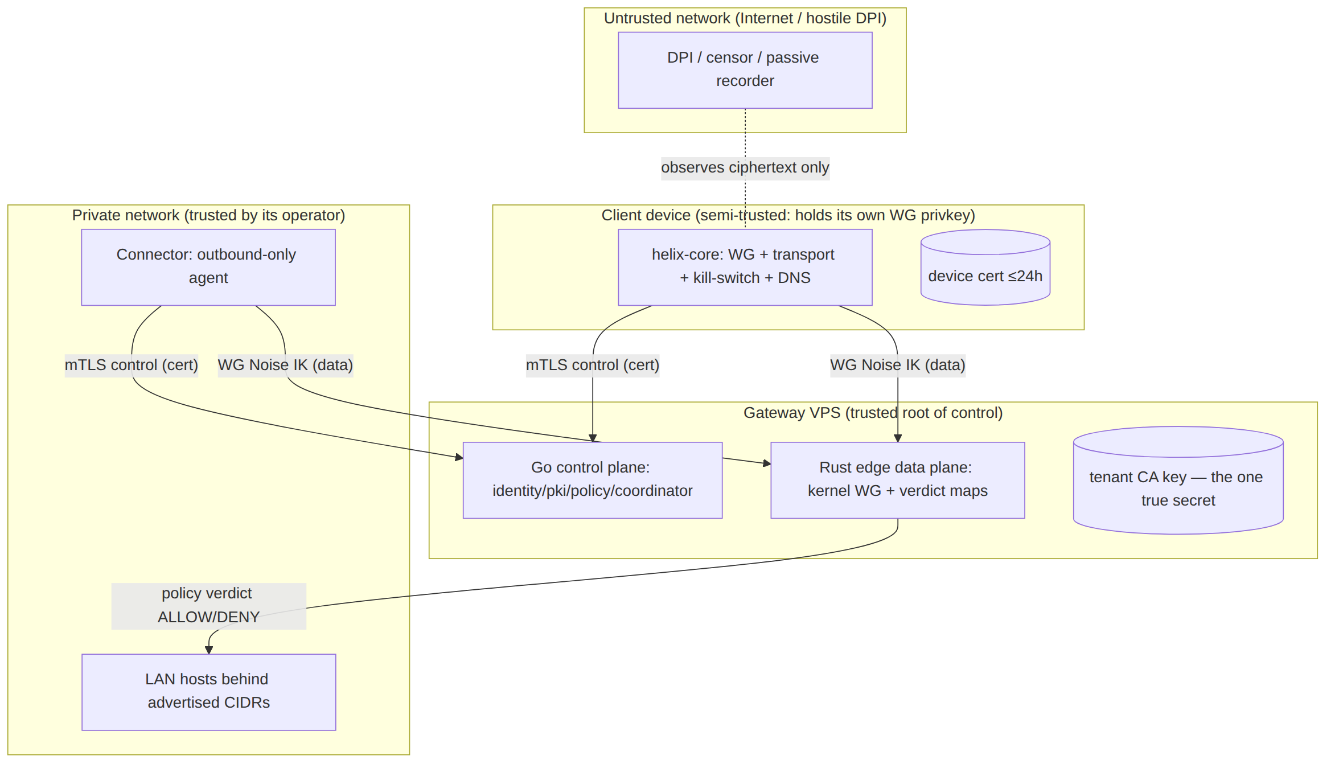
Trust gradient (high→low): the tenant CA key (root of all device identity) > Postgres control-plane truth > the Gateway control plane > the Rust edge (sees only ciphertext)
the Connector (trusted by its network operator only) > the Client device (holds its own private key but is otherwise least-privileged) > the network (fully untrusted) [04_ARCH §7, research-pki_pq_nat].

1.2 Authentication channels (two, never conflated)
Channel | Auth mechanism | Lifetime | Crypto | Owner doc
Control channel (Coordinator.WatchNetworkMap, .Enroll, .AdvertisePrefixes, .ReportStatus) | mTLS with a short-lived device cert signed by the tenant CA | ≤24 h, auto-renew | TLS 1.3 (mutual), Ed25519 leaf keys | doc 02 + this §4
Data channel (the tunnel itself) | WireGuard Noise IK handshake; peer pubkeys delivered via the policy-filtered map | per-session, rekey ~120 s | Curve25519 + ChaCha20-Poly1305 (+ optional PQ PSK §9) | doc 01
The two channels share nothing — compromising a device cert does not yield the WG private key, and stealing the WG key does not authenticate the control RPC. Both must be valid for a device to both learn its peers and reach them [04_ARCH §7, S2/S4].

1.3 Default-deny realisation (S1)
Zero-trust is not a slogan here; it is mechanical. The policy compiler (doc 02 §7) emits, per device, exactly two artefacts, both default-empty:
- AllowedIPs for the WG peer entry — WireGuard's own cryptokey-routing already drops any packet whose source/destination is outside AllowedIPs. An empty list = the peer can send/receive nothing.
- An edge verdict map (nftables named verdict map or eBPF map; doc 01 §8) keyed on (src_overlay_ip, dst_cidr, l4proto, dport) → ACCEPT|DROP. The default verdict is DROP.
A device with no policy grant has an empty AllowedIPs and no verdict entry — it is cryptographically and administratively isolated even though it is enrolled and online. This is the "enroll a client; reach an authorized LAN host; deny an unauthorized one" acceptance criterion made concrete [04_P1 §11 DoD #2].

2. Identity
Two identity modes ship in the MVP; both bind to the same devices table and the same cert chain [04_P1 §6.1].

2.1 Managed mode — OIDC
Tenant admins and operators authenticate the Console/API via OIDC against any standard IdP (Keycloak, Authentik, Auth0, Entra, Okta) [04_P1 §6.1]. HelixVPN is an OIDC Relying Party, never an IdP — it stores no passwords.
- Flow: Authorization Code + PKCE (RFC 7636), response_type=code, scope=openid profile email. The Console is a public client (PKCE); the API validates the resulting ID token's signature against the IdP JWKS and pins iss/aud.
- Claim binding: oidc_sub (the stable subject) is the join key to users.oidc_sub; email is stored only when present and only for managed tenants. First login auto-provisions a users row scoped to the tenant resolved from the IdP realm/hd claim or an explicit invite.
- RBAC: users.role ∈ {admin, operator, member} (doc 02 DDL). Role is asserted from an IdP group claim mapping configured per tenant, or assigned in-Console by an admin.
// helix-go/internal/identity/oidc.go — verification skeleton (interface, not impl)
type OIDCVerifier interface {
// Verify validates signature, iss, aud, exp, nbf against the cached JWKS,
// and returns the canonical subject + optional email. Never trusts unsigned claims.
Verify(ctx context.Context, rawIDToken string) (sub string, email *string, groups []string, err error)
}
// Tenant→IdP binding (one IdP per tenant in MVP; multi-IdP is Phase 2).
type TenantOIDC struct {
TenantID uuid.UUID
Issuer string // pinned; mismatch ⇒ reject
ClientID string // aud must contain this
JWKSURL string // refreshed on kid-miss with backoff
GroupClaim string // e.g. "groups"; mapped to role via RoleMap
RoleMap map[string]Role
}

2.2 Anonymous mode — device enroll tokens (the Mullvad posture)
A tenant can mint device enroll tokens with no email and no SSO — the "account number, no PII" stance [04_P1 §6.1, 04_ARCH §7]. The device obtains identity + cert without any personal data ever being stored. This is the privacy-VPN front end's default for end users.
- A token is a high-entropy opaque string (256-bit, base32-Crockford for QR friendliness). Only its Argon2id hash is stored (enroll_tokens.token_hash), never the plaintext (S11-class secret hygiene). The plaintext is shown/QR'd exactly once.
- Tokens are single-use (consumed on Enroll) or bounded multi-use (admin-set max_uses for fleet rollout), always with a short TTL (default 1 h, clamped [5 m, 24 h]) and an optional bind_kind (client|connector).
- The resulting users row has email = NULL, oidc_sub = NULL; the device is owned by a synthetic "anonymous" user scoped to the tenant. No reverse-link to a human exists by design.
-- enrollment tokens (owned by identity; canonical home is doc 02, quoted here for §3)
CREATE TABLE enroll_tokens (
id uuid PRIMARY KEY DEFAULT gen_random_uuid(),
tenant_id uuid NOT NULL REFERENCES tenants(id) ON DELETE CASCADE,
token_hash bytea NOT NULL, -- Argon2id(token); plaintext never stored
bind_kind device_kind, -- NULL = any; else pin client|connector
bind_site text, -- optional connector site label
max_uses int NOT NULL DEFAULT 1,
used_count int NOT NULL DEFAULT 0,
not_after timestamptz NOT NULL,
created_by text NOT NULL, -- actor (audited)
created_at timestamptz NOT NULL DEFAULT now(),
revoked boolean NOT NULL DEFAULT false
);
CREATE INDEX ON enroll_tokens (tenant_id) WHERE NOT revoked;
-- lookup is by constant-time hash compare over candidate rows, never by plaintext index.

2.3 RBAC and RLS as defence-in-depth
REST/Console authz uses OIDC session or API token + RBAC; agent RPCs use the device mTLS cert; Postgres RLS is the backstop so a logic bug in the app layer cannot cross tenants [04_P1 §2.2, §8]. Every privileged identity action is audited (§7).

3. Enrollment
The single most security-critical protocol in the system: it must mint a network identity without the device ever surrendering its WireGuard private key (S2) and without an unauthenticated party being able to enroll [04_P1 §6.2].

3.1 Enrollment sequence (Mermaid)
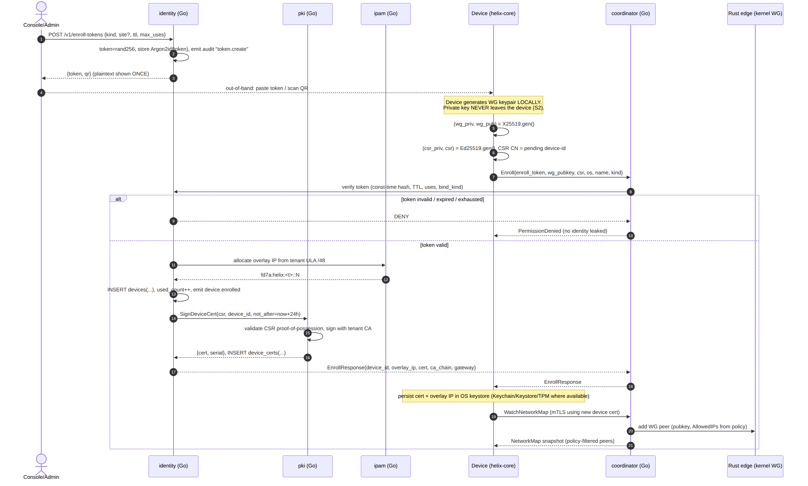

3.2 The Enroll RPC (protobuf — extends doc 03)
Doc 03 defines the Coordinator service; this document adds the CSR field so the device cert is minted from a device-held private key (proof-of-possession), not handed a server-generated key.
// helix-proto/coordinator.proto (security additions to the Enroll messages)
message EnrollRequest {
string enroll_token = 1; // single/bounded-use, TTL'd; verified by hash (§2.2)
bytes wg_pubkey = 2; // 32-byte Curve25519 PUBLIC key; private stays on device (S2)
bytes csr = 3; // PKCS#10 CSR, Ed25519 leaf key generated on device (S2)
string os = 4; // ios|android|linux|windows|macos|harmonyos|aurora
string name = 5;
DeviceKind kind = 6;
// OPTIONAL device-attestation evidence (Phase 2): platform key attestation blob.
bytes attestation = 7; // empty in MVP; verified in Phase 2 (§3.5)
}
message EnrollResponse {
string device_id = 1;
string overlay_ip = 2; // e.g. "fd7a:helix:1::2"
bytes device_cert = 3; // X.509 leaf, signed by tenant CA, not_after = now+24h
repeated bytes ca_chain = 4; // tenant CA (+ intermediate if used) for pinning
GatewayInfo gateway = 5;
uint32 cert_ttl_s = 6; // renew-before window hint for the core
}

3.3 Device-side key handling (Rust skeleton, helix-core)
The device generates two keypairs locally: the long-lived WG static key (X25519) and a short-lived control-channel leaf key (Ed25519). Only public material crosses the wire.
// helix-core/crates/helix-pki/src/enroll.rs (skeleton — contract, not full impl)
pub struct EnrolledIdentity {
pub device_id: String,
pub overlay_ip: IpAddr,
pub wg_secret: StaticSecret, // X25519 private — sealed in OS keystore, never serialised out
pub cert_der: Vec<u8>, // current device cert (mTLS leaf)
pub cert_key: SigningKey, // Ed25519 leaf private — also sealed in keystore
pub ca_chain: Vec<Vec<u8>>, // for pinning the control channel
pub renew_at: SystemTime, // = not_after - renewSkew (renewSkew = max(1h, 0.2×TTL), §4.5)
}
pub trait Enroller {
/// Generates WG + leaf keypairs locally, builds a CSR, calls Coordinator.Enroll,
/// and persists the result in the platform keystore via `KeyStore`.
/// PRECONDITION/POSTCONDITION (S2): no private key is ever returned by value to FFI,
/// logged, or written outside the sealed keystore.
fn enroll(&self, token: &str, kind: DeviceKind, ks: &dyn KeyStore)
-> Result<EnrolledIdentity, EnrollError>;
}
/// Platform-backed secret storage. Implemented per shim (doc 06):
/// iOS/macOS Keychain (Secure Enclave where present), Android Keystore (StrongBox),
/// Windows DPAPI/TPM, Linux libsecret/TPM2. Software fallback only with a logged warning.
pub trait KeyStore {
fn seal(&self, label: &str, secret: &[u8]) -> Result<(), KeyStoreError>;
fn open(&self, label: &str) -> Result<Zeroizing<Vec<u8>>, KeyStoreError>;
fn wipe(&self, label: &str) -> Result<(), KeyStoreError>;
}
StaticSecret, SigningKey, and the Zeroizing wrapper guarantee the private bytes are zeroed on drop (zeroize); FFI (doc 05/06) exposes handles and operations, never the raw key material — a device-key extraction must defeat the OS keystore, not read a Dart string.

3.4 Anti-replay & abuse controls on Enroll
- Constant-time token check. Candidate enroll_tokens rows for the tenant are hash-compared in constant time; failure returns PermissionDenied with no detail (no oracle on which field failed) — prevents token enumeration (research-pki_pq_nat).
- CSR proof-of-possession. The CSR signature is verified before signing; the leaf public key in the CSR must match the signer — a device cannot enroll a key it does not control.
- Rate limiting. Per-source-IP and per-tenant token buckets on Enroll (Redis, doc 02 §4.6). Repeated failures back off exponentially and emit auth.enroll.denied audit events.
- One pubkey, one device. UNIQUE (tenant_id, wg_pubkey) (doc 02 DDL) rejects re-use of a public key across devices.

3.5 Phase-2 hardening: platform attestation (forward-looking, not MVP)
The attestation field reserves space for platform key attestation (Apple DeviceCheck/App Attest, Android Key Attestation, Windows TPM attestation) so a Phase-2 tenant can require that the WG/leaf keys are hardware-bound. MVP leaves the field empty and does not gate on it — stated here so the wire format need not change later [04_P2 §0 "everything additive", S2].

4. PKI — key hierarchy, certificate lifecycle, rotation, revocation

4.1 Key hierarchy
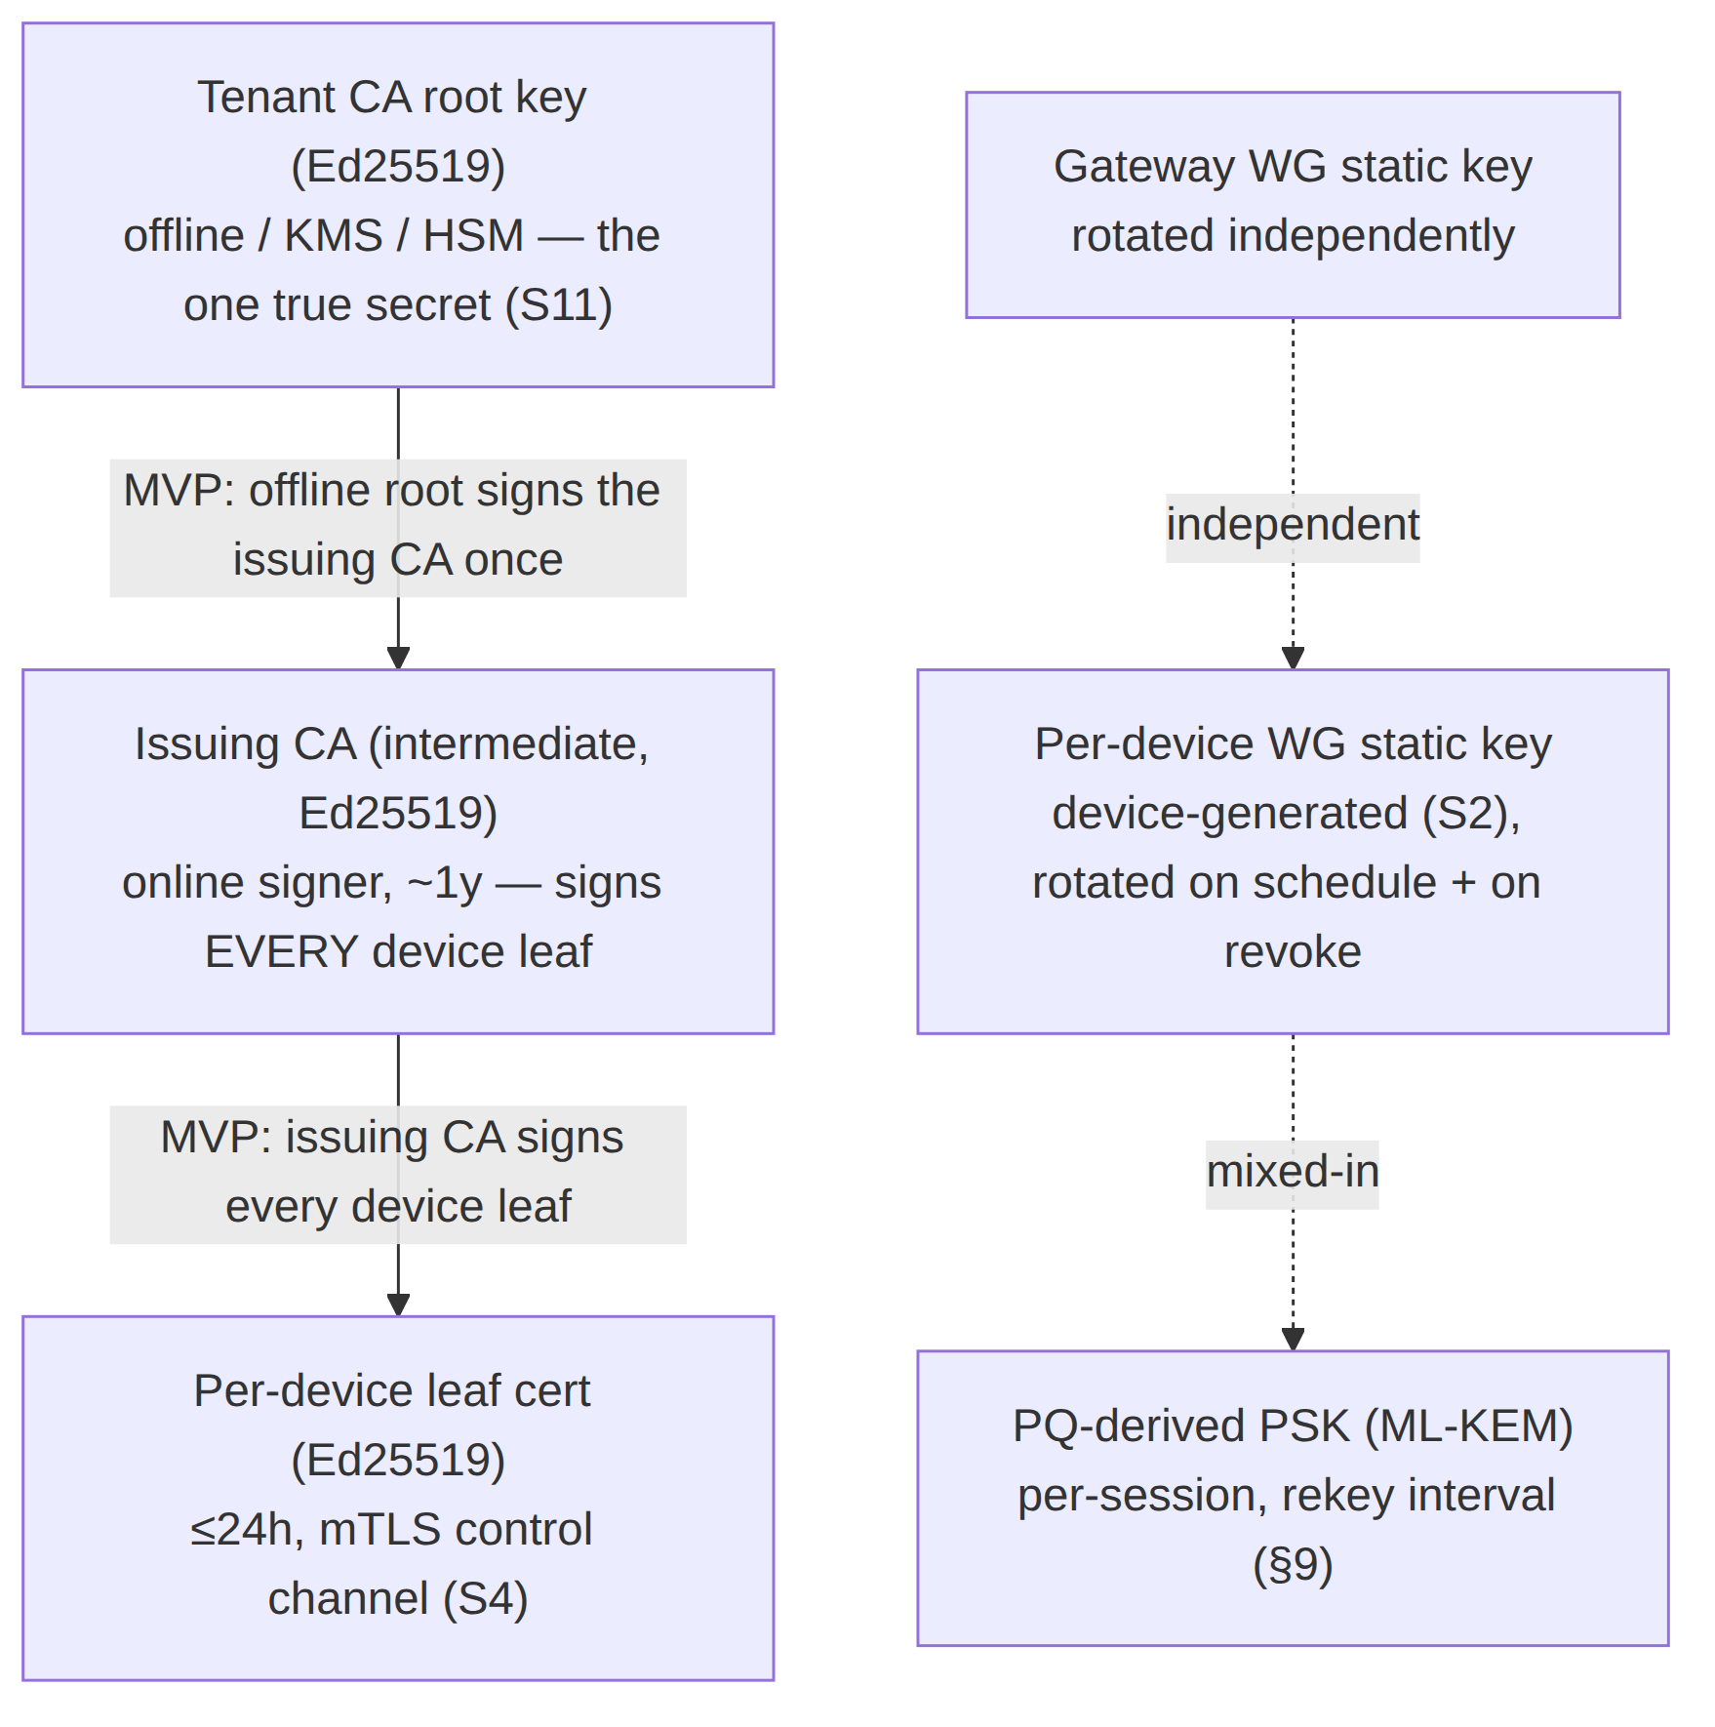
Three independent key planes, deliberately uncoupled so a compromise in one does not cascade [04_ARCH §7, research-pki_pq_nat]:
- Control-identity plane — tenant CA → device leaf certs (this §4). Governs who may talk to the control plane.
- Data plane — per-device + gateway WG static keys (doc 01). Governs who may decrypt the tunnel. WG keys are not issued by the CA; they are registered public keys.
- PQ plane — ephemeral ML-KEM exchange → WG PSK (§9). Governs harvest-now-decrypt-later resistance. Per-session, never persisted.

4.2 Certificate authority topology (decision, with recommendation)
Reconciled (§11.4.35, 2026-06-26) — D-PKI-CA-TIER: MVP ships a two-tier issuing CA (source-aligned with the authoritative control-plane spec [v03-control-plane/svc-pki.md §2] and [v05-security/pki-and-certs.md]): an offline / KMS root signs an online issuing intermediate once, and the issuing intermediate signs every ≤24 h device leaf. The earlier "single-tier (root signs leaves directly) is the MVP default, two-tier is Phase 2" framing was stale and is corrected below.
Option | Description | Pro | Con | Recommendation
A. Single-tier per-tenant CA | Tenant CA root signs device leaves directly. | Simplest; one key to back up per tenant. | Root key must be reachable by the online signer for every 24 h leaf — the offline-root property is lost, larger compromise blast radius. | Rejected for MVP — keeping the root online to sign 24 h leaves defeats S11.
B. Two-tier issuing CA (offline root + online issuing intermediate) | Offline / KMS root signs the issuing intermediate once; the online issuing intermediate signs every device leaf. | Root stays fully offline (S11); issuing CA rotates without re-establishing the root; cleaner revocation blast radius; matches the control-plane ca_keys hierarchy [v03-control-plane/svc-pki.md §2]. | More moving parts; issuing-CA rotation tooling (§2.3 of svc-pki). | MVP default. Root in KMS/HSM or offline; the online pki service signs leaves with the issuing intermediate, never with the root.
The ca_chain in EnrollResponse carries root + issuing CA from day one so clients pin the full chain root→issuing→leaf (§3.2). Phase-2 strengthening (additive, no reshape, §11.4.6): add a 2nd intermediate / per-region issuer + an HSM root-ceremony, growing the issuance fan-out without changing the wire format.

4.3 Certificate profiles (X.509, TLS 1.3 mutual)
Field | Device leaf | Tenant CA (root) | Issuing CA (intermediate, MVP)
Key alg | Ed25519 | Ed25519 | Ed25519
Validity | ≤24 h | 10 y (offline) | ~1 y
subject | CN=<device_id>, O=<tenant_id> | CN=HelixVPN Tenant CA <tenant_id> | CN=HelixVPN Issuing CA
subjectAltName | URI spiffe://<tenant_id>/device/<device_id> | — | —
keyUsage | digitalSignature | keyCertSign, cRLSign | keyCertSign, cRLSign
extKeyUsage | clientAuth (and serverAuth for gateway-facing edge cert) | — | —
basicConstraints | CA:FALSE | CA:TRUE, pathlen:1 | CA:TRUE, pathlen:0
custom ext | `1.3.6.1.4.1..helix.deviceKind = client | connector` | —
Short leaf validity (≤24 h) is the primary revocation mechanism: even if the < 1 s active revocation (§4.6) somehow misses, the cert expires within a day. mTLS uses TLS 1.3 only (no downgrade), with the device cert as the client cert and the tenant CA as the trust anchor on the server side [04_ARCH §7, research-pki_pq_nat].

4.4 Certificate-lifecycle state machine (Mermaid)
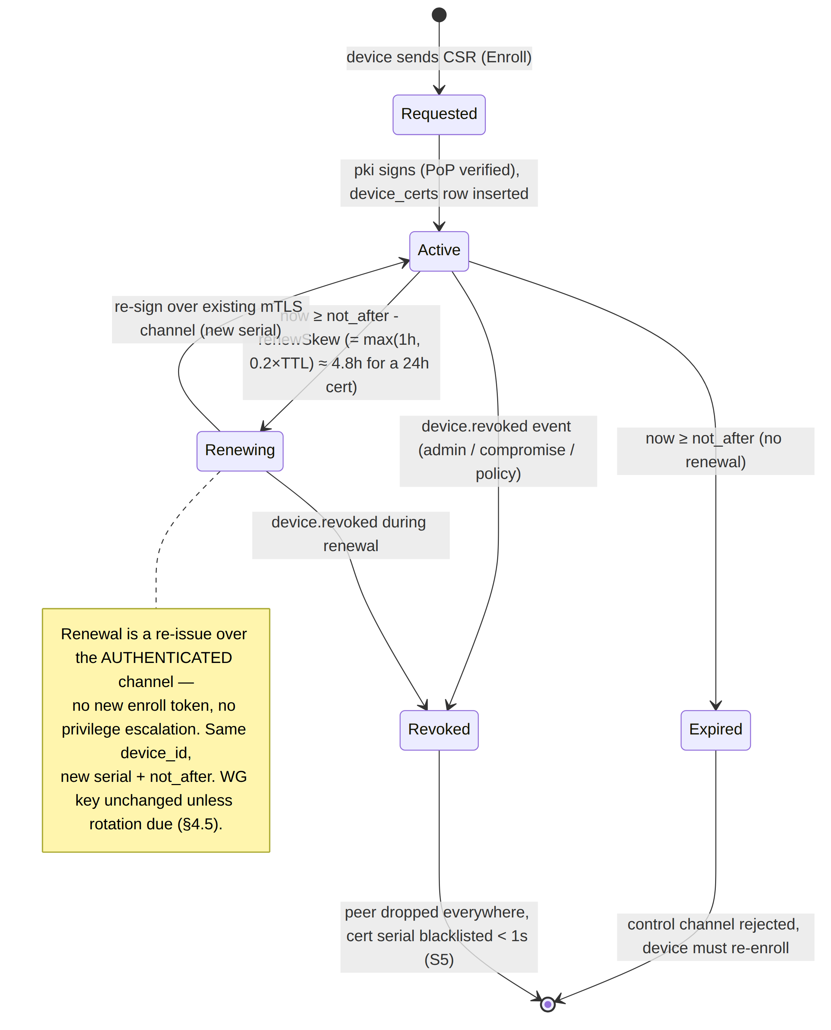

4.5 Rotation policy
- Device leaf cert: auto-renewed by the core when now ≥ not_after − renewSkew, where renewSkew = max(1h, 0.2 × TTL) (≈ 4.8 h before a 24 h cert; source-aligned with [v03-control-plane/svc-pki.md §6.1] / [v05-security/pki-and-certs.md]), over the existing authenticated mTLS channel — no enroll token, no human [04_P1 §6.3]. A missed renewal degrades to re-enrollment, not a silent failure.
- Device WG static key: rotated on a schedule (default 90 d, tenant-configurable) and immediately on device.revoked of a sibling device only if policy requires; the rotating device generates a new keypair locally and registers the new pubkey, the coordinator swaps the edge peer atomically [04_ARCH §7]. Old key removed from all maps before the new is announced (make-before-break ordering avoids a connectivity gap).
- Gateway WG static key: rotated independently of devices (helixvpnctl gateway keys), pushed to all clients as a NetworkMap delta (new gateway endpoint/pubkey); clients re-handshake [04_ARCH §7, 04_P2 §6.4].
- PQ PSK: rotated on every WG rekey interval (§9) — ephemeral, never persisted.

4.6 Revocation pipeline — device.revoked in < 1 s (S5)
Revocation is the security analogue of the convergence SLO: the same push-don't-poll machinery that propagates a route change in < 1 s propagates a revocation in < 1 s [04_P1 §6.3, SYNTHESIS §4].
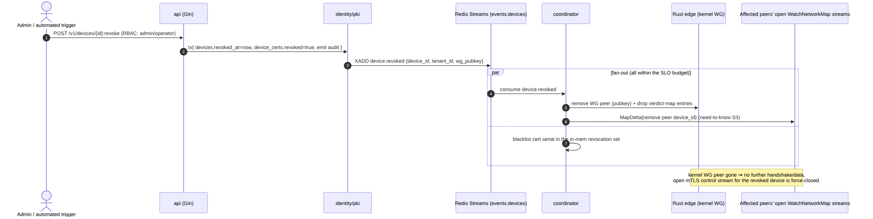
Mechanics that make < 1 s real and verifiable:
- The revocation write is a single Postgres transaction (revoked_at + device_certs.revoked + audit) so the state is atomic and crash-consistent.
- The edge enforces by removing the kernel WG peer (the data-plane truth) and dropping the verdict-map rows — not by consulting a CRL on the packet path (S6: no per-packet state lookups).
- The revoked device's open control stream is force-closed; its next mTLS attempt fails the in-memory serial blacklist and the device_certs.revoked check.
- No CRL/OCSP on the data path. Short-lived certs + active push obviate online revocation checking; an offline edge that misses the push still sees the cert expire ≤24 h (defence-in-depth) [research-pki_pq_nat].
-- device_certs already in doc 02; the revocation-relevant slice:
-- CREATE INDEX ON device_certs (tenant_id, device_id) WHERE NOT revoked; -- fast "current cert"
-- revocation = UPDATE device_certs SET revoked=true WHERE device_id=$1; (covered by the index flip)

4.7 pki service contract (Go interface — owned here, lives in doc 02's monolith)
// helix-go/internal/pki/pki.go (contract; implementation batched per §11.4.9)
type PKI interface {
// SignDeviceCert verifies CSR proof-of-possession and signs a ≤24h leaf with the tenant CA.
SignDeviceCert(ctx context.Context, t TenantID, deviceID DeviceID, csr []byte, ttl time.Duration) (cert []byte, serial string, err error)
// Renew re-issues over an authenticated channel; same device_id, new serial+not_after.
Renew(ctx context.Context, t TenantID, deviceID DeviceID, csr []byte) (cert []byte, serial string, err error)
// Revoke flips the cert row and returns the serial for the coordinator blacklist set.
Revoke(ctx context.Context, t TenantID, deviceID DeviceID) (serial string, err error)
// CAChain returns the pinning chain handed to devices in EnrollResponse.ca_chain.
CAChain(ctx context.Context, t TenantID) (chain [][]byte, err error)
}
// The CA *private* key is never in process memory in the KMS-backed deployment:
// signing is delegated to the KMS/HSM (e.g. AWS KMS asymmetric sign, PKCS#11). S11.
type CASigner interface {
Sign(ctx context.Context, t TenantID, tbs []byte) (sig []byte, err error) // tbs = to-be-signed cert bytes
}

5. Edge hardening (S8)
The Gateway runs two processes: the Go control plane and the Rust data-plane edge. The edge is the only component reachable from the hostile Internet on the data port, so it is the most hardened [04_ARCH §7, §4.7].

5.1 Rootless Podman quadlet — least privilege
Per §11.4.76 (containers submodule) + §11.4.161 (rootless), every component is an OCI image run via rootless Podman quadlets (.container units, systemd-managed, no Docker daemon) [04_ARCH §4.7, SYNTHESIS §2/§9].
# /etc/containers/systemd/helix-edge.container (rootless quadlet — the data-plane edge)
[Unit]
Description=HelixVPN Rust edge (data plane)
After=network-online.target
[Container]
Image=ghcr.io/helixdevelopment/helix-edge:1.0
# --- least privilege ---
ReadOnly=true # read-only rootfs; only declared volumes are writable
NoNewPrivileges=true # no setuid escalation
DropCapability=ALL # drop everything...
AddCapability=CAP_NET_ADMIN # ...then add ONLY what kernel WG / tun needs
AddCapability=CAP_NET_RAW # raw sockets for the obfuscated transports (doc 01)
SecurityLabelType=helix_edge.process # SELinux type (Phase 2; AppArmor profile on Debian)
SeccompProfile=/etc/helixvpn/seccomp-edge.json # §5.2 — syscall allowlist
# --- networking ---
AddDevice=/dev/net/tun # TUN; NO host network namespace sharing
PublishPort=443:443/udp # MASQUE/QUIC + plain WG
PublishPort=443:443/tcp # UoT / TCP fallback (doc 01)
# --- writable scratch only ---
Tmpfs=/run:rw,noexec,nosuid,size=16m
Tmpfs=/tmp:rw,noexec,nosuid,size=16m
# --- NO ssh, NO shell tooling in the image (distroless base) ---
Environment=CONTROL_PLANE_ADDR=unix:///run/helix/control.sock
[Service]
Restart=on-failure
RestartSec=2
[Install]
WantedBy=multi-user.target

5.2 Seccomp syscall allowlist
The edge needs a tiny syscall surface (socket I/O, tun read/write, epoll, futex, mmap). A default-deny seccomp profile (allowlist) blocks everything else — no ptrace, no execve of a shell, no mount, no kexec [04_ARCH §7].
# seccomp-edge.json (excerpt, expressed as YAML for readability)
defaultAction: SCMP_ACT_ERRNO # deny-by-default
architectures: [SCMP_ARCH_X86_64, SCMP_ARCH_AARCH64]
syscalls:
- names: [read, write, readv, writev, recvmsg, sendmsg, recvfrom, sendto,
epoll_create1, epoll_ctl, epoll_wait, epoll_pwait, ppoll,
socket, bind, connect, getsockopt, setsockopt, getsockname,
futex, mmap, munmap, mprotect, brk, rt_sigaction, rt_sigprocmask,
clock_gettime, nanosleep, close, fcntl, ioctl, exit, exit_group]
action: SCMP_ACT_ALLOW
- names: [ioctl] # TUN ioctls are required but narrow…
action: SCMP_ACT_ALLOW
args:
- index: 1 # …pin TUNSETIFF / TUNSETPERSIST argument values in Phase 2
op: SCMP_CMP_MASKED_EQ
value: 0x400454ca
# explicitly absent: execve, ptrace, mount, setuid, kexec_load, init_module, bpf(write)

5.3 No-SSH, control-plane-only management
There is no SSH on the data-plane container and no interactive shell in the image (distroless base, no /bin/sh). All management is via the control plane (helixvpnctl → API → coordinator → edge); the edge is reconfigured by NetworkMap deltas, never by hand-editing a config file inside the box [04_ARCH §7, §4.7]. The original research's fail2ban/SSH-key hardening is replaced, not augmented, by no-public-SSH + WireGuard-only management [04_ARCH §7 carry-forward].

5.4 Host-level posture (deployment doc 09 owns the full set; security floor here)
- Inbound host firewall: only :443/udp + :443/tcp (data) and the control API behind mTLS; everything else default-drop.
- Kernel: net.ipv4.conf.all.rp_filter, disable IP source routing, BPF JIT hardening; the edge process under a dedicated unprivileged user namespace (rootless).
- Image supply chain: signed images (cosign), SBOM, reproducible builds (Phase 3 [04_ARCH §12]).

6. No-logging as code (S6)
The privacy promise is a build property, enforced by absence and by a CI lint, not by an operator's good intentions [04_ARCH §7, 04_P1 §11.4].

6.1 What is and is not stored
Stored (durable, Postgres) | NOT stored (ever)
Identity: tenants, users, devices (pubkey, overlay IP, coarse last_seen_at) | Per-connection records
Topology: connectors, advertised prefixes, groups | Per-packet / per-flow records (src, dst, bytes, timestamps)
Policy: spec + compiled rules | DNS query logs
device_certs, enroll_tokens (hashed) | Destination IPs / domains visited
audit_events (control actions only, §7) | Traffic content or metadata of any kind
Aggregate counters (handshakes, bytes-total, errors — Prometheus) | Anything correlating a user to a destination
Live presence/session state is ephemeral in Redis (TTL'd), so the durable store never accumulates a connection log [04_ARCH §4.5]. last_seen_at is coarse (refreshed from presence, not per-packet) and carries no destination.

6.2 CI schema-lint (the mechanical enforcement)
A schema test fails the build if a durable table appears that is shaped like a connection log: named connections|flows|traffic|packets|sessions (durable), OR any table that has both a src/dst-type column and a bytes/ts-type column outside audit_events [04_P1 §11.4, §23]. The privacy promise is enforced by tooling, not trust.
// helix-go/internal/store/schemalint/nolog_test.go (contract; runs in CI, anti-bluff)
var forbiddenTableNames = []string{"connections", "flows", "traffic", "packets", "sessions"}
func TestNoConnectionLogTables(t *testing.T) {
schema := introspect(t) // reads live migrated schema, not the .sql source text
for _, tbl := range schema.Tables {
if contains(forbiddenTableNames, tbl.Name) {
t.Fatalf("S6 VIOLATION: durable table %q is connection-log-shaped", tbl.Name)
}
hasSrcDst := tbl.HasColumnMatching(`(?i)^(src|dst|source|dest).*`)
hasBytesTs := tbl.HasColumnMatching(`(?i)(bytes|octets)`) && tbl.HasColumnMatching(`(?i)(ts|timestamp|at)$`)
if tbl.Name != "audit_events" && hasSrcDst && hasBytesTs {
t.Fatalf("S6 VIOLATION: %q has src/dst + bytes/ts shape (looks like a flow log)", tbl.Name)
}
}
}
Anti-bluff (§11.4.1/§1.1): a paired meta-test plants a CREATE TABLE flows(src inet, dst inet, bytes bigint, ts timestamptz) migration in a throwaway schema and asserts the lint FAILs — so the lint cannot be a tautology that passes everything (§11.4.107(10) self-validated analyzer).

7. Audit — control actions only (S7)
Every state-changing control action is audited to audit_events and streamed live to the Console; traffic is never audited [04_ARCH §7, 04_P1 §2.1].
-- audit_events (canonical in doc 02; quoted for the security contract)
-- audit_events(id, tenant_id, actor, action, target, ts, meta jsonb)
- Audited actions (closed set — the canonical AuditAction enum [v03-control-plane/svc-telemetry.md §4.2], mirrored in [v05-security/audit-and-compliance.md §4]): enroll_token.mint, enroll_token.used, device.enrolled, device.revoke, device.cert.issued, device.cert.rotated, policy.create, policy.activate, policy.rollback, connector.attached, connector.prefixes.changed, tenant.create, user.role.change, auth.login, auth.enroll.denied.
- Reconciled (§11.4.35, 2026-06-26): this list is rewritten to the canonical enum names (the closed AuditAction set is the source of truth, §4.2 of svc-telemetry). The prior divergent labels map as: token.create→enroll_token.mint; device.enroll→device.enrolled; device.keyrotate→device.cert.rotated; policy.update→policy.create/policy.activate; prefix.advertise/prefix.withdraw→connector.prefixes.changed; gateway.keyrotate→device.cert.rotated (the gateway is itself a device row — its credential rotation audits under the same action, no new enum member). token.revoke and policy.compile have no canonical audit action (token revocation + internal policy compilation are not separately audited control actions in the MVP closed set) and are dropped.
- Never audited: any packet, flow, destination, DNS query, or byte-count attributable to a user — those don't exist (S6), so they cannot be audited even by mistake.
- Actor binding: actor is the OIDC sub/user id for human actions, "system" for automated ones (e.g. scheduled key rotation), and the device id for agent-initiated control writes.
- Integrity (Phase 2): optional hash-chained audit (meta.prev_hash) for tamper-evidence — reserved, not MVP.
- Live stream: audit_events writes emit on events:audit; the Console subscribes via WS/SSE for a real-time security feed (doc 02 §4.3).

8. Kill-switch & DNS-leak protection (S9)
A privacy VPN that leaks plaintext when the tunnel drops is broken. The kill-switch and DNS-leak protection are a core-owned state machine (helix-core, doc 05), not hand-edited firewall rules an operator can forget [04_ARCH §6 row, 04_P1 §11 DoD #6]. The core drives the OS firewall; the rules are an output of the state machine.

8.1 The state machine (Mermaid)
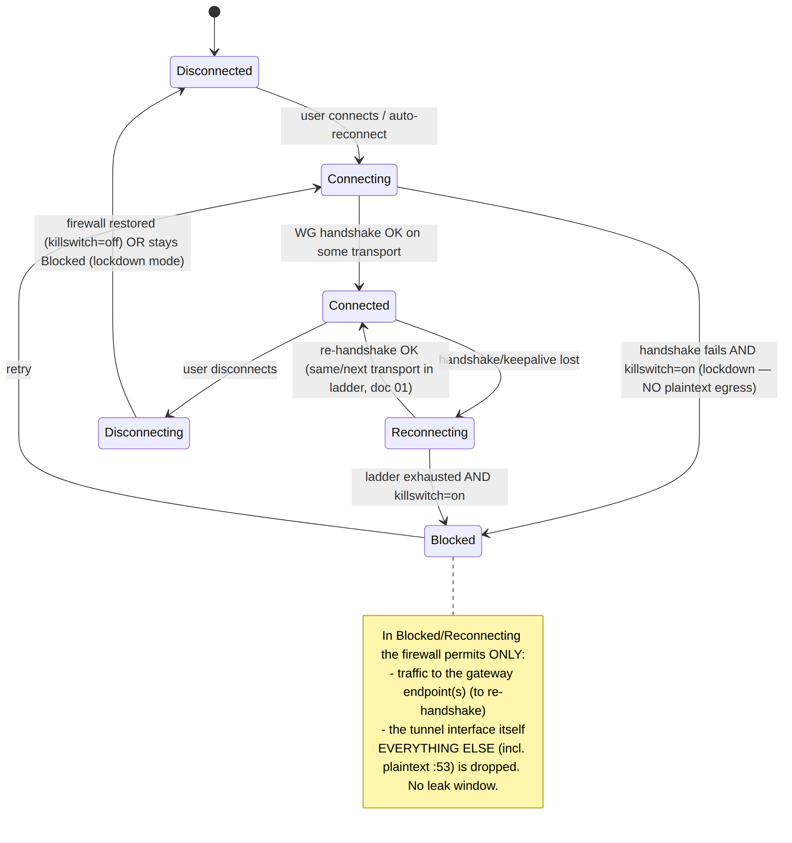

8.2 Firewall posture per state (the rules the core emits)
State | Allowed egress | DNS | Notes
Disconnected | all (killswitch off) or none (lockdown) | system | lockdown = "block until connected" toggle
Connecting / Reconnecting | only to gateway endpoint IP:port | blocked (no off-tunnel :53) | prevents leak during escalation ladder (doc 01)
Connected | only via tunnel utun/wg0 + gateway endpoint | tunnel DNS only; off-tunnel :53 dropped | the only steady-state
Blocked | only to gateway endpoint (to recover) | blocked | hard lockdown; UI shows "protected, reconnecting"

8.3 DNS-leak specifics
- The core sets the tunnel DNS (pushed in the NetworkMap: dns_servers, search_domains) and blocks plaintext :53/:853 off-tunnel in every non-Disconnected state [04_ARCH §6 row].
- On platforms with split-DNS APIs (Apple NEDNSSettings, Android VpnService.Builder.addDnsServer, Windows NRPT), the shim (doc 06) applies the tunnel resolver; the core's firewall rule is the belt-and-suspenders backstop so a misbehaving app cannot reach a hardcoded 8.8.8.8.
- IPv6 leak: if the overlay is IPv6 ULA (4via6, doc 03/D4) but the host has native IPv6, the core either routes ULA + blocks native v6 egress, or fully captures v6 — never a partial-capture leak.

8.4 Core state-machine skeleton (Rust)
// helix-core/crates/helix-killswitch/src/sm.rs (contract — state machine, not full impl)
#[derive(Clone, Copy, PartialEq)]
pub enum LinkState { Disconnected, Connecting, Connected, Reconnecting, Blocked, Disconnecting }
pub trait Firewall { // implemented per shim (doc 06): nftables(Linux), NE(Apple), WFP(Windows)…
/// Apply the leak-proof rule set for `state`. MUST be atomic (no transient open window).
fn enforce(&self, state: LinkState, gw: &[SocketAddr], tun_if: &str, dns: &[IpAddr]) -> Result<(), FwError>;
/// Restore the host's pre-VPN firewall (only on Disconnected when lockdown=off).
fn restore(&self) -> Result<(), FwError>;
}
pub struct KillSwitch { fw: Box<dyn Firewall>, lockdown: bool }
impl KillSwitch {
/// Single authority for the transition; on EVERY transition it re-enforces the firewall
/// BEFORE the network operation, so no plaintext can escape during the change (S9).
pub fn transition(&mut self, to: LinkState, ctx: &LinkCtx) -> Result<(), FwError> {
self.fw.enforce(to, &ctx.gateways, &ctx.tun_if, &ctx.dns)?; // firewall first…
// …then the actual link operation (bring up/down peer) proceeds (doc 01).
Ok(())
}
}
Anti-bluff validation (§11.4.107/§11.4.69): the DoD test drops the tunnel mid-transfer and asserts via packet capture on the host's physical interface that zero plaintext packets (incl. :53) egress during Reconnecting/Blocked — captured evidence, not an absence-of-error PASS [04_P1 §11 DoD #6].

9. Post-quantum handshake (S10)
WireGuard's Curve25519 handshake is vulnerable to harvest-now-decrypt-later: an adversary records ciphertext today and decrypts it once quantum computers mature. HelixVPN closes this the way Mullvad does — without forking WireGuard crypto — by deriving a pre-shared key (PSK) from a post-quantum KEM and mixing it into the WG handshake [04_P2 §5, research-pki_pq_nat].

9.1 Approach — PQ-derived PSK, hybrid never PQ-only
WireGuard already supports an optional symmetric PSK mixed into the handshake (the Q value in the Noise IK). If that PSK is established via a post-quantum KEM, the session gains PQ resistance even though the core handshake stays classical Curve25519 — defence-in-depth: an attacker must break both the classical ECDH and the PQ KEM [04_P2 §5.1]. This is why hybrid, never PQ-only (S10): if the (younger, less-battle-tested) PQ KEM has a flaw, classical WG still protects you; if quantum breaks classical ECDH, the PQ PSK still protects you.
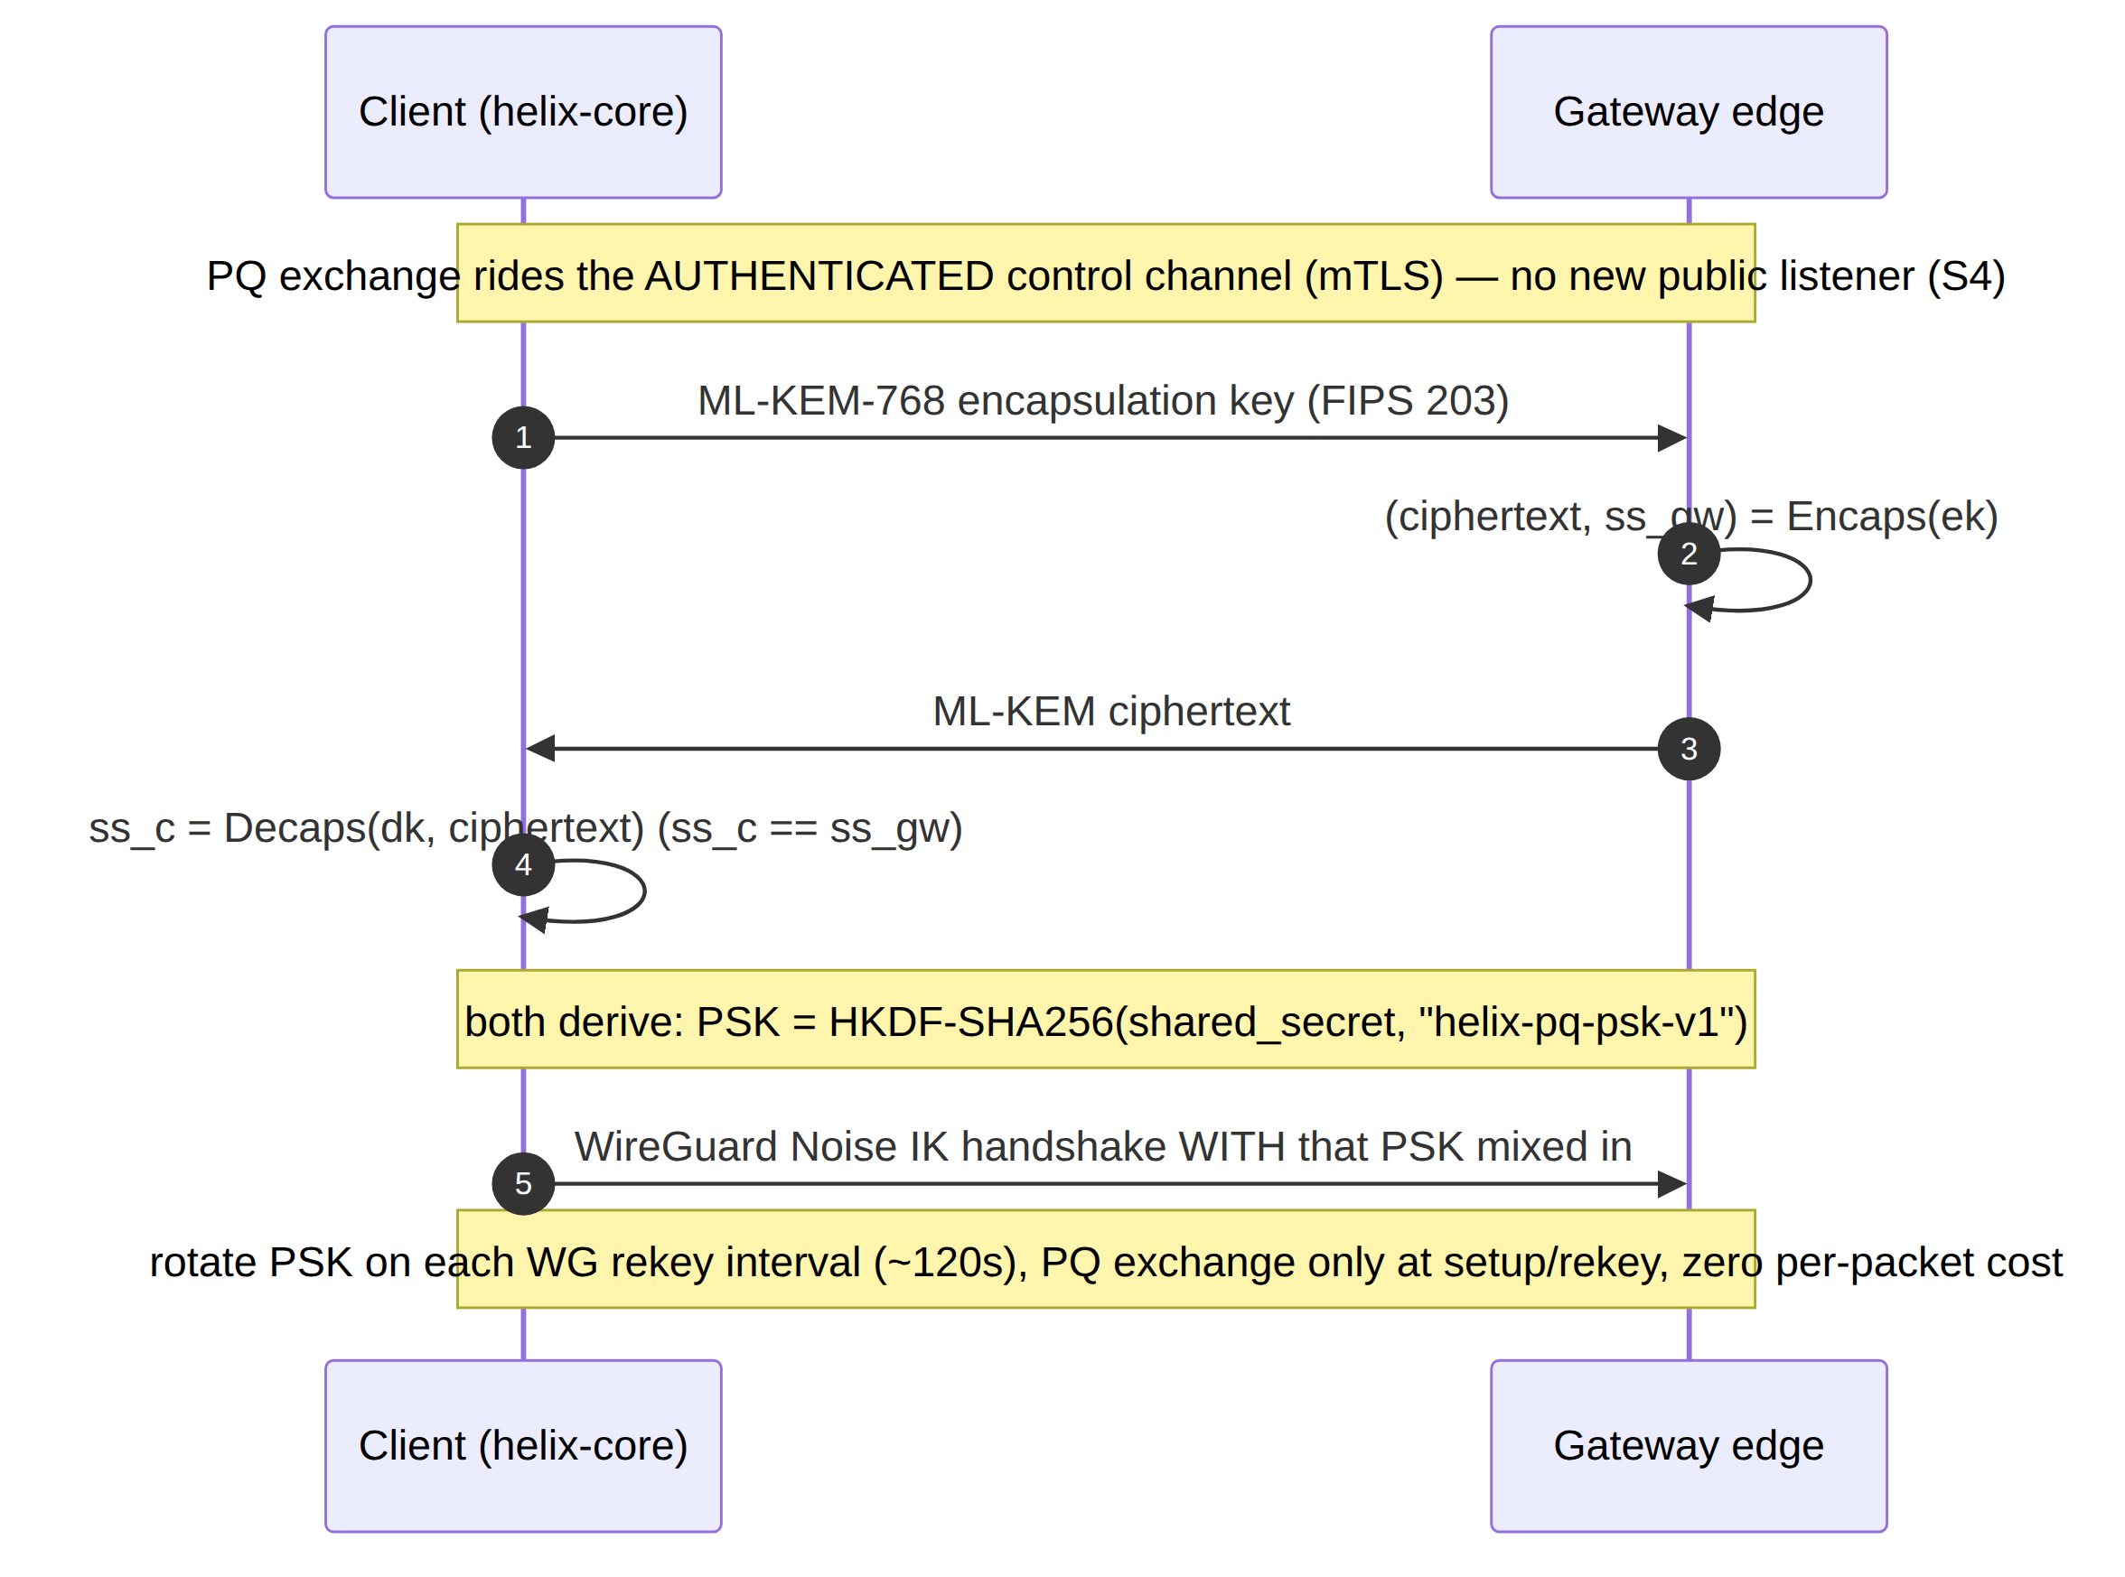

9.2 KEM choice (decision, with recommendation)
Option | KEM | Pro | Con | Recommendation
Primary | ML-KEM-768 (FIPS 203, standardized Kyber) | NIST-standardized; good size/speed; broad library support (ml-kem Rust crate, BoringSSL) | younger than classical | Default. Pluggable in pki + helix-core [04_P2 §5.2].
Conservative hybrid | ML-KEM-768 + Classic McEliece | Mullvad's original PQ tunnels combined McEliece + Kyber for exactly this hedge; code-based is a very different hardness assumption | McEliece public keys are large (≈ hundreds of KB) | Phase-2 opt-in for high-assurance tenants; only at setup/rekey so the size cost is amortised [04_P2 §5.2/§5.3].
External protocol | Rosenpass (audited PQ key-exchange daemon feeding WG a PSK) | independent audit; clean separation; reference design | extra daemon + integration | Evaluate during the Phase-2 PQ spike — prefer if an audited external protocol beats an in-house KEM exchange [04_P2 §5.4, research-pki_pq_nat].

9.3 Where it runs & negotiation
- On the authenticated control channel (Coordinator RPC over mTLS) — so there is no new public listener and no unauthenticated PQ endpoint to attack [04_P2 §5.3].
- Capability-negotiated: a "Quantum-resistant" toggle, on by default for new tunnels where both ends support it [04_P2 §5.5]. A peer that doesn't support PQ falls back to classical WG — which is still secure today.
- Cost: PQ ciphertexts are KB-scale, so the exchange happens at session setup and rekey, not per packet; steady-state overhead is zero [04_P2 §5.5].
// helix-core/crates/helix-pki/src/pq.rs (pluggable KEM contract)
pub trait PqKem {
fn keypair(&self) -> (EncapKey, DecapKey);
fn encapsulate(&self, ek: &EncapKey) -> (Ciphertext, SharedSecret);
fn decapsulate(&self, dk: &DecapKey, ct: &Ciphertext) -> SharedSecret;
}
/// PSK = HKDF-SHA256(shared_secret, salt=session_id, info=b"helix-pq-psk-v1") -> 32 bytes,
/// mixed into the WG Noise IK preshared-key slot (doc 01). Rotated every rekey.
pub fn derive_wg_psk(ss: &SharedSecret, session_id: &[u8]) -> WgPsk { /* HKDF */ }
Honest boundary (§11.4.6): PQ here protects against future decryption of today's recorded traffic; it is not a claim that classical WG is broken now. PQ-only would be reckless given the PQ KEMs' relative youth — hybrid is the deliberate, conservative choice (S10).

10. Threat model
STRIDE-flavoured, scoped to HelixVPN's roles. Each row: threat → the invariant/mechanism that addresses it → residual risk (§11.4.6 — stated honestly, never "fully solved").
# | Threat (STRIDE) | Vector | Mitigation (mechanism) | Residual risk
T1 | Spoofing a device to the control plane | Forged/stolen control credentials | Short-lived mTLS device cert (S4) + CSR proof-of-possession (§3.4); revoke < 1 s (S5) | Stolen unexpired cert usable ≤ renew window until detected → revoke
T2 | Spoofing at the data plane | Inject WG packets as another peer | WG Noise IK + per-peer static keys; AllowedIPs cryptokey routing (S1) | Compromised device key until rotation (§4.5) → revoke + rotate
T3 | Tampering with the tunnel | Modify ciphertext in flight | ChaCha20-Poly1305 AEAD (doc 01); transport carries opaque WG datagrams (doc 01 I1) | None cryptographic; DoS only
T4 | Repudiation of admin actions | Admin denies a policy/revoke change | audit_events control-action audit (S7) + Phase-2 hash-chain | Pre-Phase-2 audit is not tamper-evident → DB integrity controls
T5 | Information disclosure — traffic correlation | Operator/host compromise reads a connection log | No connection log exists (S6) + CI schema-lint (§6.2); ephemeral Redis presence | Live in-RAM presence on a hot-compromised gateway; aggregate counters only
T6 | Information disclosure — over-broad map | A device learns peers it shouldn't | Need-to-know map filtering (S3) — peers delivered already policy-filtered | Coordinator bug → covered by anti-bluff map-content tests
T7 | Information disclosure — DNS/plaintext leak | Tunnel drop / IPv6 leak / DNS fallthrough | Core kill-switch + DNS-leak state machine (S9, §8); v6 capture/block | Pre-tunnel boot window unless lockdown=on
T8 | Information disclosure — harvest-now-decrypt-later | Passive recorder + future quantum | Hybrid PQ PSK (S10, §9) | PQ KEM novelty → hybrid hedge; classical still protects
T9 | DoS on the gateway | Flood the public data port | Rate limits (Redis token buckets); stateless edge fail-static (S; doc 01 I3); rootless restart | Volumetric DDoS needs upstream scrubbing (doc 09)
T10 | DoS on enrollment | Enroll-token brute force | Single/bounded-use TTL'd tokens, Argon2id hash, const-time check, rate limit (§3.4) | None practical; tokens expire
T11 | Elevation of privilege — container escape | Exploit the edge process | Rootless Podman, read-only rootfs, cap_drop ALL + NET_ADMIN only, seccomp allowlist, no SSH/shell (S8, §5) | Kernel 0-day in the tiny allowed syscall set
T12 | Elevation of privilege — CA compromise | Steal the tenant CA key | Two-tier issuing CA in MVP — offline/KMS root + online issuing intermediate (S11, §4.2/§4.7); signing delegated, root stays offline | Online issuing-CA or KMS compromise still mints leaves until rotated → rotate issuing CA (root unaffected), re-enroll; Phase-2 HSM root ceremony hardens the root further
T13 | Spoofing the gateway to a client | MITM the control/data endpoint | Client pins ca_chain (§3.2) for mTLS; WG gateway static key in the signed map (S4) | First-enroll trust-on-the-token; mitigated by out-of-band token delivery
T14 | Cross-tenant leakage | Multi-tenant self-host bug | Postgres RLS per tenant (§2.3) + app RBAC; fungible relays see only ciphertext (doc 01) | App+RLS both bypassed (defence-in-depth)
T15 | Censorship / blocking (availability of privacy) | DPI blocks WG | Pluggable obfuscation, auto-ladder, MASQUE/QUIC (doc 01); regional priors (doc 01) | Aggressive active-probing censor → DAITA + transport tuning (doc 01)

11. Secrets management & backup
Per S11, the durable secret surface is deliberately tiny [04_ARCH §10, 04_P1 §6.3].
- The two things to protect: (1) the tenant CA key (root of device identity), (2) Postgres (identity/topology/policy truth). Everything else (data-plane nodes, edge config) is cattle, reprovisioned from IaC in minutes [04_ARCH §10].
- CA key custody: the offline / KMS root + online issuing intermediate two-tier hierarchy is the MVP baseline (§4.2, D-PKI-CA-TIER): the root signs the issuing CA once and stays offline, the online pki service signs leaves with the issuing intermediate via CASigner (§4.7) so the raw root private key is never in pki process memory; the Phase-2 upgrade is a per-region / 2nd intermediate issuer + an HSM root ceremony (§4.2), not the introduction of two tiers. Self-host minimal mode: CA keys in an OS keystore / age-encrypted file with a documented operator passphrase (§11.4.10 — never git-tracked, chmod 600).
- Backup set: GPG/age-encrypted offsite backups of Postgres (PITR) + the CA root; restic, 3-2-1, quarterly DR drill [04_ARCH §10]. RPO ≈ 0 (config in Git + Postgres PITR), RTO 15–30 min.
- Secret hygiene (§11.4.10): enroll tokens hashed (Argon2id), API tokens hashed at rest, no credential ever logged or printed by helixvpnctl; .env/secrets git-ignored project-wide with a tracked .example + README (§11.4.10/.30).

12. Phase → task → subtask plan (security workstream)
Each leaf becomes a §11.4.93 workable item (SQLite-backed single source of truth). Anti-bluff: every closure carries captured evidence (§11.4.5/.69/.107) and a paired §1.1 mutation.

Phase 0 — Spike (security-relevant slices)
- 0.S1 mTLS control channel — issue a self-signed dev CA, sign a leaf, prove a Connect RPC over mTLS rejects an unsigned/expired cert (captured handshake log).
- 0.S2 key-never-leaves proof — device generates WG + leaf keys; assert via FFI audit that no private byte crosses the FFI boundary or appears in any log (negative captured evidence).

Phase 1 — MVP
- 1.S1 identity OIDC RP — Authorization Code + PKCE; JWKS verify; tenant→IdP binding; RBAC map.
  - 1.S1.a OIDCVerifier (sig/iss/aud/exp); 1.S1.b first-login provisioning; 1.S1.c RBAC role map.
- 1.S2 anonymous enroll tokens — enroll_tokens DDL; Argon2id hash; single/bounded-use TTL; const-time verify; rate limit; abuse audit (auth.enroll.denied).
- 1.S3 enrollment protocol — Enroll RPC with CSR; device-side keygen (Enroller/KeyStore); IPAM overlay-IP allocation; device.enrolled event; sequence per §3.1.
  - 1.S3.a CSR proof-of-possession; 1.S3.b platform keystore sealing (per shim, doc 06); 1.S3.c re-enroll on missed renewal.
- 1.S4 pki two-tier issuing CA — PKI/CASigner interfaces; offline/KMS root signs the online issuing intermediate once, the issuing intermediate signs every ≤24 h Ed25519 leaf (D-PKI-CA-TIER, §4.2); ca_keys + device_certs; KMS-backed signer (with self-host file-CA fallback); cert profiles per §4.3; ca_chain carries root + issuing from day one.
- 1.S5 cert lifecycle + auto-renew — renew-before-expiry over mTLS; lifecycle state machine §4.4.
- 1.S6 revocation < 1 s — revoke pipeline §4.6; edge WG-peer removal + verdict-map drop + serial blacklist; close revoked control stream; measure p99 < 1 s (captured timing evidence).
- 1.S7 default-deny realisation — empty policy ⇒ empty AllowedIPs + DROP verdict default; reach-authorized / deny-unauthorized acceptance test (DoD #2).
- 1.S8 edge hardening — rootless quadlet (§5.1), seccomp allowlist (§5.2), read-only rootfs, cap_drop ALL+NET_ADMIN, distroless no-SSH; container-escape negative tests.
- 1.S9 no-logging schema-lint — CI lint §6.2 + paired mutation (plant a flows table ⇒ FAIL).
- 1.S10 control-action audit — audit_events writes on every privileged action; live WS feed.
- 1.S11 kill-switch + DNS-leak state machine — core KillSwitch/Firewall (§8); per-platform firewall impls (doc 06); packet-capture leak test (DoD #6).
- 1.S12 secrets hygiene — CA key custody (KMS or age-file), token/API-token hashing, backup of Postgres + CA root; helixvpnctl never prints secrets.

Phase 2 — Parity + hardening
- 2.S1 PQ handshake — PqKem ML-KEM-768 (FIPS 203) over mTLS; HKDF→WG PSK; capability negotiate; rotate on rekey; "Quantum-resistant" toggle on-by-default (§9). Spike: ML-KEM vs Rosenpass vs McEliece-hybrid (decision, §9.2).
- 2.S2 per-region / multi-intermediate issuance + HSM root ceremony — add a 2nd intermediate / per-region issuing CA under the (already two-tier, MVP) hierarchy and an HSM-backed root ceremony; additive to §4.2, no wire-format change (ca_chain already carries root + issuing).
- 2.S3 platform attestation — verify EnrollRequest.attestation (Apple/Android/TPM) (§3.5).
- 2.S4 hash-chained audit — tamper-evident meta.prev_hash (§7).
- 2.S5 WG key rotation — scheduled + make-before-break edge swap (§4.5).
- 2.S6 multi-region secret topology — per-region KMS, fungible relays see only ciphertext; cross-region revocation propagation < 1 s over NATS (doc 09).

Phase 3 — Extended
- 3.S1 reproducible builds + cosign-signed images + SBOM (so users verify binaries match source — table stakes for a privacy product) [04_ARCH §12].
- 3.S2 third-party security audit of the crypto core, enrollment, and no-logging claim.

13. Verification & anti-bluff (how each invariant is proven, not asserted)
Invariant | Captured-evidence proof (§11.4.5/.69/.107)
S2 key-never-leaves | FFI boundary audit + memory/log scan: zero private bytes cross FFI or hit any log (negative evidence)
S4 mTLS | handshake transcript: unsigned/expired/wrong-CA leaf ⇒ rejected; valid ⇒ accepted
S5 revoke < 1 s | timestamped trace: POST :revoke → edge peer gone → peer's map delta, p99 < 1 s over N runs (§11.4.50)
S6 no-logging | CI schema-lint PASS + paired mutation (flows table) FAILs (§11.4.107(10))
S7 audit | every privileged action produces an audit_events row + live WS event; traffic produces none
S8 edge hardening | container introspection: read-only rootfs, cap set = {NET_ADMIN, NET_RAW}, seccomp loaded, no /bin/sh; escape attempts blocked
S9 kill-switch/DNS | packet capture on physical iface during tunnel drop: zero plaintext incl. :53 egress
S10 PQ hybrid | handshake with PQ on ⇒ WG PSK present + ML-KEM exchange observed; PQ off ⇒ classical WG still connects
S1/S3 default-deny + need-to-know | reach-authorized PASS, reach-unauthorized DROP; map contains only policy-granted peers
All of the above run as helix_qa + challenges suites (§11.4.27) — a Challenge that scores PASS on a non-functional security control is the same class of defect as a unit-test PASS-bluff [SYNTHESIS §8/§9]. The kill-switch leak test and the revocation-timing test are the two highest-risk security validations and run FIRST in the suite per §11.4.132.

Sources verified
- 04_VPN_CLD/HelixVPN-Architecture-Refined.md §4 (control plane / pki service / data model), §7 (security architecture), §4.7 (Podman edge), §10 (backups/secrets), §12 (reproducible builds) ([04_ARCH]).
- 04_VPN_CLD/HelixVPN-Phase1-MVP.md §2.1 DDL (device_certs, audit_events), §6 (identity, enrollment, PKI), §8 (authz), §9 (quadlets), §11/§11.4 (DoD + no-logging CI lint) ([04_P1]).
- 04_VPN_CLD/HelixVPN-Phase2-Parity.md §5 (post-quantum PSK, ML-KEM/FIPS 203, Classic McEliece hybrid, Rosenpass), §3 (NAT traversal / relay-sees-only-ciphertext), §6.4 (gateway key rotation), §7 (security audit + reproducible builds) ([04_P2]).
- 05_VPN_YBO.md ([05_YBO]) — operator mandate (Go/Gin/Postgres/Redis/Podman stack; rootless).
- v09-research/_SYNTHESIS.md §7 (security/privacy invariants), §2/§8/§9 (stack + submodule wiring
  - constitution bindings) ([SYNTHESIS]).
- [research-pki_pq_nat] — RFC 8446 (TLS 1.3 mutual auth), RFC 7636 (PKCE), RFC 5280 (X.509 / CRL), FIPS 203 (ML-KEM / standardized Kyber), Rosenpass PQ key-exchange design, RFC 5869 (HKDF), WireGuard optional-PSK mechanics, Mullvad PQ-tunnel (Classic McEliece + Kyber) prior art; cross- referenced against latest official sources per §11.4.99.
Constitution bindings applied: §11.4.44 (revision header), §11.4.6 (no-guessing — every threat row states residual risk; every decision carries options + recommendation, never a silent pick), §11.4.66 (decision discipline — CA tier, KEM choice surfaced as decisions), §11.4.10/.30 (credentials/secrets hygiene), §11.4.76/.161 (containers/rootless edge), §11.4.50 (deterministic revocation-timing proof), §11.4.107(10) (self-validated schema-lint), §11.4.132 (risk-ordered validation: kill-switch + revocation first), §11.4.93 (phases→workable items), §11.4.65/.153 (HTML+PDF[+DOCX] exports follow in refinement). §11.4.5/.69/.107 captured-evidence proofs enumerated in §13.

