Repo Layout, Tooling, Deployment & Helix-Ecosystem Integration

Repo Layout, Tooling, Deployment & Helix-Ecosystem Integration
Revision: 2 Last modified: 2026-07-04T12:00:00Z Rev 2: Added §7.5 (Rate Limiting & DDoS Resilience — control-plane API token buckets + data-plane edge volumetric-attack mitigation, closing the gap left by Architecture-Refined.md §4.6 mentioning Redis token buckets but no deployment-layer detail existing anywhere in Volume 6). Status: active — subordinate to SPECIFICATION.md (the spine). Where this document disagrees with the spine on roles, principles (spine §4), or the decision register (spine §9), the spine wins until amended per §11.4.73. Authority: This document owns the physical engineering substrate of HelixVPN: the working monorepo, the decoupled reusable-component repos, schema-first codegen, the helixvpnctl operator CLI, the three deployment substrates (Podman quadlets / Docker Compose / Kubernetes), and the wiring of every already-incorporated submodules/ member into its concrete role. It is a specification, not the product — interface sketches, manifests, and skeletons are illustrative, not the shipping implementation (2–3 refinement passes follow). Evidence base: [04_ARCH §4/§9/§10/§11] = 04_VPN_CLD/HelixVPN-Architecture-Refined.md; [04_P1] = HelixVPN-Phase1-MVP.md; [04_P0] = HelixVPN-Phase0-Spike.md; [04_UI] = HelixVPN-helix-ui-Flutter.md; [05_YBO] = mandated-stack brief; [SYNTHESIS] = v09-research/_SYNTHESIS.md; per-LLM ids [02_QWN] [01_DSK] [07_GMI] [10_KMI] [11_MST]; [research-podman_k8s] = the Podman-Quadlet / podman kube / Kubernetes-for-WireGuard deep-research thread (verified against latest official sources per §11.4.99).

0. How to read this document
This document maps the logical architecture (data plane → doc 01, control plane → doc 02, client core + UI → doc 03, security/PKI → doc 04) onto files, repos, build tools, and deploy units. Three things are settled and load-bearing here:
- Reuse pillars — three reusable cores (Rust transport/VPN, Flutter UI, schema-generated clients) shared by all roles and apps [04_ARCH §5/§11, SYNTHESIS §6].
- Decoupling target — each reuse pillar becomes its own vasic-digital repo per §11.4.28/.29/.74, but only after the spec stabilizes (this is sequenced below, not done eagerly).
- Rootless-first deploy — Podman quadlets are the canonical substrate (§11.4.76/.161); Compose and Kubernetes are equivalents for operators on those substrates, generated from the same OCI images.
Conventions: MUST / SHOULD / MAY carry RFC 2119 force. Open choices live in §12 (Decision callouts) as options + recommendation per §11.4.66/.101 — never silently resolved.

1. Two-repo-shape strategy: build in a monorepo, extract reusable repos later

1.1 The tension and the resolution
The constitution wants decoupled, reusable, project-not-aware components each in its own repo (§11.4.28/.74). The MVP wants velocity and atomic cross-cutting changes (one PR touches proto + Go + Rust + Dart). These pull in opposite directions only if treated as simultaneous; they are not. The resolution, recommended and binding for this spec:
Phase 0 → Phase 1: one working monorepo helixvpn/ with internal workspace boundaries that are already the future repo boundaries. Post-MVP (Phase 1 exit gate): extract the six stabilized pillars into standalone vasic-digital repos and re-consume them as flat submodules. Nothing is extracted before its public surface stops churning (§11.4.124 — don't split before you know the seams).
This mirrors the control-plane "one Go binary, many packages; package boundaries == future service boundaries" discipline [04_ARCH §4.1] applied at the repository level. It satisfies §11.4.28 (the boundaries exist from day one; they are merely co-located until stable) without paying the multi-repo coordination tax during the highest-churn phase.
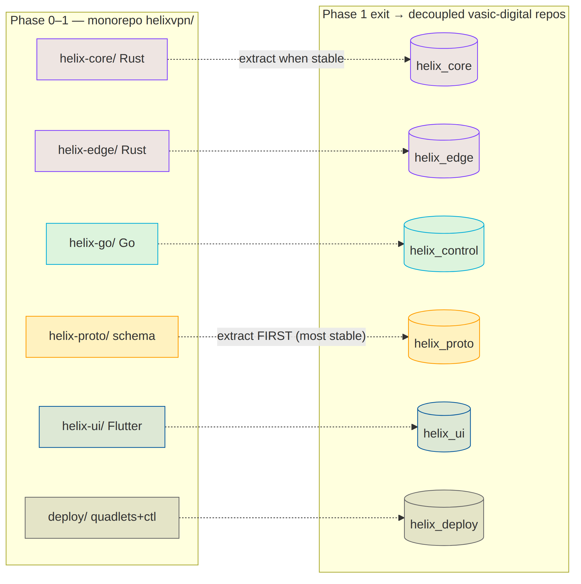

1.2 Extraction order (most-stable-first)
Order | Monorepo dir | Extracted repo (vasic-digital) | Why this order
1 | helix-proto/ | helix_proto | The schema is the contract; it must stabilize first so generated clients stop drifting. Extract at the first frozen WatchNetworkMap version [04_P1 §3].
2 | helix-core/ | helix_core | The Transport trait + FFI surface survive Phase 0 by design [04_P0]; extract once iOS memory gate G3 passes and the FFI ABI freezes.
3 | helix-edge/ | helix_edge | Depends on helix_core (helix-transport); extract right after it.
4 | helix-ui/ | helix_ui | Design system + Riverpod-over-status-stream contract stable by MVP DoD [04_UI].
5 | helix-go/ | helix_control | Largest churn surface (policy compiler, coordinator); extract last among code.
6 | deploy/ | helix_deploy | Quadlet/Compose/K8s generators + helixvpnctl; extract when image names + env contract freeze.
Each extraction is a visible commit citing §11.4.35 ("Lifted from helixvpn monorepo to vasic-digital/helix_proto per §11.4.28"), preserves history via git filter-repo --path helix-proto/, and immediately re-consumes the new repo as a flat submodule (§1.4).

2. Monorepo layout (helixvpn/) — file-by-file
The canonical tree, with the load-bearing files spelled out. Directory and file names are lowercase snake_case where they are ours to name (§11.4.29); language-mandated layouts (Rust crates/, Dart lib/, Cargo/Go file names) follow their ecosystem (§11.4.29 exception).
helixvpn/ # umbrella working repo (this repository's product code)
├── Cargo.toml # Rust workspace root — members: helix-core/crates/*, helix-edge
├── go.work # Go workspace — uses ./helix-go (+ extracted submodules later)
├── melos.yaml # Dart/Flutter monorepo manager (helix-ui packages)
├── buf.yaml buf.gen.yaml buf.lock # schema-first codegen config (§4)
├── Makefile # local task runner (gen / build / test / deploy) — NO CI (§11.4.156)
├── .gitignore # build artifacts, .env, *.db-wal/-shm (§11.4.30)
├── .env.example # HELIX_RELEASE_PREFIX, infra creds template (§11.4.77/.151)
├── helix-deps.yaml # submodule dependency manifest (§11.4.31)
│
├── helix-proto/ # ── reuse pillar 1: the contract ──
│ ├── proto/helix/v1/
│ │ ├── coordinator.proto # WatchNetworkMap + NetworkMap + MapDelta [04_P1 §3]
│ │ ├── enrollment.proto # device enroll / cert issue / revoke
│ │ └── types.proto # Peer, Route, TransportPolicy, DnsConfig, KillSwitch
│ ├── openapi/helix-rest.v1.yaml # Console/Access/Connector REST surface [04_ARCH §4.2]
│ └── gen/ # GENERATED (gitignored) → go/ dart/ rust/ ts/
│
├── helix-core/ # ── reuse pillar 2a: Rust client+connector core ──
│ ├── Cargo.toml # crate group
│ └── crates/
│ ├── helix-transport/ # Transport trait + masque/hysteria2/ss/uot impls [04_P0]
│ ├── helix-wg/ # WireGuard control + boringtun fallback [SYNTHESIS §2]
│ ├── helix-reconcile/ # network-map declarative reconciler (diff desired↔actual)
│ ├── helix-netshield/ # kill-switch + DNS-leak state machine (doc 04 §)
│ └── helix-ffi/ # flutter_rust_bridge v2 + UniFFI surface → Dart/Swift/Kotlin
│
├── helix-edge/ # ── reuse pillar 2b: Rust gateway data-plane edge ──
│ ├── Cargo.toml # depends on helix-core/crates/helix-transport (path dep)
│ └── src/ # quinn+h3 MASQUE termination + kernel-WG fast path [04_ARCH §4.7]
│
├── helix-go/ # ── the Go control plane (modular monolith) ──
│ ├── go.mod # module helixvpn/helix-go
│ ├── cmd/
│ │ ├── helixd/ # control-plane binary (all packages wired)
│ │ └── helixvpnctl/ # operator CLI (Cobra) — §5
│ └── internal/ # identity registry ipam pki policy coordinator events telemetry api store
│
├── helix-ui/ # ── reuse pillar 3: Flutter ──
│ ├── melos.yaml # (or root melos.yaml governs)
│ └── packages/
│ ├── helix_design/ # Material-3 + brand tokens, signature components [04_UI]
│ ├── helix_core_ffi/ # Dart bindings to helix-ffi (generated)
│ ├── helix_api_client/ # generated REST+Connect client from helix-proto
│ ├── app_access/ # end-user flavor
│ ├── app_connector/ # network-operator flavor
│ └── app_console/ # admin flavor (web+desktop; NO core_ffi)
│
├── shims/ # per-platform TunnelPlatform providers (only platform code)
│ ├── apple/ # NEPacketTunnelProvider (Swift, UniFFI)
│ ├── android/ # VpnService + JNI (Kotlin)
│ ├── windows/ # wireguard-nt/wintun + privileged service (named-pipe IPC)
│ ├── linux/ # kernel WG / tun (Rust)
│ ├── harmonyos/ # Network Kit ability (ArkTS → NAPI → .so) [Phase 3]
│ └── aurora/ # Qt/C++ + tun [Phase 3]
│
├── deploy/ # ── deployment substrate (→ helix_deploy) ──
│ ├── quadlets/ # *.pod *.container *.network *.volume (CANONICAL, §11.4.76)
│ ├── compose/docker-compose.yaml # equivalence target for Docker operators
│ ├── k8s/ # Helm-less plain manifests + kustomize overlays
│ ├── terraform/ # gateway VPS provisioning (cloud-init → helixvpnctl join)
│ └── grafana/ # dashboards-as-code (telemetry counters only)
│
├── submodules/ # already-incorporated Helix ecosystem (§6)
│ ├── containers/ docs_chain/ helix_qa/ challenges/ security/
│ ├── vision_engine/ llm_orchestrator/ llm_provider/ llms_verifier/
│ ├── panoptic/ doc_processor/
└── constitution/ # HelixConstitution submodule (canonical root, §11.4.35)

2.1 Workspace manifests (skeletons)
Rust workspace (Cargo.toml) — one resolver, shared lockfile, path deps so helix-edge reuses helix-transport byte-for-byte (the D5 "shares helix-transport" property [SYNTHESIS §3]):
[workspace]
resolver = "2"
members = [
"helix-core/crates/helix-transport",
"helix-core/crates/helix-wg",
"helix-core/crates/helix-reconcile",
"helix-core/crates/helix-netshield",
"helix-core/crates/helix-ffi",
"helix-edge",
]
[workspace.dependencies]
quinn = "0.11" # QUIC for MASQUE (h3) — edge + client
h3 = "0.0.6"
boringtun = "0.6" # userspace WG fallback [SYNTHESIS §2]
tokio = { version = "1", features = ["full"] }
Go workspace (go.work) — keeps helixd + helixvpnctl in one module pre-extraction; after extraction the containers/challenges submodules are added via replace directives during dev + pinned SHAs in release (§11.4.76 consumption rule):
go 1.24
use ./helix-go
// post-extraction:
// use ./submodules/containers
// replace digital.vasic.containers => ./submodules/containers
Melos (melos.yaml) governs the Flutter tree; runHelixApp(flavor, …) produces all three apps from packages/app_* [04_UI, SYNTHESIS §5]. Console is the only Web build and omits helix_core_ffi.

3. Decoupled reusable-component repos (the §11.4.28/.29/.36/.74 target)

3.1 The six repos and their public contract
Created after the spec stabilizes (per §1.2 order). Each is its own GitHub and GitLab repo (§2.1 multi-mirror), snake_case (§11.4.29), flat under the consumer (no nested own-org .gitmodules chains — §11.4.28(C)), with an upstreams/ recipe dir + install_upstreams run on clone (§11.4.36).
Repo | Language | Public surface (the only thing consumers depend on) | Consumed by
helix_proto | proto+OpenAPI | proto/helix/v1/*.proto, openapi/helix-rest.v1.yaml; ships generated Go/Dart/Rust/TS as release artifacts | core, edge, control, ui
helix_core | Rust | Transport trait, helix-wg API, helix-ffi C-ABI/UniFFI surface | edge, Access/Connector apps, shims
helix_edge | Rust | gateway data-plane binary + EdgeConfig (no public lib API beyond config) | deploy
helix_control | Go | helixd binary + internal packages stay private; only the binary + its REST/proto contracts are the surface | deploy, helixvpnctl
helix_ui | Dart/Flutter | helix_design package + runHelixApp() entry + Riverpod status-stream contract | the 3 apps
helix_deploy | Go+YAML+HCL | helixvpnctl binary + quadlet/compose/k8s generators | operators
Decoupling invariant (§11.4.28(B)): none of these may hardcode HelixVPN-specific hostnames, asset names, or tenant assumptions. helix_core is a generic WG-over-pluggable-transport engine; helix_proto is a generic coordination schema; both are reusable by any overlay-network project. Project specifics enter only via config injection (env var / config struct / constructor param) — never a hardcoded reach.

3.2 Per-repo scaffold checklist (applied to all six)
<repo>/
├── README.md CLAUDE.md AGENTS.md GEMINI.md QWEN.md # inherit constitution (§11.4.35/.157)
├── constitution/ # HelixConstitution submodule
├── upstreams/ # *.sh recipes: GitHub + GitLab remotes (§11.4.36)
│ ├── github.sh gitlab.sh
├── helix-deps.yaml # own-org Git SSH deps (§11.4.31)
├── .gitignore .env.example # §11.4.30/.77
├── docs/ # Status.md + Status_Summary.md + guides (§11.4.45/.56)
│ └── .docs_chain/contexts/<repo>.yaml # docs_chain export+DB sync (§11.4.106)
└── (language tree)
helix-deps.yaml for helix_edge (the only code repo with an own-org build-time dep):
schema_version: 1
deps:
- name: helix_core
ssh_url: git@github.com:vasic-digital/helix_core.git
ref: main
why: "helix-edge reuses the helix-transport crate byte-for-byte (D5)"
layout: flat
transitive_handling:
recursive: true
conflict_resolution: operator-required
language_specific_subtree: false

3.3 Creation procedure (operator-gated, §11.4.66)
Decision D-REPO-CREATE (operator-gated). Remote repo creation (gh repo create / glab repo create on vasic-digital) is high-blast-radius and cannot be done autonomously (§11.4.101 block-only rule). The extraction PR is prepared autonomously (filtered history, scaffold, submodule pointer staged); the actual repo-create + first push is surfaced to the operator with the exact gh/glab commands. Recommended: create all six in one batch at the Phase-1 exit gate so the release tags share the <PREFIX>- prefix across every repo in one release (§11.4.151).
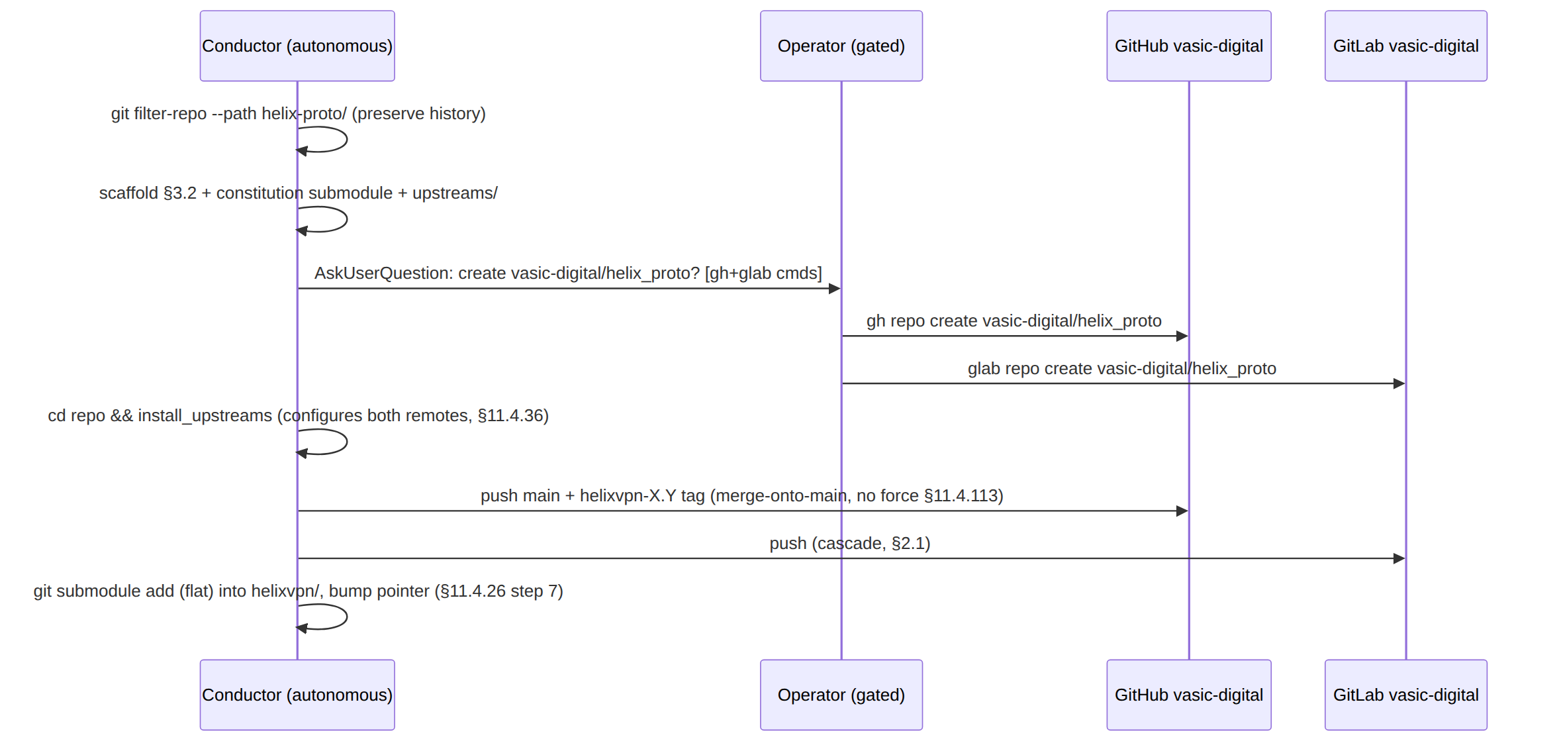

4. Schema-first codegen (zero-drift contract)
The single most important anti-drift mechanism: all Go/Dart/Rust/TS clients are generated from helix-proto; hand-written clients are forbidden so the codebases cannot drift [04_ARCH §4.2, 04_P1 §8].

4.1 buf for protobuf (agent contracts)
# buf.yaml
version: v2
modules:
- path: helix-proto/proto
lint: { use: [STANDARD] }
breaking: { use: [FILE] } # breaking-change detector vs the frozen contract
# buf.gen.yaml — Connect (gRPC + gRPC-Web + Connect) so ONE service serves
# native agents over HTTP/2 AND browser clients [04_P1 §3]
version: v2
plugins:
- remote: buf.build/protocolbuffers/go ; out: helix-proto/gen/go
- remote: buf.build/connectrpc/go ; out: helix-proto/gen/go
- remote: buf.build/protocolbuffers/dart ; out: helix-proto/gen/dart
- remote: buf.build/community/neoeinstein-prost ; out: helix-proto/gen/rust # prost for Rust
- remote: buf.build/community/neoeinstein-tonic ; out: helix-proto/gen/rust
Decision D-CODEGEN-NET. buf remote plugins need network. Per §11.4.77 the regeneration mechanism must work from a clean clone. Recommended: vendor protoc-gen-* plugins as pinned binaries under tools/ (Go tools.go + go install, Rust via cargo install --locked) so make gen runs offline after a one-time make gen-tools; buf generate --template buf.gen.local.yaml points at the local binaries. The remote-plugin form stays as the convenience path.

4.2 OpenAPI for REST (app surface)
openapi/helix-rest.v1.yaml → oapi-codegen (Go server stubs for Gin) + openapi-generator/swagger_dart_code_generator (Dart client for the three apps) [04_P1 §8]. The Console (TS/Web build) consumes the same spec via openapi-typescript.

4.3 The make gen contract (no CI — §11.4.156)
gen: gen-proto gen-openapi gen-ffi ## regenerate ALL clients from schema (run before build)
gen-proto: ; buf generate --template buf.gen.local.yaml
gen-openapi: ; oapi-codegen -config helix-go/internal/api/oapi.cfg.yaml openapi/helix-rest.v1.yaml
gen-ffi: ; cd helix-core/crates/helix-ffi && flutter_rust_bridge_codegen generate
verify-gen: gen ## §11.4.108 artifact check: regen must be a no-op
@git diff --exit-code helix-proto/gen helix-ui/packages/helix_core_ffi \
|| { echo "GENERATED CLIENTS STALE — run make gen"; exit 1; }
verify-gen is the drift gate (the local equivalent of a CI check, run in the pre-commit hook per §11.4.75): a stale generated client fails the local gate. This is the schema-first guarantee made mechanical.

5. helixvpnctl — the operator CLI (Cobra)
Replaces the original deployment doc's pile of bash install scripts with one Go binary [04_ARCH §4.7, 04_P1 §9]. It is the homelab front door (init + systemctl start = a running gateway) and the GitOps front door (policy apply).

5.1 Command tree
helixvpnctl
├── init --domain --data-dir [--substrate quadlet|compose|k8s] # bootstrap (§5.3)
├── gateway
│ ├── keys # rotate gateway WG keys
│ └── status # edge health, transport ladder posture
├── enroll-token --kind connector|client --site NAME [--qr] # mint enrollment token
├── policy
│ ├── apply ./policy.jsonc # dry-run compile → persist → emit policy.updated (GitOps)
│ └── diff ./policy.jsonc # show compiled visibility delta without applying
├── device
│ ├── list
│ └── revoke <id> # revoke <1s (doc 04)
├── network advertise|withdraw --connector ID --cidr CIDR
├── deploy
│ ├── quadlet --out /etc/containers/systemd/ # render canonical units (§7.1)
│ ├── compose --out ./ # render docker-compose.yaml (§7.2)
│ └── kube --out ./k8s/ # render K8s manifests (§7.3)
└── join --control URL --token T # fleet member joins control plane (Phase 2)

5.2 Skeleton (Cobra + cited behavior)
// helix-go/cmd/helixvpnctl/main.go (illustrative)
package main
import "github.com/spf13/cobra"
func main() {
root := &cobra.Command{Use: "helixvpnctl", Short: "HelixVPN gateway operator CLI"}
root.AddCommand(initCmd(), enrollCmd(), policyCmd(), deviceCmd(), deployCmd())
_ = root.Execute()
}
func initCmd() *cobra.Command {
var domain, dataDir, substrate string
c := &cobra.Command{Use: "init", Short: "Bootstrap a single-node gateway",
RunE: func(cmd *cobra.Command, _ []string) error {
// 1. generate tenant + admin user + overlay /48 (or 100.64/10 — D4, doc 01)
// 2. mint CA root + first gateway WG keypair (doc 04 PKI)
// 3. write Postgres+Redis creds to data-dir (mode 600, §11.4.10)
// 4. render deploy units for the chosen substrate (default quadlet, §11.4.76)
// 5. print: `systemctl --user start helixvpn-pod` [04_P1 §9]
return bootstrap(domain, dataDir, substrate)
}}
c.Flags().StringVar(&domain, "domain", "", "public gateway FQDN (required)")
c.Flags().StringVar(&dataDir, "data-dir", "/var/lib/helixvpn", "")
c.Flags().StringVar(&substrate, "substrate", "quadlet", "quadlet|compose|k8s")
_ = c.MarkFlagRequired("domain")
return c
}

5.3 init artifact set (what a fresh init writes)
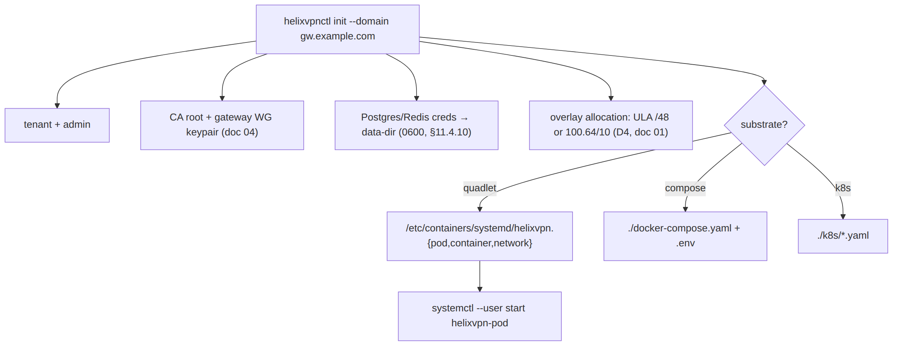

6. Helix-ecosystem submodule integration (the part the research pre-dates)
The 16 source docs were written before submodules/ was incorporated; the master spec MUST wire each in or mark not-applicable with reason [SYNTHESIS §8]. Below is the binding map. Submodules are consumed by reference (§11.4.106/.80 pattern) — never copied, never given HelixVPN-specific code (§11.4.28(B)).

6.1 Role map
Submodule | Module / kind | HelixVPN role | Binding § | Phase
containers | digital.vasic.containers (Go) | Sole container-orchestration layer: helixvpnctl deploy boot/health/compose primitives and on-demand integration-test infra (boot Postgres+Redis+gateway for e2e, tear down) | §11.4.76/.161 | 0–1
challenges | digital.vasic.challenges (Go) | Challenge engine underpinning anti-bluff acceptance Challenges (MVP DoD as executable Challenges) | §11.4.27/.5/.69 | 1
helix_qa | HelixQA (Go) | Anti-bluff QA orchestrator: drives the 8 MVP-DoD acceptance criteria with captured evidence; crash detection; ticket generation | §11.4.27/.107/.158 | 1
docs_chain | vasic-digital/docs_chain (Go) | Mechanical sync of this spec set (final/*.md → HTML/PDF/DOCX) and the workable-items SQLite DB ↔ docs | §11.4.106/.65/.93 | 0+
security | digital.vasic.security (Go) | Control-plane defensive libs: PII redaction in logs (keep no-logging honest), HTTP security headers on REST, AES-256-GCM at-rest for the data-dir secrets, SSRF-deny on outbound, privesc scan of the edge container | §7 (doc 04) | 1
vision_engine | VisionEngine (Go) | Video/screenshot evidence analysis for Flutter UI Challenges (connect-flow recordings → OCR/state verify) | §11.4.107/.158/.159 | 1–2
panoptic | Panoptic (Go) | UI automation + screenshot/video capture harness feeding vision_engine (web+desktop+mobile app drive) | §11.4.107/.154 | 1–2
doc_processor | DocProcessor (Go) | Feature-map extraction from this spec → the per-feature Status ledger (§11.4.153) coverage cross-check | §11.4.153 | 1
llm_provider | digital.vasic.llmprovider (Go) | Provider abstraction (circuit-breaker/retry) iff any LLM-assisted op ships (e.g. natural-language policy authoring). Not in the packet/control path. | §11.4.74 | 2 (opt)
llm_orchestrator | digital.vasic.llmorchestrator (Go) | Headless CLI-agent orchestration for the development loop (subagent QA), not a product runtime dependency | §11.4.70 | dev-only
llms_verifier | LLMsVerifier (Go) | Verifies any LLM the dev loop uses ("do you see my code?" gate); not a HelixVPN runtime component | §11.4.78 | dev-only

6.2 Not-applicable / dev-only justifications (§11.4.6, no silent drop)
- llm_orchestrator, llms_verifier — dev-loop only. HelixVPN ships no LLM in its data or control path; these support the autonomous build/QA loop (subagent dispatch, model verification). They are correctly present as submodules (the project uses them to build itself) but are not linked into helixd/helix-edge. Marking them runtime-N/A is the honest classification, not an omission.
- llm_provider — conditional. Only binds if Phase-2 ships LLM-assisted policy authoring (a Console convenience: "natural language → Tailscale-ACL"). If that feature is cut, llm_provider stays dev-only. Surfaced as Decision D-LLM-POLICY (§12).
- vision_engine / panoptic — test-infra, not product. They validate the Flutter apps' user-visible flows with captured video evidence per §11.4.107/.159; they never ship inside an app bundle.

6.3 containers submodule — the canonical deploy + test-infra seam
containers is the only sanctioned path to docker/podman/k8s from this project (§11.4.76 — no ad-hoc docker/podman commands outside pkg/boot/pkg/compose/pkg/health). Two concrete uses:
(A) On-demand integration-test infra (the §11.4.76 on-demand-infra invariant — operators never podman machine by hand; the test entry point boots infra):
// helix-go/internal/store/integration_test.go (illustrative)
import (
"digital.vasic.containers/pkg/boot"
"digital.vasic.containers/pkg/health"
)
func TestWatchNetworkMapDeltaStream(t *testing.T) {
ctx := context.Background()
infra := boot.Compose(ctx, boot.Spec{ // rootless Podman (§11.4.161)
Services: []boot.Service{
{Name: "pg", Image: "docker.io/library/postgres:16", Port: 5432},
{Name: "redis", Image: "docker.io/library/redis:7", Port: 6379},
},
})
t.Cleanup(func() { infra.Down(ctx) }) // §11.4.14 quiescent teardown
health.WaitReady(ctx, infra, 30*time.Second) // not a sleep — real readiness probe
// ... drive enroll → advertise → policy → assert MapDelta [04_P1 §11.1]
}
This is anti-bluff-critical (§11.4.76(5)): an integration test claiming to exercise the streamed WatchNetworkMap MUST actually boot Postgres+Redis via the submodule — a short-circuit fake that skips boot is a §11.4 violation.
(B) Deploy generation — helixvpnctl deploy {quadlet,compose,kube} renders manifests through containers/pkg/compose primitives so the three substrates derive from one in-code spec rather than three hand-maintained files (§11.4.81 cross-platform-parity: one source, per-substrate render).

6.4 docs_chain — spec + workable-items sync
This very document set is a docs_chain corpus. The consumer context lives at .docs_chain/contexts/helixvpn_spec.yaml and declares: each final/*.md → .html/.pdf/.docx (§11.4.65/.153 four-format), the workable-items SQLite DB (§11.4.93/.95) ↔ a generated docs/Issues.md view, and content-hash change detection (§11.4.86, not mtime). The engine is invoked by make docs-sync and verified by make docs-verify (the deterministic gate, §11.4.106(C)).
# .docs_chain/contexts/helixvpn_spec.yaml (illustrative)
version: 1
nodes:
- id: spec-00..05
glob: docs/research/mvp/final/*.md
transforms:
- exec: "pandoc {src} -o {src%.md}.html"
- exec: "weasyprint {src%.md}.html {src%.md}.pdf"
- exec: "pandoc {src} -o {src%.md}.docx" # §11.4.153 DOCX adds to the export set
- id: workable-items
sync:
- left: docs/.workable_items.db # git-tracked SSoT (§11.4.95)
right: docs/Issues.md
authority: db # DB wins; doc is a view

7. Deployment substrates (three, one image set)
All three substrates run the same OCI images (helixd, helix-edge, plus stock postgres/redis). Podman quadlets are canonical (§11.4.76/.161); Compose and K8s are equivalents for operators on those runtimes [research-podman_k8s]. The data-plane edge needs NET_ADMIN + UDP/443 (MASQUE) + kernel WG; everything else is unprivileged.
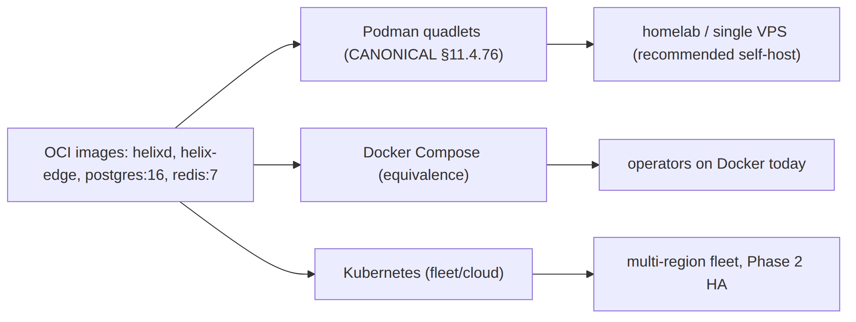

7.1 Podman quadlets (canonical, rootless)
The pod groups edge + control + Postgres + Redis for single-node self-host [04_P1 §9.2]. helixvpnctl init writes these; systemctl --user start helixvpn-pod runs them — rootless, no Docker daemon (§11.4.161).
# /etc/containers/systemd/helixvpn.pod
[Pod]
PodName=helixvpn
PublishPort=443:443/udp # MASQUE/QUIC ingress
PublishPort=51820:51820/udp # plain-WG ingress (auto-ladder base, doc 01)
# /etc/containers/systemd/helix-edge.container — DATA PLANE (Phase-0 G4 winner)
[Unit]
Description=HelixVPN data-plane edge
[Container]
Image=ghcr.io/helixdevelopment/helix-edge:1.0
Pod=helixvpn.pod
AddCapability=NET_ADMIN # ONLY this; drop the rest (doc 04 §)
ReadOnly=true # read-only rootfs (§11.4 security invariant)
SecurityLabelType=helixvpn_edge.process # seccomp/SELinux confinement
# no SSH, no shell in this image
[Install]
WantedBy=default.target
# /etc/containers/systemd/helixd.container — CONTROL PLANE
[Container]
Image=ghcr.io/helixdevelopment/helixd:1.0
Pod=helixvpn.pod
Environment=DATABASE_URL=postgres://helix_app@localhost/helix # non-superuser → RLS enforced (doc 02)
Environment=REDIS_URL=redis://localhost:6379
Secret=helix_db_pw,type=env,target=PGPASSWORD # podman secret, never in unit text
ReadOnly=true
NoNewPrivileges=true
# /etc/containers/systemd/helix-pg.container (redis analogous)
[Container]
Image=docker.io/library/postgres:16
Pod=helixvpn.pod
Volume=helix-pgdata.volume:/var/lib/postgresql/data:Z
Environment=POSTGRES_USER=helix_owner POSTGRES_DB=helix
Secret=helix_db_pw,type=env,target=POSTGRES_PASSWORD

7.2 Docker Compose (equivalence target)
For operators on Docker today. Same images, same env contract; loses rootless-by-default (operator runs docker compose in rootless mode where available — documented, §11.4.112 honest gap if their host can't).
# deploy/compose/docker-compose.yaml
name: helixvpn
services:
pg:
image: docker.io/library/postgres:16
environment: { POSTGRES_USER: helix_owner, POSTGRES_DB: helix }
secrets: [helix_db_pw]
volumes: [helix-pgdata:/var/lib/postgresql/data]
redis:
image: docker.io/library/redis:7
helixd:
image: ghcr.io/helixdevelopment/helixd:1.0
environment:
DATABASE_URL: postgres://helix_app@pg/helix # non-superuser → RLS
REDIS_URL: redis://redis:6379
secrets: [helix_db_pw]
read_only: true
cap_drop: [ALL]
depends_on: [pg, redis]
helix-edge:
image: ghcr.io/helixdevelopment/helix-edge:1.0
cap_drop: [ALL]
cap_add: [NET_ADMIN] # ONLY NET_ADMIN
read_only: true
ports: ["443:443/udp", "51820:51820/udp"]
depends_on: [helixd]
secrets:
helix_db_pw: { file: ./secrets/db_pw } # 0600, gitignored (§11.4.10/.30)
volumes: { helix-pgdata: {} }

7.3 Kubernetes (fleet / Phase-2 HA)
Plain manifests (kustomize overlays, Helm-less to start) [research-podman_k8s]. The edge runs as a DaemonSet with hostNetwork: true (so UDP/443 lands on the node IP without an extra hop) + NET_ADMIN; control plane is a stateless Deployment (HA-ready, doc 02 §); Postgres is a StatefulSet (or external managed PG/Patroni in real fleets).
Decision D-K8S-EDGE-INGRESS. WireGuard/MASQUE is UDP; most cloud L7 ingress can't carry it. Options: (a) hostNetwork DaemonSet edge (node IP = gateway IP — simplest, recommended for self-host-on-k8s); (b) Service type=LoadBalancer with a UDP-capable LB (MetalLB on-prem, NLB on AWS) [research-podman_k8s]; (c) NodePort UDP (homelab). Recommended: (a) for self-host parity with the quadlet model, (b) for managed-cloud fleets.
# deploy/k8s/edge-daemonset.yaml
apiVersion: apps/v1
kind: DaemonSet
metadata: { name: helix-edge, namespace: helixvpn }
spec:
selector: { matchLabels: { app: helix-edge } }
template:
metadata: { labels: { app: helix-edge } }
spec:
hostNetwork: true # UDP/443 on the node IP (D-K8S-EDGE-INGRESS opt a)
containers:
- name: edge
image: ghcr.io/helixdevelopment/helix-edge:1.0
securityContext:
readOnlyRootFilesystem: true
allowPrivilegeEscalation: false
capabilities: { drop: ["ALL"], add: ["NET_ADMIN"] }
ports:
- { containerPort: 443, protocol: UDP, hostPort: 443 }
- { containerPort: 51820, protocol: UDP, hostPort: 51820 }
---
# deploy/k8s/helixd-deployment.yaml
apiVersion: apps/v1
kind: Deployment
metadata: { name: helixd, namespace: helixvpn }
spec:
replicas: 2 # stateless coordinators → HA (doc 02 §)
selector: { matchLabels: { app: helixd } }
template:
metadata: { labels: { app: helixd } }
spec:
containers:
- name: helixd
image: ghcr.io/helixdevelopment/helixd:1.0
env:
- { name: DATABASE_URL, value: "postgres://helix_app@helix-pg/helix" }
- { name: REDIS_URL, value: "redis://helix-redis:6379" }
- name: PGPASSWORD
valueFrom: { secretKeyRef: { name: helix-db, key: password } }
securityContext:
readOnlyRootFilesystem: true
runAsNonRoot: true
capabilities: { drop: ["ALL"] }
---
# deploy/k8s/pg-statefulset.yaml (abridged)
apiVersion: apps/v1
kind: StatefulSet
metadata: { name: helix-pg, namespace: helixvpn }
spec:
serviceName: helix-pg
replicas: 1 # → Patroni HA in Phase-2 fleet (doc 02 §)
template:
spec:
containers:
- name: postgres
image: docker.io/library/postgres:16
env:
- { name: POSTGRES_USER, value: helix_owner }
- { name: POSTGRES_DB, value: helix }
- name: POSTGRES_PASSWORD
valueFrom: { secretKeyRef: { name: helix-db, key: password } }
volumeMounts: [{ name: data, mountPath: /var/lib/postgresql/data }]
volumeClaimTemplates:
- metadata: { name: data }
spec: { accessModes: ["ReadWriteOnce"], resources: { requests: { storage: 10Gi } } }

7.4 Substrate recommendation
Operator profile | Recommended substrate | Why
Homelab / single VPS (the primary buyer, spine §2) | Podman quadlets | Rootless, no daemon, helixvpnctl init one-shot — the §11.4.76/.161 canonical path
"We run Docker" shops | Docker Compose | Same images, lowest friction; rootless where their host allows
Multi-region fleet (Phase 2 HA) | Kubernetes | DaemonSet edge + stateless helixd replicas + Patroni PG = the doc-02 HA story

7.5 Rate limiting & DDoS resilience (enterprise hardening)
Gap closed (this revision). 04_ARCH §4.6 names "rate limiting (token buckets per API key)" as a Redis use, but no document in Volume 6 ever operationalized it, and the data-plane volumetric-attack surface (the public UDP/443 + UDP/51820 listeners) had no mitigation story at all. A public gateway with an unrated API and an un-mitigated UDP listener is not production-grade — this section closes both halves. It composes with, and does not replace, host-level cloud DDoS scrubbing (Cloudflare Spectrum / AWS Shield / a bare-metal provider's own filtering), which is an operator-chosen, infrastructure-layer control outside this spec's scope (§11.4.6 — never assumed present; the gateway's own defenses below hold even without it).

7.5.1 Control-plane API rate limiting (helixd:8443)
Two limiter layers, both backed by the Redis token-bucket primitive already declared for presence [04_ARCH §4.6]:
Layer | Key | Bucket | Enforcement point | On exceed
Per-API-token | ratelimit:token:<token_id> | 60 req/min sustained, burst 20 (mutating routes tighter: policy set/device revoke at 10/min) | Gin middleware, before any handler runs | 429 Too Many Requests + Retry-After; no DB write attempted
Per-source-IP (pre-auth) | ratelimit:ip:<src_ip_hash> | 30 req/min to unauthenticated routes (/v1/enroll-tokens/redeem, health) | edge-of-Gin middleware, keyed by a salted hash of the source IP (never the raw IP, C3 — the hash is rotated daily so it cannot become a durable per-IP profile) | 429; repeated violation escalates to the transient-ban list (§7.5.2)
Per-device-cert (agent plane) | ratelimit:device:<device_id> | WatchNetworkMap reconnect storms: max 1 reconnect/2s per device (exponential backoff enforced client-side per the reconciler, server-side as a backstop) | Connect-RPC interceptor | connection closed with a structured RESOURCE_EXHAUSTED status; the reconciler's own backoff (client-side) is the primary control, this is the belt
Anti-bluff note (§11.4.69): a 429 decision and its counter are counts only — the limiter never logs the request body, headers, or the resolved plaintext IP; only the salted-hash bucket key and a monotonic counter exist in Redis (TTL'd, same ephemeral-C2 posture as presence). This keeps rate-limiting inside the no-logging invariant rather than becoming a side-channel connection log.
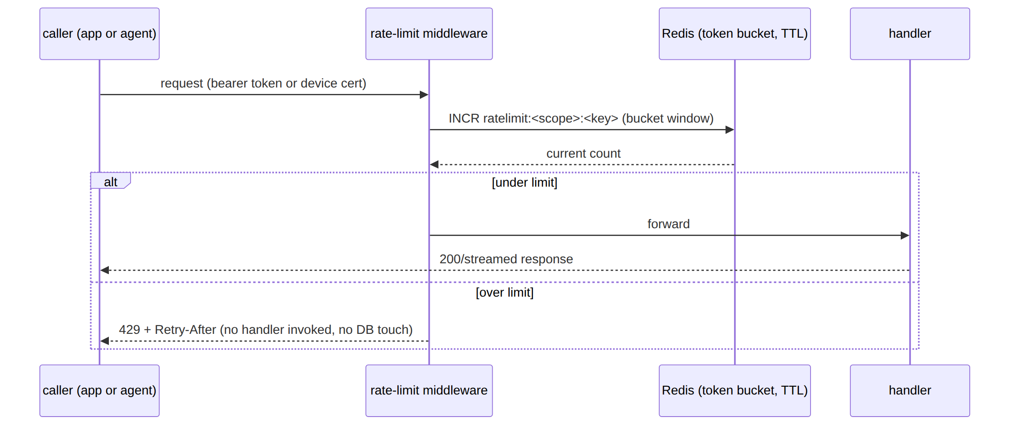

7.5.2 Data-plane edge — volumetric / handshake-flood mitigation
The edge's public listeners (:443/udp MASQUE, :51820/udp plain-WG) are the classic UDP-amplification and handshake-flood target. Concrete, deployable mitigations, layered cheapest-first (this is a SPEC — the operator applies the layers their threat model warrants; none is claimed sufficient alone):
Layer | Mechanism | Mitigates | Honest limit
WireGuard's own cookie mechanism | WG's Noise-IK handshake already includes a stateless cookie-reply under load (upstream WireGuard design, not HelixVPN-specific) — the kernel/boringtun implementation rejects malformed/replayed handshake-init packets cheaply, before any per-peer state is allocated | Basic handshake-flood amplification | Does not stop raw bandwidth-saturation floods — that is an upstream-network concern
Per-source-IP handshake-attempt cap | The edge counts failed-handshake attempts per source IP (in-memory ring buffer, NOT Redis — this is a data-plane, sub-millisecond hot-path counter, never a durable log) over a short window (e.g. 20 attempts/10s) | Repeated failed-handshake probing (the same class MASQUE detection probes exercise) | In-memory only; a restart clears the counters (acceptable — the counters are a rate-limit, not identity)
Transient IP ban (fail2ban-equivalent) | On exceeding the handshake-attempt cap, the edge inserts a short-TTL (default 10 min) nftables/eBPF DROP rule for that source IP — the same verdict-map mechanism the policy compiler already programs (01-data-plane.md), reused for a security verdict rather than a policy verdict | Sustained single-source handshake floods | The ban is an IP, not an identity; NAT'd attackers behind a shared IP could collaterally rate-limit a legitimate peer sharing that IP — documented, not silently assumed away
QUIC/MASQUE initial-packet validation | quinn's address-validation (Retry packets) is enabled for the MASQUE listener, forcing a round-trip before the server commits per-connection state to an unvalidated source address — this is the QUIC-native analogue of a TCP SYN cookie | QUIC-based amplification/spoofing floods | Adds one RTT to first connect under load; only enabled when the edge is under measured load (a static always-on Retry adds latency for the common case)
Upstream/infra-layer scrubbing (operator-chosen, out of this spec) | Cloud provider DDoS protection (AWS Shield, Cloudflare Spectrum for UDP, a bare-metal host's own filtering) in front of the gateway's public IP | Raw volumetric bandwidth floods that no application-layer control can absorb | Not assumed present. The edge-level controls above are the floor that holds with zero infra dependency; upstream scrubbing is a recommended addition, never a precondition for the spec's own controls to function
Consistency with C3 (no-logging). Every counter in this section is a rate-limit decision counter, never a connection-content log: the in-memory handshake-attempt ring buffer and the transient-ban nftables rule both hold only (ip_or_hash, count, expiry) — no destination, no payload, no duration-of-session. A transient ban list is not a connection log because it records attempts to authenticate, not sessions established or traffic carried, and it self-expires (TTL) rather than accumulating.

7.5.3 Anti-bluff evidence plan
Claim | Captured-evidence proof
Per-token 429 fires at the stated threshold | load-test driving 2× the bucket rate → 429 responses measured at the exact threshold; Redis bucket key TTL confirmed
Pre-auth per-IP limiter uses a salted hash, never a raw IP | grep the Redis keyspace under load → no plaintext IP present, only hashed keys; paired mutation removing the salt → the same test that inspects the keyspace FAILs (proves the check is real)
Edge handshake-flood cap triggers a transient ban | chaos test: script N rapid failed handshakes from one source → verdict-map DROP rule appears with the expected TTL, then self-expires; captured nft/eBPF map dump before/after
QUIC Retry engages under load | load-test past the configured threshold → first-flight packets receive a Retry before connection establishment; packet capture
No rate-limit counter becomes a durable log | schemalint (no-logging runtime signature, §11.4.108) stays green with rate-limiting active under load
Composes with §11.4.5/.69/.85 (stress+chaos evidence), §11.4.108 (no-logging runtime signature unaffected by the new counters), and the existing 01-data-plane.md verdict-map mechanism (the transient-ban rule reuses the same enforcement point as policy verdicts, not a second firewall subsystem).

8. Build & local-dev orchestration (Makefile, no CI)
Per §11.4.156 there is no active server-side CI; enforcement is the local pre-build sweep + git hooks (§11.4.75). The Makefile is the single task surface.
# Makefile (illustrative — the local task runner; §11.4.156 no CI)
.PHONY: gen build test deploy docs-sync verify
gen: ; @$(MAKE) gen-proto gen-openapi gen-ffi # §4.3
build: gen ; cargo build --release && go build ./helix-go/... && melos run build
test: ; cargo test && go test ./helix-go/... && melos run test # boots infra via containers/pkg/boot (§6.3)
qa: ; go run ./submodules/helix_qa/cmd/orchestrator --suite mvp-dod # 8 acceptance Challenges (§6.1)
docs-sync: ; docs_chain sync --context .docs_chain/contexts/helixvpn_spec.yaml # §6.4
docs-verify:; docs_chain verify --context .docs_chain/contexts/helixvpn_spec.yaml # deterministic gate
deploy: ; helixvpnctl deploy quadlet --out /etc/containers/systemd/
verify: verify-gen docs-verify # local release gate (§11.4.40 pre-tag)
The dev inner loop (Phase 0–1): make gen → make build → make test (containers submodule boots Postgres+Redis on demand) → make qa (helix_qa drives the MVP-DoD acceptance Challenges with captured evidence). No step requires a remote runner.

9. Release prefixing & versioning (§11.4.151)
Every release tag/version on the monorepo and every extracted reusable repo MUST carry the <PREFIX>- prefix, resolved as: (1) HELIX_RELEASE_PREFIX from .env (authoritative; documented in tracked .env.example), else (2) lowercased snake_case root dir name = helix_vpn. One release tags all repos with the same prefix in one batch (§3.3 recommendation) so git tag -l 'helix_vpn-*' enumerates the whole release surface across GitHub + GitLab. OCI images are tagged <PREFIX>-<version> to match. No force-push anywhere — every push is merge-onto-latest-main fast-forward (§11.4.113).

10. Mapping to workable items (§11.4.93)
This document's deliverables become workable items in the git-tracked SQLite SSoT (docs/.workable_items.db, §11.4.95). Representative seed items:
ATM-id (illustrative) | Item | Type | Phase | Dep
HVPN-050 | Stand up helixvpn/ monorepo workspaces (Cargo/go.work/melos/buf) | Task | 0 | —
HVPN-051 | helix-proto contract + make gen + verify-gen drift gate | Feature | 0 | HVPN-050
HVPN-052 | helixvpnctl init → quadlet render → systemctl start (MVP-DoD #1) | Feature | 1 | HVPN-051
HVPN-053 | containers-submodule integration-test infra harness (§6.3) | Task | 1 | HVPN-050
HVPN-054 | docs_chain context for this spec set + workable-items DB sync (§6.4) | Task | 0 | —
HVPN-055 | Compose + K8s substrate generators + parity tests (§7.2/§7.3) | Feature | 1–2 | HVPN-052
HVPN-056 | Extract 6 reusable repos to vasic-digital (operator-gated, §3.3) | Task | 1-exit | all
Each carries status/type/id on all surfaces (§11.4.148), a comprehensive description (§11.4.148-D2), and — for Features — a reproduce-first acceptance Challenge in helix_qa (§11.4.146 + §6.1).

11. Anti-bluff evidence plan for this document's claims (§11.4.5/.69/.107)
Claim | Captured-evidence proof (Phase)
make gen is offline-reproducible (§4.3) | clean-clone container run with network off → make gen-tools && make gen exits 0; transcript under docs/qa/<run-id>/
verify-gen catches drift (§4.3) | paired §1.1 mutation: edit a generated file → verify-gen FAILs
quadlet/compose/k8s run the same image (§7) | three substrates boot the gateway; helixvpnctl gateway status GREEN on each; recorded per §11.4.159
integration infra really boots (§6.3) | go test with boot.Compose; mutation removing boot.Compose → test FAILs (proves it wasn't a fake)
docs_chain keeps exports in sync (§6.4) | docs-verify GREEN; mutation backdating an .html → FAIL
no nested own-org submodule chains (§3) | CM-OWNED-SUBMODULE-LAYOUT audit of the 6 extracted repos GREEN

12. Decision callouts (options + recommendation, never silent — §11.4.66/.101)
id | Decision | Options | Recommendation
D-REPO-CREATE | When to extract reusable repos | (a) eager per-pillar; (b) one batch at Phase-1 exit | (b) — shared release prefix, stable seams (§3.3)
D-CODEGEN-NET | buf plugin source | (a) remote plugins; (b) vendored local binaries | (b) for make gen offline reproducibility (§4.1)
D-K8S-EDGE-INGRESS | UDP ingress on k8s | (a) hostNetwork DaemonSet; (b) UDP LoadBalancer; (c) NodePort | (a) self-host parity, (b) managed fleet (§7.3)
D-LLM-POLICY | Ship LLM-assisted policy authoring? | (a) yes (binds llm_provider); (b) no (stays dev-only) | Defer to Phase 2; default (b) until product-validated (§6.2)
D-SUBSTRATE-DEFAULT | init default substrate | quadlet / compose / k8s | quadlet (§11.4.76/.161 canonical) — flag overrides
These compose with the spine's decision register (D1–D8); none is resolved here without the operator where it is irreversible/high-blast-radius (§11.4.101).

Sources verified
- 04_VPN_CLD/HelixVPN-Architecture-Refined.md §4.1–4.7 (modular monolith, API surface, event bus, Podman edge), §10 (deploy/HA/DR, Terraform, GitOps), §11 (repo layout), §12 (reproducible builds) — [04_ARCH].
- 04_VPN_CLD/HelixVPN-Phase1-MVP.md §2/§3 (repo skeleton, protobuf WatchNetworkMap), §8 (codegen — buf + OpenAPI), §9 (helixvpnctl + quadlets), §11 (test layers + MVP DoD) — [04_P1].
- 04_VPN_CLD/HelixVPN-Phase0-Spike.md (surviving Transport trait + FFI surface that define extraction seams), HelixVPN-helix-ui-Flutter.md (runHelixApp flavors, Melos) — [04_P0] [04_UI].
- 05_VPN_YBO.md (mandated Go/Gin/Postgres/Redis/Podman rootless stack) — [05_YBO].
- v09-research/_SYNTHESIS.md §2 (stack floor), §6 (repo layout / reuse pillars), §8 (submodule wiring the research misses), §9 (constitution bindings) — [SYNTHESIS].
- submodules/{containers,docs_chain,helix_qa,challenges,security,vision_engine,doc_processor,llm_provider,llm_orchestrator,llms_verifier,panoptic}/README.md (module identities, public surfaces, anti-bluff guarantees) — read in full for §6.
- [research-podman_k8s] — Podman Quadlet .pod/.container/.network unit semantics, rootless systemctl --user lifecycle, podman kube generate, Kubernetes UDP ingress for WireGuard (hostNetwork DaemonSet vs UDP LoadBalancer/MetalLB/NLB vs NodePort), NET_ADMIN/hostPort requirements for in-cluster tunnels; cross-referenced against latest official Podman + Kubernetes docs per §11.4.99.
Constitution bindings applied: §11.4.44 (revision header), §11.4.28/.29/.31/.36/.74 (decoupled snake_case flat submodules + upstreams + deps manifest), §11.4.76/.161 (containers submodule sole orchestration + rootless), §11.4.106/.65/.153 (docs_chain sync + HTML/PDF/DOCX exports — generated in refinement), §11.4.93/.95 (phases→workable items in git-tracked SQLite SSoT), §11.4.151 (release prefix), §11.4.156 (no active CI), §11.4.113 (no force-push), §11.4.66/.101 (decision discipline — §12 + D-REPO-CREATE operator-gated), §11.4.27/.107/.146 (anti-bluff QA via helix_qa/challenges/vision_engine), §11.4.6 (no-guessing — every N/A submodule justified, never silently dropped). §11.4.5/.69/.107 captured-evidence proofs enumerated in §11.

