Phase 3 (Extended Reach) — Work Breakdown: phases → tasks → subtasks

Phase 3 (Extended Reach) — Work Breakdown: phases → tasks → subtasks
Revision: 2 Last modified: 2026-07-04T12:00:00Z Rev 2 (hardening pass): Added §0.1 cross-reference to v07-execution/subtask-deepening-p3.md (closes REFINEMENT_NOTES.md R5 for Phase 3 — this was already substantively addressed by that companion doc; this revision makes the pointer explicit in the WBS itself rather than leaving it implicit); added §2.2 phase-gate-failure protocol for the two device-gated tracks (E21/E22).
Master technical specification — document 09 of the HelixVPN set. Scope: the complete Work Breakdown Structure (WBS) for Phase 3 — Extended Reach & Hardening: the work that Phase 2 explicitly defers [04_P2 §11] — HarmonyOS NEXT builds, Aurora OS builds, the WASM browser‑scoped MASQUE proxy, billing‑optional multi‑tenant, a third‑party security audit, and reproducible builds. Every item carries a stable, append‑only, DB‑ready id HVPN-P3-NNN (§11.4.54) with the full field set (§11.4.93/.95). This is a SPEC — it describes what to build, the interfaces it must satisfy, and how "done" is proven with captured evidence — it does not build the product (2–3 refinement passes follow).
Honesty stance (§11.4.6). Phase 3 contains the project's two highest‑ uncertainty workstreams: the HarmonyOS NEXT and Aurora OS native tunnel shims, which are real native engineering on toolchains we do not yet own hardware/CI for [04_ARCH §5.7, 04_UI §6.1]. This WBS gives no calendar dates; effort is engineer‑days (rough order, wide error bars), every hardware‑ or device‑gated acceptance that cannot be proven without the target device is marked UNCONFIRMED: / PENDING_DEVICE: per §11.4.6 with the §11.4.3 SKIP‑with‑reason it would carry, never a silent PASS. Gates G20..G26 are the go/no‑go decisions; a gate that cannot be cleared on the real device is the finding — escalate per §11.4.66/.101/.112, do not overrun silently.
Source evidence cited inline by id: [04_P2] = 04_VPN_CLD/HelixVPN-Phase2-Parity.md; [04_ARCH] = 04_VPN_CLD/HelixVPN-Architecture-Refined.md; [04_UI] = 04_VPN_CLD/HelixVPN-helix-ui-Flutter.md; [04_P1] = Phase1‑MVP; [04_P0] = Phase0‑Spike. Companion specs: [00] product scope, [01] data plane, [02] control plane (authoritative DDL/protobuf/deploy — referenced, never re‑defined here), [03] client core + UI, [04] security/privacy/PKI, [05] repo layout + ecosystem, [08] Phase‑2 parity WBS. [SYNTHESIS] §§1–9. External facts: [research-masque] (RFC 9297/9298/9221), [research-wasm] (wasm32 + WebTransport), LLM analyses [02_QWN] [11_MST] [10_KMI] [07_GMI].

Table of contents
- 0. How to read this WBS (and the DB schema it populates)
- 1. Required‑test‑types vocabulary (§11.4.169)
- 2. Phase‑3 entry condition + the go/no‑go gates G20–G26
- 2.2 Phase-gate-failure protocol
- 3. Workable‑item schema (§11.4.93 DB‑ready)
- 4. Epic map + dependency graph
- 5. E20 — Phase‑3 readiness gate + reach CI fabric
- 6. E21 — HarmonyOS NEXT build (highest risk)
- 7. E22 — Aurora OS build
- 8. E23 — WASM browser‑scoped MASQUE proxy
- 9. E24 — Billing‑optional multi‑tenant
- 10. E25 — Third‑party security audit
- 11. E26 — Reproducible builds
- 12. E27 — Reach localization, governance, release
- 13. Definition‑of‑Done ↔ work‑item traceability
- 14. Effort roll‑up, critical path & risk register
- 15. Open decisions (D‑P3‑*) surfaced with recommendations
- Sources

0. How to read this WBS (and the DB schema it populates)
Phase 3 is additive, not a rewrite [04_P2 §11]: Phase 2's Transport trait, network‑map protocol, coordinator federation, and the TunnelPlatform shim pattern already accommodate every Phase‑3 surface. The UI ports for free across the new platforms (one Dart tree, §6 [04_UI]); the tunnel shim does not — that native‑shim delta is the whole risk and the bulk of the budget.

0.1a PR-sized subtask breakdown (closes R5)
Every task HVPN-P3-NNN below decomposes one level further into falsifiable, PR-sized subtasks HVPN-P3-NNN.k in the companion v07-execution/subtask-deepening-p3.md — the third and final part of the R5 closure (REFINEMENT_NOTES.md), alongside subtask-deepening-p1.md and -p2.md.

0.1 Decomposition hierarchy
PHASE 3 (Extended Reach)
├── ENTRY GATE Phase-2 graduation (§2.0) — prerequisite, not in-scope work
├── GATES G20..G26 — go/no-go questions (§2)
├── EPICS HVPN-P3-Enn — a reach workstream (§5..§12)
│ ├── TASKS HVPN-P3-NNN — a shippable unit (own acceptance + evidence)
│ │ └── SUBTASKS HVPN-P3-NNN.k — smallest tracked PR-sized change
└── CROSS-CUTTING E20 (CI fabric) · E27 (l10n/release)
Every TASK and SUBTASK is a workable item with the same closed field set, so the rows below load 1:1 into docs/workable_items.db (§3). IDs are monotonic, never renumbered (§11.4.54): the numeric block encodes the epic — E21 → 210..219, E24 → 240..249; entry/CI gates use 200..209. New work appends at the next free number (gaps allowed).

0.2 Field dictionary (every item row carries these)
Field | Meaning
id | stable HVPN-P3-NNN[.k] (§11.4.54) — primary key, never reused
parent | owning epic (HVPN-P3-E2n) or task id; — for epic‑level tasks
kind | task | subtask | gate | epic
title | ≥6‑word self‑contained meaning (§11.4.91)
gate | which gate(s) this advances: G20..G26 or —
description | what / how it manifests / acceptance intent (§11.4.148 D2)
depends_on | upstream ids that MUST be complete first; — = none
deliverable | concrete artefact(s): file paths, binaries (.so/.hap/.rpm/.wasm), reports
acceptance | falsifiable PASS with captured PHYSICAL evidence (§11.4.5/.69/.107); UNCONFIRMED:/PENDING_DEVICE: where device‑gated (§11.4.6)
est_effort | engineer‑days, wide error bars — not a date commitment
test_types | the §11.4.169 closed‑set codes required (§1)

0.3 Anti‑bluff floor (§11.4 / §11.4.27 / §11.4.107)
A leaf is complete only when its required test types are green with an evidence path recorded in test_diary (§11.4.149) and, for any user‑visible surface, a window‑scoped MP4 (§11.4.154/.155) vision‑verified per §11.4.159/.163. For the native platforms (E21/E22) the runtime signature (§11.4.108) is asserted on a clean install on the real device — an APK/HAP/RPM that builds is not done; the proof is the tunnel up on hardware, captured. Where no device is reachable, the item is honestly PENDING_DEVICE: (§11.4.3 hardware_not_present) with a tracked unblock condition (§11.4.148 D3), never a metadata‑only PASS.

0.4 §11.4.169 test‑type codes used here
Code | Type | Phase‑3 instantiation
UNIT | unit | Rust/#[cfg(test)], Dart test, Go _test.go, ArkTS Jest; mocks only here (§11.4.27).
INT | integration | real System; control plane + edge booted on‑demand via containers submodule (§11.4.76); no mocks.
E2E | end‑to‑end | full enroll → tunnel → reach on the target (device/emulator/browser).
FA | full‑automation | self‑driving, re‑runnable -count=3, no human after start (§11.4.98).
SEC | security | audit‑scope items, SBOM, leak audits, WASM origin/scope isolation, billing RLS.
MEM | memory | RSS / heap ceiling on device (HarmonyOS, Aurora, iOS NE budget reuse) — §11.4.107(11).
PERF | performance | throughput / p99 vs the per‑leg SLO budget [01 §SLO].
BENCH | benchmarking | WASM proxy MB/s, native shim CPU‑per‑Gbps on the bench.sh rig [04_P0 §8].
CHAOS | chaos | interface flap / process kill mid‑transfer / metering‑pipeline SIGKILL (§11.4.85).
STRESS | stress | sustained + concurrent (≥10 parallel, ≥100 iters or ≥30 s) + boundary inputs (§11.4.85).
UI | UI | widget + golden tests on the ported flavor (HarmonyOS/Aurora theme).
UX | UX | enroll→connect→reach walkthrough, window‑scoped MP4 + vision verdict (§11.4.159).
REC | recorded‑evidence | window‑scoped MP4 (§11.4.154/.155) + media‑validation verdict (§11.4.163).
REPRO | reproducibility | two independent rebuilds → bit‑identical artefact (E26); Phase‑3‑specific.
CHAL | Challenge / HelixQA | a challenges/helix_qa bank entry scoring PASS only on captured evidence (§11.4.27/.107).
DDOS becomes applicable for the first time in this phase only where billing exposes a public metering/checkout surface (E24); elsewhere it stays NOT_APPLICABLE: self-host-single-node (§11.4.6), re‑armed by the managed SKU. Each task lists only the required subset; absent types are out‑of‑scope by design, not omission.

2. Phase‑3 entry condition + the go/no‑go gates G20–G26

2.0 Entry condition (prerequisite, not Phase‑3 work)
Phase 3 starts only when Phase 2 has graduated [04_P2 §11]: the full transport set + DAITA + P2P/NAT traversal + multi‑hop + PQ handshake + desktop apps + HA/multi‑region are shipped and the §08 Phase‑2 DoD is green on a clean baseline (§11.4.40). Concretely the Phase‑3 work assumes these already exist: the Transport trait with MASQUE (helix-transport, [03]); the TunnelPlatform shim contract (helix-core/helix-ffi, [03 §5]); the multi‑tenant Postgres schema with FORCE‑RLS and the no‑durable‑connection‑log CI lint (E02, [02/04]); and the coordinator WatchNetworkMap stream [02]. Phase 3 extends each — it does not re‑invent any.

2.1 The gates
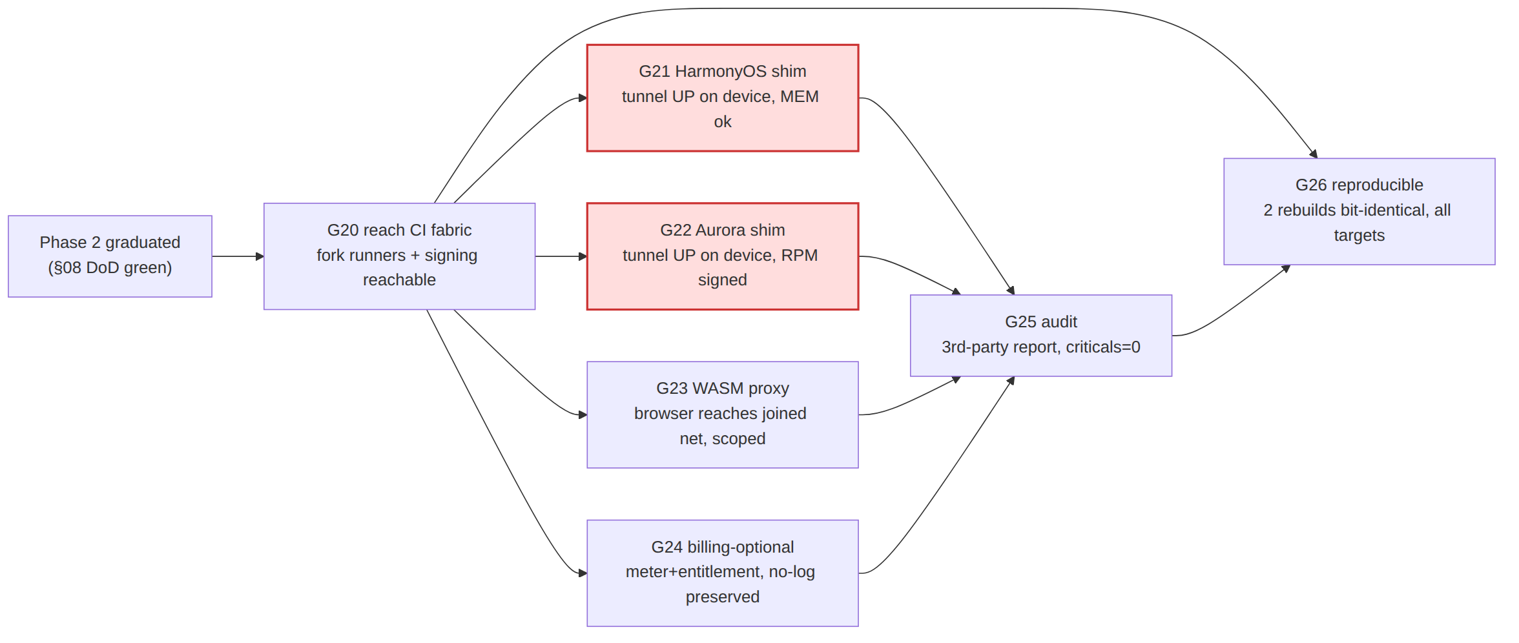
Gate | Question | Go / no‑go bar | Owning epic
G20 | Can we build + sign for every reach target in CI we control? | OpenHarmony‑SIG fork runner builds a HAP + DevEco‑signs; OMP fork runner builds a signed Aurora RPM; both pinned + isolated so a fork lag never blocks mainline [04_UI §10]. | E20
G21 | Does the HarmonyOS NEXT tunnel actually carry traffic on a real device, under the memory ceiling? | Enroll → tunnel UP → curl reaches an authorized LAN host on a HarmonyOS NEXT device; Network Kit VPN ability active; helix‑core .so heap ≥30% headroom under the extension limit (PENDING_DEVICE: until hardware) [04_UI §6.1]. | E21
G22 | Same, on Aurora OS, with a signed RPM. | Enroll → tunnel UP → reach on an Aurora device; Qt/C++ tun backend driving helix‑core C ABI; signed RPM installs from the OMP toolchain (PENDING_DEVICE:) [04_ARCH §5.7]. | E22
G23 | Can the in‑browser WASM MASQUE proxy reach a joined network without leaking beyond its declared scope? | Console page proxies the browser's own fetch/WebTransport traffic to an authorized host via MASQUE; no system‑wide tunnel claim; scope/origin isolation proven; kill on tab‑close [04_ARCH §5.7]. | E23
G24 | Can we meter + entitle tenants without breaking no‑logging? | Per‑tenant aggregate metering + plan/quota enforcement + optional payment adapter; CI schema‑lint still fails on any durable connection/traffic table; billing OFF by default = zero behaviour change. | E24
G25 | Does an independent third party confirm the security claims? | A scoped external audit (crypto, control plane, shims, WASM) completes; zero unresolved Critical/High; report published; remediation loop closed per §11.4.134. | E25
G26 | Can a user verify the binaries match the source? | Two independent rebuilds of every shipped artefact (Go control plane, Rust edge/core, Flutter apps, .so/.hap/.rpm/.wasm) are bit‑identical; a public verification script reproduces them; divergences root‑caused to zero [04_P2 §11]. | E26

2.2 Phase-gate-failure protocol
Phase 3's failure modes split cleanly along the honesty stance already built into §0.3/§13 — most gates degrade to an honest non-blocking status rather than stalling the whole release:
Failure class | Response | Cross-reference
G21/G22 (device-gated native shims) cannot be exercised — no hardware/CI access yet | Gate stays pending_device (§11.4.3 hardware_not_present) — this is not a Phase‑3 release blocker for the other gates; the release notes state plainly which reach targets are certified vs built-but-pending-device (§13). Reach targets ship independently as their gates clear. | §13 honest-gap rule; risk register R‑P3‑1/R‑P3‑2
G25 (third-party audit) stalls on unfunded engagement | Status Operator-blocked with the §11.4.21 unblock detail (fund the engagement); does not block G20/G23/G24/G26 which are self-provisionable. | HVPN-P3-252; §11.4.101
G25 finds unresolved Critical/High findings past the remediation loop | Release-blocking for the audited surfaces specifically — a surface with an open Critical/High does not ship even if its own functional gate (G21/G22/G23) is green; iterate §11.4.134 to zero findings before that surface's release. | HVPN-P3-253; §11.4.134
G26 (reproducible builds) — a fork toolchain (OHOS/Aurora) is not yet deterministic | PENDING_TOOLCHAIN: keeps that one artefact's row open honestly; does not block the rest of the artefact matrix from certifying bit-identical. | HVPN-P3-262
A huge-blocker surfaces during Phase‑3 validation (e.g. a regression in a Phase‑1/2 seam Phase‑3 depends on) | Execute §11.4.129 in full — this is the one case where Phase 3's per-gate independence does NOT apply, because the regression is in shared infrastructure every gate depends on. | §11.4.129
The distinguishing rule vs Phases 1–2: because Phase‑3's gates are largely independent reach targets (a HarmonyOS delay does not block the WASM proxy or reproducible-builds work), a single gate's honest non-pass is not by default a whole-phase blocker — only a cross-cutting regression (shared seam, or an audit finding blocking multiple surfaces) escalates to a phase-wide stop.

3. Workable‑item schema (§11.4.93 DB‑ready)
The Phase‑3 rows extend the same canonical items table as Phase 0/1 [06 §0.3, 07 §3] — no schema change, only new rows + the Phase‑3 gate rows. The DDL the rows must satisfy (Phase‑3 subset shown; gates table reused with two new outcome values for device‑gated results):
-- docs/workable_items.db (git-tracked, §11.4.95). Phase-3 rows append into the
-- canonical items table defined in [06 §0.3]; repeated here for self-containment.
CREATE TABLE IF NOT EXISTS items (
id TEXT PRIMARY KEY, -- 'HVPN-P3-210'
parent TEXT REFERENCES items(id), -- epic/task ownership
kind TEXT NOT NULL CHECK (kind IN ('task','subtask','gate','epic')),
type TEXT NOT NULL CHECK (type IN ('Bug','Feature','Task')) DEFAULT 'Feature',
status TEXT NOT NULL DEFAULT 'Queued', -- §11.4.15 closed set (+Operator-blocked §11.4.21)
severity TEXT NOT NULL DEFAULT 'Normal',
title TEXT NOT NULL CHECK (length(title) >= 40),
gate TEXT, -- 'G20'..'G26' or NULL
description TEXT NOT NULL CHECK (length(description) >= 40),
depends_on TEXT NOT NULL DEFAULT '[]', -- JSON array of ids
deliverable TEXT NOT NULL,
acceptance TEXT NOT NULL,
est_effort_d REAL NOT NULL DEFAULT 1.0,
test_types TEXT NOT NULL DEFAULT '[]', -- JSON array of §11.4.169 codes
created_at TEXT NOT NULL,
modified_at TEXT NOT NULL
);
CREATE TABLE IF NOT EXISTS gates (
id TEXT PRIMARY KEY, -- 'G20'..'G26'
question TEXT NOT NULL,
go_no_go_bar TEXT NOT NULL,
owning_epic TEXT NOT NULL,
outcome TEXT NOT NULL DEFAULT 'pending'
CHECK (outcome IN ('pending','pass','fail','pending_device','operator_blocked')),
evidence_path TEXT -- §11.4.5 captured evidence
);
Representative seed (one task row — the rest follow identically; the INSERT generator is deploy/wbs/seed_p3.sql, idempotent, upserts by id):
INSERT INTO items (id,parent,kind,type,status,severity,title,gate,description,
depends_on,deliverable,acceptance,est_effort_d,test_types,
created_at,modified_at)
VALUES (
'HVPN-P3-211','HVPN-P3-E21','task','Feature','Queued','Critical',
'HarmonyOS Network Kit VPN extension ability + lifecycle wiring',
'G21',
'ArkTS VpnExtensionAbility that opens the Network Kit tunnel fd, hands it to the '
|| 'helix-core .so over NAPI, and drives connect/disconnect/kill-switch from the '
|| 'core status stream; proven by tunnel UP carrying traffic on a real device.',
'["HVPN-P3-210","HVPN-P3-201"]',
'shims/harmonyos/entry/src/.../HelixVpnAbility.ets + napi bridge',
'PENDING_DEVICE: on a HarmonyOS NEXT device, enroll->UP->curl reaches authorized '
|| 'LAN host; window-scoped MP4 + DevEco profiler heap capture; §11.4.3 SKIP '
|| 'hardware_not_present until a device/CI runner is provisioned (G20).',
8.0,'["UNIT","INT","E2E","MEM","UX","REC","CHAL"]',
'2026-06-25T00:00:00Z','2026-06-25T00:00:00Z'
);
The docs↔DB round‑trip is mechanized by docs_chain (§11.4.106); workable-items validate runs in the local pre‑build sweep (§11.4.93). No active CI (§11.4.156) — the fork "runners" of E20 are local/self‑hosted build hosts, never a .github/workflows/*.yml.

4. Epic map + dependency graph
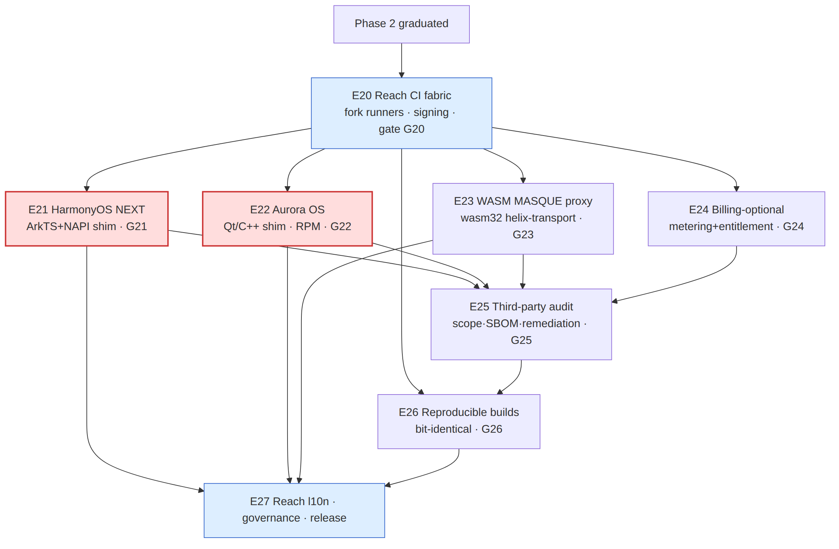
Critical path (risk‑ordered §11.4.132): E20 → {E21 ∥ E22} → E25 → E26 → E27. The two native shims (E21, E22, red) are the make‑or‑break carries and run as disjoint‑scope parallel PWUs (§11.4.58) the moment E20's fork runners exist. E23 (WASM) and E24 (billing) fan out independently off E20 with no device risk. E25 (audit) is a convergence gate: it cannot start until the surfaces it audits (E21–E24) are feature‑complete; E26 (reproducible builds) depends on E25 because the audited source tree is what must reproduce. Per §11.4.103, ≥3 background streams stay busy: while E21/E22 await device access (PENDING_DEVICE), E23/E24/E26‑tooling progress on host‑only work.

5. E20 — Phase‑3 readiness gate + reach CI fabric
HVPN-P3-E20 — Reach build & signing fabric (local/self‑hosted, no active CI §11.4.156) epic · module: deploy,ci Gate G20. The OpenHarmony‑SIG and OMP Aurora Flutter forks lag mainline and need isolated, pinned, signing‑capable build hosts so a fork bump never blocks the mainline release [04_UI §10.*]. Per §11.4.156 these are self‑hosted Podman build pods, not GitHub/GitLab pipelines.
- HVPN-P3-200 — Pin the OpenHarmony‑SIG Flutter fork + DevEco toolchain in a reproducible pod. M(5) · deps: — · gate: G20 · tests: UNIT,FA,REPRO
  - Desc: A containers‑submodule (§11.4.76) Podman quadlet builds a HarmonyOS HAP from the gitee.com/openharmony-sig/flutter_flutter ohos channel at a pinned SHA; DevEco command‑line tools + signing material mounted as secrets (§11.4.10). Deliverable: deploy/reach/harmonyos.container + docs/reach/harmonyos_toolchain.md. Acceptance: podman build produces a HAP from the sample app; toolchain SHA recorded; secrets never in the image layer (SEC leak audit green). Tests: REPRO (same SHA → same toolchain digest).
- # deploy/reach/harmonyos.container (Podman quadlet — §11.4.76/.161 rootless)
[Unit]
Description=HelixVPN HarmonyOS HAP builder (OpenHarmony-SIG Flutter fork, pinned)
[Container]
Image=localhost/helix/harmonyos-builder:ohos-3.22.0-pinned
# never the rootful Docker daemon; rootless Podman only (§11.4.161)
Volume=%h/.helix/secrets/deveco:/secrets/deveco:ro,Z
Volume=%h/Projects/helix_vpn:/src:ro,Z
Environment=OHOS_FLUTTER_REV=<pinned-sha> DEVECO_SIGN_PROFILE=/secrets/deveco/helix.p7b
ReadOnly=true
NoNewPrivileges=true
[Service]
# one-shot build; exits non-zero on signing failure (no fake-pass §11.4)
Type=oneshot
- HVPN-P3-201 — Pin the OMP Aurora flutter-aurora fork + RPM signing pod. M(5) · deps: — · gate: G20 · tests: UNIT,FA,REPRO,SEC
  - Desc: Equivalent quadlet for the gitlab.com/omprussia/flutter fork producing a signed Aurora RPM; Aurora SDK + signing keys mounted read‑only. Russian‑hosted toolchain → isolated network egress policy, mirror‑pinned (§11.4.77 regen mechanism for the SDK tarball). Deliverable: deploy/reach/aurora.container + docs/reach/aurora_toolchain.md. Acceptance: signed RPM of the sample app builds; rpm -K verifies the signature; SDK tarball SHA‑256 matches the recorded manifest. Tests: SEC (egress allow‑list), REPRO.
- HVPN-P3-202 — Reach release‑artifact registry + provenance manifest. S(3) · deps: HVPN-P3-200,HVPN-P3-201 · gate: G20,G26 · tests: UNIT,FA
  - Desc: A signed manifest (reach_artifacts.json) recording every produced HAP/RPM/.wasm with its source SHA, toolchain digest, and SBOM pointer (feeds E26). Deliverable: deploy/reach/manifest.go. Acceptance: manifest entry generated per build, schema‑validated, links resolve.
- HVPN-P3-203 — G20 readiness certification. XS(1) · deps: HVPN-P3-202 · gate: G20 · tests: FA,CHAL
  - Desc: One‑shot make reach-ci-gate that builds + signs both fork artefacts and emits the G20 verdict + evidence paths. Acceptance: HAP and signed RPM both produced from a clean checkout in two consecutive -count=2 runs; gate row outcome=pass.

6. E21 — HarmonyOS NEXT build (highest risk)
HVPN-P3-E21 — HarmonyOS NEXT app + Network Kit VPN shim epic · module: shims/harmonyos Gate G21. HarmonyOS NEXT dropped Android/ART compatibility — native ArkTS/ ArkUI + DevEco only — so the only single‑codebase path is the OpenHarmony‑SIG Flutter fork (HAP) with the VPN extension written in ArkTS bridging via NAPI to the Rust helix-core .so [04_ARCH §5.7, 04_UI §6.1]. The UI ports for free; the tunnel ability is real native work — this is the project's single biggest platform risk; treat every device‑gated acceptance as PENDING_DEVICE until hardware/CI exists (G20).
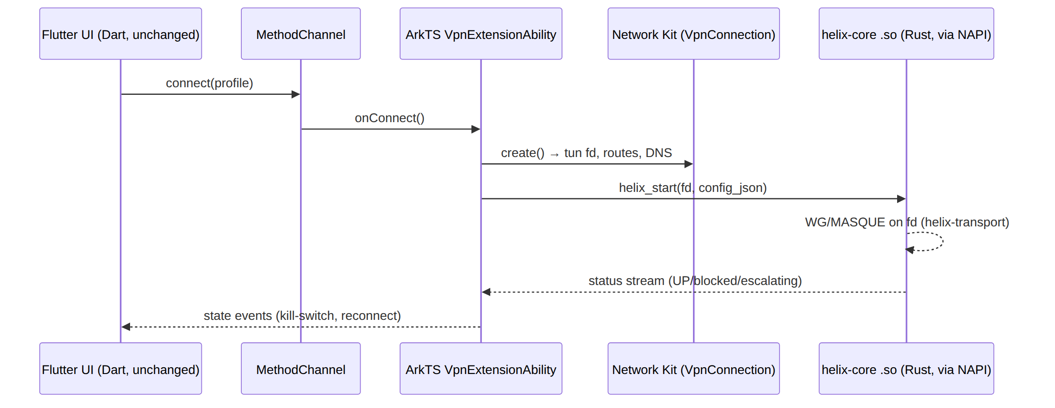
- HVPN-P3-210 — helix-core cross‑compile to OpenHarmony (aarch64‑unknown‑linux‑ohos) + NAPI surface. L(8) · deps: HVPN-P3-200 · gate: G21 · tests: UNIT,INT,MEM,BENCH
  - Desc: Build helix-ffi for the OHOS target; expose a NAPI module (libhelix_ohos.so) wrapping the existing UniFFI/FFI surface [03 §5]. Deliverable: shims/harmonyos/native/ + cargo target config. Acceptance: .so loads in an ArkTS test harness; helix_version() round‑trips; RSS ceiling sampled (PENDING_DEVICE on hardware). Tests: MEM (heap headroom), BENCH (throughput on emulator).
- // shims/harmonyos/native/src/lib.rs — NAPI surface over the SAME helix-core API.
// No HarmonyOS specifics leak into helix-core (§11.4.28 decoupling): this crate
// is the ONLY OHOS-aware code; it re-exports the platform-neutral core.
use napi_ohos::{bindgen_prelude::*, Env, JsObject};
use helix_ffi::{Core, CoreConfig, Status}; // reused, unchanged
#[napi]
pub fn helix_start(tun_fd: i32, config_json: String) -> Result<u32> {
let cfg: CoreConfig = serde_json::from_str(&config_json)
.map_err(|e| Error::from_reason(e.to_string()))?;
// tun_fd is owned by Network Kit; core writes/reads packets, never closes it.
let handle = Core::start_on_fd(tun_fd, cfg)
.map_err(|e| Error::from_reason(e.to_string()))?;
Ok(handle.id()) // opaque handle; ArkTS keeps it for stop()
}
#[napi]
pub fn helix_stop(handle: u32) -> Result<()> {
Core::stop(handle).map_err(|e| Error::from_reason(e.to_string()))
}
// Status pushed to ArkTS via a threadsafe function (kill-switch, escalation).
#[napi(ts_args_type = "callback: (status: string) => void")]
pub fn helix_subscribe(handle: u32, callback: JsFunction) -> Result<()> {
let tsfn: ThreadsafeFunction<String, ErrorStrategy::Fatal> =
callback.create_threadsafe_function(0, |ctx| Ok(vec![ctx.value]))?;
Core::on_status(handle, move |s: Status| {
tsfn.call(serde_json::to_string(&s).unwrap(), ThreadsafeFunctionCallMode::NonBlocking);
});
Ok(())
}
- HVPN-P3-211 — Network Kit VpnExtensionAbility + lifecycle + kill‑switch. L(8) · deps: HVPN-P3-210,HVPN-P3-201 · gate: G21 · tests: UNIT,INT,E2E,MEM,UX,REC,CHAL
  - Desc: The ArkTS ability that requests VPN consent, creates the VpnConnection (tun fd, routes, DNS), hands the fd to the core, and drives connect/disconnect/kill‑switch/auto‑escalate from the core status stream. Deliverable: shims/harmonyos/entry/src/main/ets/HelixVpnAbility.ets. Acceptance (PENDING_DEVICE): enroll → UP → curl reaches authorized LAN host on a HarmonyOS NEXT device; tunnel‑drop blanks plaintext (kill‑switch) per §04; window‑scoped MP4 + DevEco heap capture; §11.4.3 SKIP hardware_not_present until G20 provisions a device.
- // shims/harmonyos/entry/src/main/ets/HelixVpnAbility.ets (ArkTS)
import { vpnExtension } from '@kit.NetworkKit';
import helix from 'libhelix_ohos.so'; // the NAPI module (HVPN-P3-210)
export default class HelixVpnAbility extends vpnExtension.VpnExtensionAbility {
private handle: number = 0;
onConnect(profile: HelixProfile): void {
const conn = vpnExtension.createVpnConnection(this.context);
const fd = conn.create({ // tun fd from Network Kit
addresses: profile.overlayAddrs, // ULA /48 + 4via6 (D4, [02])
routes: profile.allowedRoutes, // policy-filtered need-to-know
dnsAddresses: profile.dns,
mtu: 1280 // MASQUE-safe floor [research-masque]
});
this.handle = helix.helix_start(fd, JSON.stringify(profile.coreConfig));
helix.helix_subscribe(this.handle, (s: string) => this.onCoreStatus(JSON.parse(s)));
}
onDisconnect(): void { if (this.handle) helix.helix_stop(this.handle); }
private onCoreStatus(s: HelixStatus): void {
// kill-switch: if s.state === 'down' && killSwitch, drop the default route
// auto-escalate: core already moved WG→MASQUE; surface 'escalating' to UI
this.context.eventHub.emit('helix.status', s);
}
}
- HVPN-P3-212 — Flutter HAP build of the Access + Connector flavors (OHOS channel). M(5) · deps: HVPN-P3-211 · gate: G21 · tests: UI,UX,REC
  - Desc: Produce signed HAPs of the two tunnel flavors via runHelixApp(flavor,...) [04_UI §2] on the SIG fork; Dart UI unchanged; ArkTS↔Dart MethodChannel wired. Deliverable: helix-access.hap, helix-connector.hap. Acceptance: app installs + drives the shim; golden UI tests pass on the OHOS theme; UX walkthrough MP4 vision‑verified (PENDING_DEVICE).
- HVPN-P3-213 — DevEco signing + market metadata + l10n (zh‑Hans first‑tier). S(3) · deps: HVPN-P3-212 · gate: G21 · tests: FA,UI
  - Desc: DevEco signing profile, AppGallery metadata, Simplified Chinese as a first‑tier locale (helix_l10n, [04_UI §8]). Deliverable: signing config + intl_zh.arb. Acceptance: signed HAP verifies; zh‑Hans strings render with no overflow (UI golden).
- HVPN-P3-214 — G21 device certification + honest gap doc. M(4) · deps: HVPN-P3-211,HVPN-P3-212 · gate: G21 · tests: E2E,FA,CHAL,REC
  - Desc: The challenges/helix_qa bank entry that drives enroll→UP→reach→kill‑switch on the device and scores PASS only on captured evidence (§11.4.27/.107). Acceptance: gate row outcome=pass with device evidence, or outcome=pending_device with the §11.4.148 D3 unblock condition (provision a HarmonyOS NEXT device + add it to the §11.4.128 tracked‑device set) — never a faked pass.

7. E22 — Aurora OS build
HVPN-P3-E22 — Aurora OS app + Qt/C++ tun shim epic · module: shims/aurora Gate G22. Aurora is Qt/QML‑native; the path is the OMP Russia Flutter fork (flutter-aurora → signed RPM) with the tunnel backend in Qt/C++ linking helix-core as a C library [04_ARCH §5.7, 04_UI §6.1]. Treat as an enterprise/government SKU with its own runners + signing; Russian‑hosted toolchain (GitLab omprussia / Mos.Hub).
- HVPN-P3-220 — helix-core C ABI for Aurora (aarch64/armv7hl Sailfish target) + cbindgen header. L(7) · deps: HVPN-P3-201 · gate: G22 · tests: UNIT,INT,MEM,BENCH
  - Desc: Build helix-ffi for the Aurora target; emit a stable C header via cbindgen so the Qt/C++ backend links it. The SAME core, no Aurora specifics inside it (§11.4.28). Deliverable: shims/aurora/native/libhelix.a + helix.h. Acceptance: header compiles in a Qt test; helix_version() round‑trips; RSS sampled (PENDING_DEVICE).
- /* shims/aurora/native/helix.h — generated by cbindgen; consumed by Qt/C++.
Platform-neutral: identical surface to the OHOS NAPI module, different ABI. */
typedef uint32_t HelixHandle;
typedef void (*HelixStatusCb)(const char *status_json, void *user);
HelixHandle helix_start(int tun_fd, const char *config_json); /* 0 = error */
void helix_stop(HelixHandle h);
void helix_subscribe(HelixHandle h, HelixStatusCb cb, void *user);
const char *helix_last_error(void); /* thread-local */
- // shims/aurora/src/HelixTunnelBackend.cpp — Qt/C++ owns the tun fd + routes;
// helix-core drives packets. This .cpp is the ONLY Aurora-aware tunnel code.
void HelixTunnelBackend::connect(const HelixProfile &p) {
int fd = openTun(p.overlayAddrs, p.allowedRoutes, p.dns, /*mtu=*/1280);
m_handle = helix_start(fd, p.coreConfigJson().toUtf8().constData());
if (!m_handle) { emit error(QString::fromUtf8(helix_last_error())); return; }
helix_subscribe(m_handle, &HelixTunnelBackend::onStatusC, this);
}
void HelixTunnelBackend::onStatusC(const char *json, void *self) {
// marshal onto the Qt event loop; drive kill-switch + UI state
QMetaObject::invokeMethod(static_cast<HelixTunnelBackend*>(self),
"onStatus", Qt::QueuedConnection, Q_ARG(QString, QString::fromUtf8(json)));
}
- HVPN-P3-221 — Qt/C++ tun lifecycle + Friflex Flutter plugin bridge + kill‑switch. L(8) · deps: HVPN-P3-220 · gate: G22 · tests: UNIT,INT,E2E,MEM,UX,REC,CHAL
  - Desc: Open/route/DNS the Sailfish tun, bridge connect/disconnect/status to Flutter via a Friflex‑style plugin, drive kill‑switch + auto‑escalate from the core stream. Deliverable: shims/aurora/src/ + aurora/plugins/helix_core_aurora/. Acceptance (PENDING_DEVICE): enroll → UP → reach on an Aurora device; kill‑switch blanks plaintext; MP4 + RSS capture; §11.4.3 SKIP until a device exists.
- HVPN-P3-222 — Flutter signed‑RPM build (Access + Connector) on the OMP fork. M(5) · deps: HVPN-P3-221 · gate: G22 · tests: UI,UX,REC,SEC
  - Desc: Produce signed Aurora RPMs of the two flavors; Russian (ru) first‑tier l10n (Aurora market) [04_UI §8]. Deliverable: helix-access.rpm, helix-connector.rpm. Acceptance: rpm -K verifies; ru strings render with no overflow; install on the Aurora emulator (PENDING_DEVICE for hardware reach).
- HVPN-P3-223 — G22 device certification + enterprise‑SKU operational doc. M(4) · deps: HVPN-P3-221,HVPN-P3-222 · gate: G22 · tests: E2E,FA,CHAL,REC
  - Desc: Bank entry driving enroll→UP→reach→kill‑switch on Aurora; plus an ops doc covering the isolated runner + Mos.Hub signing (§11.4.10 secrets). Acceptance: gate outcome=pass with device evidence, or honest pending_device with unblock condition; the toolchain‑provenance risk recorded UNCONFIRMED: until an Aurora device is in hand (§11.4.6).

8. E23 — WASM browser‑scoped MASQUE proxy
HVPN-P3-E23 — In‑browser WASM MASQUE proxy (Console) epic · module: helix-transport,helix-ui Gate G23. Browsers cannot open a TUN device, so the web build is the Console (management) + an optional in‑page WASM MASQUE client that proxies the browser's own traffic to a joined network — not a system‑wide tunnel; this must be stated plainly to users [04_ARCH §5.7, 04_UI §8.3]. The reuse pillar pays off: helix-transport (Rust) already speaks MASQUE; compiling it to wasm32 over the browser's WebTransport/HTTP‑3 yields the proxy with no protocol rewrite [research-masque, research-wasm].
- HVPN-P3-230 — helix-transport wasm32-unknown-unknown build + WebTransport binding. L(8) · deps: HVPN-P3-202 · gate: G23 · tests: UNIT,INT,BENCH
  - Desc: Feature‑gate helix-transport so the MASQUE/QUIC client compiles to WASM, binding the browser WebTransport API for the H3/datagram path (no raw UDP in a browser) [research-wasm]. Deliverable: helix-core/crates/helix-transport/src/wasm.rs + pkg/helix_transport.wasm. Acceptance: .wasm loads in a headless Chromium; a MASQUE CONNECT‑UDP session establishes to a test edge; throughput benched (BENCH).
- // helix-core/crates/helix-transport/src/wasm.rs
// The SAME MASQUE state machine; only the I/O leaf differs (WebTransport vs UDP).
#[cfg(target_arch = "wasm32")]
use wasm_bindgen::prelude::*;
#[cfg(target_arch = "wasm32")]
use web_sys::{WebTransport, WebTransportBidirectionalStream};
#[wasm_bindgen]
pub struct WasmMasqueProxy { inner: MasqueSession } // MasqueSession is shared, unchanged
#[wasm_bindgen]
impl WasmMasqueProxy {
/// `gateway_url` = https://gw.example/.well-known/masque/udp/{target_host}/{port}/
/// (RFC 9298 connect-udp template) [research-masque].
#[wasm_bindgen(constructor)]
pub async fn connect(gateway_url: String, auth_token: String) -> Result<WasmMasqueProxy, JsValue> {
let wt = WebTransport::new(&gateway_url)?; // H3 transport
JsFuture::from(wt.ready()).await?;
let inner = MasqueSession::over_webtransport(wt, auth_token).await
.map_err(|e| JsValue::from_str(&e.to_string()))?;
Ok(Self { inner })
}
/// Proxy a single browser fetch to the joined network through MASQUE.
pub async fn proxy_fetch(&self, req: web_sys::Request) -> Result<web_sys::Response, JsValue> {
self.inner.proxy_http(req).await.map_err(|e| JsValue::from_str(&e.to_string()))
}
}
- HVPN-P3-231 — Service‑worker / fetch‑shim integration + scope isolation. M(6) · deps: HVPN-P3-230 · gate: G23 · tests: UNIT,INT,E2E,SEC
  - Desc: Wire the WASM proxy behind a service worker so only explicitly‑proxied origins route through MASQUE; everything else uses normal browser networking. Hard scope boundary: the proxy reaches only policy‑authorized hosts (need‑to‑know, server‑side enforced) and dies on tab/worker close. Deliverable: helix-ui/web/helix_proxy_sw.js + Dart bridge. Acceptance (SEC): a non‑authorized host is unreachable; a non‑proxied origin never touches the gateway; tab‑close terminates the session (no lingering tunnel) — all captured.
- HVPN-P3-232 — Console UX: explicit "browser‑scoped proxy, not a system VPN" affordance. S(3) · deps: HVPN-P3-231 · gate: G23 · tests: UI,UX,REC
  - Desc: A ShieldIndicator variant + copy that states the limitation plainly (never imply a system‑wide tunnel); toggle per joined network; live reachability indicator. Deliverable: Flutter Web widgets. Acceptance: golden tests; UX MP4 vision‑verified that the scope wording is present and unambiguous (§11.4.159) — guards against an over‑claim bluff.
- HVPN-P3-233 — G23 certification + threat note (WASM origin model). S(3) · deps: HVPN-P3-231,HVPN-P3-232 · gate: G23 · tests: E2E,SEC,CHAL
  - Desc: Bank entry: browser reaches an authorized host via the proxy, is denied an unauthorized one, leaks nothing beyond scope; plus a short threat note (origin isolation, token handling in the page, no private‑key‑in‑browser — auth is a short‑lived token, never a WG private key [04 §PKI]). Acceptance: gate outcome=pass with captured evidence; the "no key in browser" invariant proven by a SEC assertion.

9. E24 — Billing‑optional multi‑tenant
HVPN-P3-E24 — Billing‑optional multi‑tenant + metering epic · module: helix-go/billing Gate G24. The decisive constraint: billing must not break no‑logging [04_ARCH §7, 04 §privacy]. Metering is aggregate counters only (bytes per device per day bucket), never per‑connection/per‑flow records; the CI schema‑lint that fails the build on any durable connection/traffic table (E02, [02/04]) stays in force and must also reject any billing table that smells like a traffic log. Billing is OFF by default (self‑host = no billing); turning it ON is purely additive (entitlement + an optional payment adapter), changing zero tunnel behaviour.
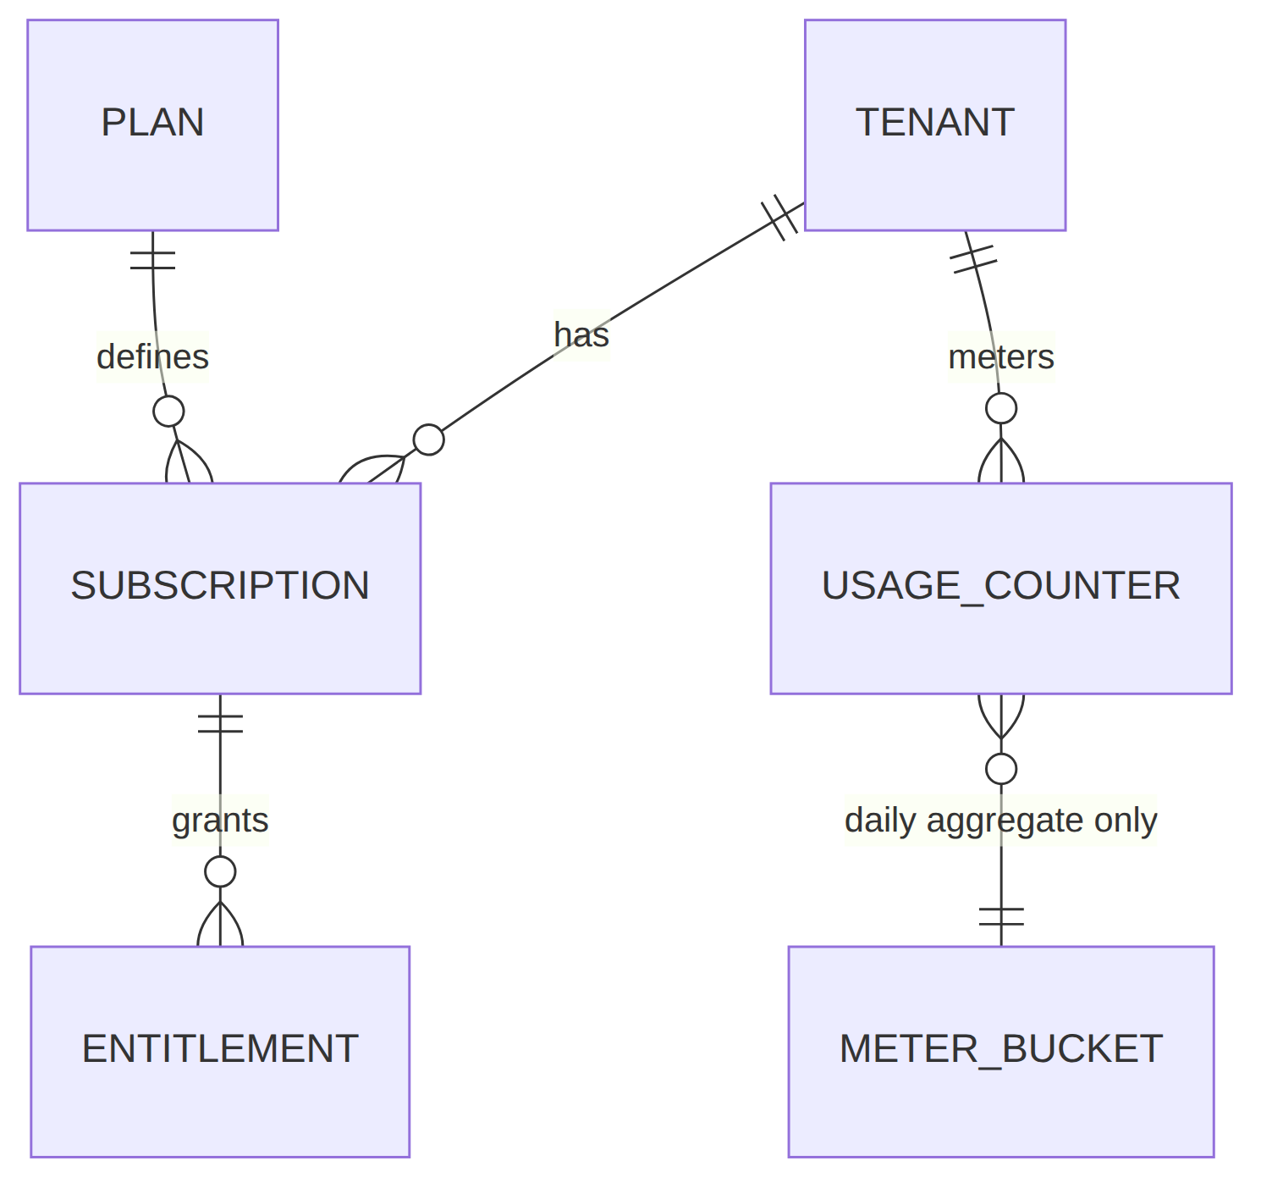
- HVPN-P3-240 — Billing schema: plans, subscriptions, entitlements, aggregate meters (RLS + no‑log lint). L(7) · deps: — · gate: G24 · tests: UNIT,INT,SEC
  - Desc: New Postgres tables under FORCE‑RLS, tenant‑scoped, with a hard invariant: usage is a daily aggregate bucket keyed by tenant/device/date — no timestamps finer than a day, no peer/host/port columns, no flow rows. Extend the no‑log CI lint (§04) to also fail on a billing column matching the forbidden traffic‑log shape. Deliverable: helix-go/store/migrations/03x_billing.sql + lint rule. Acceptance (SEC): cross‑tenant read denied (RLS); the lint fails a planted usage_flows(src,dst,port,ts) table (paired §1.1 mutation), passes the aggregate schema.
- -- helix-go/store/migrations/030_billing.sql (FORCE RLS; aggregate-only; no traffic log)
CREATE TABLE plan (
id uuid PRIMARY KEY DEFAULT gen_random_uuid(),
code text NOT NULL UNIQUE, -- 'free','team','enterprise'
max_devices int NOT NULL,
max_networks int NOT NULL,
max_bytes_mo bigint, -- NULL = unlimited
meta jsonb NOT NULL DEFAULT '{}'
);
CREATE TABLE subscription (
id uuid PRIMARY KEY DEFAULT gen_random_uuid(),
tenant_id uuid NOT NULL REFERENCES tenant(id),
plan_id uuid NOT NULL REFERENCES plan(id),
status text NOT NULL DEFAULT 'active'
CHECK (status IN ('active','past_due','canceled')),
started_on date NOT NULL DEFAULT current_date,
ext_ref text -- opaque payment-provider id (E24)
);
-- USAGE: aggregate ONLY. Day-granular. NO src/dst/host/port/flow columns — by design.
-- The no-log CI lint (§04) treats any column in (src,dst,peer,host,port,flow,conn,ts<day)
-- on a usage table as a BUILD FAILURE.
CREATE TABLE usage_counter (
tenant_id uuid NOT NULL REFERENCES tenant(id),
device_id uuid NOT NULL REFERENCES device(id),
day date NOT NULL, -- coarsest granularity, intentional
rx_bytes bigint NOT NULL DEFAULT 0,
tx_bytes bigint NOT NULL DEFAULT 0,
PRIMARY KEY (tenant_id, device_id, day)
);
ALTER TABLE plan ENABLE ROW LEVEL SECURITY; -- plan is global-read, admin-write
ALTER TABLE subscription ENABLE ROW LEVEL SECURITY;
ALTER TABLE subscription FORCE ROW LEVEL SECURITY;
ALTER TABLE usage_counter ENABLE ROW LEVEL SECURITY;
ALTER TABLE usage_counter FORCE ROW LEVEL SECURITY;
CREATE POLICY sub_isolation ON subscription USING (tenant_id = current_tenant());
CREATE POLICY usage_isolation ON usage_counter USING (tenant_id = current_tenant());
- HVPN-P3-241 — Aggregate metering pipeline (edge counters → daily upsert). M(6) · deps: HVPN-P3-240 · gate: G24 · tests: UNIT,INT,CHAOS,STRESS
  - Desc: The edge already exposes aggregate rx/tx counters (no flow detail) [01]; a metering consumer folds them into usage_counter daily upserts over the event bus. Crash‑safe: a SIGKILL mid‑fold must not double‑count nor lose a bucket (idempotent upsert keyed by tenant/device/day). Deliverable: helix-go/billing/meter.go. Acceptance: CHAOS (kill mid‑fold → exactly‑once bucket); STRESS (10k devices, bounded memory).
- HVPN-P3-242 — Entitlement enforcement in the coordinator (quota → policy/admission). M(6) · deps: HVPN-P3-240 · gate: G24 · tests: UNIT,INT,SEC,PERF
  - Desc: Plan limits (max devices/networks/bytes) become admission checks at enroll + coordinator map build — over‑quota = deny with a clear reason, never a silent drop; fail‑open vs fail‑closed is an explicit decision (D‑P3‑2). Deliverable: helix-go/billing/entitlement.go + a Entitlement protobuf message. Acceptance: an over‑device‑quota enroll is denied with reason; bytes‑quota breach degrades per the chosen policy; PERF shows the check adds <1 ms to map build.
- // helix-proto/billing/v1/entitlement.proto — entitlement, NOT traffic data.
syntax = "proto3";
package helix.billing.v1;
message Entitlement {
string tenant_id = 1;
int32 max_devices = 2;
int32 max_networks= 3;
int64 max_bytes_mo= 4; // 0 = unlimited
bool billing_on = 5; // false on self-host: enforcement is a no-op
Quota used = 6; // aggregate snapshot only
}
message Quota { int32 devices = 1; int32 networks = 2; int64 bytes_mo = 3; }
- HVPN-P3-243 — Optional payment‑provider adapter (interface + one reference impl) behind a feature flag. M(5) · deps: HVPN-P3-241 · gate: G24 · tests: UNIT,INT,SEC,DDOS
  - Desc: A narrow PaymentProvider Go interface (create‑customer, attach‑subscription, webhook→subscription‑status) with one reference adapter; provider choice is D‑P3‑3 (recommend a self‑hostable/open option first, a hosted provider as a pluggable alternative — never hardcode one). Webhook endpoint is the first public surface → DDOS becomes applicable (rate‑limit + signature‑verify). Deliverable: helix-go/billing/provider/. Acceptance: webhook signature verified; replay rejected; rate‑limit holds under flood (DDOS); billing‑OFF path never calls the adapter.
- // helix-go/billing/provider/provider.go — decoupled; no provider name in core (§11.4.28).
type PaymentProvider interface {
EnsureCustomer(ctx context.Context, tenantID string) (extRef string, err error)
AttachSubscription(ctx context.Context, extRef, planCode string) error
// VerifyWebhook authenticates a provider callback and maps it to a status change.
VerifyWebhook(ctx context.Context, hdr http.Header, body []byte) (SubscriptionEvent, error)
}
type SubscriptionEvent struct {
TenantRef string
Status string // 'active' | 'past_due' | 'canceled'
}
- HVPN-P3-244 — G24 certification: billing ON works, billing OFF is a perfect no‑op, no‑log preserved. S(3) · deps: HVPN-P3-242,HVPN-P3-243 · gate: G24 · tests: E2E,SEC,FA,CHAL
  - Desc: Bank entry proving (a) with billing ON, metering + quota + payment status flow end‑to‑end; (b) with billing OFF (default), behaviour is byte‑identical to pre‑E24 (a §11.4.108 runtime‑signature diff); (c) the no‑log lint still green and the planted traffic‑log table still fails it. Acceptance: gate outcome=pass; the no‑op proof is captured (regression‑guard §11.4.135).

10. E25 — Third‑party security audit
HVPN-P3-E25 — Independent third‑party security audit epic · module: security Gate G25. A privacy product's claims are worth what an outsider confirms; a self‑audit is not an audit. This epic prepares the surface, engages an independent firm, and runs the remediation loop to a published, zero‑Critical/High report [04_P2 §11]. Uses the security submodule (§7) for SAST/SBOM tooling but the verdict is the external party's, captured.
- HVPN-P3-250 — Audit scope, threat model, and asset inventory. M(5) · deps: HVPN-P3-214,HVPN-P3-223,HVPN-P3-233,HVPN-P3-244 · gate: G25 · tests: SEC
  - Desc: A scoped threat model covering crypto core (WG/MASQUE/PQ PSK), control plane (RLS, enroll, revoke, policy compiler), the four reach surfaces (HarmonyOS/Aurora shims, WASM proxy, billing), and the no‑log invariant. Deliverable: docs/security/audit_scope.md + threat_model.md (STRIDE per surface). Acceptance: every shipped surface mapped to ≥1 threat + ≥1 audit objective; no surface unlisted (§11.4.118 enumerated coverage).
- HVPN-P3-251 — SBOM + reproducible‑source snapshot for the auditor. S(3) · deps: HVPN-P3-202 · gate: G25,G26 · tests: SEC,REPRO
  - Desc: A complete SBOM (CycloneDX) for every artefact + a pinned source snapshot the auditor (and later users, E26) can rebuild. Deliverable: sbom/*.cdx.json + docs/security/source_snapshot.md. Acceptance: SBOM covers 100% of shipped deps; snapshot SHA recorded; endor/aikido‑class scan (security submodule) green or every finding triaged.
- HVPN-P3-252 — Engage auditor + run the engagement (operator‑gated). L(7) · deps: HVPN-P3-250,HVPN-P3-251 · gate: G25 · tests: SEC,CHAL
  - Desc: Select + contract an independent firm (operator decision — spend/3rd‑party engagement is the exact §11.4.101 block class → §11.4.66 AskUserQuestion), share scope + snapshot, receive the report. Deliverable: docs/security/audit_report_v1.pdf (external). Acceptance: report received; status tracked Operator-blocked with the §11.4.21 unblock detail until the engagement is funded — honest, not faked.
- HVPN-P3-253 — Remediation loop to zero Critical/High (§11.4.134/.146). L(8) · deps: HVPN-P3-252 · gate: G25 · tests: UNIT,INT,SEC,CHAL,REC
  - Desc: Every finding → systematic‑debug root cause (§11.4.102) → §11.4.115 RED‑on‑the‑vulnerable‑build → fix → §11.4.146 extend‑to‑all‑cases → permanent regression guard (§11.4.135); re‑audit the fixed items until the firm signs off (§11.4.134 iterate‑to‑GO). Deliverable: per‑finding closure logs docs/security/findings/<id>.md. Acceptance: zero unresolved Critical/High; each closure carries a falsifiable regression test (no console‑mark‑is‑fixed bluff §11.4.138 analogue).
- HVPN-P3-254 — G25 certification + public disclosure. S(3) · deps: HVPN-P3-253 · gate: G25 · tests: SEC,CHAL
  - Desc: Publish the report + remediation summary; gate verdict. Acceptance: gate outcome=pass only when Critical/High = 0 and the report is published; otherwise honest fail/operator_blocked with the open‑finding list.

11. E26 — Reproducible builds
HVPN-P3-E26 — Reproducible builds (bit‑identical, user‑verifiable) epic · module: deploy,security Gate G26. Table stakes for a privacy product: a user must be able to verify the shipped binaries match the public source [04_P2 §11]. Every artefact — Go control plane, Rust edge + core, Flutter apps, the OHOS .so/HAP, the Aurora .a/RPM, the .wasm — must rebuild bit‑for‑bit from the pinned source + pinned toolchain.
- HVPN-P3-260 — Determinize the Go + Rust builds (pinned toolchains, trimmed paths, SOURCE_DATE_EPOCH). M(6) · deps: HVPN-P3-202 · gate: G26 · tests: REPRO,FA
  - Desc: Pin Go + Rust toolchain versions, set -trimpath/--remap-path-prefix, fix SOURCE_DATE_EPOCH, strip non‑deterministic metadata; build inside a pinned containers‑submodule image (§11.4.76). Deliverable: deploy/repro/build.sh + pinned image digests. Acceptance (REPRO): two clean rebuilds of helix-go + helix-edge + helix-core on two hosts → identical SHA‑256.
- HVPN-P3-261 — Determinize the Flutter app builds (AOT + asset ordering). M(6) · deps: HVPN-P3-260 · gate: G26 · tests: REPRO,FA
  - Desc: Reproducible Flutter AOT for iOS/Android/desktop/web + the fork HAP/RPM; deterministic asset bundling + l10n ARB ordering. Deliverable: deploy/repro/flutter.sh. Acceptance: two rebuilds of each flavor → identical artefact (signature stripped before compare); divergences root‑caused (§11.4.102) to zero. Note (§11.4.6): signed installers differ by signature by design — compare the unsigned payload digest; record this as the honest boundary.
- HVPN-P3-262 — WASM + native‑shim reproducibility (.wasm, OHOS .so, Aurora .a). M(5) · deps: HVPN-P3-260 · gate: G26 · tests: REPRO
  - Desc: Extend determinism to the cross‑compiled artefacts; pin the OHOS/Aurora cross‑toolchains. Acceptance: two rebuilds of helix_transport.wasm + libhelix_ohos.so + Aurora libhelix.a → identical SHA‑256 (PENDING_TOOLCHAIN: honestly where a fork toolchain is not yet deterministic — a finding, not a pass).
- HVPN-P3-263 — Public verification script + transparency doc. S(3) · deps: HVPN-P3-261,HVPN-P3-262 · gate: G26 · tests: REPRO,FA,CHAL
  - Desc: A one‑command verify-reproducible.sh a user runs against a published release to confirm bit‑identity, + docs/security/reproducible_builds.md explaining the model + the honest exceptions (signatures). Deliverable: the script + doc. Acceptance: a third party (the §11.4.165 independent verifier role) runs it and confirms identity on every non‑signature‑bearing artefact; captured.
- HVPN-P3-264 — G26 certification. XS(1) · deps: HVPN-P3-263 · gate: G26 · tests: REPRO,FA,CHAL
  - Desc: Gate verdict over the full artefact matrix. Acceptance: gate outcome=pass only when every non‑signature artefact reproduces bit‑identically on two independent hosts; any PENDING_TOOLCHAIN artefact keeps the gate honest (not closed) until resolved.

12. E27 — Reach localization, governance, release
HVPN-P3-E27 — Reach l10n, docs‑chain, release tag epic · module: helix-ui,docs,deploy Cross‑cutting. The reach markets (Aurora=Russia, HarmonyOS=China) make ru + zh‑Hans first‑tier, RTL‑ready, with connection‑state clarity weighted highest for censorship‑region users [04_UI §8].
- HVPN-P3-270 — First‑tier ru + zh‑Hans localization completeness + overflow audit. M(5) · deps: HVPN-P3-213,HVPN-P3-222 · gate: — · tests: UI,UX,REC
  - Desc: Complete helix_l10n ARBs for ru/zh‑Hans; golden tests prove no label overflow/overlap (§11.4.162 layout invariant); connection state announced not just colored (a11y, §04 never‑color‑alone). Acceptance: golden UI green in both locales on Access/Connector/Console; UX MP4 vision‑verified.
- HVPN-P3-271 — Phase‑3 feature Status + Status_Summary set (§11.4.153) with per‑surface video confirmation. M(4) · deps: HVPN-P3-214,HVPN-P3-223,HVPN-P3-233,HVPN-P3-244,HVPN-P3-254,HVPN-P3-264 · gate: — · tests: REC,CHAL
  - Desc: docs/features/Status.md + Status_Summary.md enumerating every Phase‑3 surface with Implementation/Wiring/Validation/Video‑confirmation, four‑format export (HTML+PDF+DOCX §11.4.153), docs‑chain‑synced (§11.4.106). Acceptance: every confirmed row has a real‑use MP4 (PENDING_DEVICE rows honestly marked); §11.4.86 fingerprint matches.
- HVPN-P3-272 — docs‑chain sync + workable‑items DB load + reproducible‑release tag. S(3) · deps: HVPN-P3-271 · gate: — · tests: FA,REPRO
  - Desc: Load all HVPN-P3-* rows into docs/workable_items.db (§11.4.93/.95), sync exports (§11.4.65), cut the reach release tag <prefix>-3.0.0-... (§11.4.151) and fan out to all upstreams via merge‑onto‑latest‑main (§11.4.113, never force‑push). Acceptance: workable-items validate green; tag prefix correct across main + every owned submodule; artefacts reproduce (E26).

13. Definition‑of‑Done ↔ work‑item traceability
Phase‑3 ships only when G20–G26 all pass on a clean baseline (§11.4.40 full‑ suite retest, §11.4.108 runtime‑signature on a fresh install/deploy), or the remaining gates are honestly pending_device/operator_blocked with tracked unblock conditions — Phase 3 is the one phase where "ship what's provable, flag the rest honestly" is the correct stance (§11.4.6), because two surfaces depend on hardware/engagements the project cannot self‑provision.
Gate | Question (abbrev) | Primary items | Evidence class
G20 | reach build+sign in our CI | HVPN-P3-200/201/202/203 | HAP + signed RPM from clean checkout, ×2
G21 | HarmonyOS tunnel UP on device | HVPN-P3-210/211/212/213/214 | device E2E MP4 + heap capture (PENDING_DEVICE ok)
G22 | Aurora tunnel UP on device | HVPN-P3-220/221/222/223 | device E2E MP4 + RSS (PENDING_DEVICE ok)
G23 | WASM proxy scoped + reaches net | HVPN-P3-230/231/232/233 | browser E2E + SEC scope proof
G24 | billing meter+entitle, no‑log kept | HVPN-P3-240/241/242/243/244 | RLS+lint SEC, billing‑OFF no‑op diff
G25 | external audit, criticals=0 | HVPN-P3-250..254 | published 3rd‑party report + closures
G26 | reproducible, bit‑identical | HVPN-P3-260..264 | two‑host identical SHA‑256 matrix
Honest‑gap rule (§11.4.3/.6): a gate is never marked pass on metadata/config‑only evidence; a device‑ or engagement‑gated gate that cannot be proven is pending_device/operator_blocked with its §11.4.148 D3 unblock condition — the release notes state plainly which reach targets are certified vs built‑but‑pending‑device.

14. Effort roll‑up, critical path & risk register
Indicative engineer‑day totals (mid‑point of the T‑shirt range) for sizing, not a date commitment — Phase 3's device‑gated items carry the widest error bars in the whole programme.
Epic | Items | ~Engineer‑days | Risk
E20 Reach CI fabric | 4 | 14 | medium (toolchain access)
E21 HarmonyOS NEXT | 5 | 28 | high — native shim + device
E22 Aurora OS | 4 | 24 | high — native shim + device + Russian toolchain
E23 WASM MASQUE proxy | 4 | 20 | medium (browser API maturity)
E24 Billing‑optional | 5 | 27 | medium (no‑log invariant must hold)
E25 Third‑party audit | 5 | 26 | high — external + operator‑gated spend
E26 Reproducible builds | 5 | 21 | medium (fork toolchain determinism)
E27 Reach l10n/governance | 3 | 12 | low
Phase‑3 total | 35 | ~172 | —
Critical path (risk‑ordered §11.4.132): E20(200/201→203) → {E21(210→211→214) ∥ E22(220→221→223)} → E25(250→252→253→254) → E26(260→263→264) → E27(271→272). E23 + E24 run as parallel background streams off E20 (§11.4.103). The two device shims sit at the apex of the priority order (highest blast radius + highest uncertainty) per §11.4.132 — validate them first the moment a device exists.

Risk register (FACT‑grade, no guessing §11.4.6)
ID | Risk | Likelihood | Impact | Mitigation / honest stance
R‑P3‑1 | HarmonyOS native shim fails the memory ceiling / Network Kit can't drive an external fd as needed. | UNCONFIRMED: until device | Critical (E21 blocked) | G21 is a make‑or‑break gate; PENDING_DEVICE until hardware; escalate per §11.4.66 — do not fake a pass.
R‑P3‑2 | Aurora toolchain is Russian‑hosted (omprussia / Mos.Hub); availability + provenance not self‑verifiable. | High | High (E22 blocked) | Mirror‑pin the SDK (§11.4.77); isolated egress; treat as enterprise SKU; record provenance UNCONFIRMED: until audited.
R‑P3‑3 | Fork Flutter versions lag mainline → build breaks on a mainline bump. | Medium | Medium | Isolated pinned runners (E20) so a fork lag never blocks the mainline release [04_UI §10].
R‑P3‑4 | Browser WebTransport/H3 API gaps make WASM MASQUE partial. | Medium | Medium | Scope to Console‑only proxy; feature‑detect + honest fallback; never claim a system VPN [04_ARCH §5.7].
R‑P3‑5 | Billing schema silently reintroduces a traffic‑log shape. | Low | Critical (privacy) | No‑log CI lint extended to billing tables + paired §1.1 mutation (HVPN-P3-240); billing OFF by default.
R‑P3‑6 | Audit engagement unfunded → G25 stalls the release. | Medium | High | Operator‑gated (§11.4.101/.66); track Operator-blocked honestly; reach surfaces can ship pending_device while the audit is arranged.
R‑P3‑7 | A fork toolchain is not bit‑reproducible. | Medium | Medium | PENDING_TOOLCHAIN: keeps G26 open honestly for that artefact; root‑cause to zero or document the exception.

15. Open decisions (D‑P3‑*) surfaced with recommendations
Per §11.4.66/.101 — surfaced, never silently resolved; each carries a recommendation + the gate/item that finalizes it.
- D‑P3‑1 — HarmonyOS bridge: NAPI vs MethodChannel‑only for the data path. Options: (a) ArkTS owns the fd, core driven via NAPI (recommended — keeps the packet path in Rust, smallest copy overhead); (b) all bridging via Flutter MethodChannel (simpler, but routes packets through Dart — rejected on perf/memory). Rec: (a) NAPI. Finalized by HVPN-P3-210/211.
- D‑P3‑2 — Quota breach: fail‑open vs fail‑closed. Options: (a) fail‑open (over‑quota keeps existing tunnels, blocks new enroll — recommended for a privacy/uptime product: never cut a live tunnel for a billing state); (b) fail‑closed (hard stop). Rec: (a) fail‑open with a clear surfaced warning. Finalized by HVPN-P3-242.
- D‑P3‑3 — Payment provider. Options: (a) a self‑hostable/open billing layer first, hosted providers as pluggable adapters (recommended — matches the self‑host ethos, avoids vendor lock + a hosted dependency in the privacy path); (b) hardcode one hosted provider (rejected — §11.4.28 coupling). Rec: (a) interface + reference adapter, provider behind a flag. Finalized by HVPN-P3-243.
- D‑P3‑4 — Audit scope breadth. Options: (a) crypto + control plane + all four reach surfaces (recommended — the reach surfaces are the new attack surface and the whole point of Phase 3); (b) crypto + control plane only (cheaper, leaves shims/WASM unaudited — rejected). Rec: (a) full scope. Finalized by HVPN-P3-250/252.
- D‑P3‑5 — Reproducible‑build signature handling. Options: (a) compare unsigned payload digests, document signatures as the honest exception (recommended — signed installers cannot be bit‑identical by construction); (b) require identical signed artefacts (impossible — rejected). Rec: (a). Finalized by HVPN-P3-261/263.

Sources
[04_P2] 04_VPN_CLD/HelixVPN-Phase2-Parity.md — §11 "What graduates to Phase 3": HarmonyOS NEXT + Aurora builds, WASM browser MASQUE proxy, multi‑tenant billing‑optional, third‑party security audit, reproducible builds; additive‑not‑ rewrite framing. · [04_ARCH] 04_VPN_CLD/HelixVPN-Architecture-Refined.md — §5.6 per‑platform TunnelPlatform shim table (HarmonyOS Network Kit→ArkTS→NAPI; Aurora Qt/C++→tun; Web no‑tunnel→WASM), §5.7 web‑can't‑tunnel + Aurora‑Russian‑toolchain + HarmonyOS fork‑lag caveats, §7 no‑logging invariant, §11 repo layout + Phase‑3 line. · [04_UI] 04_VPN_CLD/HelixVPN-helix-ui-Flutter.md — §6 platform shim matrix, §6.1 HarmonyOS/Aurora Phase‑3 reach specifics (OpenHarmony‑SIG ohos→HAP, OMP flutter-aurora→signed RPM, DevEco/Mos.Hub signing), §8 l10n (ru/zh‑Hans first‑tier), §8.3 Console web + WASM proxy, §10 CI matrix + separate fork runners + per‑platform signing. · [04_P1] Phase1‑MVP — the FORCE‑RLS multi‑tenant schema + no‑log CI lint that E24 must preserve, the enroll/PKI + WatchNetworkMap E21/E22 reuse. · [04_P0] Phase0‑Spike — the Transport trait + FFI surface + bench.sh rig the reach shims and the WASM proxy reuse. · [02] 02-control-plane.md (authoritative DDL/RLS/protobuf/deploy, referenced not re‑defined) · [01] 01-data-plane.md (edge aggregate counters for metering) · [03] 03-client-core-and-ui.md (helix-core FFI surface reused for NAPI/C ABI/ WASM) · [04] 04-security-privacy-pki.md (no‑log‑as‑code, kill‑switch, short‑ lived token not key in browser) · [00] product scope · [05] repo layout + ecosystem (containers/security/helix_qa/challenges/docs_chain/ vision_engine wiring) · [08] Phase‑2 parity WBS (entry condition). · [research-masque] RFC 9297 (HTTP Datagrams) / 9298 (CONNECT‑UDP) / 9221 (unreliable datagram) — the MASQUE templates the WASM proxy and native shims carry. · [research-wasm] wasm32 + browser WebTransport/H3 as the only in‑browser QUIC‑datagram path. · [SYNTHESIS] §§1–9 — stack floor, reach‑platform reality, ecosystem wiring, constitution bindings (§11.4.6 honesty‑about‑uncertainty, §11.4.27/.40/.58/.66/ .76/.85/.93/.101/.103/.106/.108/.113/.118/.132/.134/.146/.151/.153/.156/.159/.161/ .162/.163/.165/.169).

