HelixVPN — Master Technical Specification (spine + index)

HelixVPN — Master Technical Specification (spine + index)
Revision: 2 Last modified: 2026-07-04T12:00:00Z Rev 2 (2026-07-04 hardening pass): Reconciled three cross-document drifts surfaced by an independent gap-analysis + hardening pass over the full final/ corpus (16 parallel review passes across every volume): (1) §7.1's illustrative Transport trait sketch annotated with a pointer to the frozen, binding signature in v02-data-plane/transport-trait.md §2 (this sketch predates that nano-detail deepening and uses renamed/repurposed identifiers — see the note below the code block); (2) §8.2's Phase-2 failover exit gate corrected from "< 30 s" to "< 3 s" to match the refined, instrumented, measured P2-SLO3 target in 08-phase2-parity-wbs.md (the WBS's tighter figure is authoritative — the 30 s figure was a coarse roadmap-era placeholder); (3) §6's ecosystem-submodule list expanded to match the authoritative, actively-maintained enumeration in v06-deploy/helix-ecosystem-integration.md (added panoptic, doc_processor, llm_provider, llm_orchestrator, llms_verifier — the spine's list had gone stale as the ecosystem doc grew). No other section changed; every subordinate final/ doc was independently reviewed for its own gaps in this same pass (see each doc's own Revision history for what was added/fixed there). Status: active — authoritative spine for the docs/research/mvp/final/ document set Authority: This document is the single entry point and architectural spine for HelixVPN. Every other document in final/ (00..11 + 99) is subordinate to and indexed from here. Where a subordinate document disagrees with this spine on scope, role definitions, the non-negotiable principles (§4), or the decision register (§9), this spine wins until amended per §11.4.73 (spec versioning). Evidence base: Synthesized from 16 source research documents under docs/research/mvp/ (11 LLM analyses 00,01,02,03,05,06,07,08,09,10,11 + the 5 refined 04_VPN_CLD documents). Citations use source ids: [04_ARCH §N] = 04_VPN_CLD/HelixVPN-Architecture-Refined.md; [04_P0] = Phase0-Spike; [04_P1] = Phase1-MVP; [04_P2] = Phase2-Parity; [04_UI] = helix-ui-Flutter; [05_YBO] = mandated-stack brief; [02_QWN] [01_DSK] [07_GMI] [10_KMI] [11_MST] etc. = per-LLM analyses; [SYN] = cross-document synthesis.

0. How to read this specification
This is a specification, not the product. It describes what to build and why, to phase → task → subtask and near-code granularity. It does not contain the shipping implementation — that follows in the build phases. Two-to-three refinement passes will iterate on this set.
Reading order for a new engineer:
- This spine — §1 (what it is) → §3 (roles) → §4 (principles) → §5 (one-screen architecture) → §8 (roadmap) → §9 (decisions).
- Then the subordinate doc for your area, via the INDEX (§10).
- The original research for primary-source depth: start with [04_ARCH].
Conventions:
- MUST / MUST NOT / SHOULD / MAY carry RFC 2119 force.
- Open decisions are never silently resolved; they live in the Decision Register (§9) as options + recommendation per §11.4.66 / §11.4.101.
- Code blocks are illustrative interface sketches (traits, DDL, protobuf, FFI, skeletons), not final implementations.

1. Executive summary
HelixVPN is a self-hostable overlay network with a privacy-VPN front end [04_ARCH §1, SYN §1]. The one-sentence pitch: Cloudflare Tunnel + WARP, rebuilt as Tailscale-style coordination, with Mullvad's obfuscation stack, fully self-hostable, on one shared codebase.
The founding constraint [05_YBO, 00]: give remote users full, policy-scoped access to one or many internal / home / lab networks without any inbound port-forward. Internal hosts dial outbound to a public gateway (reverse tunnel); the gateway relays and routes. The headline differentiator over every incumbent: one user → N joined private networks (multi-network bidirectional gateway) with per-user ACL routing, and Mullvad-grade obfuscation including QUIC/MASQUE, and 8-platform reach on one codebase.
The cryptographic core is WireGuard everywhere; obfuscation/transport is a pluggable layer beneath WireGuard — never a fork of WG crypto [04_ARCH §2/§3]. Mullvad's "QUIC mode" is not a separate protocol — it is WireGuard-over-MASQUE/HTTP-3 [04_ARCH §1, the single most important correction]. That decision drives the entire data-plane design.
The control plane is Go + Gin + PostgreSQL (RLS) + Redis + Podman (rootless) [05_YBO, mandated; confirmed by all analyses]. The client/connector/edge share a Rust core (helix-core); all three apps share a Flutter UI (helix-ui); all language clients are schema-generated from helix-proto so the codebases never drift [04_ARCH §5/§11].
Privacy is a build property, not a config toggle: there is no durable connection/traffic table; CI schema-lint fails the build if one appears [04_ARCH §7, 04_P1].

2. Product vision
Axis | Position
Primary buyer | The self-hoster / home-lab operator / small MSP who runs networks for several clients and wants Mullvad-grade privacy and Tailscale-grade coordination without a SaaS dependency [SYN §1].
Stance | Self-hosted / home-lab first (no-logs because you own it); the same code serves a managed/multi-tenant offering later. Licensing (source-available + commercial) is an open decision — see D8 (§9).
Lead differentiators | (1) self-hosted and Mullvad-grade obfuscation incl. MASQUE/QUIC; (2) 1 user → N networks bidirectional gateway with ACL routing; (3) genuine 8-platform reach incl. Aurora + HarmonyOS that no incumbent ships; (4) one shared Rust+Flutter codebase; (5) event-driven real-time control plane (sub-second convergence) [04_ARCH §1.3].
Prior-art map | Mullvad (obfuscation bar), Tailscale/Headscale (coordination/network-map model), NetBird (closest OSS shape), Cloudflare Tunnel+WARP (connector-dials-out + MASQUE) — HelixVPN is the self-hosted union [04_ARCH §1.3].
Non-goals (MVP) | Browser system-wide VPN (impossible — TUN unavailable in a browser; web = Console + optional in-page WASM MASQUE proxy only [04_ARCH §5.7]); a public managed service (Phase 3+, decision-gated); novel crypto (WireGuard only).

3. The three roles and three apps
HelixVPN is defined by three roles on a reverse-tunnel hub-and-spoke topology, and three first-party app classes that drive them — all from one shared codebase [04_ARCH §1, SYN §1].
Role | Who runs it | Responsibility | Direction | Reuses
Connector | Network operator, inside a private network | Dials outbound to the gateway, authenticates, advertises served CIDRs, routes LAN traffic for authorized clients. The in-network half of "two-way". | Outbound-only | helix-core (advertise/route mode)
Gateway | The public VPS | Rendezvous hub. Runs control plane (Go) + data plane (Rust edge + kernel WireGuard). Authenticates, holds routing/policy truth, relays/routes between clients and the networks they may reach. | Accepts dials; never initiates into private nets | helix-core (edge consumer) + helix-go
Client | End user | Mullvad-style access app. Dials in, gets an overlay IP, reaches its authorized subset of joined networks, or uses the gateway as a plain privacy exit (full-tunnel). | Outbound-only | helix-core + helix-ui

App class | User | Primary jobs | Platforms
Helix Access | End user | Connect, pick exit/network, toggle obfuscation, kill-switch, split-tunnel | iOS, Android, Aurora, HarmonyOS, Windows, Linux, macOS (Web limited) [04_ARCH §1.2]
Helix Connector | Network operator | Onboard a network, advertise CIDRs, set local ACLs, run headless | Linux/Windows/macOS daemon (+ optional Flutter UI); Android/embedded appliance
Helix Console | Admin | Tenants, users, devices, networks, routes, policies, audit, billing-optional | Web (responsive) + Desktop (same Flutter build; no helix-core, API client only)
All three share one design system, one Dart UI core, one API client. Access + Connector additionally share one Rust VPN/transport core [04_ARCH §1.2/§5.4].

4. Non-negotiable architectural principles
These are invariant across all phases. Violating any one is a redesign, not a tweak [04_ARCH §2, SYN §7].
- Control plane and data plane are strictly separated. Go services never sit in the packet path. If the control plane is down, existing tunnels keep forwarding — fail-static.
- WireGuard is the cryptographic core; transports are pluggable. Obfuscation is a swappable layer under WireGuard, never a fork of the crypto. (Noise IK, Curve25519, ChaCha20-Poly1305.)
- Outbound-only from edges. Connectors and clients always dial the gateway. No private network ever needs an inbound hole.
- Push, don't poll. State changes propagate over persistent channels as events; agents reconcile to a declared desired-state ("network map", Tailscale MapResponse-style). No cron-restart loops.
- One core per concern, reused everywhere. Rust transport/VPN core shared by client, connector, and edge. Go domain libs shared across control services. Dart UI core shared across all three apps.
- Self-hostable by one person, scalable to many gateways. One podman pod for a homelab; the same images scale to HA multi-region.
- No-logging by construction. The data plane keeps only counters + ephemeral routing state. No connection/content logs. Privacy is a build property, enforced by CI schema-lint (§10 doc 10).
- Schema-first, zero drift. Protobuf for agent contracts, OpenAPI for REST; Dart/Go/Rust clients are generated from helix-proto.
- Decoupled, reusable components per constitution §11.4.28/§11.4.74 — each reuse pillar is its own vasic-digital repo, snake_case (§11.4.29), flat submodule (§11.4.28), with upstreams/ (§11.4.36); no nested own-org submodule chains.

5. One-screen architecture overview

5.1 C4-style component view
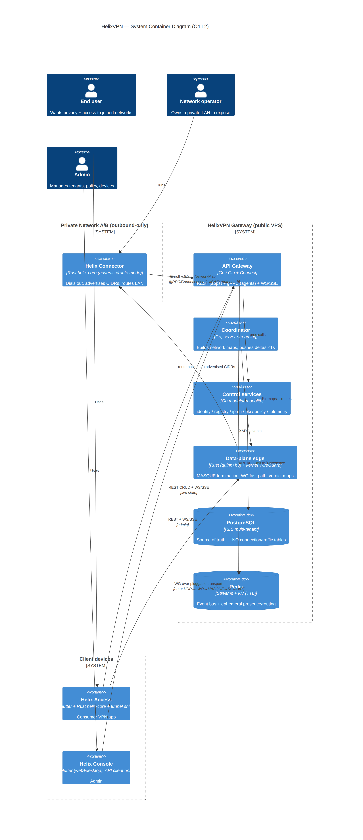

5.2 Data-plane layering (the obfuscation stack)
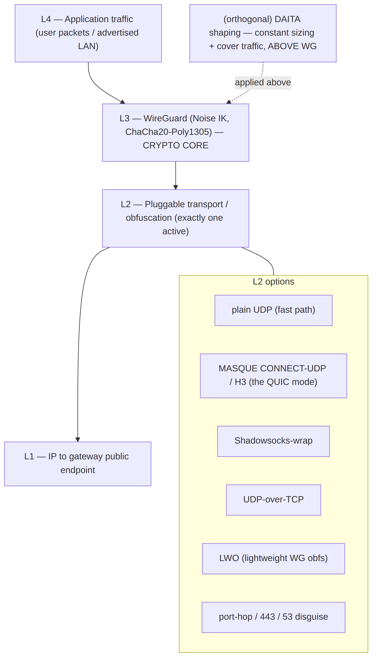
The transport layer only changes how the encrypted WG datagrams look on the wire. Selection is automatic with manual override — the client tries plain WG, and after N failed handshakes escalates LWO → MASQUE/QUIC → Shadowsocks → UoT (Mullvad's exact UX) [04_ARCH §3.2]. Full transport matrix and Transport trait → doc 01-data-plane.

5.3 Reuse map
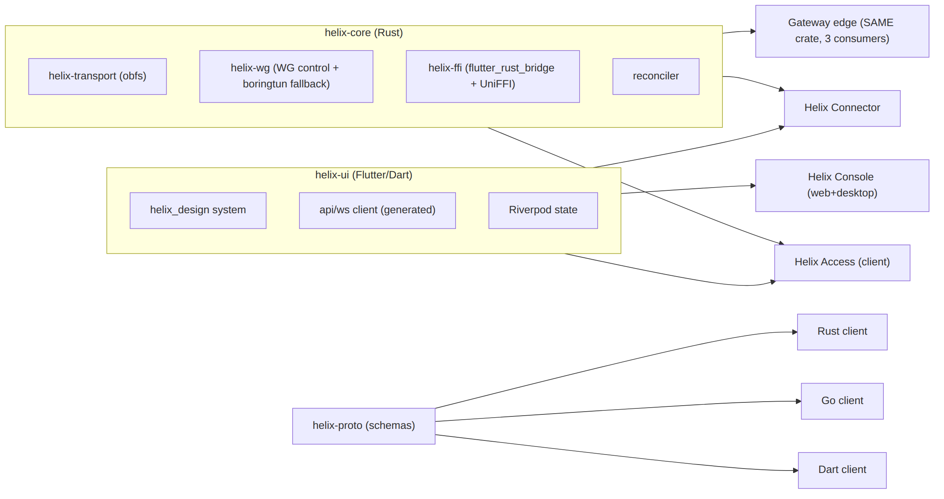
Three reuse pillars: Rust core (client+connector+edge), Flutter UI (all apps), schema-generated clients (all langs) [04_ARCH §5.5].

6. Repository & component layout
Each top-level component is a decoupled, independently reusable unit → its own vasic-digital repo + flat submodule under the umbrella, snake_case, with upstreams/ recipes (§11.4.28/.29/.36/.74).
helixvpn/ # umbrella
├── helix_core/ # Rust: WG control, transport, reconciler, FFI → reusable
│ ├── crates/helix_transport/ # QUIC/MASQUE, Shadowsocks, UoT, LWO (client+edge)
│ ├── crates/helix_wg/ # WireGuard control + boringtun fallback
│ └── crates/helix_ffi/ # flutter_rust_bridge + UniFFI surface
├── helix_edge/ # Rust: gateway data-plane edge (uses helix_transport) → reusable
├── helix_go/ # Go control plane (modular monolith) → reusable
├── helix_proto/ # Protobuf + OpenAPI → generated Dart/Go/Rust → reusable
├── helix_ui/ # Flutter: design system + screens + 3 flavors → reusable
│ ├── app_access/ app_connector/ app_console/
├── shims/ # apple/ android/ windows/ linux/ harmonyos/ aurora/
├── deploy/ # Podman quadlets, Terraform, Grafana-as-code, helixvpnctl
└── submodules/ # containers, helix_qa, challenges, docs_chain, security, vision_engine …
Helix-ecosystem submodules that the source research predates and the spec must wire in [SYN §8]: containers (vasic-digital — the §11.4.76 mandated orchestration + on-demand test infra), helix_qa + challenges (anti-bluff QA/Challenge layer §11.4.27/.5/.69/.107), docs_chain (spec-doc + workable-items sync §11.4.106), security (§7 tooling), vision_engine + panoptic (video/screenshot evidence + UI-automation capture bridge for Challenges §11.4.107/.158), doc_processor (feature-map extraction → per-feature Status ledger cross-check), plus three dev-loop-only members that are never runtime dependencies: llm_provider (conditional — binds only if Phase-2 ships LLM-assisted policy authoring per D-LLM-POLICY), llm_orchestrator and llms_verifier (build-loop subagent orchestration/verification, not shipped in any app or service). Each wired or marked not-applicable-with-reason in doc 05-repo-layout-tooling-and-helix-ecosystem (deployment/orchestration integration) and doc 10-testing-acceptance-and-qa (helix_qa/challenges QA layer). The authoritative, actively-maintained enumeration (roles, @<sha> pins, dev-loop-only vs runtime classification) lives in v06-deploy/helix-ecosystem-integration.md — this spine list is a summary and may lag; that doc wins on drift.

7. Cross-cutting contracts (defined once, referenced everywhere)
These three artifacts are the seams every component binds to. They are summarized here and specified in full in their owning docs.

7.1 The Transport trait (Rust, owning doc: 01-data-plane)
The single abstraction beneath WireGuard. One implementation, three consumers (client core, connector, edge) [04_ARCH §3.2].
/// helix_transport: every obfuscation mode implements this.
/// The WG engine sees only a datagram socket; the transport hides how bytes look on the wire.
#[async_trait]
pub trait Transport: Send + Sync {
/// Stable identifier used by the auto-ladder + telemetry (counts only, never content).
fn kind(&self) -> TransportKind; // PlainUdp | MasqueH3 | Shadowsocks | UdpOverTcp | Lwo
/// Establish the obfuscated carrier to `endpoint`. Returns when ready to pass WG datagrams.
async fn connect(&self, endpoint: &Endpoint, cfg: &TransportCfg) -> Result<TransportConn, TransportError>;
/// Server side (edge/connector): accept + de-obfuscate, yielding WG datagrams to the WG engine.
async fn accept(&self, listener: &Listener) -> Result<TransportConn, TransportError>;
}
/// A live carrier: WG datagrams in/out, plus health the auto-ladder reads.
pub trait TransportConn: Send + Sync {
async fn send(&self, wg_datagram: &[u8]) -> Result<(), TransportError>;
async fn recv(&self, buf: &mut [u8]) -> Result<usize, TransportError>;
fn health(&self) -> CarrierHealth; // rtt, loss, handshakes_failed → drives escalation
}
Note (added Rev 2, 2026-07-04). The sketch above is illustrative only (per §0). The frozen, binding Phase-0 signature lives in v02-data-plane/transport-trait.md §2 (verified byte-for-byte consistent with 01-data-plane.md §3.1): Transport itself exposes send/recv/kind/effective_mtu/health/close, and construction is via a free dial() function rather than connect/accept trait methods. Two names above were also repurposed during the nano-detail pass: TransportKind here is Transport::kind()'s return type, but in the frozen spec TransportKind is the auto-ladder's policy-ordering enum (TransportPolicy.order: Vec<TransportKind>) while Transport::kind() returns &'static str for logs/metrics; and CarrierHealth here is TransportHealth in the frozen spec. Implement against v02-data-plane/transport-trait.md, not this sketch.

7.2 The WatchNetworkMap stream (protobuf, owning doc: 02-control-plane)
The push-based desired-state spine. Every agent opens it once; polling is abolished [04_ARCH §4.2/§4.4, 04_P1].
syntax = "proto3";
package helix.coordinator.v1;
service Coordinator {
// Agent opens once; receives a full snapshot then a delta stream. Peers are ALREADY policy-filtered
// (need-to-know) — an agent never learns of peers it may not reach.
rpc WatchNetworkMap(WatchRequest) returns (stream NetworkMapEvent);
}
message WatchRequest {
string device_id = 1; // mTLS-bound; coordinator re-checks identity
uint64 known_version = 2; // 0 = send full snapshot; else resume from delta
}
message NetworkMapEvent {
oneof body {
Snapshot snapshot = 1; // overlay_ip, allowed_peers, routes, transport_policy, dns, killswitch
Delta delta = 2; // minimal change set for THIS agent
}
uint64 version = 3; // monotonic; convergence SLO: p99 < 1s
}

7.3 The FFI surface (helix-ffi, owning doc: 03-client-core-and-ui)
The Dart↔Rust boundary. Dart drives the core and consumes a status stream; UI state is a pure function of that stream [04_UI, 04_ARCH §5.1].
// helix_ffi (flutter_rust_bridge v2). Mirrors to UniFFI for native shims.
pub fn helix_start(cfg: ClientConfig) -> Result<(), HelixError>;
pub fn helix_stop() -> Result<(), HelixError>;
pub fn helix_set_exit(selection: ExitSelection) -> Result<(), HelixError>; // network | privacy-exit
pub fn helix_pin_transport(kind: Option<TransportKind>) -> Result<(), HelixError>; // None = auto-ladder
/// Hot stream the UI subscribes to; every state change pushes here.
pub fn helix_status_stream(sink: StreamSink<HelixStatus>); // Disconnected|Connecting(TransportKind)|Connected|Reconnecting|Failed

8. Phase roadmap (the spine of phase → task → subtask)
Four phases, each with hard exit gates. A phase MUST NOT be declared complete until every gate passes with captured anti-bluff evidence (§11.4.5/.69/.107). Detailed task/subtask breakdowns live in the per-phase docs (00/01/.../11) and become workable items in the SQLite single-source-of-truth DB (§11.4.93/.95).
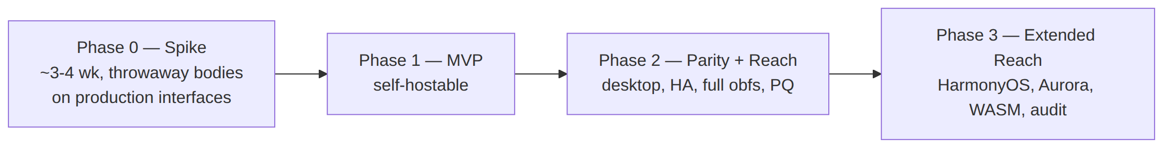

8.0 Phase 0 — Spike (prove the hard parts) [04_P0]
Throwaway bodies on production interfaces — the surviving artifacts are the interfaces: the Transport trait, the helix-wg boringtun wrapper, the orchestrator + status enum, the FFI surface. Test rig: Linux netns + nftables DPI sim + tc netem loss/jitter. Milestones S0–S8.
Exit gates (ALL must pass):
Gate | Assertion | Evidence
G1 | Plain-UDP WireGuard: client → gateway → connector LAN host, ≥80% of bare-link throughput | iperf3 capture, netns rig
G2 | MASQUE/QUIC tunnel survives a DPI UDP block, ≥50% of plain-WG throughput | nftables block + throughput capture
G3 | iOS NEPacketTunnelProvider runs the Rust core under the memory ceiling with ≥30% headroom (make-or-break — the reason core is Rust) | on-device RSS profile
G4 | Go-vs-Rust edge benchmark decides D5 (MASQUE termination language) | head-to-head throughput/CPU/p99 capture
G5 | flutter_rust_bridge FFI drives the core from Dart end-to-end | Flutter harness + status stream log
G6 | Push-based reconcile from a static network map converges with zero polling | reconciler trace
Gate G3 failure ⇒ revisit D2 (core language); G2 failure ⇒ MASQUE library/transport rework before MVP. Owning doc: 00 + 06 + 02.

8.1 Phase 1 — MVP (self-hostable) [04_P1]
Go modular monolith (identity / registry / ipam / pki / policy / coordinator / events / telemetry / api / store); Postgres + RLS (no connection/traffic tables — CI-lint enforced); protobuf Coordinator.WatchNetworkMap over Connect; coordinator with in-mem topology graph + minimal deltas (p99 convergence < 1s); Redis Streams backbone; identity (OIDC + anonymous device tokens) + enrollment (device-generated WG keypair, private key never leaves device) + short-lived mTLS device cert + revoke < 1s; policy compiler (Tailscale-ACL-flavored, default-deny, fail-closed → AllowedIPs + nftables/eBPF verdict maps); Gin REST + WS/SSE; helixvpnctl (Cobra) + Podman quadlets; hub-and-spoke data path; auto obfuscation ladder (plain / LWO / MASQUE).
Exit gate = the 8 MVP acceptance criteria (Definition of Done) [04_P1]:
- Self-host from zero (one helixvpnctl init on a clean VPS).
- Enroll a connector and a client.
- Client reaches an authorized LAN host and is denied an unauthorized one (default-deny proven).
- Auto-escalate to MASQUE when plain WG is blocked.
- Policy edit reflected < 1s, no restart.
- Device revoke enforced < 1s.
- Kill-switch + DNS-leak protection verified (no leak on tunnel drop).
- No durable connection log exists (schema-lint green) and all three apps drive the system.
Owning docs: 00/01/03/04/05/06/07/09/10.

8.2 Phase 2 — Parity + Reach [04_P2]
Full transport set (+Shadowsocks, UDP-over-TCP, hardened LWO; auto-ladder with per-network memory + regional priors); DAITA via maybenot; direct P2P + NAT traversal (STUN-like discovery, hole punching, DERP-style helix-relay fallback); multi-hop nested WG (entry/exit key separation); post-quantum handshake (ML-KEM/FIPS-203 PSK, hybrid never PQ-only; Rosenpass as alt); desktop apps (Windows wireguard-nt + privileged service; macOS Network Extension); policy-as-code / GitOps; HA + multi-region (stateless coordinators, Patroni Postgres, NATS JetStream — the D3 Phase-2 swap).
Exit gates: full Mullvad feature-parity matrix green [04_ARCH §6]; multi-hop + P2P + relay-fallback proven across a real NAT; PQ handshake interops + measured; failover < 3s (p99, P2-SLO3 — see 08-phase2-parity-wbs.md) with transport preserved; desktop apps pass the same 8 MVP DoD criteria.

8.3 Phase 3 — Extended Reach [04_P2 §12, 04_ARCH §12]
HarmonyOS NEXT (OpenHarmony SIG Flutter fork, Network Kit ability — biggest platform risk, real native tunnel-shim work) + Aurora OS (OMP Russia Flutter fork, Qt/C++ + tun; Russian-hosted toolchain → enterprise SKU); WASM browser MASQUE proxy (browser-scoped, not a system VPN); multi-tenant Console + audit + optional billing; third-party security audit + reproducible builds.
Exit gates: Access app builds + tunnels on HarmonyOS NEXT and Aurora (on-device evidence); web WASM proxy reaches a joined network from the browser; independent audit report + reproducible-build attestation.

9. Decision register (open decisions — options + recommendation)
Surfaced explicitly per §11.4.66 / §11.4.101 — not silently resolved. The refined 04_VPN_CLD docs pivoted to one camp; the broader 10-LLM consensus sometimes differs [SYN §3]. Each is a tracked workable item; the gate that resolves it is named.
# | Decision | Camp A | Camp B | Recommendation | Resolved by
D1 | Primary obfuscating transport | MASQUE/QUIC = WG-over-HTTP-3 (RFC 9298/9297/9221) — Mullvad's actual mechanism [04_ARCH §3.3, 04_P0] | Hysteria2 + Salamander (turnkey QUIC+obfs) primary, WG fallback [plurality of 10 analyses] | MASQUE primary for true Mullvad parity + single Rust impl; keep Hysteria2 tuning knobs as quinn reference. Note: "Mullvad QUIC ≠ separate protocol, it IS WG-over-MASQUE" [04_ARCH §1]. | doc 01-data-plane + gate G2
D2 | Shared client-core language | Rust core + Flutter UI [04_*, plurality] | Go core + Flutter UI (reuses Hysteria2 Go) [01_DSK, 07_GMI] | Rust — wins on iOS NE memory ceiling + WASM. CLD = Rust. | G3
D3 | Event bus | Redis Streams (MVP) → NATS JetStream (scale) [04_P1, 02_QWN, 11_MST] | NATS JetStream from start [01_DSK, 10_KMI] | Redis Streams MVP, NATS Phase 2 — taxonomy is bus-agnostic, swap is transport-only. | doc 02-control-plane
D4 | IP-subnet collision across N RFC1918 nets | IPv6 ULA /48 per tenant + Tailscale 4via6 [04_ARCH §3.4] | CGNAT 100.64/10 1:1 per network [07_GMI, 10_KMI] | 4via6 for scale + clean overlay; hide the mapping behind Console UX. A v1 must-decide. | doc 01-data-plane (addressing) / doc 04-security-privacy-pki (IPAM/policy)
D5 | Gateway edge language (MASQUE termination) | Rust (quinn+h3, shares helix-transport byte-for-byte) [04_P0 G4] | Go (quic-go + masque-go turnkey) | Rust if G4 benchmark holds — single-implementation guarantee; else Go acceptable. | G4
D6 | Transport topology | single protocol end-to-end | asymmetric per-leg: Hysteria2/QUIC user↔gateway, WireGuard gateway↔networks [11_MST] | Surface MST's best-fit-per-leg as a Phase-2 option; MVP keeps WG end-to-end with pluggable transport. | doc 01-data-plane
D7 | MVP ambition | lean tunnel-first (CLI between 2 hosts → API → apps) [02_QWN, 01_DSK, 04_P0] | full ecosystem / "Connectivity-OS" from v1 [10_KMI, 03_ZAI] | Lean Phase-0 spike then MVP; defer the ecosystem to Phase 2/3. | §8 roadmap
D8 | Licensing / positioning | source-available + commercial | pure OSS | Decide before public release [04_ARCH §13]; same code serves self-host + managed. | pre-Phase-3

10. INDEX — the final/ document set
This spine is SPECIFICATION.md. Every other document below is an actual sibling file under docs/research/mvp/final/. Each carries its own §11.4.44 revision header; .html/.pdf(/.docx) exports per §11.4.65/.153 + docs_chain sync (§11.4.106) are a deferred pass-2 deliverable (see REFINEMENT_NOTES.md). The Glossary is §11 of this spine; the live Decision Register is §9 of this spine; the source-coverage ledger is doc 99.
Doc | File | Scope | Owns
00 | 00-product-scope-and-principles.md | Product definition (is/is-not), personas, the three roles + three apps, two-way + multi-network model, self-host vs managed + licensing, in/out scope per phase, the 7 non-negotiable principles, the Mullvad-parity feature matrix, and the open decisions D1–D8 with recommendations | Requirements; principles; decision register
01 | 01-data-plane.md | Rust data plane: the Transport trait, transport matrix (plain UDP, MASQUE CONNECT-UDP quinn+h3, CONNECT-IP, Shadowsocks, UoT, LWO, Hysteria2 option), helix-wg boringtun wrapper, orchestrator + status enum, auto-escalation ladder, routing (ULA /48, 4via6), default-deny ACL → AllowedIPs + nftables/eBPF, multi-hop nested WG, MTU | D1, D6; the Transport trait
02 | 02-control-plane.md | Go modular monolith, full Postgres DDL + RLS, the protobuf Coordinator service + WatchNetworkMap streaming, coordinator brain (in-mem graph, minimal deltas, <1s SLO), Redis Streams backbone + taxonomy + XAUTOCLAIM DLQ, Gin REST + WS/SSE + Connect API surface, reconciliation flow | D3; data model; WatchNetworkMap; event bus
03 | 03-client-core-and-ui.md | helix-core FFI surface (start/stop/status_stream, TunnelStatus), Flutter helix-ui (helix_design system, Riverpod, 3 flavors via runHelixApp), per-platform TunnelPlatform shims (Apple NE, Android VpnService+JNI, Windows wireguard-nt+service, Linux, HarmonyOS, Aurora, Web-none), memory/size budgets, Melos monorepo | D2; FFI; UI/design system; platform shims
04 | 04-security-privacy-pki.md | Zero-trust default-deny, identity (OIDC + anon device tokens), enrollment + PKI (device keygen, key-never-leaves, short-lived mTLS, revoke<1s), key hierarchy/rotation, edge hardening, no-logging-as-code + CI schema-lint, kill-switch/DNS-leak state machine, post-quantum handshake, threat model | Security/privacy invariants; PKI
05 | 05-repo-layout-tooling-and-helix-ecosystem.md | Monorepo layout, the planned decoupled vasic-digital component repos (deferred), schema-first codegen, helixvpnctl, deployment as Podman quadlets + Docker Compose + Kubernetes manifests, and integration of the incorporated submodules/ (containers §11.4.76, helix_qa+challenges, docs_chain, security, vision_engine) | Repo layout; deploy; ecosystem
06 | 06-phase0-spike-wbs.md | Phase 0 Spike work-breakdown: gates G1–G6, milestones S0–S8 → tasks → subtasks (HVPN-P0-NNN), iOS-memory harness, Go-vs-Rust edge benchmark, netns+nftables-DPI+netem rig | Phase 0 execution plan
07 | 07-phase1-mvp-wbs.md | Phase 1 MVP work-breakdown (HVPN-P1-NNN), the 8-criterion MVP Definition-of-Done + SLOs as acceptance gates | Phase 1 execution plan
08 | 08-phase2-parity-wbs.md | Phase 2 Parity+Reach work-breakdown (HVPN-P2-NNN): full transport set, DAITA, P2P/NAT-traversal, multi-hop, PQ, desktop apps, GitOps, HA/multi-region | Phase 2 execution plan
09 | 09-phase3-reach-wbs.md | Phase 3 Extended-Reach work-breakdown (HVPN-P3-NNN): HarmonyOS NEXT, Aurora OS, WASM MASQUE proxy, billing-optional multi-tenant, third-party audit + reproducible builds | Phase 3 execution plan
10 | 10-testing-acceptance-and-qa.md | Anti-bluff QA strategy covering every §11.4.169 mandatory test type (unit/integration/e2e/full-automation/Challenges/HelixQA/DDoS/security/stress+chaos/concurrency/race/memory/benchmark), helix_qa+challenges integration, captured-evidence, per-phase acceptance gates, local-only enforcement (§11.4.156) | QA strategy; test-type coverage
11 | 11-deep-research-appendix.md | Cited external research per angle (wireguard, masque, hysteria2, mullvad, flutter_ffi, ios_android, go_cp, podman_k8s, pki_pq_nat, daita_test). Pass-1 status: facts marked UNVERIFIED — the web-research phase was rate-limited; pass 2 re-runs it (see REFINEMENT_NOTES.md R1). | External-source bibliography
99 | 99-source-coverage-ledger.md | Source-coverage proof: every one of the 16 source docs → which final/ doc(s) absorbed it + its unique contribution; honestly-disclosed gaps (§11.4.118) | Coverage proof
— | REFINEMENT_NOTES.md | Pass-1 → pass-2/3 punch-list: what's fixed, the open consistency worklist (R1–R6), and the deferred deliverables (repos, workable-items DB, exports) | The refinement plan

11. Glossary
Term | Definition
Connector | First-party agent inside a private network; dials outbound to the gateway, advertises CIDRs, routes LAN traffic for authorized clients [04_ARCH §1.1].
Gateway | Public VPS running control plane (Go) + data-plane edge (Rust + kernel WG); the rendezvous hub.
Client | End-user access app; gets an overlay IP, reaches authorized networks or uses the gateway as a privacy exit.
Overlay IP | Stable per-node address in the tenant overlay (ULA IPv6 /48 per tenant; advertised IPv4 LANs mapped via 4via6) [04_ARCH §3.4].
Network map | Per-agent desired-state document (overlay IP, policy-filtered peers, routes, transport policy, DNS, kill-switch posture) pushed over WatchNetworkMap [04_ARCH §4.4].
MASQUE | RFC 9298 CONNECT-UDP over HTTP/3 — the mechanism that wraps WireGuard datagrams to look like web traffic. The "QUIC mode" [04_ARCH §3.3].
LWO | Lightweight WG obfuscation — cheap XOR/padding scheme to evade naive WG signature blocks [04_ARCH §3.2].
DAITA | Defence Against AI-guided Traffic Analysis — constant packet sizing + cover traffic applied above WG (maybenot-style state machine) [04_ARCH §3.1/§6].
4via6 | Tailscale-style scheme mapping advertised IPv4 LANs into the tenant's ULA IPv6 space so overlapping RFC1918 ranges never collide [04_ARCH §3.4].
Auto-ladder | Client transport escalation: plain UDP → LWO → MASQUE/QUIC → Shadowsocks → UoT, driven by handshake-failure events [04_ARCH §3.2].
fail-static | Property that existing tunnels keep forwarding when the control plane is down [04_ARCH §2].
Verdict map | nftables/eBPF map compiled from the policy that grants/denies per-peer reachability at the edge [04_ARCH §3.4].
RLS | PostgreSQL Row-Level Security — enforces tenant isolation at the database, not just the app layer [04_ARCH §4.5].
No-logging-as-code | Architectural guarantee: no durable connection/traffic table exists; CI schema-lint fails the build if one appears [04_ARCH §7].
helix-core | Rust data-plane core shared by client, connector, and edge (WG control, transport, reconciler, FFI).
helix-transport | Rust crate implementing the Transport trait — one obfuscation implementation, three consumers.
WatchNetworkMap | Server-streaming RPC: snapshot + delta stream of desired state; replaces all polling [04_ARCH §4.2].
PWU | Parallel Work Unit — a self-contained workable item in the §11.4.58/.93 execution model.

12. Provenance & change control
- Sources: 16 research documents under docs/research/mvp/ (see citation key in metadata block). Primary architectural source: [04_ARCH]. Cross-cutting synthesis: [SYN] (v09-research/_SYNTHESIS.md).
- Versioning (§11.4.73): primary version bumps for major rewrites (this is V1); Revision bumps for additive refinements. This spine is Revision 1.
- Sync (§11.4.106): .html/.pdf exports of this and every final/ doc kept in lockstep via docs_chain.
- Decision discipline (§11.4.66/.101): open decisions live in §9 + doc 99, never silently resolved.
- Anti-bluff (§11.4.5/.69/.107): every phase exit gate requires captured evidence; no gate passes on metadata/config-only signal.
End of master spine. Subordinate documents 00–11 + 99 elaborate each area to phase → task → subtask and near-code granularity.

