Non-Functional Requirements (HVPN-NFR-NNN)

Non-Functional Requirements (HVPN-NFR-NNN)
Revision: 2 Last modified: 2026-07-04T12:00:00Z
Rev 2 (2026-07-04, independent gap-analysis pass). Added five NFR classes that were absent or thin against enterprise-production-readiness criteria: secrets management/rotation (NFR-411), WireGuard/device-key rotation cadence + triggers (NFR-412), control-plane API rate limiting (NFR-413), data-plane DDoS/UDP-flood/amplification resilience (NFR-414) — a different concern from NFR-413 (control-plane request throttling), audit-retention default (NFR-309), and a new Operability & Compatibility band (NFR-700…) covering zero-downtime rolling deploys, Postgres schema-migration backward-compatibility windows, protobuf wire-compatibility guarantees, and an infra-sizing/cost model. No existing NFR was weakened; §9 traceability and the family diagram are extended to match.
Document role. This is the Volume 1 (Product & Requirements) nano-detail spec enumerating every HelixVPN non-functional requirement (NFR) — performance, scale, availability/HA, privacy, security, resource, and portability — each numbered HVPN-NFR-NNN. It is the quantified counterpart to the seven non-negotiable principles and the Mullvad-parity matrix of the Volume 1 overview (00-product-scope-and-principles.md). Where a value is a target not yet proven on hardware it is stated as a TARGET and marked UNVERIFIED per §11.4.6 (no-guessing) — a number that only a Phase-0/1 gate or a captured benchmark can confirm is never asserted as established fact here.
Document is a SPEC. It states what quality bars the product must meet and how each is verified; it does not build the product. Every NFR carries a measurable target plus the §11.4.169 test type that proves it, so each row is falsifiable rather than aspirational (§11.4 / §11.4.169).
Evidence base. Cross-references the Volume 1 overview (00-product-scope-and-principles.md — principles P1–P7, parity matrix F1–F17, decisions D1–D7, scope §10), the control-plane coordinator SLO (v03-control-plane/svc-coordinator.md §7 — convergence p99 < 1 s), the telemetry counts-only metric registry (v03-control-plane/svc-telemetry.md §3 — what may be measured), the no-logging invariant (v05-security/no-logging-as-code.md — the privacy NFRs as testable bars), and the transport ladder (v02-data-plane/transport-selection-ladder.md). Source research is cited by the same ids the overview uses ([04_ARCH §N], [04_P0], [04_P1]).

Table of contents
- 1. How to read an NFR row
- 2. Performance NFRs (HVPN-NFR-001…)
- 3. Scale NFRs (HVPN-NFR-100…)
- 4. Availability & HA NFRs (HVPN-NFR-200…)
- 5. Privacy NFRs (HVPN-NFR-300…)
- 6. Security NFRs (HVPN-NFR-400…)
- 7. Resource NFRs (HVPN-NFR-500…)
- 8. Portability NFRs (HVPN-NFR-600…)
- 9. NFR → principle → verification traceability
- 10. The convergence-NFR dependency chain
- Sources verified

1. How to read an NFR row
Every NFR is one row with five fixed fields, so each is independently testable (§11.4 — a quality bar with no measurement is a PASS-bluff at the requirements layer):
Field | Meaning
ID | HVPN-NFR-NNN, stable, append-only — the cross-doc reference key (§11.4.54 discipline applied to NFRs).
Statement | the qualitative requirement (one sentence).
Target | the measurable bar (number + unit + percentile/condition). TARGET = not yet proven on hardware (UNVERIFIED §11.4.6).
Verify by | the §11.4.169 test type whose captured evidence proves it (unit / integration / e2e / performance / soak-stress / chaos / security / memory / benchmarking).
Priority | P0 (Phase-0 gate / make-or-break), MVP (Phase-1 DoD), P2/P3 (later phase), ALWAYS (every phase).
Priority bands map to the §10 scope spine of the overview: a P0 NFR is a make-or-break Phase-0 exit gate; an MVP NFR is part of the 8-criteria Definition-of-Done; a P2/P3 NFR binds when its phase opens.
Honest-number rule (§11.4.6). Several targets below originate from the refined research as design targets (e.g. the iOS NE memory ceiling, the ≥80%-bare-link throughput gate). They are reproduced as TARGETs and marked UNVERIFIED — the Phase-0 gate or the named benchmark is what converts a TARGET into an established fact. No target is restated here as if already measured.

2. Performance NFRs (HVPN-NFR-001…)
Performance is dominated by two budgets: datapath throughput/latency (the Rust data plane, doc 01) and control-plane convergence (the coordinator, svc-coordinator.md).
ID | Statement | Target | Verify by | Priority
HVPN-NFR-001 | Plain-UDP WireGuard datapath sustains near-bare-link throughput client→gateway→connector-LAN. | ≥ 80 % of bare-link throughput (Phase-0 gate G1) — TARGET UNVERIFIED | performance / benchmarking (iperf3 over the netns rig) | P0
HVPN-NFR-002 | MASQUE/QUIC obfuscated datapath retains usable throughput through a DPI UDP block. | ≥ 50 % of plain-UDP throughput (Phase-0 gate G2) — TARGET UNVERIFIED | performance / benchmarking | P0
HVPN-NFR-003 | Control-plane convergence: a policy/topology change reaches every affected agent's WatchNetworkMap stream. | p99 < 1 s event→delta-on-wire (helix_reconcile_seconds) | performance (synthetic policy-flap load) | MVP
HVPN-NFR-004 | Device revoke is enforced (peer-removal delta on wire + stream force-close). | < 1 s revoke-event→sub.cancel() (helix_revoke_enforce_seconds p99) | performance + security | MVP
HVPN-NFR-005 | WireGuard handshake completes within a bounded latency on a healthy link. | handshake-complete TARGET ≤ 1 s typical; rung success = WG handshake, not carrier connect — UNVERIFIED exact bound | integration (handshake-timing capture) | MVP
HVPN-NFR-006 | Transport-ladder escalation to a working rung is bounded per attempt (no unbounded hang). | per-rung budget enforced; cursor advances monotonically (L-I8); total ≤ Σ rung budgets — UNVERIFIED calibrated value | integration (ladder transition trace) | MVP
HVPN-NFR-007 | Datapath added latency (encryption + obfuscation overhead) stays within an obfuscation-aware budget. | plain-UDP overhead TARGET near-zero; MASQUE adds QUIC/H3 framing cost, bounded — UNVERIFIED measured value | benchmarking (per-rung latency histogram) | P2
HVPN-NFR-008 | MTU is chosen so WG-in-transport never fragments on a 1500-byte path. | WG MTU 1420 plain; transport-specific reductions for MASQUE/Shadowsocks documented per rung | integration (path-MTU probe, no-fragment assert) | MVP
HVPN-NFR-009 | Admin-perceived "policy edit reflected" end-to-end (REST→compile→activate→bus→delta). | < 1 s as the MVP DoD-5 criterion (superset of NFR-003, per-hop timers) | e2e / full-automation | MVP
Note on NFR-003 vs NFR-009 (§11.4.6). NFR-003 measures the coordinator's event-receive → stream.Send segment only; NFR-009 is the wider admin-edit path the DoD asserts and is a superset — they are tracked as distinct series (svc-coordinator.md §7.1, svc-telemetry.md §6.1), not conflated.

3. Scale NFRs (HVPN-NFR-100…)
Scale targets are stated as MVP single-node bars plus Phase-2 fleet bars. Where the MVP number is a sizing target not yet load-proven it is UNVERIFIED.
ID | Statement | Target | Verify by | Priority
HVPN-NFR-100 | A single self-hosted gateway pod serves a homelab-scale fleet of concurrent agents. | TARGET ≥ 10 k concurrent WatchNetworkMap streams per coordinator (the soak-test figure) — UNVERIFIED | soak-stress (24 h, N=10 k streams) | MVP
HVPN-NFR-101 | Coordinator memory stays bounded under sustained stream load (no leak). | process_resident_memory_bytes slope ≈ 0 over 24 h @ 10 k streams | soak-stress / memory | MVP
HVPN-NFR-102 | The minimal-affected-set fan-out keeps per-event work small regardless of tenant size. | helix_fanout_affected_nodes ≪ tenant size for a small change | unit + performance | MVP
HVPN-NFR-103 | One gateway supports many joined private networks (connectors) per tenant. | TARGET connectors/tenant bounded only by overlay-IP space (ULA /48, D4) — UNVERIFIED concrete ceiling | integration (multi-connector overlay) | MVP
HVPN-NFR-104 | One user reaches N joined networks (the multi-network differentiator X1). | 1 user → N nets, N bounded by policy + IPAM, not architecture | e2e (multi-network reach) | MVP
HVPN-NFR-105 | Reconnect storm (mass gateway flap) is absorbed without deadlock or unbounded buffering. | 10 k simultaneous reconnects: bounded send queues, no deadlock, drops counted not buffered | stress (reconnect-storm) | MVP
HVPN-NFR-106 | Per-tenant isolation does not let one tenant's churn block another. | per-tenant tenantState sharding; one tenant's lock never held across another | concurrency / race-deadlock | MVP
HVPN-NFR-107 | Control plane scales horizontally to stateless multi-replica coordinators. | coordinators stateless (graph rebuilt from Postgres+events on boot); N replicas, no sticky state | integration (multi-replica) | P2
HVPN-NFR-108 | Event backbone scales from single-node Redis Streams to multi-region NATS JetStream. | bus interface (D3) transport-agnostic; swap is mechanical, not a redesign | integration (bus swap) | P2

4. Availability & HA NFRs (HVPN-NFR-200…)
The load-bearing availability property is fail-static (P1): a control-plane outage is never a connectivity outage.
ID | Statement | Target | Verify by | Priority
HVPN-NFR-200 | Existing tunnels keep forwarding while the control plane is down (fail-static, P1). | 0 tunnel drops on control-plane outage; edge forwards from cached verdict map | chaos (kill control plane mid-traffic) | ALWAYS
HVPN-NFR-201 | A Postgres/Redis blip does not restart the gateway process. | liveness probe dependency-free; readiness gates new traffic only, never kills serving streams | chaos (DB/Redis blip) | MVP
HVPN-NFR-202 | Presence backend (Redis) loss degrades gracefully, never errors a tunnel (fail-static). | IsOnline→ErrPresenceUnavailable; coordinator assumes reachable-via-relay degraded; no tunnel error | chaos (drop Redis mid-stream) | MVP
HVPN-NFR-203 | A crashed coordinator consumer loses no events (no-work-loss). | XAutoClaim reclaim of stalled PEL entries; 0 lost events across a kill | chaos (kill consumer mid-apply) | MVP
HVPN-NFR-204 | A coordinator restart is transparent to connected agents (resume by known_version). | agents resume from known_version against the rebuilt-from-Postgres graph; snapshot fallback on ring gap | chaos / integration (restart mid-stream) | MVP
HVPN-NFR-205 | Multi-region HA: stateless coordinators + Patroni Postgres + NATS JetStream survive a region loss. | TARGET region-failover within an RTO/RPO budget — UNVERIFIED (Phase-2 DR runbook owns the number) | chaos (region-failover drill) | P2
HVPN-NFR-206 | Gateway failover re-points agents to a healthy gateway endpoint. | gateway.failover event → every tenant agent gets an updated endpoint within the convergence SLO | integration / chaos | P2
HVPN-NFR-207 | Poison events never spin the consumer; they route to a DLQ after a delivery-count ceiling. | delivery-count ≥ cap → DLQ + alert; no infinite retry | chaos / integration (DLQ) | MVP
Availability SLO numbers are deferred to the DR doc (§11.4.6). The concrete uptime %, RTO, and RPO budgets live in v06-deploy/disaster-recovery.md (which closes ledger gap G1); reproducing a specific "99.9 %" here would be a fabricated number — NFR-205 names the budget's owner, not a guessed value.

5. Privacy NFRs (HVPN-NFR-300…)
Privacy is the product's reason to exist; these NFRs make the no-logging guarantee testable rather than promissory. They are bound by no-logging-as-code.md — what may be measured is constrained by what may exist.
ID | Statement | Target | Verify by | Priority
HVPN-NFR-300 | No durable connection/traffic/packet/flow/session table exists anywhere in the schema (P7, S6). | schema-lint exit 0 against migrations AND the live information_schema | security (schema-lint, pre-build + post-deploy runtime signature) | ALWAYS
HVPN-NFR-301 | The schema-lint is not a tautology (it actually catches a planted flow table). | planted flows(src,dst,bytes,ts) migration → lint FAILs; removed → PASSes (paired §1.1) | meta-test (§1.1 golden-bad/good) | ALWAYS
HVPN-NFR-302 | The event bus carries no traffic shape (C3 on the bus). | zero src/dst/bytes/dns fields in any event payload struct; payload-lint green | security (payload-lint, build + publish-time) | MVP
HVPN-NFR-303 | Audit records control actions only, never traffic; the meta jsonb cannot smuggle a flow. | closed action vocabulary; meta key matched against forbidden regex → ErrAuditMetaShape | unit + integration (audit meta guard) | MVP
HVPN-NFR-304 | Live presence is ephemeral (Redis TTL), never persisted to Postgres. | presence:{tenant}:{device} TTL = 3× heartbeat; no durable session row; loss of Redis loses no durable state | integration (presence TTL/expiry) | MVP
HVPN-NFR-305 | The one durable presence derivative (last_seen_at) cannot reconstruct a session timeline. | coarsened to ≥ 5 min (LAST_SEEN_COARSEN), carries no destination | unit + integration | MVP
HVPN-NFR-306 | /metrics exposes aggregate counters only — no per-user, per-flow, per-destination, or per-tenant-label series. | every collector's label set ⊆ allow-list; no tenant_id/device_id/*_ip label | unit (label-cardinality audit) | MVP
HVPN-NFR-307 | Anonymous identity is supported (no email, no SSO required). | a tenant mints device enroll tokens with users.email = NULL, oidc_sub = NULL; no reverse-link to a human | integration (anonymous enroll) | MVP
HVPN-NFR-308 | The no-logging guarantee holds as a runtime signature, not a source grep (§11.4.108). | schema-lint green against the deployed DB, asserted post-deploy | e2e Challenge (deployed-DB lint) | MVP
HVPN-NFR-309 | Audit (control-action) retention follows an explicit, operator-set policy — never a silent default that either grows unbounded or auto-prunes accountability evidence. | default = no auto-prune (D-AC-3); operator MAY set a retention period per their compliance regime; retention config is itself an audited control action | integration (retention-policy set/enforce) | MVP
Honest boundary (§11.4.6). These NFRs guarantee durable-store + bus + audit absence of traffic data. They do not claim a hot-compromised running gateway holds nothing in RAM (live presence keys + aggregate counters are the residual surface T5 in no-logging-as-code.md §14). The privacy NFR set is "no durable user↔destination correlation ever exists," never "an attacker with root on a live box sees nothing."

6. Security NFRs (HVPN-NFR-400…)
ID | Statement | Target | Verify by | Priority
HVPN-NFR-400 | WireGuard's audited crypto core is never forked; obfuscation is a layer under it (P2). | WG Noise IK / Curve25519 / ChaCha20-Poly1305 untouched; CI lint forbids edits to WG crypto primitives | security + meta-test | ALWAYS
HVPN-NFR-401 | Edges are outbound-only; no private network needs an inbound port (P3). | only the gateway listens publicly; connectors/clients dial out | security (no-inbound assertion) | ALWAYS
HVPN-NFR-402 | Default-deny, need-to-know: a node only ever learns peers a compiled rule grants (C4). | a node with no VisibleTo entry sees zero peers; deny-unauthorized peer never appears in any snapshot | e2e + meta-test (skip-filter mutation FAILs) | MVP
HVPN-NFR-403 | Device identity is mTLS with short-lived certs and instant revocation. | short-lived device cert; revoke enforced < 1 s (NFR-004); impersonation (device_id≠cert) rejected | security | MVP
HVPN-NFR-404 | Kill-switch prevents any leak if the tunnel drops. | 0 packets off-tunnel on tunnel drop (OS firewall state machine) | security / e2e (leak test on drop) | MVP
HVPN-NFR-405 | DNS-leak protection forces tunnel DNS and blocks plaintext off-tunnel :53. | 0 plaintext DNS off-tunnel | security / e2e (DNS-leak test) | MVP
HVPN-NFR-406 | The device private WG key never leaves the device. | key generated on-device at enrollment; only the public key is registered (C6) | integration + security | MVP
HVPN-NFR-407 | Post-quantum handshake is hybrid (PQ pre-shared layer), never PQ-only. | ML-KEM/FIPS-203 PSK layered on WG; classical handshake retained — hybrid-never-PQ-only | security + integration | P2
HVPN-NFR-408 | Multi-tenant isolation is enforced at the database (RLS), not only in app code. | FORCE ROW LEVEL SECURITY; tenant A cannot read tenant B even with a crafted query as helix_app | security / integration (RLS) | MVP
HVPN-NFR-409 | Every change crosses the mandatory anti-bluff test gauntlet before release. | each §11.4.169 type present + paired §1.1 mutation that flips its gate RED | meta-test (per-gate mutation) | ALWAYS
HVPN-NFR-410 | Censorship-evasion: the ladder reaches a working obfuscated transport under DPI/UDP-block. | escalation reaches MASQUE (or a later rung) and completes a WG handshake under a DPI sim | e2e (DPI-sim escalation) | MVP
HVPN-NFR-411 | Control-plane secrets (Postgres/Redis credentials, tenant CA root/KMS key material, OIDC client secrets) are never stored in plaintext in the image or repo, and are rotatable without a rebuild. | secrets injected at runtime (env/File/KMS reference, never baked into an image layer); a credential rotation (DB password, Redis AUTH) completes with 0 dropped in-flight control RPCs | security + integration (rotate-while-serving) | MVP
HVPN-NFR-412 | Device WireGuard keys and gateway/edge transport keys rotate on an explicit cadence and immediately on revocation — never silently indefinite. | device WG key: operator-configurable rotation period (TARGET default 90 days, UNVERIFIED concrete default) and immediate re-key on device.revoked; gateway edge transport key: independent rotation schedule from device keys, rotated with 0 tunnel drop for unaffected peers | security + integration (scheduled + on-revoke rotation, zero-drop capture) | MVP
HVPN-NFR-413 | The control-plane API (Gin REST + gRPC/Connect agent surface) enforces per-principal rate limiting so no single API key/device can exhaust coordinator or Postgres capacity. | token-bucket per API key/device on api+coordinator; TARGET default ceiling UNVERIFIED (operator-tunable), 429/backpressure response, no unbounded queueing (composes NFR-506) | stress (burst-request flood) + security | MVP
HVPN-NFR-414 | The data-plane edge resists UDP-flood / reflection-amplification abuse of its public :443/udp (and other) listeners — a distinct concern from NFR-413 (that governs the authenticated control-plane API; this governs the unauthenticated public data-plane listener). | WireGuard's built-in stateless cookie-reply mechanism is enabled (bounds per-source handshake-initiation cost); the MASQUE/QUIC listener rate-limits unmatched/pre-handshake datagrams per source IP; edge CPU/bandwidth stay bounded under a simulated flood (no amplification — reply size ≤ request size for any unauthenticated packet) | DDoS test (v08-testing/ddos.md) — flood simulation with pre/post resource + amplification-ratio capture | MVP

7. Resource NFRs (HVPN-NFR-500…)
The single hardest constraint in the whole product is the iOS Network Extension memory ceiling — it shapes decision D2 (Rust core).
ID | Statement | Target | Verify by | Priority
HVPN-NFR-500 | The Rust client core runs inside the iOS NEPacketTunnelProvider memory budget with headroom (make-or-break). | working-set under the iOS NE ceiling with ≥ 30 % headroom (Phase-0 gate G3) — the historical ~15 MB ceiling is a measured constraint, TARGET UNVERIFIED until G3 on-device | memory (on-device NE soak) | P0
HVPN-NFR-501 | Mobile client is battery-sensitive: push-don't-poll, no busy loops. | event-driven reconcile (no cron/poll); TARGET measurable battery delta vs idle — UNVERIFIED | benchmarking (battery/CPU on-device) | MVP
HVPN-NFR-502 | The client core fits a small binary footprint on size-constrained platforms. | TARGET core .so/.a size budget per platform — UNVERIFIED concrete bytes | benchmarking (artifact-size check) | MVP
HVPN-NFR-503 | Project procedures (build/test/tooling) never exceed 60 % of host RAM (§12.6). | host-side resource ceiling ≤ 60 % total RAM | benchmarking (host resource sampler §11.4.24) | ALWAYS
HVPN-NFR-504 | The control-plane process holds bounded memory under sustained load (no leak). | process_resident_memory_bytes slope ≈ 0 over 24 h (= NFR-101, server side) | soak-stress / memory | MVP
HVPN-NFR-505 | Telemetry samplers (observers) stay lightweight (Heisenberg constraint). | a resource sampler stays under its own RSS/CPU budget (§11.4.24: < 50 MB RSS, < 5 % CPU) | benchmarking | MVP
HVPN-NFR-506 | Slow-consumer streams are dropped, not buffered unboundedly (back-pressure not growth). | per-stream SEND_QUEUE_CAP bound; overflow → drop + reconnect-with-snapshot | stress / memory | MVP
NFR-500 is the program's pivot (§11.4.6). The overview names G3 as the literal decider for D2: if Rust cannot fit the iOS NE ceiling with headroom, D2 and the whole client strategy re-open. The ~15 MB figure is reproduced as the historical measured constraint and marked UNVERIFIED until the G3 on-device capture exists — it is never asserted here as a settled fact.

8. Portability NFRs (HVPN-NFR-600…)
HelixVPN targets 8 platforms on one shared codebase (Rust core + Flutter UI
- per-platform tunnel shims). Portability NFRs are per-platform reachability bars, phased per §10.
ID | Statement | Target | Verify by | Priority
HVPN-NFR-600 | All three apps build from one Flutter tree via the runHelixApp(flavor,…) entrypoint. | flavors {Access, Connector, Console}; Console omits core_ffi (no tunnel core) | integration (per-flavor build) | MVP
HVPN-NFR-601 | The Rust core is shared byte-for-byte across Client, Connector, and Gateway edge (P5). | one helix-transport crate; wrap-on-client == unwrap-on-edge | integration (shared-core parity) | MVP
HVPN-NFR-602 | MVP Access app runs on iOS, Android, and Linux. | three platforms green on the 8-criteria DoD | e2e / full-automation | MVP
HVPN-NFR-603 | Connector daemon runs headless on Linux/Windows/macOS (+ Android/embedded for appliances). | headless daemon + optional slim UI; advertise/route mode | integration | MVP
HVPN-NFR-604 | Console runs responsively as Web and as a desktop Flutter build. | one Flutter build serves Web + Desktop; admin flavor, API-client only | e2e (responsive Web + desktop) | MVP
HVPN-NFR-605 | Phase-2 desktop apps reach Windows (wireguard-nt+service) and macOS (NE). | Windows + macOS Access apps green | e2e | P2
HVPN-NFR-606 | Phase-3 extends to HarmonyOS NEXT and Aurora OS (the biggest platform risk). | native tunnel-shim work green on both — TARGET UNVERIFIED (no incumbent precedent) | e2e (per-platform shim) | P3
HVPN-NFR-607 | The Web build is honestly scoped: Console + an optional browser-scoped WASM MASQUE proxy, never a system VPN. | no TUN device in-browser; the WASM proxy proxies the browser's own traffic only | e2e + documentation honesty check | P3
HVPN-NFR-608 | Every UI surface ships light + dark variants and passes visual-regression (§11.4.162 OpenDesign). | light+dark per component; no overlap/overlay; visual-regression green | UI / visual-regression | P3
HVPN-NFR-609 | Cross-platform parity: any platform-specific primitive has a per-OS equivalent or an honest gap (§11.4.81). | uname -s-dispatched equivalents or documented kernel-gap SKIP — never a silent Linux-only pass | per-OS test branches | ALWAYS

8a. Operability & Compatibility NFRs (HVPN-NFR-700…)
These NFRs close a gap the earlier revision left implicit: a self-hostable product that scales to a managed fleet (P6) MUST also be upgradeable and forecastable without a rewrite. They are the "can we run this for years, across upgrades and growth" bars — distinct from the runtime performance/scale bars above.
ID | Statement | Target | Verify by | Priority
HVPN-NFR-700 | The control plane supports zero-downtime rolling upgrades: a new version deploys without dropping in-flight WatchNetworkMap streams or existing data-plane tunnels. | rolling deploy (N replicas, one at a time) completes with 0 dropped agent streams beyond the individual replica's own graceful-drain reconnect (which resumes from known_version, NFR-204); existing edge tunnels never drop (fail-static, NFR-200 holds across a control-plane version change too) | chaos + integration (rolling-upgrade drill) | P2
HVPN-NFR-701 | Postgres schema migrations are backward-compatible for at least one prior minor version (expand-then-contract), so a rolling upgrade never requires simultaneous downtime of app + DB migration. | every migration is additive-first (new column nullable/defaulted, old column dropped only in a later release after the app no longer reads it); a mixed-version fleet (N replicas on version X, N on X+1) runs correctly against one schema version | integration (mixed-version-fleet-against-one-schema test) | P2
HVPN-NFR-702 | Protobuf (helix.coordinator.v1) and OpenAPI contracts are wire-compatible within a documented backward-compatibility window: new optional fields only, no field-number reuse, no required-field addition. | a buf/OpenAPI breaking-change linter runs in the codegen pipeline (v06-deploy/codegen-pipeline.md) and fails the build on a breaking change without an explicit major-version bump | unit (schema-diff lint) + meta-test (planted breaking change → lint FAILs) | MVP
HVPN-NFR-703 | Infra sizing (vCPU/RAM/disk/network) scales predictably with tenant/device count, so an operator can forecast cost before growing. | a documented sizing formula (or reference table) ties coordinator/Postgres/Redis/edge resource needs to {tenants, devices, connectors} counts, validated against the NFR-100/101 soak-test figures; TARGET concrete formula UNVERIFIED until the soak-test dataset exists | benchmarking (resource-vs-load curve from the soak-stress suite, v06-deploy/observability.md sizing dashboard) | P2
Honest boundary (§11.4.6). NFR-703 is deliberately not a fixed dollar figure — cloud/self-host pricing varies by operator and region. The NFR requires a sizing formula (resource units per tenant/device), not a cost quote; a managed-SKU cost model (if D8 licensing lands a managed offering) is a commercial decision layered on top of this technical sizing curve, tracked separately from this spec set.

9. NFR → principle → verification traceability
Each NFR family traces to the overview's non-negotiable principles (P1–P7) and the parity matrix (F1–F17 / X1–X5), so no quality bar floats unanchored (§11.4.25 coverage discipline).
NFR family | Principle(s) | Parity / differentiator rows | Primary §11.4.169 test types
Performance (001–009) | P1 (fail-static keeps Go off hot path), P4 (push) | F1, F2, F7 | performance, benchmarking, integration
Scale (100–108) | P4, P6 (self-host→fleet) | X3 | soak-stress, stress, concurrency
Availability/HA (200–207) | P1 (fail-static) | X3 | chaos, integration
Privacy (300–308) | P7 (no-logging by construction) | F14, F15 | security (schema/payload lint), meta-test
Security (400–410) | P2 (WG core), P3 (outbound-only) | F11, F12, F13, F16, F17, X2, X4 | security, e2e, meta-test
Resource (500–506) | P5 (one core), P6 | F1, X5 | memory, benchmarking
Portability (600–609) | P5 (one core, reused) | X5 | integration, e2e, UI/visual-regression
Operability & Compatibility (700–703) | P6 (self-host→fleet, no rewrite) | X3 | chaos, integration, unit (schema-diff), benchmarking
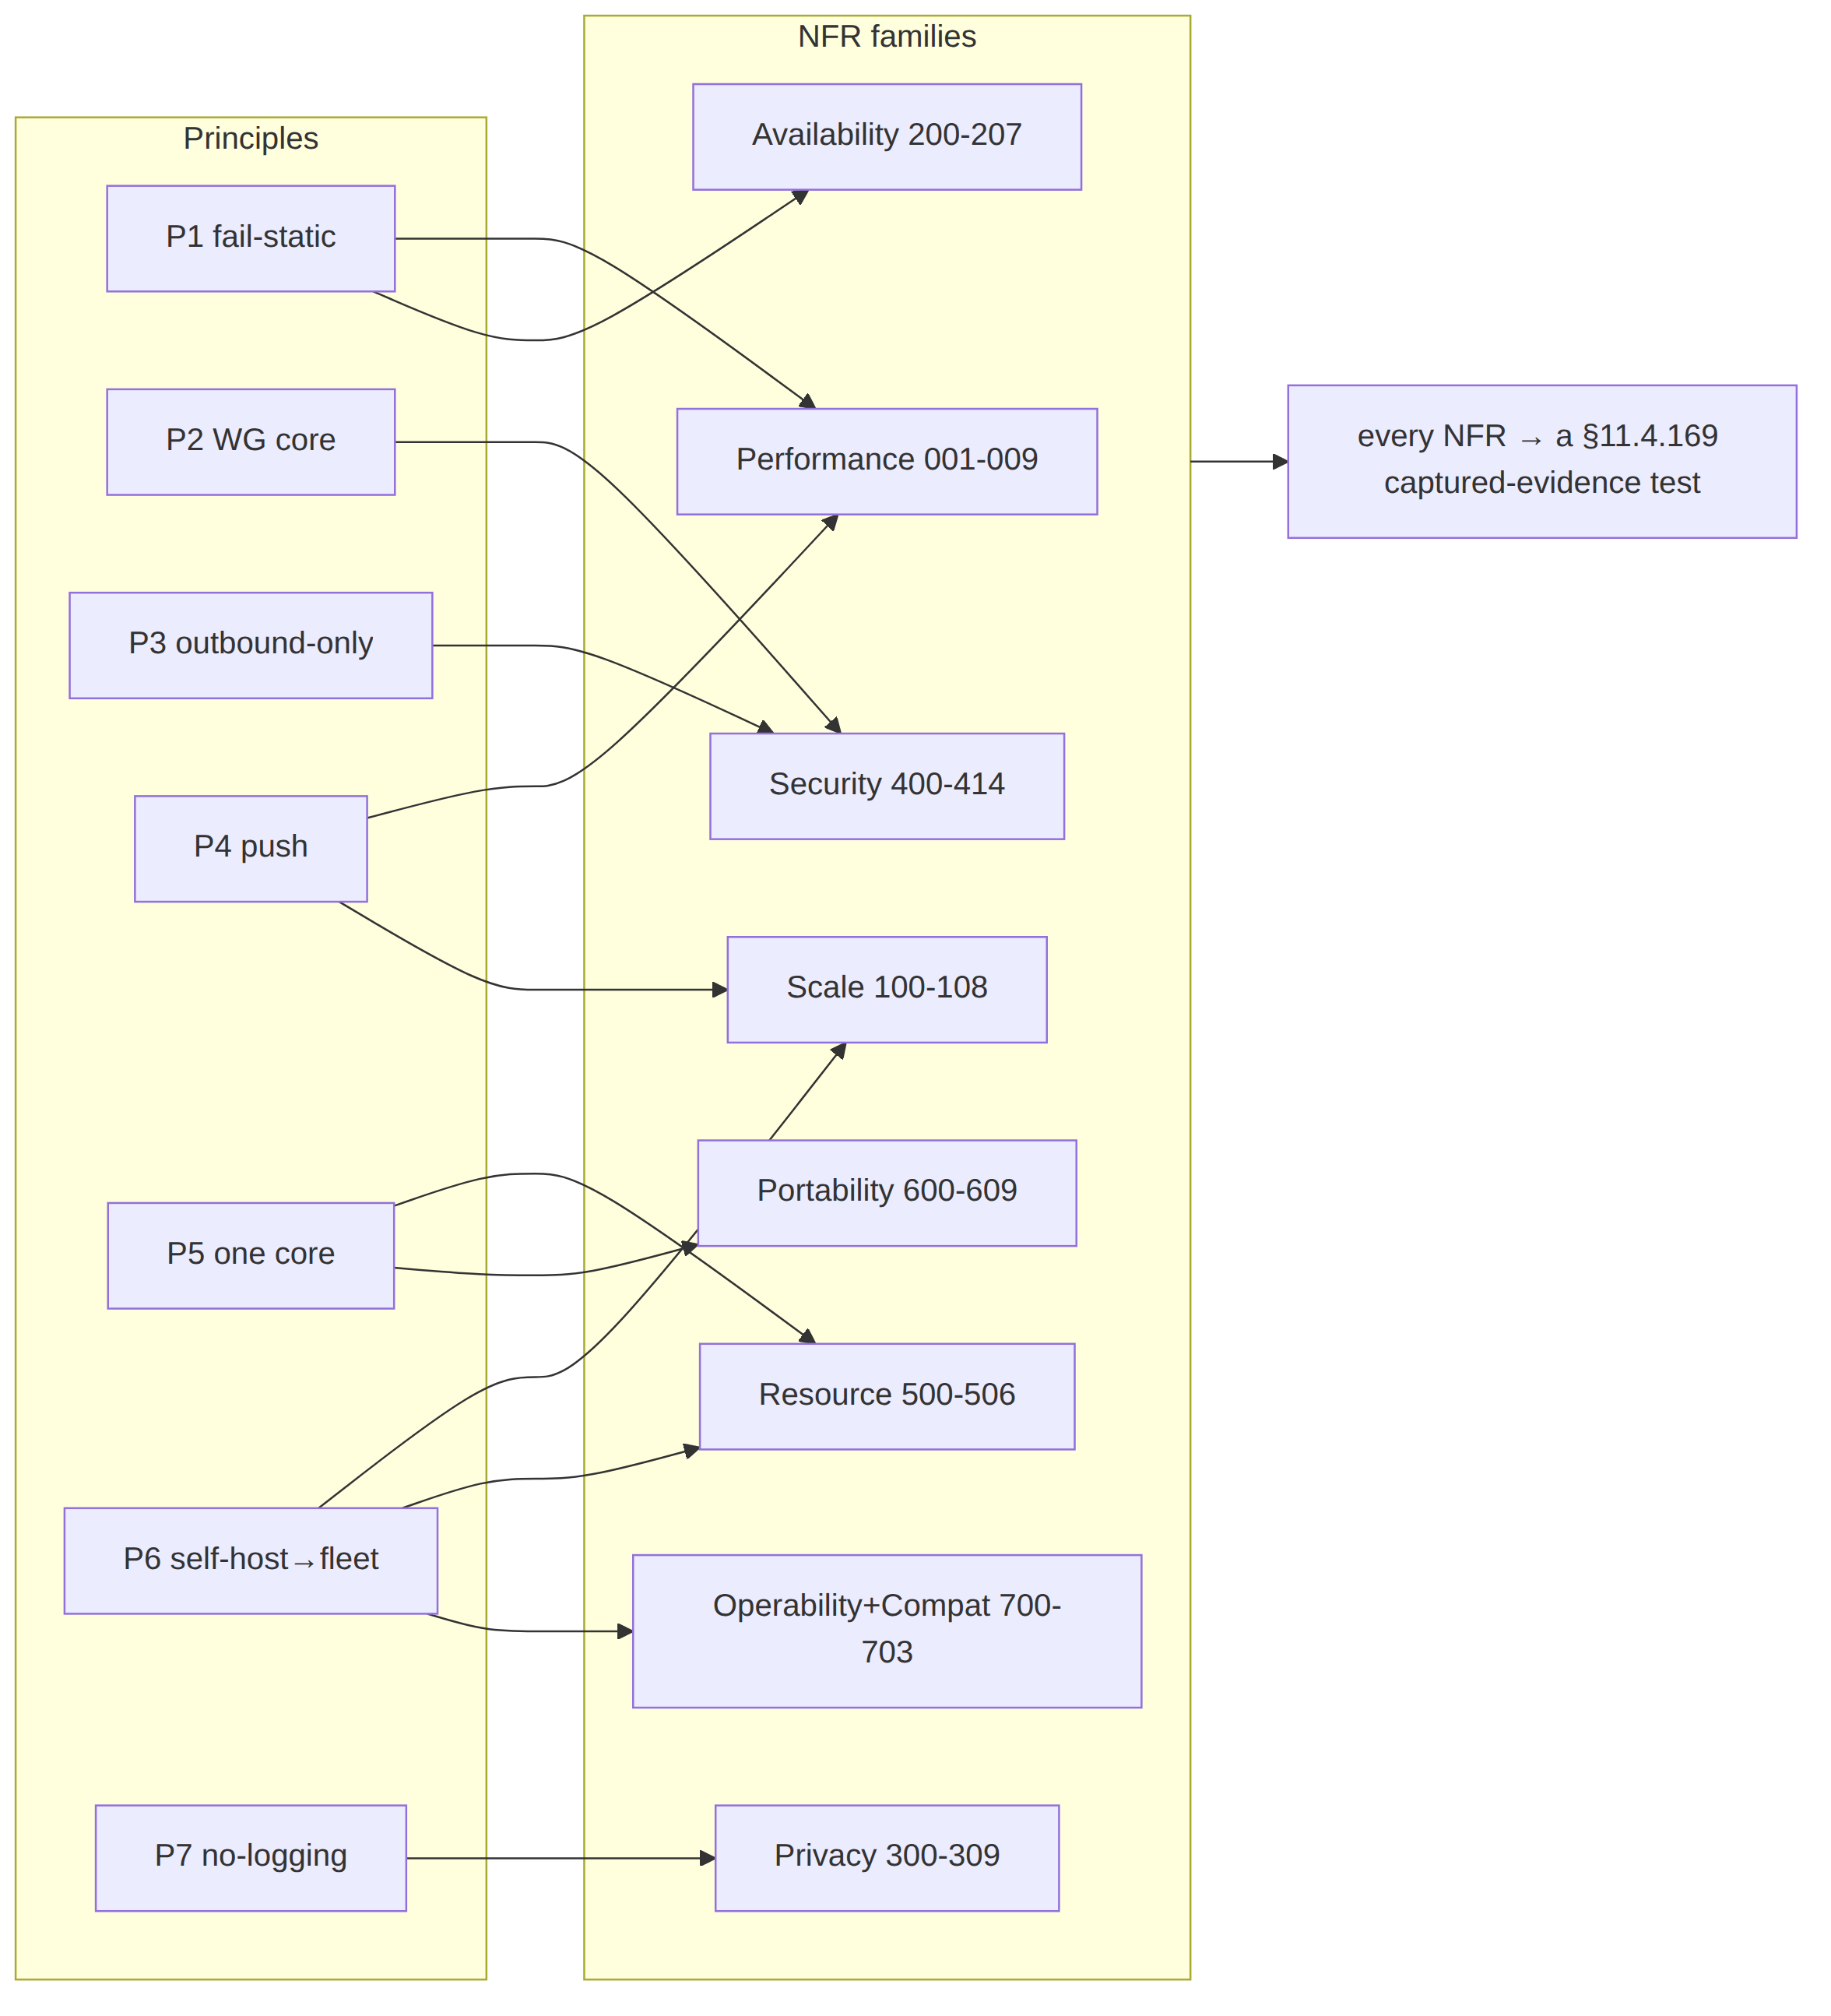

10. The convergence-NFR dependency chain
NFR-003 (p99 < 1 s convergence) and NFR-004 (< 1 s revoke) are the two headline real-time bars; they depend on a chain of lower NFRs holding, and the telemetry service makes each link a falsifiable series (counts/timing only, never traffic — svc-telemetry.md §3).
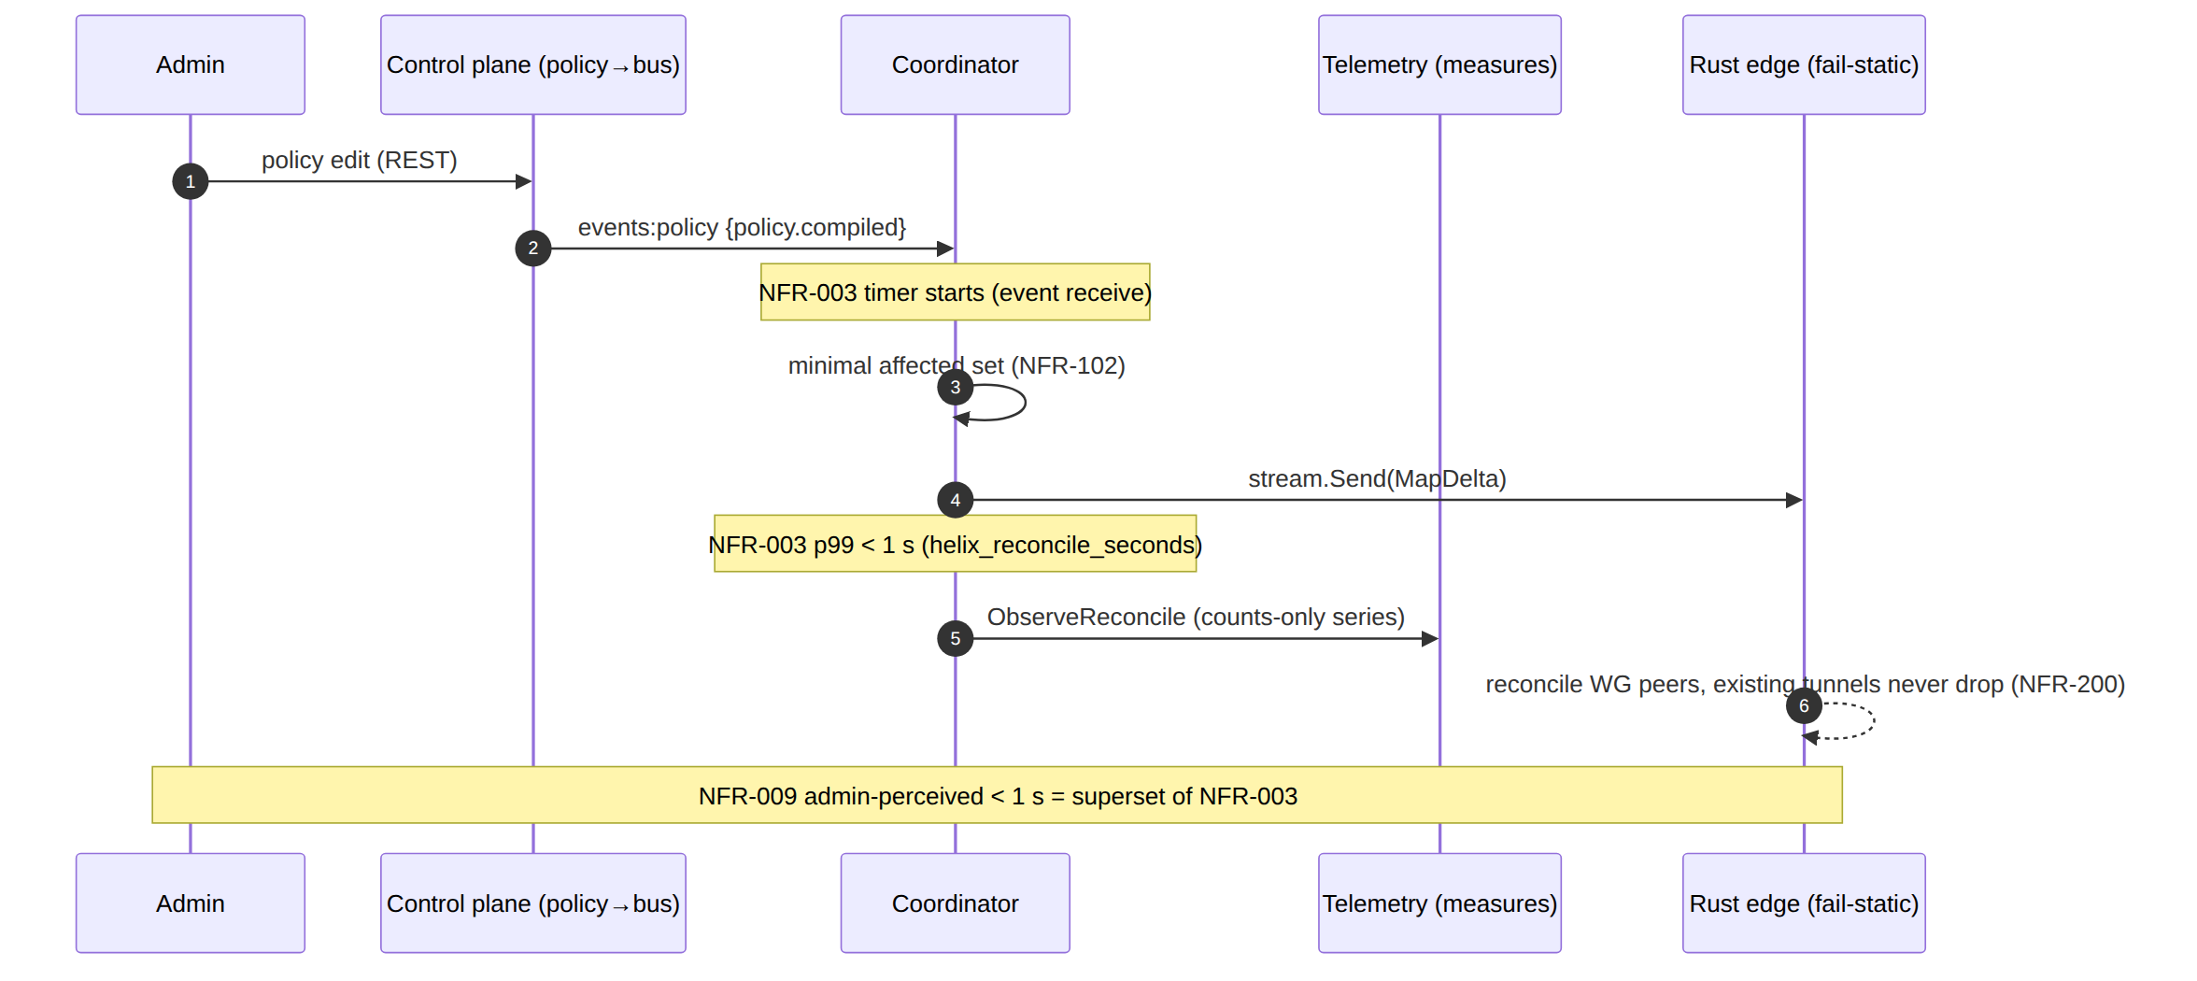
The dependency order (each lower NFR is a precondition of the SLO above it):
- NFR-101 / NFR-506 (bounded memory + back-pressure) — without these the coordinator could not hold 10 k streams to deliver a sub-second delta.
- NFR-102 (minimal-affected-set) — a tenant-wide broadcast on every change would blow the 1 s budget; the minimal set keeps per-event work small.
- NFR-203 / NFR-207 (no-work-loss + DLQ) — a stuck/lost event never converges at all, so reliability is a precondition of latency.
- NFR-200 (fail-static) — convergence is a coordination property; even when it is breached, connectivity (the edge datapath) must not be.
§11.4.6 closing note. Every numeric target in §2–§8 marked UNVERIFIED is owned by a specific Phase-0/1/2 gate or named benchmark (G1, G2, G3, G4, the soak/stress suite, the DR runbook). The verification column is the contract: an NFR is "met" only when its named test produces captured evidence (§11.4.5/§11.4.69), never when the number is merely written down here.

Sources verified
- docs/research/mvp/final/00-product-scope-and-principles.md — principles P1–P7 (§8), Mullvad-parity matrix F1–F17 + X1–X5 (§9), phase scope + exit gates G1–G6 + 8-criteria MVP DoD (§10), decisions D1–D7 incl. the iOS NE ceiling shaping D2 (§11), the "fully-responsive-web ≠ system VPN" honesty marker (§2.2).
- docs/research/mvp/final/v03-control-plane/svc-coordinator.md §7 — the convergence < 1 s SLO, helix_reconcile_seconds, revoke < 1 s, the minimal-affected-set fan-out, the 24 h no-leak soak.
- docs/research/mvp/final/v03-control-plane/svc-telemetry.md §3 — the counts-only Prometheus registry, the forbidden-label cardinality bound (no tenant_id/device_id/ip labels), the SLO→alert mapping; §10 the test matrix.
- docs/research/mvp/final/v05-security/no-logging-as-code.md — the no-logging invariant as testable NFRs (schema-lint, payload-lint, audit meta guard, ephemeral presence, coarse last_seen_at, the §11.4.108 runtime signature), the honest-boundary residual risk T5.
- docs/research/mvp/final/v02-data-plane/transport-selection-ladder.md — the escalation-ladder budgets, monotonic-cursor invariant (L-I8), and aggregate no-per-user telemetry (I5) behind NFR-006 / NFR-410.
- docs/research/mvp/final/v05-security/pki-and-certs.md — device/gateway key rotation cadence + revoke-triggered re-key behind NFR-412; the decision register D-AC-3 (audit retention, no auto-prune default) behind NFR-309.
- docs/research/mvp/final/v08-testing/ddos.md — the DDoS/flood-simulation harness behind NFR-414 (data-plane) distinct from NFR-413 (control-plane API rate limiting).
- docs/research/mvp/final/v06-deploy/codegen-pipeline.md — the D-CODEGEN-TRACK/ D-OPENAPI-AUTHORING decisions and the schema-diff breaking-change lint behind NFR-702; docs/research/mvp/final/v06-deploy/ha-and-multiregion.md and disaster-recovery.md — rolling-upgrade + RTO/RPO context behind NFR-700/701; docs/research/mvp/final/v06-deploy/observability.md — the sizing dashboard behind NFR-703.
Constitution bindings applied: §11.4.44 (revision header), §11.4.6 (no-guessing — every unproven target marked UNVERIFIED and owned by a named gate/benchmark, never asserted as measured fact), §11.4.169 (each NFR names the test type whose captured evidence proves it), §11.4.25 (coverage ledger discipline — §9 traceability), §11.4.54 (stable append-only HVPN-NFR-NNN ids), §11.4.81 (cross-platform parity — NFR-609), §11.4.108 (runtime signature — NFR-308), §11.4.65/§11.4.153 (HTML+PDF[+DOCX] exports follow in refinement).

