Personas, Jobs-to-be-Done & the RBAC Role Model

Personas, Jobs-to-be-Done & the RBAC Role Model
Revision: 3 Last modified: 2026-07-04T12:00:00Z
Rev 3 (2026-07-04, independent gap-analysis pass). §2.2 (business-admin / tenant-owner) JTBD extended with the MSP-operator's incident-response and compliance-reporting concerns — an operator running networks for several client tenants needs an audit trail it can export per-incident and reason about across tenants it administers, not only view live in Console. No other change; the four-axis model, RBAC enum, and persona↔role mapping are unchanged and remain reconciled to svc-identity.md.
Reconciled (§11.4.35, 2026-06-26): the RBAC role set is fixed to the authoritative svc-identity.md enum {member, operator, admin} (+ Device, which holds no RBAC and is policy-gated). The earlier invented "tenant owner" RBAC role is removed — admin is the top RBAC role — and the missing operator role (mint enroll tokens / manage devices + policies + advertise prefixes) is added. "Self-hoster / tenant-owner" is modelled as a host/deployment privilege, NOT an RBAC role. The connector-operator's route.advertised capability is operator-tier, not member. This aligns the document to use-cases-and-journeys.md UC-04 (admin/operator) and the svc-identity.md §7.3 minRole table, which win on any conflict.
Document role. Volume 1 deep document that expands §5 (personas and the three app classes) and §3 (the three system roles) of the overview 00-product-scope-and-principles.md into a full persona catalogue (jobs-to-be-done, journeys, pain points, success criteria) and the RBAC role/capability model. It distinguishes two orthogonal axes that the overview keeps separate and that downstream readers routinely conflate:
- System roles — Connector / Gateway / Client — the topological role a node plays in the data path [00 §3], [SPEC §3].
- Identity/RBAC roles — admin / operator / member / device (anon-device-token) — the authorization a principal holds in the control plane [00 §12 "Tenant"], (security overview S1–S5), per svc-identity.md.
A persona is a human; an app class is the software a persona drives; a system role is the topological position; an RBAC role is the permission grant. This document maps all four.
Status: SPEC-ONLY. The RBAC capability matrix here is the product-level view; the authoritative API-level permission contract is ../v03-control-plane/svc-identity.md and the enforcement points are ../04-security-privacy-pki.md (S1/S3). Where this document and svc-identity disagree on a capability, svc-identity wins (§11.4.35). Any capability not yet fixed by svc-identity is marked UNVERIFIED.
Evidence base. [00 §N] = the overview; [SPEC §N] = the spine; [SEC S#] = the security overview invariants ../04-security-privacy-pki.md.

Table of contents
- 1. The four-axis model
- 2. Persona catalogue
  - 2.1 Privacy-consumer
  - 2.2 Business-admin / tenant-owner
  - 2.3 Business-end-user
  - 2.4 Connector-operator
  - 2.5 Self-hoster
- 3. Persona → app-class → system-role → RBAC-role mapping
- 4. The RBAC role model
- 5. Persona × capability matrix
- 6. Cross-persona journeys
- 7. Cross-document contracts this document fixes
- Sources verified

1. The four-axis model
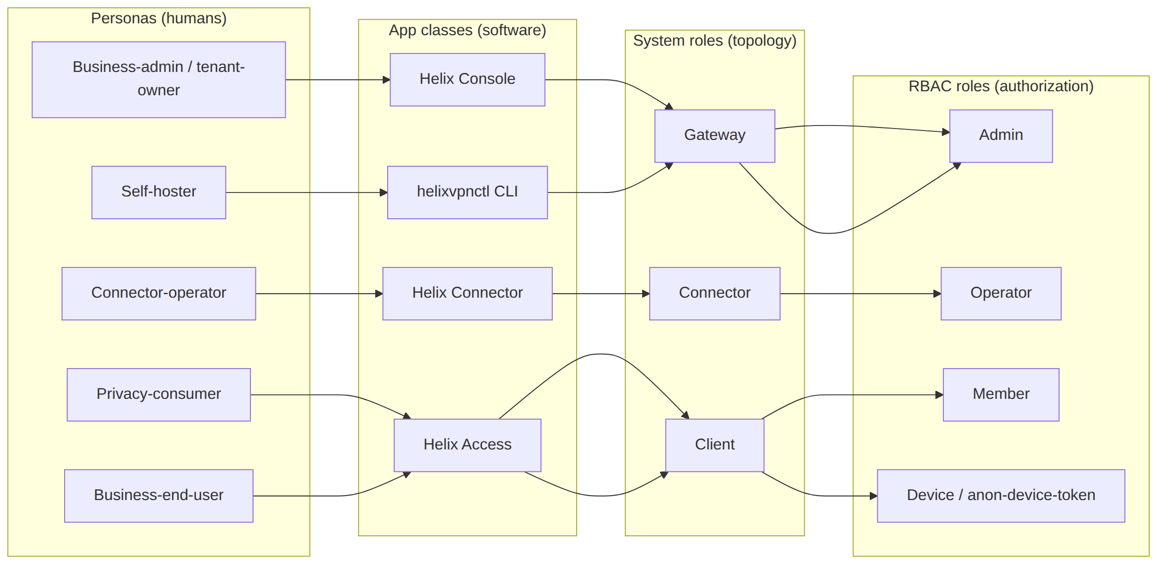
The mapping is not one-to-one: a self-hoster holds the admin RBAC role and the host/deployment-owner privilege and operates Connectors and uses an Access client — one human, several roles. ("Tenant-ownership / self-hosting" is a host/deployment privilege, not an RBAC role — see §4.) The matrix in §5 makes every cell explicit so no capability is assumed.
Axis | Closed set | Source of truth
Persona | privacy-consumer, business-admin/tenant-owner, business-end-user, connector-operator, self-hoster | this doc §2
App class | Helix Access, Helix Console, Helix Connector, helixvpnctl | [00 §5], [SPEC §3]
System role | Client, Gateway, Connector | [00 §3], [SPEC §3]
RBAC role | admin, operator, member, device (anon-device-token) | [00 §12], [SEC S1–S5], svc-identity (authoritative enum)

2. Persona catalogue
Each persona is given: JTBD (jobs-to-be-done), primary journey, pain points it removes, and success criteria (tied where possible to the 8-criteria MVP Definition-of-Done [00 §10.2], [SPEC §8.1]). Success criteria that are not yet a fixed acceptance gate are marked UNVERIFIED.

2.1 Privacy-consumer
"I want into a privacy exit (or my own lab) with one button, no email, and no way for anyone to log what I do." — the Mullvad use case [00 §5.1].
Field | Detail
Drives | Helix Access app (iOS, Android, desktop; Web limited)
System role | Client [00 §3.3]
RBAC role | Device, via anonymous device token (no email) [00 §9 F15]
JTBD | (1) connect to a privacy exit with one tap; (2) get automatic obfuscation that just works when a network blocks WG; (3) never leak when the tunnel drops; (4) hold an anonymous identity with no PII
Primary journey | install → anonymous device-token enrollment (key generated on-device, private key never leaves) → one-button connect → auto-ladder escalates plain → LWO → MASQUE if blocked → kill-switch + DNS-leak protection active throughout [00 §9 F7/F11/F13/F15], [SEC S2/S9]
Pain points removed | account email requirement (anonymous token); manual obfuscation fiddling (auto-ladder); leak-on-drop (core-owned kill-switch); trust-the-vendor no-logs (no-logging-as-code)
Success criteria | DoD#4 (auto-escalate to MASQUE when WG blocked); DoD#7 (kill-switch + DNS-leak verified, no leak on drop); anonymous enrollment succeeds with no PII captured
Sensitivities | memory- and battery-sensitive on mobile [00 §5.1]; the iOS NE ~15 MB ceiling is a hard constraint (G3)

2.2 Business-admin / tenant-owner
"I manage tenants, users, devices and policy for an organization (or several client orgs), and I need a live topology view and an audit trail of control actions." [00 §5.3]
Field | Detail
Drives | Helix Console (Web responsive + Desktop — same Flutter build, no tunnel core) [00 §5, §5.2]
System role | none in the data path — Console is API-client-only, drives the Gateway control plane [00 §5]
RBAC role | Admin (the top RBAC role; tenant-ownership is a host/deployment privilege, not an RBAC role)
JTBD | (1) CRUD tenants/users/devices/networks/routes/policies; (2) see/revoke devices instantly; (3) author default-deny ACLs that compile to reachability; (4) read a control-action audit trail; (5) optionally manage multi-tenant billing; (6) for an MSP administering several client tenants: export an audit slice for a single incident/tenant on demand (compliance reporting to that client), and run a first-response revoke/isolate action within the same <1 s enforcement guarantee as any other device revoke
Primary journey | log in (OIDC) → create a tenant → invite members → approve/enroll devices → author policy (group:contractors → net:warehouse:554/tcp) → watch it converge in <1 s → revoke a lost device and watch enforcement in <1 s → review audit_events [00 §9 F17], [SPEC §8.1 DoD#5/#6], [SEC S5/S7]
Incident-response / compliance journey (MSP-operator variant) | suspected-compromised-device report arrives → admin locates the device in Console (own-tenant scope, RLS-bounded) → revokes it (<1 s edge enforcement, DoD#6) → filters audit_events to that device/time-window → exports the filtered control-action slice as the incident evidence handed to the affected client — never a traffic/destination record, because none exists (P7) [SEC S7], audit-and-compliance.md
Pain points removed | policy edits requiring restarts (push-based, <1 s); device revoke lag (<1 s edge enforcement); destinations/flows leaking into audit (audit is control-only); an MSP having to promise "trust me" on incident evidence instead of handing over an exportable control-action trail scoped to the affected tenant only
Success criteria | DoD#5 (policy edit reflected <1 s, no restart); DoD#6 (device revoke enforced <1 s); audit records who-did-what-to-identity/policy/devices, never destinations [SEC S7]; an audit export for one tenant/time-window contains zero rows from any other tenant (RLS-bounded export, not just RLS-bounded live view)
Sensitivities | tenant isolation must be airtight — Postgres RLS, not app-layer only [SEC S6/RLS]; an MSP-operator's cross-tenant administrative access (if any) is itself an audited action — administering tenant B is never silent to tenant B's own audit trail

2.3 Business-end-user
"My admin set me up; I just want into the work networks I'm allowed to reach, and to be cleanly denied the ones I'm not." (derived from the ZTNA half of the dual model [00 §3, §4.2])
Field | Detail
Drives | Helix Access app
System role | Client
RBAC role | Member (an identity that belongs to a tenant, holds enrolled devices, but cannot administer the tenant)
JTBD | (1) connect and reach exactly the subset of joined networks policy grants; (2) be transparently denied unauthorized networks (default-deny, not an error to debug); (3) see only the peers/routes need-to-know permits
Primary journey | receive an enrollment invite/token from the admin → device generates its WG keypair (private key never leaves) → enroll → receive a policy-filtered network map (only granted peers/routes) → reach authorized LAN host, denied unauthorized one [00 §4.2, §9 F17], [SEC S1/S3]
Pain points removed | over-broad access (need-to-know map — the user never even learns of peers it cannot reach [SEC S3]); confusing all-or-nothing VPNs (policy-scoped 1→N)
Success criteria | DoD#3 (reach an authorized LAN host AND deny an unauthorized one — default-deny proven); the user's map contains only granted peers [SEC S3]
Sensitivities | must not be able to enumerate the tenant topology beyond its grants (need-to-know is server-side, pre-wire)

2.4 Connector-operator
"Install one agent inside my LAN, it dials out, done — I never touch my router." [00 §5.2]
Field | Detail
Drives | Helix Connector (headless daemon on Linux/Windows/macOS + optional slim UI; Android/embedded for appliances) [00 §3.1, §5]
System role | Connector [00 §3.1]
RBAC role | Operator — the connector identity mints/redeems enroll tokens, manages devices + policies, and advertises prefixes; the route.advertised capability is operator-tier per svc-identity.md, not member. A self-hoster operating their own connector also holds admin (§2.5)
JTBD | (1) onboard a network without opening any inbound port; (2) advertise the CIDRs the network exposes (route.advertised); (3) set local ACLs; (4) run headless and reconnect resiliently
Primary journey | install agent on a LAN host → enroll (device cert + enrollment token) → dial outbound to the Gateway (reverse tunnel) → advertise CIDRs → Gateway routes authorized client traffic into the LAN and responses back out — neither side ever opened an inbound port [00 §3.1, §4.1, §8 P3]
Pain points removed | router port-forwarding (outbound-only); inbound attack surface (none); per-network bespoke VPN configs (same Rust core in advertise/route mode)
Success criteria | DoD#2 (enroll a Connector); DoD#3 (an authorized client reaches a LAN host behind the advertised CIDR); the Connector establishes the tunnel with zero inbound exposure
Sensitivities | overlapping RFC1918 ranges across connectors must not collide (D4 → 4via6) [00 §4.2 #1]

2.5 Self-hoster
"I run the whole thing myself — Gateway, Connector(s), and my own Access client — because no-logs is credible only when I own the box." [00 §7.1]
Field | Detail
Drives | helixvpnctl (Cobra CLI) for bring-up + Console + Connector + Access — wears all software hats
System role | operates Gateway, one or more Connectors, and a Client
RBAC role | Admin of their own tenant(s) — the top RBAC role. Tenant-ownership / self-hosting is a host/deployment privilege, NOT an RBAC role: the human who owns the box bootstraps each tenant (helixvpnctl init) and then administers it as admin. A self-hoster running networks for multiple clients administers multiple tenants [00 §12]
JTBD | (1) stand up a Gateway from zero on a clean VPS with one command; (2) own the no-logs guarantee by owning the deployment; (3) scale the same images from one homelab pod to an HA fleet without a rewrite
Primary journey | helixvpnctl init on a clean VPS (one rootless Podman pod: edge + control + Postgres + Redis) → enroll a Connector and a Client → reach a LAN host → confirm no durable connection log exists (schema-lint + runtime check) [00 §7.1, §10.2 DoD#1/#8], [SPEC §8.1]
Pain points removed | SaaS coordination dependency (self-hosted); vendor-trusted no-logs (self-evident ownership + CI-enforced schema); separate codebases for homelab vs fleet (same images, P6)
Success criteria | DoD#1 (self-host from zero via helixvpnctl init); DoD#8 (no durable connection log AND all three apps drive the system); the same images scale to HA (Phase 2)
Sensitivities | the CA root key + Postgres are the only secrets to protect — data-plane nodes are cattle [SEC S11]

3. Persona → app-class → system-role → RBAC-role mapping
Persona | Primary app class | Other apps used | System role(s) | RBAC role(s) | Uses tunnel core?
Privacy-consumer | Helix Access | — | Client | Device (anon-device-token) | yes (helix-core capture mode)
Business-admin / tenant-owner | Helix Console | (Access as a user) | none in data path | Admin | no (Console is API-client only)
Business-end-user | Helix Access | — | Client | Member (+ Device per enrolled device) | yes
Connector-operator | Helix Connector | (Console to verify routes) | Connector | Operator (+ Device); or Admin if self-hosting | yes (helix-core advertise/route mode)
Self-hoster | helixvpnctl + Console + Connector + Access | all | Gateway + Connector + Client | Admin (+ host/deployment-owner privilege) | yes (as Connector/Client)
Note (the single-tree flavoring contract, [00 §5.2]). All three apps build from one Flutter tree via runHelixApp(flavor, home, capabilities), flavor ∈ {Access, Connector, Console}; Console is the only build that omits core_ffi (no Rust tunnel core). The "Uses tunnel core?" column above is a direct consequence of this contract. Owned by ../03-client-core-and-ui.md.

4. The RBAC role model
The control plane authorizes principals by RBAC role within a tenant. A tenant is an isolated organization boundary enforced by Postgres RLS [00 §12], [SEC S6/RLS]. The closed role set is the authoritative svc-identity.md enum {member, operator, admin} (+ Device, which holds no RBAC and is policy-gated). Tenant-ownership / self-hosting is a host/deployment privilege, not a member of this RBAC enum. The role lattice (admin > operator > member, per svc-identity.md §7.3):
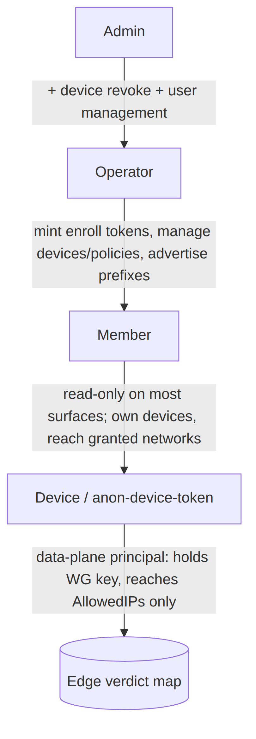

4.1 Role definitions
RBAC role | Definition | Distinguishing capability | Authenticated by
Admin | The top RBAC role within a tenant — everything an Operator can do, plus device revoke and user management; the business-admin's and self-hoster's role | device revoke; user management; full CRUD on users/devices/networks/routes/policies | OIDC identity [00 §9 F15]
Operator | Manages a tenant's devices and policies and mints enrollment tokens; the connector-operator's role | mint/redeem enroll tokens; manage devices/policies; advertise prefixes (route.advertised) | OIDC identity
Member | A user that belongs to a tenant and owns enrolled devices; read-only on most administrative surfaces | enroll own devices; connect; reach granted networks | OIDC identity
Device / anon-device-token | A data-plane principal — an enrolled device holding its own WG keypair; holds no RBAC role (policy-gated, never the RBAC matrix); the anonymous-device-token variant has no human identity behind it (the privacy-consumer case) | open WatchNetworkMap; reach AllowedIPs; nothing administrative | short-lived mTLS device cert (≤24 h, tenant-CA-signed) [SEC S4], + WG Noise IK for data [SEC §1.2]
Host/deployment privilege (not RBAC). Tenant lifecycle (create/delete a tenant), bringing up the Gateway (helixvpnctl init), and any managed-SKU billing are host/deployment-owner capabilities the self-hoster exercises by owning the box — they are not entries in the {member, operator, admin} RBAC enum. svc-identity.md §7.3's minRole table (the authoritative Permission → Role map) tops out at admin (user management + device revoke); it has no "tenant owner" tier.

4.2 Two authentication channels, never conflated
Per the security overview [SEC §1.2], a principal authenticates on two independent channels:
- Control channel (Coordinator.WatchNetworkMap/.Enroll/…): short-lived device cert (mTLS, ≤24 h, auto-renew), tenant-CA-signed [SEC S4].
- Data channel (the tunnel): WireGuard Noise IK; peer pubkeys delivered via the policy-filtered map [SEC §1.2].
Compromising one does not yield the other. A device must be valid on both to learn its peers and reach them. This is why the Device RBAC role is the join point between identity (control) and reachability (data).

4.3 Default-deny is the RBAC ground state (S1)
A Member's device with no policy grant has an empty AllowedIPs and no edge verdict entry — cryptographically and administratively isolated even though enrolled and online [SEC S1, §1.3]. RBAC roles grant administrative capability; reachability is a separate, additive, default-empty grant compiled by the policy service. Holding the Member role does not imply reaching any network.

4.4 Anonymous device tokens (the privacy lane)
The anonymous-device-token enrollment is a first-class path alongside OIDC [00 §9 F15]: a device enrolls and obtains a control identity with no email / no PII, generating its WG keypair on-device (private key never leaves) [SEC S2]. This is the privacy-consumer's principal — a Device (holding no RBAC role) with no human member/operator/admin behind it. Owned by ../v05-security/identity-and-enrollment.md
- ../v03-control-plane/svc-identity.md.
UNVERIFIED — the precise capability ceiling of an anonymous-device-token principal (e.g. whether it may advertise prefixes, or only consume a privacy-exit) is fixed by svc-identity, not here. Until svc-identity pins it, this document assumes anon tokens are privacy-exit/consume-only (the consumer case), which is the conservative default per §11.4.6.

5. Persona × capability matrix
Capabilities are grouped by control-plane domain. Legend: ✅ allowed · ⛔ denied · 🔒 allowed only on own resources · 🅟 policy-gated (granted additively, default-deny §4.3). The authoritative permission contract is svc-identity; rows it has not yet fixed are UNVERIFIED (flagged inline).
Capability | Privacy-consumer (Device/anon) | Business-end-user (Member) | Connector-operator (Operator) | Business-admin (Admin) | Self-hoster (Admin + host privilege)
Connect / open tunnel | ✅ | ✅ | ✅ (advertise/route mode) | n/a (Console) | ✅
Use Gateway as privacy exit | ✅ | ✅ | n/a | n/a | ✅
Reach a joined private network | ⛔ (anon = exit-only, UNVERIFIED) | 🅟 | 🅟 (its own LAN) | n/a | 🅟
Advertise CIDRs (route.advertised) | ⛔ | ⛔ | ✅ (for its connector) | ✅ (set on behalf) | ✅
Enroll a device | 🔒 (self only) | 🔒 (own devices) | 🔒 (own connector) | ✅ (any in tenant) | ✅
See own devices | 🔒 | 🔒 | 🔒 | ✅ (all) | ✅
Revoke a device | 🔒 (own) | 🔒 (own) | 🔒 (own connector) | ✅ (any, <1 s) | ✅
Author / edit ACL policy | ⛔ | ⛔ | ✅ (Operator tier = PermManagePolicy; local-vs-central scope UNVERIFIED) | ✅ | ✅
CRUD users | ⛔ | ⛔ | ⛔ | ✅ | ✅
CRUD networks / routes | ⛔ | ⛔ | 🔒 (its own routes) | ✅ | ✅
Read control-action audit | ⛔ | ⛔ | ⛔ | ✅ | ✅
Manage tenants (create/delete) | ⛔ | ⛔ | ⛔ | ⛔ (host/deployment privilege, not RBAC; UNVERIFIED whether ever exposed to admin) | ✅ (host/deployment privilege, not RBAC)
Manage billing (optional SKU) | ⛔ | ⛔ | ⛔ | ⛔ (host/deployment / managed-SKU privilege; UNVERIFIED) | ✅ (host/deployment / managed-SKU privilege)
Bring up Gateway (helixvpnctl init) | ⛔ | ⛔ | ⛔ | ⛔ | ✅ (host/deployment privilege, not RBAC)
Honesty note (§11.4.6). The matrix is the product-intent view. Three cells are UNVERIFIED because the exact grant is fixed by svc-identity/svc-policy, not by a product narrative: (a) whether an anon device token may reach a private network or is exit-only; (b) the local-vs-central scope of a Connector-operator's (Operator-tier) policy authoring; (c) whether tenant-lifecycle and billing — both host/deployment privileges, not RBAC — are ever surfaced through the admin role or remain box-owner-exclusive. Each is a tracked refinement item; the conservative default (narrower grant) is assumed until pinned, per §11.4.6/§11.4.101.

6. Cross-persona journeys

6.1 Onboarding a network so a remote user can reach it (the founding journey)
This is the canonical multi-persona flow that realizes the founding constraint [00 §2.1, §4.1] — three personas, no inbound port-forward:
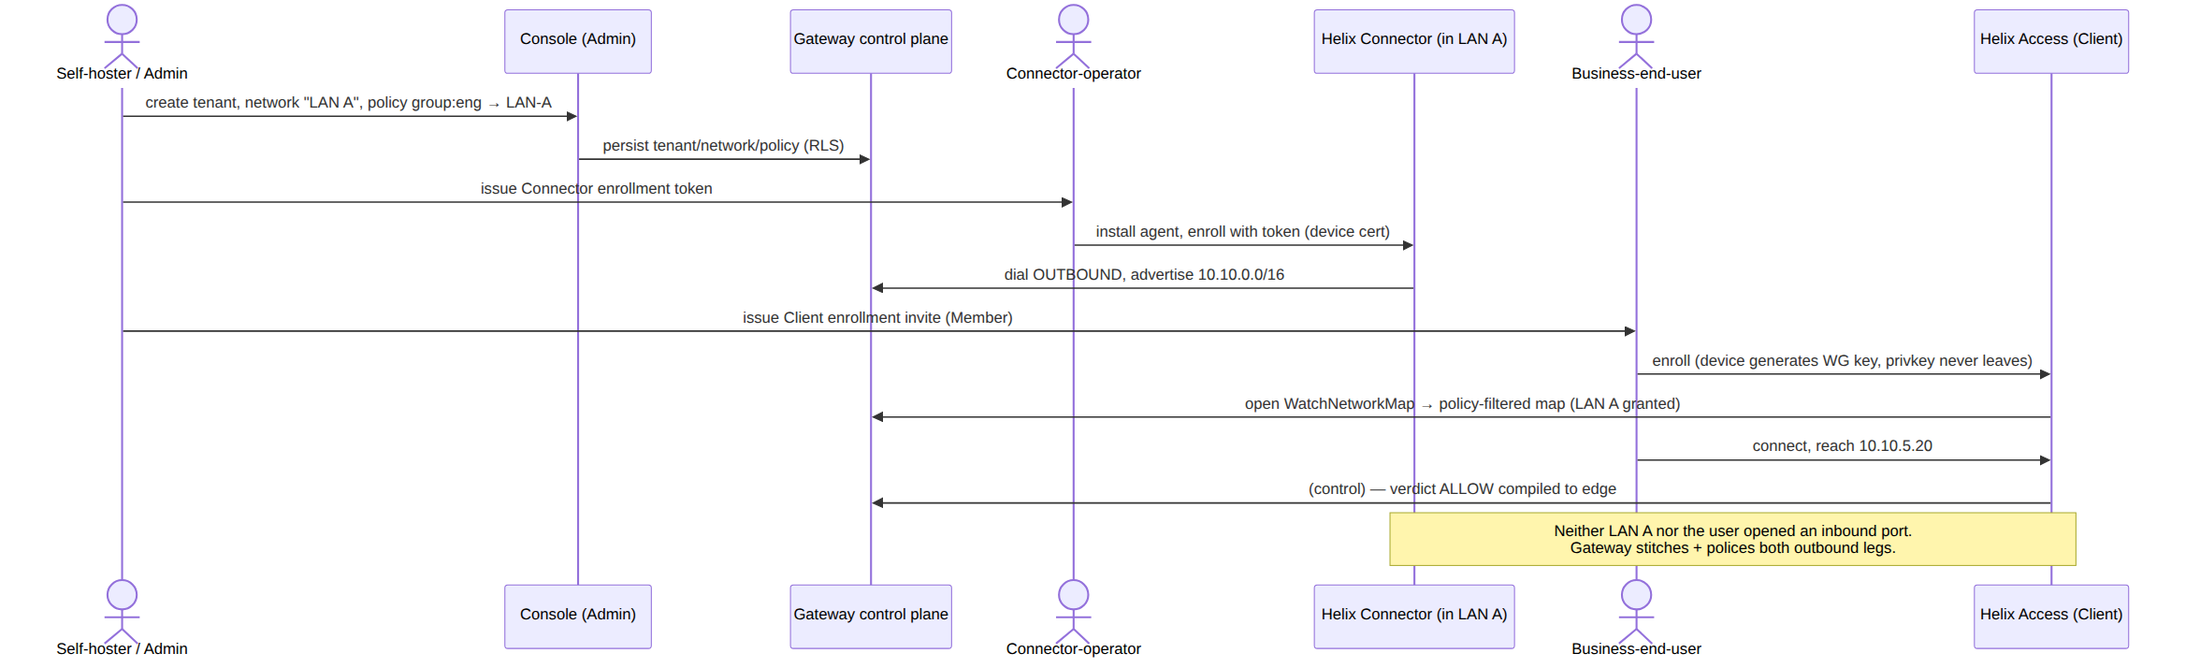

6.2 Lost-device revocation (admin + device, <1 s)
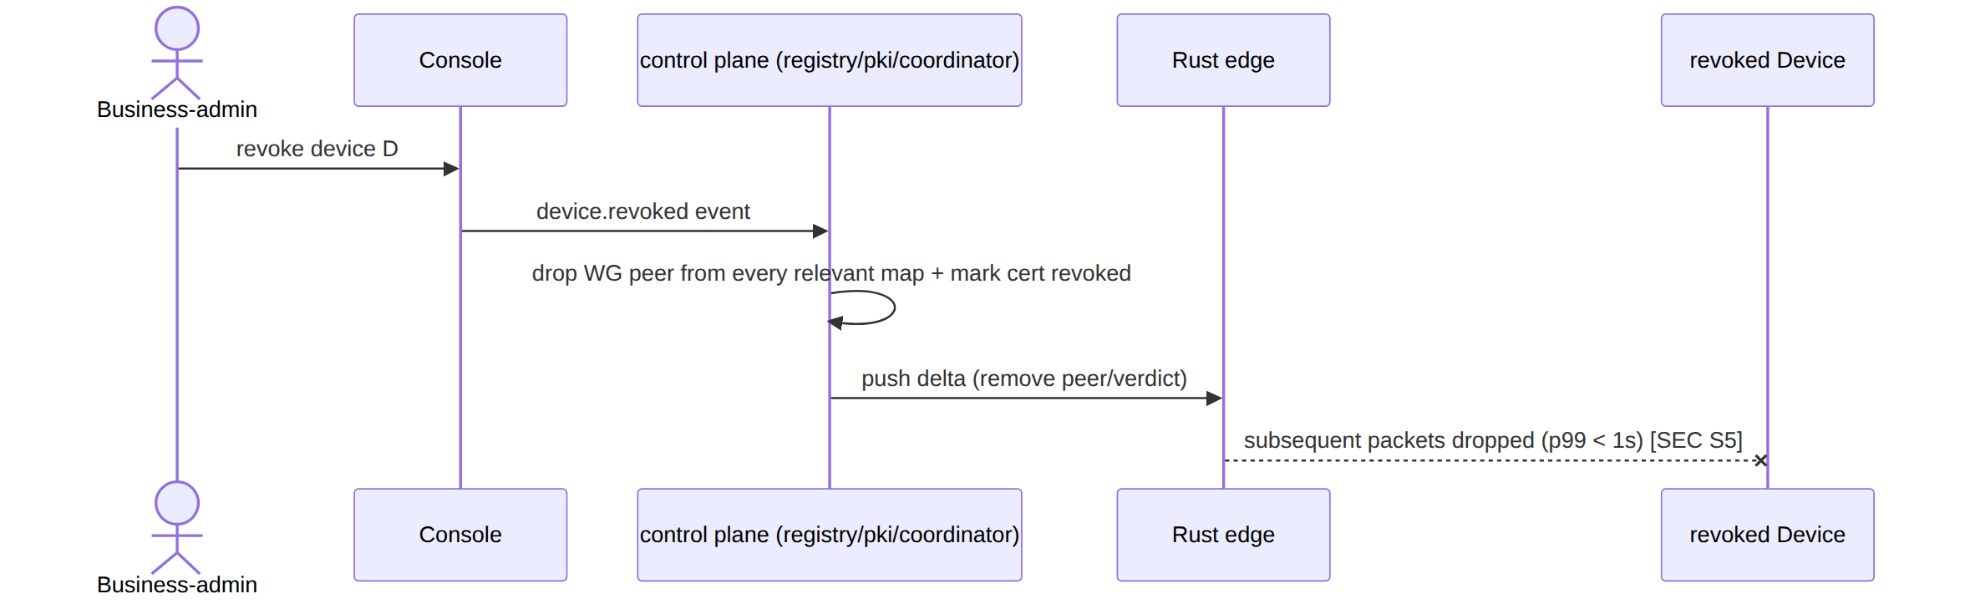

6.3 Privacy-consumer auto-obfuscation under DPI (one persona, one journey)
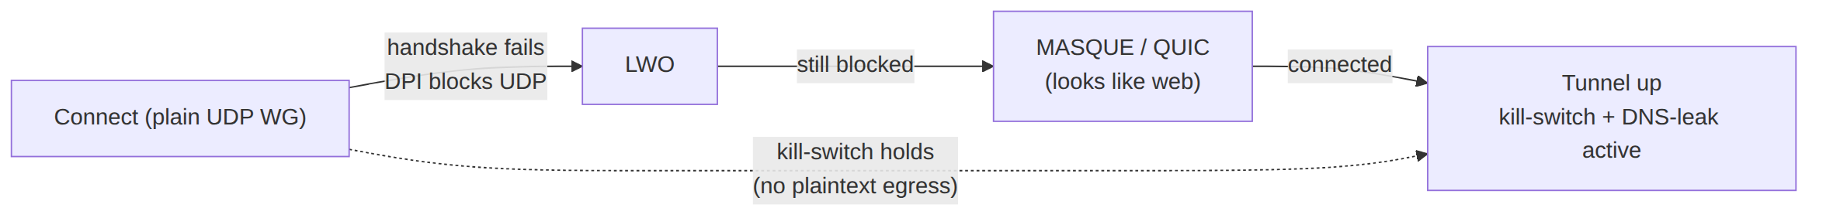
The escalation ladder is driven by handshake-failure events; throughout, the kill-switch holds so no plaintext egress occurs while escalating [00 §9 F7/F11], [SEC S9].

7. Cross-document contracts this document fixes
- Four-axis separation (§1) — persona ≠ app class ≠ system role ≠ RBAC role; every later document MUST keep these distinct (the overview conflates persona and app class loosely in §5; this document is the disambiguation authority for Volume 1).
- Persona → RBAC mapping (§3, §5) — consumed by functional-requirements.md (each FR names the persona/role it serves) and bound to the authoritative ../v03-control-plane/svc-identity.md.
- Device is the join point of control identity and data reachability (§4.2) — inherited from [SEC §1.2], not redefined.
- Default-deny is the RBAC ground state (§4.3) — RBAC grants administrative capability; reachability is a separate additive default-empty grant ([SEC S1], ../v03-control-plane/svc-policy.md).
- Anonymous device tokens are first-class (§4.4) — the privacy lane; owned by svc-identity + identity-and-enrollment.md.
- The single-tree flavoring contract (§3 note) governs "which persona's app carries the tunnel core" — inherited from [00 §5.2].

Sources verified
- 00-product-scope-and-principles.md §3 (three roles), §4 (two-way + multi-network), §5 + §5.1/§5.2 (personas, app classes, flavoring contract), §9 (parity matrix — F15 anon account, F17 device mgmt), §10.2 (8-criteria DoD), §12 (glossary — tenant).
- SPECIFICATION.md §3 (roles + app classes), §8.1 (MVP DoD), §9 (D2 client core).
- 04-security-privacy-pki.md §0.1 (S1–S11 invariants), §1.1 (trust gradient), §1.2 (two auth channels), §1.3 (default-deny realization) — authoritative for the RBAC enforcement model.
- MASTER_INDEX.md Volume 1 row (declared scope: "Each persona: jobs-to-be-done, journeys, pain points, success") + Volume 3 row (svc-identity as the authoritative permission contract).
- Cross-refs forward: svc-identity.md, svc-policy.md, identity-and-enrollment.md, 03-client-core-and-ui.md.
Honesty note (§11.4.6): the persona success criteria are tied to the 8-criteria MVP DoD where one exists; the RBAC capability matrix is the product-intent view, with every cell whose grant is not yet fixed by svc-identity/svc-policy marked UNVERIFIED and defaulted to the narrower grant. No permission was asserted as final that the authoritative control-plane docs have not yet pinned.
Constitution bindings: §11.4.44 (revision header), §11.4.6 (UNVERIFIED on un-pinned capabilities, conservative default), §11.4.35 (svc-identity wins on conflict; inherits security invariants), §11.4.104 (participant/identity model alignment), §11.4.65/.153 (HTML+PDF[+DOCX] exports follow in refinement).

