Product Vision & Positioning

Product Vision & Positioning
Revision: 2 Last modified: 2026-06-26T12:00:00Z
Document role. This is the Volume 1 (Product & Requirements) deep document that fixes why HelixVPN exists, what category it competes in, who came before, and what makes it different. It deepens §1/§2/§6/§7 of the volume overview 00-product-scope-and-principles.md and §1/§2 of the spine SPECIFICATION.md. It is the narrative spine the functional requirements (functional-requirements.md) and the persona model (personas-and-roles.md) trace back to.
Status: SPEC-ONLY — this describes the product's position, it does not build it. Every market or competitor claim that is not an architectural fact of HelixVPN is marked UNVERIFIED (§11.4.6): comparative-product facts move over time and are subject to the §11.4.99 latest-source re-verification pass (tracked in REFINEMENT_NOTES.md R1). Architectural claims about HelixVPN itself are cited to the overview/spine, not asserted from memory.
Evidence base. The synthesised overview and spine (themselves a synthesis of the 16 source research docs), cited inline as [00 §N] (the overview) and [SPEC §N] (the spine). Where the overview cites a primary source by id ([04_ARCH §N], [05_YBO], [research-masque]) that chain is preserved.

Table of contents
- 1. Vision statement
- 2. The problem HelixVPN exists to solve
- 3. Market category — the consumer/business convergence
- 4. Prior-art deep-dive
- 5. Differentiators
- 6. Explicit non-goals
- 7. Positioning statement & messaging spine
- 8. Strategic risks to the positioning
- 9. Cross-document contracts this document fixes
- Sources verified

1. Vision statement
HelixVPN is a self-hostable overlay network with a privacy-VPN front end — one codebase that a single person can stand up for a homelab and that the same images scale to an HA multi-region fleet [00 §1], [SPEC §1].
The one-sentence pitch, verbatim from the architecture source [00 §1] ([04_ARCH §1]):
Cloudflare Tunnel + WARP, rebuilt as Tailscale-style coordination, with Mullvad's obfuscation stack, fully self-hostable, on one shared codebase.
The vision is deliberately a union, not a new point product. Four mature lineages each solved one piece; no shipping product unifies all four and is self-hostable [00 §1]:
Lineage | The one thing it proved | HelixVPN inherits
Cloudflare Tunnel + WARP | a connector can dial outbound so no inbound port-forward is ever needed; MASQUE/QUIC is a viable censorship-resistant transport | the outbound-only edge model + MASQUE transport [04_ARCH §0/§3.3]
Tailscale / Headscale | coordination as a pushed desired-state network map (ACL-compiled topology), not a polling mesh | the push-based control plane [04_ARCH §4.4]
Mullvad | a privacy bar — full obfuscation stack, anonymous accounts, no-logging — is a product, not a research demo | the obfuscation + privacy bar [04_ARCH §6]
NetBird | the closest OSS shape (WireGuard + management/signal server, self-hosted) as a sanity check | architectural validation of the WG-core + control-server split [04_ARCH §1.3]
The synthesis target: a product that is self-hosted AND Mullvad-grade obfuscated AND multi-network-routed AND reachable on 8 platforms from one codebase — the combination the overview names as the core differentiator [00 §6], [SPEC §2].

2. The problem HelixVPN exists to solve

2.1 The founding constraint
The project was born from one concrete operator need [00 §1] ([05_YBO], [00]):
A remote user must obtain full, policy-scoped access to one or many internal / home / lab networks without any inbound port-forward on those networks.
Every incumbent forces a trade here: you either open a router port (a public inbound attack surface), or you accept a SaaS coordination dependency, or you give up obfuscation, or you give up self-hosting. HelixVPN's thesis is that none of those trades is necessary — internal hosts dial outbound to a public gateway (a reverse tunnel), the gateway relays and routes, and the whole thing is software you run yourself [00 §2.1], [SPEC §1].

2.2 The headline capability gap in the market
The differentiator the overview leads with is 1 user → N joined private networks — a multi-network, bidirectional, policy-routed gateway, which the overview states "no self-hostable product ships today" [00 §1] ([04_ARCH §1.3]).
UNVERIFIED — "no self-hostable product ships today" is a competitive-market claim, not an architectural fact of HelixVPN. It is plausible from the prior-art map (§4) but MUST be re-verified against current product feature sets in the §11.4.99 latest-source pass before it appears in any external-facing material (R1). The architectural fact — that HelixVPN's design provides 1→N policy-routed networks — is cited and is not UNVERIFIED.
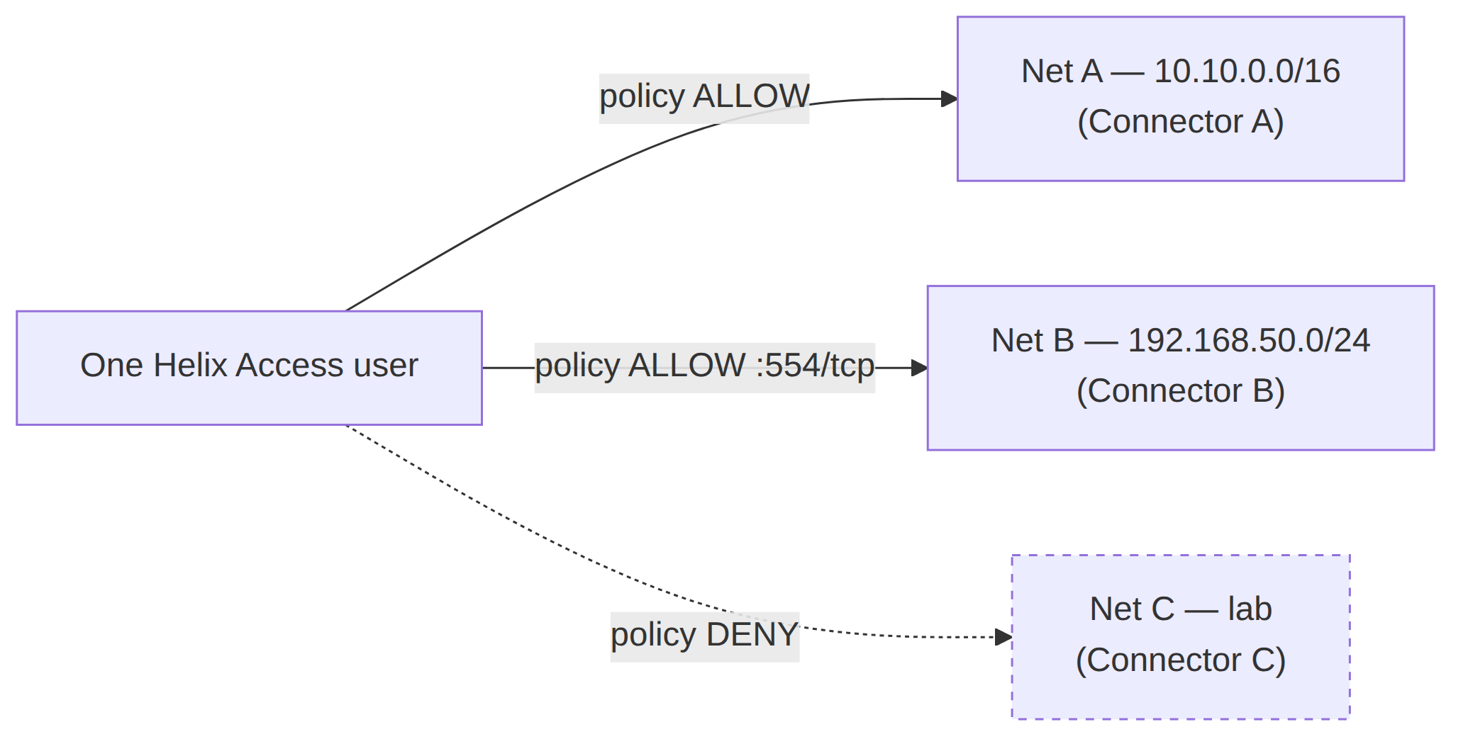
The user reaches the subset of joined networks its ACL grants and is denied the rest — default-deny microsegmentation, not all-or-nothing access [00 §4.2].

2.3 The privacy problem — credibility of "no-logs"
A privacy VPN's no-logs promise is only as strong as your trust in the operator. HelixVPN's structural answer: no-logging is a build property you can verify, not a policy you must trust — there is no durable connection/traffic/packet table in the schema, and CI schema-lint fails the build if one appears [00 §8 P7], [SPEC §4.7]. For a self-hoster the claim is self-evident (you own the box); for a future managed SKU it is the contractual promise backed by the same CI-enforced schema [00 §7.3]. This is detailed in ../v05-security/no-logging-as-code.md and the security overview ../04-security-privacy-pki.md (S6/S7).

3. Market category — the consumer/business convergence
HelixVPN sits at a convergence point of two categories that have historically been separate products [00 §6], [SPEC §2]:
Category | Canonical examples | What HelixVPN takes
Consumer privacy VPN | Mullvad, IVPN, ProtonVPN | obfuscation stack, anonymous accounts, kill-switch, no-logging, one-button connect
Business overlay network / ZTNA | Tailscale, NetBird, Twingate, Zscaler, Cloudflare Access | coordination/network-map, per-user ACL routing, device posture, multi-tenancy, audit
The same Gateway serves both use cases from one deployment [00 §3.3]:
- Privacy-exit mode (the Mullvad use case) — the Client full-tunnels to the internet through the Gateway; the Gateway is a plain privacy exit.
- Overlay-access mode (the ZTNA use case) — the Client reaches the subset of joined private networks its policy allows, via Connectors that dialed out.
The convergence is not a marketing framing; it falls out of the architecture. The same Rust core captures the device's traffic in both modes; the same control plane compiles policy in both modes; the difference is only which exit/route the network map grants [00 §5], [SPEC §3]. This is why a single codebase can address a consumer persona (privacy-consumer) and three business personas (business-admin, business-end-user, connector-operator) — all enumerated in personas-and-roles.md.
UNVERIFIED — the strategic claim that "the consumer privacy-VPN and business ZTNA categories are converging" is an industry-trend assertion, not an architectural fact. It is the rationale for the dual model, but its market-truth is out of scope for this spec and is not relied on by any requirement; requirements derive from the architecture, not the trend.

3.1 Hosting/commercial stance (settled direction, open licence)
The hosting model is settled: self-host / home-lab first; the same code can serve managed later [00 §7.1], [SPEC §2]. The licensing model is an open decision (D8) — surfaced with options + recommendation, never silently picked [00 §7.2], [SPEC §9]:
- Recommendation: permissive (Apache-2.0/MIT) for the reusable cores (helix-core, helix-ui, helix-proto) so they are maximally reusable by other Helix-ecosystem projects (§11.4.28/.74), plus source-available (BSL-class) for the commercial multi-tenant Console/managed layer [00 §7.2].
- Status: OWNER-GATED (§11.4.66) before public release; until resolved every repo carries an explicit LICENSE.PENDING marker, never an assumed licence (§11.4.6) [00 §7.2].

4. Prior-art deep-dive
This is the positioning map from [00 §6], expanded with what HelixVPN borrows, what it deliberately diverges on, and the honesty caveat per competitor. The comparison rows are competitive-product facts and carry an UNVERIFIED blanket caveat (§4.6).

4.1 Mullvad — the obfuscation & privacy bar
- What it is: a consumer privacy VPN with a best-in-class obfuscation stack (QUIC/MASQUE, Shadowsocks, UDP-over-TCP, lightweight obfs, DAITA), multi-hop, kill-switch, anonymous account numbers, and a strong no-logging stance [00 §6].
- What HelixVPN borrows: the entire obfuscation + privacy feature set — it is the acceptance checklist (the Mullvad-parity matrix, [00 §9]). The single most load-bearing inherited insight: Mullvad's "QUIC mode" is not a separate protocol — it is WireGuard-over-MASQUE/HTTP-3 [00 §2.2], ([research-masque]). This shapes the entire data plane (D1).
- What HelixVPN diverges on: Mullvad is a service you cannot self-host, and it is a privacy exit only — no multi-network overlay, no Connector model. HelixVPN is self-hostable and adds the 1→N overlay.

4.2 Tailscale / Headscale — the coordination model
- What it is: a WireGuard mesh with a coordination server that pushes a desired-state "network map" (MapResponse) to each node, ACL-compiled topology, subnet routers, and (via Headscale) partial self-hosting [00 §6].
- What HelixVPN borrows: the push-don't-poll coordination model (P4) — the WatchNetworkMap server-stream is explicitly Tailscale-MapResponse-style [00 §8 P4], [SPEC §7.2]; the ACL → per-peer AllowedIPs compilation; and the 4via6 scheme for mapping overlapping advertised IPv4 LANs into a per-tenant ULA IPv6 space (D4) [00 §11 D4].
- What HelixVPN diverges on: Tailscale is a mesh (peers connect to peers); HelixVPN's MVP is a reverse-tunnel hub-and-spoke (edges dial the Gateway), with direct P2P + DERP-style relay deferred to Phase 2 (X4) [00 §9]. Tailscale lacks a full Mullvad-grade obfuscation stack.

4.3 WireGuard-based incumbents (NetBird, Netmaker, Firezone, wg-easy)
- What they are: self-hostable WireGuard control planes / mesh managers. The overview names NetBird as the closest OSS shape (WireGuard + management/signal server, self-hosted) [00 §6].
- What HelixVPN borrows: the architectural validation that a WG-crypto-core + a separate control/signal server is the right split — HelixVPN's P2 (WG is the crypto core, transports are pluggable beneath it) is the same instinct, made strict [00 §8 P2].
- What HelixVPN diverges on: these incumbents generally lack Mullvad-grade obfuscation (MASQUE/QUIC, DAITA), and none ship a first-party 8-platform app suite including Aurora + HarmonyOS from a shared codebase. HelixVPN treats obfuscation as a first-class pluggable layer, not an add-on.
UNVERIFIED — the specific capability gaps attributed to NetBird/Netmaker/ Firezone/wg-easy (e.g. "lacks MASQUE obfuscation", "no Aurora/HarmonyOS app") are competitive-product facts at a point in time. Re-verify in the §11.4.99 pass before external use (R1).

4.4 Cloudflare Tunnel + WARP — connector-dials-out + MASQUE
- What it is: an outbound-only connector (cloudflared) that dials the Cloudflare edge, plus WARP, a consumer client using MASQUE [00 §6].
- What HelixVPN borrows: the connector-dials-out model (the founding constraint, P3) and MASQUE as a transport [00 §6] ([04_ARCH §0/§3.3]).
- What HelixVPN diverges on: Cloudflare's coordination + edge are a proprietary global SaaS; HelixVPN is self-hostable, with the edge as a Rust component you run. HelixVPN's obfuscation is Mullvad-parity, broader than WARP.

4.5 Twingate / Zscaler — the ZTNA policy model
- What they are: enterprise Zero-Trust Network Access — per-user/per-app policy, no inbound exposure, identity-driven [00 §6].
- What HelixVPN borrows: the ZTNA default-deny policy model — need-to-know peer distribution, per-user ACL → reachability [00 §6], (S1/S3 in the security overview).
- What HelixVPN diverges on: these are SaaS, not self-hostable, and operate higher in the stack; HelixVPN is an L3 IP overlay with L4 port policy (it is explicitly NOT an L7 inspection appliance, §6) [00 §2.2].

4.6 Positioning matrix (from the overview)
This is the [00 §6] matrix, reproduced as the canonical positioning table. The non-HelixVPN cells carry the §4 UNVERIFIED blanket caveat.
System | Self-host | Obfuscation | Multi-network overlay | 1st-party cross-platform apps | What HelixVPN borrows
Mullvad | ✗ (service) | ✅ best-in-class | ✗ (privacy exit only) | ✅ | the obfuscation + privacy bar
Tailscale | partial (Headscale) | ✗ | ✅ (mesh + subnet routers) | ✅ | the coordination / network-map model
NetBird | ✅ | limited | ✅ | ✅ | closest OSS shape (WG + mgmt/signal)
Cloudflare Tunnel + WARP | ✗ | MASQUE | ✅ | ✅ | connector-dials-out + MASQUE
Twingate / Zscaler | ✗ | n/a | ✅ ZTNA | ✅ | the ZTNA policy model
HelixVPN | ✅ | ✅ full Mullvad-parity stack | ✅ | ✅ on 8 platforms, one codebase | the self-hosted union of all of the above

5. Differentiators
Reconciled (§11.4.35, 2026-06-26): the overview names four differentiators to lead with externally [00 §6] ([04_ARCH §1.3]); this section expands them to seven (D-1…D-7) for the internal positioning map. The "four" and the "seven" are not in conflict — four are the headline messaging set, seven are the full enumeration here.
The differentiators the overview tells us to lead with [00 §6] ([04_ARCH §1.3]) — four to lead with externally, expanded to seven here — each tied to the architecture that delivers it and the spec doc that owns it. None is aspirational; each maps to a concrete component.

D-1 — Self-hosted AND Mullvad-grade obfuscation (incl. MASQUE/QUIC)
The combination is the headline. Mullvad has the obfuscation but is a service; the self-hostable WG incumbents lack the obfuscation. HelixVPN ships both: a pluggable Transport layer beneath WireGuard (plain UDP, LWO, MASQUE/QUIC, Shadowsocks, UoT) selectable via an auto-escalation ladder [00 §9 F1–F8], [SPEC §5.2]. Owned by ../01-data-plane.md (D1).

D-2 — Multi-network overlay: 1 user → N policy-scoped networks
The capability no incumbent self-hostable product combines with obfuscation: multiple Connectors each advertise their CIDRs, the Gateway compiles them into one policed overlay, and a single user reaches the granted subset [00 §4.2, §9 X1]. This implies three first-class problems the spec solves — overlapping RFC1918 ranges (D4 → 4via6), per-user ACL routing (default-deny → verdict maps), and split horizon (microsegmentation by default) [00 §4.2]. Owned by ../v02-data-plane/routing-and-addressing.md
- ../v03-control-plane/svc-policy.md.

D-3 — Outbound-only network onboarding (no inbound port-forward, ever)
The founding constraint, made a principle (P3): Connectors and Clients always dial the Gateway; no private network ever needs an inbound hole [00 §8 P3, §9 X2]. This removes the single largest attack surface (a public inbound port) and is what makes "expose my LAN without touching my router" literally true. Owned by the Connector spec + the security overview.

D-4 — One shared Rust + Flutter codebase across 8 platforms
The same Rust helix-core wraps obfuscation on the client and unwraps it on the edge (P5 — one implementation, three consumers); the same Flutter helix-ui builds all three apps via a flavor entrypoint [00 §8 P5, §5.2], [SPEC §3]. The platform reach — iOS, Android, Aurora OS, HarmonyOS NEXT, Windows, Linux, macOS, Web — is a differentiator no incumbent matches, with Aurora + HarmonyOS being unique [00 §9 X5]. Owned by ../03-client-core-and-ui.md and Volume 4.

D-5 — Event-driven, sub-second control plane
State changes propagate as events; agents reconcile to a pushed desired-state with a p99 < 1 s convergence SLO, including policy edits and device revocation [00 §8 P4], [SPEC §8.1]. Polling/cron-restart loops cannot meet this. Owned by ../v03-control-plane/svc-coordinator.md.

D-6 — No-logging-as-code (verifiable, not promised)
Reconciled (§11.4.35, 2026-06-26) — parity, not a Mullvad differentiator. Mullvad already runs a strong no-logging stance, so "no-logging" is a parity row, not an edge over Mullvad. HelixVPN's genuine edge is that no-logging is verifiable by construction — you self-host the box and a CI schema-lint fails the build if a durable connection/traffic/packet table appears — rather than a trust-the-operator promise.
Privacy is a build property: no durable traffic table, CI-enforced (P7) [00 §8 P7]. The mechanical teeth are a CI schema-lint that fails the build on a forbidden durable table [00 §8 illustrative guard]. Owned by ../v05-security/no-logging-as-code.md.

D-7 — Post-quantum-ready, hybrid-never-PQ-only
Reconciled (§11.4.35, 2026-06-26) — parity, not a Mullvad differentiator. Mullvad ships post-quantum too, so a PQ handshake is a parity row, not an edge over Mullvad. HelixVPN's genuine edge is that the same hybrid PQ handshake runs on a stack you self-host and can audit — the differentiation is self-host + verifiability, not the PQ feature itself.
A PQ KEM (ML-KEM / FIPS-203) derives a PSK mixed into the classical WG handshake; an attacker must break both, and disabling PQ leaves classical WG secure [00 §9 F16], (S10). Owned by ../v05-security/post-quantum.md.
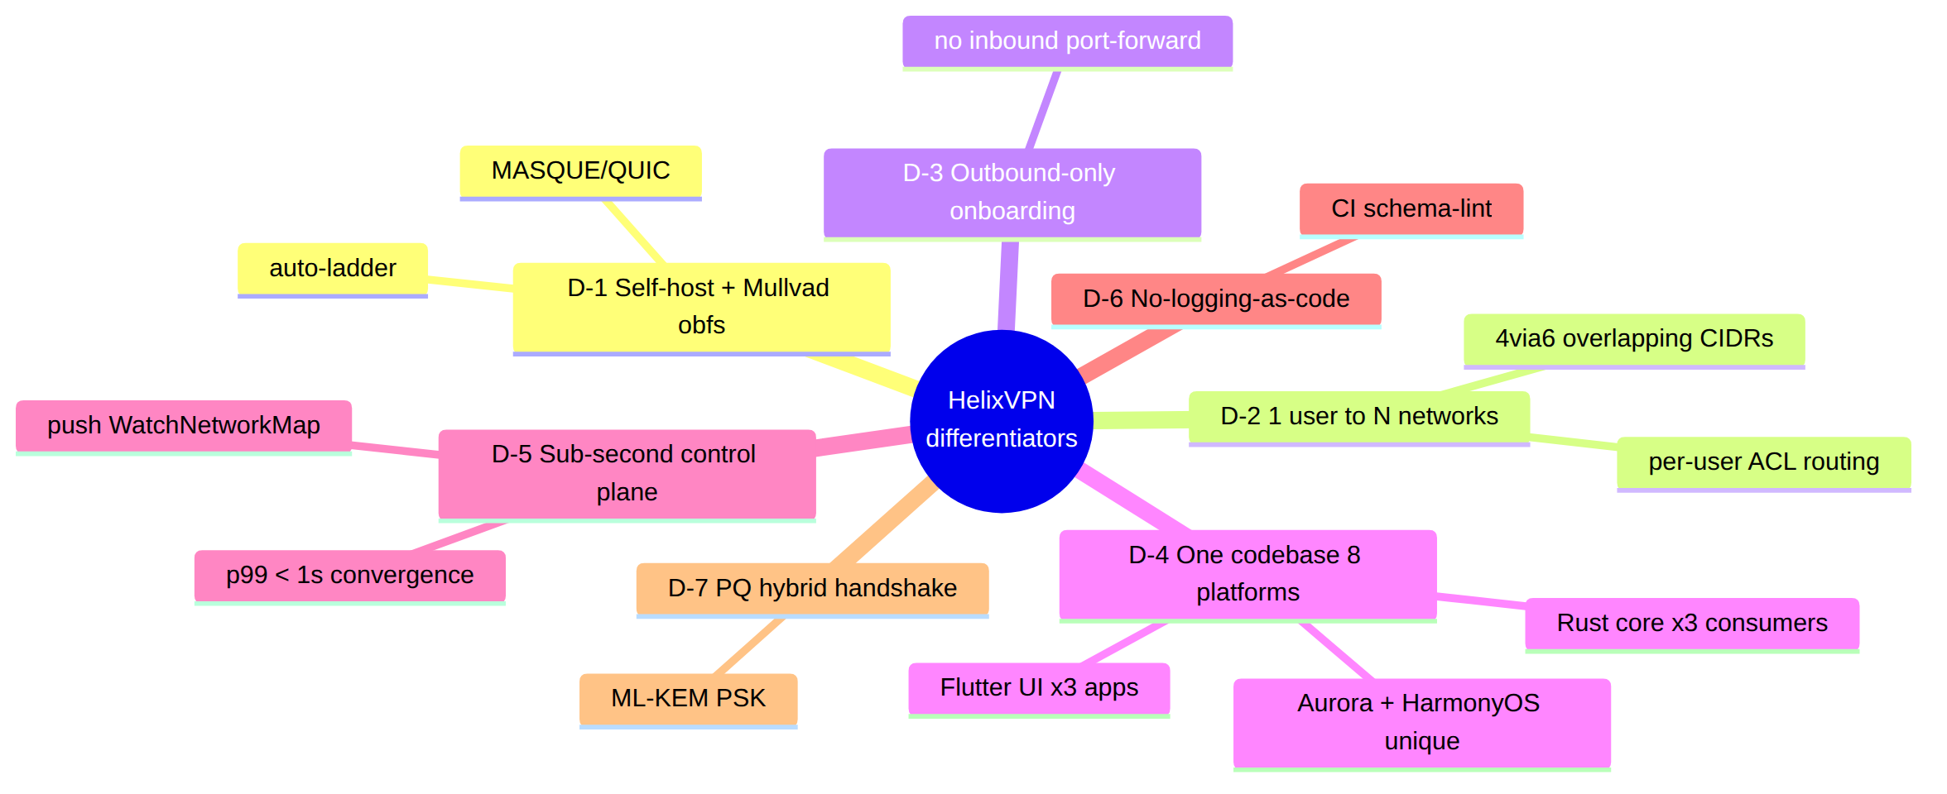

6. Explicit non-goals
The negative space is load-bearing — it keeps every downstream document from drifting into an adjacent product. These are from [00 §2.2] and [SPEC §2], stated as binding product non-goals (not "later phases").
Non-goal | Why excluded | Where enforced
NOT a forked/re-rolled WireGuard crypto | the crypto core is the audited WG Noise IK construction; HelixVPN changes only how encrypted datagrams look on the wire | ../01-data-plane.md; CI lint forbids touching WG crypto primitives [00 §2.2]
NOT a separate "QUIC protocol" alongside WG | Mullvad's QUIC mode is WG-over-MASQUE/HTTP-3, not a different protocol | D1; transport spec 01 ([research-masque])
NOT a full system VPN in a browser | browsers cannot open a TUN device; Web = Console (management) + an optional in-page WASM MASQUE proxy that proxies the browser's own traffic only | ../v04-client/web-console.md; §10 scope [00 §2.2]
NOT a logging / lawful-intercept / DLP appliance | no-logging is an architectural build property, not a toggle; control actions are audited, traffic never is | data-model spec 02; CI schema-lint [00 §2.2]
NOT a generic SDN / service-mesh / L7 API gateway | HelixVPN operates at L3 (IP overlay) + L4 port policy; it is not Envoy/Istio and does not terminate application TLS for inspection | policy spec; §2.1 scope [00 §2.2]
NOT a consumer "free VPN" ad-funded service | the default deployment is self-hosted; a managed offering is an optional later SKU, not the reason to exist | §7 [00 §2.2]
NOT dependent on inbound port-forwarding on any joined network | the reverse-tunnel insight is foundational (P3) | Principle 3; Connector spec [00 §2.2]

6.1 Two honesty markers (hard physical limits, stated to users)
Per §11.4.6, two product claims have hard physical limits and MUST be stated to users without hand-waving [00 §2.2] ([04_ARCH §5.7]):
- "Fully responsive web app" ≠ system VPN. The Web build is the Console plus a browser-scoped proxy; it cannot tunnel the whole OS (no TUN in a browser).
- iOS Network Extension ~15 MB working-set ceiling. A measured historical constraint that shapes the core-language decision (D2) and is verified on-device in Phase-0 gate G3, never assumed [00 §2.2], [SPEC §8.0 G3].

7. Positioning statement & messaging spine

7.1 The positioning statement (for-…-who-…-is-…-unlike)
For self-hosters, home-lab operators, and small MSPs who need both Mullvad-grade privacy and Tailscale-grade multi-network coordination without a SaaS dependency, HelixVPN is a self-hostable overlay network with a privacy-VPN front end that gives one user policy-scoped access to many private networks — without any inbound port-forward — on 8 platforms from one codebase. Unlike Mullvad (a service, privacy-exit only), Tailscale (no full obfuscation), or the self-hostable WG incumbents (no Mullvad-grade obfuscation), HelixVPN is the self-hosted union of all of them. [00 §6], [SPEC §2]

7.2 Per-audience messaging
Audience | Lead message | Proof point
Privacy consumer | "Mullvad's privacy stack, on a box you own — verifiable no-logs, not promised no-logs" | D-1, D-6
Home-lab operator | "Reach your lab from anywhere without opening a single router port" | D-2, D-3
Small MSP / business admin | "One overlay, N client networks, per-user default-deny policy, control-action audit" | D-2, D-5
Platform-diverse org | "One app suite on iOS, Android, Aurora, HarmonyOS, Windows, Linux, macOS, Web" | D-4
UNVERIFIED — buyer/audience segmentation and the relative appeal of each message are go-to-market hypotheses, not architectural facts. They are recorded as the messaging spine, not as requirements.

8. Strategic risks to the positioning
Honest disclosure per §11.4.6/§11.4.118 — the positioning rests on assumptions that can fail; each is a tracked risk, not a silent confidence.
Risk | Description | Mitigation / where tracked
R-V1 | The iOS NE ~15 MB memory ceiling could make the shared-Rust-core client strategy infeasible on iOS, undermining D-4 (one codebase) | Phase-0 gate G3 is make-or-break and decides D2; failure re-opens the client strategy [SPEC §8.0]
R-V2 | MASQUE may not survive real DPI at acceptable throughput, undermining D-1 | Phase-0 gate G2 (MASQUE through a DPI block ≥50% of plain); failure re-opens D1 [00 §11 D1]
R-V3 | Aurora + HarmonyOS native tunnel-shim work is the "biggest platform risk" — the unique D-4 reach could slip to Phase 3 or fail | scoped to Phase 3 with on-device exit gates [00 §10.4], [SPEC §8.3]
R-V4 | The "no self-hostable product ships 1→N + obfuscation today" claim (D-2) may be eroded by a competitor | UNVERIFIED-tagged; re-verified each §11.4.99 pass (R1)
R-V5 | Licensing (D8) unresolved could fork the community vs the managed-SKU business | OWNER-GATED decision before public release; LICENSE.PENDING until then [00 §7.2]

9. Cross-document contracts this document fixes
This document does not invent product scope — it positions the scope fixed by the overview and spine. The contracts it relies on and forwards:
- The four-lineage union pitch (§1) → inherited from [00 §1], [SPEC §1]; every differentiator (§5) traces to a borrowed lineage.
- The dual consumer+business model (§3) → the same Gateway/core serves privacy-exit and overlay-access; consumed by personas-and-roles.md (which enumerates the resulting personas) and functional-requirements.md (which numbers the resulting requirements).
- The seven non-goals (§6) → binding boundaries from [00 §2.2]; every FR in functional-requirements.md MUST stay inside them.
- Differentiators map to owning specs (§5) → each D-n names the Volume 2–5 doc that delivers it; the requirements traceability matrix (../v00-meta/requirements-traceability.md, planned) closes the loop.
- Open decisions stay open (D1/D2/D4/D8 referenced) → never silently resolved here; they live in [00 §11] / [SPEC §9].

Sources verified
- 00-product-scope-and-principles.md §1 (product definition), §2 (is/is-not + honesty markers), §6 (prior art + differentiators), §7 (hosting/licensing), §8 (principles), §9 (parity matrix), §10 (phase scope), §11 (decisions D1–D7) — primary spine for this document.
- SPECIFICATION.md §1 (executive summary), §2 (product vision), §3 (roles/apps), §8 (roadmap/gates), §9 (decision register incl. D8).
- 04-security-privacy-pki.md §0.1 (S6/S7 no-logging + control-only audit) — the privacy/no-logging product promise.
- MASTER_INDEX.md Volume 1 row (this document's declared scope: "Vision, market, prior-art deep-dive, differentiators, non-goals").
- Primary-source chain preserved from the overview: [04_ARCH §0/§1/§2/§3.3/§5.7], [05_YBO], [research-masque] (RFC 9298/9297/9221/9484).
Honesty note (§11.4.6): every competitive-market claim (prior-art capability gaps, "no product ships X today", category-convergence trend, audience segmentation) is marked UNVERIFIED and deferred to the §11.4.99 latest-source verification pass (REFINEMENT_NOTES R1). Architectural claims about HelixVPN are cited to the overview/spine. No competitor capability was asserted from training memory.
Constitution bindings: §11.4.44 (revision header), §11.4.6 (no-guessing — UNVERIFIED markers on all market claims), §11.4.66 (open decisions carry options + recommendation), §11.4.99 (latest-source re-verification deferred + tracked), §11.4.35 (inherits, never weakens, the overview's invariants), §11.4.65/.153 (HTML+PDF[+DOCX] exports follow in refinement).

