Success Metrics (KPIs) — counts-only, no-flow-by-construction

Success Metrics (KPIs) — counts-only, no-flow-by-construction
Revision: 1 Last modified: 2026-06-26T12:00:00Z
Document role. This is the Volume 1 (Product & Requirements) nano-detail spec defining HelixVPN's product KPIs and the telemetry that derives them — strictly counts and aggregates only. The defining constraint of this document is that it is bound by v05-security/no-logging-as-code.md: a KPI we cannot measure without a per-user flow, a destination, or a timestamp-of-use is a KPI we deliberately do not have — and that absence is a product feature, not a gap. Every KPI names its counts-only metric source (citing v03-control-plane/svc-telemetry.md) and the privacy boundary it respects.
Document is a SPEC. It states what we measure, from which counts-only series, against which target, within which privacy boundary; it does not build the product. Every numeric target is a TARGET marked UNVERIFIED per §11.4.6 — a product KPI threshold is a business target, not a measured fact, until the instrumented series produces data.
Evidence base. Cross-references the Volume 1 overview (principles P7 no-logging, parity F14; differentiators X1–X5; the MVP DoD §10.2), the telemetry counts-only metric registry and its forbidden-label cardinality bound (v03-control-plane/svc-telemetry.md §3), the coordinator convergence SLO (v03-control-plane/svc-coordinator.md §7), and the no-logging invariant (v05-security/no-logging-as-code.md §2 the stored-vs-never-stored partition).

Table of contents
- 1. The measurement charter (the privacy boundary is the design)
- 2. What we can measure vs what we deliberately cannot
- 3. Adoption & reach KPIs (counts-only)
- 4. Reliability & performance KPIs (SLO-derived)
- 5. Privacy-integrity KPIs (the guarantee is itself a KPI)
- 6. Censorship-resistance KPIs (aggregate ladder outcomes)
- 7. Self-host adoption KPIs (the differentiator)
- 8. The deliberately-absent metrics (and why each absence is a feature)
- 9. KPI → metric source → privacy-boundary traceability
- Sources verified

1. The measurement charter (the privacy boundary is the design)
Most products measure success with per-user funnels, destination analytics, and session timelines. HelixVPN cannot — by construction (P7 / S6): no durable connection/traffic/flow/session table exists, the event bus carries no src/dst/bytes/dns field, and /metrics forbids any tenant_id/device_id/ip label. Every KPI in this document is therefore derived from aggregate counters, SLO histograms, and bounded gauges — never from a per-user trail.
The charter, stated as three rules every KPI obeys:
- Counts and aggregates only. A KPI's source is a Prometheus counter, histogram, or bounded gauge from the telemetry registry (svc-telemetry.md §3), or an aggregate roll-up of those — never a per-user row (there is none).
- No forbidden label. A KPI may slice by a bounded label (action, event_type, stream, build version) but never by tenant_id, device_id, overlay_ip, or any traffic/PII-shaped key — that label set is forbidden by the cardinality guard (svc-telemetry.md §3.1).
- The absence is a feature. Where a conventional KPI would need a per-user flow / destination / timestamp-of-use, HelixVPN has no such KPI on purpose (§8). "We can't tell you which sites a user visited or when they were online" is the product promise, surfaced as a measurement boundary.
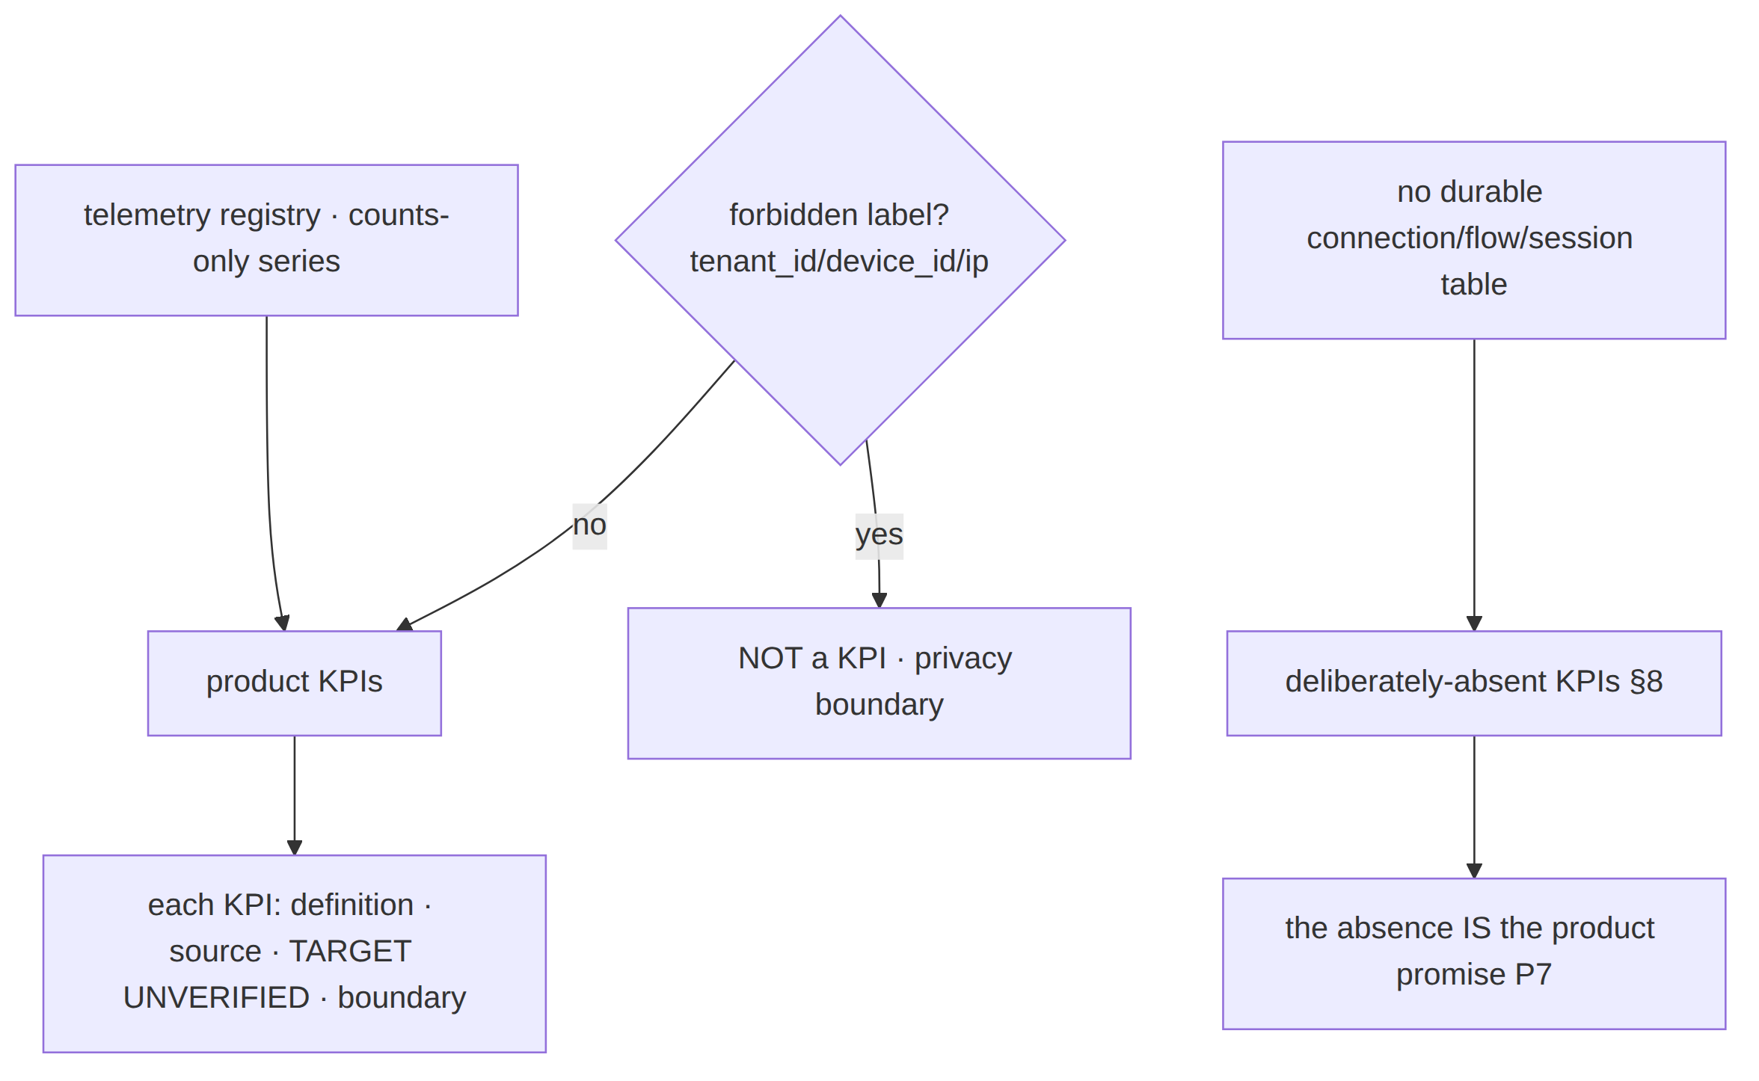
§11.4.6 honesty. Every numeric target below is a business TARGET marked UNVERIFIED — KPI thresholds are goals, not measurements. A KPI is "met" only when its named counts-only series produces data showing it; the threshold written here is never asserted as already achieved.

2. What we can measure vs what we deliberately cannot
The closed partition, drawn directly from the no-logging stored-vs-never-stored model (no-logging-as-code.md §2) projected onto the KPI layer:
Measurable (counts/aggregates exist) | Deliberately NOT measurable (no data exists)
Total devices enrolled (registry count) | Which destinations any device reached
Devices currently online (bounded presence gauge, aggregate) | When a specific user was online (no session timeline; last_seen_at coarse ≥ 5 min)
Total connectors / advertised networks (topology count) | Which user used which network at which time
Handshakes total, by transport-kind (aggregate counter) | Per-user transport history / per-user flow
Convergence/revoke SLO percentiles (histograms) | Per-user latency or per-destination latency
Aggregate bytes-total (no per-peer, no per-user) | Per-user / per-destination byte counts
Audit control-action counts, by action (bounded) | Any traffic event (none is audited — none exists)
Ladder escalation outcomes, aggregate by rung | Which user escalated on which network (no SSID, no endpoint, I5)
The right column is not "unimplemented" — it is architecturally impossible to measure because the data is never written (S6). This is the §11.4.112 structural property turned into a product virtue: the metric cannot be reconstructed because there is nothing to reconstruct it from.

3. Adoption & reach KPIs (counts-only)
KPI | Definition | Counts-only source | Target | Privacy boundary
K-ADOPT-1 Devices enrolled | total devices ever enrolled per tenant (and global aggregate) | registry row count; device.enrolled audit counter (helix_audit_events_total{action="device.enrolled"}) | TARGET growth curve — UNVERIFIED | aggregate count; /metrics exposes the global counter, per-tenant only behind authenticated /v1/stats (no tenant_id label on scrape)
K-ADOPT-2 Active devices | devices currently online | helix_presence_online_devices (bounded gauge, reconciled from SCARD) | TARGET — UNVERIFIED | aggregate gauge; no per-device identity; cannot reconstruct who or when-historically
K-ADOPT-3 Networks joined | total connectors attached + advertised prefixes (the X1 multi-network differentiator) | registry/topology counts (advertised_prefixes rows) | TARGET — UNVERIFIED | topology count (a connector's offered network), never a visited destination
K-ADOPT-4 Multi-network reach | distribution of networks-reachable-per-user (the 1 user → N nets headline) | derived aggregate from compiled-policy VisibleTo cardinality (counts, not identities) | TARGET — UNVERIFIED | a count of granted networks per role/group, never a per-user destination log
K-ADOPT-5 Apps in use | which of the three app classes (Access/Connector/Console) are active | helix_build_info + open-stream class aggregate | TARGET — UNVERIFIED | aggregate by app flavor; no per-install identity
K-ADOPT-2 boundary (§11.4.6). "Active devices" is an instantaneous aggregate count derived from the ephemeral presence set — it deliberately cannot answer "was device X online yesterday at 14:00" because presence is TTL'd and last_seen_at is coarsened to ≥ 5 min and carries no destination (no-logging §2.2). The point-in-time count is the metric; the timeline is the deliberately-absent one (§8).

4. Reliability & performance KPIs (SLO-derived)
These KPIs are roll-ups of the SLO histograms the coordinator + telemetry already expose (svc-coordinator.md §7, svc-telemetry.md §3.2). They measure system quality, never user behaviour.
KPI | Definition | Counts-only source | Target | Privacy boundary
K-REL-1 Convergence SLO attainment | % of time p99(helix_reconcile_seconds) < 1 s | helix_reconcile_seconds histogram | TARGET p99 < 1 s (DoD-5) — UNVERIFIED | histogram has no per-user/tenant label; pure system latency
K-REL-2 Revoke SLO attainment | % of revokes enforced < 1 s | helix_revoke_enforce_seconds histogram | TARGET < 1 s — UNVERIFIED | aggregate revoke timing; no per-device label
K-REL-3 Availability (fail-static) | tunnel-drops attributable to control-plane outages | chaos-test outcome + helix_presence_backend_up gauge | TARGET 0 drops on control-plane outage (NFR-200) | system gauge; no per-tunnel identity
K-REL-4 Event-pipeline health | DLQ accumulation + stream backlog | helix_events_dlq_total, helix_stream_pending_entries | TARGET DLQ flat, backlog bounded — UNVERIFIED | stream/group labels only (bounded)
K-REL-5 No-leak resource posture | coordinator memory slope over soak | process_resident_memory_bytes deriv | TARGET slope ≈ 0 over 24 h (NFR-101) | process gauge; no user data
K-REL-6 Handshake success rate | successful WG handshakes / attempts (aggregate) | aggregate handshake counter (edge /metrics) | TARGET — UNVERIFIED | aggregate by transport-kind, never per-user
K-REL-1 is the product's flagship quality KPI. It is the parity-grade real-time promise (P4) made into a falsifiable series. It carries no tenant or device label (§3.1 cardinality guard), so it measures the system's convergence, never any user's activity.

5. Privacy-integrity KPIs (the guarantee is itself a KPI)
The most important KPIs invert the usual relationship: the strength of the privacy guarantee is measured, and any erosion is a release-blocking failure.
KPI | Definition | Counts-only source | Target | Privacy boundary
K-PRIV-1 No-logging gate green | schema-lint exit-0 against migrations AND the deployed DB | schemalint exit code (pre-build + post-deploy runtime signature) | TARGET 100 % green (NFR-300/308) | meta-only; the gate proves absence, stores nothing
K-PRIV-2 Lint not a tautology | paired §1.1 mutation: planted flows table → lint FAIL | meta-test result | TARGET golden-bad FAILs every build (NFR-301) | meta-only
K-PRIV-3 Bus payload clean | zero traffic-shaped field in any event payload | payload-lint result | TARGET 0 forbidden fields (NFR-302) | meta-only
K-PRIV-4 Audit control-only | audit rows are control actions only; meta-shape guard active | helix_audit_events_total{action} (closed vocab) + reject counter | TARGET 0 traffic-shaped meta rejected-into-store (NFR-303) | bounded action label only
K-PRIV-5 Metric cardinality bound | every collector's label set ⊆ allow-list | label-audit unit test | TARGET 100 % pass (NFR-306) | the KPI enforces the boundary it lives under
K-PRIV-6 Anonymous-enroll availability | tenants can enroll devices with no email/SSO | integration test result | TARGET available (NFR-307, F15) | the feature that makes the boundary user-meaningful
K-PRIV-5 is reflexive. It measures that the KPI layer itself never grew a forbidden label — the success metric for "we did not accidentally start tracking users" is itself a counts-only, label-bounded check. A green K-PRIV-1..6 is the captured-evidence proof (§11.4.69) that the privacy promise is mechanically intact, not merely asserted.

6. Censorship-resistance KPIs (aggregate ladder outcomes)
The transport ladder records aggregate, no-per-user escalation outcomes (I5) — exactly enough to know "is obfuscation working in aggregate" without ever knowing who escalated where.
KPI | Definition | Counts-only source | Target | Privacy boundary
K-CENS-1 Obfuscation success rate | % of connect attempts that reach a working rung (aggregate) | aggregate ladder-outcome counter by terminal rung | TARGET high — UNVERIFIED | aggregate by rung-kind; no SSID, no endpoint, no per-user (I5)
K-CENS-2 DPI-survival throughput | obfuscated throughput as % of plain (the Phase-0 G2 bar) | benchmark capture (netns DPI rig) | TARGET ≥ 50 % of plain (NFR-002) — UNVERIFIED until G2 | benchmark, not production user data
K-CENS-3 Escalation-depth distribution | how far up the ladder attempts go, in aggregate | histogram of terminal-rung index (counts) | TARGET — UNVERIFIED | aggregate distribution; no per-network identity (fingerprint hash only)
K-CENS-4 Time-to-working-rung | aggregate latency to a successful WG handshake under escalation | aggregate timing histogram | TARGET bounded (NFR-006) — UNVERIFIED | aggregate timing; no per-user trace
K-CENS boundary (§11.4.6). The ladder's per-network memory persists a fingerprint hash + rung index — so K-CENS-3 can report "X% of networks needed MASQUE" in aggregate but cannot name a network, an SSID, or a user. The escalation event trace is the captured evidence (L-I9) and carries no destination.

7. Self-host adoption KPIs (the differentiator)
Self-hostability (P6 / X3) is the product's reason to exist; its success is measured by deployment-shape counts, never by reaching into deployed instances (a self-hoster's instance is theirs — HelixVPN cannot and must not phone home per-user data).
KPI | Definition | Counts-only source | Target | Privacy boundary
K-SELF-1 Self-host bootstrap success | a clean VPS reaches a working deployment via helixvpnctl init (DoD-1) | bootstrap test / Challenge outcome | TARGET 100 % on the supported path — UNVERIFIED | test outcome; no telemetry from operator instances by default
K-SELF-2 8-criteria DoD attainment | how many of the MVP DoD criteria pass on a clean self-host | DoD acceptance-suite result (8 criteria) | TARGET 8/8 — UNVERIFIED | acceptance evidence, not user data
K-SELF-3 Single-pod resource fit | the self-host pod runs within homelab resource bounds + the §12.6 60 % ceiling | host resource sampler (§11.4.24) | TARGET within budget — UNVERIFIED | host-side metric on the test host, not operator instances
K-SELF-4 Image-set parity | the same OCI image set serves self-host and fleet (no code fork) | build/artifact check | TARGET one image set — UNVERIFIED | artifact metadata, not user data
No phone-home by default (§11.4.6 / P7). A self-hosted instance does not emit per-user telemetry to any HelixVPN-operated endpoint; K-SELF KPIs are measured from the project's own acceptance suite and test hosts, never by harvesting operator deployments. A managed SKU may collect aggregate operational counters from its own fleet under the same counts-only boundary — never per-user flows.

8. The deliberately-absent metrics (and why each absence is a feature)
This is the document's thesis table: the conventional KPIs HelixVPN deliberately does not have, each paired with the product promise its absence encodes.
Conventional KPI we do NOT have | Why it cannot exist | The feature the absence encodes
Destinations per user / "top sites" | no durable destination column anywhere (S6) | "we never know where you go" — the core privacy promise
Per-user session timeline / "usage hours" | presence is ephemeral TTL; last_seen_at coarse ≥ 5 min, no destination | "we can't reconstruct when you were online"
Per-user bandwidth / data-cap analytics | no per-user/per-peer byte counts; only aggregate bytes-total | "we don't meter or profile your traffic"
Per-user transport history | ladder memory is a fingerprint hash + rung index, no per-user link (I5) | "we don't track which networks you fought censorship on"
DNS query analytics / "popular domains" | no DNS query log table (S6) | "we never log your DNS" (F13)
Funnel/cohort analysis keyed to a person | no tenant_id/device_id label on metrics; no PII-linked event | "you can be fully anonymous (F15)"
Per-tenant breakdown on public /metrics | forbidden labels; per-tenant only behind authenticated /v1/stats | "your population is not leaked to a scraper"
§11.4.112 framing. Each absence is a structural impossibility, not a backlog item: the data is never written, so the metric is unreconstructable. Reintroducing any of these would require adding a forbidden table/column/label that the schema-lint + payload-lint + cardinality guard would fail the build over (K-PRIV-1..5). The absence is therefore self-enforcing.

9. KPI → metric source → privacy-boundary traceability
KPI family | Counts-only source | Principle / parity | Privacy guard that bounds it
Adoption (K-ADOPT) | registry counts, presence gauge, audit counters | X1 multi-network | no tenant_id/device_id label; per-tenant only behind /v1/stats
Reliability (K-REL) | SLO histograms, process gauges | P4 push, P1 fail-static | no per-user/tenant label on histograms
Privacy-integrity (K-PRIV) | lint exit codes, label-audit tests | P7 no-logging, F15 | the KPIs are the boundary enforcers
Censorship (K-CENS) | aggregate ladder-outcome counters | F2/F6/F7 | fingerprint hash only; no SSID/endpoint/user (I5)
Self-host (K-SELF) | acceptance-suite + build checks | P6/X3 | no phone-home; test-host metrics only
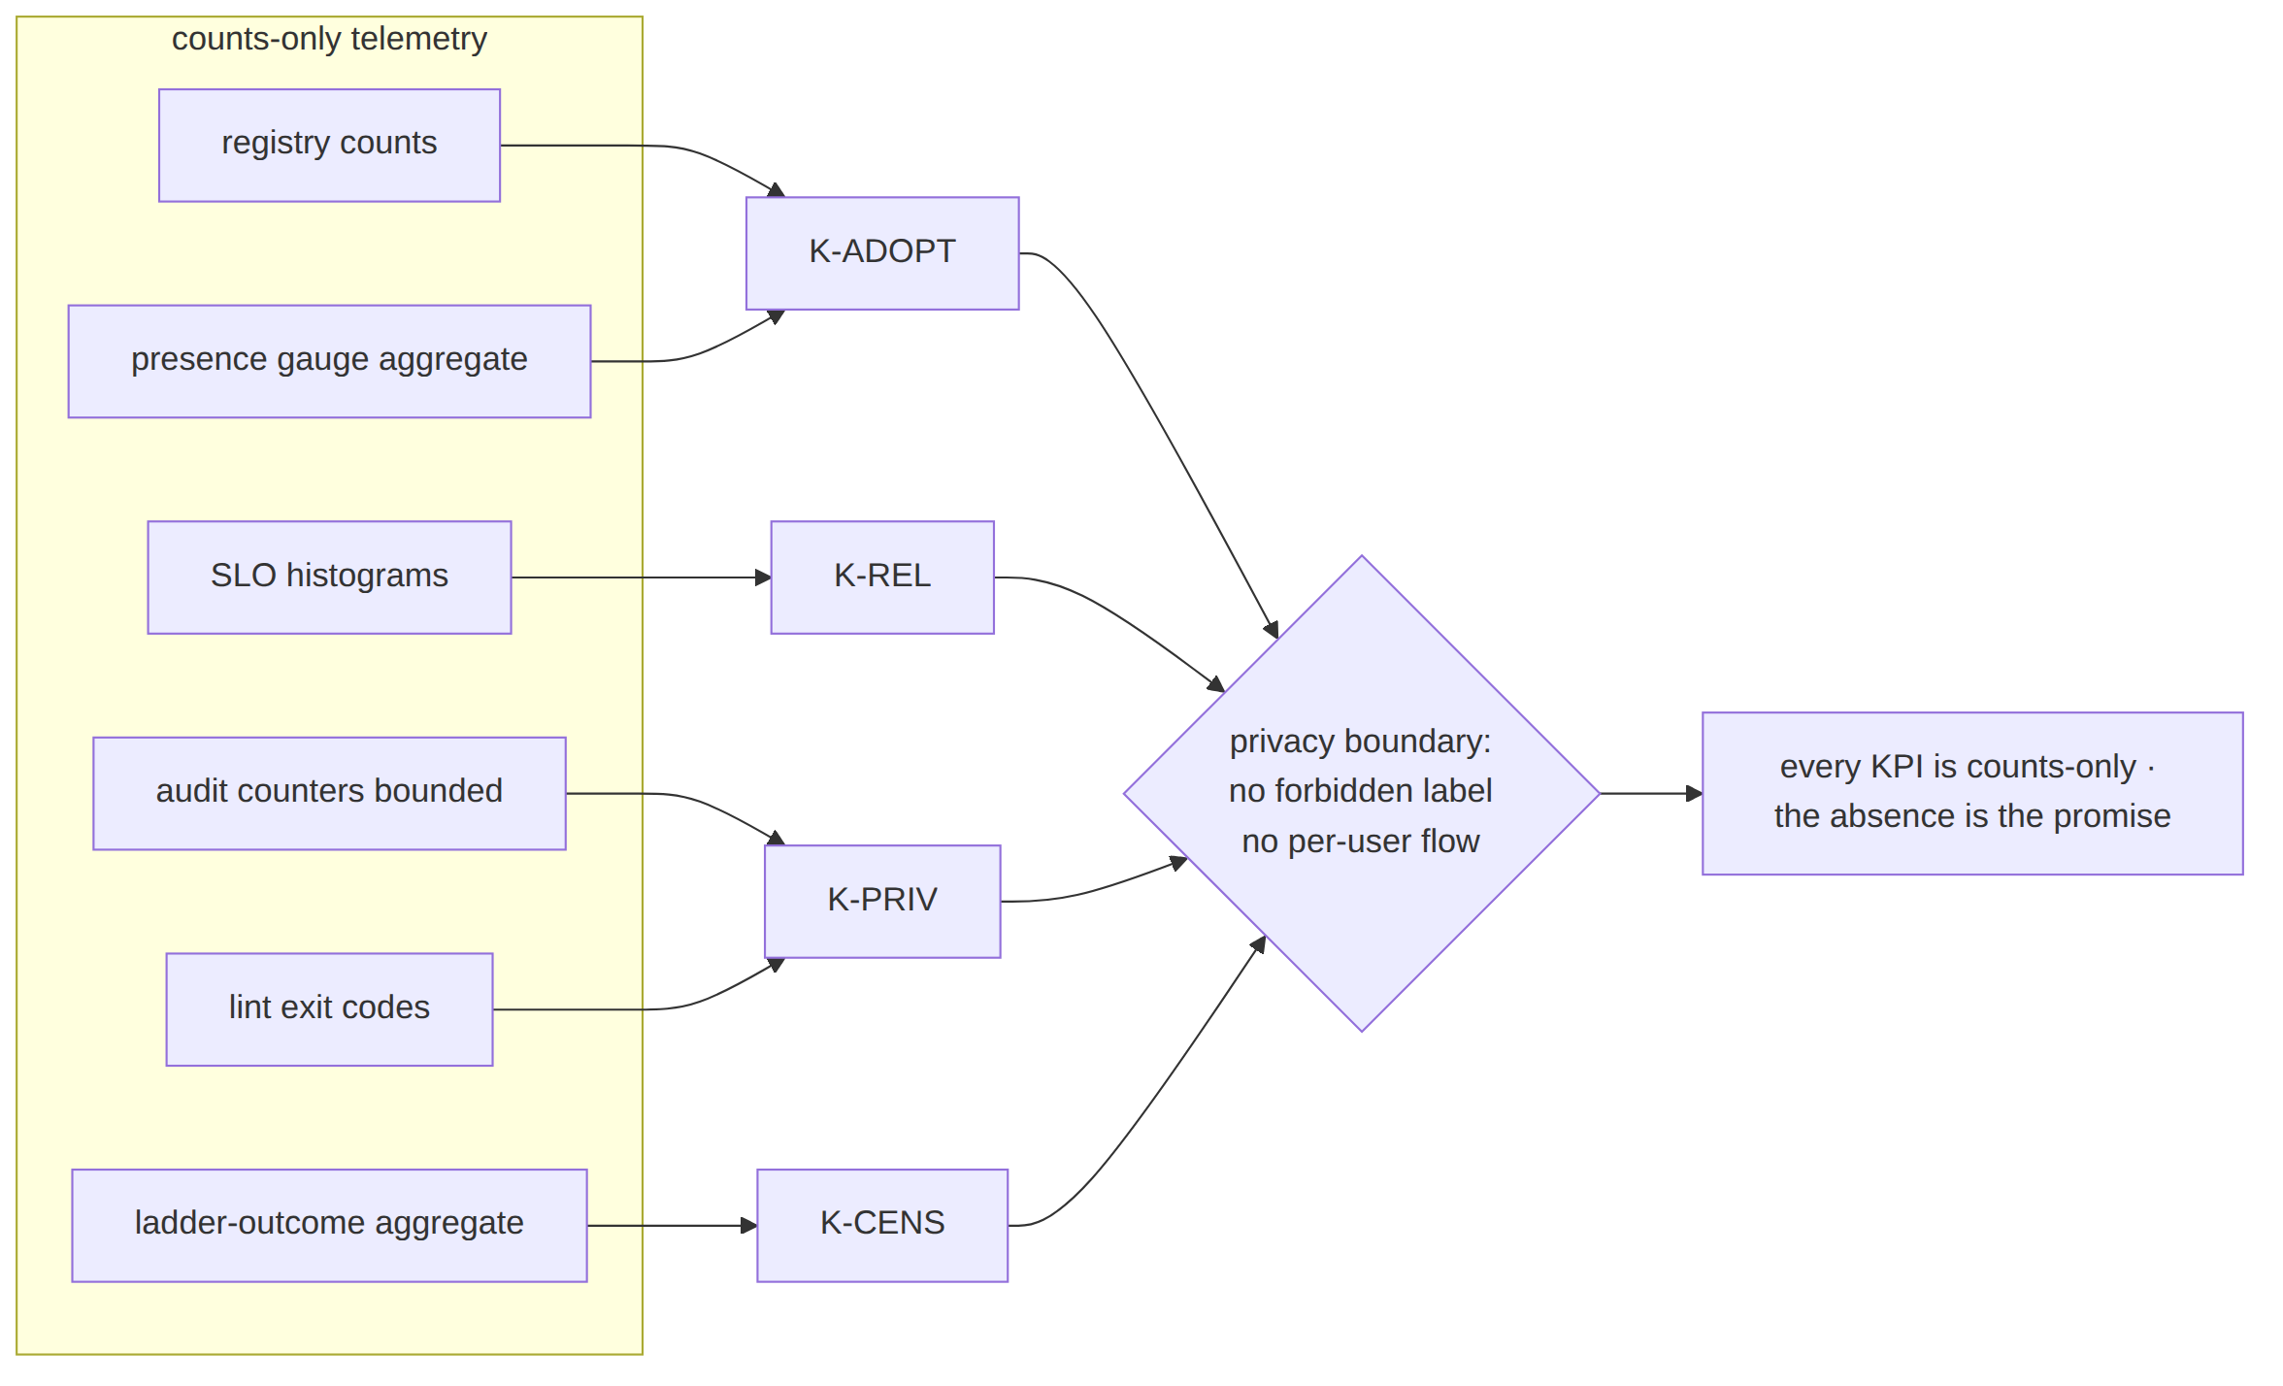
Closing honesty (§11.4.6). No target in §3–§7 is a measured result; each is a business TARGET marked UNVERIFIED and met only when its named counts-only series produces data. And by design, no KPI anywhere in this document can be computed from a per-user flow, a destination, or a timestamp-of-use — because that data never exists (P7 / S6). The measurement boundary is the product.

Sources verified
- docs/research/mvp/final/00-product-scope-and-principles.md — principle P7 (no-logging by construction §8), parity F13/F14/F15 (§9), differentiators X1/X3 (§9), the 8-criteria MVP DoD (§10.2).
- docs/research/mvp/final/v03-control-plane/svc-telemetry.md §3 — the complete counts-only Prometheus registry (helix_reconcile_seconds, helix_revoke_enforce_seconds, helix_events_dlq_total, helix_stream_pending_entries, helix_presence_online_devices, helix_audit_events_total{action}, helix_build_info, process_resident_memory_bytes); §3.1 the forbidden-label cardinality bound (no tenant_id/device_id/ip label); §5 ephemeral presence; the per-tenant /v1/stats vs public /metrics split.
- docs/research/mvp/final/v03-control-plane/svc-coordinator.md §7 — the convergence < 1 s and revoke < 1 s SLO histograms feeding K-REL.
- docs/research/mvp/final/v05-security/no-logging-as-code.md — the stored-vs-never-stored partition (§2), coarse last_seen_at (§2.2), the schema-lint + payload-lint + meta-shape guard + paired §1.1 mutation feeding K-PRIV, the deliberately-absent data classes (§8) and the structural-impossibility framing.
- docs/research/mvp/final/v02-data-plane/transport-selection-ladder.md — the aggregate, no-per-user ladder telemetry (I5) and per-network fingerprint-hash memory feeding K-CENS.
Constitution bindings applied: §11.4.44 (revision header), §11.4.6 (no-guessing — every KPI target marked UNVERIFIED, never asserted as measured), §11.4.69 (KPIs derived only from captured counts-only series), §11.4.112 (the deliberately-absent metrics framed as structural impossibilities, not backlog), the no-logging covenant (P7 / S6) bounding what any KPI may measure, §11.4.65/§11.4.153 (HTML+PDF[+DOCX] exports follow in refinement).

