Use Cases & End-to-End Journeys

Use Cases & End-to-End Journeys
Revision: 2 Last modified: 2026-07-04T12:00:00Z
Rev 2 (2026-07-04, independent gap-analysis pass). Added UC-08 — Gateway failover: the Architecture-Refined source (04_ARCH §8) sketches this flow and HVPN-NFR-206/D-GW-SELECT (decision register) depend on it, but no dedicated use-case + sequence diagram existed in this document (the other five core journeys named by the gap-analysis brief — connector onboarding, client connect+reach, policy-change propagation, and device revoke — were already covered: UC-05, UC-01, UC-04, and personas-and-roles.md §6.2 respectively). §1's catalogue table and §10's traceability table are extended to match.
Document role. This is the Volume 1 (Product & Requirements) nano-detail spec enumerating HelixVPN's primary end-to-end use cases, each rendered as a step-by-step journey with a Mermaid sequence diagram, explicit preconditions and postconditions, and the exact components and APIs exercised. It turns the three roles, seven principles, and parity matrix of the Volume 1 overview (00-product-scope-and-principles.md) into runnable narratives that the §11.4.169 test types and the 8-criteria MVP DoD trace onto.
Document is a SPEC. It describes what the user does and what the system does in response; it does not build the product. Each journey is a candidate e2e / full-automation test scenario (§11.4.98 — fully self-driving, no manual step after start) and is written so its postconditions are captured-evidence assertions, not prose claims (§11.4 / §11.4.69).
Evidence base. Cross-references the Volume 1 overview (roles §3, two-way / multi-network §4, parity matrix §9, scope §10, decisions D1/D4/D6), the coordinator streaming contract (v03-control-plane/svc-coordinator.md — WatchNetworkMap, the < 1 s convergence + revoke SLOs, the reaction table), the telemetry presence + audit model (v03-control-plane/svc-telemetry.md), the no-logging invariant (v05-security/no-logging-as-code.md), and the transport escalation ladder (v02-data-plane/transport-selection-ladder.md). Research is cited by the overview's ids ([04_ARCH §N], [04_P1]). Anything unproven is marked UNVERIFIED per §11.4.6.

Table of contents
- 1. Use-case catalogue & actor model
- 2. UC-01 — Consumer first connect (privacy exit)
- 3. UC-02 — Switch exit / server
- 4. UC-03 — Enable multihop
- 5. UC-04 — Business admin enrolls a device & sets policy
- 6. UC-05 — Connector advertises a route
- 7. UC-06 — Censorship-evade via transport escalation
- 8. UC-07 — Kill-switch trips on network drop
- 8a. UC-08 — Gateway failover
- 9. Cross-cutting postcondition invariants
- 10. Use-case → component → API → test traceability
- Sources verified

1. Use-case catalogue & actor model
The actors are the three roles of the overview plus the human personas (00-... §3, §5).
Actor | Role / persona | App
End user | Mullvad-style privacy/lab user | Helix Access
Network operator | exposes a LAN safely | Helix Connector (daemon)
Admin | manages tenants/users/devices/policy | Helix Console
Gateway control plane | Go (identity/registry/ipam/pki/policy/coordinator/events/telemetry/api) | server
Gateway edge | Rust data plane (transports + WireGuard) | server

UC | Title | Primary actor | Phase | Parity / differentiator
UC-01 | Consumer first connect (privacy exit) | End user | MVP | F1, F7, F14
UC-02 | Switch exit / server | End user | MVP | F1, X1
UC-03 | Enable multihop | End user | P2 | F10
UC-04 | Admin enrolls a device & sets policy | Admin | MVP | F15, F17, X1
UC-05 | Connector advertises a route | Network operator | MVP | X1, X2
UC-06 | Censorship-evade via transport escalation | End user | MVP | F2, F6, F7, F8
UC-07 | Kill-switch trips on network drop | End user | MVP | F11, F13
UC-08 | Gateway failover | Gateway control plane (system-initiated) | P2 | X3, NFR-206
Each journey below maps to the MVP Definition-of-Done acceptance criteria of the overview §10.2 where applicable, and each is a §11.4.98-compliant fully-automatable e2e scenario (no human step after start; non-introspectable UI falls back to the §11.4.117 pixel oracle).

2. UC-01 — Consumer first connect (privacy exit)
Goal. A new end user installs Access, enrolls anonymously (no email), and gets a full-tunnel privacy exit to the internet — the Mullvad use case.
Preconditions.
- A reachable Gateway (self-hosted or managed) with a public endpoint.
- An enrollment token (anonymous device-token path, no PII) OR an OIDC login.
- Access app installed on a supported platform (iOS/Android/Linux for MVP).
Postconditions (captured-evidence assertions).
- The device holds an overlay IP and a short-lived mTLS device cert.
- A WireGuard tunnel is established; the chosen exit carries the device's internet traffic (full-tunnel).
- A presence:{tenant}:{device} key exists in Redis (TTL'd); no durable connection row exists (NFR-300 / no-logging).
- An device.enrolled audit row exists (control action); no traffic audit.
Components / APIs exercised. identity (enroll), pki (device cert), registry (device + overlay-IP), ipam (overlay IP), coordinator (WatchNetworkMap), helix-core (tunnel + ladder), gateway edge (transport
- WG), telemetry (presence + audit).
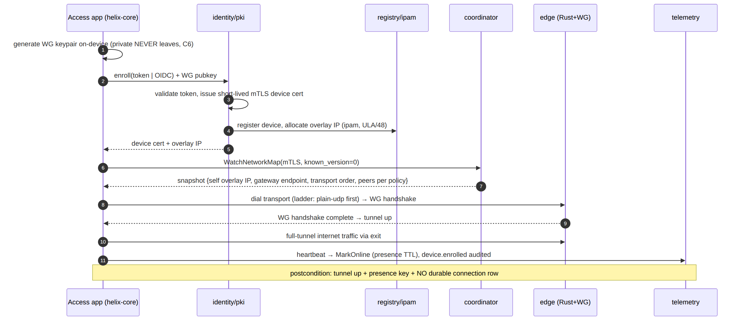
Honest boundary (§11.4.6). On iOS the tunnel runs inside the NE memory ceiling (NFR-500) — first-connect on iOS is gated by Phase-0 G3 and is UNVERIFIED until that on-device capture exists. The journey's logic is platform-neutral; the iOS resource fit is the open risk, not the flow.

3. UC-02 — Switch exit / server
Goal. A connected user picks a different exit (privacy server) or a different joined network, and traffic re-routes without dropping the app session.
Preconditions. UC-01 complete (device connected, has overlay IP + cert). The target exit/network is one the device's policy grants (need-to-know, C4).
Postconditions.
- The new exit/network carries traffic; the old one no longer does.
- Convergence to the new route is < 1 s (NFR-003) via a MapDelta, with no client restart (DoD-5 spirit).
- The kill-switch never opens a leak during the transition (NFR-404).
Components / APIs. Access UI (helix-ui ExitPicker), helix-core (re-pin/reconnect), coordinator (delta), edge (re-route), policy (VisibleTo / AllowedIPs).
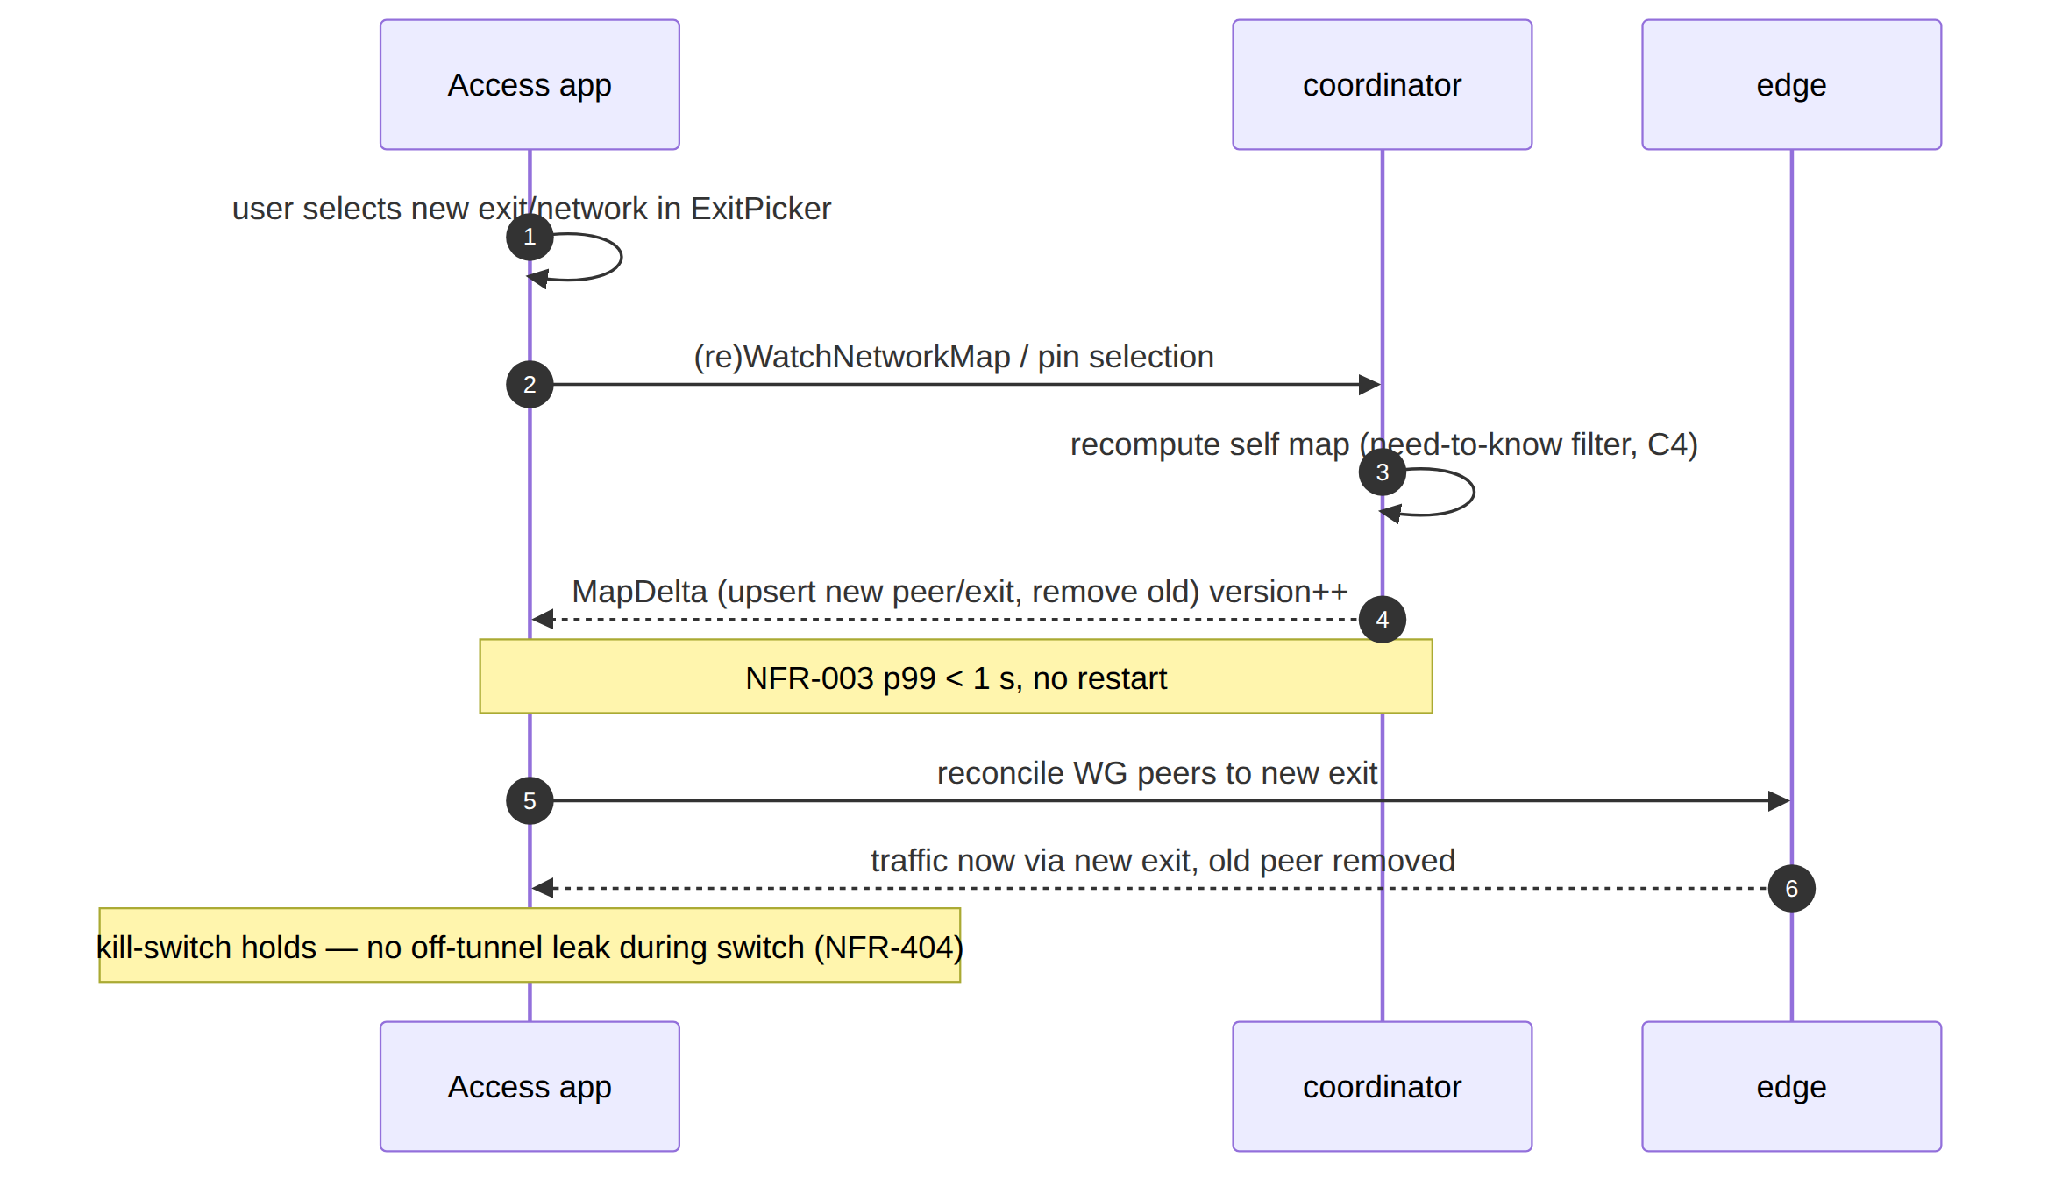
Need-to-know enforcement (C4). The user can only switch to an exit/network their compiled policy grants — a non-granted target never appears in the snapshot (NFR-402), so the UI cannot offer it. This is the multi-network (X1) differentiator surfacing as a routing choice.

4. UC-03 — Enable multihop
Goal. A privacy-conscious user enables entry/exit separation (multihop) so the entry node never sees the exit destination and vice-versa (parity F10). Phase 2.
Preconditions. P2 multihop available; user connected (UC-01). The tenant's policy/topology offers ≥2 hops in distinct jurisdictions.
Postconditions.
- Traffic traverses nested WireGuard (entry → exit), control-plane orchestrated.
- No single hop holds both the user identity and the destination.
- Latency rises (extra hop) within the obfuscation-aware budget (NFR-007) — exact added latency UNVERIFIED (P2 benchmark owns it).
Components / APIs. Access UI (multihop toggle), helix-core (nested WG), coordinator (per-hop keys in the map), policy (hop authorization), edge.
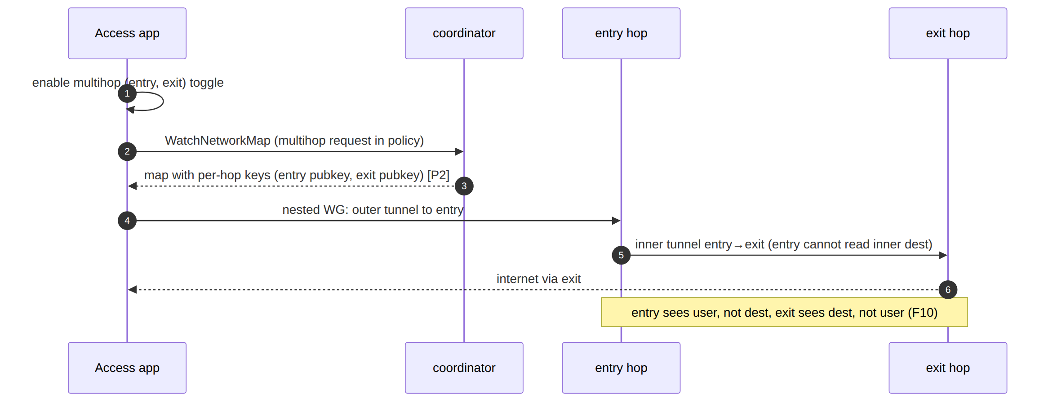
Phase boundary (§11.4.6). Multihop is explicitly OUT of MVP scope (overview §10.2 → P2). This journey is the P2 contract; its postconditions are UNVERIFIED until the P2 nested-WG implementation and its e2e capture exist.

5. UC-04 — Business admin enrolls a device & sets policy
Goal. An admin (Console) creates a user/device enrollment, then writes a default-deny ACL granting a group access to a specific network/port — reflected on the edge in < 1 s with no restart.
Preconditions. Admin authenticated to Console (RBAC admin/operator). A tenant exists; at least one connector has advertised a network (UC-05).
Postconditions.
- An enrollment token is minted (audited enroll_token.mint); the device enrolls (UC-01) and appears in the registry.
- A policy edit (group:contractors → net:warehouse:554/tcp) compiles to per-peer AllowedIPs + an edge verdict map and reaches affected agents in < 1 s (NFR-003 / DoD-5).
- Audit holds policy.create + policy.activate control rows; no traffic.
Components / APIs. Console (helix-ui admin + REST /v1/...), api (Gin REST + WS/SSE), identity (enroll token), policy (compiler), coordinator (fan-out), telemetry (audit).
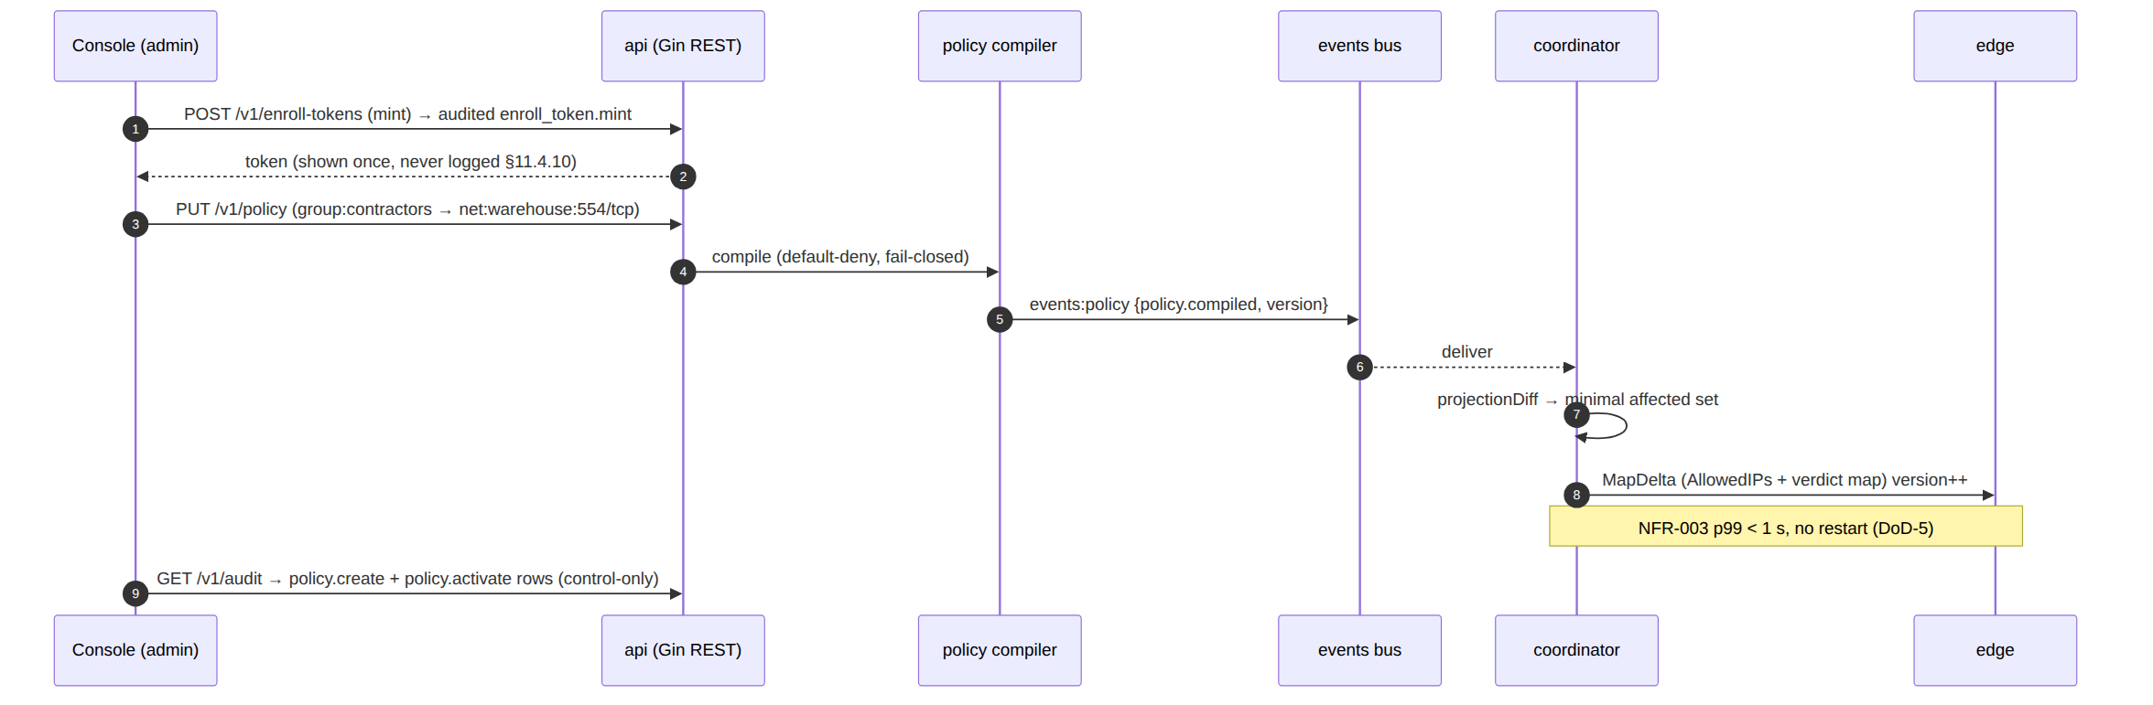
Authorization boundary. GET /v1/audit requires admin/operator; member is denied; RLS is the floor so even a mis-scoped query returns only the caller's tenant rows (NFR-408). The minted token is shown once and never logged (§11.4.10).

6. UC-05 — Connector advertises a route
Goal. A network operator installs the Connector daemon inside a private LAN; it dials outbound to the Gateway and advertises the LAN's CIDRs — no inbound port-forward, ever (P3 / X2).
Preconditions. Connector daemon installed on a host inside the LAN. An enrollment token for the connector. Outbound reachability to the Gateway.
Postconditions.
- The connector holds a device cert + overlay identity and an attached site (4via6 site id, D4).
- Its advertised CIDRs are registered; authorized users' maps gain reachable peers/routes for that network.
- Overlapping RFC1918 ranges across connectors are disambiguated by the overlay addressing scheme (ULA /48 + 4via6 / per-network NAT fallback, D4).
- No inbound port was opened on the LAN's router (P3 assertion).
Components / APIs. Connector (helix-core advertise/route mode), identity /pki, registry (route.advertised), ipam (site), coordinator (reaction connector.attached / connector.prefixes.changed), policy.
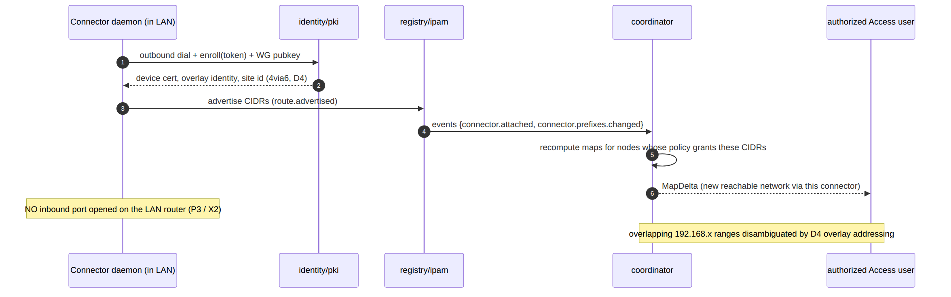
Conflict handling (§11.4.6). Two connectors advertising the same RFC1918 range raise route.conflict.detected; the coordinator does not push a delta for it — the conflict surfaces to Console and 4via6 site disambiguation resolves it (D4). The concrete addressing scheme is frozen in the Phase-1 IPAM design; until then the collision resolution detail is UNVERIFIED.

7. UC-06 — Censorship-evade via transport escalation
Goal. A user on a censored network where plain WireGuard/UDP is blocked automatically escalates the transport ladder until an obfuscated rung (MASQUE/QUIC) carries the WG handshake — Mullvad's "automatic obfuscation" (F7), looking like ordinary web traffic.
Preconditions. Device enrolled (UC-01). The current network blocks plain-UDP WG (DPI / UDP block). The ladder order is the default or a coordinator-pushed regional prior.
Postconditions.
- The ladder advances monotonically within the attempt (L-I8) until a rung completes a WG handshake (carrier-connect alone is not success, I2).
- The working rung is remembered per-network (fingerprint hash + rung index, no SSID plaintext, no endpoint, no per-connection log — I5).
- Aggregate escalation telemetry is recorded (counts only, no per-user flow).
- Throughput on the obfuscated rung meets the DPI-survival bar (NFR-002 ≥ 50 % of plain — TARGET UNVERIFIED until G2).
Components / APIs. helix-core ladder (ladder.rs), helix-transport (plain-udp / lwo / masque-h3 / …), edge (transport termination), coordinator (TransportPolicy.order regional prior), telemetry (aggregate ladder outcomes).
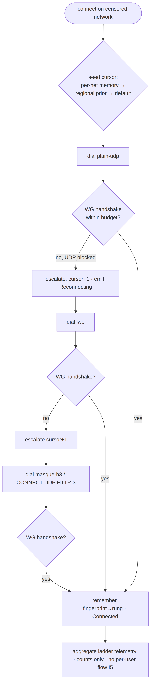
No-logging on the evade path (§11.4.6). Per-network memory persists only a fingerprint hash + last-good rung index — never the SSID, never the server endpoint, never a timestamped per-connection record (I5). The escalation event trace IS the captured evidence (L-I9), and it carries no destination. The ≥ 50 % DPI-survival throughput is a TARGET pending Phase-0 G2.

8. UC-07 — Kill-switch trips on network drop
Goal. The user's underlying network drops (or the tunnel fails); the kill-switch blocks all off-tunnel traffic so nothing leaks, and DNS stays forced through the tunnel (F11 + F13).
Preconditions. Device connected with kill-switch enabled (default-on for the privacy posture). The OS firewall integration is active (helix-core state machine + per-OS firewall driver).
Postconditions.
- On tunnel-down, 0 packets traverse the physical interface off-tunnel (NFR-404 leak test).
- 0 plaintext DNS queries escape off-tunnel (NFR-405).
- On reconnect (ladder re-runs, UC-06), the kill-switch lifts only once a tunnel is re-established — never a leak-window during the gap.
Components / APIs. helix-core (kill-switch + DNS state machine), per-OS firewall shim (nftables/WFP/NE rules), coordinator (reconnect map), edge.
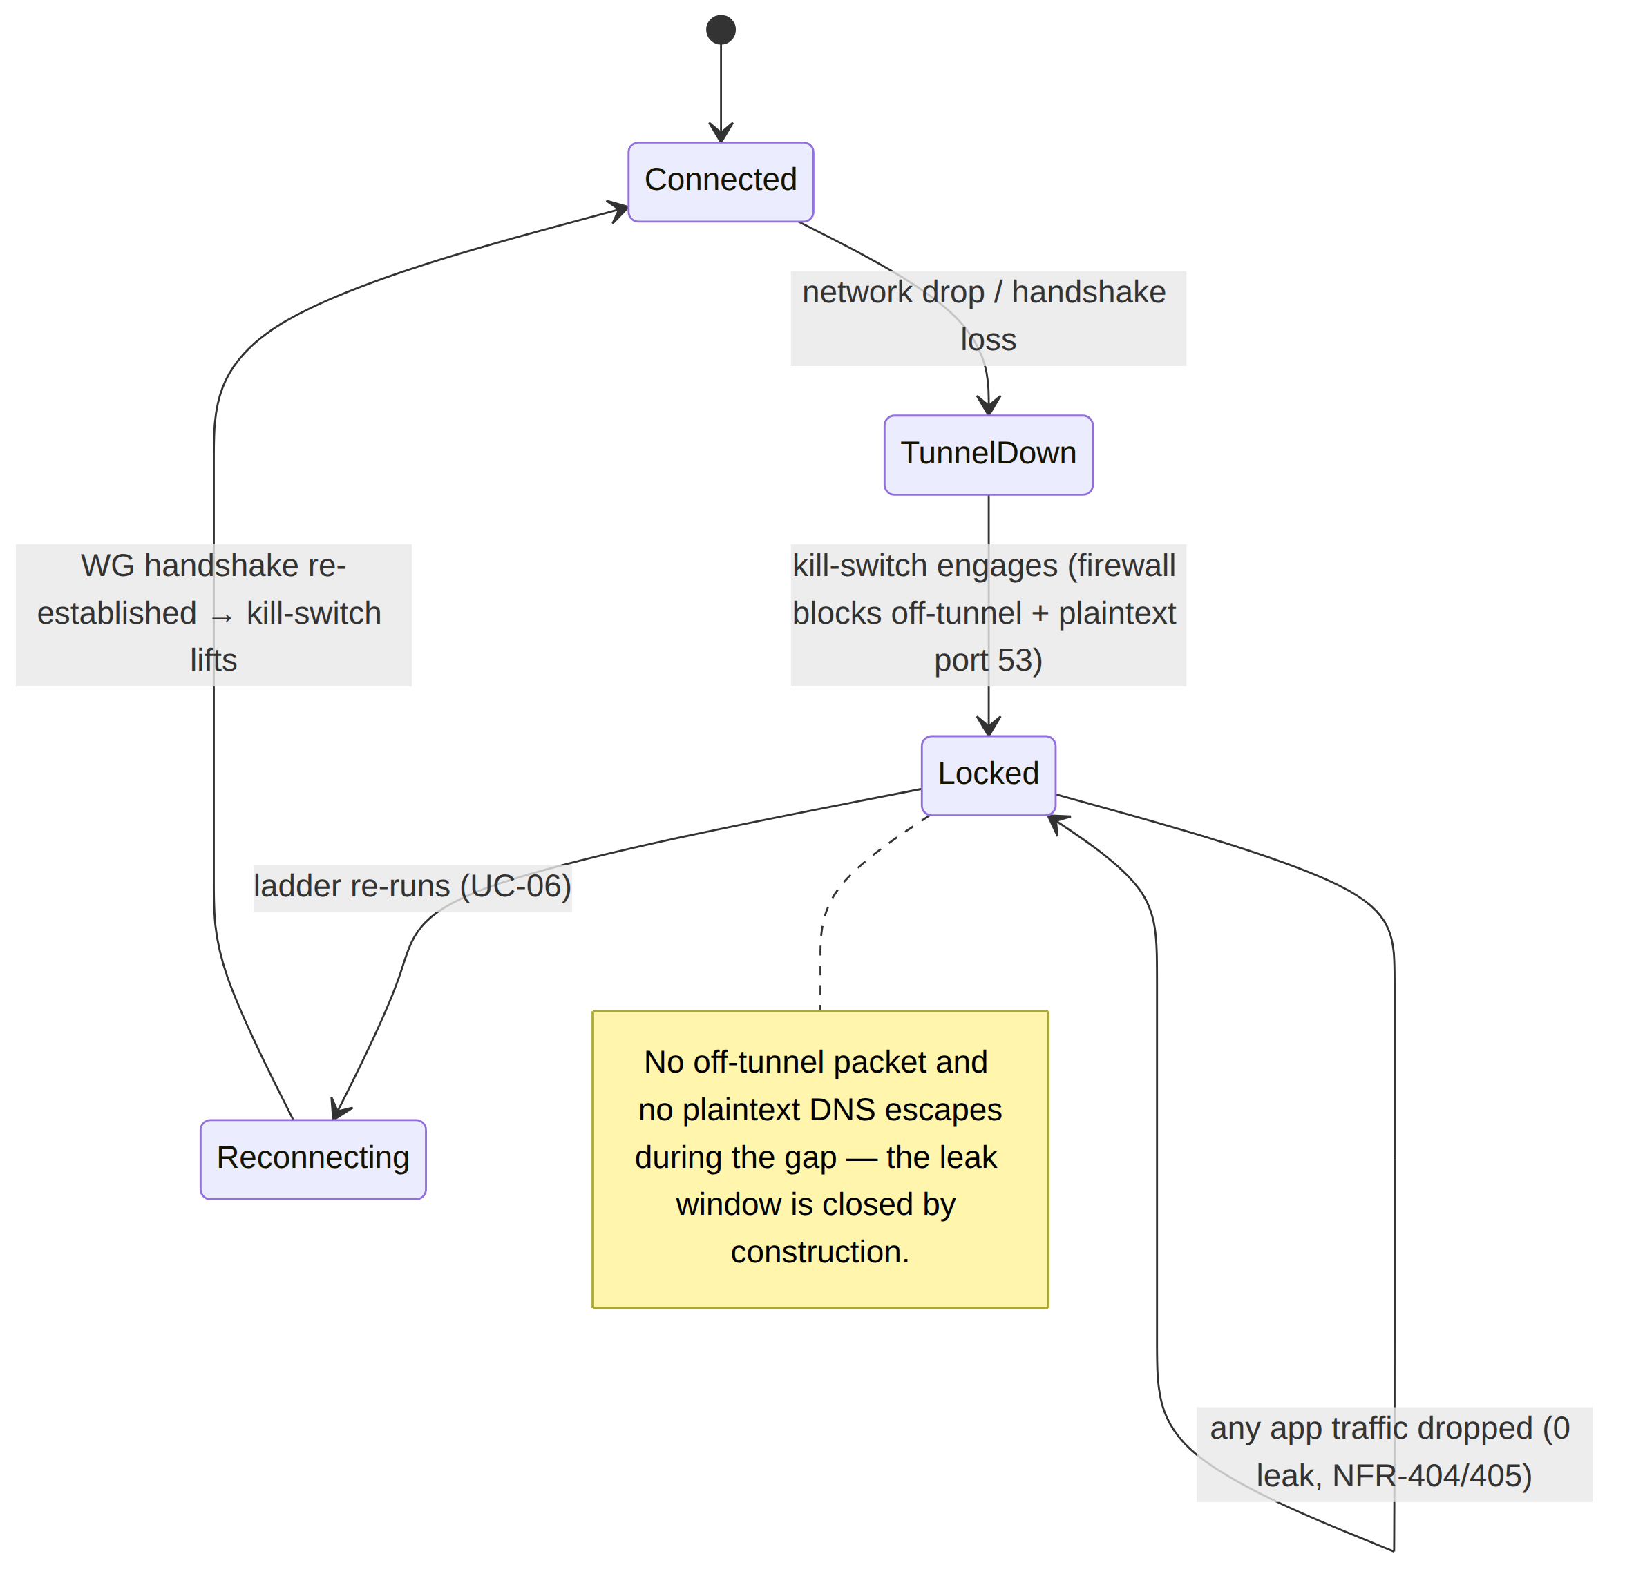
Verification (§11.4.69). The kill-switch postconditions are proven by a packet-capture leak test on the physical interface during a forced tunnel-drop: a non-zero off-tunnel packet count is a FAIL. The capture IS the evidence; "no leak observed" without the capture is a PASS-bluff (§11.4).

8a. UC-08 — Gateway failover
Goal. A gateway (region/node) becomes unhealthy; the system re-points every affected agent (clients and connectors) to a healthy gateway endpoint with the selected transport preserved and without the operator manually touching any device — the multi-region HA promise (X3, 04_ARCH §8 "Gateway failover" sketch) made into a falsifiable journey.
Preconditions. Phase-2 multi-region deployment: ≥2 gateway endpoints share control-plane state (stateless coordinators + Patroni Postgres / NATS JetStream, per v06-deploy/ha-and-multiregion.md); a health probe monitors each gateway; D-GW-SELECT (decision register) has picked a selection mechanism (geoDNS default, anycast, or map-driven GatewayInfo).
Postconditions (captured-evidence assertions).
- The health probe's failure is observed and a gateway.failover {from, to} event is emitted — never a silent gap (UNVERIFIED exact probe-timeout value until the Phase-2 HA runbook fixes it).
- Every affected agent receives a MapDelta carrying an updated GatewayInfo (new endpoint) within the convergence SLO (NFR-003 class), without the agent needing a fresh enrollment or the user taking any action.
- The client/connector re-handshakes to the new endpoint with the same selected transport (ladder position preserved — no re-run of the escalation ladder from scratch) per NFR-206.
- No private-network inbound port is opened by the failover (P3 still holds — the connector still only ever dials outbound, now to the new endpoint).
- The region-failover RTO/RPO budget is the named target owned by v06-deploy/disaster-recovery.md — this journey's postconditions are the functional correctness bar; the time bound is UNVERIFIED until that runbook's drill produces a capture (§11.4.6 — no fabricated number here).
Components / APIs exercised. health-probe/liveness (v06-deploy/observability.md), coordinator (recomputes GatewayInfo per affected tenant, emits gateway.failover), events bus, helix-core (both Client and Connector capture modes — reconnect-preserving-transport), edge (new region terminates the re-established tunnel).
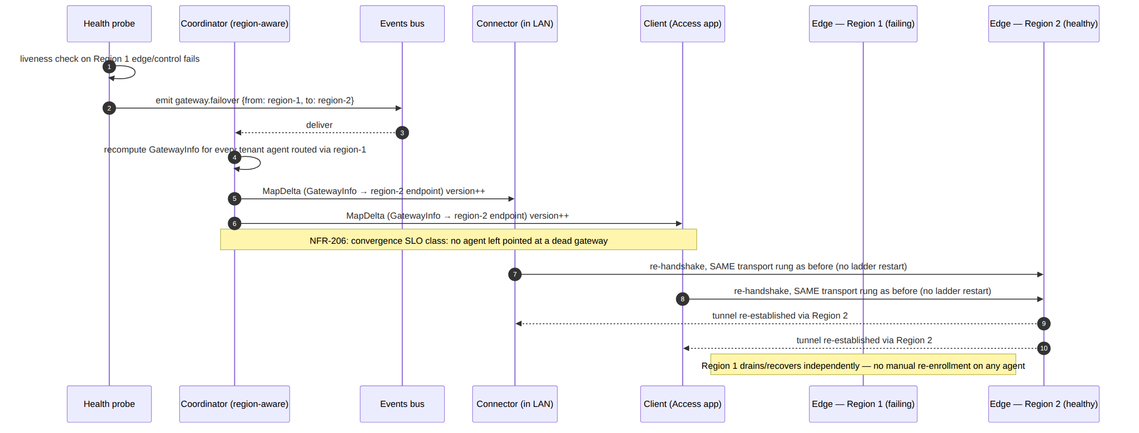
Phase + honesty boundary (§11.4.6). UC-08 is explicitly P2 (multi-region HA is out of MVP scope per the overview §10.2/§10.3) — Phase-1 self-host is single-gateway and has no failover target by design. The mechanism (health probe → gateway.failover event → GatewayInfo-only delta) is fixed here so svc-coordinator.md and ha-and-multiregion.md implement against one contract; the concrete probe-timeout and RTO/RPO numbers remain UNVERIFIED pending the Phase-2 DR drill (v06-deploy/disaster-recovery.md).

9. Cross-cutting postcondition invariants
Every journey above, regardless of actor, must leave the system in a state that satisfies these invariants — they are the union of the seven principles and the no-logging guarantee surfacing as per-journey postconditions:
Invariant | Holds in every journey because | Verified by
Fail-static (P1) | the edge forwards from a cached verdict map; a control-plane blip during any journey never drops an established tunnel | chaos (kill control plane mid-journey)
Outbound-only (P3) | every actor dials out; the gateway is the only public listener | security (no-inbound assertion)
Need-to-know (C4) | every map a journey delivers is policy-filtered; a non-granted peer never appears | meta-test (skip-filter mutation FAILs)
< 1 s convergence (P4) | every map change in a journey is a minimal MapDelta | performance (helix_reconcile_seconds)
No-logging (P7) | no journey writes a durable connection/traffic row; presence is ephemeral; audit is control-only | security (schema-lint, deployed DB)
Anonymous identity (F15) | first-connect (UC-01) needs no email/SSO | integration (anonymous enroll)
Anti-bluff coupling (§11.4 / §11.4.98). Each journey is authored as a fully self-driving e2e scenario: no human action after start, deterministic across re-runs (§11.4.50), captured evidence per postcondition. A journey that "passes" without its postcondition captures (presence key present, no durable row, delta on wire, zero leak) is a PASS-bluff at the use-case layer.

10. Use-case → component → API → test traceability
UC | Components | Key APIs / streams | DoD / NFR | §11.4.169 test type
UC-01 | identity, pki, registry, ipam, coordinator, core, edge, telemetry | enroll; WatchNetworkMap; transport dial | DoD-1/2, NFR-307/304 | e2e / full-automation
UC-02 | core, coordinator, edge, policy | WatchNetworkMap delta | DoD-5, NFR-003/402 | e2e
UC-03 | core, coordinator, edge, policy | map w/ per-hop keys (P2) | F10, NFR-007 | e2e (P2)
UC-04 | api, identity, policy, coordinator, telemetry | REST /v1/...; events:policy; audit | DoD-3/5, NFR-003/408 | e2e + integration
UC-05 | core, identity, pki, registry, ipam, coordinator, policy | route.advertised; connector.attached | X1/X2, NFR-103/104 | e2e + integration
UC-06 | core (ladder), transport, edge, coordinator, telemetry | ladder; TransportPolicy.order | DoD-4, NFR-002/410/006 | e2e (DPI-sim)
UC-07 | core (kill-switch/DNS), firewall shim, coordinator, edge | firewall state machine | DoD-7, NFR-404/405 | security / e2e (leak test)
UC-08 | health-probe, coordinator, events bus, core (client+connector), edge (2 regions) | gateway.failover event; GatewayInfo-only MapDelta | X3, NFR-206 (P2) | chaos + integration (region-failover drill)
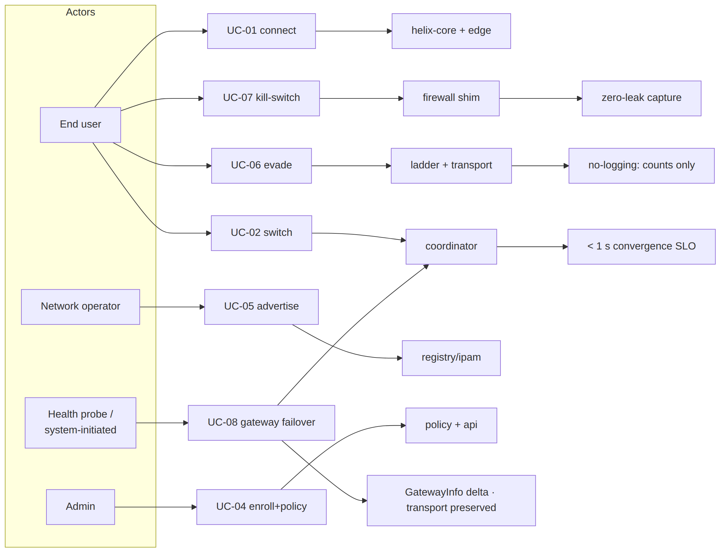
Phase honesty (§11.4.6). UC-01/02/04/05/06/07 are MVP-scoped; UC-03 (multihop) and UC-08 (gateway failover) are P2. P2/P3 postconditions are UNVERIFIED until their phase's implementation and captured e2e evidence exist — they are the forward contract, never asserted as already working.

Sources verified
- docs/research/mvp/final/00-product-scope-and-principles.md — three roles + control relationships (§3), two-way / multi-network exact meaning (§4), personas + app classes (§5), Mullvad-parity matrix F1–F17 + X1–X5 (§9), phase scope + 8-criteria MVP DoD (§10), decisions D1 (MASQUE)/D4 (ULA+4via6)/D6 (asymmetric per-leg) (§11).
- docs/research/mvp/final/v03-control-plane/svc-coordinator.md — the WatchNetworkMap streaming handler, known_version resume, the reaction table (device.enrolled/device.revoked/connector.attached/ connector.prefixes.changed/policy.compiled), need-to-know VisibleTo filtering (C4), the < 1 s convergence + < 1 s revoke SLOs (§7).
- docs/research/mvp/final/v03-control-plane/svc-telemetry.md — ephemeral Redis presence (MarkOnline/Refresh/Offline, TTL), the control-action audit vocabulary
  - meta-shape guard, counts-only metrics.
- docs/research/mvp/final/v05-security/no-logging-as-code.md — the no-logging postcondition invariants (no durable connection row, presence ephemeral, audit control-only) every journey must satisfy.
- docs/research/mvp/final/v02-data-plane/transport-selection-ladder.md — the escalation ladder behind UC-06 (seed order, monotonic cursor L-I8, WG-handshake success criterion I2, per-network memory + no-logging I5, aggregate telemetry).
- 04_VPN_CLD/HelixVPN-Architecture-Refined.md §8 ("Gateway failover" sequence sketch) and docs/research/mvp/final/v06-deploy/ha-and-multiregion.md + disaster-recovery.md (region-failover mechanism + the RTO/RPO budget owner) — the source for UC-08.
Constitution bindings applied: §11.4.44 (revision header), §11.4.6 (no-guessing — P2/P3 postconditions + unproven targets marked UNVERIFIED), §11.4.98 (every journey authored as a fully self-driving e2e scenario, no manual step after start), §11.4.50 (deterministic re-run), §11.4.69/§11.4.107 (each postcondition is a captured-evidence assertion), §11.4.117 (pixel-oracle fallback for non-introspectable UIs), §11.4.25 (use-case → component → test coverage ledger §10), §11.4.65/§11.4.153 (HTML+PDF[+DOCX] exports follow in refinement).

