DAITA (Defense Against AI-guided Traffic Analysis)

DAITA (Defense Against AI-guided Traffic Analysis)
Revision: 2 Last modified: 2026-07-04T12:00:00Z
Master technical specification — Volume 2 (Data Plane), nano-detail deepening of 01-data-plane §9. Scope: the helix-daita crate — the maybenot-based traffic-shaping stage that pads, injects cover traffic, and normalizes timing for the stream of already-encrypted WireGuard datagrams. This is a SPEC (describe what to build; do not write the shipping product). Source evidence cited inline by id: [01-DP §N] = 01-data-plane.md; [04_ARCH §N], [04_P0 §N], [04_P2 §N] = docs/research/mvp/04_VPN_CLD/*; [research-daita], [research-mullvad] = the cited research digests; [SYNTHESIS §N] = the cross-document synthesis. Anything not groundable is marked UNVERIFIED per constitution §11.4.6.

0. Position, ownership, and what this document fixes
DAITA defeats size / timing / frequency fingerprinting of fully-encrypted flows: a passive on-path observer (ISP, network tap, censor) cannot read WireGuard payloads but CAN observe packet sizes and timing, and modern ML/DL website-fingerprinting attacks (Deep Fingerprinting "DF", Robust Fingerprinting "RF") classify which site/service/contact a user is reaching purely from those size+timing traces [research-mullvad §1, research-daita §2]. DAITA = Defense Against AI-guided Traffic Analysis, Mullvad's mechanism, built on the maybenot framework developed with Karlstad University [research-daita §2].
The single load-bearing rule [01-DP §9, 04_P2 §2]: do not roll your own traffic- analysis defense. HelixVPN adopts maybenot (the same Rust framework Mullvad's DAITA runs on) as the state-machine engine; helix-daita owns only (a) the placement (L2.5, above WireGuard, below the transport), (b) the per-packet hook and timer pump, (c) the constant-size padding / cover-injection / timing-block actuators, and (d) the machine-distribution-as-data path via NetworkMap.daita. The privacy policy (which machines, the website-fingerprinting validation harness, off-by-default opt-in semantics) is referenced here for its data-plane seams and specified in full in the security doc [01-DP §9].

0.1 What helix-daita owns vs. does not own
Owns (this document) | Does NOT own
The helix-daita crate: Daita, DaitaConfig, the on_packet / tick / on_recv hooks | The maybenot state-machine engine internals (vendored crate maybenot 2.x [research-daita §1])
Constant-size padding actuator + cover-packet emitter + outgoing-block (timing-norm) actuator | The content of defense machines (authored offline as data; security doc)
Wiring into the orchestrator's outbound/inbound loops (L2.5 placement) [01-DP §5.1, §9] | The NetworkMap.daita wire schema (doc 03 WatchNetworkMap) — consumed here, defined there
The padding-marker datagram format on the WG-datagram boundary | WireGuard crypto / Tunn (helix-wg §4) — DAITA never touches plaintext
Off-by-default opt-in gate; honest overhead accounting + back-pressure | The censorship/transport ladder (helix-transport, [01-DP §3]) — DAITA is orthogonal to which transport runs
Test points (unit/integration/sim/perf/chaos) | The website-fingerprinting evaluation corpus + AI-classifier harness (security doc)

0.2 Phase
DAITA is a Phase-2 capability [SYNTHESIS §4, 01-DP §9, 04_P2 §2]. The Phase-0/1 data plane reserves its seam — the [DAITA] stage in the outbound loop TUN → WG encrypt → [DAITA] → Transport [01-DP §5.1] — but ships the stage as a transparent pass-through (DaitaMode::Off) until Phase 2. This document specifies the Phase-2 implementation against that already-frozen seam.

1. Threat model & design invariants

1.1 Threat model (what DAITA defends; what it does not)
# | Adversary capability | DAITA response | Source
T1 | Passive on-path observer reads packet sizes | Constant-size padding → every emitted datagram is one uniform size | [research-mullvad §1, research-daita §2]
T2 | Observer reads timing / inter-packet gaps | Probabilistic cover injection + outgoing-block (delay) machines distort timing | [research-daita §1, §3]
T3 | Observer detects idle vs. active (NetFlow collapse) | Inactivity-padding machine emits cover when the tunnel has been silent | [research-daita §3, research-mullvad §1]
T4 | ML/DL website-fingerprinting (DF / RF) on size+timing burst shape | Bidirectional cover during bursts reshapes the trace below classifier accuracy | [research-mullvad §1, research-daita §2]
T5 | Adversary trains a model on the current defense set | v2 server-pushed machine rotation invalidates a model trained on the previous set | [research-mullvad §1 (v2), research-daita §4]
Out of scope for DAITA (honest boundary, §11.4.6): it does not hide that a VPN is in use (that is the obfuscating-transport's job, [01-DP §3.3 masque-h3]); it does not protect against an active adversary that injects/drops packets to probe timing (maybenot's defense is statistical, not adversarial-robust against active perturbation — UNVERIFIED whether HelixVPN adds any active-probe mitigation beyond maybenot's stock behavior); it does not alter WireGuard crypto (T-confidentiality is WG's job, [01-DP §4]).

1.2 Data-plane invariants DAITA must preserve
These inherit from [01-DP §0.1] and add DAITA-specific clauses:
# | Invariant | Rationale
D1 | DAITA operates on already-encrypted WG datagrams — it never sees, pads, or reorders plaintext IP packets. Inherits [01-DP I1]. | Padding/cover must be indistinguishable-from-real to the observer; only post-WG-encrypt bytes are.
D2 | DAITA preserves WG's unreliable-datagram semantics: it may add datagrams (cover) and grow a datagram (pad), but never merges, splits, reorders, or drops a real WG datagram. Inherits [01-DP I2]. | A reordered/dropped real datagram breaks WG roaming/keepalive timing and is itself a fingerprint.
D3 | DAITA is orthogonal to the transport: identical behavior whether the active transport is plain-udp, masque-h3, shadowsocks, … [01-DP §9, 04_P2 §2.2]. | One shaping stage, N transports — same one-crate-three-consumers discipline as helix-transport [01-DP I4].
D4 | DAITA is off by default, opt-in only ("maximum privacy"), with an honest bandwidth/latency cost surfaced to the user [01-DP §9, 04_P2 §2.3]. | Cover traffic costs real bytes/CPU/battery; a silent default would be a §11.4.6 dishonesty.
D5 | DAITA machines are data, not code: distributed via NetworkMap.daita, tunable server-side without a client rebuild [01-DP §9, 04_P2 §2.3, research-daita §4 (v2)]. | Matches Mullvad v2 server-pushed model; lets defenses rotate to invalidate trained classifiers (T5).
D6 | DAITA enforces maybenot budgets (padding fraction, blocking fraction) — it can never exceed the configured overhead ceiling. [research-daita §1, research-mullvad §2]. | Bounds the worst-case cost; prevents a misconfigured machine from saturating the link.
D7 | Cover datagrams are dropped at the peer's DAITA inbound stage and never delivered to WG/TUN. | A cover datagram that reached Tunn would be a malformed WG packet and waste decrypt cycles.

2. Placement in the data plane (L2.5)
DAITA is a stage above WireGuard, below the transport — layer L2.5 in the [01-DP §1] model. It operates on the stream of WG datagrams (padding / injecting cover) before they hit the obfuscating transport, and on inbound datagrams after the transport but before WG, to strip cover and account for received-packet events [01-DP §9, 04_P2 §2.2].
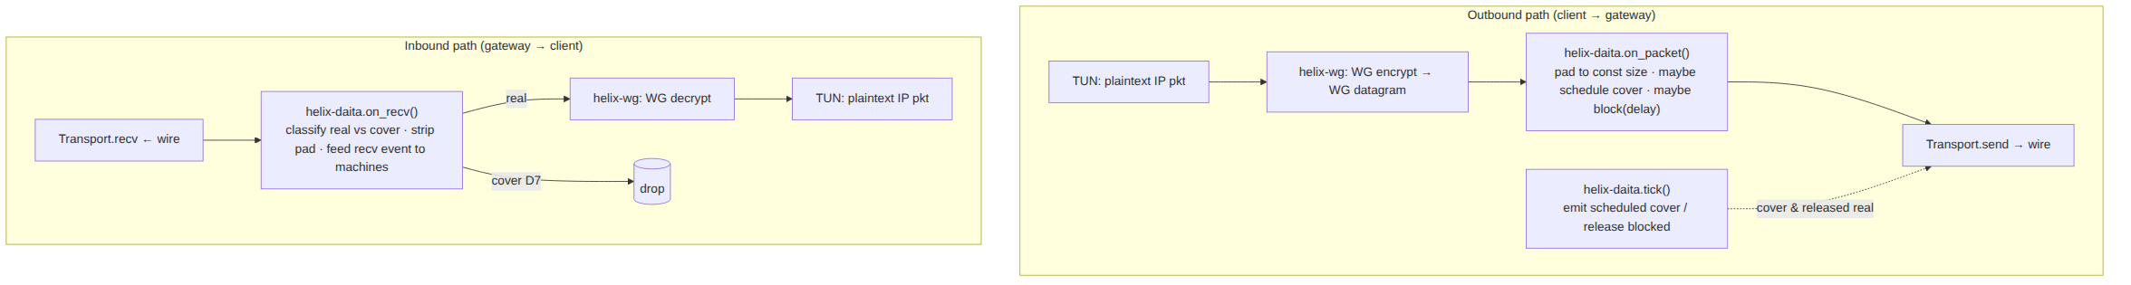
Both endpoints run a DAITA instance (symmetric deployment — one at the client, one at the gateway/relay) [research-mullvad §1, research-daita §2]. The gateway's instance is the same helix-daita crate compiled into helix-edge (the third consumer, [01-DP §2]); the relay- side machine set differs from the client-side set (v1 had 4 client + 3 relay machines [research-daita §3]) but the engine and actuators are byte-identical code.
Why above WG, not below the transport-AND-below-WG: padding/cover must look like real encrypted traffic to the observer, so it must be inserted on the encrypted datagram stream (D1). Placing it below the transport (after masque-h3 framing) would corrupt the QUIC/HTTP-Datagram structure; placing it above WG-encrypt (on plaintext) would violate D1 and risk leaking pad structure through WG's own length handling. L2.5 is the only correct seam. [01-DP §9, 04_P2 §2.2]

3. The maybenot framework (the vendored engine)

3.1 What it is, and exactly which version
maybenot is an open-source Rust framework for traffic-analysis defenses — a generalization of Tor's Circuit Padding Framework (itself a generalization of WTF-PAD), peer-reviewed at ACM WPES'23 (doi 10.1145/3603216.3624953, arXiv 2304.09510) [research-daita §1, research-mullvad §2]. A defense is expressed as a list of probabilistic state machines plus limits (padding/blocking budgets) [research-daita §1].
Pinned dependency (constitution §11.4.99 latest-source, verified 2026-06-25 [research-daita §1, §"Sources verified"]):
Crate | Version | Role | Confidence
maybenot | 2.2.2 | core framework (events → scheduled actions) | confirmed via libraries.io [research-daita §1]
maybenot-simulator | 2.2.1 | offline eval / test simulator (§9) | confirmed via crates.io [research-daita §1]
maybenot-ffi | (tracks core) | C ABI — not used by HelixVPN (we consume the Rust crate directly) | [research-daita §1]
maybenot-machines | 1.0.1 | ready-made machine library (seed defenses) | UNVERIFIED — from a search snippet, not a fetched crates.io page [research-daita §"Negative findings"]
MSRV 1.85 [research-daita §1]. The crate is MIT-licensed [research-mullvad §2]. Per constitution §11.4.74 (catalogue-first / extend-don't-reimplement): maybenot is a third-party upstream — consumed as a pinned Cargo dependency, not vendored into an owned submodule, and not re-implemented. If a needed machine primitive is missing, the path is an upstream PR to maybenot-io/maybenot, never an in-tree fork [01-DP analog, §11.4.74].
maybenot-machines version caveat (§11.4.6): the 1.0.1 figure is UNVERIFIED (search snippet only). The build MUST pin whatever version cargo resolves at integration time and record the resolved hash in Cargo.lock; treat 1.0.1 as a planning placeholder, not a fact.

3.2 maybenot execution model (the contract helix-daita drives)
An instance repeatedly takes events describing the encrypted traffic and emits 0+ scheduled actions [research-mullvad §2, research-daita §1]:
- Events in: NormalSent, NormalRecv, PaddingSent, PaddingRecv, timer expiry, etc. (the exact maybenot 2.x event enum is the upstream API — helix-daita adapts its own packet events onto it; the precise variant names are the upstream maybenot::TriggerEvent set, treated as the vendored API surface).
- Actions out: SendPadding (inject a cover packet) and BlockOutgoing (delay/hold outgoing traffic for a timer = timing normalization) [research-daita §1, research-mullvad §2]. Each action carries a machine id + a timer.
- Limits/budgets: the framework caps how much padding and how much blocking each machine may impose (the padding budget / blocking budget) [research-daita §1, §4].
helix-daita is the integration layer: it (1) translates HelixVPN packet I/O into maybenot events, (2) receives maybenot actions, and (3) actuates them on the WG-datagram stream (pad, emit cover, block) while enforcing D2/D6/D7. The state machines themselves are data loaded from config (D5).

3.3 v1 vs v2 — which generation HelixVPN targets
 | DAITA v1 [research-daita §3] | DAITA v2 [research-daita §4, research-mullvad §1]
Client machines | 4 hardcoded: (1) inactivity pad if no send in random [1.5, 9.5] s; (2) send for every 3rd packet received; (3) send for every 5th packet received; (4) randomized-delay padding when idle | None hardcoded — relay selects from a defense DB and pushes machines + limits to the client at connect time
Relay machines | 3 per defense: NetFlow machine + Interspace-inspired padding + a uniquely-generated anti-DF/RF machine | Server-side DB; rotated to invalidate trained classifiers (T5)
Bandwidth overhead | baseline | ~50% lower (~half the dummy packets) at same protection level [research-daita §4, research-mullvad §1]
Update model | client rebuild to change defenses | server-side rotation, no client update [research-mullvad §1]
HelixVPN target: the v2 model [01-DP §9 "machines distributed as data", research-daita §4 "parity takeaways"]. The NetworkMap.daita field IS the v2 server-push channel (D5). The v1 hardcoded constants ([1.5,9.5] s, 3rd/5th-packet ratios) are retained only as the seed machine set shipped as data for the first Phase-2 release (a known-good baseline authored offline), not as compiled client logic. This makes HelixVPN's client architecturally v2 from day one while reusing v1's published, evaluated machines as initial content.
§11.4.6 on the constants: the [1.5, 9.5] s window and 3rd/5th-packet ratios come from Tobias Pulls' (maybenot author) blog, authoritative for the design but not re-published by Mullvad as exact production constants [research-daita §"Negative findings"]. HelixVPN treats them as the documented seed values and re-tunes against its own evaluation corpus (§9.4) before any "matches Mullvad" claim. Exact v2 padding-budget numbers and the relay defense-DB size are not public [research-daita §"Negative findings", research-mullvad §"Honest gaps"] → HelixVPN derives its own budgets empirically.

4. helix-daita — types, traits, and the per-packet hook
The crate lives at helix-core/crates/helix-daita/ [01-DP §2]. It is a decoupled, reusable component (own logic, no project-specific reach) per §11.4.28.

4.1 Public surface
// helix-daita/src/lib.rs
use bytes::{Bytes, BytesMut};
use std::time::Instant;
/// The DAITA shaping stage. Wraps a maybenot Framework whose machines are CONFIG
/// loaded from NetworkMap.daita (D5), never code. One instance per endpoint (D3, symmetric).
pub struct Daita {
mode: DaitaMode,
fw: Option<maybenot::Framework<Vec<maybenot::Machine>>>, // None when mode == Off (pass-through)
pad_to: u16, // constant target size in bytes (T1); see §6
budget: Budget, // D6 enforced ceilings
rng: DaitaRng, // ChaCha20-seeded; cover timing must be unpredictable (T2)
stats: DaitaStats, // aggregate counters only (I5 / §11.4.6)
epoch: Instant, // monotonic base for maybenot timers
}
#[derive(Clone, Copy, Debug, PartialEq, Eq)]
pub enum DaitaMode {
Off, // D4 default: transparent pass-through, zero overhead
On, // machines active per loaded config
}
/// One action the orchestrator must perform, returned from on_packet()/tick().
/// helix-daita NEVER does I/O itself — it returns intents the orchestrator actuates,
/// keeping the stage testable and cancel-safe (matches the Transport trait discipline).
#[derive(Clone, Debug)]
pub enum ScheduledAction {
/// Send this (already-padded, real or cover) datagram now.
SendNow(Bytes),
/// Send a cover datagram at/after `at` (T2 unpredictable timing).
SendCoverAt { at: Instant, len: u16 },
/// Hold outgoing real datagrams until `until` (BlockOutgoing = timing normalization, T2).
BlockOutgoingUntil { until: Instant },
/// Release any outgoing block early (machine transition).
Unblock,
}
#[derive(Clone, Copy, Debug)]
pub struct Budget {
/// Max fraction of total emitted datagrams that may be padding/cover (e.g. 0.5 = ≤50% cover). D6.
pub max_padding_frac: f32,
/// Max fraction of wall-time outgoing traffic may be blocked/delayed. D6.
pub max_blocking_frac: f32,
/// Hard ceiling on queued cover actions (back-pressure; §7.3).
pub max_pending_cover: u16,
}
impl Daita {
/// Construct from the NetworkMap.daita config (D5). Off-config → pass-through.
pub fn from_config(cfg: &DaitaConfig, now: Instant) -> Result<Self, DaitaError>;
/// Hot-swap machines/budget when a new NetworkMap.daita delta arrives (no tunnel restart;
/// matches the §6.3 reconciler "push, don't poll"). Drains in-flight cover safely (§7.4).
pub fn reconfigure(&mut self, cfg: &DaitaConfig, now: Instant) -> Result<(), DaitaError>;
/// OUTBOUND hook — called for every real WG datagram leaving helix-wg, BEFORE the transport.
/// Pads `dg` in place to the constant size (T1) and feeds a NormalSent event to maybenot;
/// returns the actions to perform (the real datagram + any scheduled cover/block).
pub fn on_packet(&mut self, dg: &mut BytesMut, now: Instant) -> Vec<ScheduledAction>;
/// TIMER hook — called on the orchestrator tick (§7.2 cadence). Emits scheduled cover and
/// releases expired blocks; feeds timer events to maybenot.
pub fn tick(&mut self, now: Instant) -> Vec<ScheduledAction>;
/// INBOUND hook — called for every datagram from the transport, BEFORE helix-wg.
/// Classifies real vs cover (D7), strips padding, feeds NormalRecv/PaddingRecv to maybenot.
/// Returns Some(real WG datagram) to forward to WG, or None if it was cover (dropped, D7).
pub fn on_recv(&mut self, dg: Bytes, now: Instant) -> Result<Option<Bytes>, DaitaError>;
pub fn mode(&self) -> DaitaMode { self.mode }
pub fn stats(&self) -> DaitaStats { self.stats.clone() }
}

4.2 Config types (the parsed form of NetworkMap.daita)
// helix-daita/src/config.rs
/// Parsed from the `daita` field of the NetworkMap (doc 03). The wire form is doc 03's;
/// THIS is the in-memory desired-state the reconciler converges to (§6.3 pattern).
#[derive(Clone, Debug)]
pub struct DaitaConfig {
pub enabled: bool, // D4 — false ⇒ Off pass-through
pub pad_to: u16, // constant packet size target (T1); see §6.1 selection
pub budget: Budget, // D6
/// maybenot machine definitions as DATA (D5). Each is a serialized maybenot machine string
/// (the framework's own machine serialization) authored offline / generated server-side.
pub machines: Vec<MachineSpec>,
pub role: DaitaRole, // Client | Relay — selects which machine set applies
}
#[derive(Clone, Debug)]
pub struct MachineSpec {
pub id: u16, // stable id (for stats/telemetry attribution)
pub serialized: String, // maybenot machine serialization (opaque to helix-daita)
}
#[derive(Clone, Copy, Debug, PartialEq, Eq)]
pub enum DaitaRole { Client, Relay }

4.3 Error taxonomy
// helix-daita/src/error.rs
#[derive(thiserror::Error, Debug)]
pub enum DaitaError {
#[error("machine parse failed (id {id}): {reason}")]
MachineParse { id: u16, reason: String }, // bad serialized machine → reject config, keep prior (§7.5)
#[error("budget invalid: {0}")]
BudgetInvalid(String), // frac out of [0,1] etc. → reject config
#[error("pad target {target} < min real datagram {min}")]
PadTargetTooSmall { target: u16, min: u16 }, // pad_to must exceed largest unpadded WG datagram
#[error("oversize real datagram {len} > pad target {target}")]
Oversize { len: u16, target: u16 }, // a real WG datagram bigger than the const size (§6.2)
#[error("framework error: {0}")]
Framework(String), // maybenot internal error surfaced
#[error("malformed inbound DAITA frame")]
MalformedFrame, // bad pad marker on recv (§5.2)
}
Failure stance: MachineParse / BudgetInvalid on reconfigure() reject the new config and keep the prior working one (§7.5 — a bad server push must never break a working tunnel, §11.4.6/§11.4.101 reversible-safe). Oversize and MalformedFrame are per-datagram and handled per §6.2 / §5.2. PadTargetTooSmall is a construction-time hard error.

5. Wire format — the padding marker on the WG-datagram boundary
To pad a WG datagram to a constant size (T1) and let the peer distinguish a real WG datagram from cover (D7) and recover the original length, DAITA wraps each outgoing datagram in a thin DAITA frame inside the transport payload but outside the WG datagram. The transport carries the DAITA frame as its opaque datagram; the peer's on_recv strips it.
Design choice (§11.4.6): Mullvad's exact DAITA wire framing is not public — only that padding is to a constant size and cover packets are interspersed [research-mullvad §"Honest gaps", research-daita §"Negative findings"]. The format below is HelixVPN's own specification (NO external solution found — original work, §11.4.8), constrained to be minimal, length-recoverable, and cover-distinguishable. It is a HelixVPN private contract between the two helix-daita endpoints; it is never seen by the observer in cleartext (it rides inside the encrypted-looking transport payload).

5.1 DAITA frame layout (little-endian)
byte 0 : flags (u8) bit0 = IS_COVER (1=cover, 0=real) ; bits1..7 reserved=0
bytes 1..3 : real_len (u16) length in bytes of the embedded real WG datagram
(0 when IS_COVER=1)
bytes 3..3+L : payload (L = real_len bytes of the WG datagram; absent when cover)
bytes 3+L..pad_to : padding (zero or PRNG fill to reach the constant `pad_to` size, T1)
- Total on-wire DAITA-frame size is always exactly pad_to (T1) regardless of real/cover — this is the property the observer sees.
- IS_COVER=1 frames carry real_len = 0 and are all padding; the peer drops them (D7).
- real_len lets the peer slice out the exact WG datagram (D2 — no merge/split: one DAITA frame ⇒ exactly one WG datagram or one cover).
- Padding bytes: zero-fill is acceptable because the whole frame is subsequently obfuscated by the transport (e.g. QUIC/AEAD under masque-h3); UNVERIFIED whether zero-fill leaks under a weak transport (plain-udp) — under plain-udp the WG datagram itself is already encrypted so the DAITA frame's pad sits after ciphertext; to be safe the spec REQUIRES PRNG fill (not zeros) for padding bytes when the active transport is plain-udp/lwo (low-obfuscation rungs), and permits zero-fill under AEAD/QUIC transports. Implementations MUST default to PRNG fill (the conservative choice, §11.4.6).

5.2 Inbound classification (on_recv)
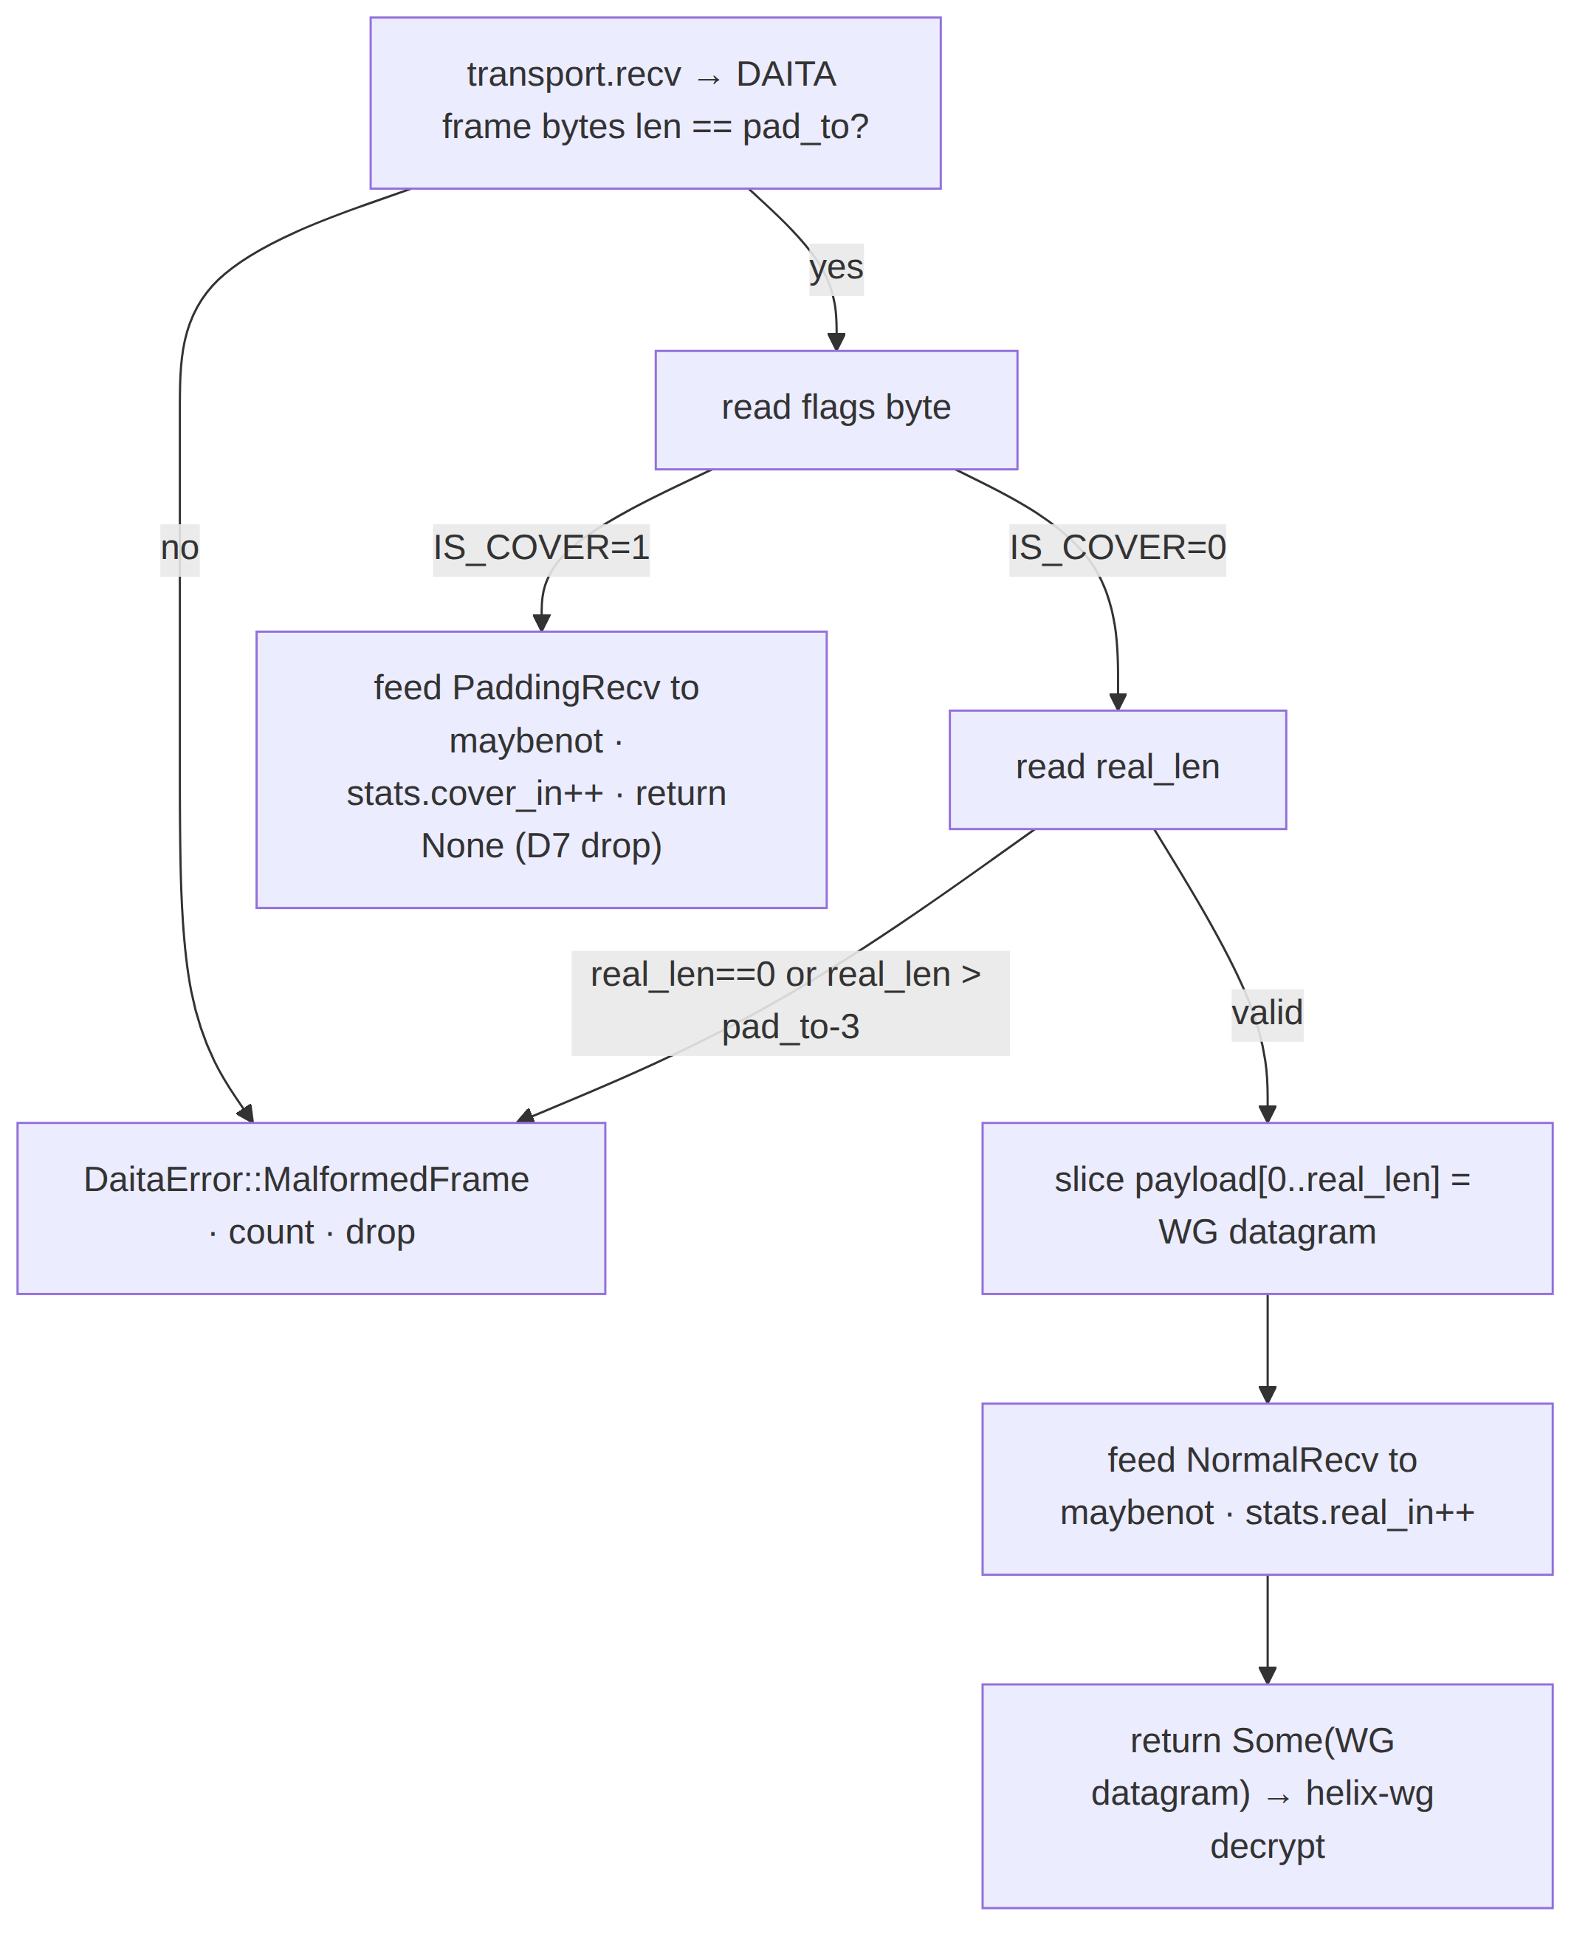
A frame whose length ≠ pad_to, or with an out-of-range real_len, is MalformedFrame: counted and dropped (never forwarded to WG). This is the inbound guard for D2/D7.

6. Constant-size padding — selection, oversize, and MTU interaction

6.1 Choosing pad_to
The constant size MUST be ≥ the largest real WG datagram that can occur on the active transport, and ≤ the transport's effective_mtu() minus the 3-byte DAITA header (§5.1) [01-DP §10 MTU table]. Selection rule:
pad_to = active_transport.effective_mtu() - 3 (DAITA header)
so a maximum-size WG datagram still fits with its header. Per the [01-DP §10] table:
Active transport | effective_mtu() | DAITA hdr | pad_to (const size) | Source
plain-udp | 1420 | 3 | 1417 | [01-DP §10]
masque-h3 | 1280 | 3 | 1277 | [01-DP §10]
shadowsocks | ~1380 | 3 | ~1377 | derived [01-DP §10]
udp-over-tcp | ~1380 | 3 | ~1377 | derived [01-DP §10]
lwo | ~1400 | 3 | ~1397 | derived [01-DP §10]
When the ladder ([01-DP §5.3]) switches transports mid-session, pad_to changes; helix-daita MUST be re-reconfigure()d with the new pad_to (the orchestrator drives this on the Connected{transport,…} status transition, §7.6). All padded frames after the switch use the new constant size — there is no requirement that the constant be identical across transports (the observer only ever sees one transport at a time, D3).

6.2 Oversize handling
A real WG datagram larger than pad_to - 3 cannot be padded up to the constant — padding only adds bytes, never removes. This is bounded away by §6.1 (the inner WG MTU is already set to min(transport.effective_mtu(), path-MTU) per [01-DP §10 rule 1], and pad_to derives from the same effective_mtu), so in correct operation it cannot occur. If it does (a misconfiguration or a path-MTU race), helix-daita returns DaitaError::Oversize; the orchestrator MUST lower the inner WG MTU (re-derive, [01-DP §10 rule 3]) rather than truncate or fragment the DAITA frame. Truncating would break WG decrypt; this is a hard error, never silent.

6.3 Padding cost accounting (the honest-overhead seam, D4)
The mean per-real-datagram overhead is the padding bytes plus the amortized cover bytes:
overhead_ratio = (padding_bytes + cover_bytes) / real_payload_bytes
DaitaStats (§8) tracks real_payload_bytes, padding_bytes, cover_bytes, cover_count, real_count as aggregate counters so the orchestrator can surface a real, measured cost figure to the user (D4) — never an estimated/guessed one (§11.4.6). Budget D6 caps max_padding_frac (e.g. 0.5 ⇒ cover ≤ 50% of emitted datagrams, mirroring the DAITA-v2 "~half the dummy packets" target [research-daita §4]).

7. Runtime behavior — loops, timing, back-pressure, reconfigure, lifecycle

7.1 Orchestrator wiring
helix-daita plugs into the [01-DP §5.1] three loops. The outbound loop gains the on_packet call between WG-encrypt and Transport.send; a fourth concern — the DAITA timer — folds into the existing timer tick loop:
outbound : TUN → wg.handle_tun_out → daita.on_packet → [SendNow|schedule] → transport.send
inbound : transport.recv → daita.on_recv → (Some? wg.handle_transport_in → TUN | None? drop)
timer : every tick → daita.tick → emit due cover / release blocks ; (also wg.tick keepalive)
The orchestrator owns the actual transport.send I/O; helix-daita only returns ScheduledActions (§4.1) — keeping it pure, deterministic, and unit-testable (no sockets in the crate).

7.2 Timer cadence
maybenot machines schedule sub-millisecond-precision actions. The orchestrator's DAITA tick MUST fire at a resolution fine enough to honor cover timing without busy-spinning. Spec: a tokio::time::sleep_until(next_action_deadline) driven loop — the crate exposes Daita::next_deadline() -> Option<Instant> (the soonest pending cover/unblock time) so the orchestrator sleeps exactly until the next action rather than polling on a fixed interval. This gives unpredictable, machine-driven cover timing (T2) without a fixed 10 ms heartbeat that would itself be a fingerprint. UNVERIFIED: the worst-case timer wake-up jitter on mobile (Android doze / iOS NE scheduling) — measured in Phase-2 perf tests (§9.3), and machines tuned to tolerate it (DAITA v1 itself chose randomized rather than strict constant-rate defenses partly because of WireGuard-Go event-reporting latency [research-mullvad §1] — the same realism applies here).

7.3 Back-pressure & budget enforcement (D6)
Before emitting a SendCoverAt, helix-daita checks Budget:
- if pending_cover ≥ max_pending_cover → drop the scheduled cover (count it), do not queue unboundedly (a runaway machine must not OOM or saturate the link, §12.6 host-safety analog);
- the rolling padding_frac (cover/(cover+real)) is checked against max_padding_frac; a cover action that would exceed the ceiling is suppressed (the budget is a hard cap, not a target).
This makes D6 mechanical: even a malformed pushed machine cannot exceed the configured overhead.

7.4 Reconfigure (hot machine swap, D5)
When a NetworkMap.daita delta arrives (server rotated the defense set, v2 model [research-daita §4]), the orchestrator calls Daita::reconfigure(new_cfg):
- Parse + validate the new DaitaConfig (machines, budget, pad_to). On any MachineParse/BudgetInvalid → return Err, keep the prior config (§7.5).
- On success: build the new maybenot::Framework, swap it in atomically, and let any in-flight scheduled cover/blocks from the old machines drain naturally (they remain valid DAITA frames). No tunnel restart, matching the [01-DP §6.3] "push, don't poll, converge without restart" reconciler discipline and the v2 "improve defenses server-side without a client update" property [research-mullvad §1].

7.5 Failure isolation — a bad push never breaks a tunnel
A defense machine pushed by the server can be malformed (operator error, partial delta). DAITA MUST fail safe-open at the shaping layer but safe for the tunnel: a rejected config leaves the prior working machines running (or Off pass-through if none was loaded). A DAITA failure is never allowed to take down WG forwarding (fail-static, [01-DP I3] generalized). This is the §11.4.101 reversible/safe-decision discipline at the data-plane layer.

7.6 Lifecycle state machine
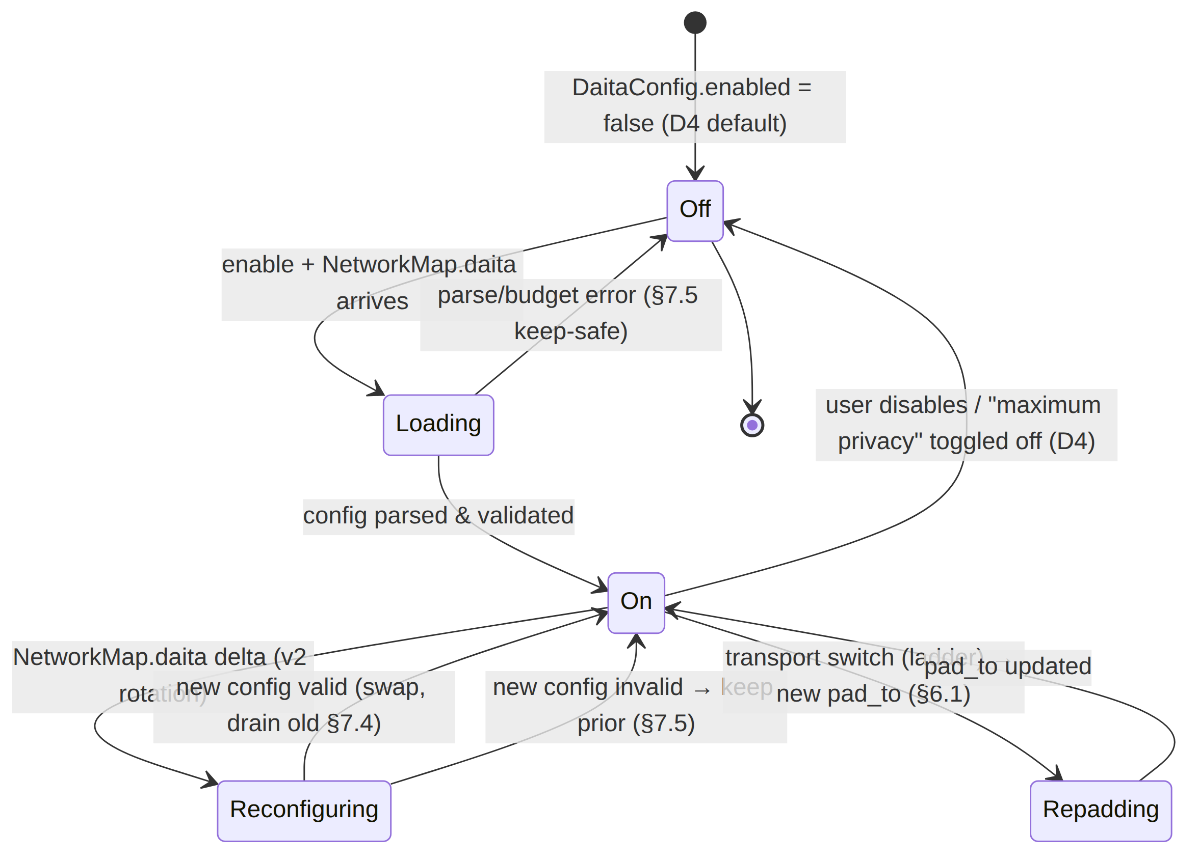

7.7 Sequence — outbound burst with cover + blocking
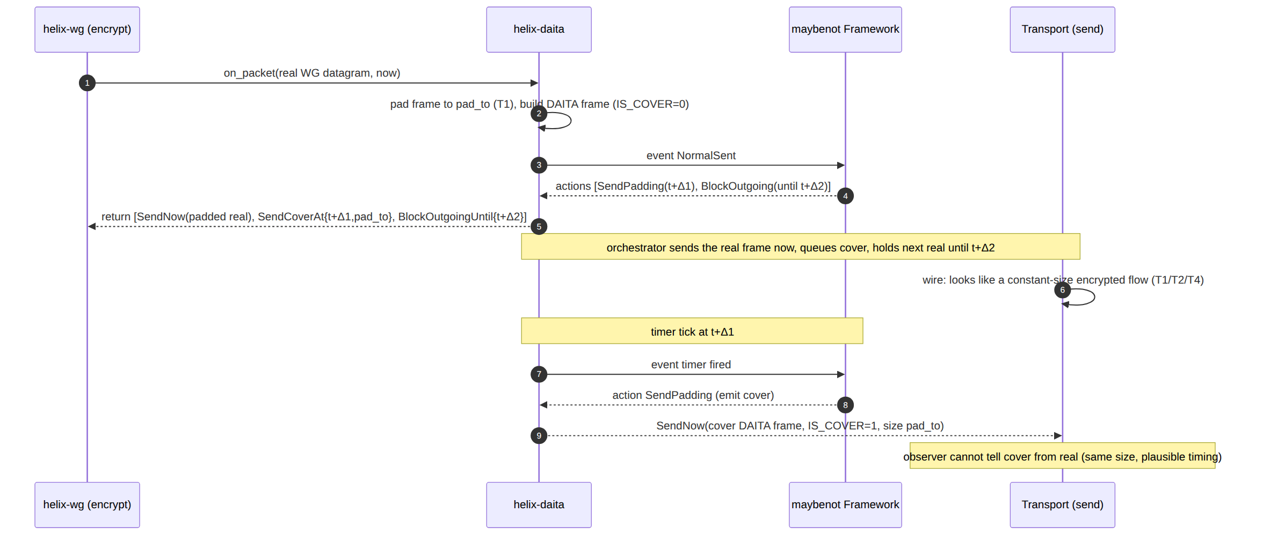

8. Telemetry — aggregate-only, no-logging by construction (I5)
DAITA telemetry is aggregate counters only, never per-packet/per-connection durable state ([01-DP I5], §11.4.6, research-mullvad §8 no-logging-as-architecture):
// helix-daita/src/stats.rs
#[derive(Clone, Debug, Default)]
pub struct DaitaStats {
pub real_count: u64, // real WG datagrams shaped
pub cover_count: u64, // cover datagrams emitted
pub real_payload_bytes: u64, // sum of real_len (for overhead_ratio, §6.3)
pub padding_bytes: u64, // bytes added as padding
pub cover_bytes: u64, // bytes spent on cover frames
pub blocked_ms_total: u64, // cumulative outgoing-block time (timing-norm cost)
pub cover_dropped_budget: u64,// cover suppressed by D6 budget / back-pressure
pub malformed_in: u64, // §5.2 inbound rejects
pub reconfigure_ok: u32,
pub reconfigure_rejected: u32,// §7.5 bad-push rejects
}
These feed the same aggregate dashboards as the transport ladder ([01-DP §5.3 telemetry: "only aggregate, no per-user data, I5"]). No machine id is logged against any user; MachineSpec.id is used only for in-memory attribution. The CI schema-lint that fails the build on any durable connection/traffic table [SYNTHESIS §7] covers helix-daita too: it MUST have no per-flow durable store.

9. Test points (tie to the §11.4.169 test-type taxonomy)
§11.4.6 note on the anchor: the constitution text available to this author enumerates §11.4 sub-anchors through §11.4.168; a literal §11.4.169 test-type-taxonomy anchor was requested but is UNVERIFIED against the constitution copy in scope. The test plan below is therefore tied to the named, verifiable test-type anchors §11.4.27 (100% test-type coverage: unit/integration/e2e/full-automation/security/stress/chaos/performance/benchmark), §11.4.85 (stress + chaos), §11.4.50 (deterministic N-iteration consistency), §11.4.5/.69/.107 (captured-evidence / anti-bluff), and §11.4.43/.115 (RED-first). If §11.4.169 exists in the canonical constitution, this section satisfies it by enumerating the same per-feature test types; the mapping is one-to-one.
Every DAITA claim ships captured evidence, never config-only PASS (§11.4.5/.69/.107). The maybenot simulator (maybenot-simulator 2.2.1 [research-daita §1]) is the primary offline oracle: it lets the build evaluate a machine set against synthetic traffic without a live tunnel, producing reproducible size/timing traces.
Test type | What it proves | Evidence artifact | Anchor
Unit | on_packet pads to exactly pad_to; DAITA frame round-trips (encode→on_recv); Oversize/MalformedFrame rejected; budget D6 suppresses over-ceiling cover | cargo test deterministic vectors | §11.4.27
Property/round-trip | for any real WG datagram ≤ pad_to-3, on_recv(on_packet(x)) == x and cover ⇒ None (D2/D7) | proptest corpus + counter-example log | §11.4.27
Integration (netns) | client+gateway helix-daita over a real plain-udp/masque-h3 tunnel in the ip netns + veth rig [research-daita §5.1]; tunnel goodput preserved within budget | tshark capture: all DAITA frames one size; goodput CSV | §11.4.27
Defense-efficacy (simulator) | the shipped machine set reduces a DF/RF classifier's accuracy below a threshold on a captured site-visit corpus | maybenot-simulator traces + classifier accuracy report (security doc owns the corpus) | §11.4.27 / security doc
Wire-fingerprint | with DAITA On, packet-size histogram is a single spike at pad_to; inter-packet timing shows injected cover (T1/T2/T4) | tshark/tc-captured size+timing histogram before/after | §11.4.5/.69
Performance / overhead | measured overhead_ratio ≤ configured budget; CPU/latency delta vs Off; timer jitter on mobile (§7.2) | per-transport overhead CSV; p99 added latency; CPU/Gbps | §11.4.27 perf
Determinism (N-iter) | same machine set + same seed ⇒ identical emitted trace across N runs (RNG seeded) | N=3/10 identical evidence hashes | §11.4.50
Stress | sustained high pps with cover at budget ceiling — no unbounded queue, cover_dropped_budget increments correctly (§7.3) | latency p50/p95/p99 + queue-depth trace | §11.4.85
Chaos | malformed pushed machine on reconfigure ⇒ prior config kept, tunnel never drops (§7.5); transport switch mid-burst ⇒ correct pad_to repad (§6.1); cover under netem loss 5% | recovery trace; reconfigure_rejected count; loss-profile goodput | §11.4.85
Security | DAITA frame pad uses PRNG fill on low-obf transports (§5.1); no per-flow durable state (CI schema-lint); off-by-default verified (D4) | static-analysis + schema-lint pass; default-Off assertion | §11.4.5 / SYNTHESIS §7
RED-first | each fix lands a reproduce-first test capturing the defect on the pre-fix artifact, polarity-switched to a standing guard | RED→GREEN capture pair | §11.4.43/.115
Phase-2 acceptance gate (the DAITA analog of [01-DP §12.1 G-gates]): DAITA On over masque-h3 in the netns rig, tshark shows single-size datagrams + interspersed cover, the maybenot-simulator efficacy report shows the shipped machine set below the DF/RF accuracy threshold, measured overhead_ratio is at/under budget, and toggling DAITA Off returns overhead to zero (D4) — all captured, no config-only PASS.

10. Open decisions & honest gaps (§11.4.6)
Ref | Item | Status
G-DAITA-1 | Exact DAITA-v2 machine/budget wire schema (client↔relay push) | Not public [research-mullvad §"Honest gaps", research-daita §"Negative findings"]. HelixVPN defines its own via NetworkMap.daita (doc 03); not a parity claim.
G-DAITA-2 | DAITA-v2 padding-budget numbers + relay defense-DB size | Not public [research-daita §"Negative findings"]. HelixVPN derives budgets empirically (§9 perf/efficacy).
G-DAITA-3 | v1 client constants ([1.5,9.5] s, 3rd/5th-packet ratios) as production values | From the maybenot author's blog, authoritative for design, not Mullvad-published constants [research-daita §"Negative findings"]. Used as seed data, re-tuned (§3.3).
G-DAITA-4 | maybenot-machines crate version (1.0.1) | UNVERIFIED (search snippet) [research-daita §"Negative findings"]. Pin at integration, record in Cargo.lock.
G-DAITA-5 | Active-adversary (packet-injection) robustness of maybenot defenses | UNVERIFIED — maybenot's published model is statistical vs a passive observer [research-mullvad §1]; HelixVPN claims no more than that.
G-DAITA-6 | True photon-level timer jitter on iOS NE / Android doze (§7.2) | Measured in Phase-2 perf tests; machines tuned to tolerate (randomized-not-constant-rate, [research-mullvad §1]).
D-DAITA-A | Pad fill: zero vs PRNG under AEAD/QUIC transports | Spec mandates PRNG fill as the conservative default (§5.1); zero-fill permitted only under proven-AEAD transports — recorded as a knob, defaulting safe (§11.4.6).

11. Build checklist (data-plane DAITA)
Phase-tagged; each maps to a §11.4.93/.95 SQLite tracker item [SYNTHESIS §9].
Crate / file | Owns | Phase | Gate
helix-daita/src/lib.rs | Daita, DaitaMode, ScheduledAction, the three hooks | 0 (Off pass-through) → 2 (On) | reserved seam P0; efficacy P2
helix-daita/src/config.rs | DaitaConfig/MachineSpec (parsed NetworkMap.daita, D5) | 2 | reconfigure test
helix-daita/src/frame.rs | DAITA frame encode/decode (§5), const-pad (§6) | 2 | round-trip + wire-fingerprint
helix-daita/src/budget.rs | Budget enforcement + back-pressure (§7.3, D6) | 2 | stress/chaos
helix-daita/src/error.rs | DaitaError taxonomy (§4.3) | 2 | unit
helix-daita/src/stats.rs | aggregate-only DaitaStats (§8, I5) | 2 | schema-lint (no durable per-flow)
helix-core wiring | on_packet/tick/on_recv in the three loops (§7.1) + pad_to on transport switch (§6.1) | 2 | integration (netns)
(vendored) maybenot 2.2.2 + maybenot-simulator 2.2.1 | engine + offline oracle (pinned dep, §3.1, §11.4.74) | 2 | efficacy report

End of DAITA nano-detail specification (Volume 2, Data Plane). Pairs with 01-data-plane.md §9 (the placement seam), doc 03 WatchNetworkMap (the NetworkMap.daita wire schema feeding §4.2 DaitaConfig), and the security doc (the defense- machine content, off-by-default policy, and the website-fingerprinting evaluation harness §9 references). Frozen contracts: the L2.5 placement (§2), the three hooks (§4.1), and the DAITA frame format (§5.1).

