Obfuscation & DPI/Censorship Landscape

Obfuscation & DPI/Censorship Landscape
Revision: 2 Last modified: 2026-07-04T12:00:00Z
Volume 2 (Data Plane) nano-detail specification. This document deepens the Obfuscation & DPI/Censorship Landscape surface of the pass-1 data-plane overview [01 §3, §3.3–§3.8, §5.3]. It is SPEC-ONLY: it describes what to build (Rust signatures, wire byte-layouts, state machines, error taxonomy, config knobs, edge cases, security analysis, performance budget, and the §11.4.169 test points), not the shipping product. Every factual claim cites a source id — [01 §N] (the pass-1 data-plane overview), [04_ARCH §N] (HelixVPN-Architecture-Refined), [04_P0 §N] (Phase0-Spike), [SYNTHESIS §N], [research-hysteria2], [research-masque], [research-daita]. Facts not groundable in the evidence base are flagged UNVERIFIED: per §11.4.6.

0. What this document owns (and what it defers)
The pass-1 overview established the layering invariant — WireGuard is the crypto core; obfuscation/transport is a swappable layer under WG, never a fork of WG crypto [01 §0, §0.1 I1–I6, 04_ARCH §0/§3.1]. It listed the transport set (plain-udp, masque-h3, connect-ip, shadowsocks, udp-over-tcp, lwo, hysteria2) [01 §3] and surfaced decision D1 (primary obfuscating transport: masque-h3 vs Hysteria2+Salamander) [01 §3.8, SYNTHESIS §3 D1].
This document owns the censorship side of that picture:
# | Owned here | Deferred to
O1 | The censorship-regime taxonomy (GFW QUIC-SNI, hard UDP block, SNI/TLS DPI, active probing, throttling) and the formal regime → transport survival matrix | —
O2 | Passive vs active probing resistance as a typed property of every Transport, plus the edge probe classifier state machine + decoy responder | bin/helix-edge.rs impl (01 §2)
O3 | D1 fully analyzed from all angles with the cited tradeoff, and the resolved spec stance (primary + ladder + per-leg) | decision log (04_P0 §7)
O4 | The regime-aware escalation ladder that selects the surviving transport per detected regime, refining the flat ladder of [01 §5.3] | helix-core/src/ladder.rs (01 §5.3)
O5 | Wire byte-layouts of the obfuscation envelopes (LWO header mangling, Salamander scramble, MASQUE HTTP-Datagram, Phantun fake-TCP) so DPI cannot fingerprint them | the per-transport send/recv (01 §3)
O6 | Anti-fingerprinting (QUIC/TLS ClientHello mimicry) as an explicit open design problem with a typed config seam | security doc
O7 | The §11.4.169 test points that prove each survival claim with captured evidence | Volume 8 testing docs
Out of scope (referenced for seams only): the WG crypto core internals [01 §4]; DAITA traffic-shaping internals (its machines live in the security doc; only its placement relative to obfuscation is noted here at §9) [01 §9, research-daita]; the control-plane push of TransportPolicy [01 §5.3, doc 03]; multi-hop nesting [01 §11.1].

1. The censorship-regime taxonomy
A "censorship regime" is the set of network-layer capabilities the adversary applies on the path between client and gateway. HelixVPN does not guess the regime from a label; it detects it from observed transport failures (§4) and selects the surviving transport. The closed taxonomy below is the type the detector emits and the survival matrix (§2) is keyed on.
// helix-transport/src/regime.rs
//
// A detected (or coordinator-asserted) property of the path. NOT a country —
// a capability set. Multiple flags may hold simultaneously (e.g. GFW = QUIC-SNI
// + active-probing + residual-throttle). Bitflags so the survival matrix can AND
// the transport's resistance mask against the regime's threat mask.
bitflags::bitflags! {
#[derive(Clone, Copy, Debug, PartialEq, Eq, Default)]
pub struct Regime: u16 {
/// Plain WireGuard/UDP to :51820 is dropped or RST — WG message-type
/// fingerprint (types 1–4) and/or invariant sizes (init 148 B,
/// response 92 B) are matched. [research-hysteria2 §4]
const WG_FINGERPRINT = 1 << 0;
/// ALL UDP (incl. QUIC/443) is dropped or throttled to unusable.
/// Corporate + China-domestic common. [research-hysteria2 §5(b)]
const UDP_BLOCK = 1 << 1;
/// QUIC is permitted BUT the QUIC-Initial SNI is extracted and matched
/// against a blocklist (GFW since ~2024-04-07). [research-hysteria2 §5(a)]
const QUIC_SNI_FILTER = 1 << 2;
/// TLS ClientHello SNI on TCP/443 is extracted + blocklist-matched.
/// [research-hysteria2 §5(c)]
const TLS_SNI_FILTER = 1 << 3;
/// The adversary actively probes the server to confirm a flagged flow
/// (Shadowsocks-class). [research-hysteria2 §5(d)]
const ACTIVE_PROBING = 1 << 4;
/// Residual/stateful enforcement: after a trigger the 3-tuple/4-tuple is
/// blocked for a window (GFW: ~3 min, ~500 ms to engage). [research-hysteria2 §5(a)]
const RESIDUAL_BLOCK = 1 << 5;
/// Bandwidth throttling of the suspected flow (not a hard drop).
const THROTTLE = 1 << 6;
/// Packet-size-distribution flagging feeds ACTIVE_PROBING. [research-hysteria2 §5(d)]
const SIZE_PROFILING = 1 << 7;
}
}
/// The threat a transport must defeat to PASS, expressed as the same flags.
/// A transport `survives` a regime iff `transport.resistance() ⊇ regime`
/// (every regime threat bit is covered by a resistance bit), with the UDP_BLOCK
/// special-case (§2.2): UDP-carried transports can NEVER cover UDP_BLOCK.
pub type ThreatMask = Regime;

1.1 Per-regime mechanism notes (cited facts)
- QUIC_SNI_FILTER (GFW, USENIX Sec '25). The GFW derives the QUIC-Initial decryption key from the packet header (RFC 9001 makes the key header-derivable), decrypts the Initial, extracts the SNI, matches a blocklist. It blocked an average of 43.8K FQDNs/week (Oct 2024–Jan 2025) [research-hysteria2 §5(a)]. Critical exploitable weakness: the GFW does not reassemble QUIC Initials split across more than one UDP datagram — fragmenting the handshake slips past [research-hysteria2 §5(a)]. This is the design basis for Salamander/Gecko (§5.3).
- RESIDUAL_BLOCK. Enforcement is stateful: ~3-minute block after a trigger, ~500 ms to engage, 58% by 3-tuple / 37% by 4-tuple [research-hysteria2 §5(a)]. Consequence: a long-lived tunnel is disrupted; a short-lived flow may complete inside the uncensored window. The ladder MUST treat a mid-session drop on a previously-working transport as a residual event, not a fresh dial failure (§4.4).
- UDP_BLOCK. QUIC / Hysteria2 / MASQUE-over-H3 / WireGuard / AmneziaWG all fail — they need UDP [research-hysteria2 §5(b)]. Only TCP-carried transports (shadowsocks, udp-over-tcp, MASQUE's HTTP/2 fallback) survive.
- ACTIVE_PROBING. The GFW passively flags a suspicious flow (partly by packet-size distribution → SIZE_PROFILING), then actively connects to the server to confirm. Mitigation: a probe-resistant front that returns nothing useful to an unauthenticated prober [research-hysteria2 §5(d)] (§3).
- Mullvad's public stance (the parity target). Mullvad shipped WG-over-MASQUE QUIC obfuscation 2025-09-09 (desktop v2025.9), auto-tried after failed normal attempts, "resembling standard web activity" — and published no performance numbers and no explicit undefended threat [research-hysteria2 §2, research-masque §2]. The "looks like HTTP/3" claim rests on collateral-damage deterrence (blocking QUIC/443 breaks Google/YouTube/Cloudflare), not on a published ClientHello-mimicry layer — that layer is an open problem (§6).
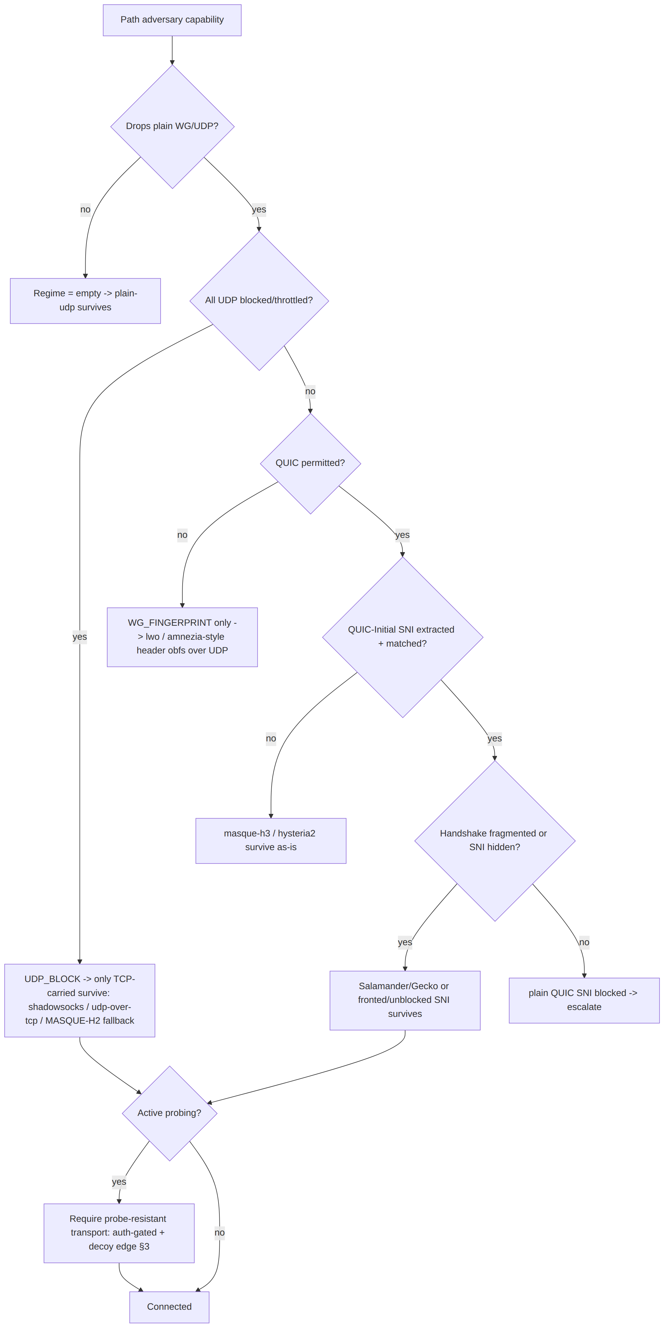

2. The regime → transport survival matrix (the load-bearing artifact)

2.1 The matrix (facts cited per cell-source)
Each transport declares a resistance mask (ThreatMask); a transport survives a regime iff its mask covers every threat bit (subject to the UDP-block carve-out, §2.2). The matrix is the compiled, testable form of [research-hysteria2 §5] and [01 §3.2 transport matrix].
Transport | Carrier | WG_FINGERPRINT | UDP_BLOCK | QUIC_SNI_FILTER | TLS_SNI_FILTER | ACTIVE_PROBING | Throughput on lossy/throttled | Source
plain-udp | UDP | ✗ (raw WG sig) | ✗ | n/a (not QUIC) | n/a | ✗ | baseline | [01 §3.2]
lwo | UDP | ✓ (header+size mangle) | ✗ | n/a | n/a | partial (no auth front) | ~baseline (−padding) | [01 §3.7, research-hysteria2 §4]
masque-h3 | QUIC/UDP 443 | ✓ (no WG sig on wire) | ✗ | ✓ iff proxy SNI unblocked/fronted | n/a | ✓ (decoy edge §3) | standard QUIC CC (fair) | [research-hysteria2 §6, research-masque §2]
hysteria2+Salamander | QUIC/UDP | ✓ | ✗ | ✓ (SNI/Initial fully scrambled) | n/a | ✓ (password auth front) | best (Brutal ignores loss) | [research-hysteria2 §1, §6]
hysteria2+Gecko | QUIC/UDP | ✓ | ✗ | ✓ (+ handshake fragmentation) | n/a | ✓ | best | [research-hysteria2 §1, §5(a)]
shadowsocks | TCP | ✓ | ✓ | n/a | ✓ (random-ish TCP) | ✓ iff AEAD + probe-resistant front | moderate (HoL) | [01 §3.5, research-hysteria2 §5(d)]
udp-over-tcp | TCP | ✓ | ✓ | n/a | ✓ iff tls_sni wrap | partial | moderate (HoL) | [01 §3.6, research-hysteria2 §5(b)]
connect-ip | QUIC/UDP 443 | ✓ | ✗ | as masque-h3 | n/a | ✓ | standard QUIC | [01 §3.4, research-masque §1]
Notes that are facts, not preferences:
- masque-h3 vs QUIC_SNI_FILTER is conditional: it survives only if the HTTP/3 proxy's own SNI is unblocked or fronted; otherwise it is SNI-filtered like any QUIC [research-hysteria2 §6]. This is why §6 (anti-fingerprinting/SNI strategy) is load-bearing, not optional.
- Hysteria2+Salamander hides the SNI/Initial entirely → survives QUIC_SNI_FILTER unconditionally; Gecko additionally fragments the handshake → directly defeats the GFW no-reassembly weakness [research-hysteria2 §1, §5(a)].
- Neither QUIC path survives UDP_BLOCK alone — both need a TCP fallback (MASQUE: in-protocol HTTP/2; Hysteria2: pair with Phantun udp2tcp or a Reality/ShadowTLS sibling) [research-hysteria2 §6].
- AmneziaWG is the lowest-overhead answer to WG_FINGERPRINT-only regimes (~3% throughput cost, still UDP) — HelixVPN realizes this class as the lwo rung rather than a separate transport [research-hysteria2 §4, 01 §3.7].

2.2 The matrix as code (compile-time + runtime)
// helix-transport/src/survival.rs
use crate::regime::{Regime, ThreatMask};
use crate::TransportKind;
/// Each transport's static resistance. Constructed once; unit-tested cell-by-cell
/// against §2.1 (a paired §1.1 mutation flips one cell and a test MUST FAIL).
pub const fn resistance(k: TransportKind) -> ThreatMask {
use Regime as R;
match k {
TransportKind::PlainUdp => R::empty(),
TransportKind::Lwo => R::WG_FINGERPRINT,
// masque-h3 covers QUIC_SNI_FILTER only when fronted (see `survives`);
// the static mask claims it, the runtime guard verifies the SNI premise.
TransportKind::MasqueH3 => R::WG_FINGERPRINT
| R::QUIC_SNI_FILTER | R::ACTIVE_PROBING,
TransportKind::Hysteria2 => R::WG_FINGERPRINT
| R::QUIC_SNI_FILTER | R::ACTIVE_PROBING | R::THROTTLE,
TransportKind::Shadowsocks=> R::WG_FINGERPRINT | R::UDP_BLOCK
| R::TLS_SNI_FILTER | R::ACTIVE_PROBING,
TransportKind::UdpOverTcp => R::WG_FINGERPRINT | R::UDP_BLOCK,
TransportKind::ConnectIp => R::WG_FINGERPRINT
| R::QUIC_SNI_FILTER | R::ACTIVE_PROBING,
}
}
/// True iff `k` is expected to carry a tunnel under `regime`.
/// The UDP_BLOCK carve-out is explicit: a UDP-carried transport can NEVER survive
/// a hard UDP block, regardless of its other resistance bits (§11.4.6 — do not let
/// a mask bug claim the impossible).
pub fn survives(k: TransportKind, regime: Regime) -> bool {
if regime.contains(Regime::UDP_BLOCK) && carrier_is_udp(k) {
return false;
}
resistance(k).contains(regime & ALL_THREATS_EXCEPT_THROTTLE)
}
pub const fn carrier_is_udp(k: TransportKind) -> bool {
matches!(k,
TransportKind::PlainUdp | TransportKind::Lwo
| TransportKind::MasqueH3 | TransportKind::Hysteria2
| TransportKind::ConnectIp)
}
const ALL_THREATS_EXCEPT_THROTTLE: Regime =
Regime::WG_FINGERPRINT.union(Regime::UDP_BLOCK)
.union(Regime::QUIC_SNI_FILTER).union(Regime::TLS_SNI_FILTER)
.union(Regime::ACTIVE_PROBING).union(Regime::RESIDUAL_BLOCK)
.union(Regime::SIZE_PROFILING);
Edge case — the conditional masque-h3 cell. resistance() statically claims QUIC_SNI_FILTER for masque-h3, but that claim holds only when the proxy SNI is fronted/unblocked. The dial path (§6.2) carries an sni_strategy; if the strategy is PlainBlockable and the regime has QUIC_SNI_FILTER, the ladder MUST treat masque-h3 as not surviving and skip to hysteria2/shadowsocks. This is a runtime refinement of the static mask, asserted by a dedicated test (§7 T-D1-c).

3. Passive vs active probing resistance (typed, edge-enforced)

3.1 The two probing models
- Passive probing = the adversary only observes. Resistance = the bytes on the wire carry no transport-distinctive signature: no WG message-type, no invariant size, no plaintext SNI, no QUIC-Initial structure. This is a property of the client-side envelope (§5).
- Active probing = the adversary, having flagged a flow, connects to the gateway and replays/forges traffic to elicit a distinctive response. Resistance = the edge returns nothing useful to an unauthenticated peer — it must be indistinguishable from a benign server to a prober [research-hysteria2 §5(d)].
Both are required for a QUIC_SNI_FILTER + ACTIVE_PROBING regime (the GFW). The client envelope defeats passive; the edge probe-classifier defeats active.
// helix-transport/src/probe.rs
/// A transport declares, as a type, what kind of probing it defeats.
#[derive(Clone, Copy, Debug, PartialEq, Eq)]
pub struct ProbeResistance {
/// Passive: no transport-distinctive bytes observable on the wire.
pub passive_unfingerprintable: bool,
/// Active: an unauthenticated prober receives an indistinguishable-from-benign
/// response (decoy site / silent drop / RST as a real closed port would).
pub active_decoy_or_silent: bool,
/// The auth secret that gates a "useful" response (separate from WG keys).
pub auth_gate: AuthGate,
}
#[derive(Clone, Copy, Debug, PartialEq, Eq)]
pub enum AuthGate {
/// Salamander/LWO PSK: wrong PSK -> packet is indistinguishable noise, edge
/// silently drops (no response at all). [research-hysteria2 §1, §5(d)]
PreSharedKey,
/// Hysteria2 password over the in-QUIC HTTP/3 auth exchange: wrong password ->
/// the H3 server returns a generic 404/decoy, never a protocol tell. [research-hysteria2 §1]
Hysteria2Password,
/// masque-h3: a non-CONNECT-UDP request is served the decoy site (§3.3).
MasqueExtendedConnect,
/// Shadowsocks AEAD: a forged/replayed first frame fails AEAD -> edge keeps the
/// TCP open and behaves like a stuck/slow benign server (no RST tell). [research-hysteria2 §5(d)]
AeadFirstFrame,
}

3.2 The edge probe-classifier state machine (bin/helix-edge.rs)
The :443 (and the regime-fallback :443/tcp) listener classifies every new flow before committing transport resources. Native edge behavior replacing the original Nginx-camouflage [01 §3.3, 04_ARCH §3.3].
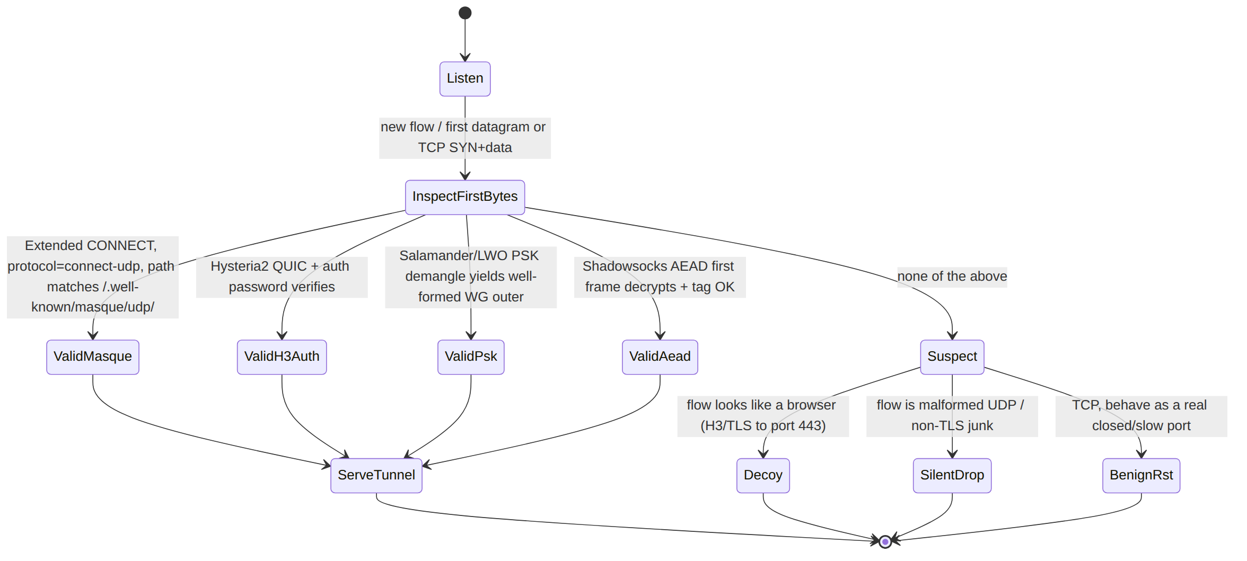
// bin/helix-edge.rs (classifier core — spec sketch)
pub enum FlowClass {
Tunnel(TransportKind), // authenticated -> hand to the transport de-obfuscator
Decoy, // serve the believable decoy site (probe sees a real website)
SilentDrop, // no response at all (Salamander/PSK miss)
BenignRst, // TCP: mimic a closed/benign port, no protocol tell
}
/// MUST be constant-time w.r.t. the auth decision to avoid a timing oracle
/// distinguishing "wrong PSK" from "no PSK" (§3.4 security). MUST NOT log the
/// peer addr durably (I5, no per-connection state).
pub fn classify(first: &FirstBytes, decoy: &DecoySite) -> FlowClass { /* … */ }

3.3 The decoy responder (masquerade)
For any flow that is not a valid tunnel, the :443 listener serves a believable decoy site so a prober/scanner sees an ordinary HTTP/3 (or HTTPS) server [01 §3.3, research-masque §2]. Requirements:
- The decoy MUST be a complete small site (valid TLS cert for the gateway's hostname, real HTML, 200 OK on /), not an empty 444/blank — a blank response is itself a fingerprint.
- The decoy hostname's certificate and the tunnel's SNI MUST be the same name so SNI inspection of a probe vs a real client cannot distinguish them.
- The decoy MUST be served by the same QUIC/TLS stack (same ClientHello-response fingerprint) as the tunnel path, so a probe cannot tell "tunnel server" from "web server" by transport fingerprint.

3.4 Security analysis of probing resistance
Threat | Defense | Residual risk
Timing oracle (auth-fail vs no-auth latency) | constant-time classify(); identical code path to first I/O | UNVERIFIED: exact constant-time guarantee of the underlying QUIC lib — must be measured (§7 T-SEC-a)
Replay of a captured authenticated first frame | Shadowsocks AEAD nonce / Hysteria2 session binding rejects replay; edge keeps TCP open (BenignRst path) so replay yields no tell | replay within a live AEAD window — bounded by per-session key
Decoy/tunnel TLS fingerprint mismatch | same QUIC/TLS stack serves both | the client ClientHello mimicry is the harder open problem (§6)
Size-distribution profiling (SIZE_PROFILING) feeding active probing | LWO/Salamander randomized padding flattens the size histogram (§5); DAITA (§9) is the strong form | padding is heuristic; DAITA is the calibrated answer (security doc)
Durable per-connection state revealing who connected | I5 no-logging by construction; classifier holds only in-flight state | none by construction [01 §0.1 I5]

4. The regime-aware escalation ladder (refines [01 §5.3])

4.1 What changes vs the flat ladder
[01 §5.3] walks a static TransportPolicy.order on repeated handshake failure. This document refines that into a detector-driven ladder: each failure updates a Regime estimate, and the next rung is chosen as the highest-throughput transport whose survives(k, regime) is true — not merely the next array element. The flat order remains the fallback when detection is inconclusive.
// helix-core/src/ladder.rs (extends the §5.3 sketch)
pub struct RegimeAwareLadder {
order: Vec<TransportKind>, // coordinator-pushed prior (§5.3 step 5)
pin: Option<TransportKind>, // manual override (skip detection)
budget: FailureBudget, // { max_handshakes, window } per rung
estimate: Regime, // accumulated from failure signatures (§4.3)
per_network_memory: PerNetworkMap // SSID/gw-fingerprint -> last working kind (§5.3 step 4)
}
impl RegimeAwareLadder {
/// Choose the next rung. Preference: survives(estimate) AND highest throughput
/// class, breaking ties by `order` position (coordinator prior).
pub fn next_rung(&self) -> Option<TransportKind> { /* … */ }
/// Fold a dial/runtime failure into the regime estimate (§4.3 mapping).
pub fn observe(&mut self, k: TransportKind, err: &TransportError, phase: FailPhase);
}
#[derive(Clone, Copy, Debug)]
pub enum FailPhase { Dial, Handshake, MidSession }

4.2 Failure-signature → regime inference (the detector)
The detector turns concrete TransportErrors (the taxonomy of [01 §3.1 error.rs]) plus the phase into Regime bits. This is the only place a regime is inferred; it is heuristic and MUST be honest about uncertainty (§11.4.6 — an inference is a hypothesis until a working transport confirms it).
Observed | Phase | Inferred bit(s) | Rationale (cited)
plain-udp → HandshakeFailed but lwo over mangled UDP → Connected | Handshake | WG_FINGERPRINT | only the WG signature was caught [research-hysteria2 §4]
every UDP transport → DialTimeout/HandshakeFailed; a TCP transport → Connected | Dial/HS | UDP_BLOCK | UDP path dead, TCP alive [research-hysteria2 §5(b)]
masque-h3 plain SNI → EndpointBlocked; fronted SNI → Connected | Handshake | QUIC_SNI_FILTER | SNI was the discriminator [research-hysteria2 §5(a)]
Connected then MidSession drop ~minutes in, redial blocked ~3 min then works | MidSession | RESIDUAL_BLOCK | stateful 3-tuple/4-tuple block window [research-hysteria2 §5(a)]
Connected but goodput collapses while ping survives | MidSession | THROTTLE | throttle not drop
handshake completes but server appears probed (out-of-band signal, coordinator-pushed) | — | ACTIVE_PROBING | passive flag → active probe [research-hysteria2 §5(d)]
// helix-core/src/ladder.rs
fn infer(err: &TransportError, phase: FailPhase, last_ok: Option<TransportKind>) -> Regime {
use TransportError as E; use FailPhase as P;
match (err, phase) {
(E::HandshakeFailed(_), P::Handshake) if last_ok == Some(TransportKind::Lwo)
=> Regime::WG_FINGERPRINT,
(E::DialTimeout, P::Dial) | (E::HandshakeFailed(_), P::Handshake)
=> Regime::empty(), // ambiguous — caller ANDs across multiple observations
(E::EndpointBlocked, _) => Regime::QUIC_SNI_FILTER | Regime::TLS_SNI_FILTER, // narrowed by carrier
(E::Closed, P::MidSession) => Regime::RESIDUAL_BLOCK,
_ => Regime::empty(),
}
}
Honest boundary (§11.4.6): a single DialTimeout is ambiguous (could be UDP block, could be packet loss). The detector only commits a bit after the contrast observation (the paired success of a differently-carried transport) or a coordinator-pushed regional prior. Until then estimate stays conservative and the ladder falls back to order. The success of a transport is the captured evidence that confirms the regime (the per-network memory then short-circuits next time — [01 §5.3 step 4]).

4.3 Regime-aware escalation sequence
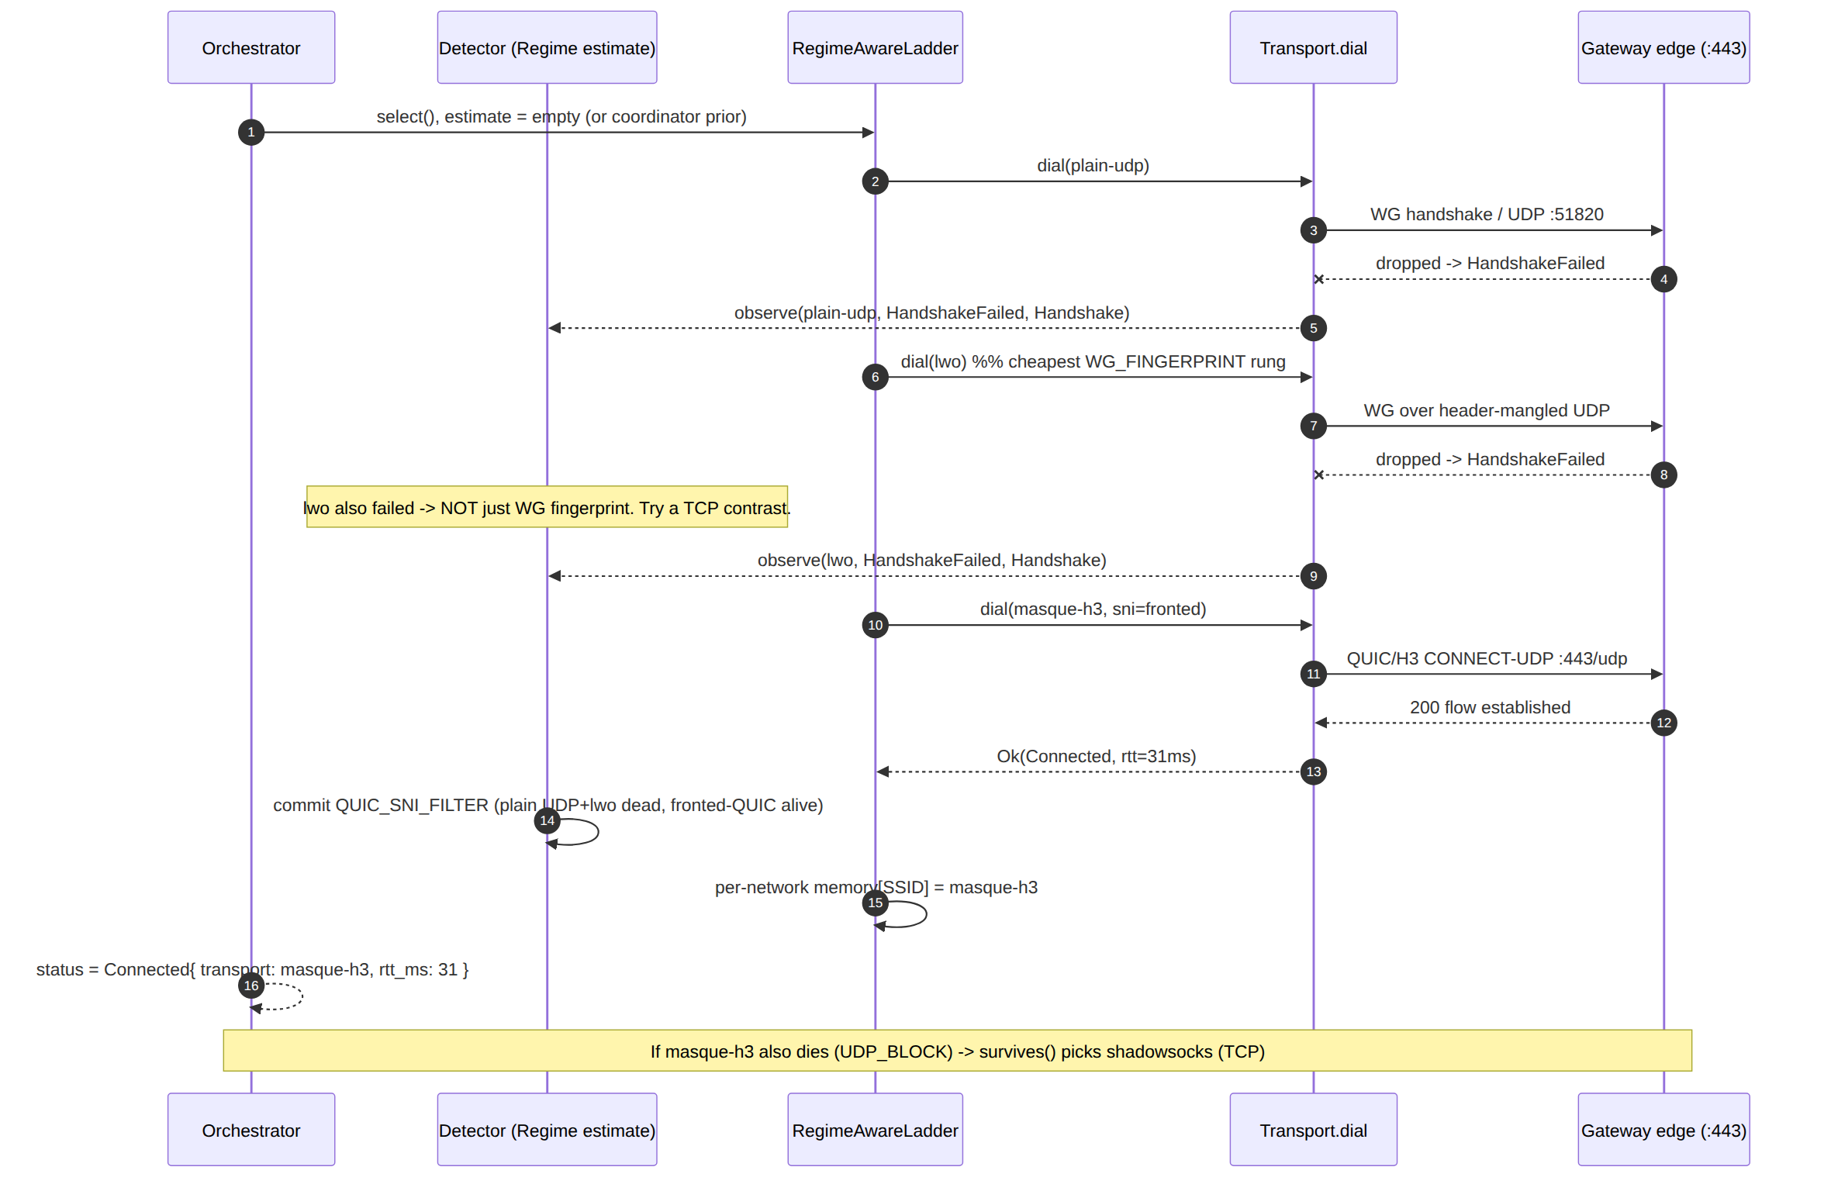

4.4 Residual-block handling (the GFW-specific edge case)
When MidSession drop is inferred as RESIDUAL_BLOCK, the ladder MUST not immediately re-dial the same transport on the same 3-tuple (it is blocked for the window). Required behavior:
- Mark the (transport, local-port) tuple cooling for the configured residual_cooldown (default 200 s, > the ~180 s observed GFW window [research-hysteria2 §5(a)]; UNVERIFIED: the exact per-PoP window — make it a config knob, §6.3).
- Re-dial the same logical transport from a fresh local port (changes the 4-tuple) OR escalate to the next surviving rung — whichever the policy prefers (residual_strategy: { RotatePort | Escalate }).
- Emit TunnelStatus::Reconnecting with a residual reason tag so the UX/telemetry distinguishes censorship-residual from ordinary roaming.

5. Wire byte-layouts of the obfuscation envelopes (so DPI cannot match)
This section specifies the exact bytes on the wire for each obfuscation layer, because "looks like X" is only testable against a byte spec. WG's own datagram is the opaque payload in every case (I1).

5.1 The WireGuard signature DPI keys on (what we must hide)
WireGuard transport/handshake datagram (the thing DPI fingerprints):
offset 0 1 2 3 4 ......
+------+------+------+------+-----------------------------+
| type | reserved (3) | (type-specific body) |
+------+------+------+------+-----------------------------+
type ∈ {1=handshake_init, 2=handshake_resp, 3=cookie, 4=transport_data}
INVARIANT SIZES the GFW/DPI match: init = 148 bytes, response = 92 bytes.
[research-hysteria2 §4]
DPI matches on: (a) the fixed 1-byte type in {1..4} at offset 0, (b) the 3 reserved zero bytes, (c) the invariant 148/92 sizes of handshakes. An obfuscation layer must break all three to defeat WG_FINGERPRINT [research-hysteria2 §4].

5.2 lwo — lightweight WG header obfuscation (Phase 1 basic → Phase 2 keyed)
lwo on-wire datagram (per session key K, 8-byte epoch nonce N):
+--------+----------------------------+----------------------+
| N (8) | mangled WG datagram | random padding (0..P)|
+--------+----------------------------+----------------------+
mangle = bytewise XOR of the FIRST 4 bytes (type+reserved) with
keystream = HKDF(K, N)[0..4] ; body bytes unchanged (cheap)
P (pad length) drawn per-packet from a per-session-seeded RNG so the size
histogram no longer shows the invariant 148/92 spikes (defeats size match).
Phase 1: XOR only the 4 header bytes + random pad (basic). [01 §3.7]
Phase 2: keyed per-session scheme over a wider prefix + size-distribution shaping.
// helix-transport/src/lwo.rs (envelope only; WG payload is opaque)
pub struct Lwo { sess_key: SecretBytes, epoch: [u8;8], pad_rng: PadRng, /* sock */ }
impl Lwo {
fn wrap(&self, wg: &[u8], out: &mut Vec<u8>) { // send path
out.clear();
out.extend_from_slice(&self.epoch); // N
let ks = hkdf4(&self.sess_key, &self.epoch); // 4-byte keystream
out.extend_from_slice(wg);
for i in 0..4 { out[8+i] ^= ks[i]; } // mangle type+reserved
let p = self.pad_rng.next_len(); // 0..=P, defeats size match
out.resize(out.len()+p as usize, 0);
self.pad_rng.fill(&mut out[out.len()-p as usize..]);
}
fn unwrap(&self, dg: &[u8]) -> Result<Bytes, TransportError> { /* strip N, de-XOR, drop pad */ }
}
Edge cases: (1) the padding MUST be cryptographically-seeded random, never a constant byte (a constant tail is itself a signature); (2) wrap MUST reject a WG datagram + max pad that would exceed effective_mtu() (TransportError::Oversize) [01 §3.1, §10]; (3) the epoch N rotates per the WG rekey so a captured keystream ages out.

5.3 hysteria2 Salamander / Gecko — full QUIC scramble (feature-gated)
Salamander obfuscation of EVERY QUIC packet [research-hysteria2 §1]:
+---------+--------------------------------------------------+
| salt(8) | scrambled = QUIC_packet XOR keystream |
+---------+--------------------------------------------------+
keystream = BLAKE2b-256( PSK || salt ) (salt = random 8 bytes/packet)
Result: no QUIC-Initial structure, no SNI, no recognizable QUIC header on wire.
-> defeats QUIC_SNI_FILTER (nothing to extract) AND WG_FINGERPRINT (WG is inside QUIC).
Gecko (experimental, builds on Salamander) [research-hysteria2 §1]:
additionally FRAGMENTS the QUIC handshake into randomly-sized, randomly-padded
chunks (config min_packet_size / max_packet_size) -> defeats the GFW's
single-datagram QUIC-Initial inspection (no reassembly). [research-hysteria2 §5(a)]
// helix-transport/src/hysteria2.rs (feature = "hysteria2")
#[cfg(feature = "hysteria2")]
pub struct Salamander { psk: SecretBytes } // 32-byte+ pre-shared key
#[cfg(feature = "hysteria2")]
impl Salamander {
fn scramble(&self, quic_pkt: &mut Vec<u8>, salt: [u8;8]) {
let ks = blake2b256(&[&self.psk[..], &salt[..]]); // 32-byte keystream block
// XOR the whole packet, keystream re-keyed per 32-byte block by counter
xor_keystream(quic_pkt, &self.psk, &salt);
// wire = salt(8) || scrambled
}
}
#[cfg(all(feature = "hysteria2", feature = "gecko"))]
pub struct Gecko { inner: Salamander, min_packet_size: u16, max_packet_size: u16 }
Facts that bound this: apernet/hysteria latest is app/v2.9.2 (2026-05-23), which adds Gecko and fixes a UDP ACL-bypass security issue — pin ≥ this version and track the advisory [research-hysteria2 §1]. Salamander gives two independent secrets (PSK for wire obfuscation + password for authz) [research-hysteria2 §1] — both wired to the AuthGate of §3.1. Congestion: Hysteria2's Brutal ignores loss ("bandwidth cheating"), the reason it wins on throttled/lossy links — but it is aggressive and MUST be rate-capped to avoid harming the gateway uplink (§6.3 knob) [research-hysteria2 §1, §6].

5.4 masque-h3 — HTTP-Datagram over QUIC (the RFC-standard envelope)
Per WireGuard datagram, MASQUE envelope [research-masque §1, 01 §3.3]:
WG datagram (opaque)
└▶ HTTP Datagram (RFC 9297): Quarter-Stream-ID (varint) || payload
└▶ QUIC DATAGRAM frame (RFC 9221, unreliable; type 0x30/0x31)
└▶ QUIC short-header packet to https://gateway:443 (HTTP/3)
Control plane, established ONCE at dial() [research-masque §1]:
Extended CONNECT (RFC 9220 :protocol = connect-udp)
:method = CONNECT
:scheme = https
:authority = gateway-host
:path = /.well-known/masque/udp/{target_host}/{target_port}/
-> proxy opens UDP socket to the WG endpoint, maps QUIC DATAGRAM <-> UDP.
Thereafter: NO per-packet HTTP round trip; WG rides as HTTP Datagrams. [01 §3.3]
// helix-transport/src/masque.rs (framing helpers — hand-rolled per research-masque §3)
/// RFC 9297 framing: prepend the Quarter-Stream-ID varint (ctx 0 here) then the WG bytes.
pub fn encode_http_datagram(qsid: u64, wg: &[u8]) -> Bytes { /* varint(qsid) || wg */ }
pub fn decode_http_datagram(dg: Bytes) -> Result<Bytes, TransportError> { /* strip varint */ }
Maturity fact (drives D5/D1, §6.4): there is no turnkey Rust crate for RFC 9298 CONNECT-UDP client+proxy — it is hand-rolled on quinn (+ h3 / h3-datagram v0.0.2, Extended CONNECT) exactly as Mullvad did (quinn_udp evidence) [research-masque §3]. Go has quic-go/masque-go v0.3.0 (2025-06-24), turnkey client+proxy [research-masque §4]. The HTTP/2 fallback of RFC 9298/9297 is the in-protocol answer to UDP_BLOCK (degraded, TCP-over-TCP-ish, but connects) [research-hysteria2 §2, research-masque §1].

5.5 TCP-carried fallbacks for UDP_BLOCK
shadowsocks (TCP, AEAD) [01 §3.5]:
per WG datagram: [ len(2, big-endian) | WG datagram ] -> AEAD-encrypt (chacha20-poly1305
or aes-256-gcm) -> TCP. AEAD tag + length give the probe-resistant first frame (§3.1 AeadFirstFrame).
effective_mtu ~1380 (TCP MSS - 2-byte len - AEAD tag) [01 §10].
udp-over-tcp (last resort) [01 §3.6]:
[ len(2) | WG datagram ] over ONE TCP connection (Mullvad udp2tcp parity); optional
TLS wrap (tls_sni) to look like HTTPS. Accept head-of-line blocking. effective_mtu ~1380.
Phantun-class udp2tcp (reference, research-hysteria2 §5(b)):
masquerades UDP as a FAKE TCP stream through L3/L4 NAT/firewall, 12-byte overhead,
user-mode TCP state machine (no real retransmit penalty). Documented pairing for
UDP-blocked nets; HelixVPN's udp-over-tcp is the in-tree equivalent rung.

6. Decision D1 — primary obfuscating transport, fully analyzed
DECISION D1 — primary obfuscating transport. SURFACED, not silently resolved [SYNTHESIS §3 D1, 01 §3.8, 04_ARCH §0].

6.1 The two camps (cited, not editorialized)
- Camp A — masque-h3 primary (CLD/04_ARCH, [01 §3.8]). WG-over-MASQUE (RFC 9298/9297/9221) is literal Mullvad parity — "Mullvad's QUIC mode IS WG-over-MASQUE" [04_ARCH §0]. One Rust transport crate shared client↔edge (I4). WG stays the crypto core unchanged.
- Camp B — Hysteria2 + Salamander/Gecko primary (plurality of the 10-LLM analyses, [SYNTHESIS §3 D1]). Mature, turnkey QUIC-obfs stack; best throughput on throttled/lossy links (Brutal); out-of-the-box GFW-QUIC evasion via Gecko fragmentation; far more mature self-host tooling — but a non-standard protocol whose obfuscation is random noise rather than genuine web traffic [research-hysteria2 §6].

6.2 The tradeoff matrix (verbatim axes from the research, cited)
Axis | Hysteria2-primary (+Salamander/Gecko) | MASQUE-primary (RFC 9298) | Source
Standardisation | custom protocol, single main impl (apernet) + sing-box | IETF RFC 9298, multiple impls (masque-go, Cloudflare, Apple Private Relay) | [research-hysteria2 §6]
Throughput on lossy/throttled | best — Brutal ignores loss ("bandwidth cheating") | standard QUIC CC (fair, lower on lossy) | [research-hysteria2 §6]
Looks like normal web | Salamander = random noise (hides QUIC, is unusual UDP); Gecko fragments | strong — genuinely is HTTP/3 to an HTTP proxy; blends with web | [research-hysteria2 §6]
GFW QUIC-SNI (2024–25) | survives via Salamander (no SNI) / Gecko (frag) | survives iff proxy SNI unblocked/fronted | [research-hysteria2 §6]
Hard UDP block | fails (needs UDP) — add Phantun | in-protocol HTTP/2 fallback | [research-hysteria2 §6]
Self-host maturity | very mature, one-click installers, low-RAM | newer; masque-go turnkey, Rust hand-rolled | [research-hysteria2 §6, research-masque §3/§4]
WG compatibility | tunnels arbitrary UDP incl. WG | designed to carry WG UDP (Mullvad's exact model) | [research-hysteria2 §6]
Throughput cost (absolute) | lower (single QUIC layer + WG inside) | higher — double crypto + double CC (WG-in-QUIC), Mullvad-acknowledged | [research-masque §2]

6.3 The resolved spec stance (the recommendation, with the seam)
Adopt Camp A (masque-h3) as the primary obfuscating transport for MVP [01 §3.8], because: (1) it preserves the WG-crypto-core, pluggable-transport invariant — a Hysteria2-primary design makes Hysteria2 the protocol, weakening I1/I4 [01 §3.8]; (2) it is the only literal Mullvad-parity path [research-hysteria2 §2, research-masque §2]; (3) it keeps one Rust transport crate shared with the edge (I4) [01 §3.8, D5].
Provide hysteria2 (Salamander + optional Gecko) as an additional Transport impl behind a Cargo feature [01 §3.8], because it is strictly better on the two axes MASQUE loses (throttled-link throughput via Brutal; out-of-the-box GFW-QUIC evasion via Gecko). It serves three concrete roles:
- A ladder rung — the surviving transport when THROTTLE or a still-effective QUIC_SNI_FILTER defeats fronted MASQUE (§2.2 / §4).
- A Phase-0 unblock — if hand-rolled masque-h3-in-Rust proves a quagmire, prototype MASQUE first in Go (masque-go) to clear gate G2, then port; meanwhile hysteria2 gives a turnkey QUIC-obfs path [01 §3.8, 04_P0 §13, research-masque §4].
- An asymmetric-per-leg option (decision D6) — Hysteria2 on the user↔gateway leg only, plain WG on the gateway↔connector leg [01 §11.3, 11_MST].
The config knobs the seam exposes (defaults are spec-fixed, all tunable per §11.4.35):
// helix-transport/src/config_knobs.rs
pub struct ObfsKnobs {
pub sni_strategy: SniStrategy, // §6.4 — fronted vs plain (default Fronted)
pub masque_congestion: Congestion, // Cubic default; Bbr for lossy mobile [01 §3.3]
pub hysteria2_brutal_mbps: Option<u32>, // cap Brutal send rate to protect uplink (REQUIRED if enabled)
pub gecko_min_packet_size: u16, // default 100 (frag chunk floor) [research-hysteria2 §1]
pub gecko_max_packet_size: u16, // default 1200 (< IPv6 min MTU) [research-hysteria2 §1]
pub residual_cooldown_s: u32, // default 200 (> ~180s GFW window) [research-hysteria2 §5(a)]
pub residual_strategy: ResidualStrategy, // RotatePort | Escalate (default RotatePort)
pub lwo_max_pad: u16, // default 64 — size-histogram flattening
}
#[derive(Clone, Copy, Debug)] pub enum SniStrategy { Fronted, PlainBlockable, DomainFront }
#[derive(Clone, Copy, Debug)] pub enum ResidualStrategy { RotatePort, Escalate }

6.4 The anti-fingerprinting / SNI open problem (O6 — do NOT mark solved)
The hardest, publicly-unsolved part of MASQUE parity is making the client's QUIC-Initial / TLS ClientHello indistinguishable from a real browser — ALPN h3, realistic SNI, Chrome/Firefox-like transport params [research-masque §2, §5]. Facts:
- Mullvad publishes no ClientHello-mimicry/uTLS layer, SNI value, ALPN, or domain-fronting detail — its "looks like HTTP/3" rests on collateral-damage deterrence, not on a documented mimicry layer [research-masque §2].
- Go's masque-go gives weaker fingerprint control than Rust+quinn (harder to do uTLS-equivalent in Go) — a point for the Rust edge (D5) precisely because fingerprint control is where DPI resistance hinges [research-masque §4, §5].
Spec stance: treat QUIC/TLS fingerprint mimicry as an explicit open design / risk item, not a checkbox. The SniStrategy enum (§6.3) is the seam: Fronted (proxy behind an unblocked CDN SNI), DomainFront (TLS SNI ≠ HTTP :authority where the fronting CDN permits), PlainBlockable (no mimicry — the honest baseline that the survival matrix down-grades under QUIC_SNI_FILTER, §2.2). The chosen strategy and its captured wire evidence (a tshark capture classified as HTTP/3 with no WG signature, the G2 check [01 §3.3, 04_P0 §8]) are the proof; "it looks like a browser" without that capture is a §11.4.6 guess.
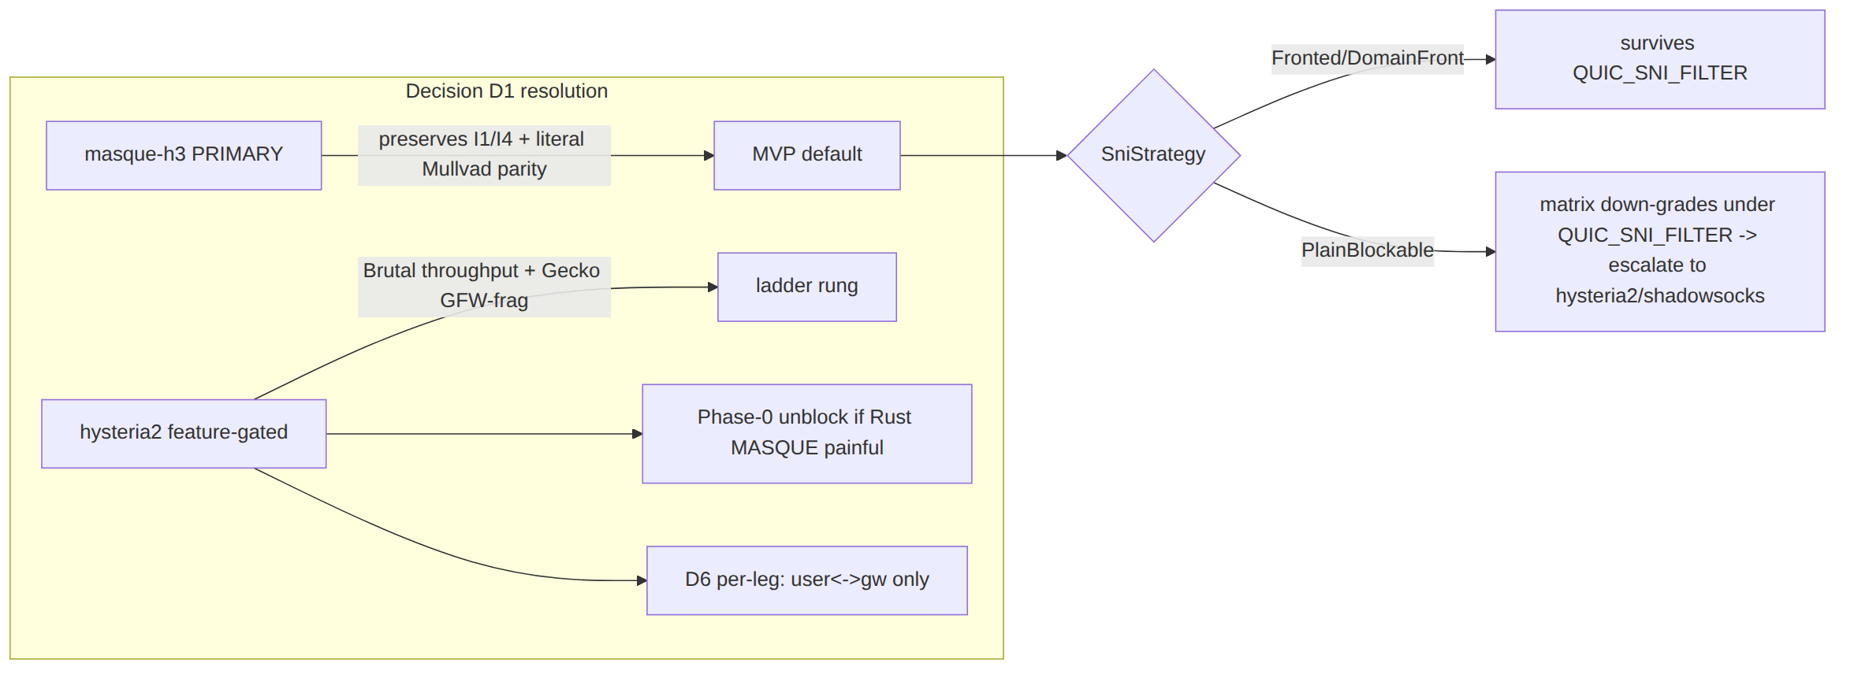

7. Test points (§11.4.169) — proving each survival claim with captured evidence
Every survival claim in §2 and every detector inference in §4 is a falsifiable test. The rig is the [research-daita §5] Linux-netns + nftables-DPI-sim + tc netem stack, booted on-demand via the containers submodule (§11.4.76). Each leaf records an evidence path in test_diary (§11.4.149); no metadata-only PASS.
Test id | §11.4.169 types | What it proves | Rig / evidence | Source
T-MATRIX | UNIT | resistance()/survives() match §2.1 cell-by-cell | table-driven Rust unit test; paired §1.1 mutation flips one cell → FAIL | §2.2
T-WGFP | INT,E2E | plain-udp blocked by a WG-type nftables match, lwo survives | netns; nft rule matching type∈{1..4}+148/92 sizes; tshark shows mangled header | [research-hysteria2 §4, research-daita §5.4]
T-UDPBLOCK | INT,E2E | under nft drop udp, shadowsocks/udp-over-tcp connect, all UDP transports fail | netns drop-all-UDP; tunnel up over TCP; iperf3 goodput | [research-hysteria2 §5(b), research-daita §5.3]
T-QUIC-SNI | INT,E2E,SEC | plain-SNI masque-h3 blocked, fronted-SNI/hysteria2+Salamander survive | netns DPI sim extracting QUIC-Initial SNI (mimics GFW key-derivation); tshark no-SNI on Salamander | [research-hysteria2 §5(a)]
T-GECKO-FRAG | INT | Gecko handshake fragmentation slips a single-datagram-Initial inspector | DPI sim that only inspects 1st datagram; capture multi-datagram Initial | [research-hysteria2 §5(a)]
T-PROBE | SEC,FA | active prober to :443 gets decoy/silent/RST, never a tunnel tell | scripted prober (forged first bytes); assert decoy HTML / no-response / benign-RST; re-runnable -count=3 | §3, [research-hysteria2 §5(d)]
T-SEC-a | SEC | classify() auth decision is constant-time (no timing oracle) | timing histogram wrong-PSK vs no-PSK; assert overlap | §3.4 (UNVERIFIED: underlying-lib CT — must measure)
T-RESIDUAL | INT,CHAOS | mid-session RESIDUAL_BLOCK triggers cooldown + port-rotate, not blind redial | netns stateful-block qdisc; assert Reconnecting{residual} + fresh 4-tuple after window | §4.4, [research-hysteria2 §5(a)]
T-LADDER | FA,E2E | detector commits the right Regime and survives() picks the surviving rung | full ladder run; assert ordered TunnelStatus trace; -count=3 deterministic (§11.4.50) | §4.3
T-MTU | UNIT,PERF | each envelope's effective_mtu() is measured, Oversize enforced | wrap a max datagram; assert TransportError::Oversize; measure on wire | [01 §10] §5.2
T-G2-WIRE | REC,SEC | masque-h3 flow classifies as HTTP/3 with no WG signature | tshark capture (the G2 wire-fingerprint check) + window-scoped MP4 vision verdict (§11.4.159) | [01 §3.3, 04_P0 §8]
T-THROTTLE | PERF,STRESS | Hysteria2/Brutal sustains goodput under netem throttle where MASQUE collapses | tc netem rate+loss; iperf3 goodput bars; assert Brutal cap honored | [research-hysteria2 §6, research-daita §5.2/§5.3]
T-LOSS | PERF | under netem loss 5%, masque-h3/QUIC beats the udp-over-tcp strawman | Gilbert-Elliott bursty loss; goodput compare | [01 §5.3, research-daita §5.2]
Anti-bluff floor (§11.4 / §11.4.107): a survival claim is complete only when its T-id is green with a captured artifact — a tshark capture, an iperf3 CSV, a probe-response transcript — recorded in test_diary; the wire-fingerprint claims additionally carry a window-scoped MP4 + media-validation verdict (§11.4.159/.163). "The transport survives regime X" with no captured DPI-sim evidence is a §11.4 PASS-bluff.

8. Performance budget (the honest cost of obfuscation)
Transport | Relative throughput vs plain-udp | CPU cost | Why | Source
plain-udp | 1.00 (the G1 ≥80%-bare-link baseline) | lowest | no obfuscation | [01 §3.2, 04_P0 §8]
lwo | ~0.98 (−padding) | near-zero | XOR 4 header bytes + pad | [01 §3.7]
masque-h3 | < 1.0, materially | highest | double crypto + double congestion control (WG-in-QUIC, two AEAD layers) — Mullvad-acknowledged "computationally very expensive" | [research-masque §2]
hysteria2+Salamander | higher than MASQUE on lossy/throttled | moderate | single QUIC layer; Brutal ignores loss | [research-hysteria2 §6]
shadowsocks/udp-over-tcp | moderate (HoL penalty) | moderate | TCP HoL blocking, AEAD | [01 §3.5/§3.6]
Spec requirement (§11.4.6, anti-bluff): the MASQUE throughput penalty MUST be measured (WG-direct vs WG-over-MASQUE, the Phase-0 G2 record: MTU / throughput / CPU vs plain-udp) — do not claim parity speed [research-masque §5, 01 §10, 04_P0 §5.3]. The numeric penalty is UNVERIFIED: until the G2 benchmark lands; Mullvad published no figures [research-hysteria2 §2]. MTU budget per envelope is fixed at [01 §10] (plain-udp 1420, masque-h3 1280-measure-and-tune, shadowsocks/udp-over-tcp ~1380, lwo ~1400).

9. Relationship to DAITA (placement only — internals deferred)
DAITA (size/timing/frequency defense) sits at L2.5 — above WG, below the transport [01 §9, research-daita §2]. Its relationship to this document's concern: DAITA is the calibrated answer to SIZE_PROFILING (which feeds ACTIVE_PROBING), where the LWO/Salamander per-packet random padding (§5) is the cheap heuristic form. Both flatten the size histogram; DAITA additionally normalizes timing and injects bidirectional cover traffic [research-daita §2].
Ordering invariant (load-bearing): DAITA shapes the stream of WG datagrams before they hit the obfuscating transport — so the transport obfuscates an already-shaped stream. The obfuscation envelope (§5) MUST NOT undo DAITA's size normalization (e.g. lwo padding is additive to DAITA's constant-size padding, not a replacement). DAITA's machines (maybenot 2.2.2 core, server-pushed v2 model) are config from the NetworkMap, specified in the security doc [research-daita §1/§4, 01 §9]; this document only fixes the placement and the no-conflict rule.

10. Edge cases & failure-mode catalogue (implementation-ready)
# | Edge case | Required behavior | Cite
EC1 | Ambiguous single DialTimeout | do NOT commit a regime bit; fall back to order; commit only on contrast success | §4.2
EC2 | masque-h3 with PlainBlockable SNI under QUIC_SNI_FILTER | treat as not-surviving; skip to hysteria2/shadowsocks | §2.2, §6.4
EC3 | GFW residual block mid-session | cooldown (default 200 s) + port-rotate or escalate; emit Reconnecting{residual} | §4.4
EC4 | LWO/Salamander padding pushes datagram > MTU | TransportError::Oversize; orchestrator lowers inner WG MTU | §5.2, [01 §10]
EC5 | Hysteria2 Brutal uncapped harms gateway uplink | hysteria2_brutal_mbps is REQUIRED when the feature is enabled; reject config if unset | §6.3
EC6 | Active prober replays a captured AEAD/auth first frame | nonce/session binding rejects; edge stays on BenignRst path, no tell | §3.4
EC7 | Decoy site returns blank/444 | forbidden — blank is itself a fingerprint; decoy MUST be a complete small site | §3.3
EC8 | masque-h3 proxy SNI ≠ decoy cert name | forbidden — same name required or SNI distinguishes probe from client | §3.3
EC9 | Hysteria2 < v2.9.2 (UDP ACL-bypass CVE-class) | pin ≥ app/v2.9.2 (2026-05-23); reject older | §5.3, [research-hysteria2 §1]
EC10 | UDP_BLOCK + TLS_SNI_FILTER together (maximally hostile) | only shadowsocks/udp-over-tcp with tls_sni + AEAD front survive; if those fail → honest Down{reason} not a fake PASS | §2.1, §11.4.6

11. Error taxonomy extensions (regime-aware)
The base TransportError [01 §3.1 error.rs] is sufficient for the carrier; this document adds the regime-classification wrapping the orchestrator records (it does NOT change the wire taxonomy — EndpointBlocked is still the DPI verdict on the wire).
// helix-core/src/ladder.rs — orchestrator-side annotation, not a transport error
#[derive(Clone, Debug)]
pub struct RegimeVerdict {
pub err: TransportErrorKind, // the carrier-level error (mirrors §3.1 taxonomy)
pub phase: FailPhase, // Dial | Handshake | MidSession
pub inferred: Regime, // bits this observation contributes (may be empty)
pub confidence: Confidence, // Hypothesis until a contrast success confirms (§11.4.6)
pub evidence_path: Option<String>, // §11.4.149 test_diary / capture path
}
#[derive(Clone, Copy, Debug)] pub enum Confidence { Hypothesis, Confirmed }
EndpointBlocked remains the single wire-level "DPI/firewall dropped this" signal [01 §3.1]; the regime is an orchestrator inference layered on top, always Hypothesis until a differently-carried transport succeeds (then Confirmed, and the per-network memory short-circuits it next time) [§4.2, 01 §5.3 step 4].

12. What this document explicitly does NOT decide
- The numeric MASQUE throughput penalty — UNVERIFIED: pending the Phase-0 G2 benchmark [research-masque §5, 04_P0 §5.3]; Mullvad published none [research-hysteria2 §2].
- The exact ClientHello mimicry layer — an open design problem, seamed by SniStrategy (§6.4), specified for resolution in the security doc, not here [research-masque §2, §5].
- The gateway edge language (D5 Rust-vs-Go for MASQUE termination) — settled by the Phase-0 G4 benchmark; this document assumes Rust for the single-implementation guarantee and notes the Go (masque-go) conformance-suite-mitigated fallback [01 §11.2, research-masque §4].
- DAITA machine internals and the post-quantum PSK — referenced for seams only (§9), specified in the security doc [01 §9, research-daita].

End of nano-detail specification: Obfuscation & DPI/Censorship Landscape (Volume 2, Data Plane). Pair with the pass-1 overview [01 §3, §5.3] (the transports and the flat ladder this document makes regime-aware), the security doc (DAITA machines, ClientHello mimicry, PQ PSK), and Volume 8 testing docs (the §11.4.169 test-type harnesses behind §7). The Regime type (§1), the survives() matrix (§2), the probe AuthGate (§3), and the regime-aware ladder (§4) are the frozen contracts this document adds; their implementations may evolve.

