helix-core Orchestrator & State Machine

helix-core Orchestrator & State Machine
Revision: 2 Last modified: 2026-07-04T12:00:00Z
Master technical specification — Volume 2 (Data Plane), nano-detail deep-dive. This document deepens the Orchestrator, status stream, and auto transport selection section of doc 01 [01-DP §5.1, §5.2] into an implementation-ready specification of the crates/helix-core orchestrator: its three async loops, the tokio::broadcast status stream, network-map reconciliation, the reconnection backoff state machine, the kill-switch + DNS coupling, and the --mode=connector posture that shares the same core. SPEC-ONLY: it describes what to build, not the shipping product. Sources cited inline by id — [01-DP §N] = doc 01 final/01-data-plane.md; [04_ARCH §N] = 04_VPN_CLD/HelixVPN-Architecture-Refined.md; [04_P0 §N] = 04_VPN_CLD/HelixVPN-Phase0-Spike.md; [04_P2 §N] = Phase-2 refined doc; [SYNTHESIS §N] = the cross-document synthesis; [01-LAD §N] = v02-data-plane/transport-selection-ladder.md; [research-masque] = the cited research digests. Any claim not grounded in the evidence base is marked UNVERIFIED per constitution §11.4.6.

0. Position, ownership, and invariants

0.1 What this document owns
The orchestrator (crates/helix-core, file helix-core/src/orchestrator.rs [01-DP §12]) is the conductor of the data plane on every role. It owns the wiring that turns the four frozen Phase-0 contracts — the Transport trait [01-DP §3.1], helix-wg's WgPeer [01-DP §4], the RouteMap reconciler input [01-DP §6.2], and the TunnelStatus broadcast enum [01-DP §5.2] — into a running tunnel, and it re-converges them without a process restart as state changes [04_ARCH §4.4, 04_P0 §4.5/§10]. Concretely it owns:
- The three async loops — tun → wg → (daita) → transport, transport → wg → tun, timer tick — and the tokio::select! driver that multiplexes them (§2, §3).
- The tokio::sync::broadcast status stream that surfaces Connecting | Handshaking | Connected{transport,rtt} | Reconnecting | Down{reason} to the FFI, the ladder, and aggregate metrics (§4) [01-DP §5.2, 04_P0 §4.5].
- The orchestrator state machine that decides which TunnelStatus is current and gates every side effect (kill-switch open/close, DNS apply/revert, ladder kick) (§5).
- Network-map reconciliation — diff desired-vs-actual RouteMap, converge peers / routes / transport policy / DNS, no restart, < 1 s convergence (§6) [04_ARCH §4.4].
- The reconnection backoff state machine — jittered exponential re-dial with roam detection, feeding the ladder (§7) [04_P2 §1.4, 04_P0 §8].
- The kill-switch + DNS coupling — OS firewall + tunnel-DNS side effects driven by the core state machine, never hand-edited (§8) [04_ARCH §5.6 table, §7].
- The connector posture (--mode=connector) — the same core with a forwarding/NAT routing posture instead of default-route capture (§9) [04_P0 §4.5].

0.2 What this document does NOT own
- The Transport trait, TransportConfig, dial(), per-transport wire framing — frozen in doc 01 [01-DP §3]; the orchestrator consumes opaque Box<dyn Transport> handles.
- The ladder selection algorithm (which rung, per-network memory, regional prior, manual pin) — owned by helix-core/src/ladder.rs and specified in [01-LAD]. This document owns the driver that asks the ladder for the next transport and reacts to its outcome; it treats ladder::select() / ladder::escalate() as upstream calls (§7.4).
- WireGuard crypto (helix-wg Tunn state machine) [01-DP §4]; routing/ACL compilation (helix-route) [01-DP §6–§7]; DAITA shaping (helix-daita) [01-DP §9] — the orchestrator drives their hooks but does not define them.
- The WatchNetworkMap protobuf that delivers the RouteMap (doc 03); the orchestrator consumes the map's shape and treats a file-watch on map.json as the Phase-0 stand-in for the stream [04_P0 §10].
- The FFI bridge that re-emits TunnelStatus to Dart (doc 05); this document owns the broadcast sender, not the FFI receiver.

0.3 Invariants this document inherits and tightens
# | Invariant | Source | Orchestrator-specific tightening
I1 | Transport never sees plaintext. | [01-DP I1] | Loop A hands WG-encrypted bytes to Transport::send; loop B hands Transport::recv bytes to WgPeer. The orchestrator never logs nor inspects either side's payload (§3, §10).
I2 | Unreliable datagrams, never an ordered stream. | [01-DP I2] | The loops carry one datagram per iteration; a dropped recv is not retried at the orchestrator layer — WG owns loss semantics.
I3 | Control plane never in the packet path; fail-static. | [01-DP I3, 04_ARCH §2.1] | If the reconcile source (stream / file-watch) dies, the existing loops keep forwarding; reconciliation is a side task, never on the hot path (§6.5).
I5 | No-logging by construction; aggregate counters only. | [01-DP I5] | The status stream carries ephemeral state, never durable per-connection records; the only persisted artefact is the ladder's per-network memory hash (§4.5, §10) [01-LAD §6.4].
O-I10 | Single state authority — exactly one OrchState is current; every TunnelStatus emission and every kill-switch / DNS side effect is a function of an OrchState transition, never an ad-hoc emit. | derived from [01-DP §5.2] | §5; prevents UI flicker and firewall races.
O-I11 | Kill-switch fails closed — on any transition into Reconnecting/Down, the firewall stays/goes closed until a Connected transition re-opens it; a crash leaves the closed rules installed. | [04_ARCH §5.6 "no leaks if tunnel drops", §7] | §8.2, §8.5.
O-I12 | Reconcile is declarative + restart-free — a map delta mutates live peer/route/policy state in place; the process is never restarted to apply a change. | [04_ARCH §4.4, 04_P0 §10] | §6.
O-I13 | Connector and client run the identical core — only the routing posture differs, selected by one flag; no forked loop bodies. | [04_P0 §4.5, 01-DP I4] | §9.

1. The orchestrator at a glance
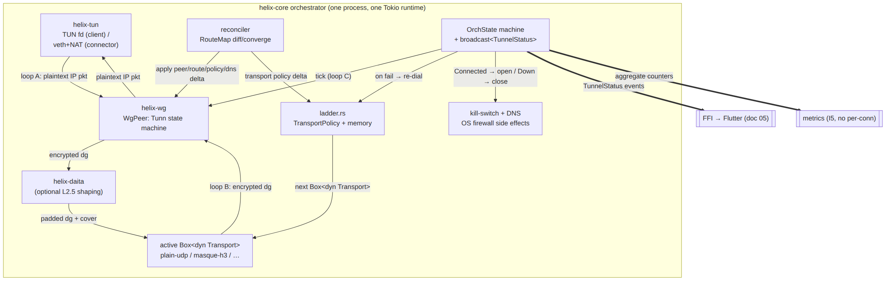
Three data-moving loops, one control state machine, two side-effect sinks (FFI + metrics), two control inputs (ladder outcomes, reconcile deltas), and one OS-effect sink (kill-switch/DNS). Everything below is the nano-detail of these eight boxes.

2. Top-level types & lifecycle

2.1 Orchestrator struct and construction
// helix-core/src/orchestrator.rs
use std::sync::Arc;
use std::net::IpAddr;
use tokio::sync::{broadcast, mpsc, watch, Mutex};
use tokio_util::sync::CancellationToken;
use bytes::Bytes;
use helix_transport::{Transport, TransportConfig, TransportError, dial};
use helix_wg::{WgPeer, WgVerdict};
use helix_tun::TunDevice;
use helix_route::{RouteMap, CompiledPolicy};
/// Run-role selected once at startup; the rest of the core is identical (O-I13).
#[derive(Clone, Copy, Debug, PartialEq, Eq)]
pub enum Mode { Client, Connector }
/// All construction inputs. Resolved from CLI flags + the first RouteMap snapshot.
pub struct OrchestratorConfig {
pub mode: Mode,
pub tun: TunSpec, // client: create/inject fd; connector: forward iface + NAT
pub initial_map: RouteMap, // first snapshot (doc 03) or static map.json (Phase 0)
pub transport_policy: TransportPolicy,// ladder order/pin/budget [01-LAD §3]
pub kill_switch: KillSwitchConfig, // §8
pub dns: DnsConfig, // §8.3
pub tunables: Tunables, // §11
}
/// The live orchestrator. Owns the broadcast sender; loops hold `Arc<OrchShared>`.
pub struct Orchestrator {
shared: Arc<OrchShared>,
cancel: CancellationToken, // cooperative shutdown of all loops (§2.4)
join: Vec<tokio::task::JoinHandle<()>>,
}
/// Shared state every loop reads; mutated only via the state machine (O-I10) and reconciler.
pub struct OrchShared {
pub mode: Mode,
pub status_tx: broadcast::Sender<TunnelStatus>, // §4
pub state: Mutex<StateCell>, // OrchState authority (§5)
pub active_tx: Mutex<Option<Arc<dyn Transport>>>, // current rung; swapped by re-dial (§7)
pub wg: Mutex<WgRegistry>, // peers keyed by pubkey (§6.3)
pub tun: TunDevice,
pub daita: Mutex<Option<helix_daita::Daita>>, // None unless opted in [01-DP §9]
pub policy: Mutex<CompiledPolicy>, // connector/edge verdict map (§9.3)
pub counters: Counters, // aggregate only (I5)
}
impl Orchestrator {
/// Build, install the kill-switch in its *armed-closed-until-connected* posture (§8.2),
/// spawn the three loops + reconciler + ladder driver, and emit `Connecting`.
pub async fn start(cfg: OrchestratorConfig) -> Result<Self, OrchestratorError> { /* … */ }
/// Subscribe to the live status stream (FFI, metrics, tests all use this) [01-DP §5.2].
pub fn subscribe(&self) -> broadcast::Receiver<TunnelStatus> {
self.shared.status_tx.subscribe()
}
/// Push a new desired-state map (Phase 1: from the WatchNetworkMap stream; Phase 0:
/// from the file-watch). Triggers reconciliation (§6).
pub async fn apply_map(&self, map: RouteMap) -> Result<(), OrchestratorError> { /* … */ }
/// User action: pin a transport (manual override) — re-arms the ladder (§7.4) [01-LAD §8].
pub async fn set_pin(&self, pin: Option<TransportKind>) { /* … */ }
/// Graceful stop: cancel loops, FIN the transport, revert kill-switch+DNS, emit Down (§2.4).
pub async fn stop(self) -> Result<(), OrchestratorError> { /* … */ }
}
active_tx is Arc<dyn Transport> (not Box) so loop A and loop B share one handle and a re-dial can atomically swap it under the mutex without tearing either loop (§7.3). The Transport trait's send/recv take &self [01-DP §3.1], so Arc<dyn Transport> is the correct shared ownership.

2.2 Spawn topology
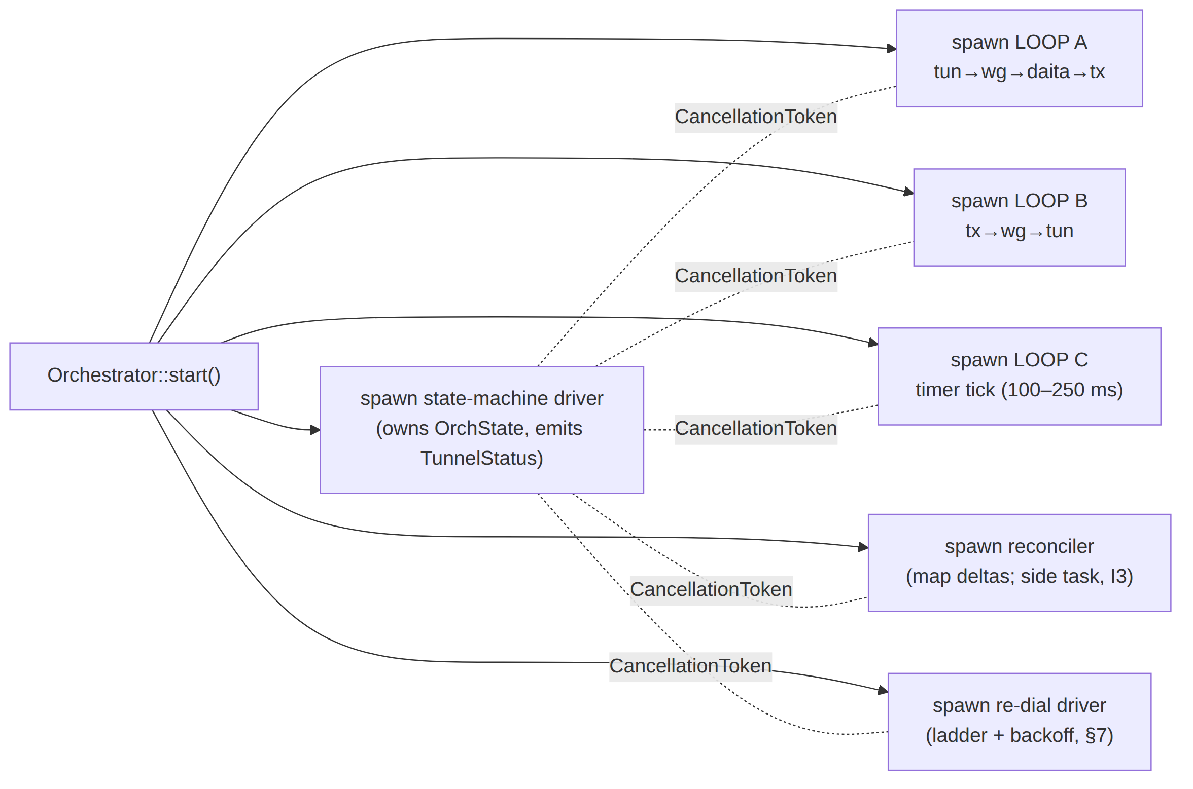
Six tasks. The state-machine driver is the single writer of OrchState; every other task requests a transition by sending an OrchEvent on an mpsc channel the driver owns (§5.3), so O-I10 holds without lock contention on the hot loops.

2.3 Internal control channels
/// Loops and the reconciler never mutate OrchState directly — they post events.
pub enum OrchEvent {
HandshakeStarted, // loop B saw first inbound after dial
HandshakeComplete { rtt_ms: u32 }, // WG session established (§5.4)
TransportError(TransportError), // loop A/B carrier failed
PeerTimeout { pubkey: [u8; 32] }, // tick: no recv within keepalive window
MapApplied { changed: MapDelta }, // reconciler converged (§6)
RoamDetected { new_local: IpAddr }, // local iface changed (§7.5)
PinChanged(Option<TransportKind>), // user manual override
Stop, // graceful shutdown
}
pub struct StateCell {
pub state: OrchState, // §5.1
pub since: tokio::time::Instant, // dwell time for budgets/metrics
pub backoff: Backoff, // §7.2
pub event_tx: mpsc::Sender<OrchEvent>, // loops clone this
}

2.4 Cancellation & shutdown ordering
stop() cancels the CancellationToken. Every loop's tokio::select! includes a _ = self.cancel.cancelled() => break arm (§3.4), so all three drain on the next iteration. Shutdown order is strict to honour O-I11 (no leak window during teardown):
- Transition OrchState → ShuttingDown (suppresses re-dial; ladder driver exits).
- active_tx.close() (FIN the QUIC/TCP carrier idempotently) [01-DP §3.1].
- Keep the kill-switch closed; revert DNS to system resolvers (§8.4).
- Cancel loops A/B/C/reconciler; join all handles with a bounded timeout (Tunables.shutdown_grace, default 2 s).
- On user-initiated stop only: revert the kill-switch to off (open) — the user asked to disconnect, so traffic flows on the underlay again (§8.6). On crash/abnormal exit the closed rules are left installed (O-I11).
- Emit Down { reason: "stopped" } last.

3. The three loops (nano-detail)
The orchestrator runs three loops [04_P0 §4.5, 01-DP §5.1]. Each is a single tokio::task with an internal loop { tokio::select! { … } }. The bodies are cancel-safe: Transport::recv and TunDevice::recv are documented cancel-safe [01-DP §3.1], and WgPeer calls are synchronous CPU work between awaits.

3.1 Loop A — outbound: tun → wg → (daita) → transport
async fn loop_a(shared: Arc<OrchShared>, cancel: CancellationToken) {
let mut scratch = vec![0u8; 65535]; // reused encrypt buffer; no per-pkt alloc
loop {
tokio::select! {
biased; // cancel checked first
_ = cancel.cancelled() => break,
pkt = shared.tun.recv() => { // plaintext IP packet from the OS (client)
let ip_pkt = match pkt { Ok(p) => p, Err(_) => continue };
// 1. WG encrypt (helix-wg owns the Tunn state machine) [01-DP §4]
let mut wg = shared.wg.lock().await;
let verdict = wg.peer_for_dst(&ip_pkt) // route by AllowedIPs (I6)
.map(|p| p.handle_tun_out(&ip_pkt, &mut scratch));
let enc: &[u8] = match verdict {
Some(WgVerdict::WriteToTransport(b)) => b,
Some(WgVerdict::Nothing) | None => continue, // no session yet / no route
Some(WgVerdict::WriteToTun(_)) => continue, // impossible here
Some(WgVerdict::Err(_)) => { shared.counters.wg_enc_err.inc(); continue }
};
let mut dg = Bytes::copy_from_slice(enc);
drop(wg); // release before await
// 2. DAITA shaping (optional, above WG / below transport) [01-DP §9]
if let Some(d) = shared.daita.lock().await.as_mut() {
for act in d.on_packet(&mut dg, tokio::time::Instant::now()) {
if let ScheduledAction::SendNow(cover) = act { let _ = send_dg(&shared, cover).await; }
}
}
// 3. hand to the active transport (I1: opaque encrypted bytes)
if let Err(e) = send_dg(&shared, dg).await { post_err(&shared, e).await; }
}
}
}
}
/// Single send path; swaps cleanly if a re-dial replaced active_tx mid-flight (§7.3).
async fn send_dg(shared: &OrchShared, dg: Bytes) -> Result<(), TransportError> {
let tx = shared.active_tx.lock().await.clone() // Arc clone; cheap
.ok_or(TransportError::Closed)?;
match tx.send(dg).await {
Err(TransportError::Oversize(n)) => { shared.counters.oversize.inc();
Err(TransportError::Oversize(n)) } // §6.6 MTU edge → caller lowers MTU
other => other,
}
}
Key points: (1) the wg mutex is released before any .await so loop B can run while loop A is in DAITA/transport — no cross-loop deadlock (§12 cross-feature analysis); (2) a WG-encrypt that yields Nothing (handshake not yet complete) silently drops the user packet — WG will buffer the handshake-trigger internally and the app's TCP/QUIC will retransmit; (3) Oversize is propagated, never silently truncated (I2) [01-DP §10].

3.2 Loop B — inbound: transport → wg → tun
async fn loop_b(shared: Arc<OrchShared>, cancel: CancellationToken) {
let mut scratch = vec![0u8; 65535];
loop {
let tx = match shared.active_tx.lock().await.clone() {
Some(t) => t, None => { tokio::time::sleep(IDLE_BACKOFF).await; continue }
};
tokio::select! {
biased;
_ = cancel.cancelled() => break,
r = tx.recv() => {
let dg = match r {
Ok(b) => b,
Err(e) => { post_err(&shared, e).await; // §5/§7 drive re-dial
tokio::time::sleep(IDLE_BACKOFF).await; continue }
};
let mut wg = shared.wg.lock().await;
match wg.handle_transport_in(&dg, &mut scratch) {
WgVerdict::WriteToTun(plain) => { // decrypted IP packet
// connector: forward into served CIDR + NAT (§9.2); client: write TUN
match shared.mode {
Mode::Client => { let _ = shared.tun.send(plain).await; }
Mode::Connector => { forward_into_lan(&shared, plain).await; }
}
}
WgVerdict::WriteToTransport(reply) => { // handshake reply → send back
let b = Bytes::copy_from_slice(reply); drop(wg);
let _ = tx.send(b).await;
post_event(&shared, OrchEvent::HandshakeStarted).await;
}
WgVerdict::Nothing => { /* keepalive / dupe */ }
WgVerdict::Err(_) => shared.counters.wg_dec_err.inc(),
}
}
}
}
}
Loop B is where handshake progress is observed: the first inbound datagram after a dial posts HandshakeStarted (→ Handshaking), and helix-wg reporting an established session (via WgPeer::session_established() polled in loop C, §3.3) posts HandshakeComplete{rtt} (→ Connected). The transport carrier connecting is not "connected" — the WG handshake is (I2 tightening, mirrors [01-LAD I2]).

3.3 Loop C — timer tick: tick → keepalive / rekey / liveness
async fn loop_c(shared: Arc<OrchShared>, cancel: CancellationToken) {
let mut scratch = vec![0u8; 4096];
let mut iv = tokio::time::interval(shared_tick_period()); // 100–250 ms [01-DP §4]
iv.set_missed_tick_behavior(tokio::time::MissedTickBehavior::Skip); // no burst after stall
loop {
tokio::select! {
biased;
_ = cancel.cancelled() => break,
_ = iv.tick() => {
let mut wg = shared.wg.lock().await;
for peer in wg.iter_mut() {
match peer.tick(&mut scratch) { // emits keepalive/rekey [01-DP §4]
WgVerdict::WriteToTransport(b) => {
let dg = Bytes::copy_from_slice(b); drop_then_send(&shared, dg);
}
_ => {}
}
// liveness: WG passive-keepalive is 10 s; declare a peer stale if no
// authenticated recv within keepalive_timeout (§7.1, default 25 s — WG's
// REKEY-after-no-recv heuristic). UNVERIFIED exact value → see §11 Tunables.
if peer.last_recv_age() > shared.tunables.keepalive_timeout {
post_event(&shared, OrchEvent::PeerTimeout { pubkey: peer.pubkey() }).await;
}
if peer.session_just_established() {
post_event(&shared, OrchEvent::HandshakeComplete { rtt_ms: peer.rtt_ms() }).await;
}
}
}
}
}
}
The 100–250 ms cadence is the [01-DP §4] guidance; MissedTickBehavior::Skip prevents a tick storm after the runtime was starved (host-safety adjacent to §12.6). PeerTimeout is the trigger that moves a healthy Connected tunnel into Reconnecting (§5.4, §7.1).

3.4 Why three loops and not one select!
Splitting into three tasks (rather than one mega-select!) gives: independent backpressure (a slow TUN write cannot stall inbound decrypt); per-loop cancel-safety reasoning; and the ability for loop B to sleep(IDLE_BACKOFF) while active_tx is None during a re-dial without blocking loop A's drain. The cost is the shared mutexes; they are held only across synchronous helix-wg calls (microseconds), never across .await, so contention is bounded (§13 performance budget). IDLE_BACKOFF is a short fixed 10 ms poll while disconnected — not the reconnection backoff of §7 (that governs re-dial attempts, this governs the busy-wait while a re-dial is in flight).

4. The status stream (tokio::broadcast)

4.1 The enum (frozen contract, mirrored across the FFI)
// helix-core/src/status.rs (mirrored across the FFI boundary, doc 05) [01-DP §5.2, 04_P0 §4.5]
#[derive(Clone, Debug, PartialEq, Eq)]
pub enum TunnelStatus {
Connecting, // dialling the first/seeded rung
Handshaking, // carrier up, WG handshake in flight
Connected { transport: String, rtt_ms: u32 }, // e.g. ("masque-h3", 23)
Reconnecting, // a working tunnel dropped; re-dialling
Down { reason: String }, // terminal for this attempt; see §4.4 reasons
}
Connected.transport is the Transport::kind() string [01-DP §3.1] ("plain-udp", "masque-h3", …) so the UI shows which rung won [01-LAD §5.4]. rtt_ms is the WG-handshake RTT EWMA from TransportHealth.rtt_ewma_ms [01-DP §3.1], refreshed on each Connected re-emit (§4.3).

4.2 Channel construction & capacity
// capacity sized for: FFI receiver + metrics receiver + ladder/test receivers, with slack.
const STATUS_CHANNEL_CAP: usize = 64;
let (status_tx, _rx0) = broadcast::channel::<TunnelStatus>(STATUS_CHANNEL_CAP);
tokio::sync::broadcast is a bounded ring [01-DP §5.2]: each receiver has an independent read cursor; a slow receiver that falls STATUS_CHANNEL_CAP behind gets a RecvError::Lagged(n) on its next recv() and is fast-forwarded to the oldest retained value. This is acceptable for a status stream (the receiver only ever needs the latest state), but the FFI/UI receiver MUST treat Lagged as "re-read latest", never as an error (§4.6 receiver contract). Status is edge-coalesced (§4.3): emissions are rare (state changes), so 64 slots is generous; lag only happens if a receiver is wedged.

4.3 Emit discipline — coalesce, never spam
Rule (O-I10): the only code that calls status_tx.send(...) is the state-machine driver, exactly once per OrchState transition, after the side effects of that transition have been applied (kill-switch/DNS first, then emit — so a UI that reacts to Connected can trust the firewall is already open). Re-emitting the same logical state is suppressed except for Connected, which is re-emitted when rtt_ms changes by more than Tunables.rtt_emit_delta_ms (default 5 ms) so the UI's latency chip updates without flicker. Reconnecting is emitted once per drop, not once per failed re-dial (§7.3).

4.4 Down.reason closed-ish vocabulary
Down.reason is a human/machine string; the orchestrator uses a stable prefix so tests and metrics can classify without parsing prose (§11.4.6 no-guessing):
reason value | Meaning | Emitted from
"stopped" | user/graceful stop | §2.4
"pinned-transport-failed" | manual pin rung failed; no auto-escalate | [01-LAD §8], §5.4
"ladder-exhausted" | every rung in order failed its budget | §7.4
"auth-failed" | WG handshake rejected (revoked/bad key) | §5.4, §8.5
"no-route" | RouteMap has no peer for the requested destination | §6.4
"host-fatal" | TUN open / firewall-apply failed at startup | §8.2
Reconnecting (not Down) is the state while any rung remains untried within budget; Down is reached only when the attempt is genuinely terminal (O-I10, §5.4).

4.5 What the stream MUST NOT carry (I5)
No per-packet, per-flow, per-peer-endpoint, or timestamped-per-connection record ever crosses the broadcast. Connected.transport is a kind label, not an endpoint; rtt_ms is an aggregate EWMA. Durable telemetry derived from the stream is aggregate only: "transport X succeeded after N escalations in region R" [01-DP §5.3 step 6, 01-LAD §9] — never the SSID, never the gateway IP. This is the data-plane half of "no-logging as code" [SYNTHESIS §7].

4.6 Receiver contract (FFI / metrics / tests)
// Reference consumer loop (doc 05 FFI + the test harness both follow this).
let mut rx = orch.subscribe();
loop {
match rx.recv().await {
Ok(s) => ui_apply(s), // render latest
Err(broadcast::error::RecvError::Lagged(_)) => continue, // skip-to-latest, NOT an error
Err(broadcast::error::RecvError::Closed) => break, // orchestrator gone
}
}

5. The orchestrator state machine

5.1 States
#[derive(Clone, Debug, PartialEq, Eq)]
pub enum OrchState {
Idle, // constructed, not started (pre-start only)
Connecting, // dialling a rung (carrier handshake in flight)
Handshaking, // carrier up; WG Noise IK handshake in flight
Connected { kind: TransportKind, rtt_ms: u32 },
Reconnecting { since_drop: tokio::time::Instant }, // re-dialling within budget
ShuttingDown, // graceful teardown in progress (§2.4)
Down { reason: DownReason },// terminal for this attempt
}
OrchState is the internal authority; TunnelStatus (§4.1) is its FFI-facing projection (Idle/ShuttingDown have no public projection — they map to Connecting/Down respectively at the FFI). The split keeps internal bookkeeping (e.g. since_drop) off the wire.

5.2 State diagram
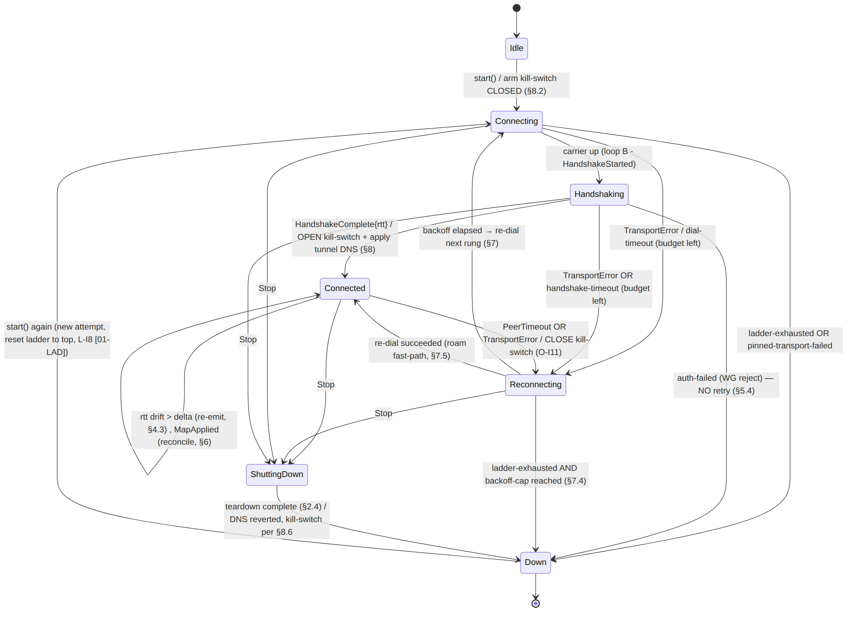

5.3 Driver task (single writer of OrchState)
async fn state_driver(shared: Arc<OrchShared>, mut ev: mpsc::Receiver<OrchEvent>,
cancel: CancellationToken) {
while let Some(event) = tokio::select! {
_ = cancel.cancelled() => None,
e = ev.recv() => e,
} {
let mut cell = shared.state.lock().await;
let next = transition(&cell.state, &event, &shared).await; // pure-ish decision (§5.4)
if let Some(ns) = next {
apply_side_effects(&cell.state, &ns, &shared).await; // kill-switch/DNS FIRST (§4.3)
cell.since = tokio::time::Instant::now();
cell.state = ns.clone();
emit_status(&shared, &ns).await; // THEN emit (O-I10)
}
}
}
transition() is the table of §5.2 encoded as a match (&state, &event); it returns Option<OrchState> (None = ignore the event in this state, e.g. a stray HandshakeComplete while already Connected). apply_side_effects() is where O-I11 (kill-switch) and §8 (DNS) live, ordered before the emit so the FFI never observes Connected before the firewall opened.

5.4 Decision details (the non-obvious transitions)
- Handshaking → Down{auth-failed} is terminal-without-retry. A WG handshake that is cryptographically rejected (peer revoked, key rotated, device.revoked propagated [04_ARCH §4.4]) will fail identically on every rung — escalating the ladder is pointless and would mask a real revocation. helix-wg distinguishes "no reply" (network/DPI → retry/ escalate) from "handshake rejected" (auth → Down). UNVERIFIED: boringtun's public API for surfacing an explicit reject vs a silent timeout — if unavailable, the orchestrator treats a handshake that never completes within handshake_timeout as the escalate class and can only infer auth-failure from the control plane (doc 02) signalling a revoke; recorded as a follow-up forensic item per §11.4.6.
- Connected → Reconnecting on PeerTimeout. A live tunnel that goes silent (carrier still "up" but WG sees no authenticated recv past keepalive_timeout) is the roam / NAT-rebind / silent-drop case [04_P0 §8 "flap the client iface; recovery < 3 s"]. The kill-switch closes immediately (O-I11) so no traffic leaks during the gap.
- Reconnecting budget. Each re-dial consults the ladder (§7.4); Reconnecting → Down only when the ladder reports exhaustion and the backoff cap is hit (§7.2) — never on a single failure (avoids premature Down).

6. Network-map reconciliation

6.1 The reconciler contract
Agents are declarative reconcilers [04_ARCH §4.4, 04_P0 §10]: they diff a desired RouteMap (pushed by the coordinator via WatchNetworkMap, doc 03; a file-watch on map.json in Phase 0) against actual live state and converge — bring peers up/down, switch transport policy, update routes, update DNS — without restarting (O-I12). Convergence target: a change reflected on all affected state in < 1 s [04_ARCH §4.4].

6.2 RouteMap (the desired state, frozen shape) [01-DP §6.2]
pub struct RouteMap {
pub self_overlay: IpAddr, // this node's overlay IP (ULA /48, D4)
pub peers: Vec<PeerRoute>, // already policy-filtered (need-to-know, I6)
pub dns: Vec<IpAddr>, // tunnel DNS servers (§8.3)
pub transport_policy: TransportPolicy, // per-leg ladder order/pin/budget [01-LAD §7]
pub daita: Option<DaitaMachines>, // optional shaping config (data, not code) [01-DP §9]
}
pub struct PeerRoute {
pub wg_pubkey: [u8; 32],
pub endpoint_candidates: Vec<SocketAddr>, // §8 NAT traversal (Phase 2)
pub allowed_ips: Vec<IpNet>, // overlay prefixes this peer is next hop for
pub via_connector: Option<SiteId>, // 4via6 site disambiguation [01-DP §6.1]
}

6.3 Diff algorithm
/// Pure diff: what changed between actual (live WgRegistry/policy/dns) and desired (new map).
pub struct MapDelta {
pub peers_added: Vec<PeerRoute>,
pub peers_removed: Vec<[u8; 32]>, // pubkeys to tear down (revocation path)
pub peers_changed: Vec<PeerRoute>, // allowed_ips / endpoint changed
pub dns_changed: bool,
pub policy_changed: bool,
pub transport_policy_changed: bool,
}
fn diff(actual: &WgRegistry, dns: &[IpAddr], pol: &CompiledPolicy, desired: &RouteMap) -> MapDelta {
// keyed by wg_pubkey; O(n) set difference on a sorted pubkey index
/* … */
}

6.4 Apply (converge) — restart-free
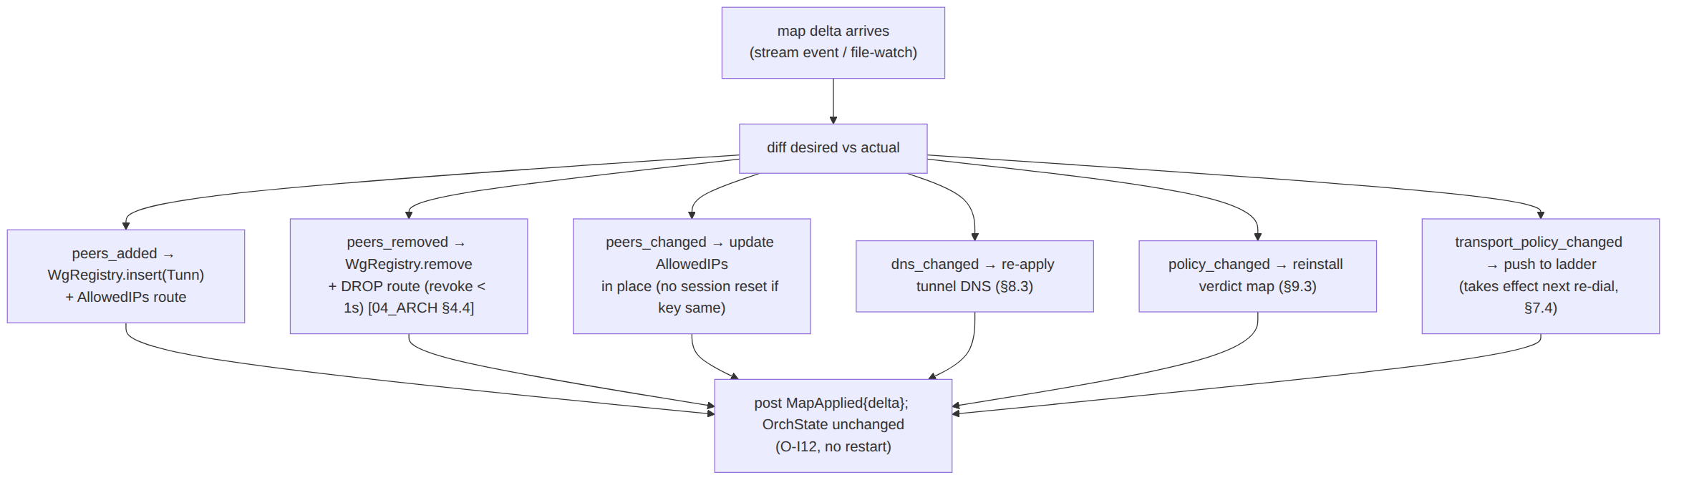
A peers_removed entry whose pubkey is the active peer (the gateway you are tunnelled through) is the revocation-of-self case: tear the session, close the kill-switch, emit Down{reason:"auth-failed"} (§5.4). A peers_changed that only touches allowed_ips updates the routing map without resetting the WG session (the key is unchanged) — this is the "policy edit < 1 s, no restart" MVP gate (AC5) [04_P1 §11.2].

6.5 Reconcile is a side task (I3 fail-static)
The reconciler runs as its own tokio::task; if its source dies (stream disconnect, file-watch error), the three loops keep forwarding on the last-applied map (fail-static [04_ARCH §2.1]). The reconciler reconnects to the stream with its own backoff (independent of §7's data-plane backoff) and re-applies a fresh snapshot on reconnect. A reconcile failure never tears the tunnel.

6.6 MTU coupling on transport change
When transport_policy_changed causes the ladder to later swap the active transport (§7.3), the inner WG MTU is recomputed: inner_mtu = min(active.effective_mtu(), path_mtu) [01-DP §10]. The orchestrator pushes the new MTU into helix-tun and into each WgPeer's fragmentation threshold. An in-flight Oversize error (§3.1) during the swap window triggers an immediate MTU lower rather than a silent drop (I2).

7. Reconnection backoff state machine

7.1 Triggers into reconnect
A reconnect begins on any of: TransportError from loop A/B (carrier died), PeerTimeout from loop C (silent WG drop), or RoamDetected (local iface changed — §7.5). All three post events that move Connected → Reconnecting (§5.4). Target recovery time is < 3 s for an interface flap / roam [04_P0 §8].

7.2 The backoff struct (jittered exponential, capped)
pub struct Backoff {
base: Duration, // first re-dial delay
cap: Duration, // ceiling
factor: f64, // multiplier per failed attempt
jitter: f64, // 0.0..=1.0 fraction of full jitter (decorrelated)
attempt: u32, // resets to 0 on Connected
rng: SmallRng,
}
impl Backoff {
/// Decorrelated jitter (AWS-style): next ∈ [base, min(cap, prev*factor)] then jitter.
fn next_delay(&mut self) -> Duration { /* … */ }
fn reset(&mut self) { self.attempt = 0; }
}
Recommended Tunables (derived, calibrated in Phase 0 against the < 3 s roam gate — values are the spec recommendation, not measured; §11.4.6): base = 250 ms, cap = 30 s, factor = 2.0, jitter = 1.0 (full decorrelated jitter to avoid thundering-herd re-dials when a gateway restarts and many clients reconnect together). The first re-dial after a drop is near-immediate (base) so a transient blip recovers well under 3 s; only a persistently dead network climbs toward the 30 s cap.

7.3 Re-dial driver + atomic transport swap
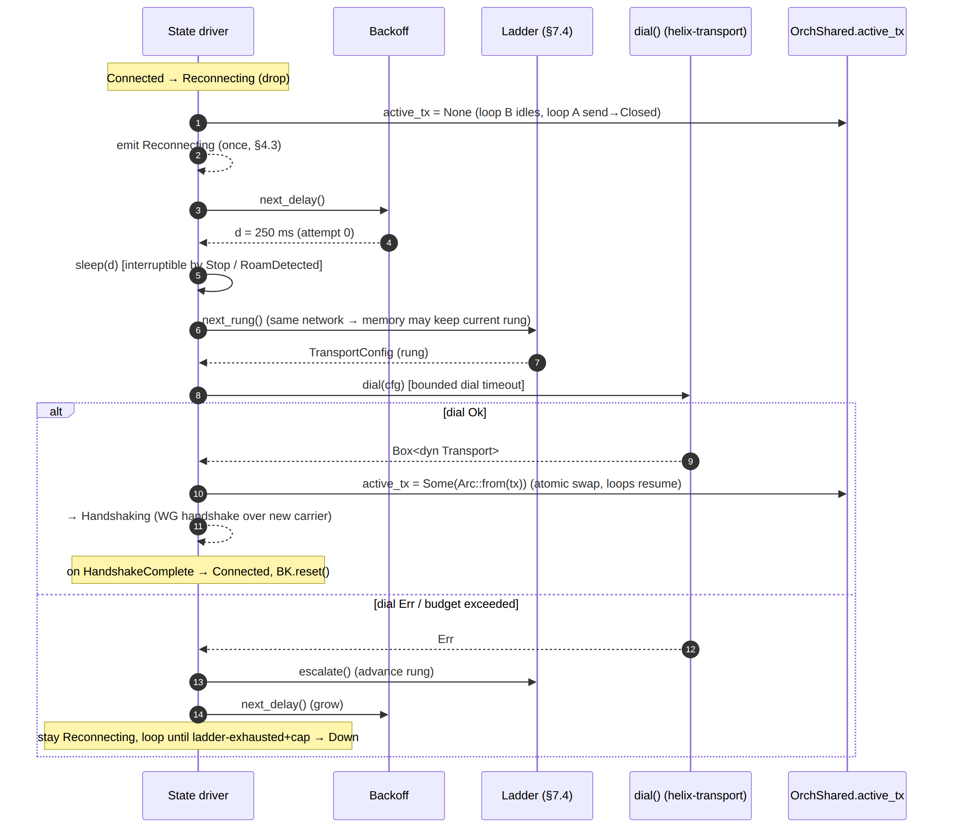
The swap is atomic under active_tx's mutex: loop A's send_dg (§3.1) and loop B's per-iteration active_tx.lock().await.clone() (§3.2) always see either the old or the new Arc, never a torn handle. While active_tx == None, loop A's sends return Closed (the user's app retransmits) and loop B idles on IDLE_BACKOFF.

7.4 Ladder coupling (this doc drives, [01-LAD] decides)
The re-dial driver calls ladder::next_rung() / ladder::escalate() [01-LAD §5]; the ladder owns which rung (per-network memory, regional prior, pin). The orchestrator owns when to re-dial (backoff timing) and whether the attempt is terminal. ladder-exhausted (every rung in order failed its budget) + backoff cap reached ⇒ Down{ladder-exhausted} (§5.4). A pinned transport that fails ⇒ Down{pinned-transport-failed} with no escalation (L-I7 [01-LAD §8]).

7.5 Roam detection (fast-path)
// A platform iface watcher (netlink on Linux; NWPathMonitor/ConnectivityManager on mobile via
// the shim, doc 06) posts RoamDetected{new_local} when the device's primary address changes.
On RoamDetected the orchestrator interrupts any in-flight backoff sleep and re-dials immediately at the remembered-good rung for the new network fingerprint [01-LAD §6], because WireGuard's roaming will re-latch onto the new source address as soon as a handshake completes [01-DP §8.2]. This is the difference between a 30 s backoff-climb and the < 3 s roam recovery gate. RoamDetected resets Backoff.attempt = 0.

8. Kill-switch + DNS coupling

8.1 Principle
The kill-switch and DNS-leak protection are owned by the core state machine, not hand-edited firewall rules [04_ARCH §5.6 carry-forward note, §7]. Every open/close and every DNS apply/revert is a side effect of an OrchState transition (O-I10, §5.3), so there is no window where the UI shows "connected" but the firewall is open, or "disconnected" while DNS still points at the tunnel.

8.2 Kill-switch posture & arming
pub struct KillSwitchConfig {
pub mode: KillSwitchMode, // Strict | Permissive | Off
pub allow_lan: bool, // permit RFC1918 LAN even when closed (printers etc.)
pub allow_gateway_endpoints: Vec<IpNet>, // the gateway IPs the transport must reach (MUST stay open)
}
pub enum KillSwitchMode {
Strict, // closed unless Connected; arm-closed at start (no leak before first connect)
Permissive, // closed only after a first successful Connected (then on every drop)
Off, // never installs firewall rules
}
On Idle → Connecting (start()), Strict mode installs the closed ruleset immediately — default-drop all egress except (a) the allow_gateway_endpoints (so the transport can reach :443), (b) DHCP/ND for link bring-up, (c) optionally allow_lan. This is "no leaks before the first handshake even completes". Permissive waits until the first Connected before it will ever close (so a never-connecting client on a captive-portal network isn't bricked). A firewall-apply failure at start ⇒ Down{host-fatal} (§4.4) — never proceed with a believed-but-unverified kill-switch (§11.4.6).

8.3 DNS coupling
pub struct DnsConfig {
pub servers: Vec<IpAddr>, // tunnel DNS (from RouteMap.dns, §6.2)
pub block_plaintext_53: bool, // drop off-tunnel :53 (UDP+TCP) when Connected (leak guard)
pub apply: DnsApplyMethod, // resolvconf | systemd-resolved | /etc/resolv.conf | shim (doc 06)
}
On Handshaking → Connected: set tunnel DNS (RouteMap.dns) via the platform method, and (if block_plaintext_53) install firewall rules dropping any :53 egress that is not to the tunnel DNS over the tunnel — closing the classic DNS-leak [04_ARCH §5.6 "force tunnel DNS; blocks plaintext :53 off-tunnel"]. On Connected → Reconnecting/Down: the DNS-leak block stays (closed-fails-safe) until either reconnect re-applies tunnel DNS or a user-stop reverts to system resolvers (§8.6).

8.4 Coupling table (the side-effect matrix)
Transition | Kill-switch | DNS | Source
Idle → Connecting (Strict) | install closed (allow gw endpoints only) | leave system DNS | §8.2
Handshaking → Connected | open (allow all egress via tunnel) | apply tunnel DNS + block off-tunnel :53 | [04_ARCH §5.6]
Connected → Reconnecting | close (O-I11) | keep tunnel-DNS block (fail-closed) | §8.1
* → Down{reason≠stopped} | stay closed | keep block | O-I11
ShuttingDown → Down{stopped} (user) | revert to off (open) | revert to system DNS | §8.6
crash / panic | closed rules remain installed | block remains | O-I11

8.5 auth-failed is closed-and-terminal
A revoked device (auth-failed, §5.4) reaches Down with the kill-switch closed and DNS blocked — a revoked client cannot leak traffic onto the underlay by virtue of being revoked. Recovery requires explicit user action (re-enroll) which goes through start() again.

8.6 The only open path
The kill-switch is reverted to open on exactly one path: a user-initiated graceful stop (Stop → ShuttingDown → Down{stopped}, §2.4 step 5). Every other terminal — crash, ladder-exhausted, auth-failed, host-fatal — leaves it closed (O-I11). This is the literal "no leaks if the tunnel drops" guarantee [04_ARCH §5.6].

8.7 Kill-switch + DNS state sub-machine
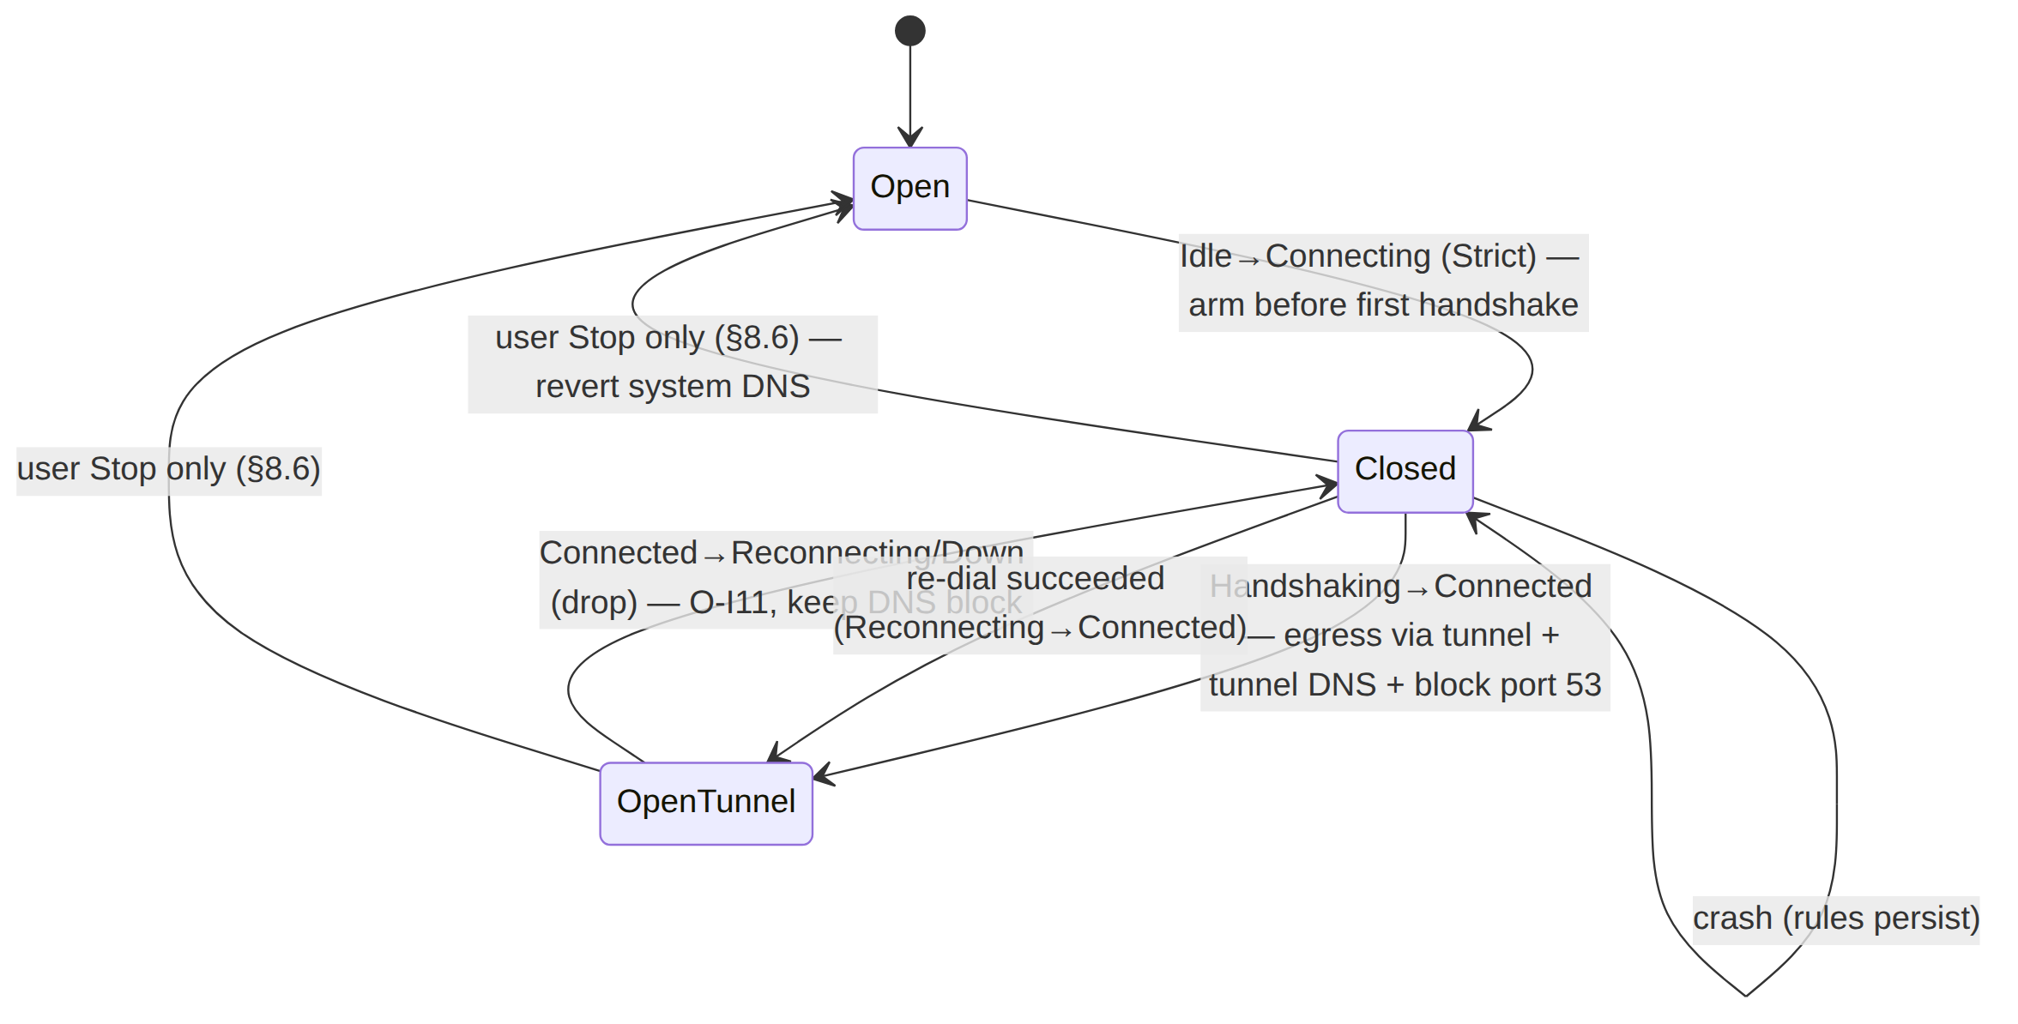

9. Connector mode (--mode=connector)

9.1 Same core, different posture (O-I13)
The connector is the same Orchestrator with Mode::Connector [04_P0 §4.5, 01-DP §5.1]. The three loops, the status stream, reconciliation, backoff, and the transport layer are byte-for-byte identical to the client (I4). Only two things differ:
client: [app traffic] → TUN → WG encrypt → [DAITA] → Transport ──▶ gateway
connector: gateway ──▶ Transport → WG decrypt → forward into served CIDR (and reverse)
- The connector does not capture the device default route; instead it (a) advertises its served CIDRs (e.g. 10.10.0.0/24) in its RouteMap, and (b) NATs/forwards decapsulated packets into the LAN interface and back [04_P0 §4.5, 01-DP §5.1].
- The connector is outbound-only — it dials the gateway; it never listens for inbound connections (the founding no-port-forward constraint [SYNTHESIS §1]).

9.2 Forwarding & NAT (loop B branch)
loop_b's WriteToTun branch (§3.2) dispatches on mode: Client writes the TUN; Connector calls forward_into_lan:
async fn forward_into_lan(shared: &OrchShared, plain: Bytes) {
// 1. ACL gate: the decapsulated packet's (src,dst,proto,port) must match the compiled
// verdict map (default-deny, I6) [01-DP §7] BEFORE it touches the LAN.
if shared.policy.lock().await.verdict(&plain) != Verdict::Allow {
shared.counters.policy_drop.inc(); return;
}
// 2. SNAT into the served CIDR and emit on the LAN iface (Linux: the veth/eth handle).
shared.tun.forward_lan(plain).await; // helix-tun owns the masquerade + reverse mapping
}
The reverse path (LAN host → connector → gateway → client) enters via the LAN iface, is matched to the originating WG session, WG-encrypted (loop A's peer_for_dst selects the gateway peer), and shipped back over the transport. The connector therefore runs loop A driven by the LAN iface rather than a TUN; TunSpec abstracts both (TunDevice::recv yields the next inbound packet regardless of source) so loop A's body is unchanged (O-I13).

9.3 Verdict map on the connector
The connector installs the compiled policy (CompiledPolicy, [01-DP §7]) as an nftables/eBPF verdict map and re-installs it on a policy_changed reconcile delta (§6.4) in < 1 s, no restart [04_ARCH §4.4]. Default-deny, fail-closed: if the compiled policy is absent/stale, drop (I6). This is the "split-horizon / microsegmentation by default" property [01-DP §7].

9.4 Status semantics on the connector
The connector emits the same TunnelStatus stream (its tunnel to the gateway is what Connected{transport,rtt} describes). The Connector Flutter flavor (doc 05) subscribes to it exactly as the Access app does — the FFI/UI code is shared (O-I13). Down on a connector means "the connector lost its gateway tunnel"; the kill-switch posture is typically Off on a connector (it is a network appliance, not a privacy client) — KillSwitchMode is a config knob (§8.2, §11), not hardcoded.

10. Error taxonomy
// helix-core/src/error.rs
#[derive(thiserror::Error, Debug)]
pub enum OrchestratorError {
#[error("tun open/inject failed: {0}")] TunOpen(String), // → Down{host-fatal}
#[error("kill-switch apply failed: {0}")] KillSwitch(String), // → Down{host-fatal} (§8.2)
#[error("dns apply failed: {0}")] Dns(String), // → Down{host-fatal}
#[error("transport: {0}")] Transport(#[from] TransportError), // → re-dial/escalate
#[error("wg: {0}")] Wg(String), // enc/dec error (counter, non-fatal)
#[error("map reconcile: {0}")] Reconcile(String), // side task; never tears tunnel (§6.5)
#[error("ladder exhausted")] LadderExhausted, // → Down{ladder-exhausted}
#[error("pinned transport failed")] PinFailed, // → Down{pinned-transport-failed}
#[error("shutdown timeout")] ShutdownTimeout, // join exceeded grace (§2.4)
}
Classification (drives §5.4): TunOpen/KillSwitch/Dns are host-fatal at startup (the core refuses to run a tunnel it cannot leak-protect). Transport errors map to the re-dial/escalate path (§7). Wg enc/dec errors are per-packet, counted, never fatal (a single malformed datagram does not tear the tunnel). Reconcile errors are side-task-only (I3). TransportError variants map to ladder behaviour exactly as [01-DP §3.1 / 01-LAD §5]: DialTimeout/HandshakeFailed/EndpointBlocked → escalate; Closed → re-dial same rung; Oversize → lower MTU (§6.6).

11. Config knobs (Tunables)
pub struct Tunables {
// --- loops ---
pub tick_period: Duration, // loop C cadence; default 200 ms [01-DP §4]
pub idle_poll: Duration, // loop B busy-wait when active_tx None; default 10 ms
// --- handshake / liveness ---
pub handshake_timeout: Duration, // Handshaking→Reconnecting; default 5 s (derived)
pub keepalive_timeout: Duration, // PeerTimeout threshold; default 25 s (WG REKEY heuristic, UNVERIFIED exact)
// --- backoff (§7.2) ---
pub backoff_base: Duration, // default 250 ms
pub backoff_cap: Duration, // default 30 s
pub backoff_factor: f64, // default 2.0
pub backoff_jitter: f64, // default 1.0 (full decorrelated)
// --- status (§4.3) ---
pub rtt_emit_delta_ms: u32, // re-emit Connected if rtt drifts >; default 5 ms
pub status_channel_cap: usize, // broadcast ring; default 64
// --- shutdown (§2.4) ---
pub shutdown_grace: Duration, // join timeout; default 2 s
// --- reconcile (§6.5) ---
pub reconcile_reconnect_base: Duration, // stream re-subscribe backoff; default 1 s
}
Every numeric default above tagged "derived" is the spec recommendation, to be calibrated against the Phase-0 gates (G1 throughput, < 3 s roam, < 1 s reconcile) with captured benchmark evidence before being frozen (§11.4.6 — a number is a guess until measured) [04_P0 §8]. keepalive_timeout = 25 s mirrors WireGuard's REKEY-after-no-recv window but the exact boringtun-surfaced value is UNVERIFIED and is a Phase-0 measurement item.

12. Edge cases (each maps to a test point, §14)
# | Edge case | Required behaviour
E1 | TUN delivers a packet before any WG session exists | loop A WgVerdict::Nothing → silent drop; app retransmits; no crash (§3.1).
E2 | active_tx swapped mid-send (re-dial races loop A) | atomic Arc swap; old or new handle, never torn (§7.3).
E3 | broadcast receiver wedged > 64 events behind | Lagged returned; receiver skips-to-latest; orchestrator unaffected (§4.2/§4.6).
E4 | Reconcile source dies while Connected | loops keep forwarding (fail-static I3); reconciler re-subscribes with backoff (§6.5).
E5 | Revoke (peers_removed includes active gateway) | tear session, close kill-switch, Down{auth-failed}; revoke effective < 1 s (§6.4).
E6 | Roam (Wi-Fi→cellular) mid-Connected | RoamDetected interrupts backoff, immediate re-dial at remembered rung, < 3 s recovery (§7.5).
E7 | All rungs fail their budget | Reconnecting→Down{ladder-exhausted} only after backoff cap; kill-switch stays closed (§7.4, O-I11).
E8 | Pinned transport fails | Down{pinned-transport-failed}, NO escalation (§7.4, L-I7).
E9 | Oversize on transport swap (smaller MTU) | lower inner WG MTU, do not truncate (§6.6, I2).
E10 | Process panic in a loop | other loops + kill-switch unaffected (closed rules persist O-I11); supervisor restarts core (start() resets ladder, L-I8).
E11 | Connector packet fails the verdict map | forward_into_lan drops + counts; never reaches LAN (§9.2, I6).
E12 | tick after runtime starvation | MissedTickBehavior::Skip — one catch-up tick, no storm (§3.3, §12.6 host-safety).

13. Security & performance

13.1 Security considerations
- No plaintext on the status path (I1/I5). TunnelStatus carries only a transport kind label + aggregate RTT; never endpoints, SSIDs, packets, or per-connection timestamps (§4.5). A code-review gate (§11.4.142) must reject any status_tx.send payload that embeds an endpoint or per-flow datum.
- Fail-closed everywhere (O-I11). Crash, exhaustion, revoke, and host-fatal all leave the kill-switch closed and DNS blocked (§8.4); only a deliberate user-stop opens it (§8.6).
- Default-deny on the connector (I6). Decapsulated packets pass the verdict map before the LAN (§9.2); a stale/absent policy drops (fail-closed) [01-DP §7].
- Single state authority (O-I10). One writer of OrchState → no firewall race, no "connected-but-leaking" window (§5.3). This is the structural defence against the classic VPN kill-switch TOCTOU bug.
- Revocation latency (SEC). device.revoked → verdict-map drop / session tear in < 1 s, no restart (§6.4) [04_ARCH §4.4, SYNTHESIS §7].
- Host-session safety (constitution §12). Loop C uses MissedTickBehavior::Skip and the loops never spin-busy except the bounded idle_poll; no unbounded memory growth (the broadcast ring is fixed, peers are bounded by the map). Reconcile and re-dial backoffs are capped so a flapping gateway cannot induce a CPU storm.

13.2 Performance budget
Budget | Target | Source / rationale
Through-tunnel throughput (plain-udp) | ≥ 80% bare link | G1 gate [04_P0 §8] — orchestrator overhead (mutex + loop dispatch) must be negligible vs WG crypto.
Roam / iface-flap recovery | < 3 s | [04_P0 §8] → §7.5 immediate re-dial.
Reconcile convergence (map delta → applied) | < 1 s (p99) | [04_ARCH §4.4] → §6 in-place apply.
Status emit latency (transition → broadcast) | < 1 ms (UNVERIFIED, measure) | side effects then emit (§4.3); dominated by the firewall syscall, not the channel.
Per-packet orchestrator overhead | bounded, no per-packet alloc | reused scratch buffers (§3.1/§3.2/§3.3); Bytes ref-count, not copy, on the hot path.
Mutex hold time (wg/active_tx) | µs-scale; never across .await | §3.4 — synchronous helix-wg calls only.
Memory | bounded by peers × Tunn + fixed channels | I5/§12 host-safety; no per-connection durable state.
Each "UNVERIFIED" / "measure" budget is a Phase-0 benchmark item with captured CSV evidence before it is treated as fact (§11.4.6) [04_P0 §8].

14. Test points (§11.4.169)
Per §11.4.169 every workable item declares its required test types from the §11.4.27 / [07-WBS §1] closed vocabulary; every PASS cites rock-solid captured evidence (§11.4.5/.69/.107), never config-only. The escalation/reconnect event trace on the TunnelStatus stream IS the captured evidence for the state-machine claims (O-I13 analogue of [01-LAD I9]).
Test id | §11.4.169 types | What it proves | Rig / captured evidence | Source
OS-1 | UNIT | transition() table is total + correct: every (state,event) pair → expected OrchState/None | table-driven unit test over the §5.2 matrix; mocks allowed (unit only, §11.4.27) | §5
OS-2 | UNIT | diff() produces the exact MapDelta for added/removed/changed peers + dns/policy flags | golden desired/actual RouteMap pairs | §6.3
OS-3 | UNIT | Backoff::next_delay() is monotonic-capped + jittered within [base, cap]; reset() zeroes | property test, fixed RNG seed (deterministic, §11.4.50) | §7.2
OS-4 | INT | three loops move real WG datagrams tun↔transport on the netns rig; curl reaches LAN host | netns + boringtun + plain-udp; tcpdump + curl 200 | [04_P0 §3/§8], §3
OS-5 | E2E+REC | full status arc Connecting→Handshaking→Connected{plain-udp,rtt} driven only by the core stream | Flutter-Linux toggle (G5); window-scoped MP4 + vision verdict (§11.4.159) | [04_P0 §9], §4
OS-6 | E2E+FA | kill-switch closes on drop — no plaintext egress while Reconnecting/Down | block gateway mid-Connected; tcpdump underlay shows ZERO leaked app packets | AC7 [04_P1 §11.2], §8
OS-7 | SEC | DNS-leak guard: off-tunnel :53 dropped when Connected; system DNS restored on user-stop | dig @off-tunnel-resolver blocked; capture; revert verified | [04_ARCH §5.6], §8.3
OS-8 | E2E | reconcile restart-free: edit map.json → peer reachable, no process restart, OrchState unchanged | file-watch delta; curl newly-reachable host; pid unchanged (G6) | [04_P0 §10], §6
OS-9 | E2E+PERF | revoke < 1 s: remove active peer → session torn, Down{auth-failed}, kill-switch closed | timestamped status trace; < 1 s revoke→drop | AC6 [04_P1 §11.2], §6.4
OS-10 | CHAOS | roam recovery < 3 s: flap the client iface → RoamDetected → re-dial → Connected | netns iface flap; status trace timing; recovery < 3 s | [04_P0 §8], §7.5
OS-11 | CHAOS | mid-send transport swap + reconcile-source SIGKILL: loops keep forwarding (fail-static) | kill the file-watch task; traffic continues; reconciler re-subscribes | I3, §6.5
OS-12 | STRESS | sustained re-dial churn (gateway flap N×) does not leak, deadlock, or grow memory unbounded | ≥100 flap iters; RSS bounded; no leaked packet; no deadlock | §11.4.85, §7
OS-13 | INT | connector posture: gateway→connector→LAN forward + reverse path, ACL-gated (default-deny) | netns LAN; allowed host reachable, unauthorized DROPPED + counted | §9, [04_P0 §4.5]
OS-14 | BENCH | orchestrator overhead: through-tunnel throughput ≥ 80% bare link (plain-udp) | iperf3 via bench.sh; CSV | G1 [04_P0 §8], §13.2
OS-15 | CHAL | a helix_qa/challenges bank entry scores PASS only on the captured status-arc + leak-free capture | HelixQA autonomous session, evidence-gated (§11.4.27/.107) | [SYNTHESIS §8]
Each meta-test ships a paired §1.1 mutation (e.g. flip apply_side_effects to emit Connected before opening the kill-switch → OS-6 must FAIL; weaken the verdict gate in §9.2 → OS-13 must FAIL) so the gates provably cannot bluff [04_P0 §8, §11.4.5].

15. What is explicitly out of scope here
The ladder selection algorithm (per-network memory, regional prior, manual pin internals — [01-LAD]); the Transport trait + per-transport framing [01-DP §3]; WireGuard crypto + Tunn timers [01-DP §4]; helix-route ACL→verdict-map compilation [01-DP §6–§7]; DAITA machines [01-DP §9]; the WatchNetworkMap protobuf that delivers the map (doc 03); the FFI bridge that re-emits TunnelStatus to Dart (doc 05); platform iface-watchers + TUN-fd handoff beyond the TunSpec contract (doc 06). This document specifies only the orchestrator — the conductor that wires those frozen contracts into a running, leak-safe, self-converging tunnel on all three roles.

End of nano-detail specification — Volume 2 (Data Plane), orchestrator-and-state.md. Pairs with transport-selection-ladder.md (the §7.4 ladder this orchestrator drives), transport-trait.md (the §3 Transport contract), wireguard-core.md (the §3/§4 WgPeer it pumps), and routing-and-addressing.md (the §6 RouteMap/verdict map it reconciles). The Orchestrator struct (§2.1), the TunnelStatus enum (§4.1), the OrchState machine (§5), and the Mode::Connector posture (§9) are the frozen Phase-0 surviving contracts [04_P0 §14]; their implementations may evolve, their shapes may not.

