Overlay Routing & Addressing

Overlay Routing & Addressing
Revision: 2 Last modified: 2026-07-04T12:00:00Z
Volume 2 (Data Plane) nano-detail specification — deepens the Overlay addressing & multi-network routing section (§6) and the Policy/ACL → AllowedIPs + verdict-map section (§7) of the pass-1 data-plane overview [01-DP §6, §7]. This is a SPEC: it describes what to build in the helix-route crate; it does not ship the product. Source evidence is cited inline by id — [01-DP §N] (final/01-data-plane.md), [04_ARCH §N] (04_VPN_CLD/HelixVPN-Architecture-Refined.md), [04_P0 §N] (Phase0-Spike.md), [research-pki_pq_nat §N] (scratchpad/kb), [SYNTHESIS §N]. Any claim not grounded in the evidence base is flagged UNVERIFIED per constitution §11.4.6 — never fabricated.

0. Position, ownership, and the problem this document solves
This document owns the helix-route crate [01-DP §2 crate layout]: overlay addressing, the 4via6 mapping engine, the connector-CIDR-advertisement → compiled routing-map pipeline, the policy/ACL → per-peer AllowedIPs + nftables/eBPF verdict-map compiler, and split-horizon microsegmentation. It is the layer that decides which overlay address a node has and which next hop / verdict a packet gets — strictly above the WireGuard crypto core and the Transport carrier, both specified in 01-DP.
It does not own: the WatchNetworkMap protobuf/Connect wire contract (doc 03 — the live source of the RouteMap stream helix-route consumes), the Go control-plane policy authoring UI (doc 02 — the ACL DSL is authored there; helix-route consumes the compiled form), nor enrollment/PKI (doc 02, [research-pki_pq_nat §1]). The split is: the control plane authors and compiles intent; helix-route is the data-plane reconciler that converges the compiled desired-state and installs kernel state [04_ARCH §4.4, 01-DP §6.3].

0.1 The founding requirement
A single user reaches N joined private networks, which may carry colliding RFC1918 ranges — two connectors each serving 192.168.1.0/24 [01-DP §6, SYNTHESIS §1, §3 D4]. That collision MUST be solved at v1 [SYNTHESIS §3 D4]. This document is the v1 solution: IPv6 ULA /48 per tenant + Tailscale-style 4via6 ([04_ARCH §3.4], decision D4 Camp A), with CGNAT 100.64/10 1:1 as the documented IPv4-only fallback (D4 Camp B), analyzed at §8.

0.2 Invariants inherited from the data plane (binding here)
# | Invariant | Source
I5 | No-logging by construction: routing/policy state is aggregate counters only; no per-peer/per-flow durable record. | [01-DP §0.1 I5, 04_ARCH §2.7]
I6 | Default-deny: no peer reaches anything without an explicit compiled rule expressed as AllowedIPs + an edge verdict map. | [01-DP §0.1 I6, 04_ARCH §3.4]
R1 | The reconciler converges without restart; a route/policy delta reflects on all affected edges in < 1 s (p99). | [04_ARCH §4.4, 01-DP §6.3]
R2 | Peers are delivered already policy-filtered (need-to-know): a node never learns of networks it cannot reach. | [SYNTHESIS §7, 01-DP §7]
R3 | The verdict map fails closed: absent/stale compiled policy ⇒ drop. | [04_ARCH §7, 01-DP §7]
R4 | ACL ACLs/routes target the IPv6 overlay address, never the underlying IPv4 of a 4via6-mapped LAN. | [research-pki_pq_nat §3.4]

1. Crate surface (helix-route)
helix-route/
├── src/lib.rs # public façade: RouteEngine, re-exports
├── src/addr.rs # §2 ULA /48 allocation + node-address layout + types
├── src/via6.rs # §3 4via6 encode/decode (byte-exact)
├── src/map.rs # §4 RouteMap desired-state + advertisement ingest
├── src/fib.rs # §5 longest-prefix-match next-hop table (overlay FIB)
├── src/policy.rs # §6 ACL→AllowedIPs + CompiledPolicy→verdict-map compiler
├── src/nft.rs # §6 nftables verdict-map renderer (Phase 1)
├── src/ebpf.rs # §6 eBPF verdict-map loader (Phase 2, feature = "ebpf")
├── src/reconcile.rs # §5/§7 declarative reconciler (push, no restart) — R1
└── src/error.rs # §9 RouteError taxonomy
// helix-route/src/lib.rs — the one object the orchestrator (helix-core) holds.
pub struct RouteEngine {
tenant: TenantPrefix, // §2.1 this node's tenant ULA /48
self_id: OverlayAddr, // §2.3 this node's stable overlay address
fib: Fib, // §5 longest-prefix-match next-hop table
policy: Option<CompiledPolicy>, // §6 None ⇒ fail-closed (R3)
verdict: Box<dyn VerdictSink>, // §6 nft (P1) | ebpf (P2)
counters: RouteCounters, // §0.2 I5 aggregate-only telemetry
}
impl RouteEngine {
/// Converge to a freshly-pushed desired-state RouteMap (doc 03 stream / Phase-0 file).
/// Diff-and-apply; NEVER restart unrelated state (R1). Returns the applied delta summary.
pub fn reconcile(&mut self, desired: &RouteMap) -> Result<ReconcileReport, RouteError>;
/// Install a new compiled policy version atomically (R3: failure leaves prior version live).
pub fn apply_policy(&mut self, p: CompiledPolicy) -> Result<(), RouteError>;
/// Resolve the next hop for an overlay destination (used by the connector forward path).
pub fn next_hop(&self, dst: &OverlayAddr) -> Option<NextHop>;
}

2. Overlay addressing — ULA /48 per tenant
Every node (client, connector, advertised host) gets a stable overlay address in the tenant's ULA /48 [04_ARCH §3.4 "every node ... gets a stable overlay address"]. HelixVPN is IPv6-native on the overlay; advertised IPv4 LANs are surfaced through 4via6 (§3), never as raw overlapping IPv4 [04_ARCH §3.4, research-pki_pq_nat §3.4].

2.1 Tenant prefix — RFC 4193 ULA byte layout
Honest correction (§11.4.6): the overview writes the prefix illustratively as fd7a:helix:<tenant>::/48 [01-DP §6.1]. helix is not valid hex and cannot appear in a real address; it is a mnemonic. The implementable layout below uses a real RFC 4193 ULA: fd + 40-bit random per-tenant Global ID. UNVERIFIED: the literal hex fd7a:115c:a1e0 example used downstream is Tailscale's fixed ULA [research-pki_pq_nat §3.4]; HelixVPN generates a fresh random 40-bit Global ID per tenant at tenant creation (control plane, doc 02) — it is NOT Tailscale's constant.
A tenant prefix is a /48 (RFC 4193 §3.1): the 8-bit ULA prefix 1111110 + L-bit 1 (0xfd), then a 40-bit Global ID. The 16 bits between bit 48 and bit 63 are the Subnet ID field, used here as an address-class discriminator; the low 64 bits are the Interface ID.
128-bit overlay address (tenant /48):
0 8 48 64 128
┌────────┬──────────────────────────────┬───────┬─────────────────────────────────┐
│ 0xfd │ 40-bit tenant Global ID (T) │ 16-bit│ 64-bit Interface ID │
│ ULA │ random, per tenant │ Class │ (class-dependent layout, §2.2) │
└────────┴──────────────────────────────┴───────┴─────────────────────────────────┘
└──────── tenant /48 prefix ────────────┘└─ Class field selects the address kind ──┘
// helix-route/src/addr.rs
use std::net::Ipv6Addr;
/// A tenant's ULA /48: 0xfd || 40-bit Global ID. Stored as the 6 high bytes.
#[derive(Clone, Copy, PartialEq, Eq, Hash, Debug)]
pub struct TenantPrefix { pub bytes: [u8; 6] } // bytes[0] == 0xfd by construction
impl TenantPrefix {
/// Random per-tenant Global ID per RFC 4193 §3.2.2 (control plane mints once).
pub fn generate(rng: &mut impl rand_core::RngCore) -> Self {
let mut b = [0u8; 6];
rng.fill_bytes(&mut b);
b[0] = 0xfd; // ULA prefix + L=1
TenantPrefix { bytes: b }
}
pub fn contains(&self, a: &Ipv6Addr) -> bool { a.octets()[..6] == self.bytes }
}
/// 16-bit Subnet-ID address class (bits 48..64).
#[derive(Clone, Copy, PartialEq, Eq, Debug)]
#[repr(u16)]
pub enum AddrClass {
Node = 0x0000, // §2.3 clients/connectors/advertised native-v6 hosts
Via6 = 0x4636, // §3 4via6-mapped IPv4 LANs ('F6' mnemonic, fixed constant)
Relay = 0x0001, // reserved: DERP-style relay overlay endpoints (doc, Phase 2)
// 0x0002..=0x4635 and 0x4637..=0xFFFF reserved; unknown class ⇒ RouteError::UnknownClass
}

2.2 Address-class layout summary
Class (bits 48..64) | Kind | Interface-ID (bits 64..128) layout | §ref
0x0000 Node | Client / connector / native-v6 host | 64-bit stable random/enrolled Node ID | §2.3
0x4636 Via6 | 4via6-mapped IPv4 LAN host/route | 0x0000 (16) ‖ siteID (16) ‖ IPv4 (32) | §3.1
0x0001 Relay | Relay overlay endpoint (Phase 2) | relay node ID | §8 NAT (doc 03)

2.3 Node addressing (class Node)
A native overlay node's Interface ID is a stable 64-bit Node ID assigned at enrollment and bound to the device's WG public key in the control plane [research-pki_pq_nat §1.3] (the WG public key is the device identity; the overlay Node ID is its routable handle). It is stable across roams — WireGuard roaming changes the underlay endpoint, never the overlay address [04_P2 §3.2, 01-DP §8].
// helix-route/src/addr.rs
/// A fully-qualified overlay address = tenant prefix + class + interface id.
#[derive(Clone, Copy, PartialEq, Eq, Hash, Debug)]
pub struct OverlayAddr(pub Ipv6Addr);
impl OverlayAddr {
pub fn node(t: TenantPrefix, node_id: u64) -> Self {
let mut o = [0u8; 16];
o[..6].copy_from_slice(&t.bytes);
o[6..8].copy_from_slice(&(AddrClass::Node as u16).to_be_bytes());
o[8..16].copy_from_slice(&node_id.to_be_bytes());
OverlayAddr(Ipv6Addr::from(o))
}
pub fn class(&self) -> Result<AddrClass, RouteError> {
let c = u16::from_be_bytes([self.0.octets()[6], self.0.octets()[7]]);
AddrClass::try_from(c).map_err(|_| RouteError::UnknownClass(c))
}
}
Edge case — stability under tenant-prefix rotation: a tenant Global ID is permanent for the tenant's life. If a tenant is ever re-keyed (operator decision, §11.4.122-class capability change), every Node ID is re-prefixed but its low-64 ID is preserved, so policy referencing Node IDs survives a prefix change. UNVERIFIED: prefix rotation is not specified in the evidence base — flagged as a future operator-gated capability, not an MVP path.

3. 4via6 — overlapping-CIDR overlay mapping
4via6 lets a tenant connect hundreds/thousands of identical (overlapping-CIDR) IPv4 networks without renumbering, by mapping each site's IPv4 route into a unique IPv6 prefix whose address encodes a site ID + the IPv4 address [research-pki_pq_nat §3.4, 04_ARCH §3.4]. This is the engine that lets two connectors both serving 192.168.1.0/24 coexist: each connector gets a distinct site ID, so its 192.168.1.0/24 maps to a distinct overlay /120, and the gateway/connector NATs back into the correct LAN [04_ARCH §3.4 overlapping-CIDR handling, 01-DP §6.1].

3.1 Byte-exact encoding (class Via6)
The 64-bit Interface ID of a Via6 address is laid out exactly as Tailscale's tailscale debug via <site-id> <ipv4-route> interface-ID region [research-pki_pq_nat §3.4], placed inside HelixVPN's tenant /48 + Via6 class:
4via6 address (class 0x4636):
0 8 48 64 80 96 128
┌────────┬───────────────────────┬─────────┬─────────┬─────────┬─────────────────┐
│ 0xfd │ 40-bit tenant Global ID│ 0x4636 │ 0x0000 │ siteID │ IPv4 (32 bit) │
│ │ (T) │ (Via6) │ (rsvd) │ (16 bit)│ big-endian │
└────────┴───────────────────────┴─────────┴─────────┴─────────┴─────────────────┘
└──────── Interface ID (64 bit) ───────┘
Site ID range: 0..=65535 (lower 16 bits only) — matches Tailscale's constraint.
A mapped IPv4 /N route → overlay /(96 + N) (e.g. /24 → /120, /32 host → /128).
// helix-route/src/via6.rs
use std::net::Ipv4Addr;
use ipnet::{Ipv4Net, Ipv6Net};
pub type SiteId = u16; // 0..=65535 [research-pki_pq_nat §3.4]
/// Encode an advertised IPv4 host into its 4via6 overlay address.
pub fn encode_host(t: TenantPrefix, site: SiteId, v4: Ipv4Addr) -> OverlayAddr {
let mut o = [0u8; 16];
o[..6].copy_from_slice(&t.bytes);
o[6..8].copy_from_slice(&(AddrClass::Via6 as u16).to_be_bytes());
// o[8..10] = 0x0000 reserved (already zero)
o[10..12].copy_from_slice(&site.to_be_bytes());
o[12..16].copy_from_slice(&v4.octets());
OverlayAddr(Ipv6Addr::from(o))
}
/// Encode an advertised IPv4 /N route into the overlay /(96+N) prefix it occupies.
pub fn encode_route(t: TenantPrefix, site: SiteId, v4: Ipv4Net) -> Result<Ipv6Net, RouteError> {
let base = encode_host(t, site, v4.network()).0;
let plen = 96u8 + v4.prefix_len(); // /24 → /120, /32 → /128
Ipv6Net::new(base, plen).map_err(|_| RouteError::BadPrefixLen(plen))
}
/// Decode a 4via6 overlay address back to (site, IPv4) for the connector's NAT-back step.
pub fn decode(a: &OverlayAddr) -> Result<(SiteId, Ipv4Addr), RouteError> {
if a.class()? != AddrClass::Via6 { return Err(RouteError::NotVia6); }
let o = a.0.octets();
if o[8] != 0 || o[9] != 0 { return Err(RouteError::ReservedNonZero); }
let site = u16::from_be_bytes([o[10], o[11]]);
let v4 = Ipv4Addr::new(o[12], o[13], o[14], o[15]);
Ok((site, v4))
}
Worked example [grounded in research-pki_pq_nat §3.4 encoding rules]:
- Tenant Global ID 12:3456:789a ⇒ tenant prefix fd12:3456:789a::/48.
- Connector A served LAN 192.168.1.0/24, assigned site 7 ⇒ overlay route fd12:3456:789a:4636:0:7:c0a8:100/120 (c0a8:0100 = 192.168.1.0).
- Connector B also serving 192.168.1.0/24, assigned site 8 ⇒ overlay route fd12:3456:789a:4636:0:8:c0a8:100/120 — distinct prefix, no collision.
- Host 192.168.1.10 behind A ⇒ fd12:3456:789a:4636:0:7:c0a8:10a/128.

3.2 Encode/decode flow diagram
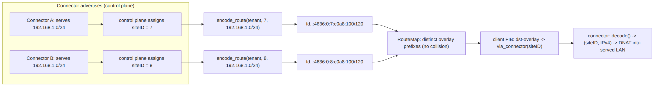

3.3 Site-ID allocation (authority = control plane, consumed here)
Site IDs are allocated by the control plane (doc 02 IPAM) at connector enrollment and delivered in PeerRoute.via_connector [01-DP §6.2]. helix-route does not mint site IDs; it validates them (0..=65535, unique within a tenant) and rejects a RouteMap that contains a duplicate (tenant, siteID) pair or two distinct connectors claiming the same site ID (RouteError::DuplicateSiteId). Allocation policy (control plane): one site ID per connector that serves at least one overlapping CIDR; non-overlapping connectors MAY share siteID = 0 (a single "default site") as an optimization. UNVERIFIED: the share-site-0 optimization is a design recommendation, not stated in the evidence base; flagged.

4. Connector CIDR advertisement → RouteMap
Connectors advertise their served CIDRs to the control plane; the control plane compiles a routing map (which connector is the next hop for which overlay prefix) and pushes it to the gateway edge + to authorized clients via WatchNetworkMap [01-DP §6.2, 04_ARCH §3.4]. The data plane consumes the map into helix-route. Phase 0 fakes the stream with a static map.json of the exact shape Phase 1 streams [01-DP §6.2, 04_P0 §10], so the reconciler is real even when the source is static.

4.1 Advertised-CIDR ingest record (the wire shape helix-route consumes)
The authoritative wire format is the doc-03 WatchNetworkMap protobuf; below is the logical Rust shape the reconciler converges to (re-stated from 01-DP §6.2, extended with the advertisement fields this document owns):
// helix-route/src/map.rs — desired-state the reconciler converges to (doc 03 streams it)
pub struct RouteMap {
pub version: u64, // monotonic; reconciler ignores a lower version (R1)
pub tenant: TenantPrefix,
pub self_overlay: OverlayAddr, // this node's stable overlay IP (§2.3)
pub peers: Vec<PeerRoute>, // ALREADY policy-filtered, need-to-know (R2)
pub dns: Vec<OverlayAddr>,
}
pub struct PeerRoute {
pub wg_pubkey: [u8; 32],
pub endpoint_candidates: Vec<std::net::SocketAddr>, // §8 NAT traversal (doc 03)
pub allowed_ips: Vec<Ipv6Net>, // overlay prefixes this peer is next hop for (R4: v6 only)
pub via_connector: Option<SiteId>, // present iff allowed_ips carry 4via6 routes
pub advertised_v4: Vec<Ipv4Net>, // the RAW served LANs (for the connector's own NAT-back)
}
Validation on ingest (map.rs::validate) — every rule rejects, never silently fixes (§11.4.6):
Check | Reject error
peer.allowed_ips all within tenant /48 | RouteError::OutOfTenant
every allowed_ips entry is a valid overlay class (Node/Via6) | RouteError::UnknownClass
a Via6 route's encoded (site, v4) matches some advertised_v4 + via_connector | RouteError::Via6Mismatch
no two peers advertise the same overlay prefix | RouteError::OverlapAdvertise
via_connector unique per distinct served-overlapping-LAN connector | RouteError::DuplicateSiteId
version > self.fib.version | (ignored, not an error — stale push)
The OverlapAdvertise check is the collision firewall: because two connectors serving the same IPv4 /24 get distinct 4via6 overlay prefixes (§3.1), their allowed_ips never overlap — a residual overlap means a site-ID allocation bug upstream and is rejected, fail-closed (R3).

4.2 Advertisement lifecycle state machine
The connector side of advertisement (the connector publishes its CIDRs; the gateway compiles and re-pushes) is a small state machine. helix-route on the connector drives the advertise path; on the client/edge it drives the consume path.
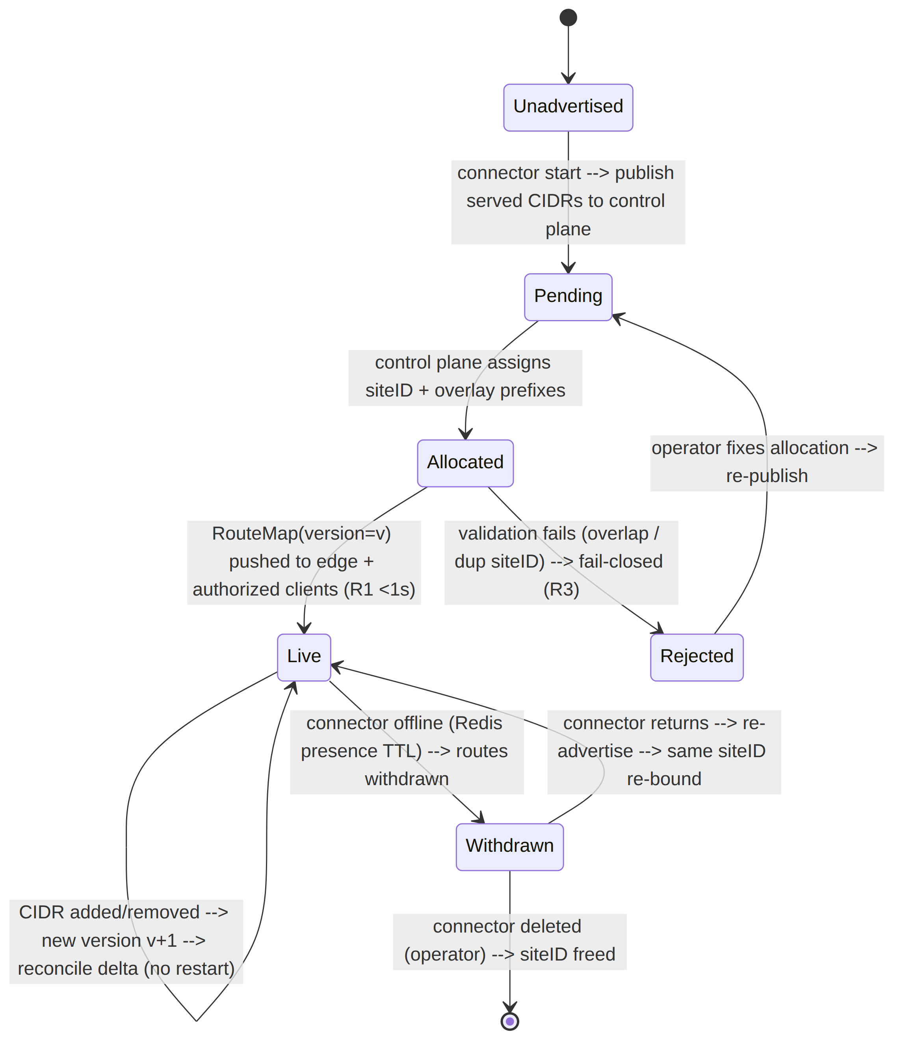
UNVERIFIED: the Redis presence-TTL withdrawal trigger and same-siteID re-bind on return are consistent with the "Redis = ephemeral presence" model [SYNTHESIS §2] but the exact TTL and re-bind semantics live in the control-plane doc (02/03), not this data-plane doc. The data-plane contract is only: a RouteMap with a withdrawn peer ⇒ reconcile that peer down in < 1 s, no restart (R1).

5. Routing map compilation → longest-prefix-match FIB
helix-route compiles the validated RouteMap into an overlay FIB — a longest-prefix-match table from overlay destination prefix → next hop (a WG peer + optional 4via6 site). This is the table the connector forward path and the client routing layer consult.
// helix-route/src/fib.rs
pub struct Fib {
pub version: u64,
trie: ip_network_table::IpNetworkTable<NextHop>, // LPM over Ipv6Net keys
}
#[derive(Clone)]
pub struct NextHop {
pub wg_pubkey: [u8; 32], // which WG peer carries it
pub via_site: Option<SiteId>, // Some ⇒ connector must decode()+DNAT into served LAN (§3.1)
}
impl Fib {
/// Build from a validated RouteMap. O(Σ prefixes); rebuilt wholesale per version,
/// then swapped atomically so next_hop() never observes a half-applied table (R1).
pub fn build(map: &RouteMap) -> Result<Fib, RouteError> { /* … */ }
/// Longest-prefix match. None ⇒ no route ⇒ packet dropped (default-deny composes I6).
pub fn next_hop(&self, dst: &OverlayAddr) -> Option<&NextHop> {
self.trie.longest_match(dst.0).map(|(_, nh)| nh)
}
}

5.1 Reconciliation — push, don't poll (R1)
The reconciler diffs desired (RouteMap) vs actual (live Fib + installed WG peers + verdict map) and converges: bring peers up/down, switch routes, update the verdict map — without restarting unrelated state [04_ARCH §4.4, 01-DP §6.3]. It never polls; it reacts to map deltas pushed on the open stream (file-watch stands in during Phase 0 [01-DP §6.2]).
// helix-route/src/reconcile.rs
pub struct ReconcileReport {
pub from_version: u64, pub to_version: u64,
pub peers_added: u32, pub peers_removed: u32,
pub routes_changed: u32, pub policy_reinstalled: bool,
pub elapsed: std::time::Duration, // asserted < 1s in the R1 test (§14)
}
Convergence target: a route/policy change reflected on all affected edges in < 1 second (p99) [04_ARCH §4.4]. The new Fib and the new verdict map are built off to the side and swapped in atomically (build-then-swap), so an in-flight packet never sees a half-built table.

5.2 Packet flow — client → connector LAN host (the headline path)
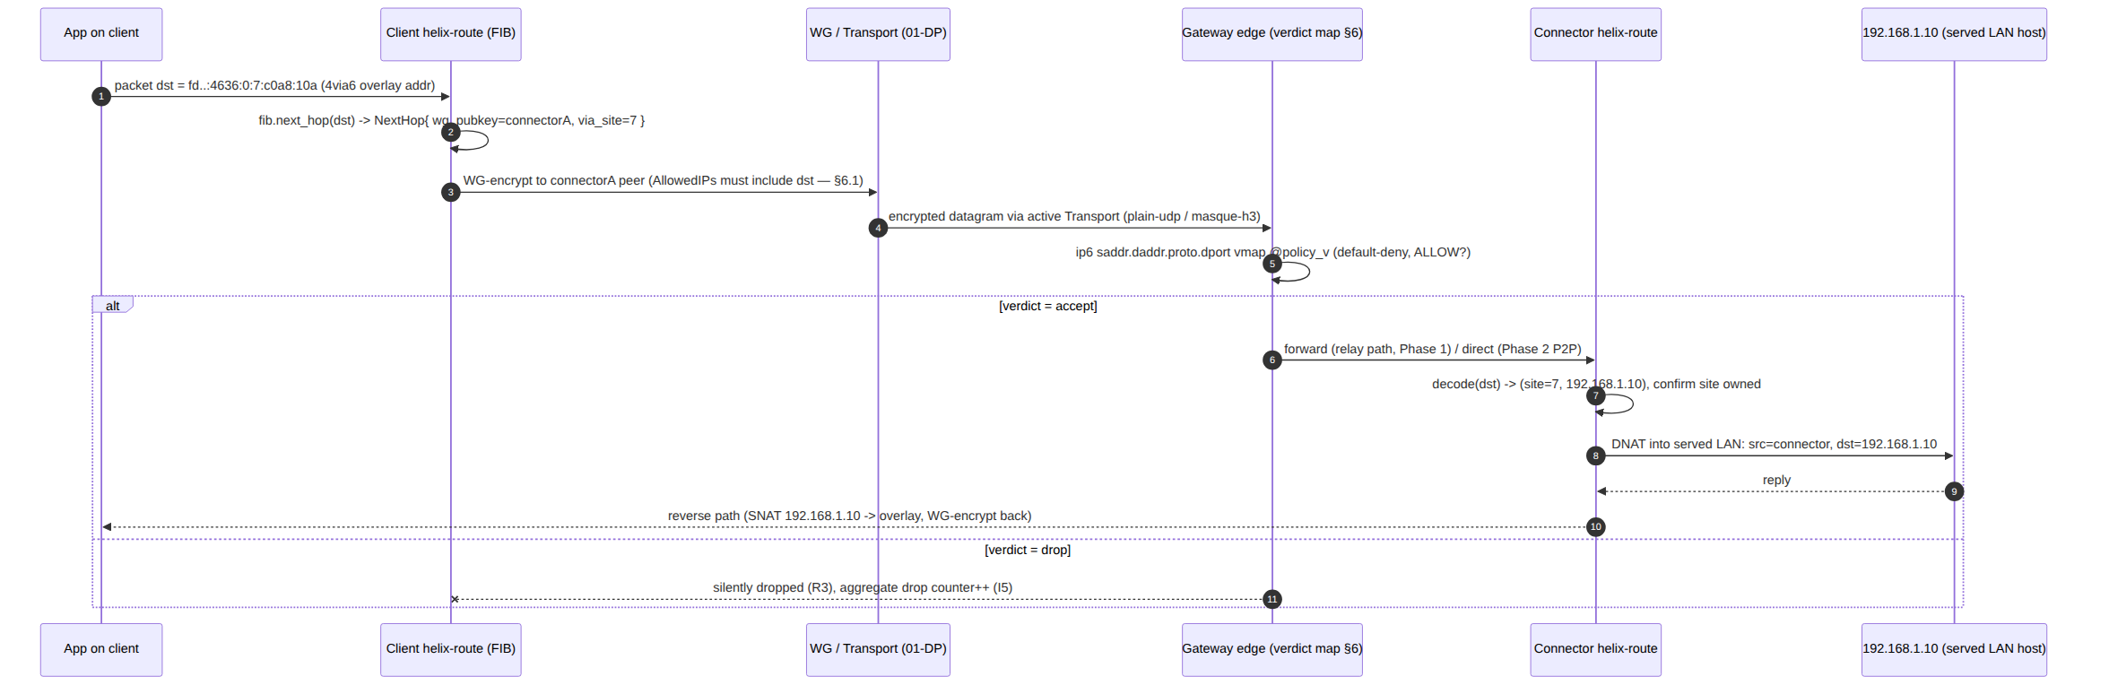

6. Policy / ACL → AllowedIPs + nftables/eBPF verdict map
Default-deny (I6). A declarative allow-list (Tailscale-ACL-flavored, group:contractors → net:warehouse-cameras:554/tcp) is authored + compiled by the control plane [04_ARCH §3.4, §7, SYNTHESIS §4]; helix-route consumes the compiled form and installs two enforcement layers, both required (defense in depth) [01-DP §7]:
- WireGuard AllowedIPs — coarse, crypto-enforced routing: each peer's AllowedIPs is the set of overlay prefixes it may send/receive; WG itself drops a packet whose source/dest does not match. This is derived from the FIB + policy and installed on the WG peer (helix-wg, 01-DP §4).
- Edge verdict map — port/proto-granular: an nftables verdict map (Phase 1) or eBPF program (Phase 2 scale) evaluates the compiled rule (src → dst : proto : ports : action) per flow; default-deny; fails closed (absent/stale policy ⇒ drop) (R3).

6.1 Compiled types (consumed; re-stated from 01-DP §7 + extended)
// helix-route/src/policy.rs
pub struct CompiledPolicy { pub version: u64, pub rules: Vec<VerdictRule> }
pub struct VerdictRule {
pub src: Ipv6Net, // overlay src prefix (R4: v6 only — 4via6 dst, never raw v4)
pub dst: Ipv6Net, // overlay dst prefix
pub proto: L4Proto,
pub ports: PortRange, // inclusive lo..=hi; full range for L4Proto::Any/Icmp
pub action: Verdict,
}
pub enum Verdict { Allow, Drop } // default Drop (I6)
pub enum L4Proto { Any, Tcp, Udp, Icmp }
pub struct PortRange { pub lo: u16, pub hi: u16 }
/// The per-peer AllowedIPs derivation: union of every dst prefix the peer is permitted to
/// receive on, plus its own self-prefix. Installed on the WG peer (helix-wg).
pub fn allowed_ips_for(peer: &PeerRoute, policy: &CompiledPolicy) -> Vec<Ipv6Net> { /* … */ }
AllowedIPs derivation rule: a peer's AllowedIPs = peer.allowed_ips (what it is the next hop for) ∩-consistent-with the policy rules whose src/dst resolve to that peer — i.e. WG is configured to carry only prefixes the policy actually permits across that peer. This is the crypto-layer realization of need-to-know (R2): a peer that is granted nothing receives an empty AllowedIPs and can carry no traffic.

6.2 nftables verdict-map renderer (Phase 1)
// helix-route/src/nft.rs
pub trait VerdictSink {
/// Install a compiled policy version atomically (nft transaction / eBPF map swap).
/// On error the PRIOR version stays live (R3 — never leaves the edge open).
fn install(&mut self, p: &CompiledPolicy) -> Result<(), RouteError>;
fn clear_to_default_deny(&mut self) -> Result<(), RouteError>; // fail-closed reset
}
pub struct NftSink { /* nft handle, table name "helix" */ }
Rendered nftables (Phase 1 representation; eBPF equivalent in Phase 2) [01-DP §7]:
# edge-installed verdict map — one atomic `nft -f` transaction per CompiledPolicy version
table inet helix {
map policy_v {
type ipv6_addr . ipv6_addr . inet_proto . inet_service : verdict
elements = {
fd12:3456:789a::a . fd12:3456:789a:4636:0:7:c0a8:14 . tcp . 554 : accept
}
}
chain forward {
type filter hook forward priority 0; policy drop; # DEFAULT-DENY (I6) / fail-closed (R3)
ip6 saddr . ip6 daddr . meta l4proto . th dport vmap @policy_v
}
}
Atomic install: the renderer writes the full new table to a temp ruleset and applies it in a single nft -f transaction; a failed apply aborts with the prior ruleset intact (R3). A port range rule expands to the nftables interval set form (th dport . { 554-560 }); L4Proto::Any omits the proto/port match keys for that element. The UNVERIFIED eBPF Phase-2 path (src/ebpf.rs, feature = "ebpf") installs the equivalent verdict in an LPM_TRIE+HASH-of-rules map and swaps the program atomically — the eBPF data-structure choice is a design recommendation, not specified in the evidence base; flagged.

6.3 ACL-compile + install sequence
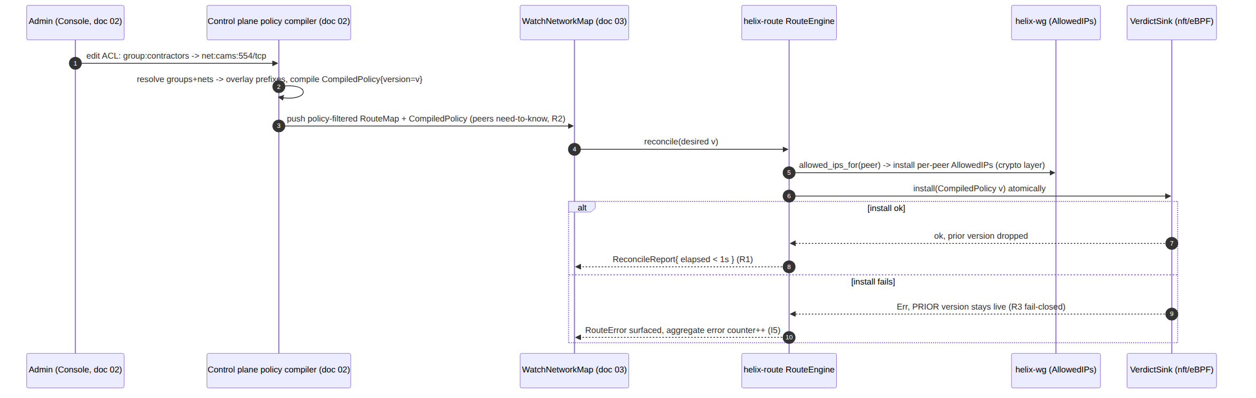

7. Split-horizon microsegmentation
Microsegmentation is the default, not an add-on [04_ARCH §3.4, §7, 01-DP §7]:
- Connectors cannot reach each other unless an explicit policy rule says so. There is no default connector↔connector route in the FIB; cross-connector traffic requires a VerdictRule{ src=connectorA-prefix, dst=connectorB-prefix, action=Allow } AND matching AllowedIPs.
- Clients cannot reach networks they are not granted. A client's RouteMap is delivered already policy-filtered (R2) — it never even learns of a connector/CIDR it cannot reach [SYNTHESIS §7], so its FIB has no entry for that prefix → next_hop() returns None → drop.
- Revocation: device.revoked (doc 02) → the verdict map drops the peer + WG removes the peer key in < 1 second with no restart [04_ARCH §4.4, SYNTHESIS §7, research-pki_pq_nat §1.1 "revocation is structurally trivial — remove the public key"]. The crypto layer (WG key removal) and the verdict layer (vmap element removal) are removed in the same reconcile pass.
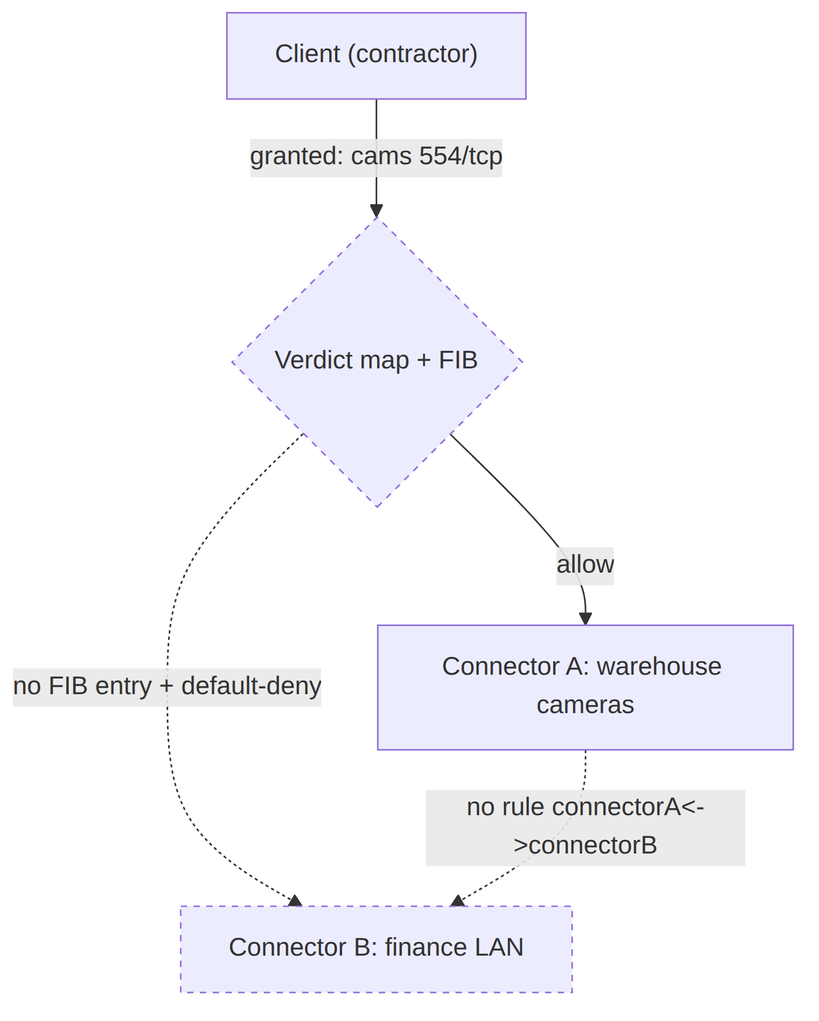
Split-horizon invariant (testable): for any two prefixes P, Q with no Allow rule between them, fib.next_hop resolution + verdict evaluation MUST drop P→Q in both directions. The default-deny forward chain policy (policy drop) guarantees the verdict half; the need-to-know filtered map guarantees the FIB half.

8. Decision D4 — 4via6 vs CGNAT 100.64, analyzed
DECISION D4 — IP-subnet collision across N joined networks. SURFACED, not silently resolved [SYNTHESIS §3 D4, 04_ARCH §3.4, 01-DP §6.1].
Axis | Camp A — ULA /48 + 4via6 (recommended) | Camp B — CGNAT 100.64.0.0/10, 1:1 per network
Collision handling | Each site gets a distinct overlay /120 via siteID encoding — overlapping 192.168.1.0/24s never collide [04_ARCH §3.4, research §3.4] | Each joined network is 1:1-NAT'd into a distinct slice of CGNAT space [SYNTHESIS §3 D4 Camp B, GMI/KMI]
Scale ceiling | Site ID = 16 bits ⇒ 65 536 sites/tenant; address space per site = full IPv4 (/120 per /24) [research §3.4] | 100.64.0.0/10 = ~4.19 M addresses total; hand-partitioning ⇒ far fewer distinct networks before exhaustion
IP family | IPv6-native (the future default); ACLs target the v6 CIDR (R4) [research §3.4] | IPv4; works on IPv4-only edges with no v6 path
Proven model | Tailscale 4via6 — connects "hundreds/thousands of identical networks" [research §3.4] | Standard CGNAT 1:1 NAT — simple, ubiquitous tooling
Tooling floor | Requires v6 on the subnet router (Tailscale parallel: v1.24+); clients reaching it may be v4 [research §3.4] | Requires no v6; but hairpinning/overlap-edge cases multiply with each added net
UX risk | 4via6 mapping is powerful but confusing — must be hidden behind Console UX (a named open risk) [04_ARCH §13, §13 risk table] | 1:1 CGNAT mapping is conceptually simpler to surface to an operator
Recommendation (adopt Camp A): ULA /48 + 4via6 scales to far more networks than a hand-partitioned CGNAT space, is the proven Tailscale model, and is IPv6-native [01-DP §6.1]. Surface 4via6 as the engine but hide it behind Console UX — the mapping confuses end users [04_ARCH §13]. CGNAT 1:1 remains a documented fallback for IPv4-only edge environments — helix-route reserves the seam: a RouteMap MAY carry an alternative Cgnat { slice: Ipv4Net } next-hop class instead of a Via6 class, decoded by an analogous cgnat.rs decoder. This MVP specifies only the 4via6 path; CGNAT is the documented escape hatch, not built in Phase 1.

8.1 CGNAT fallback — concrete design (reversal path, D4 reversal criterion)
Gap closed (2026-07-04, independent hardening pass). §8's prior text reserved the Cgnat{slice} seam by name but did not specify its mechanics. decision-register.md §6 names the reversal trigger explicitly: "4via6 client/OS support proves inadequate on a target platform → fall back to documented per-network NAT (FR-303 already provisions it)." A reversal path that is only a struct name is not "already provisioned" — this subsection makes it buildable without a fresh design cycle if the trigger fires.
Why CGNAT would ever be needed: 4via6 requires the client OS to have a working IPv6 stack up to the point of routing traffic into a synthesized Via6 destination even when the advertised LAN is IPv4-only (§3). A platform/OS combination that cannot route IPv6 at all on its TUN/VPN interface (UNVERIFIED: no cited evidence any of the 8 target platforms lack this — flagged as the reversal precondition, not a known defect) would need every peer's traffic represented as IPv4 end-to-end. CGNAT 1:1 is that IPv4-only path.
Address-space carve-out. 100.64.0.0/10 (RFC 6598, Shared Address Space) is reserved entirely for HelixVPN's CGNAT fallback — never used for anything else, so activating the fallback for one tenant cannot collide with another tenant's 4via6-native traffic on the same gateway:
100.64.0.0/10 = 100.64.0.0 – 100.127.255.255 (4 194 304 addresses, /10)
Per-tenant slice: /10 partitioned into up to 256 tenant /18s (100.64.0.0/18, 100.64.64.0/18, …)
each /18 = 16 384 addresses = up to 64 sites of /24 (site = /24 slice of the tenant /18)
// helix-route/src/cgnat.rs (Phase-2-conditional; built only if D4 reverses per decision-register §6)
use std::net::Ipv4Addr;
use ipnet::Ipv4Net;
pub type TenantCgnatSlot = u8; // 0..=255, one /18 per tenant within 100.64.0.0/10
pub type CgnatSiteId = u8; // 0..=63, one /24 per site within the tenant's /18
/// A tenant's CGNAT /18 within the shared 100.64.0.0/10 space (RFC 6598).
pub fn tenant_slice(slot: TenantCgnatSlot) -> Ipv4Net {
let base = u32::from(Ipv4Addr::new(100, 64, 0, 0)) + ((slot as u32) << 14); // /18 stride = 2^14
Ipv4Net::new(Ipv4Addr::from(base), 18).expect("valid /18 within 100.64/10")
}
/// A site's /24 within its tenant's /18 — the 1:1-NAT target range for that connector's LAN.
pub fn site_slice(slot: TenantCgnatSlot, site: CgnatSiteId) -> Ipv4Net {
let base = u32::from(tenant_slice(slot).network()) + ((site as u32) << 8); // /24 stride = 2^8
Ipv4Net::new(Ipv4Addr::from(base), 24).expect("valid /24 within tenant /18")
}
/// 1:1 host mapping: the Nth host of the served LAN <-> the Nth host of the CGNAT /24 slice.
/// Symmetric with `via6::encode_host` (§3.1) but IPv4-only — no v6 anywhere on this path.
pub fn map_host(slot: TenantCgnatSlot, site: CgnatSiteId, lan_host_offset: u8) -> Ipv4Addr {
let slice_base = u32::from(site_slice(slot, site).network());
Ipv4Addr::from(slice_base + lan_host_offset as u32)
}
Worked example (mirrors §3.1's 4via6 example so the two schemes are directly comparable): tenant assigned CGNAT slot 3 ⇒ tenant /18 = 100.64.192.0/18. Connector A serving 192.168.1.0/24, site 0 ⇒ CGNAT slice 100.64.192.0/24; host 192.168.1.10 (offset 10) ⇒ 100.64.192.10. Connector B, also serving 192.168.1.0/24, site 1 ⇒ CGNAT slice 100.64.193.0/24; the identical host ⇒ 100.64.193.10 — distinct address, no collision, the same collision-firewall property as 4via6 (§3.1), traded against a 64-site-per-tenant ceiling instead of 4via6's 65 536.
FIB and policy integration. Fib/NextHop (§5) and VerdictRule (§6.1) are IPv6-typed (Ipv6Net) because R4 mandates ACLs target the overlay, never raw v4 (§12). The CGNAT fallback does not relax R4: a Cgnat-class route is still reached via the client's IPv6 overlay tunnel to the gateway (the gateway terminates WireGuard over IPv6 exactly as today); only the LAN-side NAT target — the address the connector 1:1-NATs into — changes from a 4via6-derived v6-embedded-v4 to a CGNAT v4 slice. Concretely: PeerRoute.allowed_ips still carries the tenant's IPv6 prefixes; a new PeerRoute.cgnat_route: Option<CgnatRoute> field carries { slot, site, lan_cidr } for the connector's own NAT table, decoded by cgnat.rs exactly as via6::decode does for the Via6 class (§3.1) — same validation discipline (OverlapAdvertise, DuplicateSiteId-equivalent DuplicateCgnatSite, reject-not-fix, §4.1).
What does NOT change: the overlay is still IPv6-native end-to-end (§2); only the connector's NAT-back target address family changes. This means CGNAT is a connector-local NAT-table config change, not a re-architecture — consistent with the reversal being "additive, no client break" per decision-register.md §6.
Scale ceiling (the honest tradeoff, §11.4.6): 256 tenants × 64 sites × 254 usable hosts ≈ 4.1M mapped hosts total across the entire 100.64.0.0/10 space shared by every tenant on a gateway — materially smaller than 4via6's per-tenant 65 536-site ceiling (§8 table). This is why CGNAT remains the fallback, never the default: it is provisioned to be buildable on short notice, not to be equally scalable.

9. Error taxonomy (helix-route/src/error.rs)
Every variant is a finding, never silently swallowed (§11.4.1/.6). Ingest/validation errors reject the whole RouteMap version (atomic — a bad map never half-applies); install errors leave the prior version live (R3).
#[derive(thiserror::Error, Debug)]
pub enum RouteError {
// --- addressing / via6 (§2/§3) ---
#[error("overlay class {0:#06x} unknown")] UnknownClass(u16),
#[error("address not within tenant /48")] OutOfTenant,
#[error("address is not a 4via6 (class Via6)")] NotVia6,
#[error("4via6 reserved bytes [8..10] non-zero")] ReservedNonZero,
#[error("4via6 (site,v4) != advertised LAN")] Via6Mismatch,
#[error("bad ipv6 prefix length {0}")] BadPrefixLen(u8),
// --- map ingest / validation (§4) ---
#[error("two peers advertise overlapping overlay prefix")] OverlapAdvertise,
#[error("duplicate siteID across distinct connectors")] DuplicateSiteId(SiteId),
#[error("siteID {0} out of range 0..=65535")] SiteIdRange(u32),
// --- policy / verdict install (§6) ---
#[error("verdict-map install failed (prior version retained): {0}")] VerdictInstall(String),
#[error("policy absent — failing closed")] PolicyAbsentFailClosed,
// --- reconcile (§5) ---
#[error("fib build failed: {0}")] FibBuild(String),
#[error("io: {0}")] Io(#[from] std::io::Error),
}
Error | Trigger | Disposition | Composes
OverlapAdvertise | site-ID allocation bug upstream | reject map version, keep prior | R3, §4.1
DuplicateSiteId | two connectors claim same site | reject map version | §3.3, §4.1
Via6Mismatch | overlay route decodes to a LAN not advertised | reject map version | §3.1, §4.1
VerdictInstall | nft -f / eBPF swap fails | prior policy stays live | R3
PolicyAbsentFailClosed | reconcile with policy = None | default-deny everything | I6, R3

10. Config knobs
All knobs are data pushed in the RouteMap/CompiledPolicy (server-tunable without a client rebuild [04_P2 §2.3 pattern]) except the two host-local ones noted. No knob can weaken I6/R3 — a verdict-map install always carries policy drop as the chain default.
Knob | Where | Default | Range / values | Effect
tenant Global ID | control plane, per tenant | random 40-bit | RFC 4193 random | tenant /48 prefix (§2.1)
AddrClass::Via6 constant | compile-time | 0x4636 | fixed | 4via6 subnet discriminator (§2.1)
site-ID space | control plane | 0..=65535 | 16-bit | per-tenant site cap (§3.1)
reconcile debounce | host-local | 0 ms | 0..=250 ms | coalesce burst map deltas before rebuild
verdict backend | host-local feature | nft (P1) | nft | ebpf | enforcement engine (§6.2)
FIB rebuild mode | compile-time | wholesale build-then-swap | fixed | atomicity guarantee (§5)
CGNAT fallback | control plane | off | off | Cgnat{slice} | IPv4-only escape hatch (§8)
DAITA-orthogonal | n/a | n/a | n/a | routing is independent of DAITA/transport (01-DP §9)

11. Edge cases (each maps to a §14 test point)
- Two connectors, identical 192.168.1.0/24 — distinct site IDs ⇒ distinct overlay /120s; client FIB resolves each to the right connector; no collision (§3.1, §3.2). Primary v1 requirement.
- /32 host advertisement — encode_route yields a /128; LPM still resolves; DNAT-back to the single host (§3.1).
- Overlapping advertisement that survives to ingest (site-ID bug upstream) — OverlapAdvertise rejects the whole version, prior map stays live (§4.1, R3).
- Stale map (lower version) — silently ignored, not an error; reconciler keeps the newer FIB (§4.1).
- Reconcile during in-flight traffic — build-then-swap means next_hop() never observes a half-built FIB; an in-flight packet uses either the old or the new table, never a torn one (§5).
- Policy absent on reconcile — PolicyAbsentFailClosed → default-deny everything (I6, R3).
- Revocation mid-flow — peer removed from both WG AllowedIPs and the verdict map in one reconcile pass, < 1 s, no restart (§7, R1).
- Connector roam (underlay endpoint change) — overlay address/Node ID unchanged; only endpoint_candidates change; FIB/policy untouched (§2.3, 01-DP §8).
- Port-range rule — expands to nftables interval set; boundary ports lo/hi inclusive (§6.2).
- L4Proto::Any + PortRange full — proto/port match keys omitted for that vmap element; must not accidentally widen another rule (§6.2).
- 4via6 reserved bytes non-zero — ReservedNonZero reject; guards against a malformed/forged overlay address (§3.1, §9).
- Site ID 0 shared by non-overlapping connectors — permitted optimization; the OverlapAdvertise check still fires if their overlay prefixes actually collide (§3.3). UNVERIFIED optimization — flagged.

12. Security considerations
- R4 — ACLs/routes target the v6 overlay, never raw v4. A rule written against the underlying IPv4 of a 4via6 LAN is a category error and is impossible to express (VerdictRule.src/dst are Ipv6Net) [research-pki_pq_nat §3.4]. This prevents a misconfigured rule from matching the wrong site's identically-numbered LAN.
- Fail-closed everywhere (R3, I6). Absent/stale/failed policy ⇒ drop. The forward chain default is policy drop; a verdict-map install failure retains the prior (restrictive) version, never opens the edge.
- Need-to-know map filtering (R2). A node's RouteMap carries only peers/prefixes it is authorized for [SYNTHESIS §7]; the data plane cannot leak the existence of unreachable networks because it never receives them.
- No-logging by construction (I5). RouteCounters are aggregate (packets dropped by default-deny, reconcile count, install failures) — never per-peer/per-flow durable state [04_ARCH §2.7]. The CI schema-lint that fails the build on any durable connection/traffic table [SYNTHESIS §7] applies to the control plane; the data-plane analogue is: RouteEngine holds no per-flow map keyed by a peer identity beyond the live FIB.
- Forged overlay address. WG AllowedIPs is the crypto gate: a peer cannot source a packet from an overlay prefix outside its AllowedIPs — WG drops it before it reaches the verdict map (defense in depth, §6).
- Revocation latency is bounded by R1 (< 1 s) and is structurally a key-removal [research-pki_pq_nat §1.1] — no CRL/OCSP distribution latency.
- Site-ID exhaustion / forgery. Site IDs are minted only by the control plane and validated on ingest (range + uniqueness); a forged/duplicate site ID rejects the map (§4.1, §9).

13. Performance budget
Operation | Target | Rationale / source
fib.next_hop() (LPM) | O(prefix bits) per packet; sub-µs on the forward hot path | ip_network_table LPM trie; routing must not bottleneck the WG fast path [01-DP §10 perf framing]
Reconcile (build-then-swap FIB + verdict map) | p99 < 1 s edge-to-converged | R1 [04_ARCH §4.4]
RouteMap validation | O(Σ peers·prefixes), bounded by tenant size | reject-fast on the ingest path (§4.1)
Verdict-map install | single nft -f transaction; atomic | R3 atomicity (§6.2)
Memory | O(active prefixes + active rules); aggregate counters only | I5 — no per-flow state [04_ARCH §2.7]
4via6 encode/decode | constant-time byte ops, no allocation | §3.1 fns are pure array writes
The < 1 s convergence target is the load-bearing data-plane SLO (R1); the FIB swap + verdict-map transaction are both designed so the only time cost is the wholesale rebuild, which is bounded by tenant size and runs off the packet path.

14. Test points (constitution §11.4.169 test-type mapping)
Per §11.4.169 [constitution Status summary 2026-06-25], every PASS cites rock-solid captured physical evidence (§11.4.5/.69/.107); the only permitted absence is an honest §11.4.3 SKIP-with-reason. Four-layer §11.4.4(b) coverage; each row is a coverage-ledger entry.
§11.4.169 test type | helix-route coverage | Captured evidence
unit | via6::{encode_host,encode_route,decode} byte-exactness vs the §3.1 worked example; OverlayAddr::class; allowed_ips_for; Fib::next_hop LPM | golden-vector test: site 7 & 8 / 192.168.1.0/24 ⇒ the two distinct /120s (§3.1); assertion log
integration (real System, infra via containers submodule §11.4.76) | two real connector netns each serving 192.168.1.0/24; client reaches host behind A vs B with no collision; nft verdict map installed in a real inet helix table | ip -6 route + nft list ruleset capture; ping6/curl to each LAN host succeeds; pcap
e2e | client→edge→connector→LAN host through the full 01-DP transport + this FIB+policy; deny an unauthorized dst | TunnelStatus trace + pcap showing allow path delivered, deny path dropped
full-automation (§11.4.25/.52/.98, deterministic §11.4.50) | scripted reconcile: edit static map.json → peer reachable, no restart (the G6 gate) [01-DP §12.1 G6, 04_P0 §10]; run N=3 identical | ReconcileReport.elapsed < 1s × 3 identical runs; before/after route table
Challenges (challenges submodule §11.4.27(B)) | a Challenge that scores PASS only on a denied-flow capture for split-horizon (§7) and a collision-resolved capture (§3) | challenge result.json + pcap
HelixQA (helix_qa submodule) | route/addressing test bank: every §11 edge case as a bank entry; autonomous QA session | bank run report citing each edge-case verdict
DDoS/load-flood | verdict-map evaluation under a forwarded-packet flood; default-deny holds; no leak | throughput/drop-rate CSV; default-deny verified under load
security (§11.4.10 + security submodule) | forged-overlay-address rejection; ReservedNonZero; R4 (no raw-v4 rule); fail-closed on absent policy | rejection assertions + a fail-closed drop capture
stress + chaos (§11.4.85) | reconcile under burst map deltas (N≥100); kill the connector mid-flow → routes withdrawn → restored on return (§4.2); corrupt a pushed map.json → rejected, prior live | latency p50/p95/p99 CSV; categorised_errors.txt; recovery trace
concurrency/atomicity | build-then-swap FIB while next_hop() is read by the forward loop — reader never sees a torn table (§5, edge case 5) | concurrent-reader test: 10 readers + writer, no torn read, evidence hash identical
race-condition/deadlock | reconcile vs apply_policy vs next_hop interleavings; no deadlock; atomic version swap | thread-sanitizer / loom-style schedule log
memory | no per-flow growth under sustained churn (I5); FIB/rule memory = O(active) | RSS time-series under churn; no unbounded growth
benchmarking/performance | next_hop sub-µs; reconcile p99 < 1 s (R1) | criterion bench CSV; reconcile timing histogram
Paired §1.1 mutations (each gate proven non-bluff): (a) mutate encode_route to drop the site ID → the two 192.168.1.0/24s collide → unit + integration FAIL; (b) flip the forward chain default from drop to accept → the deny-flow capture PASSes incorrectly → security + Challenge FAIL; (c) make VerdictSink::install swallow its error and clear to accept on failure → fail-closed (R3) test FAILs; (d) make validate accept an OverlapAdvertise map → collision test FAILs. A gate whose mutation does not make it FAIL is itself a bluff (§11.4.1).

15. Frozen contracts & what this document does not own
Frozen contracts (consumed downstream, must not break): OverlayAddr/TenantPrefix/ AddrClass (§2), the 4via6 byte layout (§3.1), RouteMap/PeerRoute (§4.1 — the doc-03 WatchNetworkMap materializes this shape), CompiledPolicy/VerdictRule (§6.1 — the doc-02 compiler emits this). Not owned here: the WatchNetworkMap protobuf/Connect wire encoding (doc 03), the ACL DSL authoring + group/net resolution (doc 02), enrollment/PKI + site-ID/Node-ID allocation (doc 02, [research-pki_pq_nat §1]), NAT-traversal endpoint discovery that fills PeerRoute.endpoint_candidates (01-DP §8, doc 03), and the post-quantum PSK (security doc — no routing impact, [research-pki_pq_nat §2]).

End of Overlay Routing & Addressing (Volume 2, Data Plane). Deepens 01-DP §6–§7. Pair with doc 03 (WatchNetworkMap — the live source of the §4.1 RouteMap) and doc 02 (policy compiler + IPAM — the authority for the §3.3 site IDs and §6.1 CompiledPolicy this crate consumes). The 4via6 byte layout (§3.1) and the addressing classes (§2.2) are byte-frozen contracts.

