Lightweight Obfuscation (LWO) Transport

Lightweight Obfuscation (LWO) Transport
Revision: 2 Last modified: 2026-07-04T12:00:00Z
Rev 2 (enterprise-hardening audit, 2026-07-04): independently reviewed against the parent gap-analysis checklist. LWO is per-packet stateless on the data path (invariant L2) and UDP-based, so it carries no connection-accounting resource-exhaustion surface analogous to shadowsocks's TCP listener; the key-rotation state machine (§5 Rekeying) and honest security-boundary statement (§8) already satisfy this checklist — no addition made here. No consistency issue found against transport-trait.md or 01-data-plane.md.
Master technical specification — Volume 2 (Data Plane), nano-detail deepening of the Lightweight Obfuscation (LWO) Transport introduced at [01-data-plane §3.7]. Scope: keyed obfuscation of the WireGuard header bytes that DPI signatures key on, plus randomized padding — the cheapest obfuscation rung above plain UDP. This is a SPEC (describe what to build; do not write the shipping product). Sources cited inline by id: [01-DP §N] = the pass-1 data-plane overview; [04_ARCH §N] = HelixVPN-Architecture-Refined.md; [04_P0 §N] = Phase0-Spike.md; [04_P2 §N] = Phase-2 refined doc; [SYNTHESIS §N] = cross-document synthesis; [WG-PROTOCOL] = the public WireGuard protocol specification (wireguard.com/protocol, Noise-IK message formats — external standard, not the Helix evidence base; every byte offset taken from it is flagged). Anything not groundable is marked UNVERIFIED per §11.4.6.

0. Position in the system & what this document owns
LWO is one variant of the Transport trait [01-DP §3.1] — the single L2 carrier interface shared byte-for-byte by client, connector, and edge (invariant I4) [01-DP §0.1, 04_ARCH §134]. It carries already-encrypted WireGuard datagrams (I1) as unreliable UDP datagrams (I2): exactly one WG datagram per UDP packet, preserving WG's loss semantics with no head-of-line blocking — the same datagram-preserving property plain-udp has and that shadowsocks / udp-over-tcp lose [01-DP §3.5–§3.6].
LWO is the first escalation rung above plain-udp in the ladder because it is the cheapest non-default option: near-zero CPU, no QUIC handshake, no extra round trips [01-DP §3.7, 04_ARCH §129/§132/§385]. Default ladder order on a restricted network: [ plain-udp, lwo, masque-h3, shadowsocks, udp-over-tcp ] [01-DP §5.3].
What this document owns: the LWO wire format (byte layouts, both phase schemes), the key-derivation chain, the obfuscate/deobfuscate algorithms, the per-packet padding policy, the LWO Transport impl surface, its state machine, error taxonomy, config knobs, edge cases, security considerations (including the honest limits of cheap obfuscation), the MTU/perf budget, and the test matrix.
What it does NOT own: the Transport trait itself (frozen at [01-DP §3.1]); WG crypto (helix-wg, [01-DP §4]); the ladder selection algorithm (helix-core/src/ladder.rs, [01-DP §5.3] — LWO only contributes its dial() and health()); NetworkMap delivery of session_key (doc 03); DAITA shaping (a separate L2.5 stage, [01-DP §9] — LWO padding is not DAITA and makes no anti-fingerprinting claim beyond defeating the static WG signature).

0.1 LWO-specific invariants (extend the §0.1 data-plane set)
# | Invariant | Source
L1 | LWO is WG-agnostic: it never parses or interprets the WG datagram — it XOR-masks a fixed prefix and appends padding, treating the WG datagram as opaque bytes. This keeps it cheap (I2) and forward-compatible with any future WG message type. | derived from [04_ARCH §129] "in-house XOR/padding scheme"
L2 | LWO is per-packet stateless on the data path (Phase 2 adds only a monotonic send counter); no per-packet durable state, consistent with no-logging-by-construction (I5). | [01-DP §0.1 I5]
L3 | The obfuscation key is separate from the WG keys (derived from a transport session_key pushed by the coordinator), so an LWO key compromise never touches WG confidentiality. | analogous to shadowsocks "session keys SEPARATE from WG keys" [01-DP §3.5]
L4 | A packet that fails LWO deobfuscation is dropped and counted, never propagated as a transport error — a corrupt/probe packet must not tear down a live tunnel (matches UDP's drop-on-corrupt). | derived (I2 unreliable-datagram semantics)
L5 | LWO defeats naive/static WG-signature DPI only; it is explicitly NOT a defense against an active probing adversary or a stateful entropy classifier (that is masque-h3's job). The honest boundary is stated and tested, never overclaimed (§11.4.6). | [01-DP §3.7] "naive WG fingerprinting"; [04_ARCH §129] "near-zero" cost tier

1. Threat model — the WireGuard signature LWO defeats

1.1 What a passive DPI box keys on (the WG fingerprint)
A WireGuard datagram on the wire begins with a fixed, low-entropy header. Per the public WireGuard protocol [WG-PROTOCOL §5.4] (external standard — byte offsets below are from the WG spec, not the Helix evidence base; flagged accordingly):
WG message framing (all little-endian):
byte 0 : message_type ∈ {1,2,3,4}
bytes 1..3 : reserved_zero = 0x00 0x00 0x00 (always three zero bytes)
bytes 4.. : type-specific payload
type 1 = Handshake Initiation — TOTAL 148 bytes (fixed) [WG-PROTOCOL §5.4.2]
type 2 = Handshake Response — TOTAL 92 bytes (fixed) [WG-PROTOCOL §5.4.3]
type 3 = Cookie Reply — TOTAL 64 bytes (fixed) [WG-PROTOCOL §5.4.7]
type 4 = Transport Data — TOTAL ≥ 32 bytes (16B hdr + ≥16B AEAD) [WG-PROTOCOL §5.4.6]
Handshake Initiation (type 1) field map [WG-PROTOCOL §5.4.2]:
[0] type=1
[1..4] reserved = 0,0,0
[4..8] sender_index (u32, little-endian, attacker-observable counter)
[8..40] unencrypted_ephemeral (32B Curve25519 point — random-looking)
[40..88] encrypted_static (48B = 32B + 16B Poly1305 tag — random-looking)
[88..116] encrypted_timestamp (28B = 12B TAI64N + 16B tag — random-looking)
[116..132] mac1 (16B keyed-BLAKE2s — random-looking)
[132..148] mac2 (16B — random-looking or zero)
Transport Data (type 4) field map [WG-PROTOCOL §5.4.6]:
[0] type=4
[1..4] reserved = 0,0,0
[4..8] receiver_index (u32, little-endian)
[8..16] counter (u64, little-endian, MONOTONIC — the strongest plaintext signal)
[16..] encrypted_encapsulated_packet (≥16B AEAD — random-looking)
Three independent, cheaply-computable DPI signatures fall out of this:
- The 4-byte prefix pattern — byte[0] ∈ {1,2,3,4} AND byte[1..3] == 0x000000. A single u32 mask/compare per packet flags WG with near-zero false positives against random UDP. This is the dominant signature.
- Fixed handshake lengths — a UDP packet of exactly 148 / 92 / 64 bytes to a fresh peer is a near-certain WG handshake, independent of payload [WG-PROTOCOL §5.4].
- The transport counter — byte[8..16] of a type-4 packet increments by 1 per packet in a low-loss flow; a monotone little-endian u64 in a fixed offset is a strong stateful tell.

1.2 LWO's countermeasures (mapped 1:1 to the signatures)
Signature | LWO countermeasure | Mechanism (§3)
(1) 4-byte prefix {1..4},0,0,0 | XOR-mask the first header_obf_len bytes (default 16, ≥ the 4-byte prefix and the index/counter fields) with a keystream → prefix becomes uniform-random; the WG signature vanishes. | §3.3 obfuscate
(2) fixed lengths 148/92/64 | append pad_len ∈ [pad_min, pad_max] keyed-random padding bytes → the 148-byte init becomes a variable-length packet, breaking the fixed-length fingerprint. | §3.4 padding
(3) monotone counter at [8..16] | covered by (1) when header_obf_len ≥ 16 — the counter falls inside the XOR-masked prefix and is masked with a per-packet keystream, so it no longer presents as a clean monotone u64. | §3.3 obfuscate (note header_obf_len default = 16, not 4, precisely to cover the counter)
After LWO, every UDP packet on the wire is: an 8-byte cleartext random seed, followed by a prefix that is uniform-random (masked), followed by WG ciphertext that was already random-looking, followed by random-looking padding of varying length. To the dominant passive WG classifier there is no WG signature left. Honest boundary (L5): a stateful entropy classifier may still flag "high-entropy UDP to :443-ish with no TLS/QUIC handshake" — LWO does not claim to beat that; that is the escalation to masque-h3 [01-DP §3.3].

2. Where LWO sits — layering & ladder placement
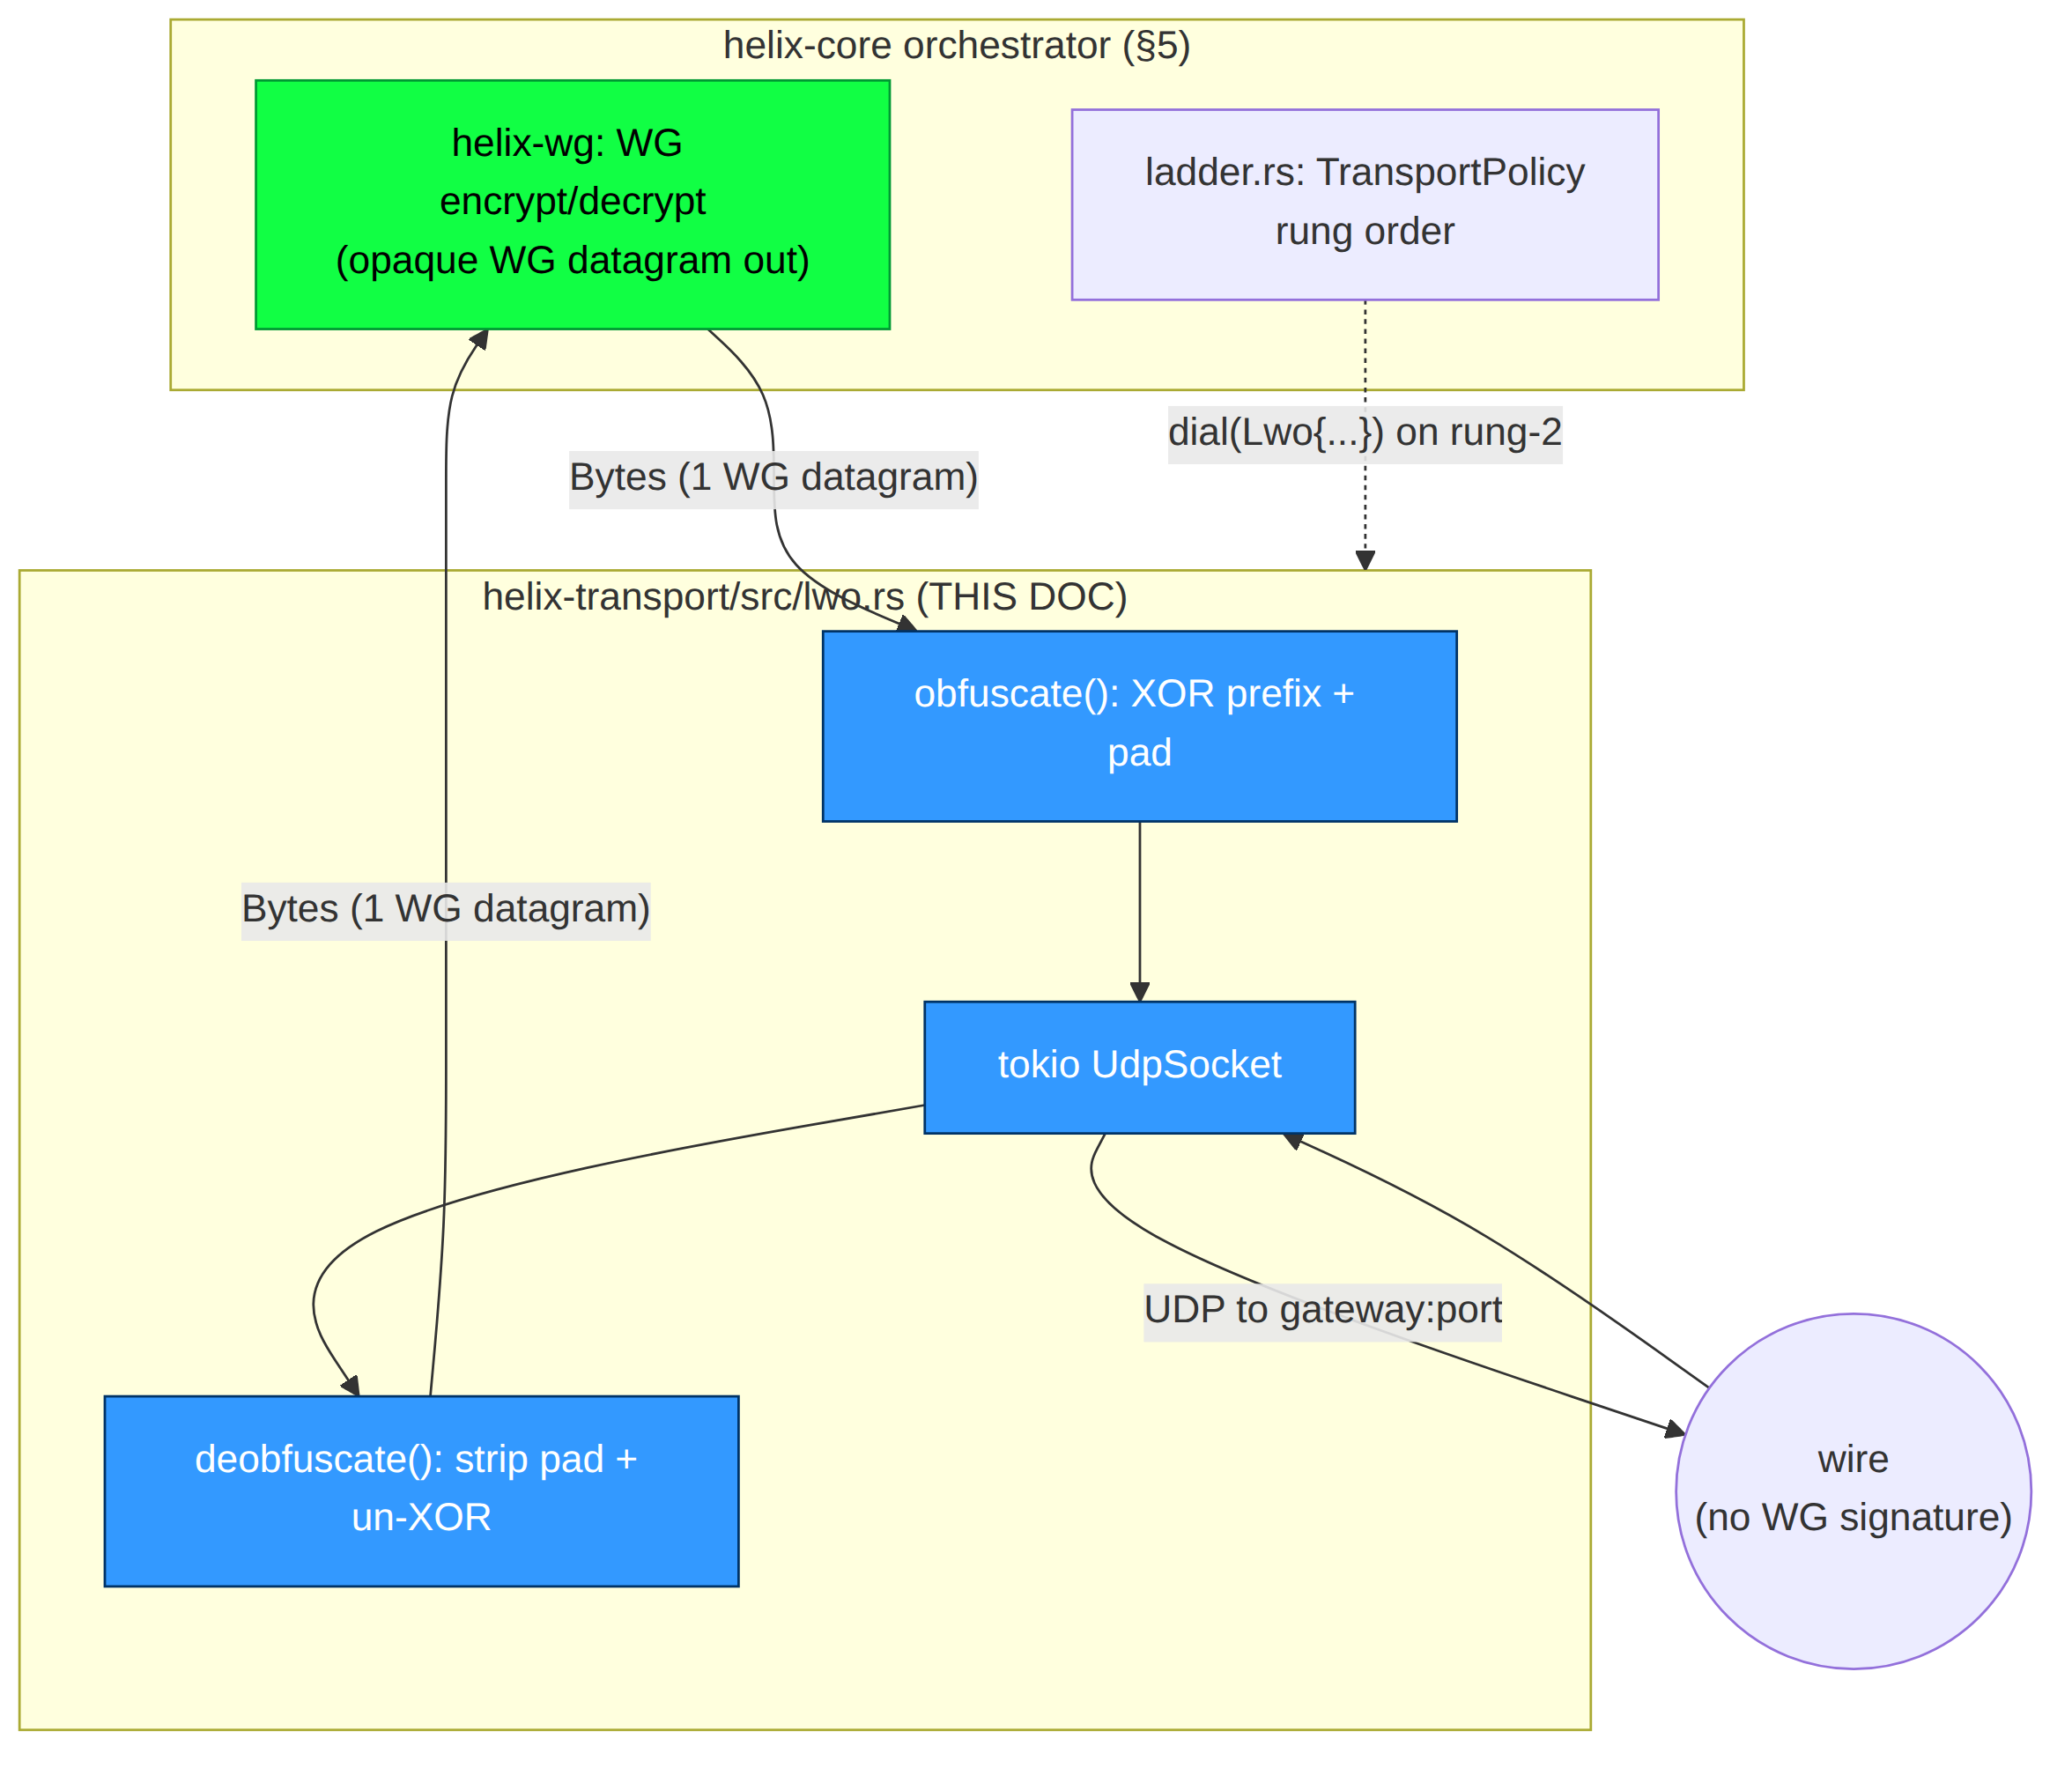
LWO is selected when plain-udp (rung 1) exceeds its handshake failure budget — i.e. WG/UDP is being dropped by a signature-matching DPI box [01-DP §5.3 step 3, sequence at §5.4 "Rung 2"]. Because LWO is also UDP, if the censor is dropping all UDP (not just WG-signed UDP), LWO will also fail its budget and the ladder escalates to masque-h3 (TCP/443-shaped QUIC). LWO's value is precisely the common middle case: UDP is allowed, but packets carrying the WG signature are dropped.

3. Wire format & algorithms
Two schemes ship across phases per [01-DP §3.7] ("Phase 1 ships a basic XOR/padding scheme; Phase 2 hardens it to a proper per-session keyed scheme"). The byte layout is identical at the framing level; the keystream source differs. scheme_version (config §11) selects which.

3.1 LWO frame layout (on-wire, one per UDP datagram)
0 1 ... 8 8+L 8+L+P
+--------+--------+--------+------------------------+-------------------+
| seed (8 bytes, cleartext)| obf(WG datagram), L B | padding, P bytes |
+--------+--------+--------+------------------------+-------------------+
|<------ SEED_LEN=8 ------>|<-- WG datagram (XOR'd |<-- keyed-random |
| per-packet random nonce | over first H bytes) | pad, length P |
| = keystream seed | rest = raw WG ct | derived from |
| | (already random) | seed (§3.4) |
+---------------------------+------------------------+-------------------+
SEED_LEN = 8 (constant)
L = true WG datagram length (1 .. effective_mtu_inner); NOT on the wire —
recovered as L = udp_payload_len - SEED_LEN - P
P = pad_len(seed, pad_key) ∈ [pad_min, pad_max] (deterministic from seed; §3.4)
H = min(L, header_obf_len) bytes of the WG datagram that get XOR-masked
udp_payload_len = SEED_LEN + L + P (== the bytes UDP hands us; known on recv)
Why no explicit length field: P is a pure deterministic function of (seed, pad_key) (§3.4), and udp_payload_len is given by the UDP stack, so the receiver recovers L = udp_payload_len − 8 − P with zero extra header bytes. This minimizes overhead (the entire LWO framing cost is SEED_LEN + P = 8 + ~[0..16] bytes) and removes a plaintext length field that would itself be a fingerprint. (Phase 1's simpler variant carries a 1-byte obfuscated pad_len; see §3.5.)
Seed is cleartext by necessity: the receiver needs it to derive the same keystream and pad_len. An 8-byte random seed is itself indistinguishable from random and carries no WG signature; its only risk is keystream reuse on seed collision, bounded by the birthday term ≈ 2^-64 per pair (§10).

3.2 Key derivation chain
session_key: SecretBytes arrives in TransportConfig::Lwo from the coordinator's NetworkMap (doc 03), per-peer and rotatable. From it LWO derives two sub-keys via HKDF-SHA256 (RFC 5869):
// helix-transport/src/lwo.rs — key schedule
use hkdf::Hkdf;
use sha2::Sha256;
const LWO_INFO_OBF: &[u8] = b"helix-lwo/v2/obf-key";
const LWO_INFO_PAD: &[u8] = b"helix-lwo/v2/pad-key";
const SEED_LEN: usize = 8;
struct LwoKeys {
obf_key: [u8; 32], // ChaCha20 key for the header keystream (§3.3)
pad_key: [u8; 16], // keyed PRF key for pad-length derivation (§3.4)
}
/// salt = a per-session 32-byte value also pushed in the NetworkMap (session_salt),
/// rotated whenever session_key rotates; binds the key schedule to one session.
fn derive_keys(session_key: &SecretBytes, session_salt: &[u8; 32]) -> LwoKeys {
let hk = Hkdf::<Sha256>::new(Some(session_salt), session_key.expose());
let mut obf_key = [0u8; 32];
let mut pad_key = [0u8; 16];
hk.expand(LWO_INFO_OBF, &mut obf_key).expect("hkdf obf"); // 32 ≤ 255*32, infallible
hk.expand(LWO_INFO_PAD, &mut pad_key).expect("hkdf pad");
LwoKeys { obf_key, pad_key }
}
SecretBytes is a zeroize-on-drop wrapper (the same SecretBytes used by TransportConfig::Shadowsocks/Lwo in [01-DP §3.1]); obf_key/pad_key live in a struct that also implements Zeroize on Drop. Keys never touch logs (§11.4.10).

3.3 The keystream & header obfuscation (Phase 2 — hardened)
use chacha20::cipher::{KeyIvInit, StreamCipher};
use chacha20::ChaCha20; // IETF ChaCha20: 32B key, 12B nonce, 32-bit block counter
/// Derive a 12-byte ChaCha20 nonce from the 8-byte per-packet seed.
/// First 4 nonce bytes are a fixed domain tag so the same seed never collides
/// with the pad-PRF input space; last 8 are the seed.
#[inline]
fn seed_to_nonce(seed: &[u8; SEED_LEN]) -> [u8; 12] {
let mut n = [0u8; 12];
n[0..4].copy_from_slice(b"OBF1");
n[4..12].copy_from_slice(seed);
n
}
/// Obfuscate IN PLACE: XOR the first H = min(L, header_obf_len) bytes of `wg`
/// with the ChaCha20 keystream. Cost: one ChaCha20 init + H bytes of XOR (H ≤ 64
/// by default → a single ChaCha20 block). The remaining L-H bytes are untouched
/// (already-random WG ciphertext, no signature).
fn obfuscate_header(keys: &LwoKeys, seed: &[u8; SEED_LEN], wg: &mut [u8], header_obf_len: usize) {
let h = wg.len().min(header_obf_len);
let mut cipher = ChaCha20::new((&keys.obf_key).into(), (&seed_to_nonce(seed)).into());
cipher.apply_keystream(&mut wg[..h]); // XOR mask; deobfuscate is the identical op
}
Deobfuscation is the identical operation (XOR is its own inverse): re-derive the keystream from the cleartext seed and obf_key, XOR the first H bytes of the recovered L-byte WG region. No separate code path.
header_obf_len default = 16 (config §11): covers the 4-byte prefix, the 4-byte sender/receiver index, and (for type-4) the 8-byte counter — i.e. every low-entropy / monotone field in §1.1, in a single ChaCha20 block's worth of XOR. A full mode (header_obf_len = u16::MAX, clamped to L) XORs the entire datagram for maximum entropy flattening at a slightly higher (still linear, ~1 GB/s/core) cost; default stays header-only because the WG body is already random (L1, §1.1).

3.4 Padding policy (keyed, deterministic from seed)
use siphasher::sip::SipHasher13; // fast keyed PRF; pad_key is the SipHash key
use std::hash::Hasher;
/// pad_len is a DETERMINISTIC function of (seed, pad_key): the sender and receiver
/// compute the identical value with no length field on the wire.
/// Range [pad_min, pad_max] inclusive; both config knobs (§11). pad_max - pad_min + 1
/// MUST be ≥ 1. Uniform over the range via rejection-free modulo on a 64-bit PRF
/// (bias ≤ 2^-58 for ranges ≤ 256 — negligible for a length distribution).
fn pad_len(keys: &LwoKeys, seed: &[u8; SEED_LEN], pad_min: u16, pad_max: u16) -> usize {
let span = (pad_max - pad_min) as u64 + 1;
let mut h = SipHasher13::new_with_key(&{
let mut k = [0u8; 16]; k.copy_from_slice(&keys.pad_key); k
});
h.write(b"PAD1");
h.write(seed);
(pad_min as u64 + (h.finish() % span)) as usize
}
/// Padding CONTENT is keystream bytes (high-entropy, indistinguishable from the body),
/// generated from the same ChaCha20 stream advanced past the header region. Receiver
/// never needs to read padding content — it strips P bytes by length only (L4).
fn fill_padding(keys: &LwoKeys, seed: &[u8; SEED_LEN], out: &mut [u8]) {
let mut cipher = ChaCha20::new((&keys.obf_key).into(), (&seed_to_nonce(seed)).into());
// advance the cipher past the 64-byte header block so padding ≠ header keystream reuse
let mut skip = [0u8; 64];
cipher.apply_keystream(&mut skip);
for b in out.iter_mut() { *b = 0; }
cipher.apply_keystream(out); // out becomes pure keystream (random-looking)
}
Padding length distribution: uniform [pad_min, pad_max] per packet, keyed so a passive observer cannot predict or remove it. Defaults pad_min = 0, pad_max = 16 (config §11). The WG handshake's three fixed lengths (148/92/64) thus spread across 17 distinct on-wire lengths each. Optional length-equalization mode (pad_to_bucket, §11): instead of a uniform range, pad each packet up to the next bucket boundary (e.g. multiples of 64) so the length histogram collapses to a few buckets — a stronger anti-length-fingerprint at higher average overhead. Default is the cheap uniform mode (L5: LWO is the cheap rung; bucket mode is the bridge toward DAITA [01-DP §9] without being DAITA).

3.5 Phase 1 (basic) scheme — scheme_version = 1
Phase 1 ships before the full keyed keystream is hardened [01-DP §3.7]. It MUST interoperate on the same frame layout (§3.1) so the Phase-2 upgrade is a keystream swap, not a wire-format break:
- Header mask: a static 32-byte mask M = HKDF(session_key, "helix-lwo/v1/mask"), XORed over the first H bytes. seed is still present and still randomizes pad_len, but the header keystream does not depend on seed → identical header bytes mask to identical ciphertext across packets (the known weakness).
- pad_len: carried as a 1-byte field at frame offset 8, XORed with M[0] (so the explicit length variant of §3.1). Recovered as P = wire[8] ^ M[0]; the WG region starts at offset 9.
- Honest limit (documented in code + tracker): the static mask is vulnerable to known-plaintext recovery — an adversary who knows the WG header structure (public) can XOR two captured LWO packets to cancel M and recover header deltas, then solve for M. Phase 1 LWO therefore defeats only a stateless signature-matcher that does not do this analysis, and is flagged Operator-blocked-grade for any active adversary until scheme_version = 2 lands. This is stated, not hidden (§11.4.6, L5).
The orchestrator MUST refuse to negotiate scheme_version = 1 once a peer advertises 2 in its NetworkMap capability set (doc 03); v1 exists only for the Phase-1 milestone window.

3.6 Send / receive packet flow
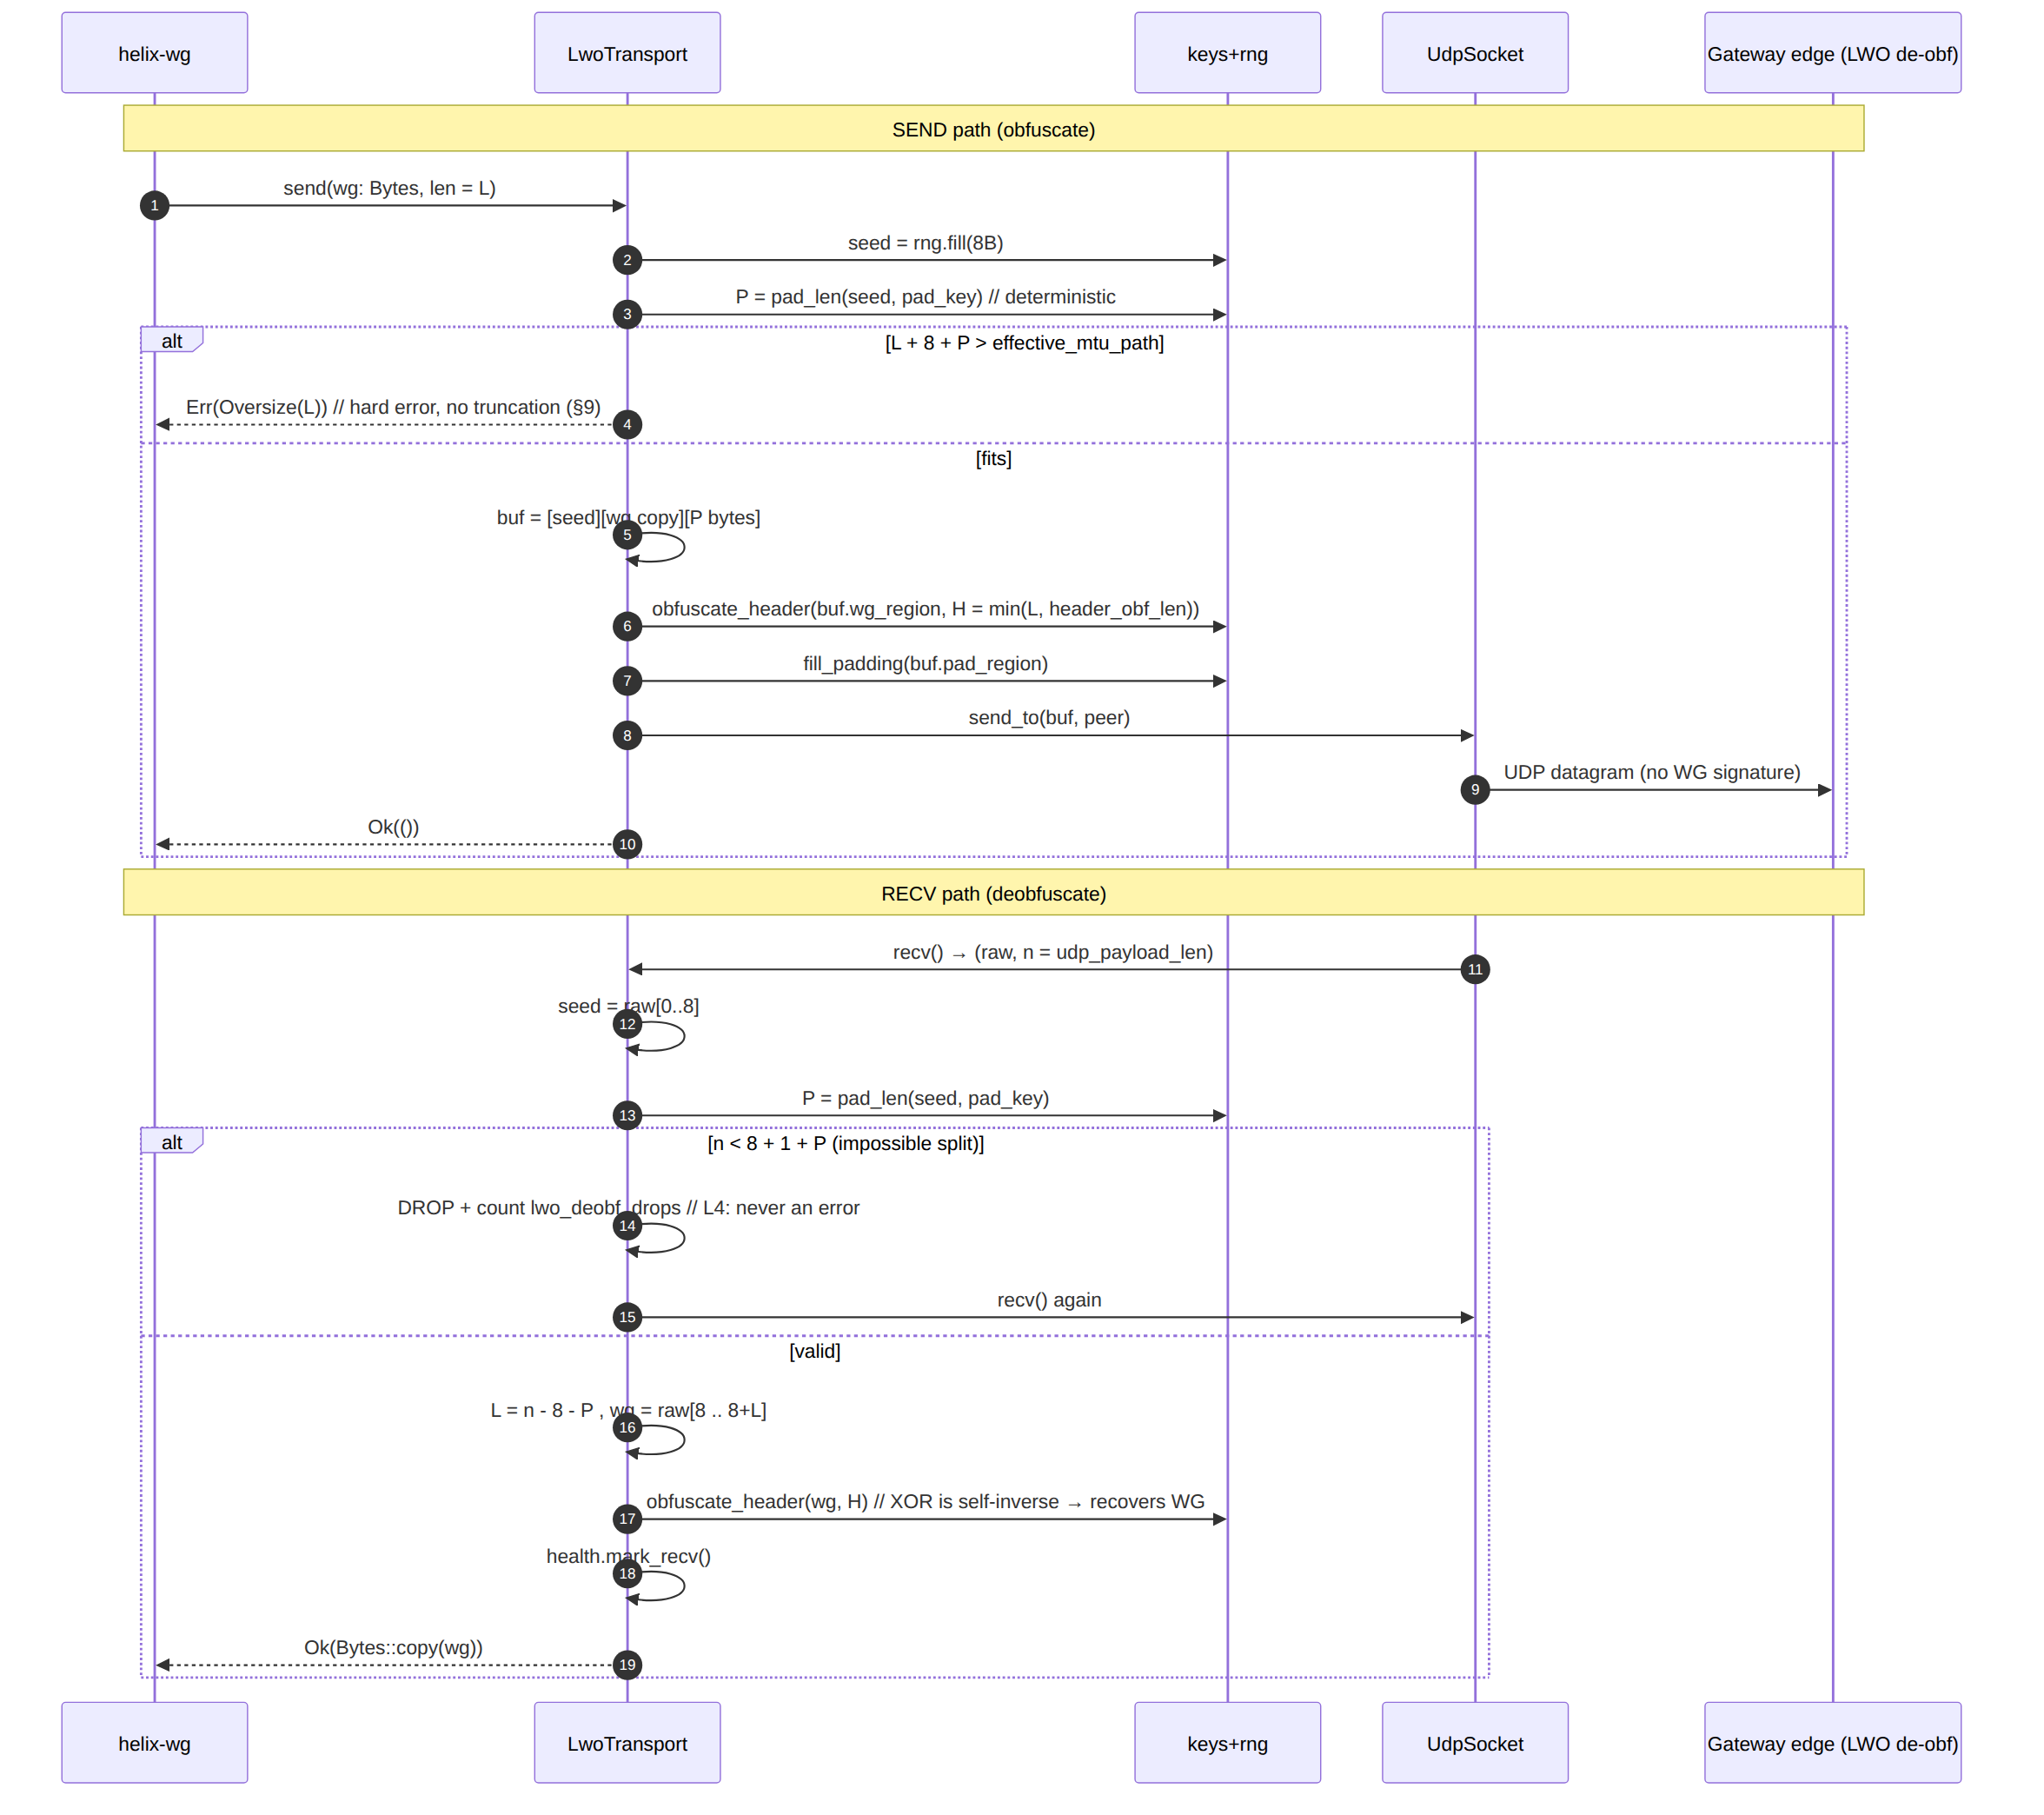

4. Rust API surface (the LWO Transport impl)
// helix-transport/src/lwo.rs
use async_trait::async_trait;
use bytes::Bytes;
use std::net::SocketAddr;
use std::sync::atomic::{AtomicU64, Ordering};
use crate::{Transport, TransportError, TransportHealth};
use crate::health::HealthCell; // shared with plain_udp (RTT EWMA, last-recv age)
/// Lightweight WG obfuscation carrier. Per-packet stateless on the data path (L2);
/// the only mutable state is the HealthCell and an optional monotonic send counter
/// used to refresh seeds under a (negligible) collision-avoidance policy.
pub struct LwoTransport {
sock: tokio::net::UdpSocket,
peer: SocketAddr,
keys: LwoKeys, // zeroized on drop (§3.2)
cfg: LwoParams, // header_obf_len, pad_min/max, scheme_version (§11)
health: HealthCell,
send_ctr: AtomicU64, // mixed into the seed RNG to harden against seed reuse
drops: AtomicU64, // lwo_deobf_drops counter (L4, metrics §11.4.5)
}
/// Tunable obfuscation parameters; all come from TransportConfig::Lwo / NetworkMap.
#[derive(Clone, Copy, Debug)]
pub struct LwoParams {
pub scheme_version: u8, // 1 = static mask (Phase 1, §3.5); 2 = keyed keystream (§3.3)
pub header_obf_len: u16, // default 16 (covers prefix+index+counter, §3.3)
pub pad_min: u16, // default 0
pub pad_max: u16, // default 16 (must be ≥ pad_min)
pub pad_to_bucket: u16, // 0 = uniform range; else round length up to this multiple (§3.4)
}
impl Default for LwoParams {
fn default() -> Self {
Self { scheme_version: 2, header_obf_len: 16, pad_min: 0, pad_max: 16, pad_to_bucket: 0 }
}
}
/// Construct from the dial() ladder (§5.3). Binds a UDP socket, derives keys.
/// Validated: pad_max ≥ pad_min, header_obf_len ≥ 4, scheme_version ∈ {1,2}.
pub(crate) async fn dial_lwo(
peer: SocketAddr, bind: SocketAddr,
session_key: SecretBytes, session_salt: [u8; 32], cfg: LwoParams,
) -> Result<LwoTransport, TransportError> {
if cfg.pad_max < cfg.pad_min || cfg.header_obf_len < 4 || !(1..=2).contains(&cfg.scheme_version) {
return Err(TransportError::HandshakeFailed("invalid LwoParams".into()));
}
let sock = tokio::net::UdpSocket::bind(bind).await?;
sock.connect(peer).await?; // connected UDP: lets recv() drop off-path datagrams cheaply
Ok(LwoTransport {
sock, peer,
keys: derive_keys(&session_key, &session_salt),
cfg, health: HealthCell::new(), send_ctr: AtomicU64::new(0), drops: AtomicU64::new(0),
})
}
#[async_trait]
impl Transport for LwoTransport {
async fn send(&self, wg: Bytes) -> Result<(), TransportError> {
let l = wg.len();
if l == 0 { return Ok(()); } // §9 edge: empty → no-op
let seed = self.next_seed(); // 8B, ctr-mixed RNG
let p = self.pad_len(&seed);
let total = SEED_LEN + l + p;
if total > self.effective_mtu() as usize + SEED_LEN /*hdr is accounted in eff_mtu*/ {
return Err(TransportError::Oversize(l)); // §9: never truncate
}
let mut buf = Vec::with_capacity(total);
buf.extend_from_slice(&seed);
buf.extend_from_slice(&wg);
buf.resize(total, 0);
self.obfuscate(&seed, &mut buf[SEED_LEN..SEED_LEN + l]); // §3.3
self.fill_padding(&seed, &mut buf[SEED_LEN + l..]); // §3.4
self.sock.send(&buf).await?; // connected UDP
Ok(())
}
async fn recv(&self) -> Result<Bytes, TransportError> {
let mut buf = vec![0u8; (self.effective_mtu() as usize) + SEED_LEN + self.cfg.pad_max as usize + 64];
loop {
let n = self.sock.recv(&mut buf).await?; // cancel-safe (I2)
match self.deobfuscate(&buf[..n]) {
Some(wg) => { self.health.mark_recv(); return Ok(wg); }
None => { self.drops.fetch_add(1, Ordering::Relaxed); continue; } // L4: drop+loop
}
}
}
fn kind(&self) -> &'static str { "lwo" }
fn effective_mtu(&self) -> u16 { 1400 } // plain-udp 1420 − SEED_LEN(8) − ~12 pad headroom (§10)
fn health(&self) -> TransportHealth { self.health.snapshot() }
async fn close(&self) -> Result<(), TransportError> { Ok(()) } // UDP: nothing to flush
}
// private helpers (sketch)
impl LwoTransport {
fn next_seed(&self) -> [u8; SEED_LEN] {
// 8 random bytes from a CSPRNG, mixed with the monotonic send counter so that
// even a (broken) RNG returning a repeat cannot reuse a full seed within a session.
let ctr = self.send_ctr.fetch_add(1, Ordering::Relaxed);
let mut s = [0u8; SEED_LEN];
rand::rng().fill_bytes(&mut s);
let cb = ctr.to_le_bytes();
for i in 0..SEED_LEN { s[i] ^= cb[i]; } // counter is non-secret; only de-dups seeds
s
}
fn pad_len(&self, seed: &[u8; SEED_LEN]) -> usize {
let p = pad_len(&self.keys, seed, self.cfg.pad_min, self.cfg.pad_max);
if self.cfg.pad_to_bucket == 0 { p } else { /* round-up-to-bucket variant, §3.4 */ p }
}
fn obfuscate(&self, seed: &[u8; SEED_LEN], region: &mut [u8]) {
match self.cfg.scheme_version {
2 => obfuscate_header(&self.keys, seed, region, self.cfg.header_obf_len as usize),
_ => obfuscate_header_static_v1(&self.keys, region, self.cfg.header_obf_len as usize),
}
}
fn fill_padding(&self, seed: &[u8; SEED_LEN], out: &mut [u8]) { fill_padding(&self.keys, seed, out); }
/// Returns None ⇒ DROP (L4): never an error, never tears the tunnel down.
fn deobfuscate(&self, raw: &[u8]) -> Option<Bytes> {
if raw.len() < SEED_LEN + 1 { return None; }
let mut seed = [0u8; SEED_LEN]; seed.copy_from_slice(&raw[..SEED_LEN]);
let p = self.pad_len(&seed);
if raw.len() < SEED_LEN + p + 1 { return None; } // pad can't exceed payload (with ≥1 WG byte)
let l = raw.len() - SEED_LEN - p;
if l == 0 || l > self.effective_mtu() as usize { return None; } // sanity bound
let mut wg = raw[SEED_LEN..SEED_LEN + l].to_vec();
self.obfuscate(&seed, &mut wg[..wg.len().min(self.cfg.header_obf_len as usize)]); // self-inverse
Some(Bytes::from(wg))
}
}

4.1 TransportConfig & dial() wiring
LWO is already a variant of the frozen TransportConfig enum [01-DP §3.1]:
// (from helix-transport/src/lib.rs — UNCHANGED, shown for context)
Lwo { peer: SocketAddr, bind: SocketAddr, session_key: SecretBytes },
This document proposes the additive fields session_salt: [u8; 32] and params: LwoParams on the Lwo variant so the coordinator can push the salt and per-region obfuscation tuning (UNVERIFIED: the pass-1 enum at [01-DP §3.1] shows only peer/bind/session_key; whether these two extra fields are added to the public enum or carried in a side-channel is a doc-03 NetworkMap schema decision — flagged for reconciliation when doc 03 lands). The dial() ladder routes TransportConfig::Lwo{..} → dial_lwo() (§4).

5. State machine
LWO has almost no connection state (it is connectionless UDP), but the orchestrator-visible lifecycle and the key-rotation path are state-machine-worthy:
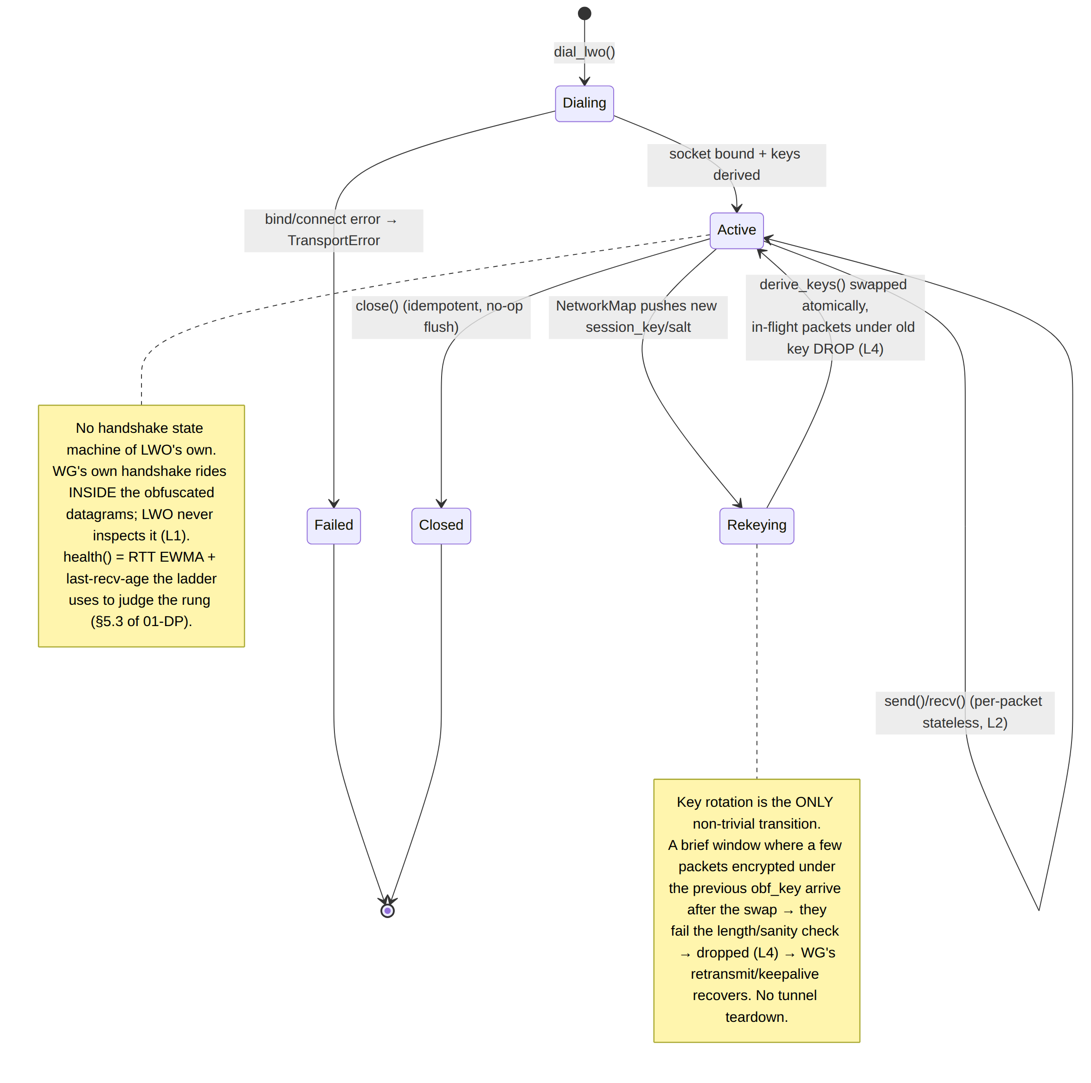
Rekeying detail: derive_keys() produces a fresh LwoKeys; the swap is a single ArcSwap<LwoKeys> (or Mutex<LwoKeys>) replacement. There is no negotiated cutover — LWO carries no control messages. Packets in flight under the old key deobfuscate to a wrong L/P and are dropped (L4); the WG layer above does not even notice (its own keepalive/retransmit [01-DP §4 tick] covers the ≤ RTT gap). Rekey cadence is a coordinator policy (rekey_interval, §11); default rotation aligns with WG's own rekey (~120 s) so an LWO-key and a WG-key rotation coincide, minimizing distinct key-lifetime windows. UNVERIFIED: the exact coordinator rekey push mechanism is doc-03 territory.

6. Error taxonomy
LWO reuses the shared TransportError [01-DP §3.1, error.rs] and adds no new public variant (keeping the trait surface uniform). Mapping:
Condition | Surfaced as | Path | Notes
bind/connect UDP socket failure at dial | TransportError::Io | dial_lwo | propagates to the ladder → escalate rung (§5.3)
invalid LwoParams (pad_max<pad_min, header_obf_len<4, bad scheme) | TransportError::HandshakeFailed("invalid LwoParams") | dial_lwo | a config error reads as a handshake failure → ladder skips LWO
send() of a datagram that won't fit eff_mtu after seed+pad | TransportError::Oversize(L) | send | hard error, never truncates (§9); orchestrator lowers inner WG MTU
socket send/recv I/O error mid-session | TransportError::Io | send/recv | repeated → health degrades → ladder may re-escalate
a received packet fails deobfuscation (bad length split, sanity bound, probe traffic) | NOT an error — dropped + lwo_deobf_drops++ | recv (loops) | L4: corrupt/probe/old-key packets must not kill a live tunnel
internal deobf logic invariant broken (would be a bug) | debug_assert! in debug; drop in release | deobfuscate | §11.4.1 — a script/logic bug must never masquerade as a product FAIL
There is deliberately no DeobfuscationFailed public error: per L4 a failed deobfuscation is indistinguishable, from LWO's standpoint, from random noise/probe traffic, and the correct response is silent drop, not tunnel teardown.

7. Edge cases (enumerated, each with the defined behavior)
# | Edge case | Defined behavior
E1 | Empty WG datagram (L == 0) | send returns Ok(()) no-op; deobf rejects L==0 (drop). WG never emits empty datagrams, but the guard is explicit.
E2 | WG datagram smaller than header_obf_len | H = min(L, header_obf_len) — XOR only the available L bytes; never reads past the buffer (§3.3 clamps).
E3 | pad_max == 0 (padding disabled) | pad_len returns pad_min (=0) every packet → no padding; LWO still obfuscates the header (signature 1) but does NOT break fixed lengths (signature 2). A valid cheap mode; flagged in metrics so an operator knows length-fingerprinting is unmitigated.
E4 | Path MTU smaller than eff_mtu (PMTUD shrink) | orchestrator lowers inner WG MTU (min(eff_mtu, pmtu)) [01-DP §10 rule 1]; a transient oversize before PMTUD converges → Oversize → WG re-emits smaller.
E5 | Received UDP packet of length < SEED_LEN + 1 | cannot contain a seed + ≥1 WG byte → drop (L4). Defends against a truncating middlebox / runt probe.
E6 | Received packet where pad_len(seed) ≥ payload (no room for WG bytes) | drop (L4) — a spoofed/forged packet whose seed implies impossible split.
E7 | Seed collision within a session (two packets, same 8-byte seed) | keystream reused on the masked prefix only; counter-mixing (§4 next_seed) makes a full collision require both an RNG repeat AND an equal send-counter low byte — practically impossible; residual risk ≈2^-64 per pair, accepted & documented (§10).
E8 | Coordinator pushes new session_key mid-flight (rekey) | atomic key swap (§5); ≤1 RTT of old-key packets drop (L4); WG keepalive recovers. No teardown.
E9 | Scheme downgrade attempt (peer advertises v2, attacker forces v1) | the orchestrator MUST pin scheme_version from the authenticated NetworkMap, never from any on-wire signal (LWO carries none) → no in-band downgrade surface.
E10 | DPI drops all UDP, not just WG-signed | LWO's handshake budget is exhausted exactly like plain-udp's → ladder escalates to masque-h3 (§2). LWO correctly fails fast rather than hanging.
E11 | Off-path datagram delivered to a connected UDP socket | sock.connect(peer) causes the kernel to drop datagrams from other sources; any that slip through fail deobf → drop (L4).
E12 | header_obf_len = full (XOR whole datagram) on a max-size datagram | multi-block ChaCha20 over ~1400 bytes; still O(L), ~1 GB/s/core; eff_mtu unaffected (padding budget unchanged).

8. Security considerations (honest boundary — §11.4.6, L5)
- What LWO IS for: defeating a stateless, signature-matching DPI box that blocks UDP packets exhibiting the WG fingerprint (§1.1 signatures 1–3). Against that adversary, Phase-2 LWO removes all three signals at near-zero cost.
- What LWO is NOT for (stated, never overclaimed):
  - Active probing. A censor that replays/probes the gateway endpoint is not defeated by LWO (LWO has no anti-probe response). The anti-probe story is the masque-h3 decoy site [01-DP §3.3].
  - Stateful entropy / flow classifiers. "High-entropy UDP, no TLS/QUIC handshake, periodic small packets" can still cluster. pad_to_bucket (§3.4) helps marginally; full defense is DAITA [01-DP §9] + masque-h3. LWO makes no traffic-analysis claim.
  - Confidentiality / integrity. LWO is obfuscation, not encryption — the WG datagram it wraps already provides AEAD confidentiality+integrity (I1). LWO's XOR keystream is NOT a security boundary; a recovered obf_key reveals only the (already-encrypted) header bytes, never WG plaintext (L3). LWO MUST NOT be relied on for any security property WG does not already provide.
- Phase-1 static-mask weakness (§3.5): known-plaintext recovery of the static mask. Phase-1 LWO is a milestone artifact; it ships flagged and is auto-superseded by v2 (E9). Tracked as a known limitation, never presented as production-grade obfuscation.
- Seed reuse → keystream reuse (E7): bounded to ≈2^-64 per packet pair by the 8-byte CSPRNG seed + counter mix; even on reuse only the masked header prefix leaks an XOR delta, not WG plaintext. Acceptable for the cheap rung; masque-h3 is the answer where this risk is unacceptable.
- Key separation (L3): obf_key/pad_key derive from a transport session_key distinct from WG keys, with their own salt and rotation; an LWO key compromise is contained to deobfuscation, never WG.
- Replay / amplification: LWO neither adds nor mitigates replay beyond WG's own counter (WG drops replayed transport packets). LWO is not a reflection/amplification vector — it is a 1:1 datagram wrapper with no response generation of its own.
- No logging: lwo_deobf_drops and health are aggregate counters only (I5, §11.4.5); no per-packet/per-peer durable state.

9. MTU & overhead budget
LWO's wire overhead per packet = SEED_LEN(8) + P(pad_len). With defaults pad_max = 16, the worst-case overhead is 8 + 16 = 24 bytes; average 8 + 8 = 16. Reconciling with [01-DP §10] (which lists lwo ≈ 1400):
plain-udp inner WG MTU = 1420 [01-DP §10]
− SEED_LEN = 1412
− pad_max headroom (16) = 1396 → reported effective_mtu() = 1400 (rounded, conservative)
Rules (inherit [01-DP §10]):
- inner WG MTU = min(lwo.effective_mtu()=1400, path-MTU-discovered).
- effective_mtu() already subtracts seed + worst-case padding, so a send() that respects it cannot exceed path MTU even at pad_max. The runtime Oversize guard (§4, E4) is a belt-and-suspenders against a stale inner-MTU during PMTUD shrink.
- Padding is added after WG encrypt and counts against the LWO budget, never the inner WG MTU ([01-DP §10] rule 2 — LWO padding behaves like the DAITA-padding rule).
CPU budget (the "near-zero" claim, [04_ARCH §129]): per packet = one CSPRNG draw (8 B) + one SipHash-1-3 (pad_len) + one ChaCha20 init + XOR of H ≤ 64 bytes (header mode) + ChaCha20 of P ≤ 16 padding bytes. All sub-microsecond on a modern core; the dominant cost remains the UDP syscall, shared with plain-udp. Target: LWO throughput ≥ 95% of plain-udp throughput (the cheap-rung promise) — measured, not assumed (§12 PT/BT). This is far below masque-h3's QUIC overhead, which is exactly LWO's reason to exist [01-DP §3.7].

10. Config knobs (operator + coordinator surface)
Knob | Type | Default | Source | Effect
scheme_version | u8 ∈ {1,2} | 2 | NetworkMap | 1 = Phase-1 static mask (§3.5); 2 = keyed keystream (§3.3). v1 auto-superseded (E9).
header_obf_len | u16 (≥4) | 16 | NetworkMap | bytes of the WG datagram XOR-masked; 16 covers prefix+index+counter (§3.3); u16::MAX→full-datagram mask.
pad_min | u16 | 0 | NetworkMap | floor of the uniform padding range.
pad_max | u16 (≥ pad_min) | 16 | NetworkMap | ceil of the uniform padding range; 0 disables padding (E3).
pad_to_bucket | u16 | 0 | NetworkMap | 0 = uniform range; N = round each on-wire length up to a multiple of N (stronger length-equalization, §3.4).
rekey_interval | Duration | 120 s | coordinator | LWO key-rotation cadence; default aligned to WG rekey (§5).
session_key | SecretBytes | — (required) | NetworkMap | root of the key schedule (§3.2); per-peer, rotatable.
session_salt | [u8;32] | — (required) | NetworkMap | binds the key schedule to one session; rotates with session_key.
bind | SocketAddr | 0.0.0.0:0 | client config | local UDP bind (ephemeral by default).
Seed length (SEED_LEN = 8), the HKDF info strings, and the ChaCha20/SipHash choices are compile-time constants, not knobs — changing them is a wire-format break requiring a scheme_version bump (kept out of the runtime config surface deliberately).
UNVERIFIED: the precise field placement of header_obf_len/pad_*/pad_to_bucket in the NetworkMap schema is doc-03 territory; this doc fixes their semantics and defaults, doc 03 fixes their transport.

11. Region/ladder integration (read-only dependencies)
- Ladder rung: LWO is order[1] in the restricted-network prior (§2); the coordinator may push a regional prior that starts directly at lwo for regions where naive WG-signature blocking is common but UDP is otherwise open, so users skip the plain-udp failure round-trip [01-DP §5.3 step 5].
- Per-network memory: on a successful LWO connection the ladder remembers (SSID / gateway fingerprint → start at lwo) so reconnects on the same hostile network skip straight to it [01-DP §5.3 step 4]. LWO contributes only health(); the memory lives in ladder.rs.
- Telemetry: "lwo succeeded after N escalations in region R" — aggregate only, feeds the Censorship-Evasion Success dashboard [01-DP §5.3 step 6, 04_ARCH §416]; plus lwo_deobf_drops as a health signal. No per-user data (I5).

12. Test matrix (§11.4.169 test types — anti-bluff captured evidence)
UNVERIFIED: §11.4.169 is named by the operator as the test-type taxonomy but is not present in the constitution text loaded for this session (loaded anchors end at §11.4.168). The concrete test types below are grounded in the canonical enumeration of §11.4.27 (unit / integration / e2e / full-automation / security / DDoS / scaling / chaos / stress / performance / benchmarking) + §11.4.85 (stress+chaos) + §11.4.5/.69/.107 (captured evidence). The mapping is presented under the §11.4.169 label as instructed; reconcile the anchor number when §11.4.169 is available.
Test type | LWO test point | Captured-evidence artifact (§11.4.5/.69)
Unit | obfuscate_header then deobfuscate (same seed/key) round-trips a WG datagram byte-identically, for L ∈ {1, 16, 64, 148, 1400}; header_obf_len ∈ {4,16,full}. | cargo test vector table; per-case input/output hashes.
Unit | pad_len is deterministic, uniform over [pad_min,pad_max] (χ² over 10⁶ seeds), and identical sender↔receiver. | histogram CSV + χ² statistic.
Unit | key schedule: derive_keys matches a frozen HKDF-SHA256 test vector (RFC 5869 style); keys zeroize on drop (miri/valgrind). | committed test vector + zeroize proof.
Property/Fuzz (security) | cargo fuzz on deobfuscate(arbitrary bytes) — never panics, never reads OOB, always returns Some(valid-len) or None; corpus seeded with runt/oversize/forged-seed packets (E5/E6). | fuzz corpus + zero-crash run log.
Integration | Linux netns: client dial_lwo ⇄ edge LWO de-obf ⇄ WG handshake completes; LAN host ping succeeds through the tunnel. | ping + iperf3 CSV; netns topology script.
Integration / Security | The signature test: nft rule drops UDP matching the WG 4-byte prefix {1..4},0,0,0; plain-udp tunnel FAILS, LWO tunnel SUCCEEDS through the same rule. tshark capture shows the LWO flow carries no WG-prefix and a non-constant length distribution. | nft ruleset, before/after tshark pcap, length histogram, success/fail verdicts.
Integration | Ladder escalation: WG-signature DPI block → ladder walks plain-udp (fail) → lwo (success); the TunnelStatus event trace shows the ordered Connecting → Reconnecting → Connected{transport:"lwo"}. | broadcast event trace [01-DP §5.4].
Chaos (§11.4.85) | mid-session session_key rekey injection: tunnel survives (≤ RTT of dropped old-key packets, WG keepalive recovers, no teardown); kill the edge process mid-flow → ladder re-dials. | drop-count trace + recovery timeline.
Chaos | tc netem loss 5% reorder 10% on the LWO path: deobf drops only the lost/corrupt packets, never tears the tunnel (L4); goodput recorded. | netem profile + goodput CSV + lwo_deobf_drops series.
Stress (§11.4.85) | sustained ≥ 30 s / ≥ 10⁶ packets at line rate; no leak (RSS bounded), no deadlock; p50/p95/p99 per-packet obf latency recorded. | latency.json + RSS series.
Performance / Benchmark | LWO throughput vs plain-udp on the same link ≥ 95% (§9 promise); CPU/Gbps delta < 5%; vs masque-h3 shows the LWO cost advantage that justifies the rung. | bench.sh CSV: throughput, CPU/Gbps, latency for plain-udp / lwo / masque-h3.
Security (negative / overclaim guard) | the honest-limit test: a static-mask v1 flow IS recoverable by a known-plaintext XOR analyzer (proves the §3.5/§8.3 weakness is real, not hand-waved); the v2 keyed flow is NOT (per-packet keystream). Asserts LWO never claims more than it delivers (L5, §11.4.6). | analyzer output: v1 mask recovered, v2 not; self-validated golden-good/golden-bad fixtures (§11.4.107(10)).
Challenge / HelixQA (§11.4.27) | end-to-end Challenge: a censored-region emulation where only LWO (not plain-udp) connects, scored PASS only on a captured working-tunnel + no-WG-signature pcap. | HelixQA result.json + pcap evidence.
Every PASS uses ab_pass_with_evidence citing the artifact path (§11.4.69); a config-only / grep-only PASS is a covenant violation. The G2-class wire-fingerprint check (tshark classifies the flow with no WG signature [01-DP §12.1]) is the central anti-bluff gate for LWO, exactly as it is for masque-h3.

13. File-by-file build checklist (LWO slice)
File | Owns | Phase | Gate
helix-transport/src/lwo.rs | LwoTransport, LwoParams, dial_lwo, obfuscate/deobfuscate/pad | 1 (v1) → 2 (v2 hardened) | the §12 signature + escalation tests
helix-transport/src/lwo_keys.rs | derive_keys, LwoKeys (zeroize), HKDF schedule | 1 | key-schedule unit vector
helix-transport/src/error.rs | (no new variant — reuses TransportError) | 1 | —
helix-transport/src/lib.rs | TransportConfig::Lwo routing in dial() (additive session_salt/params — §4.1) | 1 | dial-routing test
helix-core/src/ladder.rs | LWO as rung-1; per-network memory (read-only dep) | 1 | escalation test
Phasing matches [01-DP §12]: lwo is Phase 1 (basic, §3.5) → Phase 2 (hardened, §3.3).

14. Out of scope for this document
The Transport trait, TransportHealth, TransportError definitions (frozen, [01-DP §3.1]); the ladder selection algorithm and per-network memory store ([01-DP §5.3], ladder.rs — LWO is a consumer); NetworkMap delivery of session_key/session_salt/LwoParams and the exact schema field placement (doc 03); WG crypto and the WG handshake state machine ([01-DP §4]); DAITA shaping ([01-DP §9] — LWO padding is a cheap length-fingerprint breaker, not DAITA and makes no traffic-analysis claim, L5); masque-h3 / shadowsocks / udp-over-tcp (sibling transports, [01-DP §3.3/§3.5/§3.6]); the coordinator rekey-push mechanism and regional-prior policy source (control plane, doc 02/03).

End of LWO transport specification (Volume 2, Data Plane). Pairs with [01-DP §3.7] (the rung it deepens), [01-DP §5.3] (the ladder that selects it), and doc 03 (WatchNetworkMap — the live source of session_key/session_salt/LwoParams). The frame layout (§3.1), key schedule (§3.2), and the Transport impl surface (§4) are the implementation-ready contracts; the Phase-1→Phase-2 path is a keystream swap on a stable wire format (§3.5).

