MASQUE / QUIC Transport

MASQUE / QUIC Transport
Revision: 2 Last modified: 2026-07-04T12:00:00Z
Rev 2 (enterprise-hardening pass, 2026-07-04): added §6.4 QUIC anti-amplification limit (RFC 9000 §8.1) as an explicit DDoS-resilience mechanism for the gateway edge — a gap identified against the parent task's enterprise-hardening checklist (rate-limiting / DDoS resilience at the Connector/Gateway roles). No other section changed; all prior content (§0–§10) stands.
Master technical specification — Volume 2 (Data Plane), nano-detail document deepening the MASQUE / QUIC Transport section of 01-data-plane.md §3.3. Scope: the masque-h3 implementation of the Transport trait — WireGuard datagram → HTTP Datagram (RFC 9297) → QUIC DATAGRAM frame (RFC 9221) → HTTP/3 CONNECT-UDP (RFC 9298) to :443/udp, the hand-rolled CONNECT-UDP framing on quinn + h3, SNI masquerade, browser-HTTP/3 indistinguishability, MTU 1280, and the edge termination side. This is a SPEC — it describes what to build; it does not contain the shipping product. Source evidence cited inline by id: [01-DP §N] = 01-data-plane.md; [research-masque §N] = the MASQUE research note; [04_ARCH §N] / [04_P0 §N] = the refined architecture / Phase-0 spike; [SYNTHESIS §N] = the cross-document synthesis; [RFC NNNN] = the cited IETF RFC (all RFC facts are sourced through [research-masque §1] unless otherwise noted). Facts not grounded in the evidence base are marked UNVERIFIED per constitution §11.4.6.

0. Position, invariants, and what this document owns
masque-h3 is one Transport impl among N; it is the headline obfuscating carrier and Mullvad's actual mechanism — Mullvad's "QUIC mode" is not a separate protocol, it is WireGuard tunnelled over MASQUE/HTTP-3 [01-DP §0, §3.3; 04_ARCH §0, §22; research-masque §2]. This document owns the crates/helix-transport/src/masque.rs module and its edge-side termination in bin/helix-edge.rs; it does not re-specify the Transport trait (owned by [01-DP §3.1]), the WG crypto core (helix-wg, [01-DP §4]), the ladder (helix-core/src/ladder.rs, [01-DP §5.3]), or connect-ip (RFC 9484, a distinct datapath, [01-DP §3.4]).

0.1 Inherited invariants this module must not break
# | Invariant | Source | How masque-h3 upholds it
I1 | Transport never sees plaintext — carries only already-encrypted WG datagrams. | [01-DP I1] | The HTTP Datagram payload is the opaque WG datagram byte-for-byte (§3); masque.rs never parses it.
I2 | Transport carries unreliable datagrams, never an ordered byte stream. | [01-DP I2] | WG datagrams ride QUIC DATAGRAM frames (RFC 9221), not a QUIC stream — preserving WG loss semantics, avoiding head-of-line blocking [01-DP §3.1; 04_P0 §4.2, §5.1; research-masque §1].
I4 | One transport crate, three consumers — the client obfuscation code is the edge de-obfuscation code. | [01-DP I4] | masque.rs framing functions (encode_http_datagram/decode_http_datagram) are shared byte-for-byte by client and helix-edge (Decision D5 = Rust edge) [01-DP §11.2; SYNTHESIS §3 D5].
I5 | No-logging by construction — only aggregate counters. | [01-DP I5] | The module exports only TransportHealth EWMA counters; no per-packet/per-flow durable state (§7).

0.2 Maturity caveat (load-bearing, governs the whole module)
There is NO turnkey Rust crate that gives RFC 9298 CONNECT-UDP client+proxy out of the box. You hand-roll it on top of quinn + h3. This is exactly what Mullvad did [research-masque §3, §5]. Concretely the module implements, by hand: (a) the Extended-CONNECT request/response (RFC 9220 :protocol bootstrap), (b) the Quarter-Stream-ID + context-id HTTP-Datagram mux (RFC 9297/9298), (c) the proxy UDP-socket relay (edge side) [research-masque §3]. Strong evidence this is the trodden path: Mullvad's mullvad-daemon depends on quinn/quinn_udp [research-masque §2]. This immaturity-vs-Go (masque-go is turnkey) is itself the input to Decision D5/G4 [01-DP §11.2; 04_P0 §7; research-masque §4]. The documented G2 unblock if Rust proves painful: prototype MASQUE first in Go to pass G2, then port [01-DP §3.8; 04_P0 §13].

1. The RFC stack (the standardised building blocks)
WG-over-MASQUE is a layering of four published IETF Proposed Standards (stable, not drafts) [research-masque §1]:
RFC | Role | What masque-h3 uses from it
RFC 9298 — Proxying UDP in HTTP (CONNECT-UDP) | MASQUE control plane. Extended-CONNECT (:protocol = connect-udp) to a URI template, proxy opens a UDP socket to the target and relays. | The one-time flow-setup request at dial() (§2); the URI template (§4.2).
RFC 9297 — HTTP Datagrams & the Capsule Protocol | The HTTP Datagram abstraction + Quarter Stream ID multiplexing tying each datagram to its request stream. Over HTTP/3 they ride the QUIC DATAGRAM frame. | The per-WG-datagram framing (§3).
RFC 9221 — QUIC DATAGRAM frame extension | Unreliable, un-retransmitted datagram frame inside a QUIC connection. Negotiated via the max_datagram_frame_size transport parameter. | The data-plane carrier (send_datagram/read_datagram), upholding I2.
RFC 9220 — Bootstrapping WebSockets / Extended CONNECT over HTTP/3 | Adds the :protocol pseudo-header that CONNECT-UDP requires over HTTP/3. | The Extended-CONNECT handshake (§2.3).
Distinct sibling (out of scope here): RFC 9484 — Proxying IP in HTTP (CONNECT-IP) — proxies IP packets, not UDP; not what Mullvad uses; specified separately in [01-DP §3.4] [research-masque §1].
The canonical data-plane flow [01-DP §3.3; 04_P0 §5.1; research-masque §1]:
client WG datagram (Bytes, already-encrypted, opaque — I1)
└▶ HTTP Datagram (RFC 9297, context-id = 0 for the proxied UDP payload)
└▶ QUIC DATAGRAM frame (RFC 9221, unreliable — matches WG semantics, I2)
└▶ QUIC / HTTP-3 connection to https://gateway:443 (looks like web)
└▶ EDGE: extract HTTP Datagram → WG datagram → kernel WG fast path
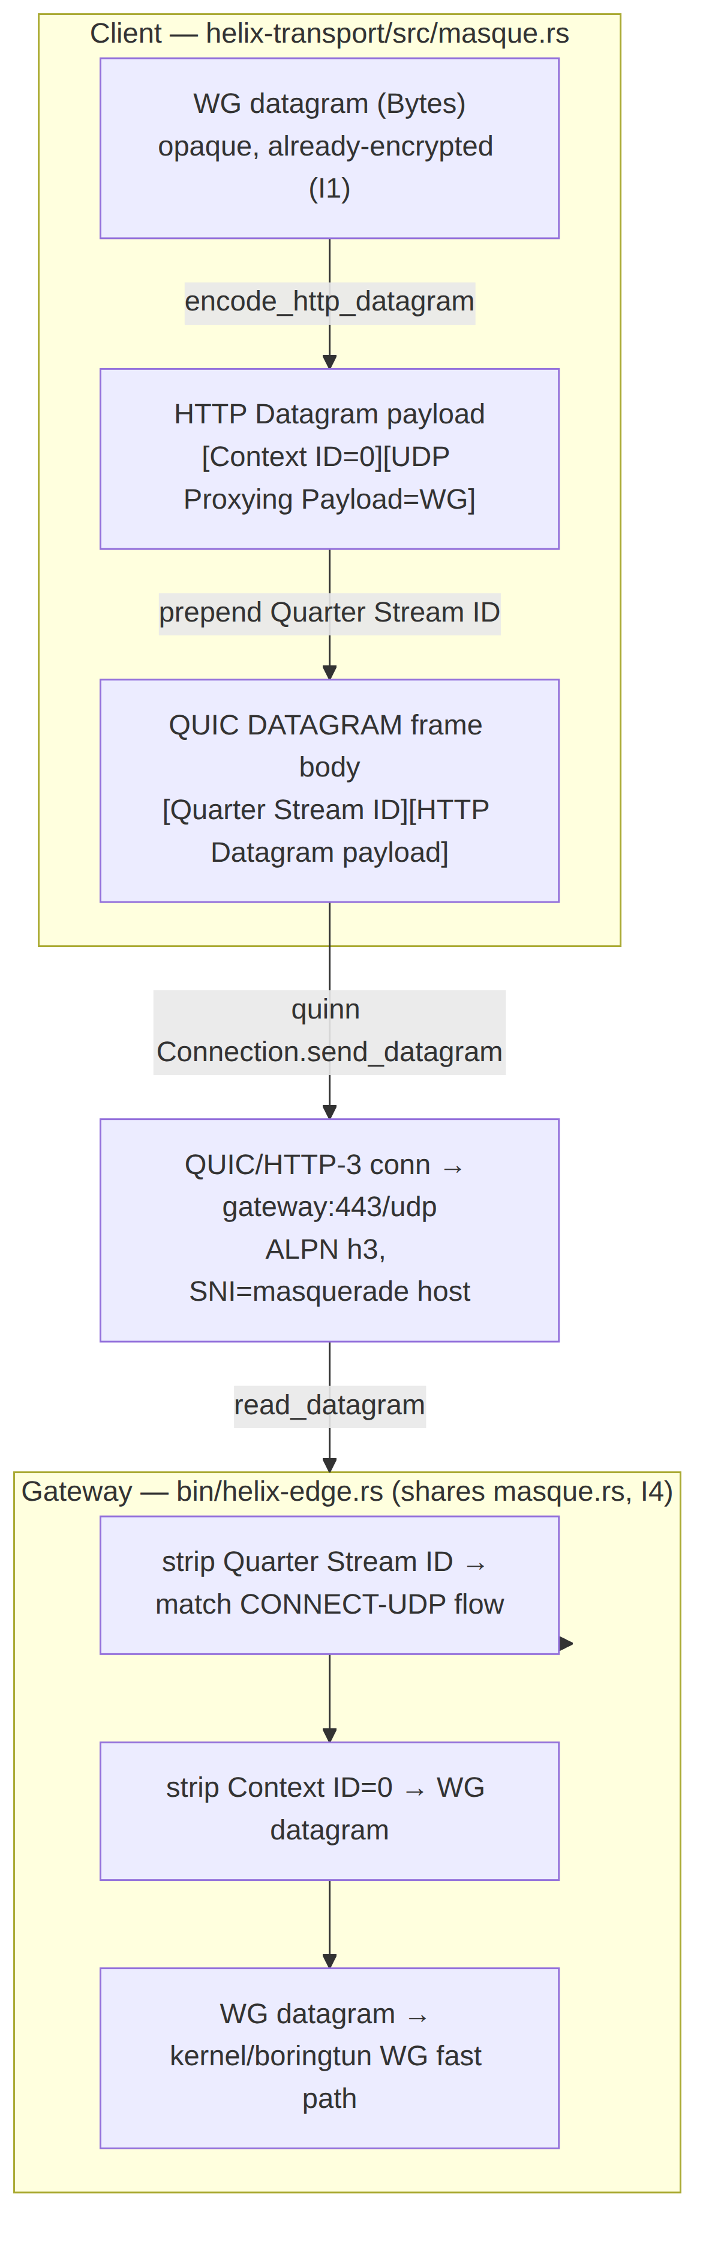

2. dial() — connection bring-up state machine
dial(TransportConfig::MasqueH3 { url, sni, bind, congestion }) returns a live Box<dyn Transport> within a bounded timeout, or a TransportError that the ladder maps to escalation [01-DP §3.1, §5.3]. The CONNECT-UDP request establishes the proxied UDP flow once at dial(); thereafter WG datagrams ride as HTTP Datagrams with no per-packet HTTP round trip [01-DP §3.3; 04_P0 §5.1; research-masque §1].

2.1 The bring-up state machine
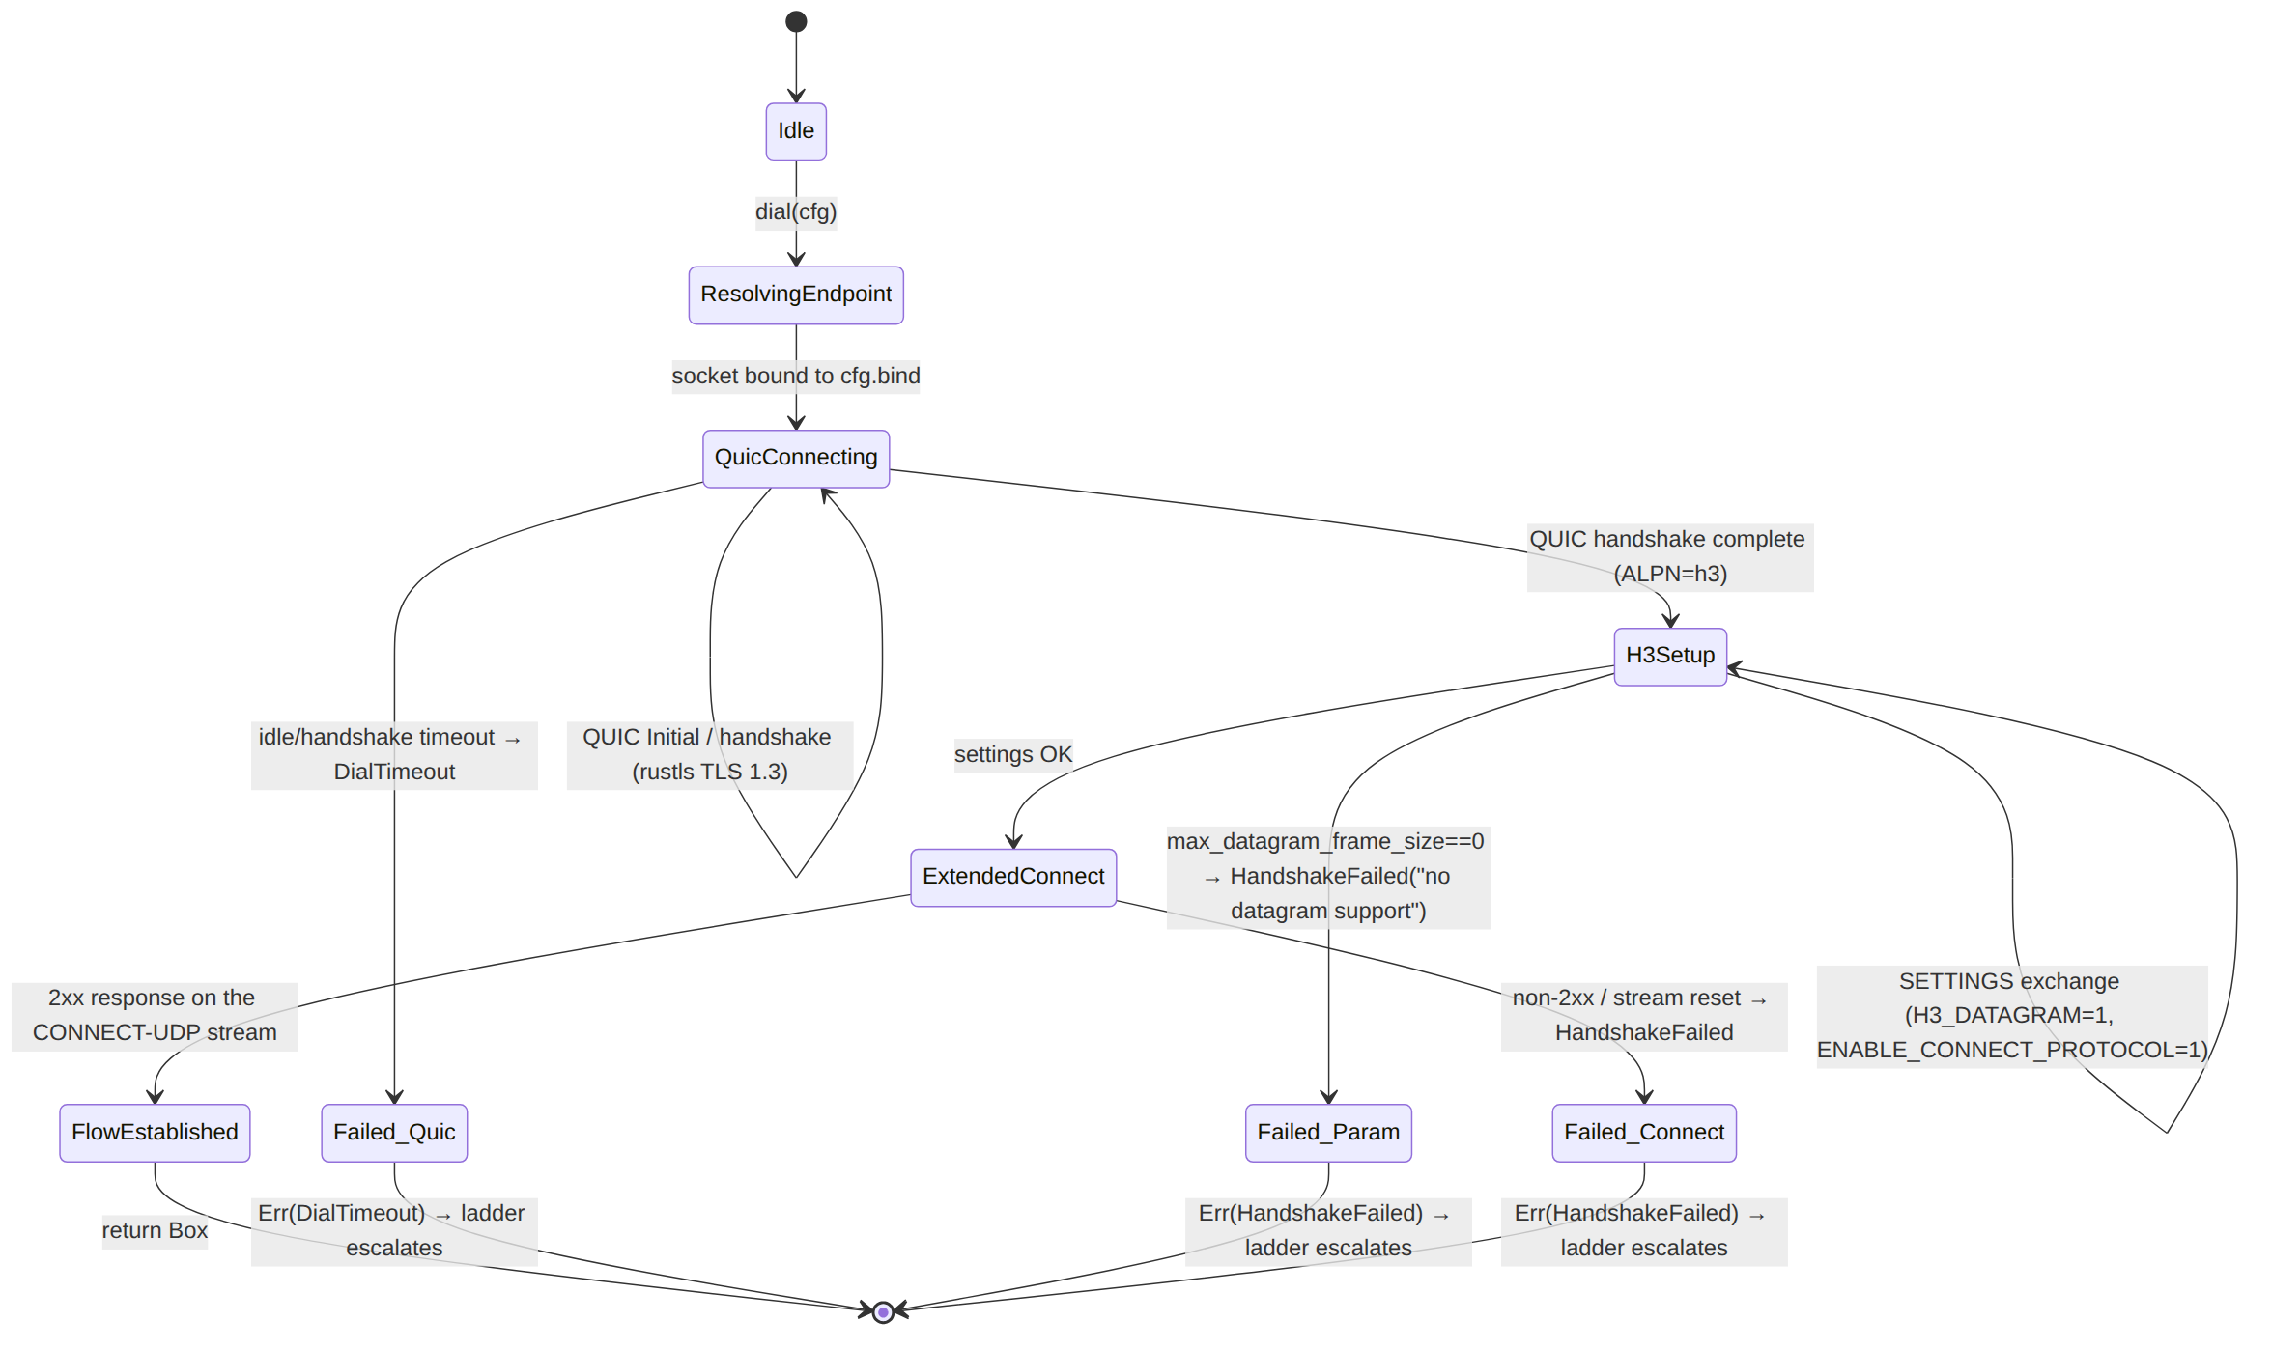

2.2 Bring-up step contract (each step is a hard gate, no guessing — §11.4.6)
Step | Action | Success signal | Failure → TransportError
1. Resolve + bind | Parse url → SocketAddr (gateway :443/udp); bind a quinn::Endpoint to cfg.bind. | socket bound | Io → caller treats as DialTimeout
2. QUIC connect | endpoint.connect_with(client_cfg, addr, &sni)?.await — rustls TLS 1.3, ALPN = h3, SNI = cfg.sni (the masquerade host, §5). | QUIC handshake complete | DialTimeout (idle/handshake timeout); EndpointBlocked if QUIC Initial is dropped repeatedly (DPI)
3. Datagram param check | Verify peer advertised max_datagram_frame_size > 0 (RFC 9221 transport parameter) so I2 is honourable. | param present, ≥ 1252 (§3.4) | HandshakeFailed("peer rejects QUIC datagrams")
4. H3 SETTINGS | Open the H3 control stream; require SETTINGS_H3_DATAGRAM=1 (RFC 9297) and SETTINGS_ENABLE_CONNECT_PROTOCOL=1 (RFC 9220) from the server. | both settings = 1 | HandshakeFailed("server lacks H3 datagram / extended-connect")
5. Extended CONNECT | Send the CONNECT-UDP request stream (§2.3); record its Quarter Stream ID (= stream-id ÷ 4, §3.2). | 2xx response received | HandshakeFailed(status); stream RESET → HandshakeFailed("connect-udp reset")
6. Establish flow | Bind flow_ctx = 0 (context-id of the proxied UDP payload) + qstream_id; spawn the recv pump. | MasqueTransport constructed | —
Honest gap (§11.4.6). The numeric H3_DATAGRAM / ENABLE_CONNECT_PROTOCOL SETTINGS identifier code-points and the exact quinn/h3 API surface that exposes them are UNVERIFIED against this evidence base — h3-datagram is pre-1.0 (v0.0.2, "API subject to change") and Extended CONNECT is a separate modular h3 feature [research-masque §3]; the implementer MUST pin them against the then-current h3/h3-datagram/RFC 9297/9220 text and capture the negotiated values as evidence (§8), never assume them.

2.3 The CONNECT-UDP request line (RFC 9298 over HTTP/3)
The Extended-CONNECT request issued in step 5 [research-masque §1]:
:method = CONNECT
:protocol = connect-udp (RFC 9220 Extended CONNECT)
:scheme = https
:authority= <gateway host:443> (matches cfg.sni masquerade host, §5)
:path = /.well-known/masque/udp/<target_host>/<target_port>/
└─ default-template-vars resolve to the gateway's INTERNAL WG socket
capsule-protocol = ?1 (RFC 9297, Capsule Protocol enabled)
<target_host>/<target_port> resolve to the gateway's internal WireGuard endpoint (e.g. 127.0.0.1/51820) — the proxy opens a UDP socket there and relays [01-DP §3.3; 04_P0 §5.1; research-masque §1]. The client never sees that internal address; it is the URI-template target the edge fixes (§4.2).
The .well-known/masque/udp/{target_host}/{target_port}/ template shape is the RFC 9298 canonical default [research-masque §1]. HelixVPN pins the template at the edge (§4.2) so the client sends a fixed :path; the exact pinned literal is a §11.4.35 project-instantiation value, recorded in the edge config, not guessed here.

3. Wire format — the per-datagram framing (the hand-rolled core)
This is the byte-level contract the implementer hand-rolls (the maturity caveat, §0.2). Two nested framings sit between the WG datagram and quinn's send_datagram(Bytes).

3.1 QUIC variable-length integer (the encoding primitive)
All length/id fields below are QUIC varints (RFC 9000 §16 — the QUIC base over which RFC 9221/9297 are defined). The 2 most-significant bits of the first byte select length: 00→1 byte (6-bit value, 0–63), 01→2 bytes (14-bit, 0–16383), 10→4 bytes (30-bit), 11→8 bytes (62-bit).
The varint encoding is RFC-9000-standard QUIC and is UNVERIFIED against this evidence base (the cited research notes do not reproduce RFC 9000 §16); it is stated as the well-known QUIC primitive the implementer pins against RFC 9000. For HelixVPN's identifiers (flow_ctx = 0, small qstream_id) the common case is the 1-byte form.

3.2 Layer A — HTTP Datagram payload (RFC 9297 + RFC 9298 context)
The HTTP Datagram Payload carried for a CONNECT-UDP flow is (RFC 9297 + RFC 9298 [research-masque §1]):
HTTP Datagram Payload (CONNECT-UDP / RFC 9298) {
Context ID (QUIC varint) ; = 0 → the proxied UDP payload itself
UDP Proxying Payload (bytes) ; = the opaque WireGuard datagram (I1)
}
- Context ID = 0 is the registered "UDP packet payload" context for CONNECT-UDP [01-DP §3.3; 04_P0 §5.1; research-masque §1]. As a 1-byte varint it is the single byte 0x00.
- The UDP Proxying Payload is the WG datagram verbatim — masque.rs does not inspect it (I1).
So encode_http_datagram(0, wg) ⇒ 0x00 || wg (1 prefix byte for the common ctx-0 case). decode_http_datagram reads the leading varint context-id; a non-zero context-id is an unknown context and the datagram MUST be dropped silently per RFC 9297 (a future extension context), not surfaced as an error (§6 E-CTX).

3.3 Layer B — QUIC DATAGRAM frame body (RFC 9221 + RFC 9297 mux)
Over HTTP/3, an HTTP Datagram rides one QUIC DATAGRAM frame; the frame body is (RFC 9297 §2.1 [research-masque §1]):
QUIC DATAGRAM frame body {
Quarter Stream ID (QUIC varint) ; = (CONNECT-UDP request stream-id) / 4
HTTP Datagram Payload (bytes) ; = Layer A above
}
- Quarter Stream ID ties the datagram to its CONNECT-UDP request stream (RFC 9297 multiplexing) [research-masque §1, §3]. The client's first client-initiated bidirectional stream is stream-id 0 → Quarter Stream ID 0 (1-byte varint 0x00); HelixVPN runs exactly one CONNECT-UDP flow per QUIC connection, so qstream_id is fixed for the connection's life.
- quinn prepends the QUIC DATAGRAM frame type + handles the QUIC framing; the module supplies only this frame body to Connection::send_datagram(Bytes) [04_P0 §5.2; research-masque §3].

3.4 Full on-the-wire byte layout (common case: ctx 0, qstream 0)
quinn-supplied: [ DATAGRAM frame type (0x30/0x31) ] ← quinn writes this
module-supplied body:
byte 0: Quarter Stream ID varint = 0x00 ← Layer B
byte 1: Context ID varint = 0x00 ← Layer A
bytes 2..n: WireGuard datagram (opaque, already-encrypted) ← I1
Per-datagram framing overhead in the common case = 2 bytes (Quarter Stream ID
- Context ID), atop QUIC/UDP/IP headers. This 2-byte module overhead, plus QUIC short-header + AEAD tag + UDP + IP, is what drives effective_mtu() to 1280 (§3.5). The QUIC DATAGRAM frame-type byte values 0x30/0x31 are RFC 9221 and are UNVERIFIED against this evidence base — pinned by quinn, captured in §8 wire evidence, never assumed.

3.5 effective_mtu() = 1280
masque-h3 reports 1280 [01-DP §3.3, §10; 04_P0 §5.2]:
- 1280 is the IPv6 minimum-MTU floor — the largest value guaranteed deliverable on any IPv6 path without fragmentation [01-DP §10].
- QUIC + HTTP-Datagram + UDP-proxy overhead "eats headroom"; 1280 is the measure & tune floor, not a computed exactness [01-DP §3.3, §10; 04_P0 §5.2]. The exact MTU penalty is quantified in Phase 0 (record MTU/throughput/CPU vs plain-udp) so the ladder's cost model is real [01-DP §10; 04_P0 §5.3, §8].
- The orchestrator sets inner WG MTU = min(masque.effective_mtu()=1280, path-MTU-discovered) [01-DP §10]. A WG datagram exceeding the budget after framing is a hard TransportError::Oversize — never silent truncation [01-DP §10].
- Relation to the RFC 9221 max_datagram_frame_size step-3 floor (≥ 1252): 1252 = 1280 IPv6 floor − 28 (typical IPv6+UDP minimal headroom) is a derived sanity floor for "can a ≥1280-inner datagram ever fit"; the precise constant is UNVERIFIED and MUST be measured (§8), not assumed.

4. Steady-state datapath (send / recv)
Once FlowEstablished, the module is a pure datagram relay — no HTTP round trips [01-DP §3.3; 04_P0 §5.1].

4.1 The Transport impl (signatures + framing wiring)
// crates/helix-transport/src/masque.rs
use async_trait::async_trait;
use bytes::{Bytes, BytesMut, BufMut, Buf};
use crate::{Transport, TransportError, TransportHealth, HealthCell};
pub struct MasqueTransport {
conn: quinn::Connection, // established QUIC/H3 connection to gw:443 (ALPN h3)
qstream_id: u64, // Quarter Stream ID of the CONNECT-UDP request stream (§3.3)
flow_ctx: u64, // CONNECT-UDP context-id (= 0) established at dial() (§3.2)
health: HealthCell, // RTT EWMA + last-recv age + send-error counters (I5, §7)
}
#[async_trait]
impl Transport for MasqueTransport {
async fn send(&self, wg: Bytes) -> Result<(), TransportError> {
let body = encode_quic_datagram_body(self.qstream_id, self.flow_ctx, &wg)?; // §3.3+§3.2
self.conn
.send_datagram(body) // RFC 9221 unreliable (I2)
.map_err(map_send_err)?; // §6 error mapping
self.health.mark_send_ok();
Ok(())
}
async fn recv(&self) -> Result<Bytes, TransportError> {
loop {
let dg = self.conn.read_datagram().await.map_err(map_recv_err)?;
match decode_quic_datagram_body(self.qstream_id, self.flow_ctx, dg) {
Ok(Some(wg)) => { self.health.mark_recv(); return Ok(wg); }
Ok(None) => continue, // foreign qstream / unknown ctx → drop, keep reading (§6)
Err(e) => return Err(e),
}
}
}
fn kind(&self) -> &'static str { "masque-h3" }
fn effective_mtu(&self) -> u16 { 1280 } // §3.5
fn health(&self) -> TransportHealth { self.health.snapshot() }
async fn close(&self) -> Result<(), TransportError> {
self.conn.close(0u32.into(), b"bye"); // QUIC CONNECTION_CLOSE
Ok(()) // idempotent
}
}

4.2 The framing helpers (the I4-shared byte contract)
/// Encode one outbound WG datagram into a QUIC DATAGRAM frame BODY.
/// Layout (§3.4): [Quarter Stream ID varint][Context ID varint][WG bytes].
/// Shared byte-for-byte with the edge decode path (I4).
fn encode_quic_datagram_body(qsid: u64, ctx: u64, wg: &[u8]) -> Result<Bytes, TransportError> {
let need = varint_len(qsid) + varint_len(ctx) + wg.len();
// Enforce the transport budget BEFORE handing to quinn (§3.5, §6 Oversize).
if need > MASQUE_MAX_DATAGRAM_BODY { return Err(TransportError::Oversize(need)); }
let mut b = BytesMut::with_capacity(need);
put_varint(&mut b, qsid); // Layer B (§3.3)
put_varint(&mut b, ctx); // Layer A context-id (§3.2)
b.put_slice(wg); // opaque WG datagram (I1)
Ok(b.freeze())
}
/// Decode one inbound QUIC DATAGRAM frame body back to a WG datagram.
/// Returns Ok(None) for a datagram that is NOT our flow (foreign Quarter Stream ID
/// or unknown context-id) — RFC 9297 says drop silently, keep the connection (§6).
fn decode_quic_datagram_body(exp_qsid: u64, exp_ctx: u64, mut dg: Bytes)
-> Result<Option<Bytes>, TransportError>
{
let qsid = get_varint(&mut dg).ok_or(TransportError::Quic("trunc qsid".into()))?;
if qsid != exp_qsid { return Ok(None); } // not our CONNECT-UDP flow → drop
let ctx = get_varint(&mut dg).ok_or(TransportError::Quic("trunc ctx".into()))?;
if ctx != exp_ctx { return Ok(None); } // unknown context (future ext) → drop
Ok(Some(dg)) // remainder = WG datagram, verbatim
}
// QUIC varint primitives (RFC 9000 §16, §3.1). `UNVERIFIED` exactness — pin to RFC 9000.
fn varint_len(v: u64) -> usize { if v < 64 {1} else if v < 16384 {2} else if v < 1<<30 {4} else {8} }
fn put_varint(b: &mut BytesMut, v: u64) { /* 2-MSB length tag + big-endian value */ }
fn get_varint(b: &mut Bytes) -> Option<u64> { /* read tag, then 1/2/4/8 bytes */ }
/// Largest module-supplied DATAGRAM body that fits the negotiated QUIC datagram
/// limit; derived from the peer's max_datagram_frame_size (step 3) MINUS quinn's
/// own frame-type byte. Computed at dial(), never hardcoded (§3.5).
const MASQUE_MAX_DATAGRAM_BODY: usize = /* set from negotiated max_datagram_frame_size */ 1300;

4.3 Send / recv sequence
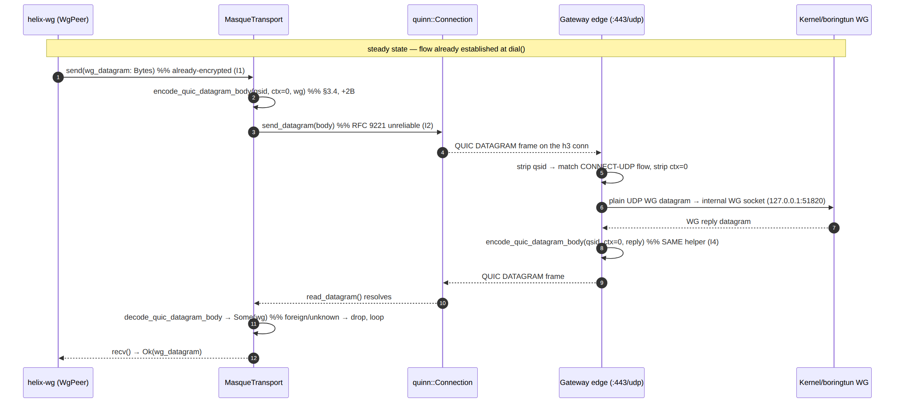

5. SNI masquerade & browser-HTTP/3 indistinguishability

5.1 What is actually claimed (and what is not — §11.4.6 honest boundary)
The public, documented DPI-resistance mechanism is collateral-damage deterrence: the flow is HTTP/3 on QUIC/UDP 443; blocking it risks breaking the open web (Google, YouTube, Cloudflare all run HTTP/3), so censors face a high false-positive cost [research-masque §2; 04_ARCH §3.3]. To a passive observer the flow is indistinguishable from a browser doing HTTP/3 to a web server [01-DP §3.3; 04_P0 §5.3].
What is NOT publicly documented by Mullvad, and therefore an OPEN design problem, not a solved checkbox [research-masque §2, §5]: the exact TLS/QUIC ClientHello fingerprint matching (uTLS-style), the SNI value used, the ALPN set ordering, domain-fronting, and how closely the QUIC Initial mimics Chrome/Firefox. A serious parity effort MUST treat QUIC/TLS fingerprint mimicry as an explicit research/risk item, never claim it is done. This module therefore specifies the seams for fingerprint control and marks the fingerprint policy itself UNVERIFIED / research-tracked.

5.2 SNI + ALPN config seam
// TransportConfig::MasqueH3 carries the fingerprint-relevant knobs:
// url : "https://<gateway-host>:443" — the dialled endpoint
// sni : "<masquerade host>" — TLS SNI sent in the QUIC Initial (§5.3)
// congestion : Cubic | Bbr — CC profile (§6.3, lossy-mobile knob)
- SNI = the masquerade host, set to a believable web hostname; the edge's certificate MUST be valid for it (§5.4) so the TLS handshake completes cleanly and the flow "looks like web" [01-DP §3.3; 04_P0 §5.3].
- ALPN MUST be exactly h3 (and only h3) — a non-h3 ALPN, or an extra protocol, is a fingerprint deviation from real browser HTTP/3 (§5.5).
- The Phase-0 tshark/tls SNI capture (G2) verifies SNI matches the masquerade host and the flow classifies as HTTP/3 with no WG signature [01-DP §3.3, §12.1; 04_P0 §5.3, §8].

5.3 The QUIC/TLS fingerprint surface (research-tracked, UNVERIFIED)
The following are the parameters a uTLS-equivalent would have to mimic for a real browser. HelixVPN exposes them as a future FingerprintProfile config object; their target values are UNVERIFIED and an open research item [research-masque §2, §5] — the spec mandates the seam, not specific values:
Surface | Why it matters | Status
TLS ClientHello cipher/extension order | uTLS-style mimicry of Chrome/Firefox | UNVERIFIED — research item; Mullvad does not publish
QUIC transport parameters (incl. max_datagram_frame_size, idle timeout, flow-control windows) | a non-browser-like set is a fingerprint | seam: derive from a captured browser profile; values UNVERIFIED
ALPN | must be h3 only | specified (§5.2)
SNI value | must be a plausible web host | specified (§5.2), value is §11.4.35 project config
QUIC version / Initial packet shape | Chrome/Firefox-like Initial | UNVERIFIED — research item

5.4 Edge masquerade (decoy site for non-CONNECT-UDP traffic)
The edge :443 listener serves a believable decoy site to anything that is not a valid CONNECT-UDP flow (probes, scanners) — native edge behaviour replacing the original doc's Nginx-camouflage idea [01-DP §3.3; 04_P0 §5.4; 04_ARCH §3.3]. Phase 0 ships a static "it's just a website" page behind the same QUIC listener [04_P0 §5.4]. Classification rule (§4 edge side):
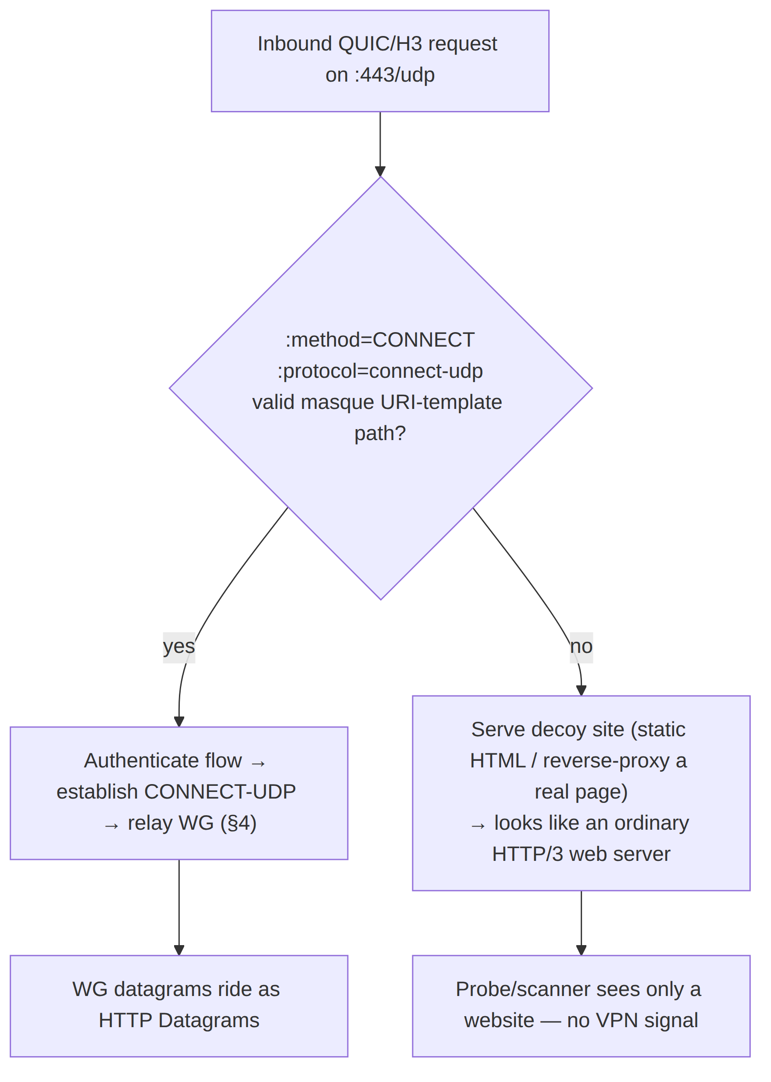

5.5 Indistinguishability acceptance (the G2 wire-fingerprint gate)
tshark capture of the masque-h3 flow MUST classify it as HTTP/3 with no WG signature, with SNI matching the masquerade host, while plain WG/UDP is nft-blocked [01-DP §3.3, §12.1; 04_P0 §5.3, §8]. This is the G2 / S3 gate and the SEC-DPI test point (§8).

6. Error taxonomy, edge cases, and ladder mapping
The module maps every failure onto the shared TransportError enum [01-DP §3.1]; the ladder consumes DialTimeout / HandshakeFailed / EndpointBlocked as escalation triggers and Closed as a reconnect trigger [01-DP §5.3].

6.1 Error mapping table
Condition (masque-h3) | TransportError | Ladder effect [01-DP §5.3]
QUIC handshake idle/timeout at dial() | DialTimeout | escalate to next rung
QUIC Initial repeatedly dropped (DPI on :443) | EndpointBlocked | escalate; note region telemetry (I5, aggregate)
peer max_datagram_frame_size == 0 (step 3) | HandshakeFailed("no datagram support") | escalate
missing H3 settings (step 4) | HandshakeFailed("no h3-datagram / extended-connect") | escalate
CONNECT-UDP non-2xx / stream RESET (step 5) | HandshakeFailed(status) | escalate
send_datagram over budget | Oversize(n) | orchestrator lowers inner WG MTU or fragments at L3 [01-DP §10]
send_datagram transient (datagram queue full / blocked) | Quic(msg) | counted in health.send_errors; caller retries/keeps state
QUIC CONNECTION_CLOSE / path lost mid-session | Closed | orchestrator → Reconnecting, re-dial() (per-network memory may re-pin masque-h3)
read_datagram foreign Quarter Stream ID | (none) → drop, keep reading | no effect — RFC 9297 silent drop (§4.2)
read_datagram unknown context-id (≠ 0) | (none) → drop, keep reading | no effect — future-extension context (§3.2)

6.2 Edge cases (each is a test point, §8)
- E-CTX — unknown context-id: an inbound HTTP Datagram with context-id ≠ 0 is a registered-future-extension payload; drop silently, do not error, do not close the connection (RFC 9297) [research-masque §1]. (Test: UNIT framing.)
- E-QSID — foreign Quarter Stream ID: datagram for a different stream/flow on the same QUIC connection; drop silently and continue the recv loop (§4.1). HelixVPN runs one flow per connection, so this is normally adversarial/spurious. (Test: UNIT.)
- E-TRUNC — truncated framing: a datagram too short to hold the qsid/ctx varints → Quic("trunc …") and the orchestrator treats it as a single lost datagram (I2 — WG tolerates loss), not a connection kill. (Test: UNIT + CHAOS.)
- E-OVERSIZE — datagram > budget: enforced before quinn (§4.2) → Oversize; orchestrator lowers inner MTU rather than silently truncating [01-DP §10]. (Test: UNIT + BENCH MTU sweep.)
- E-0RTT — early data: 0-RTT QUIC resumption is disabled by default for the obfuscation path (a 0-RTT Initial is a distinguishable fingerprint and risks replay); seam exists to enable per FingerprintProfile once §5.3 is settled. Status UNVERIFIED — research-tracked. (Test: SEC-DPI.)
- E-RECONNECT — roaming / NAT-rebind: QUIC connection migration may carry the flow across a client IP change; if migration fails the module surfaces Closed and the ladder re-dials, with WG's own roaming latching onto the new path [01-DP §8]. (Test: CHAOS iface-flap.)
- E-DRAIN — close() idempotency: close() calls conn.close() once; a second call is a no-op (Ok(())) (§4.1). (Test: UNIT.)

6.3 Congestion-control knob
congestion: Cubic | Bbr selects the quinn congestion controller [01-DP §3.1, §3.3]: Cubic default; Bbr for lossy mobile networks (the Hysteria "Brutal" lineage / quinn window-ratio tuning is the reference) [01-DP §3.3, §11_arch tuning note]. Loss resilience is the reason mobile got this feature: under netem loss 5%, masque-h3 MUST sustain higher goodput than the UDP-over-TCP strawman [01-DP §3.3, §12.1; 04_P0 §5.3, §8].

6.4 Edge DDoS resilience — the QUIC anti-amplification limit (enterprise hardening)
Gap closed (2026-07-04): the edge's :443/udp listener is a public, unauthenticated QUIC endpoint before a client completes address validation — exactly the shape of a reflection/amplification vector (a spoofed-source client sends a small QUIC Initial, the server replies with a larger Handshake/response to the spoofed victim address). QUIC (RFC 9000 §8.1) closes this by construction, and helix-edge MUST enforce it, not merely inherit it silently from quinn:
- The 3× rule. Until the client's address is validated (by successfully processing an Initial packet whose UDP datagram was padded to ≥ 1200 bytes, or by returning a Retry token the client echoes back), the server MUST NOT send more than three times the number of bytes received from that (as-yet-unvalidated) address. quinn implements this limit internally; helix-edge MUST NOT bypass or relax it via any transport-config knob, and the Phase-0 G4/G2 benchmark harness MUST capture the enforced ratio (bytes-sent : bytes-received per unvalidated 4-tuple) as evidence, not assume quinn's default is wired in correctly.
- Retry tokens under load. When the edge's concurrent-unvalidated-handshake count crosses an operator-tunable threshold (masque_retry_threshold, default: an evidence-calibrated value from the Phase-0 rig, UNVERIFIED until measured), the edge SHOULD start issuing QUIC Retry packets (stateless, HMAC-tagged token, no per-source-IP state held) before accepting the CONNECT-UDP flow — the standard QUIC answer to a handshake flood, symmetric to WireGuard's own MAC1/cookie-reply defence (helix-wg §14.3, wireguard-core.md). This composes with, and does not replace, connection-ID-based routing/load-balancing at the edge.
- Amplification-factor test point. A new LOAD/SEC test point (feeds §8 table): send an Initial from a spoofed/unvalidated source, assert the edge's response byte count never exceeds 3× the request byte count before validation, captured via a pcap byte-count ratio — never a config-only assertion that "quinn handles it."
- Composition with the edge decoy (§5.4). A non-CONNECT-UDP probe that never completes address validation is bounded by the same 3× ceiling regardless of whether it is ultimately routed to the decoy site or the CONNECT-UDP handler — the anti-amplification limit is a QUIC-transport-layer property, applied before HTTP/3 request routing even begins.
This closes a concrete DDoS-resilience gap: without an explicit test asserting the 3× ratio, "quinn handles amplification" is an unverified assumption, not a proven property of helix-edge's configuration (§11.4.6 no-guessing). Cross-references: the Connector/Gateway-role rate-limiting design lives in v06-deploy/ha-and-multiregion.md and v06-deploy/kubernetes.md (edge ingress hardening); this subsection is the transport-layer half of that story.

7. Performance budget & no-logging counters

7.1 The acknowledged tax (anti-bluff — do NOT claim parity speed)
masque-h3 wraps the WG tunnel in a QUIC tunnel; this is computationally expensive and reduces throughput — the double-encryption + double-congestion- control tax (WG crypto inside QUIC crypto = two AEAD layers; QUIC CC over UDP atop WG's own pacing) [research-masque §2, §5]. Mullvad explicitly acknowledges this and advises "use only when needed" [research-masque §2]. The spec MUST require captured throughput evidence WG-direct vs WG-over-MASQUE and MUST NOT claim parity speed [research-masque §5; 01-DP §10].

7.2 Quantified budget (Phase-0 gates, captured not assumed)
Metric | masque-h3 target | Source
Through-tunnel throughput | ≥ 50% of plain-UDP | [04_P0 §8; SYNTHESIS §4 G2]
Added latency (p50/p99) | < 15 ms added vs bare | [04_P0 §8]
Handshake time (connect→first-data) | < 2 s | [04_P0 §8]
Loss resilience @ netem loss 5% | goodput > UoT strawman | [01-DP §3.3; 04_P0 §5.3, §8]
MTU | 1280 (penalty quantified vs plain-udp) | [01-DP §3.5, §10; 04_P0 §5.2]
Wire fingerprint | HTTP/3, no WG signature (tshark) | [01-DP §12.1; 04_P0 §8]
The plain-udp baseline these are measured against is ≥ 80% of bare link (the G1 gate) [01-DP §3.2; 04_P0 §8]. So masque-h3's floor is ≥ 50% of (≥ 80% of bare).

7.3 No-logging counters (I5)
The module exports only the aggregate TransportHealth snapshot — rtt_ewma_ms, last_recv_age_ms, send_errors [01-DP §3.1, I5] — plus optional aggregate escalation telemetry ("transport masque-h3 succeeded after N escalations in region R") with no per-connection/per-packet durable state [01-DP §5.3 step 6, I5]. No SNI, no flow-id, no peer address is logged durably.

8. Test points (tie to §11.4.169 test types)
Every claim ships captured evidence, not config-only PASS (§11.4.5/.69/.107; [01-DP §12.1]). Test-type abbreviations are the canonical taxonomy of [10-testing-acceptance-and-qa.md §2].
Test point | §11.4.169 type | What it proves | Captured evidence
Framing round-trip — encode_quic_datagram_body∘decode = identity for ctx 0, qsid 0 (§3.4) | UNIT | byte-exact framing; mocks allowed only here (§11.4.27) | cargo test vectors + golden hex fixtures
E-CTX / E-QSID / E-TRUNC silent-drop (§6.2) | UNIT | unknown-context / foreign-stream / truncated datagram dropped, connection survives | assertion log
effective_mtu()=1280 enforced; E-OVERSIZE before quinn (§4.2) | UNIT + BENCH | budget enforced, no silent truncation | MTU-sweep CSV
Slice works with plain WG/UDP nft-blocked (S3/G2) | E2E + FA | real censorship evasion, not "QUIC also works" | netns rig run log [04_P0 §3]; -count=3 re-runnable (§11.4.98)
Flow classifies as HTTP/3, no WG signature, SNI = masquerade host (§5.5) | SEC (DPI) | browser-HTTP/3 indistinguishability (public layer) | tshark/pcap capture [01-DP §12.1; 04_P0 §8]
QUIC/TLS fingerprint mimicry (§5.3) | SEC (DPI) | research-tracked UNVERIFIED gap — not a PASS until §5.3 settled; tracked item, honest SKIP-with-reason (§11.4.3) | risk-item ticket + capture diff vs browser profile
Anti-amplification enforcement (§6.4): unvalidated-source response bytes ≤ 3× request bytes | SEC + LOAD | edge does not amplify toward a spoofed victim (RFC 9000 §8.1) | pcap byte-count ratio per unvalidated 4-tuple
Throughput WG-direct vs WG-over-MASQUE; CPU-per-Gbps; handshake/sec (§7) | BENCH + PERF | quantified tax — no parity claim (§7.1) | bench.sh CSV [04_P0 §8]
Loss resilience @ netem loss 5% beats UoT (§6.3, §7.2) | BENCH + STRESS | QUIC loss recovery (the mobile rationale) | goodput comparison [04_P0 §5.3]
Sustained ≥30 s / ≥100-iter framing under load; ≥10 parallel conns | STRESS | no leak, no deadlock in the recv pump | stress_chaos.sh ab_stress_* (§11.4.85)
Mid-flight QUIC CONNECTION_CLOSE / iface-flap → Closed → re-dial recovery (E-RECONNECT) | CHAOS | recovery restores a consistent flow | ab_chaos_* recovery trace (§11.4.85)
recv-pump data-race / deadlock on the hot path | RACE | concurrency-safe send/recv/close | cargo +nightly loom / tsan
Edge: probe / scanner → decoy site, valid CONNECT-UDP → relay (§5.4) | SEC + E2E | masquerade classification correct | pcap of probe→decoy + valid→relay
Self-validated analyzer for the tshark "is-HTTP/3" verdict (golden-good HTTP/3 pcap PASS, golden-bad WG-signature pcap FAIL) | CHAL / HQA | the DPI analyzer itself cannot bluff (§11.4.107(10)) | challenges/helix_qa bank entry
iOS: masque-h3 buffers under the NE memory ceiling (run plain-udp AND masque separately) | MEM | QUIC buffers fit ≥30% headroom (G3-critical) | Instruments / /proc RSS [04_P0 §6]
Anti-bluff stance (§11.4.6). The DPI-evasion SEC test proves only the public "looks like HTTP/3 / collateral-damage" layer. The QUIC/TLS fingerprint mimicry layer (§5.3) is an open research problem [research-masque §2, §5]; until it is settled it MUST be carried as a tracked risk item with an honest SKIP-with-reason, never reported as a passing checkbox.

9. Decisions this module is downstream of (surfaced, not re-resolved)
Decision | Resolution this module assumes | Source
D1 primary obfuscating transport | masque-h3 primary (true Mullvad parity, single Rust impl, WG stays crypto core); Hysteria2 a feature-gated ladder rung | [01-DP §3.8; SYNTHESIS §3 D1]
D5 gateway edge language | Rust (quinn+h3+hand-rolled CONNECT-UDP) so the edge shares this module byte-for-byte (I4); Go (quic-go+masque-go) is the conformance-suite-mitigated fallback decided by G4 benchmark | [01-DP §11.2; 04_P0 §7; research-masque §4]
D6 transport topology | per-leg TransportPolicy makes masque-h3 a user↔gateway-leg choice for free; no module change | [01-DP §11.3]
The G2-unblock contingency (prototype CONNECT-UDP in Go via masque-go, then port to this module) is the documented escape if MASQUE-in-Rust over-runs budget [01-DP §3.8; 04_P0 §13; research-masque §4]; it does not change the trait contract (§4.1) or the wire format (§3) — those are the I4-frozen surfaces.

10. File-by-file build checklist (this module)
File / symbol | Owns | Phase | Phase-0 gate
crates/helix-transport/src/masque.rs — MasqueTransport (§4.1) | the Transport impl | 0 | G2 / S3
…/masque.rs — dial() bring-up FSM (§2) | QUIC connect → H3 settings → Extended CONNECT → flow | 0 | G2 / S3
…/masque.rs — encode/decode_quic_datagram_body + varint helpers (§3, §4.2) | the hand-rolled RFC 9297/9298 framing (I4-shared) | 0 | G2 / S3 (UNIT)
…/masque.rs — FingerprintProfile seam (§5.3) | SNI/ALPN/transport-param fingerprint knobs (research-tracked) | 0→2 | SEC (DPI), UNVERIFIED
bin/helix-edge.rs — CONNECT-UDP termination + decoy classifier (§5.4) | edge relay + masquerade | 0 | G2 / G4 / S3-S4
error mapping map_send_err/map_recv_err (§6.1) | TransportError taxonomy bridge | 0 | S3

End of nano-detail document — MASQUE / QUIC Transport. Parent overview: 01-data-plane.md §3.3, §10, §11.2. Sibling nano-docs in this volume cover the other Transport impls (plain-udp, shadowsocks, udp-over-tcp, lwo, connect-ip, hysteria2) against the same frozen trait [01-DP §3.1]. The Transport trait (§4.1 here), the 1280 MTU (§3.5), and the encode/decode framing byte contract (§3) are I4-frozen surfaces shared client↔edge; their internals may evolve, the wire bytes may not without a coordinated client+edge change. Fingerprint mimicry (§5.3) and the precise h3/h3-datagram SETTINGS/API surface (§2.2) are the two UNVERIFIED, research-tracked items the implementer MUST pin against current RFC + crate text and capture as evidence (§8) — never assume.

