Plain-UDP Transport

Plain-UDP Transport
Revision: 2 Last modified: 2026-07-04T12:00:00Z
Rev 2 (enterprise-hardening audit, 2026-07-04): independently reviewed against the parent gap-analysis checklist. MTU/overhead budget (§4.4), failure detection (§6), and edge-case enumeration (§8, including E8 ENOBUFS backpressure) already cover the relevant resource-exhaustion and fragmentation concerns for a connectionless UDP carrier — no addition made here. No consistency issue found against transport-trait.md or 01-data-plane.md.
Master technical specification — Volume 2 (Data Plane), nano-detail document. Deepens the Plain-UDP Transport section (§3.2) of [01-data-plane §3.2]. This is a SPEC — it describes the helix-transport::plain_udp module to be built, not the shipping product. Source evidence cited inline by id: [01-DP §N] = final/01-data-plane.md; [04_ARCH §N] = 04_VPN_CLD/HelixVPN-Architecture-Refined.md; [04_P0 §N] = HelixVPN-Phase0-Spike.md; [SYNTHESIS §N] = the cross-document synthesis; [10-QA §N] = final/10-testing-acceptance-and-qa.md. External WireGuard protocol constants (not part of this evidence base) are tagged [WG-PROTO] and, where their exact value is not load-bearing for this module, annotated honestly per constitution §11.4.6.

0. Scope & contract summary
plain-udp is the default fast-path transport: it carries already-encrypted WireGuard datagrams directly inside UDP, with zero obfuscation, over a single tokio::net::UdpSocket [01-DP §3.2, 04_P0 §4.3]. It is the lowest-latency, lowest-CPU carrier and the throughput baseline every other transport is measured against (the G1 Phase-0 gate: through-tunnel iperf3 ≥ 80% of bare-link [04_P0 §G1, §8]).
This document owns, to nano-detail:
- The PlainUdp type and its full Transport implementation (§3).
- The on-the-wire byte layout — what plain-udp puts on L1, and why it treats the payload as opaque (I1) (§4).
- The connection lifecycle state machine (§5).
- Failure detection that triggers ladder escalation — the hard part, because UDP is connectionless and rarely errors on send (§6).
- Error taxonomy, config knobs, edge cases, security, performance budget (§7–§11).
- The concrete test points, tied to the §11.4.169 test-type taxonomy [10-QA §1] (§12).
Invariants inherited unchanged [01-DP §0.1]: I1 the transport never sees plaintext (it carries opaque WG datagrams); I2 the transport carries unreliable datagrams, never an ordered stream; I4 one transport crate, three consumers (client / connector / edge). plain-udp is the simplest possible witness to all three.
File: helix-transport/src/plain_udp.rs (the unit this doc specifies)
Trait: helix-transport/src/lib.rs::Transport (the contract; frozen Phase-0 interface)
Errors: helix-transport/src/error.rs::TransportError

1. When plain-udp is used — selection conditions
plain-udp is ladder rung 0 in every TransportPolicy.order [01-DP §5.3]. The orchestrator selects it in these cases (closed set):
# | Condition | Source
C1 | Unrestricted network, auto mode — order[0] == plain-udp; the default first attempt on every fresh connect. | [01-DP §5.3 "Default order"], [04_ARCH §3.2]
C2 | Per-network memory hit — a prior successful plain-udp connect on this SSID / gateway fingerprint is remembered and re-tried first. | [01-DP §5.3 step 4], [04_P2 §1.4]
C3 | Manual pin — user sets TransportPolicy.pin = PlainUdp, skipping the ladder entirely (Mullvad "WireGuard / automatic" UX). | [01-DP §5.3 step 1], [04_ARCH §3.2]
C4 | Cooperative-leg policy — on the gateway↔connector leg of an asymmetric topology (D6), where the connector dials out of a cooperative network, plain-udp is the standing carrier. | [01-DP §11.3 D6], [SYNTHESIS §3 D6]
C5 | Phase-0 spike — the only fully-implemented transport alongside masque-h3; the G1 vertical slice runs on plain-udp. | [04_P0 §4.3, §S0/§S1]
It is escalated away from (rung 0 → rung 1) only when its handshake-failure budget is exceeded (§6.4). It is never de-escalated to mid-session: a working tunnel that was established on a higher rung does not opportunistically downgrade to plain-udp without a fresh ladder walk (the per-network memory in C2 applies only at the next connect).

2. Module dependencies
Dependency | Role | Note
tokio (net, time, sync) | async UdpSocket, timers, Notify | the single async runtime [01-DP §3.2]
bytes::Bytes | zero-copy datagram buffers | the Transport send/recv currency [01-DP §3.1]
async_trait | object-safe async Transport | matches the trait def [01-DP §3.1]
socket2 | raw socket options (SO_SNDBUF, IP_MTU_DISCOVER, SO_BINDTODEVICE, recvmmsg) | needed for the knobs in §11; tokio::net::UdpSocket::from_std adopts the configured fd
std::sync::atomic | lock-free HealthCell counters | hot-path health updates without a mutex (§3.3)
No obfuscation crate, no extra crypto crate — plain-udp adds nothing to the datagram. WG (helix-wg [01-DP §4]) is the only cryptography in the path.

3. Public API — full signatures

3.1 The PlainUdp type
// helix-transport/src/plain_udp.rs
use std::net::SocketAddr;
use std::sync::Arc;
use bytes::Bytes;
use tokio::net::UdpSocket;
use crate::{Transport, TransportError, TransportHealth};
/// The baseline carrier: one UDP socket, peer endpoint, opaque WG datagrams (I1, I2).
/// Cheap to clone-share via `Arc`; the orchestrator holds it behind `Box<dyn Transport>`.
pub struct PlainUdp {
sock: Arc<UdpSocket>, // bound + (optionally) connected; see §3.4 / §11
peer: SocketAddr, // gateway/connector endpoint (fixed unless §3.6 rebind)
health: HealthCell, // §3.3 — lock-free liveness counters
opts: UdpSocketOpts, // §11 — recorded so health/rebind logic can read them
}
Field rationale (nano-detail):
- sock: Arc<UdpSocket> — Arc (not bare UdpSocket) because send and recv run on two independent task loops (tun→wg→transport and transport→wg→tun) [01-DP §5.1]; both hold a clone. tokio::net::UdpSocket::send/recv take &self, so a single socket is shared read+write concurrently with no lock — UDP send and recv on one fd are independent kernel operations.
- peer: SocketAddr — resolved from TransportConfig::PlainUdp { peer, bind } [01-DP §3.1], itself sourced from the RouteMap's PeerRoute.endpoint_candidates[0] pushed by the coordinator (doc 03) [01-DP §6.2]. v4 or v6 (§8 E5).
- health: HealthCell — the only state the transport surfaces upward; the WG handshake state lives in helix-wg, fused with this by the ladder (§6.3).

3.2 The Transport impl (complete)
This refines the Phase-0 sketch [01-DP §3.2, 04_P0 §4.3] into the production form: pooled recv buffer, RTT-unaware send, health marking, idempotent close.
#[async_trait::async_trait]
impl Transport for PlainUdp {
async fn send(&self, dg: Bytes) -> Result<(), TransportError> {
// Oversize guard FIRST (I-budget §4.4): never hand the kernel a datagram the path
// cannot carry — that yields a silent drop or EMSGSIZE depending on DF (§8 E2).
if dg.len() > self.opts.max_datagram {
return Err(TransportError::Oversize(dg.len()));
}
let n = if self.opts.connect_peer {
self.sock.send(&dg).await // connected socket (ICMP errors surface, §6.2)
} else {
self.sock.send_to(&dg, self.peer).await
};
match n {
Ok(_sent) => { self.health.mark_sent(); Ok(()) }
Err(e) => { self.health.mark_send_err(); Err(map_io(e)) } // §7
}
}
async fn recv(&self) -> Result<Bytes, TransportError> {
// One MTU-sized scratch per call; pooled in the production impl (§10 P4).
let mut buf = vec![0u8; self.opts.recv_scratch]; // default 1500 (§11)
let n = if self.opts.connect_peer {
self.sock.recv(&mut buf).await
} else {
// recv_from so we can drop datagrams whose source != peer (§8 E4, anti-spoof)
let (n, from) = self.sock.recv_from(&mut buf).await.map_err(map_io)?;
if !self.source_accepted(from) { return Err(TransportError::Closed /*see §6.2 note*/); }
Ok::<usize, std::io::Error>(n)
}.map_err(map_io)?;
self.health.mark_recv(); // liveness clock reset (§6.2 D2)
buf.truncate(n);
Ok(Bytes::from(buf))
}
fn kind(&self) -> &'static str { "plain-udp" }
fn effective_mtu(&self) -> u16 { 1420 } // standard WG-over-IPv4 (§4.4) [04_P0 §4.3]
fn health(&self) -> TransportHealth { self.health.snapshot() }
async fn close(&self) -> Result<(), TransportError> {
// UDP is connectionless: no FIN. Closing = dropping the socket. Idempotent — a second
// close is a no-op. The fd is released when the last Arc clone drops (§5 Closed).
Ok(())
}
}
Honest correction vs the Phase-0 sketch. [01-DP §3.2] / [04_P0 §4.3] show recv returning on a bare self.sock.recv(&mut buf) with no source check and no oversize guard. That is a deliberately trivial spike body. The production recv here adds the §8 E4 source filter and the §3.2 send adds the §4.4 oversize guard — both required to avoid the bluff failure modes §6/§8 enumerate. The wire behaviour (an unmodified WG datagram in a UDP payload) is identical.

3.3 HealthCell — lock-free liveness
TransportHealth [01-DP §3.1] is { rtt_ewma_ms: Option<u32>, last_recv_age_ms: u64, send_errors: u32 }. plain-udp populates it without a mutex on the hot path:
use std::sync::atomic::{AtomicU64, AtomicU32, Ordering};
pub(crate) struct HealthCell {
last_recv_epoch_ms: AtomicU64, // monotonic ms since process start of the last recv
send_errors: AtomicU32,
sent: AtomicU64, // counters (no per-packet log — I5 no-logging)
recvd: AtomicU64,
rtt_ewma_ms: AtomicU32, // 0 == "unset" → mapped to None in snapshot()
start: std::time::Instant,
}
impl HealthCell {
fn mark_recv(&self) { self.last_recv_epoch_ms.store(self.now_ms(), Ordering::Relaxed);
self.recvd.fetch_add(1, Ordering::Relaxed); }
fn mark_sent(&self) { self.sent.fetch_add(1, Ordering::Relaxed); }
fn mark_send_err(&self) { self.send_errors.fetch_add(1, Ordering::Relaxed); }
/// RTT is NOT measured by plain-udp itself (it cannot — it does not parse WG, I1).
/// `helix-wg` measures handshake RTT and pushes it here via `set_rtt` (§6.3).
pub(crate) fn set_rtt(&self, ms: u32) { self.rtt_ewma_ms.store(ms.max(1), Ordering::Relaxed); }
fn snapshot(&self) -> TransportHealth {
let r = self.rtt_ewma_ms.load(Ordering::Relaxed);
TransportHealth {
rtt_ewma_ms: if r == 0 { None } else { Some(r) },
last_recv_age_ms: self.now_ms().saturating_sub(self.last_recv_epoch_ms.load(Ordering::Relaxed)),
send_errors: self.send_errors.load(Ordering::Relaxed),
}
}
fn now_ms(&self) -> u64 { self.start.elapsed().as_millis() as u64 }
}
Why RTT is set externally: plain-udp obeys I1 (never parses the payload), so it cannot tell a handshake-response datagram from a transport-data datagram. Liveness it can measure (last_recv_age_ms = "a datagram of any kind arrived"). RTT it cannot — that requires matching a WG handshake-init to its response, which only helix-wg sees. helix-wg calls HealthCell::set_rtt on each completed handshake (§6.3). This keeps the I1 boundary clean.

3.4 Construction — the dial() entry & bind
dial(TransportConfig::PlainUdp { peer, bind }) [01-DP §3.1] resolves to:
impl PlainUdp {
/// Bind, apply socket options, optionally connect(), return a live carrier.
/// Returns within the orchestrator's bounded dial timeout; never blocks (§6.4).
pub async fn dial(peer: SocketAddr, bind: SocketAddr, opts: UdpSocketOpts)
-> Result<Self, TransportError>
{
// 1. Build the raw socket with socket2 so we can set DF / buffers / SO_BINDTODEVICE
// BEFORE the fd is adopted by tokio (some options must precede bind).
let domain = if bind.is_ipv6() { socket2::Domain::IPV6 } else { socket2::Domain::IPV4 };
let raw = socket2::Socket::new(domain, socket2::Type::DGRAM, Some(socket2::Protocol::UDP))?;
raw.set_nonblocking(true)?;
apply_opts(&raw, &opts)?; // §11 — DF, buffers, bind-device, DSCP
raw.bind(&bind.into())?; // EADDRINUSE → §7 / §8 E7
if opts.connect_peer { raw.connect(&peer.into())?; } // surfaces ICMP errors (§6.2)
let sock = UdpSocket::from_std(raw.into())?; // adopt into tokio
Ok(Self { sock: Arc::new(sock), peer, health: HealthCell::new(), opts })
}
}
dial() itself does no WireGuard handshake — binding a UDP socket cannot fail for "endpoint blocked" the way a TCP/QUIC connect can. The connect-time failure surfaces later, at the WG layer, as a handshake that never completes (§6). This is the crucial asymmetry that shapes plain-udp's failure-detection design: dial() succeeds almost always; the failure is discovered after handshake-init, not at dial.

3.5 No TransportConfig secrets
TransportConfig::PlainUdp { peer, bind } carries no SecretBytes — unlike Shadowsocks (psk), Lwo (session_key), or Hysteria2 (salamander_pw) [01-DP §3.1]. plain-udp has no transport-layer key material; all secrecy is WG's. This is a security property, not a gap (§9 S1).

3.6 Endpoint rebind (roaming)
The peer may change once Phase-2 NAT traversal fills multiple endpoint_candidates [01-DP §8]. plain-udp exposes a non-trait helper the orchestrator calls when WG roaming latches onto a new source address:
impl PlainUdp {
/// Switch the peer endpoint without re-binding the local socket (keeps the source port
/// stable so the gateway's NAT mapping survives). For connected sockets this re-issues
/// connect(); for unconnected it just swaps `self.peer`. Cheap, lock-free under &mut.
pub fn rebind_peer(&mut self, new_peer: SocketAddr) -> Result<(), TransportError> { /* … */ }
}
Phase-0/Phase-1 never call this (single fixed gateway endpoint). It exists so the §8 E6 roaming edge case is handled by construction in Phase 2, not retrofitted.

4. Wire format — byte layout
plain-udp is the one transport whose wire bytes equal the WG bytes — there is no framing of its own. Understanding what is on the wire is what makes the security analysis (§9) and the failure-detection design (§6) precise.

4.1 L1/L2 stack (one user-bound WG datagram on plain-udp/IPv4)
+---------------------------------------------------------------+
| IPv4 header (20 bytes, no options) | ← L1 (kernel)
+---------------------------------------------------------------+
| UDP header (8 bytes: src port | dst port | len | csum) | ← L1 (kernel)
+---------------------------------------------------------------+
| WireGuard datagram (≤ 1452 bytes on a 1500-byte path) | ← L2 payload = opaque to plain-udp (I1)
| byte 0 : message type (1) |
| bytes 1..4 : reserved (zero) (3) | [WG-PROTO] — informational only;
| bytes 4.. : type-specific body (handshake / transport) | plain-udp NEVER reads these.
+---------------------------------------------------------------+
- The WG datagram is byte-identical to what a stock WireGuard peer would emit. plain-udp copies it from Bytes into the UDP payload unmodified and back. That is the entire transform.
- Default endpoint: the gateway's WG UDP port (51820 in the Phase-0 rig; nft … udp dport 51820 drop is the DPI block that triggers escalation [04_P0 §3, §S?]). The production peer.port() comes from the RouteMap, not hard-coded.
Packet flow through plain-udp (the two hot loops [01-DP §5.1]; the carrier is a thin opaque copy at the L2 boundary):
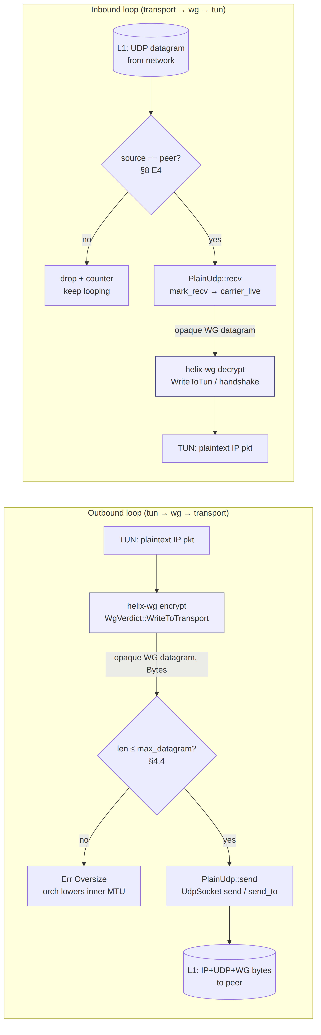
The only plain-udp-owned steps are the Oversize guard, the source filter, and the 1:1 byte copy to/from the socket — everything cryptographic (blue) is helix-wg's, honouring I1.

4.2 The payload is opaque (I1) — what plain-udp does and does not do
plain-udp DOES | plain-udp DOES NOT
copy the WG Bytes into one UDP datagram (1:1, no fragmentation, no coalescing) | parse, decrypt, validate, or reorder the WG payload
enforce a max size (Oversize guard, §4.4) | add length prefixes, headers, padding, or obfuscation
drop datagrams from a non-peer source (§8 E4) | maintain per-flow or per-packet durable state (I5)
reset the liveness clock on any recv | distinguish handshake vs transport-data (that is WG's job)

4.3 WG message taxonomy (informational — transport does NOT branch on it)
These are external WireGuard protocol constants [WG-PROTO], included only so the §6 failure analysis is concrete. plain-udp treats all four identically (opaque payload, I1). Exact byte sizes are protocol facts outside this evidence base; they are not load-bearing for this module and any consumer that needs them parses WG inside helix-wg, never here:
type (byte 0) | Meaning | Approx. fixed size | Relevance to plain-udp
1 | Handshake Initiation | UNVERIFIED: ~148 B [WG-PROTO] | the first datagram plain-udp sends after dial; its loss-without-response is the core failure signal (§6)
2 | Handshake Response | UNVERIFIED: ~92 B [WG-PROTO] | the first inbound datagram on a healthy connect; its arrival = liveness + RTT sample (§6.3)
3 | Cookie Reply | UNVERIFIED: ~64 B [WG-PROTO] | load/DoS defence; opaque to plain-udp
4 | Transport Data | variable, 32 B WG overhead (4 type+reserved · 4 receiver-index · 8 counter · 16 Poly1305 tag) | steady-state payload; the 32-B figure is the grounded basis of the MTU budget §4.4 [04_P0 §4.3 via 01-DP §10]
The 32-byte transport-data overhead is grounded — it is the 32 WG hdr/tag term in the 1500 − 20 IP − 8 UDP − 32 = 1420 MTU derivation [04_P0 §4.3, 01-DP §10]. The init/resp/cookie sizes are marked UNVERIFIED per §11.4.6 because they are not in the evidence base and are not needed by this module.

4.4 MTU & overhead budget
plain-udp adds zero transport overhead on top of WG, so it reports the highest effective_mtu() of any carrier [01-DP §10]:
effective_mtu = 1420 (IPv4: 1500 − 20 IP − 8 UDP − 32 WG hdr/tag ≈ 1420) [04_P0 §4.3]
Path | L1 MTU | IP hdr | UDP hdr | WG hdr/tag | inner WG MTU
IPv4 (typical) | 1500 | 20 | 8 | 32 | 1420 [04_P0 §4.3]
IPv6 | 1500 | 40 | 8 | 32 | UNVERIFIED: ~1400 (derived: 1500−40−8−32; not asserted in evidence base)
IPv6 min-MTU floor | 1280 | 40 | 8 | 32 | UNVERIFIED: ~1200 (derived)
Budget rules [01-DP §10]:
- Inner WG MTU = min(effective_mtu(), path-MTU-discovered) — the orchestrator sets WG's MTU from effective_mtu() clamped by PMTU (§11 set_df = true enables honest PMTUD).
- max_datagram (the Oversize threshold, §3.2) = effective_mtu() + 32 (the WG header/tag), i.e. the largest WG datagram a 1420-byte inner MTU can produce ≈ 1452 bytes on IPv4. A larger datagram is a hard TransportError::Oversize — never silently truncated (§8 E2).
- plain-udp performs no L3 fragmentation; if the path MTU drops below the configured inner MTU, the orchestrator lowers the inner WG MTU (it does not ask the transport to fragment).

5. Connection lifecycle state machine
plain-udp's own lifecycle is intentionally tiny — it has no handshake of its own. The tunnel state (Connecting/Handshaking/Connected/…) is the orchestrator's TunnelStatus [01-DP §5.2]; plain-udp contributes the carrier sub-states below, observed via health().
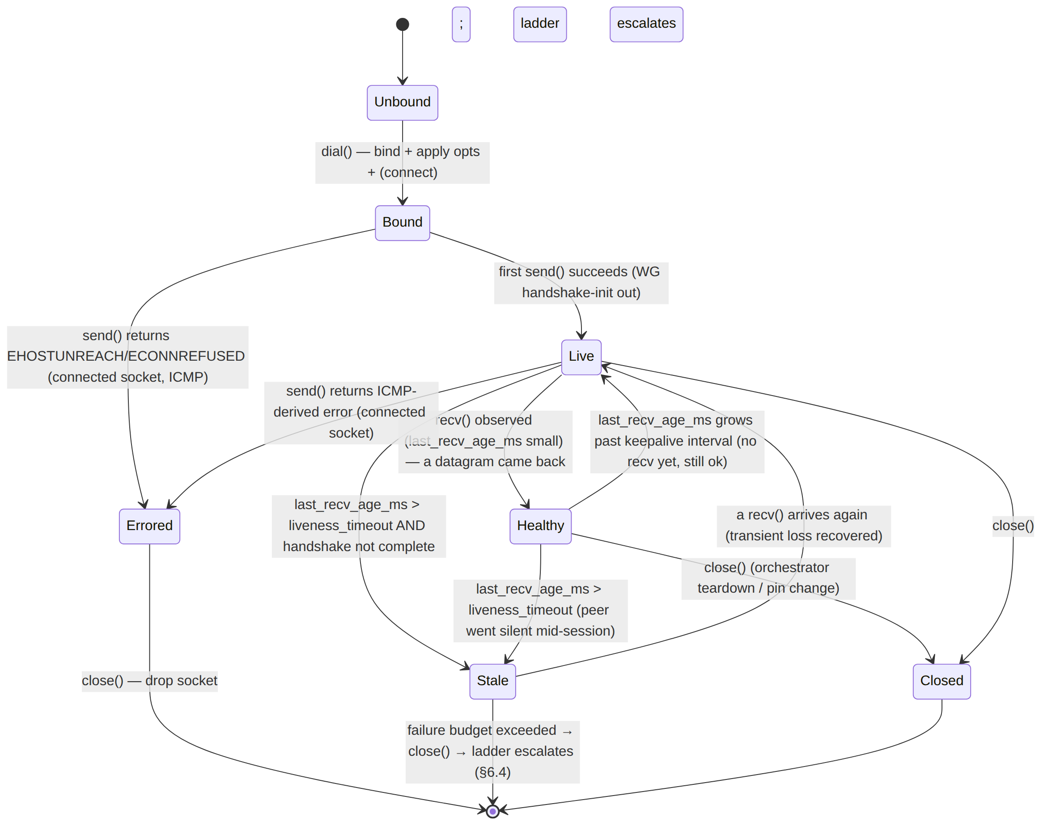
State meanings (what the orchestrator reads from TransportHealth):
Carrier state | Detected by | Tunnel-level meaning
Bound | dial() returned Ok | socket exists; nothing sent yet
Live | sent > 0, recvd == 0, send_errors == 0 | handshake-init(s) out, awaiting response — the critical window (§6)
Healthy | recvd > 0, last_recv_age_ms < keepalive | datagrams flowing both ways
Stale | last_recv_age_ms > liveness_timeout | peer silent; transient or terminal (§6.2 D2)
Errored | send_errors > 0 from an ICMP-derived io::Error (connected socket) | endpoint actively rejecting (§6.2 D3)
Closed | close() / Arc dropped | carrier gone

6. Failure detection that triggers escalation
This is the heart of the document. The escalation ladder [01-DP §5.3] walks to the next rung on DialTimeout / HandshakeFailed / EndpointBlocked exceeding a per-rung failure budget. For plain-udp specifically, dial() almost never fails (§3.4) — so the failure signal must be synthesised from liveness + WG handshake progress, not from a send error.

6.1 Why UDP send rarely errors (the connectionless trap)
A bare (unconnected) UdpSocket::send_to returns Ok as soon as the datagram is queued to the kernel — even if the destination is a black hole. There is no SYN/ACK, no connection refusal at the transport. Consequently:
- A DPI block that silently drops udp dport 51820 [04_P0 §3] produces zero send errors. plain-udp's send keeps returning Ok; the only symptom is that no response ever arrives.
- Therefore plain-udp's failure detector is fundamentally a timeout-on-no-recv detector, optionally sharpened by ICMP errors on a connected socket.

6.2 The detection signals (closed set)
ID | Signal | Source | Maps to
D1 | Dial failure — bind/connect syscall error (rare: EADDRINUSE, bad bind addr) | dial() (§3.4) | TransportError::Io → orchestrator may retry bind or DialTimeout
D2 | Liveness timeout — health().last_recv_age_ms > liveness_timeout_ms while the WG handshake has not completed | HealthCell + helix-wg handshake state (§6.3) | synthesised HandshakeFailed("no response")
D3 | ICMP rejection — on a connected socket (opts.connect_peer = true), an ICMP port/host/net unreachable surfaces as send/recv returning ECONNREFUSED / EHOSTUNREACH / ENETUNREACH | kernel → io::Error (§3.2) | EndpointBlocked (D3 is a fast signal — no need to wait the full liveness timeout)
D4 | Source mismatch flood — many inbound datagrams whose source ≠ peer (spoof / wrong-NAT) | recv_from filter (§8 E4) | counter only; does not by itself escalate, but suppresses false "Healthy"
D5 | Persistent send error — EMSGSIZE (DF + oversize), ENOBUFS, EPERM (firewall) | send io::Error (§3.2) | Io; repeated → budget toward escalation
D3 is why the spec recommends connect_peer = true for the fixed-gateway client leg (§11): it converts a silent black hole into a fast, explicit EndpointBlocked, cutting escalation latency from liveness_timeout (seconds) to one RTT. The trade-off: a connected socket pins the peer, so it must be rebind_peer'd (§3.6) on Phase-2 roaming. For the connector leg (cooperative network, fixed gateway) connect_peer = true is strictly better.

6.3 Fusing carrier liveness with WG handshake state (the I1-clean seam)
Because plain-udp cannot see WG (I1), the authoritative "is the tunnel up?" verdict is the WG handshake state in helix-wg, not the carrier. The orchestrator fuses them:
tunnel_up == helix_wg.handshake_complete() // WG says a session key exists
carrier_live == health().last_recv_age_ms < liveness_timeout // plain-udp says bytes flow
- helix-wg emits WgVerdict::WriteToTransport(handshake_init) on connect; the orchestrator sends it via plain-udp. plain-udp marks sent.
- If a response arrives, recv yields it, plain-udp marks recv (→ carrier_live), and helix-wg.handle_transport_in completes the handshake (→ tunnel_up) and reports RTT, which the orchestrator feeds to HealthCell::set_rtt (§3.3).
- If no response arrives within liveness_timeout AND !helix_wg.handshake_complete(), that is D2 → the orchestrator synthesises HandshakeFailed("plain-udp: no response") and charges the rung's failure budget.
This division is deliberate: plain-udp stays a dumb opaque carrier; the smart "did the crypto handshake succeed?" decision lives where the crypto lives.

6.4 The failure budget & escalation trigger
The rung's FailureBudget { max_handshakes: u8, window: Duration } [01-DP §5.3] is evaluated by the ladder, fed by plain-udp's signals:
on each connect attempt for rung=plain-udp:
send WG handshake-init (retry per WG's own backoff, ~5 s × max_handshakes)
await EITHER:
tunnel_up → Connected{transport:"plain-udp", rtt} (emit, remember §C2)
D3 (ICMP EndpointBlocked) → immediate budget hit (fast path)
D2 (liveness_timeout, no resp) → budget hit
if budget exceeded (handshakes ≥ max_handshakes within window):
close() this PlainUdp; orchestrator emits Reconnecting; ladder → rung 1 (lwo) [01-DP §5.3]
Recommended Phase-1 defaults (project-tunable knob, §11): max_handshakes = 3, window = 15 s, liveness_timeout_ms = 4000. These mirror "a few seconds before escalating" [04_ARCH §3.2 "after N failed handshakes"] and are calibrated, not hard-coded, against the Phase-0 G1 rig (§12) per §11.4.6/§11.4.107(13).

6.5 Sequence — plain-udp failure → escalation to rung 1
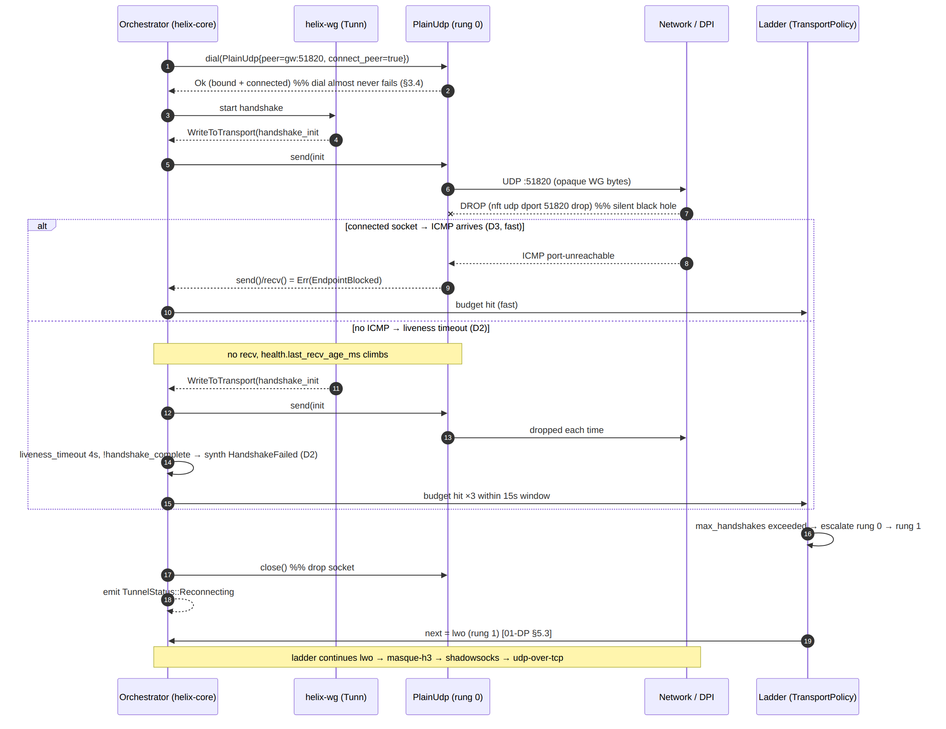

7. Error taxonomy & mapping
plain-udp produces a strict subset of TransportError [01-DP §3.1 error.rs]. The map_io helper classifies std::io::Error:
fn map_io(e: std::io::Error) -> TransportError {
use std::io::ErrorKind::*;
match e.kind() {
ConnectionRefused => TransportError::EndpointBlocked, // ICMP port-unreach (D3)
HostUnreachable | NetworkUnreachable => TransportError::EndpointBlocked, // ICMP net/host (D3)
// EMSGSIZE has no stable ErrorKind on all platforms → matched via raw_os_error below
_ if is_emsgsize(&e) => TransportError::Oversize(0), // DF + too big (D5/E2)
_ => TransportError::Io(e), // ENOBUFS, EPERM, …
}
}
TransportError | Cause on plain-udp | Triggers escalation? | Detect signal
DialTimeout | dial() exceeded the orchestrator's bound dial timeout (rare; bind hang) | yes | D1
HandshakeFailed(String) | synthesised by orchestrator on D2 (liveness timeout, no WG response) | yes (budget) | D2
EndpointBlocked | ICMP unreachable on connected socket | yes (fast) | D3
Oversize(usize) | datagram > max_datagram; or EMSGSIZE with DF set | no — caller bug / PMTU; orchestrator lowers inner MTU (§4.4) | D5/E2
Closed | recv after close(); or source-mismatch sentinel (§3.2 note) | n/a (teardown) | —
Io(io::Error) | ENOBUFS, EPERM (firewall), EADDRINUSE (bind) | repeated → budget | D1/D5
Quic(_) | never — plain-udp has no QUIC | — | —
Note (§3.2 source-mismatch): returning Closed for a spoofed-source datagram is a placeholder; the production impl loops internally (drops the bad datagram, keeps awaiting a good one) rather than surfacing an error, so one spoofed packet cannot tear the tunnel. Treat the inline return Err(Closed) in §3.2 as shorthand for "continue the recv loop" — captured as test point T-EDGE-4 (§12).

8. Edge cases (closed enumeration)
ID | Edge case | Required behaviour | Test
E1 | 0-length datagram received | accept; Bytes::new(); mark recv (a WG keepalive can be tiny but is ≥ 32 B — a true 0-length is a probe, still counts as liveness) | T-EDGE-1
E2 | Oversize on send (dg.len() > max_datagram) | hard Oversize BEFORE syscall; never truncate; never split | T-EDGE-2 (UNIT)
E3 | recv buffer too small (n == recv_scratch, possible truncation) | the WG payload ≤ inner MTU < recv_scratch=1500, so truncation cannot occur for in-spec datagrams; an n == scratch event is logged as a counter anomaly (over-MTU peer) and the datagram dropped (WG would reject a truncated tag anyway) | T-EDGE-3
E4 | Source-address mismatch (recv_from source ≠ peer) | drop + counter (D4); do not mark recv (else a spoofer keeps carrier_live falsely true); keep looping | T-EDGE-4 (SEC)
E5 | Dual-stack v4/v6 peer | bind domain follows bind.is_ipv6(); a v6 bind with IPV6_V6ONLY=false can reach v4-mapped peers (§11 knob); effective_mtu adjusts (§4.4) | T-EDGE-5
E6 | Peer roams (Phase 2, new candidate) | rebind_peer (§3.6); keep local port stable so gateway NAT mapping survives | T-EDGE-6 (Phase 2)
E7 | EADDRINUSE on bind | surface Io; orchestrator picks an ephemeral port (bind 0.0.0.0:0) and retries once before DialTimeout | T-EDGE-7
E8 | ENOBUFS under send burst | Io; the send loop applies bounded backpressure (await writable()), never busy-spins; counts toward D5 only if persistent | T-EDGE-8 (STRESS)
E9 | Socket closed under an in-flight recv | recv returns Closed; the recv loop exits cleanly (cancel-safe — recv is select!-usable per the trait contract [01-DP §3.1]) | T-EDGE-9 (RACE)
E10 | DF set, path MTU shrinks | EMSGSIZE → Oversize; orchestrator lowers inner WG MTU and the next send fits (§4.4 rule 3) | T-EDGE-10

9. Security considerations
plain-udp is the least private transport by design — it is the fast path for unrestricted networks, not the evasion path. Its security posture:
ID | Property | Detail
S1 | No transport secrets | TransportConfig::PlainUdp carries no key (§3.5). Nothing to leak at the transport layer; WG owns all confidentiality/integrity (Noise IK, ChaCha20-Poly1305) [01-DP §4, SYNTHESIS §2].
S2 | Trivially DPI-fingerprintable | the wire bytes ARE WireGuard (byte 0 = WG message type, fixed handshake sizes) [WG-PROTO]; a censor's udp dport 51820 drop or a WG-signature rule blocks it instantly [04_P0 §3]. This is expected — when blocked, the ladder escalates to an obfuscating rung (lwo/masque-h3) [01-DP §5.3]. plain-udp must not be presented to the user as censorship-resistant.
S3 | Source-spoof resistance | the recv_from source filter (E4) drops datagrams not from peer; combined with WG's cryptographic peer authentication, a spoofed source cannot inject into the tunnel — it can at most waste a buffer. No amplification: plain-udp never replies to an unsolicited datagram (it only echoes WG, which itself does not amplify).
S4 | Kill-switch interface pin | opts.bind_device = Some("wg-kill0") (SO_BINDTODEVICE) binds the socket to the protected interface so a route flap cannot leak cleartext onto the physical NIC. The kill-switch state machine (security doc) drives this; plain-udp only honours the option.
S5 | No-logging by construction (I5) | HealthCell holds only aggregate atomics (sent/recvd/send_errors) — never a per-packet or per-connection durable record [01-DP §0.1 I5, SYNTHESIS §7].
S6 | PMTU/DF honesty | set_df = true (§11) prevents on-path fragmentation that could be a side channel and yields honest EMSGSIZE (E10) rather than silent black-holing.
S7 | ICMP trust | D3 trusts ICMP unreachable to escalate faster, but ICMP is unauthenticated. A forged ICMP could force a premature escalation (DoS-to-slow-path, not a confidentiality break). Mitigation: ICMP only accelerates an escalation that the liveness timeout (D2) would reach anyway; it never causes a downgrade or key exposure. Recorded as an accepted residual risk (§11.4.6 — stated, not hidden).

10. Performance budget
plain-udp is the baseline — every other transport is measured as a fraction of it [01-DP §3.2, 04_P0 §8].
ID | Metric | Target | Source
P1 | through-tunnel throughput (TCP+UDP iperf3) | ≥ 80% of bare-link (the G1 gate) | [04_P0 §G1, §8]
P2 | added latency vs bare path (ping overlay) | < 2 ms added, p50 and p99 | [04_P0 §8 table]
P3 | CPU | lowest of all transports (no obfuscation, no extra crypto) | [01-DP §3.2, 04_ARCH §3.2]
P4 | per-recv allocation | one pooled MTU buffer; production uses a BytesMut slab + recvmmsg batch (§11 recv_mmsg_batch) to amortise syscalls — the §3.2 vec![0u8;1500] per call is the spike form, replaced by a pool | derived [04_P0 §8 "CPU/Gbps"]
P5 | handshake-to-Connected | one RTT after a non-blocked path (no transport handshake to add) | derived (§6)
Performance levers (nano-detail, all §11 knobs):
- SO_SNDBUF / SO_RCVBUF sized to ≥ BDP so bursts do not ENOBUFS (E8) / drop on recv.
- GSO/GRO (Linux UDP_SEGMENT / UDP_GRO): batch multiple WG datagrams per syscall on the edge's high-fan-in path. UNVERIFIED whether Phase-0/1 enables it — flagged as a Phase-2 edge-throughput lever, not asserted as shipped.
- recvmmsg (P4) batches inbound datagrams; the recv loop yields a Vec<Bytes> internally and feeds them to WG one at a time (preserving I2 unreliable-datagram semantics).

11. Configuration knobs — UdpSocketOpts
#[derive(Clone, Debug)]
pub struct UdpSocketOpts {
pub send_buf_bytes: usize, // SO_SNDBUF — default 2 MiB
pub recv_buf_bytes: usize, // SO_RCVBUF — default 4 MiB (edge: larger)
pub recv_scratch: usize, // per-recv buffer — default 1500 (≥ max_datagram)
pub max_datagram: usize, // Oversize guard — default effective_mtu()+32 = 1452
pub set_df: bool, // IP_MTU_DISCOVER=DO / IP_DONTFRAG — default true (PMTUD)
pub connect_peer: bool, // UdpSocket::connect() → ICMP errors (D3) — default true (fixed gw)
pub bind_device: Option<String>, // SO_BINDTODEVICE — kill-switch pin (S4) — default None
pub dscp: Option<u8>, // IP_TOS / IPV6_TCLASS — default None
pub v6_only: bool, // IPV6_V6ONLY — default false (dual-stack, E5)
pub recv_mmsg_batch: usize, // recvmmsg batch (Linux) — default 64
// --- ladder-facing (read by the orchestrator, not the socket) ---
pub liveness_timeout_ms: u64, // D2 — default 4000
pub max_handshakes: u8, // failure budget — default 3 [04_ARCH §3.2]
pub budget_window_ms: u64, // failure budget window — default 15000
}
Every numeric default is calibrated against the Phase-0 G1 rig, not adopted from literature, per §11.4.6 / §11.4.107(13). They are project knobs (§11.4.35) the coordinator may override per-network via the pushed TransportPolicy [01-DP §5.3].

12. Test points — tied to §11.4.169 [10-QA §1]
Each row is a workable-item test obligation; abbreviations are the [10-QA §1] taxonomy. Every PASS cites captured evidence (§11.4.5/.69/.107), never config-only.
ID | Test point | §11.4.169 type | Evidence / harness
T-UNIT-1 | effective_mtu() == 1420; max_datagram == 1452 | UNIT | cargo test assert
T-UNIT-2 | Oversize guard: send(1453 B) → Err(Oversize(1453)), no syscall | UNIT | cargo test (mock socket)
T-UNIT-3 | map_io classification table (ECONNREFUSED→EndpointBlocked, EMSGSIZE→Oversize, …) | UNIT | table-driven cargo test
T-UNIT-4 | HealthCell snapshot math: last_recv_age_ms, rtt None↔Some, atomic counters | UNIT | cargo test
T-S0 | loopback echo: dial() two PlainUdp, send/recv round-trips a WG-sized blob (the S0 milestone) | INT | netns loopback [04_P0 §S0]
T-G1 | through-tunnel iperf3 ≥ 80% bare-link + ping LAN host succeeds (the G1 gate, throughput baseline) | BENCH/E2E/PERF | netns+netem rig, bench.sh [04_P0 §G1, §8]
T-FAIL-D2 | DPI drop (nft udp dport 51820 drop) → no response → D2 liveness timeout → synth HandshakeFailed → ladder escalates rung 0→1; captured as an ordered TunnelStatus trace | E2E/SEC | netns + nftables [04_P0 §3]
T-FAIL-D3 | connected socket + ICMP port-unreachable → EndpointBlocked within one RTT (faster than D2) | E2E | netns reject rule
T-EDGE-1..10 | the §8 edge cases (0-len, oversize, source-mismatch drop, dual-stack, EADDRINUSE, ENOBUFS, cancel-safe recv, DF/PMTU) | UNIT/SEC/RACE/STRESS | per-row harness in §8
T-STRESS-1 | ≥ 100 iters / ≥ 30 s sustained + ≥ 10 parallel sockets; no leak, no ENOBUFS storm (§11.4.85) | STRESS | stress_chaos.sh ab_stress_* [10-QA §5.9]
T-CHAOS-1 | kill the edge mid-iperf3; assert the tunnel recovers (reconnect/escalate) and no cleartext leaks during the gap | CHAOS | ab_chaos_kill_pid_during [10-QA §5.9]
T-RACE-1 | concurrent send+recv on the shared Arc<UdpSocket>; cargo +nightly loom / tsan — no data race, no deadlock | RACE | loom model [10-QA §1]
T-SEC-1 | source-spoof injection (E4): spoofed-source datagrams dropped, carrier_live not falsely set, WG never accepts | SEC | pcap + netns [10-QA §1]
T-REC-1 | window-scoped MP4 of the G1 slice + media-validation verdict (per user-visible-claim, §11.4.154/.163) | REC | panoptic→vision_engine [10-QA §1]
T-CHAL-1 | a challenges/helix_qa bank entry scoring PASS only on the captured G1 evidence (§11.4.27/.107) | CHAL/HQA | challenges submodule [10-QA §1]
DDOS and SCALE are NOT_APPLICABLE for plain-udp at MVP (single-node self-host topology, §11.4.3 topology-SKIP) and re-arm in Phase 2 [10-QA §1 table]. The plain-udp paired §1.1 meta-test mutation: invert the Oversize guard (> → <) and assert T-UNIT-2 FAILs — proving the guard test is not a bluff.

13. Frozen contract & out-of-scope
- Frozen Phase-0 interface [01-DP §3.1, 04_P0 §14]: the Transport trait method set (send/recv/kind/effective_mtu/health/close) is a frozen contract; PlainUdp's implementation (pooling, recvmmsg, GSO) may evolve, its signatures may not.
- Out of scope here (owned elsewhere): the Transport trait & dial() registry, the escalation-ladder algorithm, and TransportPolicy live in [01-DP §3.1 / §5.3]; WG handshake state and WgVerdict in helix-wg [01-DP §4]; the RouteMap that sources peer in helix-route [01-DP §6.2]; the obfuscating transports (lwo, masque-h3, shadowsocks, udp-over-tcp) in their own v02 docs. The kill-switch state machine (which drives bind_device, S4) is referenced for its seam only and specified in the security doc.
End of transport-plain-udp.md (Volume 2 — Data Plane). Pair with 01-data-plane.md §3.2 (the parent section this deepens), the transport-masque-h3.md nano-spec (the rung-2 obfuscating counterpart whose MTU/CPU penalty is measured against this baseline), and 10-testing-acceptance-and-qa.md §1 (the §11.4.169 test-type contract the §12 points instantiate).

