Automatic Transport Selection Ladder

Automatic Transport Selection Ladder
Revision: 2 Last modified: 2026-07-04T12:00:00Z
Master technical specification — Volume 2 (Data Plane), nano-detail deep-dive. This document deepens the Auto transport selection — the escalation ladder section of doc 01 [01-DP §5.3, §5.4] into an implementation-ready specification of the ladder state machine, its timers, per-network memory, coordinator-pushed regional priors, manual override, telemetry, and the byte layouts of every persisted/streamed artefact. SPEC-ONLY: it describes what to build, not the shipping product. Sources cited inline by id — [01-DP §N] = doc 01 final/01-data-plane.md; [04_ARCH §N] = 04_VPN_CLD/HelixVPN-Architecture-Refined.md; [04_P0]/[04_P2] = Phase-0/Phase-2 refined docs; [research-masque], [research-hysteria2], [research-daita_test] = the cited research digests; [SYNTHESIS §N] = the cross-document synthesis. Any claim not grounded in the evidence base is marked UNVERIFIED per constitution §11.4.6.

0. Position, ownership, and invariants

0.1 What this document owns
The ladder is the client-side control logic that, given an ordered list of candidate L2 transports (plain-udp → lwo → masque-h3 → shadowsocks → udp-over-tcp, with hysteria2 and connect-ip as feature-gated rungs), picks the one that actually carries WireGuard datagrams to the gateway on the current network, and re-picks automatically when a rung stops working [01-DP §5.3, §3.1]. It is the code behind helix-core/src/ladder.rs [01-DP §12]. It owns:
- The ladder state machine + its transition timers/budgets (§3, §4).
- The driver that calls helix_transport::dial() and reacts to TransportError (§5).
- Per-network memory — remember-what-worked keyed by network fingerprint (§6).
- Consumption of the coordinator-pushed regional prior TransportPolicy.order (§7).
- Manual override (pin) — Mullvad's "force this transport" toggle (§8).
- Aggregate, no-per-user telemetry of escalation outcomes (§9, invariant I5).

0.2 What this document does NOT own
It does not define the Transport trait, TransportConfig, dial(), or the wire framing of any transport — those are frozen contracts in doc 01 [01-DP §3]. It does not own the WatchNetworkMap protobuf that delivers the regional prior — that is doc 03; this document specifies only the shape the ladder consumes and treats the protobuf as the upstream source (§7.1). It does not own WireGuard crypto (helix-wg [01-DP §4]), routing/ACL (helix-route [01-DP §6–§7]), DAITA (helix-daita [01-DP §9]), or the FFI surface (doc 05). It surfaces TunnelStatus events but does not own the FFI bridge that re-emits them.

0.3 Invariants this document inherits and tightens
# | Invariant | Source | Ladder-specific tightening
I1 | Transport never sees plaintext. | [01-DP I1] | The ladder operates on opaque Box<dyn Transport> handles + health snapshots; it never inspects datagram bytes.
I2 | Unreliable datagrams, never an ordered stream. | [01-DP I2] | The ladder's success criterion is a completed WG handshake over the rung, not a TCP/QUIC connect — a connected carrier with no WG handshake is not a successful rung (§5.5).
I5 | No-logging by construction; only aggregate counters. | [01-DP I5, 04_ARCH §2.7] | Per-network memory persists a fingerprint hash + last-good rung index, never the SSID plaintext, never a server endpoint, never a timestamped per-connection log (§6.4, §9).
L-I7 | Automatic with manual override — Mullvad's exact UX. | [04_ARCH §3.2, 01-DP §5.3] | pin short-circuits the ladder entirely; auto mode walks order with per-rung budgets (§3, §8).
L-I8 | Escalation is monotonic within one connect attempt — never oscillate up-and-down inside a single attempt; only reset to the top on a new attempt or successful reconnect. | derived from [04_P2 §1.4] | Prevents thrash; §3.3, §4.4.
L-I9 | Every PASS carries captured evidence (the escalation event trace IS the evidence). | [01-DP §12.1, §11.4.5/.69/.107] | §9, §10.

1. The ladder model in one picture
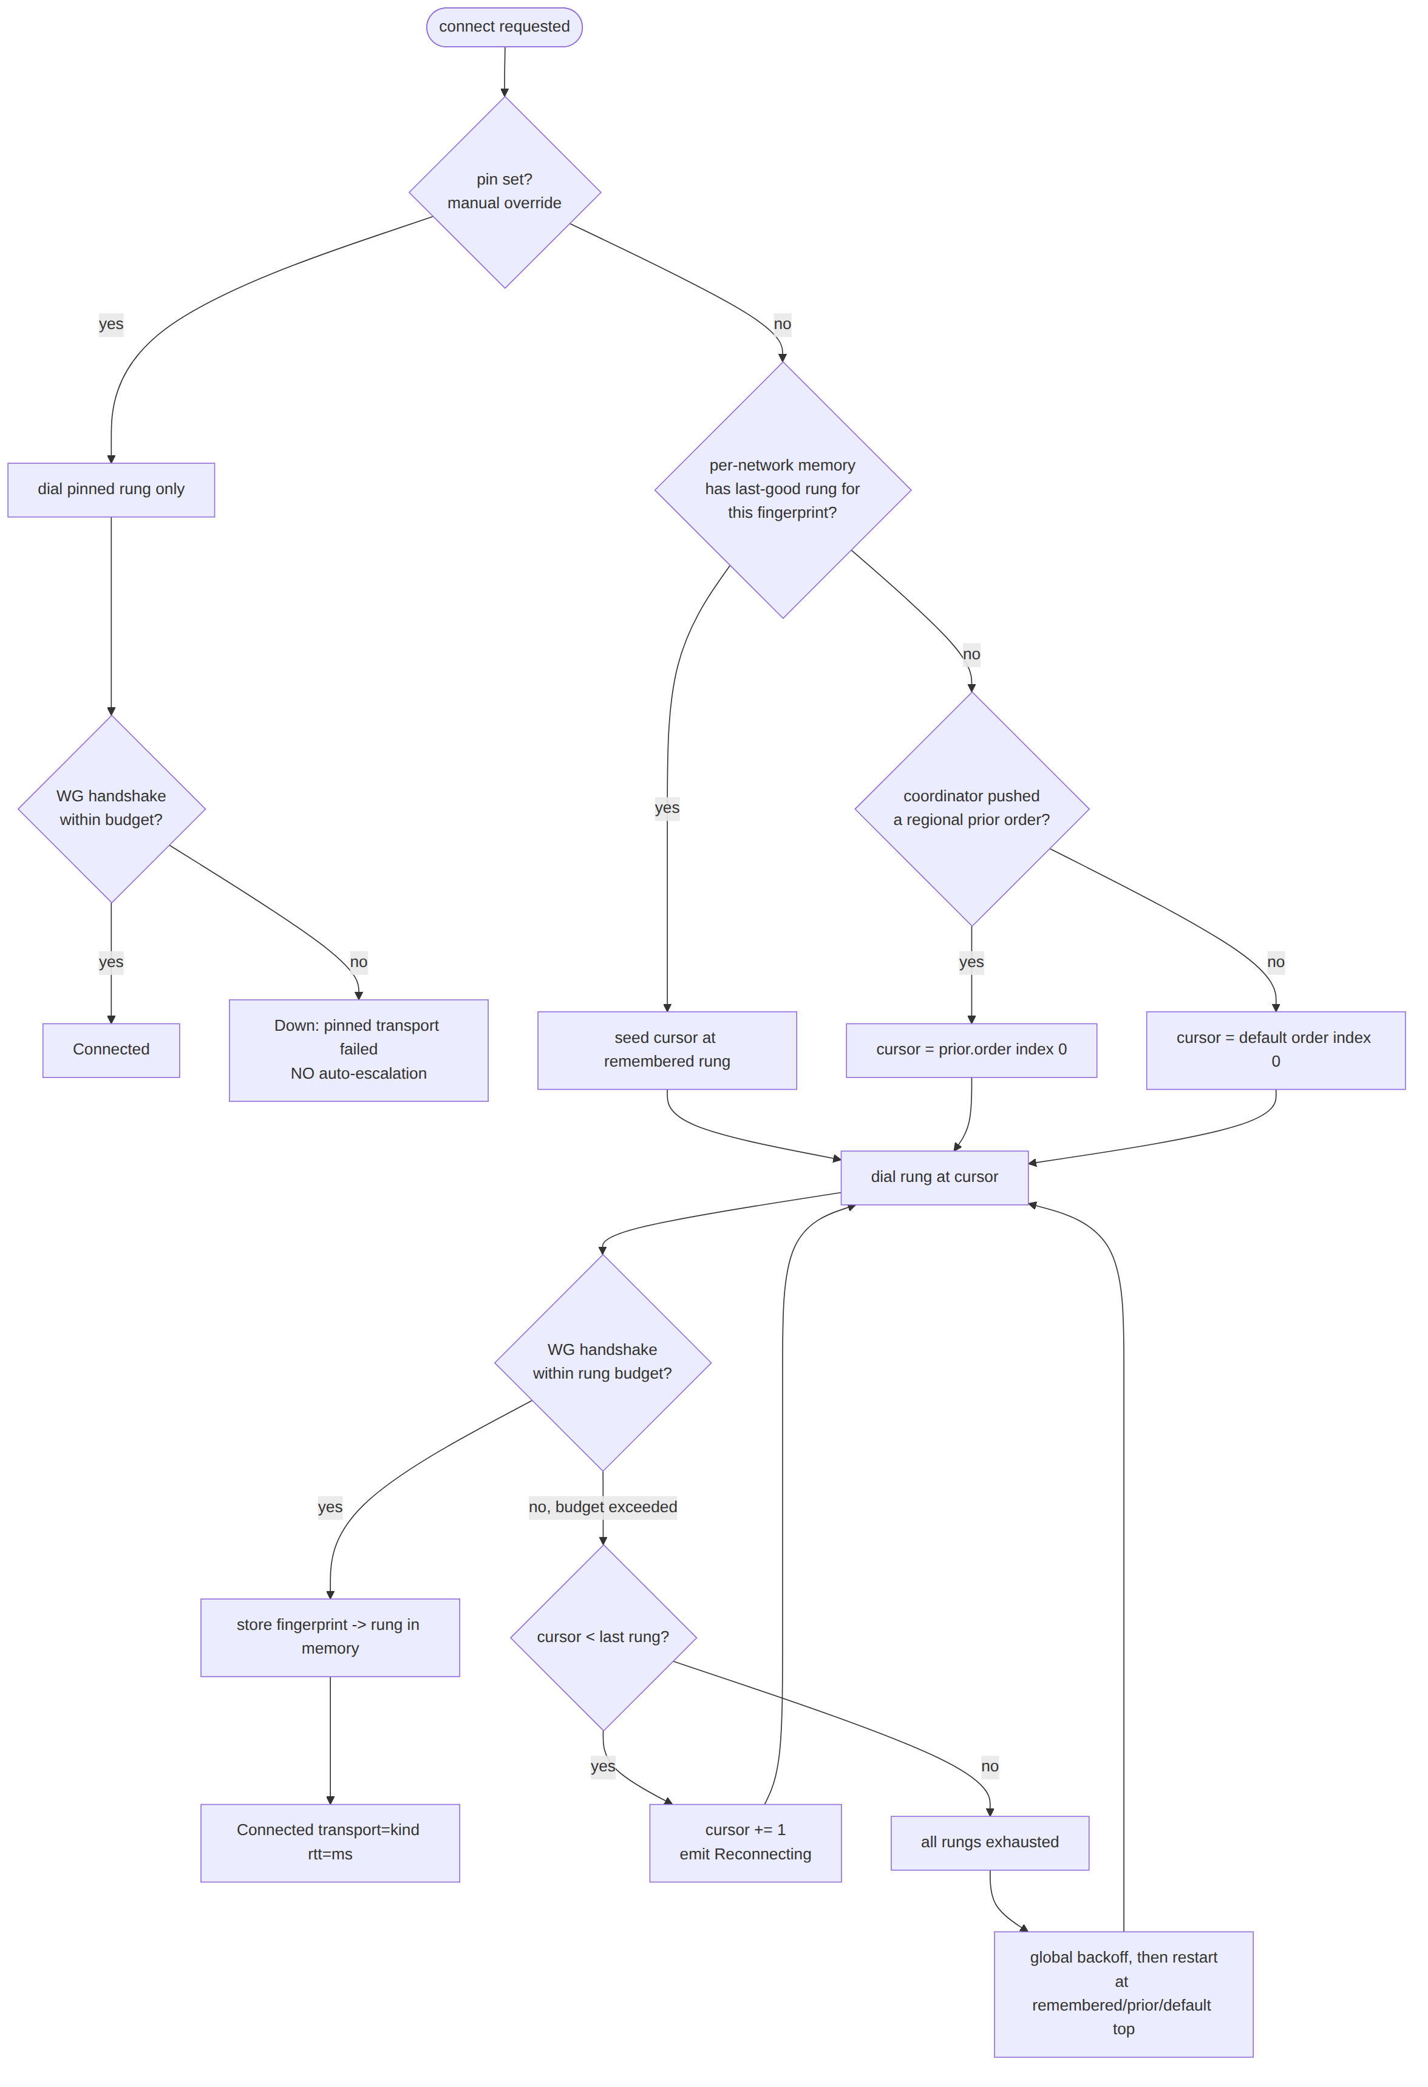
The cursor only ever advances within one attempt (L-I8). The three seed sources — per-network memory, regional prior, default — are tried in that priority order (§2.3). pin bypasses all of it (§8).

2. Ordered rung taxonomy & the policy object

2.1 TransportKind — the ordinal the ladder walks
// helix-core/src/ladder.rs
// The closed set of ladder rungs. Ordinal order is the *default* escalation order
// (cheapest/fastest first → most evasive/most expensive last) [01-DP §5.3, 04_P2 §1.4].
#[derive(Clone, Copy, Debug, PartialEq, Eq, Hash, PartialOrd, Ord)]
#[repr(u8)]
pub enum TransportKind {
PlainUdp = 0, // baseline, lowest latency/CPU [01-DP §3.2]
Lwo = 1, // cheap header obfuscation, first escalation rung [01-DP §3.7]
MasqueH3 = 2, // CONNECT-UDP / HTTP-3 — primary obfuscation (D1 camp A) [01-DP §3.3]
Hysteria2 = 3, // QUIC+Salamander/Gecko, feature="hysteria2" (D1 camp B) [01-DP §3.8]
Shadowsocks = 4, // WG-in-Shadowsocks AEAD over TCP [01-DP §3.5]
UdpOverTcp = 5, // last resort when ALL udp/quic blocked [01-DP §3.6]
ConnectIp = 6, // RFC 9484 IP-over-H3, feature="connect-ip", advanced [01-DP §3.4]
}
impl TransportKind {
/// Stable wire/metric label — MUST equal the matching `Transport::kind()` string [01-DP §3].
pub const fn label(self) -> &'static str {
match self {
TransportKind::PlainUdp => "plain-udp",
TransportKind::Lwo => "lwo",
TransportKind::MasqueH3 => "masque-h3",
TransportKind::Hysteria2 => "hysteria2",
TransportKind::Shadowsocks => "shadowsocks",
TransportKind::UdpOverTcp => "udp-over-tcp",
TransportKind::ConnectIp => "connect-ip",
}
}
/// Compact persistence/telemetry code (1 byte) — the discriminant.
pub const fn code(self) -> u8 { self as u8 }
pub fn from_code(b: u8) -> Option<TransportKind> { /* match 0..=6 → variant; else None */ }
/// Carrier requires UDP/QUIC reachability (fails on a hard UDP block) — used by the
/// network-class hint (§6.5) to skip provably-dead rungs early.
/// plain-udp/lwo/masque-h3/hysteria2/connect-ip = true; shadowsocks/udp-over-tcp = false
/// [research-hysteria2 §5(b): "QUIC/Hysteria2/MASQUE-over-H3/WireGuard all fail … need UDP"].
pub const fn needs_udp(self) -> bool {
!matches!(self, TransportKind::Shadowsocks | TransportKind::UdpOverTcp)
}
}
Why this ordinal order (each rung is strictly more evasive and more expensive than the prior): plain-udp is the ≥80%-bare-link baseline [01-DP §3.2, 04_P0 §0]; lwo is "near-zero-cost evasion of naive WG fingerprinting" [01-DP §3.7]; masque-h3 "genuinely is HTTP/3 to an HTTP proxy" (strong blend-in) but pays the double-crypto/double-CC throughput tax [research-masque §2; research-hysteria2 §6]; hysteria2 wins raw throughput on lossy/throttled links (Brutal CC) but is a non-standard "random noise" wire [research-hysteria2 §1, §6]; the two TCP carriers carry the head-of-line-blocking penalty and exist purely to keep a tunnel possible [01-DP §3.5, §3.6, 04_P2 §1.2]. connect-ip is last and feature-gated because it loses I1 at the gateway [01-DP §3.4].
DECISION D1 dependency. Where hysteria2 sits in the default order is contingent on D1 [01-DP §3.8, SYNTHESIS §3 D1]. This spec places it after masque-h3 (adopting Camp A: masque-h3 primary) and only when feature = "hysteria2" is compiled in; if the project later resolves D1 to Camp B, the coordinator's regional prior (§7) re-orders it to index 0 for the relevant regions without a client rebuild — the ladder reads order from policy, not from the enum ordinal (§2.2). The enum ordinal is only the fallback default when no prior is pushed.

2.2 TransportPolicy — the per-leg ladder configuration
This refines the doc-01 sketch [01-DP §5.3] with the fields the ladder actually needs:
// helix-core/src/ladder.rs
#[derive(Clone, Debug)]
pub struct TransportPolicy {
/// The escalation order to walk in auto mode. Source priority (§2.3):
/// coordinator regional prior > compiled default. Never empty (validated, §2.4).
pub order: Vec<TransportKind>,
/// Manual override (Mullvad "force transport X"). When `Some`, the ladder dials ONLY
/// this rung and NEVER auto-escalates (§8). Survives reconnects until the user clears it.
pub pin: Option<TransportKind>,
/// Per-rung failure budget before escalating to the next rung (§4).
pub budget: FailureBudget,
/// Global backoff applied after the WHOLE order is exhausted, before restarting (§4.3).
pub exhaust_backoff: Backoff,
/// Monotonic version of the policy (from the regional-prior delta, §7.1). The ladder
/// adopts a higher-versioned policy mid-session on the next attempt boundary, never
/// mid-attempt (L-I8). Lower/equal version deltas are ignored (§7.4).
pub version: u64,
/// Provenance for telemetry + UX ("why is my order what it is"). No per-user data.
pub source: PolicySource,
}
#[derive(Clone, Copy, Debug, PartialEq, Eq)]
pub enum PolicySource { CompiledDefault, RegionalPrior, OperatorOverride }
impl TransportPolicy {
/// The compiled fallback used when no prior has arrived yet (e.g. first launch, offline).
/// Unrestricted-network default: try the fast path first, escalate on failure [01-DP §5.3].
pub fn compiled_default() -> Self {
TransportPolicy {
order: vec![
TransportKind::PlainUdp,
TransportKind::Lwo,
TransportKind::MasqueH3,
#[cfg(feature = "hysteria2")] TransportKind::Hysteria2,
TransportKind::Shadowsocks,
TransportKind::UdpOverTcp,
],
pin: None,
budget: FailureBudget::default(),
exhaust_backoff: Backoff::default(),
version: 0,
source: PolicySource::CompiledDefault,
}
}
}

2.3 Seed-source priority (which rung the ladder STARTS at)
For a given connect attempt the starting cursor is resolved deterministically (no guessing, §11.4.6):
1. if policy.pin.is_some() → dial pin ONLY, no ladder (§8)
2. else if per-network memory hit → start cursor at remembered rung (§6) [01-DP §5.3 step 4]
(clamped into policy.order; if remembered rung absent from order → fall through)
3. else if policy.source == RegionalPrior → start cursor at order[0] (§7) [01-DP §5.3 step 5]
4. else → start cursor at order[0] (default) (§2.2)
Per-network memory out-ranks the regional prior because a remembered success on this exact network is stronger evidence than a region-wide statistical prior — the difference between "VPN that sometimes connects" and "VPN that just works" [01-DP §5.3 step 4, 04_P2 §1.4]. The regional prior still governs the order of escalation if the remembered rung subsequently fails (§6.3).

2.4 Policy validation (fail-loud, never silent)
order MUST be non-empty, contain no duplicate TransportKind, and reference only rungs the build actually compiled (e.g. Hysteria2/ConnectIp only when their feature is enabled). A regional prior that references an uncompiled rung is filtered (the rung is dropped from order with a counted policy_rung_unavailable telemetry tick, §9), not rejected wholesale — so a partial-feature client still gets a usable subset. An empty-after-filter order falls back to compiled_default() (§2.2) and counts policy_empty_fallback. Validation runs on every adopted policy delta (§7.4).

3. The ladder state machine

3.1 States
// helix-core/src/ladder.rs
#[derive(Clone, Debug)]
pub enum LadderState {
/// No attempt in flight; awaiting a `start` command. Cursor undefined.
Idle,
/// Resolving the seed source (§2.3) and constructing the next TransportConfig.
Selecting { cursor: usize, attempt_id: u64 },
/// `dial()` in flight for `order[cursor]`; waiting up to `budget.dial_timeout`.
Dialing { cursor: usize, attempt_id: u64, rung_started: Instant, dial_tries: u8 },
/// Carrier up; waiting for the WG handshake to complete over it (§5.5),
/// up to `budget.handshake_timeout`.
Handshaking { cursor: usize, attempt_id: u64, rung_started: Instant },
/// WG handshake completed → tunnel live. Steady state. Holds the live transport.
Connected { cursor: usize, kind: TransportKind, rtt_ms: u32, since: Instant },
/// A rung failed within budget; escalating to `order[cursor+1]` on the same attempt (L-I8).
Escalating { from: usize, to: usize, attempt_id: u64, reason: EscalationReason },
/// Entire order exhausted; in `exhaust_backoff` before a fresh attempt (new attempt_id).
Exhausted { attempt_id: u64, until: Instant },
/// Connected tunnel lost liveness (no recv past `liveness_grace`); re-running the ladder
/// from the seed source while keeping the old transport for fail-static forwarding (§5.6).
Reconnecting { prev_kind: TransportKind, attempt_id: u64 },
/// Terminal-for-now: pinned transport failed (no escalation, §8) OR a non-retryable error.
Down { reason: DownReason },
}
attempt_id is a monotonic u64 minted at each fresh top-of-ladder entry (start, exhaust-restart, reconnect). It scopes per-attempt budgets and lets late dial() results from a superseded attempt be discarded (§5.4 cancel-safety).

3.2 LadderState → TunnelStatus projection
The ladder never owns the FFI; it projects its internal state onto the doc-01 TunnelStatus broadcast enum [01-DP §5.2] so Flutter/metrics/telemetry see a stable surface:
LadderState | Emitted TunnelStatus
Idle | (none / Down{reason:"idle"} on first stop)
Selecting, Dialing | Connecting
Handshaking | Handshaking
Connected{kind,rtt_ms,..} | Connected { transport: kind.label().into(), rtt_ms }
Escalating, Exhausted | Reconnecting
Reconnecting | Reconnecting
Down{reason} | Down { reason: reason.to_string() }
The ordered sequence of these events on one escalation is itself the captured-evidence trace the acceptance gate checks (§9, §10.4) [01-DP §12.1].

3.3 State diagram
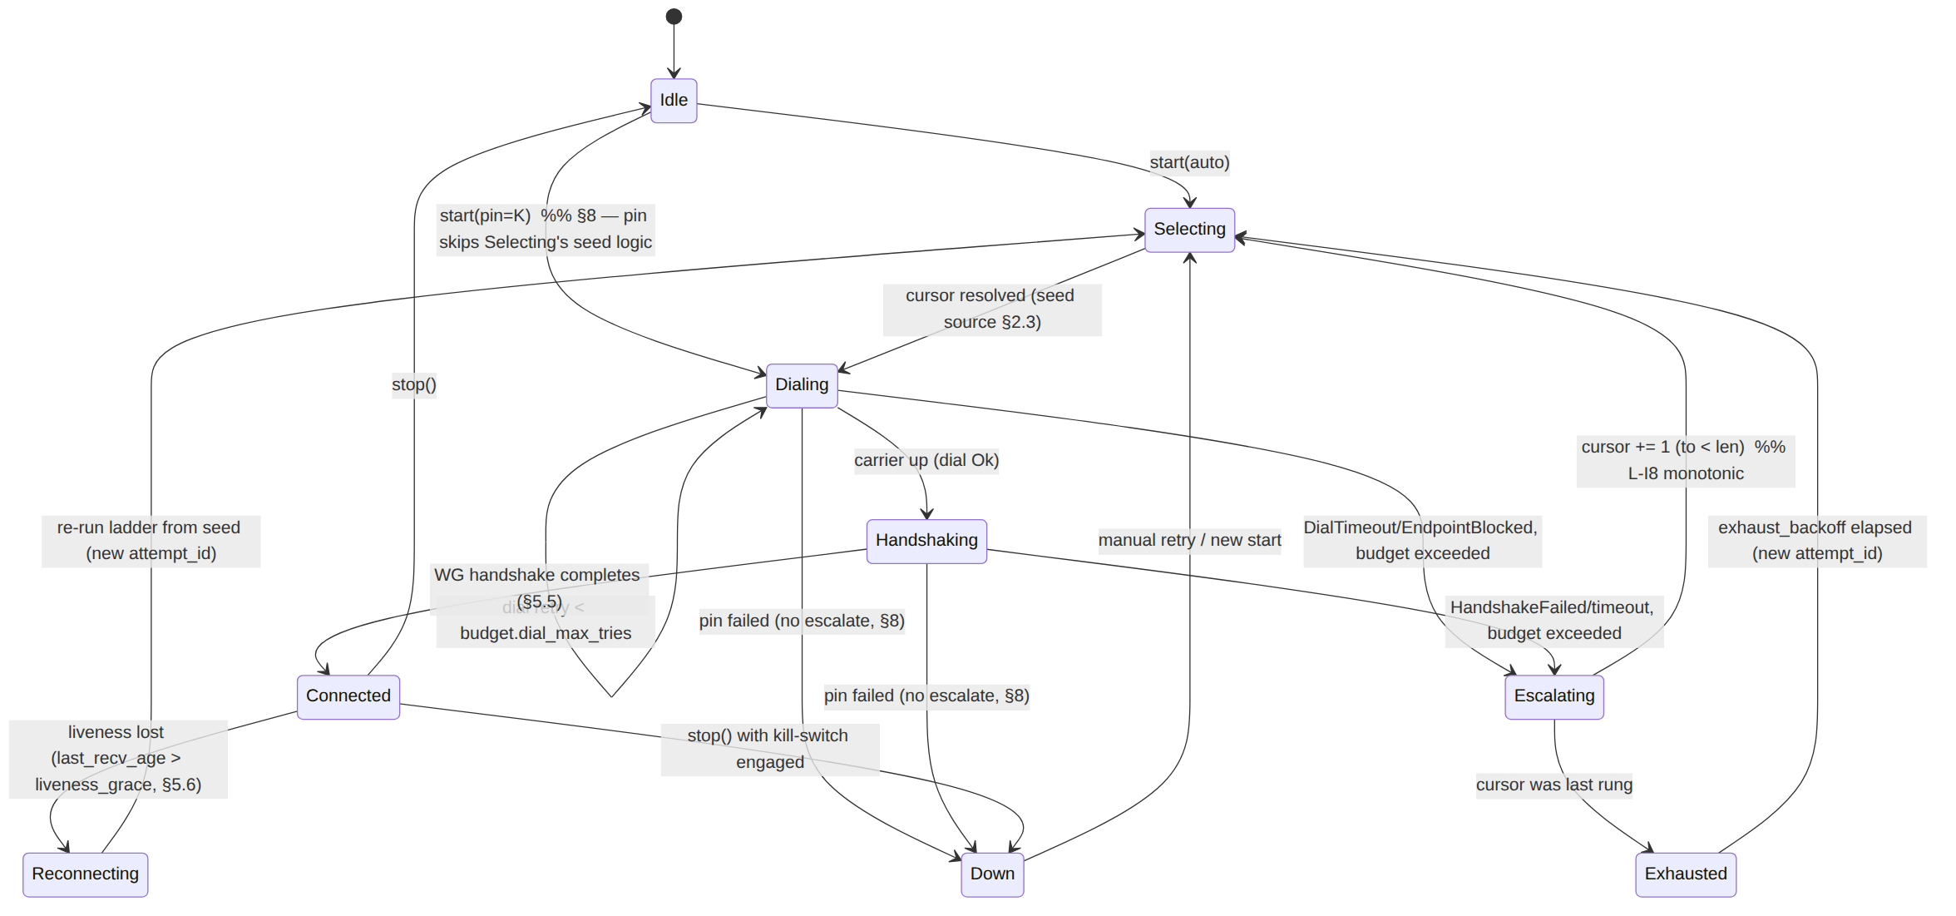
Connected → Reconnecting is the only downgrade path, and it always re-enters at the seed source (memory/prior/default), never mid-cursor — preserving L-I8 across the connected→lost boundary.

4. Timers, budgets, and backoff

4.1 FailureBudget — per-rung failure tolerance
A rung is abandoned when it exhausts its budget; the budget is per rung, per attempt [01-DP §5.3, 04_P2 §1.4]. The doc-01 sketch { max_handshakes: u8, window: Duration } [01-DP §5.3] is refined to separate the dial phase (is the carrier reachable) from the handshake phase (does WG complete):
// helix-core/src/ladder.rs
#[derive(Clone, Copy, Debug)]
pub struct FailureBudget {
/// Max wall-clock for a single `dial()` before it counts as one failed try.
pub dial_timeout: Duration,
/// Max `dial()` retries on the SAME rung before escalating (handles transient packet loss).
pub dial_max_tries: u8,
/// Max wall-clock waiting for the WG handshake to complete after the carrier is up (§5.5).
pub handshake_timeout: Duration,
/// Max WG handshake retransmits over an up carrier before escalating.
pub max_handshakes: u8,
/// Hard ceiling on total time spent on ONE rung across all its tries before forced escalate.
pub rung_deadline: Duration,
}
impl Default for FailureBudget {
fn default() -> Self {
FailureBudget {
dial_timeout: Duration::from_secs(3), // [04_P0 §4.5 bounded dial; tuned in P0]
dial_max_tries: 2,
handshake_timeout: Duration::from_secs(5), // ≈ WG handshake retransmit window
max_handshakes: 3,
rung_deadline: Duration::from_secs(10), // do not let one rung eat >10s
}
}
}
UNVERIFIED (calibration): the concrete millisecond values above are engineering defaults to be calibrated in Phase 0 against the netns rig [04_P0 §8, research-daita_test §5.2–5.3], not values taken from any cited source. Per §11.4.6/§11.4.107(13), thresholds MUST be tuned on the project's own fixtures, not hardcoded from literature. The structure (dial vs handshake split, per-rung deadline) is the spec; the numbers are the tunable surface.

4.2 Per-rung cost weighting (smarter than uniform budgets)
plain-udp should fail fast (it is either reachable or DPI-blocked within an RTT or two); masque-h3/hysteria2 deserve a slightly longer handshake window because the QUIC handshake itself has more round trips and the GFW residual-censorship window (~500 ms to start blocking, [research- hysteria2 §5(a)]) means a short-lived QUIC handshake can complete inside the uncensored window. The budget is therefore scaled per rung:
/// Multiplier applied to the base budget per rung. UDP fast-fail; QUIC gets headroom.
pub fn rung_budget(base: FailureBudget, kind: TransportKind) -> FailureBudget {
let mul = match kind {
TransportKind::PlainUdp | TransportKind::Lwo => 0.7, // fail fast
TransportKind::MasqueH3 | TransportKind::Hysteria2
| TransportKind::ConnectIp => 1.3, // QUIC handshake headroom
TransportKind::Shadowsocks | TransportKind::UdpOverTcp => 1.0, // TCP connect+handshake
};
base.scaled(mul) // scales the three Durations; clamps integers ≥1
}
UNVERIFIED (weights): the 0.7/1.0/1.3 multipliers are design heuristics for Phase-0 calibration, not sourced constants. The rationale (UDP fast-fail, QUIC headroom for the ~500 ms residual- censorship window) is grounded in [research-hysteria2 §5(a)].

4.3 Backoff — after the WHOLE order is exhausted
#[derive(Clone, Copy, Debug)]
pub struct Backoff {
pub initial: Duration, // first wait after exhausting the order
pub max: Duration, // ceiling
pub factor: f32, // exponential factor
pub jitter_frac: f32, // ± fraction of the computed wait (decorrelates clients, §11.1)
}
impl Default for Backoff {
fn default() -> Self {
Backoff { initial: Duration::from_secs(2), max: Duration::from_secs(60),
factor: 2.0, jitter_frac: 0.25 }
}
}
Exhaust-backoff is per attempt-cycle, doubling each full-order exhaustion up to max, with ±jitter_frac so a region-wide outage does not produce a synchronized reconnect stampede on the gateway (§11.1). It resets to initial on any successful Connected.

4.4 Timing budget worked example (default order, hostile network)
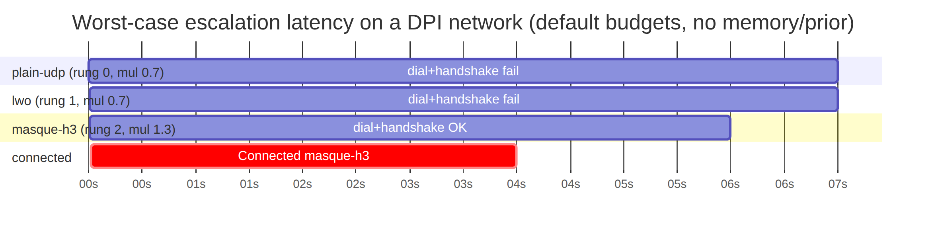
Worst case to reach masque-h3 from cold with no memory/prior ≈ rung0 + rung1 deadlines + masque handshake ≈ 10 s + 10 s + ~6 s under the default rung_deadline ceiling. This is exactly the latency per-network memory (§6) and regional priors (§7) exist to eliminate on the second connect [01-DP §5.3 steps 4–5, 04_P2 §1.4]. After one success the same network reconnects straight to masque-h3 (memory hit), and a CN-resolved client starts at shadowsocks/masque-h3 (prior), never paying the 20 s walk.

5. The driver: dialing, escalation, and the success criterion

5.1 Driver entry points (signatures)
// helix-core/src/ladder.rs
pub struct Ladder {
policy: TransportPolicy,
state: LadderState,
memory: Arc<NetworkMemory>, // §6
status_tx: broadcast::Sender<TunnelStatus>, // [01-DP §5.2]
telemetry: TelemetrySink, // §9
next_attempt_id: u64,
}
impl Ladder {
/// Begin a connect attempt on the current network. Resolves the seed source (§2.3),
/// then drives the state machine to `Connected` or `Down`/`Exhausted-loop`.
/// `fp` is the current network fingerprint (§6.1). Cancel-safe: dropping the future
/// closes the in-flight transport.
pub async fn connect(&mut self, fp: NetworkFingerprint) -> Result<(), LadderError>;
/// Replace the active policy (e.g. a regional-prior delta arrived, §7). Adopted at the
/// next attempt boundary if `new.version > self.policy.version` (§7.4); never mid-attempt.
pub fn update_policy(&mut self, new: TransportPolicy);
/// User pinned/cleared a transport (Mullvad force-mode, §8). Triggers an immediate
/// reconnect using the new pin on the next attempt boundary.
pub fn set_pin(&mut self, pin: Option<TransportKind>);
/// Called by the orchestrator when liveness is lost on the connected transport (§5.6).
pub fn on_liveness_lost(&mut self);
/// Current projected status (also pushed on the broadcast).
pub fn status(&self) -> TunnelStatus;
}

5.2 Mapping TransportConfig from TransportKind + RouteMap
The ladder holds TransportKinds; dial() needs a fully-resolved TransportConfig [01-DP §3.1]. The concrete endpoint, SNI, PSK, and method come from the RouteMap/PeerRoute pushed by the coordinator (doc 03) [01-DP §6.2]:
/// Resolve a dialable config for `kind` toward the current gateway, pulling endpoint/secret
/// material from the live RouteMap. Returns None if the build lacks the rung's feature or the
/// map lacks required material (→ skip rung, count `rung_unresolvable`, §9).
fn resolve_config(kind: TransportKind, gw: &GatewayEndpoint, rm: &RouteMap)
-> Option<TransportConfig>;
// e.g. MasqueH3 → TransportConfig::MasqueH3{ url: gw.h3_url, sni: gw.sni,
// bind, congestion: Congestion::Bbr } [01-DP §3.3]
// Shadowsocks → needs gw.ss_psk + method; if absent → None (skip rung)
congestion defaults to Bbr for the mobile/lossy obfuscated rungs (the Hysteria "Brutal" lineage tuning that sustains goodput under loss [01-DP §3.3, research-hysteria2 §1]) and Cubic for the unrestricted baseline.

5.3 The escalation algorithm (pseudocode, normative)
fn run_attempt(seed_cursor, attempt_id):
cursor = seed_cursor
loop:
kind = policy.order[cursor]
cfg = resolve_config(kind, gw, route_map)
if cfg is None: # uncompiled feature / missing secret
telemetry.tick(rung_unresolvable, kind); goto escalate_or_exhaust
budget = rung_budget(policy.budget, kind)
emit Connecting
match dial_with_budget(cfg, budget, attempt_id): # §5.4
CarrierUp(transport):
emit Handshaking
match await_wg_handshake(transport, budget, attempt_id): # §5.5
Ok(rtt):
memory.remember(fp, kind, policy.version) # §6.2
telemetry.success(kind, escalations = cursor - seed_cursor, region_tag) # §9
emit Connected{ kind, rtt }
return Connected(transport)
Err(reason): # HandshakeFailed/timeout
transport.close().await
# fall through to escalate
Err(reason): # DialTimeout/EndpointBlocked
# fall through to escalate
escalate_or_exhaust:
if policy.pin.is_some(): # §8 — pinned, never escalate
emit Down{ reason = PinnedTransportFailed(kind) }; return Down
if cursor + 1 < policy.order.len():
emit Reconnecting; telemetry.tick(escalated_from, kind)
cursor += 1 # L-I8 monotonic advance
continue
else:
return Exhausted # → exhaust_backoff, new attempt (§4.3)

5.4 Cancel-safety & superseded attempts
dial() is cancel-safe [01-DP §3.1]; the driver wraps each rung in tokio::time::timeout and a select! against an attempt_epoch watch channel. When set_pin/update_policy/on_liveness_lost mints a new attempt_id, the epoch bumps, every in-flight dial()/await_wg_handshake future is dropped (closing its half-open transport), and any straggler result tagged with a stale attempt_id is discarded — preventing a late success on an abandoned rung from clobbering a newer attempt (a §11.4.84-class residue at the runtime layer). This is the analogue of Mullvad's "client now randomly selects one of several in-addresses per connection attempt" robustness [research-masque §2], applied to per-rung attempts.

5.5 The success criterion is the WG handshake, NOT the carrier (I2)
A connected Transport only means bytes can flow; the rung is "working" only when a WireGuard handshake completes over it (helix-wg emits its first decrypted/keepalive verdict) [01-DP §4, I2]. This is load-bearing for DPI realism: a DPI box may let the QUIC/TLS carrier connect (so it can fingerprint inside) yet drop the WG datagrams — a carrier-only success would be a PASS-bluff at the ladder layer [§11.4.107 liveness; research-masque §5(d) active probing]. The handshake-complete signal crosses from helix-wg to the ladder via a oneshot the orchestrator wires:
/// Resolves when `helix-wg` reports the WG handshake completed over `t`, or errors on timeout.
async fn await_wg_handshake(t: &dyn Transport, b: FailureBudget, epoch: u64)
-> Result<u32 /*rtt_ms*/, EscalationReason>;
rtt_ms reported on success is the WG-handshake RTT (from Transport::health().rtt_ewma_ms [01-DP §3.1]), surfaced in Connected{rtt_ms}.

5.6 Liveness loss on a Connected tunnel (downgrade trigger)
While Connected, the orchestrator samples Transport::health() [01-DP §3.1]. If last_recv_age_ms > liveness_grace (default 15 s; ≥ WG persistent-keepalive interval so a quiet but alive tunnel is not falsely downgraded), the ladder transitions Connected → Reconnecting and re-runs from the seed source. Fail-static: the previous transport keeps forwarding any traffic WG still encrypts until the new rung is Connected, honoring I3 (control/liveness churn never black-holes an existing tunnel) [01-DP I3]. liveness_grace is calibrated against tc netem loss profiles in Phase 0 so transient loss does not trigger needless re-ladders [research-daita_test §5.2].

6. Per-network memory — remember what worked per network
"On success, remember the working transport per-network (SSID / gateway fingerprint) so reconnects on the same hostile network skip straight to what worked — the difference between 'VPN that sometimes connects' and 'VPN that just works'" [01-DP §5.3 step 4, 04_P2 §1.4].

6.1 The network fingerprint (privacy-preserving key)
The memory key MUST NOT store the SSID plaintext, BSSID, or gateway endpoint (I5, §11.4.10) — those are identifying. The key is a keyed hash of stable network identifiers, so the on-disk cache reveals nothing about which networks the user joins:
// helix-core/src/netmem.rs
/// Opaque, non-reversible network identity. 16 bytes = BLAKE2s-128 over the network signals,
/// keyed by a device-local secret so two devices on the same SSID produce different keys
/// (defeats cross-device correlation of the cache file). [I5; §11.4.10]
#[derive(Clone, Copy, PartialEq, Eq, Hash)]
pub struct NetworkFingerprint([u8; 16]);
pub struct NetworkSignals<'a> {
pub ssid: Option<&'a str>, // wifi SSID if available (hashed, never stored raw)
pub gateway_mac: Option<[u8; 6]>, // L2 default-gw MAC (best stable LAN identifier)
pub local_subnet: Option<IpNet>, // e.g. 192.168.1.0/24
pub connection_type: ConnType, // Wifi | Ethernet | Cellular | Unknown
}
impl NetworkFingerprint {
/// fp = BLAKE2s-128( device_secret || ssid? || gateway_mac? || subnet? || conntype )
/// Cellular networks (no stable LAN id) fold the carrier/conntype only → coarse but stable.
pub fn derive(sig: &NetworkSignals, device_secret: &[u8; 32]) -> NetworkFingerprint;
}
#[derive(Clone, Copy, PartialEq, Eq)] pub enum ConnType { Wifi, Ethernet, Cellular, Unknown }
UNVERIFIED (algorithm choice): BLAKE2s-128 + device-keying is a spec design choice consistent with WireGuard's own BLAKE2s usage [01-DP §4] and the I5/§11.4.10 privacy constraint; no cited source prescribes the exact fingerprint construction. Mullvad's internal per-network-memory representation is not public — treat this layout as HelixVPN's own design, not a parity reproduction.

6.2 The memory store (signatures)
// helix-core/src/netmem.rs
pub struct NetworkMemory { /* in-mem LRU + atomic-write persistence (§6.4) */ }
impl NetworkMemory {
/// Record that `kind` succeeded on `fp` under policy `policy_version`.
/// Idempotent; updates `last_good` + bumps `success_count`, refreshes `last_seen_epoch_day`.
pub fn remember(&self, fp: NetworkFingerprint, kind: TransportKind, policy_version: u64);
/// Look up the remembered starting rung for `fp`, if any AND not stale (§6.5).
/// Returns the rung to seed the cursor at (§2.3 step 2). None ⇒ fall through to prior/default.
pub fn recall(&self, fp: NetworkFingerprint, now_epoch_day: u32) -> Option<TransportKind>;
/// On repeated failure of the remembered rung, demote it so next time we don't re-pay it
/// (§6.3). After `demote_threshold` consecutive failures the entry is cleared.
pub fn demote(&self, fp: NetworkFingerprint, failed: TransportKind);
/// Persist the in-mem map to disk atomically (write-temp+rename). Called debounced (§6.4).
pub fn flush(&self) -> std::io::Result<()>;
}

6.3 Remember/demote lifecycle
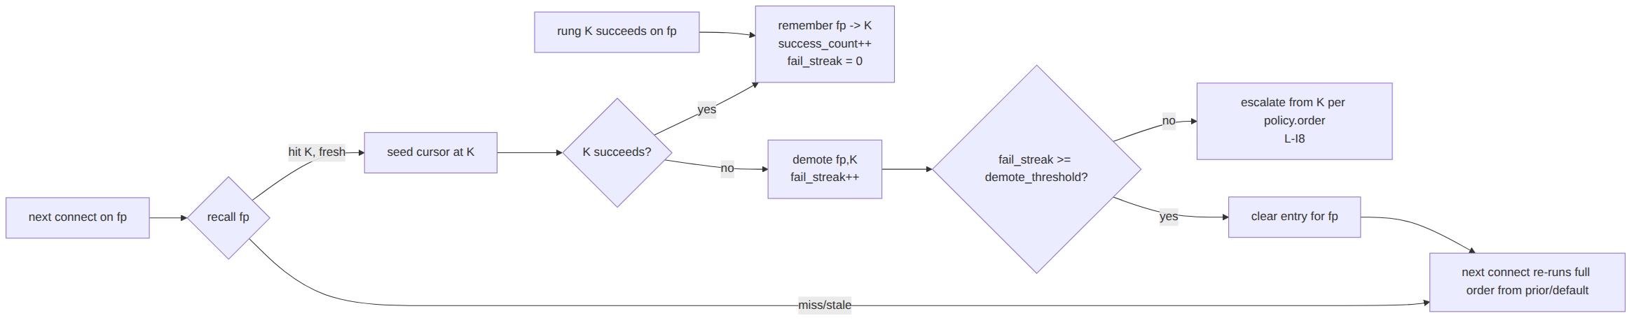
Crucially, after a memory hit the ladder still escalates upward from the remembered rung if it fails (it does not reset to order[0]) — the remembered rung was the minimum that worked, so a network that got worse only needs to climb further, not restart from the bottom [01-DP §5.3 step 4].

6.4 On-disk byte format (the persisted cache)
The cache is a small, fixed-layout binary file at the platform config dir ($XDG_CONFIG_HOME/helixvpn/netmem.bin on Linux; analogous per-platform), chmod 600, listed in .gitignore with recall() itself as the §11.4.77 "regenerate by re-learning" mechanism (it is a pure cache — losing it costs one slow connect, never correctness):
netmem.bin (little-endian, append-tolerant, atomically rewritten via temp+rename)
┌────────────────────────────────────────────────────────────────────────┐
│ Header (16 bytes) │
│ magic u32 = 0x484C4E4D ("HLNM") │
│ format_ver u16 = 1 │
│ reserved u16 = 0 │
│ entry_count u32 │
│ crc32 u32 (over all entries; mismatch ⇒ discard whole file) │
├────────────────────────────────────────────────────────────────────────┤
│ Entry[entry_count] (24 bytes each) │
│ fingerprint [u8;16] BLAKE2s-128 network key (§6.1) │
│ last_good u8 TransportKind::code() (§2.1) │
│ fail_streak u8 consecutive failures of last_good │
│ success_cnt u16 capped at u16::MAX │
│ last_seen u32 days since unix epoch (coarse → no fine timing) │
└────────────────────────────────────────────────────────────────────────┘
No plaintext SSID, no endpoint, no per-connection timestamp — only the irreversible fingerprint, a 1-byte rung, and a day-granularity recency (coarse enough not to be a behavioral log, satisfying I5 [01-DP I5, §11.4.10]). Total size for 256 remembered networks ≈ 16 + 256×24 ≈ 6.1 KiB. Writes are debounced (≤1 flush / 5 s) and atomic (temp file + rename) so a crash mid-write never corrupts the cache (the CRC + magic gate discards a torn file and re-learns).

6.5 Staleness, eviction, and the network-class fast-skip
- Staleness: recall() ignores entries older than memory_ttl_days (default 30) — a transport that worked a month ago on a network whose DPI policy has since changed is weak evidence; re-learn.
- Eviction: LRU by last_seen, capped at max_entries (default 256) — bounded disk + bounded cross-network correlation surface.
- Network-class fast-skip: if the current network has already demonstrated a hard UDP block (any UDP/QUIC rung failed with EndpointBlocked this session), the ladder may skip the remaining needs_udp()==true rungs and jump to shadowsocks/udp-over-tcp — because "QUIC/Hysteria2/ MASQUE-over-H3/WireGuard all fail [on a hard UDP block]" [research-hysteria2 §5(b)]. This is a within-attempt optimization (still monotonic, L-I8): once UDP is proven dead, climbing through three more UDP rungs is wasted latency.

7. Coordinator-pushed regional priors
"The coordinator may push a regional prior (e.g. clients from CN-resolved IPs start at shadowsocks) via TransportPolicy.order, so users in censored regions do not pay the escalation latency every time" [01-DP §5.3 step 5, 04_P2 §1.4].

7.1 Source: a transport_prior field on the NetworkMap (doc 03 owns the protobuf)
The regional prior rides the existing WatchNetworkMap server-stream [01-DP §6.2, SYNTHESIS §2] — no new channel (push, don't poll; reconcile, don't restart [01-DP §6.3, 04_ARCH §4.4]). This document specifies only the shape the ladder consumes; doc 03 owns the wire protobuf:
// helix-route/src/map.rs — additive field the reconciler surfaces to the ladder
pub struct RouteMap {
// … existing fields [01-DP §6.2] …
pub transport_prior: Option<TransportPrior>, // pushed regional prior; None ⇒ use default
}
/// The coordinator's recommended ladder for THIS client on THIS network leg.
pub struct TransportPrior {
pub order: Vec<TransportKind>, // recommended escalation order (e.g. [shadowsocks, masque-h3, udp-over-tcp] for CN)
pub version: u64, // monotonic; ladder ignores ≤ current (§7.4)
pub leg: LegId, // user↔gateway vs gateway↔connector (per-leg, D6 §11.3 of doc 01)
pub reason: PriorReason, // why (for UX + telemetry; NOT per-user data)
}
pub enum LegId { UserToGateway, GatewayToConnector }
pub enum PriorReason { GeoCensored, OperatorPolicy, DefaultUnrestricted, LearnedAggregate }
The coordinator derives the prior server-side from the client's resolved source region (it already terminates the connection, so it sees the source IP's geo without the client reporting it) and from the aggregate censorship-evasion telemetry (§9) — "transport X succeeded after N escalations in region R" feeds back into the prior for region R, closing the loop [01-DP §5.3 step 6, 04_ARCH §9]. No per-user history is consulted; the prior is a region-wide statistic.

7.2 Worked regional-prior table (illustrative, coordinator-configurable)
Resolved region / condition | Pushed order | Rationale (sourced)
Unrestricted | [plain-udp, lwo, masque-h3, …] (= default) | fast path first [01-DP §5.3]
CN (GFW QUIC-SNI block) | [masque-h3, shadowsocks, udp-over-tcp] or [hysteria2, …] | GFW blocks QUIC by SNI but MASQUE survives iff the H3 proxy SNI is unblocked; Salamander/Gecko-obfuscated QUIC survives by hiding SNI [research-hysteria2 §5(a), §6]
Hard-UDP-block region/corp | [shadowsocks, udp-over-tcp] | "QUIC/…/WireGuard all fail … need UDP" [research-hysteria2 §5(b)]
Operator override | exactly as configured | OperatorPolicy
UNVERIFIED (specific orders): the exact per-region orders are coordinator policy data, tuned by operators against live conditions and the §9 aggregate feedback — they are not fixed by this spec. The table illustrates the mapping logic grounded in the cited censorship-regime research; the values are examples, not normative constants.

7.3 Prior vs memory vs default — combined decision
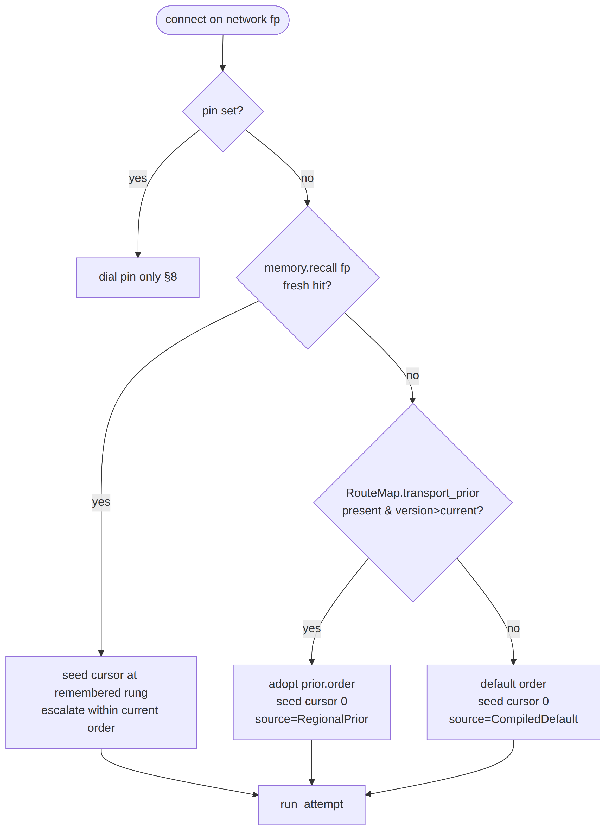
Note the order that a memory hit escalates within is still the currently adopted policy order (prior-or-default) — memory chooses the start rung, the prior/default chooses the escalation sequence above it (§6.3). This composes cleanly: a CN client whose memory says "shadowsocks worked" seeds at shadowsocks but, if that fails, climbs udp-over-tcp per the CN prior, never wandering back to plain-udp.

7.4 Reconcile semantics (push-don't-poll, no restart)
The ladder adopts a new prior via update_policy() (§5.1) only when new.version > self.policy.version (monotonic; stale/replayed deltas ignored — the §11.4.116 "snapshot reporting a lower version is a contradiction" discipline). Adoption takes effect at the next attempt boundary (L-I8), never mid-attempt; a prior arriving while Connected does not tear down a working tunnel — it is staged and applied on the next Reconnecting/manual reconnect. Convergence target inherited from the control plane: a pushed prior reflected on the client in < 1 second of the delta arriving [04_ARCH §4.4, 01-DP §6.3].

8. Manual override (pin) — Mullvad force-mode parity
Mullvad lets the user force a transport ("mullvad obfuscation set mode quic") [research-masque §2, research-hysteria2 §2]; HelixVPN mirrors this with TransportPolicy.pin [01-DP §5.3]:
- set_pin(Some(kind)) → the ladder dials only kind, with the rung budget, and on failure goes straight to Down{ PinnedTransportFailed(kind) } — no auto-escalation (the user asked for exactly this transport; silently using a different one would violate their explicit intent and could be a privacy regression, e.g. falling back from an obfuscated rung onto plain-udp on a monitored network). The UX surfaces the failure and the option to clear the pin.
- set_pin(None) → return to auto (ladder + memory + prior).
- A pin is honored on every reconnect until cleared (it is policy, not per-attempt state).
- pin does not write per-network memory on success (a forced choice is not evidence about what the network requires, only about what the user preferred) — so clearing the pin later falls back to genuine learned/prior behavior, not a memory entry biased by the override. (Telemetry still counts a pinned success under source=OperatorOverride, §9.)
#[derive(Clone, Debug)]
pub enum DownReason {
PinnedTransportFailed(TransportKind), // §8 — no escalation by design
AllRungsExhausted, // every rung failed; in exhaust-backoff loop
NoRouteMap, // map not yet received (control plane bootstrap)
KillSwitchEngaged, // fail-closed: egress blocked, tunnel intentionally down
NonRetryable(String), // config/build error (e.g. uncompiled pinned feature)
}

9. Telemetry — aggregate only, no per-user data (I5)
"Telemetry records only 'transport X succeeded after N escalations in region R' (aggregate, no per-user data, I5) → feeds the Censorship-Evasion Success dashboard" [01-DP §5.3 step 6, 04_ARCH §9].
// helix-core/src/ladder_telemetry.rs
/// A single aggregate-safe outcome. Emitted at most once per connect attempt. Contains NO
/// fingerprint, NO endpoint, NO timestamp finer than the day, NO SSID — only counters + coarse tags.
#[derive(Clone, Debug)]
pub struct LadderOutcome {
pub winning_kind: Option<TransportKind>, // None ⇒ exhausted (no rung worked)
pub escalations: u8, // rungs climbed before success (cursor - seed)
pub region_tag: RegionTag, // coarse, k-anonymized bucket (e.g. "CN","EU","XX")
pub policy_source: PolicySource, // default / regional-prior / operator-override
pub udp_blocked: bool, // did any needs_udp rung hit EndpointBlocked?
}
pub trait TelemetrySink: Send + Sync {
fn record(&self, o: LadderOutcome); // batched, sampled, sent to control plane
fn tick(&self, counter: &'static str, kind: TransportKind); // e.g. "rung_unresolvable"
}
Hard constraints (CI-enforced per [01-DP I5, SYNTHESIS §7] — "CI schema-lint fails build if any durable connection/traffic/packet table appears"):
- region_tag is a k-anonymized coarse bucket (country/region class), never a city/ASN/IP; a bucket with < k clients in the window is reported as XX (no-region). UNVERIFIED: the concrete k is an operator privacy parameter, not a sourced constant.
- No LadderOutcome field may be joined to a device id, user id, or fingerprint at the sink.
- The escalation event trace (TunnelStatus sequence) is captured locally as anti-bluff evidence (§10.4) and is NOT shipped — only the post-hoc aggregate LadderOutcome is.

10. Edge cases, security, performance, and test points

10.1 Error → ladder-action taxonomy
The doc-01 TransportError [01-DP §3.1, error.rs] maps to ladder actions as follows:
TransportError | Phase | Ladder action
DialTimeout | dial | retry on same rung up to dial_max_tries; then escalate
HandshakeFailed(_) | dial/WG | escalate (carrier or WG handshake refused)
EndpointBlocked | dial | escalate and set session udp_blocked if needs_udp() (enables §6.5 fast-skip)
Oversize(_) | runtime | NOT an escalation trigger — lower inner WG MTU [01-DP §10]; ladder stays put
Closed | runtime (connected) | treat as liveness-lost → Reconnecting (§5.6)
Io(_) | any | transient: retry within dial_max_tries; persistent → escalate
Quic(_) | dial/runtime (QUIC rungs) | escalate (QUIC handshake/transport error)

10.2 Enumerated edge cases (each is a test point, §10.4)
- Carrier connects but WG never handshakes (DPI lets QUIC through to fingerprint, drops WG) → Handshaking times out → escalate; NOT a false success (§5.5) [research-masque §5(d)].
- Remembered rung now blocked → demote, climb from it, clear after demote_threshold (§6.3).
- Prior references an uncompiled rung (hysteria2 without the feature) → filter it, count policy_rung_unavailable, continue with the subset (§2.4).
- Hard UDP block mid-order → after first EndpointBlocked on a UDP rung, fast-skip remaining UDP rungs to the TCP carriers (§6.5) [research-hysteria2 §5(b)].
- Policy delta arrives while Connected → staged, applied at next attempt boundary, tunnel not torn down (§7.4, L-I8).
- Network changes mid-session (roam Wi-Fi → cellular) → fingerprint changes → orchestrator triggers on_liveness_lost → re-ladder under the new fp's memory/class (§6.1, WG roaming latches the new path [01-DP §8.2]).
- All rungs exhausted → exhaust-backoff with jitter, restart from seed (§4.3); never a tight spin loop (host-safety §12, §11.1).
- Pinned-feature missing at runtime → Down{ NonRetryable }, not a silent fallback (§8).
- Torn netmem.bin → CRC/magic mismatch discards file, re-learns; never a crash, never corrupt recall (§6.4).
- Stale superseded dial() result → discarded by attempt_id epoch (§5.4).

10.3 Security considerations
- No privacy regression on override/escalation. The ladder MUST NOT silently downgrade from an obfuscated rung to a less-evasive one while a pin is set (§8); in auto mode, escalation only ever moves toward more evasive rungs (monotonic, L-I8) — it never falls back to plain-udp within an attempt once an obfuscated rung is reached.
- Fingerprint cache is non-identifying. Device-keyed BLAKE2s-128, no SSID/endpoint/fine-timing (§6.1, §6.4) — the cache file leaks nothing about which networks the user joins, even if exfiltrated (§11.4.10).
- Telemetry cannot deanonymize. Coarse k-anonymized region bucket, no device join key, schema-lint forbids durable per-connection rows (§9, [SYNTHESIS §7]).
- DPI-realism is a probe, not an assumption. The success criterion is the WG handshake over the carrier (§5.5); the wire-fingerprint of the carrier (e.g. masque-h3 classifies as HTTP/3 with no WG signature via tshark) is verified by the SEC test, not assumed [01-DP §12.1 G2, research-masque §5].
- GFW residual-censorship awareness. Budgets give QUIC rungs handshake headroom because the GFW's QUIC block is residual (≈500 ms to start, 3-min block) so a fast QUIC handshake can complete in the uncensored window [research-hysteria2 §5(a)]; the ladder must not abandon a QUIC rung before that window has had a fair chance (§4.2).
- No-guessing on cause. A rung failure is classified from the concrete TransportError (§10.1), never reported as "probably blocked" — EndpointBlocked vs DialTimeout vs HandshakeFailed are distinct, captured facts (§11.4.6).

10.4 Performance budget
Metric | Target | Source / rationale
Memory-hit reconnect (warm) | seed straight to last-good rung; 0 wasted escalations | the entire point of §6 [04_P2 §1.4]
Prior-seeded first connect (censored region) | start at the region's working rung; 0–1 escalations typical | §7 [01-DP §5.3 step 5]
Cold worst-case (no memory/prior, DPI net) | bounded by Σ rung_deadline to the working rung (≈20 s to masque-h3, §4.4) | §4.4
Ladder CPU overhead | negligible vs transport crypto; the ladder is control logic, not a data path | the data path is helix-wg+transport [01-DP §3,§4]
netmem.bin size | ≤ ~6 KiB for 256 networks; ≤1 flush/5 s debounced | §6.4
Exhaust-backoff | exponential 2 s→60 s ±25% jitter; no tight spin | §4.3, §11.1 host-safety
The MASQUE throughput tax itself ("computationally very expensive … affects throughput" [research- masque §2]) is a transport budget owned by doc 01 §10/§11; the ladder only chooses the rung, so its job is to spend the cheapest rung that works — which is precisely why the default order is cheapest-first and memory/prior exist to avoid over-escalating.

10.5 Test points (tied to §11.4.169 closed test-type vocabulary)
Using the §11.4.169 code map [06-P0 §0.4]: UT unit, IT integration, E2E, FA full-automation/deterministic, SEC security, SC stress+chaos, CONC concurrency, RACE race/deadlock, BENCH performance, CH Challenges, HQA HelixQA. Every PASS carries captured evidence per §11.4.5/.69/.107 — for the ladder the evidence is the ordered TunnelStatus event trace [01-DP §12.1].
# | Test | Type(s) | Evidence captured
T1 | Escalation order walked on repeated HandshakeFailed (mock transports) | UT,CONC | ordered TunnelStatus trace Connecting→Reconnecting…→Connected{masque-h3}
T2 | Carrier-up-but-WG-never-handshakes → escalate, not false success (§5.5) | UT,SEC | trace shows Handshaking→Reconnecting, never Connected on the dead rung
T3 | Per-network memory: 2nd connect on same fp seeds at last-good rung, 0 escalations (§6) | IT,E2E,FA | two traces; 2nd has escalations=0; netns rig [research-daita_test §5.1]
T4 | Regional prior pushed → CN-tagged client starts at prior order[0] (§7) | IT,E2E | RouteMap delta + trace showing seed at prior rung
T5 | Pin forces rung, no escalation on failure (§8) | UT,SEC | trace ends Down{PinnedTransportFailed}, no other rung dialed
T6 | Hard-UDP-block fast-skip to TCP carriers (§6.5) over nft drop udp | IT,SEC | nftables UDP-drop + trace skips udp rungs [research-daita_test §5.4]
T7 | Deterministic: T1/T3 produce identical traces over N=3 runs (§11.4.50) | FA | three byte-identical evidence hashes
T8 | Cancel-safety: pin/policy change mid-dial discards stale result (§5.4) | RACE,CONC | loom/-race; no stale Connected after epoch bump
T9 | netmem.bin torn-write recovery + atomic flush (§6.4) | SC | kill mid-flush; next boot recalls cleanly OR discards torn file
T10 | Exhaust-backoff bounded, jittered, no spin loop (§4.3) | SC,BENCH | timer trace; CPU sample stays flat during backoff
T11 | End-to-end escalation through a real DPI-sim slice to a live edge | E2E,CH,HQA | edge+connector booted via containers submodule [01-DP §12.1 G2]
T12 | Paired §1.1 mutation: break await_wg_handshake to accept carrier-only → T2 MUST fail | UT (meta) | mutation makes the gate FAIL (proves the gate is real)
Per §11.4.169 the only permitted absence of a warranted type is an honest §11.4.3 SKIP-with-reason (e.g. MEM on a host with no iOS device → topology_unsupported), never a silent gap.

11. How this mirrors Mullvad's UX
Mullvad behavior (cited) | HelixVPN ladder mechanism
Auto-tries QUIC obfuscation after a few failed normal connection attempts [research-masque §2, research-hysteria2 §2] | Default order puts masque-h3 after plain-udp/lwo; the failure budget (§4) is the "few failed attempts" before escalation
User can force a transport (mullvad obfuscation set mode quic) [research-masque §2] | TransportPolicy.pin — dials only that rung, no auto-escalation (§8)
Client randomly selects one of several in-addresses per connection attempt for robustness [research-masque §2] | attempt_id epoching + per-attempt re-resolution from RouteMap.endpoint_candidates (§5.4); endpoint selection is doc-01's NAT-traversal field [01-DP §6.2, §8]
Positioned for "restrictive networks that allow web traffic only" [research-masque §2] | Regional prior seeds censored-region clients straight at the web-blending rung (§7); never pays the cold-walk
Throughput cost acknowledged, "use only when needed" [research-masque §2] | Cheapest-rung-first order + per-network memory ensures the expensive obfuscation is used only where it is actually required (§2.1, §6, §10.4)
Server-pushed defense selection (DAITA v2 negotiated model) [research-daita_test §4] | Same control-plane push pattern: the coordinator pushes the prior as NetworkMap data, no client rebuild (§7.1, §7.4)

11.1 Host-session-safety note (constitution §12)
The exhaust-backoff (§4.3) with jitter, the debounced cache flush (§6.4), and the bounded per-rung deadlines (§4.1) jointly guarantee the ladder is a low, bounded CPU/IO load even under a total regional outage — no tight reconnect spin, no unbounded disk churn, no memory growth (LRU-capped cache §6.5). This satisfies §12 host-safety and the §12.6 ≤60% memory ceiling for the client process.

12. Frozen-contract surface & cross-document seams
Artefact | Owner | This doc's relation
Transport trait, TransportConfig, dial(), TransportError | doc 01 §3 (frozen) | consumed verbatim; never modified
TunnelStatus broadcast enum | doc 01 §5.2 (frozen) | projected onto (§3.2)
RouteMap / PeerRoute / endpoint_candidates | doc 01 §6.2 (frozen) | source of resolved configs (§5.2) + regional prior (§7.1)
WatchNetworkMap protobuf delivering transport_prior | doc 03 | this doc specifies only the shape consumed; doc 03 owns the wire
Per-leg TransportPolicy (D6 asymmetric topology) | doc 01 §11.3 | LegId on the prior (§7.1) makes per-leg ladders free
FFI re-emission of TunnelStatus + pin command | doc 05 | out of scope; surfaced via §3.2 / §5.1
§11.4.169 test-type vocabulary | doc 06/07/10 | §10.5 cites the closed-set codes
New types introduced by this document (additive to doc 01, not modifications): TransportKind, TransportPolicy (refined), FailureBudget, Backoff, LadderState, EscalationReason, DownReason, NetworkFingerprint, NetworkSignals, NetworkMemory, TransportPrior, LegId, PriorReason, LadderOutcome, RegionTag, PolicySource, TelemetrySink, and the Ladder driver. All live in helix-core/src/ladder.rs, helix-core/src/netmem.rs, and helix-core/src/ladder_telemetry.rs [01-DP §2, §12]; the transport_prior field is additive on helix-route/src/map.rs.

End of nano-detail specification — Automatic Transport Selection Ladder (Volume 2, Data Plane). Deepens [01-DP §5.3, §5.4]. Pair with doc 03 (WatchNetworkMap — the live source of the transport_prior seam §7.1) and doc 01 (the frozen Transport/TunnelStatus/RouteMap contracts). Every UNVERIFIED mark flags a value/structure that is HelixVPN design rather than a sourced fact, per constitution §11.4.6 — those are the calibration surfaces Phase 0 resolves with captured evidence, not guesses to ship.

