Shadowsocks-Wrap Transport

Shadowsocks-Wrap Transport
Revision: 2 Last modified: 2026-07-04T12:00:00Z
Rev 2 (enterprise-hardening pass, 2026-07-04): added §9.7 edge-side connection / resource-exhaustion accounting — a gap identified against the parent task's enterprise-hardening checklist (rate-limiting / DDoS resilience at the Gateway role). No other section changed; all prior content (§0–§13) stands.
Volume 2 (Data Plane) nano-detail specification — deepens the Shadowsocks-Wrap Transport section of [01-data-plane §3.5]. SPEC ONLY: this document describes the helix-transport/src/shadowsocks.rs implementation to be built; it is not the shipping code. Source evidence cited inline by id: [01-DP §N] = final/01-data-plane.md; [04_ARCH §N] = 04_VPN_CLD/HelixVPN-Architecture-Refined.md; [04_P2 §N] = Phase-2 refined doc; [SYNTHESIS §N]; [research-hysteria2 §N]. Wire-format byte layouts that are standard Shadowsocks/SIP protocol knowledge but not present in the HelixVPN evidence base are flagged UNVERIFIED per constitution §11.4.6 and MUST be confirmed against the shadowsocks-rust source before implementation.

0. Position, purpose, and what this transport owns
shadowsocks is one of the N pluggable L2 carriers implementing the Transport trait [01-DP §3.1]. It wraps already-encrypted WireGuard datagrams inside a Shadowsocks AEAD byte-stream over a single TCP connection, so that on the wire the flow looks like random / TLS-ish encrypted TCP — the canonical evasion for China-style DPI regimes where even QUIC is throttled or SNI-filtered [04_ARCH §3.2, §3.5; 04_P2 §1.1; research-hysteria2 §5a].

0.1 Why this transport exists (threat it answers)
The QUIC-primary path (masque-h3) is the headline obfuscation [01-DP §3.3], but it fails in two regimes that Shadowsocks-wrap is specifically the answer to:
Regime | masque-h3 outcome | shadowsocks outcome | Source
GFW SNI-based QUIC censorship (blocking QUIC by SNI since ~2024-04) | blocked unless the H3 proxy SNI is unblocked/fronted | survives — no QUIC, no SNI on the wire | [research-hysteria2 §5a, §6]
Hard UDP block / UDP throttling (corporate + China domestic) | fails (needs UDP) | survives — rides TCP | [research-hysteria2 §5b]
Active-probing of suspicious TCP endpoints | n/a | mitigated by AEAD + auth (no response to an unauthenticated prober) | [research-hysteria2 §5d]
It is therefore the second-to-last rung of the escalation ladder: above masque-h3 (tried when QUIC is blocked) and above udp-over-tcp (the absolute last resort) [01-DP §5.3].

0.2 Invariants this transport MUST preserve
Inherited from the data-plane non-negotiable invariants [01-DP §0.1]:
# | Invariant as it binds shadowsocks
I1 | The transport carries only already-encrypted WG datagrams; the Shadowsocks AEAD layer never sees plaintext and the WG keys are never the Shadowsocks keys (separate secret, §3).
I2 | The carrier conceptually transports discrete WG datagrams, never an application byte stream. Because the L1 substrate is TCP (ordered, reliable), datagram boundaries MUST be reconstructed by an explicit length-prefix framing (§4) — TCP's stream nature is hidden behind a datagram API; head-of-line blocking is the accepted cost (§7).
I4 | One crate, three consumers: the same shadowsocks.rs obfuscates on the client and de-obfuscates on the edge [01-DP §I4].
I5 | No-logging: only aggregate counters (bytes, frame count, AEAD-failure count); never per-connection durable state.

0.3 Out of scope
WG crypto (§4 of [01-DP]); the ladder policy that selects this transport (specified in [01-DP §5.3], consumed here); DAITA placement (above WG, below transport — orthogonal, [01-DP §9]); the control-plane delivery of the pre-shared Shadowsocks password (doc 02/03 — this doc consumes it as SecretBytes). The udp-over-tcp sibling rung is [01-DP §3.6].

1. Layering & encapsulation (where the bytes go)
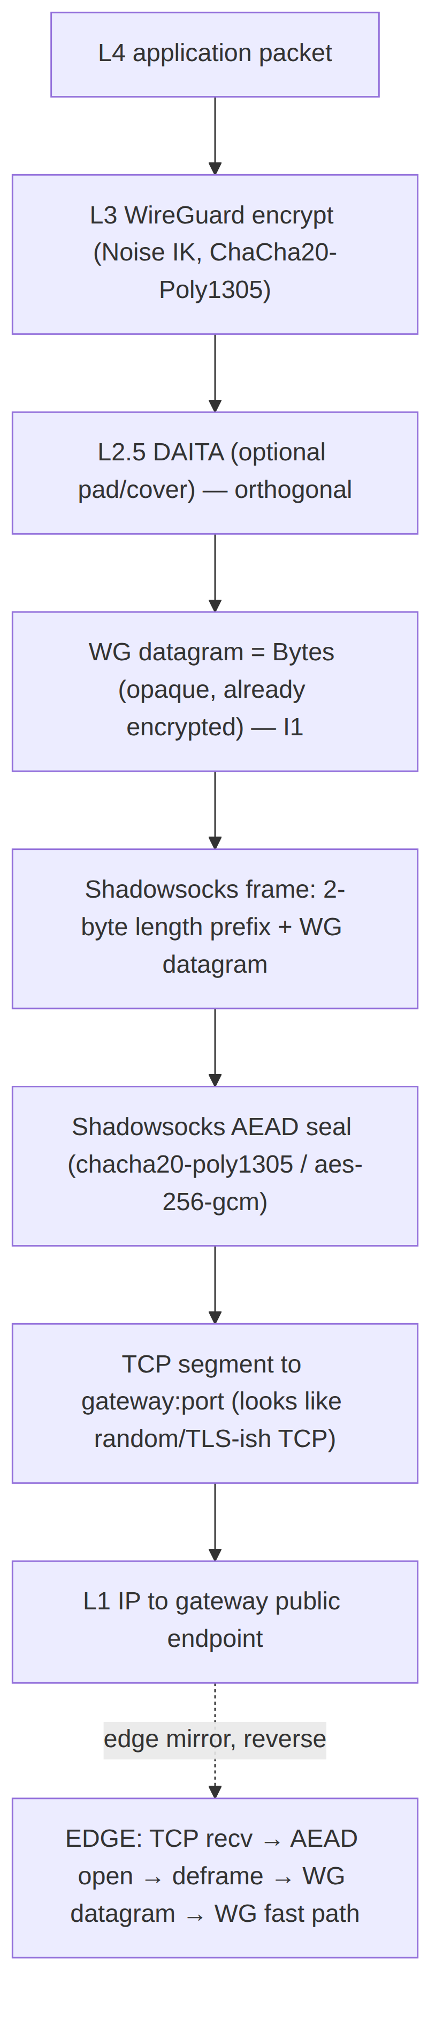
The Shadowsocks AEAD layer sits strictly between the WG-datagram producer (the orchestrator's send) and the TCP socket. It adds exactly two things on top of the opaque WG bytes: (a) a 2-byte length prefix so discrete datagrams survive the byte stream (§4), and (b) AEAD confidentiality + integrity + a per-record nonce chain so DPI sees only high-entropy bytes [04_ARCH §3.5; 04_P2 §1.1; 01-DP §3.5].

2. Public surface — trait impl, config, ciphers

2.1 Transport impl signature
ShadowsocksTransport implements the frozen Transport trait [01-DP §3.1] unchanged — the orchestrator cannot tell it apart from plain_udp or masque-h3 at the API level (that is the whole point of the trait, I4).
// helix-transport/src/shadowsocks.rs
use async_trait::async_trait;
use bytes::{Bytes, BytesMut};
use tokio::net::TcpStream;
use tokio::sync::Mutex;
use std::net::SocketAddr;
/// WG datagrams wrapped in a Shadowsocks AEAD byte-stream over a single TCP connection.
/// China-style-DPI evasion rung of the ladder [01-DP §3.5]. NEVER sees plaintext (I1).
pub struct ShadowsocksTransport {
/// Send half — AEAD-sealing writer over the TCP write half. Mutex because `Transport::send`
/// takes `&self` but the AEAD nonce counter + TCP write half are single-owner (§4.4).
tx: Mutex<SsWriter>,
/// Recv half — AEAD-opening reader over the TCP read half + a reassembly buffer (§4.5).
rx: Mutex<SsReader>,
peer: SocketAddr,
method: SsMethod,
health: HealthCell,
/// Aggregate counters only (I5): frames sent/recv, bytes, aead_open_failures.
counters: SsCounters,
}
#[async_trait]
impl Transport for ShadowsocksTransport {
async fn send(&self, datagram: Bytes) -> Result<(), TransportError>; // §4.4
async fn recv(&self) -> Result<Bytes, TransportError>; // §4.5
fn kind(&self) -> &'static str { "shadowsocks" }
fn effective_mtu(&self) -> u16 { SS_EFFECTIVE_MTU } // 1380 (§6)
fn health(&self) -> TransportHealth { self.health.snapshot() }
async fn close(&self) -> Result<(), TransportError>; // §5.4 (FIN the TCP carrier)
}

2.2 Config variant (already in the frozen TransportConfig enum)
The Shadowsocks variant is part of the frozen TransportConfig enum [01-DP §3.1]; this doc specifies its semantics, it does not add a field.
// (reproduced from helix-transport/src/lib.rs [01-DP §3.1] — frozen contract)
TransportConfig::Shadowsocks {
peer: SocketAddr, // gateway TCP endpoint, e.g. gw:443/tcp or gw:8388/tcp (§9 port choice)
method: SsMethod, // AEAD cipher selection (§2.3)
psk: SecretBytes, // pre-shared Shadowsocks password — SEPARATE from WG keys (I1, §3)
}
#[derive(Clone, Copy, Debug, PartialEq, Eq)]
pub enum SsMethod {
Chacha20Poly1305, // SIP004 AEAD "chacha20-ietf-poly1305" — default (§2.3)
Aes256Gcm, // SIP004 AEAD "aes-256-gcm" — AES-NI hosts (§2.3)
}
peer, method, and psk are resolved from the NetworkMap pushed by the coordinator (doc 03); they are never compiled in [01-DP §3.1]. SecretBytes is a zeroize-on-drop wrapper (§3.3).

2.3 Cipher choice — which AEAD, and why
Two SIP004 AEAD methods are offered [01-DP §3.5 SsMethod]; both are reused from the shadowsocks-rust crypto primitives rather than re-implemented [04_P2 §1.1].
SsMethod | Primitive | Tag | Nonce | When the ladder/config picks it
Chacha20Poly1305 (default) | ChaCha20-Poly1305 (IETF) | 16 B | 12 B (LE counter, §4.3) | Default. Constant-time in software; best on ARM / non-AES-NI mobile. Same AEAD family WG itself uses, so no new primitive class on the device.
Aes256Gcm | AES-256-GCM | 16 B | 12 B (LE counter, §4.3) | Hosts with AES-NI / ARMv8 crypto extensions where hardware AES beats ChaCha. Selected by config when the gateway advertises it for that region.
Both use a 32-byte master key derived from the psk (§3.1) and a per-direction random salt at connection start (§4.1). Tag length is 16 bytes; nonce is a 12-byte little-endian counter incremented once per AEAD record (§4.3). UNVERIFIED (SIP004 byte sizes — standard Shadowsocks AEAD spec, not in HelixVPN evidence base; confirm against shadowsocks-rust crypto module before implementing).
Hardening option (Phase 2): the SIP022 "AEAD-2022" edition (BLAKE3-keyed, fixed 32/16-byte PSK, per-session subkey, built-in replay window) is materially more probe-resistant than SIP004. It is not the default because the frozen SsMethod enum names SIP004 ciphers; adding Aead2022Blake3Chacha20Poly1305 is a tracked Phase-2 work item, not an MVP requirement. UNVERIFIED (SIP022 design — external Shadowsocks-2022 spec, not in HelixVPN evidence base).

3. Key schedule & secret handling

3.1 Master key derivation (SIP004 path)
/// Derive the 32-byte AEAD master key from the user PSK.
/// SIP004 uses the legacy Shadowsocks "EVP_BytesToKey" (MD5-chain) KDF over the password
/// to produce the cipher key length (32 B for both offered methods).
fn ss_master_key(psk: &SecretBytes, key_len: usize) -> SecretBytes; // key_len = 32
UNVERIFIED (EVP_BytesToKey MD5-chain KDF — this is the SIP004 master-key derivation in the Shadowsocks ecosystem, NOT in the HelixVPN evidence base. It is a known-weak KDF; §11 records the recommendation to move to SIP022 BLAKE3 PSK in Phase 2. Confirm the exact shadowsocks-rust KDF call before implementing.)

3.2 Per-connection subkey (the actual AEAD key)
Each TCP connection generates a fresh random salt per direction; the per-direction subkey that actually seals/opens records is derived by HKDF-SHA1 over (master_key, salt, info="ss-subkey") [SIP004 convention].
fn ss_subkey(master_key: &SecretBytes, salt: &[u8]) -> SecretBytes; // HKDF-SHA1, 32-byte out
UNVERIFIED (HKDF-SHA1 + "ss-subkey" info string — SIP004 spec, not in HelixVPN evidence base; confirm against shadowsocks-rust.) This per-connection salt is what makes two connections with the same psk produce unrelated wire bytes — required to resist the GFW's packet-size / correlation heuristics [research-hysteria2 §5d].

3.3 Secret lifetime
- psk: SecretBytes and every derived key are wrapped in a Zeroize-on-drop container; no key material is ever logged (I5) or written to durable storage.
- The orchestrator MUST drop ShadowsocksTransport (and thus the keys) on close() and on ladder de-selection; keys do not outlive the TCP connection.
- The Shadowsocks psk is categorically distinct from the WG private key (I1): a leak of the psk exposes only the obfuscation layer, never WG confidentiality. Credential handling follows constitution §11.4.10 (never git-tracked, chmod 600, rotation on suspected leak).

4. Wire format & framing state machine (the nano-detail core)

4.1 Connection-open wire layout (per direction, once)
┌───────────────────────────────────────────────────────────────────────┐
│ DIRECTION HEADER (sent once, first bytes on the TCP stream, per side) │
├───────────────────────────────────────────────────────────────────────┤
│ salt[salt_len] (random, plaintext on the wire; salt_len == key_len) │
└───────────────────────────────────────────────────────────────────────┘
then a sequence of AEAD records (§4.2) for the life of the connection
salt_len = 32 for both offered methods. The salt is sent in the clear (it is an input to the receiver's subkey derivation, not a secret). UNVERIFIED (salt-first SIP004 framing — Shadowsocks AEAD spec, not in HelixVPN evidence base.)

4.2 Per-datagram record layout (SIP004 AEAD)
Each WG datagram becomes exactly one logical Shadowsocks "chunk", encoded as two AEAD records — a length record then a payload record:
┌──────────────────────────────────────────────────────────────────────────────┐
│ LENGTH RECORD │
│ ciphertext: AEAD_seal(subkey, nonce_n, plaintext = u16_be(payload_len)) │ 2 B plaintext
│ tag: 16 B │ → 2 + 16 = 18 B
├──────────────────────────────────────────────────────────────────────────────┤
│ PAYLOAD RECORD │
│ ciphertext: AEAD_seal(subkey, nonce_n+1, plaintext = WG_datagram[payload_len])│ payload_len B
│ tag: 16 B │ → payload_len + 16 B
└──────────────────────────────────────────────────────────────────────────────┘
- payload_len = the WG datagram length, encoded big-endian u16. SIP004 caps a single chunk payload at 0x3FFF (16383) bytes; WG datagrams (≤ ~1420 B over IPv4) are always far below this cap, so a WG datagram is never split across chunks — preserving I2's 1-datagram ↔ 1-frame mapping.
- The two records consume two consecutive nonces (nonce_n, nonce_n+1) from the per-direction counter (§4.3). The 16-byte tag on the length record is what makes the length itself unforgeable (a DPI box cannot inject a fake length to desync the stream).
UNVERIFIED (0x3FFF chunk cap + 2-byte BE length + double-record framing — SIP004 AEAD wire spec, not in HelixVPN evidence base; confirm against shadowsocks-rust before implementing. The 2-byte length prefix + AEAD-tag overhead IS grounded in [01-DP §3.5, §10].)

4.3 Nonce discipline
/// Per-direction 12-byte little-endian counter, incremented by 1 after EACH AEAD record
/// (so a datagram consumes two increments: one for the length record, one for the payload).
struct AeadNonce([u8; 12]);
impl AeadNonce {
fn zero() -> Self { Self([0u8; 12]) }
fn next(&mut self) -> [u8; 12] { let n = self.0; le_increment(&mut self.0); n }
}
Rules:
- Send and receive maintain independent counters (send counter on SsWriter, recv counter on SsReader).
- The counter starts at 0 for the first record after the salt and is never reset within a connection; nonce reuse is a fatal AEAD violation → close the connection.
- On counter exhaustion (2^96 records — unreachable in practice) the connection MUST be torn down and re-dialled rather than wrap.
UNVERIFIED (LE 12-byte per-record counter starting at 0 — SIP004 nonce convention, not in HelixVPN evidence base.)

4.4 send algorithm
async fn send(&self, datagram: Bytes) -> Result<(), TransportError> {
if datagram.len() > SS_MAX_FRAME { return Err(TransportError::Oversize(datagram.len())); } // §6
let mut w = self.tx.lock().await; // serialize writers (single nonce chain)
// 1. length record
let len_pt = (datagram.len() as u16).to_be_bytes(); // 2 B BE
let len_ct = w.seal(&len_pt)?; // AEAD record (2 + 16 B)
// 2. payload record
let pay_ct = w.seal(&datagram)?; // AEAD record (n + 16 B)
// 3. one write (or vectored write) — never interleave with another datagram's records
w.tcp.write_all_vectored(&[&len_ct, &pay_ct]).await
.map_err(TransportError::Io)?;
self.counters.inc_sent(datagram.len());
Ok(())
}
Atomicity requirement: the length record and its payload record MUST hit the socket as one indivisible unit relative to other send calls (the Mutex<SsWriter> guarantees this). Interleaving two datagrams' records would desync the receiver's nonce chain (§8 E3).

4.5 recv algorithm + reassembly state machine
Because TCP delivers a byte stream, recv runs a small state machine that buffers partial records until a whole length-record then a whole payload-record are available:
enum RxState { NeedSalt, NeedLen, NeedPayload { payload_len: usize } }
async fn recv(&self) -> Result<Bytes, TransportError> {
let mut r = self.rx.lock().await;
loop {
match r.state {
RxState::NeedSalt => {
r.fill_at_least(SALT_LEN).await?; // read 32-byte salt
r.derive_subkey_from_salt(); // §3.2 (recv subkey)
r.state = RxState::NeedLen;
}
RxState::NeedLen => {
r.fill_at_least(2 + TAG_LEN).await?; // 18-byte length record
let len = r.open_len_record()?; // AEAD open → u16 BE, advance nonce
if len == 0 || len > SS_MAX_FRAME { return Err(TransportError::HandshakeFailed("bad ss frame len".into())); }
r.state = RxState::NeedPayload { payload_len: len };
}
RxState::NeedPayload { payload_len } => {
r.fill_at_least(payload_len + TAG_LEN).await?; // payload record
let wg = r.open_payload_record(payload_len)?; // AEAD open → WG datagram, advance nonce
r.state = RxState::NeedLen; // ready for next datagram
self.health.mark_recv();
self.counters.inc_recv(wg.len());
return Ok(wg); // exactly one WG datagram (I2)
}
}
}
}
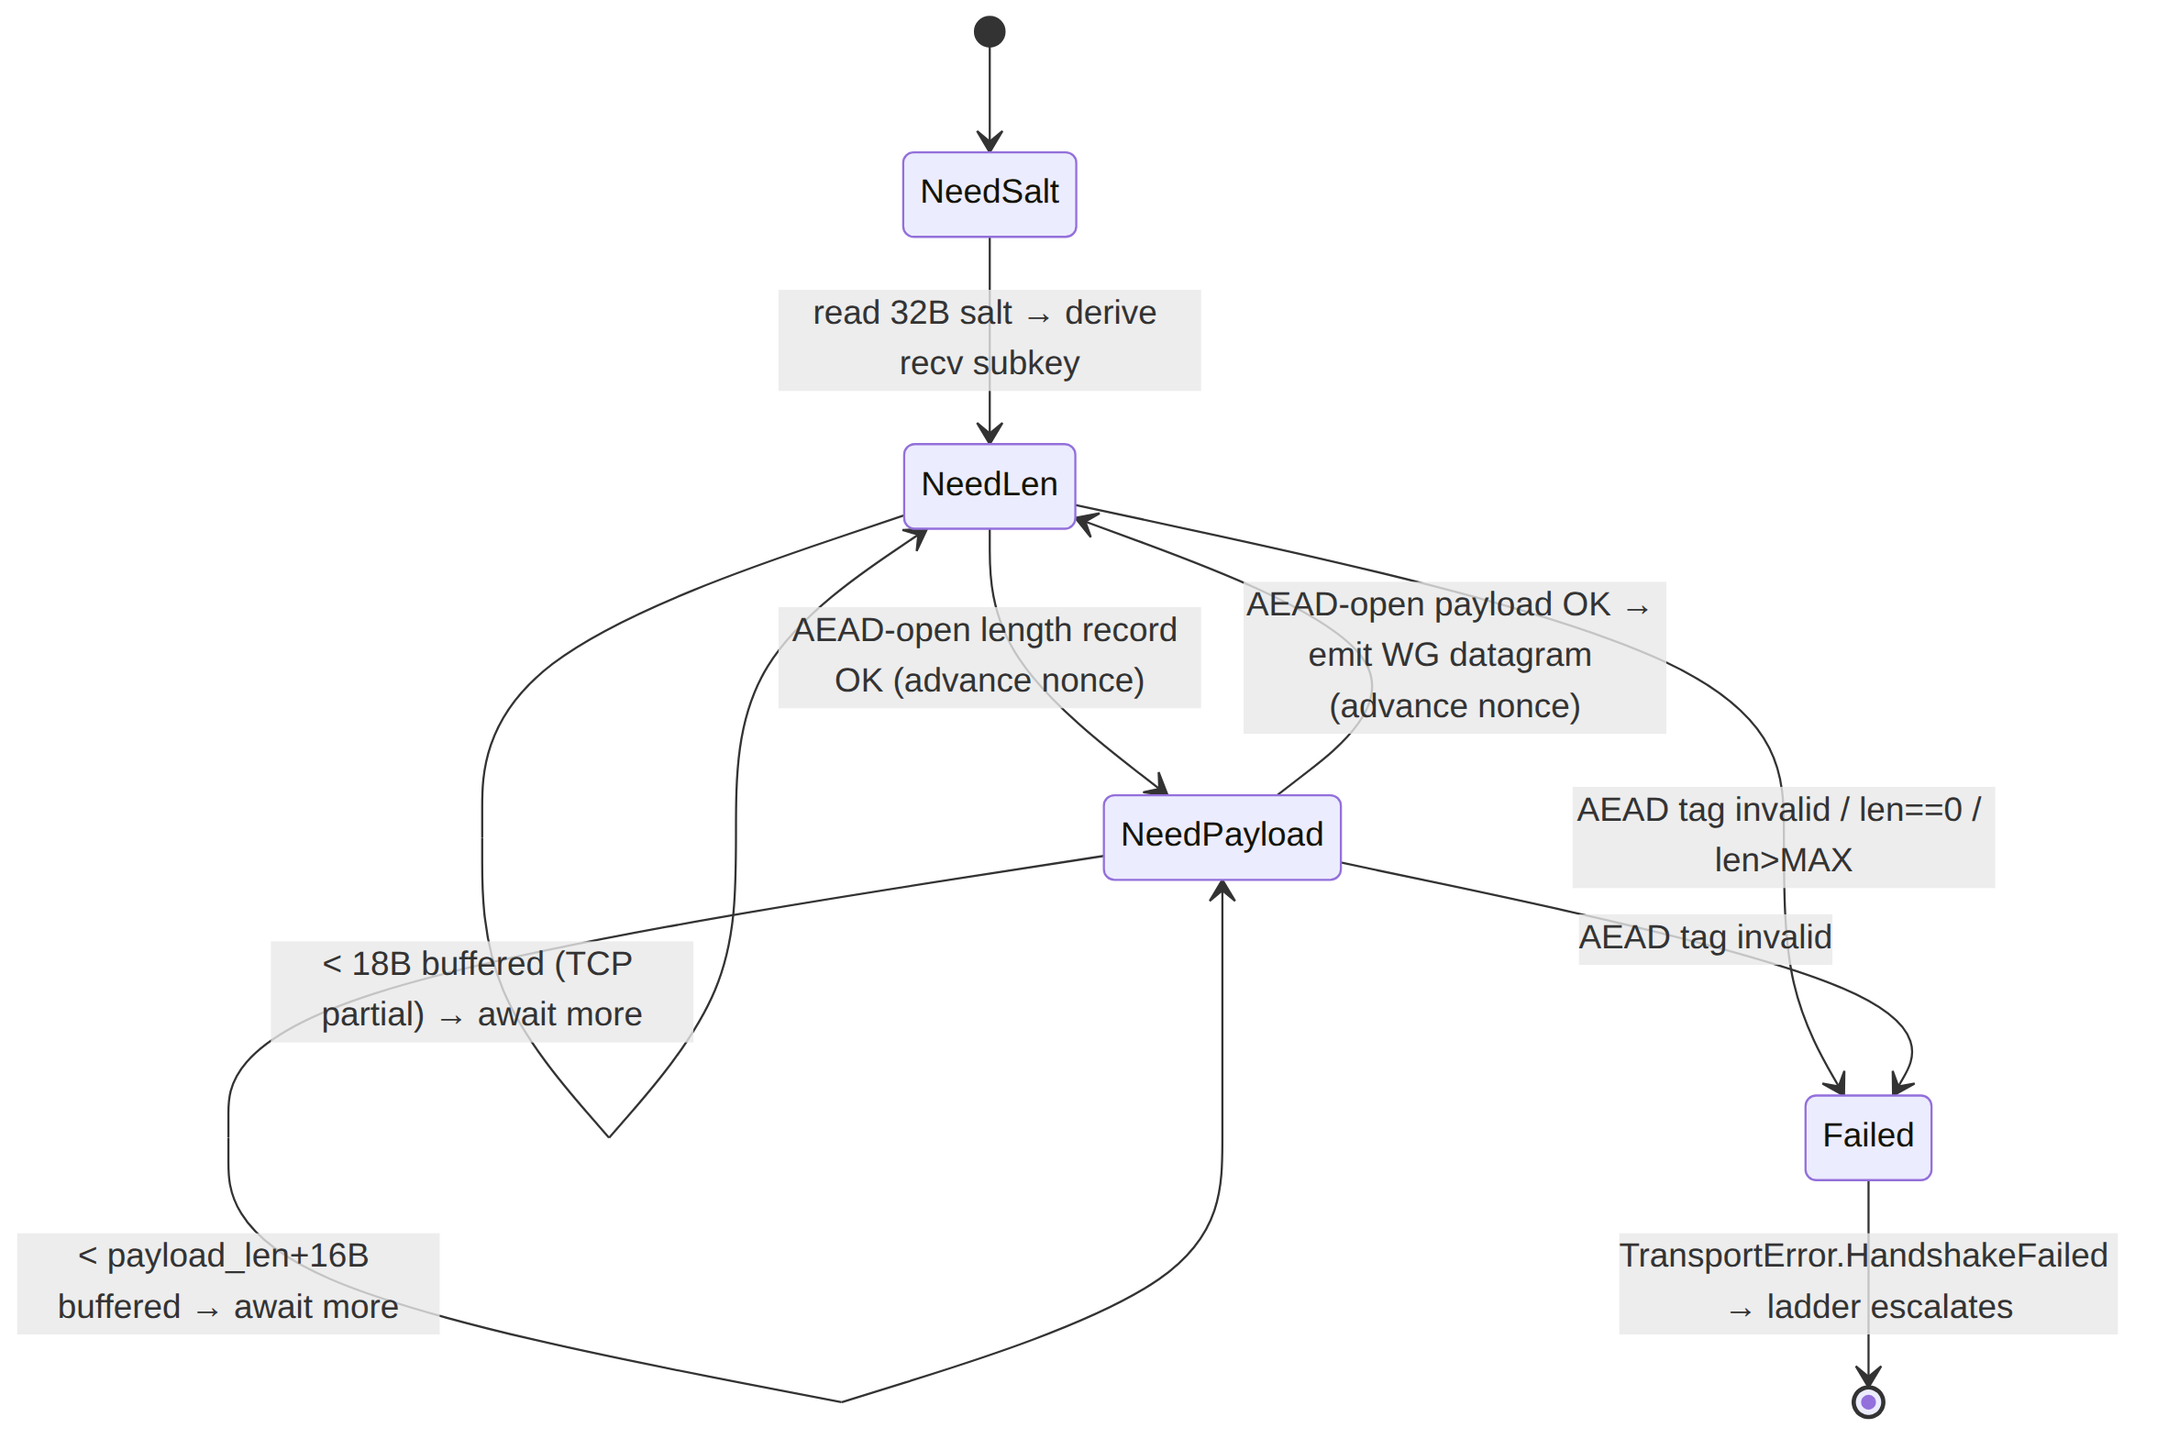
fill_at_least(n) reads from the TCP socket into the reassembly buffer until ≥ n bytes are buffered; on EOF before n it returns TransportError::Closed. The state machine is cancel-safe (an awaited recv dropped inside a select! leaves RxState + buffer intact) [01-DP §3.1 cancel-safe requirement].

5. Dial / connection lifecycle state machine

5.1 dial() for the Shadowsocks variant
// dispatched from helix-transport::dial() [01-DP §3.1] for TransportConfig::Shadowsocks
async fn dial_shadowsocks(
peer: SocketAddr, method: SsMethod, psk: SecretBytes,
) -> Result<Box<dyn Transport>, TransportError> {
// 1. TCP connect within the ladder's bounded dial timeout (§5.3 budget)
let tcp = tokio::time::timeout(DIAL_TIMEOUT, TcpStream::connect(peer))
.await.map_err(|_| TransportError::DialTimeout)?
.map_err(TransportError::Io)?;
tcp.set_nodelay(true).map_err(TransportError::Io)?; // §7 latency: disable Nagle
let (rh, wh) = tcp.into_split();
// 2. derive master key, generate per-direction send salt
let mk = ss_master_key(&psk, 32);
let send_salt = random_salt(SALT_LEN);
let mut writer = SsWriter::new(wh, ss_subkey(&mk, &send_salt), AeadNonce::zero(), method);
// 3. emit our salt (plaintext) as the FIRST bytes on the stream
writer.write_salt(&send_salt).await?; // §4.1
// 4. reader starts in NeedSalt — peer's salt arrives lazily on first recv (§4.5)
let reader = SsReader::new(rh, mk.clone(), method); // recv subkey derived on first salt byte-run
Ok(Box::new(ShadowsocksTransport { tx: Mutex::new(writer), rx: Mutex::new(reader), /* … */ }))
}
Key point — there is no application-level Shadowsocks handshake to wait on. Unlike masque-h3 (a CONNECT-UDP request/200 round trip [01-DP §3.3]), the Shadowsocks AEAD layer is connectionless at the obfuscation layer: once the TCP connection is up and our salt is flushed, the carrier is "live" and the first real liveness signal is the WG handshake completing through it [04_ARCH §3.5]. dial() returning Ok therefore means "TCP + salt sent", not "peer reachable"; the orchestrator's WG handshake over this transport is the actual end-to-end proof, and a WG-handshake timeout maps to a ladder escalation (§8 E5).

5.2 Connection state machine (carrier lifecycle)
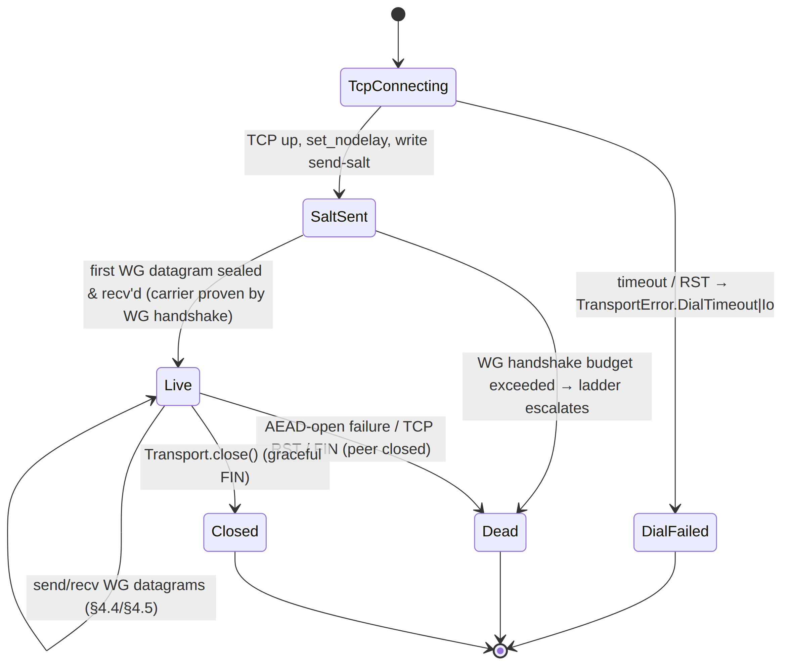

5.3 Dial-timeout & ladder budget
dial_shadowsocks returns within DIAL_TIMEOUT (the ladder's bounded per-rung budget, FailureBudget { max_handshakes, window } [01-DP §5.3]). A DialTimeout/Io(RST) at TCP connect, or a WG-handshake budget overrun after the carrier is live, escalates the ladder to the next rung (udp-over-tcp) [01-DP §5.3]. On success the orchestrator emits TunnelStatus::Connected { transport: "shadowsocks", rtt_ms } [01-DP §5.2] and the ladder remembers shadowsocks per-network (SSID / gateway fingerprint) so a reconnect on the same hostile network skips straight to it [01-DP §5.3 step 4].

5.4 close()
async fn close(&self) -> Result<(), TransportError> {
let mut w = self.tx.lock().await;
let _ = w.tcp.shutdown().await; // graceful FIN; idempotent — second call is a no-op
Ok(())
}
Idempotent per the trait contract [01-DP §3.1]. Keys zeroize on ShadowsocksTransport drop (§3.3). No half-open lingering: a FIN is sent; an unacked peer is reaped by TCP keepalive / the OS.

6. MTU & overhead budget
pub const SS_EFFECTIVE_MTU: u16 = 1380; // [01-DP §10]
pub const TAG_LEN: usize = 16;
pub const SALT_LEN: usize = 32;
pub const SS_MAX_FRAME: usize = 0x3FFF; // SIP004 chunk cap (UNVERIFIED, §4.2)
effective_mtu() reports 1380 [01-DP §10]: derived as TCP MSS (~1460 over IPv4) − 2-byte length prefix − AEAD tag, left conservative to leave room for the per-datagram framing overhead [01-DP §3.5, §10]. Per-WG-datagram on-wire overhead:
Component | Bytes | Note
TCP/IP headers | 40 (IPv4) / 60 (IPv6) | per TCP segment, amortised across coalesced datagrams
salt | 32 | once per connection, not per datagram
length record (2 B len + tag) | 18 | per datagram
payload record tag | 16 | per datagram
per-datagram AEAD/framing total | 34 | (18 + 16); independent of TCP/IP
Rules (inherited [01-DP §10]): the inner WG MTU = min(SS_EFFECTIVE_MTU, path-MTU-discovered); DAITA padding (if active) is added after WG-encrypt and counts against the transport budget, not the inner MTU; an oversize WG datagram (> SS_MAX_FRAME) is a hard TransportError::Oversize — never silently truncated. The exact 1380 value is measured in Phase 2 bring-up, not assumed [01-DP §10, §12.1].

7. Performance cost vs the UDP transports
Shadowsocks-wrap rides TCP, so it inherits TCP semantics the UDP/QUIC transports do not [01-DP §3.5; 04_ARCH §3.5; 04_P2 §1.1]:
Axis | plain-udp | masque-h3 (QUIC) | shadowsocks (this doc)
Substrate | UDP datagrams | QUIC DATAGRAM frames (unreliable, RFC 9221) | single TCP byte-stream
Head-of-line blocking | none | none (QUIC datagrams independent) | yes — one lost/late TCP segment stalls every WG datagram behind it (§8 E2)
TCP-over-TCP meltdown | n/a | n/a | risk — WG over TCP carrying TCP app traffic can double-retransmit under loss; mitigated only by being last-resort, not default
Loss behaviour | WG drops, recovers | QUIC recovers, WG loss-tolerant | TCP retransmits + reorders → latency spikes, no goodput collapse but jittery
CPU cost | lowest | QUIC + H3 framing | AEAD seal/open per datagram + TCP stack (moderate [04_ARCH §3.5 "moderate"])
Nagle | n/a | n/a | disabled (TCP_NODELAY, §5.1) to avoid 40 ms coalescing latency
Goodput @ 5% loss | baseline | beats UoT strawman [01-DP §3.3] | below QUIC; acceptable because it is the survival rung, not the fast rung
Design stance [01-DP §3.5, §5.3]: the ladder prefers shadowsocks only when UDP and QUIC are blocked. Its job is to keep a tunnel possible under China-style DPI, not to be fast; the head-of-line-blocking + TCP-over-TCP penalties are the accepted cost of surviving a regime where the faster transports do not connect at all [research-hysteria2 §5a, §6]. It sits above udp-over-tcp on the ladder because the AEAD wrap gives genuine "looks-random" camouflage that bare length-prefixed udp-over-tcp lacks [01-DP §3.6].

8. Error taxonomy & edge cases
All errors surface through the frozen TransportError enum [01-DP §error.rs]; no new variants.
# | Edge case | Detection | Mapped error / action
E1 | TCP connect refused / reset / timeout at dial | connect() err / DIAL_TIMEOUT elapsed | DialTimeout / Io → ladder escalates to udp-over-tcp
E2 | TCP segment loss/reorder mid-stream (HOL block) | OS TCP stalls recv | not an error — recv blocks until reassembly completes; surfaces as latency, accounted in §7
E3 | Nonce desync (two datagrams' records interleaved) | impossible by construction (Mutex<SsWriter> atomic write, §4.4) | prevented; if ever observed → fatal HandshakeFailed, close + re-dial
E4 | AEAD tag verification failure on recv (corruption / active tamper / wrong psk) | open_*_record returns AEAD error | HandshakeFailed("ss aead open") → close + escalate; counter aead_open_failures++
E5 | WG handshake never completes over a live carrier (silent drop / fake-accept by middlebox) | orchestrator WG-handshake budget overrun | escalate ladder (carrier "Dead", §5.2); the WG handshake is the real liveness oracle (§5.1)
E6 | Oversize WG datagram (> SS_MAX_FRAME) | length check in send (§4.4) | Oversize(len) → orchestrator lowers inner MTU / L3-fragments [01-DP §10]
E7 | Bad decrypted length (0 or > MAX) on recv | check after length-record open (§4.5) | HandshakeFailed("bad ss frame len") → close (a tamper/desync signal)
E8 | Peer FIN / half-close mid-stream | fill_at_least hits EOF | Closed → orchestrator reconnects (ladder remembers shadowsocks for this network)
E9 | Salt never arrives (peer sends no bytes) | recv blocks in NeedSalt past WG-handshake budget | orchestrator-side timeout → E5 path
E10 | Active prober connects, sends junk | AEAD open fails on first record (no valid salt+subkey) | server side returns nothing useful → prober learns nothing [research-hysteria2 §5d]; client side: E4
Anti-bluff (§11.4.1): every error path MUST fail only for a genuine carrier/product defect. A script-internal panic (buffer underflow, nonce-counter overflow handled by §4.3 rule 3) is a defect to fix at source, never a FAIL-bluff.

9. Security considerations
- Separate trust domain (I1). The Shadowsocks psk protects only the obfuscation envelope. WG confidentiality/integrity is independent and unchanged; a psk compromise downgrades the wire to "visibly WG-shaped TCP" but never decrypts user traffic. This layering is why Shadowsocks-wrap is safe to use even though SIP004's KDF is weak (§3.1).
- Active-probing resistance [research-hysteria2 §5d]. The GFW passively flags suspicious TCP endpoints (partly by packet-size distribution) then actively probes the server. The AEAD-from-the-first-record design means an unauthenticated prober that sends arbitrary bytes gets an AEAD-open failure and no protocol response — the server returns nothing useful (E10). To strengthen this, the edge SHOULD (a) randomise/avoid distinctive response timing, and (b) on AEAD failure behave like a generic closed/decoy service (mirror of the masque-h3 edge decoy [01-DP §3.3]). UNVERIFIED (edge decoy-on-probe behaviour for the SS port — design recommendation; the masque decoy IS grounded [01-DP §3.3], its SS analogue is not separately attested in the evidence base).
- Packet-size fingerprinting. SIP004's per-connection random salt + AEAD high-entropy output defeat static signatures, but constant 18-byte length records can leak a cadence. The Phase-2 SIP022 migration (§11) and optional DAITA padding [01-DP §9] address residual size/timing leakage; do not claim size-unfingerprintability for SIP004 alone (§11.4.6).
- Replay. SIP004 has no built-in replay window across connections; the per-connection nonce chain prevents intra-connection replay, but a recorded-and-replayed whole connection is only stopped by WG's own handshake anti-replay (the inner layer). Note this honestly; SIP022 adds a replay filter.
- No-logging (I5). Only aggregate counters (§2.1 SsCounters); never per-connection or per-datagram durable records. AEAD-failure counts are aggregate, not keyed to a peer.
- Key zeroization (§3.3). All key material is Zeroize-on-drop; the psk is never logged (constitution §11.4.10) and never crosses the FFI boundary as plaintext (doc 05).

9.7 Edge-side resource-exhaustion accounting (enterprise hardening)
Gap closed (2026-07-04): unlike the UDP/QUIC carriers, shadowsocks accepts an inbound TCP connection per client at helix-edge — a fundamentally different resource-exhaustion surface (file descriptors, per-connection buffers, kernel socket memory) than a connectionless UDP listener. The edge MUST bound this surface explicitly rather than rely on the OS's default backlog:
- Per-source-IP concurrent-connection cap. The edge tracks (in-RAM, aggregate-only — I5) a counter of live Shadowsocks TCP connections per source IP/CIDR; beyond a configured threshold (ss_max_conns_per_source, an operator/coordinator-tunable knob, default UNVERIFIED — calibrate against the Phase-2 rig, §11.4.107(13)) new connect attempts from that source are accepted-then-immediately-closed (never silently dropped at the TCP layer, which would look like a network fault rather than a policy decision) so a single source cannot exhaust the edge's fd table.
- Half-open / pre-AEAD-salt connection timeout. A connection that completes the TCP handshake but never sends a valid 32-byte salt (§4.1) within a bounded ss_pre_auth_timeout (default UNVERIFIED, calibrate) is closed — this is the Shadowsocks-specific analogue of a SYN-flood half-open-connection guard, closing the gap between "TCP accept()" and "AEAD session proven live" during which an attacker can hold a connection open for free.
- Global connection ceiling with graceful shed. The edge's total concurrent Shadowsocks connection count is bounded (ss_max_conns_global); beyond it, new connections are refused at accept() (a fast, cheap rejection) rather than accepted and then starved of buffer/CPU resources — protects the edge's other listeners (masque-h3, plain-udp, udp-over-tcp) from head-of-line resource contention when the Shadowsocks port is targeted.
- No new state exposed durably. All of the above counters are in-RAM aggregate counters only (I5) — no per-connection or per-source durable log; a source-IP's connection count is process-lifetime state, reset on edge restart, never a "ban list" requiring persistent storage (which would itself be a no-logging-by-construction violation, [01-DP §0.1 I5]).
- Test point. A DDOS/LOAD test point (extends §12): flood the edge's Shadowsocks TCP port from N source IPs with connect-then-idle and connect-then-junk patterns; assert (a) legitimate connections from a distinct source IP still complete within the performance budget (§7), (b) the edge's fd/memory usage stays bounded (no unbounded growth), (c) the per-source cap and global ceiling are both observably enforced via connection-count telemetry, never inferred.
Cross-reference: the Connector/Gateway-role rate-limiting and DDoS-resilience design for the control-plane API surface (a distinct concern — token-bucket per API key, not per raw TCP connection) lives in v06-deploy/ha-and-multiregion.md; this subsection is the data-plane, connection-accounting half of that story, specific to the one Transport carrier that terminates a real TCP socket per peer.

10. Config knobs (consumed from the NetworkMap)
Knob | Type | Source | Default | Effect
peer | SocketAddr | NetworkMap | — | gateway TCP endpoint (§9 port: 443/tcp to blend with HTTPS, or a dedicated SS port)
method | SsMethod | NetworkMap | Chacha20Poly1305 | AEAD cipher (§2.3)
psk | SecretBytes | NetworkMap (per-tenant secret) | — | obfuscation password (§3)
ladder rung index | derived | TransportPolicy.order [01-DP §5.3] | after masque-h3, before udp-over-tcp | when the ladder reaches this transport
regional prior | TransportPolicy.order push | coordinator [01-DP §5.3 step 5] | CN-resolved clients MAY start at shadowsocks | skip escalation latency in censored regions
DIAL_TIMEOUT | Duration | ladder FailureBudget [01-DP §5.3] | bounded | TCP-connect + carrier-up budget before escalation
TCP_NODELAY | bool | fixed | true (§5.1) | disable Nagle for latency
ss_max_conns_per_source | u32 | UNVERIFIED (calibrate, §9.7) | edge-only, coordinator policy | per-source-IP concurrent Shadowsocks connection cap (§9.7)
ss_pre_auth_timeout | Duration | UNVERIFIED (calibrate, §9.7) | edge-only | close a TCP connection that never completes the AEAD salt handshake within this window
ss_max_conns_global | u32 | UNVERIFIED (calibrate, §9.7) | edge-only | total concurrent Shadowsocks connection ceiling before new connects are refused at accept()
No knob is compiled in; all are resolved from the coordinator-pushed map [01-DP §3.1, §6.2] except the three edge-only resource-accounting knobs (§9.7), which are gateway-local operational configuration, not per-tenant NetworkMap fields.

11. Phasing & evolution
Phase | Deliverable | Source
1 | lwo ships first; shadowsocks scaffolded behind the ladder but udp-over-tcp/shadowsocks are tagged Phase 2 | [01-DP §12 file-by-file]
2 | Full shadowsocks.rs (SIP004 AEAD, both methods), ladder integration, per-network memory, regional priors | [01-DP §12; 04_P2 §1.1]
2+ | SIP022 "AEAD-2022" method (BLAKE3 PSK, replay window) as a hardening SsMethod addition; DAITA padding interplay | §2.3, §9; UNVERIFIED (SIP022 — external spec)
The Transport trait, TransportConfig::Shadowsocks variant, and SsMethod enum are frozen contracts [01-DP §3.1, §12 closing note]; only the shadowsocks.rs body evolves.

12. Test points — §11.4.169 comprehensive test-type coverage
Every PASS cites rock-solid captured physical evidence (§11.4.5/.69/.107); the only permitted absence is an honest §11.4.3 SKIP-with-reason, never a silent gap (§11.4.169). The closed enumerated set, instantiated for this transport:
Test type (§11.4.169) | Concrete test point for shadowsocks | Captured evidence
unit | framing round-trip (send→recv over an in-memory duplex): 1-datagram = 1-frame (I2); nonce monotonicity; length-record AEAD detects a flipped length byte (E7); Oversize boundary at SS_MAX_FRAME (E6); cancel-safety of recv in select!; salt-first ordering (§4.1). Mocks permitted only here (§11.4.27). | test logs + assertion traces
integration (real System, infra via containers submodule §11.4.76) | real shadowsocks-rust-derived crypto against a real helix-edge over a real TCP socket in a Linux netns; WG handshake completes end-to-end through the carrier (§5.1). | pcap of the netns link + WG handshake success log
e2e | client→gateway→connector LAN-host reachability with shadowsocks pinned; ping/curl to an advertised LAN host succeeds. | tshark capture + reachability log
full-automation (§11.4.25/.52/.98, deterministic §11.4.50) | the headline DPI test: nft block all UDP and QUIC on :443; assert the ladder auto-escalates plain-udp→lwo→masque-h3→shadowsocks and the tunnel survives; tshark shows high-entropy TCP with no WG signature, no QUIC, no SNI; N=3 identical runs (§11.4.50). | ordered TunnelStatus event trace + wire capture, ×3 identical
Challenges (challenges submodule §11.4.27(B)) | a Challenge bank entry that drives the DPI-block scenario and scores PASS only on positive captured wire evidence. | Challenge result.json + evidence path
HelixQA (helix_qa submodule) | written test-bank entry exercising the carrier under an autonomous QA session. | HelixQA session artefacts
DDoS / load-flood | flood the SS TCP port with junk/half-open connections; assert the edge does not leak resources, active-probers get no useful response (E10), legitimate carriers stay up. | connection-count + latency telemetry under flood
security (§11.4.10 + security submodule) | active-probing emulation (send junk → expect AEAD-fail, no protocol response, decoy behaviour, §9.2); wrong-psk rejection (E4); psk never logged / never git-tracked (§11.4.10). | prober transcript + log-scan proof
stress + chaos (§11.4.85) | sustained N≥100-iteration send/recv with tc netem loss 5% reorder; mid-stream TCP RST injection (E8) → clean reconnect; corrupt one AEAD tag mid-stream (E4) → connection closed not desynced. | per-iteration latency/goodput JSON + recovery trace
concurrency / atomicity | many concurrent send calls assert the Mutex<SsWriter> keeps each datagram's two records contiguous (no interleave, E3). | interleave-detector log over K parallel senders
race-condition / deadlock | concurrent send/recv/close under loom-style or stress scheduling; assert no deadlock between tx/rx mutexes, close idempotent during in-flight recv. | scheduler/stress run report
memory | long-lived connection: assert the reassembly buffer (SsReader) does not grow unbounded under a slow/partial-segment peer; keys zeroize on drop (§3.3). | RSS/heap trace + zeroize assertion
benchmarking / performance | measure goodput + CPU/Gbps + p99 latency vs plain-udp baseline and masque-h3; quantify the HOL-blocking penalty (§7); confirm effective_mtu()=1380 is measured not assumed (§6). | bench.sh CSV (throughput @ 1/10/100 clients, CPU/Gbps, p99)
Four-layer §11.4.4(b) enforcement: pre-build gate (framing unit tests + sh -n/cargo check)
- post-build (integration in netns) + runtime (full-automation DPI escalation) + paired §1.1 meta-test mutation (e.g. strip the length-record AEAD tag check → the E7 unit test MUST FAIL). Coverage ledger row per §11.4.25/.52: shadowsocks × {invariant-1..6} × status.

13. Cross-references
- Transport trait / dial() ladder / TransportError — [01-DP §3.1]
- masque-h3 (the QUIC primary this transport backstops) — [01-DP §3.3]
- udp-over-tcp (the rung below) — [01-DP §3.6]
- escalation ladder & per-network memory — [01-DP §5.3, §5.4]
- MTU/overhead budget — [01-DP §10]
- China GFW / active-probing / Shadowsocks evasion facts — [research-hysteria2 §5a, §5b, §5d, §6]
- AEAD-2022 / Phantun udp2tcp alternatives surveyed — [research-hysteria2 §3, §5b]
End of Shadowsocks-Wrap Transport nano-detail specification (Volume 2, Data Plane). All wire-format byte layouts flagged UNVERIFIED are standard Shadowsocks SIP004 protocol facts absent from the HelixVPN evidence base and MUST be confirmed against shadowsocks-rust before implementation, per §11.4.6.

