The Transport Trait

The Transport Trait
Revision: 2 Last modified: 2026-07-04T12:00:00Z
Rev 2 (consistency reconciliation, 2026-07-04): added §2.4 reconciling this document's frozen trait signature against SPECIFICATION.md §7.1's illustrative sketch (see below) — no signature or behavioural change, documentation-only.
Volume 2 (Data Plane) nano-detail specification — deepens §3 ("The Transport trait") of the pass-1 data-plane overview [01-data-plane §3]. SPEC ONLY: describe what to build (signatures, wire formats, state machines, error taxonomy, edge cases, security, performance budget, test points); do not write the shipping product. Source evidence cited inline by id — [01-DP §N] (final/01-data-plane.md), [04_ARCH §N] (04_VPN_CLD/HelixVPN-Architecture-Refined.md), [04_P0 §N] (04_VPN_CLD/HelixVPN-Phase0-Spike.md), [04_P2 §N] (04_VPN_CLD/HelixVPN-Phase2-Parity.md), [research-masque] (v09-research/research-masque.md), [SYNTHESIS §N] (v09-research/_SYNTHESIS.md). Anything not grounded in that evidence base is tagged UNVERIFIED per constitution §11.4.6 — never fabricated.

0. Position, ownership, and the one-sentence contract
helix-transport is the data plane's L2 carrier crate: a decoupled, project-agnostic Rust crate (vasic-digital/helix_core workspace, snake_case, flat submodule per §11.4.28/.29/.74) [01-DP §2, SYNTHESIS §9]. It owns exactly one public abstraction — the Transport trait — plus its config enum, its constructor (dial), its error taxonomy, and the concrete impls (plain_udp, masque, connect_ip, shadowsocks, udp_over_tcp, lwo, hysteria2) [01-DP §2, §3].
The one-sentence contract. A Transport is a bidirectional carrier for already-encrypted, unreliable WireGuard datagrams between this node and exactly one peer endpoint — it never sees plaintext (invariant I1), never reorders or retransmits (invariant I2), and is the same code on client, connector, and edge (invariant I4) [01-DP §0.1, §3, 04_P0 §4.2].
This document does not own: the WG crypto core (helix-wg, §4 of [01-DP]), the orchestrator three-loop (helix-core, [01-DP §5]), the WatchNetworkMap wire contract that sources TransportConfig (doc 03), nor the per-platform TUN shims (doc 06). It owns the seam between helix-wg above and the OS socket below.
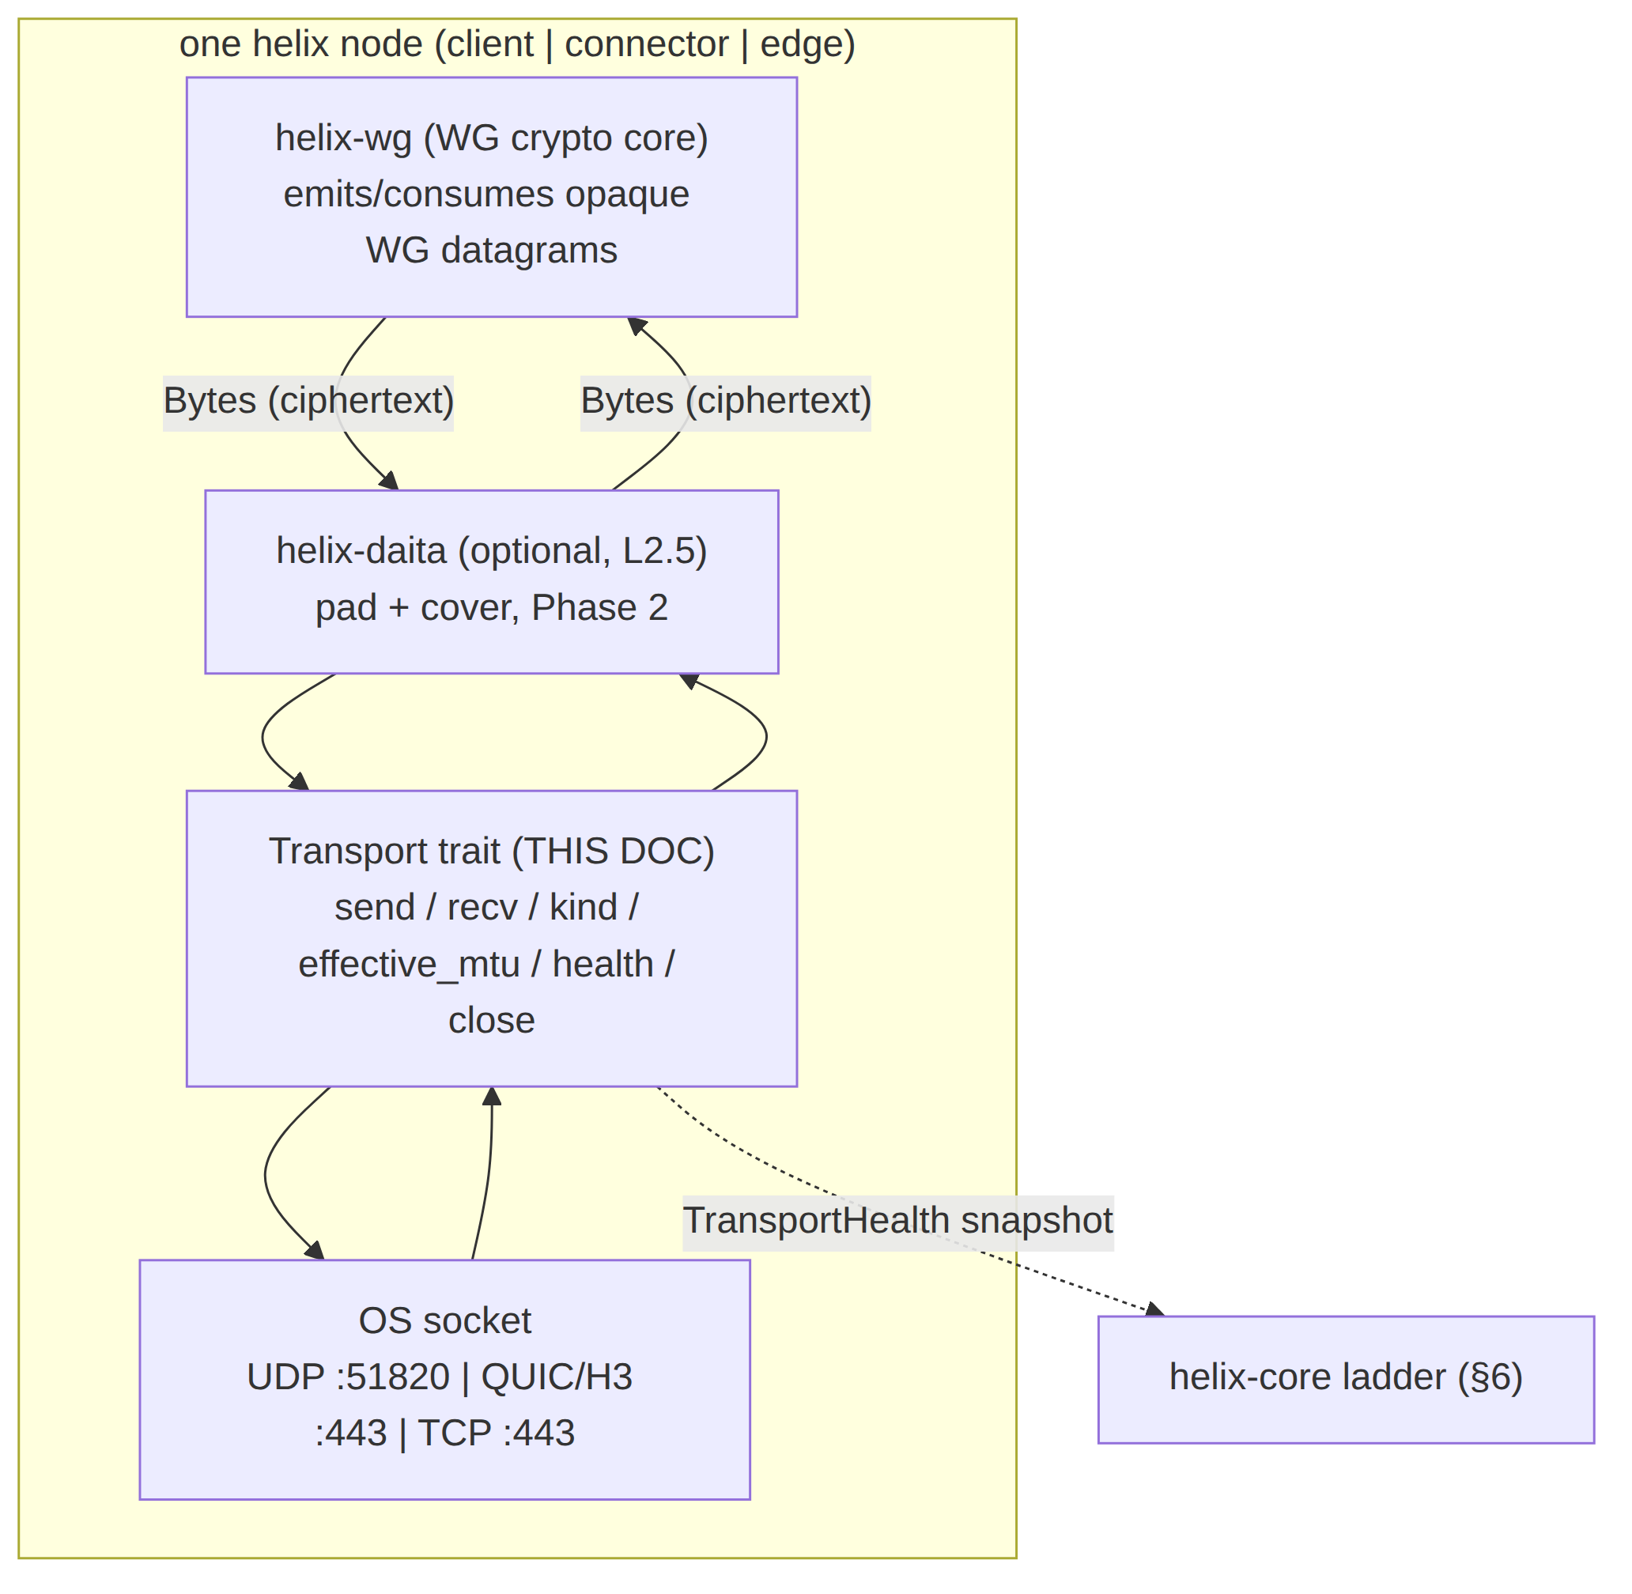

1. Non-negotiable transport invariants (the contract every impl must keep)
These bind every Transport impl. A violation is a release blocker (§11.4 anti-bluff at the data-plane layer) [01-DP §0.1].
# | Invariant | Mechanical consequence in this trait | Source
I1 | The transport never sees plaintext; it carries only already-encrypted WG datagrams. | send/recv operate on opaque Bytes; no impl ever parses the WG header beyond what an obfuscation layer mangles (lwo), and even then it mutates ciphertext bytes, never decrypts. | [04_P0 §4.2]
I2 | The transport carries unreliable datagrams, never an ordered byte stream; WG's own loss/reorder semantics are preserved; no head-of-line blocking. | MASQUE uses QUIC DATAGRAM frames (RFC 9221), not a QUIC stream. TCP-based carriers (shadowsocks, udp-over-tcp) accept the HoL penalty only as last resort and frame each datagram independently so a parser can still emit per-datagram. | [04_P0 §4.2 design note], [research-masque §1]
I3 | Control plane is never in the packet path; transports keep forwarding if control is down (fail-static). | A Transport, once dialed, holds no live dependency on the coordinator — it only needs its TransportConfig snapshot (resolved at dial). | [01-DP §0.1]
I4 | One transport crate, three consumers. | The trait + impls compile identically into helix-client, helix-connector, helix-edge; the edge's de-obfuscation is the inverse of the same encode_*/decode_* functions the client uses. | [04_ARCH §3.2, §5.5]
I5 | No-logging by construction. | Transport impls hold only aggregate counters in TransportHealth; no per-packet, per-connection durable state is written. Tracing is opt-in, counters-only, never payload. | [01-DP §0.1]
DG | Datagram-message boundary preservation. One send(dg) ⇒ exactly one recv() on the peer yields that same dg's bytes (modulo loss). No coalescing, no splitting across recv calls. | UDP/QUIC-DATAGRAM are message-oriented natively; TCP carriers MUST re-impose the boundary with an explicit length prefix (§4.3, §4.4). | derived from I2
Honest boundary (§11.4.6). I2 is preserved over UDP and QUIC-DATAGRAM natively. Over TCP (shadowsocks, udp-over-tcp) the wire is an ordered stream; the impl re-creates datagram boundaries with a length prefix but cannot restore loss-tolerance — a lost/late TCP segment HoL-blocks every following datagram. This is an accepted, documented degradation, not a bug; the ladder (§6) prefers TCP carriers last for exactly this reason [01-DP §3.5, §3.6].

2. The Transport trait — full signature & per-method nano-contract
The pass-1 trait [01-DP §3.1] is the frozen Phase-0 surface [04_P0 §4.2, §14]. This section pins the exact semantics of every method: argument ownership, cancel-safety, blocking behaviour, and the closed set of errors each may return.
// helix-transport/src/lib.rs
use async_trait::async_trait;
use bytes::Bytes;
use std::net::SocketAddr;
use std::time::Duration;
/// A bidirectional carrier for ALREADY-ENCRYPTED WireGuard datagrams.
/// Invariants: I1 (never plaintext), I2 (unreliable datagrams, never a stream),
/// DG (1 send => 1 recv, boundary-preserving). All async methods are cancel-safe:
/// dropping the returned future at any await point leaves the Transport usable.
#[async_trait]
pub trait Transport: Send + Sync {
/// Send exactly one WG datagram toward the single peer endpoint.
/// Ownership: takes `Bytes` by value (cheap ref-counted clone upstream).
/// Returns Ok(()) once the datagram is handed to the OS / QUIC stack
/// (NOT once the peer acks — there is no ack; this is fire-and-forget, I2).
/// Errors: Oversize (dg.len() > effective_mtu+headroom), Closed, Io, Quic,
/// EndpointBlocked (ICMP port-unreachable / connection refused seen).
async fn send(&self, datagram: Bytes) -> Result<(), TransportError>;
/// Receive the next WG datagram from the peer.
/// Cancel-safe: usable as a branch in `tokio::select!`; a cancelled recv
/// MUST NOT drop an already-dequeued datagram (no data loss on cancel).
/// Blocks (async) until one full datagram is available or the carrier dies.
/// Errors: Closed (graceful peer FIN / QUIC CONNECTION_CLOSE), Io, Quic.
async fn recv(&self) -> Result<Bytes, TransportError>;
/// Stable, lowercase, hyphenated label for logs/metrics/status:
/// "plain-udp" | "masque-h3" | "connect-ip" | "shadowsocks"
/// | "udp-over-tcp" | "lwo" | "hysteria2". MUST match `TransportKind` (§3.3).
fn kind(&self) -> &'static str;
/// MTU (bytes) the upper layer (WG) may use over this transport, AFTER
/// per-transport overhead (§7). Constant for the lifetime of the impl
/// UNLESS path-MTU discovery lowers it (then it MAY shrink, never grow
/// above the dialed ceiling). Always <= 1420 and >= 1280 (IPv6 floor).
fn effective_mtu(&self) -> u16;
/// Cheap, lock-light snapshot of liveness for the ladder's decisions (§6).
/// MUST be callable at >= 10 Hz without contending the hot send/recv path.
fn health(&self) -> TransportHealth;
/// Graceful close: flush QUIC / send TCP FIN / drop the UDP socket.
/// IDEMPOTENT — a second call is a no-op Ok(()). After close, send/recv
/// return Err(Closed). MUST complete within CLOSE_GRACE (§5.6).
async fn close(&self) -> Result<(), TransportError>;
}

2.1 Per-method nano-contract table
Method | Concurrency | Cancel-safe? | Returns Ok when | Hot-path? | May trigger ladder escalation?
send | callable concurrently with recv from another task; MUST be &self (interior mutability) | yes — partial send is impossible at the datagram level (UDP/QUIC-DATAGRAM are atomic; TCP send is buffered & resumable) | datagram handed to OS/QUIC tx queue | yes | only via repeated EndpointBlocked/Io raising send_errors, surfaced through health() to §6
recv | one logical reader; MUST NOT be called from two tasks simultaneously (UNVERIFIED: impls MAY internally serialize, but the orchestrator runs a single recv loop per transport [01-DP §5.1]) | yes — a cancelled recv re-queues any partially-read state | one whole datagram dequeued | yes | no (recv errors map to Down/Reconnecting at orchestrator, §5)
kind | lock-free, const | n/a | always | metrics only | no
effective_mtu | lock-free, near-const | n/a | always | per-config only | no
health | lock-light snapshot of atomics | n/a | always | sampled, not hot | feeds §6 decisions
close | idempotent | n/a (not awaited under select normally) | carrier flushed/closed | teardown | no

2.2 Object-safety, sizing, and dynamic dispatch
- Transport is object-safe: dial returns Box<dyn Transport> [01-DP §3.1]. No generic methods, no Self-returning methods, no associated consts in the public surface — all preserved so dyn dispatch works.
- The orchestrator holds the active carrier as Box<dyn Transport> and swaps it atomically on a ladder escalation (§6.4) — a single Box pointer write under the orchestrator's transport lock, never mid-datagram.
- Send + Sync are required supertraits: the carrier is shared between the send loop and recv loop tasks (Arc<dyn Transport> inside the orchestrator) [01-DP §5.1]. UNVERIFIED: whether the orchestrator wraps in Arc vs moves the Box into a single combined loop is an orchestrator decision (doc owns §5.1), not a trait constraint.

2.3 TransportHealth — the liveness snapshot
#[derive(Clone, Debug)]
pub struct TransportHealth {
/// EWMA of RTT in ms; None until the first RTT sample lands.
/// RTT source: per-transport — UDP/lwo: WG keepalive echo timing
/// (UNVERIFIED: helix-wg owns keepalive RTT; transport MAY expose a
/// carrier-level probe instead); MASQUE/hysteria2: quinn's path RTT
/// estimate (quinn exposes `Connection::rtt()`); TCP carriers: socket RTT
/// via TCP_INFO where available, else None.
pub rtt_ewma_ms: Option<u32>,
/// Wall-clock ms since the last successful recv() of a datagram.
/// The ladder uses this for "carrier went silent" detection (§6.3).
pub last_recv_age_ms: u64,
/// Monotonic count of send() errors since dial (Io/EndpointBlocked/Quic).
/// Reset only on a fresh dial(), never decremented (I5: aggregate counter).
pub send_errors: u32,
}
EWMA recommendation (UNVERIFIED, calibrate per §11.4.107(13) on real fixtures, not literature-hardcoded): rtt_ewma = 7/8 * rtt_ewma + 1/8 * sample (the classic TCP SRTT α=1/8 [RFC 6298] is the documented starting point; final α set by Phase-0 BENCH evidence).

2.4 Reconciliation vs SPECIFICATION.md §7.1 (documentation-only)
Gap identified (2026-07-04): the master spine's §7.1 "Cross-cutting contracts" shows an earlier, deliberately-illustrative sketch of the Transport trait — kind() -> TransportKind, connect()/accept() returning a separate TransportConn object with its own send/recv/health. That sketch predates this nano-detail deepening and differs at the surface level from the frozen signature in §2 above (where Transport itself exposes send/recv/kind/effective_mtu/health/close, and construction is via the free function dial() rather than connect/accept methods on the trait). SPECIFICATION.md §0 explicitly self-declares its code blocks as "illustrative interface sketches, not final implementations" — so this is not a release-blocking contradiction per the parent task's reconciliation rule (§11.4.35: a per-doc callout stays authoritative in its owning doc), but it is a genuine drift worth recording so a reader does not implement against the stale sketch:
- Canonical, frozen signature: this document (§2) and [01-DP §3.1] — both agree byte-for-byte (verified 2026-07-04) — are the binding Phase-0 contract.
- TransportKind (§3.3 below) is real and does exist, but it is the ladder's policy-ordering enum (TransportPolicy.order: Vec<TransportKind>), not the return type of Transport::kind() (which returns &'static str for logs/metrics, §2). SPECIFICATION.md's sketch conflates the two; they are related but distinct types here.
- CarrierHealth in the spine sketch is this document's TransportHealth (§2.3 above) — same concept, renamed during the nano-detail pass.
- Action recorded, not taken here: this document is not the owner of SPECIFICATION.md; a future editorial pass on the spine (outside this document's file scope) should update §7.1's sketch to mirror the signature in this section, or add a forward-pointer here so implementers are never tempted to code against the older illustrative form. Recorded per §11.4.6 (no silent drift) rather than left implicit.

3. TransportConfig, supporting types, and the wire-config seam

3.1 The config enum (one variant per L2 carrier)
TransportConfig is the resolved per-carrier dial parameters. Every variant is hydrated from the NetworkMap pushed by the coordinator (doc 03) — endpoints, SNI, PSKs, session keys all arrive already policy-filtered (need-to-know, I6) [01-DP §3.1, §6.2]. The data plane never invents an endpoint or a secret.
// helix-transport/src/lib.rs
#[derive(Clone, Debug)]
pub enum TransportConfig {
/// Baseline UDP carrier; lowest latency/CPU; throughput baseline (§7).
PlainUdp { peer: SocketAddr, bind: SocketAddr },
/// CONNECT-UDP over HTTP/3 (RFC 9298/9297/9221) — the headline obfs (§4.2).
MasqueH3 { url: String, sni: String, bind: SocketAddr, congestion: Congestion },
/// IP-over-HTTP/3 (RFC 9484). Advanced, feature-gated, Phase 2+ (§4.5).
ConnectIp { url: String, sni: String, bind: SocketAddr },
/// WG-in-Shadowsocks AEAD over TCP (China-grade DPI) (§4.3).
Shadowsocks { peer: SocketAddr, method: SsMethod, psk: SecretBytes },
/// WG datagrams length-prefixed over one TCP conn; last resort (§4.4).
UdpOverTcp { peer: SocketAddr, tls_sni: Option<String> },
/// Lightweight per-session keyed header obfs + padding (§4.6).
Lwo { peer: SocketAddr, bind: SocketAddr, session_key: SecretBytes },
/// Hysteria2 + Salamander QUIC-obfs carrier; feature-gated; decision D1.
#[cfg(feature = "hysteria2")]
Hysteria2 { url: String, sni: String, salamander_pw: SecretBytes },
}
#[derive(Clone, Copy, Debug, PartialEq, Eq)] pub enum Congestion { Cubic, Bbr }
#[derive(Clone, Copy, Debug, PartialEq, Eq)] pub enum SsMethod { Chacha20Poly1305, Aes256Gcm }
Field semantics:
Field | Type | Meaning | Constraint
peer | SocketAddr | the gateway/connector L1 endpoint to send datagrams to | v4 or v6; resolved, never a hostname
bind | SocketAddr | local socket bind addr (0.0.0.0:0 / [::]:0 for ephemeral) | UDP carriers only
url | String | full HTTPS URL of the gateway H3 listener, e.g. https://gw.example:443 | scheme MUST be https; informs the RFC 9298 URI template (§4.2.1)
sni | String | TLS SNI presented in the QUIC Initial / ClientHello | drives the fingerprint-mimicry research item (§8.3)
congestion | Congestion | quinn CC: Cubic default, Bbr for lossy mobile | [01-DP §3.3]
method | SsMethod | Shadowsocks AEAD cipher | reuse shadowsocks-rust primitives [04_P2 §1.1]
psk / session_key / salamander_pw | SecretBytes | per-transport secret, separate from WG keys | §3.2; zeroized on drop
tls_sni | Option<String> | if Some, wrap the TCP carrier in TLS to look like HTTPS | optional camouflage [01-DP §3.6]

3.2 SecretBytes — the secret-handling type (§11.4.10 binding)
SecretBytes is the closed type for every transport secret. It is distinct from WG keys — a transport-layer password/PSK, never the device's WG private key (which never leaves the device, doc 02) [01-DP §3.5, §4].
// helix-transport/src/secret.rs
/// A transport secret (SS PSK, lwo session key, salamander password).
/// - Debug/Display REDACT (prints "SecretBytes(<redacted>)") — §11.4.10 no-leak.
/// - Zeroize on Drop (memory scrubbed) — uses `zeroize` crate.
/// - No Serialize/Deserialize derive: secrets arrive via the doc-03 wire path,
/// never serialized into a tracked artifact (§11.4.10 / §11.4.30).
pub struct SecretBytes(/* zeroize::Zeroizing<Vec<u8>> */);
impl std::fmt::Debug for SecretBytes {
fn fmt(&self, f: &mut std::fmt::Formatter<'_>) -> std::fmt::Result {
f.write_str("SecretBytes(<redacted>)") // never the bytes (§11.4.10)
}
}
Security rules (release-blocking, §11.4.10): (1) SecretBytes MUST impl Drop zeroizing the buffer; (2) Debug/Display MUST redact; (3) no derive(Serialize); (4) no logging API ever accepts SecretBytes. The SEC test type (§9) plants a secret value and asserts a repo-wide + log-capture grep finds it nowhere.

3.3 TransportKind — the carrier identifier the ladder orders
TransportKind is the lightweight, secret-free enum the ladder (§6) sorts and the coordinator pushes in TransportPolicy.order [01-DP §5.3]. One-to-one with TransportConfig variants and with kind() strings.
// helix-transport/src/lib.rs
#[derive(Clone, Copy, Debug, PartialEq, Eq, Hash)]
pub enum TransportKind {
PlainUdp, MasqueH3, ConnectIp, Shadowsocks, UdpOverTcp, Lwo,
#[cfg(feature = "hysteria2")] Hysteria2,
}
impl TransportKind {
pub const fn label(self) -> &'static str { /* matches kind() strings (§2) */ }
}

4. Per-carrier dial detail & wire formats (byte layouts)
Each subsection pins the on-wire byte layout the impl must produce/consume so the client encode and edge decode (I4) are provably inverse. WG datagram = the opaque ciphertext payload from helix-wg; its own header layout (message type, sender/receiver index, counter, AEAD tag) is owned by WG and treated as opaque here [01-DP §4].

4.1 plain-udp — baseline (Phase 0, always available)
Wire = the WG datagram, raw, in one UDP payload. No framing added.
L1 IP | UDP(:51820) | [ ---- WG datagram (opaque ciphertext) ---- ]
effective_mtu() = 1420 (1500 − 20 IPv4 − 8 UDP − ~52 WG hdr+tag headroom per [04_P0 §4.3]; 1440 over IPv6 path-MTU UNVERIFIED — measured in Phase 0 BENCH, the table value 1420 is the conservative IPv4 default) [01-DP §10]. dial = bind the UDP socket, connect(peer) (so send/recv need no addr), return immediately — there is no carrier handshake (the WG handshake rides on top, owned by helix-wg). Fastest dial (sub-ms).

4.2 masque-h3 — CONNECT-UDP over HTTP/3 (the headline obfuscation)
The "QUIC mode" — Mullvad's literal mechanism, WG-over-MASQUE [04_ARCH §0, research-masque §2]. Four-RFC layering [research-masque §1]:
WG datagram (Bytes, opaque ciphertext)
└▶ HTTP Datagram (RFC 9297): [ Quarter-Stream-ID (varint) | Context-ID=0 (varint) | WG payload ]
└▶ QUIC DATAGRAM frame (RFC 9221, UNRELIABLE — matches WG loss semantics, I2)
└▶ QUIC / HTTP-3 connection to https://gw:443 (looks like a browser doing H3)
└▶ EDGE: CONNECT-UDP proxy (RFC 9298) strips framing → WG datagram → kernel WG

4.2.1 CONNECT-UDP establishment (once, at dial)
Per RFC 9298 + RFC 9220 Extended CONNECT [research-masque §1]:
- Open a QUIC/H3 connection to url (quinn + h3), TLS SNI = sni, ALPN = h3. Negotiate max_datagram_frame_size transport param > 0 (RFC 9221) — if the peer does not offer QUIC datagrams, dial fails HandshakeFailed (the carrier is unusable without unreliable datagrams, I2) [research-masque §1].
- Issue an Extended CONNECT request stream: :method = CONNECT, :protocol = connect-udp, :scheme = https, :authority = <host:port>, :path = /.well-known/masque/udp/{target_host}/{target_port}/ (RFC 9298 URI template; {target} = the gateway's local WG endpoint) [research-masque §1].
- On 2xx the flow is established; record the Quarter-Stream-ID (= the request stream id / 4) used to tag every datagram to this flow (RFC 9297). This is flow_ctx in the pass-1 sketch [01-DP §3.3].
- Thereafter WG datagrams ride as HTTP Datagrams with no per-packet HTTP round trip [01-DP §3.3, 04_P0 §5.1].
Maturity caveat (release-relevant, not a spec defect). There is NO turnkey Rust crate for RFC 9298 CONNECT-UDP; it is hand-rolled on quinn
- h3 + h3-datagram (v0.0.2, pre-1.0) [research-masque §3]. The impl MUST hand-write: the Extended-CONNECT request/response, the Quarter-Stream-ID datagram mux, and (edge side) the UDP-socket relay. Mullvad's published quinn_udp dependency confirms this is the trodden path [research-masque §2]. Budget as real engineering; this immaturity is the input to decision D5 (edge language, [01-DP §11.2]).

4.2.2 HTTP-Datagram byte layout (the per-packet hot path)
HTTP/3 Datagram (RFC 9297) payload, carried in one QUIC DATAGRAM frame (RFC 9221):
┌────────────────────────────┬──────────────────────────┬───────────────────────┐
│ Quarter Stream ID (QUIC │ Context ID (QUIC varint) │ Proxied UDP payload │
│ varint, identifies the │ = 0x00 for the raw UDP │ = the WG datagram │
│ CONNECT-UDP request stream) │ payload (RFC 9298 §5) │ (opaque, I1) │
└────────────────────────────┴──────────────────────────┴───────────────────────┘
encode_http_datagram(flow_ctx, wg) prepends the two varints; send_datagram hands it to quinn [01-DP §3.3]. decode_http_datagram(dg) strips them back to the WG bytes. Edge = the exact inverse (I4). Context-ID 0 = raw UDP payload per RFC 9298 §5 [research-masque §1].
effective_mtu() = 1280 (measure & tune): QUIC long/short header + DATAGRAM frame header + the two varints eat headroom; 1280 is the IPv6 minimum-MTU floor and a safe default [01-DP §3.3, §10]. The exact penalty is quantified in Phase-0 BENCH (record MTU/throughput/CPU vs plain-udp) so the ladder cost model is real [04_P0 §5.3].

4.2.3 Masquerade (decoy on non-CONNECT-UDP probes)
The edge :443 listener serves a believable decoy site to anything that is not a valid CONNECT-UDP flow (scanners/probes) — native edge behaviour, not Nginx camouflage [01-DP §3.3, 04_P0 §5.4]. Verified by the SEC/IT G2 check: tshark classifies the flow as HTTP/3 with no WG signature [04_P0 §8].

4.3 shadowsocks — WG-in-Shadowsocks AEAD over TCP
WG datagrams wrapped in a Shadowsocks AEAD stream — "looks like random/TLS-ish TCP" where even QUIC is throttled [01-DP §3.5, 04_P2 §1.1]. Reuse shadowsocks-rust crypto primitives, do not re-implement AEAD framing [04_P2 §1.1].
Per-datagram wire (re-imposes the DG boundary over the TCP stream):
TCP stream (after SS AEAD session established) carries repeated frames:
[ 2-byte length prefix (big-endian, = WG datagram len) | WG datagram ] ──► AEAD-encrypt each chunk
recv: AEAD-decrypt ──► read 2-byte len ──► read len bytes ──► one WG datagram (DG boundary restored)
dial = TCP connect to peer, derive the SS session subkey from psk + salt (per SS AEAD spec, owned by shadowsocks-rust), no extra app handshake. effective_mtu() ≈ 1380 (TCP MSS − 2-byte length prefix − AEAD tag) [01-DP §10]. Carries the I2 HoL caveat (TCP); ladder rung above QUIC.

4.4 udp-over-tcp — last resort (all UDP blocked)
WG datagrams length-prefixed over one TCP connection — matches Mullvad's udp2tcp [01-DP §3.6, 04_P2 §1.2]. Optional TLS wrap (tls_sni) to look like HTTPS. Lowest ladder rung; exists only to keep a tunnel possible.
TCP (optionally inside TLS if tls_sni=Some) stream of frames:
[ 2-byte length prefix (big-endian) | WG datagram ] [ 2-byte len | WG datagram ] ...
effective_mtu() ≈ 1380 (TCP MSS − length prefix) [01-DP §10]. Full HoL penalty accepted by design.

4.5 connect-ip — IP-over-HTTP/3 (RFC 9484, advanced, feature-gated)
Proxies IP packets (not inner WG) over HTTP/3 via CONNECT-IP [01-DP §3.4, research-masque §1]. Spec stance: Phase 2+, behind a Cargo feature; default path stays inner-WG-over-masque-h3. CONNECT-IP loses I1's "transport never sees plaintext" at the gateway (the gateway terminates IP), so it is not offered to privacy clients by default — only explicit site-to-site routing where the gateway is already a trusted router [01-DP §3.4]. effective_mtu() ≈ 1300 (IP-over-H3, no inner-WG header but QUIC overhead) [01-DP §10].

4.6 lwo — lightweight WG obfuscation (cheap evasion)
Per-session keyed obfuscation of the WG header bytes DPI signatures key on (message-type / reserved fields) + randomized padding — near-zero-cost evasion of naive WG fingerprinting without QUIC overhead [01-DP §3.7, 04_P2 §1.3]. Mullvad's "LWO" is the design reference. Phased: Phase-1 basic XOR/padding, Phase-2 hardened per-session keyed scheme [01-DP §3.7].
Over UDP, per datagram:
obfuscate(session_key, wg) = [ mangle WG header bytes via keystream(session_key) | WG body | random pad (len ∈ [0, P]) ]
deobfuscate inverts the mangle + strips pad (pad length carried in a keyed field — UNVERIFIED exact field; Phase-1 design owns it)
I1 preserved: lwo mutates ciphertext bytes; it never decrypts. First (cheap) escalation rung above plain-udp [01-DP §3.7]. effective_mtu() ≈ 1400 (plain-udp minus padding budget) [01-DP §10].

4.7 hysteria2 — decision D1 carrier (feature-gated)
WG datagrams over Hysteria2's QUIC-datagram channel + Salamander packet obfs; reuses the same quinn dependency as masque-h3; the obfs differs, the WG-datagram contract is identical (I2) [01-DP §3.8]. D1 recommendation: masque-h3 is primary (literal Mullvad parity, single Rust impl, keeps WG the crypto core); hysteria2 ships as an additional Transport impl behind a Cargo feature — a ladder rung and a Phase-0 unblock if MASQUE-in-Rust proves painful [01-DP §3.8, SYNTHESIS §3 D1]. DECISION D1 is SURFACED, not silently resolved (§11.4.66).

4.8 MTU & overhead summary (effective_mtu() per carrier)
Carrier | effective_mtu() | Basis | Source
plain-udp | 1420 | 1500 − 20 IP − 8 UDP − ~52 WG | [01-DP §10, 04_P0 §4.3]
masque-h3 | 1280 (measure & tune) | QUIC + HTTP-Datagram + 2 varints; IPv6 floor | [01-DP §10, 04_P0 §5.2]
connect-ip | ~1300 | IP-over-H3, QUIC overhead | derived [01-DP §10]
shadowsocks | ~1380 | TCP MSS − 2B len − AEAD tag | derived [04_P2 §1.1]
udp-over-tcp | ~1380 | TCP MSS − len prefix | derived [04_P2 §1.2]
lwo | ~1400 | plain-udp − pad budget | derived [04_P2 §1.3]
hysteria2 | ~1280 | QUIC + Salamander, same family as masque | UNVERIFIED (measure)
Rules [01-DP §10]: (1) inner WG MTU = min(active.effective_mtu(), path-MTU-discovered); (2) DAITA padding is added after WG encrypt and counts against the transport budget, not the inner MTU; (3) Oversize is a hard error — the orchestrator lowers inner MTU / L3-fragments rather than silently truncate.

5. Lifecycle state machine (connect / handshake / up / reconnect / down)
A Transport's lifecycle has two coupled layers: the carrier layer (this crate — socket/QUIC/TCP up-or-down) and the tunnel layer (helix-wg handshake on top, owned by [01-DP §4]). The orchestrator's TunnelStatus [01-DP §5.2] is the user-facing projection of both.

5.1 Carrier-level states (owned by a single Transport impl)
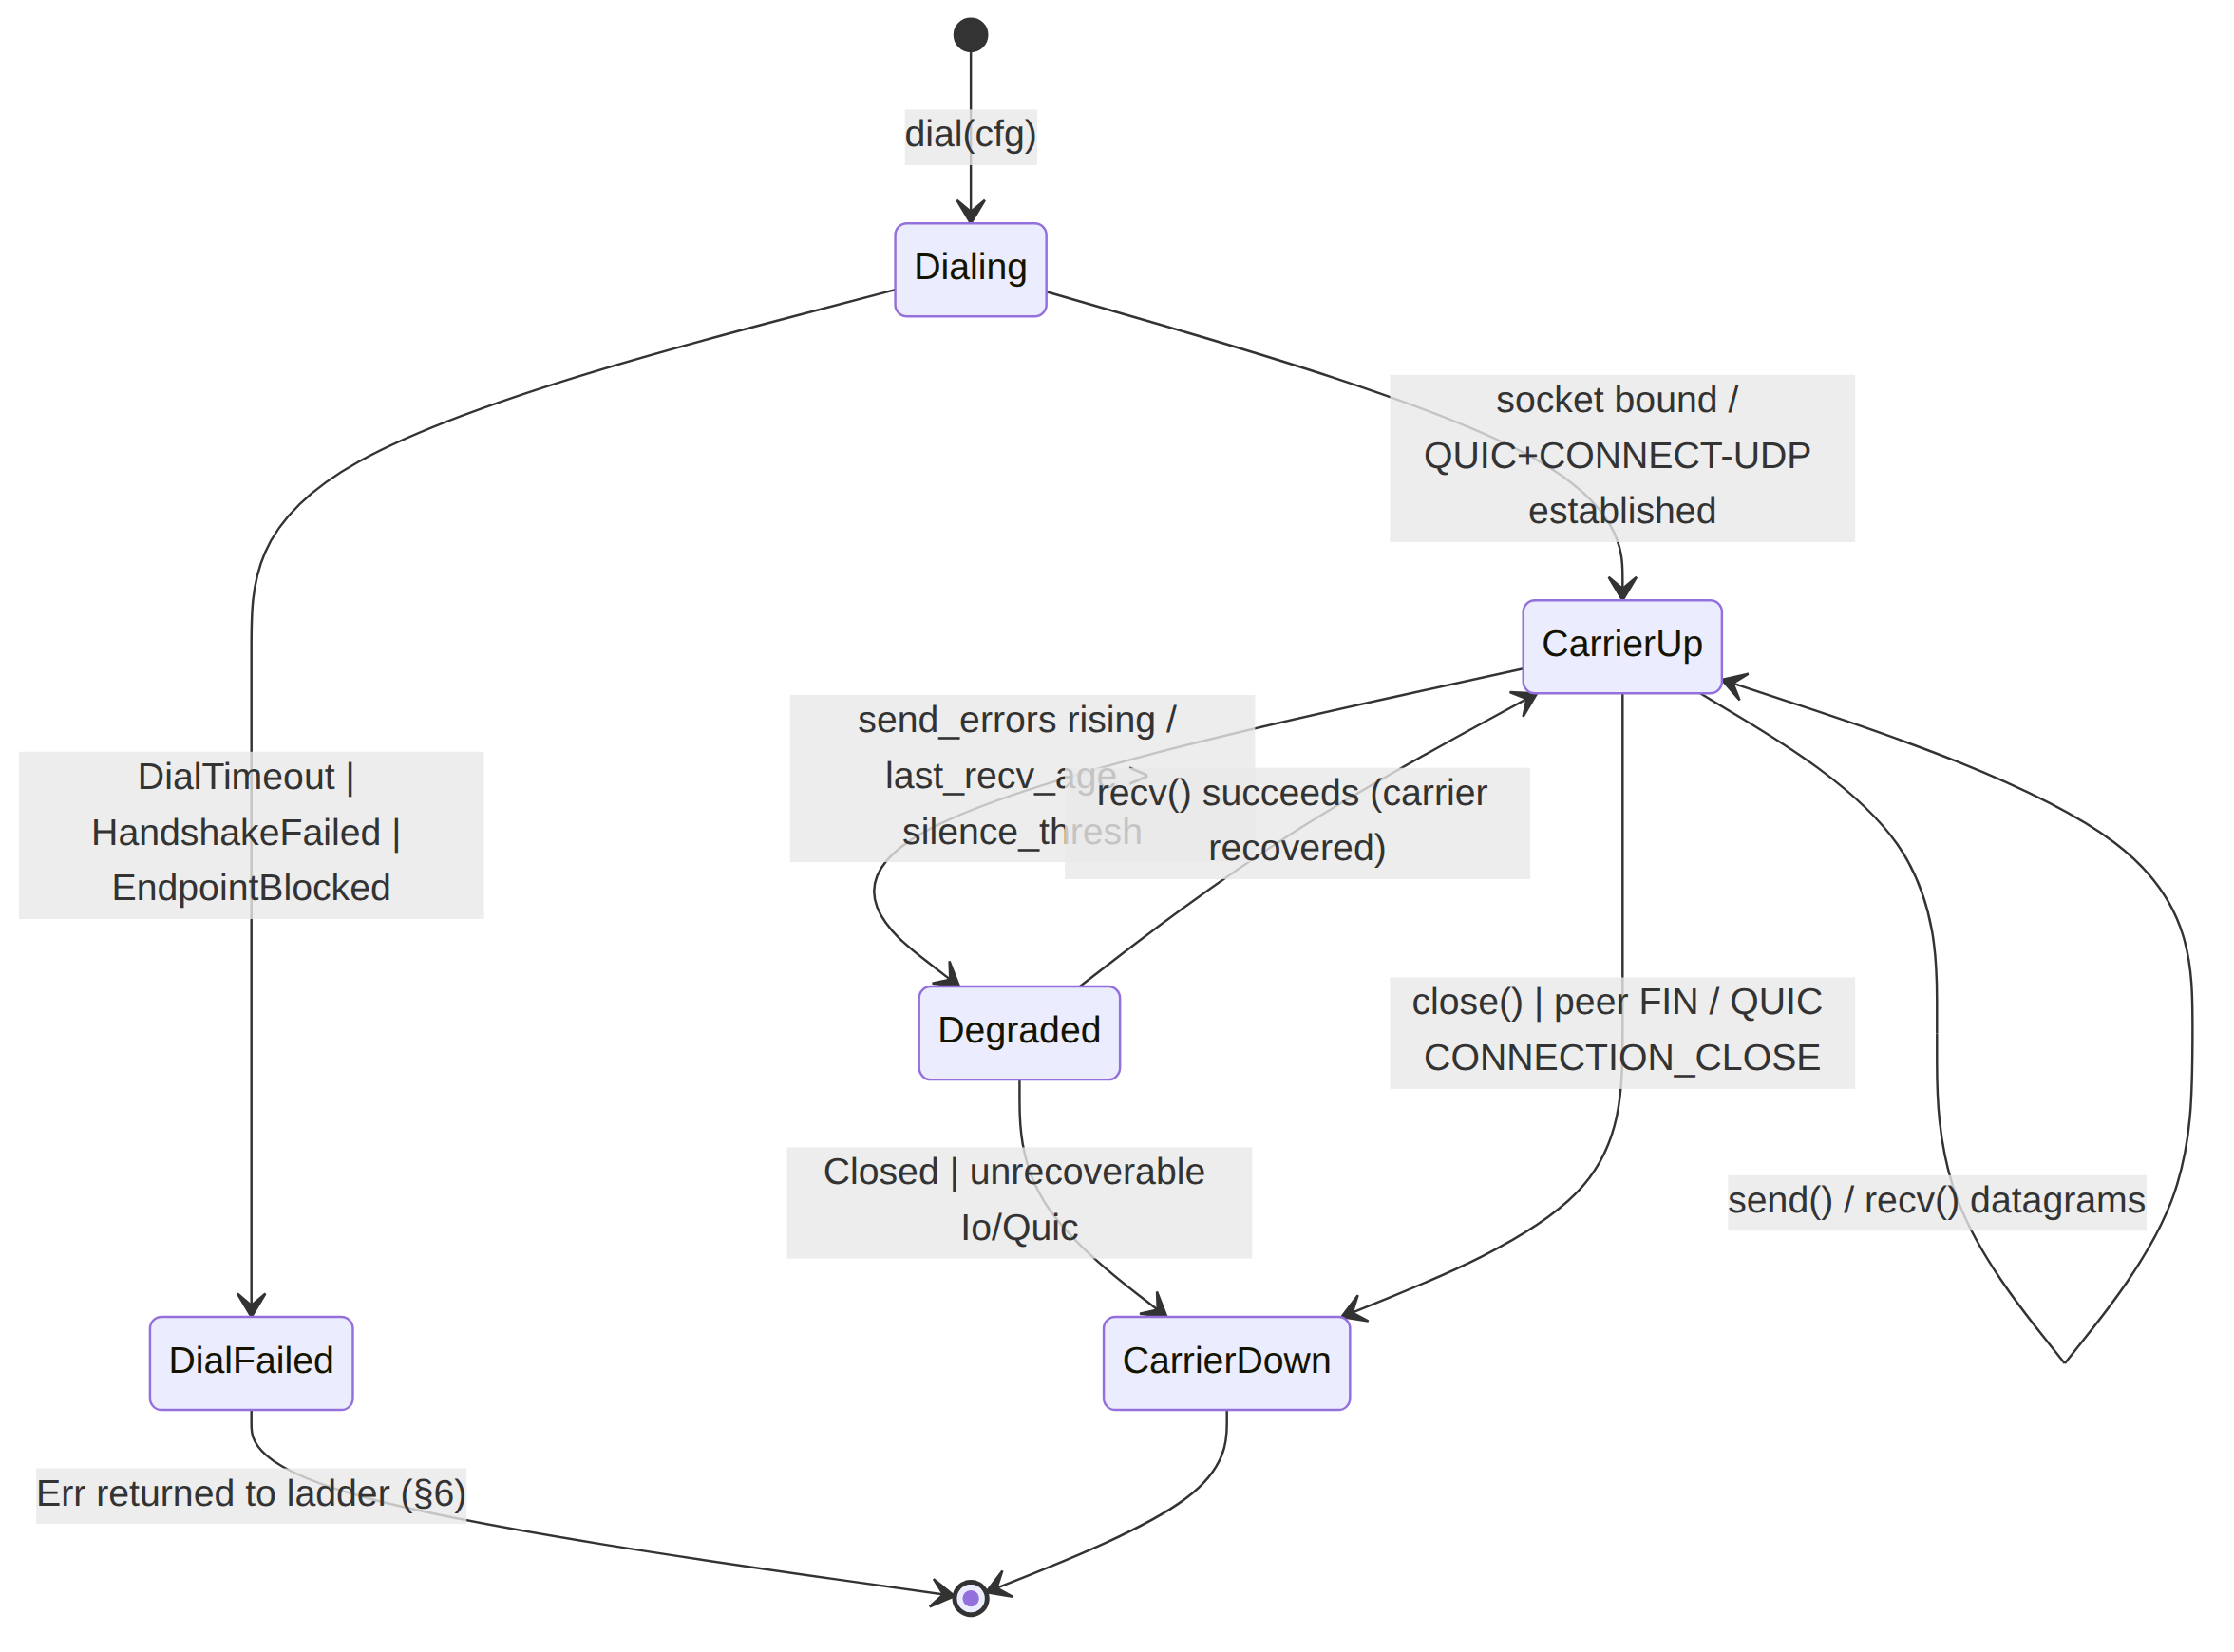
- Dialing: dial(cfg) runs within a bounded DIAL_TIMEOUT (§5.5). For plain-udp this is a socket bind (sub-ms); for masque-h3 it is the full QUIC + Extended-CONNECT establishment (§4.2.1).
- CarrierUp: datagrams flow. No WG state here — the carrier is oblivious to whether the WG handshake on top has completed (I1).
- Degraded: a soft state surfaced via health() (rising send_errors / growing last_recv_age_ms), not a hard error. The orchestrator/ladder reads it to pre-emptively escalate before a hard failure (§6.3).
- CarrierDown: terminal; send/recv return Err(Closed). Reached by close() (graceful) or an unrecoverable error.

5.2 Tunnel-level states (orchestrator projection — the UX seam)
The orchestrator composes carrier state with the WG handshake into TunnelStatus, broadcast to FFI + metrics + ladder via tokio::sync::broadcast [01-DP §5.2]:
// helix-core/src/status.rs (consumed here; OWNED by [01-DP §5.2])
#[derive(Clone, Debug)]
pub enum TunnelStatus {
Connecting, // dial in flight (carrier Dialing)
Handshaking, // carrier up, WG handshake in flight
Connected { transport: String, rtt_ms: u32 }, // carrier up + WG established
Reconnecting, // carrier down/escalating; ladder advancing
Down { reason: String }, // all rungs exhausted / fatal
}

5.3 Combined lifecycle (carrier ⇄ WG ⇄ status)
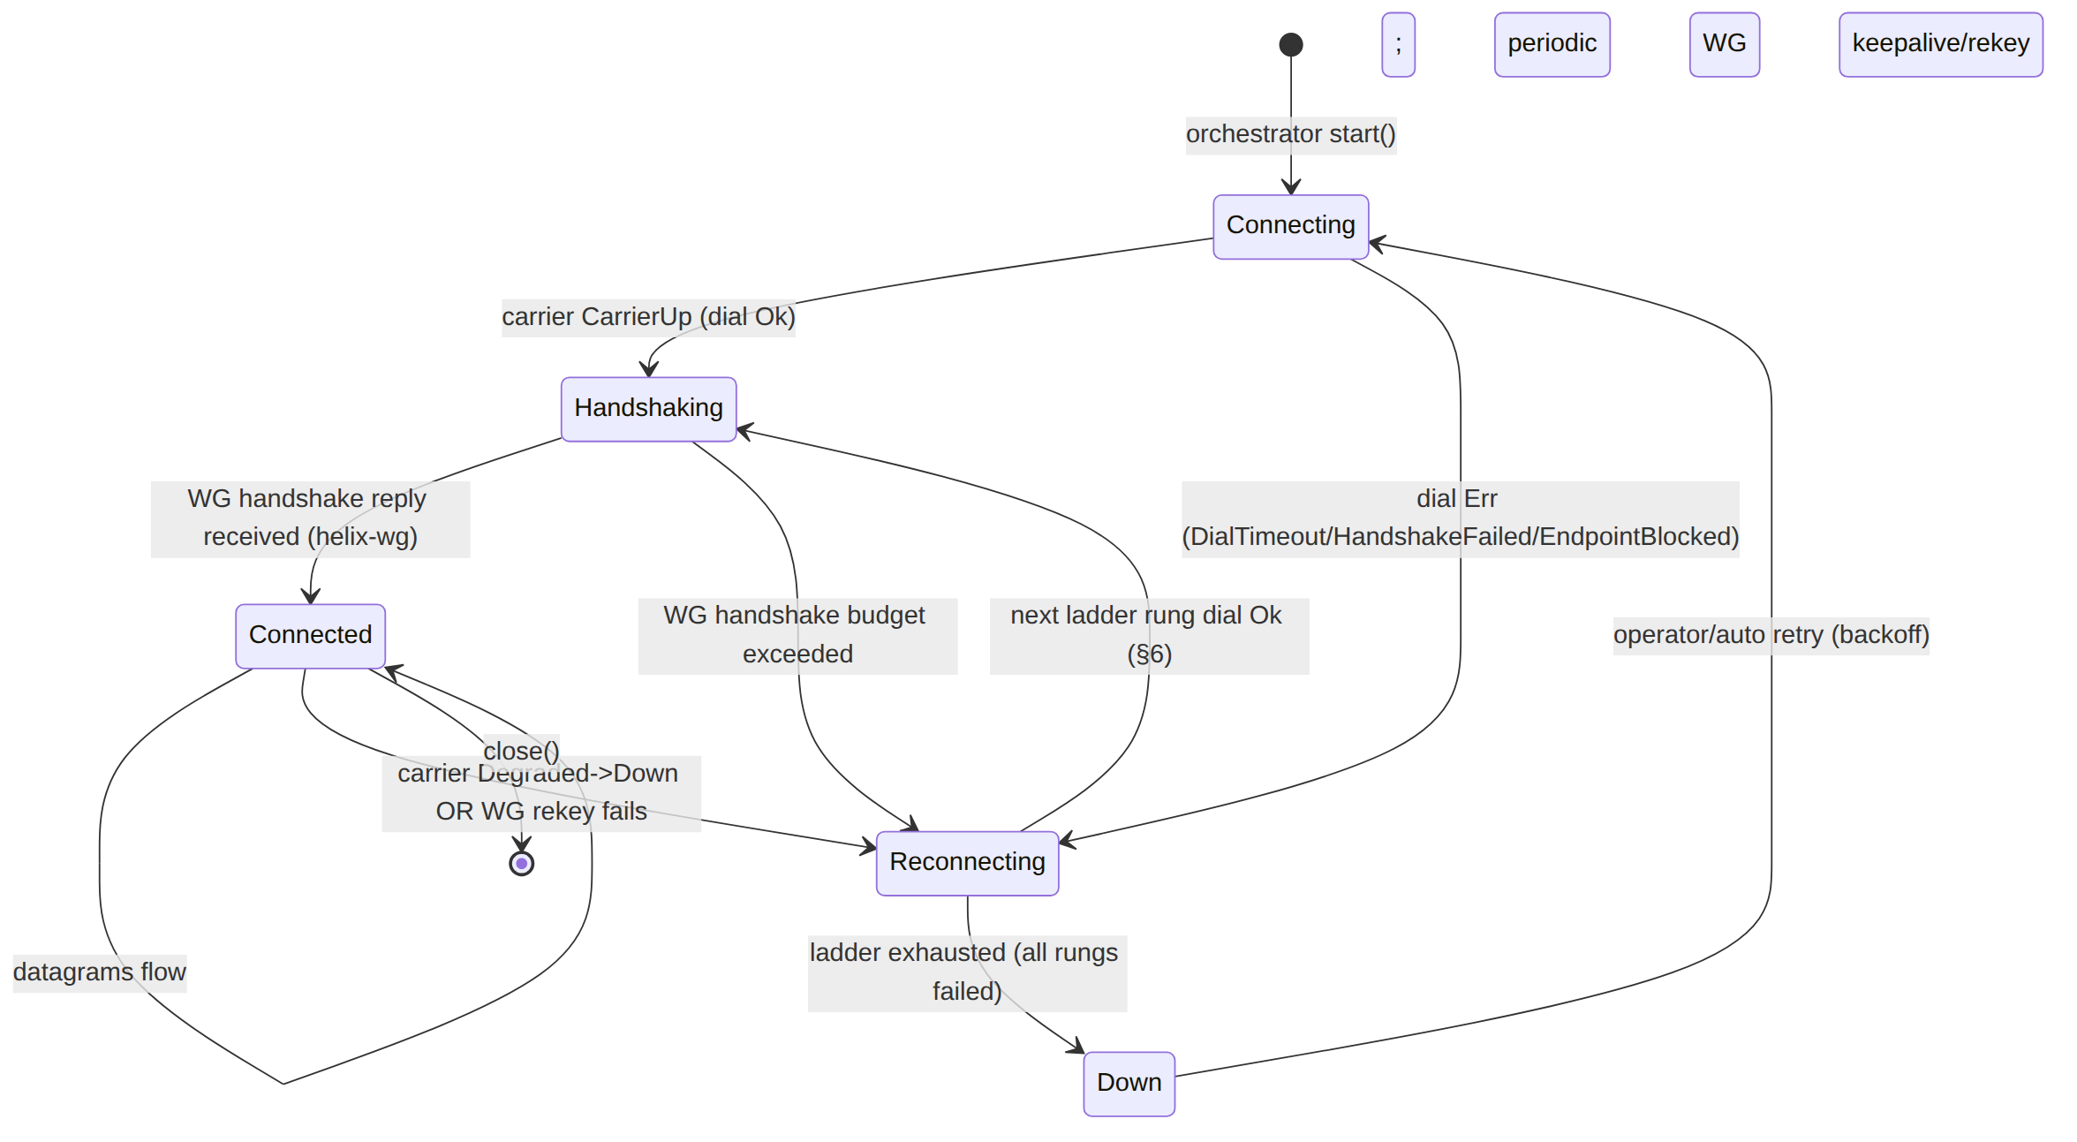
Boundary note (§11.4.6). Connected{rtt_ms} is emitted only after the WG handshake reply lands (a helix-wg event), not merely on CarrierUp — a carrier can be up while the WG tunnel never establishes (e.g. wrong WG peer key). The status enum reflects tunnel liveness, the truth the user cares about [01-DP §5.2].

5.4 Reconnect / roaming semantics
- WG roaming is free. WireGuard latches onto whatever source address a valid handshake/keepalive arrives from; a network change (Wi-Fi→cellular) that keeps the carrier reachable needs no transport re-dial — WG roams on top [01-DP §8 step 2]. The transport only re-dials when the carrier dies (socket error, QUIC CONNECTION_CLOSE).
- Per-network memory. On a successful dial, the ladder remembers the working TransportKind keyed by network identity (SSID / gateway fingerprint) so a reconnect on the same hostile network skips straight to what worked [01-DP §5.3 step 4]. This is ladder state (§6), not transport state.
- Reconnect backoff (UNVERIFIED exact schedule — orchestrator owns it): recommended exponential backoff with jitter between full ladder sweeps to avoid thundering-herd re-dials; the per-rung failure budget (§6.2) governs within a sweep.

5.5 Timeout & budget constants (carrier-level)
Constant | Recommended default | Meaning | Source
DIAL_TIMEOUT | 5 s (UNVERIFIED, tune) | max time for dial before DialTimeout | [01-DP §3.1 "bounded dial timeout"]
silence_thresh (last_recv_age) | 15 s (UNVERIFIED) | carrier→Degraded if no recv | derived from §6.3
CLOSE_GRACE | 2 s (UNVERIFIED) | max time close() may take to flush | §2 close contract
per-rung FailureBudget | { max_handshakes: 3, window: 10 s } (UNVERIFIED) | dials/handshakes before escalate | [01-DP §5.3]
All four are calibrated on Phase-0 fixtures (§11.4.107(13) no-hardcoded-from- literature) and recorded in the BENCH evidence, not asserted [04_P0 §8].

5.6 close() semantics
close is idempotent and bounded by CLOSE_GRACE. Per carrier: plain-udp drops the socket (Ok immediately); masque-h3/hysteria2 call quinn::Connection::close(0, b"bye") and let quinn flush [01-DP §3.3]; shadowsocks/udp-over-tcp send TCP FIN. After close, send/recv return Err(Closed). A second close is a no-op Ok(()).

6. dial() and the escalation-ladder constructor

6.1 dial — the single constructor
/// Build a live, CarrierUp Transport from a resolved config.
/// Returns within DIAL_TIMEOUT (§5.5). On DialTimeout/HandshakeFailed/
/// EndpointBlocked the LADDER (§6.4) escalates to the next rung.
/// On Ok, the returned Box<dyn Transport> is in state CarrierUp (§5.1).
pub async fn dial(cfg: TransportConfig) -> Result<Box<dyn Transport>, TransportError> {
match cfg {
TransportConfig::PlainUdp { peer, bind } => /* §4.1 */,
TransportConfig::MasqueH3 { url, sni, bind, congestion } => /* §4.2 */,
TransportConfig::ConnectIp { .. } => /* §4.5 feature-gated */,
TransportConfig::Shadowsocks { peer, method, psk } => /* §4.3 */,
TransportConfig::UdpOverTcp { peer, tls_sni } => /* §4.4 */,
TransportConfig::Lwo { peer, bind, session_key } => /* §4.6 */,
#[cfg(feature = "hysteria2")]
TransportConfig::Hysteria2 { url, sni, salamander_pw } => /* §4.7 */,
}
}
dial is the only way to obtain a Transport; impls expose no public new that bypasses the bounded-timeout + state-machine guarantees.

6.2 The ladder policy (owned by helix-core/src/ladder.rs, consumed here)
// helix-core/src/ladder.rs ([01-DP §5.3])
pub struct TransportPolicy {
pub order: Vec<TransportKind>, // coordinator-pushed; e.g. regional prior (§6.5)
pub pin: Option<TransportKind>, // user manual override — skip the ladder
pub budget: FailureBudget, // { max_handshakes: u8, window: Duration } per rung
}
pub struct FailureBudget { pub max_handshakes: u8, pub window: Duration }
// Default order (unrestricted network): [ PlainUdp ]
// Restricted prior (censored region, coordinator): [ PlainUdp, Lwo, MasqueH3, Shadowsocks, UdpOverTcp ]

6.3 Selection algorithm (the rung-walk) [01-DP §5.3]
- Start at pin if set (manual override), else order[0].
- Resolve the rung's TransportKind to a TransportConfig (hydrate secrets from the NetworkMap), call dial(cfg).
- On Ok(carrier) within the rung's FailureBudget → done; the WG handshake proceeds on top; emit Connected{transport, rtt} once WG establishes.
- On DialTimeout/HandshakeFailed/EndpointBlocked exceeding the rung's budget → escalate to the next rung; emit Reconnecting.
- A Degraded carrier (§5.1) that crosses silence_thresh is treated as a soft failure and triggers escalation without waiting for a hard error (pre-emptive, reads health()).
- On success, remember the working TransportKind per-network (SSID / gateway fingerprint) — reconnects on the same hostile network skip straight to what worked [01-DP §5.3 step 4].
- Telemetry records only "transport X succeeded after N escalations in region R" (aggregate, no per-user data, I5) → Censorship-Evasion Success dashboard [01-DP §5.3 step 6].

6.4 Atomic carrier swap
On escalation the orchestrator: close() the failed carrier (best-effort, ignore error) → dial the next rung → on Ok, atomically swap the active Box<dyn Transport> under the transport lock (§2.2) → resume the send/recv loops against the new carrier. The swap never happens mid-datagram (datagrams are atomic, DG).

6.5 Regional prior & per-leg topology
- The coordinator may push a regional prior (e.g. CN-resolved clients start at Shadowsocks) so users in censored regions don't pay escalation latency every time [01-DP §5.3 step 5].
- Per-leg topology (decision D6) is free: each leg is an independent Transport selection. The coordinator pushes a TransportPolicy.order per leg — user↔gateway may start at masque-h3/hysteria2 while gateway↔connector stays plain-udp on cooperative networks. No code change beyond per-leg policy [01-DP §11.3, SYNTHESIS §3 D6]. D6 SURFACED.

6.6 Ladder sequence (the headline diagram)
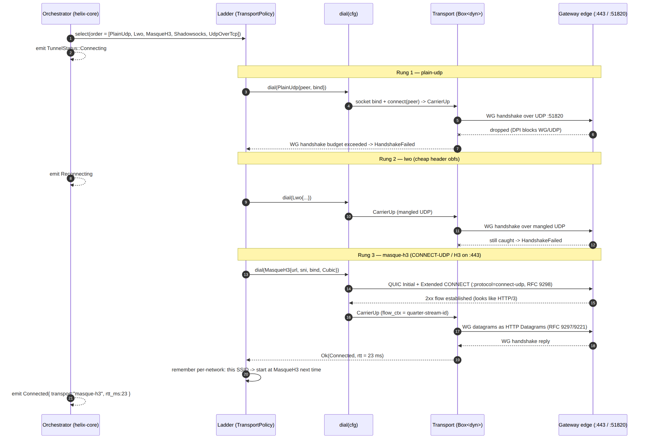

7. Error taxonomy
// helix-transport/src/error.rs ([01-DP §3.1])
#[derive(thiserror::Error, Debug)]
pub enum TransportError {
#[error("dial timed out")] DialTimeout,
#[error("handshake failed: {0}")] HandshakeFailed(String), // -> ladder escalation
#[error("peer endpoint blocked")] EndpointBlocked, // DPI/firewall verdict
#[error("transport closed")] Closed,
#[error("oversize datagram {0} > mtu")] Oversize(usize),
#[error("io: {0}")] Io(#[from] std::io::Error),
#[error("quic: {0}")] Quic(String),
}

7.1 Per-variant semantics & ladder coupling
Variant | Raised by | Carrier-state effect | Ladder action | Source
DialTimeout | dial exceeding DIAL_TIMEOUT | Dialing→DialFailed | escalate to next rung | [01-DP §3.1]
HandshakeFailed(why) | dial (QUIC/CONNECT-UDP failed) or orchestrator (WG handshake budget exceeded) | Dialing→DialFailed | escalate (the canonical escalation trigger) | [01-DP §3.1, §5.3]
EndpointBlocked | send/dial on ICMP port-unreachable / TCP RST / connection-refused (DPI/firewall verdict) | CarrierUp→CarrierDown | escalate | [01-DP §3.1]
Closed | send/recv after close or peer FIN / QUIC CONNECTION_CLOSE | →CarrierDown | orchestrator → Reconnecting/Down | [01-DP §3.1]
Oversize(n) | send when datagram.len() > effective_mtu + headroom | none (rejects the one datagram) | no escalation; orchestrator lowers inner MTU / L3-fragments (§4.8 rule 3) | [01-DP §3.1, §10]
Io(e) | any syscall error | varies; repeated → Degraded | counted in send_errors; sustained → escalate | [01-DP §3.1]
Quic(s) | quinn errors (masque/hysteria2/connect-ip) | varies | sustained → escalate | [01-DP §3.1]

7.2 Error classification rules (§11.4.6 no-guessing)
- An error is never labelled "transient/flaky" without captured evidence (§11.4.6/.50) — the RACE/SC test types (§9) deterministically reproduce each class N times.
- EndpointBlocked vs Io discrimination is observational, not guessed: EndpointBlocked requires a concrete signal (ICMP unreachable, RST, refused); ambiguous silence is last_recv_age Degraded, not EndpointBlocked.
- HandshakeFailed carries a String reason (e.g. "no QUIC datagram support", "CONNECT-UDP 4xx", "WG no handshake reply in budget") for the §6 telemetry — never a secret value (§11.4.10).

8. How the same trait serves client, connector, and edge (I4)
One trait, three consumers, N transports [04_P0 §4.2]. The byte-for-byte shared-code guarantee is the whole point of the crate [01-DP §0.1 I4].
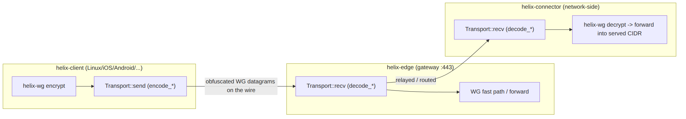

8.1 Client role
Captures the device default route, encrypts in helix-wg, optionally shapes in helix-daita, then Transport::sends. Runs the ladder (§6) — it is the only role that escalates (the edge/connector accept whatever carrier the client dials). effective_mtu() sets the inner WG MTU [01-DP §5.1, §10].

8.2 Connector role
The same core, different routing posture: instead of capturing the default route it (a) advertises served CIDRs, (b) NATs/forwards decapsulated packets into the LAN [01-DP §5.1]. It is a Transport recv-side consumer for gateway↔connector traffic; on cooperative networks this leg typically stays plain-udp (per-leg D6, §6.5) [01-DP §11.3]. One binary, --mode={client|connector} [01-DP §5.1].

8.3 Edge role (gateway MASQUE termination — decision D5)
The edge is the third consumer of helix-transport [01-DP §2]. It runs the inverse of every encode_*/decode_*: decode_http_datagram where the client encoded, terminating CONNECT-UDP and emitting plain WG datagrams to the kernel WG fast path (§4.2). Decision D5 (Rust vs Go edge) is SETTLED BY THE PHASE-0 G4 BENCHMARK [01-DP §11.2, SYNTHESIS §3 D5]: this spec assumes Rust (shares helix-transport byte-for-byte, no GC on the hot path), with Go (quic-go+masque-go) as the conformance-suite-mitigated fallback if MASQUE-in-Rust proves painful (dual impls kept in sync by **shared test vectors
- a cross-edge conformance suite**) [01-DP §11.2, research-masque §4]. D5 SURFACED.
Conformance-suite contract (anti-bluff, §11.4.27/.50). If the Go edge is adopted, the I4 guarantee is preserved by a shared encode/decode test vector corpus: a frozen set of (WG datagram, on-wire bytes) pairs that BOTH the Rust client encode and the Go edge decode (and vice versa) must satisfy bit-for-bit. A divergence is a release blocker — it is the mechanical proof that "the client obfuscates with the same logic the edge de-obfuscates."

9. Test points — tied to the §11.4.169 closed test-type vocabulary
Every Transport workable item declares its required test types from the §11.4.169 closed set; the ONLY permitted absence of a warranted type is an honest §11.4.3 SKIP-with-reason, never a silent gap [06-phase0-spike-wbs §0.4]. Four- layer enforcement per §11.4.4(b) applies to every closure.
Code (§11.4.169) | Type | Concrete test point for helix-transport | Evidence (§11.4.5/.69/.107)
UT | unit | encode_http_datagram/decode_* round-trip is identity for random WG-sized Bytes; effective_mtu boundary; TransportError mapping; SecretBytes Debug redaction + zeroize-on-drop | cargo test output; redaction assertion
IT | integration (real System, netns + edge + connector booted via containers submodule §11.4.76) | dial each carrier against a real edge; send→peer recv yields identical bytes; CONNECT-UDP flow really establishes | netns capture; per-carrier round-trip log
E2E | end-to-end | client overlay ns → curl http://10.10.0.20/ over each carrier, incl. plain-UDP blocked (MASQUE only) | curl hello-page capture (G1/G2)
FA | full-automation (§11.4.25/.52/.98, deterministic §11.4.50) | one-shot make spike, N=3 identical ladder-escalation runs producing the same ordered TunnelStatus trace | 3× identical status-trace artifacts
CH | Challenges (challenges submodule §11.4.27(B)) | per-gate Challenge scores the captured G1/G2 evidence, not config | Challenge result.json
HQA | HelixQA (helix_qa submodule) | autonomous QA session drives dial→escalate→connected across carriers | HelixQA session evidence
LOAD | DDoS / load-flood | 1/10/100 concurrent carriers + handshake-flood at dial; no fd leak, bounded mem | iperf3 + handshake-flood CSV
SEC | security (§11.4.10 + security submodule) | (a) tshark shows MASQUE flow = HTTP/3, no WG signature (G2); (b) secret-leak grep: plant a SecretBytes value, prove it appears in no log/tracked file; (c) no-plaintext-leak: recv bytes never decrypted in-crate (I1) | tshark classification; grep-empty proof
SC | stress + chaos (§11.4.85) | iface flap, netem loss 5% (MASQUE goodput > UoT strawman [04_P0 §5.3]), process-kill mid-transfer → reconnect; close during in-flight send | goodput-under-loss CSV; recovery trace
CONC | concurrency / atomicity | concurrent send (task A) + recv (task B) on one carrier; atomic carrier-swap (§6.4) under load drops zero datagrams mid-swap | concurrency harness log
RACE | race / deadlock | cargo test --features loom on the health-cell + swap; -race on the Go edge if adopted | loom report
MEM | memory | RSS under iOS NE ceiling for plain-udp and masque (G3 make-or-break); no per-datagram heap growth | /proc/Instruments RSS sample
BENCH | benchmarking / performance | bench.sh: per-carrier throughput / CPU-per-Gbps / p99 incl. GC tail; effective_mtu measured not assumed | throughput/CPU/p99 CSV

9.1 Carrier-specific acceptance gates (Phase 0) [01-DP §12.1, 04_P0 §8]
- G1 plain-udp — iperf3 through-tunnel ≥ 80% bare link + curl to LAN host succeeds (BENCH + E2E).
- G2 masque-h3 through DPI block — works with plain WG blocked (nft rule), tshark classifies HTTP/3 with no WG signature, goodput @ 5% netem loss beats the UoT strawman (SC + SEC + E2E).
- Per-transport — effective_mtu() measured (not assumed); ladder escalation captured as an ordered TunnelStatus event trace (FA); Oversize is a hard error, proven by a denied-oversize capture.

9.2 Anti-bluff rule for this crate (§11.4.5/.69/.107)
Every Transport PASS ships captured wire/throughput evidence, never a config-only or grep-only PASS. A green send/recv unit test does not prove a carrier works end-to-end — the IT/E2E netns round-trip with a real edge is the authoritative evidence [04_P0 §8, §12.1]. The MASQUE "looks like a browser" claim is proven by the tshark G2 capture, not asserted [04_P0 §5.4, §8].

10. Security considerations
# | Consideration | Mitigation in this spec | Source
S1 | Plaintext never reaches the transport | I1 enforced by Bytes-opaque API; SEC test proves no in-crate decrypt; even lwo mutates ciphertext only | [01-DP §0.1 I1]
S2 | Transport secrets must not leak | SecretBytes: redacted Debug, zeroize-on-drop, no Serialize, never logged; SEC plant-and-grep proof (§9) | §3.2, §11.4.10
S3 | QUIC/TLS fingerprint mimicry is an OPEN problem | Mullvad does NOT publish its anti-fingerprint layer (uTLS-style ClientHello/SNI/ALPN/transport-param mimicry of a real browser). Treat as an explicit research/risk item, not a solved checkbox; sni/congestion are the seams. Do not claim DPI-proof. | [research-masque §2, §5] (honest gap)
S4 | No durable per-connection state | I5: only aggregate TransportHealth counters; no per-packet/per-conn durable log; telemetry is "transport X after N escalations in region R" aggregate | [01-DP §0.1 I5, §5.3]
S5 | Default-deny survives the carrier | the transport carries only what WG AllowedIPs + the edge verdict map permit; a carrier compromise does not bypass policy (defense in depth, [01-DP §7]) | [01-DP §7]
S6 | Double-crypto / double-CC cost is real | WG-over-MASQUE = WG AEAD inside QUIC AEAD + QUIC CC over UDP; throughput loss is acknowledged, BENCH must capture WG-direct vs WG-over-MASQUE — do not claim parity speed | [research-masque §2, §5]
S7 | Masquerade decoy | edge serves a believable decoy to non-CONNECT-UDP probes; verified by SEC G2 | [01-DP §3.3, 04_P0 §5.4]

11. Performance budget
Metric | Budget / target | Basis | Source
plain-udp throughput | ≥ 80% of bare-link (the G1 baseline every carrier is measured against) | G1 gate | [01-DP §3.2, 04_P0 §8]
masque-h3 throughput | ≥ 50% of plain-udp (G2 bar); real loss from double-crypto/double-CC | G2 gate; acknowledged tax | [04_P0 §8, research-masque §2]
masque-h3 goodput @ 5% loss | > UDP-over-TCP strawman (the mobile-loss reason this feature exists) | G2 sub-bar | [01-DP §3.3, 04_P0 §5.3]
effective_mtu (masque) | 1280 floor, measured & tuned in Phase 0 (not assumed) | MTU budget | [01-DP §10, 04_P0 §5.2]
iOS NE RSS (plain-udp + masque) | under device ceiling with ≥ 30% headroom (G3 make-or-break) | G3 gate | [04_P0 §1 G3]
health() sample cost | callable ≥ 10 Hz without contending hot send/recv | §2.3 contract | derived
CC selection | Cubic default; Bbr for lossy mobile (Hysteria "Brutal" lineage as window-ratio reference) | tuning knob | [01-DP §3.3, 04_ARCH §14]
dial latency | plain-udp sub-ms (bind only); masque-h3 = QUIC+CONNECT-UDP RTT (bounded by DIAL_TIMEOUT) | §4.1, §4.2 | derived
All budgets are captured in the Phase-0 BENCH CSV (throughput @ 1/10/100 clients, CPU/Gbps, p99 incl. GC tail, handshake churn/sec, memory under churn) [04_P0 §7.2, §8] — measured evidence, never asserted (§11.4.6/.123).

12. Frozen-contract status & cross-doc seams
The Transport trait (§2), TransportConfig/TransportKind (§3), TransportError (§7), and dial (§6) are frozen Phase-0 contracts designed to survive into Phase 1 — their implementations may evolve, their surface may not without an explicit decision (§11.4.66) [04_P0 §4.2, §14, 01-DP §13].
Cross-doc seams: TransportConfig is sourced by doc 03 (WatchNetworkMap — the live source of the static map.json seam [01-DP §6.2]); effective_mtu() feeds helix-wg inner-MTU ([01-DP §4, §10]); the carrier lifecycle projects into TunnelStatus owned by helix-core [01-DP §5.2]; the edge consumer's MASQUE termination is settled by Phase-0 G4 (decision D5, [01-DP §11.2]). Out of scope here: WG crypto internals (doc 01 §4), orchestrator loops (doc 01 §5.1), platform TUN shims (doc 06).

End of nano-detail specification — The Transport Trait (Volume 2, Data Plane). Pairs with [01-DP §3] (the overview this deepens), doc 03 (WatchNetworkMap, the TransportConfig source), and the security doc (QUIC/TLS fingerprint mimicry research item S3). Surfaced decisions: D1 primary obfs transport (§4.7), D5 edge language (§8.3), D6 per-leg topology (§6.5) — all presented, none silently resolved (§11.4.66).

