UDP-over-TCP Transport

UDP-over-TCP Transport
Revision: 2 Last modified: 2026-07-04T12:00:00Z
Rev 2 (enterprise-hardening audit, 2026-07-04): independently reviewed against the parent gap-analysis checklist. This document already contains the deepest resource-exhaustion treatment in Volume 2 — §9 E8 (slow-loris) / E12 (huge-LEN buffer-cap) edge cases and §12 S5 (reassembly-buffer DoS bound by max_acc_bytes) — no addition made here to avoid duplicating already-thorough content. No consistency issue found against transport-trait.md or 01-data-plane.md.
Master technical specification — Volume 2 (Data Plane), nano-detail document. Deepens the udp-over-tcp — last resort when all UDP is blocked section (§3.6) of [01-DP §3.6]. This is a SPEC — it describes the helix-transport::udp_over_tcp module to be built, not the shipping product. Source evidence cited inline by id: [01-DP §N] = final/01-data-plane.md; [04_ARCH §N] = 04_VPN_CLD/HelixVPN-Architecture-Refined.md; [04_P2 §N] = the Phase-2 refined doc; [SYNTHESIS §N] = the cross-document synthesis; [11-DR §N] = final/11-deep-research-appendix.md; [10-QA §N] = final/10-testing-acceptance-and-qa.md. External protocol constants not part of this evidence base (WireGuard message sizes, TCP/TLS header sizes) are tagged [WG-PROTO] / [TCP] / [TLS] and, where their exact value is not load-bearing, annotated honestly per constitution §11.4.6. Anything not grounded in the evidence base is marked UNVERIFIED.

0. Scope & contract summary
udp-over-tcp (UoT) is the lowest rung of the transport escalation ladder [01-DP §5.3]: it length-prefixes already-encrypted WireGuard datagrams over a single TCP connection, matching Mullvad's udp2tcp / the Rust udp-over-tcp crate [01-DP §3.6, 04_ARCH §3.2, 04_P2 §1.2, 11-DR A4]. It exists for exactly one purpose: keep a tunnel possible on networks where all UDP is blocked — the failure mode where plain-udp, lwo, masque-h3 (QUIC/UDP), and shadowsocks-over-QUIC all fail because the path drops UDP entirely [11-DR A3 "Hard UDP block"]. It pays a head-of-line-blocking (HoL) penalty by construction (TCP imposes an ordered, reliable byte stream over WG's unreliable datagrams) and is therefore ranked last in every ladder order — preferred only when nothing faster connects [01-DP §3.6, §0.1 I2].
This document owns, to nano-detail:
- The UdpOverTcp type and its full Transport implementation (§4).
- The on-the-wire framing — the 2-byte big-endian length prefix + opaque WG datagram, the optional TLS wrap, byte-exact layouts (§5).
- The connection lifecycle + framer/deframer state machines (§6).
- The HoL-blocking tradeoff — why it is unavoidable, what it costs, how the orchestrator bounds its damage (§7).
- Error taxonomy, config knobs, edge cases, security, performance budget (§8–§12).
- The concrete test points, tied to the §11.4.169 test-type taxonomy [10-QA §1] (§13).
Invariants inherited unchanged [01-DP §0.1]:
# | Invariant | How UoT honours it
I1 | Transport never sees plaintext. | UoT frames an opaque WG datagram; it never inspects, parses, or decrypts the payload — the length prefix is the only byte it adds.
I2 | Transport carries unreliable datagrams, not an ordered stream. | UoT violates the spirit of I2 at the wire (TCP is ordered+reliable) but preserves the contract at the trait boundary: send/recv still exchange whole WG datagrams. WG's own loss/replay handling runs unchanged on top; the cost is HoL latency, not a semantic break (§7). This is the documented, accepted tradeoff of the last rung.
I4 | One transport crate, three consumers. | The same udp_over_tcp.rs runs on client (frames out), edge (deframes in), and connector; framing is symmetric.
I5 | No-logging by construction. | Only aggregate counters (bytes, frames, reconnects) — never per-datagram durable state.
File: helix-transport/src/udp_over_tcp.rs (the unit this doc specifies)
Trait: helix-transport/src/lib.rs::Transport (the contract; frozen Phase-0 interface) [01-DP §3.1]
Config: helix-transport/src/lib.rs::TransportConfig::UdpOverTcp { peer, tls_sni } [01-DP §3.1]
Errors: helix-transport/src/error.rs::TransportError [01-DP §3.1]
Phase: 2 (full transport set) [01-DP §12, 04_P2 §1.2]; the `Transport` trait it implements is frozen Phase-0.

1. When udp-over-tcp is selected — selection conditions
UoT is ladder rung N (last) in any restricted-network TransportPolicy.order; on an unrestricted network it is never reached [01-DP §5.3]. The orchestrator selects it in this closed set of cases:
# | Condition | Source
C1 | All UDP blocked — plain-udp, lwo, masque-h3, shadowsocks (QUIC-carried) each exceeded their per-rung failure budget; the ladder has escalated to its final rung. | [01-DP §5.3 step 3], [11-DR A3]
C2 | Per-network memory hit — a prior successful UoT connect on this SSID / gateway fingerprint is remembered and re-tried first, so the user does not pay the full escalation latency again on the same hostile network. | [01-DP §5.3 step 4], [04_P2 §1.4]
C3 | Regional prior — the coordinator pushed a TransportPolicy.order that ends in (or, for a known UDP-blackholing region, starts higher up but still terminates at) udp-over-tcp. | [01-DP §5.3 step 5], [04_P2 §1.4]
C4 | Manual pin — user sets TransportPolicy.pin = UdpOverTcp (rare; deliberate "make it work on this captive/corporate network" choice). | [01-DP §5.3 step 1], [04_ARCH §3.2]
UoT is never the default order[0]. The default unrestricted order is [plain-udp]; the restricted prior is [plain-udp, lwo, masque-h3, shadowsocks, udp-over-tcp] [01-DP §5.3]. Rule: the orchestrator MUST exhaust every UDP-capable rung before UoT, because UoT's HoL penalty makes it the worst-performing carrier (§7).
UNVERIFIED (TLS-443 DPI residual): [11-DR A3] notes that on a path with SNI/TLS DPI on TCP 443, a naive TLS-wrapped UoT may still be fingerprinted unless it presents a real-site TLS fingerprint (VLESS+Reality / ShadowTLS class). HelixVPN's MVP UoT ships the plain and opportunistic-TLS-camouflage variants only (§5.4); a Reality-grade TLS-mimic UoT is a Phase-3 hardening item, not specified here. Where TLS-443 DPI also blocks UoT, the honest outcome is EndpointBlocked → no tunnel (the residual-censorship boundary), not a silent degraded PASS.

2. Reference implementations & build stance
Reference | What it gives us | Stance
Mullvad udp-over-tcp Rust crate | The canonical 2-byte-length-prefix framing this module reproduces; Mullvad's udp2tcp obfuscation mode is literally this crate. | Reuse the framing design; reimplement in-crate so UoT shares helix-transport's Transport trait, error taxonomy, and HealthCell (I4) rather than bolting on a foreign socket loop. [11-DR A4], [04_P2 §1.2]
dndx/phantun (fake-TCP, 12-byte overhead, user-mode TCP, 100% safe Rust) | An alternative fake-TCP approach (forges TCP segments over a raw/AF_PACKET socket; no real kernel TCP, no HoL because it does not implement TCP retransmit). | Phase-3 option, not MVP. Phantun needs CAP_NET_RAW / raw-socket privileges and a kernel that lets it inject TCP segments — heavier deploy surface. Recorded as a documented alternative; MVP UoT uses a real kernel TCP socket (tokio::net::TcpStream) for portability. [11-DR A3, A4]
Decision (build stance): MVP udp_over_tcp.rs = real kernel TCP (tokio::net::TcpStream), Mullvad-style 2-byte length framing, optional opportunistic TLS wrap. Fake-TCP (Phantun-style) is a Phase-3 escape hatch for environments where even real-TCP UoT is throttled but raw-socket injection is available. This keeps the MVP last-rung portable and unprivileged at the cost of real-TCP HoL (§7) — the accepted tradeoff for "keep a tunnel possible" [01-DP §3.6].

3. Module surface (types this document specifies)
// helix-transport/src/udp_over_tcp.rs
use async_trait::async_trait;
use bytes::{Bytes, BytesMut, Buf, BufMut};
use std::net::SocketAddr;
use std::sync::Arc;
use tokio::io::{AsyncReadExt, AsyncWriteExt};
use tokio::sync::Mutex;
use crate::error::TransportError;
use crate::health::HealthCell; // shared with plain-udp/masque [01-DP §3.2]
use crate::{Transport, TransportHealth};
/// Wire constant: the length prefix is a 2-byte big-endian (network order) u16,
/// giving a 0..=65535 byte datagram budget — strictly larger than any WG datagram
/// at any effective_mtu (WG max is well under 1500). [01-DP §3.6, §10]
pub const UOT_LEN_PREFIX_BYTES: usize = 2;
pub const UOT_MAX_DATAGRAM: usize = u16::MAX as usize; // 65535
/// The carrier sub-mode: plain TCP, or TCP wrapped in opportunistic TLS to look like HTTPS.
#[derive(Clone, Debug)]
pub enum UotWrap {
Plain,
/// Opportunistic TLS camouflage; `sni` is the ClientHello SNI presented to blend with HTTPS.
/// NOT a security boundary — WG already provides confidentiality (I1). [01-DP §3.6 "Optional TLS wrap"]
Tls { sni: String },
}
/// Live UoT transport. ONE TCP connection; `send`/`recv` exchange whole WG datagrams.
pub struct UdpOverTcp {
/// Write half behind a mutex: TCP writes must be atomic per-frame (no interleave). (§6.4)
wr: Arc<Mutex<WriteHalf>>,
/// Read half + deframer state behind a mutex: recv() is the sole reader. (§6.5)
rd: Arc<Mutex<ReadHalf>>,
peer: SocketAddr,
kind: &'static str, // "udp-over-tcp" or "udp-over-tcp-tls"
health: HealthCell,
}
/// Internal write side (either plain TcpStream write half or a TLS stream write half).
struct WriteHalf { inner: TcpOrTlsWrite }
/// Internal read side carrying the partial-frame reassembly buffer (§6.5).
struct ReadHalf { inner: TcpOrTlsRead, acc: BytesMut /* unconsumed bytes across reads */ }
/// Sum type so the same framing code drives plain TCP and TLS-wrapped TCP without generics leaking
/// into the Transport object. (`TcpOrTls*` wrap tokio TcpStream halves or tokio-rustls TlsStream halves.)
enum TcpOrTlsWrite { Tcp(/* tokio write half */), Tls(/* tokio-rustls write half */) }
enum TcpOrTlsRead { Tcp(/* tokio read half */), Tls(/* tokio-rustls read half */) }
UdpOverTcp is constructed only by dial() (§4.1); it is never directly instantiated by callers. The Arc<Mutex<..>> split (separate write/read locks) lets send and recv run concurrently (full-duplex) while serialising multiple sends against each other so frames never interleave on the wire (§6.4).

4. The Transport impl (nano-detail)

4.1 dial() — establishing the carrier
dial(TransportConfig::UdpOverTcp { peer, tls_sni }) constructs a live UdpOverTcp within the bounded dial timeout; on timeout/refusal it returns DialTimeout / HandshakeFailed, which the orchestrator treats as "this rung failed" — but since UoT is the last rung, a failure here means the ladder is exhausted and the orchestrator emits Down { reason } rather than escalating [01-DP §5.3, §3.1].
// helix-transport/src/lib.rs::dial() dispatch arm for UdpOverTcp
pub(crate) async fn dial_udp_over_tcp(
peer: SocketAddr,
tls_sni: Option<String>,
dial_timeout: std::time::Duration, // from TransportConfig defaults (§11)
) -> Result<UdpOverTcp, TransportError> {
// 1. TCP connect with a hard timeout (UDP-blocking firewalls often *also* RST :51820/tcp,
// so a fast, bounded connect is the common "blocked" signal). [11-DR A3]
let tcp = tokio::time::timeout(dial_timeout, tokio::net::TcpStream::connect(peer))
.await
.map_err(|_| TransportError::DialTimeout)? // timed out → ladder exhausted
.map_err(|e| match e.kind() {
std::io::ErrorKind::ConnectionRefused
| std::io::ErrorKind::ConnectionReset => TransportError::EndpointBlocked, // RST = DPI/firewall
_ => TransportError::Io(e),
})?;
// 2. Disable Nagle: WG datagrams are latency-sensitive; Nagle would coalesce small frames
// and add up to ~40 ms of artificial delay on top of the HoL cost (§7). [TCP]
tcp.set_nodelay(true).map_err(TransportError::Io)?;
// 3. Optional TLS wrap (opportunistic HTTPS camouflage; NOT a security boundary). (§5.4)
let (wr, rd, kind) = match tls_sni {
None => split_plain(tcp),
Some(sni) => {
let tls = tls_client_handshake(tcp, &sni, dial_timeout) // tokio-rustls; ALPN "h2"/"http/1.1"
.await
.map_err(|e| TransportError::HandshakeFailed(format!("uot-tls: {e}")))?;
split_tls(tls)
}
};
Ok(UdpOverTcp {
wr: Arc::new(Mutex::new(WriteHalf { inner: wr })),
rd: Arc::new(Mutex::new(ReadHalf { inner: rd, acc: BytesMut::with_capacity(8 * 1024) })),
peer,
kind,
health: HealthCell::new(),
})
}
Notes:
- No application handshake of its own. UoT carries the WG handshake as its first framed datagrams; the carrier is "up" the moment the TCP (and optional TLS) connection is established. The tunnel is up when WG completes its Noise IK handshake over UoT — that liveness is the orchestrator's concern via TunnelStatus, not UoT's [01-DP §5.2].
- EndpointBlocked vs DialTimeout: a TCP RST (refused/reset) → EndpointBlocked (active DPI/firewall verdict); a connect timeout → DialTimeout (blackhole). Both are terminal for the last rung; the distinction feeds the aggregate censorship telemetry ("UoT EndpointBlocked in region R" vs "UoT timeout in region R", §13) [01-DP §5.3 step 6].

4.2 send — frame one WG datagram
#[async_trait]
impl Transport for UdpOverTcp {
async fn send(&self, dg: Bytes) -> Result<(), TransportError> {
// Hard cap: WG datagram must fit the 2-byte length prefix (always true at any MTU,
// but assert rather than truncate — I1 forbids mangling the opaque payload). (§5.2)
if dg.len() > UOT_MAX_DATAGRAM {
return Err(TransportError::Oversize(dg.len()));
}
let mut frame = BytesMut::with_capacity(UOT_LEN_PREFIX_BYTES + dg.len());
frame.put_u16(dg.len() as u16); // big-endian length prefix [01-DP §3.6]
frame.put_slice(&dg); // opaque WG datagram, byte-for-byte (I1)
// One mutex-guarded write_all: the whole frame lands contiguously; concurrent sends
// serialise here so two frames never interleave on the byte stream (§6.4).
let mut wr = self.wr.lock().await;
wr.inner.write_all(&frame).await.map_err(|e| {
self.health.mark_send_error();
map_io_to_transport(e) // BrokenPipe/Reset → Closed/EndpointBlocked (§8)
})?;
// NOTE: no flush() needed — TCP_NODELAY is set, write_all hands bytes to the kernel.
Ok(())
}

4.3 recv — deframe the next WG datagram
async fn recv(&self) -> Result<Bytes, TransportError> {
let mut rd = self.rd.lock().await;
// Pull whole frames out of the reassembly accumulator; read more bytes only when a
// complete frame is not yet buffered. Cancel-safe: state lives in `rd.acc`, not on the
// stack, so a dropped recv() future (e.g. in select!) loses no bytes. (§6.5)
loop {
if let Some(dg) = try_take_frame(&mut rd.acc)? { // (§6.6)
self.health.mark_recv();
return Ok(dg);
}
// Need more bytes: read into a scratch buffer, append to acc.
let mut scratch = [0u8; 16 * 1024];
let n = rd.inner.read(&mut scratch).await.map_err(map_io_to_transport)?;
if n == 0 {
return Err(TransportError::Closed); // peer FIN / half-close (§6.3)
}
rd.acc.put_slice(&scratch[..n]);
}
}

4.4 kind, effective_mtu, health, close
fn kind(&self) -> &'static str { self.kind } // "udp-over-tcp" | "udp-over-tcp-tls"
fn effective_mtu(&self) -> u16 {
// Inner WG MTU budget left after TCP/TLS + 2-byte length prefix overhead. (§10)
// Plain UoT ~1380; TLS-wrapped is lower (TLS record overhead) — both reported here.
match self.kind {
"udp-over-tcp" => 1380, // TCP MSS − 2-byte length prefix [01-DP §10]
"udp-over-tcp-tls" => 1360, // additionally TLS record header+tag [TLS] (measure & tune, §10)
_ => 1380,
}
}
fn health(&self) -> TransportHealth { self.health.snapshot() }
async fn close(&self) -> Result<(), TransportError> {
// Graceful: flush + shutdown(Write) so the peer sees a clean FIN, then drop. Idempotent. (§6.3)
let mut wr = self.wr.lock().await;
let _ = wr.inner.flush().await;
let _ = wr.inner.shutdown().await; // ignore errors — close is best-effort, idempotent
Ok(())
}
}
effective_mtu() values are derived [01-DP §10 marks UoT ~1380 "derived"] and MUST be re-measured against the path in Phase 2 (record real MSS via the connected socket) rather than trusted as constants — the §11.4.6 honest stance: the table value is a planning floor, not a measured fact, until a BENCH/MEM run confirms it (§13).

5. Wire format (byte-exact)

5.1 The frame
UoT puts a sequence of length-prefixed frames onto the TCP byte stream. Each frame:
byte: 0 1 2 2+L-1
┌──────┬──────┬─────────────────────┐
│ LEN (u16 BE) │ WG datagram (opaque, L bytes) │
└──────┴──────┴─────────────────────┘
\____________/ \____________________/
2-byte prefix payload = exactly one WG datagram
- LEN: u16, big-endian / network byte order, = the length L of the WG datagram that follows (NOT including the 2 prefix bytes). Range 0..=65535; in practice L ≈ 32..1420 [WG-PROTO] [01-DP §3.6, §10].
- Payload: exactly L bytes of opaque WG datagram — UoT never inspects it (I1).
- Frames are back-to-back on the stream with no separator, no checksum, no sequence number: TCP already provides ordering, reliability, and integrity, so UoT adds only the length prefix needed to recover datagram boundaries from the byte stream (the sole job of UoT framing) [01-DP §3.6].

5.2 Why 2 bytes / big-endian / no checksum
Choice | Rationale | Source
2-byte length | u16 covers 0..=65535, strictly larger than any WG datagram at any effective_mtu (max WG payload ≪ 1500) [WG-PROTO]; a 1-byte prefix could not. Matches Mullvad udp-over-tcp. | [11-DR A4], [01-DP §3.6]
Big-endian | Network byte order is the wire convention; symmetric framer/deframer on both ends agree by spec, not by host endianness. | [TCP convention]
No checksum / no seq | TCP delivers an ordered, error-checked, reliable stream; re-adding a checksum or sequence number would be redundant overhead. WG's own AEAD already authenticates the payload. | [01-DP §3.6, I1]
Oversize is a hard error | If a caller ever hands a datagram > 65535 (impossible at real MTU but defended), send returns TransportError::Oversize — UoT MUST NOT truncate or split the opaque payload (I1). | [01-DP §3.1, §10 rule 3]

5.3 Worked example (handshake-init datagram)
A WireGuard handshake-initiation datagram is 148 bytes on the wire [WG-PROTO; value cross-checked in 11-DR A3 "fixed 148-byte handshake-init"]. UoT frames it as:
00 94 | <148 opaque WG bytes>
└┬─┘
└ 0x0094 = 148 (big-endian u16)
total on TCP stream = 2 + 148 = 150 bytes
The deframer reads 0x0094 → expects 148 payload bytes → emits exactly the original 148-byte WG datagram up to recv. Byte-for-byte round-trip; no mangling (I1).

5.4 The optional TLS wrap (UotWrap::Tls)
When tls_sni is Some(sni), the entire UoT frame stream rides inside a TLS record stream so a passive observer on TCP :443 sees an HTTPS-looking handshake + encrypted records, not a bare length-prefixed stream [01-DP §3.6 "Optional TLS wrap (tls_sni) to look like HTTPS"].
L1: IP
L2: TCP (:443/tcp typically)
└ TLS records (ClientHello SNI = <sni>, ALPN h2/http1.1) ← camouflage layer
└ UoT frames: [u16 LEN][WG datagram] [u16 LEN][WG datagram] …
└ opaque WG datagrams (I1)
- Camouflage only, NOT a security boundary. WG already provides confidentiality + integrity (I1); the TLS layer exists to make the flow resemble HTTPS to DPI, not to protect the payload. Its keys are unrelated to WG keys.
- SNI is presented to blend with real HTTPS to the gateway's :443/tcp listener; the edge's :443 listener already serves a believable decoy site to non-tunnel TLS (the masquerade property described for masque-h3) [01-DP §3.3 "Masquerade"], so a probe that completes the TLS handshake but sends no valid framed WG handshake gets the decoy, not a UoT signature.
- ALPN SHOULD advertise h2 / http/1.1 to match a browser; the inner bytes are UoT frames regardless of the advertised protocol (the ALPN is camouflage, the gateway routes by listener config). UNVERIFIED: exact ALPN/JA3 mimicry quality is a Phase-3 DPI-hardening concern (§1 TLS-443 DPI note); MVP ships a standard tokio-rustls ClientHello.

6. State machines & lifecycle

6.1 Carrier lifecycle (the UdpOverTcp object)
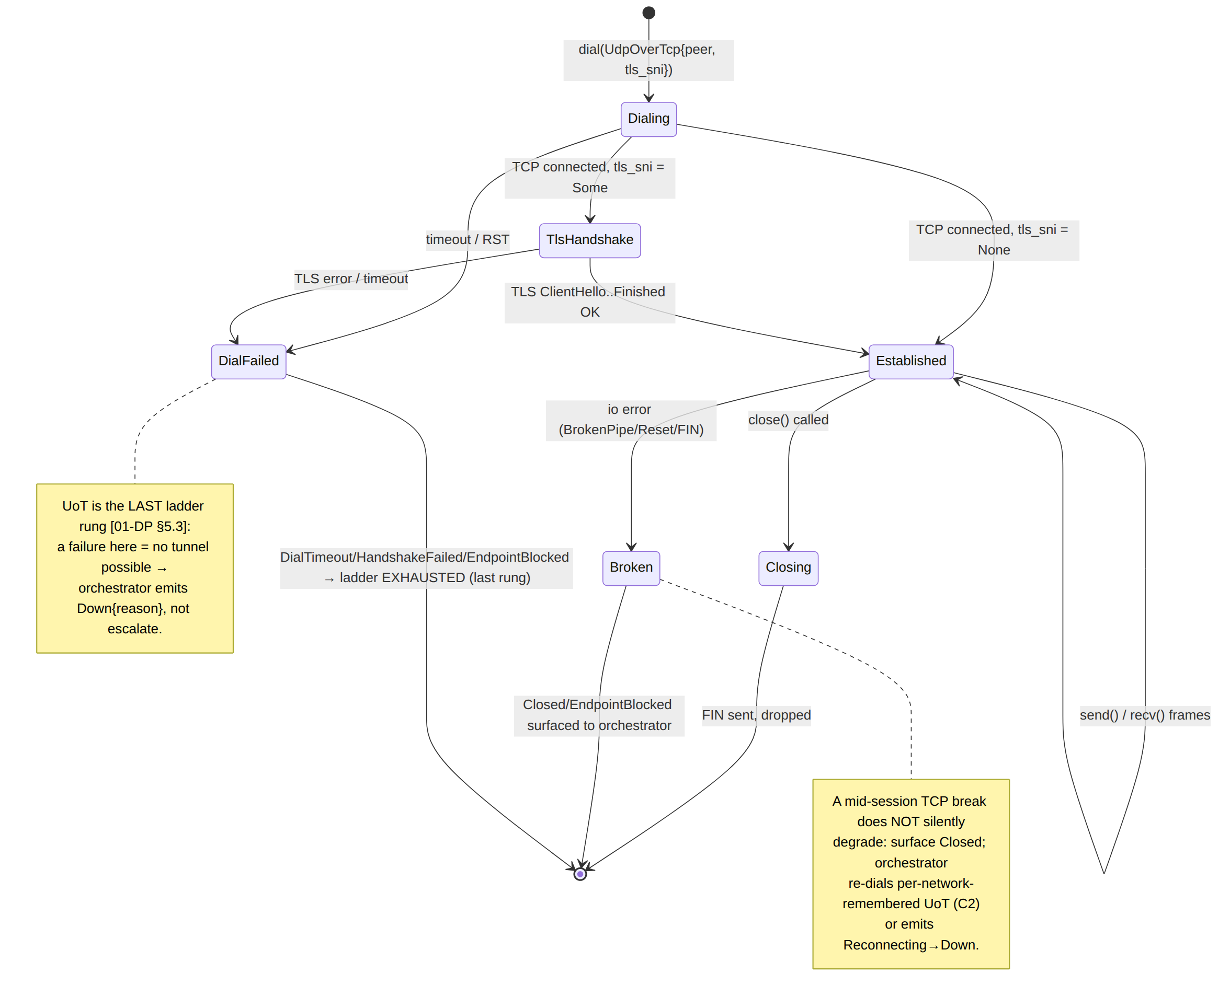

6.2 Send-path framing FSM (per datagram)
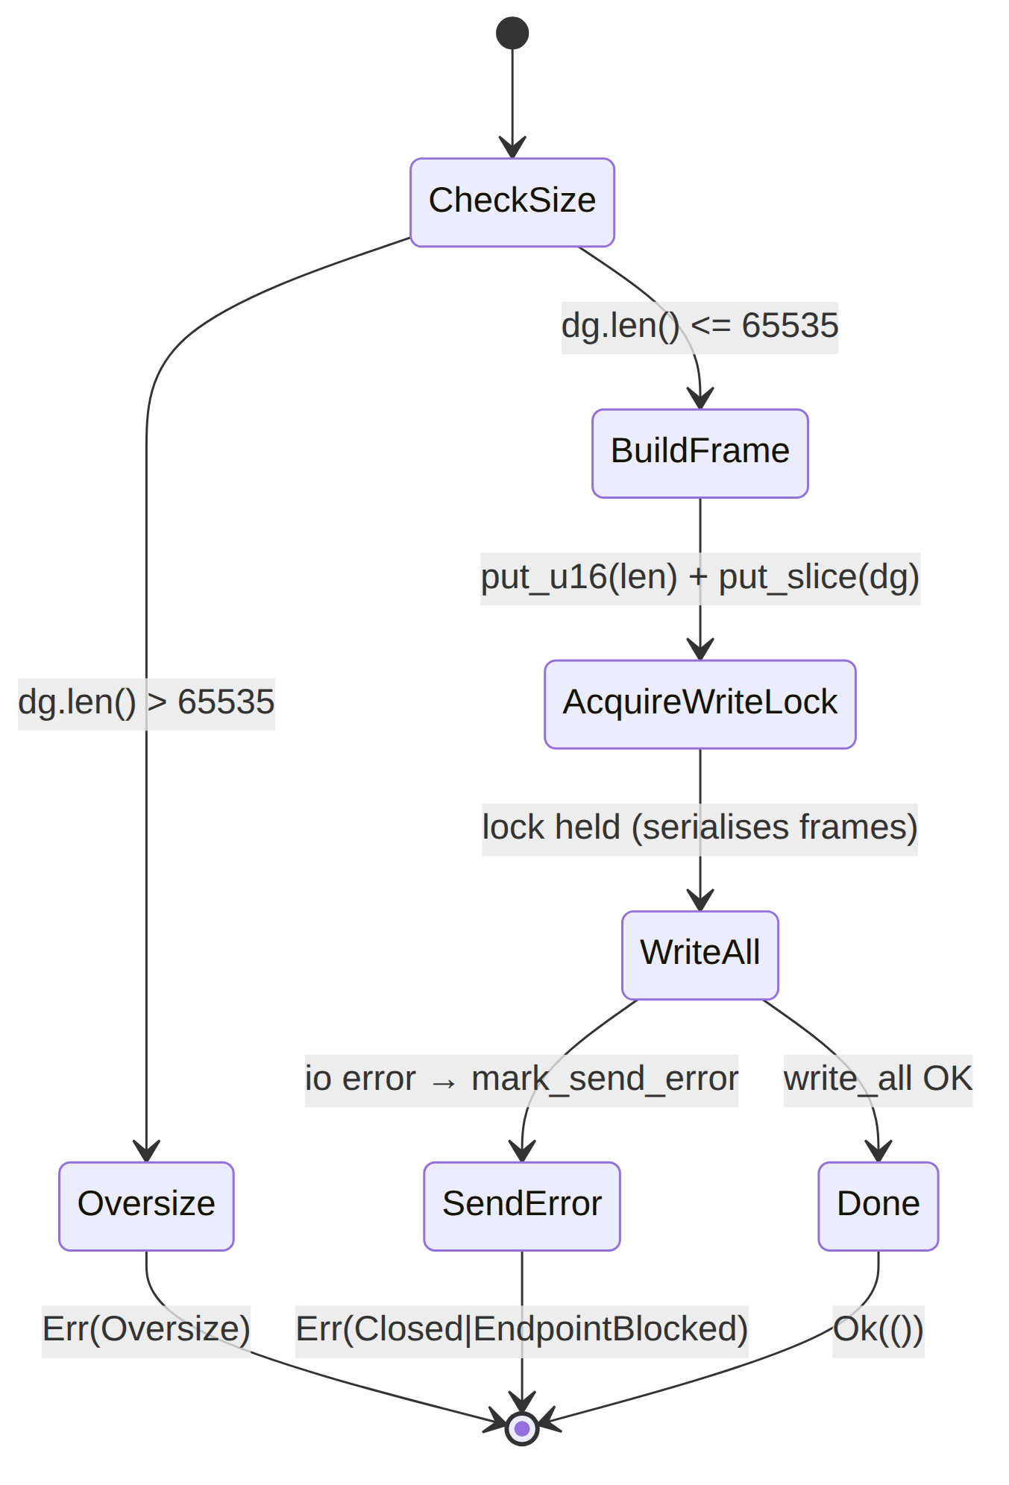

6.3 Close & half-close
- Graceful close (close()): flush write buffer → shutdown(Write) (sends TCP FIN) → drop. Idempotent — second close() is a no-op (locks + best-effort flush/shutdown ignore already-closed errors). The peer's recv then observes read == 0 and returns Closed.
- Peer FIN during recv: read() returns 0 → recv returns TransportError::Closed. The orchestrator treats this as a transport drop → Reconnecting (re-dial UoT) or, if re-dial also fails, Down [01-DP §5.2].
- No silent half-open: UoT MUST NOT keep sending into a write-closed socket pretending it is healthy; the first send after a peer RST surfaces BrokenPipe/Reset → Closed/ EndpointBlocked via map_io_to_transport (§8). (Honesty over a fake-up tunnel — §11.4.6.)

6.4 Write atomicity (why the write half is mutex-guarded)
A WG datagram's frame ([len][payload]) MUST land contiguously on the TCP stream; if two send calls interleaved their write_alls, the deframer on the far end would read a corrupted length prefix. The Arc<Mutex<WriteHalf>> serialises all sends: each holds the lock across its single write_all(&frame), so frames are atomic with respect to one another. recv uses a separate lock (Arc<Mutex<ReadHalf>>), so the connection is full-duplex (a send never blocks a recv). This is the data-race / deadlock surface the RACE test type targets (§13).

6.5 Receive-path reassembly (the partial-frame problem)
TCP delivers a byte stream, not datagrams: one read() may return half a frame, several frames, or a frame split across two reads. The deframer keeps an accumulator acc: BytesMut across recv calls and is cancel-safe (the accumulator lives in ReadHalf, not on the recv future's stack, so dropping a recv in a select! loses no buffered bytes — the I2 cancel-safety contract [01-DP §3.1]).
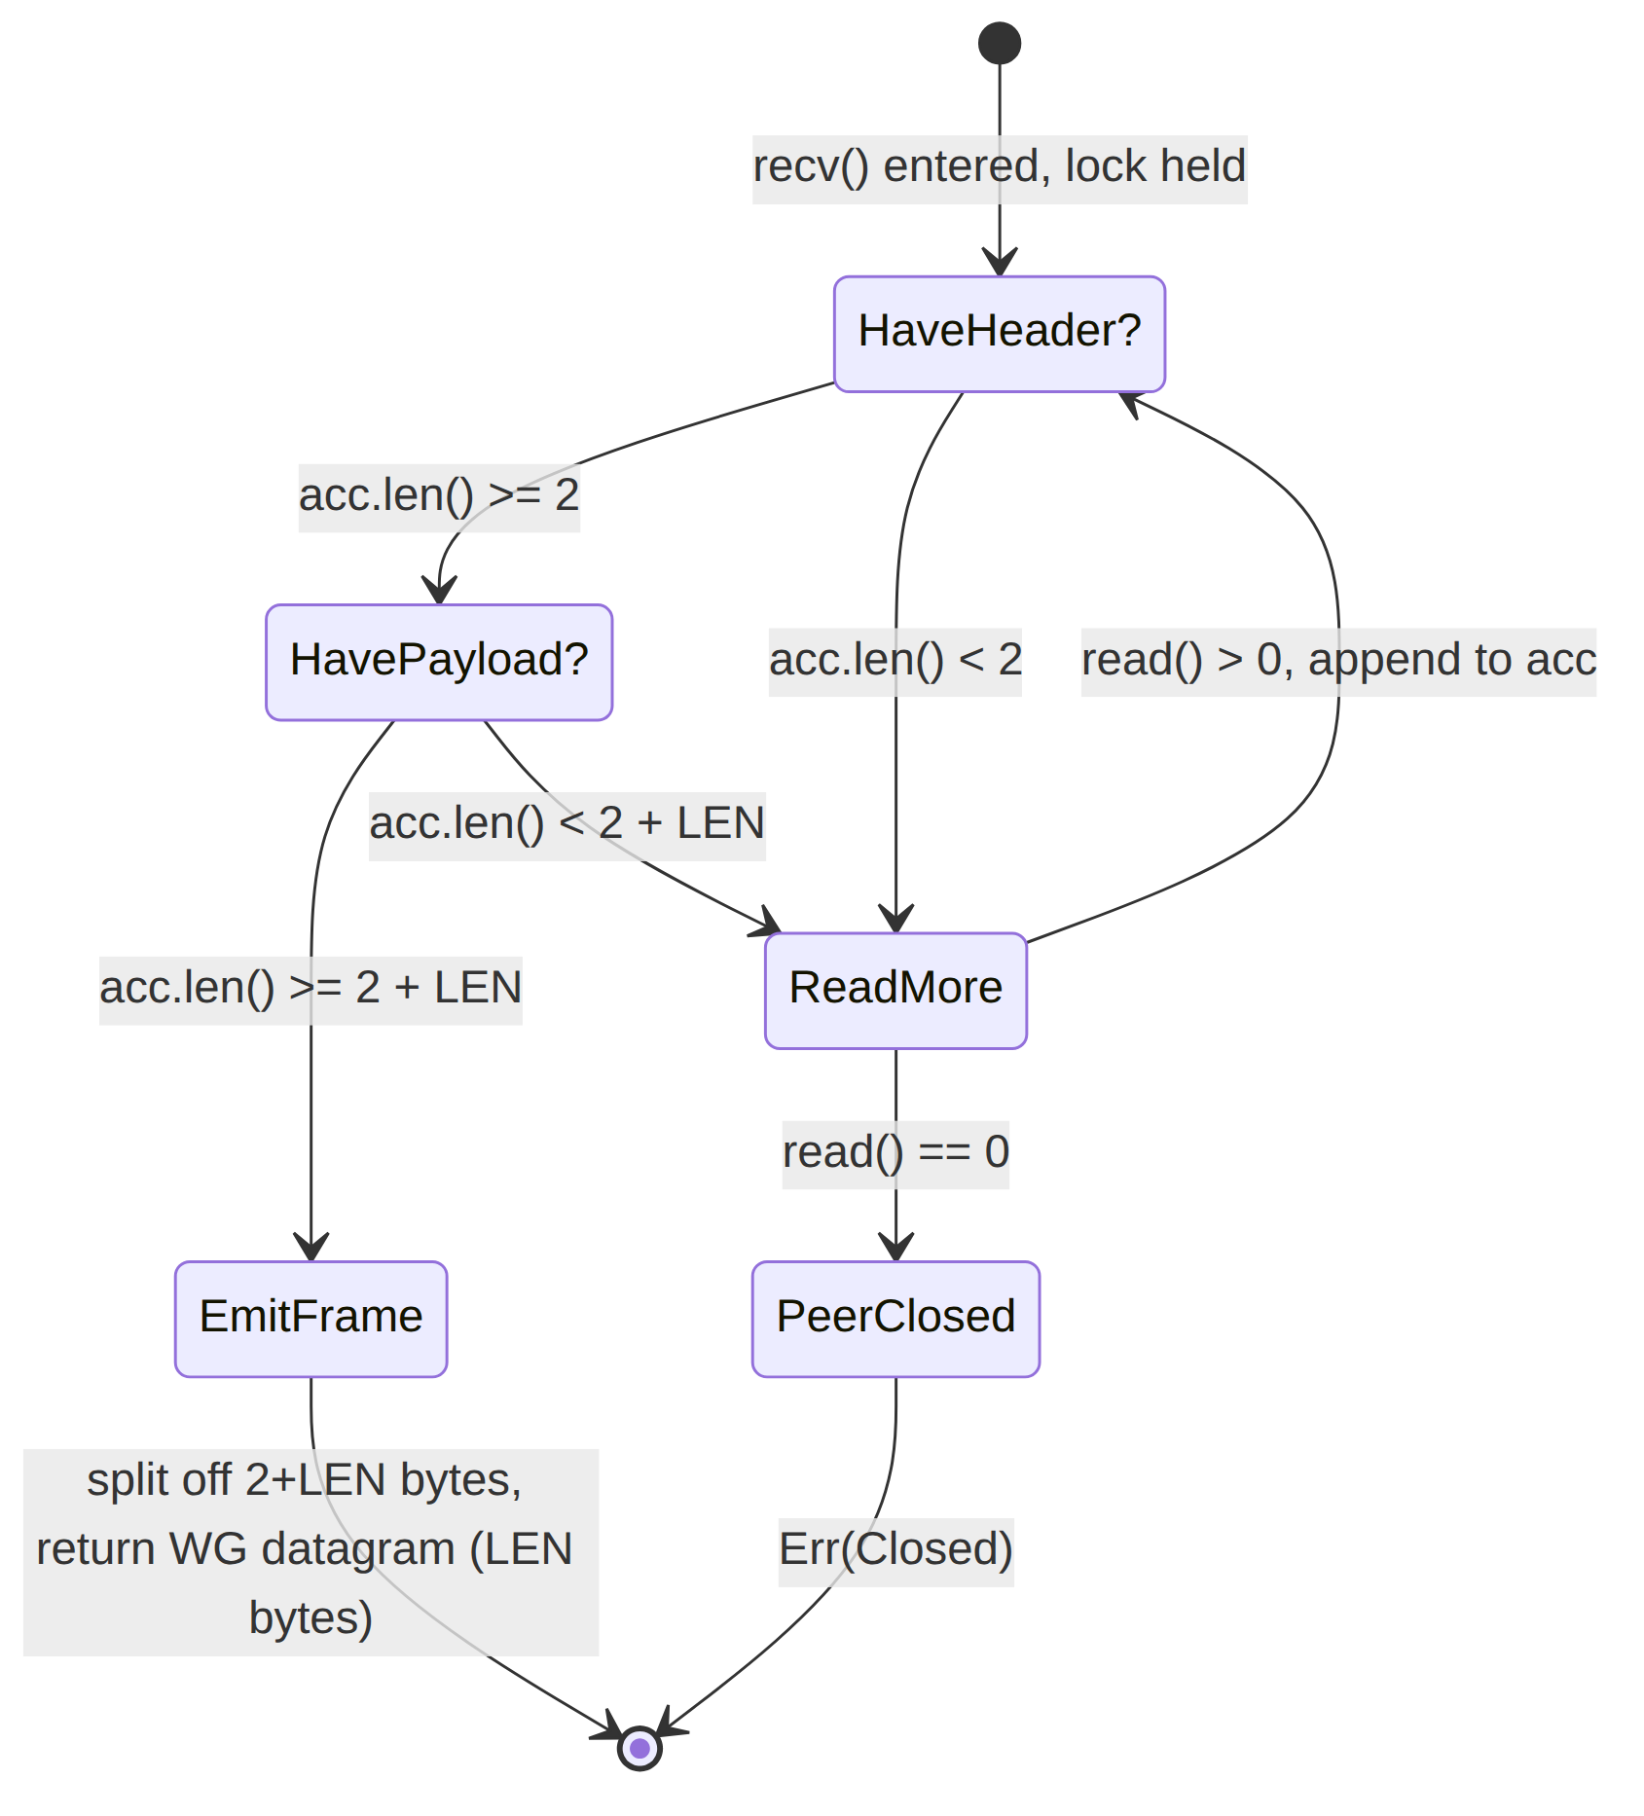

6.6 try_take_frame (the pure deframer — fully testable in isolation)
/// Pull exactly one complete frame out of `acc` if present; otherwise return Ok(None).
/// Pure function of the buffer → the `UNIT`-testable core of the deframer (§13).
fn try_take_frame(acc: &mut BytesMut) -> Result<Option<Bytes>, TransportError> {
if acc.len() < UOT_LEN_PREFIX_BYTES {
return Ok(None); // not even a length prefix yet
}
// Peek the big-endian u16 length WITHOUT consuming it.
let len = u16::from_be_bytes([acc[0], acc[1]]) as usize;
let total = UOT_LEN_PREFIX_BYTES + len;
if acc.len() < total {
return Ok(None); // payload not fully arrived
}
acc.advance(UOT_LEN_PREFIX_BYTES); // drop the prefix
let dg = acc.split_to(len).freeze(); // take exactly `len` payload bytes
Ok(Some(dg)) // remaining bytes (next frame, partial) stay in acc
}
Edge cases this function MUST handle (each a UNIT test, §13):
- acc empty → None.
- acc = 1 byte → None (header incomplete).
- acc = [0x00,0x94] only → None (header complete, 0 payload bytes arrived).
- acc = exactly one full frame → Some(dg), acc emptied.
- acc = 1.5 frames → Some(first), second frame's partial bytes retained.
- acc = 3 back-to-back frames → three successive Some across three calls, no read in between.
- LEN == 0 (a zero-length datagram) → Some(empty Bytes). Policy: a 0-length frame is a protocol anomaly (WG never sends empty datagrams [WG-PROTO]); the transport returns it faithfully, and helix-wg drops it — UoT does not editorialise the opaque payload (I1). A flood of 0-length frames is a DoS vector handled by the read-rate guard (§9 G4, §12).

7. The head-of-line-blocking tradeoff (the defining property)

7.1 Why HoL is unavoidable here
WG datagrams are independent and loss-tolerant (I2): if datagram k is lost, datagram k+1 is still useful, and WG's own state machine tolerates loss/reorder/replay. Carrying them over reliable, ordered TCP inverts that: if the TCP segment carrying datagram k is lost, TCP holds back every later byte (including datagrams k+1, k+2, … already received) until k is retransmitted and ACKed. That stall is head-of-line blocking — the structural cost of running a datagram protocol over a stream protocol [01-DP §0.1 I2, §3.6, 04_P2 §1.2].
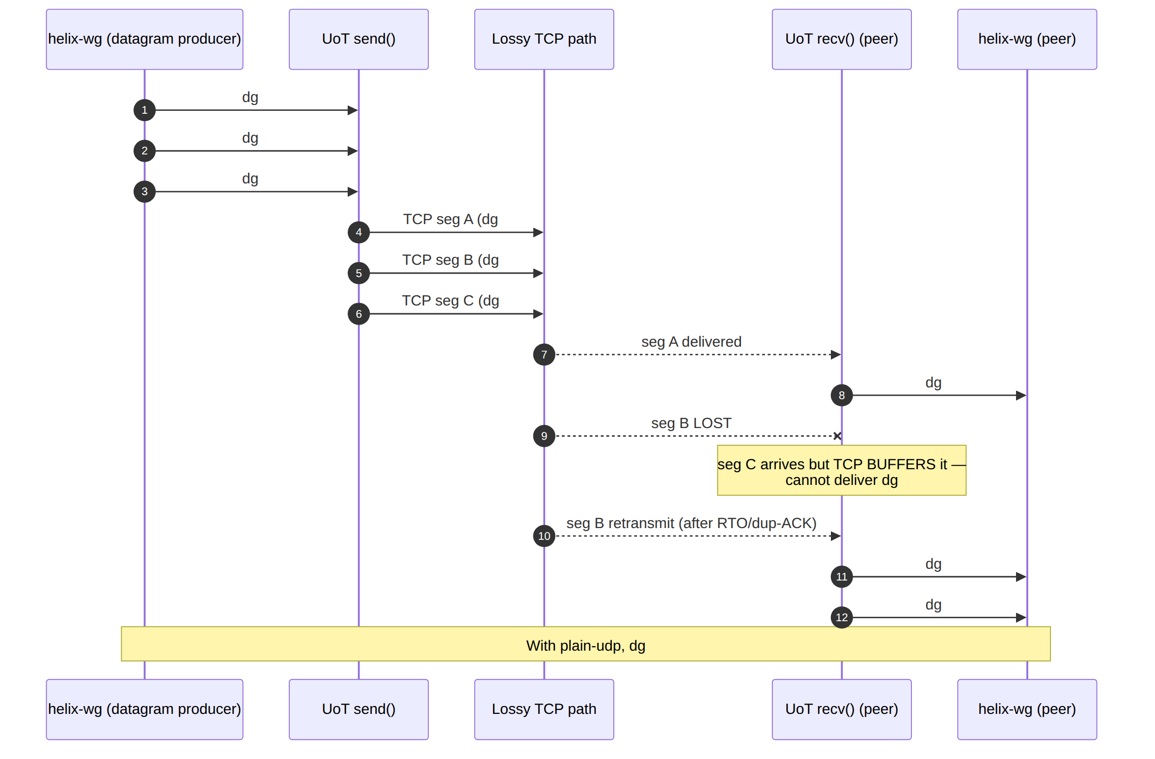

7.2 What it costs & how the orchestrator bounds the damage
Effect | Magnitude | Mitigation in spec
Added latency under loss | Each loss event stalls delivery by ≈ 1 TCP RTO (or fast-retransmit RTT). On a 5% loss path this is frequent — exactly the scenario where masque-h3/QUIC keeps higher goodput [01-DP §3.3 "Loss resilience", 04_P0 §5.3]. | The ladder prefers QUIC carriers precisely because of this; UoT runs only when UDP (hence QUIC) is impossible (§1). The ladder ranks UoT last [01-DP §5.3].
Throughput ceiling | TCP congestion control + HoL caps goodput below plain-udp/QUIC on lossy/throttled links. | Accepted: "exists purely to keep a tunnel possible" [01-DP §3.6]. effective_mtu and a BENCH run quantify it (§13).
WG retransmit interaction | WG also retransmits its handshake; over reliable TCP, WG retransmits are rarely needed (TCP already delivered them) — mostly benign, occasionally redundant work. | No special handling — WG timers run unchanged (helix-wg::tick) [01-DP §4].
TCP-in-TCP meltdown risk | If the inner tunnelled traffic is itself TCP (the common case), you have TCP-over-WG-over-TCP; under loss the two congestion controllers can interact pathologically. | UNVERIFIED (classic "TCP meltdown" lore; not measured in this evidence base). Documented as a known risk; UoT is last-resort so the exposure window is minimised. A STRESS/PERF run under netem loss characterises it (§13) rather than assuming it.
Design stance: UoT does not try to fix HoL (that would mean reimplementing QUIC). It accepts HoL as the price of working on a UDP-blackholed network, and the system bounds the damage by only ever reaching UoT as the last rung. This is the honest, no-bluff framing: UoT is the transport that works when nothing else can, explicitly at the cost of being the slowest [01-DP §3.6].

8. Error taxonomy (mapping IO → TransportError)
UoT reuses the shared TransportError enum [01-DP §3.1]; it adds no new variants. The mapping from std::io::Error (and TLS error) to TransportError is the load-bearing contract:
fn map_io_to_transport(e: std::io::Error) -> TransportError {
use std::io::ErrorKind::*;
match e.kind() {
BrokenPipe | ConnectionAborted => TransportError::Closed, // local/peer closed write
ConnectionReset => TransportError::EndpointBlocked, // RST mid-session = active block
UnexpectedEof => TransportError::Closed, // peer FIN mid-frame
TimedOut => TransportError::DialTimeout, // (read/connect timeout)
_ => TransportError::Io(e),
}
}
TransportError | UoT trigger | Orchestrator response [01-DP §5.3]
DialTimeout | TCP connect (or TLS handshake) exceeded dial_timeout. | Last rung → Down { reason } (ladder exhausted).
HandshakeFailed(String) | TLS handshake error (UotWrap::Tls). | Last rung → Down.
EndpointBlocked | TCP RST on connect or mid-session reset — active firewall/DPI verdict. | Down; record "UoT EndpointBlocked region R" (aggregate, I5).
Closed | Peer FIN / broken pipe / EOF mid-frame. | Reconnecting → re-dial UoT (C2); persistent → Down.
Oversize(usize) | send got a datagram > 65535 (defensive; impossible at real MTU). | Bug-class; surfaced, never truncated (I1).
Io(std::io::Error) | Any other IO error. | Reconnecting; logged as aggregate counter only (I5).
§11.4.1 FAIL-bluff guard: a UoT failure MUST be a genuine transport failure, never a script artifact — e.g. a deframer panic on a malformed length prefix is a §11.4.1 violation; the deframer returns Closed/Io, it does not panic (the RACE/CHAOS tests assert no panic, §13).

9. Edge cases (closed enumeration)
# | Edge case | Required behaviour | Test
E1 | Partial frame across reads (half a length prefix, then the rest). | Accumulate in acc; emit only on a complete frame (§6.5). | UNIT (§6.6 cases 1–6)
E2 | Multiple frames in one read(). | Emit each on successive recv calls without an extra read (§6.6 case 6). | UNIT
E3 | LEN == 0 frame. | Return empty Bytes; helix-wg drops it; do not editorialise (I1). | UNIT (§6.6 case 7)
E4 | send of an oversize datagram. | Err(Oversize); never truncate/split (I1). | UNIT
E5 | Peer RST mid-session. | recv/send → EndpointBlocked/Closed; orchestrator re-dials or Down. | CHAOS
E6 | TCP connect succeeds but WG handshake never completes (port-forward to a black hole). | Carrier "up" but tunnel never Connected; the orchestrator's WG-handshake timeout fires → escalate/Down — UoT itself reports healthy TCP, honestly (it is carrying bytes). | E2E (negative)
E7 | TLS handshake to a non-UoT :443 (decoy site answered). | TLS completes, but no valid framed WG handshake returns → WG handshake timeout → Down (the masquerade working against a misdirected client). | SEC
E8 | Slow-loris-style trickle (1 byte/sec) feeding acc. | Read-idle + per-frame assembly timeout bounds buffering (§12); surface Closed on timeout, do not grow acc unbounded. | STRESS, DDOS (Phase 2)
E9 | Concurrent sends from multiple tasks. | Serialised by the write mutex; frames never interleave (§6.4). | RACE, CONC
E10 | recv future dropped in a select! then re-entered. | Cancel-safe: acc retains buffered bytes; no datagram lost (§6.5). | UNIT, RACE
E11 | NAT/firewall idle-timeout kills an idle TCP connection silently. | WG keepalives (helix-wg::tick) generate periodic framed traffic [01-DP §4]; a dead connection surfaces as Closed on next send. | CHAOS
E12 | Maliciously huge LEN (e.g. 0xFFFF) with no payload following. | try_take_frame returns None and waits; the per-frame assembly timeout (§12) caps the wait → Closed; acc is bounded by UOT_MAX_DATAGRAM so memory cannot blow up. | SEC, STRESS

10. MTU & overhead budget
The inner WG MTU over UoT = min(effective_mtu(), path-MTU-discovered) [01-DP §10 rule 1].
Layer | Overhead | Note
L1 IP | 20 (v4) / 40 (v6) [IP] | path-dependent
L2 TCP | 20 base (+ options) [TCP] | TCP header
UoT length prefix | 2 | the only byte UoT adds [01-DP §3.6]
(TLS wrap, if UotWrap::Tls) | TLS record header 5 + AEAD tag 16 ≈ 21/record [TLS] | camouflage variant only
Reported effective_mtu() | plain 1380, TLS 1360 | both derived [01-DP §10]; measure & tune in Phase 2 (§13)
Rules (inherited [01-DP §10]):
- Inner WG MTU = min(transport.effective_mtu(), path-MTU).
- DAITA padding (if active) is added after WG encrypt and counts against the transport budget, not the inner MTU [01-DP §10 rule 2, §9].
- Oversize is a hard error — the orchestrator lowers the inner MTU rather than letting UoT truncate (I1) [01-DP §10 rule 3].
- The effective_mtu() constants are planning floors, not measured facts (§11.4.6); a BENCH/MEM run replaces them with the real connected-socket MSS (§13).

11. Config knobs
TransportConfig::UdpOverTcp { peer, tls_sni } is the public, NetworkMap-resolved config [01-DP §3.1]. Internal tunables (defaults; coordinator may override per-network via the policy push):
Knob | Type | Default | Meaning | Source
peer | SocketAddr | from NetworkMap | gateway TCP endpoint (typically :443/tcp for TLS variant, or :51820/tcp). | [01-DP §3.1]
tls_sni | Option<String> | None | Some(sni) enables the opportunistic TLS wrap (§5.4). | [01-DP §3.1]
dial_timeout | Duration | 5 s UNVERIFIED (planning default; not pinned in evidence base) | bound on TCP+TLS connect before DialTimeout. | derived
tcp_nodelay | bool | true (always) | disable Nagle (§4.1). | [TCP]
read_idle_timeout | Duration | 30 s UNVERIFIED | no bytes (incl. WG keepalive) for this long → Closed (§9 E11). | derived
frame_assembly_timeout | Duration | 10 s UNVERIFIED | a partial frame must complete within this; else Closed (§9 E12 slow-loris guard). | derived
max_acc_bytes | usize | UOT_MAX_DATAGRAM (65535) | reassembly buffer hard cap; a single frame can never exceed it (§9 E12). | spec
All Duration defaults are tagged UNVERIFIED because the evidence base does not pin them; they are planning values to be calibrated against the netns rig in Phase 2, not invented facts (§11.4.6). The per-network failure budget that governs when the ladder escalates to/past UoT lives in TransportPolicy.budget, not here [01-DP §5.3].

12. Security considerations
# | Concern | Spec response | Source
S1 | Transport must not see plaintext (I1). | UoT frames an opaque WG datagram; it never parses/decrypts. The 2-byte prefix is the only added byte. | [01-DP §0.1 I1]
S2 | TLS wrap is camouflage, not security. | WG provides confidentiality/integrity; the TLS layer only resembles HTTPS to DPI. Its compromise does not expose payload. | [01-DP §3.6, I1]
S3 | DPI fingerprinting of a bare length-prefixed stream. | Plain UoT on a non-443 port is fingerprintable; the TLS variant + edge decoy-site masquerade raises the bar. Reality-grade mimicry deferred to Phase 3 (§1 UNVERIFIED note). | [11-DR A3], [01-DP §3.3]
S4 | Active probing of the :443/tcp listener. | The edge serves a believable decoy to any TLS client that does not produce a valid framed WG handshake (§9 E7), returning nothing useful to a prober. | [01-DP §3.3 masquerade], [11-DR A3 active-probing]
S5 | Reassembly-buffer DoS (huge LEN, slow-loris). | max_acc_bytes caps memory at one max datagram; frame_assembly_timeout + read_idle_timeout bound trickle attacks; surface Closed, never OOM (§9 E8/E12). | spec (§11)
S6 | No-logging by construction (I5). | Only aggregate counters (bytes, frames, reconnects, EndpointBlocked-per-region); no per-datagram/per-connection durable state. | [01-DP §0.1 I5], [SYNTHESIS §7]
S7 | Deframer robustness (no panic on malformed input). | try_take_frame is total over arbitrary byte input — it returns None/Closed, never panics (a panic would be a §11.4.1 FAIL-bluff + a DoS). | §6.6, §11.4.1
S8 | Secret handling. | UoT holds no WG keys; TLS keys (camouflage) are ephemeral, never logged (§11.4.10). | [§11.4.10]

13. Test points (§11.4.169 taxonomy [10-QA §1])
Per §11.4.169 the udp_over_tcp.rs workable item declares the closed set of test types below; any warranted-but-absent type is an explicit NOT_APPLICABLE: <reason> / §11.4.3 SKIP, never an omission [10-QA §1]. Four-layer coverage per §11.4.4(b) (pre-build gate + post-build + runtime-on-clean-target + paired §1.1 mutation) and §11.4.50 determinism (N=3 / N=10) apply to every PASS.
Code | Scope for UoT | Captured-evidence shape (§11.4.5/.69/.107)
UNIT | try_take_frame (§6.6 cases 1–7), send frame builder, map_io_to_transport, effective_mtu per wrap. Mocks allowed only here (§11.4.27). | cargo test pass log; property test: deframe(frame(dg)) == dg for random dg (round-trip identity, I1).
INT | Real tokio::net::TcpStream loopback (+ tokio-rustls TLS variant) carrying real WG datagrams between two helix-wg instances; no mocks. | testcontainers / loopback log; pcap of the framed stream.
E2E | netns rig with all UDP dropped (nft drop udp); ladder escalates to UoT; curl reaches an authorized LAN host through the real tunnel [04_P0 §3 rig]. | curl HTTP 200 body hash from overlay netns + pcap showing TCP-only carriage + StatusReport.transport=="udp-over-tcp".
FA | The above E2E self-driving, re-runnable -count=3, zero human-in-loop (§11.4.98). | make qa one-shot exit 0, identical evidence hashes ×3 (§11.4.50).
SEC | Decoy-site response to a TLS probe that sends no valid WG handshake (E7); deframer no-panic on fuzzed input (S7); no plaintext on wire (I1) via pcap. | pcap (no WG signature in clear), fuzz corpus pass, decoy-response capture.
STRESS | ≥100 iters / ≥30 s sustained framed throughput; ≥10 parallel sends (write-mutex serialisation); slow-loris + huge-LEN buffer-cap (E8/E12) [§11.4.85]. | stress_chaos.sh ab_stress_* latency.json; acc bytes bounded ≤ 65535 (counter).
CHAOS | Mid-session TCP RST / FIN / iface flap; recovery re-dials UoT and restores reachability (E5/E11) [§11.4.85]. | ab_chaos_* recovery_trace.log; TunnelStatus event trace Connected→Reconnecting→Connected.
CONC | Concurrent multi-task send + recv full-duplex; no interleaved frames, no lost update (E9/E10). | Go/Rust harness pass; ordered-frame assertion.
RACE | cargo +nightly loom / tsan on the write-lock / read-lock + acc cancel-safety (§6.4/§6.5). | loom report 0 findings; no panic.
MEM | acc reassembly buffer never exceeds max_acc_bytes; no leak over a soak; (iOS path inherits the general MEM ceiling — UoT itself is allocation-light). | /proc/Instruments RSS flat over soak; buffer high-water counter.
BENCH | UoT goodput + p99 framing latency vs plain-udp baseline, under netem loss 0/1/5% — quantifies the HoL penalty (§7) so the ladder cost model is real. | bench.sh CSV [04_P0 §8]; goodput-vs-loss curve showing UoT degrading faster than QUIC (the documented tradeoff).
PERF | latency p50/p99 vs SLO budget; TCP-in-TCP interaction characterised under loss (§7.2 UNVERIFIED risk → measured, not assumed). | histogram metrics; loss-sweep report.
REC | window-scoped MP4 of the Console/Access showing Connected { transport: "udp-over-tcp" } on a UDP-blocked network (§11.4.154/.155) + media-validation verdict (§11.4.163). | panoptic capture → vision_engine PASS verdict.
CHAL/HQA | A challenges/helix_qa bank entry scoring PASS only on the E2E captured evidence above (§11.4.27/.107). | bank result.json PASS citing the pcap + curl artifacts.
DDOS | handshake-flood / huge-LEN flood against the edge :443/tcp UoT listener. | NOT_APPLICABLE: single-node-selfhost (Phase 2) [10-QA §1, 04_P1 §11] — parked, re-arms with HA.
SCALE | N simulated UoT clients holding TCP carriers. | NOT_APPLICABLE: single-node-selfhost (Phase 2) [10-QA §1]; partial soak only at MVP.
UI/UX | covered by REC + the shared client-core status walkthrough (transport label surfaces in the UI). | flutter golden + flow walkthrough vision verdict.
Anti-bluff acceptance gate (the one that matters): the headline UoT claim — "a tunnel comes up when all UDP is blocked" — is proven by the E2E/FA row: nft drops all UDP, the ladder escalates to UoT, and curl reaches a real LAN host through the real tunnel, with a pcap proving TCP-only carriage and zero UDP egress. Config-only / "the code path exists" PASS is forbidden (§11.4 / §11.4.69) — the captured curl 200 + pcap is the evidence [01-DP §12.1, 04_P2 §1.2 acceptance].

14. Build checklist & cross-references
Item | Owns | Phase | Gate
helix-transport/src/udp_over_tcp.rs | UdpOverTcp, framing, dial_udp_over_tcp, deframer | 2 | — (Phase-2 transport set) [01-DP §12]
TransportConfig::UdpOverTcp arm in lib.rs::dial() | dispatch | 2 | —
helix-core/src/ladder.rs last-rung ordering | UoT ranked last in restricted order | 1→2 | [01-DP §5.3]
Cross-references: the Transport trait + dial() ladder [01-DP §3.1]; the escalation sequence [01-DP §5.3, §5.4]; the MTU budget [01-DP §10]; plain-udp (the baseline UoT is measured against, §7.2) [01-DP §3.2 / transport-plain-udp.md]; masque-h3 (the QUIC carrier the ladder prefers before UoT) [01-DP §3.3 / transport-masque-quic.md]; shadowsocks (the sibling TCP-riding carrier with the same HoL caveat) [01-DP §3.5]; the §11.4.169 taxonomy [10-QA §1].

End of UDP-over-TCP transport nano-detail spec (Volume 2, Data Plane). Deepens [01-DP §3.6]. The Transport trait it implements is a frozen Phase-0 contract [01-DP §3.1]; this module is a Phase-2 deliverable [01-DP §12, 04_P2 §1.2]. All UNVERIFIED tags mark facts not grounded in the evidence base (TLS-443 DPI residual, TCP-in-TCP meltdown magnitude, the timeout defaults) and are to be resolved by measurement, not assumption (§11.4.6).

