WireGuard Core (helix-wg)

WireGuard Core (helix-wg)
Revision: 2 Last modified: 2026-07-04T12:00:00Z
Rev 2 (enterprise-hardening audit, 2026-07-04): independently reviewed against the parent gap-analysis checklist (key rotation, resource exhaustion, MTU/fragmentation). §6 (per-device key generation + rotation, including the make-before-break state machine at §6.4) and §14.3 (handshake anti-DoS / cookie-reply rate limiting) already satisfy this checklist in full depth — no addition made here to avoid duplicating already-thorough content. No consistency issue found against transport-trait.md or 01-data-plane.md.
Volume 2, document 01 of the HelixVPN master technical specification — the nano-detail deepening of the WireGuard Core (helix-wg) section of the pass-1 data-plane overview [01-DP §4]. This is a SPEC: it describes what to build (every trait/struct/enum/fn signature, wire layout, state machine, error taxonomy, config knob, edge case, security note, performance budget, and test point) — it does not ship the product. Sources are cited inline by id.

Evidence-base honesty notes (constitution §11.4.6 — stated, not guessed)
Three grounding caveats apply to this whole document; every claim that rests on them carries an inline UNVERIFIED: marker:
- research-wireguard.md does not exist in the supplied evidence base (scratchpad/kb/ contains research-mullvad.md, research-masque.md, research-hysteria2.md, … but no research-wireguard.md). Therefore every WireGuard protocol wire-byte layout (handshake message sizes, field offsets, MAC layout, transport-data header) in §3 is UNVERIFIED: against the evidence base — it is reproduced from the public WireGuard protocol (Donenfeld, WireGuard: Next Generation Kernel Network Tunnel) and MUST be re-confirmed against the WireGuard whitepaper + RFC-equivalent + the boringtun source before implementation. The architectural facts (Noise IK, Curve25519, ChaCha20-Poly1305, BLAKE2s, PSK seam) ARE grounded [01-DP §4, SYNTHESIS §2, research-mullvad §4].
- boringtun internal API signatures (Tunn::encapsulate, decapsulate, update_timers, TunnResult) are UNVERIFIED: against the evidence base — they are reproduced from the public boringtun crate (cloudflare/boringtun) and MUST be pinned to the exact crate version's API at implementation time. The evidence base grounds only the wrapper shape (WgPeer, WgVerdict, the three pump methods) [01-DP §4, 04_P0 §4.4].
- §11.4.169 ("test types") referenced in the authoring brief is not present in this document's constitution context (which ends at §11.4.168). UNVERIFIED: its exact enumeration. The concrete test types in §13 are therefore drawn from the in-context §11.4.27 test-type set (unit, integration, e2e, full-automation, security, fuzz, stress, chaos, performance, benchmark, Challenges, HelixQA) + the §11.4.5/.69/.107 captured-evidence covenant, and labelled "§11.4.169-class" where the brief intends the per-component mandate.

0. Position, ownership, and invariants
helix-wg is the crate at L3 — the WireGuard cryptographic core of the layering model [01-DP §1]. It is the only crate in the workspace that touches WireGuard plaintext on one side and WireGuard ciphertext on the other; the Transport layer (§3 of [01-DP]) sits strictly beneath it and never sees plaintext (invariant I1) [01-DP §0.1]. helix-wg owns the WireGuard Tunn state machine, pumps its timers, routes its output verdicts, and enforces per-peer AllowedIPs crypto-routing. It is the same crate byte-for-byte on client, connector, and gateway edge (invariant I4) [01-DP §0.1, §4; 04_ARCH §3.2].
What helix-wg owns (this document):
- boringtun-vs-kernel selection per platform (§1).
- The WgPeer / WgDevice wrapper over boringtun Tunn, its WgVerdict output enum, and the four pump entry points (§2).
- The Noise IK handshake state machine + WireGuard message wire formats it drives (§3) — UNVERIFIED: byte layouts per note 1.
- The fixed crypto parameter set + the additive PSK (post-quantum) seam (§4).
- AllowedIPs semantics: the longest-prefix-match crypto-routing trie (§5).
- Per-device key generation + rotation lifecycle (§6).
- MTU derivation from the active transport's effective_mtu() (§7).
- Timer / rekey / keepalive state machine (§8).
- The encrypted-datagram boundary contract with helix-transport (§9).
- Error taxonomy (§10), config knobs (§11), edge cases (§12), test points (§13), security (§14), performance budget (§15).
What helix-wg does NOT own: the obfuscating transport (helix-transport, [01-DP §3]); the TUN device (helix-tun); the orchestrator's three loops and TunnelStatus stream (helix-core, [01-DP §5]); the route map / ACL compiler (helix-route, [01-DP §6–§7]); DAITA shaping (helix-daita, [01-DP §9]); the full post-quantum KEM exchange protocol (security doc — helix-wg exposes only the PSK field, §4.4).

0.1 Crate-local invariants (extend the §0.1 data-plane invariants)
# | Invariant | Source
W1 | helix-wg performs zero heap allocation on the steady-state encrypt/decrypt path; all framing uses caller-provided scratch buffers (&mut [u8]). | derived from iOS NE memory ceiling [04_P0 §6, 04_ARCH §5.6]
W2 | Crypto parameters are fixed and never altered (Noise IK / Curve25519 / ChaCha20-Poly1305 / BLAKE2s); the only additive seam is the WG PSK field. | [01-DP §4, SYNTHESIS §2]
W3 | A device private key is generated on-device and never leaves it; helix-wg exposes only the public key for enrollment. | [01-DP §4, 04_ARCH §7, SYNTHESIS §7]
W4 | A packet whose decrypted source / encrypted destination does not match the peer's AllowedIPs is dropped — crypto-routing is the coarse default-deny layer (I6). | [01-DP §7, 04_ARCH §3.4]
W5 | helix-wg keeps no durable per-packet or per-connection state — only in-RAM session state + aggregate counters (no-logging by construction, I5). | [01-DP §0.1, 04_ARCH §2.7, research-mullvad §8]
W6 | The wrapper is the same crate on all three roles; role differences (client default-route capture vs connector CIDR forwarding) live in helix-core, not here. | [01-DP §4, §5.1]

1. boringtun (userspace) vs kernel WireGuard — per platform

1.1 The decision (grounded)
boringtun is the default and the cross-platform floor: pure-Rust userspace WireGuard, no kernel module, runs identically on Linux/Android/iOS — exactly the iOS path, where there is no kernel WG regardless [04_P0 §4.4]. On Linux the kernel WG fast path is used where available, with boringtun userspace as fallback; the project ships both and defaults to kernel on Linux [01-DP §4, 04_ARCH §13 "ship both, default to kernel"].

1.2 Per-platform matrix
Platform | Backend selected | Rationale | Source
Linux (client/connector/edge) | kernel WG (wireguard netlink/wg), boringtun fallback | kernel is faster; constrains containerization/permissions → fallback exists | [04_ARCH §13, §3.2; 04_P0 §4.4]
Android | boringtun (via VpnService+JNI) | userspace, no root, uniform | [04_ARCH §5.3, SYNTHESIS §5]
iOS / macOS (NE) | boringtun (in NEPacketTunnelProvider) | no kernel WG on iOS; bounded-memory Rust is the make-or-break gate G3 | [04_P0 §4.4, §6; 04_ARCH §5.6]
Windows | boringtun over wireguard-nt/wintun, or kernel-ish wireguard-nt data path | shim owns the adapter; backend abstracted | [04_ARCH §5.3]
HarmonyOS / Aurora | boringtun (native shim → .so) | no kernel WG; Phase 3 | [04_ARCH §5.3, SYNTHESIS §4]
UNVERIFIED: exact Windows kernel-vs-userspace split — the evidence base says "wireguard-nt / wintun" [04_ARCH §5.3] without pinning whether boringtun or wireguard-nt's own crypto runs the data path; settle in the Windows shim spec (doc 06).

1.3 Backend abstraction — WgBackend
The two backends hide behind one trait so helix-core and the rest of the workspace are backend-agnostic; backend selection is a build-time + runtime choice resolved once at device construction.
// helix-wg/src/backend.rs
/// Selects how WireGuard crypto + the Tunn state machine are executed.
#[derive(Clone, Copy, Debug, PartialEq, Eq)]
pub enum WgBackend {
/// Pure-Rust userspace (boringtun Tunn). The cross-platform floor.
Userspace,
/// Linux kernel WireGuard via netlink (`wg`/`wireguard` module).
LinuxKernel,
}
impl WgBackend {
/// Resolve the backend for the current platform + availability.
/// Linux: prefer LinuxKernel if the module is loadable AND not running
/// inside a constrained container; else Userspace. All other platforms: Userspace.
pub fn resolve(prefer_kernel: bool) -> WgBackend { /* … */ }
}
/// The role-neutral handle the orchestrator drives, regardless of backend.
/// (Userspace impl wraps boringtun Tunn per §2; LinuxKernel impl drives netlink.)
pub trait WgDataPath: Send + Sync {
/// Encrypt one outbound plaintext IP packet for `peer_index` (userspace path);
/// kernel path is configured once and the kernel does this — see §9.3.
fn encapsulate<'a>(&mut self, peer: PeerIndex, ip_pkt: &[u8], scratch: &'a mut [u8])
-> WgVerdict<'a>;
fn decapsulate<'a>(&mut self, datagram: &[u8], scratch: &'a mut [u8]) -> WgVerdict<'a>;
fn tick<'a>(&mut self, scratch: &'a mut [u8]) -> WgVerdict<'a>;
fn backend(&self) -> WgBackend;
}
Kernel-path note (§9.3 expands): when LinuxKernel is selected, the per-packet encrypt/decrypt happens inside the kernel, NOT through encapsulate/decapsulate. In that mode helix-wg (a) programs the kernel peer set + AllowedIPs via netlink, and (b) the transport must still be userspace for any non-plain-udp carrier — so a kernel/userspace split applies only to plain-udp; every obfuscating transport forces the userspace data path because the kernel cannot emit MASQUE/Shadowsocks framing. This is a first-class edge case (§12.7).

1.4 Backend placement in the packet flow
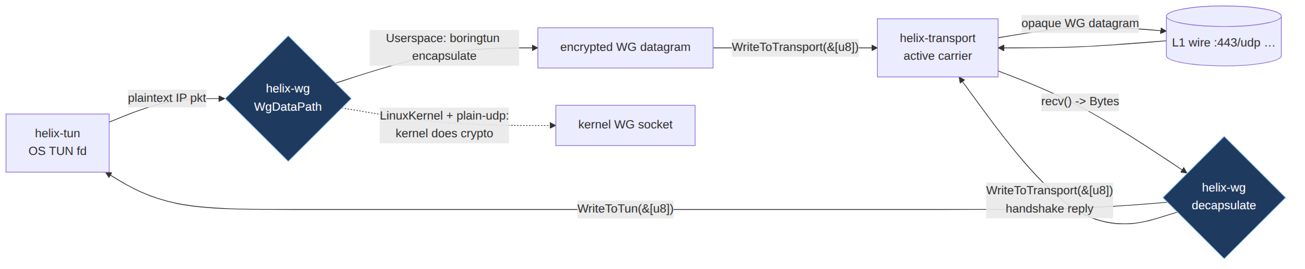

2. The helix-wg boringtun Tunn wrapper + WgVerdict

2.1 The four-verdict output model (grounded)
boringtun's Tunn is a sans-I/O state machine: you feed it bytes and it returns a verdict telling you what to do next [04_P0 §4.4]. helix-wg maps boringtun's TunnResult onto a tighter, lifetime-bound WgVerdict [01-DP §4]:
// helix-wg/src/lib.rs
/// The output of every helix-wg pump call. Borrows the caller's scratch buffer
/// (W1: no heap alloc on the hot path) — the orchestrator acts on it immediately
/// before the next pump call reuses the scratch.
pub enum WgVerdict<'a> {
/// Encrypted datagram (handshake or transport-data) → hand to the active Transport (§3 of 01-DP).
WriteToTransport(&'a [u8]),
/// Decrypted inner IP packet → hand to the TUN. Carries the parsed inner src for AllowedIPs audit (§5).
WriteToTun { pkt: &'a [u8], inner_src: IpAddr },
/// Nothing to emit this call (e.g. duplicate, keepalive consumed, queued).
Nothing,
/// A genuine WireGuard-layer error (see WgError, §10). NEVER used for "no output".
Err(WgError),
}
Mapping from boringtun TunnResult (UNVERIFIED: boringtun API per note 2; this is the public crate surface to confirm at pin time):
boringtun TunnResult | helix-wg WgVerdict | Notes
Done | Nothing | nothing to emit
Err(WireGuardError) | Err(WgError::from(_)) | translated taxonomy (§10)
WriteToNetwork(&[u8]) | WriteToTransport(&[u8]) | ciphertext → transport
WriteToTunnelV4(&[u8], Ipv4Addr) | WriteToTun { pkt, inner_src: V4(..) } | plaintext → TUN, src for §5 audit
WriteToTunnelV6(&[u8], Ipv6Addr) | WriteToTun { pkt, inner_src: V6(..) } | plaintext → TUN, src for §5 audit

2.2 WgPeer and WgDevice — full signatures
A WgPeer wraps exactly one boringtun Tunn (one peer session). A WgDevice owns the local static key + the set of peers + the AllowedIPs routing trie (§5). The client has one peer (the gateway); the connector has one peer (the gateway); the edge has N peers (every connected client + connector) and is the only multi-peer instance.
// helix-wg/src/peer.rs
use std::net::{IpAddr, SocketAddr};
pub type PeerIndex = u32; // dense index into WgDevice.peers
pub type PubKey = [u8; 32]; // Curve25519 public key
pub type PrivKey = SecretBytes; // Curve25519 private key (zeroizing, never logged — W3)
pub type Psk = [u8; 32]; // optional pre-shared key (post-quantum seam, §4.4)
pub struct WgPeer {
tunn: boringtun::noise::Tunn, // UNVERIFIED: exact path/type per note 2
pub remote_pubkey: PubKey,
pub endpoint: Option<SocketAddr>, // current latched endpoint (WG roaming, §8.4)
pub allowed_ips: Vec<IpNet>, // this peer's permitted overlay prefixes (W4, §5)
pub persistent_keepalive: Option<u16>, // seconds; None = off (§8.3)
pub last_handshake: Option<Instant>, // in-RAM only (W5)
stats: PeerStats, // aggregate counters only (W5)
}
pub struct WgDevice {
local_private: PrivKey, // generated on-device, never leaves (W3)
local_public: PubKey,
peers: Vec<WgPeer>,
routing: AllowedIpsTrie, // §5 — maps inner src/dst → PeerIndex
backend: WgBackend,
rate_limiter: HandshakeRateLimiter, // §14.3 anti-DoS (cookie reply path)
index_map: PeerIndexMap, // WG receiver-index → PeerIndex demux (§3.5)
}
impl WgDevice {
/// Construct from the local static key + initial peer set (from the RouteMap, 01-DP §6.2).
pub fn new(local_private: PrivKey, backend: WgBackend) -> Self { /* … */ }
/// Add / update a peer (reconciler-driven, no restart — 01-DP §6.3). Idempotent on pubkey.
pub fn upsert_peer(&mut self, cfg: PeerConfig) -> PeerIndex { /* … */ }
/// Remove a peer (e.g. device.revoked → drop in <1s — 01-DP §7). Zeroizes its session.
pub fn remove_peer(&mut self, peer: PeerIndex) { /* … */ }
/// OUTBOUND: a plaintext IP packet left the TUN → find the peer by dst (§5),
/// encrypt, return ciphertext for the transport. Drops (W4) if no AllowedIPs match.
pub fn handle_tun_out<'a>(&mut self, ip_pkt: &[u8], scratch: &'a mut [u8]) -> WgVerdict<'a>;
/// INBOUND: bytes arrived from the transport → demux to the right peer by WG
/// receiver index (§3.5), decrypt; emit plaintext for the TUN (after §5 src audit)
/// or a handshake reply for the transport.
pub fn handle_transport_in<'a>(&mut self, datagram: &[u8], from: Option<SocketAddr>,
scratch: &'a mut [u8]) -> WgVerdict<'a>;
/// TIMER: call every TICK_INTERVAL (§8.1); emits keepalives, rekeys, expirations
/// for ALL peers (round-robins which peer needs work this tick).
pub fn tick<'a>(&mut self, now: Instant, scratch: &'a mut [u8]) -> Vec<WgVerdict<'a>>;
pub fn local_public(&self) -> PubKey { self.local_public }
pub fn peer_stats(&self, peer: PeerIndex) -> PeerStats { /* aggregate only, W5 */ }
}
#[derive(Clone, Debug, Default)]
pub struct PeerStats { // W5: aggregate counters only, never per-packet logs
pub tx_bytes: u64, pub rx_bytes: u64,
pub tx_packets: u64, pub rx_packets: u64,
pub handshakes_ok: u32, pub handshakes_failed: u32,
pub last_handshake_age_s: Option<u32>,
}
pub struct PeerConfig {
pub remote_pubkey: PubKey,
pub allowed_ips: Vec<IpNet>,
pub endpoint: Option<SocketAddr>,
pub persistent_keepalive: Option<u16>,
pub psk: Option<Psk>, // §4.4
}

2.3 Why handle_tun_out takes the whole device, not a single peer
A multi-hop chain or an edge with N peers must select the right peer from the inner destination IP via the AllowedIPs trie (§5) before encrypting — so the outbound entry point lives on WgDevice, not WgPeer. The single-peer client case is just N=1. (The pass-1 sketch put handle_tun_out on WgPeer for the one-peer slice [01-DP §4]; this nano-spec lifts it to WgDevice for the edge's N-peer reality, a deliberate refinement — the one-peer body is unchanged.)

3. Noise IK handshake + WireGuard message wire formats
UNVERIFIED: (note 1) — the byte sizes/offsets below are the public WireGuard protocol values, NOT confirmed against an evidence-base research-wireguard.md (which is absent). Confirm against the WireGuard whitepaper + boringtun source before coding. The architecture (Noise IK, 1-RTT, the four message types, the MAC1/MAC2 cookie anti-DoS) is grounded [01-DP §4, research-mullvad §4 PQ-PSK-over-WG].

3.1 Handshake shape (grounded architecture)
WireGuard uses the Noise IK pattern: a 1-RTT handshake where the initiator already knows the responder's static public key (the "I" = initiator immediately transmits its static key encrypted; "K" = responder's static key is known in advance) [01-DP §4]. HelixVPN learns the responder's static pubkey from the RouteMap (PeerRoute.wg_pubkey) pushed by the coordinator [01-DP §6.2].
Four message types (UNVERIFIED: sizes):
Type | Name | Size (bytes) | Direction
1 | Handshake Initiation | 148 | initiator → responder
2 | Handshake Response | 92 | responder → initiator
3 | Cookie Reply | 64 | responder → initiator (under load / anti-DoS, §14.3)
4 | Transport Data | 16 + 16·⌈(plaintext+0)/16⌉ … header 16 + ciphertext | both, steady state

3.2 Message 1 — Handshake Initiation (148 B, UNVERIFIED: layout)
offset size field
0 1 message_type = 0x01
1 3 reserved = 0x000000
4 4 sender_index (u32 LE, initiator's receiver index)
8 32 unencrypted_ephemeral (Curve25519 ephemeral public)
40 48 encrypted_static (32 B static pub + 16 B Poly1305 tag)
88 28 encrypted_timestamp (12 B TAI64N + 16 B tag)
116 16 mac1 (BLAKE2s keyed MAC over preceding bytes)
132 16 mac2 (cookie MAC; zero unless under cookie challenge)

3.3 Message 2 — Handshake Response (92 B, UNVERIFIED: layout)
offset size field
0 1 message_type = 0x02
1 3 reserved = 0x000000
4 4 sender_index (responder's receiver index)
8 4 receiver_index (echoes initiator's sender_index)
12 32 unencrypted_ephemeral
44 16 encrypted_nothing (empty payload + 16 B tag — confirms key schedule)
60 16 mac1
76 16 mac2

3.4 Message 4 — Transport Data header (UNVERIFIED: layout)
offset size field
0 1 message_type = 0x04
1 3 reserved = 0x000000
4 4 receiver_index (peer's receiver index — demux key, §3.5)
8 8 counter (u64 LE nonce; monotonic per session, anti-replay)
16 N encrypted_packet (ChaCha20-Poly1305 of the inner IP packet, incl. 16 B tag)
The plaintext is padded to a multiple of 16 bytes before AEAD (WireGuard padding); the 16-byte Poly1305 tag is appended inside encrypted_packet. This fixed 16-byte data header + 16-byte tag is the 32-byte WG overhead that the MTU budget (§7) accounts for.

3.5 Receiver-index demux (the edge's N-peer dispatch)
On inbound, handle_transport_in reads bytes [4..8) (the receiver_index, which the local device assigned at handshake) to select the PeerIndex via index_map before decrypting — O(1), no trial decryption across N peers. A datagram with an unknown receiver index, a type ∉ {1,2,3,4}, or a malformed length is dropped as WgError::Malformed (§10), counted, not logged (W5).

3.6 Handshake state machine
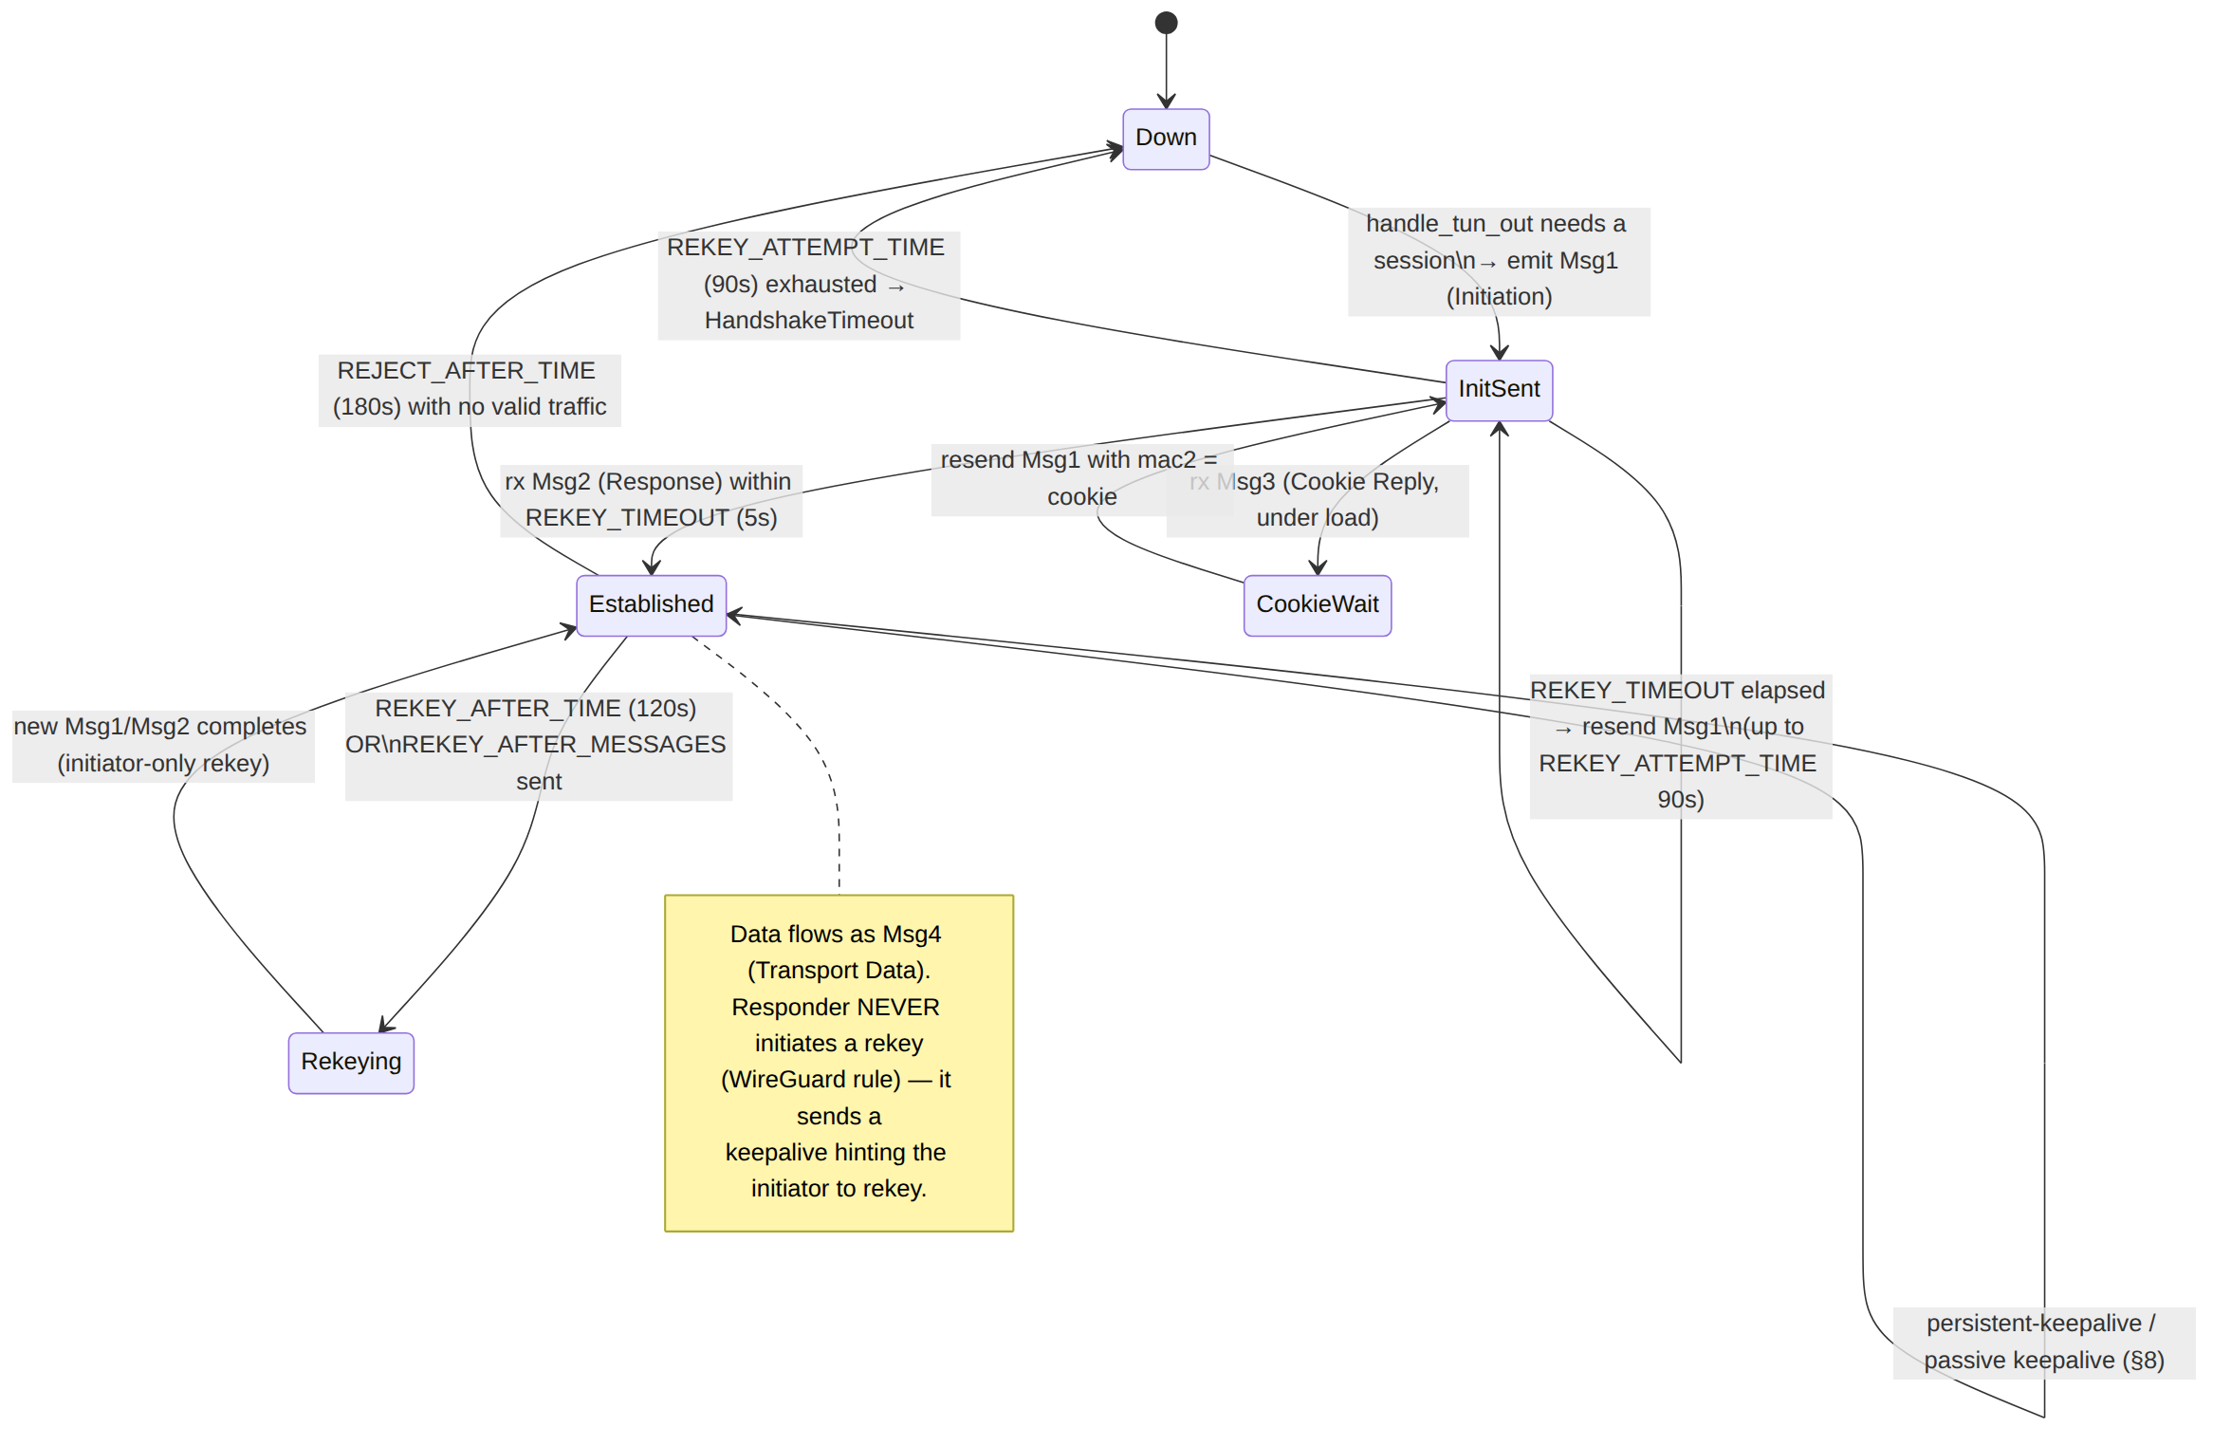
Timer constants (UNVERIFIED: exact values — standard WireGuard defaults, pin against boringtun): REKEY_AFTER_TIME = 120s, REKEY_TIMEOUT = 5s, REKEY_ATTEMPT_TIME = 90s, REJECT_AFTER_TIME = 180s, KEEPALIVE_TIMEOUT = 10s, REKEY_AFTER_MESSAGES = 2^60, REJECT_AFTER_MESSAGES = 2^64 − 2^13. These are surfaced as read-only constants, NOT config knobs (W2 — crypto invariants are fixed).

4. Crypto parameters (fixed) + the additive PSK seam

4.1 Fixed primitive set (grounded, W2)
Never altered [01-DP §4, SYNTHESIS §2]:
Role | Primitive
Key agreement | Curve25519 ECDH (X25519)
AEAD (data + handshake) | ChaCha20-Poly1305 (IETF, 96-bit nonce = 32-bit zero ‖ 64-bit counter)
Hash / KDF / MAC | BLAKE2s (HKDF-style key schedule; keyed BLAKE2s for MAC1/MAC2)
Handshake | Noise IK (1-RTT, known responder static key)
Timestamp (anti-replay of Msg1) | TAI64N (12 B)

4.2 Key schedule (grounded architecture; UNVERIFIED: exact chaining)
The Noise IK key schedule mixes: responder static pub, initiator ephemeral, initiator static, the optional PSK (§4.4), and BLAKE2s-chained Ck/Hk values to derive the two directional transport keys (T_send, T_recv). Each direction has an independent 64-bit message counter; the receiver maintains a sliding anti-replay window (UNVERIFIED: exact window size — WireGuard uses a 2048-bit / 8000-packet-class window; pin against boringtun).

4.3 Device keys never leave the device (W3)
helix-wg generates the Curve25519 keypair on-device; only local_public() is exported for enrollment (doc 02 PKI) [01-DP §4, SYNTHESIS §7]. The private key is held in a SecretBytes zeroizing wrapper, never logged, never serialized to durable storage in plaintext (§14.1).

4.4 Post-quantum PSK seam (additive, Phase 2)
Post-quantum is an additive pre-shared-key layer, hybrid-never-PQ-only, that slots into the WG PSK field with no transport change [01-DP §4, SYNTHESIS §4]. Mechanism (parity target, grounded): establish a vanilla WG tunnel, run a PQ KEM exchange (ML-KEM-1024 / FIPS-203, optionally hybridized with Classic McEliece) over it, install the negotiated shared secret as WireGuard's PSK — the PSK is mixed into the symmetric key schedule so the tunnel stays secure even if X25519 is broken [research-mullvad §4]. helix-wg's only surface is the PeerConfig.psk: Option<Psk> field (§2.2) + the key-schedule mix-in (§4.2); the full KEM exchange protocol is owned by the security doc, NOT here. Cost: ~1–2 s extra at handshake, steady-state unchanged [research-mullvad §4]. UNVERIFIED: the exact PQ-PSK message sequence — public Mullvad docs are high-level on this [research-mullvad §"Honest gaps"]; treat as security-doc design work.

5. AllowedIPs semantics — the crypto-routing trie

5.1 Two roles of one field (grounded)
AllowedIPs is WireGuard's cryptographic routing table and serves both directions [01-DP §7 layer 1, 04_ARCH §3.4]:
- Outbound (routing): for a plaintext packet leaving the TUN, the inner destination IP selects which peer to encrypt for — longest-prefix match across all peers' AllowedIPs.
- Inbound (access control / W4): for a packet decrypted from a peer, the inner source IP MUST fall inside that peer's AllowedIPs, else drop. A peer cannot spoof a source it was not granted — the coarse, crypto-enforced default-deny layer (I6); the port/proto-granular layer is the edge verdict map [01-DP §7 layer 2].

5.2 Data structure — longest-prefix-match trie
// helix-wg/src/allowed_ips.rs
/// A binary radix (Patricia) trie over IPv4+IPv6 prefixes → PeerIndex,
/// matching the kernel WireGuard `allowedips` structure. O(W) lookup
/// (W = address bit-width: 32 / 128), no allocation on lookup.
pub struct AllowedIpsTrie { /* dual v4/v6 radix roots */ }
impl AllowedIpsTrie {
pub fn insert(&mut self, prefix: IpNet, peer: PeerIndex);
pub fn remove(&mut self, prefix: IpNet, peer: PeerIndex);
pub fn remove_peer(&mut self, peer: PeerIndex); // revoke path (<1s, 01-DP §7)
/// Longest-prefix match for an address → the peer that owns it (outbound routing).
pub fn lookup(&self, addr: IpAddr) -> Option<PeerIndex>;
/// True iff `addr` falls within ANY prefix granted to `peer` (inbound audit, W4).
pub fn permits(&self, peer: PeerIndex, addr: IpAddr) -> bool;
}

5.3 Overlapping-prefix rule
Within one device, AllowedIPs prefixes across peers MUST be disjoint after longest-prefix resolution (WireGuard semantics: a more-specific prefix on peer B overrides a less-specific one on peer A). The RouteMap compiler (helix-route, [01-DP §6–§7]) guarantees disjointness post-4via6 — the overlay ULA /48 + 4via6 mapping is exactly what prevents two connectors that both serve 192.168.1.0/24 from colliding here [01-DP §6.1, 04_ARCH §3.4]. helix-wg trusts the compiled, disjoint overlay prefixes; it does not itself resolve RFC1918 collisions (that is solved one layer up). Edge case §12.4 covers a malformed (overlapping) map.

5.4 Crypto-routing decision flow
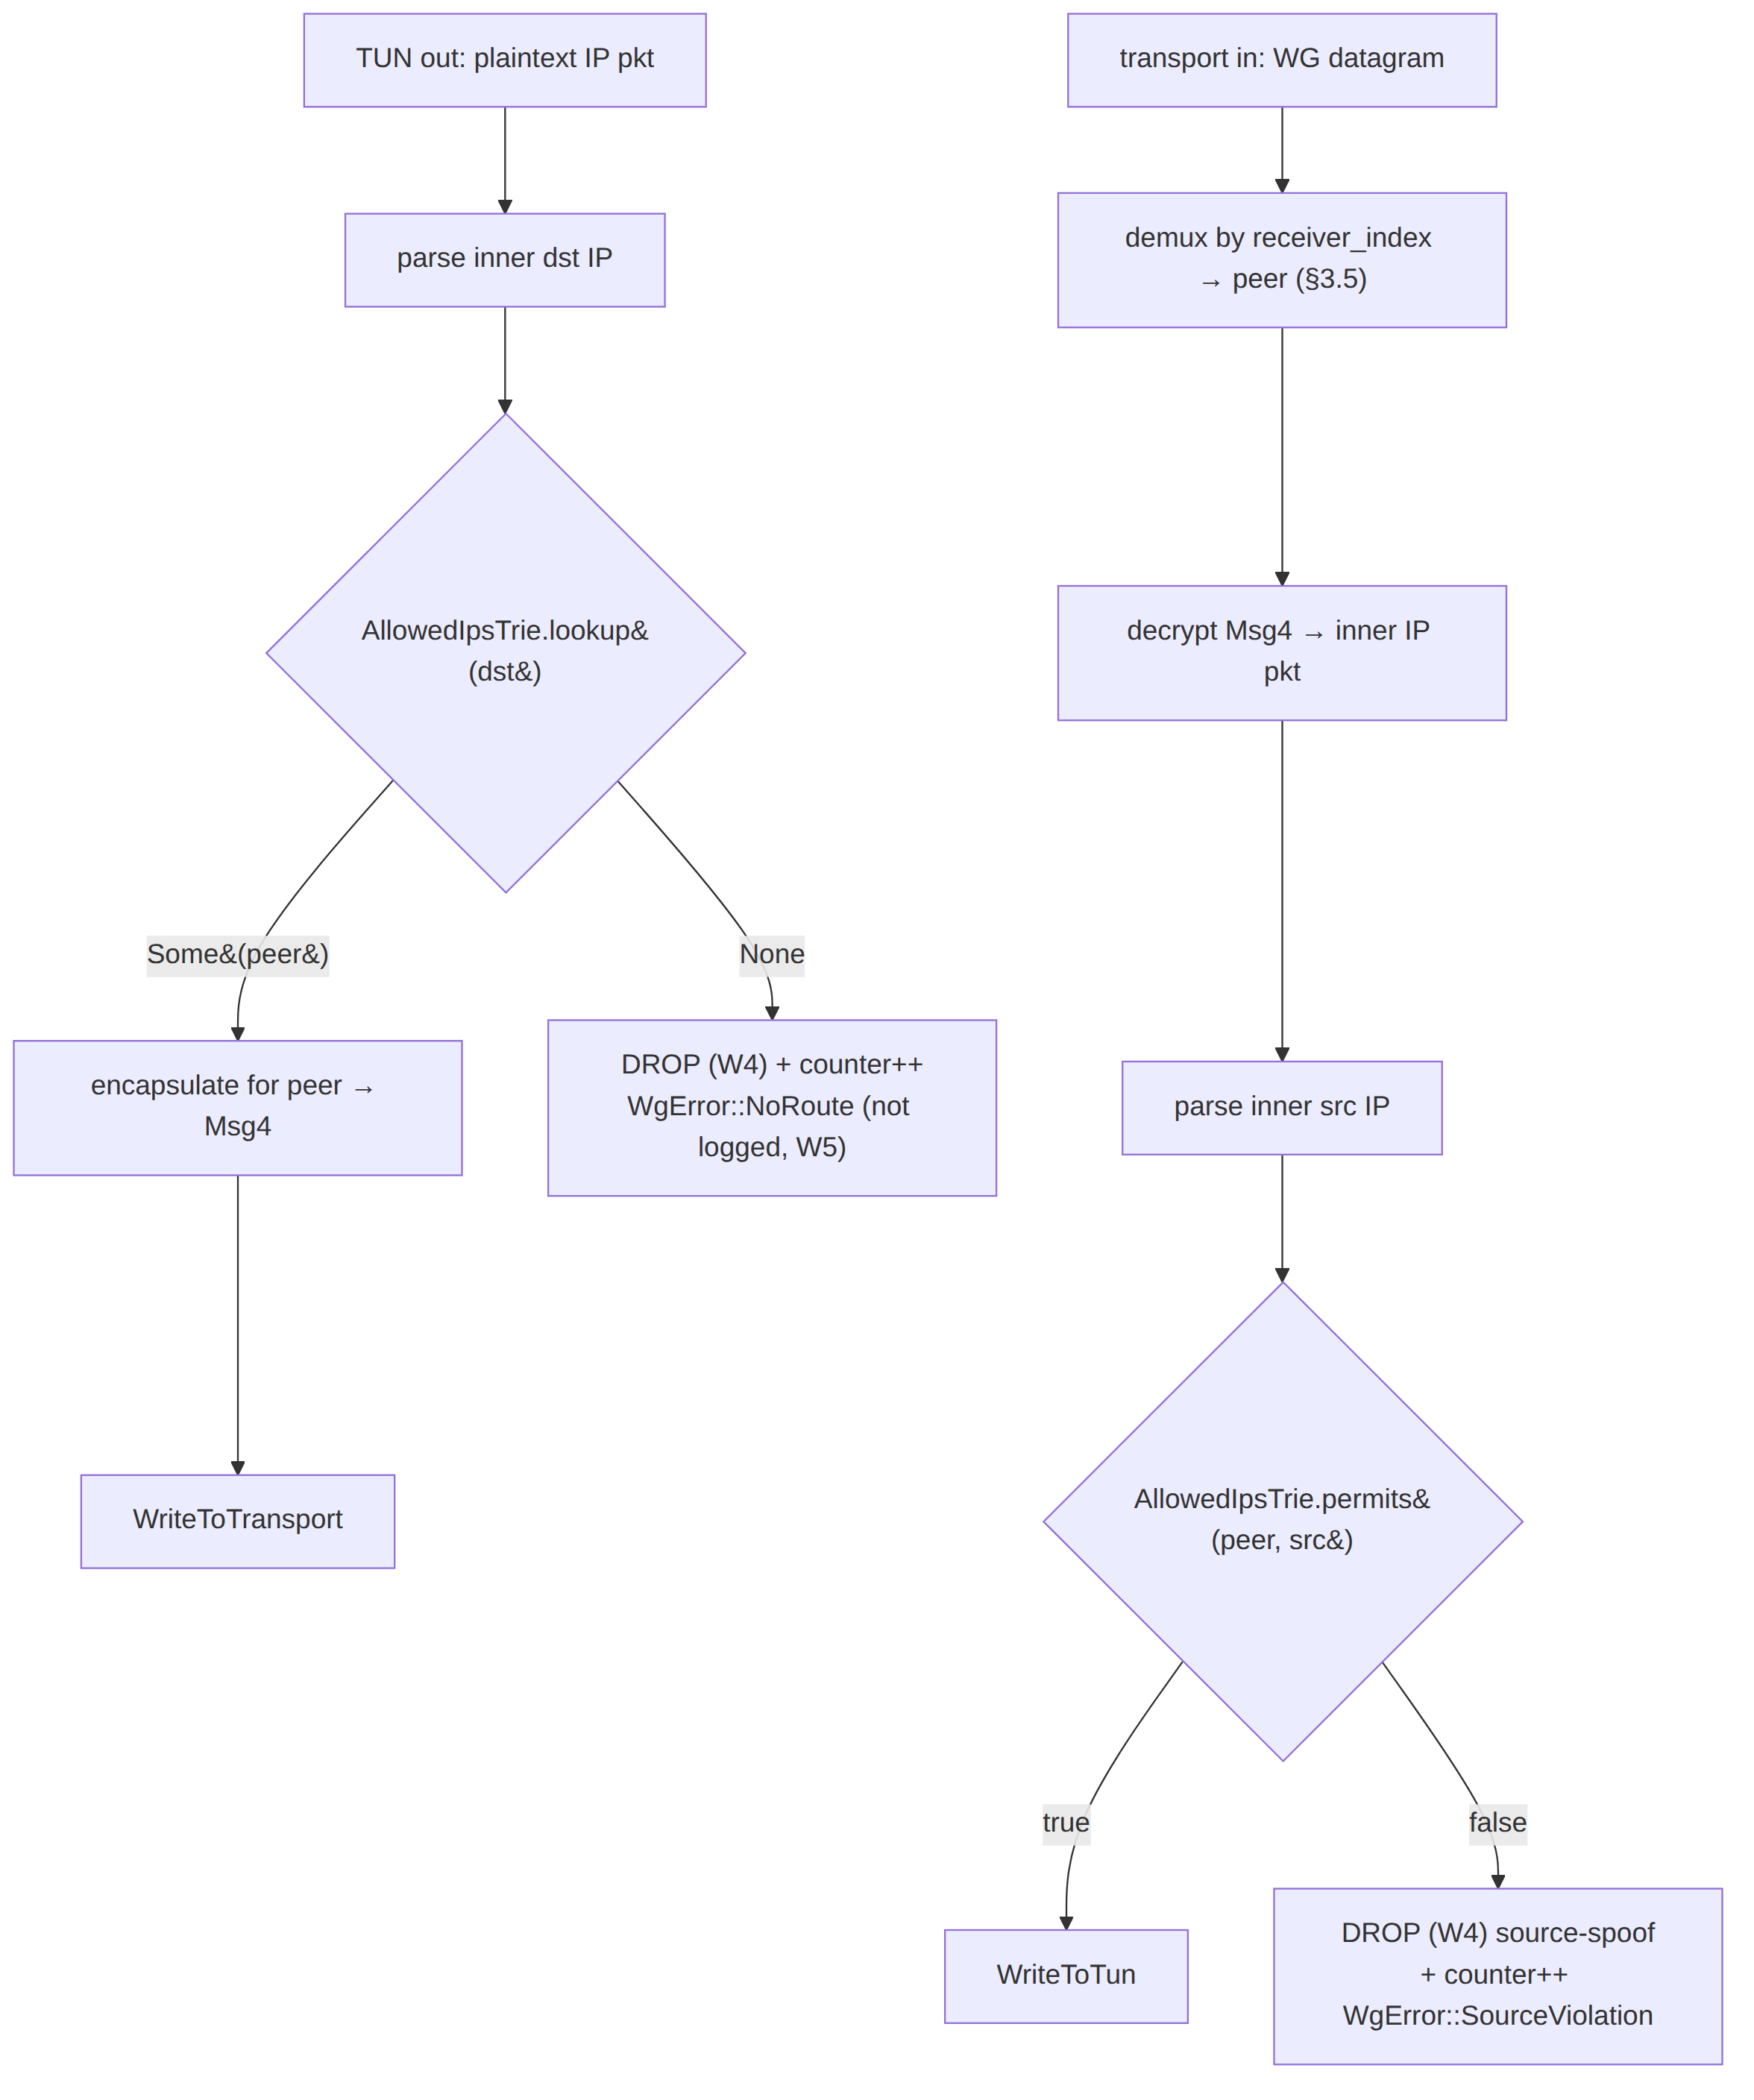

6. Per-device key generation + rotation

6.1 Generation (grounded, W3)
Each device (client, connector, edge) generates its Curve25519 keypair locally at enrollment; the private key never leaves the device, only the public key is registered with the control plane PKI [01-DP §4, 04_ARCH §7, research-mullvad §8].
// helix-wg/src/keys.rs
pub struct DeviceKeypair { pub public: PubKey, private: PrivKey /* zeroizing */ }
impl DeviceKeypair {
/// Generate from a CSPRNG (OS getrandom). The ONLY way to mint a device key.
pub fn generate() -> DeviceKeypair;
/// Load a previously-generated private key from the platform secure store
/// (Keychain / Keystore / TPM-backed) — never from a plaintext file (§14.1).
pub fn from_secure_store(handle: SecureKeyHandle) -> Result<DeviceKeypair, WgError>;
pub fn public(&self) -> PubKey;
}

6.2 Two rotation tiers (grounded)
WireGuard distinguishes ephemeral session rekey (automatic, every ~2 min, §3.6 Rekeying) from static device-key rotation (policy-driven). Both exist [01-DP §4 "rotated on schedule and on device.revoked"; 04_ARCH §7].
Tier | Trigger | Mechanism | Owner
Session rekey | REKEY_AFTER_TIME (120s) / REKEY_AFTER_MESSAGES / inbound after REKEY_AFTER_TIME | new Noise IK handshake, same static keys (§3.6) | helix-wg (automatic)
Static rotation | schedule (e.g. 30/90d) OR device.revoked event | mint new DeviceKeypair, re-enroll public key, coordinator pushes updated PeerRoute.wg_pubkey, peers upsert_peer the new pub, old peer remove_peer | helix-core + PKI (doc 02); helix-wg executes the upsert/remove

6.3 Revocation is a peer removal (grounded, <1s)
device.revoked → the coordinator pushes a map delta removing the peer → helix-core calls WgDevice::remove_peer → the session is zeroized and the AllowedIpsTrie entry dropped, in < 1 second, no restart [01-DP §7, 04_ARCH §4.4, SYNTHESIS §7]. On the edge, this composes with the verdict-map drop (layer 2); helix-wg owns the crypto-routing half.

6.4 Static-rotation state machine (make-before-break)
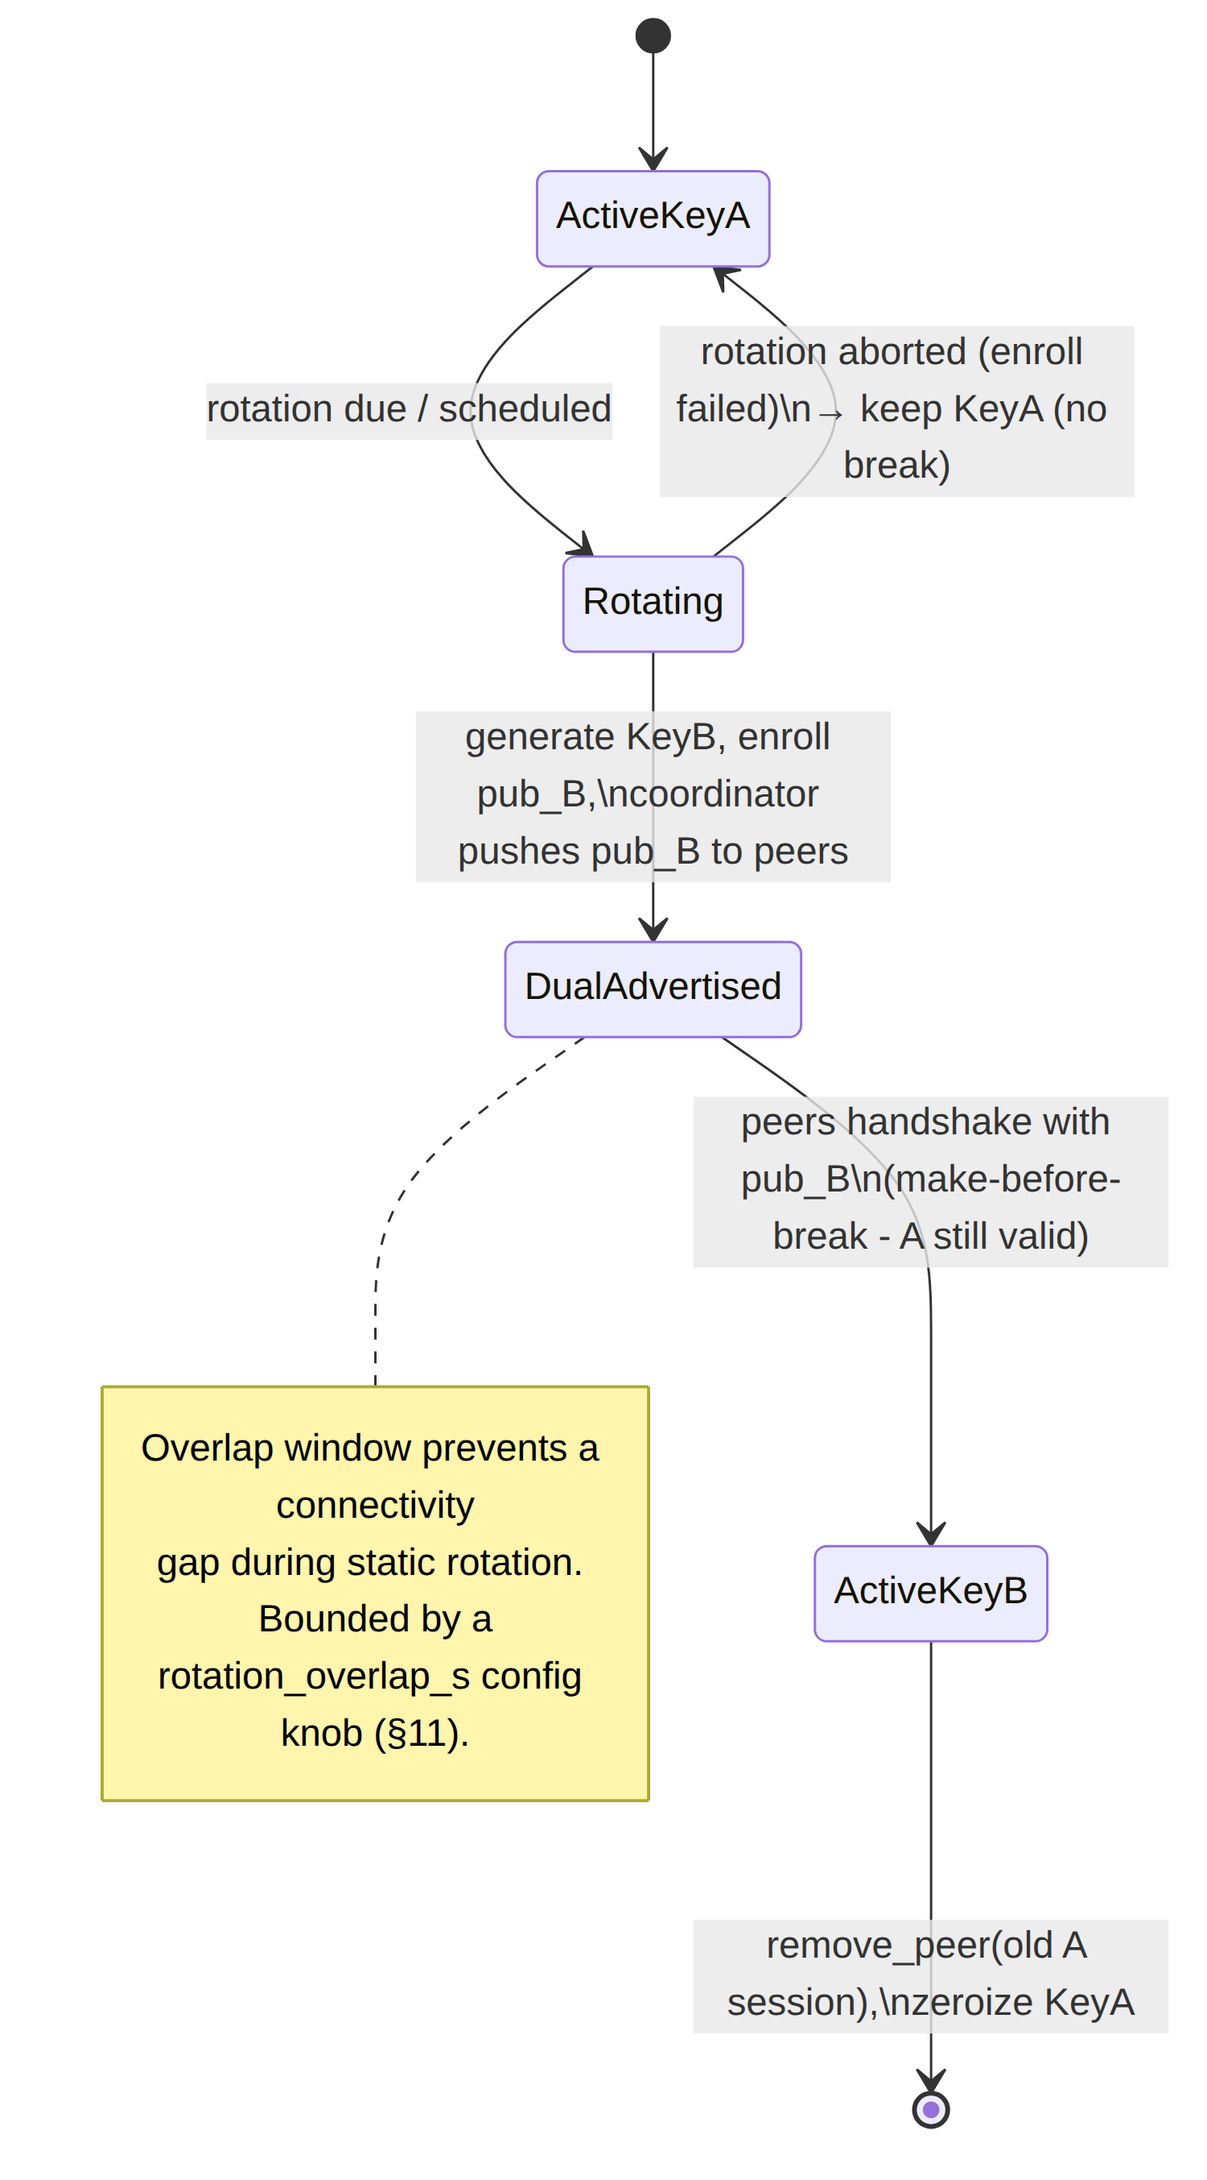

7. MTU derivation

7.1 The rule (grounded)
The inner WG MTU is derived from the active transport's effective_mtu() minus nothing further (the transport already subtracted its own overhead), then clamped by path-MTU discovery [01-DP §3.1 trait, §10]:
inner_wg_mtu = min( active_transport.effective_mtu(), path_mtu_discovered )
helix-wg does not hardcode an MTU; it reads it from the transport it is handed (decoupling — the same WG core runs over any carrier, W6). The transport budget table is owned by [01-DP §10]; reproduced for the WG-overhead derivation:
Transport | effective_mtu() | WG-relevant overhead accounted | Source
plain-udp | 1420 | 1500 − 20 IP − 8 UDP − 32 WG (16 hdr + 16 tag, §3.4) | [01-DP §10, 04_P0 §4.3]
masque-h3 | 1280 (measure & tune) | QUIC + HTTP-Datagram + UDP-proxy overhead; 1280 = IPv6 min-MTU floor | [01-DP §10, 04_P0 §5.2]
shadowsocks | ~1380 | TCP MSS − 2 B length prefix − AEAD tag | [01-DP §10, 04_P2 §1.1]
udp-over-tcp | ~1380 | TCP MSS − length prefix | [01-DP §10]
lwo | ~1400 | plain-udp − padding bytes | [01-DP §10]

7.2 The 32-byte WG overhead is already inside effective_mtu()
plain-udp's 1420 already subtracts the WireGuard 16-byte data header + 16-byte Poly1305 tag (§3.4). So helix-wg configures the TUN MTU to exactly inner_wg_mtu; the transport's effective_mtu() is the post-WG-overhead figure for the inner IP payload. (UNVERIFIED: whether the 1420 figure folds the WG overhead or the IP/UDP overhead — the pass-1 doc's arithmetic 1500 − 20 − 8 − 32 ≈ 1420 folds both; confirm the split during the §13 benchmark.)

7.3 Oversize handling
A plaintext packet whose encrypted size would exceed the active transport's MTU yields TransportError::Oversize at the transport boundary; helix-wg's contract is to lower the inner TUN MTU (preferred) or signal L3 fragmentation rather than silently truncate [01-DP §10 rule 3]. The orchestrator sets the TUN MTU from inner_wg_mtu, so under normal operation oversize is unreachable; it is a defensive edge (§12.5). When DAITA pads (§9 of [01-DP]), padding is added after WG encrypt and counts against the transport budget, not the inner MTU [01-DP §10 rule 2] — helix-wg is unaware of DAITA padding (placement is L2.5, beneath WG output, above transport).

7.4 MTU derivation flow
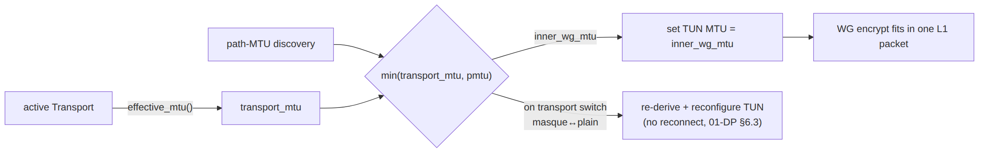
When the ladder switches transport (e.g. plain-udp → masque-h3, [01-DP §5.3]), the inner MTU changes (1420 → 1280) and helix-core re-derives + reconfigures the TUN MTU without a reconnect of unrelated state — a first-class reconcile event.

8. Timers, rekey, and keepalive state machine

8.1 The tick (grounded)
helix-core calls WgDevice::tick(now, scratch) every TICK_INTERVAL — ~100–250 ms [01-DP §4, 04_P0 §4.4 "every 100–250 ms"]. Each tick advances every peer's WireGuard timers (boringtun update_timers-equivalent, UNVERIFIED: API note 2) and returns the batch of WgVerdicts to emit (keepalives, rekey Msg1s, expirations).

8.2 Timer effects (grounded constants, §3.6)
Condition | Effect
REKEY_AFTER_TIME (120s) since last handshake, AND outbound traffic pending | initiator emits Msg1 (rekey)
KEEPALIVE_TIMEOUT (10s) since last received data, AND data was sent | passive keepalive (empty Msg4)
persistent_keepalive set (e.g. 25s) | unconditional keepalive every N seconds — keeps NAT mappings alive (§8.3)
REJECT_AFTER_TIME (180s) with no valid traffic | session expires → Down; next packet re-handshakes

8.3 Persistent keepalive (NAT survival)
PeerConfig.persistent_keepalive: Option<u16> (§2.2). The connector and client behind NAT set it (typical 25s) so the gateway-bound mapping never expires; the gateway edge generally does not (peers dial it). This composes with Phase-2 NAT traversal [01-DP §8] but is independent of it.

8.4 Roaming (endpoint latch — grounded)
WireGuard roaming: when a valid, authenticated Msg4 arrives from a new source SocketAddr, helix-wg updates WgPeer.endpoint to that address — no re-handshake [01-DP §8.2 "WireGuard's roaming latches onto whatever source address a valid handshake arrives from"]. This is what makes mobile network switches (Wi-Fi ↔ cellular) seamless and is the substrate for Phase-2 hole punching [01-DP §8.2]. Only a cryptographically valid packet moves the endpoint — a spoofed source cannot hijack the session (§14.2).

9. The encrypted-datagram boundary (transport sits beneath)

9.1 The contract (grounded, I1/I2)
helix-wg ↔ helix-transport exchange only opaque, already-encrypted WG datagrams as bytes::Bytes [01-DP §3.1, §0.1 I1/I2]. The transport never sees plaintext (I1) and carries unreliable datagrams, never an ordered stream (I2). The boundary is exactly two calls:
// helix-core orchestrator loop (01-DP §5.1) — the seam between §2 and 01-DP §3:
// OUTBOUND
match device.handle_tun_out(&ip_pkt, &mut scratch) {
WgVerdict::WriteToTransport(dg) => transport.send(Bytes::copy_from_slice(dg)).await?,
WgVerdict::Nothing => {}
WgVerdict::Err(e) => metrics.wg_error(e), // counter only (W5)
WgVerdict::WriteToTun{..} => unreachable!(), // tun_out never yields tun output
}
// INBOUND
let dg = transport.recv().await?; // opaque WG bytes (I1)
match device.handle_transport_in(&dg, from, &mut scratch) {
WgVerdict::WriteToTun{ pkt, .. } => tun.write(pkt).await?,
WgVerdict::WriteToTransport(reply) => transport.send(Bytes::copy_from_slice(reply)).await?, // handshake reply
WgVerdict::Nothing => {}
WgVerdict::Err(e) => metrics.wg_error(e),
}

9.2 Why helix-wg is transport-agnostic (W6, decoupling)
helix-wg holds no reference to a concrete transport — it returns bytes and takes bytes. The orchestrator owns the Box<dyn Transport> and the ladder [01-DP §5.3]. This is what makes the same WG core run over plain-udp, masque-h3, shadowsocks, … and what makes multi-hop trivial: an outer hop's Transport simply carries the inner hop's WG datagrams [01-DP §11.1]. helix-wg is unaware of obfuscation, DAITA, or which carrier is active — it only knows the active MTU (§7).

9.3 Kernel-backend boundary variation
When WgBackend::LinuxKernel runs plain-udp, the encrypt/decrypt happens in the kernel and the datagram boundary is a kernel UDP socket, not the Transport::send/recv calls (§1.3). For any obfuscating transport, the kernel cannot emit the carrier framing, so the userspace boundary (9.1) is mandatory — i.e. masque-h3/shadowsocks/… force WgBackend::Userspace. The WgDataPath trait (§1.3) hides this: helix-core calls the same verdict pump; the kernel impl short-circuits to netlink config + raw socket for plain-udp only. Edge case §12.7 enumerates the forbidden kernel+obfs combination.

9.4 Multi-hop nesting (grounded, Phase 2)
A 2-hop chain [Entry, Exit] is an ordered Vec<Hop> where Hop = { wg: WgPeer, transport: Box<dyn Transport> } [01-DP §11.1]. Outbound: encrypt for Exit (innermost WgPeer) → the Exit ciphertext is the plaintext fed to the Entry WgPeer's handle_tun_out → Entry ciphertext → Entry.transport.send(). helix-wg provides the per-hop WgPeer/WgDevice; the chain orchestration is helix-core::hop_chain [01-DP §11.1]. Entry sees the client but not the destination; Exit sees the destination but not the client — the Mullvad multi-hop property [01-DP §11.1, research-mullvad §3].

10. Error taxonomy
// helix-wg/src/error.rs
#[derive(thiserror::Error, Debug, Clone, PartialEq)]
pub enum WgError {
// ---- handshake ----
#[error("handshake timed out after {0:?}")] HandshakeTimeout(Duration), // REKEY_ATTEMPT_TIME exhausted
#[error("handshake rejected: bad MAC1")] BadMac1, // anti-DoS first gate (§14.3)
#[error("handshake rejected: bad MAC2/cookie")] BadMac2,
#[error("handshake AEAD verification failed")] HandshakeAead, // wrong peer / tampered
#[error("stale handshake timestamp (replay)")] StaleTimestamp, // TAI64N anti-replay (§3.2)
// ---- transport-data ----
#[error("AEAD decrypt failed (peer {0})")] DataAead(PeerIndex), // tampered / wrong key
#[error("replayed counter (peer {0})")] Replay(PeerIndex), // anti-replay window (§4.2)
#[error("unknown receiver index {0}")] UnknownIndex(u32), // demux miss (§3.5)
#[error("malformed WG datagram (len {0})")] Malformed(usize),
// ---- routing / access control (W4) ----
#[error("no AllowedIPs route for dst {0}")] NoRoute(IpAddr), // outbound drop (§5)
#[error("source {src} not permitted for peer {peer}")] SourceViolation { peer: PeerIndex, src: IpAddr },
// ---- session lifecycle ----
#[error("no current session (peer {0}); handshake required")] NoSession(PeerIndex),
#[error("peer {0} expired (REJECT_AFTER_TIME)")] SessionExpired(PeerIndex),
// ---- config / key ----
#[error("invalid key material")] InvalidKey,
#[error("secure store error: {0}")] SecureStore(String),
}
Classification rules (anti-bluff, §11.4.1/.6):
- NoRoute / SourceViolation / Replay / BadMac1 are expected, policy-or-attack-driven drops — counted (PeerStats), surfaced as metrics, never an Err propagated to the user as a tunnel failure, never logged per-packet (W5). They map to WgVerdict::Nothing at the orchestrator with a counter bump, NOT a Down{reason} status.
- HandshakeTimeout / HandshakeAead are genuine connection failures → surface as TunnelStatus::Reconnecting then ladder escalation [01-DP §5.3].
- Malformed / UnknownIndex are defensive drops at the edge under scan load — bounded by the rate limiter (§14.3), counted, never logged.
- A script-internal failure (panic, OOB slice) is a §11.4.1 FAIL-bluff and MUST fail the build, never reach this enum.

11. Configuration knobs
Only operational knobs are exposed; crypto parameters (§4) and WireGuard timer constants (§3.6) are fixed (W2) and are read-only constants, NOT config.
// helix-wg/src/config.rs
#[derive(Clone, Debug)]
pub struct WgDeviceConfig {
pub prefer_kernel: bool, // Linux only; resolve() honours availability (§1.3)
pub tick_interval: Duration, // default 200ms; clamp [100ms, 250ms] (§8.1)
pub rotation_overlap_s: u32, // static-key make-before-break window (§6.4); default 120
pub handshake_rate_limit: RateLimit,// per-source cookie-challenge threshold (§14.3)
pub scratch_size: usize, // per-loop scratch buffer bytes; default 65535 (max IP pkt)
pub max_peers: u32, // edge guardrail; client/connector = 1
}
// Per-peer knobs live in PeerConfig (§2.2): allowed_ips, endpoint,
// persistent_keepalive, psk. All are reconciler-pushed from the RouteMap (01-DP §6.2).
Defaults are chosen so the client/connector single-peer case needs zero explicit config; the edge sets max_peers + a tighter handshake_rate_limit.

12. Edge cases (enumerate, do not hand-wave — §11.4.118)
# | Edge case | Required behaviour
12.1 | Inbound Msg4 before any handshake completes | WgError::NoSession → drop + counter; do NOT emit plaintext. Trigger a rekey if outbound traffic is queued.
12.2 | Two concurrent handshake initiations (both sides initiate) | WireGuard tie-break by handshake hash / timestamp; keep the winner, drop the loser. UNVERIFIED: exact tie-break — pin to boringtun.
12.3 | Peer removed (remove_peer) mid-decrypt of its datagram | Datagram in flight is dropped (UnknownIndex); zeroize must complete before the index is reused.
12.4 | Malformed/overlapping AllowedIPs in a pushed map | helix-wg trusts the compiler's disjointness (§5.3); a longest-prefix collision resolves deterministically; an invalid prefix is rejected at upsert_peer with InvalidKey-class error, map delta NACKed to helix-core.
12.5 | Plaintext packet larger than inner_wg_mtu | Lower TUN MTU (preferred) or L3-fragment; never silent truncate (§7.3).
12.6 | Transport switch (ladder) mid-session | Re-derive MTU (§7.4); the WG session is preserved across transport change — same keys, new carrier; no re-handshake unless the endpoint changed.
12.7 | WgBackend::LinuxKernel requested with an obfuscating transport | Forbidden combination → force Userspace for that tunnel (§9.3); surface a one-time warning, never a silent wrong-backend run (§11.4.6).
12.8 | Counter exhaustion (REJECT_AFTER_MESSAGES) | Force rekey before the 64-bit counter nears exhaustion; a session that cannot rekey expires (SessionExpired).
12.9 | Clock skew breaking TAI64N timestamp check | StaleTimestamp drop; the device clock MUST be monotonic-enough for handshake — surface a health warning, do not weaken the check.
12.10 | iOS NE memory pressure during QUIC buffering | helix-wg itself is alloc-free on the hot path (W1); buffering lives in the transport. The memory gate G3 is a transport+core measurement, not a helix-wg-only one [04_P0 §6].
12.11 | Roaming: valid Msg4 from a new source while old endpoint still sends | Latch to the newest cryptographically valid source (§8.4); ignore the stale one.

13. Test points (§11.4.169-class; types per §11.4.27 — see note 3)
Every claim ships captured evidence, not a config-only PASS (§11.4.5/.69/.107). UNVERIFIED: §11.4.169's exact enumeration (note 3); the types below are the in-context §11.4.27 set.
Test type | What it exercises | Evidence (anti-bluff) | Maps to gate
unit | AllowedIpsTrie longest-prefix + permits; WgVerdict mapping from TunnResult; MTU derivation arithmetic (§7.1); error classification (§10) | property tests: random prefix sets vs a reference linear matcher; assert byte-identical routing decisions | —
fuzz | handle_transport_in on arbitrary bytes (malformed datagrams, §3.5/§12) | cargo-fuzz corpus; zero panics (W1/§11.4.1), every input → a WgVerdict (drop or output), never a crash | —
integration | client↔gateway↔connector plain-UDP WG up; ping overlay IP; reach 10.10.0.20:80 through the netns rig | iperf3 ≥ 80% bare link + curl hello page CSV from bench.sh | G1 / S1–S2 [04_P0 §8]
integration (obfs) | same slice over masque-h3 with plain WG blocked (nft rule) | tshark capture classified HTTP/3, no WG signature; goodput @ 5% netem loss beats UoT strawman | G2 / S3 [04_P0 §5.3, §8]
e2e | full ladder escalation plain-udp → … → masque-h3; session survives transport switch (§12.6) | ordered TunnelStatus event trace captured; WG session keys unchanged across switch | — [01-DP §5.4]
security | source-spoof drop (W4/§5.4); replay drop (§4.2); MAC1/cookie anti-DoS (§14.3); revoked peer unreachable in <1s (§6.3) | denied-flow packet capture; revoke→drop timing < 1s captured | [01-DP §7]
performance / benchmark | encrypt/decrypt throughput; CPU per Gbps; handshake/sec churn; per-platform RSS (W1) | bench.sh CSV: throughput @ 1/10/100 peers, p50/p99, CPU/Gbps; iOS Instruments RSS soak | G3 (iOS mem), G4 (edge) [04_P0 §6–§8]
stress / chaos (§11.4.85) | sustained N≥100-iteration handshake churn; mid-handshake peer removal (§12.3); clock-skew injection (§12.9); counter-exhaustion forced rekey (§12.8) | per-iteration latency.json + categorised-error census; recovery trace; no deadlock/leak | —
deterministic-consistency (§11.4.50) | the integration + obfs slices run N times (3 normal / 10 cycle) on the same rig | identical PASS + identical evidence hashes every run | —
Challenge / HelixQA (§11.4.27) | the §11.4.169-class per-feature "really works" challenge: drive the real client→LAN journey, confirm the hello page, captured | HelixQA result.json + captured transcript under docs/qa/<run-id>/ (§11.4.83) | —
Each fix to helix-wg follows §11.4.115 RED-on-broken + §11.4.135 standing regression guard (e.g. the source-spoof-accept bug → a permanent permits()-rejects-spoof guard).

14. Security considerations
- Private key custody (W3, §4.3/§6.1). Device private keys live in the platform secure store (iOS Keychain / Android Keystore / TPM-backed where available), SecretBytes-wrapped (zeroizing), never logged, never written to a plaintext file [01-DP §4, 04_ARCH §7, research-mullvad §8]. A leak path is a §11.4.10 violation.
- Cryptographic source authentication (§8.4/§12.11). Only a valid AEAD- authenticated Msg4 moves a peer's latched endpoint; a spoofed-source packet cannot hijack a session or redirect traffic — roaming is safe by construction.
- Handshake anti-DoS (§14.3, grounded architecture). MAC1 (keyed BLAKE2s over the static pubkey) is the cheap first gate: a Msg1 with a bad MAC1 is dropped before any expensive Curve25519 work. Under load the responder issues a Cookie Reply (Msg3, §3.1) demanding MAC2, rate-limited per source — the edge's defence against handshake floods. UNVERIFIED: exact cookie TTL / rate-limit constants (pin to WireGuard whitepaper + boringtun).
- No-logging by construction (W5). Only aggregate PeerStats counters exist; no per-packet, per-connection, or durable session state. The edge's sim-connection accounting is in-RAM only [research-mullvad §8, 01-DP §0.1 I5].
- Default-deny crypto-routing (W4/§5). A peer reaches only its granted AllowedIPs; this is the coarse crypto layer beneath the port/proto edge verdict map — both required (defense in depth) [01-DP §7].
- Harvest-now-decrypt-later (§4.4). The additive PQ-PSK seam protects today's recorded traffic against future quantum decryption, hybrid (never PQ-only) so a flaw in either KEM alone does not break the PSK [research-mullvad §4].
- Target-system safety (§11.4.133). The Linux kernel-WG netlink path writes only the documented WireGuard config surface; no out-of-range or unverified kernel writes. Backend selection never bricks the host.

15. Performance budget
Metric | Target | Source
plain-UDP through-tunnel throughput | ≥ 80% of bare link | G1 [04_P0 §8]
masque-h3 through-tunnel throughput | ≥ 50% of plain-UDP | G2 [04_P0 §8]
Added latency (plain-UDP) | < 2 ms | [04_P0 §8]
Added latency (masque-h3) | < 15 ms | [04_P0 §8]
Handshake time (plain) | < 1 s | [04_P0 §8]
Handshake time (masque-h3) | < 2 s | [04_P0 §8]
Reconnect / roam recovery | < 3 s | [04_P0 §8]
iOS NE steady-state RSS (core, both transports) | under device ceiling with ≥ 30% headroom, 30-min soak | G3 (make-or-break) [04_P0 §6.3]
Steady-state heap alloc on encrypt/decrypt | zero (scratch-buffer only) | W1
Edge CPU per Gbps | recorded (cost-to-serve, feeds D5 edge-language decision) | G4 [04_P0 §7–§8]
PQ-PSK handshake extra cost | ~1–2 s at handshake; steady-state unchanged | research-mullvad §4
The MASQUE throughput penalty (double crypto + double congestion control) is real and must be measured, never claimed at parity [research-masque §5 "do NOT claim parity speed"]. The §13 benchmark fills these cells with captured numbers (§11.4.5/.69/.123).

16. Build checklist (this crate)
File | Owns | Phase | Gate
helix-wg/src/lib.rs | WgVerdict, re-exports | 0 | G1 / S1
helix-wg/src/backend.rs | WgBackend, WgDataPath, resolve() (§1.3) | 0→1 | G1
helix-wg/src/peer.rs | WgPeer, WgDevice, pump methods (§2) | 0 | G1 / S1
helix-wg/src/allowed_ips.rs | AllowedIpsTrie (§5) | 0→1 | G6 / S8
helix-wg/src/keys.rs | DeviceKeypair, rotation (§6) | 0→1 | —
helix-wg/src/config.rs | WgDeviceConfig (§11) | 0 | —
helix-wg/src/error.rs | WgError taxonomy (§10) | 0 | S0
Surviving interfaces (frozen contracts per [01-DP §4, 04_P0 §14]): WgVerdict, WgPeer/WgDevice pump signatures, the encrypted-datagram boundary (§9). Their implementations may evolve; the signatures hold from Phase 0.

End of helix-wg nano-detail specification (Volume 2, doc 01). Pair with [01-DP] §4 (the section this deepens), the Transport trait spec ([01-DP] §3 — the layer beneath this one at the §9 boundary), and the security doc (PQ-PSK KEM exchange §4.4, kill-switch/DNS-leak state machine). Wire-byte layouts (§3) and boringtun signatures (§2) are UNVERIFIED: against the evidence base and MUST be confirmed against the WireGuard whitepaper + the pinned boringtun crate before implementation (§11.4.6).

