events backbone (Redis Streams)

events backbone (Redis Streams)
Revision: 1 Last modified: 2026-06-25T00:00:00Z
Master technical specification — Volume 3, Control Plane (Go), nano-detail service spec. Deepens the events backbone introduced in [02-control-plane §5] (internal/events). This document owns the byte-level and operational contract of the event bus: the bus-agnostic Envelope, the five Redis Streams, the full event taxonomy → coordinator reactions, the XReadGroup/XACK/XAUTOCLAIM consumer + dead-letter machinery, at-least-once + idempotent-reaction discipline, the per-event authz rules, the edge cases, the < 1 s convergence SLO, and the Phase-2 NATS-JetStream swap behind the same Bus interface. This is a SPEC — it describes the implementation; it does not build it. Source evidence cited inline by id: [02_CP] (final/02-control-plane.md), [04_P1] (HelixVPN-Phase1-MVP.md), [04_ARCH §4] (HelixVPN-Architecture-Refined.md §4), [research-go_cp] (cited research, accessed 2026-06-25), [SYNTHESIS §N]. Proto package is unified across the Volume-3 set: helix.coordinator.v1.

1. Position, scope, and governing invariants

1.1 What this service owns vs. what it does not
internal/events is the only path by which a Postgres state mutation reaches the coordinator [02_CP R3]. It is a thin, durable, bus-agnostic message fabric. It owns:
- the events.Bus interface (the swap seam, D3) and its Redis Streams implementation;
- the Envelope wire shape {id,type,tenant_id,ts,actor,payload,trace_id} [02_CP §5.2];
- the five canonical streams + their consumer-group topology [02_CP §5.1];
- the at-least-once consume loop, XACK discipline, XAUTOCLAIM reclaim, and DLQ routing;
- the idempotency contract every consumer must honour;
- the publish-side transactional-outbox guarantee that couples a DB write to its event.
It does not own: the durable tables (those are internal/store — the bus carries no truth, only change notifications [02_CP C2]); the topology graph or map-diffing (that is internal/coordinator §6, which is a consumer of this bus); the agent wire protocol (Coordinator proto §4 — the bus is internal east-west, never exposed to agents).

1.2 Governing invariants this service obeys (from [02_CP §0.1])
# | Invariant | Consequence for the bus
C2 | Postgres = truth; Redis is ephemeral. Losing Redis loses no durable state. | A lost event is recoverable by rehydrating the coordinator graph from Postgres (§7.4). The bus is a fast-path, never the system of record.
C3 | No-logging by construction. | Event payloads carry identity/topology/policy deltas only — never src/dst IP pairs, ports-in-use, byte counts, flows. A §1.1 payload-lint mirrors the schema-lint [02_CP §2.4] (§9.4).
C4 | Default-deny, need-to-know. | Events carry a tenant_id and the coordinator filters fan-out by compiled policy; an event NEVER instructs delivery of a peer a node may not reach.
C5 | Push, don't poll; convergence p99 < 1 s. | The bus latency budget (event-publish → consumer-receive) is the largest single term in the SLO; §8 allots it ≤ 250 ms p99.
C7 | Package boundaries == service boundaries. | events.Bus is bus-agnostic so the Phase-2 NATS swap is a transport change, not a rewrite (§10).
Decision D3 (restated, [02_CP §1.3, SYNTHESIS §3]). Redis Streams for the MVP, NATS JetStream for Phase-2 scale. Redis is already mandated for presence [05_YBO], so the MVP reuses it with zero new operational dependency; the Bus interface is the seam.

2. The bus-agnostic contract

2.1 events.Bus interface (the swap seam)
// internal/events/iface.go
//
// Bus is the bus-agnostic seam (D3). The MVP impl is Redis Streams (§4); the Phase-2 impl
// is NATS JetStream (§10). NOTHING above this interface knows which transport is live.
package events
import (
"context"
"time"
"github.com/google/uuid"
)
// Stream is a typed stream name. The five canonical values are declared in §3.1.
type Stream string
// Bus is the publish/subscribe/ack contract. All methods are context-cancellable.
type Bus interface {
// Publish appends env to stream and returns the transport-assigned message id
// (Redis stream id "<ms>-<seq>"; NATS sequence as decimal string in P2). At-least-once.
// MUST be called inside the same logical unit of work as the DB write that caused it
// (transactional outbox, §5.2) — never best-effort fire-and-forget.
Publish(ctx context.Context, stream Stream, env Envelope) (msgID string, err error)
// Subscribe joins (group,consumer) to the given streams and returns a delivery channel.
// The channel yields Delivery values until ctx is cancelled or the bus is closed.
// Delivery semantics: at-least-once; the caller MUST Ack each Delivery after a
// successful, idempotent reaction (§6). Redelivery on crash is the contract, not a bug.
Subscribe(ctx context.Context, group, consumer string, streams ...Stream) (<-chan Delivery, error)
// Ack marks one delivered message as processed for (stream,group). Idempotent: acking an
// already-acked or unknown id is a no-op, not an error.
Ack(ctx context.Context, stream Stream, group, msgID string) error
// Nack signals the reaction failed and the message should be retried later. The Redis impl
// simply does NOT ack (the entry stays in the PEL and is reclaimed by XAUTOCLAIM, §6.4);
// Nack increments an in-process metric so retries are observable. Provided so callers do
// not rely on "forget to ack" as the failure signal.
Nack(ctx context.Context, stream Stream, group, msgID string, cause error) error
// Health returns nil when the transport is reachable (PING ok) AND no consumer group is
// lagging beyond the alarm threshold (§8.4). Wired into /healthz readiness.
Health(ctx context.Context) error
// Close stops all subscriptions and releases the connection pool.
Close() error
}
// Delivery is one received message plus the addressing needed to Ack it.
type Delivery struct {
Stream Stream
Group string
MsgID string // transport message id; the Ack key
Env Envelope // decoded payload (§2.2)
Attempt int // 1 on first delivery; >1 means a prior delivery was not acked (PEL)
IdleSince time.Time // when this entry was last delivered/claimed (for XAUTOCLAIM forensics)
}

2.2 Envelope — the wire shape (bus-agnostic, [02_CP §5.2])
The envelope is identical across Redis (MVP) and NATS (P2). It is encoded as a flat Redis hash field-set on XADD (one field per envelope key; payload is a JSON string) and as a JSON message body on NATS. The canonical Go type and its JSON form:
// internal/events/envelope.go
package events
import (
"encoding/json"
"fmt"
"time"
"github.com/google/uuid"
)
type Envelope struct {
// ID is the transport-assigned message id, filled by the bus on receive (empty on publish).
// On Redis this is the stream entry id "<ms>-<seq>"; it doubles as the natural dedup key (§6.2).
ID string `json:"id"`
Type EventType `json:"type"` // closed vocabulary, §3.3
TenantID uuid.UUID `json:"tenant_id"` // RLS/fan-out scope (C4); NEVER empty except SystemTenant
TS time.Time `json:"ts"` // RFC3339 UTC, producer clock at publish
Actor string `json:"actor"` // "user:<uuid>" | "device:<uuid>" | "system"
Payload json.RawMessage `json:"payload"` // type-specific, schema per §3.4; identity/topology/policy ONLY (C3)
TraceID string `json:"trace_id"` // W3C traceparent-derived; correlates DB→bus→stream.Send
// SchemaV is the payload schema version (default 1). Lets a consumer reject/upgrade an
// unknown payload shape instead of mis-parsing it (forward-compat, §10.3).
SchemaV int `json:"schema_v"`
}
// redisFields renders the envelope as the field map XADD stores. payload + ts are stringified.
func (e Envelope) redisFields() map[string]any {
return map[string]any{
"type": string(e.Type),
"tenant_id": e.TenantID.String(),
"ts": e.TS.UTC().Format(time.RFC3339Nano),
"actor": e.Actor,
"payload": string(e.Payload), // already-compact JSON
"trace_id": e.TraceID,
"schema_v": e.SchemaV,
}
}
// New builds an envelope with TS=now, SchemaV=1, and a validated, compacted payload.
// It is the ONLY constructor producers use; it enforces the C3 payload shape via the
// payload lint (§9.4) at build time in tests and at publish time as a cheap guard.
func New(t EventType, tenant uuid.UUID, actor string, payload any) (Envelope, error) {
raw, err := json.Marshal(payload)
if err != nil {
return Envelope{}, fmt.Errorf("events.New marshal %s: %w", t, err)
}
if !t.Valid() { // closed-vocabulary guard (§3.3)
return Envelope{}, fmt.Errorf("events.New: unknown type %q", t)
}
return Envelope{
Type: t, TenantID: tenant, TS: time.Now().UTC(),
Actor: actor, Payload: raw, TraceID: traceIDFromContext(), SchemaV: 1,
}, nil
}
Canonical JSON instance (the device.revoked example, [02_CP §5.2]):
{
"id": "1735689600000-0",
"type": "device.revoked",
"tenant_id": "8a1f9c2e-0b3d-4e5a-9f6b-1c2d3e4f5a6b",
"ts": "2026-06-25T12:00:00.000Z",
"actor": "user:3f2a...",
"payload": { "device_id": "d41d8cd9-8f00-4b20-a8d1-3c2e1f0a9b8c" },
"trace_id": "00-4bf92f3577b34da6a3ce929d0e0e4736-00f067aa0ba902b7-01",
"schema_v": 1
}
Privacy boundary (C3, anti-bluff). The payload object is structurally constrained to identity/topology/policy keys. There is no field anywhere in the taxonomy for a source/destination address pair in use, a port a flow used, a byte count, or a DNS query. advertised_prefixes CIDRs and a device's stable overlay_ip appear (they are topology, not traffic) — exactly the same allowlist the schema-lint enforces [02_CP §2.4]. The §9.4 payload-lint is the runtime signature that proves this is live, not merely promised.

3. Streams, groups, and the event taxonomy

3.1 The five canonical streams + consumer groups [02_CP §5.1]
// internal/events/streams.go
const (
StreamDevices Stream = "events:devices" // identity + registry produce
StreamRoutes Stream = "events:routes" // registry produces (connector prefixes)
StreamPolicy Stream = "events:policy" // policy produces
StreamPresence Stream = "events:presence" // api (heartbeats) produces; high-churn, short TTL
StreamGateway Stream = "events:gateway" // edge health probes produce
)
// dlqOf returns the dead-letter stream name for a primary stream (§6.5).
func dlqOf(s Stream) Stream { return s + ":dlq" }
Stream | Producers | Consumer groups (<group>) | Trim policy (§8.5)
events:devices | identity, registry | coordinator, telemetry, audit | MAXLEN ~ 100000
events:routes | registry | coordinator, telemetry | MAXLEN ~ 50000
events:policy | policy | coordinator, audit | MAXLEN ~ 20000
events:presence | api (heartbeats) | coordinator | MAXLEN ~ 200000 (high churn)
events:gateway | edge health probes | coordinator, telemetry | MAXLEN ~ 50000
Each (stream, group) pair is a durable cursor; multiple helixd replicas in Phase 2 join the same group with distinct consumer names so work is partitioned, not duplicated [research-go_cp §5]. In the MVP single-binary deploy there is one consumer per group named by the host id (hostID, the container's stable name).

3.2 Stream/group topology diagram
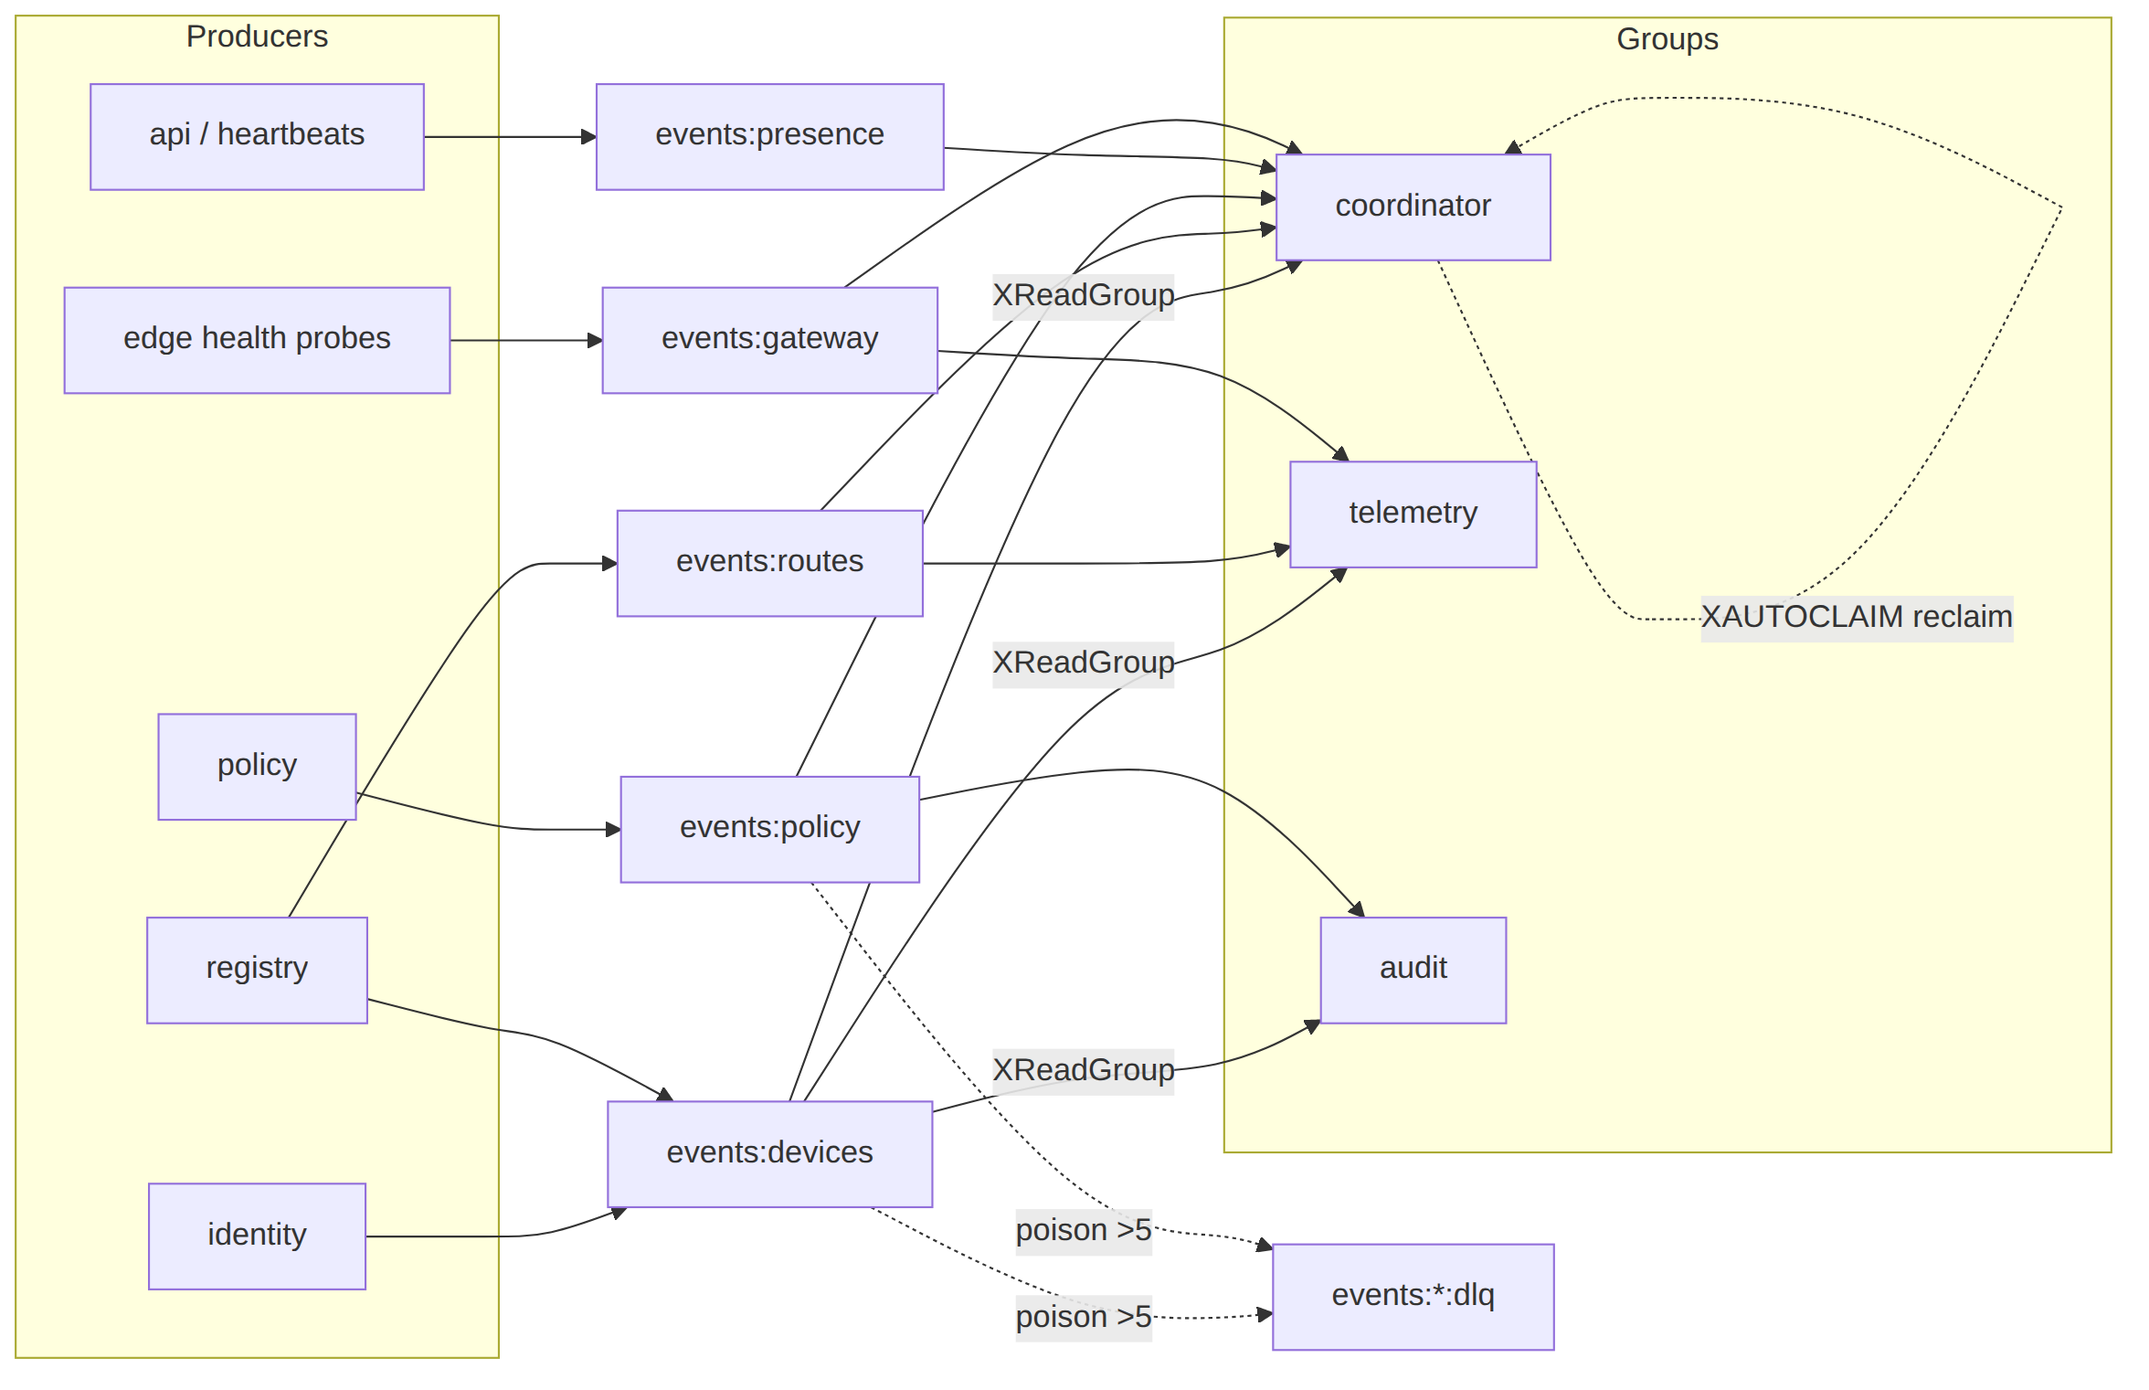

3.3 EventType — the closed vocabulary
// internal/events/types.go
type EventType string
const (
EvDeviceEnrolled EventType = "device.enrolled"
EvDeviceOnline EventType = "device.online"
EvDeviceOffline EventType = "device.offline"
EvDeviceRevoked EventType = "device.revoked"
EvConnectorAttached EventType = "connector.attached"
EvConnectorPrefixesChng EventType = "connector.prefixes.changed"
EvRouteConflictDetected EventType = "route.conflict.detected"
EvPolicyUpdated EventType = "policy.updated"
EvPolicyCompiled EventType = "policy.compiled"
EvGatewayFailover EventType = "gateway.failover"
)
var validTypes = map[EventType]Stream{
EvDeviceEnrolled: StreamDevices,
EvDeviceOnline: StreamPresence, // online/offline are presence, not durable identity
EvDeviceOffline: StreamPresence,
EvDeviceRevoked: StreamDevices,
EvConnectorAttached: StreamDevices,
EvConnectorPrefixesChng: StreamRoutes,
EvRouteConflictDetected: StreamRoutes,
EvPolicyUpdated: StreamPolicy,
EvPolicyCompiled: StreamPolicy,
EvGatewayFailover: StreamGateway,
}
func (t EventType) Valid() bool { _, ok := validTypes[t]; return ok }
// Stream returns the canonical stream a type belongs on. Publishing a type to the wrong
// stream is a programmer error caught by a unit test (§9.1) and by Publish (§5.2).
func (t EventType) Stream() Stream { return validTypes[t] }

3.4 Full taxonomy: payload schema → coordinator reaction → idempotency key
Every payload is {...}-JSON under the envelope's payload. The Idempotency key column is the natural key a consumer derives to make the reaction safe under at-least-once redelivery (§6.2). All reactions are recomputed from current graph state, so replay is harmless [02_CP §5.4].
Type | Payload schema (Go struct) | Coordinator reaction | Idempotency key
device.enrolled | {device_id uuid, kind "client"|"connector", overlay_ip string} | Insert node into tenant graph; if any active policy grants it, recompute + push upsert-peer delta to grantee maps (C4). | (tenant, "enrolled", device_id)
device.online | {device_id uuid, rtt_ms uint32} | Flip presence→online; mark relay availability; push presence-only delta to peers that already see it. No topology change. | (tenant, device_id, last-write-wins on TS)
device.offline | {device_id uuid} | Flip presence→offline; peers see relay unavailable; no peer removal (still authorized, just unreachable). | LWW on TS
device.revoked | {device_id uuid} | Remove node from graph; push remove-peer delta to everyone who could see it; edge drops the WG peer (< 1 s, §8). Cert marked revoked by pki. | (tenant, "revoked", device_id) — terminal, monotonic
connector.attached | {device_id uuid, site string} | Register connector; allocate site_id for 4via6 (D4); recompute routes for nodes whose policy includes its prefixes. | (tenant, "attached", device_id)
connector.prefixes.changed | {connector_id uuid, cidrs []string, gen int64} | Recompute routes; push delta to nodes whose compiled policy grants any of these CIDRs (minimal affected set, §6.4). gen is a per-connector monotonic counter — drop a stale gen. | (tenant, connector_id, gen)
route.conflict.detected | {cidr string, connector_ids []uuid} | Flag overlapping-CIDR; surface in Console via events:*→WS (§3.6). Does not block; resolved by 4via6 or operator choice [02_CP §7.3]. | (tenant, cidr, sorted(connector_ids))
policy.updated | {version int64} | (Informational.) Trigger compile if not already dry-run-compiled. Usually a no-op for the coordinator (it waits for policy.compiled). | (tenant, "updated", version)
policy.compiled | {version int64} | Recompute the whole tenant's visibility from the new CompiledPolicy; diff against last pushed map per node; push minimal deltas. The heaviest reaction. | (tenant, "compiled", version) — monotonic; ignore a version ≤ last-applied
gateway.failover | {from string, to string} | Re-point affected nodes' GatewayInfo.endpoint; push GatewayInfo-only delta. | (tenant, "gw", to, TS) LWW
// internal/events/payloads.go — the typed payload structs (one per type), all snake_case JSON.
type DeviceEnrolled struct { DeviceID uuid.UUID `json:"device_id"`; Kind string `json:"kind"`; OverlayIP string `json:"overlay_ip"` }
type DevicePresence struct { DeviceID uuid.UUID `json:"device_id"`; RTTMs uint32 `json:"rtt_ms,omitempty"` }
type DeviceRevoked struct { DeviceID uuid.UUID `json:"device_id"` }
type ConnectorAttached struct { DeviceID uuid.UUID `json:"device_id"`; Site string `json:"site"` }
type ConnectorPrefixes struct { ConnectorID uuid.UUID `json:"connector_id"`; CIDRs []string `json:"cidrs"`; Gen int64 `json:"gen"` }
type RouteConflict struct { CIDR string `json:"cidr"`; ConnectorIDs []uuid.UUID `json:"connector_ids"` }
type PolicyVersion struct { Version int64 `json:"version"` }
type GatewayFailover struct { From string `json:"from"`; To string `json:"to"` }

3.5 Per-event authorization rules (who may emit what)
The bus is internal — agents NEVER publish. Authz is enforced at the producing module's public boundary (REST RBAC [02_CP §8.1] / agent mTLS [02_CP §8.2]) before events.New. The bus itself enforces two structural rules at Publish:
Event | Permitted producer module | Permitted actor origin | Bus-enforced structural rule
device.enrolled | identity | the enrolled device:<id> via a valid single-use enroll token | tenant_id must match the device's tenant; actor prefix device: or system
device.online/offline | api (heartbeat handler) | device:<id> (mTLS cert) | actor device:<id> must equal payload device_id
device.revoked | identity / api | user:<uuid> with admin role, or system | actor must be user: (admin) or system; never device: (a device cannot revoke itself or others)
connector.attached | registry | device:<id> (connector mTLS) | kind=connector asserted from the device row
connector.prefixes.changed | registry | the connector device:<id> or user: admin/operator | prefixes must already be persisted+validated (no unvalidated CIDR on the bus)
route.conflict.detected | registry (compiler dry-run) | system | actor system only
policy.updated/policy.compiled | policy | user: admin/operator or system | actor must be user:(admin/operator) or system
gateway.failover | (edge health subsystem) | system | actor system only
// internal/events/authz.go — structural guards applied inside the Redis Publish (§5.2).
// These are belt-and-suspenders: the producing module already authorized the action; the bus
// refuses a malformed actor/tenant so a coding bug cannot inject a spoofed-origin event.
func guardPublish(stream Stream, env Envelope) error {
if env.Type.Stream() != stream {
return fmt.Errorf("events: type %s may not publish to %s", env.Type, stream)
}
if env.TenantID == uuid.Nil && env.Actor != "system" {
return fmt.Errorf("events: non-system event %s requires tenant_id", env.Type)
}
switch env.Type {
case EvDeviceRevoked, EvPolicyUpdated, EvPolicyCompiled:
if !strings.HasPrefix(env.Actor, "user:") && env.Actor != "system" {
return fmt.Errorf("events: %s requires user/system actor, got %q", env.Type, env.Actor)
}
case EvRouteConflictDetected, EvGatewayFailover:
if env.Actor != "system" {
return fmt.Errorf("events: %s requires system actor", env.Type)
}
}
return nil
}

3.6 Bridge to the live-UI stream
A subset of events (device.online, route.conflict.detected, connector.prefixes.changed, gateway.failover) is re-emitted to the Console WS/SSE endpoint GET /v1/stream [02_CP §8]. The api module runs a thin events:* consumer in group ws-fanout that maps an Envelope → a UI event JSON and writes it to connected admin sockets. This is read-only projection; it never acks on behalf of coordinator (distinct group), so a slow Console cannot stall map convergence (back-pressure isolation, §6.6).

4. Redis Streams implementation

4.1 Construction & client
Go client: redis/go-redis/v9 (XAdd, XReadGroup, XAck, XAutoClaim, XPending, XTrim with MAXLEN) [research-go_cp §5]. Redis pinned to a known version; if ≥ 8.4 the single-shot XREADGROUP ... CLAIM form is available (§6.4 note) — the MVP uses the portable XAUTOCLAIM-then-XREADGROUP two-step so it does not require 8.4 [research-go_cp §5].
// internal/events/redisbus.go
type RedisBus struct {
rdb *redis.Client
hostID string // stable consumer name (container name)
dlqCap int // poison redelivery ceiling (default 5, §6.5)
log *slog.Logger
mx metrics // §8 counters/histograms
}
func NewRedisBus(rdb *redis.Client, hostID string, log *slog.Logger, mx metrics) *RedisBus {
return &RedisBus{rdb: rdb, hostID: hostID, dlqCap: 5, log: log, mx: mx}
}
// EnsureGroups is called once at boot. It creates each (stream,group) with MKSTREAM so the
// stream exists even before the first XADD, and starts the cursor at "$" (only-new) for a
// FRESH group or "0" to replay backlog — the coordinator uses "0" exactly once on cold boot
// AFTER it has hydrated from Postgres, so it never double-applies (§7.4).
func (b *RedisBus) EnsureGroups(ctx context.Context, plan map[Stream][]string) error {
for stream, groups := range plan {
for _, g := range groups {
err := b.rdb.XGroupCreateMkStream(ctx, string(stream), g, "$").Err()
if err != nil && !strings.Contains(err.Error(), "BUSYGROUP") {
return fmt.Errorf("xgroupcreate %s/%s: %w", stream, g, err)
}
}
}
return nil
}

4.2 Decode / encode
// fromRedis reconstructs an Envelope from an XMessage's Values (the redisFields map, §2.2).
func fromRedis(stream Stream, group string, m redis.XMessage, attempt int, idle time.Time) (Delivery, error) {
get := func(k string) string { v, _ := m.Values[k].(string); return v }
tenant, err := uuid.Parse(get("tenant_id"))
if err != nil && get("tenant_id") != "" { // SystemTenant events carry no tenant
return Delivery{}, fmt.Errorf("bad tenant_id on %s: %w", m.ID, err)
}
ts, _ := time.Parse(time.RFC3339Nano, get("ts"))
sv, _ := strconv.Atoi(get("schema_v"))
env := Envelope{
ID: m.ID, Type: EventType(get("type")), TenantID: tenant, TS: ts,
Actor: get("actor"), Payload: json.RawMessage(get("payload")),
TraceID: get("trace_id"), SchemaV: sv,
}
if !env.Type.Valid() {
return Delivery{}, fmt.Errorf("unknown event type %q on %s", env.Type, m.ID)
}
return Delivery{Stream: stream, Group: group, MsgID: m.ID, Env: env, Attempt: attempt, IdleSince: idle}, nil
}

5. Publish side — transactional outbox guarantee

5.1 The hazard and the rule
[02_CP R3] says "every state mutation emits an event." The hazard: if the DB COMMIT succeeds but the XADD is lost (process crash between the two), the coordinator never learns of the change and a node converges to a stale map — a silent correctness hole, worse than a duplicate. Conversely, XADD before COMMIT can publish a change that then rolls back.
Rule P1 — outbox-then-relay (at-least-once, never at-most-once). The producing module writes an outbox row in the same WithTenant transaction as the state mutation; a relay loop drains the outbox to Redis and deletes the row only after a successful XADD. A crash after commit re-drains on restart (duplicate XADD possible → harmless, idempotent reactions §6.2). A crash before commit rolls back the outbox row too (no phantom event). This is the canonical transactional-outbox pattern; it is the only way to make "DB write ⇒ event" atomic without distributed transactions [research-go_cp §7 async-path; SYNTHESIS §3].

5.2 Outbox table, relay, and Publish
-- migrations/NNNN_outbox.sql (tenant-scoped, RLS like every table — [02_CP §2.3])
CREATE TABLE event_outbox (
id bigint GENERATED ALWAYS AS IDENTITY PRIMARY KEY,
tenant_id uuid NOT NULL REFERENCES tenants(id) ON DELETE CASCADE,
stream text NOT NULL, -- "events:policy" etc.
type text NOT NULL, -- closed vocabulary (§3.3)
actor text NOT NULL,
payload jsonb NOT NULL, -- identity/topology/policy only (C3) — payload-lint §9.4
trace_id text NOT NULL,
schema_v int NOT NULL DEFAULT 1,
created_at timestamptz NOT NULL DEFAULT now(),
relayed_at timestamptz -- NULL = pending; set when XADD succeeds, then row is reaped
);
CREATE INDEX event_outbox_pending ON event_outbox (id) WHERE relayed_at IS NULL;
ALTER TABLE event_outbox ENABLE ROW LEVEL SECURITY;
ALTER TABLE event_outbox FORCE ROW LEVEL SECURITY;
CREATE POLICY tenant_isolation ON event_outbox
USING (tenant_id = current_setting('app.tenant_id')::uuid)
WITH CHECK (tenant_id = current_setting('app.tenant_id')::uuid);
// internal/events/outbox.go
//
// StageInTx writes the outbox row inside the caller's existing tenant transaction. The caller
// (policy.Activate, registry.SetPrefixes, identity.Enroll, ...) MUST call this within the same
// q the state mutation used — that is the atomicity guarantee (P1).
func StageInTx(ctx context.Context, q *db.Queries, env Envelope) error {
if err := env.Type.requireStream(env.Type.Stream()); err != nil { // §3.3 guard
return err
}
return q.InsertOutbox(ctx, db.InsertOutboxParams{
TenantID: env.TenantID, Stream: string(env.Type.Stream()), Type: string(env.Type),
Actor: env.Actor, Payload: env.Payload, TraceID: env.TraceID, SchemaV: int32(env.SchemaV),
})
}
// Relay is the single background loop that moves committed outbox rows to Redis. One per
// helixd process; a SKIP-LOCKED claim makes it safe to run on every replica in Phase 2.
func (b *RedisBus) Relay(ctx context.Context, store *store.Store) error {
t := time.NewTicker(50 * time.Millisecond) // tight: contributes to the §8 publish budget
defer t.Stop()
for {
select {
case <-ctx.Done():
return ctx.Err()
case <-t.C:
// FOR UPDATE SKIP LOCKED LIMIT 256: each replica grabs a disjoint batch (no dup relay).
rows, err := store.ClaimOutboxBatch(ctx, 256)
if err != nil { b.log.Error("outbox claim", "err", err); continue }
for _, r := range rows {
env := r.ToEnvelope()
if err := guardPublish(env.Type.Stream(), env); err != nil { // §3.5
b.log.Error("outbox guard reject", "id", r.ID, "err", err)
_ = store.MarkOutboxRelayed(ctx, r.ID) // poison-out a malformed row; never block the loop
b.mx.outboxRejected.Inc()
continue
}
id, err := b.xadd(ctx, env) // the actual XADD with MAXLEN trim
if err != nil { b.mx.publishErrors.Inc(); break } // leave row pending; retry next tick
_ = store.MarkOutboxRelayed(ctx, r.ID)
b.mx.published.WithLabelValues(string(env.Type)).Inc()
b.mx.outboxLagSeconds.Observe(time.Since(r.CreatedAt).Seconds())
_ = id
}
}
}
}
// xadd is the low-level append with the per-stream trim cap (§8.5).
func (b *RedisBus) xadd(ctx context.Context, env Envelope) (string, error) {
return b.rdb.XAdd(ctx, &redis.XAddArgs{
Stream: string(env.Type.Stream()),
MaxLen: trimCapFor(env.Type.Stream()), // approximate (~) trim, O(1) amortized
Approx: true,
Values: env.redisFields(),
}).Result()
}
// Publish (the Bus interface method) is the NON-transactional convenience for the rare
// caller that has no DB write to couple (e.g. gateway.failover from the edge-health loop,
// actor=system). It stages to outbox in an autonomous tx then lets Relay carry it, so even
// the "no DB mutation" path keeps the same at-least-once + ordering guarantees.
func (b *RedisBus) Publish(ctx context.Context, stream Stream, env Envelope) (string, error) {
if err := guardPublish(stream, env); err != nil { return "", err }
err := b.store.WithSystemOrTenant(ctx, env.TenantID, func(q *db.Queries) error {
return StageInTx(ctx, q, env)
})
return "", err // real msgID is assigned by Relay's XADD; callers needing it read the outbox row
}

5.3 Why not publish directly inside the tenant tx?
A direct XADD inside the SQL transaction would couple Redis availability to every DB commit (a Redis blip would roll back legitimate identity/policy writes — violating C2 "losing Redis loses no durable state"). The outbox decouples them: Postgres commits regardless of Redis health; the relay catches up when Redis returns. This is the C2-correct ordering.

6. Consume side — at-least-once, idempotent, dead-letter

6.1 The consumer loop (coordinator is the canonical consumer)
// internal/events/consumer.go
//
// Run is the durable consume loop for one (group). It is started once per group per process.
// Order each tick: (1) reclaim stalled work with XAUTOCLAIM, then (2) read new work with
// XREADGROUP > — the production-proven order [research-go_cp §5]. Every successfully reacted
// message is XACKed; a failed reaction is LEFT in the PEL (no ack) so the next XAUTOCLAIM
// retries it; a message past the redelivery ceiling is DLQ'd (§6.5).
func (b *RedisBus) Run(ctx context.Context, group string, streams []Stream,
react func(ctx context.Context, d Delivery) error) error {
for {
select {
case <-ctx.Done():
return ctx.Err()
default:
}
// (1) reclaim: per stream, claim PEL entries idle >= MinIdle (30s) into THIS consumer.
for _, s := range streams {
b.reclaimAndHandle(ctx, s, group, react)
}
// (2) new work: block up to 2s across all streams for this group.
args := &redis.XReadGroupArgs{
Group: group, Consumer: b.hostID, Count: 64, Block: 2 * time.Second,
Streams: idsForRead(streams), // [stream1, stream2, ..., ">", ">", ...]
}
res, err := b.rdb.XReadGroup(ctx, args).Result()
if err == redis.Nil { continue } // timeout, no new messages — loop
if err != nil { b.mx.readErrors.Inc(); time.Sleep(200 * time.Millisecond); continue }
for _, st := range res {
for _, m := range st.Messages {
d, derr := fromRedis(Stream(st.Stream), group, m, 1, time.Now())
if derr != nil { // undecodable → straight to DLQ (poison)
b.toDLQ(ctx, Stream(st.Stream), group, m, derr, 1); continue
}
b.handleOne(ctx, group, react, d)
}
}
}
}
// handleOne runs the reaction under a per-message timeout, then acks on success.
func (b *RedisBus) handleOne(ctx context.Context, group string,
react func(context.Context, Delivery) error, d Delivery) {
start := time.Now()
hctx, cancel := context.WithTimeout(ctx, 3*time.Second)
defer cancel()
err := react(hctx, d)
b.mx.reactSeconds.WithLabelValues(string(d.Env.Type)).Observe(time.Since(start).Seconds())
if err == nil {
if aerr := b.rdb.XAck(ctx, string(d.Stream), group, d.MsgID).Err(); aerr != nil {
b.mx.ackErrors.Inc() // ack failed → entry stays in PEL → reclaimed later (still safe)
}
return
}
// reaction failed → DO NOT ack. Leave in PEL; XAUTOCLAIM retries; ceiling routes to DLQ.
b.mx.reactErrors.WithLabelValues(string(d.Env.Type)).Inc()
b.log.Warn("reaction failed", "type", d.Env.Type, "id", d.MsgID, "attempt", d.Attempt, "err", err)
}

6.2 Idempotency contract (the heart of at-least-once safety)
At-least-once means every consumer MUST be safe under redelivery [02_CP §5.4, research-go_cp §5]. Two cooperating mechanisms:
- Recompute-from-state reactions (primary). The coordinator never applies a delta of a delta; it applies the event to its in-memory graph and recomputes the affected nodes' maps from current state. Replaying policy.compiled v=7 twice yields the identical map the second time — a no-op diff, nothing pushed. This makes most reactions naturally idempotent with no dedup store [02_CP §5.4].
- Monotonic-version / seen-set guard (for non-idempotent side effects). Where a reaction has an external side effect that is NOT naturally idempotent (e.g. the audit group writes an audit_events row; the ws-fanout group emits a UI toast), the consumer derives the §3.4 Idempotency key and guards on it:
// internal/events/idem.go
//
// The coordinator tracks the last-applied monotonic marker per (tenant,kind) in-memory; an
// event whose version/gen is <= the applied marker is dropped. Durable consumers (audit) use a
// small Redis SET with TTL as the seen-set so a duplicate XADD does not write two audit rows.
type applied struct {
policyVersion map[uuid.UUID]int64 // tenant -> last applied policy.compiled version
connectorGen map[uuid.UUID]int64 // connector -> last applied prefixes gen
revoked map[uuid.UUID]struct{} // device ids already removed (terminal)
}
// shouldApply returns false (skip) when the event is stale/duplicate by its monotonic key.
func (a *applied) shouldApply(d Delivery) bool {
switch d.Env.Type {
case EvPolicyCompiled:
var p PolicyVersion; _ = json.Unmarshal(d.Env.Payload, &p)
if p.Version <= a.policyVersion[d.Env.TenantID] { return false } // already applied or older
a.policyVersion[d.Env.TenantID] = p.Version
return true
case EvConnectorPrefixesChng:
var c ConnectorPrefixes; _ = json.Unmarshal(d.Env.Payload, &c)
if c.Gen <= a.connectorGen[c.ConnectorID] { return false }
a.connectorGen[c.ConnectorID] = c.Gen
return true
case EvDeviceRevoked:
var r DeviceRevoked; _ = json.Unmarshal(d.Env.Payload, &r)
if _, done := a.revoked[r.DeviceID]; done { return false } // revoke is terminal+idempotent
a.revoked[r.DeviceID] = struct{}{}
return true
default:
return true // online/offline/enrolled/etc. are recompute-from-state idempotent (mechanism 1)
}
}
Ordering note. Redis Streams preserve per-stream order; the monotonic guard means an out-of-order retry of an older version (delivered late by XAUTOCLAIM after a newer one already applied) is correctly dropped, not regressed. This is why the taxonomy keys are monotonic (version, gen) rather than wall-clock for the topology-changing events.

6.3 Consumer state machine (per message)
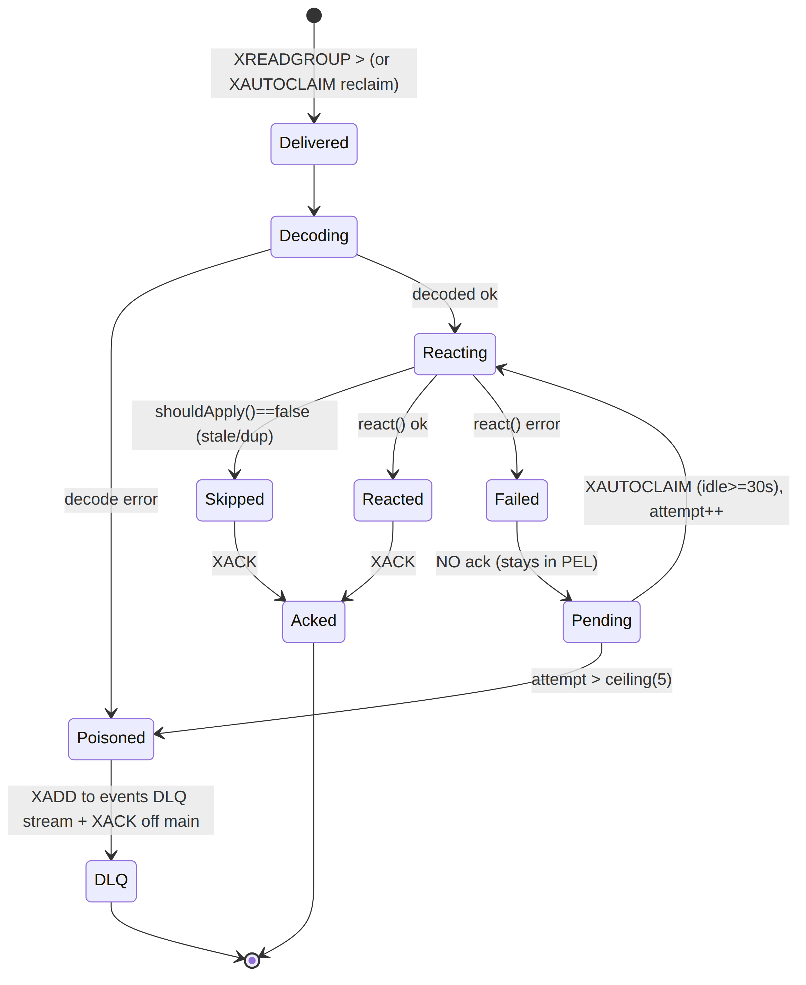

6.4 XAUTOCLAIM reclaim — the crash-recovery path
// reclaimAndHandle transfers stalled PEL entries (idle >= 30s) to this consumer and re-reacts.
// This is the dead-letter recovery path: a crashed coordinator's un-acked entries are NOT lost
// — composes constitution §11.4.147 (no-work-loss) [02_CP §5.4].
func (b *RedisBus) reclaimAndHandle(ctx context.Context, s Stream, group string,
react func(context.Context, Delivery) error) {
cursor := "0-0"
for {
msgs, next, err := b.rdb.XAutoClaim(ctx, &redis.XAutoClaimArgs{
Stream: string(s), Group: group, Consumer: b.hostID,
MinIdle: 30 * time.Second, Start: cursor, Count: 64,
}).Result()
if err != nil { b.mx.claimErrors.Inc(); return }
for _, m := range msgs {
// delivery count from XPENDING tells us the attempt; ceiling check first.
attempt := b.deliveryCount(ctx, s, group, m.ID)
if attempt > b.dlqCap {
b.toDLQ(ctx, s, group, m, errPoison, attempt)
continue
}
d, derr := fromRedis(s, group, m, attempt, time.Now())
if derr != nil { b.toDLQ(ctx, s, group, m, derr, attempt); continue }
b.handleOne(ctx, group, react, d)
}
if next == "0-0" || len(msgs) == 0 { return } // cursor wrapped — done this pass
cursor = next
}
}
Redis 8.4 shortcut (deferred). Redis ≥ 8.4 folds reclaim into the read via XREADGROUP ... CLAIM <min-idle> [research-go_cp §5]. The MVP keeps the portable two-step so it does not pin 8.4; §10.4 lists the one-line swap if the deployment can guarantee ≥ 8.4.

6.5 Dead-letter routing (poison messages)
// toDLQ moves a message past the redelivery ceiling (or an undecodable one) to the per-stream
// DLQ and ACKs it off the main PEL so it stops being redelivered. The DLQ entry carries the
// delivery count + first-seen + the failure cause for forensics [research-go_cp §5].
func (b *RedisBus) toDLQ(ctx context.Context, s Stream, group string, m redis.XMessage, cause error, attempt int) {
dlq := dlqOf(s)
fields := map[string]any{}
for k, v := range m.Values { fields[k] = v }
fields["dlq_reason"] = cause.Error()
fields["dlq_attempts"] = attempt
fields["dlq_group"] = group
fields["dlq_orig_id"] = m.ID
fields["dlq_at"] = time.Now().UTC().Format(time.RFC3339Nano)
// DLQ retention OUTLIVES the main stream (audit), so a larger MAXLEN.
_ = b.rdb.XAdd(ctx, &redis.XAddArgs{Stream: string(dlq), MaxLen: 1_000_000, Approx: true, Values: fields}).Err()
_ = b.rdb.XAck(ctx, string(s), group, m.ID).Err() // remove from main PEL
b.mx.dlqTotal.WithLabelValues(string(s), string(group)).Inc() // helix_events_dlq_total [02_CP §5.4]
b.log.Error("event dead-lettered", "stream", s, "group", group, "id", m.ID,
"attempts", attempt, "reason", cause)
}
A DLQ entry is never silently dropped; helix_events_dlq_total increments fire an alert (§8.4). The DLQ is inspectable (XRANGE events:policy:dlq - +) and replayable by an operator tool (helixvpnctl events replay-dlq <stream>), which re-XADDs the original fields onto the primary stream after the operator fixes the cause — closing the §11.4.147 no-work-loss loop.

6.6 Back-pressure & slow-consumer isolation
Each consumer group has an independent cursor; a slow audit/ws-fanout/telemetry group cannot stall the coordinator group (distinct PELs). Within the coordinator, the per-stream send-queue to each agent is bounded [02_CP §6.4]; a slow agent that fills its queue is dropped and forced to reconnect-with-snapshot — so a slow downstream never converts into unbounded coordinator memory or a stuck event cursor (the §8 24 h-soak SLO).

7. End-to-end reconciliation through the bus (the < 1 s promise)

7.1 The policy-activate path (event publish → delta on wire)
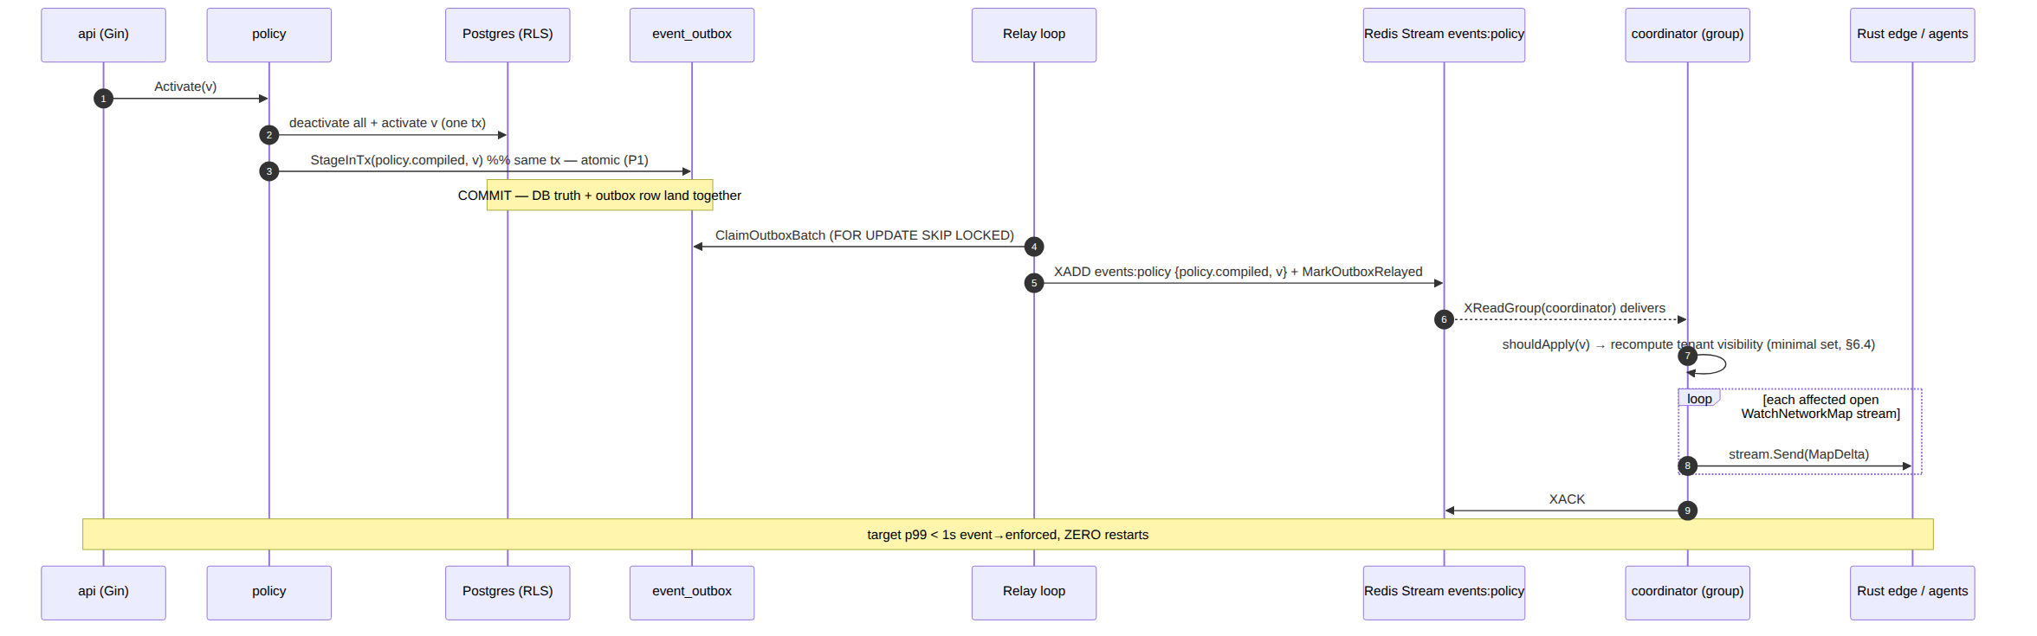

7.2 Latency budget decomposition (how < 1 s is met)
Segment | Budget (p99) | Mechanism
COMMIT → outbox row visible | ≤ 20 ms | same-tx insert; index event_outbox_pending
Relay tick latency (claim→XADD) | ≤ 70 ms | 50 ms ticker + SKIP LOCKED batch
Redis XADD→consumer XReadGroup | ≤ 60 ms | BLOCK 2s returns immediately on append
coordinator recompute + diff (tenant ≤ 1k devices) | ≤ 200 ms | in-mem graph; minimal affected set §6.4; [02_CP §10.2 compile <200ms]
stream.Send enqueue → edge reconcile | ≤ 150 ms | bounded per-agent queue; HTTP/2 server-stream
Total event→enforced | ≤ 500 ms typical, < 1 s p99 | measured by helix_reconcile_seconds [02_CP §10.2]
The bus's own contribution (outbox+relay+XADD+deliver) is budgeted ≤ 250 ms p99 — comfortably inside the 1 s SLO, leaving headroom for the coordinator's recompute and the edge apply.

7.3 Revoke path (the < 1 s security-critical case)
device.revoked is the latency-critical security event. It travels the same outbox→relay→ events:devices→coordinator path; the coordinator removes the node, pushes a remove-peer delta to every map that contained it, and the edge removes the kernel WG peer — all within the same < 1 s budget [02_CP §9.3]. Because revoke is terminal + idempotent (§6.2), a redelivered device.revoked is a no-op (the node is already gone), so an XAUTOCLAIM retry after a coordinator crash re-enforces rather than errors.

7.4 Cold-boot rehydration (Redis-loss / coordinator-restart correctness, C2)
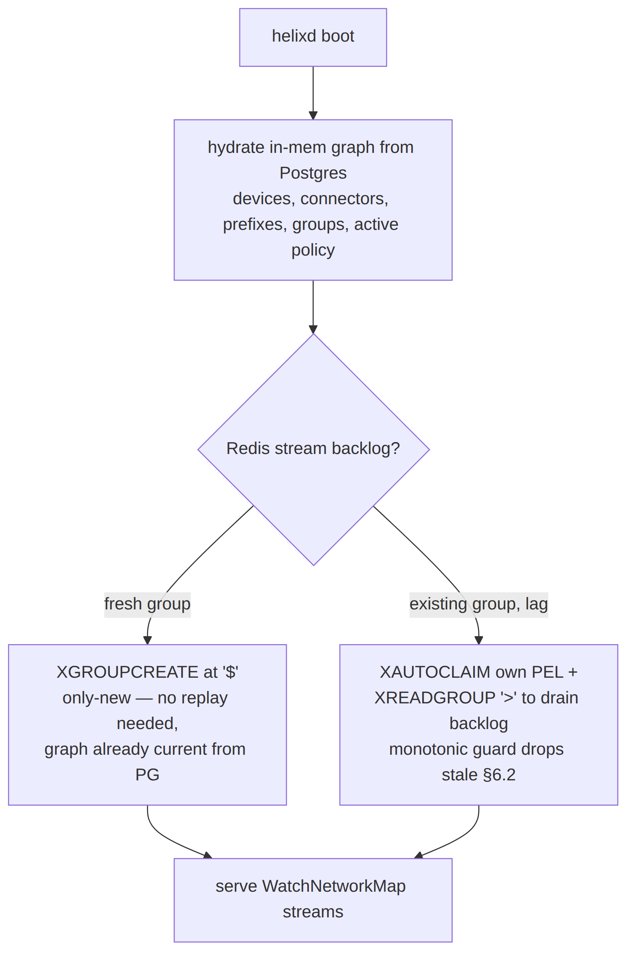
Because Postgres is truth (C2), the coordinator always rebuilds its graph from Postgres on boot, then attaches to the bus for the delta stream. A totally lost Redis (flushed, restarted empty) costs nothing durable: the next state mutation re-publishes via the outbox, and any in-flight change that was only on the bus is reconstructable because its DB write already committed (the outbox row either relayed or will re-relay). This is the C2 guarantee made concrete: the bus is a fast-path accelerator over Postgres truth, never a second source of truth.

8. SLO, metrics, and operational thresholds

8.1 The convergence SLO (anti-bluff, measured)
Metric | Target | How measured [02_CP §10.2]
event-publish → consumer-receive | p99 ≤ 250 ms | helix_event_bus_seconds (outbox.created_at → consumer fromRedis)
event → delta-on-wire (whole chain) | p99 < 1 s | helix_reconcile_seconds (event-receive → stream.Send)
device revoke → edge enforced | < 1 s | revoke-to-WG-peer-removed timer on the edge
outbox relay lag | p99 ≤ 100 ms | helix_event_outbox_lag_seconds (created_at → relayed)
DLQ rate | 0 sustained | helix_events_dlq_total (any sustained increase alerts)
coordinator memory @ 10k streams | bounded, no leak / 24 h | process_resident_memory_bytes slope ≈ 0

8.2 Prometheus metric definitions
// internal/events/metrics.go
type metrics struct {
published *prometheus.CounterVec // helix_events_published_total{type}
publishErrors prometheus.Counter // helix_events_publish_errors_total
outboxRejected prometheus.Counter // helix_events_outbox_rejected_total (guard reject)
outboxLagSeconds prometheus.Histogram // helix_event_outbox_lag_seconds
busSeconds *prometheus.HistogramVec // helix_event_bus_seconds{type} (publish→receive)
reactSeconds *prometheus.HistogramVec // helix_event_react_seconds{type}
reactErrors *prometheus.CounterVec // helix_event_react_errors_total{type}
readErrors prometheus.Counter // helix_events_read_errors_total
claimErrors prometheus.Counter // helix_events_claim_errors_total
ackErrors prometheus.Counter // helix_events_ack_errors_total
dlqTotal *prometheus.CounterVec // helix_events_dlq_total{stream,group}
pelDepth *prometheus.GaugeVec // helix_events_pel_depth{stream,group} (lag gauge)
}

8.3 Consumer-group lag gauge
A background sampler runs XPENDING <stream> <group> every 5 s and sets helix_events_pel_depth{stream,group} to the pending-entries count. A growing PEL depth is the leading indicator of a stuck consumer before the DLQ rate moves — it feeds the Health readiness check.

8.4 Alert thresholds (operational)
Condition | Threshold | Action
helix_events_dlq_total rate | > 0 over 1 min | page; inspect DLQ, fix cause, replay-dlq
helix_events_pel_depth (coordinator) | > 1000 sustained 30 s | warn; consumer likely stalled/slow
helix_event_bus_seconds p99 | > 250 ms 5 min | warn; Redis or relay degraded
helix_event_outbox_lag_seconds p99 | > 500 ms 5 min | warn; relay loop starved
Bus.Health PING fail | any | readiness NOT READY (fail-static: existing tunnels keep forwarding, C1)

8.5 Stream trimming (bounded memory)
Each XADD carries the per-stream MAXLEN ~ N from the §3.1 table so a stream never grows unbounded [research-go_cp §5]. Presence (events:presence) gets the largest cap (high churn); policy the smallest (rare, high-value). DLQ streams use MAXLEN ~ 1_000_000 and outlive the primary for audit. A nightly XTRIM MINID reaps anything older than 24 h on the non-DLQ streams as a backstop.

9. Test points (constitution §11.4.169 — comprehensive test-type coverage)
§11.4.169 mandates comprehensive test-type coverage; every claim below is backed by a concrete, anti-bluff test with captured evidence per §11.4.5/§11.4.69/§11.4.107. Mocks/stubs are permitted only in unit tests (§11.4.27); all other types exercise a real Redis + Postgres booted on-demand via the vasic-digital/containers submodule (§11.4.76) — never ad-hoc docker run.

9.1 Unit tests (mocks allowed)
- Envelope round-trip: New → redisFields → fromRedis is byte-stable for every type; payload JSON is canonical/compact; schema_v defaults to 1.
- Type/stream mapping: EventType.Stream() returns the §3.3 table for all 10 types; guardPublish rejects a type on the wrong stream and a non-user/system actor on device.revoked/policy.*.
- Idempotency guard (shouldApply): replaying policy.compiled v=7 twice → second call returns false; an out-of-order v=6 after v=7 → false; connector.prefixes.changed stale gen → false; duplicate device.revoked → false after first.

9.2 Integration tests (real Redis + Postgres, §11.4.76)
- Transactional outbox atomicity (P1): kill the relay between COMMIT and XADD; restart; assert the event still reaches the stream exactly once acked (at-least-once, no loss, no phantom on a rolled-back tx). Captured evidence: stream XRANGE + outbox row state.
- At-least-once + idempotent reaction: force a redelivery (don't ack, wait MinIdle, XAUTOCLAIM); assert the coordinator graph + pushed deltas are identical to the single- delivery run (recompute-from-state idempotence, §6.2).
- DLQ routing: inject a poison policy.compiled whose reaction always errors; assert it is redelivered exactly ceiling=5 times then lands in events:policy:dlq with dlq_attempts=6
  - dlq_reason, and helix_events_dlq_total increments; assert it is gone from the main PEL.
- Cold-boot rehydration (C2): flush Redis; restart helixd; assert the graph is rebuilt from Postgres and WatchNetworkMap serves a correct snapshot with zero durable loss.

9.3 End-to-end / full-automation tests
- Drive enroll → connector.attached → connector.prefixes.changed → policy.compiled through the real bus; assert the WatchNetworkMap delta stream content and the event→delta helix_reconcile_seconds p99 < 1 s with captured evidence (§11.4.69/§11.4.107) — the same SLO the parent doc asserts [02_CP §10.3].
- Revoke E2E: device.revoked → edge WG-peer-removed timer < 1 s.

9.4 Payload no-logging lint (C3) + paired §1.1 mutation
// tools/payloadlint/main.go — parses internal/events/payloads.go + every events.New call site
// and FAILS the build if any payload struct/field matches the forbidden traffic-log shape
// (mirrors the schema-lint [02_CP §2.4]). Allowlist: device_id, overlay_ip, cidr(s),
// connector_id, version, gen, site, kind, rtt_ms, from, to — identity/topology/policy only.
var forbiddenPayloadFields = regexp.MustCompile(
`(?i)\b(src_ip|dst_ip|dest_ip|src_port|dst_port|bytes_(in|out)|packet_count|payload_bytes|sni_host|flow_id|dns_query)\b`)
Paired §1.1 mutation: a test that adds a BytesOut int json:"bytes_out" field to a payload struct MUST make payloadlint FAIL; removing it MUST make it pass. This is the runtime signature (§11.4.108) proving the bus carries no traffic data — C3 is live, not promised.

9.5 Stress + chaos (§11.4.85)
- Stress: 50k events across the five streams at 5k/s; assert no PEL growth beyond the §8.4 threshold, helix_event_bus_seconds p99 ≤ 250 ms, zero DLQ.
- Chaos — consumer kill: SIGKILL the coordinator mid-batch; assert XAUTOCLAIM reclaims the un-acked PEL on restart and no event is lost (§11.4.147 no-work-loss).
- Chaos — Redis partition: drop the Redis connection for 30 s; assert Postgres commits keep succeeding (C2), the outbox accumulates, and the relay drains the backlog on reconnect with no duplicate-induced incorrect map (idempotent reactions absorb the duplicates).
- Chaos — clock skew: publish events with a producer clock 5 s ahead; assert the monotonic version/gen guards (not wall-clock) keep ordering correct.

10. Phase-2 NATS-JetStream swap (the bus-agnostic seam, D3)

10.1 Why the swap is a transport change, not a rewrite
The events.Bus interface (§2.1) and the Envelope (§2.2) are the entire surface above the transport. NATS JetStream provides the same primitives the Redis impl uses [SYNTHESIS §3, 04_P1 §12]:
Redis Streams (MVP) | NATS JetStream (P2) | Maps to
stream events:policy | JetStream stream EVENTS_POLICY (subject events.policy.*) | Stream name
consumer group coordinator | durable pull consumer coordinator | Subscribe(group,...)
XReadGroup > | fetch() on the pull consumer | delivery channel
XACK | msg.Ack() | Bus.Ack
XAUTOCLAIM (MinIdle reclaim) | JetStream AckWait + auto-redelivery | reclaim (built-in)
:dlq stream + ceiling | MaxDeliver + advisory → DLQ subject | toDLQ
MAXLEN ~ N | stream MaxMsgs/MaxAge retention | trim
XADD outbox relay | JetStream publish (same outbox relay) | Relay/xadd

10.2 What changes / what does not
Changes (transport only): a new internal/events/natsbus.go implementing Bus; the deployment swaps Redis-for-bus → NATS (Redis stays for presence in some topologies, or presence also moves). Unchanged: the outbox table + relay (relay's xadd becomes a NATS publish), the Envelope, the taxonomy, every consumer's reaction + idempotency guard, the authz guards, the metrics names, and every test in §9 (they target the Bus interface, so they re-run unchanged against the NATS impl — the §11.4.81 cross-platform-parity discipline applied to the transport axis).

10.3 Forward-compat already wired
Envelope.SchemaV lets a Phase-2 consumer reject/upgrade an unknown payload shape rather than mis-parse it; the closed EventType vocabulary + validTypes map mean a new event type is an additive map entry, not a reshaping. NATS multi-region fan-out (the actual reason to swap) needs no envelope change — tenant_id already scopes routing.

10.4 The one-line MVP optimisation (Redis ≥ 8.4)
If the MVP deployment can guarantee Redis ≥ 8.4, the §6.4 two-step reclaim collapses to the single-shot XREADGROUP ... CLAIM <min-idle> [research-go_cp §5] — a localized change inside Run only; the Bus interface and all callers are untouched.

11. Phase → task → subtask plan (events backbone slice)
Derived from [02_CP §13] CP-T5, expanded to nano-detail. Each leaf is a workable item (§11.4.93). Risk-descending (§11.4.132): the outbox atomicity + payload-lint first (they are the correctness/privacy floor).
- EV-T1 — bus-agnostic contract.
  - EV-T1.1 events.Bus interface + Envelope + EventType closed vocabulary + validTypes.
  - EV-T1.2 events.New constructor + guardPublish structural authz (§3.5).
- EV-T2 — transactional outbox (the atomicity floor).
  - EV-T2.1 event_outbox table + RLS + event_outbox_pending index (§5.2).
  - EV-T2.2 StageInTx + ClaimOutboxBatch (FOR UPDATE SKIP LOCKED) + MarkOutboxRelayed.
  - EV-T2.3 Relay loop (50 ms tick) + xadd with MAXLEN ~ trim; P1 atomicity integration test (§9.2).
- EV-T3 — Redis Streams impl.
  - EV-T3.1 RedisBus + EnsureGroups (MKSTREAM) + fromRedis/redisFields codec.
  - EV-T3.2 Run consume loop: XAUTOCLAIM-then-XReadGroup + handleOne + XACK (§6.1).
  - EV-T3.3 reclaimAndHandle (MinIdle 30 s) + delivery-count ceiling + toDLQ + replay tool.
- EV-T4 — idempotency + reactions.
  - EV-T4.1 applied/shouldApply monotonic guards (policy version, connector gen, revoke).
  - EV-T4.2 coordinator reaction adapter (recompute-from-state, §6.2 mechanism 1).
- EV-T5 — observability + SLO.
  - EV-T5.1 the §8.2 metric set + helix_event_bus_seconds/helix_reconcile_seconds wiring.
  - EV-T5.2 PEL-depth sampler (XPENDING) + Bus.Health + §8.4 alert rules.
- EV-T6 — privacy + anti-bluff gates.
  - EV-T6.1 tools/payloadlint (§9.4) + paired §1.1 mutation (add bytes_out → FAIL).
  - EV-T6.2 §9.2–9.5 integration/E2E/stress/chaos suites + a challenges Challenge asserting the event→delta < 1 s SLO with captured evidence (§11.4.27/§11.4.69/§11.4.107).
- EV-T7 — Phase-2 seam proof.
  - EV-T7.1 Bus interface conformance test-suite re-runnable against any impl (the seam proof for the NATS swap, §10.2).

12. Edge cases (explicit, no-guessing — §11.4.6)
# | Edge case | Defined behaviour
E1 | XADD succeeds but the relay crashes before MarkOutboxRelayed | Row stays pending → re-relayed → duplicate XADD → idempotent reaction absorbs it (§6.2). At-least-once, never lost.
E2 | Reaction partially completes then errors (e.g. pushed delta to 3 of 5 streams) | Not acked → reclaimed → re-reacted; recompute-from-state re-pushes all 5 (the 3 already-correct are no-op diffs). Safe.
E3 | Duplicate policy.compiled for the same version | shouldApply drops the second (version ≤ applied marker). No double recompute.
E4 | Out-of-order delivery: v=6 reclaimed after v=7 applied | Monotonic guard drops v=6 (no regression). The taxonomy uses version/gen, not wall-clock, exactly for this.
E5 | Redis fully flushed while helixd up | Coordinator graph already current from PG (C2); next mutation re-publishes via outbox; PEL reset is harmless.
E6 | Poison event that NO consumer can ever process | Redelivered ceiling=5 times → DLQ + alert; operator inspects/fixes/replay-dlq. Never spins forever (§6.5).
E7 | Undecodable message (corrupt fields) | Straight to DLQ on first delivery (no retry loop on a structurally-broken message), dlq_reason="bad ...".
E8 | Producer clock skew | Ordering keys are monotonic counters, not ts; ts is informational only — skew cannot misorder topology changes (§9.5 chaos).
E9 | Slow audit/ws-fanout consumer | Distinct group/PEL — cannot stall coordinator; isolated back-pressure (§6.6).
E10 | Event for a tenant whose RLS context is unset | guardPublish rejects a non-system event with tenant_id == Nil; consumer fan-out is tenant-scoped so a malformed-tenant event cannot leak across tenants (C4).
E11 | DLQ itself grows unbounded | DLQ MAXLEN ~ 1_000_000 + nightly audit export; alert fires long before the cap.

13. Sources
[02_CP] final/02-control-plane.md (events backbone §5, coordinator §6, SLO §10, invariants §0.1, RLS §2.3, proto helix.coordinator.v1 §4) · [04_P1] HelixVPN-Phase1-MVP.md (Redis Streams backbone, at-least-once + idempotent reactions, DLQ, p99 < 1 s convergence, Phase-2 NATS seam §12) · [04_ARCH §4] HelixVPN-Architecture-Refined.md (schema-generated clients, control/data separation, no-logging, default-deny) · [research-go_cp] cited research (accessed 2026-06-25): Redis Streams consumer-groups + XAUTOCLAIM dead-letter + delivery-count ceiling + Redis 8.4 CLAIM; redis/go-redis/v9; transactional-outbox async path; goose RLS migrations — full source list with access dates in that file's "Sources verified" section · [SYNTHESIS] §2 (stack floor), §3 (D3 event-bus decision Redis→NATS), §7 (no-logging invariant), §8/§9 (ecosystem + constitution bindings).

