policy service + compiler

policy service + compiler
Revision: 1 Last modified: 2026-06-25T00:00:00Z
Master technical specification — Volume 3 (Control Plane, Go), nano-detail document svc-policy. Deepens [02-control-plane.md §7] (policy model & compiler) into an implementation-ready contract: the declarative Tailscale-ACL-flavored model, the pure versioned compile algorithm, the two compiled artifacts (coarse AllowedIPs + port-level verdict map), need-to-know visibility, fail-closed dry-run validation, and instant monotonic-version rollback. SPEC ONLY — describe the implementation, do not build it. Sources cited inline by id: [04_P1] = HelixVPN-Phase1-MVP.md, [04_ARCH §N] = HelixVPN-Architecture-Refined.md, [research-go_cp] = 02-control-plane.md, [SYNTHESIS §N]. Unproven facts are marked UNVERIFIED per constitution §11.4.6 — never fabricated.

0. Position, ownership, and the invariants this document obeys
The policy package (internal/policy/) is the access-control brain of the control plane: it turns the declarative "who may reach what" ACL document into compiled, per-device, need-to-know reachability that the coordinator (§6 of [research-go_cp]) streams to edges. It is a pure, deterministic, versioned compiler plus a thin transactional service wrapper [04_P1 §7, research-go_cp §7].
This document owns: the source-document schema (§2), the compiled in-memory artifacts (§3), the compile algorithm (§4), validation/fail-closed semantics (§5), activation + instant rollback (§6), the event + protobuf surface the compiler feeds (§7), the error taxonomy (§8), authz (§9), edge cases (§10), the convergence-budget contribution to the <1 s SLO (§11), and the §11.4.169 comprehensive test-type coverage (§12).
It does not own: the in-memory topology graph or stream fan-out (coordinator, [research-go_cp §6]); the protobuf wire-evolution byte semantics (doc 03 WatchNetworkMap contract); the edge enforcement of the verdict map (Rust data plane, doc 01); IPAM/4via6 address allocation (ipam, [research-go_cp §3]) — the compiler consumes 4via6 site mappings, it does not assign them.

0.1 Governing invariants (every clause below obeys these)
# | Invariant | Source
P1 | Default-deny, need-to-know. A device appears in another device's map only if a compiled accept rule grants the edge. No deny verbs in the MVP model — absence is denial. | [04_ARCH §3.4/§7, 04_P1 §7, C4 of research-go_cp]
P2 | Pure + deterministic. Compile(tenant, spec, graph) is a pure function of its inputs; identical inputs ⇒ byte-identical CompiledPolicy. No clock, no RNG, no map-iteration-order leakage. | [04_P1 §7.2, research-go_cp §7.2]
P3 | Two artifacts. WG AllowedIPs is CIDR-only (not port-aware), so compile emits BOTH a coarse per-peer AllowedIPs[][] AND a fine port-level Verdicts map enforced at the edge. | [04_P1 §7.2, research-go_cp §7.2]
P4 | Fail-closed. policy.update dry-run-compiles first; only a clean compile may persist/activate. A compile error rejects the change; it never silently degrades to allow-all or to the prior policy. | [04_P1 §7.3, research-go_cp §7.3]
P5 | Monotonic version + instant rollback. policies.version is monotonic per tenant; at most one active. Rollback = re-activate an older version (no recompile needed — every version reproduces its artifact from spec). | [04_P1 §7.4, research-go_cp §2.2/§7.4]
P6 | Tenant-scoped at the database. Every DB touch runs through store.WithTenant under RLS FORCE ROW LEVEL SECURITY; the compiler reads registry/pki through interfaces, never their stores (R1/R4 of [research-go_cp §1.2]). | [research-go_cp §1.2/§2.3, C8]
P7 | Cross-checked against advertised reality. A dst host CIDR not covered by any advertised_prefixes row fails the dry-run (P4); overlapping advertised CIDRs emit route.conflict.detected (non-blocking, resolved by 4via6). | [04_P1 §7.3, research-go_cp §5.3/§7.3]
P8 | Privacy-preserving identity resolution. group members are resolved by user→device join; an anonymous (no-email) user still resolves by its synthetic identity, never requiring PII (C6). | [04_P1 §6.1, research-go_cp §9.1]

1. Package surface (Go signatures — the seam)
internal/policy/ exposes exactly the interface the rest of the monolith depends on [research-go_cp §1.3]. The package splits into parse.go (spec → typed AST), resolve.go (groups/hosts → ids/CIDRs), compile.go (the pure core), validate.go (dry-run gate), activate.go (transactional flip), and iface.go (the public surface below).
// internal/policy/iface.go
package policy
import (
"context"
"net/netip"
"github.com/google/uuid"
)
// Compiler is pure + deterministic (P2). Compile is dry-run safe (no writes, no events).
type Compiler interface {
// Parse validates the jsonb document into a typed Spec; returns a *SpecError list on
// any structural fault. Pure.
Parse(raw []byte) (Spec, error)
// Compile resolves + compiles a Spec against a frozen TopologySnapshot into the two
// artifacts (P3). Pure: identical (spec, snap) ⇒ byte-identical CompiledPolicy (P2).
// Returns non-fatal advisories (route conflicts) alongside the result.
Compile(ctx context.Context, t uuid.UUID, spec Spec, snap TopologySnapshot) (CompiledPolicy, []Advisory, error)
}
// PolicyService is the transactional wrapper: it owns persistence, the dry-run gate (P4),
// activation, rollback, and event emission (R3). NOT pure — it touches the store + bus.
type PolicyService interface {
// Validate dry-run-compiles raw against the current topology; never persists. Used by
// `helixvpnctl policy apply --dry-run` and by Update before insert.
Validate(ctx context.Context, t uuid.UUID, raw []byte) (DryRunReport, error)
// Update parses+dry-run-compiles, and ONLY on a clean compile inserts a new
// monotonic policies row (active=false) and emits policy.updated. Fail-closed (P4).
Update(ctx context.Context, t uuid.UUID, raw []byte, actor string) (Version, error)
// Compile materializes the compiled artifact for an inserted version, stamps
// compiled_at, caches it, and emits policy.compiled. Idempotent per version.
Compile(ctx context.Context, t uuid.UUID, v Version) error
// Activate atomically flips active to v (clearing the prior active) and emits
// policy.compiled so the coordinator recomputes + pushes (P5).
Activate(ctx context.Context, t uuid.UUID, v Version, actor string) error
// Rollback is sugar over Activate(t, olderVersion) — no recompile (P5).
Rollback(ctx context.Context, t uuid.UUID, to Version, actor string) error
// Compiled returns the cached compiled artifact for a version (coordinator hydrate path).
Compiled(ctx context.Context, t uuid.UUID, v Version) (CompiledPolicy, error)
}
type Version int64
// Advisory = non-fatal compile finding (P7). Surfaced to Console, never blocks compile.
type Advisory struct {
Kind AdvisoryKind // ADVISORY_ROUTE_CONFLICT | ADVISORY_UNREACHABLE_RULE | ...
Message string
Refs []string // connector ids / cidrs / rule indexes implicated
}
type AdvisoryKind string
const (
AdvisoryRouteConflict AdvisoryKind = "route.conflict"
AdvisoryUnreachableRule AdvisoryKind = "rule.unreachable" // rule whose src resolves to ∅
AdvisoryShadowedRule AdvisoryKind = "rule.shadowed" // fully subsumed by an earlier rule
)

1.1 The TopologySnapshot input (why Compile is pure)
Compile must be a pure function (P2), but groups/hosts resolve against live topology (users, devices, group membership, advertised prefixes). The service therefore freezes a read-consistent snapshot inside one WithTenant transaction and passes it as a value — the compiler never reaches the store. This is the seam that makes the compiler unit-testable with table fixtures and makes determinism a property test (§12).
// internal/policy/snapshot.go
type DeviceID = uuid.UUID
type TopologySnapshot struct {
// identity → device resolution (P8). UserKey is email OR oidc_sub OR the synthetic
// "device:" + device_id form used for anonymous, group-less direct grants.
UsersByKey map[string]uuid.UUID // "alice@corp"|"oidc:sub"|"device:<uuid>" -> user_id
DevicesByUser map[uuid.UUID][]DeviceID // user_id -> its devices
GroupMembers map[string][]DeviceID // "group:admins" -> device ids (pre-joined)
Devices map[DeviceID]DeviceMeta // every non-revoked device in tenant
// advertised reality (P7): connector_id -> enabled CIDRs; and a reverse index
// covering CIDR -> connector(s) for host resolution + conflict detection.
ConnPrefixes map[DeviceID][]netip.Prefix
PrefixOwners []PrefixOwner // sorted; supports longest-prefix + overlap scan
GatewayID DeviceID // the exit/relay node (exitNodes target)
SnapAt int64 // unix-nanos; recorded for evidence, NOT used in compile (P2)
}
type DeviceMeta struct {
ID DeviceID
Kind DeviceKind // CLIENT | CONNECTOR
WGPubKey [32]byte
OverlayIP netip.Addr
Revoked bool // belt-and-suspenders; revoked never enters visible[] (P1)
}
type PrefixOwner struct {
CIDR netip.Prefix
ConnectorID DeviceID
Site uint16 // 4via6 site-id (assigned by ipam); compiler emits, does not assign
}
type DeviceKind uint8
const (
DeviceKindClient DeviceKind = 1
DeviceKindConnector DeviceKind = 2
)
SnapAt is recorded for captured-evidence/audit only and must not influence the compiled bytes (P2) — a unit test asserts two compiles of the same (spec, snap) with different SnapAt produce byte-identical CompiledPolicy (§12, determinism property).

2. Source document — the declarative ACL model (policies.spec jsonb)
The operator authors a Tailscale-ACL-flavored JSON document; it is stored verbatim in policies.spec jsonb [04_P1 §7.1, research-go_cp §7.1]. Comments (//) are accepted on ingest (JSONC) and stripped before storage so spec is canonical RFC-8259 JSON.

2.1 Worked source example (the running example for this whole document)
{
"schemaVersion": 1,
"groups": {
"group:admins": ["alice@corp", "bob@corp"],
"group:contractors": ["carol@ext"]
},
"hosts": {
"warehouse-cams": "10.10.0.0/24", // served by connector A
"office-lan": "192.168.50.0/24" // served by connector B
},
"acls": [
{ "action": "accept", "src": ["group:admins"], "dst": ["*:*"] },
{ "action": "accept", "src": ["group:contractors"], "dst": ["warehouse-cams:554,80"] }
],
"exitNodes": ["group:admins"], // who may use the gateway as a full-tunnel exit
"connectors": {
"<conn-A-device-id>": { "local_denylist": ["10.10.0.128/25"] } // connector tightens central allow (FR-705)
}
}

2.2 Typed AST (the parse target)
// internal/policy/spec.go
type Spec struct {
SchemaVersion int `json:"schemaVersion"`
Groups map[string][]string `json:"groups"` // "group:NAME" -> member keys
Hosts map[string]string `json:"hosts"` // "alias" -> CIDR string
ACLs []Rule `json:"acls"`
ExitNodes []string `json:"exitNodes"` // selectors permitted to full-tunnel
Connectors map[string]Connector `json:"connectors,omitempty"` // device_id -> per-connector local overrides
}
type Connector struct {
LocalDenylist []netip.Prefix `json:"local_denylist,omitempty"` // CIDRs this connector always denies (FR-705)
}
type Rule struct {
Action string `json:"action"` // CLOSED SET: only "accept" in MVP (P1)
Src []string `json:"src"` // selectors: "group:X" | "user@dom" | "*"
Dst []string `json:"dst"` // "host:ports" | "cidr:ports" | "*:*" | "<deviceSel>:ports"
}
// A Dst token parses to this. Ports empty => all ports.
type DstTarget struct {
Raw string
HostName string // non-empty if a hosts[] alias
CIDR netip.Prefix // resolved (host alias OR literal CIDR OR "*"=0.0.0.0/0 + ::/0)
Wildcard bool // "*" destination
Ports []PortRange // empty => ALL_PORTS
}
type PortRange struct {
Proto Proto // TCP|UDP|ANY (MVP: ANY unless "tcp:"/"udp:" prefix; default ANY)
Lo uint16 // inclusive
Hi uint16 // inclusive (==Lo for a single port)
}
type Proto uint8
const (
ProtoAny Proto = 0
ProtoTCP Proto = 6 // matches IANA protocol number (edge nft uses it directly)
ProtoUDP Proto = 17
)

2.3 Grammar (closed-set, validated at parse)
Element | Accepted form | Rejected → error
action | exactly "accept" | any other verb ⇒ ERR_UNSUPPORTED_ACTION (no deny/drop in MVP; default-deny makes them redundant, P1)
group name | group:[a-z0-9_-]+ | missing group: prefix ⇒ ERR_BAD_GROUP_NAME
member key | email | oidc:<sub> | device:<uuid> | nested group:X | unknown shape ⇒ ERR_BAD_MEMBER_KEY
host alias | [a-z0-9_-]+ mapping to a parseable CIDR | bad CIDR ⇒ ERR_BAD_HOST_CIDR
src token | group:X | member key | * | unresolvable ⇒ ERR_UNKNOWN_SRC
dst token | <host>:<ports> | <cidr>:<ports> | *:* | missing : ⇒ ERR_BAD_DST_FORMAT
ports | * | N | N-M | comma list | tcp:N/udp:N | non-numeric / Lo>Hi ⇒ ERR_BAD_PORT_SPEC
exitNodes entry | group:X | member key | resolves to a connector ⇒ ERR_EXIT_IS_CONNECTOR
connectors key | existing connector device_id (as known to registry) | unknown id ⇒ ERR_UNKNOWN_CONNECTOR
connectors[id].local_denylist | array of parseable CIDRs | bad CIDR ⇒ ERR_BAD_HOST_CIDR; not covered by this connector's advertised prefixes ⇒ ERR_LOCAL_DENY_NOT_ADVERTISED (P7)
Nested groups (a group:X member of group:Y) resolve transitively with cycle detection; a membership cycle ⇒ ERR_GROUP_CYCLE (§8). UNVERIFIED: the source docs [04_P1 §7.1] show only flat groups; nested-group support is a forward-compatible superset this spec defines — flag it as a design decision, not an inherited fact.

3. The compiled artifacts (CompiledPolicy — what coordinator consumes)
// internal/policy/compiled.go — the two-artifact output (P3). Returned by Compile and
// cached per (tenant, version). coordinator.buildMap reads it directly [research-go_cp §6.2].
type CompiledPolicy struct {
Version Version
SpecHash [32]byte // sha256 of canonical spec — ties artifact to source (audit + dedup)
// ARTIFACT 1 — need-to-know visibility (P1): src device -> reachable peer-device set.
VisibleTo map[DeviceID]map[DeviceID]struct{}
// ARTIFACT 1b — coarse WG AllowedIPs (CIDR-only, P3): src -> peer -> CIDRs.
AllowedIPs map[DeviceID]map[DeviceID][]netip.Prefix
// ARTIFACT 2 — fine port-level verdict map (P3): src -> peer -> port rules. Edge
// enforces via nftables/eBPF (doc 01). A peer present in AllowedIPs but with an
// empty Verdicts entry means "all ports" (the coarse rule already gates it).
Verdicts map[DeviceID]map[DeviceID][]PortRule
// 4via6 routes for colliding IPv4 LANs (D4): src -> peer(connector) -> mappings.
Via6 map[DeviceID]map[DeviceID][]Via6Route
// exit-node grants: device ids permitted to full-tunnel through the gateway.
ExitNodes map[DeviceID]struct{}
}
type PortRule struct {
DstCIDR netip.Prefix
Proto Proto
Lo, Hi uint16
}
type Via6Route struct {
IPv4CIDR netip.Prefix
Via6Prefix netip.Prefix // fd7a:helix:<rand>:<site-id>::/96 (ipam-assigned site)
}

3.1 Canonical determinism rules (so SpecHash and the artifact are stable, P2)
- Canonical spec hash: SpecHash = sha256(canonicalJSON(spec)) where canonicalJSON sorts object keys, strips comments/whitespace, normalizes CIDR text, and sorts every string array. Two semantically-identical specs hash identically.
- Deterministic maps → deterministic bytes: all output maps are serialized for the determinism property test through a canonicalEncode that sorts device-id keys and sorts each []netip.Prefix / []PortRule slice by (addr,bits,proto,lo,hi). Go map iteration order is non-deterministic, so the compiler MUST never range a map to build output order; it ranges a pre-sorted key slice. A go vet-style custom lint flags range someMap inside compile.go (§12 meta-test).
- No ambient inputs: no time.Now, no rand, no environment reads inside Compile.

4. The compile algorithm (pure core)

4.1 Pseudocode (the authoritative algorithm)
compile(tenant, spec, snap) -> (CompiledPolicy, []Advisory, error):
adv := []
# ── phase 1: resolve selectors ───────────────────────────────────────────
groupSet := resolveGroups(spec.groups, snap) # transitive, cycle-checked → device-id sets
hostCIDR := {} # alias -> netip.Prefix
for alias, cidr in spec.hosts:
p := parsePrefix(cidr) # ERR_BAD_HOST_CIDR on fault
if not coveredByAdvertised(p, snap): # P7 cross-check
return _, _, ERR_HOST_NOT_ADVERTISED(alias, p)
hostCIDR[alias] = p
# ── phase 1b: per-connector local denylist (FR-705) ──────────────────────
localDeny := {} # connector device_id -> []netip.Prefix
for connID, cfg in spec.connectors:
if snap.Devices[connID].Kind != CONNECTOR:
return _, _, ERR_NOT_A_CONNECTOR(connID)
for p in cfg.local_denylist:
if not coveredByConnectorAdvertised(p, connID, snap): # P7 per-connector coverage
return _, _, ERR_LOCAL_DENY_NOT_ADVERTISED(connID, p)
localDeny[connID] = sortedPrefixes(cfg.local_denylist)
# ── phase 2: per-device rule application (default-deny base, P1) ──────────
out := CompiledPolicy{ all maps empty }
devOrder := sortedDeviceIDs(snap.Devices) # deterministic iteration (P2)
for d in devOrder where not snap.Devices[d].Revoked: # revoked never gets visibility (P1)
for ri, rule in spec.acls: # rules in author order (precedence)
srcSet := resolveSrc(rule.src, groupSet, snap)
if d not in srcSet: continue
if srcSet == ∅: adv += unreachableRule(ri); continue
for dstTok in rule.dst:
dt := parseDst(dstTok, hostCIDR) # ERR_BAD_DST_* on fault
targets := expandDst(dt, snap) # → set of (peerDeviceID, cidr, site)
for (peer, cidr, site) in targets:
if peer == d: continue # no self-edge
if snap.Devices[peer].Revoked: continue
# FR-705: local-deny overrides central-allow; subtract per-connector denylist.
# central-deny (absence of allow) is the default-deny floor and already wins.
deniedParts := localDenySubtraction(peer, cidr, dt.Ports, localDeny)
for (allowCidr, allowPorts) in deniedParts:
out.VisibleTo[d].add(peer) # ARTIFACT 1 (P1)
out.AllowedIPs[d][peer].add(allowCidr) # ARTIFACT 1b (coarse, P3)
if allowPorts not ALL:
out.Verdicts[d][peer].add(portRules(allowCidr, allowPorts)) # ARTIFACT 2
if site != 0:
out.Via6[d][peer].add(via6(cidr, site, snap)) # D4
# ── phase 3: exit nodes ───────────────────────────────────────────────────
for sel in spec.exitNodes:
for dev in resolveSrc([sel], groupSet, snap):
if snap.Devices[dev].Kind == CONNECTOR: return _,_, ERR_EXIT_IS_CONNECTOR(dev)
out.ExitNodes.add(dev) # may full-tunnel via gateway
# ── phase 4: advisories (non-fatal, P7) ──────────────────────────────────
adv += detectRouteConflicts(snap.PrefixOwners) # overlapping advertised CIDRs
adv += dedupAndSortAllSlices(&out) # canonical order (P2/§3.1)
out.SpecHash = sha256(canonicalJSON(spec))
return out, adv, nil

4.2 localDenySubtraction — connector local-deny overrides central-allow (FR-705)
For a central-allow grant toward peer (usually a connector) with CIDR c and ports ports, localDenySubtraction enforces the adopted precedence rule:
- Local-deny overrides central-allow. Every CIDR (and optional port range) in spec.connectors[peer].local_denylist is removed from the grant.
- Central-deny overrides local-allow. If the central ACL never granted c, the default-deny floor keeps it denied; the connector cannot use local_denylist to re-open a flow the central policy did not allow.
- The result is the union of central policy minus local-deny for that peer.
localDenySubtraction(peer, cidr, ports, localDeny) -> [(cidr, ports)]:
if peer not in localDeny:
return [(cidr, ports)]
remaining := [(cidr, ports)]
for deny in localDeny[peer]:
next := []
for (c, ps) in remaining:
if c overlaps deny:
for splitCidr in subtractCidr(c, deny):
next.append((splitCidr, ps))
else:
next.append((c, ps))
remaining := next
return remaining
If the subtraction empties a CIDR entirely, nothing is added for that peer. The operation is deterministic: localDeny[peer] is sorted at parse time and subtractCidr returns disjoint, sorted results (P2).

4.3 expandDst — the destination resolver (the heart)
expandDst(dt, snap) maps one parsed dst token to the concrete set of peer devices + CIDRs the source may reach:
- *:* (wildcard): every non-revoked peer device in the tenant the rule's src is not (each peer's overlay CIDR), PLUS every connector's advertised prefixes, PLUS the gateway exit (0.0.0.0/0 + ::/0). This is the group:admins → *:* "reach everything" grant.
- <host>:ports: look the alias up in hostCIDR; the target is the connector(s) serving that CIDR (snap.PrefixOwners longest-prefix match). The peer device id is the connector's device_id; the CIDR is the host CIDR (or its covered sub-CIDR); the site is the connector's 4via6 site-id (drives Via6, D4).
- <cidr>:ports: identical to host but the CIDR is literal; still must be covered by an advertised prefix (P7) or it is unreachable → compile error at the dry-run gate (§5).
- <deviceSelector>:ports (a group:X or member key used as a destination, e.g. client-to-client): the target peer device set is resolveSrc([sel],…); the CIDR is each target device's overlay /128. UNVERIFIED: the source example uses only CIDR/host destinations; device-as-destination is a defined superset for client↔client policy — flag as design, not inherited.

4.4 Worked example output (running example from §2.1)
Given tenant devices — alice-laptop, bob-laptop (admins' devices), carol-laptop (contractor), conn-A (connector serving 10.10.0.0/24, site-id 1), conn-B (connector serving 192.168.50.0/24, site-id 2), gateway gw — the compiler emits:
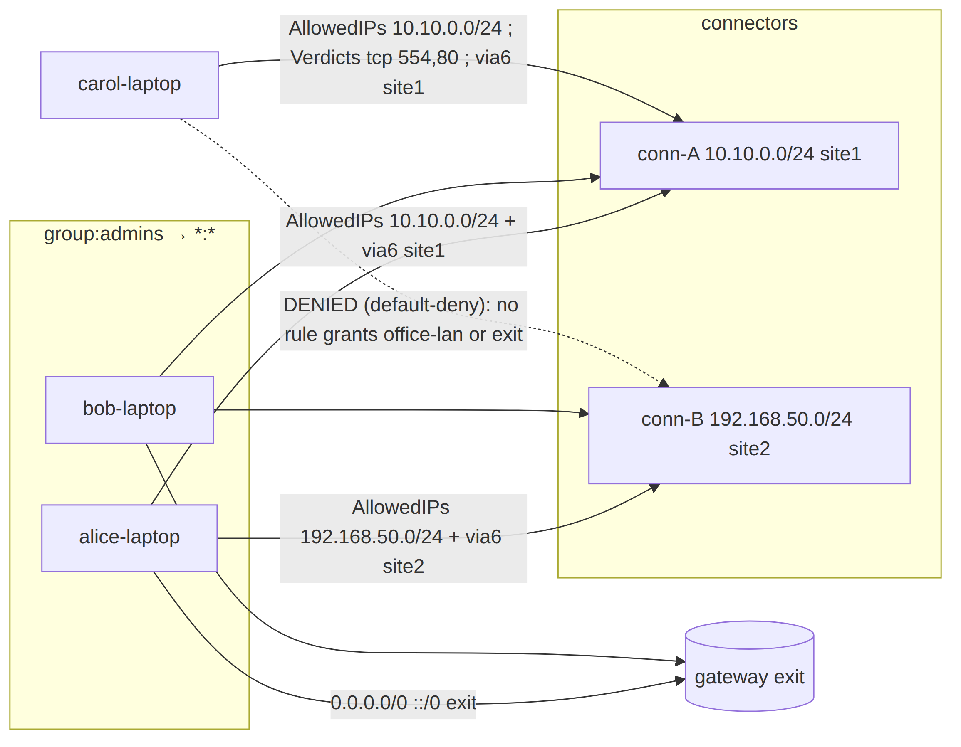
Concrete artifact for carol-laptop (the precise, port-restricted grant), reflecting the connector-A local_denylist 10.10.0.128/25 from §2.1:
VisibleTo[carol-laptop] = { conn-A }
AllowedIPs[carol-laptop][conn-A] = [ 10.10.0.0/25 ] # 10.10.0.128/25 removed by local-deny (FR-705)
Verdicts[carol-laptop][conn-A] = [ {10.10.0.0/25, ANY, 554, 554}, {10.10.0.0/25, ANY, 80, 80} ]
Via6[carol-laptop][conn-A] = [ {10.10.0.0/25, fd7a:helix:rrrr:0001::/96} ]
ExitNodes = { alice-laptop, bob-laptop } # carol absent → no exit
# carol-laptop has NO entry for conn-B or office-lan → default-deny (P1)
alice-laptop/bob-laptop get AllowedIPs [10.10.0.0/25, 192.168.50.0/24, 0.0.0.0/0, ::/0] toward the relevant peers (10.10.0.128/25 removed by conn-A's local-denylist), empty Verdicts (all ports, coarse rule suffices, P3), and membership in ExitNodes.

5. Validation — fail-closed dry-run (P4)
PolicyService.Update and helixvpnctl policy apply both route through Validate, which dry-run-compiles against a frozen snapshot and rejects on any blocking finding. Only a clean dry-run may persist (Update) [04_P1 §7.3, research-go_cp §7.3].

5.1 Blocking vs. advisory taxonomy
Finding | Class | Behavior
unknown group/host/member selector | BLOCKING | reject; ERR_UNKNOWN_*
dst CIDR not covered by any advertised_prefixes | BLOCKING (P7) | reject; ERR_HOST_NOT_ADVERTISED
connectors[id].local_denylist CIDR not covered by that connector's advertised prefixes | BLOCKING (P7 + FR-705) | reject; ERR_LOCAL_DENY_NOT_ADVERTISED
connectors key references a non-connector device | BLOCKING | reject; ERR_NOT_A_CONNECTOR
rule that would grant a revoked device (as src or dst) | BLOCKING | reject; ERR_GRANTS_REVOKED
exitNodes entry resolving to a connector | BLOCKING | reject; ERR_EXIT_IS_CONNECTOR
unsupported action (≠ accept) | BLOCKING | reject; ERR_UNSUPPORTED_ACTION
group membership cycle | BLOCKING | reject; ERR_GROUP_CYCLE
schemaVersion unknown/future | BLOCKING | reject; ERR_SCHEMA_VERSION
overlapping advertised CIDRs (two connectors) | ADVISORY | compile succeeds; emit route.conflict.detected; surface in Console; resolved by 4via6 or operator choice [research-go_cp §5.3]
rule whose src resolves to ∅ (no devices) | ADVISORY | rule.unreachable
rule fully shadowed by an earlier rule | ADVISORY | rule.shadowed
// internal/policy/validate.go
type DryRunReport struct {
OK bool
SpecHash [32]byte
Blocking []SpecError // empty iff OK
Advisories []Advisory // surfaced even when OK
Stats DryRunStats // devices affected, peers granted, ports opened (Console preview)
}
type DryRunStats struct {
DevicesAffected int
EdgesGranted int
ExitNodes int
}
Fail-closed proof obligation: a §1.1 paired mutation makes Validate return OK:true for a spec referencing an unadvertised CIDR; the test asserts Update then refuses to insert. If the mutation slips through (insert happens), the gate FAILs — this is the runtime signature (§11.4.108) that P4 is live, not merely promised (§12).

5.2 Validation state — what is read, when it can be stale
Validate freezes the topology snapshot inside its own WithTenant tx; the compile is pure against that frozen view. A device revoked after the dry-run but before activation is caught at activation time by re-checking the active compile against current revocations (§6.3) and by the coordinator's belt-and-suspenders revoked-stream refusal ([research-go_cp §6.3]). This is the honest race window (§10.3), not a bluff: the system narrows it to <1 s, it does not claim zero.

6. Activation, versioning & instant rollback (P5)

6.1 Version lifecycle state machine
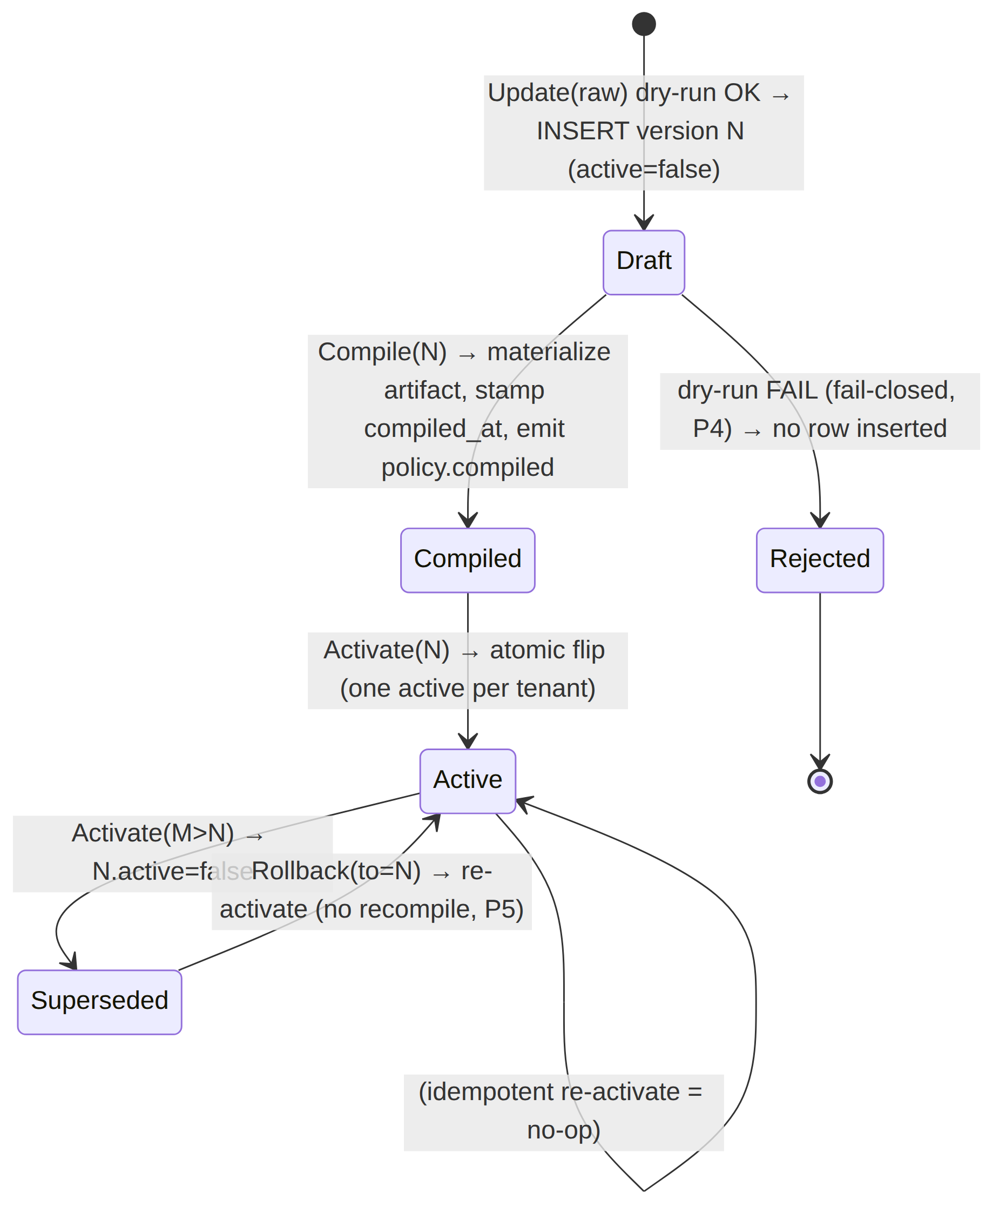

6.2 DDL the service relies on (from [research-go_cp §2.2], restated for self-containment)
CREATE TABLE policies (
id uuid PRIMARY KEY DEFAULT gen_random_uuid(),
tenant_id uuid NOT NULL REFERENCES tenants(id) ON DELETE CASCADE,
spec jsonb NOT NULL, -- canonical ACL document (§2)
spec_hash bytea NOT NULL, -- sha256(canonicalJSON(spec)) — dedup + audit (§3.1)
version bigint NOT NULL, -- monotonic per tenant (P5)
active boolean NOT NULL DEFAULT false,
compiled_at timestamptz, -- NULL until Compile(N) materializes the artifact
created_at timestamptz NOT NULL DEFAULT now(),
created_by text NOT NULL, -- actor (audit + §11.4.104 attribution)
UNIQUE (tenant_id, version)
);
-- at most one active policy per tenant; instant rollback = re-activate an older version (P5)
CREATE UNIQUE INDEX one_active_policy_per_tenant ON policies (tenant_id) WHERE active;
-- compiled-artifact cache (so rollback/coordinator-hydrate need not recompile). The artifact
-- is reproducible from spec, so this table is a SPEED cache, NOT a source of truth — it is
-- rebuildable and therefore safe to truncate (constitution §11.4.77 regen = re-run Compile).
CREATE TABLE compiled_policies (
tenant_id uuid NOT NULL REFERENCES tenants(id) ON DELETE CASCADE,
version bigint NOT NULL,
spec_hash bytea NOT NULL,
artifact bytea NOT NULL, -- canonicalEncode(CompiledPolicy) (§3.1)
built_at timestamptz NOT NULL DEFAULT now(),
PRIMARY KEY (tenant_id, version),
FOREIGN KEY (tenant_id, version) REFERENCES policies (tenant_id, version) ON DELETE CASCADE
);
The monotonic version is allocated SELECT coalesce(max(version),0)+1 FROM policies WHERE tenant_id=$1 inside the insert tx (the RLS tx serializes concurrent updates per tenant, so no two versions collide; the UNIQUE(tenant_id, version) is the backstop).

6.3 Atomic activation + rollback (Go)
// internal/policy/activate.go — atomic flip; prior version stays compiled for instant
// rollback (P5). Emits on the bus (R3) so the coordinator recomputes + pushes.
func (p *policyService) Activate(ctx context.Context, t uuid.UUID, v Version, actor string) error {
return p.store.WithTenant(ctx, t, func(q *db.Queries) error {
// 0. guard: the version must exist AND be compiled (artifact present).
row, err := q.GetPolicyVersion(ctx, db.GetPolicyVersionParams{TenantID: t, Version: int64(v)})
if err != nil {
return errNotFound(ErrVersionNotFound, v) // ERR_VERSION_NOT_FOUND
}
if !row.CompiledAt.Valid {
return ErrNotCompiled // ERR_NOT_COMPILED — must Compile(v) first (fail-closed, P4)
}
// 0b. re-check the active compile against CURRENT revocations (§5.2 race window).
if bad := p.revokedGrantsAfter(ctx, q, t, v); len(bad) > 0 {
return ErrGrantsRevoked(bad) // ERR_GRANTS_REVOKED — a device revoked since dry-run
}
// 1. atomic flip: clear prior active, set v active (partial unique index guarantees one).
if err := q.DeactivateAllPolicies(ctx, t); err != nil {
return err
}
if err := q.ActivatePolicyVersion(ctx, db.ActivateParams{TenantID: t, Version: int64(v)}); err != nil {
return err // unique-violation here ⇒ a concurrent activate; caller retries (idempotent)
}
// 2. audit (control action only — never traffic, C3).
_ = q.InsertAudit(ctx, db.AuditParams{TenantID: t, Actor: actor,
Action: "policy.activate", Target: fmt.Sprintf("v%d", v)})
// 3. R3: emit on the bus so the coordinator recomputes + pushes minimal deltas.
_, err = p.bus.Publish(ctx, "events:policy",
events.New("policy.compiled", t, actor, map[string]any{"version": int64(v)}))
return err
})
}
func (p *policyService) Rollback(ctx context.Context, t uuid.UUID, to Version, actor string) error {
// instant: no recompile — the older version's artifact is cached/reproducible (P5).
return p.Activate(ctx, t, to, actor)
}
Why rollback is instant (P5): every version's CompiledPolicy is reproducible from its spec (pure compile, P2) and cached in compiled_policies. Re-activating version N flips the index and emits policy.compiled{version:N}; the coordinator diffs its current served version against N and pushes the (small) delta — no recompile, no rebuild [04_P1 §7.4].

7. The event + protobuf surface the compiler feeds

7.1 Events emitted/consumed (envelope per [research-go_cp §5.2])
The policy service is the producer on events:policy and a consumer for the connector.prefixes.changed recompile trigger.
Direction | Type | Payload | Trigger / reaction
emit | policy.updated | {version} | a clean dry-run inserted version N (active=false)
emit | policy.compiled | {version} | Compile(N) materialized the artifact, OR Activate/Rollback(N) flipped active — coordinator recomputes tenant visibility + pushes deltas
emit | route.conflict.detected | {cidr, connector_ids[]} | dry-run advisory P7 (overlapping advertised CIDRs)
consume | connector.prefixes.changed | {connector_id, cidrs[]} | recompile the active version against new prefixes; if a previously-resolvable host CIDR is now unadvertised, emit route.conflict.detected (does NOT auto-deactivate — fail-static, C1)
consume | connector.local_denylist.changed | {connector_id, local_denylist[]} | recompile the active version with the new per-connector denylist; if a deny CIDR is no longer covered by the connector's advertised prefixes, emit route.conflict.detected (does NOT auto-deactivate)
consume | device.revoked | {device_id} | drop the device from the served compiled view immediately (coordinator removes peer); next activation re-validates (§6.3)
Canonical envelope (bus-agnostic, [research-go_cp §5.2]):
{
"id": "<redis-stream-id>",
"type": "policy.compiled",
"tenant_id": "8f3c…",
"ts": "2026-06-25T00:00:00Z",
"actor": "alice@corp",
"payload": { "version": 7 },
"trace_id": "01J…"
}

7.2 Protobuf the artifact projects into (helix.coordinator.v1)
The compiler does not own the wire contract, but its artifact projects 1:1 into the coordinator.v1 Peer message the coordinator streams [research-go_cp §4, package helix.coordinator.v1]. Restated for the policy↔coordinator boundary:
// proto/helix/coordinator/v1/coordinator.proto — package helix.coordinator.v1 (canonical, unified set)
message Peer {
string device_id = 1;
bytes wg_pubkey = 2;
repeated string allowed_ips = 3; // from CompiledPolicy.AllowedIPs[self][peer] (P3 coarse)
string endpoint = 4; // gateway relay in MVP
bool is_connector = 5;
repeated Via6Route via6 = 6; // from CompiledPolicy.Via6[self][peer] (D4)
repeated PortRule verdicts = 7; // from CompiledPolicy.Verdicts[self][peer] (P3 fine)
repeated string local_denylist = 8; // FR-705: connector-advertised local denies; edge may cross-check/audit
}
message PortRule { string dst_cidr = 1; uint32 proto = 2; uint32 lo = 3; uint32 hi = 4; }
message Via6Route { string ipv4_cidr = 1; string via6_prefix = 2; }
verdicts (field 7) is the policy-fed addition to the [research-go_cp §4] Peer message; field numbers ≥7 are reserved so adding it is backward-compatible (doc 03 owns the wire evolution rules). The edge applies allowed_ips as the WG AllowedIPs and verdicts as the nftables/eBPF port filter (doc 01).

8. Error taxonomy (the closed set)
// internal/policy/errors.go — every compile/validate/activate fault maps to ONE coded error.
type SpecError struct {
Code ErrCode
RuleIx int // -1 if not rule-scoped
Token string // the offending selector/cidr/port
Msg string // human, no PII (C6); safe to log
}
type ErrCode string
const (
// ── parse / structural (BLOCKING) ──
ErrSchemaVersion ErrCode = "ERR_SCHEMA_VERSION" // unknown/future schemaVersion
ErrUnsupportedAction ErrCode = "ERR_UNSUPPORTED_ACTION" // action != "accept" (P1)
ErrBadGroupName ErrCode = "ERR_BAD_GROUP_NAME"
ErrBadMemberKey ErrCode = "ERR_BAD_MEMBER_KEY"
ErrBadHostCIDR ErrCode = "ERR_BAD_HOST_CIDR"
ErrBadDstFormat ErrCode = "ERR_BAD_DST_FORMAT"
ErrBadPortSpec ErrCode = "ERR_BAD_PORT_SPEC" // non-numeric or Lo>Hi
// ── resolution (BLOCKING) ──
ErrUnknownSrc ErrCode = "ERR_UNKNOWN_SRC"
ErrUnknownHost ErrCode = "ERR_UNKNOWN_HOST"
ErrGroupCycle ErrCode = "ERR_GROUP_CYCLE" // nested-group membership cycle
// ── semantic / fail-closed (BLOCKING, P4/P7) ──
ErrHostNotAdvertised ErrCode = "ERR_HOST_NOT_ADVERTISED" // dst CIDR not in advertised_prefixes
ErrLocalDenyNotAdvertised ErrCode = "ERR_LOCAL_DENY_NOT_ADVERTISED" // connector local_denylist CIDR not in its advertised prefixes (FR-705)
ErrNotAConnector ErrCode = "ERR_NOT_A_CONNECTOR" // connectors[] key is not a connector device
ErrGrantsRevoked ErrCode = "ERR_GRANTS_REVOKED" // rule grants a revoked device
ErrExitIsConnector ErrCode = "ERR_EXIT_IS_CONNECTOR" // exitNodes entry resolves to connector
// ── lifecycle (BLOCKING) ──
ErrVersionNotFound ErrCode = "ERR_VERSION_NOT_FOUND"
ErrNotCompiled ErrCode = "ERR_NOT_COMPILED" // Activate before Compile
)
Mapping to API/RPC status (§9): all ERR_* parse/resolution/semantic faults → HTTP 422 Unprocessable Entity (REST) / Connect InvalidArgument; ERR_VERSION_NOT_FOUND → 404 / NotFound; ERR_NOT_COMPILED → 409 Conflict / FailedPrecondition. The error body carries the []SpecError array so the Console highlights the exact RuleIx/Token — never a bare "invalid policy" (anti-bluff, the operator must see what failed).

9. Authz — who may touch policy (RBAC + RLS backstop)
Policy mutation is the highest-privilege control action; it composes [research-go_cp §8.1] RBAC with the RLS database floor (C8).
Operation | REST route | admin | operator | member | enforcement
dry-run validate | POST /v1/policies:validate | ✓ | ✓ | ✗ | requireRole("admin","operator")
create version | POST /v1/policies | ✓ | ✓ | ✗ | RBAC + WithTenant insert
compile version | (implicit on create / POST /v1/policies/{v}:compile) | ✓ | ✓ | ✗ | RBAC
activate / rollback | POST /v1/policies/{v}/activate | ✓ | ✓ | ✗ | RBAC + atomic flip (§6.3)
read versions / compiled preview | GET /v1/policies, GET /v1/policies/{v} | ✓ | ✓ | ✓ (own tenant) | RLS scope
- RLS is the floor: even if RBAC middleware is misconfigured, every handler runs its DB work through WithTenant(ctx.TenantID, …) under FORCE ROW LEVEL SECURITY as the non-superuser helix_app role — a member cannot read another tenant's policy even with a crafted query (C8, [research-go_cp §2.3]).
- Actor attribution: created_by/audit actor is the canonical participant handle (constitution §11.4.104); anonymous-mode operators resolve to their synthetic handle, never PII (C6/P8).
- Agents never write policy: the Coordinator RPC surface (WatchNetworkMap etc.) is read-only w.r.t. policy — devices receive compiled maps, they cannot author specs.

10. Edge cases (each with the defined behavior — no guessing, §11.4.6)
# | Edge case | Defined behavior
E1 | Empty acls (only groups/hosts) | Compiles to all-empty visibility → everyone denied everything (default-deny floor, P1). Valid, not an error.
E2 | *:* for a non-admin via a group | Honored — wildcard expands per §4.3; the operator chose to grant broad reach. No implicit narrowing.
E3 | Overlapping advertised CIDRs (conn-A & conn-B both 10.0.0.0/24) | Advisory route.conflict.detected (P7); compile succeeds; 4via6 site-ids disambiguate at the data path; Console surfaces the conflict for operator choice.
E4 | dst CIDR is a sub-range of an advertised prefix (10.10.0.128/25 ⊂ 10.10.0.0/24) | Allowed — longest-prefix coverage check passes; AllowedIPs carries the narrower /25; the connector still routes it.
E5 | Device revoked between dry-run and activate | Caught at activate (revokedGrantsAfter re-check, §6.3) → ERR_GRANTS_REVOKED; never streams to a revoked device (coordinator belt-and-suspenders). Honest <1 s race window (§5.2).
E6 | A user in two groups with conflicting reach | Union — accept rules are additive (no deny to subtract, P1). The broader grant wins; documented, not surprising.
E7 | exitNodes references a group containing a connector | BLOCKING ERR_EXIT_IS_CONNECTOR — connectors are not exits (a connector full-tunneling the gateway is nonsensical).
E8 | Duplicate identical rules | Idempotent — dedupAndSortAllSlices collapses them; rule.shadowed advisory if fully subsumed.
E9 | Spec references a host alias never used in any acl | Allowed (unused alias is harmless); no advisory (operator may stage it). An acl referencing an unknown alias is ERR_UNKNOWN_HOST (blocking).
E10 | Massive tenant (10k devices, 1k rules) | Compile is O(devices × matching-rules × dst-targets); the §11 budget caps it at <200 ms (benchmark gate). Output maps pre-sized from snapshot counts to avoid rehash churn.
E11 | connector.prefixes.changed removes a CIDR a live policy granted | Active version recompiled; the now-unadvertised CIDR drops from AllowedIPs → coordinator pushes a peer-removal delta; emits route.conflict.detected. Existing tunnels fail-static until the delta lands (C1). Policy is not auto-deactivated.
E12 | Nested-group cycle (A∈B, B∈A) | BLOCKING ERR_GROUP_CYCLE (DFS cycle detection in resolveGroups).
E13 | Connector local_denylist narrows a central-allow | The compiled AllowedIPs/Verdicts toward that connector exclude the denied CIDR (FR-705). Central-deny (absence of allow) still wins; the connector cannot re-open a denied flow.

10.3 The honest convergence-race boundary (§11.4.6)
The compiler + service guarantee eventual per-edge correctness within the <1 s SLO (§11), not a globally-atomic instant across all edges. Between Activate and the last edge's delta apply there is a sub-second window in which different edges enforce different versions. This is stated as a FACT, not hidden: the MVP target is p99 <1 s, the floor is fail-static (old tunnels keep forwarding under the old policy until the delta lands, C1) — never a fail-open gap. UNVERIFIED: the exact p99 under 10k concurrent streams is a measured number the §12 soak test produces; this document states the target, not a measured result.

11. Convergence SLO — the policy service's budget contribution (<1 s)
The end-to-end "policy edit → enforced on all affected edges < 1 s, no restart" promise [04_ARCH, 04_P1 §10] decomposes; the policy service owns the first two segments:
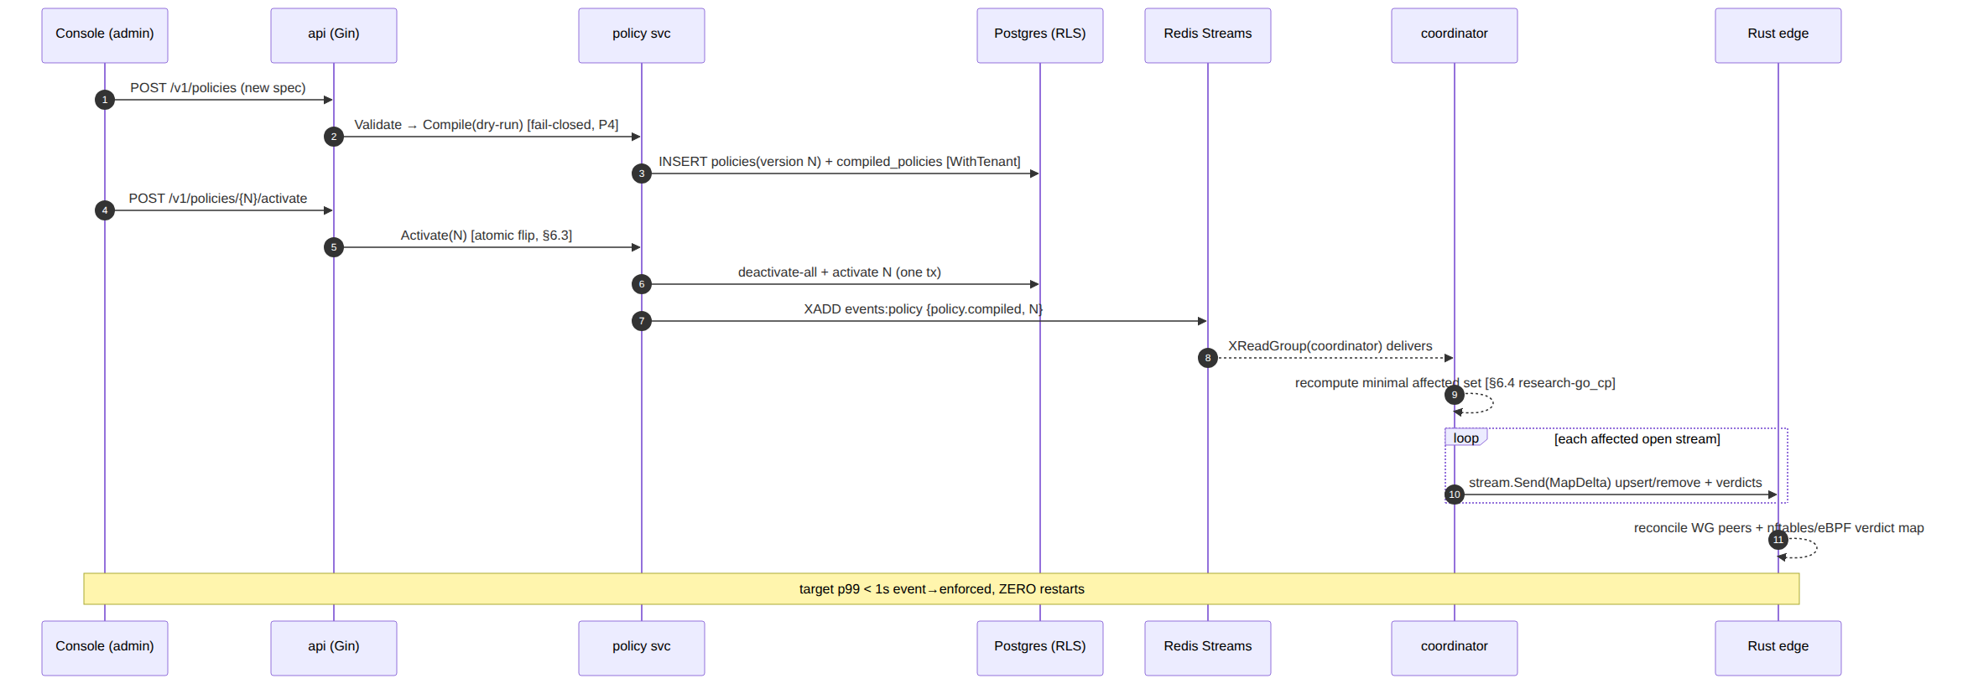
Budget segment | Owner | Target | Measured by
dry-run compile (1k devices) | policy | < 200 ms | policy_compile_seconds histogram + benchmark gate
activate flip + emit (tx + XADD) | policy | < 20 ms | policy_activate_seconds histogram
event → delta-on-wire | coordinator | < 1 s p99 (whole budget) | helix_reconcile_seconds [research-go_cp §10.2]
delta → edge enforced | edge (doc 01) | included in the <1 s | revoke-to-WG-peer-removed timer
Metrics the policy package exports (Prometheus, [research-go_cp §10.2] family): policy_compile_seconds{tenant}, policy_activate_seconds{tenant}, policy_compile_errors_total{code}, policy_route_conflicts_total{tenant}, policy_active_version{tenant} (gauge — supports rollback observability).

12. Test-type coverage (constitution §11.4.169 — comprehensive, anti-bluff)
§11.4.169 mandates comprehensive test-type coverage; every type below has a concrete, captured-evidence test point [04_P1 §10, research-go_cp §10.3, §11.4.27/§11.4.5/§11.4.69/§1.1].
Test type | Concrete test point | Captured evidence (§11.4.69)
Unit | Compile(runningExample) → assert exact CompiledPolicy for carol-laptop (§4.4): VisibleTo={conn-A}, Verdicts tcp 554+80 only, ExitNodes excludes carol. | golden compiled.json byte-compare
Unit — determinism (P2) | compile same (spec,snap) twice with different SnapAt → canonicalEncode outputs byte-identical; property test over 1000 random specs. | hash-equality log per iter
Unit — purity lint (§3.1) | custom analyzer asserts no time.Now/rand/bare range map inside compile.go. | analyzer report
Unit — error taxonomy | table-driven: each ERR_* (§8) reproduced by a crafted spec; assert exact Code+RuleIx. | per-code assertion table
Integration (real PG+Redis via vasic-digital/containers §11.4.76) | drive enroll→advertise→POST /v1/policies→activate→consume policy.compiled→assert coordinator pushed carol the port-restricted delta and denied office-lan. | event stream + delta capture
Integration — fail-closed (P4) | spec citing unadvertised 172.16.0.0/24 → Update returns 422 ERR_HOST_NOT_ADVERTISED; assert NO policies row inserted. | DB row-count before/after
Integration — instant rollback (P5) | activate v2 (broken-but-valid), then Rollback(v1); assert active flips, no recompile call (spy), coordinator re-pushes v1 delta. | policy_active_version gauge trace
RLS (C8) | as helix_app, tenant-A session cannot read tenant-B policies even with crafted WHERE; FORCE ROW LEVEL SECURITY on. | denied-query capture
E2E / full-automation (§11.4.98) | self-host from zero → enroll connector+client → policy grant → client reaches authorized LAN host + denied unauthorized → edit policy → reflected <1 s no restart. | recorded transcript docs/qa/<run-id>/
Security | a member-role token attempting POST /v1/policies/{v}/activate → 403; an agent RPC attempting to author policy → rejected. | authz-denial capture
Stress (§11.4.85) | 10k-device / 1k-rule compile ×100 iters → p95 < 200 ms (E10/§11 budget); 10 concurrent Update per tenant → monotonic versions, no collision. | latency.json distribution
Chaos (§11.4.85) | SIGKILL the service mid-Activate (after deactivate, before activate) → recovery restores a single active (partial unique index + tx rollback); replay a duplicated policy.compiled → idempotent (no double-push). | recovery_trace.log
Performance/benchmark | BenchmarkCompile1kDevices < 200 ms; BenchmarkActivate < 20 ms — wired to §11 SLO gate. | benchmark output
Meta-test (§1.1 paired mutation) | (a) strip the §5 dry-run gate → fail-closed integration test must FAIL; (b) make Compile range a map for output order → determinism test must FAIL; (c) drop the revoked-grant check → E5 test must FAIL. Each mutation FAILs its gate, restore PASSes. | mutate→FAIL→restore→PASS log
Challenge (HelixQA, §11.4.27) | CME-POLICY-001: drives the running example end-to-end, scores PASS only on captured proof carol reaches 10.10.0.0/24:554 AND is denied 192.168.50.0/24. | challenge result.json
Anti-bluff floor: a policy "PASS" is valid only with captured evidence that an authorized edge and an unauthorized edge behaved correctly — a green compile is necessary, never sufficient (the §0.1 covenant). The §1.1 mutations are the runtime signatures (§11.4.108) that P1/P2/P4/E5 are live, not promised.

13. Phase → task mapping (workable items, §11.4.93)
Restates the [research-go_cp §13] CP-T6 leaf into nano-detail work items, risk-descending (§11.4.132 — fail-closed validation + determinism first, they are the irreversible floor):
- CP-T6.1 spec parser + typed AST (§2.2/§2.3) + grammar errors (§8).
- CP-T6.2 resolve.go: groups (transitive + cycle, E12) + hosts + advertised cross-check (P7).
- CP-T6.3 compile.go: two-artifact pure core (§4) + canonical determinism (§3.1) + purity lint.
- CP-T6.4 validate.go: fail-closed dry-run gate (§5) + blocking/advisory taxonomy.
- CP-T6.5 activate.go: monotonic version + atomic flip + instant rollback (§6) + compiled cache DDL.
- CP-T6.6 event emit/consume wiring (§7.1) + coordinator.v1.Peer.verdicts projection (§7.2).
- CP-T6.7 metrics (§11) + the §12 full test-type matrix + CME-POLICY-001 Challenge.

Sources
[04_P1] HelixVPN-Phase1-MVP.md §§5–7, §10–11 (ACL model, compile algorithm, two artifacts, fail-closed validation, instant rollback, test strategy, MVP DoD) · [04_ARCH] HelixVPN-Architecture-Refined.md §3.4 (multi-network routing/policy, default-deny, AllowedIPs+nftables/eBPF verdict map, ULA /48 + 4via6), §7 (zero-trust, no-logging) · [research-go_cp] 02-control-plane.md §1.3 (Compiler interface), §2.2/§2.3 (policies DDL + RLS), §4 (helix.coordinator.v1 proto), §5 (events), §6 (coordinator consumption), §7 (policy model & compiler), §10 (SLOs + test strategy) · [SYNTHESIS] §§2–4, §7, §9 (stack floor, key decisions D3/D4, security invariants, constitution bindings). UNVERIFIED items (nested groups, device-as-destination, measured p99) flagged inline per §11.4.6.

