Connector (network agent)

Connector (network agent)
Revision: 1 Last modified: 2026-07-06T10:44:05Z Status: active — Volume 4 (Clients) nano-detail document; closes GAP-4 in ../v00-meta/requirements-traceability.md §6.
Document role. Single consolidating owner for the HelixVPN Connector — the appliance-side agent that advertises private LAN CIDRs to the gateway and routes authorized client traffic into those LANs without opening any inbound port. This document consolidates behaviour that was previously distributed across v04-client/helix-core-rust.md §9, v03-control-plane/svc-registry.md, v02-data-plane/routing-and-addressing.md, the Volume-4 platform shims, and the FR-7xx requirements in v01-product/functional-requirements.md §H.
SPEC-ONLY. This is the what-to-build spec, not the shipped product. Every claim is cited inline; anything not yet pinned in the source docs is tagged UNVERIFIED per §11.4.6.

Table of contents
- 0. Position, ownership & non-goals
- 1. Invariants inherited from the source docs
- 2. Functional consolidation (FR-701..707)
- 3. Architecture — one core, two postures
- 4. Registry contract (advertise + route)
- 5. Data-plane routing and addressing
- 6. Platform shims, packaging & deployment
- 7. Test points — mapped to §11.4.169
- 8. Sources verified / GAP-4 closure

0. Position, ownership & non-goals

0.1 What this document owns
# | Contract | Owned here | Delegated to
C1 | The Connector as a single component with one owning nano-detail doc | this file | —
C2 | The Connector's mode flag / posture: --mode=connector, CoreMode::Connector, Mode::Connector | §3 | orchestrator internals live in v02-data-plane/orchestrator-and-state.md
C3 | The headless daemon packaging and the optional Flutter/embedded config UI | §3, §6 | per-platform lifecycle in shim-linux.md §9, shim-android.md, helix-ui-flutter.md
C4 | The registry contract: connector enrollment, AttachConnector, SetPrefixes, CIDR conflict detection, presence | §4 | implementation detail in svc-registry.md
C5 | The advertise/route data-plane contract: CIDR → 4via6 overlay prefix, RouteMap lifecycle, FIB, DNAT-back | §5 | byte-exact math in routing-and-addressing.md
C6 | The local-denylist × central-policy precedence rule at the Connector edge | §3.3 | rule authority in v03-control-plane/svc-policy.md §4.2
C7 | The Connector-specific §11.4.169 test-type mapping | §7 | Volume-8 harness docs in v08-testing/

0.2 What this document does NOT own
- The orchestrator three-loop body, TunnelStatus enum, transport ladder, or kill-switch/DNS state machine — owned by v02-data-plane/orchestrator-and-state.md.
- The Transport trait and carrier wire formats — owned by v02-data-plane/transport-trait.md and transport-*.md.
- The policy compiler grammar / AllowedIPs synthesis — owned by v03-control-plane/svc-policy.md.
- Enrollment token minting, OIDC, mTLS cert lifecycle — owned by svc-identity.md and svc-pki.md.
- Availability-following / drop-detect-reconnect timings — owned by v02-data-plane/orchestrator-and-state.md (FR-707 traceability target).

1. Invariants inherited from the source docs
# | Invariant | Source | Connector consequence
I1 | Outbound-only, no inbound. The Connector dials the gateway; no port-forward or inbound listener is required on the private network. | FR-701, helix-core-rust.md §9.1, routing-and-addressing.md §0.2 R2 | Connector never binds a listening socket on the LAN side for the overlay.
I2 | One core, no forked bodies. Access and Connector share the same helix-core crate; the difference is the Mode parameter. | FR-703, helix-core-rust.md §9.1, shim-linux.md §9 | Same WG, transport ladder, reconciler, and status stream; only routing posture changes.
I3 | Headless by default. The Connector is primarily a daemon; the UI is an optional slim config surface. | FR-702, helix-core-rust.md §9.2 | bin/helixd --mode=connector is the primary appliance form.
I4 | Default-deny / fail-closed. Absent or stale policy ⇒ drop; the Connector installs the verdict map locally as well as honoring central policy. | FR-705, svc-policy.md §4.2, routing-and-addressing.md §0.2 R3 | Local local_denylist is enforced at the connector edge even if the control-plane delta is delayed.
I5 | No-logging by construction. No per-flow/per-packet durable table; only aggregate counters and coarse presence. | svc-registry.md §1.2 C3 | Connector heartbeat is coarse (last_seen_at debounced ≥30 s); presence TTL is ephemeral Redis.
I6 | Push, don't poll. Route/policy deltas reach affected edges in p99 < 1 s with no restart. | FR-305, routing-and-addressing.md §0.2 R1 | Connector re-reconciles on every pushed RouteMap version; it does not poll.
I7 | Need-to-know map filtering. A client/edge only receives routes/peers its policy already grants. | FR-207, routing-and-addressing.md §0.2 R2 | Connector's own map is also policy-filtered; it learns only the gateway/peer set it needs.

2. Functional consolidation (FR-701..707)
The Connector requirement band (FR-7xx) is owned here; detailed implementation authority is cited per row.
Req | Statement | Acceptance criterion | Test type(s) (from traceability matrix) | Implementation authority
HVPN-FR-701 | The Connector MUST dial outbound to the Gateway and MUST NOT require any inbound port-forward. | The Connector establishes the tunnel with zero inbound exposure on its network. [evidence] | SEC (no-inbound) + E2E | §3.1; helix-core-rust.md §9.1
HVPN-FR-702 | The Connector MUST run headless (daemon) with an optional slim config UI. | The daemon runs without a UI; the optional UI configures it. [evidence] | INT | §3.2, §6; helix-core-rust.md §9.2
HVPN-FR-703 | The Connector MUST share the same Rust helix-core as the Client, in advertise/route mode (not capture mode). | The Connector links the same crate; runs in advertise/route mode. | INT (shared-crate) | §3; helix-core-rust.md §9.1
HVPN-FR-704 | The Connector MUST advertise its network's CIDRs to the Gateway and route authorized traffic into the LAN. | Advertised CIDR appears in the registry; authorized client reaches a LAN host. [evidence] | E2E | §4, §5; svc-registry.md §6, routing-and-addressing.md §4
HVPN-FR-705 | The Connector SHOULD support local ACLs scoped to its own network, interacting with central policy by the precedence rule. | A local ACL on the connector is honoured; local-deny overrides central-allow, central-deny overrides local-allow, and the connector advertises its local_denylist to the coordinator. [evidence] | INT (local-ACL honoured + central-deny wins) | §3.3; helix-core-rust.md §9.3, svc-policy.md §4.2
HVPN-FR-706 | The Connector MUST be runnable on Android/embedded appliance hardware in addition to Linux/Windows/macOS. | A Connector build runs on an embedded/Android target. [evidence] | E2E (embedded target) | §6; helix-core-rust.md §9.2, shim-android.md, shim-aurora.md, shim-harmonyos.md
HVPN-FR-707 | The Connector MUST follow availability-following on drop: detect, log offline, reconnect with defined timings, resume (§11.4.144 alignment). | A simulated drop is logged offline, reconnected, and resumed with no silent gap. [evidence] | CHAOS (drop→resume) | v02-data-plane/orchestrator-and-state.md; this doc traces the requirement to that owner

3. Architecture — one core, two postures

3.1 One binary, one core, two postures
The Connector is the same helix-core Orchestrator with Mode::Connector helix-core-rust.md §9.1. The three loops, status stream, reconciler, backoff, and transport layer are byte-for-byte identical to the client; only the routing posture differs:
client: [app traffic] → TUN → WG encrypt → [DAITA] → Transport ──▶ gateway
connector: gateway ──▶ Transport → WG decrypt → forward into served CIDR (and reverse)
- No default-route capture. The Connector does not capture the host's default route.
- Outbound-only. It dials the gateway; it never listens on the LAN for overlay-initiated connections helix-core-rust.md §9.1, routing-and-addressing.md §0.2 R2.

3.2 The two entrypoints share the core
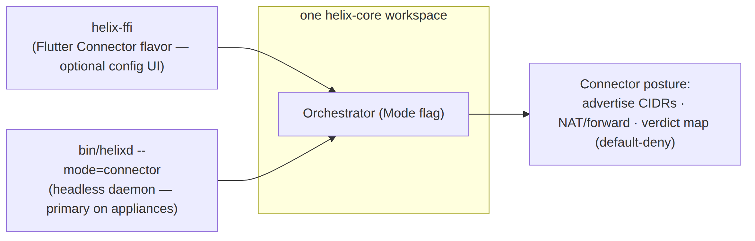
- Headless daemon (bin/helixd --mode=connector) is the primary form on network appliances — no Flutter, no FFI weight, just the core helix-core-rust.md §9.2, shim-linux.md §9.
- Flutter Connector flavor is the optional config surface; it links helix-ffi and drives the same core with CoreMode::Connector, calling advertise(cidrs) for the advertise UI helix-core-rust.md §9.2.
On Linux the daemon is a Type=notify systemd service (helix-connectord) with CAP_NET_ADMIN only, read-only rootfs protections, and a rootless Podman quadlet variant shim-linux.md §9.3/§9.4.

3.3 advertise and local_denylist (FFI verbs, connector only)
// helix-ffi/src/api.rs (connector mode)
pub async fn advertise(cidrs: Vec<String>) -> Result<AdvertiseResult, CoreError>;
pub async fn advertise_with_local_denylist(
cidrs: Vec<String>,
local_denylist: Vec<String>,
) -> Result<AdvertiseResult, CoreError>;
advertise pushes the served CIDRs into the Connector's RouteMap; the gateway reconciles them. AdvertiseResult.conflicts surfaces overlapping-CIDR findings to the UI helix-core-rust.md §9.3.
The local_denylist precedence rule (FR-705) is enforced in two places so it never fails open:
- Control-plane compiler (svc-policy.md §4.2) — the coordinator computes the union of central policy minus local-deny for this connector.
- Connector local edge — the Connector installs its local local_denylist as an additional verdict-map check while the central delta is in flight helix-core-rust.md §9.3.
Precedence:
Local | Central | Effective verdict
allow | allow | allow
deny | allow | deny (local tightens)
allow | deny | deny (central default-deny wins)
deny | deny | deny
The Connector advertises the local_denylist to the coordinator alongside its CIDR advertisements so the edge enforces it consistently helix-core-rust.md §9.3.

3.4 Status semantics on the connector
The Connector emits the same TunnelStatus stream as the client — its tunnel to the gateway is what Connected{transport,rtt} describes; Down means the connector lost its gateway tunnel helix-core-rust.md §9.4. The Connector Flutter flavor subscribes to status_stream() exactly as Access does.

4. Registry contract (advertise + route)

4.1 Connector enrollment
A Connector enrolls as a device row with kind = 'connector'. The registry inserts a 1:1 connectors detail row at enrollment, allocating a per-connector site_id via IPAM for 4via6 disambiguation svc-registry.md §2, §4. AttachConnector is called when the connector first opens its control channel and refreshes attached_at idempotently svc-registry.md §3.

4.2 Prefix advertisement
A connector advertises its served CIDRs through either the Coordinator.AdvertisePrefixes agent RPC or the Console REST route POST /v1/connectors/{id}/prefixes. Both converge on Registry.SetPrefixes svc-registry.md §6.1.
SetPrefixes is declarative-replace (the full desired set), not additive. It:
- Canonicalises and de-duplicates CIDRs (Masked()).
- Detects intra-tenant overlapping prefixes against other connectors (advisory only — the write succeeds; conflicts are surfaced to the Console).
- Atomically replaces the connector's advertised_prefixes rows.
- Emits connector.prefixes.changed and, per conflict, route.conflict.detected inside the same WithTenant transaction svc-registry.md §6.2.
An empty prefix list clears all advertisements for that connector — a legitimate "this site advertises nothing now" state svc-registry.md §10.

4.3 Conflict semantics (advisory, never blocking)
Two connectors legitimately advertising the same RFC1918 CIDR (e.g. two sites both numbering 192.168.1.0/24) is the exact "1 user → N networks" collision HelixVPN exists to solve. The registry detects and reports the overlap; resolution is downstream by 4via6 site disambiguation or operator policy choice svc-registry.md §6.3.

4.4 Presence and route withdrawal
- Redis presence key: helix:presence:<tenant_id>:<device_id> with a 45 s TTL (3 × 15 s heartbeat default) svc-registry.md §5.3.
- A connector going offline (TTL expiry or explicit MarkPresence(false)) causes the coordinator to withdraw its routes from dependent maps within the < 1 s reconcile budget routing-and-addressing.md §4.2.
- last_seen_at is rate-limited to ≥30 s to avoid a per-packet write storm svc-registry.md §5.2.

5. Data-plane routing and addressing

5.1 From advertised CIDR to overlay prefix
Connectors advertise their served IPv4 LANs; the control plane compiles a RouteMap and pushes it to the gateway edge and to authorized clients via WatchNetworkMap routing-and-addressing.md §4.
Colliding RFC1918 ranges are resolved by 4via6: each connector receives a site_id, and an advertised IPv4 route is encoded into a unique IPv6 overlay prefix:
fd<tenant>:4636:0:<site_id>:<ipv4-network>/<96+prefixlen>
Example from routing-and-addressing.md §3.1:
- Connector A serves 192.168.1.0/24 with site 7 → overlay route fd..:4636:0:7:c0a8:100/120.
- Connector B serves the same CIDR with site 8 → overlay route fd..:4636:0:8:c0a8:100/120.

5.2 Advertisement lifecycle
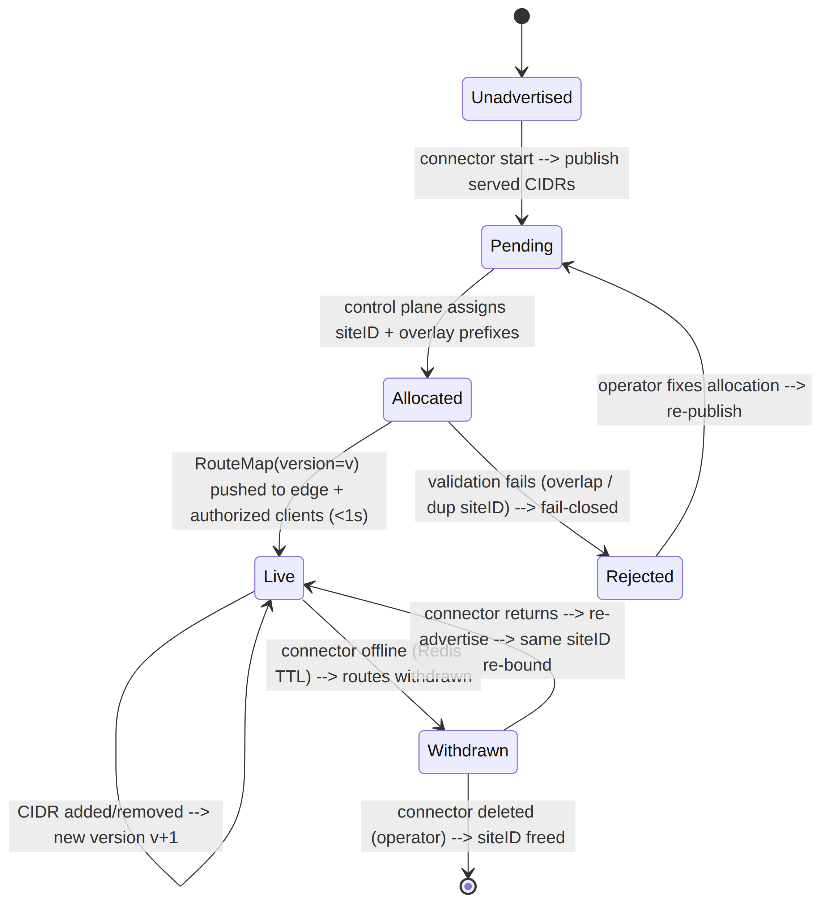
UNVERIFIED: the exact heartbeat TTL and same-siteID re-bind semantics are owned by the control-plane docs; the data-plane contract is: a RouteMap with a withdrawn peer ⇒ reconcile that peer down in < 1 s, no restart routing-and-addressing.md §4.2.

5.3 Packet flow — client → connector LAN host
- Client FIB resolves the overlay destination to NextHop{ wg_pubkey=connectorA, via_site=7 }.
- Client WG-encrypts to the connector peer; AllowedIPs includes the 4via6 prefix.
- Gateway/edge forwards to the connector.
- Connector decrypts, checks the verdict map (default-deny), decodes the 4via6 address to (siteID, IPv4), DNATs into the served LAN, and forwards out the LAN interface routing-and-addressing.md §5.2.
The return path is the reverse: LAN reply → SNAT → WG encrypt → gateway → client.

5.4 Validation on ingest (fail-closed)
helix-route rejects a RouteMap version that:
- carries a Via6 route whose (site, v4) does not match an advertised_v4 + via_connector,
- has two peers advertising the same overlay prefix (OverlapAdvertise),
- gives two distinct connectors the same siteID (DuplicateSiteId) routing-and-addressing.md §4.1.
A bad map never half-applies; install errors leave the prior live map in place routing-and-addressing.md §0.2 R3.

6. Platform shims, packaging & deployment

6.1 Linux — primary connector host
Linux is the Connector's primary host. The daemon ships as:
- A Type=notify systemd service helix-connectord with CAP_NET_ADMIN only, NoNewPrivileges=yes, and Restart=on-failure shim-linux.md §9.3.
- A rootless Podman quadlet (.container unit) with AddCapability=NET_ADMIN and userspace TUN backend shim-linux.md §9.4.

6.2 Android / embedded / other platforms
- Android: the same helix-core .so is loaded with CoreMode::Connector; the optional Connector Flutter flavor uses advertise() over the JNI/UniFFI bridge shim-android.md §3.1.
- Windows: the Connector flavor exposes advertise(cidrs) in the C# privileged service shim shim-windows.md.
- Aurora OS: helix_core_advertise_json(cidrs_json) crosses the Qt/C++ Friflex channel because frb-in-the-embedder is UNVERIFIED on the omprussia fork shim-aurora.md.
- HarmonyOS NEXT: helix_core_advertise(int64_t h, const char* cidrs_json) is the connector-mode C-ABI verb shim-harmonyos.md.
UNVERIFIED: P3 platforms (HarmonyOS, Aurora) are tracked as platform-risk items; they get honest §11.4.3 SKIP-with-reason until on-device evidence is captured shim-android.md §10.2 C12, functional-requirements.md FR-1009/1010.

6.3 Deployment invariants
- The connector credential file (connector.toml) and any enrollment secret are 0600 root-owned and git-ignored — never in the unit file, never logged shim-linux.md §9.3.
- The connector is not a privacy client: kill-switch is typically KillSwitchMode::Off shim-linux.md §9.1.

7. Test points — mapped to §11.4.169
§11.4.169 mandates the closed enumerated test-type set; every PASS must cite captured physical evidence. The Connector test points below map the FR-7xx band to that vocabulary.
§11.4.169 type | Concrete Connector test point | Evidence / oracle | Traced FR
unit | classifyOverlap symmetry; CIDR canonicalisation; Mode::Connector does not alter core loop bodies | table-test output; diff of client vs connector crate graph | FR-703
integration | Enroll connector → AttachConnector → SetPrefixes → assert advertised_prefixes rows + connector.prefixes.changed event; shared-crate parity (client+connector link same helix-core artifact) | DB dump + event capture + build artefact hash | FR-702, FR-703, FR-704
e2e | Client → gateway → connector → LAN host and back; unauthorized host dropped; no inbound listener on the connector network | ping6/curl + pcap + ss -l showing no listening socket on the LAN side | FR-701, FR-704, FR-705
full-automation | Re-runnable script: stand up gateway, enroll connector, advertise CIDR, reach LAN host, revoke connector, assert withdrawal | 3× identical run artifacts | FR-701..705
Challenges | Challenge bank drives enroll→advertise→conflict→revoke; scores on captured DB+event evidence, not a green log line | result.json + evidence dir | FR-704
HelixQA | Connector test bank run in an autonomous QA session | HelixQA session report | FR-701..707
DDoS / load-flood | Flood MarkPresence and AdvertisePrefixes; assert ≤1 transition event per state change and no last_seen_at write storm | event-rate + DB write-rate metrics | FR-707 (registry side)
security | Port-scan the connector LAN side — no listening overlay socket; local_denylist blocks a central-allowed flow at the connector edge; central-deny blocks a local-allowed flow | scan output + drop counters | FR-701, FR-705
stress + chaos | Kill connector mid-flow → routes withdrawn → restored on return; corrupt map.json → rejected, prior map stays live | recovery trace + FIB snapshot | FR-704, FR-707
concurrency / atomicity | Concurrent SetPrefixes for the same connector ⇒ last-full-set-wins, never a half-merge svc-registry.md §10 | captured no-torn-prefix assertion | FR-704
race-condition / deadlock | -race build green across connector advertise path and presence edge-detect | go test -race / cargo test output | FR-704
memory | 24 h connector soak with flapping presence + advertising; RSS slope ≈ 0 | memory slope capture | FR-702, FR-707
benchmarking / performance | SetPrefixes p99 ≤ 100 ms @ 100 CIDRs; route converge < 1 s after connector comes online | histograms vs §11 budgets | FR-704, FR-707

8. Sources verified / GAP-4 closure
- v01-product/functional-requirements.md §H — FR-701..707 statements, acceptance criteria, and original distributed owning-doc citations.
- v04-client/helix-core-rust.md §9 — Mode::Connector packaging, headless daemon, advertise/local_denylist verbs, status semantics, one-core invariant.
- v03-control-plane/svc-registry.md — connector enrollment, AttachConnector, SetPrefixes, conflict detection, presence model, events.
- v02-data-plane/routing-and-addressing.md — 4via6 CIDR advertisement, RouteMap lifecycle, FIB, DNAT-back, fail-closed validation.
- v04-client/shim-linux.md §9 — Linux connector daemon deployment (systemd + rootless Podman quadlet).
- v04-client/shim-android.md, shim-windows.md, shim-aurora.md, shim-harmonyos.md — connector-mode FFI surface on other platforms.
- v00-meta/requirements-traceability.md §6 — GAP-4 was the absence of a single consolidating Connector doc; this document closes it.
GAP-4 closure note. With v04-client/connector.md now the primary owning doc for FR-701..707, the Connector's traceability no longer spans multiple files as a primary owner. Secondary implementation authority remains in the source docs cited above, but the requirement-to-component pin is consolidated here.
Constitution bindings: §11.4.44 (revision header), §11.4.6 (UNVERIFIED on un-pinned contracts; no invented runtime), §11.4.69 (captured-evidence acceptance), §11.4.93 (each FR → workable item), §11.4.118 (coverage honesty), §11.4.169 (mandatory test-type coverage), §11.4.161 (rootless deployment), §1.1 (paired mutations / anti-bluff).

