FFI surface (Dart ⇄ Rust)

FFI surface (Dart ⇄ Rust)
Revision: 2 Last modified: 2026-07-04T12:00:00Z
Master technical specification — Volume 4 (Clients), nano-detail deep-dive. This document deepens the FFI surface — Dart ⇄ helix-core section of the pass-1 client overview [04_CLIENT §3] into an implementation-ready specification of the helix-ffi exported surface: the two binding generators (flutter_rust_bridge v2 primary, UniFFI native-shim fallback), the exact Rust/Dart/Swift/Kotlin/C signatures of start/stop/status_stream/exits/ set_exit/set_shields/advertise/attach_tun, the mirrored TunnelStatus enum and its projection from the orchestrator's canonical enum, StreamSink event delivery, the tokio threading model, error propagation, the codegen + drift-gate pipeline, memory budgets, edge cases, and test points tied to the §11.4.169 closed test-type vocabulary.
SPEC-ONLY. It describes what to build — signatures, state machines, memory ceilings, error taxonomy, edge cases, test points — not the shipping product.
Boundary with sibling docs. This document owns only the exported FFI surface of helix-core. It consumes: the orchestrator's canonical TunnelStatus broadcast enum and Orchestrator::{start,stop,subscribe,apply_map, set_pin} API [02_ORCH §2.1, §4.1]; the Transport/TransportKind labels [02_TRANS §2, §3.3]; the TunnelPlatform MethodChannel/EventChannel shim contract [04_CLIENT §4]; the per-platform tunnel mechanisms (NEPacketTunnelProvider, VpnService) [04_CLIENT §5, research-ios_android]. The orchestrator internals (three loops, kill-switch coupling, reconciler) are doc 02's; this doc owns only how that core is exposed across the language boundary.
Evidence base. Citations inline by id: [04_CLIENT §N] = final/03-client-core-and-ui.md; [04_ARCH §5] = 04_VPN_CLD/HelixVPN-Architecture-Refined.md §5; [04_UI] = 04_VPN_CLD/HelixVPN-helix-ui-Flutter.md; [02_ORCH §N] = final/v02-data-plane/orchestrator-and-state.md; [02_TRANS §N] = final/v02-data-plane/transport-trait.md; [research-flutter_ffi] / [research-ios_android] = the cited research digests; [10_QA §N] = final/10-testing-acceptance-and-qa.md (§11.4.169 taxonomy). Any claim not grounded in the evidence base is tagged UNVERIFIED per constitution §11.4.6 — never fabricated.

Table of contents
- 0. Position, ownership, and the load-bearing seam
- 1. Two generators, two consumption modes
- 2. The Rust source of truth (helix-ffi/src/api.rs)
- 3. The TunnelStatus enum — mirror + projection
- 4. StreamSink event delivery & the threading model
- 5. The Dart-facing surface (helix_core.dart)
- 6. UniFFI native-shim surface (Swift / Kotlin / C)
- 7. The TunnelPlatform ⇄ FFI division of labor
- 8. Error propagation across the boundary
- 9. Lifecycle, idempotence, and attach_tun fd ownership
- 10. Codegen + drift-gate pipeline
- 11. Memory & performance budgets
- 12. Edge cases & failure modes
- 13. Test points — §11.4.169 closed vocabulary
- 14. Surfaced decisions & cross-doc contracts
- Sources verified

0. Position, ownership, and the load-bearing seam
helix-ffi is the single hand-authored Rust crate that both binding generators read; it is the only place the core's surface crosses a language boundary [04_CLIENT §3.1]. It is decoupled and project-agnostic (vasic-digital/helix_core workspace, snake_case flat submodule per §11.4.28/.29/.74): it depends up on helix-core (orchestrator, status enum) and exposes down a stable Dart/Swift/ Kotlin/C surface, but contains no project-specific UI glue.

0.1 What this document owns
# | Owned artifact | Where
F1 | The exact Rust API of helix-ffi (start/stop/status_stream/exits/set_exit/set_shields/advertise/apply_map/attach_tun/detach_tun) + the mirrored DTO types (ClientConfig, CoreMode, Shields, ExitOption, AdvertiseResult, MapApplied, CoreError) | §2
F2 | The Dart-facing TunnelStatus (7-variant) and its deterministic projection from the orchestrator's canonical 5-variant core::TunnelStatus | §3
F3 | The StreamSink<TunnelStatus> delivery mechanism + the tokio runtime / forwarding-task threading model + the pause/resume re-emit rule | §4
F4 | The idiomatic Dart wrapper (helix_core.dart) and the UniFFI Swift/Kotlin/C surface | §5, §6
F5 | Error propagation (frb exception ⇄ UniFFI typed error ⇄ C error code) | §8
F6 | The codegen + drift-gate (a generated-Dart/Rust mismatch is a build-blocking finding) | §10

0.2 What this document does NOT own
- The orchestrator loops / kill-switch / DNS / reconciler — doc 02 [02_ORCH §3–§9]; this doc consumes Orchestrator::subscribe() and the broadcast enum.
- The Transport trait and its impls — doc 02 [02_TRANS]; this doc surfaces only the kind() label string inside Connected.transport.
- The OS tunnel lifecycle (TUN creation, permission, packet pump) — the TunnelPlatform shim [04_CLIENT §4–§5]; this doc owns only the attach_tun/detach_tun handoff and the in-process-vs-native-shim consumption split (§7).
- The Riverpod data layer / widgets — [04_CLIENT §7–§8]; this doc stops at the Stream<TunnelStatus> the providers watch.

0.3 The load-bearing invariant (CI1 + CI2, restated at the FFI layer)
helix-ffi owns logic and status; it does NOT own the OS tunnel lifecycle. Lifecycle commands flow UI → shim → core (the OS owns the tunnel process); status events flow core → FFI → UI (the core owns truth about protection state). set_shields/set_exit/exits are pure logic and go straight UI → FFI without touching the OS tunnel. The UI only ever believes the core's status stream, never its own intent. [04_CLIENT §0.1 CI1/CI2, §3.3]
This is the seam that mechanically prevents the classic "UI says connected while the OS tunnel is actually down" bug — the FFI never reports a state the orchestrator did not emit (§3, §4.5).

1. Two generators, two consumption modes
Two binding generators read one Rust surface — the canonical Mullvad/WARP pattern [04_CLIENT §3, 04_ARCH §5.1, research-flutter_ffi §7]:
- flutter_rust_bridge (frb) v2 — 2.12.0 (Flutter Favorite; StreamSink support; arbitrary/async Rust types; new SSE codec) [research-flutter_ffi §1]. The primary generator: emits the Dart⇄Rust glue (frb_generated.dart + a Rust wrapper) for the UI process.
- UniFFI (Mozilla) — first-party Kotlin / Swift output [research-flutter_ffi §2]. The native-shim fallback: emits the typed Swift/Kotlin bindings a platform tunnel extension (NEPacketTunnelProvider, VpnService, HarmonyOS ArkTS→NAPI) uses when it links the core directly rather than through Dart. uniffi-dart is NOT production-ready and is NOT used for the Dart surface (frb owns Dart) [research-flutter_ffi §2].
- cbindgen C header — the raw-C fallback where UniFFI's language support is thin (HarmonyOS NAPI shim, Aurora Qt/C++ backend) [04_CLIENT §5.5/§5.6, D-CLIENT-3].
These map onto two distinct consumption modes, and which mode a platform uses decides where each TunnelStatus originates:
Mode | Where the core runs | Generator | Status path | Platforms
(A) In-process frb | the Dart/UI process (same process as Flutter) | frb v2 | core → StreamSink → frb port → Dart isolate | Linux desktop (core in-process); Windows app side talks to the privileged service over a pipe but the Dart-facing surface is still frb
(B) Native-shim UniFFI/C | a separate OS tunnel extension process | UniFFI (Swift/Kotlin) / cbindgen (C) | core → shim → EventChannel → Dart (the TunnelPlatform event stream, §7) | iOS/macOS NE, Android VpnService, HarmonyOS, Aurora
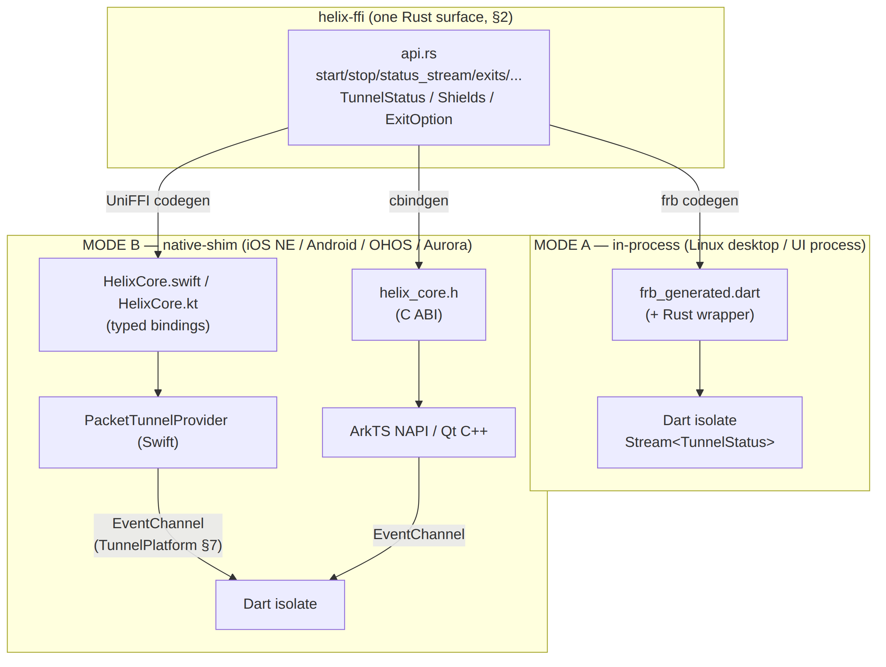
Honest boundary (§11.4.6). In Mode B the core never runs in the Dart isolate — it runs inside the OS extension process (the memory-constrained one, §11). The frb runtime + tokio threads of Mode A are therefore NOT part of the iOS NE footprint; the NE links the UniFFI/cbindgen staticlib only [research-ios_android §1 "applies to the process as a whole"]. This is why the iOS memory ceiling (§11) is a native-shim constraint, not an frb constraint.

2. The Rust source of truth (helix-ffi/src/api.rs)
This is the only hand-authored FFI source; both generators read it. It promotes the pass-1 sketch [04_CLIENT §3.1] to the production surface; the lean Phase-0 subset (start/stop/status_stream) is the G5 gate [04_CLIENT §13 T0.1].
// helix-ffi/src/api.rs
// frb + UniFFI generate Dart / Swift / Kotlin / C bindings from THIS file.
// The transport/WG/orchestrator internals are doc 02's; this is purely the EXPORTED surface.
use flutter_rust_bridge::frb;
use flutter_rust_bridge::StreamSink;
// ───────────────────────── construction inputs ─────────────────────────
pub struct ClientConfig {
/// Phase 0: filesystem path to a static map.json. Phase 1+: an opaque control-plane
/// session token (handed straight to the orchestrator; the FFI never parses it).
pub map_path_or_session: String,
/// Ladder seed: "auto" | "plain" | "masque" | "shadowsocks" | "uot" | "lwo".
/// "auto" => the coordinator-pushed TransportPolicy.order decides [02_TRANS §6.2].
pub transport: String,
pub mode: CoreMode,
}
#[frb(mirror(CoreMode))] // re-export helix_core::CoreMode's Dart mirror
pub enum CoreMode { Client, Connector }
// ───────────────────── lifecycle (LOGIC only — NOT the OS tunnel, CI1) ─────────────────────
/// Construct + start the orchestrator (doc 02 Orchestrator::start). Idempotent guard:
/// a second start while already running returns Err(CoreError::AlreadyStarted) (§9.2).
pub async fn start(cfg: ClientConfig) -> Result<(), CoreError>;
/// Graceful stop (doc 02 Orchestrator::stop). Idempotent: stop-when-stopped => Ok(()).
pub async fn stop() -> Result<(), CoreError>;
// ───────────────────── the live status stream (§3, §4) ─────────────────────
/// Register a sink; the FFI forwarding task projects core::TunnelStatus → ffi::TunnelStatus
/// (§3.3) and pushes each onto `sink`. Returns once the sink is registered; events arrive
/// asynchronously. The CURRENT status is re-emitted immediately on (re)registration (§4.5).
pub fn status_stream(sink: StreamSink<TunnelStatus>) -> Result<(), CoreError>;
// ───────────────────── exits / routing (Phase 1+) ─────────────────────
pub async fn exits() -> Result<Vec<ExitOption>, CoreError>;
pub async fn set_exit(id: String, multi_hop_chain: Option<Vec<String>>) -> Result<(), CoreError>;
// ───────────────────── privacy shields ─────────────────────
pub async fn set_shields(s: Shields) -> Result<(), CoreError>;
// ───────────────────── connector mode only ─────────────────────
pub async fn advertise(cidrs: Vec<String>) -> Result<AdvertiseResult, CoreError>;
// ───────── desired-state push (Phase 1 bridges WatchNetworkMap; Phase 0 file-watch) ─────────
/// Push a fresh RouteMap into the running orchestrator (doc 02 Orchestrator::apply_map).
/// Malformed JSON => Err(CoreError::Config); the last-applied map stays live (fail-static).
/// `MapApplied` reports the diff (peers added/removed/changed) for the Connector/Console UI.
pub async fn apply_map(map_json: String) -> Result<MapApplied, CoreError>;
// ───────────────────── shim handoff (called by the platform shim, NOT the UI) ─────────────────────
/// The core never opens the TUN; the shim hands it a packet fd. Ownership of `fd` transfers
/// to the core on Ok (the core close()s it on detach/stop) — §9.3. Synchronous (no await):
/// it only stores the fd + wakes loop A/B.
pub fn attach_tun(fd: i32) -> Result<(), CoreError>;
pub fn detach_tun() -> Result<(), CoreError>;
// ───────────────────── DTOs (mirrored byte-for-byte into Dart/Swift/Kotlin) ─────────────────────
pub struct Shields {
pub kill_switch: bool,
pub dns_protection: bool,
pub daita: bool,
pub post_quantum: bool,
pub split_tunnel: Vec<String>, // per-route bypass CIDRs; per-APP split is shim-layer
}
pub struct ExitOption {
pub id: String,
pub kind: String, // "privacy_exit" | "network"
pub label: String,
pub country: Option<String>,
pub rtt_ms: Option<u32>,
pub jurisdiction: Option<String>, // multi-hop labels
}
pub struct AdvertiseResult {
pub accepted: Vec<String>,
pub conflicts: Vec<String>, // overlapping-CIDR conflicts surfaced to the Connector UI
}
#[frb(mirror(T))] semantics. CoreMode/TunnelStatus are defined in helix-core (so the orchestrator and the FFI share one definition — no parallel hand-written enum). #[frb(mirror(T))] tells frb to generate the Dart mirror for a type owned by another crate [research-flutter_ffi §1, frb V2 "mirror" facility]. DTOs defined in helix-ffi (ClientConfig, Shields, ExitOption, AdvertiseResult, CoreError) need no mirror — frb auto-mirrors them. This is the corrected, precise form of the [04_CLIENT §3.1] sketch (which annotated own types with bare #[frb(mirror)]).
Result<T, CoreError> vs anyhow::Result. The [04_CLIENT §3.1] sketch used anyhow::Result<()>; the production surface uses a typed CoreError enum (§8) so UniFFI (which needs a concrete error type, not anyhow::Error) and frb both surface a classified failure to the UI — a typed error drives an honest, specific UI message instead of an opaque string (§11.4.6). anyhow may remain internal to the orchestrator; the FFI boundary converts to CoreError.

3. The TunnelStatus enum — mirror + projection

3.1 The canonical (core-owned) enum — consumed, not redefined
The orchestrator owns the canonical 5-variant enum and broadcasts it on a tokio::sync::broadcast channel [02_ORCH §4.1]:
// helix-core/src/status.rs (OWNED by doc 02 — this doc CONSUMES it)
pub enum TunnelStatus { // core::TunnelStatus
Connecting,
Handshaking,
Connected { transport: String, rtt_ms: u32 }, // transport = Transport::kind() [02_TRANS §3.3]
Reconnecting,
Down { reason: String }, // stable-prefix vocabulary [02_ORCH §4.4]
}

3.2 The Dart-facing (FFI-owned) enum — the 7-variant surface
The FFI exposes the extended 7-variant enum the UI's color/announce logic switches on [04_CLIENT §3.1, §7.1]. It is the Dart-facing canonical and is what the StreamSink carries:
// helix-ffi re-exports + extends — the Dart-facing surface
pub enum TunnelStatus { // ffi::TunnelStatus
Disconnected, // clean idle — DISTINCT from Down
Connecting,
Handshaking,
Connected { transport: String, path: String, rtt_ms: u32 }, // path = "direct" | "relay"
Reconnecting,
Down { reason: String }, // unexpected drop (reason ∉ danger-class)
Danger { kind: String }, // "leak" | "killswitch_tripped" — red palette
}
The three FFI extensions over the core enum [04_CLIENT §3.1 status-enum note]:
- Disconnected — clean user-idle (never started / cleanly stopped), distinct from Down (an unexpected drop). Drives the neutral-grey stateDisconnected token [04_CLIENT §7.1].
- path on Connected — "direct" (P2P/NAT-traversal) vs "relay" (DERP-style), surfaced by the StatusChip [04_CLIENT §7.2].
- Danger { kind } — leak / kill-switch-tripped, drives the red stateDanger palette and overrides any user intent [04_CLIENT §8.4].

3.3 The projection — StatusProjector (the only place the extension happens)
The helix-ffi forwarding task (§4) runs a pure deterministic projector from core::TunnelStatus (+ two side snapshots the core exposes) to ffi::TunnelStatus. This is the single, testable seam where the extension is computed — never ad-hoc in the UI:
// helix-ffi/src/project.rs
pub struct ProjCtx {
pub last_stop_was_user: bool, // distinguishes clean idle from drop (from Orchestrator)
pub active_path: Option<String>,// "direct"|"relay" from the active route/transport (§14 C3)
pub shields_tripped: Option<String>, // Some("leak")|Some("killswitch_tripped") | None
}
pub fn project(s: &core::TunnelStatus, cx: &ProjCtx) -> ffi::TunnelStatus {
use core::TunnelStatus as C;
// Danger overrides everything (§8.4): a live leak / tripped kill-switch always paints red.
if let Some(kind) = &cx.shields_tripped { return ffi::TunnelStatus::Danger { kind: kind.clone() }; }
match s {
C::Connecting => ffi::TunnelStatus::Connecting,
C::Handshaking => ffi::TunnelStatus::Handshaking,
C::Connected { transport, rtt_ms } => ffi::TunnelStatus::Connected {
transport: transport.clone(),
path: cx.active_path.clone().unwrap_or_else(|| "direct".into()), // §14 C3 default
rtt_ms: *rtt_ms,
},
C::Reconnecting => ffi::TunnelStatus::Reconnecting,
// The clean-idle vs drop split: orchestrator emits Down{reason:"stopped"} on a USER
// stop [02_ORCH §2.4 step 6] → Disconnected; every other Down is an unexpected drop.
C::Down { reason } => match classify(reason) {
DownClass::UserStop => ffi::TunnelStatus::Disconnected,
DownClass::Danger(k) => ffi::TunnelStatus::Danger { kind: k },
DownClass::Drop => ffi::TunnelStatus::Down { reason: reason.clone() },
},
}
}
/// Classify on the orchestrator's STABLE reason prefix [02_ORCH §4.4] — no prose parsing (§11.4.6).
fn classify(reason: &str) -> DownClass {
match reason {
"stopped" => DownClass::UserStop,
"auth-failed" => DownClass::Danger("killswitch_tripped".into()),
_ /* ladder-exhausted | host-fatal | ... */ => DownClass::Drop,
}
}
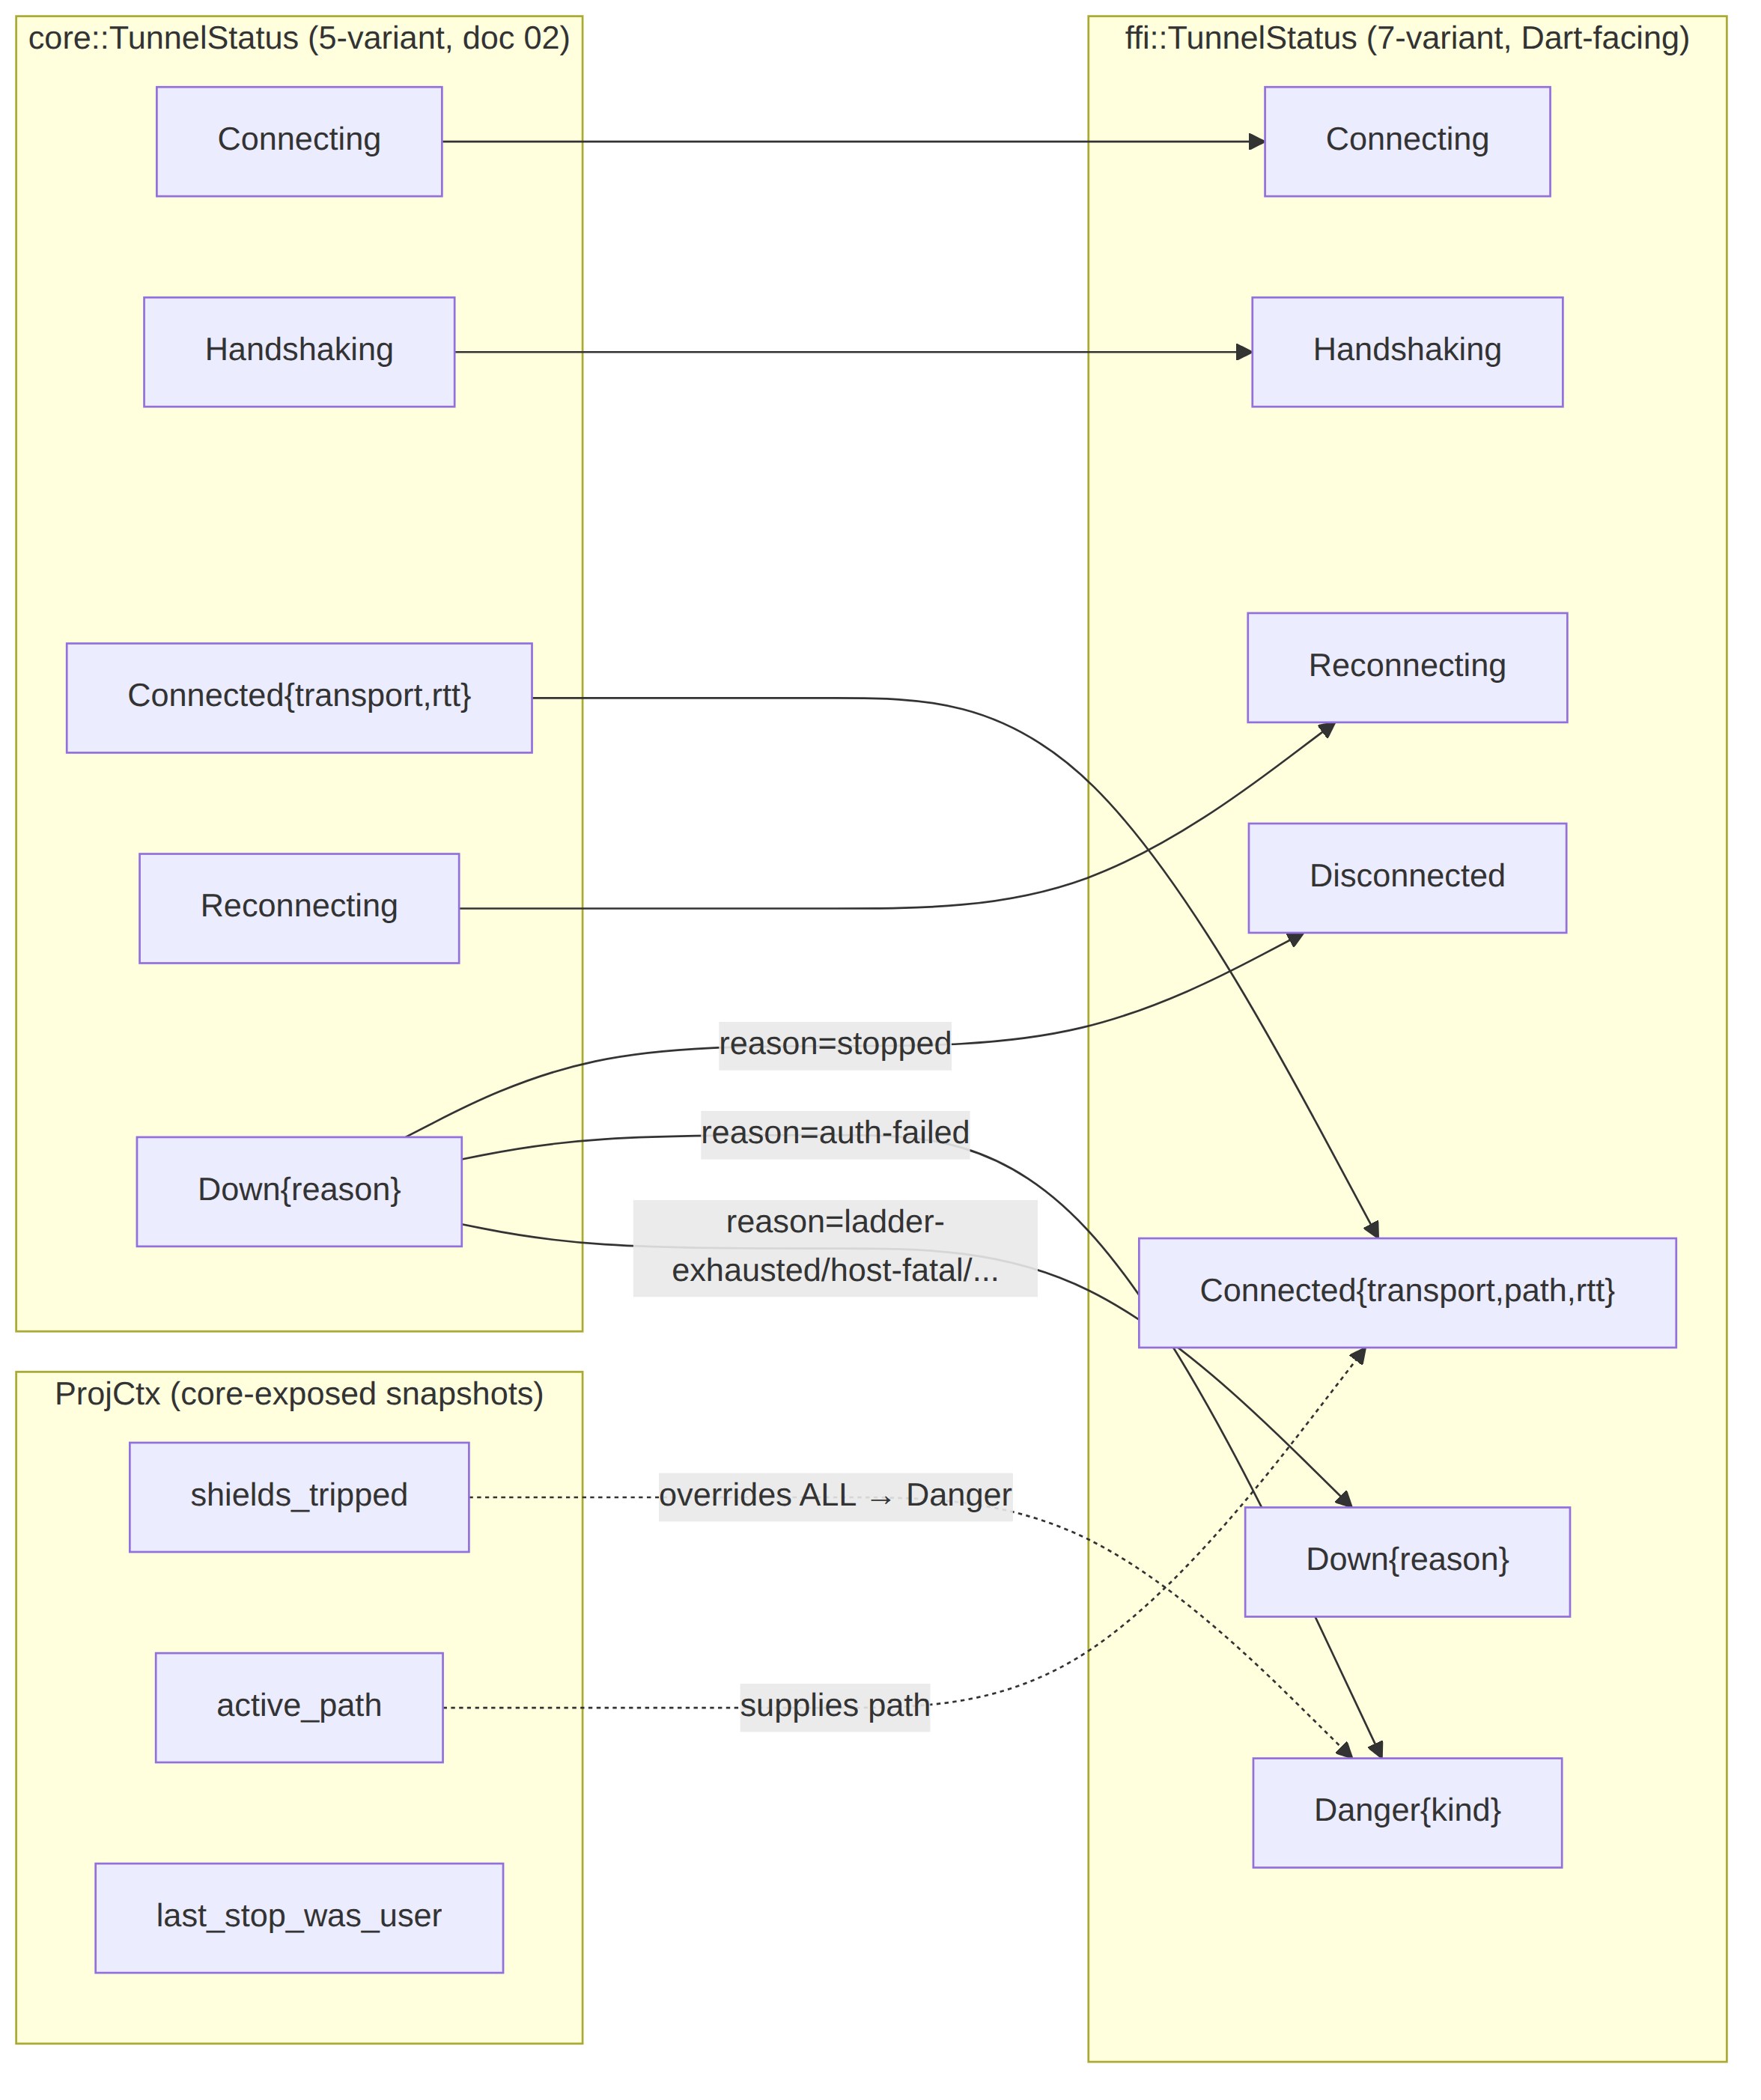

3.4 The Dart-facing state diagram (what the UI switches on)
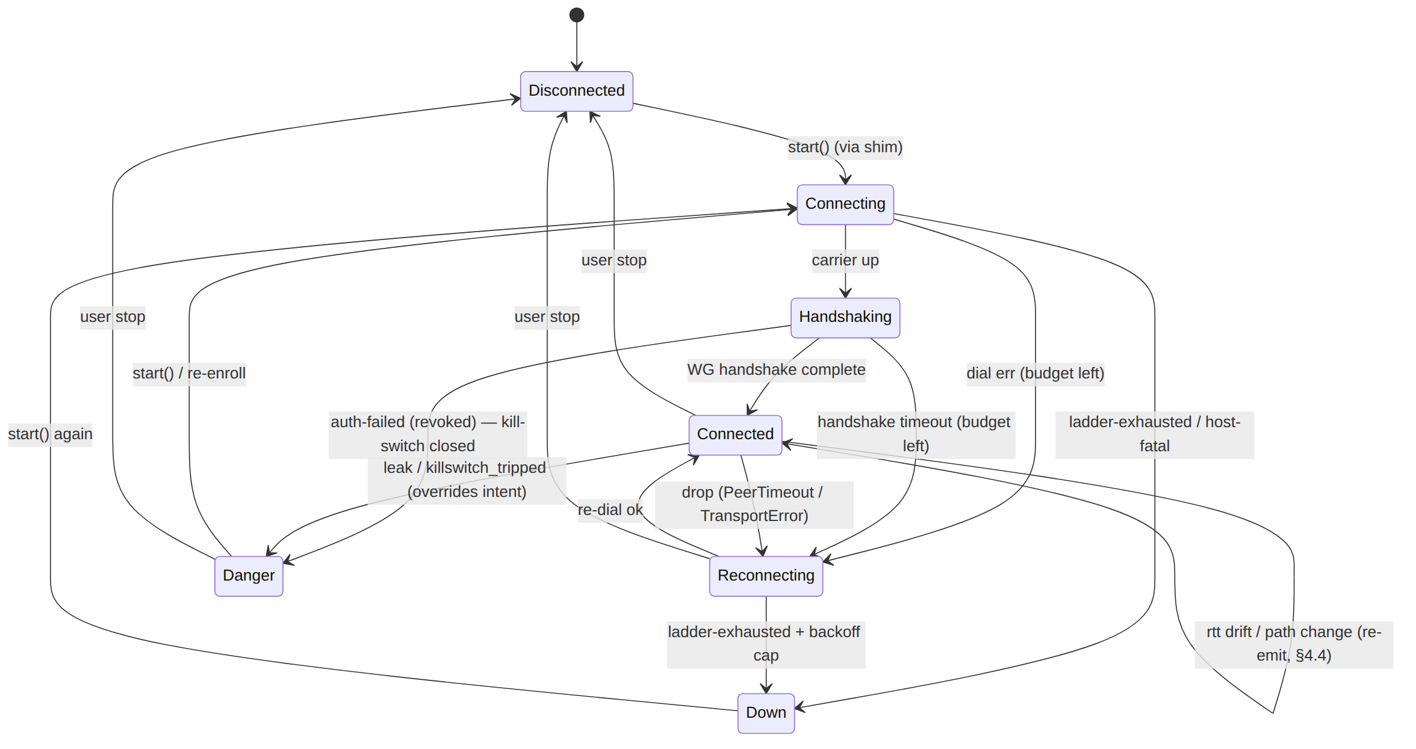

3.5 What the stream MUST NOT carry (I5 at the FFI layer)
The FFI re-emits exactly what the orchestrator broadcasts: ephemeral state, never durable per-connection records [02_ORCH §4.5]. Connected.transport is a kind label; path is "direct"|"relay"; rtt_ms is an aggregate EWMA. No SSID, no gateway IP, no per-packet data ever crosses the StreamSink (§11.4.10, [02_ORCH §4.5]). The projector is pure and holds no buffer beyond the single cached latest value (§4.5).

4. StreamSink event delivery & the threading model

4.1 Why StreamSink
frb v2 explicitly supports StreamSink: a Rust fn takes a StreamSink<T> argument and Dart receives a Stream<T> it can listen() — the canonical way to push continuous events from a long-lived Rust task to Dart (frb issue #347, solved by StreamSink) [research-flutter_ffi §1]. This Stream<TunnelStatus> is exactly what the Riverpod StreamProvider watches [04_CLIENT §8.2, research-flutter_ffi §6].

4.2 The tokio runtime (Mode A, in-process)
helix-ffi owns one tokio::runtime::Runtime, created lazily on the first start() and reused for the process lifetime (re-created only if fully torn down):
// helix-ffi/src/runtime.rs
static RT: OnceCell<tokio::runtime::Runtime> = OnceCell::new();
static ORCH: tokio::sync::Mutex<Option<helix_core::Orchestrator>> = /* ... */;
fn rt() -> &'static tokio::runtime::Runtime {
RT.get_or_init(|| tokio::runtime::Builder::new_multi_thread()
.worker_threads(2) // small: the orchestrator's loops are I/O-bound (§11)
.thread_name("helix-core")
.enable_all()
.build()
.expect("tokio runtime"))
}
- frb already drives Rust on its own worker thread(s) off the Dart isolate [research-flutter_ffi §1]; the FFI additionally owns a tokio runtime so the orchestrator's three async loops + reconciler + re-dial driver run on dedicated worker threads [02_ORCH §2.2]. async fn FFI calls (start/stop/exits/...) are rt().spawn-ed and their result awaited by frb, so the Dart await never blocks the UI isolate.
- Bridge-version pinning (mandatory). The flutter_rust_bridge crate version MUST equal the flutter_rust_bridge Dart-dep version, else the generated glue mismatches [research-flutter_ffi §1 caveat]. Enforced by the drift gate (§10).

4.3 The forwarding task
status_stream(sink) registers the sink with a long-lived forwarding task that drains the orchestrator broadcast receiver and pushes projected events:
pub fn status_stream(sink: StreamSink<TunnelStatus>) -> Result<(), CoreError> {
let orch = ORCH.blocking_lock();
let mut rx = orch.as_ref().ok_or(CoreError::NotStarted)?.subscribe(); // broadcast::Receiver
let projector_ctx = ctx_handle(); // shared ProjCtx (updated by the orchestrator)
sink.add(project(&last_status(), &projector_ctx.snapshot())).ok(); // §4.5 re-emit latest
rt().spawn(async move {
loop {
match rx.recv().await {
Ok(core_s) => { let _ = sink.add(project(&core_s, &projector_ctx.snapshot())); }
Err(broadcast::error::RecvError::Lagged(_)) => continue, // skip-to-latest (§4.6)
Err(broadcast::error::RecvError::Closed) => { sink.close_sink(); break; }
}
}
});
Ok(())
}
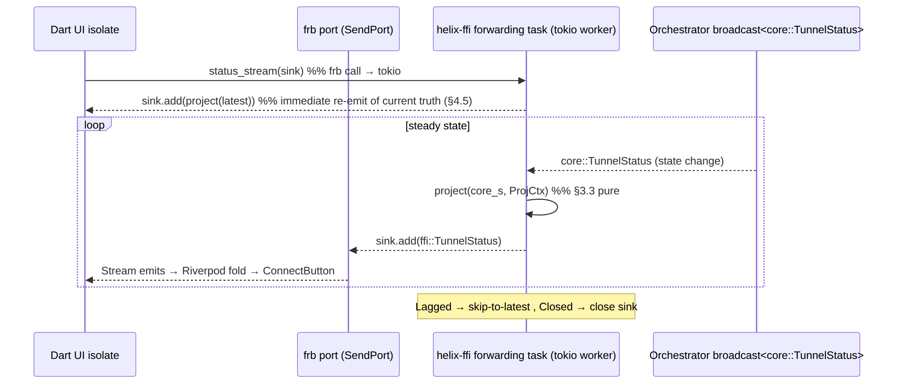

4.4 Emit discipline (coalesce, inherited from the orchestrator)
The orchestrator already coalesces: one emit per OrchState transition; Connected is re-emitted only when rtt_ms drifts > rtt_emit_delta_ms (default 5 ms) [02_ORCH §4.3]. The FFI projector adds one extra coalescing rule: if project() yields a value byte-identical to the last forwarded ffi::TunnelStatus, the forward is suppressed (so a core-side re-emit that does not change the projected value — e.g. an rtt drift below the UI's threshold — does not wake the UI). A path change does re-emit Connected (the StatusChip updates).

4.5 Pause / resume + the "current truth" guarantee
Riverpod 3.0 pauses a StreamProvider's subscription when no widget listens, and StreamProvider.autoDispose tears the underlying stream down when unwatched [research-flutter_ffi §6]. Two FFI obligations follow:
- The forwarding task NEVER stops on Dart pause. It holds the broadcast receiver independent of Dart listen-state, because the kill-switch / protection truth must not be lost while the UI is backgrounded. A paused Dart subscription only stops delivery to the isolate; the orchestrator keeps running (Mode A) or the extension keeps running (Mode B).
- On (re)subscribe, the FFI re-emits the cached latest status immediately (§4.3 first sink.add), so a resumed StreamProvider renders current truth, never a stale gap or an empty AsyncLoading that misrepresents protection state (§11.4.6, [04_CLIENT §8.4]). helix-ffi keeps exactly one cached ffi::TunnelStatus (the last forwarded value) — not a history (I5, §3.5).
Recommendation (D-FFI-1, §14). Use @riverpod / StreamProvider.autoDispose for the tunnel-status provider so a paused subscription is cheap, BUT rely on the §4.5(2) re-emit for correctness on resume — do NOT make the kill-switch UI depend on a non-autoDispose "always alive" provider, which "is almost never destroyed" [research-flutter_ffi §6].

4.6 Lagged is NOT an error
tokio::broadcast is a bounded ring (cap 64) [02_ORCH §4.2]: a slow receiver that falls behind gets RecvError::Lagged(n) and is fast-forwarded. For a status stream the receiver only ever needs the latest state, so the forwarding task treats Lagged as "continue → next recv() yields the newest" and never surfaces it to Dart as an error (§4.3). This mirrors the orchestrator's documented receiver contract [02_ORCH §4.6].

4.7 Named backpressure policy (what happens if the Dart consumer is slow)
The mechanism above (§4.2–§4.6) is the backpressure policy; this subsection names it explicitly so a slow-consumer question always has a one-line answer instead of requiring a re-derivation from the mechanics: bounded ring (cap 64) + drop-to-latest-on-lag, never block, never grow unbounded, never error the UI. Concretely: (1) the orchestrator's broadcast sender NEVER blocks on a slow receiver — a full ring silently overwrites the oldest unread entry (tokio::broadcast semantics); (2) the forwarding task NEVER buffers past the ring — on Lagged it drops straight to "read the newest" (§4.6), so memory is bounded regardless of how far behind Dart falls; (3) the UI therefore never sees a growing backlog and never sees an out-of-order replay — it sees the current truth, possibly having skipped some now-stale intermediate states, which is exactly correct for a status signal (the UI cares "what is true now", not "the full history of transitions"); (4) this is safe specifically because TunnelStatus is idempotent-to-replay state, not an event log — a backpressure design that dropped entries from an audit/event stream would be a §11.4.10/ §11.4.13 violation, but dropping a stale status value the moment a fresher one exists is not (§3.5 already forbids the stream from carrying per-packet/audit-grade data). A future FFI stream carrying non-idempotent events (none currently planned) would need a different, explicitly-designed backpressure policy — this one is scoped to status_stream only.

5. The Dart-facing surface (helix_core.dart)
frb mirrors every type, so the Dart TunnelStatus is the generated mirror of ffi::TunnelStatus (never a hand-written parallel). The thin wrapper adds ergonomics only [04_CLIENT §3.2]:
// helix_core_ffi/lib/helix_core.dart — idiomatic wrapper over frb_generated.dart
abstract class HelixCore {
Future<void> start({required String transport, String? mapPathOrSession,
CoreMode mode = CoreMode.client});
Future<void> stop();
/// frb StreamSink → Dart broadcast Stream. NO polling (CI2). The first event is the
/// current status (§4.5); subsequent events are coalesced state changes (§4.4).
Stream<TunnelStatus> statusStream();
Future<List<ExitOption>> exits();
Future<void> setExit(String id, {List<String>? multiHopChain});
Future<void> setShields(Shields s);
// connector mode:
Future<AdvertiseResult> advertise(List<String> cidrs);
// shim handoff (called by the platform shim, NOT the UI):
Future<void> attachTun(int fd);
Future<void> detachTun();
}
/// Console (no Capability.tunnel) gets this null impl — never links the Rust staticlib (CI3).
class NoCore implements HelixCore {
@override Stream<TunnelStatus> statusStream() => const Stream.empty();
// every method throws StateError('Console has no tunnel core') — compile-gated out anyway.
// ...
}
// the entire happy path a client app drives (the Phase-0 G5 demo, [04_CLIENT §13 T0.1]):
await core.start(transport: 'auto', mapPathOrSession: session.token);
core.statusStream().listen((s) => /* Riverpod fold → ConnectButton, [04_CLIENT §8] */);
// ...later:
await core.stop();

5.1 Dart-side error surface
Every Future-returning method may throw a CoreException (the Dart mirror of CoreError, §8). The wrapper does NOT swallow it — the controller surfaces it as an honest UI message (§8.3). statusStream() never throws on Lagged (§4.6); it closes only when the core is torn down (RecvError::Closed).

6. UniFFI native-shim surface (Swift / Kotlin / C)
In Mode B the core runs inside the OS tunnel extension; UniFFI generates the typed binding the extension calls. The same api.rs produces it; the surface is the same verbs, named in each language's idiom. The status flows out via the platform EventChannel (§7), not via frb.

6.1 Swift (iOS / macOS NEPacketTunnelProvider)
// generated by UniFFI from helix-ffi (HelixCore.swift) — used inside the NE extension
import HelixCore
final class PacketTunnelProvider: NEPacketTunnelProvider {
override func startTunnel(options: [String:NSObject]?,
completionHandler: @escaping (Error?) -> Void) {
let cfg = decodeTunnelConfig(options) // overlay IP, routes, DNS, session
let settings = makeNetworkSettings(cfg) // NEPacketTunnelNetworkSettings
setTunnelNetworkSettings(settings) { [weak self] err in
guard err == nil, let self else { return completionHandler(err) }
do {
try helixCoreStart(cfg: ClientConfig(mapPathOrSession: cfg.sessionToken,
transport: "auto", mode: .client)) // typed throw
let fd = self.packetFlowFd() // the NE packet fd (Mode B handoff)
try helixAttachTun(fd: fd) // §9.3 ownership transfer
self.relayStatus() // subscribe → EventChannel (§7)
completionHandler(nil)
} catch let e as CoreError { completionHandler(coreErrorToNSError(e)) } // §8.2
catch { completionHandler(error) }
}
}
override func stopTunnel(with r: NEProviderStopReason, completionHandler: @escaping () -> Void) {
try? helixDetachTun(); try? helixCoreStop(); completionHandler() // O4 quiescent
}
}
helixCoreStart/helixAttachTun/helixCoreStop are UniFFI-generated Swift throwing functions; CoreError is a UniFFI error enum (§8.2). The Swift side reads/writes the packet fd handed to the core (Layer-3 IP packets) [research-ios_android §1, §3].

6.2 Kotlin (Android VpnService + JNI)
// generated by UniFFI from helix-ffi (HelixCore.kt) — used inside the foreground VpnService
class HelixVpnService : VpnService() {
override fun onStartCommand(intent: Intent?, flags: Int, startId: Int): Int {
val cfg = TunnelConfig.from(intent)
val builder = Builder().addAddress(cfg.overlayIp, 32).setMtu(cfg.mtu)
cfg.routes.forEach { builder.addRoute(it.addr, it.prefix) } // AllowedIPs
cfg.dnsServers.forEach { builder.addDnsServer(it) } // tunnel DNS
cfg.splitExcludeApps.forEach { builder.addDisallowedApplication(it) }
val pfd: ParcelFileDescriptor = builder.establish()!! // OS creates TUN
startForeground(NOTIF_ID, persistentNotification()) // required for bg tunnel
HelixCore.start(ClientConfig(cfg.sessionToken, "auto", CoreMode.CLIENT))
HelixCore.attachTun(pfd.detachFd()) // detachFd transfers ownership → core close()s (§9.3)
relayStatus() // subscribe → EventChannel (§7)
return START_STICKY
}
override fun onRevoke() { HelixCore.detachTun(); HelixCore.stop(); emitEvent(REVOKED) } // O3
override fun onDestroy() { HelixCore.detachTun(); HelixCore.stop(); stopForeground(true) } // O4
}
detachFd() transfers fd ownership to native (the core now owns close(2)); getFd() would keep ownership in Java [research-ios_android §3]. The choice is load-bearing for §9.3 (double-close avoidance). HarmonyOS/Aurora use the cbindgen C ABI (§6.3) instead of UniFFI Kotlin/Swift.

6.3 C ABI (HarmonyOS NAPI / Aurora Qt) — cbindgen fallback
// helix_core.h — generated by cbindgen (the raw-C fallback, D-CLIENT-3)
typedef enum HxCoreErr {
HX_OK = 0, HX_ERR_NOT_STARTED = 1, HX_ERR_ALREADY_STARTED = 2,
HX_ERR_AUTH = 3, HX_ERR_CONFIG = 4, HX_ERR_HOST_FATAL = 5, HX_ERR_INTERNAL = 6
} HxCoreErr;
HxCoreErr hx_core_start(const char* session, const char* transport, int mode);
HxCoreErr hx_core_stop(void);
HxCoreErr hx_attach_tun(int fd);
HxCoreErr hx_detach_tun(void);
/// Status callback: the C consumer registers a fn-ptr; the core invokes it on each
/// projected status. `json` is a UTF-8 ffi::TunnelStatus JSON (the C ABI has no enum-payload
/// type), freed by the core after the call returns. (UNVERIFIED: exact JSON schema fixed in
/// the cbindgen contract test, §13 UNIT.)
typedef void (*hx_status_cb)(const char* json, void* user);
HxCoreErr hx_status_subscribe(hx_status_cb cb, void* user);
The C surface carries TunnelStatus as JSON because the C ABI cannot express a tagged-union-with-payload; the Swift/Kotlin UniFFI paths carry the real enum. The JSON schema is frozen by the cbindgen contract test (§13) and is the same projected ffi::TunnelStatus (§3.2).

7. The TunnelPlatform ⇄ FFI division of labor
The seam that prevents the classic bug [04_CLIENT §3.3, §4]. Lifecycle commands flow UI → shim → core; status flows core → FFI → UI. In Mode B the status takes the EventChannel (the TunnelPlatform.events() stream) because the core is in the extension process, not the Dart isolate.
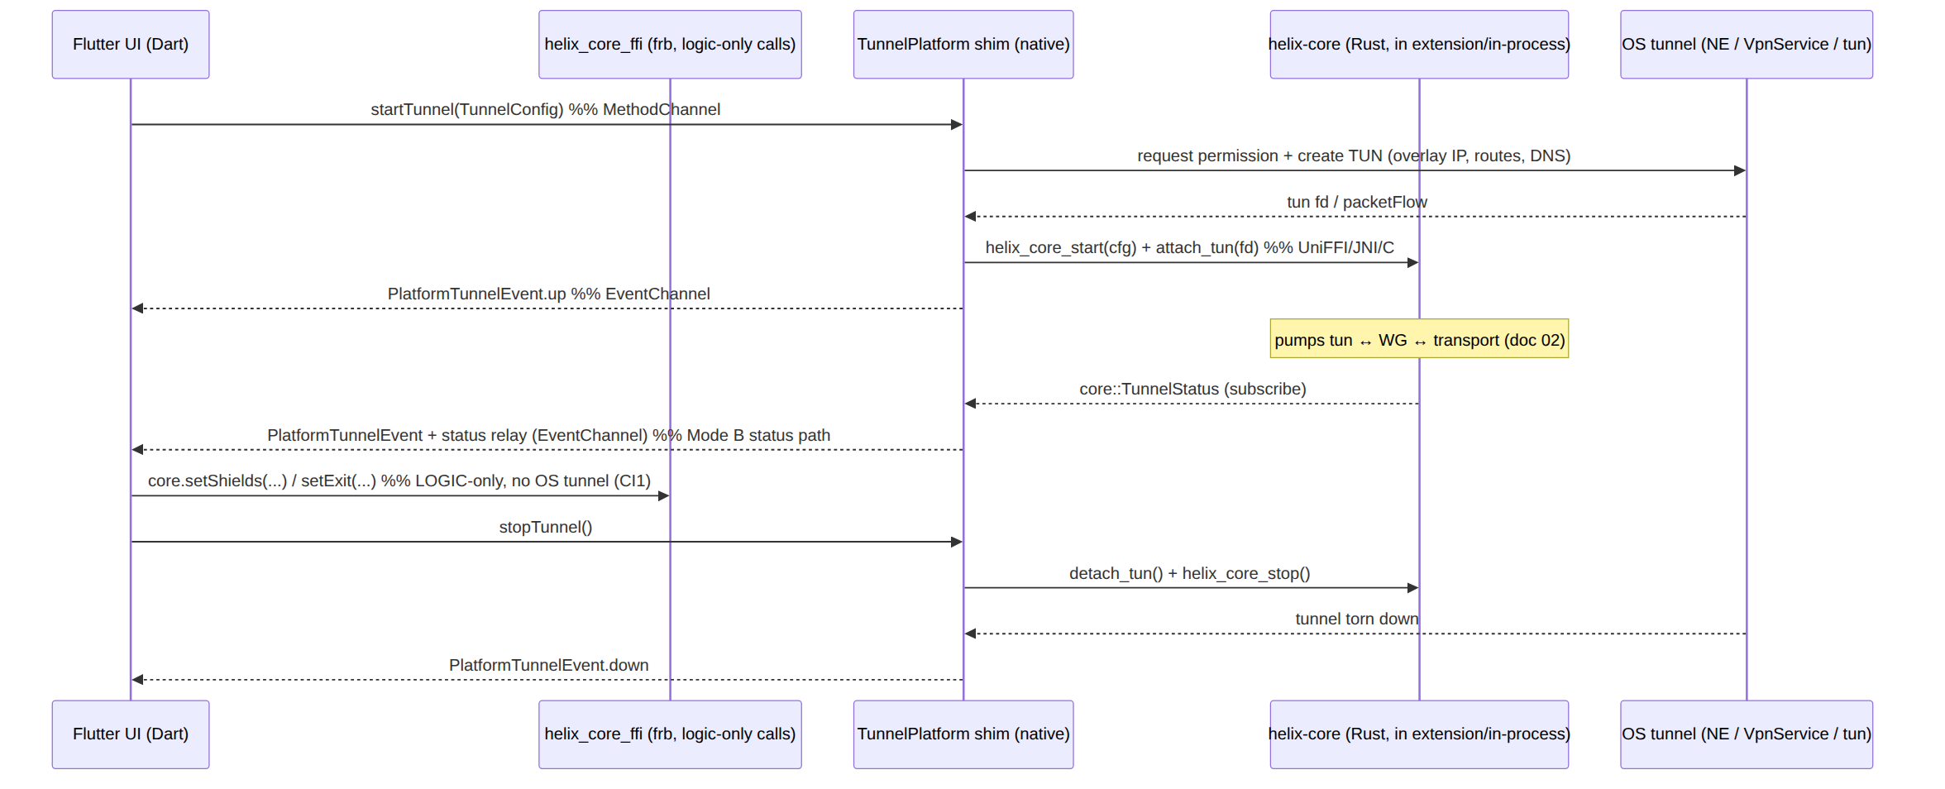

7.1 Where each TunnelStatus originates (the mode split)
Call | Mode A (in-process frb) | Mode B (native shim)
start/stop | the shim calls the FFI start/stop (Linux: core in-process) | the shim calls the UniFFI/C helix_core_start/stop inside the extension
attach_tun(fd) | Linux tun fd → FFI attach_tun | NE packetFlow fd / pfd.detachFd() → UniFFI/JNI attach_tun
status_stream | frb StreamSink → Dart isolate directly | core subscribe → shim → EventChannel → Dart
set_shields/set_exit/exits | frb call, in-process | frb call to the UI-process FFI if a logic-only core handle exists there, else marshalled to the extension over the platform channel (D-FFI-2, §14)
Honest boundary (§11.4.6 / §14 C2). In Mode B the logic-only verbs (set_shields/set_exit/exits) target the core in the extension, while the UI runs in the app process. The pass-1 sketch [04_CLIENT §3.3] drew these as "straight UI → FFI"; on iOS/Android that requires either (a) a second in-app-process core handle for pure-logic queries, or (b) marshalling the verb over the TunnelPlatform MethodChannel to the extension. This is surfaced as D-FFI-2 — not silently assumed.

8. Error propagation across the boundary

8.1 The typed CoreError enum
// helix-ffi/src/error.rs
#[derive(thiserror::Error, Debug)]
pub enum CoreError {
#[error("core not started")] NotStarted, // status_stream/stop before start
#[error("core already started")] AlreadyStarted, // double start (§9.2)
#[error("invalid config: {0}")] Config(String), // bad transport string / map path
#[error("auth failed (revoked)")] Auth, // maps from Down{auth-failed}
#[error("host fatal: {0}")] HostFatal(String), // TUN open / firewall-apply failed
#[error("tun fd invalid")] BadFd, // attach_tun(fd) not a usable fd
#[error("internal: {0}")] Internal(String), // last resort; never a secret (§11.4.10)
}
CoreError is the only error type the FFI surface returns; the orchestrator's internal anyhow/OrchestratorError/TransportError are converted at the boundary (From impls). Reasons are classified on the orchestrator's stable prefixes [02_ORCH §4.4], never parsed from prose (§11.4.6). No variant ever carries a SecretBytes value (§11.4.10, [02_TRANS §3.2]).

8.2 Per-generator mapping
Generator | Err(CoreError) becomes | UI sees
frb (Dart) | a thrown CoreException (frb maps Result::Err of a custom error enum to a Dart exception of the mirrored type) | try { await core.start() } on CoreException catch (e) { … }
UniFFI (Swift) | a Swift throws of the CoreError error enum | do { try helixCoreStart() } catch let e as CoreError { … }
UniFFI (Kotlin) | a Kotlin CoreException subclass per variant | try { HelixCore.start() } catch (e: CoreException.Auth) { … }
cbindgen (C) | an HxCoreErr integer code (§6.3) | if (hx_core_start(...) != HX_OK) …
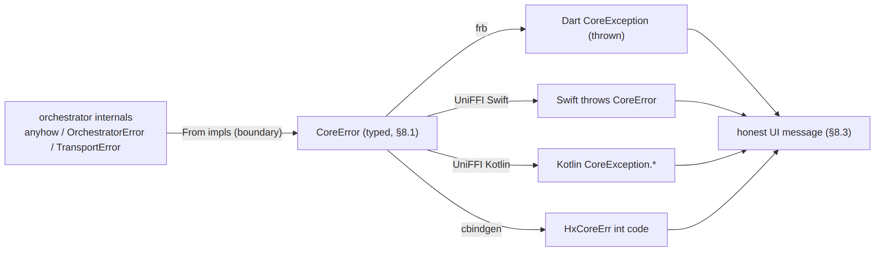

8.3 Errors vs status (two distinct channels)
A synchronous failure of a verb (start could not open the TUN) is a thrown CoreError; a runtime transition (the tunnel later drops) is a TunnelStatus event. The UI must handle both: an await core.start() that throws HostFatal shows a start-failure message; a later Down/Danger event on the stream repaints the ConnectButton. A verb MUST NOT silently swallow an error and rely on the status stream to reflect it (that would be a §11.4.1 FAIL-bluff at the boundary) — the throw and the event are complementary, not redundant.

9. Lifecycle, idempotence, and attach_tun fd ownership

9.1 Verb lifecycle contract
Verb | Pre-state | Post-state | Idempotence
start | core stopped | orchestrator running, emits Connecting | double start → Err(AlreadyStarted) (§9.2)
stop | running | torn down, emits Disconnected (Down{stopped} → projected) | stop when stopped → Ok(()) (no-op)
status_stream | any | sink registered; immediate latest re-emit (§4.5) | many concurrent sinks allowed (broadcast fan-out)
attach_tun(fd) | started, no fd | core pumps fd | second attach_tun without detach → Err(BadFd)-class guard (§9.3)
detach_tun | fd attached | fd closed, pump idle | detach when none attached → Ok(())
set_shields/set_exit/exits/advertise | started | applied | naturally idempotent (declarative)

9.2 Double-start / start-while-connected guard
start acquires the ORCH mutex and refuses if Some(_) is already present (Err(AlreadyStarted)) — the UI's ConnectController must not call start while a tunnel exists (it calls toggle, [04_CLIENT §8.2]). This guards the §11.4.84-class hazard of two orchestrators racing one TUN fd.

9.3 attach_tun fd ownership (the double-close hazard)
attach_tun(fd) takes ownership of the fd on Ok: the core close(2)s it on detach_tun/stop. The shim MUST therefore hand a fd it has relinquished:
- Android: use ParcelFileDescriptor.detachFd() (transfers ownership) — NOT getFd() (keeps ownership; the core close()ing it then double-closes when the PFD is GC'd) [research-ios_android §3]. The Kotlin shim (§6.2) uses detachFd().
- iOS NE: the NE owns packetFlow; the core does not close it — instead the iOS path uses the read/write-callback pump (helix_core_set_tun_writer + packetFlow.readPackets) rather than a raw fd, so attach_tun on iOS registers the callback pair, not an owned fd [04_CLIENT §5.1]. (UNVERIFIED whether a raw fd is even exposed by NEPacketTunnelFlow; the callback-pump form is the documented path — §13 records this as the iOS handoff.)
- Linux: the in-process core owns the tun fd directly (no cross-process transfer).
A failed attach_tun MUST leave no half-open TUN (§11.4.14 cleanup): on Err, the shim closes the fd it created and emits PlatformTunnelEvent.error with an honest reason [04_CLIENT §4.1 O1].

9.4 Out-of-band revoke / OS kill
When the OS or admin kills the tunnel out-of-band (onRevoke, device.revoked from the control plane), the shim calls detach_tun + stop and emits revoked; the FFI projects the resulting Down/auth-failed to Danger{killswitch_tripped} (§3.3) so the UI repaints red — never "still connected" [04_CLIENT §4.1 O3, CI2].

10. Codegen + drift-gate pipeline
The no-drift guarantee [04_CLIENT §11, 04_ARCH §4.2]: the generated Dart/Swift/Kotlin can never silently diverge from the Rust surface. A drift is a build-blocking finding.
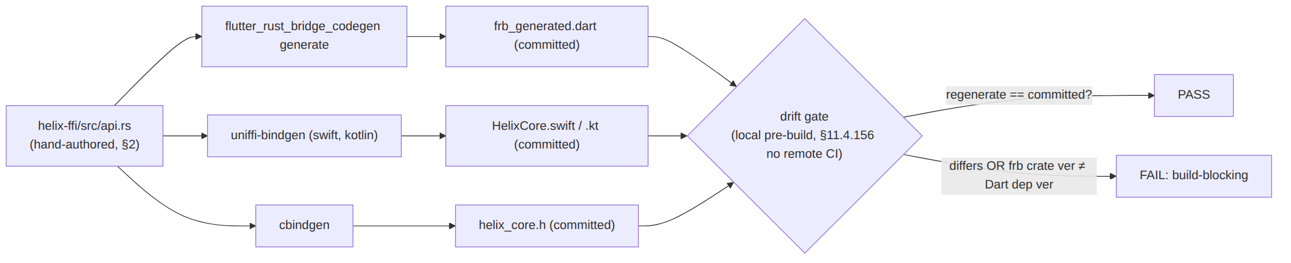
- Trigger: any edit to api.rs (or a mirrored core type) re-runs all three generators; the regenerated output MUST byte-match the committed artifacts (git diff --exit-code).
- Version pin check: the gate asserts the flutter_rust_bridge crate version equals the flutter_rust_bridge Dart-dep version [research-flutter_ffi §1 caveat].
- Enum-parity check: the §13 UNIT FFI-contract test asserts the Dart/Swift/Kotlin TunnelStatus/Shields/ExitOption mirrors match the Rust types byte-for-byte (the projected 7-variant surface) [04_CLIENT §12 FFI-contract row].
- Run locally (melos run drift-check) — there is no active server-side CI (§11.4.156).

11. Memory & performance budgets
Budget | Target | Basis / source
iOS NE process RSS (Mode B) | steady-state well under the device ceiling — design to ~12–15 MB working set, NOT to the 50 MiB figure | iOS NE limit is 50 MiB on iOS 15–18 (was 15 MiB on iOS 11–14), undocumented, MUST NOT be hardcoded, and observed 15 MB jetsam kills on some iOS 17 devices (PENDING_FORENSICS) [research-ios_android §1]
iOS NE spike control | bound packet-buffer pools; single fixed-size receive buffer to MTU+headroom; no per-flow state growth | spikes (upload-heavy bursts), not steady state, are the jetsam killer [research-ios_android §1]
frb runtime cost (Mode A) | tokio runtime = 2 worker threads; broadcast cap 64; one cached latest status | the loops are I/O-bound [02_ORCH §13]; the runtime does not run in the iOS NE (§1)
FFI projection cost | project() is pure, allocation-light (clones small strings); callable at status-change frequency (rare) | §3.3
status_stream fan-out | many sinks via broadcast; lagged receiver fast-forwards, never blocks the core | §4.6, [02_ORCH §4.2]
attach_tun latency | synchronous, sub-ms (stores fd + wakes loops; no await) | §2, §9.3
Mobile install size contribution | lean Rust staticlib: opt-level=z/s + fat LTO + codegen-units=1 + panic=abort + strip; optional build-std + panic_immediate_abort + optimize_for_size | [research-ios_android §2], [04_CLIENT §10]
The iOS NE ceiling is the architecture (CI4). It is the single strongest reason the core is Rust not Go — a GC runtime risks the working set [04_CLIENT §0.1 CI4, §10, 04_ARCH §5.6]. Because Mode B links only the UniFFI/cbindgen staticlib (not frb + tokio + Dart), the FFI generator choice does not inflate the NE footprint; the MEM test (§13) measures the extension process, plain-UDP and MASQUE separately (G3) [research-ios_android §1, 04_CLIENT §5.1].

12. Edge cases & failure modes
# | Edge case | Required behaviour
E1 | status_stream called before start | Err(NotStarted) — never a silent empty stream that the UI reads as "Disconnected-but-fine" (§8.3)
E2 | Broadcast Lagged under a wedged UI | forwarding task skips to latest; never surfaced to Dart as an error (§4.6)
E3 | Dart StreamProvider paused (backgrounded), then resumed | forwarding task keeps running; on resume the cached latest status is re-emitted (§4.5) — no stale gap
E4 | Dart isolate hot-restart (dev) / app process restart | frb port invalidated; sink.add errors → forwarding task drops that sink; a fresh status_stream re-registers + re-emits latest
E5 | Native extension crash (Mode B) | shim emits error/down on the EventChannel; FFI/UI shows Down (not "connected"); the OS may restart the extension (START_STICKY Android) → fresh start
E6 | Double start | Err(AlreadyStarted) (§9.2)
E7 | attach_tun with an invalid/closed fd | Err(BadFd); shim closes its TUN, emits error (no half-open TUN, §11.4.14)
E8 | detach_tun then core keeps a stale fd | forbidden — detach_tun close(2)s and clears the fd; loops idle until a fresh attach_tun (§9.3)
E9 | fd double-close (shim getFd + core close) | prevented by mandating detachFd() ownership transfer (§9.3) [research-ios_android §3]
E10 | Connected.path unknown at emit time | projector defaults path = "direct" and re-emits Connected when the real path resolves (§3.3, §14 C3)
E11 | Danger (leak) while user intent = connected | Danger overrides intent; UI paints red immediately (§3.3, [04_CLIENT §8.4]) — never green-on-intent
E12 | CoreError::Internal carries a secret | forbidden (§11.4.10): the boundary From impls scrub; the SEC test plants a secret and greps logs/messages empty (§13)
E13 | Console flavor (no Capability.tunnel) calls a tunnel verb | compile-gated out; runtime fallback is NoCore throwing StateError (§5, CI3) — never links the staticlib
E14 | frb crate ver ≠ Dart dep ver | drift gate FAILs the build (§10) [research-flutter_ffi §1]

13. Test points — §11.4.169 closed vocabulary
Every FFI workable item declares its required test types from the §11.4.169 closed set [10_QA §2]; the ONLY permitted absence of a warranted type is an honest §11.4.3 SKIP-with-reason. Four-layer enforcement per §11.4.4(b). Every PASS ships captured evidence per §11.4.5/.69/.107 — never a config-only or grep-only PASS.
Code | Type | Concrete FFI test point | Evidence
UNIT | unit | project() truth table for all 7×(5+ctx) input combos; classify() on every stable Down.reason prefix; CoreError From mappings; FFI-contract: regenerated Dart/Swift/Kotlin TunnelStatus/Shields/ExitOption mirrors match Rust byte-for-byte; cbindgen JSON schema frozen. Mocks allowed only here (§11.4.27). | cargo test + dart test output; generated-mirror diff
INT | integration (real System, no mocks) | start→status_stream against a real orchestrator (in-process Mode A) yields the ordered Connecting→Handshaking→Connected trace; attach_tun(fd) with a real netns tun fd pumps packets | netns capture; ordered status-trace log
E2E | end-to-end | the Phase-0 G5 demo: Flutter-Linux window, one connect/disconnect toggle, StatusChip driven only by the Rust stream [04_CLIENT §13 T0.1] | window-scoped MP4 (§11.4.159) of the connect journey
FA | full-automation | make qa drives start→status→stop N=3 identical runs producing the same ordered status trace (deterministic §11.4.50/.98) | 3× identical status-trace artifacts
SEC | security | (a) plant a session token / secret in ClientConfig, prove it appears in no log/CoreError/stream (§11.4.10); (b) the stream carries no SSID/gateway-IP/per-packet data (I5, §3.5) | grep-empty proof; stream-content audit
STRESS | stress | ≥100 rapid set_shields/set_exit calls + ≥10 concurrent status_stream sinks; no leak, bounded broadcast | call-throughput CSV
CHAOS | chaos | mid-start SIGKILL of the extension (Mode B) → shim emits down → fresh start recovers; isolate hot-restart (E4) → re-subscribe re-emits latest | recovery trace
CONC | concurrency / atomicity | concurrent status_stream (many sinks) + set_shields while a re-dial swaps active_tx [02_ORCH §7.3]; zero dropped/duplicated terminal status | concurrency harness log
RACE | race / deadlock | cargo test --features loom on the ORCH mutex + ProjCtx snapshot + forwarding-task shutdown; no deadlock between stop and an in-flight recv | loom report
MEM | memory | iOS NE extension RSS for plain-UDP and MASQUE separately, ≥30% headroom under the device ceiling, 30-min soak (G3 make-or-break); no per-event heap growth in the forwarding task | Instruments / /proc RSS sample [research-ios_android §1]
BENCH/PERF | benchmarking / performance | project() cost; status_stream end-to-end latency (core emit → Dart receive); attach_tun latency | latency histogram CSV
UI/UX | UI / UX | ConnectButton renders correctly across every ffi::TunnelStatus (incl. Danger); golden frames light+dark | golden PNGs [04_CLIENT §12]
REC | recorded-evidence | window-scoped MP4 (§11.4.154/.155) of the G5 connect journey, vision-validated StatusChip reads masque-h3 · direct · 23ms (OCR) (§11.4.163) | panoptic→vision_engine verdict
CHAL/HQA | Challenge / HelixQA | a bank entry scores PASS only on the captured G5 status-trace + device recording, never config | Challenge / HelixQA result.json
Anti-bluff rule (§11.4.5/.69/.107). A green project() unit test is not proof the user is protected. The authoritative evidence is the E2E/REC G5 device recording: the StatusChip reading the live transport·path·rtt confirmed by OCR/vision, plus the iOS NE MEM Instruments RSS report. Fake the orchestrator with the same generated model types so unit tests exercise real contracts, but the user-visible claim is earned only by the device recording [04_CLIENT §12].

14. Surfaced decisions & cross-doc contracts
Per §11.4.6/§11.4.66 — options + recommendation, never silently resolved.
# | Decision / contract | Options | Recommendation
D-FFI-1 | Riverpod provider disposal for the status stream | @riverpod/autoDispose (paused when unwatched) vs always-alive StreamProvider | autoDispose — cheap when backgrounded; correctness on resume comes from the §4.5(2) cached-latest re-emit, not from keeping the provider alive [research-flutter_ffi §6]
D-FFI-2 | Mode-B logic-only verbs (set_shields/set_exit/exits) target the in-extension core | (a) second in-app-process core handle for pure-logic queries vs (b) marshal over the TunnelPlatform MethodChannel to the extension | Gate on the platform: (b) for iOS/Android (single source of truth = the extension's core); (a) only if a pure read needs sub-ms latency. Surfaced, not assumed (§7.1)
D-FFI-3 | Native-shim error type | UniFFI typed CoreError enum vs flat string error | typed CoreError (§8.1) — drives honest, specific UI messages; cbindgen falls back to HxCoreErr int codes (§6.3)
Cross-document contracts this document fixes (consumed by the named docs):
# | Contract | Fixed value | Consumed by
C1 | The Dart-facing ffi::TunnelStatus (7-variant) + the project() mapping from core::TunnelStatus | §3.2, §3.3 | doc 02 (must emit the 5-variant on its stable prefixes); all apps
C2 | The two consumption modes (in-process frb vs native-shim UniFFI/C) and where each status originates | §1, §7.1 | every per-platform shim [04_CLIENT §5]
C3 | Connected.path requirement — the core MUST surface "direct"|"relay" (added to core::TunnelStatus.Connected or queryable via the active route), else the projector defaults "direct" and re-emits (§3.3, E10). UNVERIFIED in the current orchestrator enum [02_ORCH §4.1] (which carries only transport+rtt_ms) — recorded as a follow-up cross-doc item per §11.4.6 | §3.3 | doc 02 (orchestrator enum), doc 02 multihop/relay
C4 | The typed CoreError boundary enum (frb exception ⇄ UniFFI error ⇄ HxCoreErr) | §8 | all apps, all shims
C5 | attach_tun fd ownership transfer (core close()s on detach/stop; shim hands a relinquished fd: Android detachFd, iOS callback-pump, Linux in-process) | §9.3 | every per-platform shim [04_CLIENT §5], doc 02 (helix-tun)

Sources verified
- final/03-client-core-and-ui.md [04_CLIENT] — §0.1 (CI1–CI6 invariants), §3 (FFI surface, the api.rs sketch, the Dart wrapper, the FFI⇄shim seam), §4 (TunnelPlatform contract), §5 (per-platform shims, iOS NE, Android VpnService), §7 (tokens / TunnelStatus→palette), §8 (Riverpod, offline/intent honesty), §10–§12 (budgets, build/codegen, testing). Accessed 2026-06-25.
- 04_VPN_CLD/HelixVPN-Architecture-Refined.md [04_ARCH §5] — §5.1 (two binding generators, Rust core + Flutter UI), §5.6 (iOS NE memory = Rust-not-Go), §5.7 (Web has no shim). Accessed 2026-06-25.
- 04_VPN_CLD/HelixVPN-helix-ui-Flutter.md [04_UI] — §4 (Riverpod stream model), §5 (FFI surface), §6 (shim matrix). Accessed 2026-06-25.
- final/v02-data-plane/orchestrator-and-state.md [02_ORCH] — §2.1 (Orchestrator API + subscribe), §4.1 (canonical 5-variant TunnelStatus), §4.2 (broadcast cap/Lagged), §4.3 (emit coalescing), §4.4 (stable Down.reason prefixes), §4.5 (no-durable-record), §4.6 (receiver contract), §5.1 (OrchState), §7.3 (atomic transport swap). Accessed 2026-06-25.
- final/v02-data-plane/transport-trait.md [02_TRANS] — §2 (Transport trait), §3.2 (SecretBytes redaction/zeroize), §3.3 (TransportKind labels = Connected.transport), §5.2 (carrier↔WG↔status projection). Accessed 2026-06-25.
- v09-research/research-flutter_ffi.md [research-flutter_ffi] — §1 (frb 2.12.0, StreamSink, async fn, mirror, version-pin caveat), §2 (UniFFI first-party Kotlin/Swift; uniffi-dart not production-ready), §3 (per-platform staticlib/cdylib packaging), §6 (Riverpod 3.0 StreamProvider pause-when-unlistened, autoDispose, overrideWithValue), §7 (synthesis recommendations). Accessed 2026-06-25.
- v09-research/research-ios_android.md [research-ios_android] — §1 (iOS NE memory limit 50 MiB iOS 15–18 / 15 MiB iOS 11–14, undocumented, MUST-NOT-hardcode, observed 15 MB iOS 17 kills, whole-process scope, spike-driven jetsam, ~12–15 MB design budget), §2 (Rust staticlib size-opt flags), §3 (Android VpnService.Builder→establish()→ParcelFileDescriptor, detachFd() ownership transfer to JNI, protect()). Accessed 2026-06-25.
- final/10-testing-acceptance-and-qa.md [10_QA] — §2 (the canonical §11.4.169 closed test-type taxonomy + abbreviations). Accessed 2026-06-25.
Constitution: §11.4.44 (revision header), §11.4.6/§11.4.66 (decisions = options + recommendation; UNVERIFIED never fabricated), §11.4.5/§11.4.69/§11.4.107/§11.4.159 (captured/window-scoped evidence), §11.4.10 (secrets never cross the boundary), §11.4.14 (no half-open TUN on attach failure), §11.4.28/§11.4.74 (decoupled reusable helix-ffi), §11.4.156 (no active CI — local drift gate), §11.4.169 (per-item test-type coverage).
End of nano-detail specification — FFI surface (Dart ⇄ Rust), Volume 4 (Clients). Deepens [04_CLIENT §3]; consumes the orchestrator status contract [02_ORCH §4] and the TunnelPlatform shim contract [04_CLIENT §4]. Surfaced decisions: D-FFI-1 (provider disposal), D-FFI-2 (Mode-B logic-verb routing), D-FFI-3 (native error type); cross-doc contract C3 (Connected.path) flagged UNVERIFIED against the current orchestrator enum — all presented, none silently resolved (§11.4.66).

