helix-core (Rust client/connector core)

helix-core (Rust client/connector core)
Revision: 2 Last modified: 2026-07-04T12:00:00Z
Master technical specification — Volume 4 (Clients), nano-detail deep-dive. This document deepens the helix-core (Rust client/connector core) part of the pass-1 client overview [04_UI §0/§1/§5, 04_ARCH §5.1] into an implementation-ready specification of the Rust workspace that the FFI consumes: the cargo crate layout (helix-transport, helix-wg, helix-ffi, the orchestrator+reconciler in helix-core), the size/memory build strategy (opt-level=z · LTO · panic=abort · strip), the network-map reconciler (consume RouteMap/MapDelta → bring WG peers up/down, update AllowedIPs), the kill-switch + DNS state machine, the --mode=connector posture sharing the same core, and how the core sits beneath the FFI.
Boundary with sibling docs. This document is the client-core counterpart of the data-plane internals owned by Volume 2: the orchestrator three-loop, the TunnelStatus broadcast, the reconciler diff/apply, the backoff machine, and the kill-switch/DNS coupling are specified in depth by v02-data-plane/orchestrator-and-state.md (cited [v02-orch §N]) and the carrier seam by v02-data-plane/transport-trait.md (cited [v02-tx §N]). This document owns the packaging + FFI seam of that core: the cargo workspace, the per-platform library artifacts, the build/memory profile, the helix-ffi crate surface, and the FFI-driven entry points into the orchestrator/reconciler/kill-switch (it drives them; v02 defines their bodies). It does not re-specify the three loops, the Tunn crypto, the ladder algorithm, or the per-carrier wire formats. The FFI surface and the TunnelStatus enum here are kept byte-consistent with [v02-orch §4.1, §5] and the FFI sketch in [04_UI §5 / doc 03 §3].
Evidence base. Citations inline by id: [04_UI] = 04_VPN_CLD/HelixVPN-helix-ui-Flutter.md; [04_ARCH §N] = 04_VPN_CLD/HelixVPN-Architecture-Refined.md; [04_P0 §N] = …Phase0-Spike.md; [research-flutter_ffi] / [research-ios_android] = the cited research digests; [v02-orch §N] / [v02-tx §N] = the Volume-2 data-plane nano-docs; [SYN §N] = cross-document synthesis. Any claim not grounded in the evidence base is tagged UNVERIFIED per constitution §11.4.6 — never fabricated.

Table of contents
- 0. Position, ownership, and invariants
- 1. The cargo workspace & crate layout
- 2. Per-platform library artifacts (how the core ships)
- 3. Size / memory build strategy
- 4. The helix-ffi crate — the surface beneath the FFI
- 5. TunnelStatus — core enum ⇄ FFI projection
- 6. FFI lifecycle & the TUN-fd handoff (the shim seam)
- 7. The network-map reconciler beneath the FFI
- 8. Kill-switch + DNS state machine
- 9. Connector mode (--mode=connector)
- 10. Error handling & edge cases
- 11. Config knobs (CoreTunables)
- 12. Test points (§11.4.169)
- 13. Open decisions & cross-doc contracts
- Sources verified

0. Position, ownership, and invariants
helix-core is the bounded-memory Rust data-plane core shared by three consumers — Helix Access (client), Helix Connector (advertise/route), and the gateway edge — from one workspace [04_ARCH §5.1/§5.5, SYN §5, v02-tx §0]. On the client side it is consumed through an FFI: flutter_rust_bridge (frb) v2 emits the Dart glue, UniFFI emits the Swift/Kotlin glue where a native OS extension links the core directly [04_UI §5, research-flutter_ffi §1/§2]. This document is the nano-detail of that core as a shippable, FFI-consumable artifact.

0.1 What this document owns
# | Owned here | Deepened from
W1 | The cargo workspace — crates, crate-type, feature flags, dependency DAG (§1) | [04_ARCH §11, SYN §6]
W2 | The per-platform library artifacts (staticlib/cdylib/xcframework/.so/.a/.dll) and how each shim links them (§2) | [research-flutter_ffi §3, research-ios_android §2/§3]
W3 | The size/memory build profile (opt-level=z · LTO · codegen-units=1 · panic=abort · strip · iOS build-std) + budgets (§3) | [research-ios_android §1/§2, 04_P0 §6]
W4 | The helix-ffi crate surface — api.rs (start/stop/status_stream/exits/set_exit/set_shields/advertise/attach_tun/detach_tun), the mirrored value types (§4) | [04_UI §5, doc 03 §3, v02-orch §2.1]
W5 | The TunnelStatus projection — core 5-variant (v02) ⇄ Dart-facing FFI enum, the StreamSink pump, receiver contract (§5) | [v02-orch §4.1, doc 03 §3.1]
W6 | The FFI-driven entry points into the orchestrator/reconciler/kill-switch — attach_tun, apply_map, set_shields — and the C-ABI TUN-fd seam (§6, §7, §8) | [v02-orch §2.1/§6/§8, research-ios_android §3]
W7 | The --mode=connector packaging — one binary, mode flag, headless daemon entrypoint (§9) | [v02-orch §9, 04_ARCH §5.4]

0.2 What this document does NOT own
- The orchestrator three loops, the backoff machine, the broadcast sender body — [v02-orch §3/§4/§7]. This doc drives them through helix-ffi.
- The Transport trait, dial(), per-carrier wire formats — [v02-tx §2/§4]. The core holds opaque Box<dyn Transport> handles.
- WireGuard crypto / the Tunn state machine (helix-wg) — doc 01 §4.
- The Dart helix_core_ffi wrapper, Riverpod, TunnelPlatform Dart contract, and every pixel of UI — doc 03 §3.2/§4/§8 [04_UI §4/§5/§6].
- The WatchNetworkMap protobuf that delivers the RouteMap — doc 02. The core consumes the map's shape; a file-watch on map.json is the Phase-0 stand-in [04_P0 §10].

0.3 Invariants this document inherits and enforces at the FFI seam
# | Invariant | Source | FFI-seam enforcement
F-I1 | The core owns truth about protection state; the UI is a pure function of the status stream. | [04_UI §4.2 CI2] | The FFI exposes only status_stream(); there is no is_connected() poll getter (§5.4).
F-I2 | The core never opens the OS tunnel. The shim creates the TUN and hands the core a packet fd / pump via attach_tun (the one place crypto+transport live stays in Rust). | [04_UI §5 CI1, v02-tx I4] | start() does logic only; attach_tun(fd) is the sole packet-path entry (§6).
F-I3 | One core, three consumers, no forked bodies — client/connector differ only by Mode. | [v02-orch O-I13] | CoreMode is a start() parameter; §9 adds no second loop body.
F-I4 | Fail-closed by construction — kill-switch/DNS side effects are a function of OrchState transitions, surviving crash. | [v02-orch O-I11] | The FFI cannot open the firewall directly; only a state transition does (§8).
F-I5 | No-logging / no-secret-leak by construction. | [v02-tx I5, §11.4.10] | SecretBytes redacts+zeroizes; the FFI never returns a secret; the status stream carries only aggregate state (§5.5).
F-I6 | iOS-NE memory ceiling is the hardest budget and the reason the core is Rust not Go; every build/runtime decision defers to it. | [04_ARCH §5.6 CI4, research-ios_android §1] | §3 build profile + §3.3 runtime budget.
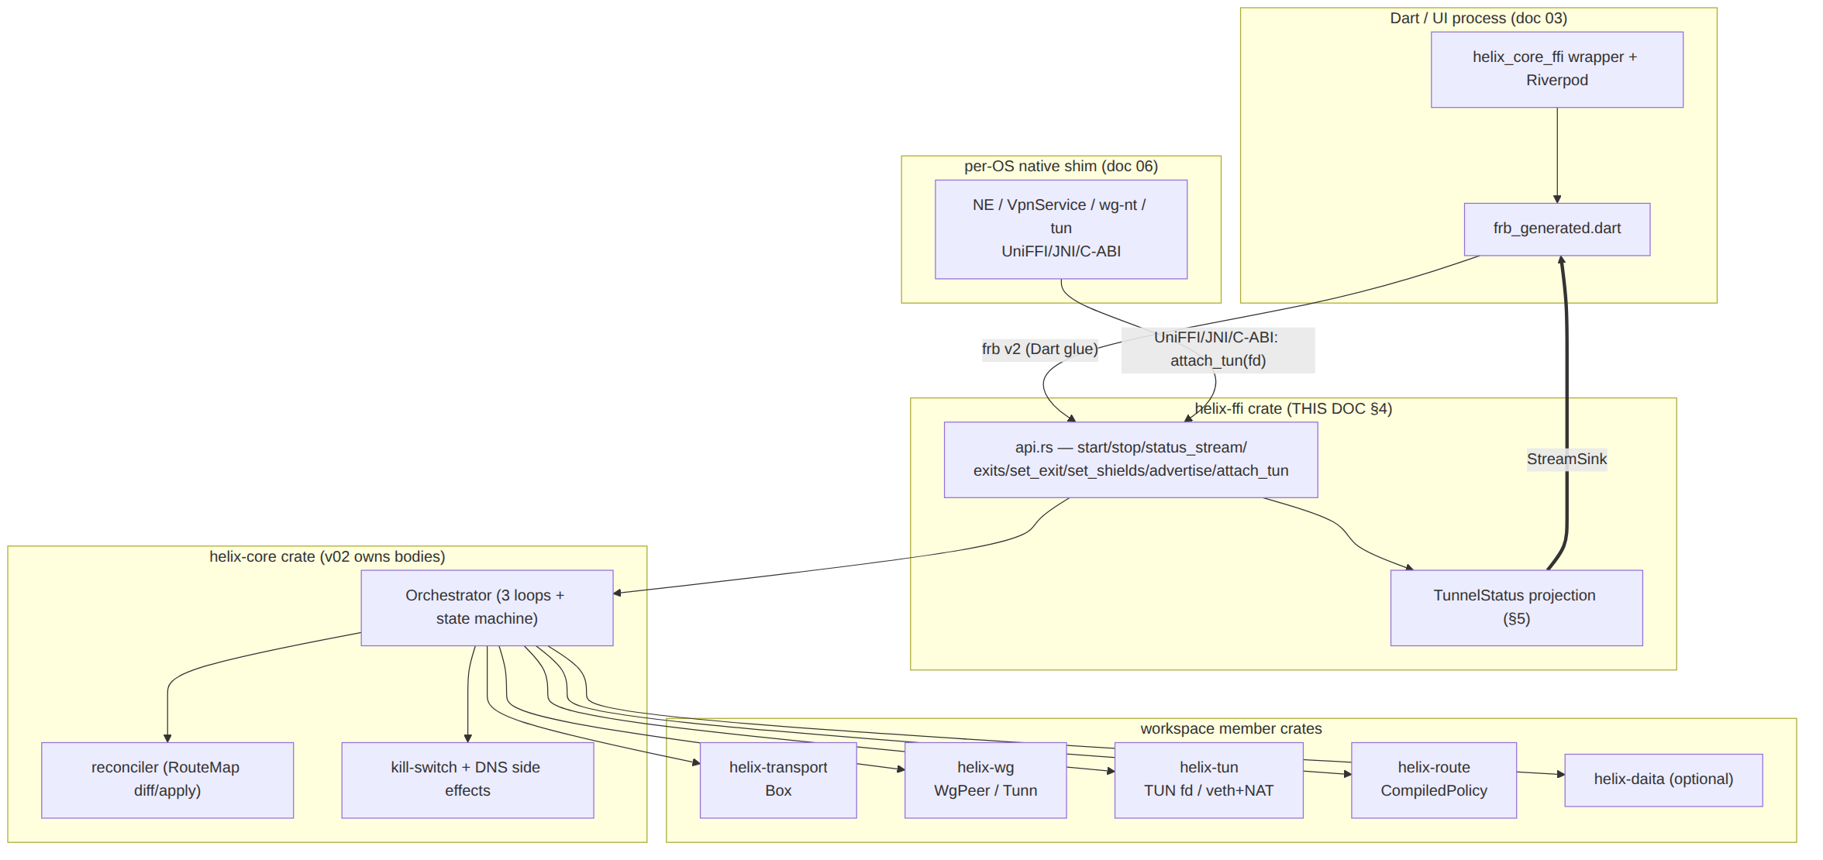

1. The cargo workspace & crate layout
helix-core/ is a single cargo workspace (snake_case, flat submodule per §11.4.28/.29/.74) [v02-tx §0, SYN §6/§9]. Each member is decoupled and independently testable; only helix-ffi and the binary depend on the OS/FFI.
helix-core/ # the Rust workspace (own vasic-digital repo)
├── Cargo.toml # [workspace] members + shared [profile.*] (§3)
├── upstreams/ # install_upstreams recipes (§11.4.36)
├── crates/
│ ├── helix-transport/ # L2 carriers: Transport trait + impls [v02-tx]
│ │ └── crate-type = ["rlib"]
│ ├── helix-wg/ # WG crypto core: WgPeer (boringtun wrap) [doc 01 §4]
│ │ └── crate-type = ["rlib"]
│ ├── helix-tun/ # TUN device abstraction (client fd / connector veth+NAT)
│ │ └── crate-type = ["rlib"]
│ ├── helix-route/ # RouteMap, CompiledPolicy, verdict map [doc 01 §6-§7]
│ │ └── crate-type = ["rlib"]
│ ├── helix-daita/ # optional L2.5 shaping (maybenot) [doc 01 §9]
│ │ └── crate-type = ["rlib"]
│ ├── helix-core/ # ORCHESTRATOR + RECONCILER + state machine [v02-orch]
│ │ └── crate-type = ["rlib"] # (the "conductor" — owns the loops, NOT exported directly)
│ └── helix-ffi/ # THE FFI SURFACE (THIS DOC §4)
│ └── crate-type = ["staticlib", "cdylib"] # platform-selected at build (§2)
└── bin/
└── helixd.rs # the daemon: --mode={client|connector}, no Flutter (§9)

1.1 Dependency DAG (acyclic, FFI at the apex)
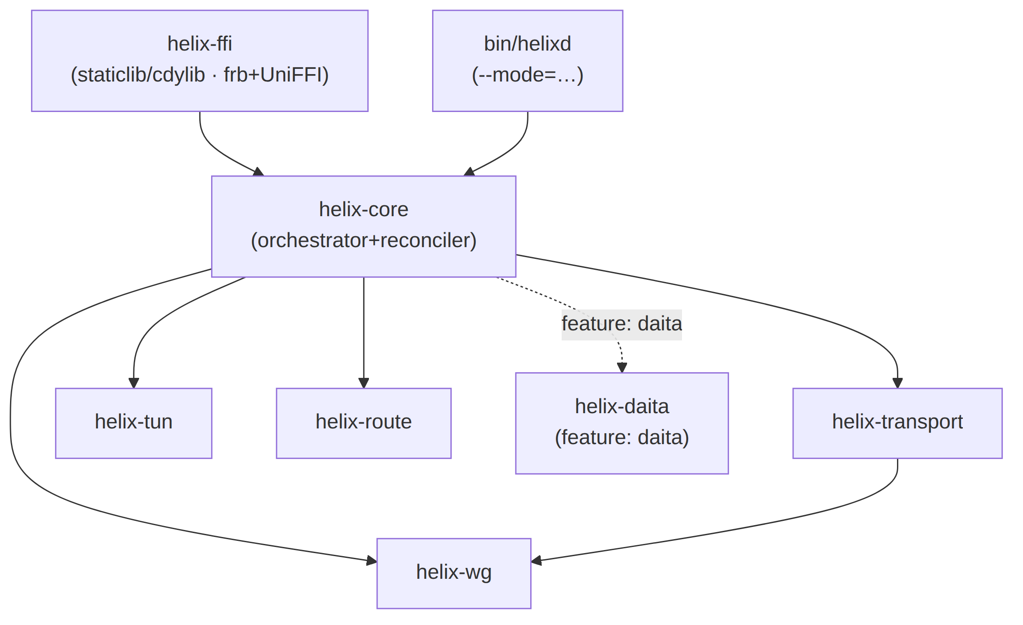
Rules: (1) no crate depends on helix-ffi — the FFI is a sink, never a dependency, so the same helix-core links into the edge binary with zero FFI weight [v02-tx I4]. (2) helix-core depends only on rlib members; the crate-type distinction (staticlib/cdylib) lives only in helix-ffi, so the heavy linker artifact is produced once at the apex (§2). (3) helix-daita is behind a cargo feature = "daita" (off in Phase-1) so DAITA code is not even compiled into the lean MVP staticlib [doc 01 §9].

1.2 Workspace Cargo.toml (skeleton)
# helix-core/Cargo.toml
[workspace]
members = ["crates/*", "bin/*"]
resolver = "2"
[workspace.dependencies]
tokio = { version = "1", features = ["rt-multi-thread", "net", "time", "sync", "macros"] }
tokio-util = "0.7" # CancellationToken
bytes = "1"
async-trait = "0.1"
thiserror = "1"
zeroize = "1" # SecretBytes scrubbing (§11.4.10)
boringtun = "*" # helix-wg backend (version pinned at Phase-0 graduation; UNVERIFIED exact)
# frb + UniFFI live ONLY in helix-ffi (§4); not workspace-wide.
[profile.release] # the lean default (§3.1) — every crate inherits
opt-level = "z"
lto = "fat"
codegen-units = 1
panic = "abort"
strip = true

2. Per-platform library artifacts (how the core ships)
The only crate that changes shape per platform is helix-ffi; everything below it is rlib [research-flutter_ffi §3]. Two binding generators read one Rust surface (the canonical Mullvad/WARP pattern [04_ARCH §5.1, research-flutter_ffi §2]):
Consumer | Linkage | crate-type | Generator | Artifact
Dart (all in-process FFI platforms) | linked or dlopened by the Flutter engine | staticlib (iOS/macOS) / cdylib (Android/Linux/Windows) | frb v2 (flutter_rust_bridge_codegen) → frb_generated.dart + Rust glue | .a / .so / .dll
iOS / macOS NE (Swift) | linked into the NEPacketTunnelProvider extension | staticlib → xcframework | UniFFI (Swift) + cbindgen for the raw attach_tun C-ABI | libhelix_ffi.a in .xcframework
Android (Kotlin) | System.loadLibrary in VpnService | cdylib per ABI via cargo-ndk | UniFFI (Kotlin) + JNI for attach_tun(fd) | libhelix_core.so (arm64-v8a, armeabi-v7a, x86_64)
Windows (C#) | privileged service hosts the core | cdylib | cbindgen C header (named-pipe IPC marshals the FFI verbs) | helix_core.dll
Linux (Dart-FFI / in-process) | DynamicLibrary.open | cdylib | frb v2 | libhelix_core.so
HarmonyOS NEXT (ArkTS) | NAPI .so, ArkTS bridge | cdylib | cbindgen / N-API (UniFFI-Kotlin not available) | libhelix_core.so
Aurora OS (C++/Qt) | linked into the Qt backend | cdylib/staticlib | cbindgen C ABI | libhelix_core.so / .a
Generator decision (D-CORE-1, surfaced per §11.4.66). frb v2 for Dart, UniFFI for native Swift/Kotlin, cbindgen C-ABI where UniFFI is thin. flutter_rust_bridge 2.12.0 is a Flutter Favorite with first-class StreamSink support — the canonical way to push the status stream Rust→Dart [research-flutter_ffi §1/§7]. uniffi-dart is community WIP and "should not be trusted" [research-flutter_ffi §2], so UniFFI is used only for its first-party Kotlin/Swift output where a native extension links the core directly (iOS NE, Android VpnService) [research-flutter_ffi §2/§7]. HarmonyOS/Aurora fall back to cbindgen C-ABI because neither has UniFFI-target support [research-flutter_ffi §4/§5]. frb-crate version MUST equal the Dart-dep version — a drift is a build-blocking finding (§12 UT/IT) [research-flutter_ffi §1 caveat].

2.1 Build commands (per target)
# Android: cdylib per ABI, bundled into jniLibs [research-ios_android §3]
cargo ndk -t arm64-v8a -t armeabi-v7a -t x86_64 -o ../apps/access/android/app/src/main/jniLibs build --release
# iOS/macOS: staticlib → xcframework, nightly build-std for the smallest NE footprint (§3.2)
cargo +nightly build --release -p helix-ffi --target aarch64-apple-ios \
-Z build-std=std,panic_abort -Z build-std-features=panic_immediate_abort,optimize_for_size
# then: lipo/xcodebuild -create-xcframework
# Linux/Windows desktop: cdylib loaded via Dart FFI DynamicLibrary
cargo build --release -p helix-ffi --target x86_64-unknown-linux-gnu

3. Size / memory build strategy
The iOS Network-Extension memory ceiling is the architecture (F-I6) [04_ARCH §5.6 CI4, research-ios_android §1/§4]. The strategy has two halves: the build profile (smaller code → fewer mapped pages → lower resident footprint) and the runtime budget (bounded buffers, no per-flow growth).

3.1 Release profile (the lean default, every crate inherits)
# [profile.release] from the workspace Cargo.toml (§1.2) [research-ios_android §2]
opt-level = "z" # smallest code. (Evaluate "s": often ~similar size, faster — §3.4 measure)
lto = "fat" # whole-program optimization across crates
codegen-units = 1 # better cross-module size opt (slower compile, accepted)
panic = "abort" # drops unwinding tables + landing pads → smaller + sometimes faster
strip = true # strip symbols (Rust 1.59+), ~3–8% extra reduction
panic = "abort" is doubly motivated: it shrinks the binary AND removes unwinding, which the FFI boundary requires anyway — a Rust panic! must never unwind across the C-ABI into Swift/Kotlin/Dart (UB) [research-ios_android §2].
Corrected panic-boundary contract (fixes a self-contradiction, §11.4.6). An earlier draft of this section claimed the helix-ffi entry points wrap their bodies in std::panic::catch_unwind-equivalent guards that convert a caught panic into CoreError::Internal. This is impossible under panic=abort: catch_unwind requires the unwind panic strategy to have anything to catch; under abort, the process terminates at the panic site before any unwinding (and therefore any catching) can occur. The two cannot coexist in one profile — the corrected, honest contract is:
- No panic is ever caught at the FFI boundary. With panic=abort set workspace-wide (§1.2), a panic! anywhere in helix-core/helix-ffi terminates the entire hosting process — the iOS NE extension, the Android app process, the Windows service, or the edge binary. This is a real availability risk (an aborted NE extension is not guaranteed a prompt OS-triggered relaunch), not a caught-and-recovered error.
- The mitigation is defensive-coding rigor at the boundary, not runtime recovery. Every helix-ffi entry point (§4.1) MUST validate externally-supplied input and return a typed CoreError variant (Config/BadFd/Auth/…) instead of ever reaching a .unwrap()/ .expect()/panicking-index/unreachable!() on FFI-boundary data. A CoreError is the ONLY sanctioned way an FFI call reports failure — a panic is by definition a bug, not an expected error path.
- Enforced mechanically, not by convention. helix-ffi (and any crate an FFI entry point calls into on the hot path) carries a clippy.toml/lint config denying unwrap_used, expect_used, panic, unimplemented, todo, and indexing_slicing — a pre-build gate (§11.4.4(b) layer 1), with a paired §1.1 mutation (reintroduce a denied lint call → the gate FAILs).
- Accepted tradeoff, stated honestly. A genuine internal-invariant violation (a real bug, not user error) aborts the host process. This is the deliberate, accepted cost of the panic=abort size optimization (this section); the alternative (panic=unwind + a real catch_unwind) would re-admit the unwinding machinery §3.2's build-std reduction removes, undermining the iOS memory budget (§3.3) this whole strategy exists to protect. The lint-enforced no-panic-on-boundary-data discipline (point 3) is what keeps this an acceptable risk rather than a routine crash surface.

3.2 iOS-only: build-std for the largest reduction
For the aarch64-apple-ios target the standard library is rebuilt with size features — this drops the gimli backtrace machinery and all panic-formatting code from std [research-ios_android §2]:
-Z build-std=std,panic_abort
-Z build-std-features=panic_immediate_abort,optimize_for_size
Representative published reduction: ~43 % over the baseline release profile [research-ios_android §2, markaicode]. This is the make-or-break lever for the G3 memory gate (§3.3). staticlib (not dylib) for iOS — no dynamic-loading entitlement friction, and the linker dead-strips unreferenced symbols [research-ios_android §2].

3.3 Runtime memory budget & the G3 gate
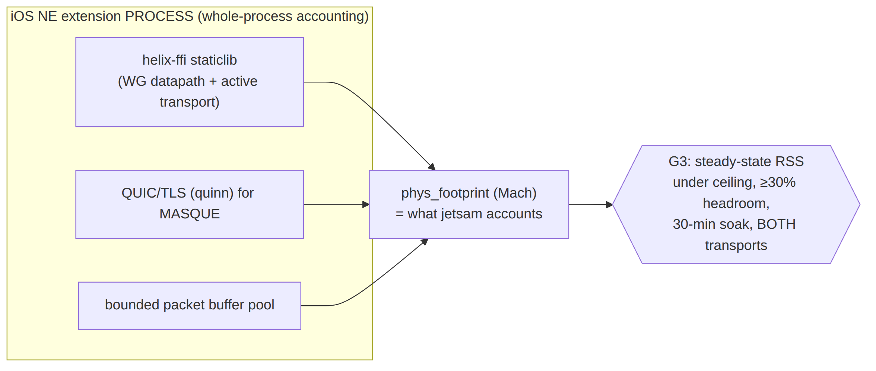
Fact | Value | Source
Documented NE limit (iOS 15–18) | 50 MiB (whole process incl. all linked libs) | [research-ios_android §1, Apple DTS]
Observed real-world jetsam kill | ~15 MB on iOS 17.3.1 (root cause PENDING_FORENSICS) | [research-ios_android §1]
Dominant kill cause | memory spikes during upload-heavy throughput, not steady-state | [research-ios_android §1, sing-box #3976]
Engineering target (this spec) | steady-state ≤ ~12–15 MB working set, never plan to 50 MiB | [research-ios_android §1/§4]
The limit | undocumented, MUST NOT be hardcoded — measure on real devices | [research-ios_android §1, Quinn DTS]
Runtime rules: (1) bounded packet-buffer pool sized to negotiated MTU + headroom (§6.3), never an arbitrary large read buffer [research-ios_android §1]; (2) WG-class low-state datapath — no TCP connection tracking, minimal persistent heap [research-ios_android §1/§4]; (3) measure phys_footprint / task_vm_info (the value jetsam accounts against — UNVERIFIED exact Mach field, verify on device) sampled from inside the extension, plus Instruments Allocations/VM-Tracker [research-ios_android §1].
G3 (make-or-break) gate [04_P0 §6, doc 03 §5.1]: build the same helix-ffi as aarch64-apple-ios with §3.1+§3.2; drive a 1 GB transfer on a real device (Simulator memory is not representative); sample the extension process RSS; run plain-UDP and MASQUE separately (QUIC buffers cost more). Pass = steady-state under the device-enforced ceiling with ≥ 30 % headroom across a 30-minute soak, both transports. Documented fallbacks in order (each a real product decision — D-CLIENT-1, surfaced [04_P0 §6.4, doc 03 §14]): (a) shrink buffers / cap QUIC flow-control windows in the iOS build; (b) move MASQUE off-device for iOS (plain WG + on-path obfuscation only — partial feature loss); (c) split the core so only the lean WG datapath is in-extension and QUIC negotiation lives in the app via app-extension IPC.

3.4 Android memory posture (contrast)
Android VpnService runs as a normal foreground service — no hard 15/50 MiB jetsam cap; standard per-app lowmemorykiller applies, far more generous [research-ios_android §3]. The severe constraint is iOS-only; the same lean build is used everywhere (smaller is always better), but the budget is gated on iOS.

3.5 App-size budgets (the install-size half)
Budget | Target | Means | Source
Mobile install (per ABI) | Access < ~15–20 MB | --split-per-abi, lean staticlib (LTO+strip), tree-shake | [04_UI §10]
Core staticlib size | record per target; smallest is the goal | §3.1/§3.2; audit fat deps (regex/formatting/async) [research-ios_android §2 bitdrift] | [research-ios_android §2]

4. The helix-ffi crate — the surface beneath the FFI
helix-ffi/src/api.rs is the only hand-authored FFI source; both generators read it [04_UI §5, doc 03 §3.1]. It is a thin, panic-safe adapter over the helix-core Orchestrator (§6) — it holds the live Orchestrator behind a process-global handle and translates FFI calls into orchestrator methods. The surface is frozen at the Phase-0 → Phase-1 graduation [04_P0 §11]; its shape matches [04_UI §5 / doc 03 §3] and its TunnelStatus matches [v02-orch §4.1] via the §5 projection.

4.1 api.rs — the exported function surface
// helix-ffi/src/api.rs — frb v2 + UniFFI generate Dart/Swift/Kotlin/C bindings.
// Transport/WG/orchestrator internals are v02/doc-01's; this is the EXPORTED surface only.
use flutter_rust_bridge::frb;
pub struct ClientConfig {
pub map_path_or_session: String, // Phase 0: path to map.json; Phase 1+: control-plane session token
pub transport: String, // "auto" | "plain" | "masque" | "shadowsocks" | "uot" | "lwo"
pub mode: CoreMode, // Client | Connector (F-I3)
}
#[frb(mirror(CoreMode))]
pub enum CoreMode { Client, Connector }
// ---- lifecycle (LOGIC ONLY — NOT the OS tunnel; the shim owns that, F-I2) ----
/// Build the Orchestrator (§6.1), arm the kill-switch closed (§8.2), spawn the
/// loops, emit Connecting. Idempotent: a second start while running is Err(AlreadyStarted) (§6.1).
pub async fn start(cfg: ClientConfig) -> Result<(), CoreError>;
/// Graceful stop: cancel loops, FIN transport, revert kill-switch+DNS per §8.6, emit Down{stopped}.
pub async fn stop() -> Result<(), CoreError>;
// ---- the live status stream (maps to the orchestrator broadcast, §5) ----
/// frb StreamSink → Dart broadcast Stream. Many concurrent sinks are allowed (broadcast
/// fan-out, §5.3); each call subscribes a fresh receiver and immediately re-emits the
/// cached latest status (§5.2). Returns Err(NotStarted) if the core is not running.
pub fn status_stream(sink: StreamSink<FfiTunnelStatus>) -> Result<(), CoreError>;
// ---- exits / routing (Phase 1+) ----
pub async fn exits() -> Result<Vec<ExitOption>, CoreError>;
pub async fn set_exit(id: String, multi_hop_chain: Option<Vec<String>>) -> Result<(), CoreError>;
// ---- privacy shields (pure logic — no OS tunnel touched, F-I2) ----
pub async fn set_shields(s: Shields) -> Result<(), CoreError>;
// ---- connector mode only (§9) ----
pub async fn advertise(cidrs: Vec<String>) -> Result<AdvertiseResult, CoreError>;
// ---- desired-state push (Phase 1: bridges WatchNetworkMap; Phase 0: file-watch) (§7) ----
pub async fn apply_map(map_json: String) -> Result<MapApplied, CoreError>;
// ---- shim handoff: the core NEVER opens the TUN; the shim hands it a packet fd / pump (F-I2, §6) ----
pub fn attach_tun(fd: i32) -> Result<(), CoreError>; // Android ParcelFileDescriptor / Linux tun fd
pub fn detach_tun() -> Result<(), CoreError>;
Canonical FFI contract (R7-reconciled). Every FFI verb returns the typed CoreError (§10.1), never anyhow::Result — anyhow stays internal to the orchestrator and is converted at the boundary via From impls (see v04-client/ffi-surface.md §8.1, the canonical owner of the exported surface). The Dart-facing status enum is FfiTunnelStatus (§5.1); ffi-surface.md writes it path-qualified as ffi::TunnelStatus purely to contrast with the orchestrator's core::TunnelStatus — it is the same Rust type.

4.2 Mirrored value types (frb #[frb(mirror)] → identical Dart/Swift/Kotlin)
#[frb(mirror(Shields))]
pub struct Shields {
pub kill_switch: bool, // → KillSwitchConfig.mode Strict/Off (§8.2)
pub dns_protection: bool, // → DnsConfig.block_plaintext_53 (§8.3)
pub daita: bool, // feature-gated; Phase 2 [doc 01 §9]
pub post_quantum: bool, // PQ PSK; Phase 2 [SYN §4]
pub split_tunnel: Vec<String>, // per-route bypass; per-APP split handled in the shim layer
}
#[frb(mirror(ExitOption))]
pub struct ExitOption {
pub id: String, pub kind: String, // "privacy_exit" | "network"
pub label: String, pub country: Option<String>, pub rtt_ms: Option<u32>,
pub jurisdiction: Option<String>, // for multi-hop labels
}
#[frb(mirror(AdvertiseResult))]
pub struct AdvertiseResult { pub accepted: Vec<String>, pub conflicts: Vec<String> }
#[frb(mirror(MapApplied))]
pub struct MapApplied { // §7 reconcile outcome surfaced to the UI
pub peers_added: u32, pub peers_removed: u32, pub peers_changed: u32,
pub dns_changed: bool, pub restart_free: bool, // always true (O-I12); a false here is a bug
}

4.3 Panic-safety & the process-global handle
// helix-ffi/src/state.rs — exactly one live Orchestrator per process.
use once_cell::sync::OnceCell;
use tokio::sync::Mutex;
static RUNTIME: OnceCell<tokio::runtime::Runtime> = OnceCell::new(); // multi-thread runtime
static ORCH: OnceCell<Mutex<Option<helix_core::Orchestrator>>> = OnceCell::new();
// Every async fn body is dispatched on RUNTIME and guarded:
// - frb v2 marshals async Rust to a Dart Future; a Rust Err becomes a Dart exception.
// - with panic=abort (§3.1) a genuine bug ABORTS the process — it is NEVER caught
// at this boundary (no catch_unwind is possible under abort; see §3.1's corrected
// panic-boundary contract). "Guarded" here means INPUT-VALIDATED, not panic-caught:
// every body validates its arguments and returns CoreError on anything unexpected,
// so the only path left to an abort is a genuine internal-invariant bug, not bad input.
// - CoreError (§10) is the structured, surfaced failure; never a silent bluff (§11.4.6).
UNVERIFIED: whether frb v2's generated async runtime obviates a hand-rolled RUNTIME (frb manages a worker pool) — confirm at codegen; if frb owns the runtime, RUNTIME collapses to frb's [research-flutter_ffi §1]. The single-live- orchestrator invariant (one TUN, one tunnel per app process) is enforced regardless.

5. TunnelStatus — core enum ⇄ FFI projection
The core broadcast type is the frozen 5-variant enum owned by [v02-orch §4.1]:
// helix-core/src/status.rs (OWNED by v02-orch §4.1 — reproduced for the seam, MUST match)
#[derive(Clone, Debug, PartialEq, Eq)]
pub enum TunnelStatus {
Connecting, // dialling the first/seeded rung
Handshaking, // carrier up, WG handshake in flight
Connected { transport: String, rtt_ms: u32 }, // e.g. ("masque-h3", 23)
Reconnecting, // a working tunnel dropped; re-dialling
Down { reason: String }, // terminal for this attempt (§10 reasons)
}
The FFI-facing enum (the Dart/Swift/Kotlin surface, doc 03 §3.1) is a strict projection of the core enum plus three FFI-only additions. The projection is the only place the two differ; the §12 contract test asserts the mapping byte-for-byte so they can never silently drift.
// helix-ffi/src/api.rs
#[frb(mirror(FfiTunnelStatus))]
pub enum FfiTunnelStatus {
Disconnected, // FFI-only: clean idle (pre-start / post user-stop)
Connecting, // ← core Connecting
Handshaking, // ← core Handshaking
Connected { transport: String, path: String, rtt_ms: u32 }, // ← core Connected; `path`="direct"|"relay" (§5.1)
Reconnecting, // ← core Reconnecting
Down { reason: String }, // ← core Down{reason} (unexpected drop)
Danger { kind: String }, // FFI-only: "leak" | "killswitch_tripped" (§5.2)
}

5.1 The projection map (core → FFI)
Core TunnelStatus | FFI FfiTunnelStatus | Notes
(no live orchestrator) | Disconnected | pre-start() and after stop() → Down{stopped} is re-mapped to Disconnected for the UI (clean idle)
Connecting | Connecting | 1:1
Handshaking | Handshaking | 1:1
Connected{transport,rtt_ms} | Connected{transport, path, rtt_ms} | path derived: "relay" if the active leg is DERP-style relay, else "direct" (P2P/NAT-traversal — doc 01 §8); Phase-1 default "direct"
Reconnecting | Reconnecting | 1:1
Down{reason: "stopped"} | Disconnected | user-stop is clean, not a danger
Down{reason: r} (r≠stopped) | Down{reason: r} | unexpected/terminal drop (kill-switch stays closed, §8)
(kill-switch trip / leak detected) | Danger{kind} | FFI-only overlay derived from the §8 sub-machine + leak probe; drives the red stateDanger palette (doc 03 §7)
Consistency note (§11.4.6). The core never emits Disconnected or Danger — they are FFI-layer derivations, so the v02 5-variant broadcast contract is untouched. Danger is not a guessed UI state: it is raised only on a concrete signal — the §8 kill-switch sub-machine reporting killswitch_tripped, or an explicit DNS/leak probe firing — never inferred from prose.

5.2 The StreamSink pump
// helix-ffi/src/api.rs — status_stream wiring
pub fn status_stream(sink: StreamSink<FfiTunnelStatus>) {
let mut rx = orchestrator().subscribe(); // broadcast::Receiver<core::TunnelStatus> [v02-orch §2.1]
spawn_on_runtime(async move {
// emit initial Disconnected so the UI has a value before the first transition (CI2)
let _ = sink.add(FfiTunnelStatus::Disconnected);
loop {
match rx.recv().await {
Ok(core_s) => { let _ = sink.add(project(core_s)); } // §5.1 map
Err(broadcast::error::RecvError::Lagged(_)) => continue, // skip-to-latest, NOT an error [v02-orch §4.6]
Err(broadcast::error::RecvError::Closed) => break, // orchestrator gone → stream ends
}
}
});
}
frb v2 turns this StreamSink<FfiTunnelStatus> into a Dart Stream that feeds a Riverpod StreamProvider.autoDispose [research-flutter_ffi §6]. Riverpod 3.0 pauses the subscription when no widget listens — so the FFI pump is torn down when the UI backgrounds the status, and re-subscribes on resume; the core keeps running regardless (the broadcast sender outlives any receiver) [research-flutter_ffi §6].

5.3 Receiver contract (Dart side, doc 03 §8.2 honors this)
Lagged MUST be treated as "re-read latest", never an error; Closed ends the stream. The status is edge-coalesced (emissions are rare — state changes), so the 64-slot broadcast ring [v02-orch §4.2] never lags unless a receiver is wedged.

5.4 No poll getter (F-I1)
The FFI exposes no is_connected() / current_status() synchronous getter. The UI's only source of protection truth is status_stream() — this structurally prevents the "UI says connected while the tunnel is down" bug (CI2) [04_UI §4.2].

5.5 What the FFI MUST NOT return (F-I5)
No endpoint, SSID, gateway IP, per-packet/per-flow datum, or SecretBytes ever crosses the FFI. Connected.transport is a kind label; rtt_ms is an aggregate EWMA [v02-orch §4.5, v02-tx I5]. A code-review gate (§11.4.142) rejects any FFI return embedding an endpoint or secret.

6. FFI lifecycle & the TUN-fd handoff (the shim seam)
The seam that prevents the classic VPN bug [doc 03 §3.3, v02-orch §2.1]: lifecycle commands flow UI → shim → core (the OS owns the tunnel process), while status events flow core → FFI → UI (the core owns protection truth). set_shields/set_exit/exits are pure logic and go straight UI → FFI without touching the OS tunnel (F-I2).

6.1 start() → builds the Orchestrator
// helix-ffi/src/api.rs (body sketch) — drives helix-core; v02-orch §2.1 owns Orchestrator::start
pub async fn start(cfg: ClientConfig) -> Result<(), CoreError> {
let mut guard = orch_cell().lock().await;
if guard.is_some() { return Err(CoreError::AlreadyStarted); } // idempotent: no double tunnel
let initial_map = load_map(&cfg.map_path_or_session).await?; // Phase 0: file; Phase 1: session→WatchNetworkMap
let oc = helix_core::OrchestratorConfig {
mode: cfg.mode.into(), // F-I3
tun: TunSpec::AttachLater, // the shim calls attach_tun (§6.2) — core does NOT open it
initial_map,
transport_policy: TransportPolicy::from_hint(&cfg.transport),
kill_switch: KillSwitchConfig::default(), // armed-closed-until-connected (§8.2)
dns: DnsConfig::from(&initial_map),
tunables: CoreTunables::default(), // §11
};
*guard = Some(helix_core::Orchestrator::start(oc).await?); // arms kill-switch CLOSED, spawns loops, emits Connecting
Ok(())
}
start() does not open the TUN. The orchestrator is built in TunSpec::AttachLater and idles loop A/B until attach_tun(fd) injects the packet pipe (F-I2). This is the contract that keeps the only per-platform code in the shim [04_UI §5/§6].

6.2 The TUN-fd handoff (the C-ABI seam, per OS)
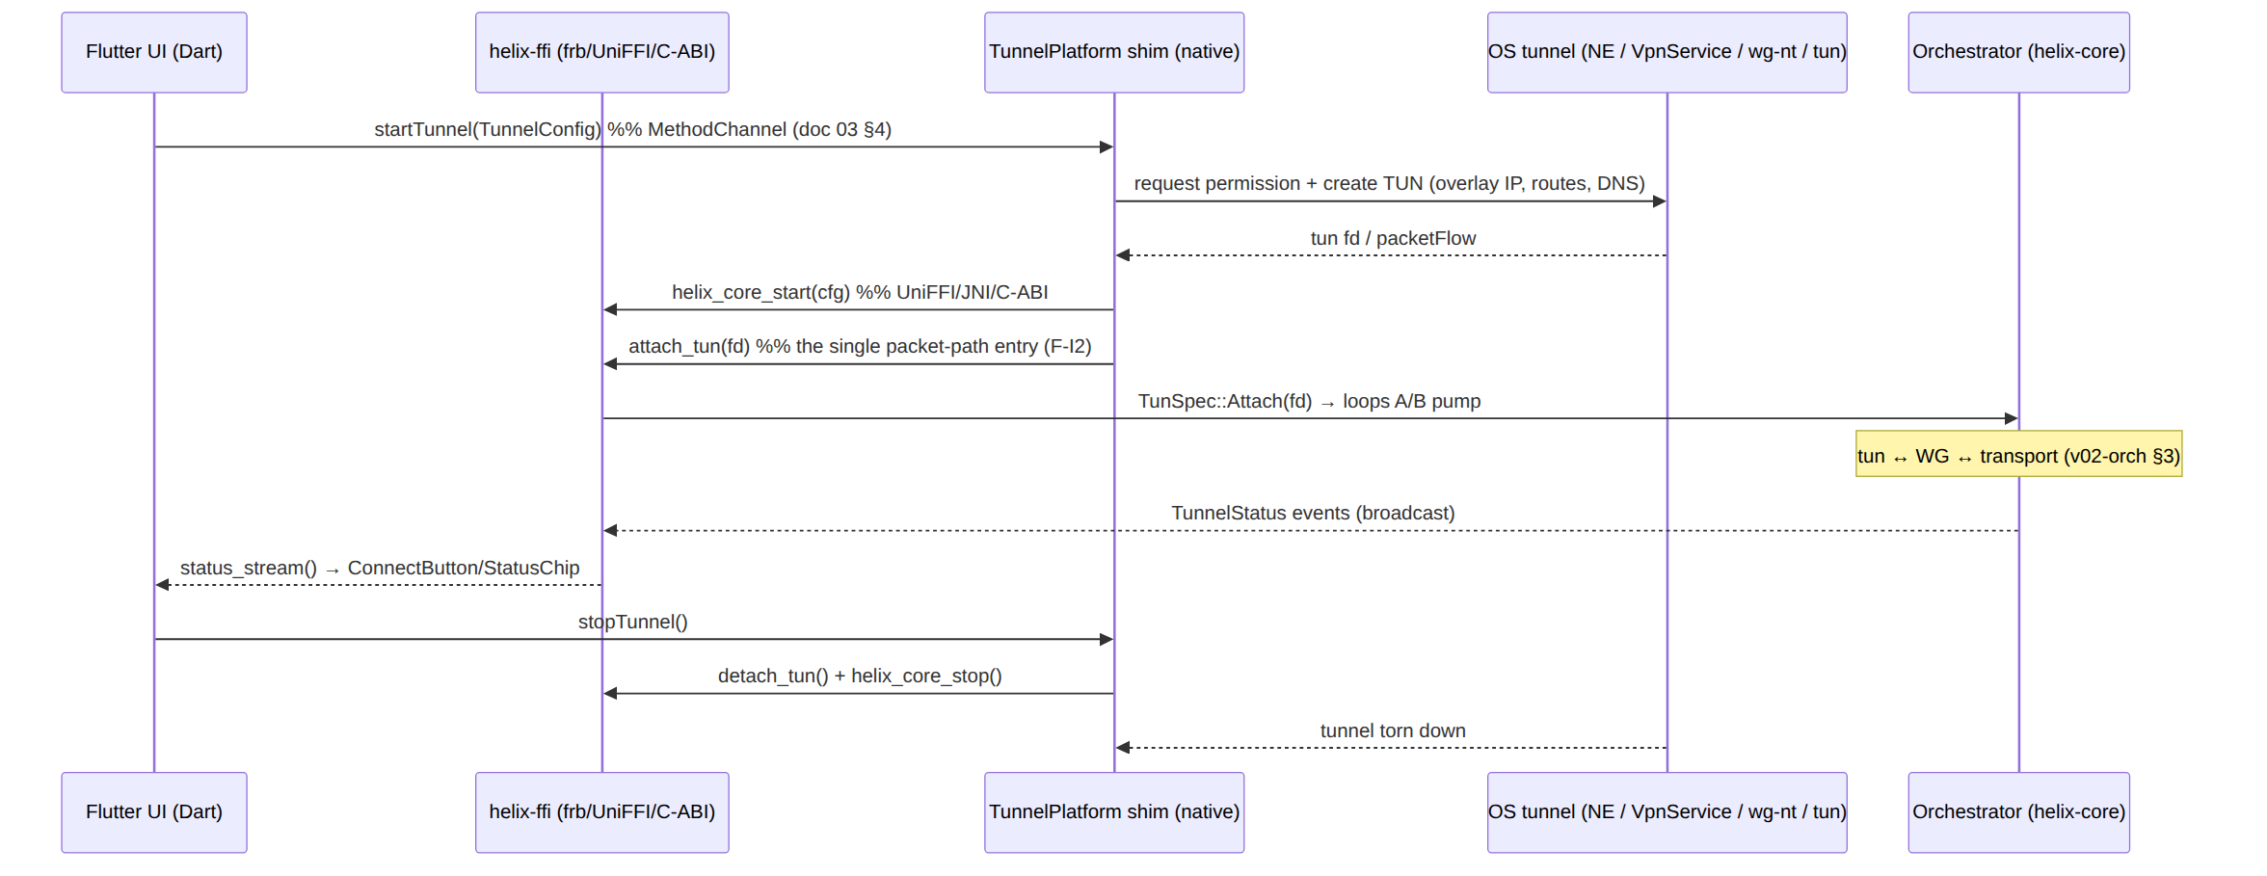
Per-OS fd source [research-ios_android §3, doc 03 §5]:
- Android (Kotlin/JNI): ParcelFileDescriptor.detachFd() transfers ownership; the int fd is passed into JNI; the core read(2)/write(2)s directly on it. Every outbound transport socket the core opens MUST be protect()ed (ideally native protectFromVpn to avoid per-socket JNI upcalls) so the tunnel's own packets don't loop back into the tun [research-ios_android §3].
- // apps/access/android/.../HelixVpnService.kt
external fun coreStart(sessionToken: String): Int // JNI → helix_ffi start()
external fun attachTun(fd: Int): Int // JNI → helix_ffi attach_tun()
// ...
val pfd: ParcelFileDescriptor = builder.establish()!! // OS creates the TUN
coreStart(cfg.sessionToken); attachTun(pfd.detachFd()) // hand raw fd to the core
- iOS/macOS (Swift, NE): the extension owns packetFlow; there is no integer fd — instead the shim wires the read/write callbacks. The C-ABI exposes a tun_out push and a set_tun_writer callback (the core has no fd, it pumps via the closures):
- // apps/access/ios/HelixTunnel/PacketTunnelProvider.swift
helix_core_start(cfg.sessionToken) // UniFFI/cbindgen
packetFlow.readPackets { packets, _ in
for p in packets { helix_core_tun_out(p) } // core encrypts + sends via transport
}
helix_core_set_tun_writer { data in // core → OS: decrypted IP packets
self.packetFlow.writePackets([data], withProtocols: [AF_INET])
}
- Linux (in-process): the core opens/owns the tun fd directly (a setcap cap_net_admin helper or polkit-gated daemon covers privilege); the Phase-0 G5 reference platform "the core can drive the TUN directly" [04_P0 §9, doc 03 §5.4].
- Windows: a privileged service hosts the core + the wireguard-nt/wintun adapter; the Flutter app marshals the FFI verbs over a named pipe; the wintun ring is the core↔OS packet path [doc 03 §5.3].
- HarmonyOS NEXT (ArkTS): the VpnExtensionAbility tun is bridged via NAPI to the .so; honest SKIP-with-reason (§11.4.3) where the SIG port lacks the VPN API [research-flutter_ffi §5, research-ios_android n/a].
- Aurora OS (Qt/C++): the Qt backend owns the tun; the C-ABI receives the fd [doc 03 §5.6].

6.3 The C-ABI surface for the native packet path (cbindgen)
// helix_ffi.h (cbindgen-generated) — the raw seam UniFFI does not cover (packet hot path)
int32_t helix_core_start(const char* session_token, int32_t mode); // 0=Client 1=Connector
int32_t helix_core_attach_tun(int32_t fd); // Android/Linux fd path
void helix_core_tun_out(const uint8_t* pkt, uintptr_t len); // iOS push-in path (one IP packet)
void helix_core_set_tun_writer(void (*writer)(const uint8_t*, uintptr_t)); // core → OS callback
int32_t helix_core_detach_tun(void);
int32_t helix_core_stop(void);
The read buffer the core allocates for tun_out/the fd read loop is bounded to the negotiated MTU + headroom (§3.3), never an arbitrary large value — the single strongest lever against iOS jetsam spikes [research-ios_android §1].

7. The network-map reconciler beneath the FFI
Ownership. The reconciler's diff/apply bodies are specified in depth by [v02-orch §6]. This section specifies the FFI-driven entry (apply_map), the consumed RouteMap/MapDelta shapes, and the client-core obligation to bring WG peers up/down and update AllowedIPs restart-free — kept byte-consistent with [v02-orch §6.2/§6.3].
The core is a declarative reconciler [04_ARCH §4.4, 04_P0 §10]: it diffs a desired RouteMap (Phase 1: pushed by WatchNetworkMap, doc 02; Phase 0: a file-watch on map.json) against live state and converges — peers up/down, AllowedIPs, transport policy, DNS — without restarting (O-I12), < 1 s convergence [04_ARCH §4.4].

7.1 Consumed shapes (frozen, from [v02-orch §6.2])
// helix-route (consumed by the reconciler) — MUST match v02-orch §6.2 byte-for-byte
pub struct RouteMap {
pub self_overlay: IpAddr, // this node's overlay IP (ULA /48, D4)
pub peers: Vec<PeerRoute>, // already policy-filtered (need-to-know, I6)
pub dns: Vec<IpAddr>, // tunnel DNS servers (§8.3)
pub transport_policy: TransportPolicy, // per-leg ladder order/pin/budget [v02-tx §6.2]
pub daita: Option<DaitaMachines>, // optional shaping config (data, not code; feature-gated)
}
pub struct PeerRoute {
pub wg_pubkey: [u8; 32],
pub endpoint_candidates: Vec<SocketAddr>, // NAT traversal (Phase 2)
pub allowed_ips: Vec<IpNet>, // overlay prefixes this peer is next hop for
pub via_connector: Option<SiteId>, // 4via6 site disambiguation [doc 01 §6.1]
}
pub struct MapDelta { // produced by diff(), surfaced to the FFI as MapApplied (§4.2)
pub peers_added: Vec<PeerRoute>,
pub peers_removed: Vec<[u8; 32]>, // pubkeys to tear down (revocation path)
pub peers_changed: Vec<PeerRoute>, // allowed_ips / endpoint changed
pub dns_changed: bool, pub policy_changed: bool, pub transport_policy_changed: bool,
}

7.2 apply_map — the FFI-driven converge
// helix-ffi/src/api.rs — Phase 1 wires WatchNetworkMap → this; Phase 0 the file-watch task calls it.
pub async fn apply_map(map_json: String) -> Result<MapApplied, CoreError> {
let desired: RouteMap = serde_json::from_str(&map_json)?; // Phase-0 stand-in shape == Phase-1 stream
let delta = orchestrator().apply_map(desired).await?; // v02-orch §6.4 in-place converge (O-I12)
Ok(MapApplied {
peers_added: delta.peers_added.len() as u32,
peers_removed: delta.peers_removed.len() as u32,
peers_changed: delta.peers_changed.len() as u32,
dns_changed: delta.dns_changed,
restart_free: true, // ALWAYS true; a false here is a bug (O-I12)
})
}

7.3 Apply flow (restart-free) — what the client core does per delta class
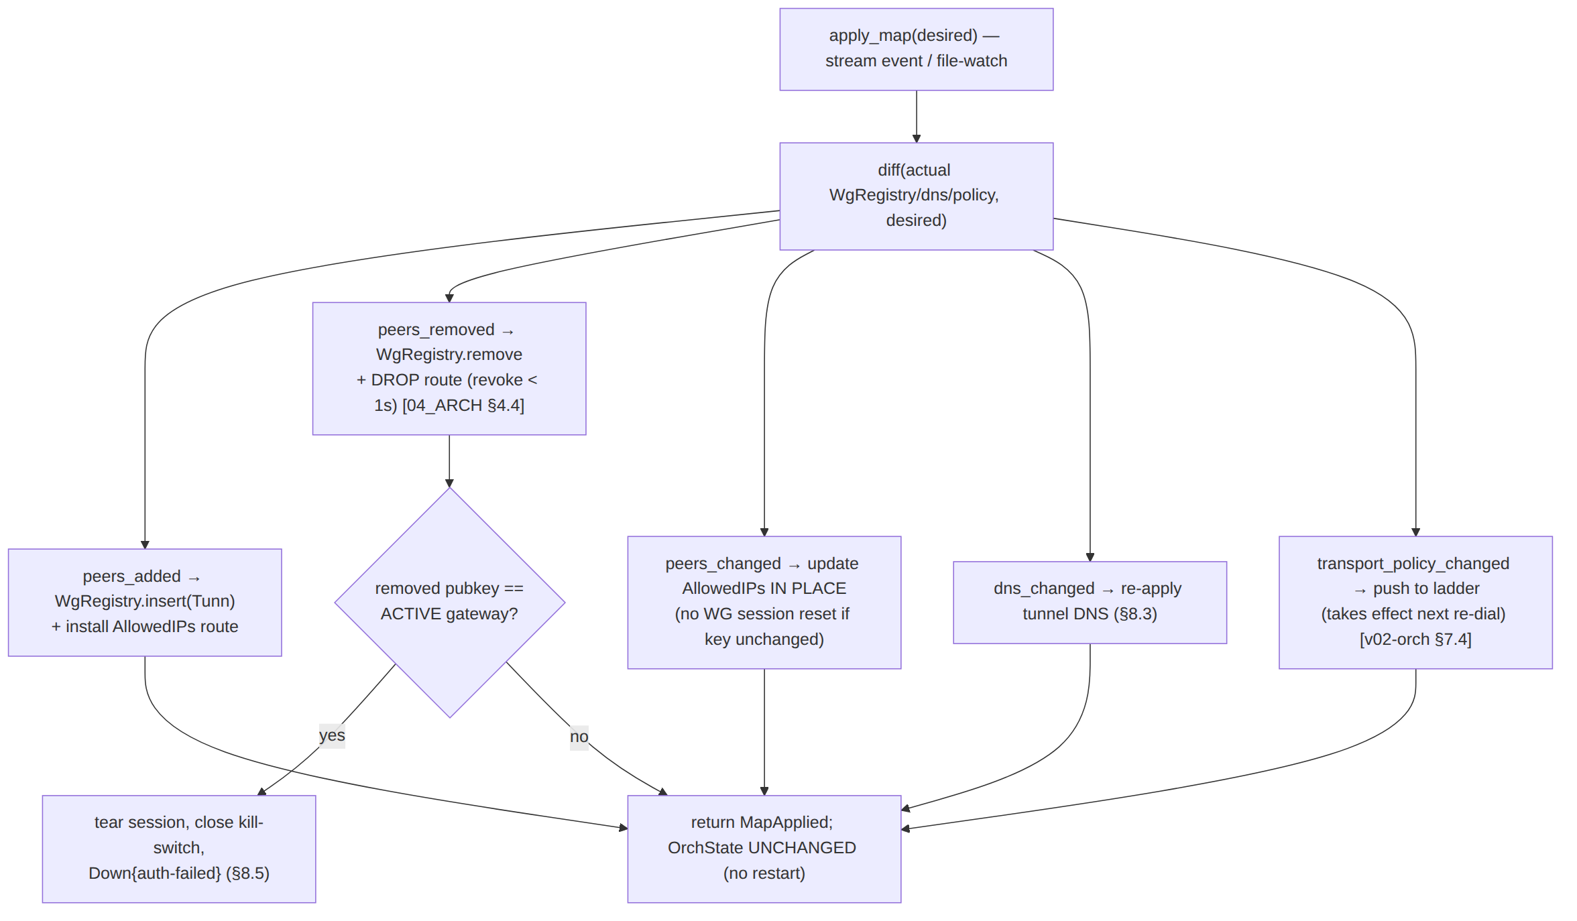
- peers_added → insert a Tunn into the WG registry and install its allowed_ips as overlay routes; the new peer is reachable without a tunnel restart [v02-orch §6.4].
- peers_removed → remove the Tunn and DROP its routes; if the removed pubkey is the active gateway (revocation-of-self), tear the session, close the kill-switch, emit Down{auth-failed} → FFI Down{"auth-failed"} (§8.5). Effective < 1 s [04_ARCH §4.4].
- peers_changed touching only allowed_ips → update the routing map in place, no WG session reset (the key is unchanged) — the "policy edit < 1 s, no restart" MVP gate (AC5) [v02-orch §6.4, 04_P1 §11.2].

7.4 Reconcile is a side task (fail-static, I3)
The reconcile source dying (stream disconnect / file-watch error) never tears the tunnel — the loops keep forwarding on the last-applied map (fail-static) [04_ARCH §2.1, v02-orch §6.5]. The FFI surface is unaffected; apply_map simply isn't called until the source recovers (Phase-1 stream re-subscribes with its own backoff, independent of the data-plane backoff).

8. Kill-switch + DNS state machine
Ownership. The kill-switch/DNS coupling bodies are specified by [v02-orch §8]. This section specifies how the core configures and exposes them beneath the FFI (the Shields mapping, the Danger projection) — kept consistent with [v02-orch §8.4].
The kill-switch and DNS-leak protection are owned by the core state machine, never hand-edited firewall rules [04_ARCH §5.6/§7]. Every open/close and DNS apply/revert is a side effect of an OrchState transition (O-I10), so there is no window where the UI shows "connected" but the firewall is open (F-I4).

8.1 Config (from Shields + RouteMap)
// helix-core (configured by start() from ClientConfig+RouteMap; v02-orch §8.2/§8.3 owns bodies)
pub struct KillSwitchConfig {
pub mode: KillSwitchMode, // Strict | Permissive | Off
pub allow_lan: bool, // permit RFC1918 LAN while closed (printers etc.)
pub allow_gateway_endpoints: Vec<IpNet>, // gateway IPs the transport MUST reach (stay open)
}
pub enum KillSwitchMode { Strict, Permissive, Off }
pub struct DnsConfig {
pub servers: Vec<IpAddr>, // tunnel DNS (from RouteMap.dns)
pub block_plaintext_53: bool, // drop off-tunnel :53 when Connected (leak guard)
pub apply: DnsApplyMethod, // resolvconf | systemd-resolved | /etc/resolv.conf | shim
}
The FFI Shields (§4.2) maps onto these: kill_switch=true ⇒ KillSwitchMode::Strict; dns_protection=true ⇒ block_plaintext_53=true. set_shields() re-applies live (no restart) [doc 03 §3.1].

8.2 The side-effect matrix (from [v02-orch §8.4], drives Danger projection)
Transition | Kill-switch | DNS | FFI projection
Idle → Connecting (Strict) | install closed (allow gw endpoints only) | system DNS | Connecting
Handshaking → Connected | open (egress via tunnel) | apply tunnel DNS + block off-tunnel :53 | Connected
Connected → Reconnecting (drop) | close (O-I11) | keep tunnel-DNS block (fail-closed) | Reconnecting
* → Down{reason≠stopped} | stay closed | keep block | Down{reason} (or Danger{killswitch_tripped} if a leak probe fired)
ShuttingDown → Down{stopped} (user) | revert to off (open) | revert system DNS | Disconnected
crash / panic | closed rules remain | block remains | (process restarts; start() re-arms)

8.3 Kill-switch + DNS sub-machine (from [v02-orch §8.7])
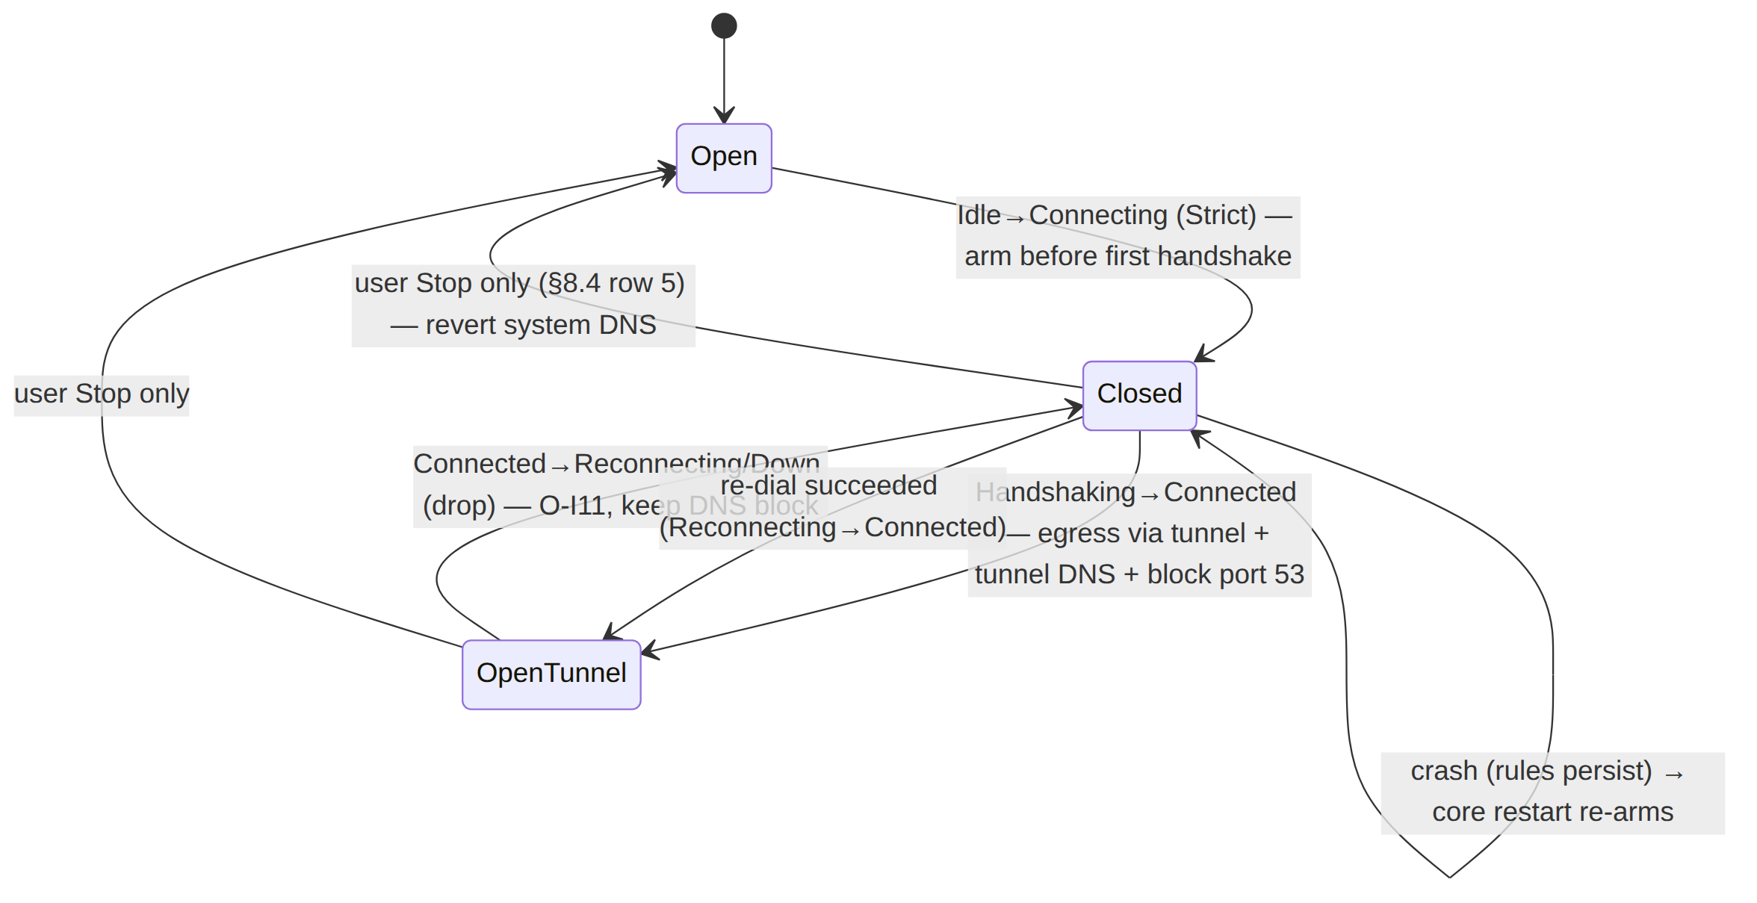

8.4 Danger projection (the FFI-only overlay, §5.2)
The FFI raises Danger{kind} when, and only when, a concrete signal fires:
- kind="killswitch_tripped" — the sub-machine reports the kill-switch closed while the user intends connected (a drop the user can see); or
- kind="leak" — an explicit DNS/leak probe detects off-tunnel egress.
Danger overrides any optimistic UI intent and paints the red stateDanger palette immediately (doc 03 §7/§8.4). It is never guessed (§11.4.6) — absent a signal the FFI emits Reconnecting/Down, not Danger.

8.5 auth-failed is closed-and-terminal
A revoked device (peers_removed includes the active gateway, §7.3) reaches Down{auth-failed} with the kill-switch closed and DNS blocked — a revoked client cannot leak onto the underlay by virtue of being revoked [v02-orch §8.5]. Recovery requires explicit user re-enroll through start().

9. Connector mode (--mode=connector)
Ownership. The connector forwarding/NAT/verdict-map bodies are [v02-orch §9]. This section specifies the packaging — one binary, the mode flag, the headless daemon, and the FFI advertise verb sharing the same core.

9.1 One binary, one core, two postures (F-I3)
The connector is the same helix-core Orchestrator with Mode::Connector [v02-orch §9.1, 04_P0 §4.5]. The three loops, status stream, reconciler, backoff, and transport layer are byte-for-byte identical to the client; only the routing posture differs (no default-route capture; instead advertise served CIDRs + NAT/forward decapsulated packets into the LAN) [v02-orch §9.1/§9.2]. The connector is outbound-only — it dials the gateway, never listens (the founding no-port-forward constraint [SYN §1]).
client: [app traffic] → TUN → WG encrypt → [DAITA] → Transport ──▶ gateway
connector: gateway ──▶ Transport → WG decrypt → forward into served CIDR (and reverse)

9.2 The two entrypoints share the core
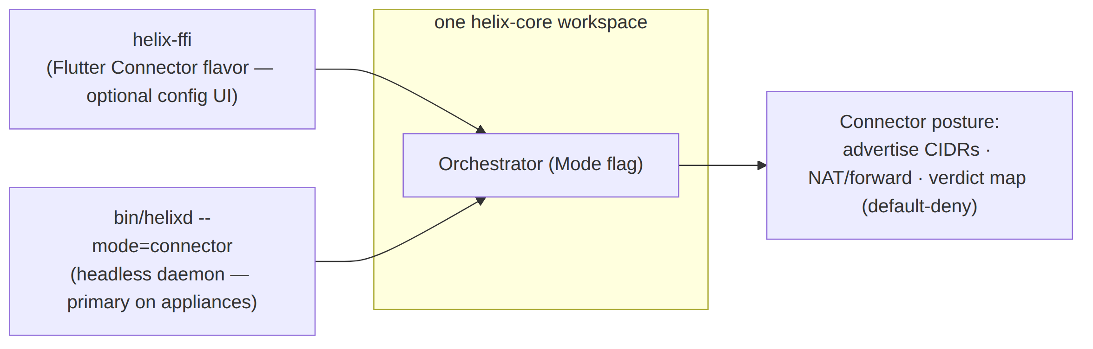
- Headless daemon (bin/helixd --mode=connector) is the primary form on network appliances — no Flutter, no FFI weight, just the core [04_ARCH §5.4, doc 03 §6]. It reads its RouteMap from the control plane (or map.json) and runs the same reconciler (§7) + kill-switch knobs (typically KillSwitchMode::Off — a connector is an appliance, not a privacy client [v02-orch §9.4]).
- Flutter Connector flavor is the optional config surface; it links helix-ffi and drives the same core with CoreMode::Connector, calling advertise(cidrs) for the advertise UI [doc 03 §6, §3.1].

9.3 advertise and local_denylist (FFI verbs, connector only)
// helix-ffi/src/api.rs (connector mode)
pub async fn advertise(cidrs: Vec<String>) -> Result<AdvertiseResult, CoreError>;
// → orchestrator pushes the served CIDRs into its RouteMap; the gateway reconciles them.
// AdvertiseResult.conflicts surfaces overlapping-CIDR rejections to the Connector UI (doc 03 §6).
pub async fn advertise_with_local_denylist(
cidrs: Vec<String>,
local_denylist: Vec<String>,
) -> Result<AdvertiseResult, CoreError>;
// → advertises served CIDRs AND the connector's local_denylist to the control plane.
// The denylist is sent alongside CIDR advertisements (e.g. in the `connector.local_denylist.changed`
// event payload or equivalent agent RPC) so the coordinator/edge applies the same precedence rule.
The connector accepts a local_denylist config value (daemon flag --local-denylist <cidrs>, JSON array, or FFI parameter) scoped to its own network. The same precedence rule is enforced both in the control-plane compiler (svc-policy.md §4.2) and at the connector's local edge:
- Local-deny overrides central-allow — a connector may tighten policy for its own network.
- Central-deny overrides local-allow — the tenant-wide default-deny/fail-closed invariant wins; a connector cannot use local_denylist to re-open a flow the central policy did not grant.
- The resulting AllowedIPs + edge verdict map equal the union of central policy minus local-deny for that connector's traffic.
The connector advertises the local_denylist to the coordinator alongside its CIDR advertisements so the edge enforces it consistently; the local edge also applies it as a belt-and-suspenders check in case the control-plane delta is delayed (fail-static, never fail-open).

9.4 Status semantics on the connector
The connector emits the same TunnelStatus stream — its tunnel to the gateway is what Connected{transport,rtt} describes; Down means "the connector lost its gateway tunnel" [v02-orch §9.4]. The Connector Flutter flavor subscribes to status_stream() exactly as Access does (the FFI/UI code is shared, F-I3).

10. Error handling & edge cases

10.1 FFI error taxonomy
// helix-ffi/src/error.rs — what crosses the FFI as a Dart exception / Swift-Kotlin throw
#[derive(thiserror::Error, Debug)]
pub enum CoreError { // canonical = ffi-surface.md §8.1
#[error("core not started")] NotStarted, // status_stream/stop/apply_map/exits before start
#[error("core already started")] AlreadyStarted, // start() while running (§6.1)
#[error("invalid config: {0}")] Config(String), // bad transport/map path; apply_map bad JSON (§7.2)
#[error("auth failed (revoked)")] Auth, // maps from Down{auth-failed} (§8)
#[error("host fatal: {0}")] HostFatal(String), // TUN open / firewall apply failed (§8)
#[error("tun fd invalid")] BadFd, // attach_tun on a dead/foreign fd
#[error("internal: {0}")] Internal(String), // panic guard (§4.3) — bug, surfaced not hidden; never a secret (§11.4.10)
}
// The orchestrator's internal anyhow / OrchestratorError / TransportError are converted to
// CoreError at the FFI boundary via `From` impls (ffi-surface.md §8.1): map-parse → Config,
// tun-attach → BadFd, auth-revoked → Auth, leak-unprotectable → HostFatal, else → Internal.
Classification: HostFatal (the core refuses to run a tunnel it cannot leak-protect) → the orchestrator emits Down{host-fatal} (§8) and start() returns Err. AlreadyStarted/NotStarted are caller-discipline errors surfaced as Dart exceptions, never silent no-ops (§11.4.6). A caught panic becomes Internal (a bug, surfaced honestly); with panic=abort (§3.1) an uncatchable panic aborts the process rather than corrupting the C-ABI.

10.2 Edge cases (each maps to a §12 test point)
# | Edge case | Required behaviour | Source
C1 | start() called twice | second returns Err(AlreadyStarted); one live orchestrator, one tunnel (§6.1) | §4.3
C2 | attach_tun(fd) on a closed/foreign fd | Err(BadFd); no half-open pump; kill-switch unchanged | §6.2
C3 | status_stream receiver wedged > 64 events behind | Lagged → skip-to-latest; core unaffected (§5.3) | [v02-orch §4.2]
C4 | iOS NE memory spike during upload soak | bounded buffer pool (§3.3); G3 soak must hold ≥30% headroom; else D-CLIENT-1 fallback | [research-ios_android §1]
C5 | apply_map with malformed JSON | Err(Config); last-applied map stays live (fail-static, §7.4) | §7.2
C6 | Revoke (peers_removed = active gateway) | tear session, close kill-switch, FFI Down{auth-failed}; < 1 s (§7.3/§8.5) | [v02-orch §6.4]
C7 | Lagged/Closed on the FFI pump | Lagged→continue; Closed→end Dart stream (§5.2) | §5
C8 | Rust panic! in an FFI body | caught → CoreError::Internal; uncatchable → panic=abort process abort (never unwind across C-ABI) | §3.1/§4.3
C9 | stop() then start() | clean re-arm: ladder reset to top, kill-switch re-armed closed (L-I8) | [v02-orch §5.2]
C10 | frb-crate ≠ Dart-dep version | build-blocking drift finding (§12 UT) | [research-flutter_ffi §1]
C11 | Android socket not protect()ed | tunnel loops its own packets back into tun — MUST protect every outbound transport socket | [research-ios_android §3]
C12 | HarmonyOS/Aurora VPN API absent in the fork | honest §11.4.3 SKIP-with-reason + tracked migration item; never a faked PASS | [research-flutter_ffi §4/§5]

11. Config knobs (CoreTunables)
The FFI passes through the orchestrator tunables [v02-orch §11]; the client-core adds the FFI/runtime knobs. Every numeric default tagged "derived" is the spec recommendation, calibrated against Phase-0 gates with captured evidence before it is frozen (§11.4.6 — a number is a guess until measured).
pub struct CoreTunables {
pub orch: helix_core::Tunables, // [v02-orch §11]: tick/handshake/keepalive/backoff/status
// --- FFI / runtime ---
pub tun_read_buf: usize, // bounded to negotiated MTU + headroom; default 1500+64 (§3.3) [research-ios_android §1]
pub status_initial_emit: bool, // emit Disconnected on subscribe; default true (CI2, §5.2)
pub ios_mem_sample_period: Duration, // phys_footprint sampler cadence in NE; default 1 s (derived) [research-ios_android §1]
}
UNVERIFIED: keepalive_timeout = 25 s mirrors WG's REKEY-after-no-recv window but the exact boringtun-surfaced value is a Phase-0 measurement item [v02-orch §11]. tun_read_buf is the single strongest iOS-memory lever and is measured on device, never assumed (§3.3).

12. Test points (§11.4.169)
Per §11.4.169 every workable item declares its required test types from the closed vocabulary [06-phase0-spike-wbs §0.4]; every PASS cites rock-solid captured evidence (§11.4.5/.69/.107), never config-only. The FfiTunnelStatus event trace
- the on-device RSS report are the captured evidence for the core's claims.
Test id | §11.4.169 codes | What it proves | Rig / captured evidence | Source
HC-1 | UT | the §5.1 projection map is total + correct: every core TunnelStatus → expected FfiTunnelStatus; Down{stopped}→Disconnected | table-driven unit over the §5.1 matrix; mocks allowed (unit only) | §5
HC-2 | UT | FFI ⇄ Dart mirror parity: the generated Dart FfiTunnelStatus/Shields/ExitOption match the Rust #[frb(mirror)] types byte-for-byte; frb-crate==Dart-dep version | generated-fixture diff; a drift FAILs the build | §4.2, [research-flutter_ffi §1]
HC-3 | UT | SecretBytes Debug redacts + zeroizes on drop; no FFI return embeds an endpoint/secret (F-I5) | redaction assertion; grep-empty proof | §5.5, [v02-tx §3.2]
HC-4 | IT | start() builds the orchestrator, attach_tun(fd) pumps real WG datagrams tun↔transport on the netns rig; curl reaches LAN host | netns + boringtun + plain-udp; tcpdump + curl 200 | §6, [04_P0 §3]
HC-5 | E2E+FA | full status arc Disconnected→Connecting→Handshaking→Connected{plain-udp,direct,rtt} driven ONLY by the FFI stream; N=3 identical traces (deterministic §11.4.50) | Flutter-Linux toggle (G5); window-scoped MP4 + vision verdict (§11.4.159) | §5, [04_P0 §9]
HC-6 | E2E | reconcile restart-free: apply_map edit → peer reachable, pid unchanged, MapApplied.restart_free==true | file-watch delta; curl newly-reachable host; pid unchanged (G6) | §7, [04_P0 §10]
HC-7 | E2E+PERF | revoke < 1 s: peers_removed=active gateway → session torn, FFI Down{auth-failed}, kill-switch closed | timestamped status trace; < 1 s revoke→drop | §7.3, AC6 [04_P1 §11.2]
HC-8 | SEC | kill-switch closes on drop — no plaintext egress while Reconnecting/Down; off-tunnel :53 dropped when Connected | block gateway mid-Connected; tcpdump underlay shows ZERO leaked packets | §8, AC7 [04_P1 §11.2]
HC-9 | MEM | G3 make-or-break: iOS NE extension RSS under the device ceiling with ≥30% headroom, 30-min soak, plain-UDP AND MASQUE separately; upload-spike soak holds | real-device Instruments / phys_footprint RSS CSV | §3.3, [04_P0 §6, research-ios_android §1]
HC-10 | BENCH | the §3.1/§3.2 build profile produces the recorded staticlib size; build-std reduction measured (not assumed) | per-target .a/.so size CSV; before/after build-std | §3, [research-ios_android §2]
HC-11 | SC (stress+chaos) | start/stop/attach_tun/detach_tun churn N×; reconcile-source SIGKILL mid-Connected → loops keep forwarding (fail-static); no fd leak, bounded RSS | ≥100 churn iters; RSS bounded; no leaked fd/packet | §6/§7.4, §11.4.85
HC-12 | CONC+RACE | concurrent FFI calls (status_stream listener + set_shields + apply_map) on one core: no torn state, no deadlock; cargo test --features loom on the handle cell | concurrency harness log; loom report | §4.3, [v02-orch §12]
HC-13 | IT | connector posture: bin/helixd --mode=connector + the Flutter Connector flavor drive the SAME core; gateway→connector→LAN forward + reverse, ACL default-deny | netns LAN; allowed host reachable, unauthorized DROPPED | §9, [v02-orch §9]
HC-14 | SEC | Android protect()/protectFromVpn applied to every outbound transport socket — no tunnel-loopback | netns/device capture: outbound transport packets not re-entering tun | §6.2, [research-ios_android §3]
HC-15 | CH+HQA | a challenges/helix_qa bank entry scores PASS only on the captured status arc + leak-free capture + G3 RSS report | HelixQA autonomous session, evidence-gated (§11.4.27/.107) | [SYN §8]
Each meta-test ships a paired §1.1 mutation (e.g. flip the §5.1 projection to map Down{stopped}→Down → HC-1 FAILs; emit Connected before opening the kill-switch → HC-8 FAILs; remove the tun_read_buf bound → HC-9 must FAIL on the upload soak) so the gates provably cannot bluff [04_P0 §8, §11.4.5].

13. Open decisions & cross-doc contracts

13.1 Decisions surfaced (options + recommendation, never silently resolved — §11.4.6/§11.4.66)
# | Decision | Option A | Option B | Recommendation
D-CORE-1 | FFI binding generator | frb v2 (Dart) + UniFFI (Swift/Kotlin) + cbindgen (HarmonyOS/Aurora) | cbindgen C-ABI everywhere | A — frb's StreamSink is the mature status-stream path; UniFFI gives typed Swift/Kotlin; cbindgen where UniFFI is thin [research-flutter_ffi §2/§7]
D-CLIENT-1 | iOS NE memory fallback (if G3 fails) | shrink buffers / cap QUIC windows in iOS build | move MASQUE off-device or split-core app-extension IPC | Gate on the G3 measurement (§3.3); prefer A if it reaches ≥30% headroom [04_P0 §6.4]
D-CORE-2 | iOS build-std adoption | nightly build-std + optimize_for_size (~43% smaller) | stable toolchain, [profile.release] only | A for the iOS target if the size win is needed to pass G3; B elsewhere (stable) [research-ios_android §2]

13.2 Cross-document contracts this document fixes
Contract | Fixed value | Consumed by
helix-ffi exported surface (start/stop/status_stream/exits/set_exit/set_shields/advertise/apply_map/attach_tun/detach_tun) | §4.1 | doc 03 (Dart wrapper), every native shim
FfiTunnelStatus + its projection from the core 5-variant TunnelStatus | §5 | doc 03 §3.2 (Dart mirror), [v02-orch §4.1] (must emit the 5 core variants)
TUN-fd C-ABI seam (attach_tun(fd) / tun_out / set_tun_writer / detach_tun) | §6.3 | every per-platform shim (NE/VpnService/wg-nt/tun)
apply_map reconcile entry (RouteMap/MapDelta shape, restart-free) | §7 | doc 02 (WatchNetworkMap source), [v02-orch §6]
Build/memory profile (opt-level=z·LTO·panic=abort·strip + iOS build-std; ≤~12–15 MB steady-state, G3) | §3 | the iOS NE build, [04_P0 §6]
--mode=connector packaging (one binary + headless daemon, advertise) | §9 | doc 03 §6 (Connector flavor), [v02-orch §9]

Sources verified
- 04_VPN_CLD/HelixVPN-helix-ui-Flutter.md [04_UI] — §0 (is/is-not), §1 (melos layout), §2 (flavors), §4 (Riverpod), §5 (FFI surface), §6 (per-platform shim matrix + HarmonyOS/Aurora), §10 (budgets).
- 04_VPN_CLD/HelixVPN-Architecture-Refined.md [04_ARCH §5] — §5.1 (two-cores strategy + frb/UniFFI), §5.3 (shim matrix), §5.4 (connector headless), §5.5 (reuse map), §5.6 (size/memory, iOS-NE = Rust-not-Go), §5.7 (Web/Aurora caveats), §11 (repo layout).
- 04_VPN_CLD/HelixVPN-Phase0-Spike.md [04_P0] — §6 (iOS NE memory experiment G3 + fallbacks), §9 (FFI boundary G5 + Rust/Dart skeletons), §10 (static-map shape), §11 (graduation).
- v09-research/research-flutter_ffi.md [research-flutter_ffi] — §1 (frb v2 2.12.0 + StreamSink), §2 (UniFFI not Dart-production-ready), §3 (staticlib/cdylib packaging), §4 (Aurora fork), §5 (HarmonyOS SIG fork), §6 (Riverpod 3.0 StreamProvider pause/autoDispose), §7 (synthesis).
- v09-research/research-ios_android.md [research-ios_android] — §1 (NE memory: 50 MiB documented iOS 15–18, ~15 MB observed kills, target ~12–15 MB, do-not-hardcode), §2 (Rust size optimization: opt-level=z/LTO/panic=abort/ strip + build-std), §3 (Android VpnService detachFd/protect/JNI), §4 (cross-platform synthesis).
- Sibling Volume-2 docs v02-data-plane/orchestrator-and-state.md [v02-orch] (Orchestrator, the 5-variant TunnelStatus, the reconciler diff/apply, the kill-switch/DNS coupling, Mode::Connector) and v02-data-plane/transport-trait.md [v02-tx] (the Transport trait, SecretBytes, invariants I1–I5). [SYN] cross-document synthesis — §5 (client architecture), §6 (repo layout), §8/§9 (submodules, constitution bindings).
Constitution: §11.4.44 (revision header), §11.4.6/§11.4.66 (decisions = options + recommendation, UNVERIFIED never fabricated), §11.4.5/§11.4.69/§11.4.107/§11.4.159 (captured/window-scoped evidence), §11.4.10 (SecretBytes no-leak), §11.4.28/.29/.74 (decoupled reusable workspace, snake_case, flat submodule), §11.4.169 (mandatory per-item test types). SPEC-ONLY — describes what to build, does not build it.
End of nano-detail specification — Volume 4 (Clients), helix-core-rust.md. Pairs with v02-data-plane/orchestrator-and-state.md (the orchestrator this FFI drives), v02-data-plane/transport-trait.md (the carrier seam), and doc 03 (the Dart helix_core_ffi wrapper + TunnelPlatform shim contract above this surface). The helix-ffi surface (§4.1), the FfiTunnelStatus projection (§5), the TUN-fd C-ABI seam (§6.3), and the --mode=connector packaging (§9) are the frozen Phase-0 surviving contracts [04_P0 §11]; their implementations may evolve, their shapes may not.

