Audit & compliance

Audit & compliance
Revision: 3 Last modified: 2026-07-04T12:00:00Z Rev 3: Fixed an internal contradiction — §4's inline reconciliation note already resolved D-AC-1 (adopting auth.login/auth.enroll.denied into the closed enum) but §11's honest boundary ledger and §13.1's decision table still listed it as an open "reconcile before tag" item. Both now read RESOLVED, consistent with §4.
Master technical specification — Volume 5 (Security & Privacy), nano-detail deep-dive. This document deepens the audit + compliance posture of the master security doc (04-security-privacy-pki.md §6 "no-logging-as-code", §7 "audit — control actions only", invariants S6/S7) into an implementation-ready specification of what is auditable, what is structurally un-loggable, and what compliance posture follows from the no-traffic-logs stance. It pins the audit_events write contract, the closed control-action taxonomy, the append-only / tamper-evident guarantees, the GDPR data-minimisation and SOC2-style control mapping, retention, and SIEM/export integration — and it draws the honest line (§11.4.6) between what is designed-in and mechanically enforced and what is aspirational and UNVERIFIED (a real audit/certification, not a code property). SPEC ONLY — it describes what to build, not the shipping product.
Ownership boundary. The audit_events DDL + RLS + the write path are owned by the telemetry service, cited [svc-telemetry §N] (../v03-control-plane/svc-telemetry.md). The no-logging-as-code schema-lint is owned by telemetry §7 + the no-logging-as-code sibling, cited [no-log §N] / [svc-telemetry §7]. The security invariants (S6/S7) are owned by the master security doc §6/§7, cited [04-SEC §N]. This document owns the audit + compliance synthesis: the auditable-vs-un-loggable taxonomy, the control mapping, the retention + SIEM contract, the honest aspirational-vs-designed-in ledger, and the §11.4.10 credentials / §11.4.156 no-remote-CI context that bounds the compliance claims. It does not redefine the telemetry interface, the DDL, or the RLS policy.
Evidence base, cited inline by id. [04-SEC §N] = ../04-security-privacy-pki.md; [svc-telemetry §N] = ../v03-control-plane/svc-telemetry.md; [no-log §N] = the no-logging-as-code sibling (the CI schema-lint, governed by telemetry §7); [04_ARCH §N] / [04_P1 §N] = the pass-1 architecture + Phase-1 MVP docs. Any claim not grounded in the evidence base — especially any certification claim — is tagged UNVERIFIED per constitution §11.4.6, never fabricated.

Table of contents
- 0. Position, ownership, and invariants
- 1. The two halves: what is audited, what is structurally un-loggable
- 2. The control-action audit model
- 3. The audit_events schema (append-only, tamper-evident)
- 4. The closed control-action taxonomy
- 5. A sample audit record
- 6. No-logging-as-code — the negative guarantee that IS the compliance feature
- 7. Compliance posture
- 8. Retention & erasure
- 9. Export / SIEM integration
- 10. Credentials, supply chain & the no-remote-CI context
- 11. Honest boundary — designed-in vs aspirational
- 12. Test points (§11.4.169)
- 13. Open decisions & cross-doc contracts
- Sources verified

0. Position, ownership, and invariants
HelixVPN's audit model is defined as much by what it refuses to record as by what it records. Two cooperating invariants from the master security doc bind every later choice [04-SEC §0.1]:
# | Invariant | Enforced where | Source
S6 | No durable connection/traffic log — by construction. The only persistent traffic-derived data is aggregate counters. A CI schema-lint fails the build if a connection-log-shaped table appears. | §6; the no-logging-as-code lint | [04-SEC §6], [svc-telemetry §7]
S7 | Control actions are audited; traffic is not. audit_events records who-did-what to identity/policy/devices, never destinations/flows. | §2–§5 | [04-SEC §7], [svc-telemetry §4]
The non-obvious consequence: the privacy promise and the compliance promise are the same mechanism. "We cannot hand a government a log of who connected where" and "we minimise personal data to nothing for GDPR" are one build property — the absence of a connection log — enforced by one CI gate, not two policies. The audit trail covers accountability for administrative actions (who revoked a device, who changed a policy) precisely because those are the only sensitive actions that exist to be recorded; user traffic is not recorded, so it cannot be audited even by mistake [04-SEC §7].

0.1 What this document does NOT own
- The audit_events DDL, RLS policy, and the validated write path — [svc-telemetry §4].
- The Prometheus aggregate-counter registry (the only traffic-derived durable data) — [svc-telemetry §3].
- The Redis TTL presence mechanism (ephemeral, never durable) — [svc-telemetry §5].
- The CI schema-lint implementation — [no-log] / [svc-telemetry §7]; this doc states the invariant and the compliance consequence, not the regex.
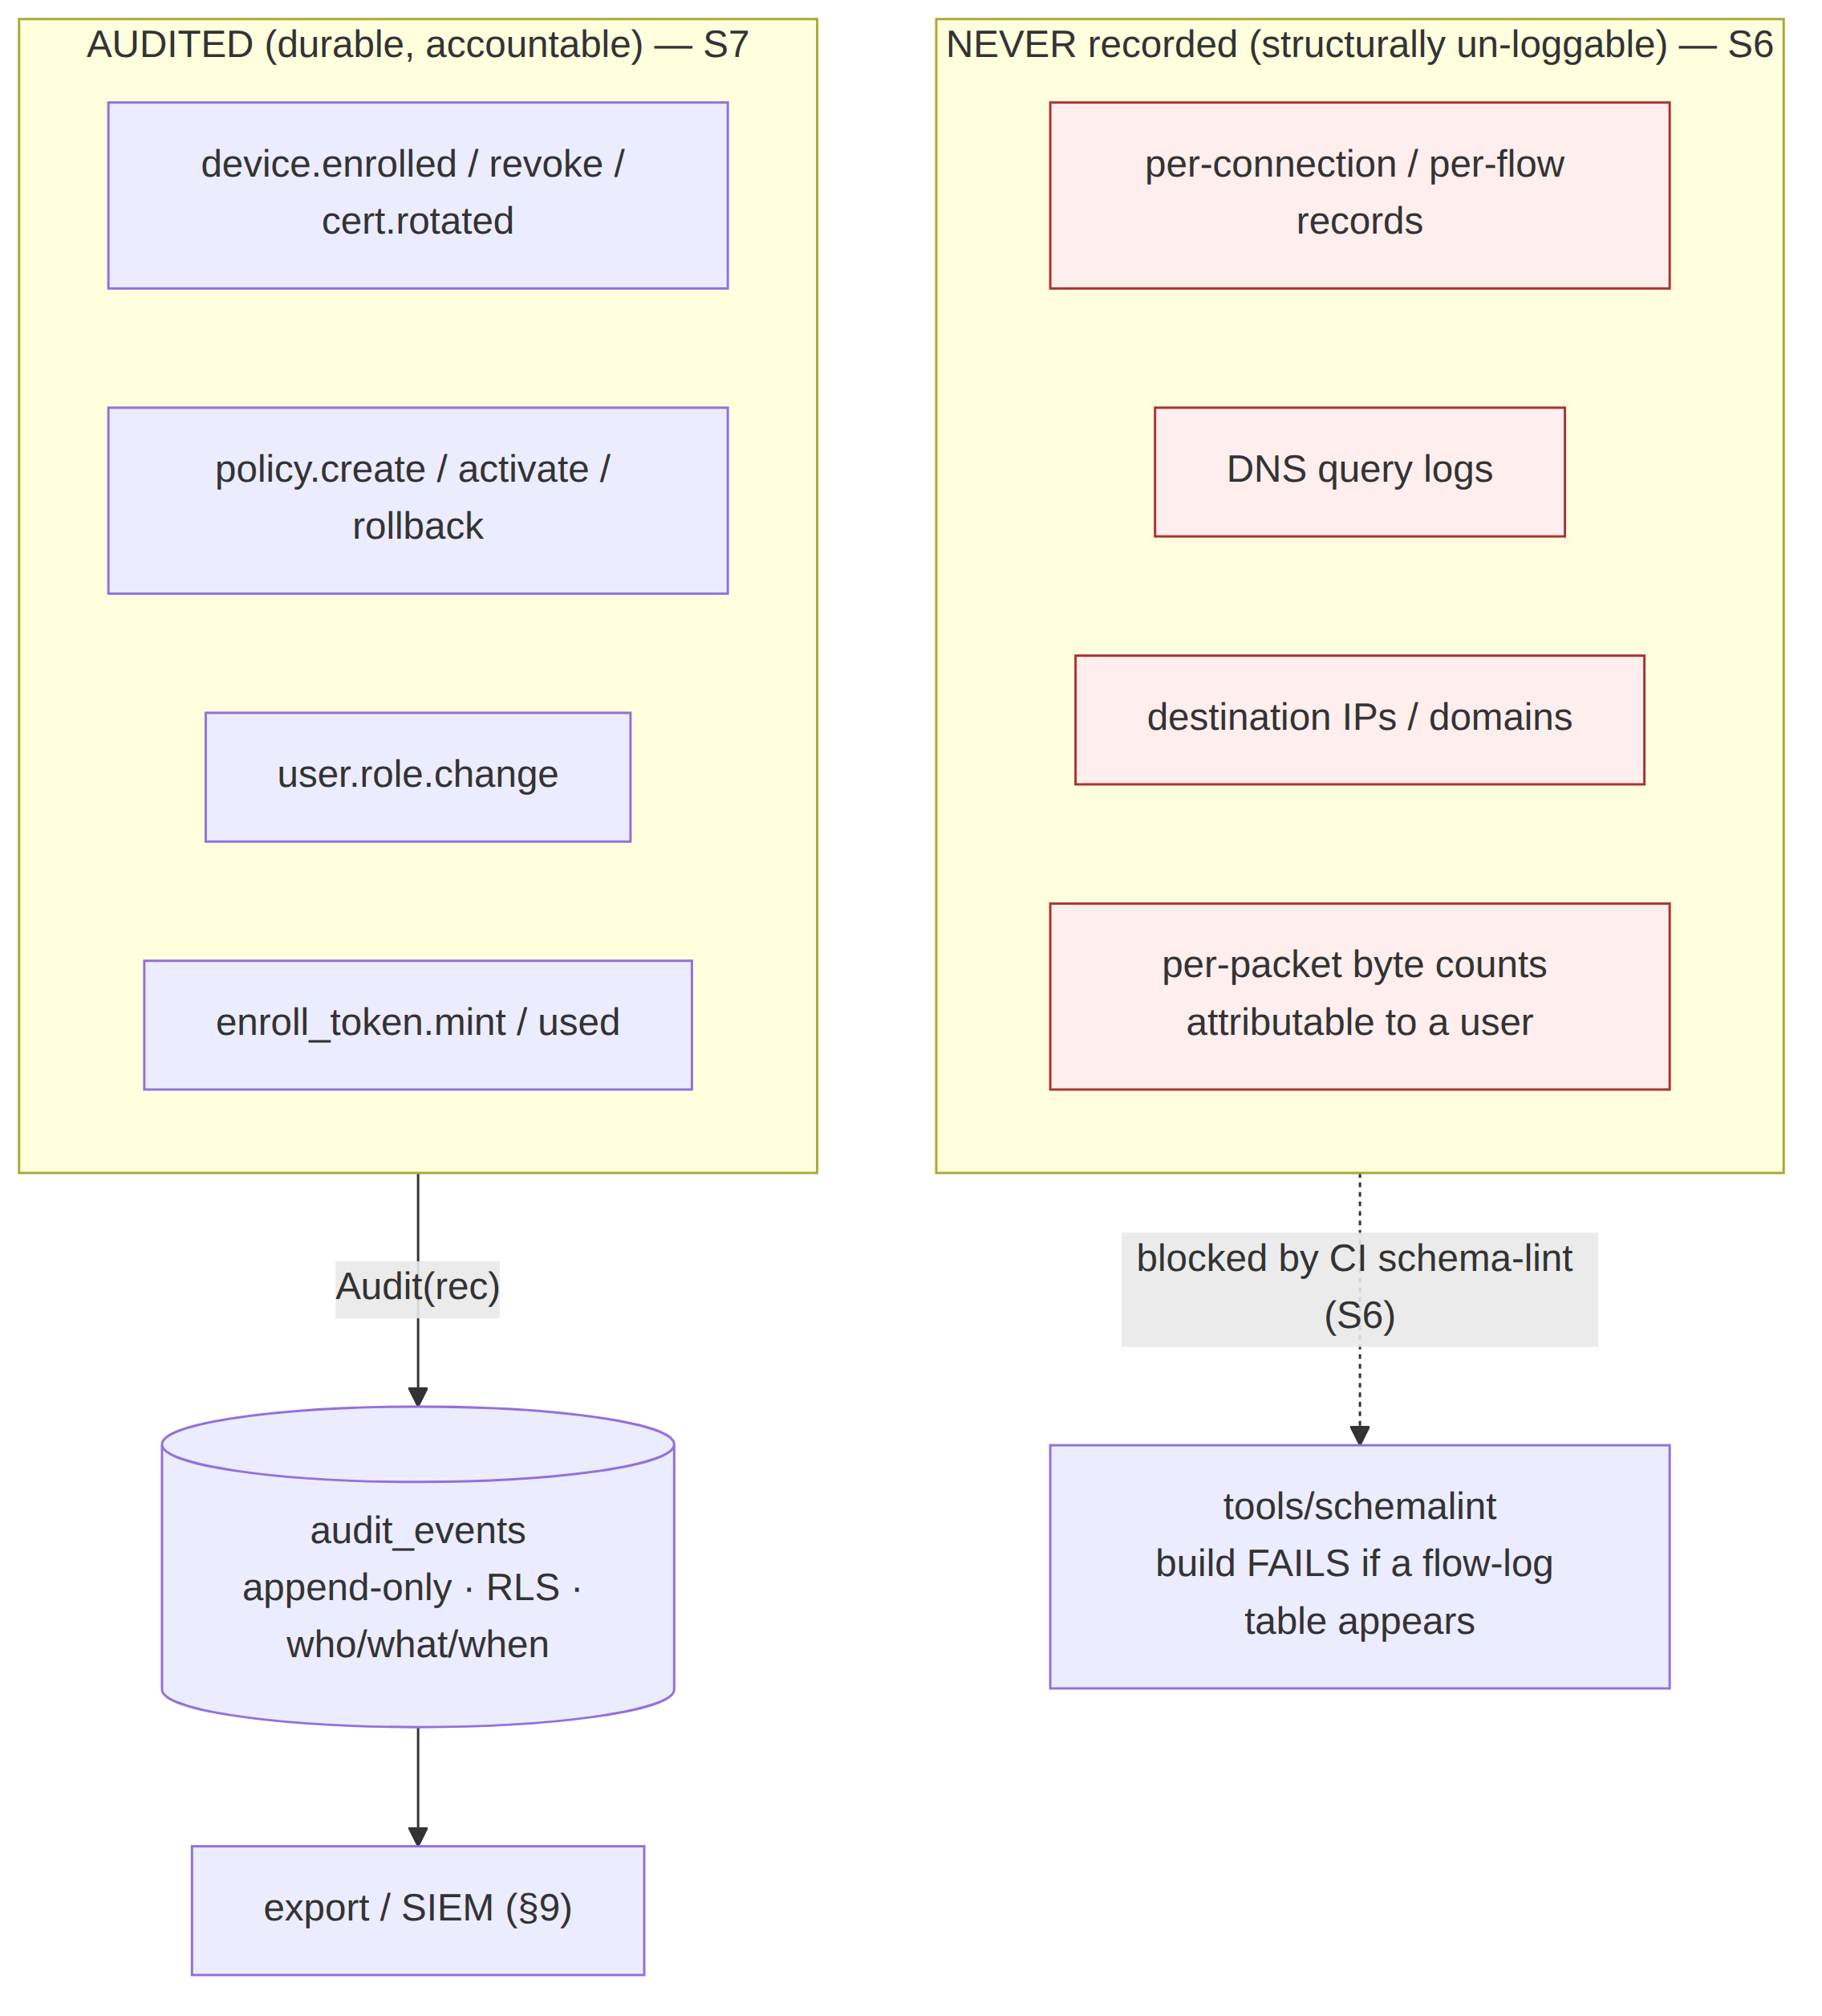

1. The two halves: what is audited, what is structurally un-loggable

1.1 The auditable surface (control actions)
Every state-changing control action is audited [04-SEC §7, svc-telemetry §4]. These are administrative facts about identity, policy, and devices — the actions a tenant admin, an operator, or the system itself takes against the control plane. They are durable, accountable, and tenant-scoped.

1.2 The un-loggable surface (traffic / usage)
The following do not exist as durable records, by construction [04-SEC §6, svc-telemetry §0/§7]:
NOT stored (ever) | Why it cannot be audited
Per-connection records | no connections/sessions durable table exists (lint-enforced)
Per-packet / per-flow records (src, dst, bytes, timestamps) | no flows/packets/traffic table; no src/dst+bytes/ts column shape outside audit_events (lint-enforced)
DNS query logs | no dns_queries table; DNS is resolved inside the tunnel, never recorded
Destination IPs / domains visited | nothing correlates a user to a destination
Anything correlating a user to a destination | the schema cannot express it; the lint blocks the build if it appears
The distinction is shape-based, not policy-based: the no-logging-as-code lint (§6) fails the build if any durable table looks like a flow log — a src/dst column and a bytes/ts column outside audit_events is forbidden regardless of intent [svc-telemetry §7.1, 04-SEC §6.2]. You cannot accidentally add traffic logging; the gate catches it before merge.

1.3 The one ephemeral middle: presence
Live online/offline state lives only in Redis with a TTL [svc-telemetry §5, 04_ARCH §4.5]. presence:{tenant}:{device} carries health-only data (current transport + rtt) and never a destination, byte count, or flow. It is never copied to Postgres; devices.last_seen_at is coarse (refreshed at most every 5 min, not per-heartbeat) so even the durable "last seen" cannot reconstruct a session timeline [svc-telemetry §5.1]. Presence is the mechanism that operationalises no-logging: the system knows who is online right now without a durable session table.

2. The control-action audit model

2.1 The write contract (one validated sink)
Every audit row passes through one validated sink so the S6/S7/RLS guarantees hold exactly once [svc-telemetry §4.3]. There are two ingestion paths into the same sink:
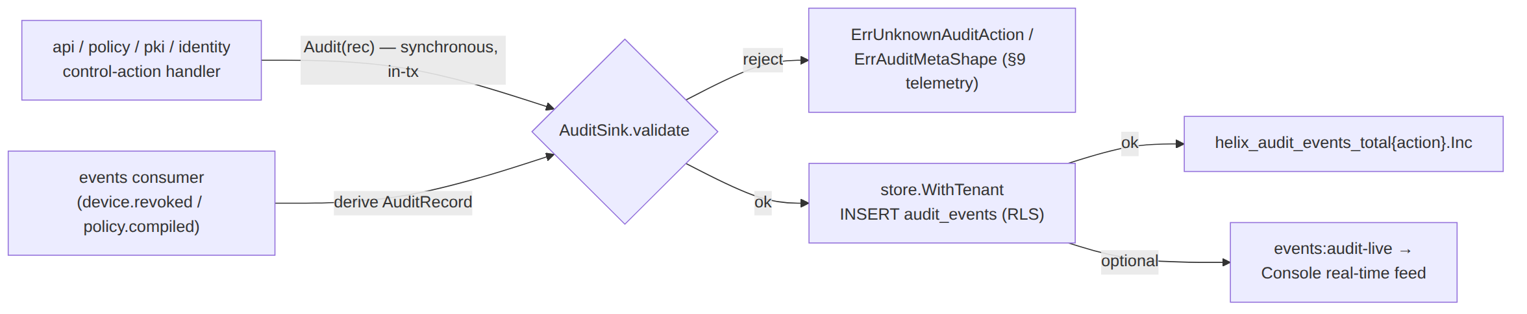
- Synchronous path (authoritative). A handler performing a privileged mutation calls Audit() inside the same transaction as the mutation it records, so a committed policy.activate cannot exist without its audit row — either both land or neither [svc-telemetry §4.3]. This is the primary path and the one the DoD asserts.
- Event-derived path (best-effort enrichment). The events consumer may also derive an audit row from a bus event for Console live-streaming; it is idempotent on (tenant_id, trace_id, action) via a partial unique index, so a double-write collapses to a no-op [svc-telemetry §4.3]. OFF by default in Phase 1.

2.2 Audit fails closed (the accountability guarantee)
If the audit insert is refused — unknown action, forbidden meta shape, or a Postgres write failure — the control action it records is rolled back [svc-telemetry §9]. An unrecordable control action must not proceed un-audited. This asymmetry is deliberate and load-bearing: audit fails closed (no un-audited privileged mutation), while presence fails static (a Redis blip never breaks a tunnel). Conflating them would either lose audit or brick tunnels [svc-telemetry §9].

2.3 Actor binding (who-did-what)
actor is bound by the action's origin [04-SEC §7]:
Action origin | actor value
human (Console / API, OIDC-authenticated) | the OIDC sub / user UUID
automated (scheduled key rotation, reaper) | "system"
agent-initiated control write (device self-action) | the device id
The actor is the identity of the principal that caused the change, captured at the point of the mutation, never inferred later (§11.4.6).

3. The audit_events schema (append-only, tamper-evident)
The DDL is canonical in [svc-telemetry §4.1]; reproduced here with the audit + compliance constraints made explicit.
-- audit_events — owned by store; the WRITE PATH is owned by telemetry [svc-telemetry §4.1]
CREATE TABLE audit_events (
id bigint GENERATED ALWAYS AS IDENTITY PRIMARY KEY,
tenant_id uuid NOT NULL REFERENCES tenants(id) ON DELETE CASCADE,
actor text NOT NULL, -- user id / "system" / device id (§2.3)
action text NOT NULL, -- closed vocabulary (§4)
target text, -- opaque id (device / policy version / connector)
ts timestamptz NOT NULL DEFAULT now(), -- WHEN
meta jsonb -- small; lint-checked shape (no traffic keys, §6.3)
);
CREATE INDEX ON audit_events (tenant_id, ts DESC);
-- (S7) There is NO ip/port/bytes/dst column on this table — by design [svc-telemetry §1.1].
-- (C8) RLS: FORCE ROW LEVEL SECURITY + tenant_isolation, identical to every tenant table.
-- The sink writes ONLY through store.WithTenant — never raw db.Exec.
-- APPEND-ONLY is a GRANT, not a trigger (simplest mechanical guarantee):
REVOKE UPDATE, DELETE ON audit_events FROM helix_app;
-- → an audit row cannot be mutated or erased by the request-path role.
-- Retention pruning (if ever enabled) runs as the out-of-band helix_sys role, not request-path.

3.1 Who/what/when — the three audit facts
Fact | Column | Notes
WHO | actor (+ tenant_id scope) | the principal that caused the change (§2.3)
WHAT | action (closed vocab §4) + target (opaque id) + meta (small JSON) | never a traffic descriptor — the meta shape guard (§6.3) blocks src_ip/dst_ip/bytes keys
WHEN | ts (timestamptz, server clock) | append-only; the row's id is monotonic

3.2 Append-only enforcement
REVOKE UPDATE, DELETE ON audit_events FROM helix_app is the mechanical append-only guarantee [svc-telemetry §4.1]: the request-path role cannot mutate or erase an audit row. This is simpler and harder to bypass than an UPDATE/DELETE trigger — the privilege is simply absent. Retention pruning, if ever enabled, runs as a separate out-of-band role (helix_sys) on a schedule, never from request handling (§8).

3.3 Tamper-evidence (Phase 2, UNVERIFIED as MVP)
Phase 2 reserves an optional hash-chained audit: each row carries meta.prev_hash = H(prev_row) so a deletion or reorder breaks the chain and is detectable [04-SEC §7]. This is UNVERIFIED / not-MVP — Phase 1 ships the append-only grant (§3.2) as the tamper-resistance floor; the hash chain is the additive tamper-evidence upgrade, not claimed for MVP. Stating it now reserves the meta.prev_hash key so the schema need not change later (§11.4.6 — the additive seam is documented, the capability is not claimed present).

4. The closed control-action taxonomy
Audit covers control actions only, drawn from a closed Go enum [svc-telemetry §4.2, 04-SEC §7]. A closed set is the mechanical guarantee that audit never silently grows toward traffic logging — a typo cannot mint a new high-cardinality value, and the action Prometheus label + the lint allow-list stay bounded.
// internal/telemetry — the closed AuditAction vocabulary [svc-telemetry §4.2]
type AuditAction string
const (
ActionDeviceEnrolled AuditAction = "device.enrolled"
ActionDeviceRevoked AuditAction = "device.revoke"
ActionDeviceCertIssued AuditAction = "device.cert.issued"
ActionDeviceCertRotated AuditAction = "device.cert.rotated"
ActionPolicyCreated AuditAction = "policy.create"
ActionPolicyActivated AuditAction = "policy.activate"
ActionPolicyRolledBack AuditAction = "policy.rollback"
ActionConnectorAttached AuditAction = "connector.attached"
ActionPrefixesChanged AuditAction = "connector.prefixes.changed"
ActionEnrollTokenMinted AuditAction = "enroll_token.mint"
ActionEnrollTokenUsed AuditAction = "enroll_token.used"
ActionTenantCreated AuditAction = "tenant.create"
ActionUserRoleChanged AuditAction = "user.role.change"
ActionAuthLogin AuditAction = "auth.login" // login (control-action audit)
ActionAuthEnrollDenied AuditAction = "auth.enroll.denied" // rejected enroll (abuse signal)
)
// Audit() rejects any Action not in this closed set with ErrUnknownAuditAction (§9 telemetry).
Reconciled (§11.4.35, 2026-06-26) — D-AC-1: auth.login + auth.enroll.denied adopted into the AuditAction enum. The master security doc §7 and this taxonomy both list auth.login and auth.enroll.denied; they are now adopted enum members in the canonical closed set [svc-telemetry §4.2] (the superset source of truth) and mirrored here — no longer an open reconciliation item. They are legitimate control-action audits (a login, a rejected enroll), never traffic; adopting them is an additive enum extension (the closed set + lint allow-list grow together), so audit still cannot silently drift toward traffic logging.

4.1 The taxonomy mapped to compliance categories
Category | Actions | Why it matters for compliance
Identity lifecycle | device.enrolled, device.revoke, enroll_token.mint, enroll_token.used, tenant.create | accountability for who joined / left the network (access-management evidence)
Credential lifecycle | device.cert.issued, device.cert.rotated | evidence that short-lived certs are issued/rotated per policy (S4)
Policy lifecycle | policy.create, policy.activate, policy.rollback | accountability for who changed access rules (change-management evidence)
Topology lifecycle | connector.attached, connector.prefixes.changed | accountability for what networks were exposed
Authorisation | user.role.change | accountability for privilege grants (least-privilege evidence)
Authentication | auth.login, auth.enroll.denied | accountability for who authenticated + a rejected-enroll abuse signal (access-management evidence)
Every one of these is an administrative fact. None describes user traffic — which is the point: the audit trail is complete for control actions precisely because control actions are the only sensitive events that durably exist.

5. A sample audit record
A concrete device.revoke row, showing the who/what/when shape and the deliberate absence of any traffic descriptor:
{
"id": 84213,
"tenant_id": "8f2c1e10-3a4b-4c5d-9e6f-0a1b2c3d4e5f",
"actor": "u-7b3d9a02-1f44-4e88-bc21-9d0e6f4a55c1", // OIDC sub of the admin who revoked
"action": "device.revoke",
"target": "dev-c19a77e4-2b8f-4a31-8e0c-6f2d1a9b3c44", // the revoked device id (opaque)
"ts": "2026-06-25T11:42:07.318Z",
"meta": {
"reason": "lost-device", // small, bounded, NO traffic keys (§6.3 shape guard)
"trace_id": "01J9X7QH3K…", // correlates to the originating event Envelope.trace_id
"cert_serial": "5e:3a:9c:…" // the blacklisted cert serial (identity, not traffic)
}
}
What this record does not contain — and structurally cannot — is any destination, domain, byte count, or flow attributable to the revoked device. The meta shape guard (§6.3) rejects a row whose meta carries a dst_ip/bytes_in/payload-class key with ErrAuditMetaShape [svc-telemetry §4.4]. The record answers "who revoked which device, when, and why" — and nothing about what that device ever did.

5.1 What a reader can and cannot reconstruct
Question | Answerable from audit_events?
"Who revoked device X, and when?" | ✅ yes — actor + ts
"Which admin activated policy version N?" | ✅ yes — policy.activate row
"When was device X enrolled, and with what token?" | ✅ yes — device.enrolled + enroll_token.used rows (correlated by trace_id)
"What sites did the user behind device X visit?" | ❌ structurally impossible — no such data exists (S6)
"How many bytes did device X transfer to host Y?" | ❌ structurally impossible — only aggregate, non-attributable counters exist [svc-telemetry §3]

6. No-logging-as-code — the negative guarantee that IS the compliance feature
The privacy promise is a build property, enforced by absence and by a CI lint, not by an operator's good intentions [04-SEC §6, svc-telemetry §7]. It is the single most important compliance feature: a VPN that cannot produce a connection log cannot be compelled to hand one over, and minimises personal data to nothing.

6.1 What is and is not stored
Stored (durable, Postgres) | NOT stored (ever)
Identity: tenants, users, devices (pubkey, overlay IP, coarse last_seen_at) | Per-connection records
Topology: connectors, advertised prefixes, groups | Per-packet / per-flow records (src, dst, bytes, timestamps)
Policy: spec + compiled rules | DNS query logs
device_certs, enroll_tokens (hashed) | Destination IPs / domains visited
audit_events (control actions only, §2–§5) | Traffic content or metadata of any kind
Aggregate counters (handshakes, bytes-total, errors — Prometheus) | Anything correlating a user to a destination

6.2 The CI schema-lint (mechanical enforcement)
A schema test fails the build if a durable table appears that is shaped like a connection log [svc-telemetry §7.1, 04-SEC §6.2, no-log]: a forbidden table name (connections/flows/traffic/packets/sessions/dns_queries/…), OR any table with both a src/dst-type column and a bytes/ts-type column outside audit_events. It parses both the migration SQL (static) and the live information_schema (dynamic), so a table that drifts into the DB without a migration is also caught. The privacy promise is enforced by tooling, not trust.

6.3 The meta-shape guard (closing the back door)
Audit could become a traffic log through the back door if a handler stuffed a destination into meta.jsonb. AuditSink.validate runs a meta shape check before insert: the JSON keys are matched against the same forbidden-column regex the schema-lint uses, so a control-action audit carrying a dst_ip/bytes_in/payload/sni_host key is rejected with ErrAuditMetaShape [svc-telemetry §4.4]. The bound (maxMetaKeys, default 16) also caps the blob. This closes the "log traffic inside meta" evasion of S6.

6.4 Self-validating the lint (§11.4.107(10), §1.1)
The lint is itself anti-bluff: a paired meta-test plants a CREATE TABLE flows(src inet, dst inet, bytes bigint, ts timestamptz) migration and asserts the lint FAILs; removing it asserts it passes [04-SEC §6.2, svc-telemetry §7.2]. An analyzer that PASSes its golden-bad fixture is a bluff gate. Wired as a runtime signature (§11.4.108), the lint also runs against the deployed DB post-deploy, proving S6 is active, not merely promised at build time [svc-telemetry §7.2].

7. Compliance posture
The no-traffic-logs stance is a privacy feature first and a compliance feature as a direct consequence. This section maps the design to the standard frameworks — and §11 draws the honest line between what the code guarantees and what a certification would require.

7.1 GDPR — data minimisation by construction
GDPR principle (Art. 5) | How the design satisfies it | Mechanism
Data minimisation (5(1)(c)) | The anonymous-mode device has email=NULL, oidc_sub=NULL; no traffic is recorded; presence is ephemeral | [04-SEC §2.2] anonymous enroll tokens; §6 no-logging; [svc-telemetry §5] TTL presence
Storage limitation (5(1)(e)) | Presence self-expires (TTL); last_seen_at is coarse; audit is low-volume control-only; optional operator-driven prune (§8) | [svc-telemetry §5.1] TTL; §8 retention
Purpose limitation (5(1)(b)) | The only durable personal-ish data (audit actor) exists solely for administrative accountability, not profiling | §2–§5 control-action-only audit
Integrity & accountability (5(1)(f), 5(2)) | Append-only audit (§3.2) provides accountability for control actions; RLS isolates tenants | §3, [svc-telemetry §4.1 RLS]
Right to erasure (Art. 17) | Anonymous mode stores no PII to erase; for managed tenants, helixvpnctl audit prune --before + tenant deletion cascade | §8, [svc-telemetry §4.1]
The strongest GDPR position is the anonymous mode ("account number, no PII" [04-SEC §2.2]): a device obtains identity + a cert with no email and no SSO, so there is no personal data to minimise, retain, or erase — the data-protection problem is dissolved, not managed. UNVERIFIED: whether a given deployment qualifies for a specific GDPR posture depends on the operator's own processing (e.g. a managed tenant that does collect email) — the code minimises by construction; the deployment's GDPR compliance is the operator's determination, not a property this spec can certify (§11).

7.2 SOC2-style control mapping (Trust Services Criteria)
This maps the design to SOC2 TSC categories. It is a control mapping, not a SOC2 attestation — a real SOC2 report requires an independent auditor and operational evidence over a period, which is UNVERIFIED and out of scope for the code (§11).
TSC area | Control the design provides | Evidence artefact
Security / Access (CC6) | Zero-trust default-deny (S1); short-lived device certs (S4); RBAC + RLS defence-in-depth | policy compiler output; device_certs; audit_events user.role.change
Change management (CC8) | Every policy change is audited (policy.create/activate/rollback) and atomically tied to its mutation | audit_events policy rows; §2.1 in-tx write
Logical access provisioning/deprovisioning | Enrollment + revocation are audited; revocation is sub-second (S5) | device.enrolled/device.revoke rows; revocation pipeline [04-SEC §4.6]
Monitoring (CC7) | Aggregate health/SLO metrics + control-action audit; live audit feed | Prometheus series [svc-telemetry §3]; events:audit-live
Confidentiality (C1) | No traffic logs to disclose; tenant isolation via RLS; CA key as the one protected secret (S11) | §6 no-logging lint; RLS; §10 secrets
Privacy (P-series) | Data-minimisation-by-construction; no destination/usage data | §6; §7.1

7.3 The no-traffic-logs stance as a feature, not just a compliance checkbox
The design treats "we keep no logs" as a product feature with a mechanical proof, not a privacy-policy paragraph: the CI lint (§6.2) and its runtime signature (§6.4) mean an operator (or an auditor, or a court order) can be shown that no connection-log table exists in the deployed schema. This is the difference between a claimed no-logs VPN (a promise in prose) and a provable one (a green schema-lint against the live DB). The honest limit (§11): the lint proves the durable schema carries no flow log; it does not prove an operator did not run an out-of-band packet capture on the host — that is an operational control, not a code property (§11.2).

8. Retention & erasure
Data class | Retention | Mechanism
Presence (Redis) | PRESENCE_TTL (default 45 s) | self-expires; never durable [svc-telemetry §5.1]
last_seen_at (Postgres) | coarse, overwritten | refreshed at most every 5 min; cannot reconstruct a timeline [svc-telemetry §5.1]
audit_events | Phase 1 default: no auto-prune (control-action audit is low-volume + operator-valuable) | append-only grant (§3.2); operator-driven prune below
Aggregate counters (Prometheus) | per the operator's Prometheus retention | non-attributable; not personal data
Traffic / flows / DNS | never stored | structurally impossible (§6)

8.1 Operator-driven erasure
Phase 1 ships no automatic audit pruning — control-action audit is the operator's accountability record [svc-telemetry §4.1]. A documented, operator-driven path exists for GDPR-style erasure:
helixvpnctl audit prune --before <ts> # runs as the out-of-band helix_sys role, NOT request-path
Tenant deletion cascades (ON DELETE CASCADE on tenant_id), so deleting a tenant erases its audit rows. Erasure is operator-initiated and audited as an administrative action — never silent, never request-path (§11.4.122 — removing existing records is operator-confirmed). The choice of a retention period for a given deployment is the operator's compliance determination, surfaced not silently chosen (§11.4.66).

9. Export / SIEM integration
Enterprises integrating HelixVPN into a wider security posture need audit events in their SIEM. The export model carries only the control-action audit — never traffic, because none exists.

9.1 Export surfaces
Surface | Shape | Auth | Notes
GET /v1/audit (REST, tenant-scoped) | paginated audit_events JSON | RBAC: admin/operator (member denied) | RLS floor: a mis-scoped query returns only the caller's tenant [svc-telemetry §4.5]
events:audit-live (WS/SSE) | real-time audit stream to the Console / a SIEM forwarder | RBAC + tenant scope | the live security feed [04-SEC §7, svc-telemetry §4.3]
Aggregate /metrics (Prometheus) | helix_audit_events_total{action} counts only | scrape-network only (mTLS / allow-list) | carries no audit content — only the aggregate count [svc-telemetry §4.5/§8.3]

9.2 What export must never carry
- No traffic. There is no flow/DNS/destination data to export — the export is complete precisely because the un-loggable surface (§1.2) is empty.
- No cross-tenant leakage. Every export path runs through RLS (store.WithTenant); the Prometheus surface carries no tenant_id label (it would leak tenant population and be unbounded) [svc-telemetry §3.1]. Per-tenant counts, if ever needed, live behind the authenticated REST /v1/stats, never /metrics.
- No secrets. Audit meta is shape-guarded (§6.3); credentials never appear in an audit row (§10).

9.3 SIEM forwarding pattern
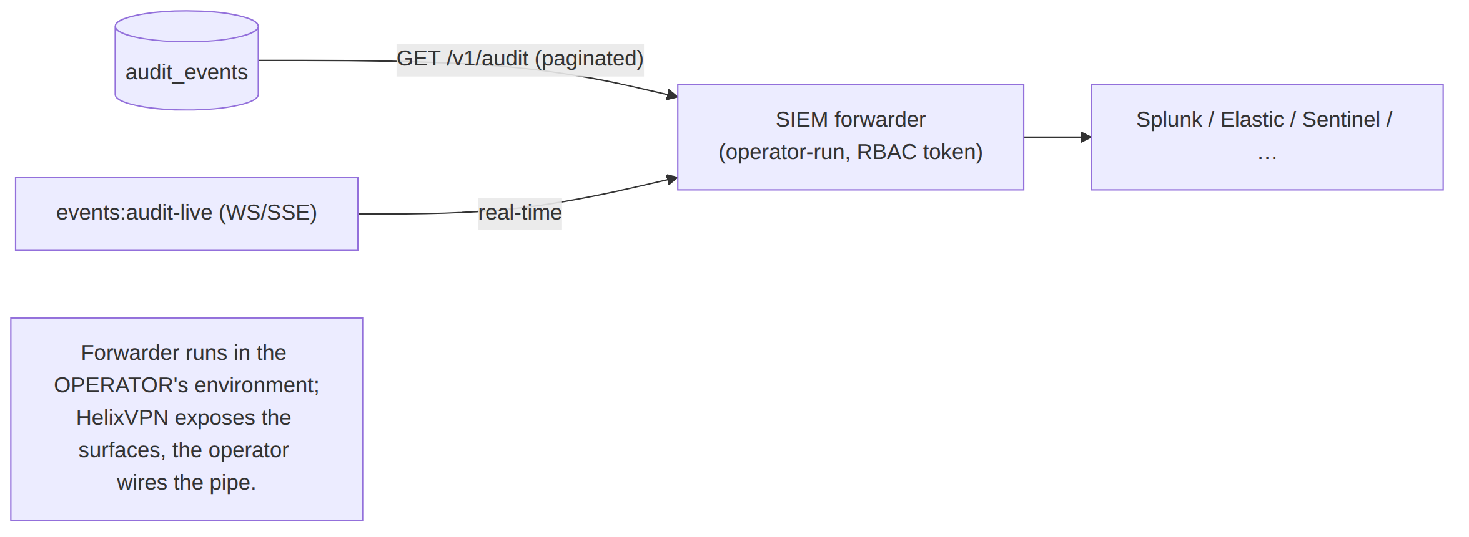
The forwarder is operator-run in the operator's own SIEM environment; HelixVPN exposes the RBAC-gated surfaces, the operator wires the integration. UNVERIFIED: no specific SIEM connector ships in MVP — the export is generic JSON over REST/WS, and a named connector (Splunk HEC, Elastic ECS mapping) is a Phase-2 additive item, not claimed for MVP (§11.4.6).

10. Credentials, supply chain & the no-remote-CI context
Two cross-cutting constitution bindings frame the compliance posture; both are stated for completeness because they bound what the audit/export surfaces may carry and how the build is trusted.

10.1 Credentials handling (§11.4.10)
- The CA root key and Postgres are the only secrets to protect (S11 [04-SEC §0.1/§11]). In the KMS-backed deployment the CA private key is never in process memory — signing is delegated to KMS/HSM [04-SEC §4.7].
- No credential ever appears in an audit row, a metric, a log line, or an export. Audit meta is shape-guarded (§6.3); the telemetry write path redacts; enroll-token plaintext is stored only as an Argon2id hash and shown exactly once [04-SEC §2.2]. A credential reaching audit_events.meta would be both a §11.4.10 leak and an ErrAuditMetaShape rejection.
- Credentials live in gitignored config (.env / secrets/) per §11.4.10; the audit trail records that a token was minted/used (enroll_token.mint/used), never the token value.

10.2 The no-remote-CI context (§11.4.156)
All server-side CI/CD automation is disabled — no GitHub Actions / GitLab pipeline runs on push [§11.4.156]. The no-logging-as-code lint (§6.2), the audit-sink tests (§12), and the schema-lint runtime signature (§6.4) therefore run as the local pre-build + pre-tag ritual (§11.4.40 / §11.4.75 local hooks), not on a remote runner. The compliance consequence: the proof that no connection-log table exists is generated locally and captured as evidence before a tag, not delegated to a cloud CI whose logs would themselves be a data surface. This keeps the build-trust story entirely within the operator's controlled environment — itself a small supply-chain hardening (the build pipeline is not a third party with access to the schema). UNVERIFIED: the broader supply-chain controls (signed images via cosign, SBOM, reproducible builds) are Phase-3 items [04-SEC §5.4], not MVP-claimed.

11. Honest boundary — designed-in vs aspirational
§11.4.6 forbids claiming a compliance certification as if it were a code property. This ledger is the explicit line between what the code mechanically guarantees and what is aspirational / UNVERIFIED (requires an external audit, an operator determination, or a Phase-2/3 deliverable).
Claim | Status | Why
No durable connection/traffic log exists in the schema | ✅ designed-in, mechanically proven | CI schema-lint (§6.2) + runtime signature against the deployed DB (§6.4); golden-bad self-validation (§6.4)
Control actions are audited atomically with their mutation | ✅ designed-in | in-tx synchronous audit (§2.1); fails-closed (§2.2)
Audit is append-only (request-path cannot mutate/erase) | ✅ designed-in | REVOKE UPDATE,DELETE grant (§3.2)
Anonymous mode stores no PII | ✅ designed-in | email/oidc_sub = NULL [04-SEC §2.2]
Data-minimisation (GDPR Art. 5(1)(c)) by construction | ✅ designed-in at the schema level | §6, §7.1
Tamper-evident (hash-chained) audit | ⚠️ UNVERIFIED / Phase 2 | §3.3 — MVP ships append-only grant, not the hash chain
auth.login / auth.enroll.denied are audited | ✅ designed-in — reconciled 2026-06-26 | §4 — both adopted as regular closed-enum members (D-AC-1 resolved, option A); no longer an open reconciliation item
"HelixVPN is GDPR compliant" | ⚠️ aspirational — operator determination | the code minimises data; a deployment's GDPR compliance depends on the operator's own processing (§7.1)
"HelixVPN is SOC2 certified" | ⚠️ aspirational — requires an independent audit | §7.2 is a control mapping, not an attestation; a SOC2 report needs an auditor + operational evidence over a period
A named SIEM connector (Splunk/Elastic) ships | ⚠️ UNVERIFIED / Phase 2 | §9.3 — MVP exposes generic REST/WS; connectors are additive
The lint proves no operator-side packet capture occurs | ❌ out of scope | §7.3 — the lint proves the durable schema; host-level capture is an operational control, not a code property
The discipline: every ✅ is a property a reviewer can verify against the code/schema; every ⚠️ is honestly flagged as needing an external audit, an operator decision, or a future phase — never asserted as if the code certified it (§11.4.6/§11.4.123).

12. Test points (§11.4.169)
Every PASS cites captured evidence (§11.4.5/§11.4.69/§11.4.107); the audit-row trace and the lint exit codes are the captured evidence.
Test id | §11.4.169 codes | What it proves | Captured evidence
AC-1 | UT | AuditSink.validate rejects every non-vocabulary action + every forbidden meta key; accepts the closed set (§4, §6.3) | table-test report (mirrors [svc-telemetry §10] T-UNIT-1)
AC-2 | IT (RLS) | tenant A cannot read tenant B's audit_events even with a crafted query under FORCE ROW LEVEL SECURITY; REVOKE UPDATE,DELETE makes a row immutable (§3.2) | psql transcript (T-STORE-1)
AC-3 | IT | a committed policy.activate always has its audit_events row (atomic tx); a forced insert failure rolls back the activation (§2.1/§2.2) | tx-log evidence (T-INT-2)
AC-4 | SEC+meta-test (§1.1) | the no-logging schema-lint FAILs on a planted flows(src,dst,bytes,ts) migration; PASSes after removal; golden-bad fixture FAILs (self-validation §6.4) | lint exit codes (T-LINT-1)
AC-5 | SEC | runtime signature: the schema-lint runs GREEN against the deployed DB (S6 active, not just promised) (§6.4) | post-deploy lint exit code against live information_schema
AC-6 | SEC | audit_events.meta cannot smuggle dst_ip/bytes (§6.3); GET /v1/audit denied to member; /metrics carries no audit content (§9.2) | scan + RBAC matrix (T-SEC-1)
AC-7 | SEC | no credential appears in any audit row / metric / export (§10.1) | grep-empty proof over a captured audit corpus
AC-8 | E2E+CH | full enroll→revoke→policy drive produces the expected audit rows with correct actor/action/target/ts; a Challenge scores PASS only on the captured audit trace (§11.4.27) | HelixQA autonomous session result.json (T-CHAL-1)
Each meta-test ships a paired §1.1 mutation (e.g. weaken the meta-shape regex → AC-6 must FAIL; remove the REVOKE UPDATE,DELETE → AC-2 immutability must FAIL) so the gates provably cannot bluff [svc-telemetry §10, §11.4.107(10)].

13. Open decisions & cross-doc contracts

13.1 Decisions surfaced (options + recommendation — §11.4.6/§11.4.66)
# | Decision | Option A | Option B | Recommendation
D-AC-1 | auth.login/auth.enroll.denied audit rows | add to the closed enum (MVP) | defer to Phase 2 | ✅ RESOLVED 2026-06-26 — option A adopted (§4 note): both are regular closed-enum members; master §7 aligned to the same taxonomy. No longer open.
D-AC-2 | tamper-evident hash chain | ship in MVP | Phase 2 additive (append-only grant is the MVP floor) | B — §3.3; the meta.prev_hash seam is reserved now, the capability is not claimed for MVP
D-AC-3 | audit retention default | no auto-prune (operator-driven) | a default TTL | A — §8; control-action audit is low-volume + accountability-valuable; the operator chooses a period per their compliance regime
D-AC-4 | SIEM connector | named connector in MVP | generic REST/WS, connectors Phase 2 | B — §9.3; MVP exposes the generic surfaces, a named connector is additive

13.2 Cross-document contracts this document fixes
Contract | Fixed value | Consumed by / source
The auditable-vs-un-loggable taxonomy (S6/S7) | §1 | [04-SEC §6/§7], [svc-telemetry §0/§4]
The closed control-action vocabulary | §4 | [svc-telemetry §4.2] owns the enum; this doc maps it to compliance categories
The audit_events who/what/when + append-only contract | §3 | [svc-telemetry §4.1] owns the DDL/RLS/grant
The compliance-claim honesty ledger (designed-in vs aspirational) | §11 | §11.4.6/§11.4.123 — no certification claimed as a code property
The export/SIEM surface (control-action only, RBAC + RLS, no traffic) | §9 | [svc-telemetry §4.5] (REST RBAC), §3.1 (no PII labels)

Sources verified
- ../04-security-privacy-pki.md [04-SEC] — §0.1 (S6/S7/S11 invariants), §2.2 (anonymous enroll tokens — no-PII / GDPR posture), §4.6 (revocation audited), §5.4 (Phase-3 supply chain), §6 (no-logging-as-code: stored-vs-not table + CI schema-lint + golden-bad self-validation), §7 (control-action-only audit: actions, actor binding, append-only, Phase-2 hash chain, live stream), §11 (CA key + Postgres as the protected secret set).
- ../v03-control-plane/svc-telemetry.md [svc-telemetry] — §0 (audit + presence charter, governs the schema-lint), §1.1 (the AuditRecord shape with NO ip/port/bytes field), §3 (aggregate Prometheus series — the only traffic-derived durable data; no PII labels), §4.1 (audit_events DDL + RLS + REVOKE UPDATE,DELETE append-only grant), §4.2 (closed AuditAction enum), §4.3 (synchronous in-tx
  - idempotent event-derived ingestion), §4.4 (meta-shape guard / ErrAuditMetaShape), §4.5 (audit-read RBAC; /metrics carries no audit content), §5 (TTL presence operationalises no-logging; coarse last_seen_at), §7 (no-logging-as-code lint + runtime signature + golden-bad self-validation), §9 (audit fails closed, presence fails static), §10 (test matrix).
- The no-logging-as-code sibling [no-log] — the CI schema-lint governed by [svc-telemetry §7]: static + live information_schema parse, forbidden-table/column regex, allow-list, meta-shape guard, paired §1.1 mutation, post-deploy runtime signature (§6.2/§6.4).
- kill-switch-and-dns-leak.md — the sibling leak-proofing this audit/compliance posture supports (a dropped tunnel never persists a connection log; §1.3 presence is ephemeral).
Constitution: §11.4.44 (revision header), §11.4.6/§11.4.66/§11.4.123 (decisions = options + recommendation; UNVERIFIED/aspirational never asserted as a code property — the §11 honesty ledger), §11.4.10 (credentials never in an audit row/metric/export — §10.1), §11.4.156 (no remote CI — local pre-build/pre-tag proof of the no-logging lint — §10.2), §11.4.122 (audit erasure operator-confirmed, never silent — §8.1), §11.4.69/§11.4.107/§11.4.107(10) (captured audit-trace + lint-exit evidence; self-validated lint), §1.1 (paired mutations — §12). SPEC-ONLY — describes what to build, does not build it.
End of nano-detail specification — Volume 5 (Security & Privacy), audit-and-compliance.md. Pairs with kill-switch-and-dns-leak.md (the leak-proofing that keeps the no-traffic-logs stance honest at the data plane), the master security doc §6/§7 (the S6/S7 invariants it deepens), and ../v03-control-plane/svc-telemetry.md (the audit_events write path + the no-logging schema-lint it synthesises).

