Identity & Enrollment — the key-never-leaves invariant

Identity & Enrollment — the key-never-leaves invariant
Revision: 2 Last modified: 2026-06-26T12:00:00Z
Master technical specification — Volume 5 (Security & Privacy), nano-detail document identity-and-enrollment. Deepens the identity + enrollment slice of the security spine [04-security-privacy-pki.md §2–§3] from a security-and-privacy lens: the identity model (tenants, users, SSO via OIDC, anonymous device tokens for privacy-VPN mode), the device-enrollment protocol and its load-bearing invariant — the device private key is generated on the device and NEVER leaves it (S2, "the key-never-leaves invariant") — the OIDC Authorization-Code + PKCE integration and claim→role binding, the anonymous device-token (account-number, no-PII) path, and re-enrollment + device revocation. SPEC ONLY — it describes the security properties the build must have; it builds nothing. This document is the security/privacy contract; the control-plane mechanics (Go interfaces, DDL/RLS, atomic single-use consumption) live in [v03-control-plane/svc-identity.md], the cert lifecycle in [v03-control-plane/svc-pki.md] and the sibling [pki-and-certs.md], and the threat justification in the sibling [threat-model.md]. Sources cited inline by id: [04_ARCH §N] (HelixVPN-Architecture-Refined.md), [04_P1 §N] (HelixVPN-Phase1-MVP.md), [research-pki_pq_nat] (the cited PKI/PQ/NAT research), [SYNTHESIS §N], and sibling specs by filename. Invariant ids S1–S11 are those of [04-security-privacy-pki.md §0.1]; threat ids T-*/LP-* are those of [threat-model.md]. Any claim not grounded in the evidence base is flagged UNVERIFIED per constitution §11.4.6 — never fabricated; any measured-latency figure is stated as a target, never a result.

Table of contents
- 0. Position, ownership & the invariants this document guards
- 1. The identity model — two postures, one device spine
- 2. The key-never-leaves invariant (S2)
- 3. Device enrollment — the protocol
- 4. OIDC SSO integration — managed posture
- 5. Anonymous device-token path — the privacy posture
- 6. Enroll-token security
- 7. Re-enrollment & device revocation
- 8. Threat mapping — what enrollment defends
- 9. Test & validation mapping (§11.4.169)
- 10. Phase-2 forward seams
- Sources verified

0. Position, ownership & the invariants this document guards
Enrollment is the single most security-critical protocol in HelixVPN: it mints a network identity for a brand-new device without that device ever surrendering its WireGuard private key and without an unauthenticated party being able to enroll [04_P1 §6.2]. Every other security property — zero-trust routing, sub-second revocation, no-logging — assumes the identity established here is sound. This document owns the security/privacy contract of that protocol; it cites, never re-defines, the control-plane wiring.

0.1 What this document owns vs. references
Concern | Owner | Relationship here
Identity model security properties (what an attacker can/cannot do) | this doc | authoritative
The key-never-leaves invariant (S2) and its proof obligations | this doc | authoritative
Enrollment protocol security (anti-replay, PoP, no-PII path) | this doc | authoritative
OIDC security (PKCE, JWKS pinning, nonce/state, claim→role trust) | this doc | authoritative
Identity Go interface, DDL/RLS, atomic token consumption | [v03-control-plane/svc-identity.md] | referenced
Cert issuance / CSR signing / cert lifecycle | [v03-control-plane/svc-pki.md], [pki-and-certs.md] | referenced
Overlay-IP allocation, device rows, presence | ipam/registry (Volume 3) | referenced
Threat justification (STRIDE/LINDDUN rows) | [threat-model.md] | referenced

0.2 The invariants this document is the guardian of
# | Invariant (verbatim from [04-security-privacy-pki.md §0.1]) | This doc's role
S2 | Device private keys never leave the device. The control plane only ever sees the 32-byte Curve25519 public key. | §2 is the full proof obligation set
S4 | Short-lived control-channel mTLS. Every agent authenticates with a ≤24 h device cert. | §3.4 mints it; lifecycle in [pki-and-certs.md]
S5 | Revocation latency == convergence SLO (p99 < 1 s, a TARGET). | §7.2 originates the cascade
S11 | The CA root + Postgres are the only secrets to protect. | §6 keeps enroll-token plaintext out of the store
— | Anonymous-by-default for end users (Mullvad "account number, no PII"). | §5 is the no-PII path
A violation of any is a release blocker (§11.4.169 / the §11.4 anti-bluff covenant), not a tunable.

1. The identity model — two postures, one device spine
HelixVPN ships two identity postures that bind to the same devices table and the same cert chain [04_P1 §6.1]. The posture decides how a human (or none) is associated with a device; it does not change the cryptographic device-enrollment spine (§2–§3).
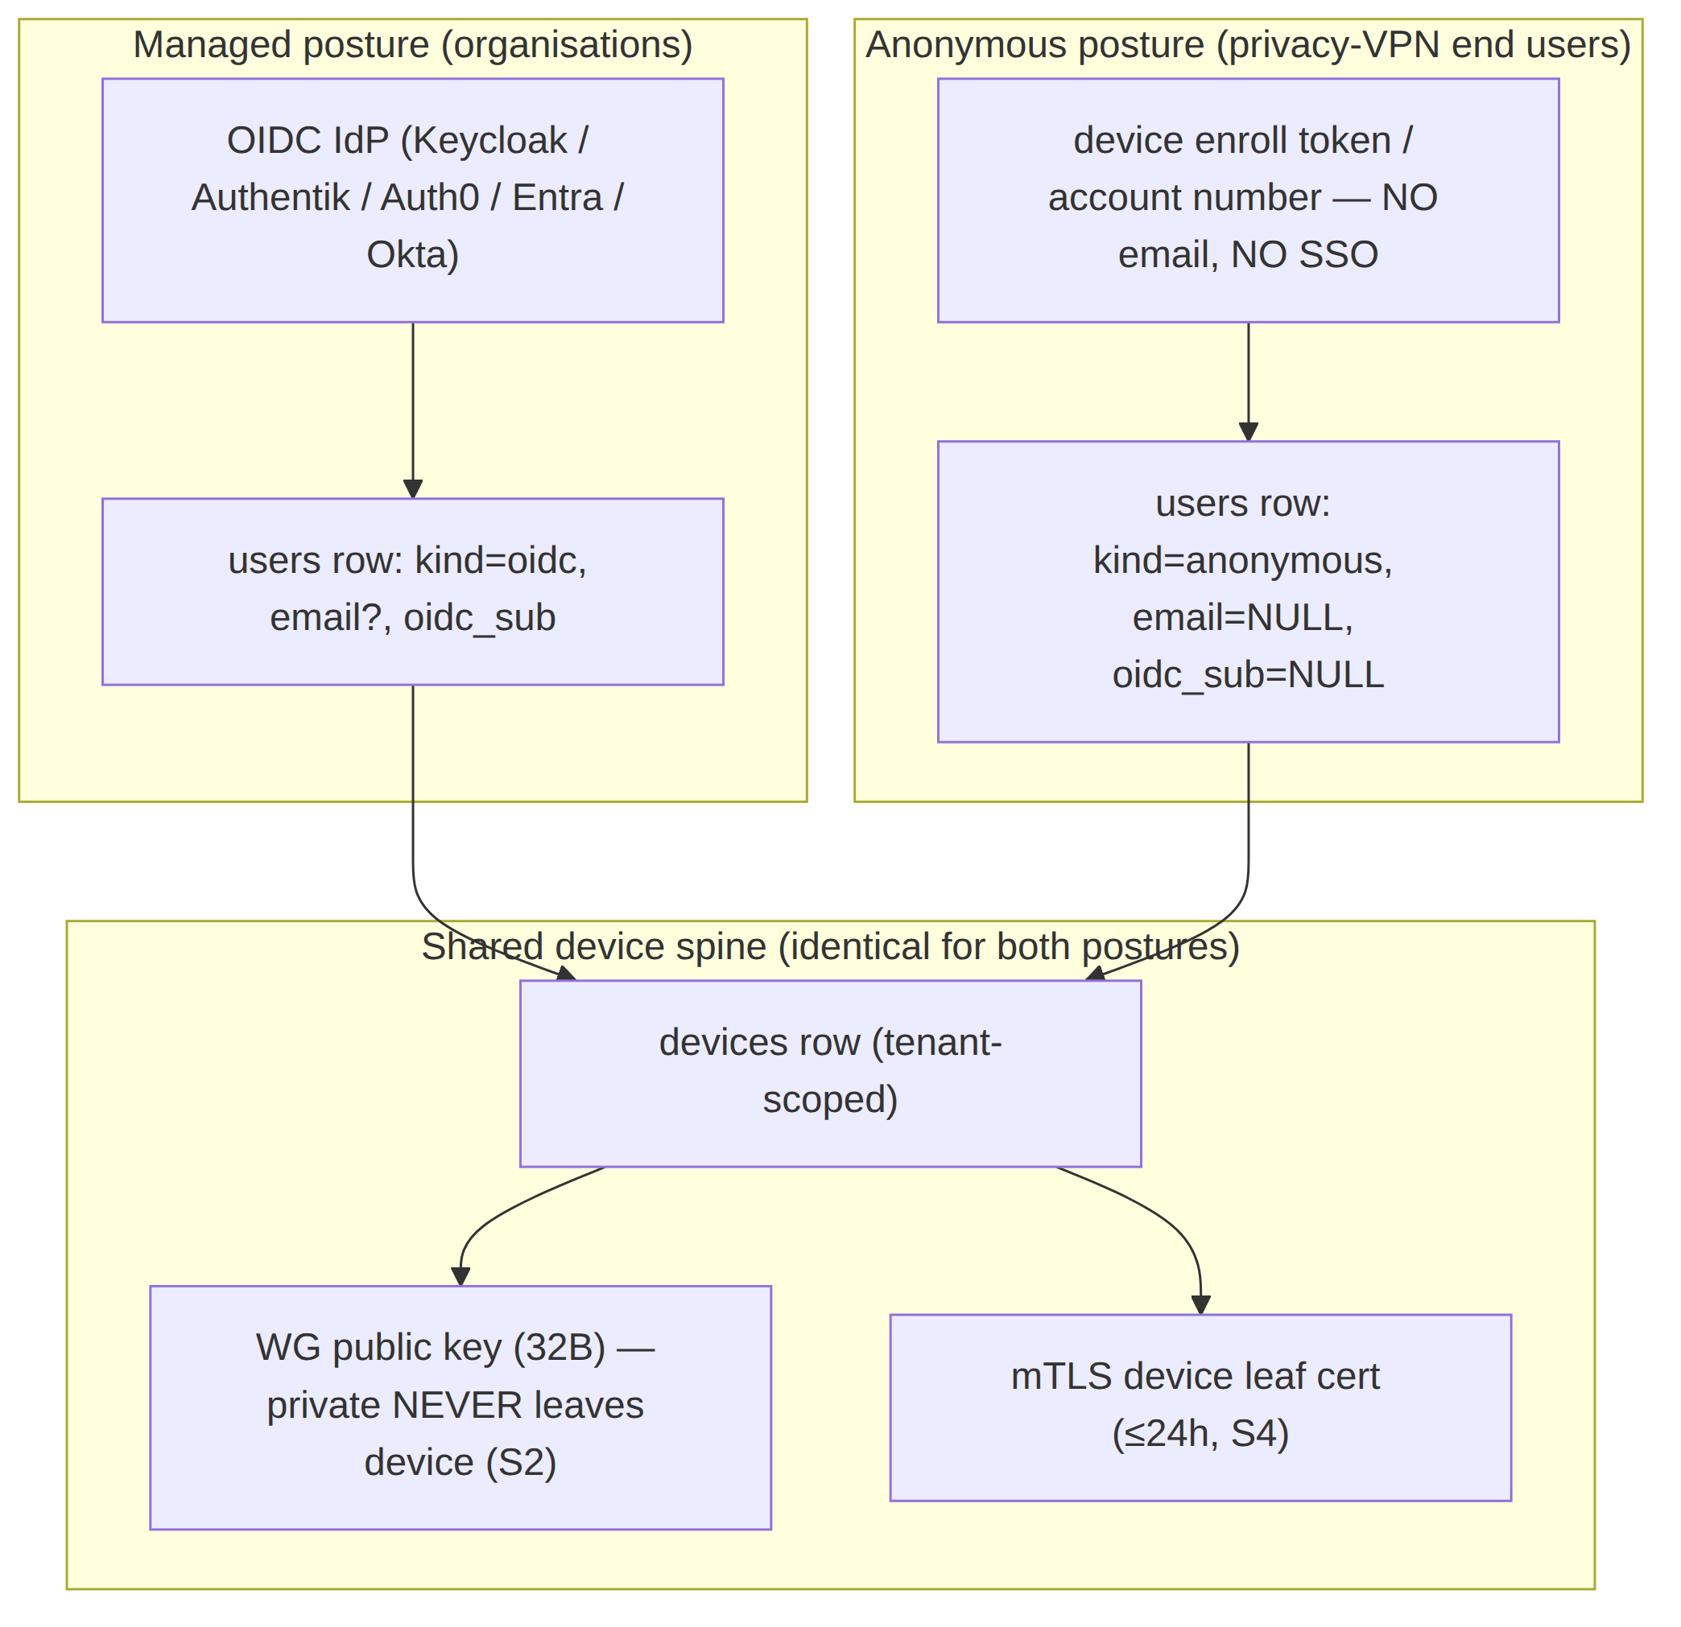
Posture | Who authenticates | What PII is stored | Reverse-link to a human | Source
Managed (OIDC) | A human, via the tenant's IdP | oidc_sub (always), email (when the IdP provides it) | yes — by the tenant's own choice (stated, not hidden; LP-I-1 residual) | [04_P1 §6.1], §4
Anonymous | A high-entropy token / account number, no human identity | none — email=NULL, oidc_sub=NULL; only argon2id(secret) stored | none by design (LP-I-1 mitigated) | [04_P1 §6.1], [04_ARCH §6], §5
HelixVPN is, in the managed posture, an OIDC Relying Party — never an IdP: it stores no passwords and runs no credential database [04-security-privacy-pki.md §2.1]. The anonymous posture is the privacy-VPN front end's default for end users and is the LINDDUN Identifying mitigation LP-I-1: there is no human to tie a tunnel to.
Design note — RBAC vs. device reach. Human roles (admin > operator > member, [v03-control-plane/svc-identity.md §7.3]) govern Console/API authorisation only. A device's reach is never a role — it is compiled need-to-know policy ([v03-control-plane/svc-policy.md]). A device principal that tries to authorise via RBAC is rejected (PrincipalDevice ⇒ ErrForbidden, AZ4) — closing T-COORD-E-1 / T-CP-E-1 at the identity layer.

2. The key-never-leaves invariant (S2)
This is the spine of enrollment security and the reason WireGuard's "the public key IS the device identity" model [research-pki_pq_nat §1.1] is safe to build on. The device generates its keypair locally; the control plane learns only the public half. An attacker who fully owns the control plane (C-INS) still never possesses a device's WG private key.

2.1 What "never leaves" means — the proof obligations
# | Obligation | Mechanism | Verified by
K1 | The WG private key is generated on the device by a CSPRNG. | helix-core X25519.gen() at enroll time [04-security-privacy-pki.md §3.2] | unit: re-derive pub from a known priv fixture, assert the stored value equals the public ([v03-control-plane/svc-pki.md §3.3])
K2 | Only the 32-byte public key is transmitted (EnrollRequest.wg_pubkey). | wire contract names wg_pubkey; agent sends the public half only | §1.1 mutation: feed a private-shaped key → handler MUST reject
K3 | No control-plane table has a private-key column. | device_wg_keys.wg_pubkey only; CA keys in KMS/sealed ([v03-control-plane/svc-pki.md §3.3]) | schema-lint asserts no *_private*/*_secret* cleartext column
K4 | The key is sealed in the OS keystore, never serialised out, never logged. | KeyStore.seal; Zeroizing on drop; FFI exposes operations, not raw bytes [04-security-privacy-pki.md §3.3] | security test: attempt to read a sealed key via FFI → blocked; log-grep finds no key bytes
K5 | A second leaf key (Ed25519, control channel) is also device-generated; only its CSR/public crosses the wire. | CSR proof-of-possession (§3.3) | sign refused on a CSR whose key the requester does not hold (T-PKI-S-1)
The 32-byte ambiguity, handled honestly (§11.4.6). A Curve25519 private key is also 32 bytes, so a length check alone cannot distinguish public from private. The structural guarantee a private key is never accepted is threefold: (a) the API contract names the field wg_pubkey; (b) the agent only ever transmits the public half (K1/K2); (c) a §1.1 mutation test re-derives the public key from a known-private fixture and asserts the stored value equals the public, never the private ([v03-control-plane/svc-pki.md §3.3]). The invariant is enforced by the test, not by the byte length.

2.2 Two device keypairs, two planes (deliberately uncoupled)
The device generates two keypairs at enroll; they live on independent key planes so a compromise of one does not cascade [04-security-privacy-pki.md §1.2, §4.1]:
// helix-core/crates/helix-pki/src/enroll.rs — the device-side contract (skeleton)
pub struct EnrolledIdentity {
pub device_id: String,
pub overlay_ip: IpAddr,
pub wg_secret: StaticSecret, // X25519 PRIVATE — sealed in OS keystore, NEVER serialised out (S2/K4)
pub cert_der: Vec<u8>, // current mTLS leaf (public material)
pub cert_key: SigningKey, // Ed25519 leaf PRIVATE — also sealed (S2/K4)
pub ca_chain: Vec<Vec<u8>>, // root + issuing CA, for pinning the control channel
pub renew_at: SystemTime, // = not_after - renew_window (auto-renew before expiry, §7.1)
}
pub trait Enroller {
/// Generates WG + leaf keypairs LOCALLY, builds a CSR, calls Coordinator.Enroll,
/// and persists the result via KeyStore. POSTCONDITION (S2): no private key is ever
/// returned by value to FFI, logged, or written outside the sealed keystore.
fn enroll(&self, token: &str, kind: DeviceKind, ks: &dyn KeyStore)
-> Result<EnrolledIdentity, EnrollError>;
}
Plane | Keypair | Purpose | Crosses the wire?
Control-identity | Ed25519 leaf (CSR) | authenticate the mTLS control channel (WatchNetworkMap etc., S4) | CSR (public) only
Data | X25519 WG static | decrypt the tunnel (WG Noise IK) | 32-byte public key only
Compromising a device leaf cert does not yield the WG private key, and stealing the WG key does not authenticate the control RPC — both must be valid for a device to learn its peers (map) and reach them (tunnel) [04-security-privacy-pki.md §1.2].

2.3 Platform key storage — keystore-first, software-fallback-with-warning
The seal target is the strongest the platform exposes (this is the AS-WGK / AS-LEAF mitigation T-CLI-I-1):
Platform | Sealed by | Hardware-backed when present
iOS / macOS | Keychain | Secure Enclave
Android | Keystore | StrongBox / TEE
Windows | DPAPI | TPM
Linux | libsecret | TPM2
pub trait KeyStore { // implemented per shim (Volume 6)
fn seal(&self, label: &str, secret: &[u8]) -> Result<(), KeyStoreError>;
fn open(&self, label: &str) -> Result<Zeroizing<Vec<u8>>, KeyStoreError>;
fn wipe(&self, label: &str) -> Result<(), KeyStoreError>;
}
A software fallback is permitted only with a logged warning [04-security-privacy-pki.md §3.3]; a device whose keystore is already defeated is the honest residual R-DEV ([threat-model.md §10]) — keys are sealed against extraction, but a rooted device (C-DEV) can invoke key operations in place. Hardware-bound attestation that closes R-DEV is Phase-2 (§10, [04-security-privacy-pki.md §3.5]).

3. Device enrollment — the protocol

3.1 Enrollment sequence (security-annotated)
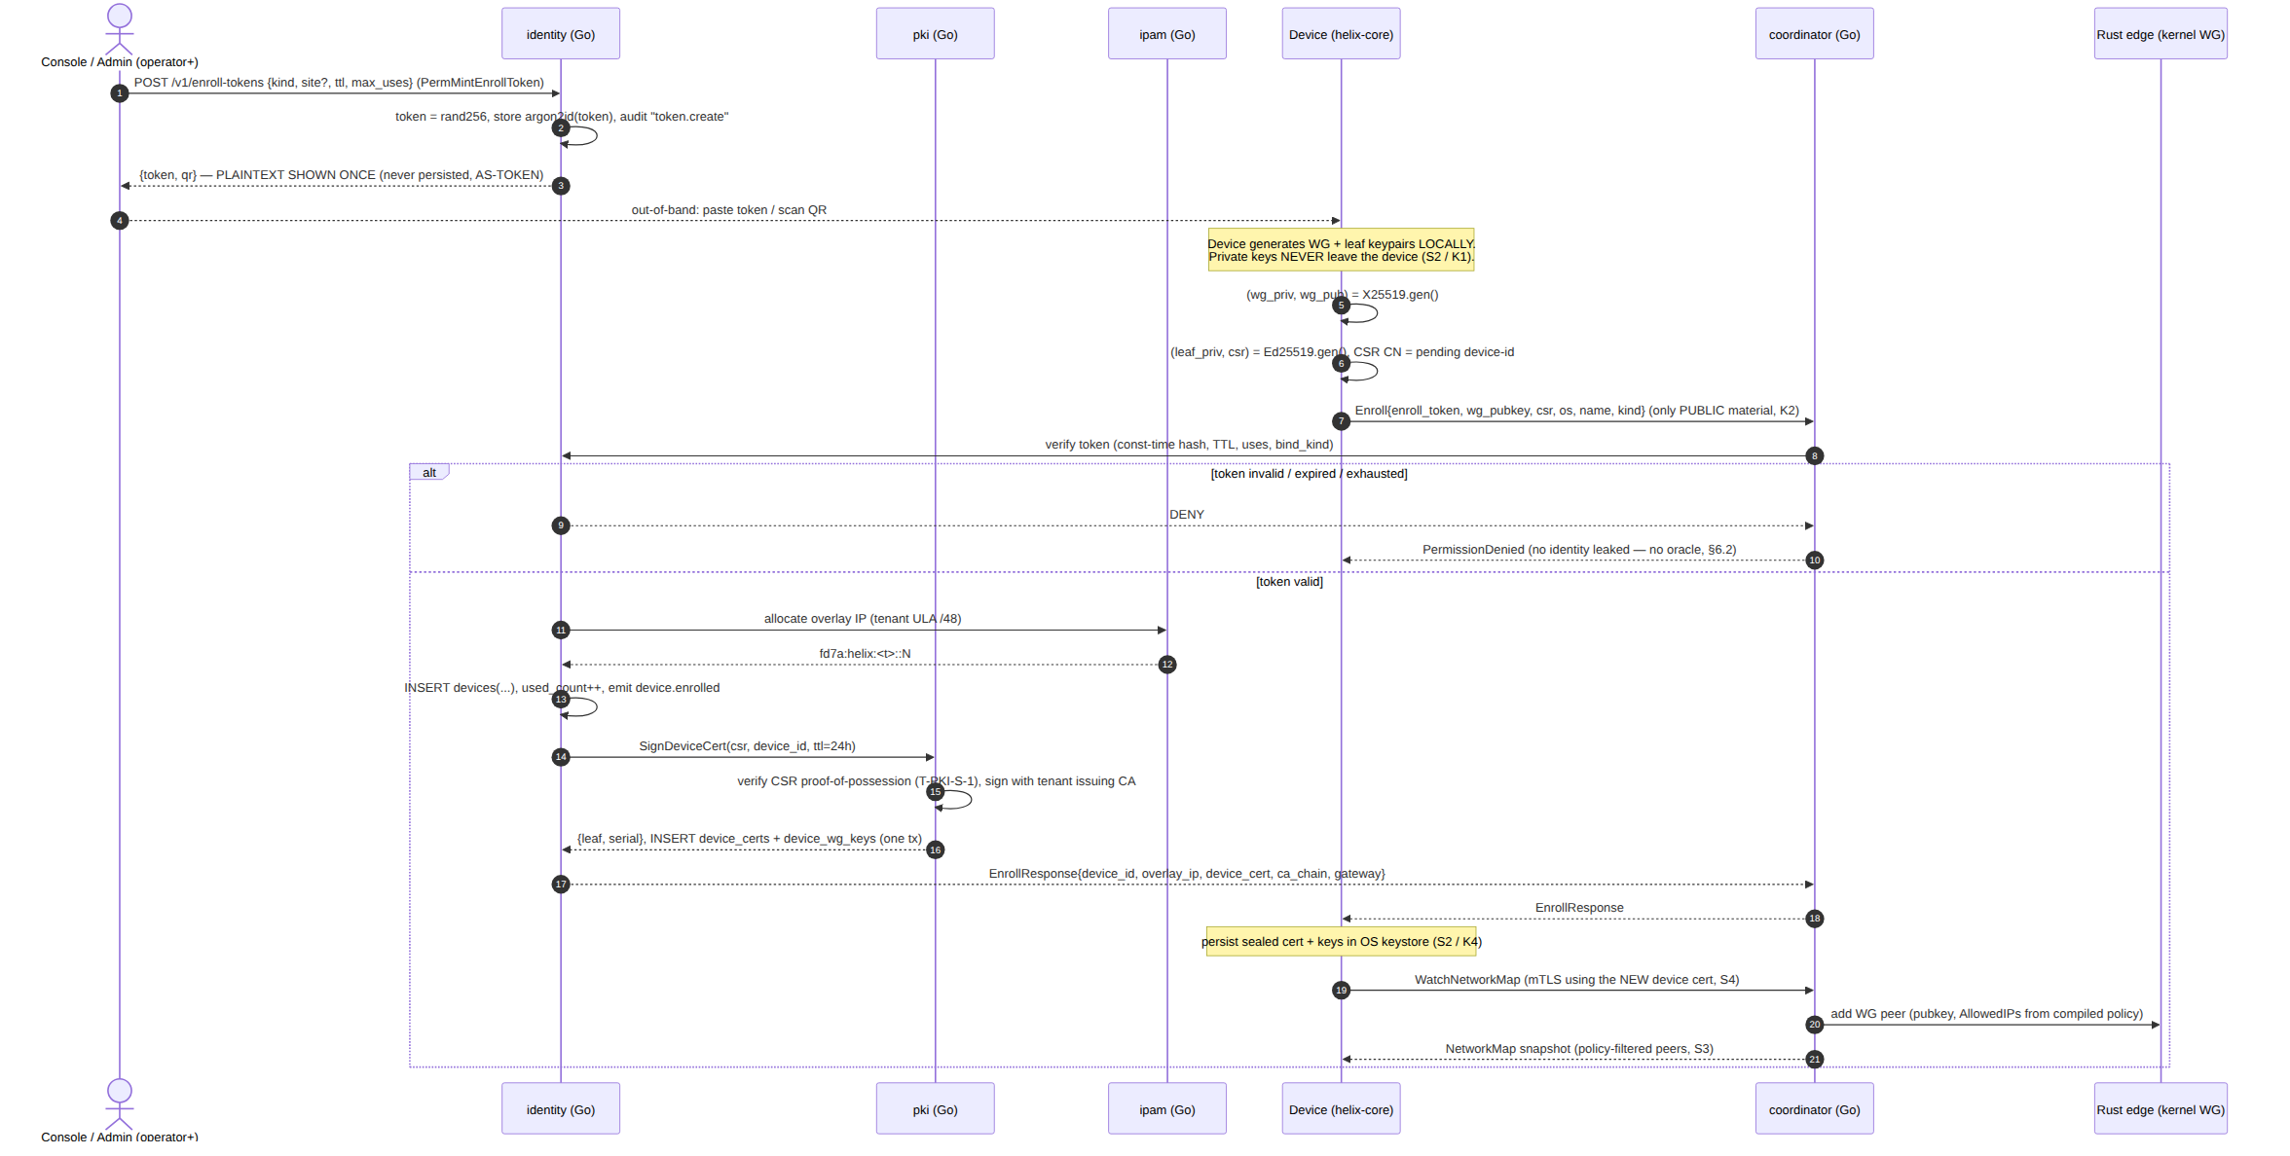
Five security properties are visible in this one flow: (1) the plaintext token is shown once and never stored (AS-TOKEN); (2) only public key material crosses the wire (S2/K2); (3) a bad token returns an opaque PermissionDenied with no field-level oracle (§6.2); (4) token-burn + device-insert + IP-alloc + cert-issue are one transaction so a partial enrollment is impossible ([v03-control-plane/svc-identity.md §6]); (5) the freshly-minted leaf is the credential for the very next call (WatchNetworkMap), so the unauthenticated enroll RPC is the only unauthenticated agent RPC.

3.2 The Enroll wire contract (security-relevant fields)
The CSR field is what makes the device cert mint from a device-held private key (proof-of-possession) rather than from a server-generated key — the structural defence against T-PKI-S-1.
// helix-proto: the security-relevant Enroll messages (package helix.coordinator.v1)
message EnrollRequest {
string enroll_token = 1; // single/bounded-use, TTL'd; verified by hash (§6, no oracle)
bytes wg_pubkey = 2; // 32-byte Curve25519 PUBLIC key; private stays on device (S2/K2)
bytes csr = 3; // PKCS#10 CSR, Ed25519 leaf key generated ON device (S2/K5)
string os = 4; // ios|android|linux|windows|macos|harmonyos|aurora
string name = 5;
DeviceKind kind = 6; // CLIENT | CONNECTOR — must match token bind_kind
bytes attestation = 7; // OPTIONAL platform key-attestation blob; empty in MVP (§10)
}
message EnrollResponse {
string device_id = 1;
string overlay_ip = 2; // e.g. "fd7a:helix:1::2"
bytes device_cert = 3; // X.509 leaf, signed by tenant issuing CA, not_after = now+24h
repeated bytes ca_chain = 4; // root + issuing CA — the agent PINS the root (T-COORD-T-1)
GatewayInfo gateway = 5;
uint32 cert_ttl_s = 6; // renew-before-window hint for the core (§7.1)
}
protovalidate field constraints enforce wg_pubkey length == 32, enroll_token non-empty, kind ∈ {CLIENT, CONNECTOR} declaratively next to the contract ([v03-control-plane/svc-identity.md §8.1]); a malformed request is InvalidArgument, never a panic (§11.4.1 — no FAIL-bluff).

3.3 Anti-replay & abuse controls on Enroll
Control | Mechanism | Threat closed
Constant-time token check | candidate enroll_tokens rows hash-compared in constant time; failure returns PermissionDenied with no field-level detail (no enumeration oracle) | token enumeration
CSR proof-of-possession | the CSR signature is verified before signing; the leaf public key in the CSR must match the signer | T-PKI-S-1 (sign a key you don't hold)
Rate limiting | per-source-IP and per-tenant Redis token buckets on Enroll; exponential backoff; auth.enroll.denied audit | T-PKI-D-1, T-CONN-D-1 (enroll flood)
One pubkey, one device | UNIQUE (tenant_id, wg_pubkey) ([v03-control-plane/svc-pki.md §3.3]) | WG-key re-use across devices
kind must match token | a connector token cannot enroll a client device (ErrKindMismatch) | privilege-shape confusion
Rate-limit buckets hold counters + timestamps only — never IPs, destinations, or flows (privacy invariant: this is abuse metering, not a connection log; LP-L-1 stays clean).

4. OIDC SSO integration — managed posture
Managed tenants log a human into the Console with Authorization Code + PKCE, validate the ID token against the IdP's JWKS, and JIT-provision a users row [04_P1 §6.1]. The IdP is any compliant OIDC provider; Keycloak/Authentik are reference IdPs but nothing is provider-specific.

4.1 The flow & its security gates
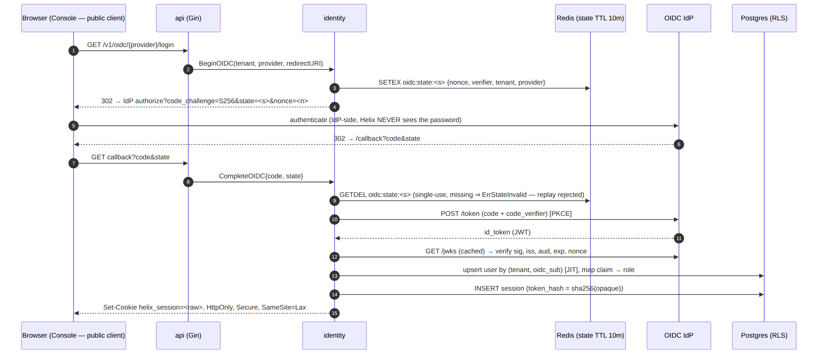
Gate | What it stops | Threat
PKCE S256 | code interception/injection even for a public client | T-CP-S-2 (forged-code path)
state single-use (GETDEL) | CSRF / login-fixation / replay of the callback | request forgery
nonce bound to the ID token | replay of a previously-issued ID token | token replay
JWKS sig + iss/aud pinning | a forged/foreign ID token granting admin | T-CP-S-2
alg=none rejected | unsigned-token forgery | T-CP-S-2
The state carries the tenant + provider + PKCE verifier + nonce in Redis with a short TTL; a callback whose state is missing/expired/replayed is ErrStateInvalid (single-use is the defence). HelixVPN never sees the user's password — authentication happens entirely IdP-side.

4.2 Claim → role binding — the IdP is the role authority, re-evaluated every login
// role = role_map[ valueAt(claims, role_claim) ] ?? oidc_providers.default_role
// highest role wins on multiple groups: admin > operator > member.
role := mapRole(prov, idt)
Rule | Security property
Role asserted from an IdP group claim, mapped per tenant (role_map), never client-supplied | the client cannot self-elevate (a tampered claim fails the JWKS sig check first)
Role refreshed on every login | an IdP-side group removal demotes on next sign-in — no stale admin
Removed from all mapped groups ⇒ falls to default_role (default member) | never silently retains a privilege
A SuspendedAt user ⇒ ErrUserSuspended, no session | suspension denies login immediately
The trust boundary here is explicit: HelixVPN trusts the IdP to assert group membership; a compromised IdP is out of scope [threat-model.md §1.2] (residual of T-CP-S-2). Library choice (coreos/go-oidc over x/oauth2) and exact pinned versions are UNVERIFIED until implementation and MUST be re-verified against the IdP's current docs before shipping (§11.4.99, [v03-control-plane/svc-identity.md §4]).

5. Anonymous device-token path — the privacy posture
The privacy-VPN default: a device obtains identity + cert with no email and no SSO — the Mullvad "account number, no PII" stance [04_P1 §6.1, 04_ARCH §6]. This is the LINDDUN Identifying mitigation LP-I-1: there is no human to which the tunnel can be tied.

5.1 Two anonymous front doors (both no-PII)
Front door | Use | Secret | Stored as
Device enroll token | one device joins (paste/QR) | 256-bit base32-Crockford string (het_…) | argon2id(token) (hash only)
Account number | a human-memorable login for a privacy account (Mullvad-style) | 16-digit decimal, grouped ####-####-####-#### | argon2id(number) (hash only)
-- the anonymous account: a users row with NO PII + an accounts row whose ONLY
-- authenticator is a hashed high-entropy number ([`v03-control-plane/svc-identity.md` §2.2]).
-- users: kind='anonymous', email=NULL, oidc_sub=NULL
-- accounts: number_hash = argon2id(number), number_last4 (display hint, NOT a secret)
Design D-ID1 — account-number entropy (carried from [v03-control-plane/svc-identity.md §3]). 16 decimal digits ≈ 53.1 bits of entropy; this is the display secret. Online-guessing resistance comes from (a) storing only argon2id(number), (b) rate-limiting LoginAccount per (tenant, ua_hash) bucket, and (c) treating the number as a bearer credential the operator must store securely. That Mullvad uses exactly 16 digits internally is UNVERIFIED (not in the cited research) — 16 is our design, not a claim about Mullvad's implementation (§11.4.6).

5.2 What the anonymous path guarantees — and its honest boundary
Guarantee | Mechanism
No reverse-link to a human | email=NULL, oidc_sub=NULL; the device is owned by a synthetic anonymous user scoped to the tenant; no directory maps the number to a person
No password to phish | the only authenticator is the high-entropy secret; argon2id verify is constant-time (hit and miss cost the same wall-clock)
Lost secret is unrecoverable by design | there is no "reset" path — no PII to recover against; the operator mints a fresh account
Secret never persisted in plaintext | only argon2id(secret) stored; the plaintext is returned to the caller exactly once
Honest boundary (§11.4.6). Anonymous enrollment removes the human link in the stored data. It does not make the user anonymous to a network observer (C-PASV/C-NAT) — that is the job of transport obfuscation + the no-logging invariant (S6), and traffic-analysis correlation remains the residual R-TA ([threat-model.md §10]). Anonymous mode closes LP-I-1 (identifying via stored data), not LP-D-1 (detecting VPN use on the wire).
D-ID2 — anonymous login needs a tenant scope. Because the accounts table is RLS-scoped, the raw number alone cannot identify a tenant. MVP routes anonymous login tenant-addressed (POST /v1/t/{tenant}/account/login); a global number→tenant directory is out of scope — it would be a cross-tenant index that weakens isolation (C8). Multi-tenant-SaaS anonymous login is a Phase-2 decision (§10, [v03-control-plane/svc-identity.md §3.2]).

6. Enroll-token security
An enroll token is the device-bootstrap secret: a single-use (or bounded-multi-use), short-lived, hashed credential an operator/admin mints and hands (paste/QR) to a device, redeemed exactly once in the Enroll RPC. It is the only unauthenticated agent RPC's credential.

6.1 Token security properties
Reconciled (§11.4.35, 2026-06-26): the enroll token is hashed with Argon2id only — the earlier "sha256(raw) (or argon2id)" alternative is dropped. It is a bootstrap bearer credential, so a memory-hard hash (matching the overview + [no-logging-as-code]) is required; a plain sha256 is reserved for opaque high-rate session tokens, not this bearer secret.
Property | Mechanism | Why
High entropy | 256-bit randomBytes(32), het_-prefixed (greppable), base32-no-pad | infeasible to guess
Hash-at-rest only | argon2id(raw) stored; raw returned once | a DB read never yields a usable token (AS-TOKEN; S11-class hygiene)
Short TTL | clamped to [5m, 24h], default 1h | a leaked token expires fast
Single / bounded use | max_uses (default 1); atomic conditional consume | no double-spend
Kind-bound | bind_kind ∈ {client, connector} enforced at Enroll | a connector token can't mint a client device
Audited mint | enroll_token.minted event carries {token_id, kind} — never the raw token | the audit trail itself doesn't leak the secret

6.2 Atomic single-use consumption (no double-spend)
The double-spend hazard is two devices racing the same token. Atomicity is a conditional UPDATE … RETURNING — the row lock serialises the racers and the WHERE consumed_at IS NULL guard guarantees exactly one wins ([v03-control-plane/svc-identity.md §5.2]):
-- name: ConsumeEnrollToken :one (runs INSIDE the Enroll transaction)
UPDATE enroll_tokens
SET consumed_at = now(), consumed_device = sqlc.arg(device_id)
WHERE tenant_id = current_setting('app.tenant_id')::uuid
AND token_hash = sqlc.arg(token_hash)
AND consumed_at IS NULL -- single-use guard
AND revoked_at IS NULL -- not revoked
AND expires_at > now() -- not expired
RETURNING id, kind, site_name, bind_user_id;
-- zero rows updated ⇒ token already used / expired / revoked / wrong-tenant ⇒ ErrTokenUnusable
The anti-bluff acceptance test is N=100 concurrent Enroll of one token ⇒ exactly 1 success ([v03-control-plane/svc-identity.md §11]); the paired §1.1 mutation removes the AND consumed_at IS NULL guard and asserts the test now sees 2 successes (the gate is proven not a tautology).

6.3 Enroll-token state machine
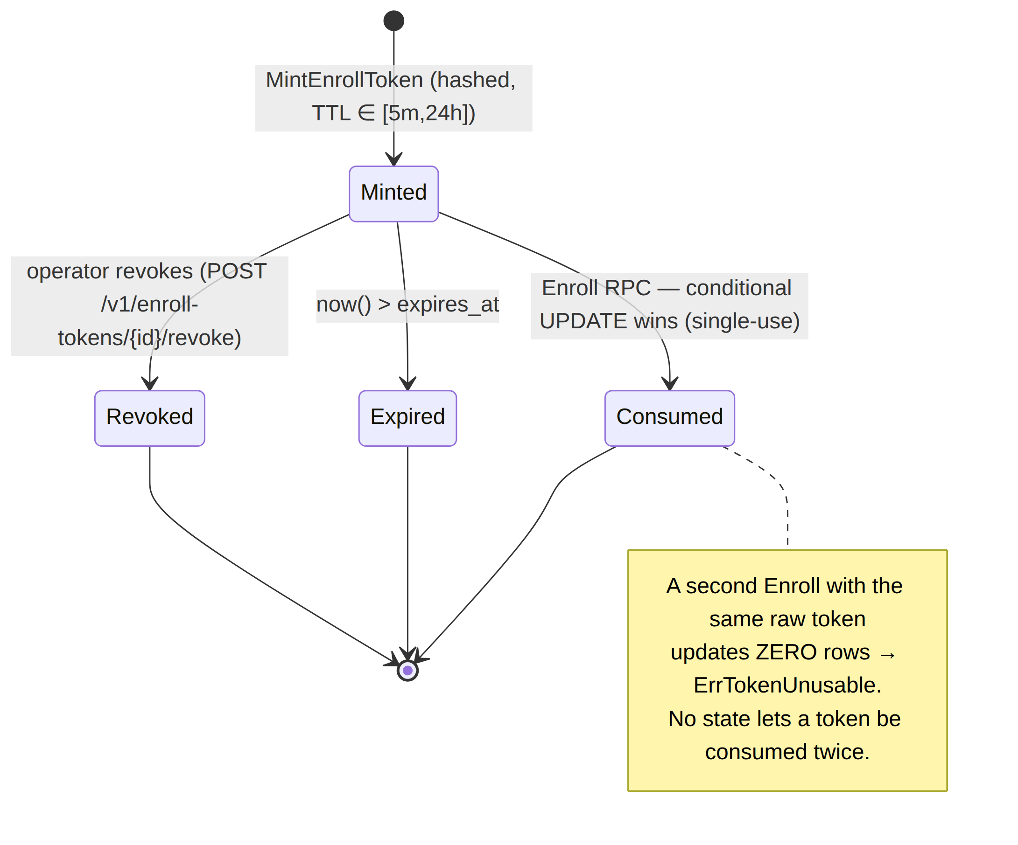
The only legal terminal-by-success transition is Minted → Consumed; every other terminal state rejects redemption.

7. Re-enrollment & device revocation

7.1 Re-enrollment — degrade-to-re-enroll, never silent failure
A device's mTLS leaf is short-lived (≤24 h, S4). The agent proactively renews it over the existing authenticated channel at T − renewSkew (renewSkew = max(1h, 0.2 × TTL) → ~4.8 h before a 24 h cert expires) — no enroll token, no human ([v03-control-plane/svc-pki.md §6.1]). Renewal is a re-issue over the authenticated channel: same device_id, new serial + not_after, WG key unchanged. The security properties:
Property | Detail
No privilege escalation on renew | renewal is authenticated by the current still-valid leaf — it never needs the enroll token again, so it cannot widen scope
Make-before-break | both old and new leaves are valid during the overlap; the old flips to renewed (the only non-active status AuthDevice tolerates, and only until its not_after) — no mid-stream cutoff
Degrade to re-enroll | a missed renewal (agent offline past expiry) degrades to full re-enrollment with a fresh token — never a silent failure [04_P1 §6.3]
A full re-enrollment (lost device, wiped keystore, missed-renewal expiry) is the §3 protocol run again with a fresh enroll token; the new keypairs are generated locally exactly as before (S2 holds across re-enrollment — a re-enrolling device never re-uses or transmits old private material).

7.2 Device revocation — origin of the sub-second cascade (S5)
Revocation is the security analogue of the convergence SLO: the same push-don't-poll machinery that propagates a route change propagates a revocation. Identity is the origin; coordinator measures the tail.
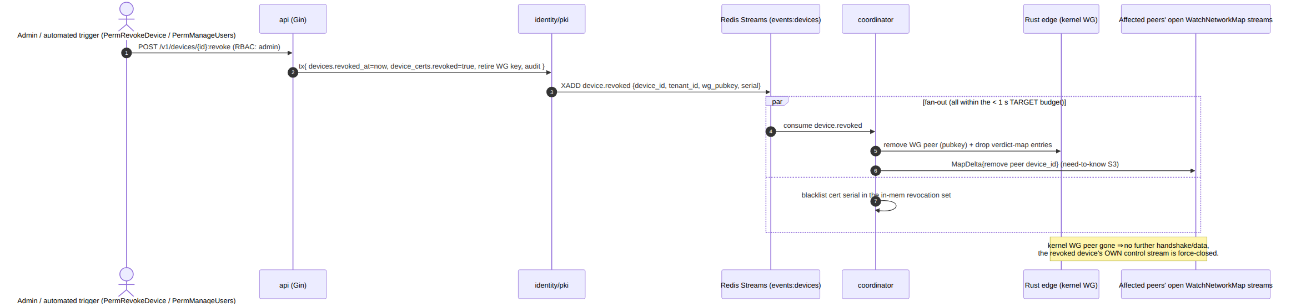
The two cooperating teeth (belt-and-suspenders [research-pki_pq_nat §1.2/§1.3]): (a) stop renewing the short-lived mTLS cert → it self-expires within ≤24 h (defence-in-depth floor), and (b) remove the WG public key from every peer set → instant data-path cutoff. There is no CRL/OCSP on the data path — short-lived certs + active push obviate online revocation checking.
Latency is a TARGET, not a measured result (§11.4.6). The revoke→edge-enforced budget is p99 < 1 s as a design target measured by the helix_pki_revoke_seconds histogram ([v03-control-plane/svc-pki.md §10.3]); it is UNVERIFIED as an achieved number until the §9 soak captures it. The sub-second race window is honest, not zero — residual R-RACE ([threat-model.md §10]); the floor is fail-static (a stale grant never fails open), and ≤24 h cert expiry is the hard ceiling even if a push is missed.

7.3 User suspension cascades to every owned device
SuspendUser / RevokeAccount fan out to: session revoke (human Console access dies immediately), cert revoke (control channel dies), and N device.revoked events (data-path peers removed within the convergence budget). All session/cert writes commit in the same tenant transaction; the events publish in-tx so no device is left half-revoked ([v03-control-plane/svc-identity.md §10]). A guard (AZ3) forbids the last active admin from suspending themselves — preventing an un-administerable tenant.

8. Threat mapping — what enrollment defends
Every mechanism above closes specific threats from [threat-model.md]; conversely no mechanism here is unjustified (§11.4 — a control with no threat is a removal candidate).
Mechanism (this doc) | Invariant | Threats closed ([threat-model.md])
Device keys generated on-device, sealed in OS keystore | S2 | T-CLI-I-1, T-PKI-S-1 (partial)
CSR proof-of-possession at sign | — | T-PKI-S-1 (sign a key you don't hold)
mTLS leaf ≤24 h + auto-renew over authenticated channel | S4 | T-CLI-S-1, T-CP-S-1, T-COORD-S-1
OIDC PKCE + JWKS pin + nonce/state single-use | S4 | T-CP-S-2 (forged ID token / replay)
Claim→role re-evaluated every login | — | stale-privilege elevation (T-CP-E-1 adjacent)
Anonymous enroll (no email / no SSO) | — | LP-I-1 (identifying), LP-N-1 (partial)
Enroll token: hashed, single-use, TTL, kind-bound | S11 | AS-TOKEN abuse, T-PKI-D-1 (enroll flood)
Constant-time token check, no field oracle | — | token enumeration
Sub-second revocation cascade (origin) | S5 | T-PKI-E-1 (revoked device keeps access)
RLS FORCE ROW LEVEL SECURITY under the app RBAC | P6 | T-CP-T-1, T-CP-I-1 (cross-tenant)
The two honest residuals enrollment leaves open are R-DEV (a fully-compromised device can use sealed keys in place — closed only by Phase-2 hardware attestation) and the managed-mode PII choice behind LP-I-1 (a tenant that opts into OIDC stores email — stated, not hidden).

9. Test & validation mapping (§11.4.169)
Per constitution §11.4.169 (comprehensive test-type coverage) composing §11.4.27 (no-fakes-beyond-unit), §11.4.5/§11.4.69/§11.4.107 (captured evidence), §11.4.85 (stress+chaos), §1.1 (paired mutation). Integration spins Postgres+Redis on-demand via the vasic-digital/containers submodule (§11.4.76 — never ad-hoc docker run). Every PASS cites a captured-evidence artefact; mocks live only in unit tests.
Capability | Unit | Integration (real PG+Redis) | Security / fuzz | Stress / chaos | Paired §1.1 mutation
Key-never-leaves (S2 / K1–K5) | re-derive pub from known priv fixture; assert stored == public, never private | enroll → assert device_wg_keys.wg_pubkey is the public half | attempt FFI read of sealed key → blocked; log-grep finds no key bytes | — | feed a private-shaped key → enroll handler MUST reject (else FAIL)
Enroll-token single-use | state-machine transitions (Diagram §6.3) | mint → consume → re-consume = ErrTokenUnusable | token-guess fuzz over het_ space | N=100 concurrent Enroll of one token ⇒ exactly 1 success | drop AND consumed_at IS NULL guard → 2 successes → test FAILs
OIDC login | mapRole claim→role; nonce/state checks | full auth-code+PKCE vs a Keycloak/Authentik container; JIT provision; role refresh on re-login | tampered ID-token sig rejected; replayed state rejected; alg=none rejected | — | accept nonce mismatch → replay test FAILs
Anonymous account | genAccountNumber unbiased (χ² over digits); argon2id calibration 30–150 ms | create → login → session; lost-number unrecoverable | constant-time hit vs miss; online-guess throttle | login brute-force ⇒ ErrRateLimited | store plaintext number → schema-lint FAILs
Enroll all-or-nothing | — | cert-issue failure ⇒ token NOT burned, IP NOT consumed (retry same token) | — | SIGKILL helixd mid-enroll ⇒ no orphan cert without device row | drop the in-tx publish (R3) → coordinator never adds peer → DoD test FAILs
Revocation cascade (origin, S5) | last-admin guard (AZ3) | suspend/revoke → sessions dead + N device.revoked emitted; revoke→edge target p99 < 1 s captured | suspended user cannot re-login | suspend a user owning 1k devices, all events emitted | drop in-tx publish → peer never removed → SLO test FAILs
No-PII privacy (LP-I-1) | — | anonymous enroll ⇒ users.email IS NULL AND oidc_sub IS NULL | grep live schema — anonymous device has no human link | — | set email on an anonymous user → privacy invariant test FAILs
Anti-bluff floor (§11.4.107(10)). Each analyzer/gate above ships with a golden-good + golden-bad fixture pair so the gate provably cannot pass everything; a security "PASS" is valid only with captured evidence that the attack was attempted and blocked — a green assertion that the mitigation "exists" is necessary, never sufficient. The enroll-DoD acceptance is the [04_P1 §11] "enroll a client; reach an authorized LAN host; deny an unauthorized one" criterion captured at packet level.

10. Phase-2 forward seams (additive, not a rewrite)
The enrollment interfaces extend without reshaping [v03-control-plane/svc-identity.md §12, 04_P1 §12]:
- Platform attestation — the reserved EnrollRequest.attestation field carries Apple App Attest / Android Key Attestation / Windows TPM attestation so a Phase-2 tenant can require hardware-bound WG/leaf keys — closing residual R-DEV. The wire format already reserves the slot so it need not change later [04-security-privacy-pki.md §3.5].
- SCIM provisioning + group sync — oidc_providers gains push-provisioning + directory sync, replacing per-login JIT for large tenants (role mapping stays the same).
- WebAuthn / passkey step-up — sessions gains a hardware-second-factor step-up for admin actions (revoke, CA rotation).
- Anonymous recovery codes — accounts gains optional recovery codes (still no PII) and a multi-tenant number→tenant directory behind an explicit operator opt-in (the §5 D-ID2 deferral).
- Service extraction — the Identity interface itself is the seam along which a standalone identity service splits from the monolith; the Bus / store.WithTenant / pki / ipam boundaries already in place make the extraction wiring, not redesign.
Phase 2 is additive because Phase 1 drew the seams — the Enroll proto, the two key planes, the OIDC provider table, the anonymous-account model — in the right places, honouring §11.4.6 (no silent reshape).

Sources verified
- [04-security-privacy-pki.md] HelixVPN security spine — §0.1 invariants S1–S11, §1 trust model + two-channel auth, §2 identity (OIDC managed + anonymous device tokens), §3 enrollment
  - §3.2 Enroll proto + §3.3 device-side key handling/keystore + §3.4 anti-replay + §3.5 attestation, §4 PKI/cert lifecycle, §4.6 revocation < 1 s (target). (Read 2026-06-25.)
- [v03-control-plane/svc-identity.md] — §1 ownership + Identity interface, §2 DDL/RLS (oidc_providers/accounts/enroll_tokens/sessions/api_tokens), §3 anonymous accounts (D-ID1/2, account-number entropy), §4 OIDC auth-code+PKCE + claim→role, §5 enroll-token mint + atomic single-use consumption, §6 Enroll orchestration (one tx), §7 RBAC (AZ1–AZ4), §10 suspend/revoke cascade, §11 test matrix, §12 Phase-2 seams. (Read 2026-06-25.)
- [v03-control-plane/svc-pki.md] — §1 WG-no-native-PKI baseline + SPIFFE two-identity split, §5 issuance (CSR PoP), §6 auto-renew (renewSkew, make-before-break), §9 revocation two-teeth. (Read 2026-06-25.)
- [pki-and-certs.md] (sibling) — CA hierarchy, cert profiles, revocation < 1 s target, PQ material slot — referenced for the cert lifecycle this doc mints into.
- [threat-model.md] (sibling) — attacker classes (C-DEV/C-INS/C-NAT…), threats T-CLI-S-1 / T-CLI-I-1 / T-CP-S-2 / T-PKI-S-1 / T-PKI-E-1, privacy threats LP-I-1 / LP-N-1, residuals R-DEV / R-RACE. (Read 2026-06-25.)
- [research-pki_pq_nat] — §1.1 WireGuard native identity (public key IS the identity, revocation trivial, no built-in PKI), §1.2/§1.3 SPIFFE/SPIRE short-lived-mTLS two-identity split, generate-the-WG-private-key-on-device, revocation = stop-renew + remove-pubkey. Access date 2026-06-25.
- [04_P1] HelixVPN-Phase1-MVP.md §6 (two identity modes, enrollment flow, key-never-leaves, 24h cert, revoke < 1 s), §11 DoD (authorized/denied acceptance). [04_ARCH] §4.1/§6/§7 (identity service, Mullvad parity anonymous account #, OIDC + anonymous device tokens). [SYNTHESIS] §1/§7 (roles, security/privacy invariants). — cited via the spine doc.
- Constitution §11.4.6 (no-guessing — UNVERIFIED marks; latency stated as target), §11.4.10 (credentials never logged), §11.4.27/§11.4.85/§11.4.107/§11.4.169/§1.1 (test-type coverage + self-validated analyzers), §11.4.76 (containers submodule), §11.4.99 (latest-source verification for OIDC libs/flows before shipping).

