Kill-switch & DNS-leak protection

Kill-switch & DNS-leak protection
Revision: 2 Last modified: 2026-06-26T12:00:00Z
Master technical specification — Volume 5 (Security & Privacy), nano-detail deep-dive. This document deepens the kill-switch / DNS-leak invariant (04-security-privacy-pki.md §8, invariant S9) into an implementation-ready specification of the leak-proof firewall state machine: how the core-owned KillSwitch arms closed-before-the-first-handshake, blocks every non-tunnel egress on a drop, and reverts only on a user-initiated stop; how each OS shim realises that single abstract state machine in its native firewall primitive (Apple NE routing + NEDNSSettings, Android always-on lockdown + VpnService.protect(), Windows WFP, Linux nftables); how DNS-leak and IPv6-leak windows are closed; and how a trip projects to the FFI Danger overlay the UI paints red. SPEC ONLY — it describes what to build, not the shipping product.
Ownership boundary. The state-machine bodies (the Firewall::enforce contract, the side-effect matrix, the kill-switch ⇄ DNS coupling) are owned by the data-plane orchestrator, cited [v02-orch §8] (../v02-data-plane/orchestrator-and-state.md). The security invariant (S9: no plaintext egress when the tunnel is down or escalating) is owned by the master security doc §8, cited [04-SEC §8]. The per-OS firewall realisation is owned by the four shim docs (cited [shim-apple §N], [shim-android §N], [shim-windows §N], [shim-linux §N]). The FFI Danger projection is owned by the Rust client core, cited [hc §5/§8] (../v04-client/helix-core-rust.md). This document owns the cross-platform synthesis: the one abstract state machine, the per-OS capability matrix, the DNS/IPv6 leak-closure taxonomy, the honest-gap ledger, and the anti-bluff validation contract. It does not redefine the orchestrator loops, the Transport trait, or the WG crypto core.
Evidence base, cited inline by id. [04-SEC §N] = ../04-security-privacy-pki.md; [hc §N] = ../v04-client/helix-core-rust.md; [v02-orch §N] = ../v02-data-plane/orchestrator-and-state.md; [shim-apple §N] / [shim-android §N] / [shim-windows §N] / [shim-linux §N] = the four Volume-4 shim nano-docs; [04_ARCH §N] / [04_P1 §N] = the pass-1 architecture + Phase-1 MVP docs. Any claim not grounded in the evidence base is tagged UNVERIFIED per constitution §11.4.6 — never fabricated.

Table of contents
- 0. Position, ownership, and invariants
- 1. The threat: a privacy VPN that leaks when the tunnel drops is broken
- 2. The abstract kill-switch state machine (one machine, all platforms)
- 3. Firewall posture per state — the rules the core emits
- 4. The Firewall trait — the cross-platform seam
- 5. Per-OS enforcement realisation
- 6. DNS-leak prevention
- 7. IPv6-leak closure
- 8. The Danger projection — surfacing a trip to the UI
- 9. Per-OS capability matrix + honest gaps
- 10. Anti-bluff validation (§11.4.107/§11.4.69)
- 11. Config knobs
- 12. Open decisions & cross-doc contracts
- Sources verified

0. Position, ownership, and invariants
The kill-switch and DNS-leak protection are a core-owned state machine (helix-core, the helix-killswitch crate), never hand-edited firewall rules an operator can forget to apply or forget to revert [04-SEC §8, 04_ARCH §6 row]. The core drives the OS firewall; the rules are an output of the state machine, not an input. This is the load-bearing inversion: a VPN whose leak protection is a config-file the user toggles has a leak window every time the config and the link state disagree. Here the firewall posture is a pure function of the OrchState transition (O-I10/O-I11 [v02-orch §8]), re-applied before the network operation it guards, so there is no instant where the UI shows "connected" while the firewall is open.

0.1 The invariants this document enforces
# | Invariant | Enforced where | Source
K1 | Armed-closed-before-the-first-handshake. In Strict mode the firewall installs the closed rule set on Idle → Connecting — before any packet can leave — so there is no pre-connect plaintext window. | §2, §3 | [v02-orch §8.2], [shim-linux §11.1]
K2 | Fail-closed on drop. A lost handshake/keepalive transitions to Reconnecting/Down and the firewall stays closed (keeps the DNS block too). The user's apps cannot reach the underlay while the tunnel is re-dialling. | §2, §3 | [v02-orch §8.4], [04-SEC §8.1]
K3 | Revert only on user-stop. The closed rule set is removed only on a user-initiated stop (ShuttingDown → Down{stopped}). Every other terminal (auth-failed, ladder-exhausted, crash) leaves it closed. | §2, §5 | [shim-windows §8.6], [shim-linux §8.6]
K4 | Survives crash. If the core process dies, the closed firewall rules remain (Windows FWPM_FILTER_FLAG_PERSISTENT; Linux systemd ExecStopPost; the next start() re-arms). A crash must not become a leak. | §3, §5 | [v02-orch §8.4 crash row], [shim-windows §8.2]
K5 | DNS is forced through the tunnel; off-tunnel :53/:853 is dropped in every non-Disconnected state. A misbehaving app cannot reach a hardcoded 8.8.8.8. | §6 | [04-SEC §8.3], [hc §8.1]
K6 | No partial IPv6 capture. If the host has native IPv6, the core either routes the overlay v6 and blocks native v6 egress, or fully captures v6 — never a partial-capture leak. | §7 | [04-SEC §8.3]
K7 | A trip is surfaced, never hidden. A kill-switch trip or a positive leak probe projects to the FFI Danger{kind} overlay and the red stateDanger palette — and is never guessed (raised only on a concrete signal). | §8 | [hc §5.2/§8.4], §11.4.6

0.2 What this document does NOT own
- The orchestrator state machine bodies and the OrchState enum — [v02-orch §3/§8].
- The TunnelStatus core 5-variant enum and its FFI projection mechanics — [hc §5].
- The transport ladder / re-dial backoff that drives Reconnecting — [v02-orch §7].
- The WireGuard crypto handshake whose success drives Connected — doc 01.
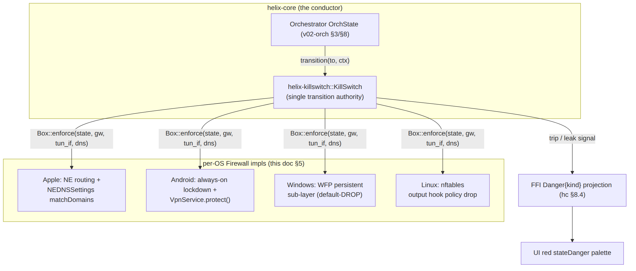

1. The threat: a privacy VPN that leaks when the tunnel drops is broken
The end-user promise of a privacy VPN is "my real IP and my DNS queries are never visible on the underlay." That promise is easiest to break at the seams — the moments the tunnel is not steadily up:
Leak window | What leaks | Without a kill-switch
Pre-connect (app sends before the tunnel is up) | real IP + plaintext DNS to the underlay | every packet before the first handshake escapes
Mid-session drop (Wi-Fi flap, server restart, transport ladder re-dial) | real IP for the entire reconnect window | the OS silently falls back to the physical interface
DNS bypass (app hardcodes 8.8.8.8 / uses DoH to a public resolver) | the destinations the user visits | tunnel-DNS settings alone do not block a hardcoded resolver
IPv6 fall-through (overlay is v4/ULA-v6 only, host has native v6) | real v6 address + v6 destinations | native v6 egress bypasses a v4-only tunnel
Crash / extension restart | everything until the process re-arms | the firewall is gone with the process
Each row is a real, observed failure class in commodity VPNs. HelixVPN closes all five by construction: the firewall is armed before the first handshake (closes pre-connect), stays closed on drop (closes mid-session), drops off-tunnel :53 (closes DNS bypass for plaintext; DoH/DoT handled in §6.4), captures-or-blocks v6 (closes IPv6 fall-through), and persists the closed rules across a crash (closes the restart window). The acceptance test is mechanical: drop the tunnel mid-transfer and assert via packet capture on the host's physical interface that zero plaintext packets — including :53 — egress during Reconnecting/Blocked [04-SEC §8.4, 04_P1 §11 DoD #6]. See §10.

2. The abstract kill-switch state machine (one machine, all platforms)
There is exactly one kill-switch state machine. It lives in helix-core; every OS shim implements only the Firewall::enforce primitive it calls (§4). The link states mirror the orchestrator's OrchState and the TunnelStatus it broadcasts [hc §5, v02-orch §4.1]; Blocked is the hard-lockdown sub-state the kill-switch adds.
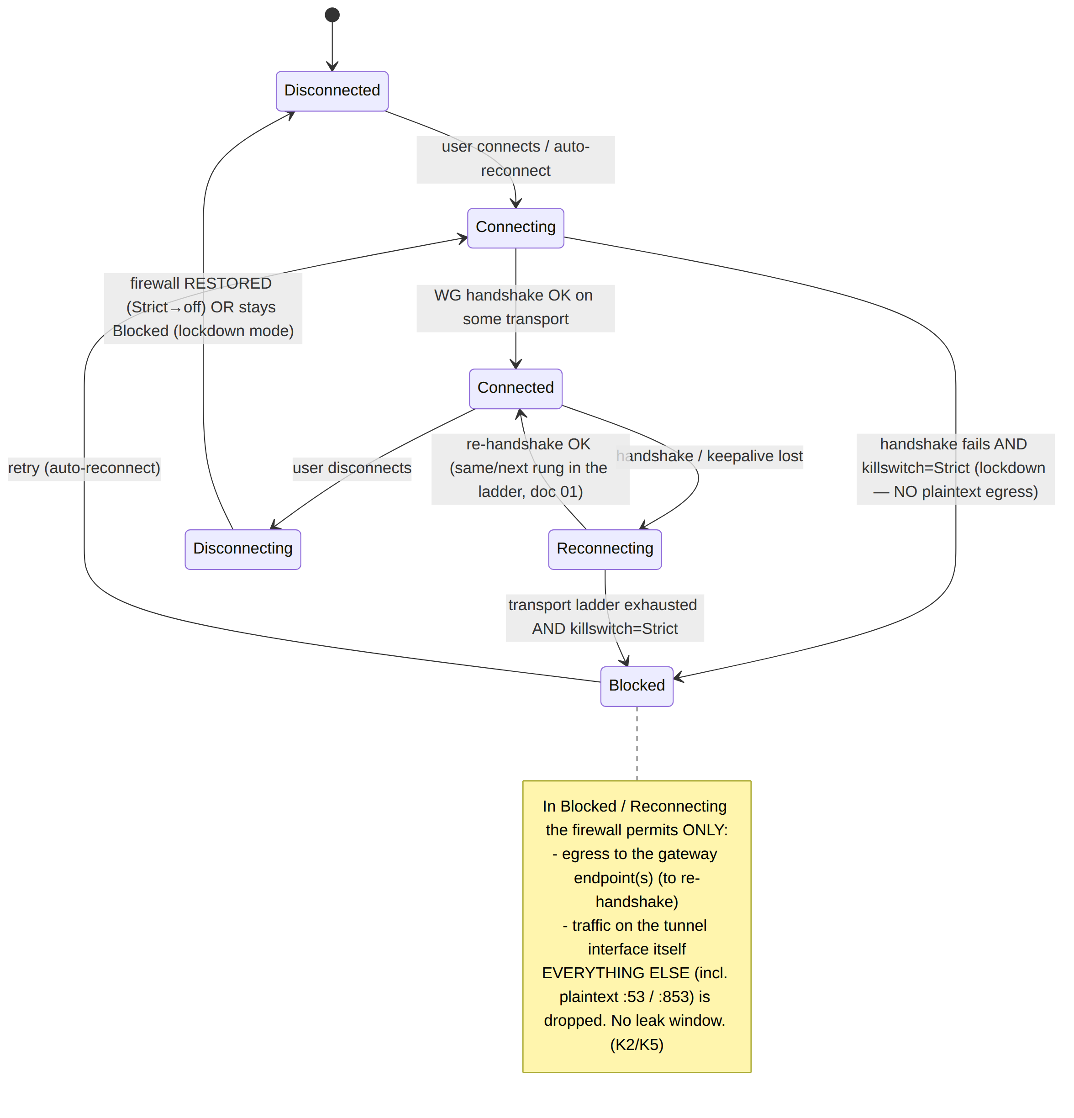

2.1 The single transition authority
// helix-core/crates/helix-killswitch/src/sm.rs (contract — state machine, not full impl)
// [04-SEC §8.4 reproduced; the body coupling is owned by v02-orch §8]
#[derive(Clone, Copy, PartialEq, Eq)]
pub enum LinkState { Disconnected, Connecting, Connected, Reconnecting, Blocked, Disconnecting }
pub enum KillSwitchMode { Strict, Permissive, Off } // maps from Shields.kill_switch (hc §8.1)
// MVP FFI reach: Shields.kill_switch is a BOOL -> only { Strict (true), Off (false) }.
// `Permissive` is Phase-2 / internal-only — NOT selectable through the MVP FFI (see §2.2).
pub struct LinkCtx {
pub gateways: Vec<SocketAddr>, // allow_gateway_endpoints — stay reachable to re-handshake
pub tun_if: String, // the tun/wg carrier device name
pub dns: Vec<IpAddr>, // tunnel DNS servers (from RouteMap.dns)
pub allow_lan: bool, // permit RFC1918 LAN while closed (printers etc.)
}
pub struct KillSwitch { fw: Box<dyn Firewall>, mode: KillSwitchMode }
impl KillSwitch {
/// THE single authority for the transition. On EVERY transition it re-enforces the
/// firewall BEFORE the network operation, so no plaintext can escape during the change
/// (S9/K1/K2). Idempotent: re-applying the same state is a no-op at the OS layer.
pub fn transition(&mut self, to: LinkState, ctx: &LinkCtx) -> Result<(), FwError> {
if matches!(self.mode, KillSwitchMode::Off) { return self.fw.restore(); }
self.fw.enforce(to, &ctx.gateways, &ctx.tun_if, &ctx.dns)?; // firewall FIRST…
// …then the orchestrator's link operation (bring up/down peer) proceeds (v02-orch §8).
Ok(())
}
}
The ordering is the invariant: enforce runs before the link op, so even a transition that is about to open the tunnel first installs the closed-or-tunnel-only rule set. There is never a window where the orchestrator has changed OrchState but the firewall has not yet caught up (F-I4 [hc §0.3]).

2.2 Mode semantics
KillSwitchMode | Behaviour | Typical user
Strict | armed-closed before the first handshake; fail-closed on every drop; Blocked lockdown when re-dial fails; revert only on user-stop | privacy client (default for Helix Access)
Permissive (Phase-2 / internal-only) | tunnel-DNS + off-tunnel :53 block while Connected, but a drop reverts to system networking (no Blocked lockdown) | a user who prefers connectivity-over-privacy on drop — not reachable from the MVP FFI (§2.2 note)
Off | no firewall side effects; restore() keeps the host's pre-VPN posture | the connector appliance (KillSwitchMode::Off default [v02-orch §9.4])
Strict is the default for the privacy client; the connector defaults to Off because it is an appliance, not a privacy endpoint [hc §9.4, v02-orch §9.4].
Reconciled (§11.4.35, 2026-06-26): the MVP FFI surface exposes Shields.kill_switch as a bool, which maps to exactly two modes — Strict (true) and Off (false). Permissive is therefore Phase-2 / internal-only: it exists in the core enum for the future "connectivity on drop" choice (an explicit, surfaced mode, never a silent fallback, §11.4.6) but is not selectable through the MVP FFI — the doc must not imply an MVP control that does not yet exist.

3. Firewall posture per state — the rules the core emits
This is the abstract rule set every shim realises. The columns are the intent; §5 maps each to a native primitive.
State | Allowed egress | DNS | FFI projection | Notes
Disconnected | all (Strict→off) or none (lockdown-on-disconnect toggle) | system | Disconnected | lockdown toggle = "block until connected"
Connecting / Reconnecting | only to gateway endpoint IP:port | blocked (no off-tunnel :53) | Connecting / Reconnecting | prevents leak during the escalation ladder
Connected | only via the tunnel utun/wg0 + the gateway endpoint | tunnel DNS only; off-tunnel :53/:853 dropped | Connected{...} | the only steady state
Blocked | only to the gateway endpoint (to recover) | blocked | Reconnecting or Danger{killswitch_tripped} | hard lockdown; UI shows "protected, reconnecting"

3.1 The side-effect matrix (drives both the firewall and the Danger projection)
This matrix is the canonical coupling [v02-orch §8.4, hc §8.2]; the FFI column is the §8 projection.
Transition | Kill-switch (Strict) | DNS | FFI projection
Idle → Connecting | install closed (allow gateway endpoints only) — K1 | system DNS | Connecting
Handshaking → Connected | open (egress via tunnel) | apply tunnel DNS + block off-tunnel :53 — K5 | Connected{transport,rtt}
Connected → Reconnecting (drop) | close — K2 (O-I11) | keep tunnel-DNS block (fail-closed) | Reconnecting
* → Down{reason≠stopped} | stay closed — K3 | keep block | Down{reason} (or Danger{killswitch_tripped} if a leak probe fired)
ShuttingDown → Down{stopped} (user) | revert to off (open) — K3 | revert system DNS | Disconnected
crash / panic | closed rules remain — K4 | block remains | (process restarts; start() re-arms)

3.2 The kill-switch ⇄ DNS sub-machine
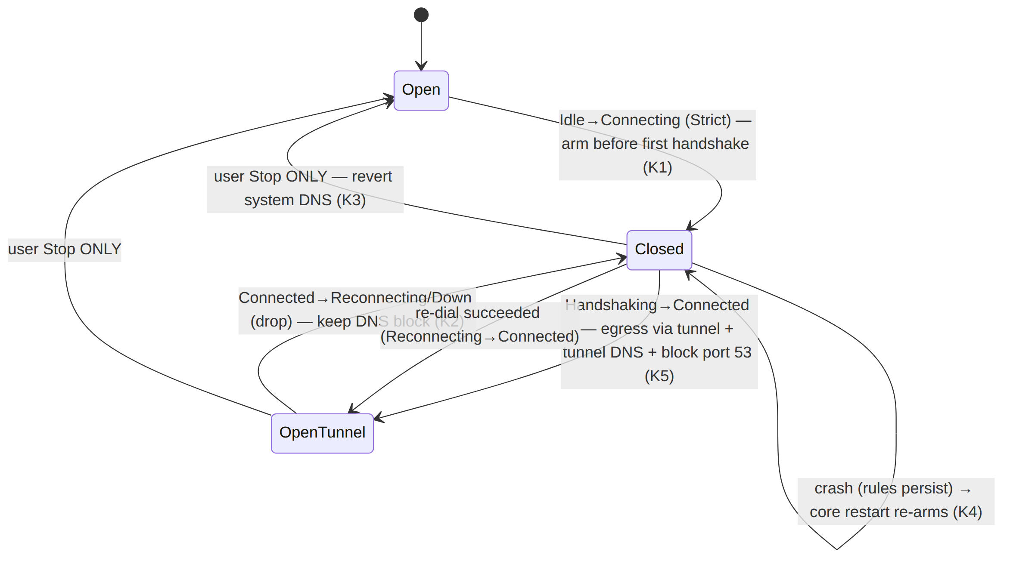

3.3 auth-failed is closed-and-terminal
A revoked device — whose peers_removed delta includes the active gateway (the revocation path, [hc §7.3]) — reaches Down{auth-failed} with the kill-switch closed and DNS blocked. A revoked client cannot leak onto the underlay by virtue of being revoked [hc §8.5, v02-orch §8.5]: the firewall is in the Closed state, not Open. Recovery requires explicit user re-enroll through start(). This is the security intersection of revocation (S5, [04-SEC §4.6]) and the kill-switch (S9): a sub-second revocation does not merely stop the tunnel, it leaves the device leak-proofed.

4. The Firewall trait — the cross-platform seam
Every shim implements one trait; the abstract state machine (§2) is platform-agnostic.
// helix-core/crates/helix-killswitch/src/firewall.rs (the seam each shim implements)
// [04-SEC §8.4 reproduced; impls owned by the four shim docs §5]
pub trait Firewall {
/// Apply the leak-proof rule set for `state`. MUST be ATOMIC — there is no transient
/// open window between flushing the old rules and installing the new (K1). On a platform
/// whose primitive is non-atomic, the impl uses a transaction/lock (nft atomic ruleset,
/// WFP transaction) so a reader never observes a half-applied posture.
fn enforce(&self, state: LinkState, gw: &[SocketAddr], tun_if: &str, dns: &[IpAddr])
-> Result<(), FwError>;
/// Restore the host's pre-VPN firewall. Called ONLY on Disconnected when the mode is Off
/// or on a user-initiated stop (K3). Never called on a drop.
fn restore(&self) -> Result<(), FwError>;
/// Probe: does any off-tunnel egress currently escape? Used by the leak probe (§8/§10)
/// to raise Danger{leak} on positive evidence — never to guess (§11.4.6).
fn leak_probe(&self, tun_if: &str) -> Result<LeakVerdict, FwError>;
}
pub enum LeakVerdict { Clean, OffTunnelEgressDetected { proto: String, dport: u16 } }
pub enum FwError {
/// The host firewall could not be programmed. The core treats this as HostFatal:
/// it REFUSES to run a tunnel it cannot leak-protect (maps to CoreError::HostFatal, hc §10.1).
EnforceFailed(String),
NotPermitted(String), // missing CAP_NET_ADMIN / WFP access / NE entitlement
}
The EnforceFailed → HostFatal rule is load-bearing: if the firewall cannot be programmed, the core does not silently run an unprotected tunnel — it emits Down{host-fatal} and start() returns Err(HostFatal) [hc §10.1]. A VPN that cannot guarantee leak protection is honestly refused, not optimistically run. This is the §11.4 anti-bluff posture at the firewall layer: no "probably protected" PASS.

5. Per-OS enforcement realisation
One abstract machine, five native primitives. Each shim owns the column-3 mechanism; this section is the synthesis with concrete rule sketches and exact citations.

5.1 Linux — nftables output-hook default-drop
The reference platform [shim-linux §11]. The kill-switch is an nftables table whose output chain has policy drop, installed at Idle → Connecting (Strict):
# helix-netd installs this at Idle→Connecting (Strict). [shim-linux §11.1]
table inet helix_killswitch {
chain output {
type filter hook output priority 0; policy drop; # default-DROP egress (fail-closed, K1/K2)
oifname "helix0" accept # the tun/wg carrier device (tunnel traffic)
ip daddr <gateway_endpoints> udp dport 443 accept # allow_gateway_endpoints (re-handshake)
ip daddr <gateway_endpoints> tcp dport 443 accept # masque / uot dial
ip6 daddr <gateway_endpoints6> udp dport 443 accept # dual-stack gateway reach (K6)
meta l4proto { icmp, icmpv6 } accept # ND / DHCP link bring-up
ip daddr <rfc1918> accept # allow_lan (config; printers etc.)
}
}
# Plaintext :53 leak guard (block_plaintext_53 when Connected) — [shim-linux §11.2]:
# chain output { ... meta l4proto { udp, tcp } th dport 53 oifname != "helix0" drop; }
- <gateway_endpoints> = KillSwitchConfig.allow_gateway_endpoints [v02-orch §8.2] — interpolated by the core, never hand-edited.
- Fail-closed across crash (K4): the table stays installed on crash; the systemd unit's ExecStopPost=/usr/lib/helixvpn/helix-netd --flush-killswitch-on-crash is the only path that flushes it, and only on a user stop [shim-linux §8.6, §11.1].
- Atomicity: the impl swaps the ruleset with an nft -f atomic transaction so no reader observes a half-applied table.
- DNS: conditional on the host stack — resolvectl dns helix0 <dns> + resolvectl domain helix0 '~.' (systemd-resolved), resolvconf -a helix0 (resolvconf), or an atomic /etc/resolv.conf rewrite-with-backup-and-restore (static) [shim-linux §11.2].

5.2 Windows — WFP persistent sub-layer
A privileged SYSTEM service hosts the core and installs WFP filters [shim-windows §8]. On Idle → Connecting (Strict) it installs a default-block filter at the outbound IP layers plus narrow permits:
# WFP filters [shim-windows §8.2] — installed FWPM_FILTER_FLAG_PERSISTENT (survive crash, K4)
Layers: FWPM_LAYER_OUTBOUND_IPPACKET_V4 / _V6 (dual-stack, K6)
Default: policy = DROP
Permits:
- ip.remote_address ∈ allow_gateway_endpoints (udp dport 443, tcp dport 443)
- ip.local_interface = wintun LUID (tunnelled traffic via the adapter)
- meta l4proto { icmp, icmpv6 } (ND / bootstrap)
- ip.daddr ∈ RFC1918 (only if allow_lan)
# DNS guard [shim-windows §8.3] — on Handshaking→Connected:
- drop any :53 (UDP+TCP) egress NOT over the wintun interface
- apply tunnel DNS via SetInterfaceDnsSettings on the adapter LUID
# Per-app split: dynamic FWPM_CONDITION_ALE_APP_ID at ALE_AUTH_CONNECT [shim-windows §8.5]
- Persistent filters survive a service crash (K4) — the FWPM_FILTER_FLAG_PERSISTENT flag means the block holds even if HelixTunnelSvc dies; the next start reconciles.
- The only open path (K3): the persistent kill-switch is removed only on a user-initiated StopTunnel → ShuttingDown → Down{stopped}; every other terminal (crash, auth-failed, ladder-exhausted) leaves it closed [shim-windows §8.6].
- The full transition→filter coupling is the [shim-windows §8.4] table (mirrors §3.1).

5.3 Android — always-on lockdown + protect()
Android has no in-process firewall API for an app; the kill-switch is the system always-on VPN with "Block connections without VPN" (lockdown) [shim-android §9.2]. The OS drops all non-VPN egress at the routing layer when lockdown is enabled; the core's KillSwitch state machine drives when the tunnel should be up, the OS lockdown is the platform mechanism.
// Loopback avoidance — the Android-specific kill-switch corollary [shim-android §6.2]
// EVERY outbound transport socket the core opens MUST be protect()ed BEFORE connect(),
// else the tunnel's own packets loop back into the tun.
override fun protect(fd: Int): Boolean = protect(fd) // VpnService.protect(int)
// helix-core: a failed protect() is a HARD dial error — never connect unprotected. [shim-android §6.2]
if !PROTECT.get().map_or(false, |cb| cb.protect(sock.as_raw_fd())) {
return Err(TransportError::Io(io::Error::other("protect() failed")));
}
sock.connect(&peer.into())?;
- DNS leak guard: b.addDnsServer(<tunnel-dns>) for every tunnel resolver; with a full-tunnel 0.0.0.0/0 + ::/0 route set and no bypass route, off-tunnel :53 cannot egress [shim-android §10.2].
- Split-tunnel: VpnService.Builder.addDisallowedApplication(pkg) (exclude-list model); an unknown package is skipped honestly, never aborts the tunnel [shim-android §10.1].
- protect() is the kill-switch's twin: without it the core would leak its own encrypted transport packets back through the tunnel — a loop, not a plaintext leak, but the same "socket escaped the intended path" defect class [shim-android §6].

5.4 Apple — NE routing + NEDNSSettings
The iOS/macOS NEPacketTunnelProvider extension has no in-extension firewall (the NE sandbox provides none); the kill-switch is protocol/routing enforcement via the Network Extension framework [shim-apple §3.4]:
// [shim-apple §3.2] — DNS forced into the tunnel; off-tunnel :53 blocked by OS routing
let dns = NEDNSSettings(servers: cfg.dnsServers)
dns.matchDomains = [""] // match ALL domains → no plaintext :53 off-tunnel (K5)
settings.dnsSettings = dns
// IPv6 capture (K6):
if let v6 = cfg.overlayIp6 {
let s6 = NEIPv6Settings(addresses: [v6], networkPrefixLengths: [128])
s6.includedRoutes = cfg.routes6.map { /* … */ }
settings.ipv6Settings = s6
}
// Kill-switch routing: NETunnelProviderProtocol.includeAllNetworks = true
// (+ excludeLocalNetworks if allow_lan) — [shim-apple §3.4]
- Kill-switch = includeAllNetworks plus NEOnDemandRule for always-on/lockdown; the OS routes all networks into the tunnel and there is no in-extension firewall to leak around [shim-apple §3.4].
- Honest gap (UNVERIFIED, [shim-apple §3.4]): whether includeAllNetworks fully blocks egress during the extension-restart window on every iOS version is measured in the G3 / SC soak, never assumed. This is a tracked, captured-evidence item (§9, §10), not a claimed guarantee.

6. DNS-leak prevention
DNS leakage is the subtlest privacy failure: the tunnel may carry the traffic, but if a single query escapes to a public resolver, the destinations the user visits are exposed. HelixVPN closes the plaintext path mechanically and documents the encrypted-resolver path honestly.

6.1 Force all DNS through the tunnel
The core sets the tunnel DNS — pushed in the NetworkMap as dns_servers + search_domains [04-SEC §8.3, hc §7.1] — and applies it via the platform's split-DNS API: Apple NEDNSSettings.servers + matchDomains=[""], Android VpnService.Builder.addDnsServer, Windows SetInterfaceDnsSettings (NRPT-class), Linux resolvectl dns <if> + resolvectl domain <if> '~.'. matchDomains=[""] / domain '~.' is the "route all domains through this resolver" idiom — a partial match-domain set would leak the unmatched domains.

6.2 Block plaintext :53/:853 off-tunnel
The split-DNS setting tells well-behaved apps which resolver to use; it does not stop an app that hardcodes 8.8.8.8. So the firewall rule is the belt-and-suspenders backstop [04-SEC §8.3]: in every non-Disconnected state, drop UDP+TCP :53 (plaintext DNS) and :853 (DoT) that is not destined for the tunnel resolver over the tunnel interface. The Linux rule (th dport 53 oifname != "helix0" drop), the Windows WFP :53 filter, and the Apple matchDomains=[""] routing each realise this; Android relies on the no-bypass-route full-tunnel posture.

6.3 The two layers, why both
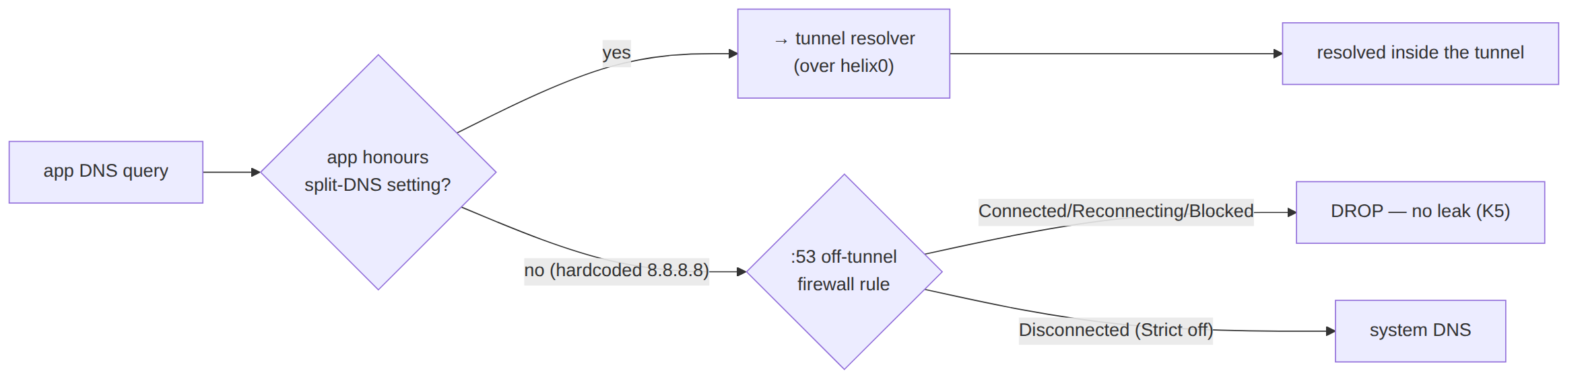
The split-DNS setting handles the 99% well-behaved case cheaply; the firewall rule catches the hostile/buggy 1%. Setting or rule alone is a leak; both together is the guarantee.

6.4 DoH / DoT — the honest boundary
Plaintext :53 and DoT :853 are blocked off-tunnel by the firewall rule. DoH (DNS over HTTPS on :443) is indistinguishable from ordinary HTTPS at the firewall layer — a :443 drop would break the web. The honest posture:
- Plaintext :53 / DoT :853: mechanically blocked off-tunnel (§6.2). Closed.
- DoH to a public resolver on :443: UNVERIFIED / out-of-firewall-scope. The firewall cannot distinguish a DoH POST from a web request. Mitigation options, surfaced not silently chosen (§11.4.66): (a) the OS-level "disable private DNS / DoH" enterprise control on managed Android/Windows; (b) an app-level resolver-allowlist where the platform exposes one; (c) accept that an app deliberately configured for public DoH is the user's own choice — the VPN routes the :443 bytes through the tunnel regardless, so the DoH query travels inside the tunnel and is not an underlay leak as long as the full-tunnel route holds. The genuine residual leak is a split-tunnelled app doing DoH to a public resolver on an excluded route — a documented split-tunnel caveat, tracked per §9, never claimed closed.
This DoH boundary is stated as a fact, not a guess: the firewall closes plaintext and DoT; DoH-on-443 inside a full tunnel is not an underlay leak; DoH-on-443 on a split-tunnelled route is a documented residual the operator configures around.

7. IPv6-leak closure
The classic dual-stack leak: the overlay is IPv4 (or ULA IPv6 via 4via6 [doc 03/D4]) but the host has native IPv6 connectivity. A v4-only tunnel leaves native v6 egress on the physical interface — the user's real v6 address and v6 destinations escape.
The rule (K6): the core never leaves a partial v6 capture. Two acceptable postures, chosen by the platform's capability:
Posture | Mechanism | Platforms
Full v6 capture | route ::/0 (or the overlay v6 prefix) into the tunnel; native v6 egress is then subject to the same kill-switch rules as v4 | Apple NEIPv6Settings.includedRoutes; Android addRoute(::/0); Windows WFP _V6 layer; Linux inet6 nft family
v6 block | if the overlay carries no v6, drop all native v6 egress in the kill-switch (so v6 cannot fall through) | Linux nft ip6 drop; Windows WFP _V6 default-DROP; Apple — relies on includeAllNetworks
What is forbidden is the third, leaky posture: overlay v6 present but native v6 egress left open on the physical interface. The kill-switch rule sets are dual-stack by construction — Linux nft has both ip and ip6 daddr rules, Windows installs filters at both FWPM_LAYER_OUTBOUND_IPPACKET_V4 and _V6, Apple sets NEIPv6Settings alongside NEIPv4Settings [shim-windows §8.2, shim-apple §3.2]. UNVERIFIED: the exact interaction of includeAllNetworks with a host that gains native v6 mid-session on iOS is a measured item (§9), not an assumed guarantee.

8. The Danger projection — surfacing a trip to the UI
A leak-proof firewall is necessary but not sufficient: the user must see that the tunnel dropped and they are now in lockdown, not be told "connected" while re-dialling. The FFI projects a kill-switch trip or a positive leak probe to the Danger{kind} overlay [hc §5.2, §8.4].

8.1 The two danger kinds (raised only on a concrete signal)
// helix-ffi FfiTunnelStatus (hc §5.1) — Danger is an FFI-only overlay, the core never emits it.
Danger { kind: String }, // kind ∈ { "killswitch_tripped", "leak" }
- kind="killswitch_tripped" — the §3.2 sub-machine reports the kill-switch closed while the user intends connected (a drop the user can see). Raised on the Connected → Reconnecting/Blocked transition when the user's intent is "connected".
- kind="leak" — an explicit DNS/leak probe (Firewall::leak_probe, §4) returns OffTunnelEgressDetected. Raised only on a positive probe result, never inferred.

8.2 Never guessed (§11.4.6)
Danger is not a guessed UI state. Absent a concrete signal — the sub-machine reporting closed-while-intended-connected, or a leak probe firing — the FFI emits Reconnecting / Down, never Danger [hc §5.1 consistency note]. This is the no-guessing mandate at the UI layer: the red stateDanger palette appears only when the system has captured evidence of a danger condition, so a red screen is always a true positive, never an alarmist guess. Conversely, a real trip is never hidden behind an optimistic Connected — Danger overrides any optimistic UI intent and paints red immediately [hc §8.4].
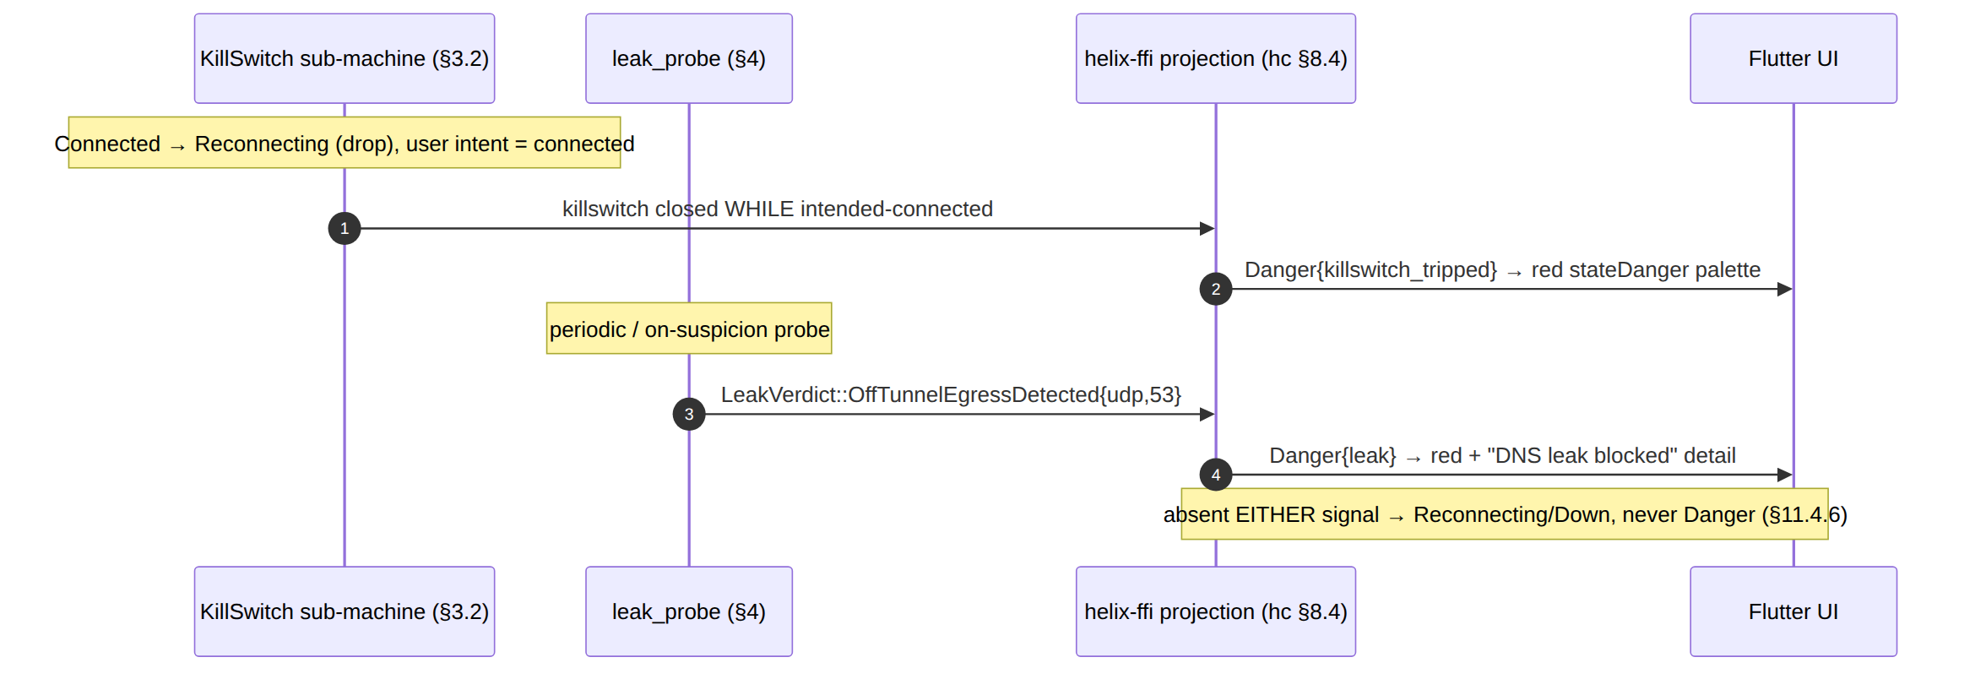

9. Per-OS capability matrix + honest gaps
The single abstract machine maps to five primitives of differing strength. This matrix states, per OS, what is mechanically guaranteed vs. what is UNVERIFIED / operator-attended — the honest-gap ledger (§11.4.6: a capability is UNVERIFIED until measured on a real device, never assumed).
Capability | Linux | Windows | Android | Apple (iOS/macOS)
Kill-switch primitive | nftables output policy drop [shim-linux §11.1] | WFP persistent sub-layer default-DROP [shim-windows §8.2] | always-on VPN + lockdown (OS) [shim-android §9.2] | includeAllNetworks routing [shim-apple §3.4]
Arms before first handshake (K1) | ✅ installed at Idle→Connecting | ✅ persistent filter installed at Connecting | ⚠️ relies on OS lockdown being enabled (user/MDM setting) | ✅ NE config applied before pump
Fail-closed on drop (K2) | ✅ table stays | ✅ filter stays | ✅ lockdown holds | ✅ routing holds
Survives crash (K4) | ✅ ExecStopPost-gated flush only | ✅ FWPM_FILTER_FLAG_PERSISTENT | ✅ OS lockdown is OS-side | ⚠️ UNVERIFIED extension-restart window [shim-apple §3.4]
Off-tunnel :53 block (K5) | ✅ nft :53 oifname != helix0 drop | ✅ WFP :53 filter | ✅ full-tunnel + no bypass route | ✅ matchDomains=[""]
DoT :853 block | ✅ same nft rule (dport 853) | ✅ WFP filter | ✅ no bypass route | ✅ routing
DoH-on-443 off-tunnel | ⚠️ out-of-firewall-scope (§6.4) | ⚠️ out-of-firewall-scope (§6.4) | ⚠️ (enterprise DoH control on MDM) | ⚠️ out-of-firewall-scope (§6.4)
IPv6 capture/block (K6) | ✅ inet6 family rules | ✅ _V6 WFP layer | ✅ addRoute(::/0) | ⚠️ UNVERIFIED mid-session native-v6 gain [shim-apple §3.2]
Self-protect socket loopback | n/a (routing) | n/a (WFP) | ✅ protect() mandatory [shim-android §6] | n/a (NE owns the socket)

9.1 The tracked honest gaps (each a captured-evidence item, never a claimed PASS)
Gap | OS | Posture | Resolution path
includeAllNetworks egress during the extension-restart window | iOS | UNVERIFIED [shim-apple §3.4] | measured in the G3 / SC on-device soak (§10); tracked migration item, not a claimed guarantee
native-v6 gained mid-session | iOS | UNVERIFIED [shim-apple §3.2] | on-device dual-stack capture test (§10)
always-on lockdown not enabled by the user/MDM | Android | ⚠️ operator/user-attended | the app surfaces a "enable Always-on VPN + lockdown" prompt; until enabled, the core's kill-switch is the only layer (no OS backstop) — documented, not silently assumed protected
DoH-on-443 on a split-tunnelled excluded route | all | ⚠️ documented residual (§6.4) | enterprise DoH control / resolver allowlist where the platform exposes one; surfaced per §11.4.66
No gap is a faked PASS. Each is either UNVERIFIED pending a captured-evidence measurement, or an operator/user-attended condition the app surfaces. The §11.4 anti-bluff posture forbids reporting "leak-proof on iOS" when the extension-restart window is unmeasured — it is reported as UNVERIFIED with a tracked resolution path.

10. Anti-bluff validation (§11.4.107/§11.4.69)
The kill-switch claim is validated by captured packet-level evidence, never an absence-of-error PASS [04-SEC §8.4, 04_P1 §11 DoD #6]. The canonical DoD test:
- Establish a tunnel; start a continuous transfer.
- Drop the tunnel mid-transfer (block the gateway endpoint at the upstream, or stop the edge) so the orchestrator transitions Connected → Reconnecting → Blocked.
- Capture on the host's physical interface (tcpdump/pktap) for the entire Reconnecting/Blocked window.
- Assert zero plaintext packets egress — including :53 DNS — during the window. A single leaked packet is a FAIL. The captured pcap is the evidence (sink-side positive evidence per §11.4.69, captured-evidence per §11.4.107), not a green log line.

10.1 The test matrix (per §11.4.169, captured evidence per row)
Test id | §11.4.169 codes | What it proves | Captured evidence
KS-1 | SEC | kill-switch closes on drop: no plaintext egress while Reconnecting/Blocked; off-tunnel :53 dropped when Connected | physical-iface pcap shows ZERO leaked packets (mirrors [hc §12] HC-8)
KS-2 | SEC | pre-connect armed-closed (K1): packets sent before the first handshake do not escape | pcap during Idle→Connecting window
KS-3 | SEC+CHAOS | crash persistence (K4): SIGKILL the core mid-Connected → closed rules remain; no leak until re-arm | pcap across the kill→restart window; nft/WFP rule dump post-kill
KS-4 | SEC | DNS leak: an app hardcoding 8.8.8.8 cannot resolve off-tunnel when Connected | pcap shows the :53 packet DROPPED
KS-5 | SEC | IPv6 leak (K6): host with native v6 → no native-v6 egress escapes the tunnel | dual-stack pcap
KS-6 | E2E+UI | Danger{killswitch_tripped} projects on a real drop; Danger{leak} projects on a positive probe; neither is raised absent a signal | FfiTunnelStatus event trace + window-scoped MP4 of the red palette (§11.4.159)
KS-7 | SEC (iOS) | the §9.1 extension-restart-window gap: measured, not assumed | on-device pcap across an NE restart — resolves the UNVERIFIED marker or files the migration item

10.2 Self-validating the analyzer (§11.4.107(10))
Each leak-test ships a paired §1.1 mutation so the gate provably cannot bluff: emit a Connected projection before the firewall opens → KS-1 must FAIL; a golden-bad pcap with a leaked :53 packet → the pcap analyzer must FAIL it (a golden-good leak-free pcap PASSes). An analyzer that PASSes its golden-bad fixture is itself a bluff gate. The leak_probe (§4) is likewise validated: a synthetic off-tunnel socket must make it return OffTunnelEgressDetected, a clean run Clean.

11. Config knobs
// helix-core — configured by start() from Shields + RouteMap [hc §8.1, 04-SEC §8]
pub struct KillSwitchConfig {
pub mode: KillSwitchMode, // Strict | Permissive | Off (§2.2)
pub allow_lan: bool, // permit RFC1918 LAN while closed (printers etc.)
pub allow_gateway_endpoints: Vec<IpNet>, // gateway IPs the transport MUST reach (stay open)
pub lockdown_on_disconnect: bool, // "block until connected" toggle for Disconnected
}
pub struct DnsConfig {
pub servers: Vec<IpAddr>, // tunnel DNS (from RouteMap.dns)
pub block_plaintext_53: bool, // drop off-tunnel :53/:853 when Connected (leak guard)
pub apply: DnsApplyMethod, // resolvconf | systemd-resolved | /etc/resolv.conf | shim
}
The FFI Shields (§4.2 of [hc]) maps onto these: kill_switch=true ⇒ KillSwitchMode::Strict; dns_protection=true ⇒ block_plaintext_53=true. set_shields() re-applies live (no restart) [hc §8.1]. Every numeric default is calibrated against captured evidence before it is frozen (§11.4.6 — a number is a guess until measured); none is hardcoded as a guarantee.

12. Open decisions & cross-doc contracts

12.1 Decisions surfaced (options + recommendation, never silently resolved — §11.4.6/§11.4.66)
# | Decision | Option A | Option B | Recommendation
D-KS-1 | DoH-on-443 off-tunnel posture | accept (DoH inside full tunnel is not an underlay leak); document the split-tunnel residual | enterprise DoH-disable control on MDM platforms | A for the default; B offered to managed tenants — the split-tunnel residual is documented, never claimed closed (§6.4)
D-KS-2 | Android lockdown enforcement | rely on user/MDM enabling Always-on VPN + lockdown | ship the core kill-switch as the sole layer with an in-app "enable lockdown" prompt | both layers — core kill-switch always on; surface the OS-lockdown prompt; never silently assume the OS backstop is present (§9.1)
D-KS-3 | iOS extension-restart-window guarantee | claim leak-proof | measure on-device, mark UNVERIFIED until proven | B — measure in G3/SC (§10); the marker is honest until the pcap exists (§11.4.6)

12.2 Cross-document contracts this document fixes
Contract | Fixed value | Consumed by / source
The abstract kill-switch state machine (LinkState, the side-effect matrix) | §2/§3 | [v02-orch §8] owns the bodies; this doc owns the cross-platform synthesis
The Firewall trait seam (enforce/restore/leak_probe, EnforceFailed → HostFatal) | §4 | the four shim Firewall impls; [hc §10.1] for the error mapping
The DNS leak-closure taxonomy (split-DNS setting + :53 block + DoH boundary) | §6 | [shim-* §DNS], [04-SEC §8.3]
The Danger{kind} projection contract (raised only on a concrete signal) | §8 | [hc §5.2/§8.4], the Flutter UI
The per-OS capability matrix + honest-gap ledger | §9 | [shim-apple §3], [shim-android §6/§9/§10], [shim-windows §8], [shim-linux §11]
The anti-bluff DoD (physical-iface pcap, zero plaintext) | §10 | [04-SEC §8.4], [04_P1 §11 DoD #6], [hc §12 HC-8]

Sources verified
- ../04-security-privacy-pki.md [04-SEC] — §0.1 (S9 invariant), §8 (kill-switch & DNS-leak state machine, the §8.2 posture table, §8.3 DNS specifics + IPv6, §8.4 Rust Firewall skeleton + anti-bluff pcap DoD), §4.6 (revocation intersection with §8.5 auth-failed).
- ../v04-client/helix-core-rust.md [hc] — §5.1/§5.2 (FfiTunnelStatus projection, the Danger{kind} overlay), §8.1 (KillSwitchConfig / DnsConfig + Shields mapping), §8.2 (side-effect matrix), §8.3 (sub-machine), §8.4 (Danger projection raised only on a concrete signal), §8.5 (auth-failed closed-and-terminal), §10.1 (CoreError::HostFatal), §12 (HC-8 kill-switch test point).
- ../v02-data-plane/orchestrator-and-state.md [v02-orch] — §8 (the kill-switch/DNS coupling bodies, O-I10/O-I11 fail-closed), §8.2 (allow_gateway_endpoints), §8.4 (side-effect matrix incl. crash row), §8.5 (auth-failed), §9.4 (connector KillSwitchMode::Off).
- ../v04-client/shim-apple.md [shim-apple] — §3.2 (NEDNSSettings.matchDomains=[""], NEIPv6Settings.includedRoutes), §3.4 (kill-switch = includeAllNetworks; the UNVERIFIED extension-restart-window marker).
- ../v04-client/shim-android.md [shim-android] — §6 (protect() loopback-avoidance contract), §9.2 (always-on VPN + lockdown kill-switch), §10.1 (addDisallowedApplication split-tunnel), §10.2 (addDnsServer DNS leak guard).
- ../v04-client/shim-windows.md [shim-windows] — §8.2 (WFP persistent default-DROP sub-layer, FWPM_FILTER_FLAG_PERSISTENT, dual-stack _V4/_V6), §8.3 (:53 DNS guard + SetInterfaceDnsSettings), §8.4 (coupling table), §8.5 (FWPM_CONDITION_ALE_APP_ID per-app split), §8.6 (user-stop-only open path).
- ../v04-client/shim-linux.md [shim-linux] — §11.1 (nftables helix_killswitch table, output policy drop, gateway/LAN permits, atomic ruleset), §11.2 (systemd-resolved / resolvconf / /etc/resolv.conf DNS methods, :53 block), §8.6 (ExecStopPost user-stop-only flush).
- svc-telemetry.md [svc-telemetry] — §5 (presence is ephemeral; an offline tunnel never persists a connection log — the privacy context this kill-switch protects).
Constitution: §11.4.44 (revision header), §11.4.6/§11.4.66 (decisions = options + recommendation, UNVERIFIED never fabricated, no-guessing for the Danger projection), §11.4.69/§11.4.107/§11.4.159 (sink-side / captured / window-scoped leak evidence — physical pcap, never absence-of-error), §11.4.107(10) (self-validated leak analyzer + golden-bad pcap), §1.1 (paired mutations). SPEC-ONLY — describes what to build, does not build it.
End of nano-detail specification — Volume 5 (Security & Privacy), kill-switch-and-dns-leak.md. Pairs with audit-and-compliance.md (the audit + compliance posture this leak-proofing supports), the master security doc §8 (the invariant it deepens), and the four Volume-4 shim docs (the per-OS firewall realisations it synthesises).

