PKI & Certificates — the tenant CA, short-lived mTLS, and sub-second revocation

PKI & Certificates — the tenant CA, short-lived mTLS, and sub-second revocation
Revision: 1 Last modified: 2026-06-25T12:00:00Z
Master technical specification — Volume 5 (Security & Privacy), nano-detail document pki-and-certs. Deepens the PKI slice of the security spine [04-security-privacy-pki.md §4] from a security lens, grounded in the cited research [research-pki_pq_nat]: the CA hierarchy (root → tenant issuing CA → short-lived device leaf), the certificate lifecycle (issue / renew / rotate / revoke) with a state diagram, the short-lived mTLS device certs (TTL, auto-renew before expiry), revocation (target sub-second propagation via the event/coordinator path — stated as a TARGET, never a measured result, §11.4.6), mTLS everywhere on the control plane, the post-quantum material slot (hybrid PSK-into-WG, see sibling [post-quantum.md] / spine §9), key storage (KMS/HSM with software fallback; device-side secure-element where available), and the concrete cert profiles / fields / TTLs / rotation timers. SPEC ONLY — it describes the credential-lifecycle properties the build must have; it builds nothing. The control-plane mechanics (Go PKI interface, DDL/RLS, signer seam) live in [v03-control-plane/svc-pki.md]; the enrollment protocol in the sibling [identity-and-enrollment.md]; the threat justification in [threat-model.md]. Sources cited inline by id: [research-pki_pq_nat §N] (the cited PKI/PQ/NAT research — the primary evidence base for this doc), [04_ARCH §N], [04_P1 §N], [SYNTHESIS §N], sibling specs by filename. Invariants S1–S11 per [04-security-privacy-pki.md §0.1]; P1–P7 per [v03-control-plane/svc-pki.md §1.3]; threat ids T-* per [threat-model.md]. Unproven facts are UNVERIFIED per §11.4.6; any latency figure is a target, never a result.

Table of contents
- 0. Position, ownership & governing invariants
- 1. Why PKI is built AROUND WireGuard, not inside it
- 2. The CA hierarchy
- 3. Certificate profiles — fields, TTLs, key algorithms
- 4. Certificate lifecycle — the state machine
- 5. Short-lived mTLS device certs & auto-renew
- 6. Rotation — devices, CAs, WG keys, PQ PSK
- 7. Revocation — the sub-second target
- 8. mTLS everywhere on the control plane
- 9. Post-quantum material slot (hybrid, never PQ-only)
- 10. Key storage — KMS/HSM, secure element, software fallback
- 11. Threat mapping & test/validation (§11.4.169)
- 12. Phase-2 forward seams
- Sources verified

0. Position, ownership & governing invariants
The PKI is the credential-lifecycle authority that makes WireGuard's keys-only identity model safe to operate at scale: it adds the cert lifecycle, granular revocation, and rotation that WireGuard itself does not have [research-pki_pq_nat §1.1]. This document owns the security contract of that PKI; it cites, never re-defines, the Go wiring.

0.1 What this document owns vs. references
Concern | Owner | Relationship here
CA-hierarchy security model (isolation, blast radius, offline root) | this doc | authoritative
Cert profiles (fields, TTLs, key usage) and their security rationale | this doc | authoritative
Cert lifecycle security (issue/renew/rotate/revoke properties) | this doc | authoritative
Revocation target + the two-teeth model | this doc | authoritative
PQ material slot security (hybrid-never-PQ-only, what is/isn't stored) | this doc | authoritative
Key-storage security (KMS/HSM, secure element, fallback) | this doc | authoritative
Go PKI interface, DDL/RLS, CASigner seam, hot-path AuthDevice | [v03-control-plane/svc-pki.md] | referenced
Enrollment protocol (CSR PoP, key-never-leaves) | [identity-and-enrollment.md] | referenced
PQ handshake mechanics (KEM exchange, PSK derivation) | [post-quantum.md] / spine §9 | referenced
Threat justification | [threat-model.md] | referenced

0.2 Governing invariants (every clause below obeys these)
# | Invariant | Source
P1 / S2 | Device private keys never leave the device. The control plane receives/stores only the 32-byte WG public key. | [research-pki_pq_nat §1.3], [04-security-privacy-pki.md §0.1]
P2 / S4 | Short-lived control-channel certs. Default device-cert TTL ≈ 24 h; agent auto-renews ahead of expiry; revocation-latency target == the p99 < 1 s convergence SLO. | [04_P1 §6.3], [v03-control-plane/svc-pki.md §10.2]
P3 / S11 | The tenant CA key is the one true secret. KMS/HSM or offline; it + Postgres are the only stateful things to protect. Never git-tracked, never logged (§11.4.10). | [04_P1 §6.3], [04_ARCH §10]
P4 / S10 | Hybrid-never-PQ-only PQ. PQ is a PSK fed into WG (Mullvad/Rosenpass pattern), classical X25519 + ML-KEM; never a forked WG handshake, never PQ-only. | [research-pki_pq_nat §2.1/§2.4]
P5 | Default-deny, fail-closed. A revoked or expired credential never authenticates; an unknown serial is rejected, not trusted. | [v03-control-plane/svc-pki.md §1.3]
P6 | Every credential mutation emits a bus event so coordinator/audit react without polling. | [v03-control-plane/svc-pki.md §1.3]
P7 | Tenant-isolated at the DB — every PKI table RLS-scoped under FORCE ROW LEVEL SECURITY. | [v03-control-plane/svc-pki.md §1.3]

1. Why PKI is built AROUND WireGuard, not inside it
WireGuard has no native PKI [research-pki_pq_nat §1.1]: one Curve25519 keypair per device, the public key IS the device identity, access = adding the peer's public key to the peer set, and revocation is structurally trivial — remove the public key and the device is instantly cut off; there is no CA, cert expiry, CRL, OCSP, or enrollment protocol in WireGuard itself. So the cert/PKI lifecycle, granular revocation, and rotation are built around WireGuard, not inside it.
The chosen pattern is the SPIFFE/SPIRE-style two-identity split [research-pki_pq_nat §1.2]:
- a long-lived device-attestation cert (CA-signed leaf proving "I am a genuine enrolled device of tenant T", optionally TPM/Secure-Enclave-bound), and
- a short-lived mTLS credential (the per-device control-channel cert, "I am authorised to call the control API right now"), auto-rotated by the agent before expiry.
Revocation therefore has two cooperating teeth (belt-and-suspenders, the dominant 2025 model) [research-pki_pq_nat §1.2/§1.3]:
- (a) stop renewing the short-lived mTLS cert → it self-expires within its TTL, and
- (b) remove the WG public key from every peer set → instant data-path cutoff.
Two key spaces, one device. The CA-signed cert governs the control channel; the WG public key governs the data channel. They are independent (P1/S2, [identity-and-enrollment.md §2.2]) — a cert is not a WG key, and the CA never issues WG keys; WG keys are registered public keys, not issued certs. This separation is why a cert compromise does not yield tunnel decryption and vice versa.

2. The CA hierarchy
Each tenant gets its own isolated certificate hierarchy — there is no shared global root. Multi-tenant isolation reaches into the trust anchor, not just the row filter ([v03-control-plane/svc-pki.md §2.1]).
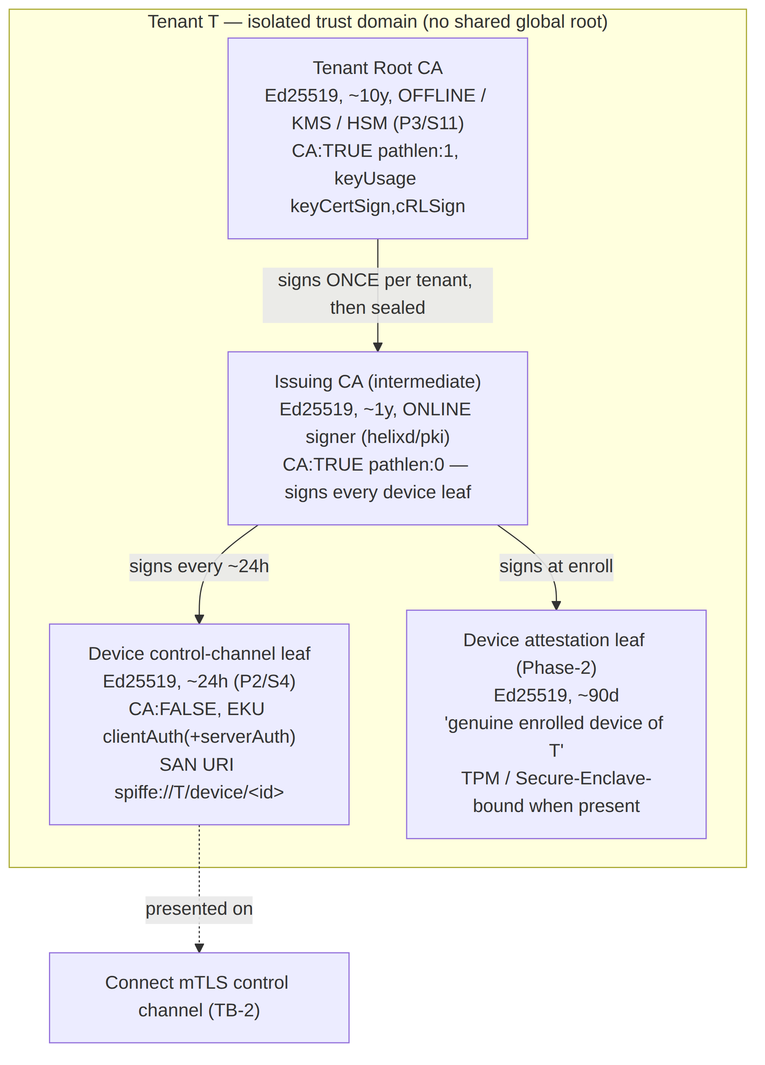

2.1 The three tiers and their security properties
Tier | Alg / TTL | Where the key lives | Security property
Tenant Root CA | Ed25519 / ~10 y | offline or KMS/HSM (P3) — used once per tenant to sign the issuing CA, then sealed; private key never touches the request path | theft mints arbitrary trusted identities (AS-CA, the "one true secret") — so it is kept off the hot path entirely
Issuing CA (intermediate) | Ed25519 / ~1 y | online signer (the key pki actually uses); KMS data-key-sealed or KMS-resident | rotating/compromising it does not require re-establishing the root — smaller blast radius, cleaner revocation
Device control-channel leaf | Ed25519 / ~24 h | device OS keystore (private), CA-signed (public) | short TTL caps blast radius (S4); SPIFFE SAN binds it to a device_id (T-COORD-T-1)
Device attestation leaf | Ed25519 / ~90 d | device keystore, TPM/SE-bound when present | Phase-2 — Phase-1 schema-provisions it but issues the mTLS leaf only; the device row + consumed enroll token are the Phase-1 attestation surrogate (stated honestly, §11.4.6)
CA topology decision (carried from [04-security-privacy-pki.md §4.2]). MVP default = single online issuing CA under an offline/KMS root (option B in the spine: two-tier with the root offline and a short-lived online intermediate). The ca_chain delivered to the device at enroll has length ≥ 1, so clients pin a chain from day one; promoting topology (e.g. adding a second regional intermediate) is additive — the chain grows, honouring §11.4.6 (no silent reshape).

2.2 Chain delivery & verification (mutual pinning)
- The EnrollResponse ships the device leaf plus the issuing-CA cert so the agent builds and pins the chain root → issuing → leaf.
- The agent pins the tenant root CA public key (delivered once at enroll) and verifies every future leaf/issuing cert against it — so a rogue control plane cannot substitute a different root (closes a control-plane-MITM substitution; T-COORD-T-1 adjacent).
- The control plane (Connect server) verifies the client leaf against the tenant's issuing CA on every handshake (§8) — the auth is mutual.

2.3 Key-algorithm choice — Ed25519, with an honest escape hatch
Ed25519 for all CA + leaf signing: small keys, fast sign/verify, no parameter pitfalls, broad TLS 1.3 support. UNVERIFIED whether every target platform's mTLS stack (HarmonyOS Network Kit, Aurora Qt TLS) accepts Ed25519 client certs; if a platform rejects them, that tenant's issuing CA MAY be provisioned as ECDSA-P256 instead — the ca_keys.key_alg column carries the choice so the issuer is algorithm-agnostic ([v03-control-plane/svc-pki.md §2.1]). This is a per-tenant provisioning decision, not a code branch on the hot path.

3. Certificate profiles — fields, TTLs, key algorithms
The cert profile is enforced in the signer, not taken from a request field — a requester cannot ask for a long-lived or wildcard cert (closes T-PKI-T-1). Concrete X.509 fields, TLS 1.3 mutual:
Field | Device control-channel leaf | Tenant Root CA | Issuing CA (intermediate) | Device attestation leaf (Ph2)
Key alg | Ed25519 (ECDSA-P256 fallback, §2.3) | Ed25519 | Ed25519 | Ed25519
Validity | ≤ 24 h (P2) | ~10 y (offline) | ~1 y | ~90 d
subject | CN=<device_id>, O=<tenant_id> | CN=HelixVPN Tenant CA <tenant_id> | CN=HelixVPN Issuing CA <tenant_id> | CN=<device_id>
subjectAltName | URI spiffe://<tenant_id>/device/<device_id> | — | — | URI spiffe://<tenant_id>/device/<device_id>
keyUsage | digitalSignature | keyCertSign, cRLSign | keyCertSign, cRLSign | digitalSignature
extKeyUsage | clientAuth (+serverAuth for the gateway-facing edge cert) | — | — | clientAuth
basicConstraints | CA:FALSE | CA:TRUE, pathlen:1 | CA:TRUE, pathlen:0 | CA:FALSE
serialNumber | 20 random bytes (the mTLS lookup key + revocation-set key) | random | random | 20 random bytes
custom ext | helix.deviceKind = client | connector | — | — | attestation evidence ref
Key security choices: the ≤ 24 h leaf validity is the primary revocation mechanism — even if active sub-second revocation (§7) somehow misses, the cert expires within a day (S4 defence-in-depth). The SPIFFE SAN is a structured URI bound to the device at issuance [research-pki_pq_nat §1.2] (not an IP or hostname), so AuthDevice can assert the leaf's SAN matches the resolved device — a cert presented for the wrong device is rejected (ErrSpiffeMismatch, a cert-swap attack signal). mTLS is TLS 1.3 only — no downgrade ([04-security-privacy-pki.md §4.3]).

4. Certificate lifecycle — the state machine
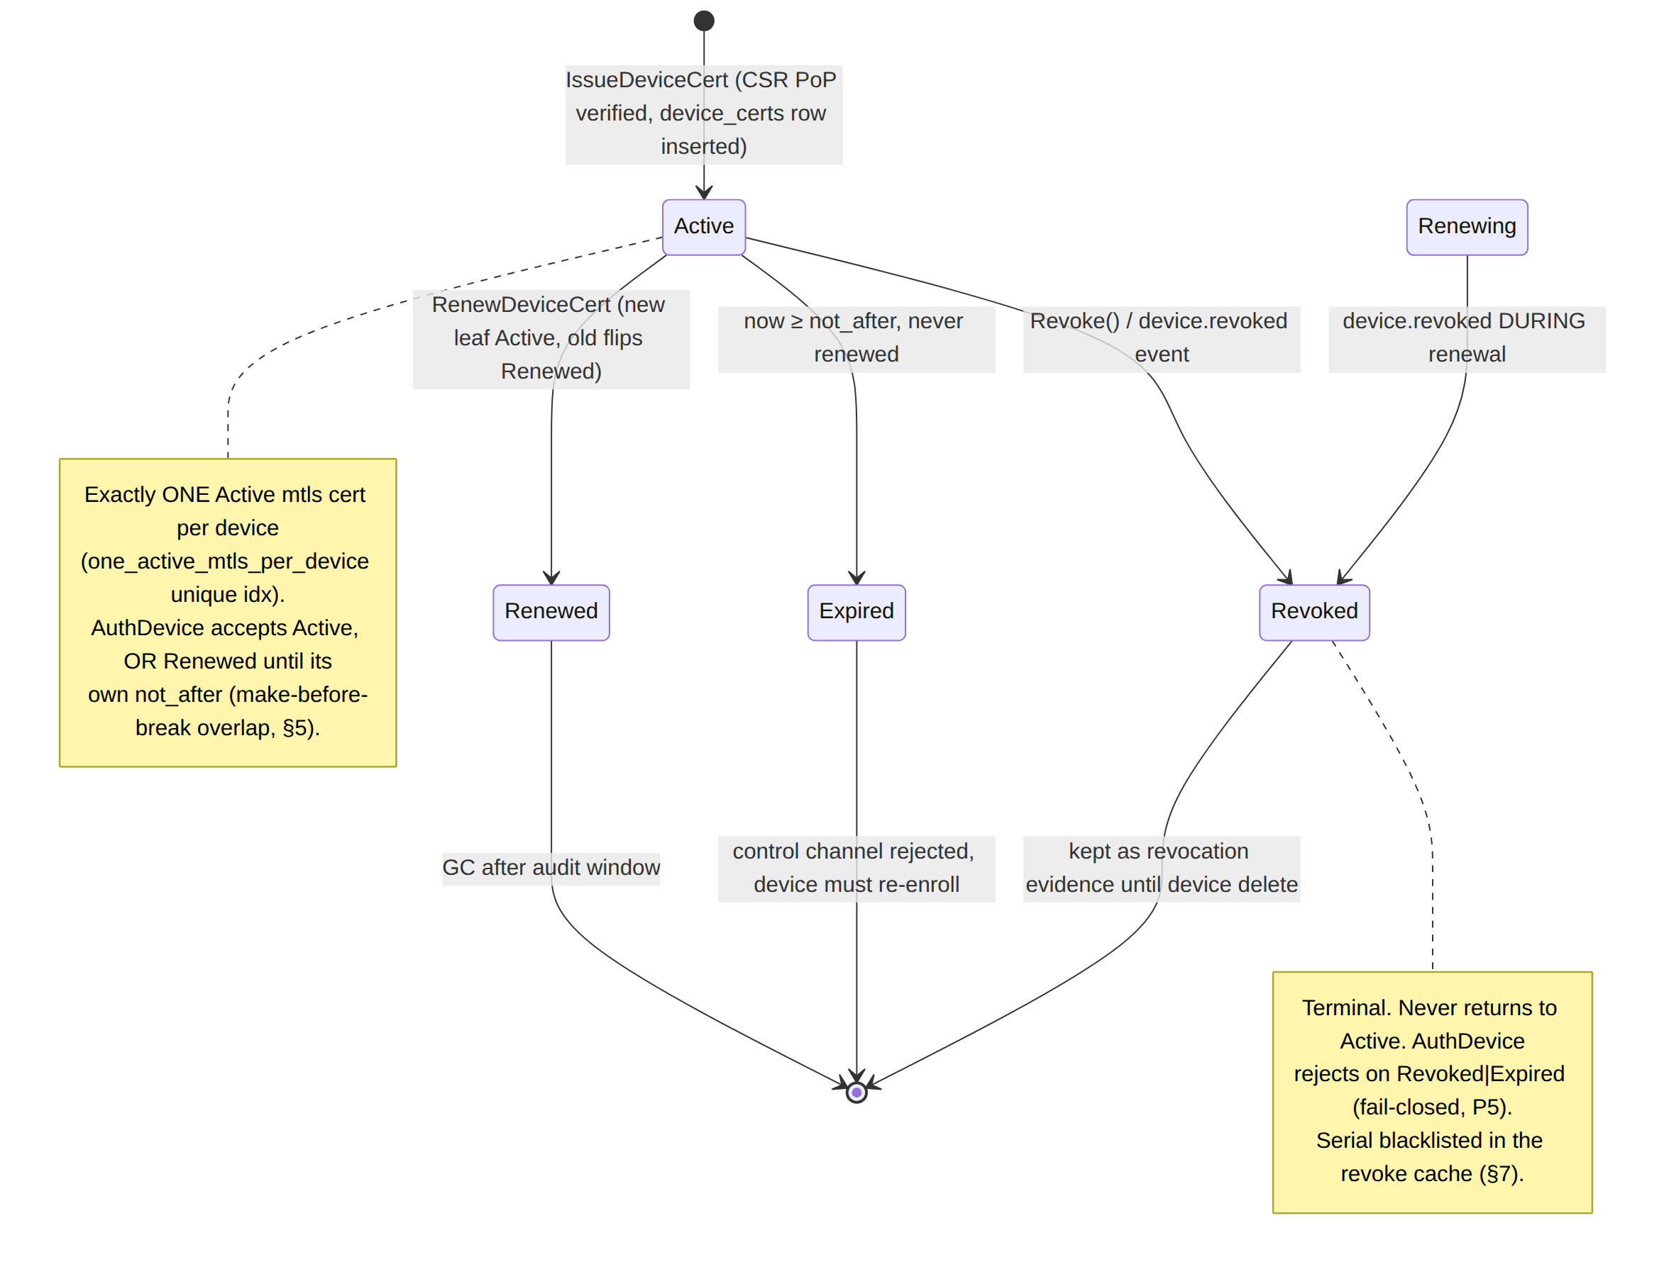
The lifecycle is fail-closed (P5): the only non-Active status AuthDevice tolerates is Renewed, and only until that leaf's not_after (the renew overlap); Revoked and Expired are hard rejections; an unknown serial is rejected, not trusted. The Revoked state is kept (not GC'd immediately) as revocation evidence.

5. Short-lived mTLS device certs & auto-renew

5.1 Why short-lived (the SPIFFE 2025 model)
2025 best practice keeps SVID/mTLS TTL ≤ 60 min for hot paths, auto-rotated by the agent before expiry, so revocation becomes largely "stop renewing" — the credential self-expires within the TTL window, avoiding CRL/OCSP distribution latency [research-pki_pq_nat §1.2]. HelixVPN's ≈ 24 h device-cert TTL [04_P1 §6.3] is the deliberate balance for a fleet of mobile devices that go offline: short enough to be the defence-in-depth revocation floor, long enough that a device asleep overnight is not forced to re-enroll. (A tenant MAY tighten the TTL; the issuer clamps it to [renewSkew, 7d].)

5.2 Auto-renew — agent-driven, over the existing authenticated channel
The agent drives renewal over the existing authenticated channel [04_P1 §6.3, research-pki_pq_nat §1.2]. It renews at T − renewSkew where renewSkew = max(1h, 0.2 × TTL) → for a 24 h TTL the agent renews ~4.8 h before expiry, giving generous margin for a flapping link. The renew RPC is authenticated by the current still-valid leaf, so renewal never needs the enroll token again — no privilege escalation path opens at renew.
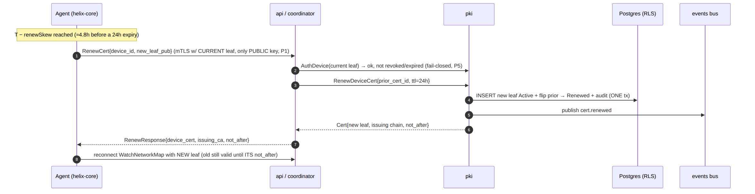
Properties: the new leaf is inserted Active and the prior flips Renewed (so the one_active_mtls_per_device unique index holds); renewed_from chains predecessor → successor; the WG key is unchanged (renewal ≠ WG rotation — those are independent, §6.2); both leaves are valid during the overlap so the open WatchNetworkMap stream is never mid-stream-cut ([v03-control-plane/svc-pki.md §6]).

5.3 Server-side expiry sweeper — safety net, not the primary path
A leader-elected background sweeper runs every 60 s and marks any Active leaf whose not_after has passed as Expired:
UPDATE device_certs SET status='expired'
WHERE status='active' AND not_after < now();
The sweeper is a safety net — the agent's proactive renewal (§5.2) is the primary path; the sweeper only catches agents that went away. An expired-but-still-streaming device is force-reconnected (its AuthDevice now fails → the stream closes at the next keepalive boundary).

6. Rotation — devices, CAs, WG keys, PQ PSK
Three independent key planes rotate on independent schedules so a rotation in one does not disturb the others:

6.1 Device leaf cert — auto, ~24 h cadence
Per §5.2: agent-driven, make-before-break, no token, no human. A missed renewal degrades to re-enrollment, never a silent failure.

6.2 Device WG static key — overlap-then-retire
WG-key rotation is independent of cert renewal (a device can keep its 24 h-cert cadence while rotating its WG key on a slower schedule or on demand). Default schedule 90 d (tenant-configurable) + immediately on relevant compromise. The rotating device generates a new keypair locally (P1 holds — the private never leaves) and registers the new public key; the coordinator swaps the edge peer key.
Overlap window — make-before-break. Because the MVP data path is hub-and-spoke through the gateway, the gateway holds both old+new WG peer keys for a short window (default 30 s) so in-flight handshakes complete, then drops the old — preventing a momentary blackout. The 30 s value is UNVERIFIED as a tuned number; it MUST be validated by a rotation soak (zero dropped sessions across rotation) before being treated as fact ([v03-control-plane/svc-pki.md §7.2]).

6.3 Issuing-CA rotation — trusted overlap
Scheduled ~annually or on suspected compromise: the offline root signs a new issuing CA; both old and new issuing certs are trusted during an overlap window (= the max device-cert TTL, 24 h) so in-flight 24 h leaves remain valid; after the window the old issuing CA is retired and new leaves are signed by the new issuing CA. Tracked as ca_keys.status ∈ {active, retiring, retired}. The blast radius is bounded to the intermediate — the root is untouched.

6.4 Root-CA rotation — rare, operator-gated
Multi-year, cross-sign the new root with the old during a long overlap. Operator-gated (§11.4.66 / §11.4.101 — irreversible, high blast radius, cannot be auto-decided): Phase-1 models the schema + the manual helixvpnctl ca rotate-root path; automation is Phase 2.

6.5 Gateway WG static key & PQ PSK
The gateway WG key rotates independently of devices (helixvpnctl gateway keys), pushed to clients as a NetworkMap delta. The PQ PSK (§9) rotates on every WG rekey interval — ephemeral, never persisted.
Rotation | Default cadence | Trigger | Blast radius
Device leaf cert | ~24 h (renewSkew ~4.8 h early) | timer / on-demand | one device, one channel
Device WG static key | ~90 d | timer / compromise | one device, one tunnel (30 s overlap)
Issuing CA | ~1 y | timer / compromise | tenant intermediate (24 h overlap)
Root CA | multi-year | compromise (operator-gated) | tenant trust anchor (long cross-sign)
Gateway WG key | operator-set | operator | all clients (map delta)
PQ PSK | every WG rekey (~120 s) | rekey | one session (ephemeral)

7. Revocation — the sub-second target
Revocation is the security analogue of the convergence SLO: the same push-don't-poll machinery that propagates a route change propagates a revocation. There is no CRL/OCSP on the data path — short-lived certs + active push obviate online revocation checking [research-pki_pq_nat §1.2].

7.1 The two teeth (P5, fail-closed)
// internal/pki: the revocation contract ([`v03-control-plane/svc-pki.md` §9.2])
func (s *Service) Revoke(ctx, deviceID, reason) error {
// ONE tenant tx:
// tooth (a): mark the LIVE mtls cert revoked → self-expiry safety net (≤24h ceiling)
// tooth (b): retire the WG public key → data path cut even before TTL
// + audit row
// then: revokeCache.Add(serial) → instant hot-path reject (no DB round-trip)
// bus.Publish("device.revoked", {device_id, serial, reason}) → coordinator fan-out
}
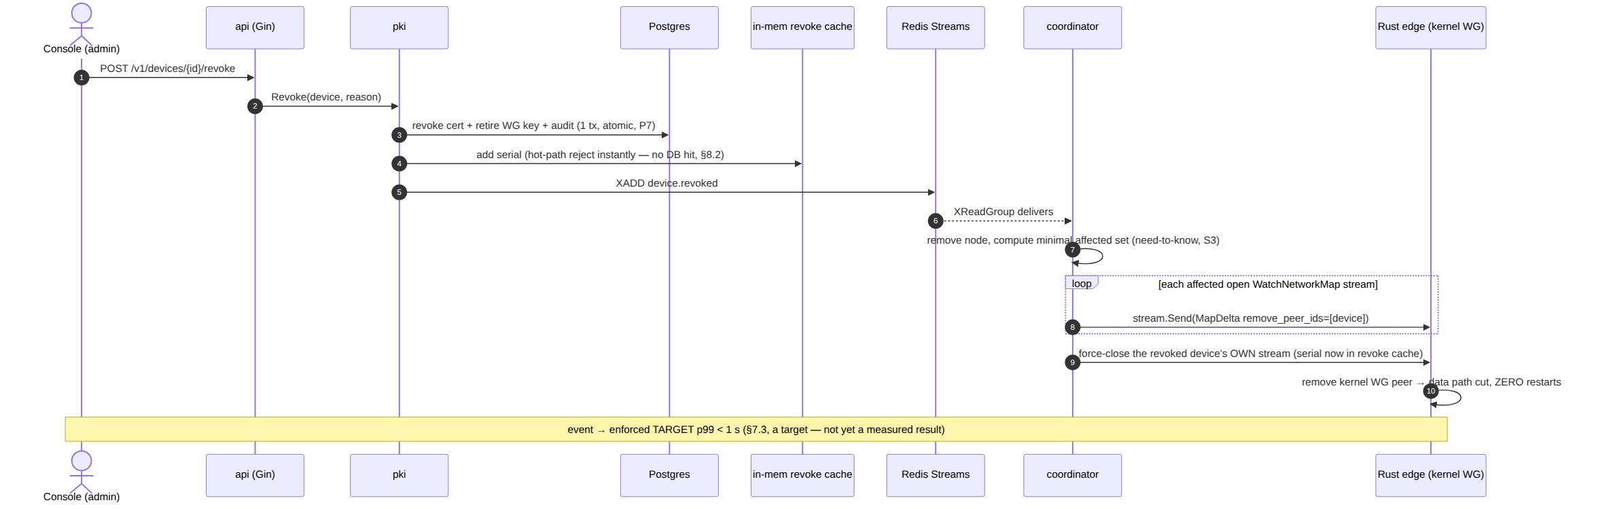
The fast revocation cache (in-memory map[serial]struct{} hydrated from device_certs WHERE status='revoked' on boot and updated by the device.revoked event) lets AuthDevice reject a revoked serial without a DB round-trip on the hot path — the data structure that makes the sub-second target achievable on open streams.

7.2 Revoke-reason closed set (no free-text in the audit trail)
device_certs.revoked_reason ∈ { manual | compromise | superseded | deprovision } — the RevokeReason enum stringified; any other value is rejected at the DB CHECK and the API validator, so no free-text reasons leak into the audit trail (keeps §11.4.6 no-guessing).

7.3 The latency budget is a TARGET, not a result (§11.4.6)
Metric | Target | How it will be measured
device revoke → edge WG-peer removed | p99 < 1 s | helix_pki_revoke_seconds histogram: revoke-call → edge confirms peer gone
cert issue (enroll path) | < 150 ms | helix_pki_issue_seconds
cert renew round-trip | < 150 ms | helix_pki_renew_seconds
AuthDevice hot path (cache hit) | < 1 ms | helix_pki_authdevice_seconds
WG-key rotation → no dropped session | 0 drops across the 30 s overlap | rotation soak
CA issuing-rotation overlap | no leaf rejected during the 24 h window | overlap soak
Every figure above is a design target / acceptance number, UNVERIFIED until the §11 soak captures the histogram on real hardware. The sub-second race window is honest, not zero — residual R-RACE ([threat-model.md §10]); the floor is fail-static (a stale grant never fails open) and the ≤ 24 h cert expiry is the hard ceiling even if a push is missed.

8. mTLS everywhere on the control plane
Every agent RPC — WatchNetworkMap / AdvertisePrefixes / ReportStatus / RenewCert / RotateWGKey — is authenticated by the presented mTLS leaf (TLS 1.3 mutual). Enroll is the only unauthenticated agent RPC, and it validates a single-use hashed enroll token ([identity-and-enrollment.md §6]). REST/Console surfaces use OIDC/RBAC; the two channels share nothing (S4).

8.1 Hot-path device authentication (AuthDevice, fail-closed)
// the hot-path auth ([`v03-control-plane/svc-pki.md` §8.2]) — every check fails CLOSED (P5)
func (s *Service) AuthDevice(ctx, leaf *x509.Certificate) (AuthedDevice, error) {
// 1. chain: verify leaf against the tenant issuing CA (root pinned client-side, §2.2)
if err := s.verifyChain(ctx, leaf); err != nil { return _, ErrCertChainInvalid }
// 2. resolve serial → LIVE cert row (accepts Active OR Renewed-while-now<not_after)
row, err := s.lookupBySerial(ctx, serialHex(leaf.SerialNumber))
if err != nil { return _, ErrCertUnknownSerial } // unknown ⇒ REJECT
if row.Status == "revoked" { return _, ErrCertRevoked } // belt + suspenders
if time.Now().After(row.NotAfter) { return _, ErrCertExpired }
// 3. SPIFFE SAN in the leaf must match the resolved device (binding, not just serial)
if leaf.URIs[0].String() != row.SpiffeUri { return _, ErrSpiffeMismatch } // cert-swap signal
return AuthedDevice{DeviceID: row.DeviceID, TenantID: row.TenantID, CertID: row.ID}, nil
}
The revoke-cache check makes step 2's revoked-serial rejection a memory lookup, not a DB hit — the property that lets revocation enforce on open streams within the sub-second target.

8.2 PKI RPC/REST surface & authz
Route / RPC | Auth | Effect
Enroll (Connect) | enroll token (only unauth RPC) | issue first leaf + register WG key (one tx)
RenewCert (Connect) | current mTLS leaf | re-issue ~24 h leaf over the existing channel
RotateWGKey (Connect) | current mTLS leaf | overlap-then-retire WG key swap
POST /v1/devices/{id}/revoke | RBAC admin | Revoke() → device.revoked (§7)
POST /v1/ca/rotate-issuing | RBAC admin | RotateIssuingCA() (24 h overlap)
POST /v1/ca/rotate-root | RBAC admin, operator-gated | manual root rotation (§6.4)
POST /v1/tenants/{id}/pq | RBAC admin | enable/disable the PQ suite (§9)
RBAC gates the route; RLS is the database floor even if RBAC is misconfigured (defense in depth). RenewCert/RotateWGKey carry only public key bytes (P1).

9. Post-quantum material slot (hybrid, never PQ-only)
WireGuard's Curve25519 handshake is vulnerable to harvest-now-decrypt-later (HNDL): an adversary records ciphertext today and decrypts it once quantum computers mature [research-pki_pq_nat §2.1]. HelixVPN closes this the way Mullvad/Rosenpass do — without forking WireGuard crypto — by deriving a pre-shared key (PSK) from a post-quantum KEM and mixing it into the WG handshake. The PKI's role here is the material slot + coordination metadata; the handshake mechanics live in the sibling [post-quantum.md] / spine §9.

9.1 Hybrid, never PQ-only (P4 / S10)
WireGuard already supports an optional symmetric PSK mixed into the Noise IK. If that PSK is established via a post-quantum KEM, the session gains PQ resistance even though the core handshake stays classical Curve25519 — defence-in-depth: an attacker must break both the classical ECDH and the PQ KEM [research-pki_pq_nat §2.1]. This is why hybrid, never PQ-only: if the (younger, less-battle-tested) PQ KEM has a flaw, classical WG still protects; if quantum breaks classical ECDH, the PQ PSK still protects. WireGuard's own crypto is unchanged, so the result is "cryptographically no less secure than WireGuard on its own" plus PQ protection [research-pki_pq_nat §2.1].

9.2 What the control plane stores — metadata only, never the PSK
PQ is a PSK fed into WG established peer-to-peer / device↔gateway, ephemerally; the control plane stores only the metadata needed to coordinate PSK derivation ([v03-control-plane/svc-pki.md §3.4]):
Stored (control plane) | NEVER stored
device's ML-KEM-768 public encapsulation key (~1184 B) | the derived PSK
psk_epoch (monotonic counter, bumps each rotation) | the ML-KEM decapsulation (private) key
negotiated KEM suite (none | x25519_mlkem768 | x25519_mlkem768_mceliece) | the X25519 private half
The control plane only coordinates which suite + which epoch applies, and ships the peer's mlkem_pubkey inside the network map so two endpoints can encapsulate to each other. The PSK itself is never seen by the control plane (P4).

9.3 KEM choice (decision, research-cited)
Option | KEM | Rationale | Status
Primary | ML-KEM-768 (FIPS 203) — hybrid X25519 + ML-KEM-768 | NIST-standardized 2024-08-13; CNSA 2.0 requires ML-KEM; good size/speed; broad library support [research-pki_pq_nat §2.4] | Default when PQ enabled (Phase-2 roadmap)
Conservative hybrid | ML-KEM-768 + Classic McEliece | Mullvad's production parity (McEliece + ML-KEM); code-based is a very different hardness assumption — the HNDL hedge [research-pki_pq_nat §2.2] | Phase-2 opt-in for high-assurance tenants (McEliece public keys are large, amortised at setup/rekey)
External protocol | Rosenpass (audited PQ key-exchange daemon feeding WG a PSK, 2-min refresh) | independent symbolic analysis (ProVerif); clean separation; mullvad/wgephemeralpeer reference [research-pki_pq_nat §2.2/§2.3] | Evaluate in the Phase-2 PQ spike
Phase-1 status (honest, §11.4.6). PQ defaults to kem='none', enabled=false; the table + proto fields + plumbing exist so enabling PQ is config, not a schema change [SYNTHESIS §4 — PQ is Phase 2]. UNVERIFIED: Rosenpass's tagged release was still Kyber-512 (not yet ML-KEM) at research time [research-pki_pq_nat §2.3] — verify upstream before relying on ML-KEM in Rosenpass specifically. Do not claim PQ ships live in Phase 1.

9.4 PQ PSK epoch rotation
When enabled, the PSK is rotated by bumping psk_epoch and re-publishing the peer ML-KEM public keys in the network map; the endpoints re-derive a fresh PSK and mix it into the WG handshake. Rosenpass-style aggressive rotation refreshes the symmetric key every ~2 min [research-pki_pq_nat §2.3]; HelixVPN's control-plane role is only to bump the epoch + ship the public keys — the PSK is established at the endpoints (P4). The PQ exchange rides the authenticated control channel (mTLS) so there is no new public listener to attack, and PQ ciphertexts are KB-scale so the exchange happens at session setup + rekey, not per packet — steady-state overhead is zero ([04-security-privacy-pki.md §9.3]).

10. Key storage — KMS/HSM, secure element, software fallback
The two highest-value secrets (AS-CA, AS-WGK) live in deliberately different places, each as hardened as the platform allows.

10.1 The CA key — KMS/HSM, never in process memory (P3/S11)
The raw CA private key is never stored in a plaintext column and, in the recommended deployment, never enters helixd process memory ([v03-control-plane/svc-pki.md §3.1]):
Backend | Mechanism | Security property
KMS/HSM-backed (recommended) | ca_keys.key_ref = a KMS/HSM URN; signing is delegated (digest → KMS Sign API); the raw key stays in the HSM | a control-plane compromise (C-INS) never yields the CA key — assumption A1 ([threat-model.md §1.3])
File-sealed (self-host floor) | ca_keys.key_sealed = the DER private key envelope-encrypted under a KMS-wrapped data key; decrypted into a locked, zeroed-after buffer only at sign time | the key at rest is ciphertext; in-memory exposure is bounded to the sign window
// the signer seam — same interface, two backends ([`v03-control-plane/svc-pki.md` §4.3])
type CASigner interface {
Sign(ctx, t uuid.UUID, tmpl *x509.Certificate, leafPub crypto.PublicKey) ([]byte, error)
}
// kmsSigner: digest sent to KMS Sign API; raw key stays in the HSM.
// fileSigner: key_sealed envelope-decrypted into a locked, zeroed-after buffer.
A schema-lint asserts no column named *_private*/*_secret* holds cleartext (the §11 gate CM-PKI-NO-PRIVATE-KEY-STORED); the paired §1.1 mutation adds a plaintext key column and asserts the lint FAILs. The CA key is the highest residual R-CA ([threat-model.md §10]) — an insider with both DB and KMS-log access is the catastrophic case, shrunk (not eliminated) by the offline-root two-tier topology and Phase-2 HSM quorum.

10.2 The device keys — OS keystore / secure element (S2)
Device WG + leaf private keys are sealed in the strongest store the platform exposes — Keychain
- Secure Enclave (Apple), Keystore + StrongBox/TEE (Android), DPAPI + TPM (Windows), libsecret + TPM2 (Linux) — with a software fallback only on a logged warning ([identity-and-enrollment.md §2.3]). FFI exposes operations, not raw bytes; Zeroizing guarantees the bytes are wiped on drop. A device whose keystore is already defeated is residual R-DEV (closed only by Phase-2 hardware attestation).

10.3 The PQ material — public stored, private ephemeral
Per §9.2: the control plane stores only ML-KEM public encapsulation keys + the epoch counter; the decapsulation (private) key and the derived PSK are never persisted — they live in device + edge memory per-session and are wiped on rekey.

11. Threat mapping & test/validation (§11.4.169)

11.1 What the PKI defends ([threat-model.md])
Mechanism (this doc) | Invariant | Threats closed
CA key in KMS/HSM, never in process memory | S11 / P3 | T-PKI-I-1 (read CA key), T-PKI-T-1 (forge profile)
Cert profile fixed in the signer (≤24 h, CA:FALSE, clientAuth) | S4 | T-PKI-T-1 (long-lived/wildcard cert)
CSR proof-of-possession before sign | — | T-PKI-S-1 (sign a key you don't hold)
Short-lived leaf + auto-renew over authenticated channel | S4 | T-CLI-S-1, T-CP-S-1, T-COORD-S-1
SPIFFE SAN bound at issuance; AuthDevice SAN check | — | ErrSpiffeMismatch cert-swap
Sub-second revocation, two teeth, revoke cache | S5 | T-PKI-E-1 (revoked device keeps access)
Fail-closed AuthDevice (unknown serial rejected) | P5 | spoofed/forged-serial control access
mTLS everywhere; two channels never conflated | S4 | T-CP-S-1, T-COORD-S-1
Hybrid PQ PSK (never PQ-only) | S10 / P4 | T-DP-I-2 (harvest-now-decrypt-later)
RLS FORCE ROW LEVEL SECURITY on every PKI table | P7 | cross-tenant cert/CA read (T-CP-I-1)

11.2 Test points (§11.4.169 — comprehensive test-type coverage)
Composing §11.4.27 (no-fakes-beyond-unit), §11.4.5/§11.4.69/§11.4.107 (captured evidence), §11.4.85 (stress+chaos), §11.4.119 (single edge-resource owner for revoke/rotate tests), §1.1 (paired mutation). Integration spins Postgres+Redis on-demand via vasic-digital/containers (§11.4.76).
Test type | Concrete pki test point | Evidence / anti-bluff
unit | issued leaf has EKU clientAuth(+serverAuth), ≤24 h not_after, SPIFFE SAN, CA:FALSE; revoke-reason round-trips | golden cert DER asserted field-by-field
unit (property) | IssueDeviceCert → AuthDevice accepts; revoked never authenticates (P5) — fuzz serials | property test, 10k cases
unit (privacy, P1) | enroll/rotate handlers store the public WG key — re-derive pub from a known private fixture, assert stored == public | §1.1 mutation: feed a private-shaped key → handler MUST reject
integration | enroll → issue → renew → revoke; assert device_certs state-machine transitions (§4) | captured DB snapshots + bus event log
integration (RLS, P7) | tenant A cannot SELECT/UPDATE tenant B's ca_keys/device_certs/device_wg_keys as helix_app under FORCE ROW LEVEL SECURITY | denied-query capture
e2e | enroll → WatchNetworkMap (mTLS) → renew-over-channel → revoke → stream force-closed | captured stream transcript
security | ErrSpiffeMismatch cert-swap rejected; expired/revoked rejected; CA private key never in a process-memory dump nor any log line (P3); schema-lint asserts no cleartext *_private*/*_secret* column | memory-scan + log-grep evidence; §1.1 adds a plaintext key column → lint FAILs
performance | IssueDeviceCert < 150 ms; AuthDevice cache-hit < 1 ms (targets, §7.3) | go test -bench histograms
scaling | 10k devices each with a live 24 h cert; renew-sweeper at 60 s stays bounded | process_resident_memory_bytes slope ≈ 0
stress (§11.4.85) | N≥100 concurrent enroll+revoke on one tenant; no double-active-cert (unique idx holds); p50/p95/p99 recorded | latency.json captured
chaos (§11.4.85) | SIGKILL helixd mid-issue (tx atomic → no orphan cert without device row); Redis drop mid-revoke (PEL reclaimed) → revoke still converges to the < 1 s target on recovery | recovery_trace.log
soak (24 h) | continuous 24 h-cert renewal churn + WG-key rotations; assert zero dropped sessions across the rotation overlap (validates the §6.2 30 s window, removing its UNVERIFIED tag) | session-continuity counter
Challenge / HelixQA | a Challenge drives enroll→revoke and asserts edge WG-peer removed within the < 1 s target with captured runtime evidence (the revoke-SLO anti-bluff) | result.json + captured timing
meta-test (§1.1) | every gate (CM-PKI-NO-PRIVATE-KEY-STORED, CM-REVOKE-SLO, the schema-lint) has a paired mutation that makes it FAIL | mutation FAILs proven
Anti-bluff floor (§11.4.107(10)). The revoke-SLO Challenge is valid only with captured evidence the peer was actually removed and timed — a green assertion that "revocation exists" is necessary, never sufficient. The < 1 s figure is the acceptance target the soak must measure; until measured it is UNVERIFIED (§11.4.6), never reported as an achieved result.

12. Phase-2 forward seams (additive, not a rewrite)
The Phase-1 seams extend without reshaping ([v03-control-plane/svc-pki.md §13]):
- Attestation leaf hardware binding — the optional ~90 d attestation leaf gains TPM / Secure-Enclave binding [research-pki_pq_nat §1.2], closing residual R-DEV.
- PQ flip — device_pq_material.enabled=true with kem='x25519_mlkem768' (Mullvad-parity adds +mceliece); the PSK feeds the WG handshake at the endpoints (Rosenpass / wgephemeralpeer template) [research-pki_pq_nat §2.2/§2.4] — config, not a schema change.
- Signer upgrade — the CASigner swaps file-sealed → HSM with no caller change (the seam is already in place).
- CA-rotation automation — replaces the operator-gated manual root path (§6.4).
- Two-tier CA topology growth — ca_chain already ≥ 1, so adding a regional intermediate is the chain growing, not a redesign ([04-security-privacy-pki.md §4.2]).
- Revoke-cache federation — across regional helixd over NATS JetStream (the events.Bus swap), keeping the sub-second target as the fleet scales.
Phase 2 is additive because Phase 1 drew the seams — the PKI interface, the signer seam, the four RLS tables, the bus events, the PQ material slot — in the right places, honouring §11.4.6 (no silent reshape).

Sources verified
- [research-pki_pq_nat] — the primary evidence base for this doc. §1.1 WireGuard native identity (one Curve25519 keypair, public key IS the identity, revocation trivial = remove pubkey, no built-in PKI/CA/CRL/OCSP), §1.2 SPIFFE/SPIRE two-identity split (long-lived attestation + short-lived auto-rotated mTLS, ≤60 min hot-path TTL, structured-URI-bound-at-issuance, revocation = stop-renewing), §1.3 generate-the-WG-private-key-on-device + two-teeth revocation, §2.1 PSK-injection PQ (hybrid not PQ-only, "no less secure than WG"), §2.2 Mullvad production (McEliece + ML-KEM, default-on-desktop 2025-01-09, mullvad/wgephemeralpeer, Kyber→ML-KEM), §2.3 Rosenpass (Rust, PSK 2-min refresh, ProVerif symbolic analysis, tagged release still Kyber-512), §2.4 FIPS-203 ML-KEM (NIST 2024-08-13, CNSA 2.0), hybrid X25519+ML-KEM-768. Access date 2026-06-25.
- [04-security-privacy-pki.md] HelixVPN security spine — §0.1 invariants S1–S11, §4 PKI (key hierarchy, CA topology decision A/B, cert profiles, §4.4 lifecycle state machine, §4.5 rotation, §4.6 revocation < 1 s target, §4.7 pki/CASigner contract), §9 hybrid PQ PSK (KEM choice, control-channel exchange, zero per-packet cost). (Read 2026-06-25.)
- [v03-control-plane/svc-pki.md] — §1 ownership + WG-no-PKI baseline + governing invariants P1–P7, §2 CA hierarchy (three tiers, Ed25519/ECDSA fallback, rotation), §3 DDL/RLS (ca_keys, device_certs extended, device_wg_keys, device_pq_material), §4 PKI interface + signer seam, §5 issuance + state machine, §6 auto-renew (renewSkew, sweeper), §7 WG/PSK rotation, §8 proto + AuthDevice hot path + revoke cache, §9 events + revocation two-teeth, §10 errors + SLO targets, §11 test matrix, §12 task plan, §13 Phase-2 seams. (Read 2026-06-25.)
- [identity-and-enrollment.md] (sibling) — §2 key-never-leaves (two key planes, keystore), §3 enrollment protocol (CSR PoP), §6 enroll-token security, §7 re-enrollment & revocation origin — referenced for the enrollment this PKI mints into. (Read 2026-06-25.)
- [threat-model.md] (sibling) — assets AS-CA/AS-WGK/AS-LEAF/AS-PSK, threats T-PKI-* / T-CLI-S-1 / T-COORD-S-1 / T-DP-I-2, residuals R-CA / R-RACE / R-DEV / R-PQ, assumption A1 (CA key in KMS). (Read 2026-06-25.)
- [04_P1] HelixVPN-Phase1-MVP.md §6 (24 h cert, revoke < 1 s, key-never-leaves). [04_ARCH] §4/§7/§10 (pki module, short-lived certs, CA = one true secret, backups = Postgres + CA root). [SYNTHESIS] §4 (PQ in Phase 2). — cited via the spine doc.
- Constitution §11.4.6 (no-guessing — UNVERIFIED marks; all latency stated as targets), §11.4.10 (CA key never logged/git-tracked), §11.4.27/§11.4.85/§11.4.107/§11.4.119/§11.4.169/§1.1 (test-type coverage + self-validated analyzers + single-resource-owner for edge tests), §11.4.66/§11.4.101 (operator-gated root rotation), §11.4.76 (containers submodule for integration infra).

