Post-Quantum Handshake (PQ-derived PSK, hybrid never PQ-only)

Post-Quantum Handshake (PQ-derived PSK, hybrid never PQ-only)
Revision: 3 Last modified: 2026-07-04T12:00:00Z Rev 3: Added §4.1a — an explicit downgrade-attack-resistance statement (an on-path MITM cannot force a PQ-capable pair to classical-only because the capability exchange rides the already-authenticated mTLS channel; tampering breaks TLS 1.3 transcript integrity rather than silently downgrading). Closes a gap-analysis finding that the property was implied but never stated as its own reasoned claim.
Master technical specification — Volume 5 (Security & Privacy), nano-detail spec. Deepens invariant S10 and §9 of [04-sec] (04-security-privacy-pki.md): the post-quantum handshake. This document owns the byte-level and operational contract of HelixVPN's harvest-now-decrypt-later (HNDL) defence — the PQ KEM exchange, the HKDF→WireGuard-PSK derivation, the hybrid-never-PQ-only rule, the capability negotiation, the rekey lifecycle, the KEM decision (ML-KEM-768 vs Rosenpass vs Classic-McEliece-hybrid), the wire framing, the rollout phasing, and the anti-bluff validation. This is a SPEC — it describes the implementation; it does not build the product.
The PQ exchange does not modify the WireGuard protocol: it fills WireGuard's already-present, optional 32-byte preshared-key (PSK) slot — the single injection point. The PSK mechanics, key schedule, and the PeerConfig.psk field live in the data plane (helix-wg); this document references them rather than redefining them.
Source evidence cited inline by id: [04-sec §9] (04-security-privacy-pki.md §9 + S10 + threat T8), [wg-core §4.4] (v02-data-plane/wireguard-core.md PQ-PSK seam), [wg-core §2.2/§4.2] (the PeerConfig.psk field + key-schedule mix-in), [research-pq] (v09-research/research-pki_pq_nat.md §2 post-quantum WireGuard), [research-wg §6] (v09-research/research-wireguard.md §6 the PSK injection point), [research-mullvad] (the PQ-PSK-over-WG prior art). Access date for all external facts: 2026-06-25. Unproven claims are marked UNVERIFIED: per §11.4.6 — never fabricated.

Table of contents
- 0. Position, ownership, and the one-sentence contract
- 1. The threat: harvest-now-decrypt-later (HNDL)
- 2. The mechanism: WireGuard's PSK slot is the only injection point
- 3. The hybrid model — classical X25519 ⊕ PQ KEM, never PQ-only (S10)
- 4. The hybrid handshake (Mermaid + step-by-step)
- 5. KEM choice — decision with recommendation
- 6. Key sizes, performance, and the steady-state-zero-cost claim
- 7. Negotiation, capability flags, and fallback
- 8. Rekey & PSK rotation lifecycle
- 9. Wire framing of the PQ exchange (on the mTLS control channel)
- 10. Pluggable KEM contract (Rust)
- 11. Rollout phasing (Phase 2+) and standardized-vs-experimental honesty
- 12. Threat-model placement & residual risk
- 13. Anti-bluff validation (how PQ is proven, not asserted)
- 14. Phase → task → subtask plan (PQ workstream)
- Sources verified

0. Position, ownership, and the one-sentence contract
One-sentence contract. HelixVPN derives a 32-byte symmetric pre-shared key from a post-quantum KEM exchange and mixes it into WireGuard's existing optional-PSK slot, so a session is secure unless an attacker breaks both the classical X25519 ECDH and the PQ KEM — closing the HNDL threat without changing the WireGuard protocol [04-sec §9, wg-core §4.4, research-pq §2.1].
What this document owns:
- the PQ KEM exchange protocol that runs over the authenticated control channel;
- the HKDF derivation shared_secret → 32-byte WireGuard PSK;
- the hybrid combiner (classical + PQ, S10) and the never-PQ-only rule;
- the capability negotiation + classical-WG fallback;
- the per-rekey PSK rotation lifecycle;
- the KEM decision (ML-KEM-768 default; Rosenpass / Classic-McEliece-hybrid options);
- the PqKem pluggable Rust contract and the wire framing.
What this document does NOT own (referenced, not redefined):
- the WireGuard Noise IK handshake, the PSK key-schedule mix-in, and the PeerConfig.psk: Option<Psk> field — those are [wg-core §4.2/§4.4/§2.2]; this doc only fills the field;
- the control channel mTLS + device-cert lifecycle the PQ exchange rides on — [04-sec §4];
- where the PQ code physically lives in helix-core crates + FFI — Volume 5 client-core (the helix-pki crate's pq module); this doc defines the protocol, not the file tree.
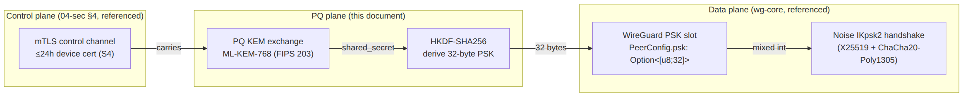

1. The threat: harvest-now-decrypt-later (HNDL)
WireGuard's handshake is Noise_IK over Curve25519 (X25519) ECDH [research-wg §1, §2]. X25519 is classically secure but not post-quantum secure: a sufficiently large quantum computer running Shor's algorithm recovers the ECDH private key from observed public values, decrypting any session whose key agreement used it.
The operative danger is not "quantum computers exist today" — they do not at the scale required (§12 residual risk). The danger is harvest-now-decrypt-later: a passive adversary (a censor, an ISP, a nation-state recorder) records ciphertext today and decrypts it years later once a cryptographically-relevant quantum computer matures [research-pq §2.1, 04-sec §9]. For a privacy VPN this is the worst class of threat because:
- The victim cannot detect the recording — it is passive.
- The damage is retroactive — every session recorded before the mitigation shipped is exposed; you cannot re-secure traffic an adversary already holds.
- The window is long — HNDL captures accumulate for as long as the adversary chooses, and the decryption deadline is the adversary's, not the victim's.
This is exactly the threat invariant S10 binds and threat T8 enumerates in [04-sec §0.1, §10]: passive recorder + future quantum, mitigated by the hybrid PQ PSK, residual risk = "PQ KEM novelty → hybrid hedge; classical still protects."
Honest boundary (§11.4.6). PQ protection here defends future decryption of today's recorded traffic. It is not a claim that classical WireGuard is broken now — X25519 + ChaCha20-Poly1305 is sound against every classical adversary [research-wg §2]. The PQ layer is a forward hedge, deliberately conservative.

2. The mechanism: WireGuard's PSK slot is the only injection point
WireGuard already supports an optional 32-byte symmetric pre-shared key. The protocol page is explicit: "When pre-shared key mode is not in use, the pre-shared key value used below is assumed to be an all-zero string of 32 bytes" [research-wg §6] — i.e. the PSK slot always exists; it is simply all-zero when unused. In the Noise_IKpsk2 variant the PSK is mixed into the chaining key during response generation: temp = HMAC(responder.chaining_key, preshared_key) [research-wg §6].
Reconciled (§11.4.35, 2026-06-26): this key-schedule formula is cited to [research-wg §6] only; the prior dual-citation to wireguard-core.md §4.2 is dropped because wg-core §4.2 marks its key-schedule transcription UNVERIFIED — the authoritative source for the PSK mix-in is the WireGuard protocol research §6.
The PSK enters the symmetric key schedule (BLAKE2s/HMAC chaining), downstream of the X25519 ECDH. The cryptographic consequence is the whole reason this works:
Because the PSK is mixed into the symmetric chaining key, the tunnel stays confidential even if the X25519 ECDH is later broken — an attacker who recovers the ECDH secret still faces an unknown 32-byte symmetric secret folded into the key schedule. [research-wg §6]
So the injection point is exactly one field and the WireGuard protocol surface needs zero change — only the PSK field is filled with a value derived from a PQ KEM, instead of being left all-zero or a static manual key [research-pq §2.1, research-wg §6].
In HelixVPN's data plane this is the single seam helix-wg exposes:
// referenced from v02-data-plane/wireguard-core.md §2.2 — NOT redefined here.
pub type Psk = [u8; 32]; // optional pre-shared key (post-quantum seam, §4.4)
pub struct PeerConfig {
// ... allowed_ips, endpoint, persistent_keepalive, public_key ...
pub psk: Option<Psk>, // §4.4 — THIS is where the PQ-derived PSK lands
}
and the underlying boringtun Tunn::new takes the same slot directly [research-wg §10]:
// boringtun (referenced) — the PSK slot at the implementation floor.
pub fn new(
static_private: StaticSecret,
peer_static_public: PublicKey,
preshared_key: Option<[u8; 32]>, // ← the PQ-derived PSK installs here
persistent_keepalive: Option<u16>,
index: u32,
rate_limiter: Option<Arc<RateLimiter>>,
) -> Self
The UAPI configures it as the preshared_key config key (hex; all-zero to remove) [research-wg §6]. HelixVPN's only data-plane work is to populate psk from the PQ exchange; everything below PeerConfig.psk is unmodified, well-audited WireGuard.

3. The hybrid model — classical X25519 ⊕ PQ KEM, never PQ-only (S10)
Invariant S10: PQ is hybrid, never PQ-only. The session derives security from both a classical ECDH and a PQ KEM, combined so an attacker must break both [04-sec §0.1 S10, research-pq §2.1].
The two halves and why each is load-bearing:
Half | Primitive | Protects against | Failure mode it covers
Classical | X25519 ECDH (WireGuard's native handshake) | every classical adversary today | a flaw discovered in the (younger, less battle-tested) PQ KEM
Post-quantum | ML-KEM-768 KEM (FIPS 203), default | a future quantum HNDL adversary | quantum break of X25519 ECDH
The combiner is defence-in-depth: the X25519 handshake runs exactly as WireGuard always runs it (the classical half is intrinsic — it is the Noise IK handshake itself), and the PQ KEM's shared secret is folded into the same session via the PSK slot. An attacker must break both the classical ECDH and the PQ KEM to recover the session keys [04-sec §9.1, research-pq §2.1].
Why never PQ-only (the conservative choice, §11.4.6). PQ KEMs are younger than X25519 and have had less cryptanalytic exposure. If the project shipped a PQ-only handshake and the chosen PQ KEM later proved flawed, every session would be exposed. With the hybrid:
- if the PQ KEM has a flaw → classical WireGuard still protects you against today's attackers;
- if quantum breaks classical X25519 → the PQ PSK still protects you against HNDL.
This is the standing industry recommendation — "hybrid, not PQ-only … production deployments combine a classical KEM and a PQ KEM so the result is no weaker than either" [research-pq §2.1] — and matches Mullvad's production posture (Classic McEliece + ML-KEM, hybrid by default) [research-pq §2.2, research-mullvad].
Combiner construction (the symmetric fold is the combiner). HelixVPN does not build a bespoke KEM combiner construction. The classical half is the X25519 ECDH already inside the Noise IK handshake; the PQ half is the KEM shared secret installed as the WireGuard PSK. The WireGuard key schedule itself is the combiner: the final session keys depend on the X25519 chaining and the PSK mix-in temp = HMAC(chaining_key, psk) [research-wg §6]. Breaking one input does not yield the session keys. UNVERIFIED: the formal IND-CCA composition argument for "Noise IKpsk2 with a KEM-derived PSK is a sound hybrid" — this rests on the WireGuard whitepaper's Noise_IKpsk2 security argument, which a human must read directly [research-wg §"Honest gaps", wg-paper UNREACHABLE]; flagged, not claimed.

4. The hybrid handshake (Mermaid + step-by-step)
The PQ KEM exchange rides the authenticated mTLS control channel (S4) — there is no new public listener and no unauthenticated PQ endpoint to attack [04-sec §9.3, research-pq §1.2]. Both ends already hold a valid ≤24 h device cert (S4); the PQ exchange is one more RPC over that channel, before/alongside the WireGuard data handshake.
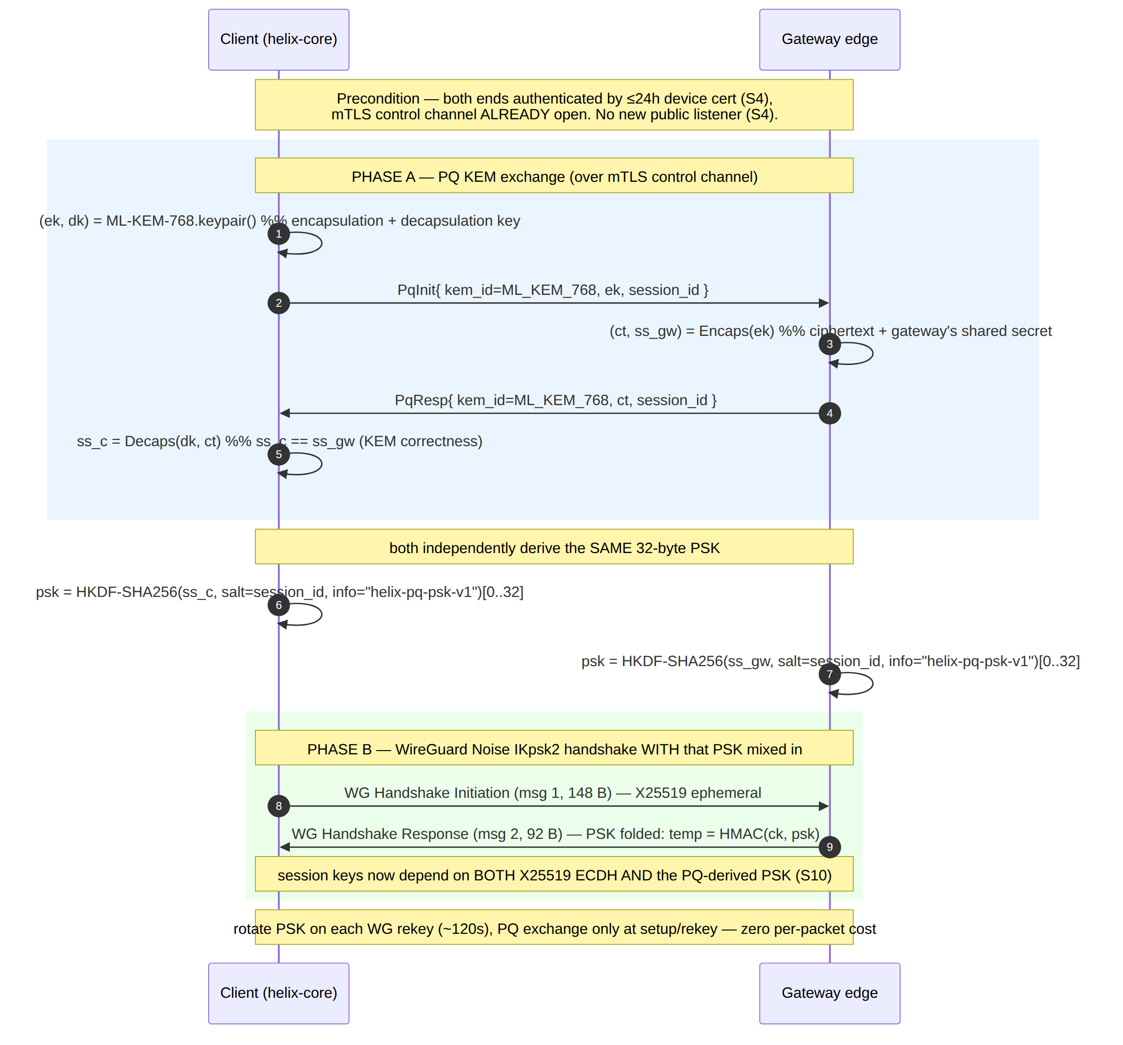

4.1 Step-by-step (the contract)
- Both ends authenticate first. The mTLS control channel is already open with valid ≤24 h device certs (S4) [04-sec §4]. PQ negotiation is gated on this — an unauthenticated party never reaches the PQ exchange.
- Capability check (§7). Both ends advertise pq_capable=true + the supported kem_id set. If either end lacks PQ support, the session falls back to classical WireGuard (still secure today) and skips Phase A entirely [04-sec §9.3, research-pq §2.2 mobile-experimental].
- PQ KEM exchange (Phase A). The client generates an ML-KEM-768 keypair (ek, dk), sends the encapsulation key ek to the gateway. The gateway runs Encaps(ek) → (ct, ss_gw), returns the ciphertext ct. The client runs Decaps(dk, ct) → ss_c. By KEM correctness, ss_c == ss_gw [research-pq §2.4]. The client's decapsulation key dk never leaves the device.
- PSK derivation. Both ends independently compute psk = HKDF-SHA256(shared_secret, salt=session_id, info=b"helix-pq-psk-v1") truncated to 32 bytes [04-sec §9.3 code, RFC 5869]. The session_id salt domain-separates each session so the same KEM material never yields the same PSK twice.
- WireGuard handshake with the PSK (Phase B). The standard Noise IKpsk2 handshake runs; the 32-byte PSK is mixed into the chaining key temp = HMAC(ck, psk) during response generation [research-wg §6]. The resulting session keys depend on both the X25519 ECDH and the PQ-derived PSK (S10).
- Rotation. On every WireGuard rekey (REKEY_AFTER_TIME ≈ 120 s [research-wg §9]) the PQ exchange re-runs and a fresh PSK is installed (§8). The PSK is ephemeral — never persisted (§4.5 of [04-sec], the PQ plane "per-session, never persisted").

4.1a Downgrade-attack resistance (why an on-path MITM cannot force classical-only)
A natural question: could an active on-path attacker (C-ACT, [threat-model.md §4]) force a PQ-capable pair down to classical-only by tampering with the PqCapabilities exchange (§7)? No — the capability advertisement and the PqInit/PqResp exchange ride the already- authenticated mTLS control channel (S4, step 1 above), not a bare unauthenticated pre-handshake negotiation. An attacker without a valid device cert cannot inject or rewrite PqCapabilities/PqInit/PqResp frames — TLS 1.3's transcript integrity means any tampering with the mTLS-carried bytes is detected and the connection aborts, not silently falls back. The only legitimate path to classical-only is (a) one peer genuinely lacking PQ support, or (b) the user's own toggle set to off (§7.2) — both are observable, honest outcomes, never an attacker-forced one. This closes the downgrade vector structurally: forcing a fallback requires first breaking mTLS (T-CP-S-1/[threat-model.md §5.2]), at which point the attacker already has a stronger foothold than a PQ downgrade would gain them.

4.2 What the adversary sees
A passive recorder on the data path sees only opaque WireGuard datagrams carried by the obfuscation transport (doc 01) — the PQ exchange happened on the encrypted, authenticated mTLS control channel, so the recorder cannot even observe the KEM ciphertext, let alone the PSK [04-sec §9.3]. Even granting the adversary the KEM ciphertext, recovering the session requires breaking ML-KEM-768 and X25519 (S10).

5. KEM choice — decision with recommendation
Per §11.4.66 (decision discipline) the KEM is surfaced as a decision with options, never a silent pick. The PqKem trait (§10) makes the choice pluggable so the decision is reversible.
Option | KEM(s) | Pro | Con | Recommendation
Primary | ML-KEM-768 (FIPS 203, standardized Kyber) | NIST-standardized (FIPS 203, published 2024-08-13); good size/speed balance; broad library support (ml-kem Rust crate, BoringSSL); NSA CNSA 2.0 mandates ML-KEM for NSS key-encapsulation | younger than X25519; lattice assumption is newer cryptanalysis | DEFAULT. Pluggable in helix-core's pq module [04-sec §9.2, research-pq §2.4].
Conservative hybrid | ML-KEM-768 + Classic McEliece | Mullvad's production posture combines McEliece + ML-KEM for exactly this hedge; code-based (McEliece) is a very different hardness assumption from lattice (ML-KEM) — a break of one does not imply a break of the other | Classic McEliece public/encapsulation keys are large (hundreds of KB) → larger control-channel exchange | Phase-2 opt-in for high-assurance tenants; runs only at setup/rekey so the size cost is amortised, not per-packet [04-sec §9.2, research-pq §2.2].
External protocol | Rosenpass (audited PQ key-exchange daemon feeding WG a PSK) | independent symbolic analysis (ProVerif); clean separation of concerns; reference design Mullvad embeds in its agent (since v0.25.4) auto-rotating PSKs | extra daemon + integration surface; tagged release (v0.2.2, 2024-06-05) still uses Kyber-512 + Classic McEliece, not yet ML-KEM in the tagged build; full cryptographic proof "in progress", not complete | Evaluate during the Phase-2 PQ spike — prefer Rosenpass if an audited external protocol beats an in-house KEM exchange; verify upstream ML-KEM status before relying on it [04-sec §9.2, research-pq §2.3].

5.1 Decision rationale
- ML-KEM-768 as the default because it is the standardized primitive (FIPS 203), has the cleanest Rust library story (ml-kem crate), and gives the best size/speed for a per-rekey exchange. NSA CNSA 2.0 requiring ML-KEM for national-security systems means the ecosystem and tooling will converge on it [research-pq §2.4].
- Why not 1024. Mullvad uses ML-KEM-1024 in its current production tunnels [research-wg §6 cross-ref]. HelixVPN's MVP/Phase-2 default is 768 for the size/speed balance, with the parameter set being a kem_id field (§9) so a tenant can negotiate 1024 if it wants the larger margin. UNVERIFIED: whether 768 vs 1024 is the right default for HelixVPN's threat model at GA — this is a Phase-2 spike decision; 768 is the documented starting recommendation, not a final pin (§11.4.6).
- Rosenpass vs in-house. The genuine question the Phase-2 spike answers: is it better to embed an audited external PQ protocol (Rosenpass, the path Mullvad took) or to drive ML-KEM directly via the PqKem trait? Rosenpass brings independent analysis and a maintained reference, at the cost of an extra daemon and a tagged release that is not yet on ML-KEM. The decision is deferred to the spike with captured evidence, not pre-judged here [04-sec §9.2, research-pq §2.3].
Honest gap (§11.4.6 / §11.4.99). Rosenpass's verification status is a symbolic analysis (ProVerif), NOT a full cryptographic proof — the proof is "in progress" per its README [research-pq §2.3]. The tagged Rosenpass release (v0.2.2, 2024-06-05) still uses Kyber-512, not ML-KEM. Both facts MUST be re-verified against upstream at implementation time per §11.4.99 (latest-source) before relying on Rosenpass-specific ML-KEM behaviour.

6. Key sizes, performance, and the steady-state-zero-cost claim
The defining performance property: the PQ exchange runs at session setup and rekey only — never per packet — so steady-state overhead is zero [04-sec §9.3, research-pq §2.4].

6.1 Approximate key/ciphertext sizes (orientation, verify at impl)
KEM | Encapsulation key | Ciphertext | Shared secret | Note
ML-KEM-768 | UNVERIFIED: ≈ 1184 B | UNVERIFIED: ≈ 1088 B | 32 B | FIPS 203 Module-Lattice KEM; verify exact sizes against the ml-kem crate / FIPS 203 at impl time
ML-KEM-1024 | UNVERIFIED: ≈ 1568 B | UNVERIFIED: ≈ 1568 B | 32 B | larger margin; negotiable via kem_id
Classic McEliece | hundreds of KB (large public key) | small | 32 B | the size cost is at setup/rekey only, amortised [research-pq §2.2]
Rosenpass (Kyber-512 + McEliece) | dominated by McEliece public key | — | 32 B → WG PSK | external daemon; refreshes PSK every 2 min [research-pq §2.3]
UNVERIFIED: byte sizes. The exact ML-KEM-768/1024 key and ciphertext byte sizes are standardized in FIPS 203 but are not re-confirmed from a fetched primary source in this writing context (the figures above are orientation only) — they MUST be pinned against the chosen ml-kem crate version and FIPS 203 at implementation time per §11.4.6/§11.4.99.

6.2 Cost model
- Per-packet cost: zero. The PQ exchange does not touch the data path. Once the PSK is installed, every transport-data packet is plain ChaCha20-Poly1305 with the PSK-influenced session key — identical cost to classical WireGuard [04-sec §9.3].
- Per-rekey cost: KB-scale exchange + one Encaps/Decaps. ML-KEM Encaps/Decaps are fast (microsecond-class on commodity hardware) and the exchange is KB-scale; with REKEY_AFTER_TIME ≈ 120 s [research-wg §9] this is one small exchange every ~2 minutes per peer.
- Handshake-time budget. The PQ-PSK exchange adds roughly ~1–2 s at handshake, with steady-state unchanged [wg-core §"perf table" / research-mullvad §4]. HelixVPN's handshake budget already allots for this (handshake < 1 s plain, < 2 s MASQUE) [wg-core §15].
- Classic McEliece caveat. McEliece's hundreds-of-KB public key makes its setup/rekey exchange materially larger; this is why it is the Phase-2 high-assurance opt-in, not the default, and why it runs only at setup/rekey where the size is amortised [research-pq §2.2].

7. Negotiation, capability flags, and fallback
PQ is capability-negotiated with a graceful classical fallback — a peer that does not support PQ falls back to classical WireGuard, which is still secure today [04-sec §9.3, research-pq §2.2].

7.1 The toggle and the default
- A "Quantum-resistant" toggle is exposed to the user, on by default for new tunnels where both ends support it [04-sec §9.3]. This mirrors Mullvad's posture: quantum-resistant tunnels became the default on desktop as of 2025-01-09 [research-pq §2.2].
- Mobile honesty (§11.4.6). Mullvad shipped PQ for iOS, but its embedded Rosenpass-server PSK auto-rotation path is still marked experimental and not yet supported on mobile in the agent [research-pq §2.2]. HelixVPN treats mobile PQ as Phase-2 with the same honesty: the toggle exists, the on-by-default policy is platform-gated, and a platform where the PQ path is not yet proven ships PQ as opt-in, not silent default — never a faked "PQ on" that is actually classical (§11.4.6 no-guessing).

7.2 Negotiation outcomes (closed set)
Client PQ | Gateway PQ | Outcome | PSK | Security posture
supports + toggle on | supports | PQ hybrid | PQ-derived (this doc) | X25519 ⊕ PQ KEM (S10)
supports + toggle off | supports | classical WG | all-zero (none) | X25519 only — secure today, no HNDL hedge
supports | does not support | classical WG (fallback) | all-zero | X25519 only — graceful degrade, never a faked PQ PASS
does not support | supports | classical WG (fallback) | all-zero | X25519 only
The negotiation result is observable: the runtime signature for "PQ is actually on" is the WireGuard PSK is non-zero AND an ML-KEM exchange was observed (§13). A toggle that reads "on" while the PSK is all-zero is a §11.4 PASS-bluff and a §13 test catches it.

7.3 kem_id negotiation
Both ends advertise their supported kem_id set (ML-KEM-768, optionally ML-KEM-1024, optionally McEliece-hybrid, optionally Rosenpass). They select the strongest mutually supported KEM. An unknown kem_id is rejected (closed-set, §9) — never silently downgraded to a weaker one without recording the negotiation outcome [§11.4.6].

8. Rekey & PSK rotation lifecycle
The PQ-derived PSK is ephemeral and rotated on every WireGuard rekey — it is never persisted [04-sec §4.5 "PQ PSK rotated on every WG rekey interval; ephemeral, never persisted"].
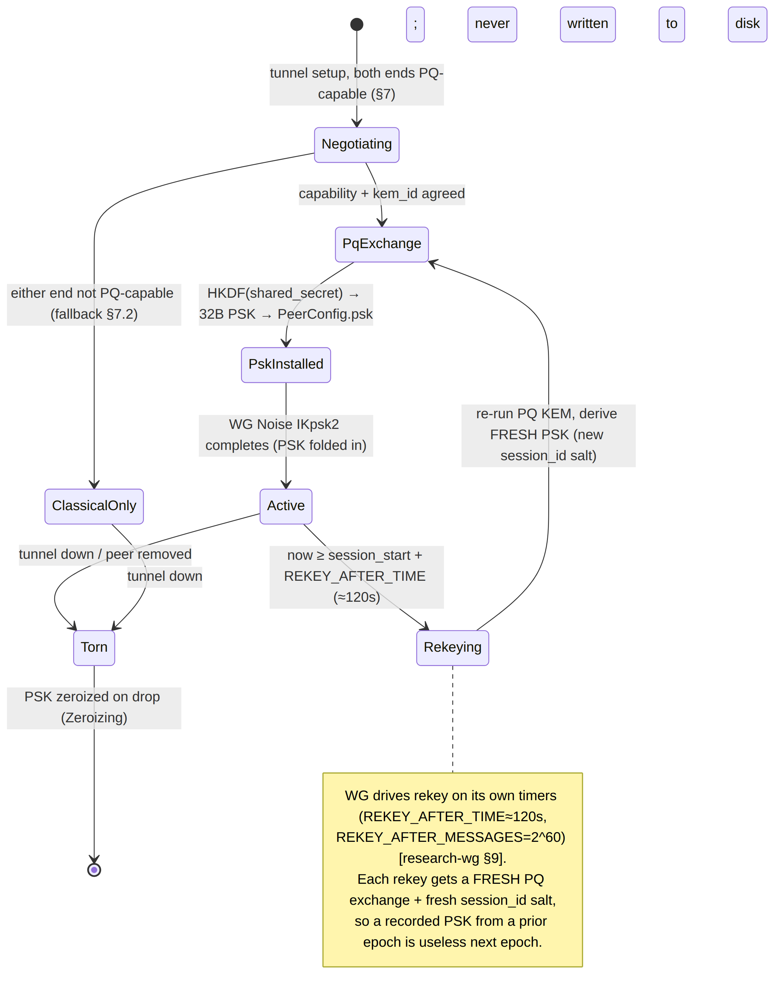

8.1 Rotation contract
- Trigger. WireGuard's own rekey timers drive rotation: REKEY_AFTER_TIME ≈ 120 s or REKEY_AFTER_MESSAGES = 2^60 [research-wg §9]. The PQ layer does not invent its own rotation cadence — it reuses WireGuard's, so the timings are never guessed (§11.4.6).
- Fresh material each epoch. Every rekey runs a new PQ KEM exchange with a new session_id salt, yielding a fresh PSK. A PSK recorded during epoch N (even if somehow extracted) is useless in epoch N+1 — forward secrecy at the PSK layer.
- Ephemerality (S11-class hygiene). The PSK lives only in memory, wrapped in Zeroizing so it is wiped on drop; it is never written to disk, never logged, never serialized across the FFI boundary as raw bytes [04-sec §3.3 key-handling discipline, §4.5]. WireGuard's own session zeroization (REJECT_AFTER_TIME × 3) wipes the derived session keys [research-wg §9].
- Rosenpass cadence cross-ref. If Rosenpass is chosen (§5), it refreshes the PSK every 2 minutes on its own [research-pq §2.3] — which aligns with WireGuard's ~120 s rekey, so the two cadences compose naturally. UNVERIFIED: exact interaction of Rosenpass's 2-min refresh with WireGuard's rekey timing under HelixVPN's specific wiring — a Phase-2 integration detail.

9. Wire framing of the PQ exchange (on the mTLS control channel)
The PQ exchange is two messages over the authenticated mTLS control channel — PqInit (client → gateway, carries the encapsulation key) and PqResp (gateway → client, carries the KEM ciphertext). It is an extension of the Coordinator RPC surface [04-sec §3.2 extends doc 03], so it inherits mTLS authentication and needs no new listener.
// helix-proto/coordinator.proto (PQ additions — extends the Coordinator service)
// All PQ RPCs ride the SAME mTLS control channel as Enroll/WatchNetworkMap (S4). No new listener.
enum KemId {
KEM_UNSPECIFIED = 0; // reject (closed-set; never silently downgrade)
KEM_ML_KEM_768 = 1; // DEFAULT (FIPS 203)
KEM_ML_KEM_1024 = 2; // larger margin, negotiable
KEM_MCELIECE_HYB = 3; // Phase-2 ML-KEM-768 + Classic McEliece (high-assurance opt-in)
KEM_ROSENPASS = 4; // Phase-2 external Rosenpass protocol (evaluated in the spike)
}
message PqCapabilities { // exchanged during negotiation (§7)
bool pq_capable = 1; // false ⇒ classical fallback, never a faked PQ PASS
repeated KemId supported = 2; // strongest mutually-supported wins
bool toggle_on = 3; // user "Quantum-resistant" toggle state (§7.1)
}
message PqInit { // client → gateway (PHASE A step 1)
KemId kem_id = 1; // selected per §7.3; KEM_UNSPECIFIED ⇒ PermissionDenied
bytes encap_key = 2; // ML-KEM-768 encapsulation key (ek); size per §6.1
bytes session_id = 3; // 16-byte random; the HKDF salt (domain-separates epochs)
}
message PqResp { // gateway → client (PHASE A step 2)
KemId kem_id = 1; // MUST echo PqInit.kem_id; mismatch ⇒ abort
bytes ciphertext = 2; // ML-KEM ciphertext (ct); client Decaps(dk, ct) → ss
bytes session_id = 3; // MUST echo PqInit.session_id
}
// NOTE: the decapsulation key (dk) and the derived 32-byte PSK NEVER appear on the wire (S2-class).
// Only ek (public) and ct (public) cross the channel; ss and psk are computed independently each side.

9.1 Framing invariants
- Public material only on the wire. Only ek (encapsulation key, public) and ct (ciphertext, public) cross the channel. The decapsulation key dk and the derived psk are computed independently on each side and never transmitted (S2-class key hygiene).
- session_id binds the epoch. The 16-byte random session_id is the HKDF salt; echoing it in PqResp binds request↔response and domain-separates each rekey epoch.
- Closed kem_id set. KEM_UNSPECIFIED (0) is rejected; an unknown kem_id aborts the exchange — never a silent downgrade to a weaker KEM (§11.4.6).
- UNVERIFIED: exact PQ-PSK message sequence. The precise KEM-exchange framing is a HelixVPN design choice — Mullvad's equivalent is deliberately high-level in public docs and is "a Mullvad-specific protocol on top of WireGuard … NOT part of the WireGuard protocol itself" [research-wg §6, research-pq §2.2]. The two-message PqInit/PqResp shape above is HelixVPN's spec design, not a copy of a published wire format; it MUST be reviewed against the chosen KEM library's API and (if Rosenpass) Rosenpass's own protocol at impl time.

10. Pluggable KEM contract (Rust)
The KEM is behind a trait so the §5 decision is reversible and the §13 self-validation can swap a golden-good / golden-bad implementation [04-sec §9.3].
// helix-core/crates/helix-pki/src/pq.rs (pluggable KEM contract — SPEC, not full impl)
/// A post-quantum KEM. The default impl is ML-KEM-768 (FIPS 203). Pluggable so the §5 decision
/// (ML-KEM vs McEliece-hybrid vs Rosenpass) is a swap, not a rewrite, and so the analyzer
/// self-validation (§13) can inject a golden-good and a golden-bad KEM.
pub trait PqKem {
fn kem_id(&self) -> KemId;
/// Generate an (encapsulation key, decapsulation key) pair. dk NEVER leaves the device.
fn keypair(&self) -> (EncapKey, DecapKey);
/// Gateway side: encapsulate to the client's ek, producing (ciphertext, shared_secret).
fn encapsulate(&self, ek: &EncapKey) -> (Ciphertext, SharedSecret);
/// Client side: decapsulate the ciphertext with dk, recovering the SAME shared_secret.
fn decapsulate(&self, dk: &DecapKey, ct: &Ciphertext) -> SharedSecret;
}
/// PSK = HKDF-SHA256(shared_secret, salt=session_id, info=b"helix-pq-psk-v1") -> 32 bytes,
/// installed into the WireGuard Noise IKpsk2 preshared-key slot (PeerConfig.psk, wg-core §2.2/§4.4).
/// Rotated every WG rekey (§8). The returned WgPsk is Zeroizing — wiped on drop, never persisted.
pub fn derive_wg_psk(ss: &SharedSecret, session_id: &[u8]) -> WgPsk {
// HKDF-Extract(salt=session_id, ikm=ss) -> prk; HKDF-Expand(prk, "helix-pq-psk-v1", 32) -> psk
// (RFC 5869). The 32-byte output is exactly the WireGuard PSK width.
/* HKDF-SHA256 */ unimplemented!("contract — impl batched per §11.4.9")
}
/// The hybrid combiner is NOT a bespoke construction: the classical X25519 half is intrinsic to
/// the Noise IK handshake; this PSK is the PQ half folded into the SAME session key schedule
/// (wg-core §4.2 `temp = HMAC(ck, psk)`). Breaking one input alone does not yield the session keys (S10).

10.1 Boundary discipline
- EncapKey and Ciphertext are public, serialized onto the wire (§9). DecapKey and SharedSecret and WgPsk are secret: Zeroizing-wrapped, never serialized, never logged, never crossing the FFI boundary as raw bytes [04-sec §3.3].
- The trait is the seam for the §13 self-validation: a golden-bad PqKem whose decapsulate returns a value ≠ the gateway's encapsulate shared secret MUST make the handshake fail (PSK mismatch ⇒ WG handshake fails) — proving the test catches a broken KEM, not just agreeing with a working one (§11.4.107(10)).

11. Rollout phasing (Phase 2+) and standardized-vs-experimental honesty
PQ is Phase 2+, not MVP — the MVP ships classical WireGuard (secure today) and reserves the PSK seam so PQ is purely additive [04-sec §9, §12 Phase-2 plan, wg-core §4.4 "additive, Phase 2"].
Phase | Scope | Status honesty (§11.4.6)
MVP (Phase 1) | Classical WireGuard only; PSK slot present but all-zero; PqCapabilities reserved in the proto | STANDARDIZED + shipping — X25519 Noise IK is mature, well-audited [research-wg §2]
Phase 2 | PqKem ML-KEM-768 over mTLS; HKDF→WG PSK; capability negotiate; rotate on rekey; "Quantum-resistant" toggle on-by-default where both ends support; spike: ML-KEM vs Rosenpass vs McEliece-hybrid | ML-KEM-768 is STANDARDIZED (FIPS 203, 2024-08-13); the HelixVPN wire framing (§9) is design work, not a standard; Rosenpass is EXPERIMENTAL (symbolic-only analysis) [research-pq §2.3]
Phase 2 (high-assurance opt-in) | ML-KEM-768 + Classic McEliece hybrid for tenants wanting the code-based hedge | McEliece is a NIST-approved primitive; the combination matches Mullvad production [research-pq §2.2]
Phase 3 | Reproducible builds + cosign-signed images + SBOM + third-party audit of the PQ core (so users can verify the PQ claim) [04-sec §12.3 Phase 3] | the PQ claim is only as trustworthy as the auditable build

11.1 Standardized vs experimental — the honest split
- Standardized (relyable now): ML-KEM (FIPS 203, published 2024-08-13); the WireGuard PSK mechanism (the PSK slot is part of the WireGuard protocol) [research-pq §2.4, research-wg §6].
- Design work (HelixVPN-specific, must be reviewed): the §9 PqInit/PqResp wire framing; the capability-negotiation flow (§7); the HKDF info-string "helix-pq-psk-v1" and the PSK derivation parameters. These are HelixVPN's protocol design, not a published standard.
- Experimental (do not over-claim): Rosenpass — symbolic analysis (ProVerif) only, full cryptographic proof "in progress", tagged release still on Kyber-512 [research-pq §2.3]; mobile PQ auto-rotation (Mullvad marks it experimental-not-yet-supported on mobile) [research-pq §2.2]. Any HelixVPN doc/UI that claims these as production-grade is a §11.4.99 stale/over-claim violation — re-verify against latest upstream before relying on them.

12. Threat-model placement & residual risk
PQ closes threat T8 in [04-sec §10]:
# | Threat (STRIDE) | Vector | Mitigation (this doc) | Residual risk (§11.4.6)
T8 | Information disclosure — harvest-now-decrypt-later | Passive recorder + future quantum computer | Hybrid PQ PSK (S10, §3–§9): X25519 ⊕ ML-KEM-768, PSK rotated per rekey | PQ KEM novelty → the hybrid hedge covers it (classical still protects if the PQ KEM is flawed); a break of both X25519 and ML-KEM is required to recover a session
Residual risks stated honestly:
- PQ KEM novelty. ML-KEM is younger than X25519; a future cryptanalytic break is possible. The hybrid design (§3) is exactly the hedge: a PQ-KEM break leaves classical WireGuard intact for today's adversaries.
- HelixVPN wire-framing risk. The §9 PqInit/PqResp framing is design work, not a standard — a protocol flaw in the framing (not the KEM) is possible and is why §13 + a third-party audit (Phase 3) are required before over-claiming.
- Mobile/Rosenpass maturity. Where the PQ path is experimental (mobile, Rosenpass), PQ is opt-in, not silent default — never a faked "PQ on."
- Formal-composition gap. The IND-CCA composition argument for Noise IKpsk2 + KEM-derived PSK rests on the WireGuard whitepaper's security argument, which was UNREACHABLE via the fetch tool and must be read directly by a human [research-wg §"Honest gaps"]. Flagged, not claimed.
- Not a claim classical WG is broken now. PQ is a forward hedge; X25519 + ChaCha20-Poly1305 is sound against every classical adversary today [research-wg §2].

13. Anti-bluff validation (how PQ is proven, not asserted)
Per S10's verification row [04-sec §13] and §11.4.107/§11.4.69, "PQ is on" is proven by captured evidence, never by a toggle reading "on."
Invariant | Captured-evidence proof (§11.4.5/§11.4.69/§11.4.107)
PQ hybrid active | Handshake with PQ on ⇒ the WireGuard PSK is non-zero AND an ML-KEM exchange is observed on the mTLS channel (captured PqInit/PqResp + non-zero PeerConfig.psk). A toggle "on" with an all-zero PSK is a §11.4 PASS-bluff and FAILs.
Classical fallback works | PQ off (or peer not PQ-capable) ⇒ classical WireGuard still connects (captured handshake), proving the fallback path is real and never a faked PQ PASS [04-sec §13].
Hybrid, not PQ-only | With PQ on, the X25519 handshake is still present (captured msg-1/msg-2) AND the PSK is non-zero — both halves observed, proving the session depends on both (S10).
Rotation | Across a forced rekey, the captured PSK at epoch N+1 ≠ epoch N (fresh PQ exchange), proving rotation is real, not a static reused PSK.
KEM correctness | Decaps(dk, ct) == Encaps(ek).shared_secret over N runs (§11.4.50 deterministic-consistency).
Self-validated analyzer | A golden-bad PqKem whose decapsulate returns the wrong shared secret MUST make the WG handshake FAIL (PSK mismatch) — proving the PQ test catches a broken KEM, not merely agreeing with a working one (§11.4.107(10), paired §1.1 mutation).
The PQ validation runs as helix_qa + challenges suites (§11.4.27) — a Challenge that scores PASS on a non-functional PQ control is the same class of defect as a unit-test PASS-bluff [04-sec §13]. PQ is not in the highest-risk-first set (kill-switch + revocation are, per §11.4.132) because it is Phase-2 additive, but its self-validation gate (golden-bad KEM ⇒ handshake fails) is mandatory before any "PQ on" claim ships.

14. Phase → task → subtask plan (PQ workstream)
Each leaf becomes a §11.4.93 workable item. Anti-bluff: every closure carries captured evidence (§11.4.5/§11.4.69/§11.4.107) and a paired §1.1 mutation. Mirrors [04-sec §12 Phase-2 2.S1].

Phase 1 (MVP) — reserve the seam, ship classical
- PQ-1.a — PeerConfig.psk: Option<Psk> present in helix-wg; all-zero in MVP (the seam exists, unfilled) [wg-core §2.2/§4.4].
- PQ-1.b — PqCapabilities/PqInit/PqResp/KemId reserved in coordinator.proto so the wire format need not change later (§9; additive per §11.4.6 no-silent-reshape).

Phase 2 — PQ handshake
- PQ-2.a — PqKem trait + ML-KEM-768 impl (ml-kem crate, pinned + re-verified per §11.4.99); keypair/encapsulate/decapsulate (§10).
- PQ-2.b — derive_wg_psk HKDF-SHA256 (salt=session_id, info="helix-pq-psk-v1") → 32 B, Zeroizing (§4, §8).
- PQ-2.c — PqInit/PqResp exchange over the mTLS control channel; no new listener (§9).
- PQ-2.d — capability negotiation + classical fallback; "Quantum-resistant" toggle on-by-default where both support (§7); mobile gated as opt-in (§7.1 honesty).
- PQ-2.e — rotate PSK on every WG rekey; ephemeral, never persisted (§8).
- PQ-2.f — spike: ML-KEM-768 vs Rosenpass vs McEliece-hybrid decision (§5), captured evidence, deep-research per §11.4.150 before the structural pick.
- PQ-2.g — anti-bluff suite: non-zero-PSK + observed-ML-KEM-exchange evidence; golden-bad KEM ⇒ handshake FAILs (§13); rotation evidence; N-iter KEM-correctness (§11.4.50).

Phase 2 (high-assurance opt-in)
- PQ-2.h — ML-KEM-768 + Classic McEliece hybrid PqKem impl for high-assurance tenants (§5); size-amortised at setup/rekey only (§6).

Phase 3 — auditable trust
- PQ-3.a — reproducible builds + cosign-signed images + SBOM so users verify the PQ binary matches source [04-sec §12.3].
- PQ-3.b — third-party cryptographic audit of the PQ core (KEM integration, HKDF derivation, wire framing, hybrid composition) [04-sec §12.3 3.S2].

Sources verified
- final/04-security-privacy-pki.md ([04-sec]) — §0.1 invariant S10 (PQ hybrid, never PQ-only) + S11 (PQ plane, ephemeral, never persisted); §9 (post-quantum handshake: PQ-derived PSK §9.1, hybrid handshake Mermaid §9.1, KEM choice table §9.2, where-it-runs + capability-negotiate + on-by-default + steady-state-zero-cost §9.3, PqKem/derive_wg_psk §9.3); §10 threat T8 (HNDL) + residual risk; §13 PQ verification row; §12 Phase-2 task 2.S1 + Phase-3 reproducible builds/audit; §4.1 PQ plane key hierarchy; §4.5 PSK rotated on rekey, ephemeral. — local spec.
- v02-data-plane/wireguard-core.md ([wg-core]) — §2.2 (PeerConfig.psk: Option<Psk>, Psk = [u8;32]), §4.2 (key-schedule PSK mix-in temp = HMAC(ck, psk)), §4.4 (post-quantum PSK seam, additive Phase 2, no transport change, install negotiated shared secret as WG PSK), §15 (handshake budget), perf table (PQ-PSK ~1–2 s at handshake, steady-state unchanged). — local spec.
- v09-research/research-pki_pq_nat.md ([research-pq]) — §2.1 (PSK-injection approach, hybrid-not-PQ-only), §2.2 (Mullvad production: Classic McEliece + ML-KEM, default-on-desktop 2025-01-09, mobile experimental, wgephemeralpeer reference, Kyber→ML-KEM migration), §2.3 (Rosenpass: Rust, PSK refresh every 2 min, Classic McEliece + Kyber-512, ProVerif symbolic analysis not full proof, v0.2.2 2024-06-05 still Kyber-512), §2.4 (FIPS 203 ML-KEM published 2024-08-13, NSA CNSA 2.0, target hybrid X25519 + ML-KEM-768, PSK feed not a WG fork). — cited research, access date 2026-06-25.
- v09-research/research-wireguard.md ([research-wg]) — §1/§2 (Noise IK, X25519, fixed crypto set), §6 (the PSK = post-quantum injection point: optional 32-byte PSK, all-zero when unused, temp = HMAC(responder.chaining_key, preshared_key), enters symmetric schedule so secure even if X25519 broken; Mullvad ML-KEM-1024/McEliece-over-WG prior art; PeerConfig.psk surface; UAPI preshared_key; UNVERIFIED: exact PQ-PSK message sequence), §9 (rekey timers REKEY_AFTER_TIME=120s, REKEY_AFTER_MESSAGES=2^60, session zeroization), §10 (boringtun Tunn::new preshared_key: Option<[u8;32]>), §"Honest gaps" (whitepaper PDF UNREACHABLE). — cited research, access date 2026-06-25.
- [research-mullvad] (via research-wg §6 / wg-core perf table cross-ref) — PQ-PSK-over-WG prior art; PQ-PSK ~1–2 s at handshake, steady-state unchanged.
Constitution bindings applied: §11.4.44 (revision header), §11.4.6 (no-guessing — every unproven size/framing/composition claim marked UNVERIFIED:; KEM choice + 768-vs-1024 + Rosenpass surfaced as decisions, never silent picks; rekey cadence reused from WireGuard, never invented), §11.4.66 (decision discipline — §5 KEM table with options + recommendation), §11.4.99 (latest-source — Rosenpass/ML-KEM status flagged for re-verification at impl), §11.4.107(10) (self-validated analyzer — golden-bad KEM ⇒ handshake fails), §11.4.50 (deterministic KEM-correctness over N runs), §11.4.150 (deep-research before the structural KEM pick), §11.4.93 (phases → workable items), §11.4.65/§11.4.153 (HTML+PDF[+DOCX] exports follow in refinement). Honest boundary (§11.4.6): the hybrid-composition formal proof rests on the WireGuard whitepaper, UNREACHABLE here — a human must verify it before relying on §3's IND-CCA argument.

