Zero-Trust Model & Default-Deny Enforcement

Zero-Trust Model & Default-Deny Enforcement
Revision: 1 Last modified: 2026-06-25T12:00:00Z
Master technical specification — Volume 5 (Security & Privacy), nano-detail document zero-trust-and-default-deny. Deepens the S1 zero-trust default-deny invariant of [04-security-privacy-pki.md §0.1/§1.3] into an implementation-grade contract: the no-implicit-trust-by-network-location model, the two policy enforcement points (control-plane compile-time + data-plane runtime), the least-privilege two-artifact output (AllowedIPs + verdict map), the need-to-know peer-filtering algorithm, fail-closed semantics on control-plane/policy unavailability, and a fully worked policy evaluation with Mermaid. SPEC ONLY — describe the implementation, do not build the product. This document references the policy compiler ([v03-control-plane/svc-policy.md]) and the data-plane verdict-map renderer ([v02-data-plane/routing-and-addressing.md]) rather than redefining them; it owns the zero-trust property and the default-deny enforcement contract that bind both. Sources cited inline by id: [04_ARCH §N], [04_P1 §N], [research-pki_pq_nat], [SYNTHESIS §N], and sibling specs by filename. Invariant ids: S1–S11 ([04-security-privacy-pki.md §0.1]); P1–P8 ([v03-control-plane/svc-policy.md §0.1]); I5/I6/R1–R4 ([v02-data-plane/routing-and-addressing.md §0.2]). Unproven facts are flagged UNVERIFIED per constitution §11.4.6 — never fabricated.

Table of contents
- 0. Position, ownership & governing invariants
- 1. The zero-trust model — no implicit trust by network location
- 2. Authenticate AND authorize — the two gates every peer crosses
- 3. The two policy enforcement points (compile-time + runtime)
- 4. Default-deny enforcement — the empty policy denies all
- 5. Least-privilege artifacts — AllowedIPs + verdict map
- 6. Need-to-know peer filtering — the algorithm
- 7. Fail-closed semantics — deny on unavailability, never allow
- 8. Worked policy evaluation (end to end)
- 9. Edge cases (defined behavior, no guessing)
- 10. Test & validation mapping (§11.4.169)
- Sources verified

0. Position, ownership & governing invariants
Zero-trust is the spine of HelixVPN: routing, no-logging, and revocation are all properties of the build only because nothing is trusted by default [04_ARCH §7]. The mechanisms that realize zero-trust live in other documents — the policy compiler in [v03-control-plane/svc-policy.md], the verdict-map renderer in [v02-data-plane/routing-and-addressing.md], the enrollment/PKI/mTLS in [04-security-privacy-pki.md]. This document owns the zero-trust contract that binds them: what "no implicit trust" means precisely, where it is enforced, and what "default-deny" and "fail-closed" must do under every condition.
This document owns: the zero-trust property statement (§1), the authenticate-AND-authorize gate model (§2), the two-enforcement-point map (§3), the default-deny floor (§4), the least-privilege artifact contract (§5), the need-to-know filtering algorithm restated as a zero-trust obligation (§6), and the fail-closed semantics (§7).
It does not own: the ACL DSL grammar, the compile algorithm, the version lifecycle, or the protobuf wire — all [v03-control-plane/svc-policy.md]; the FIB/4via6 mechanics or the nftables/eBPF rendering — [v02-data-plane/routing-and-addressing.md]; the auth handshakes themselves — [04-security-privacy-pki.md].

0.1 Governing invariants (every clause obeys these)
# | Invariant | Owner
S1 | Zero-trust default-deny — no peer reaches anything without an explicit compiled policy rule; the empty policy denies all. | [04-security-privacy-pki.md §0.1]
S3 | Need-to-know map distribution — a device's map contains only the peers/routes its policy grants; filtered server-side before the wire. | [04-security-privacy-pki.md §0.1]
S4 | Two-channel auth — control (mTLS leaf cert) and data (WG Noise IK) are separate and both required. | [04-security-privacy-pki.md §0.1]
P1 | Default-deny, need-to-know — a device appears in another's map only via a compiled accept edge; no deny verb (absence is denial). | [v03-control-plane/svc-policy.md §0.1]
P4 | Fail-closed — a compile error rejects the change; it never degrades to allow-all or silently keeps the prior policy. | [v03-control-plane/svc-policy.md §0.1]
I6 | Default-deny at the data plane — no peer reaches anything without an explicit rule expressed as AllowedIPs + an edge verdict map. | [v02-data-plane/routing-and-addressing.md §0.2]
R2 | Peers delivered already policy-filtered (need-to-know): a node never learns of networks it cannot reach. | [v02-data-plane/routing-and-addressing.md §0.2]
R3 | The verdict map fails closed — absent/stale compiled policy ⇒ drop. | [v02-data-plane/routing-and-addressing.md §0.2]

1. The zero-trust model — no implicit trust by network location

1.1 The principle
Classic VPNs are perimeter models: once you are "on the network" (past the VPN concentrator) you are implicitly trusted to reach everything on it. HelixVPN rejects this. The overlay is zero-trust: being enrolled, online, and cryptographically connected grants a device nothing by itself. Network location — "I have an overlay address; I completed a WG handshake to the gateway" — confers zero reachability. Every reachable peer and every reachable CIDR is the result of an explicit, compiled, per-device policy grant [04_ARCH §7, S1, P1].
The contrast, stated as a contract:
Perimeter VPN (rejected) | HelixVPN zero-trust (this spec)
"On the network" ⇒ reach the whole subnet | "On the overlay" ⇒ reach nothing until policy grants it
Trust derives from IP/segment location | Trust derives from identity (cert) plus authorization (compiled rule)
One firewall at the perimeter | Per-device least-privilege grant compiled into two enforcement layers
A breached host can move laterally freely | A breached host can reach only its compiled grant (microsegmentation)
Map = the whole topology | Map = only the need-to-know slice (S3/R2)

1.2 What "no implicit trust" forbids — the closed list
A conforming implementation MUST NOT, anywhere, grant reachability from any of these implicit signals (each is the perimeter-trust anti-pattern):
- Enrollment — a freshly-enrolled device with no policy grant has an empty AllowedIPs and no verdict-map entry; it is online but isolated ([04-security-privacy-pki.md §1.3]).
- Online presence — being in Redis presence state grants nothing.
- Overlay-address adjacency — sharing a tenant ULA /48 grants nothing; two devices in the same /48 cannot reach each other without a rule.
- A completed WG handshake — the data channel being up grants nothing the map did not already authorize (the map is the set of peers it may handshake with).
- Group membership alone — membership resolves to a device set, but a group reaches a destination only via an accept rule naming that group as src ([v03-control-plane/svc-policy.md §4.1]).
There is no "default LAN", no "trusted subnet", no implicit gateway full-tunnel. Absence of a rule is denial (P1) — there is no deny verb in the MVP model because there is nothing to subtract from; the base state is already deny-all.
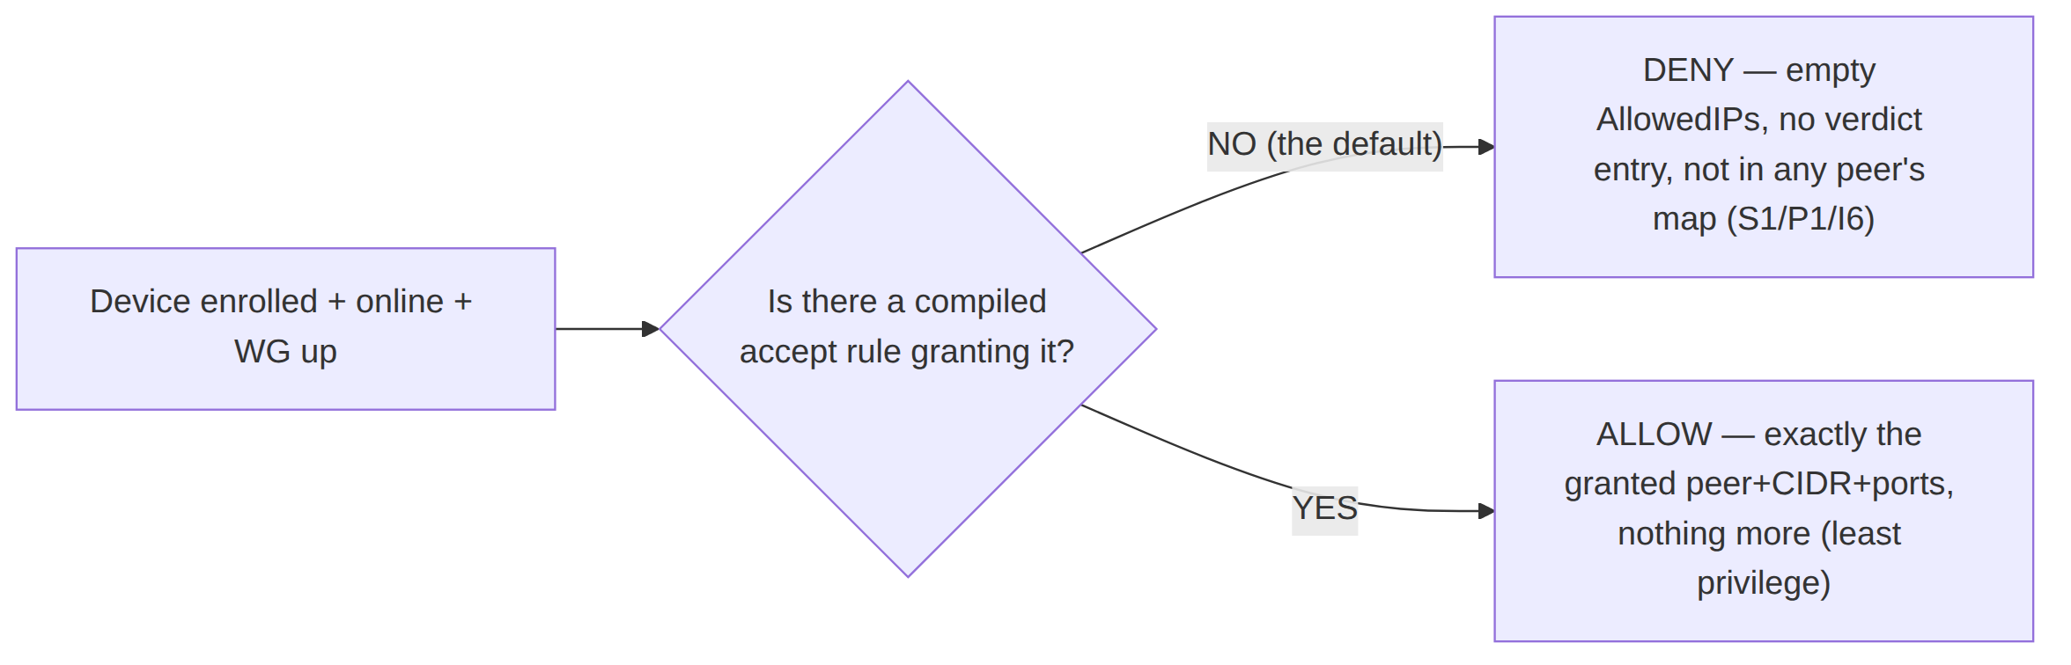

2. Authenticate AND authorize — the two gates every peer crosses
Zero-trust requires both authentication (who are you) and authorization (what may you reach). HelixVPN keeps these on two separate, never-conflated channels (S4) — a property the threat model relies on (compromising one does not yield the other, [threat-model.md §5.2/§5.4]).
Gate | Question | Mechanism | Owner | Failure mode
G1 — Authenticate (control) | Who are you? | mTLS with a ≤24 h CA-signed device leaf cert on every Coordinator RPC | [04-security-privacy-pki.md §1.2/§4] | no valid cert ⇒ stream refused; nothing learned
G2 — Authorize (compile) | What may you reach? | the device's compiled CompiledPolicy slice (VisibleTo/AllowedIPs/Verdicts) | [v03-control-plane/svc-policy.md §3] | empty slice ⇒ reach nothing (default-deny)
G3 — Authenticate (data) | Are you the keyholder? | WG Noise IK handshake to a peer pubkey delivered by G2's filtered map | doc 01 / [04-security-privacy-pki.md §1.2] | wrong key ⇒ handshake fails
G4 — Enforce (runtime) | Is this packet within the grant? | AllowedIPs cryptokey routing + verdict map at the edge | [v02-data-plane/routing-and-addressing.md §6] | outside grant ⇒ dropped
A device must pass G1 to learn anything, G2 to be granted anything, G3 to connect to a peer, and G4 to send a packet to it. The four gates are independent; bypassing one does not bypass the others. In particular, even a device that somehow obtained a peer's pubkey out-of-band cannot reach it: G4's AllowedIPs + verdict map drop the packet unless G2 compiled the grant.
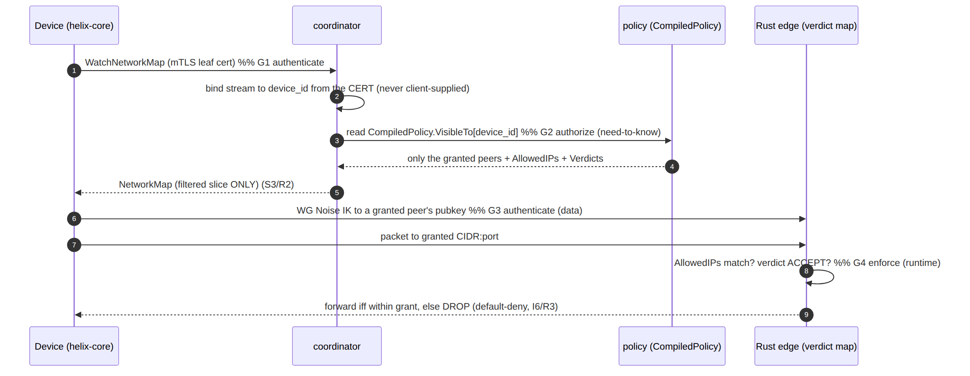

3. The two policy enforcement points (compile-time + runtime)
Zero-trust in HelixVPN is enforced at two points — once when intent becomes least-privilege artifacts (control plane, compile-time) and once when packets meet those artifacts (data plane, runtime). This is the PDP/PEP split (policy decision point / policy enforcement point) made concrete.
Enforcement point | Where | What it decides/enforces | Artifact | Owner
EP1 — Compile-time (PDP) | Go control plane | resolves the ACL into per-device need-to-know reachability; rejects anything default-deny does not grant | CompiledPolicy (§5) | [v03-control-plane/svc-policy.md §4]
EP2a — Distribution filter (PEP at the wire) | coordinator | filters each device's map to its VisibleTo slice before serialization (S3/R2) | filtered NetworkMap | coordinator (doc 03)
EP2b — Runtime (PEP at the packet) | Rust edge / device | drops any packet outside AllowedIPs (cryptokey routing) and outside the verdict map (default DROP) | kernel WG AllowedIPs + nftables/eBPF verdict map | [v02-data-plane/routing-and-addressing.md §6]
The two-layer runtime (EP2b) is deliberate defense-in-depth: WG's own AllowedIPs cryptokey routing is a coarse CIDR gate, and the verdict map is the fine port-level gate; both must allow for a packet to pass, and both default to deny ([v03-control-plane/svc-policy.md §3 P3], I6). A bug in one layer is caught by the other.
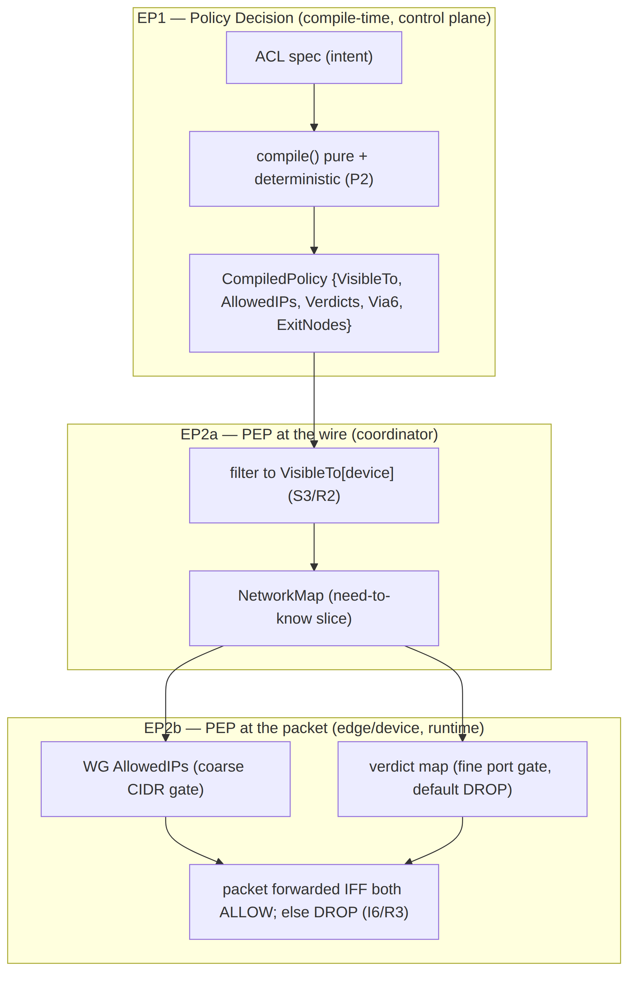

4. Default-deny enforcement — the empty policy denies all

4.1 The floor: the empty policy
The base case proves the model. A tenant with no ACL rules (only groups/hosts, or nothing at all) compiles to an all-empty CompiledPolicy: every map is empty, every AllowedIPs is empty, every verdict entry is absent. Result: everyone is denied everything ([v03-control-plane/svc-policy.md §10 E1]). This is valid, not an error — it is the default-deny floor (P1/S1). Reachability is added by rules; it is never the starting state.

4.2 Default-deny at each layer (the closed table)
Layer | "No grant" state | Effect
CompiledPolicy.VisibleTo[d] | empty set | device d learns of no peers (S3)
CompiledPolicy.AllowedIPs[d][peer] | absent | WG cryptokey routing drops all packets to/from peer (I6)
CompiledPolicy.Verdicts[d][peer] | absent / default | edge verdict map default verdict is DROP (R3)
coordinator distribution | peer not in VisibleTo | peer never serialized into d's map (S3/R2)
edge, no compiled policy at all | policy: None | the RouteEngine fails closed — every packet dropped ([v02-data-plane/routing-and-addressing.md §1 policy: Option<CompiledPolicy> None ⇒ fail-closed (R3)])

4.3 Least-privilege is the only addition path
A grant adds exactly the (peer, CIDR, ports) the rule names and nothing more ([v03-control-plane/svc-policy.md §4.1]):
- A host:554,80 grant adds AllowedIPs = [host CIDR] and a Verdicts entry restricting to TCP/UDP 554 and 80 — not all ports.
- A *:* grant is the operator's explicit choice to grant broad reach (no implicit narrowing, E2); it is still compiled per device, not an ambient "trust the network" rule.
- A device absent from ExitNodes cannot full-tunnel through the gateway, even if it can reach individual CIDRs ([v03-control-plane/svc-policy.md §4.3]).
No rule ever widens beyond its tokens, and the compiler is pure + deterministic (P2) so the same intent always yields the same least-privilege artifact — a property the §10 tests assert byte-for-byte.

5. Least-privilege artifacts — AllowedIPs + verdict map
The compiler emits the single source of zero-trust truth: CompiledPolicy. Restated from [v03-control-plane/svc-policy.md §3] for the zero-trust contract (this document references it, does not redefine the Go types):
// from internal/policy/compiled.go — the per-(tenant,version) zero-trust artifact.
type CompiledPolicy struct {
Version Version
SpecHash [32]byte // sha256(canonicalJSON(spec)) — ties artifact to intent (audit + dedup)
// ARTIFACT 1 — need-to-know visibility (S3/P1): src device -> reachable peer set.
VisibleTo map[DeviceID]map[DeviceID]struct{}
// ARTIFACT 1b — coarse WG AllowedIPs (CIDR-only, I6): src -> peer -> CIDRs.
AllowedIPs map[DeviceID]map[DeviceID][]netip.Prefix
// ARTIFACT 2 — fine port-level verdict map (R3 default-DROP): src -> peer -> port rules.
Verdicts map[DeviceID]map[DeviceID][]PortRule
// 4via6 routes for colliding IPv4 LANs (D4): src -> peer(connector) -> mappings.
Via6 map[DeviceID]map[DeviceID][]Via6Route
// exit-node grants: devices permitted to full-tunnel through the gateway.
ExitNodes map[DeviceID]struct{}
}
The three reachability fields are the zero-trust enforcement surface:
Field | Role | Default-deny meaning | Enforced at
VisibleTo[d] | who d may learn about | empty ⇒ learns nothing (S3) | EP2a coordinator filter
AllowedIPs[d][peer] | which CIDRs d may reach via peer | absent ⇒ all dropped (I6, coarse) | EP2b WG cryptokey routing
Verdicts[d][peer] | which ports of those CIDRs | absent ⇒ default DROP (R3, fine) | EP2b nftables/eBPF verdict map
SpecHash ties every artifact back to the exact authored intent (a zero-trust audit anchor — you can always prove which spec produced this grant), and Version makes rollback a flip to a previously-compiled artifact, never a recompile under pressure ([v03-control-plane/svc-policy.md §6 P5]).
The Peer protobuf the coordinator streams projects 1:1 from these fields — allowed_ips from AllowedIPs[self][peer], verdicts from Verdicts[self][peer] ([v03-control-plane/svc-policy.md §7.2]). The wire delivers only the filtered slice, so a device physically never receives a peer it cannot reach (S3/R2) — least-privilege is enforced even at the byte level, not just at the firewall.

6. Need-to-know peer filtering — the algorithm
Need-to-know (S3/R2) is the zero-trust distribution obligation: filter the map server-side, before the wire, so a device's map contains only its grant. A device that should not reach conn-B never learns conn-B exists — preventing both reconnaissance and accidental over-share.

6.1 The filtering algorithm
For a device d opening WatchNetworkMap (authenticated as device_id = d by its mTLS cert, G1/§2), the coordinator builds d's NetworkMap thus (deriving strictly from CompiledPolicy, [v03-control-plane/svc-policy.md §3/§4.1]):
buildMap(d, cp /* active CompiledPolicy */) -> NetworkMap:
# ZERO-TRUST RULE: start from nothing; add only what cp grants.
m := NetworkMap{ peers: [] } # default-deny base (S1/P1)
for peer in sortedKeys(cp.VisibleTo[d]): # ONLY the need-to-know set (S3)
if snapshot.Devices[peer].Revoked: continue # revoked never visible (P1)
p := Peer{
device_id: peer,
wg_pubkey: snapshot.Devices[peer].WGPubKey, # so d can do WG IK (G3)
allowed_ips: cp.AllowedIPs[d][peer], # coarse CIDR grant (I6)
verdicts: cp.Verdicts[d][peer], # fine port grant (R3)
via6: cp.Via6[d][peer], # 4via6 for colliding LANs (D4)
is_connector: snapshot.Devices[peer].Kind == CONNECTOR,
endpoint: gatewayRelay, # MVP relays via gateway
}
m.peers.append(p)
m.dns := tunnelDNS; m.exit_allowed := (d in cp.ExitNodes) # exit only if granted (§4.3)
return m # contains EXACTLY d's grant — nothing else
Three zero-trust properties the algorithm guarantees:
- Server-authoritative identity — d is taken from the cert, never from a client field, so a device cannot ask for another device's map ([threat-model.md §5.5 T-COORD-S-1]).
- Filter before serialize — peers outside VisibleTo[d] are never placed in the message, so the over-share threat is closed at the data structure, not at a later firewall (S3/R2).
- Revoked-exclusion — a revoked peer never enters VisibleTo (P1) and is re-checked here (belt-and-suspenders), tying into the <1 s revocation pipeline (S5, [04-security-privacy-pki.md §4.6]).

6.2 Delta updates preserve need-to-know
When policy changes, the coordinator pushes a MapDelta (peer upsert/remove) to each affected open stream — the same need-to-know filter applies to the delta: a device only ever receives upserts for peers in its new VisibleTo and removals for peers leaving it ([v03-control-plane/svc-policy.md §11]). A device never learns a peer it lost reach to was reachable beyond the removal itself; it never learns a peer it never had.

7. Fail-closed semantics — deny on unavailability, never allow
Zero-trust must hold especially when something breaks. Every unavailability path resolves to deny, never to allow (P4/R3). "When in doubt, drop" is the contract.

7.1 The fail-closed table (closed enumeration)
Failure condition | Where | Behavior | Invariant
Policy spec fails to compile | control plane, EP1 | reject the update; no row inserted; prior active policy stays live (never allow-all) | P4
dst CIDR not covered by an advertised prefix | EP1 dry-run | blocking ERR_HOST_NOT_ADVERTISED; change rejected | P4/P7
Edge has no compiled policy (policy: None) | EP2b edge | drop every packet (the Option<CompiledPolicy> is None) | R3
Compiled policy is stale (delta not yet applied) | EP2b edge | fail-static: keep enforcing the old policy (old tunnels keep forwarding under old rules) — never fail-open to allow-all | R3 / [v03-control-plane/svc-policy.md §10.3]
Control plane unreachable from a device | device | device keeps its last filtered map (fail-static to its existing grant); cannot widen without a new push; kill-switch keeps the leak window closed (S9) | R3 / S9
Coordinator stream drops | coordinator | the device re-authenticates (G1) and re-fetches; until then it has only its prior grant | R2/R3
Device revoked mid-flight | control + edge | revocation removes the peer + closes the stream in <1 s (S5); a revoked grant is re-checked at activation (E5) | S5 / P4

7.2 Fail-static is not fail-open — the honest distinction (§11.4.6)
"Fail-closed" here has two faces, both deny-leaning, and the spec is precise about which:
- Fail-closed (reject) — a new change that cannot be safely compiled/validated is rejected; the system does not adopt it (P4). Default-deny is preserved by not widening.
- Fail-static (hold) — when a delta is in flight, edges keep enforcing the last known good policy until the new one lands; they never drop to allow-all and never blindly widen. This is the <1 s convergence floor: a sub-second window of old-but-correct enforcement, never a window of open enforcement ([v03-control-plane/svc-policy.md §10.3]).
Neither face ever resolves to "allow because we're unsure". The honest boundary: the system guarantees no fail-open gap; it does not claim globally-atomic instantaneous convergence — there is a measured sub-second window where different edges may enforce different (both valid, both deny-correct) versions. UNVERIFIED: the exact p99 of this window under 10k concurrent streams is a measured number the soak test produces ([v03-control-plane/svc-policy.md §10.3]) — this document states the target (<1 s), not a measured result.
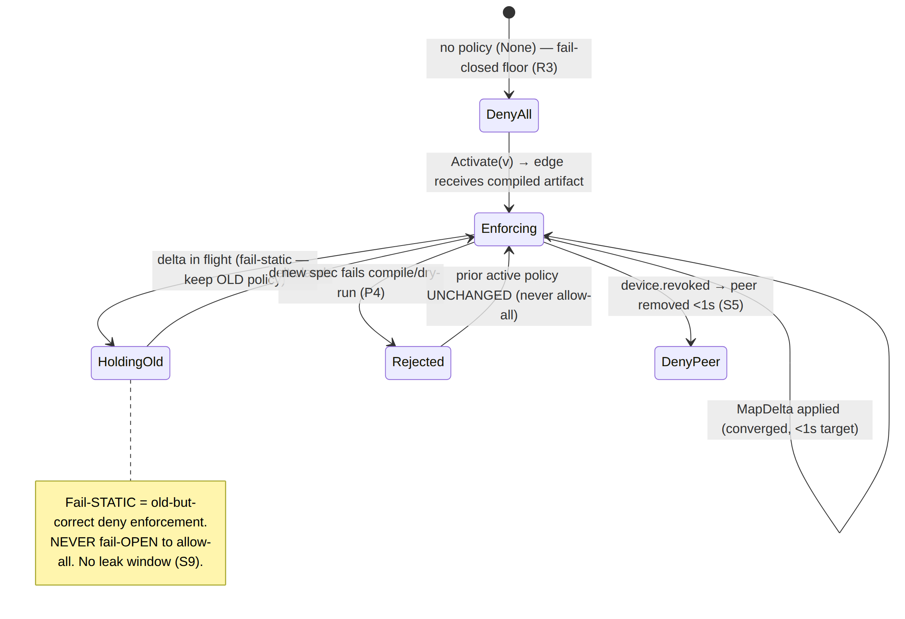

8. Worked policy evaluation (end to end)
Reusing the running example of [v03-control-plane/svc-policy.md §2.1/§4.3] to show zero-trust
- default-deny operating concretely. Tenant devices: alice-laptop, bob-laptop (group admins), carol-laptop (group contractors), conn-A (serves 10.10.0.0/24, site 1), conn-B (serves 192.168.50.0/24, site 2), gateway gw.
Intent (the ACL):
{
"acls": [
{ "action": "accept", "src": ["group:admins"], "dst": ["*:*"] },
{ "action": "accept", "src": ["group:contractors"], "dst": ["warehouse-cams:554,80"] }
],
"exitNodes": ["group:admins"] // only admins may full-tunnel
}

8.1 Evaluation — what each device may reach (and may NOT)
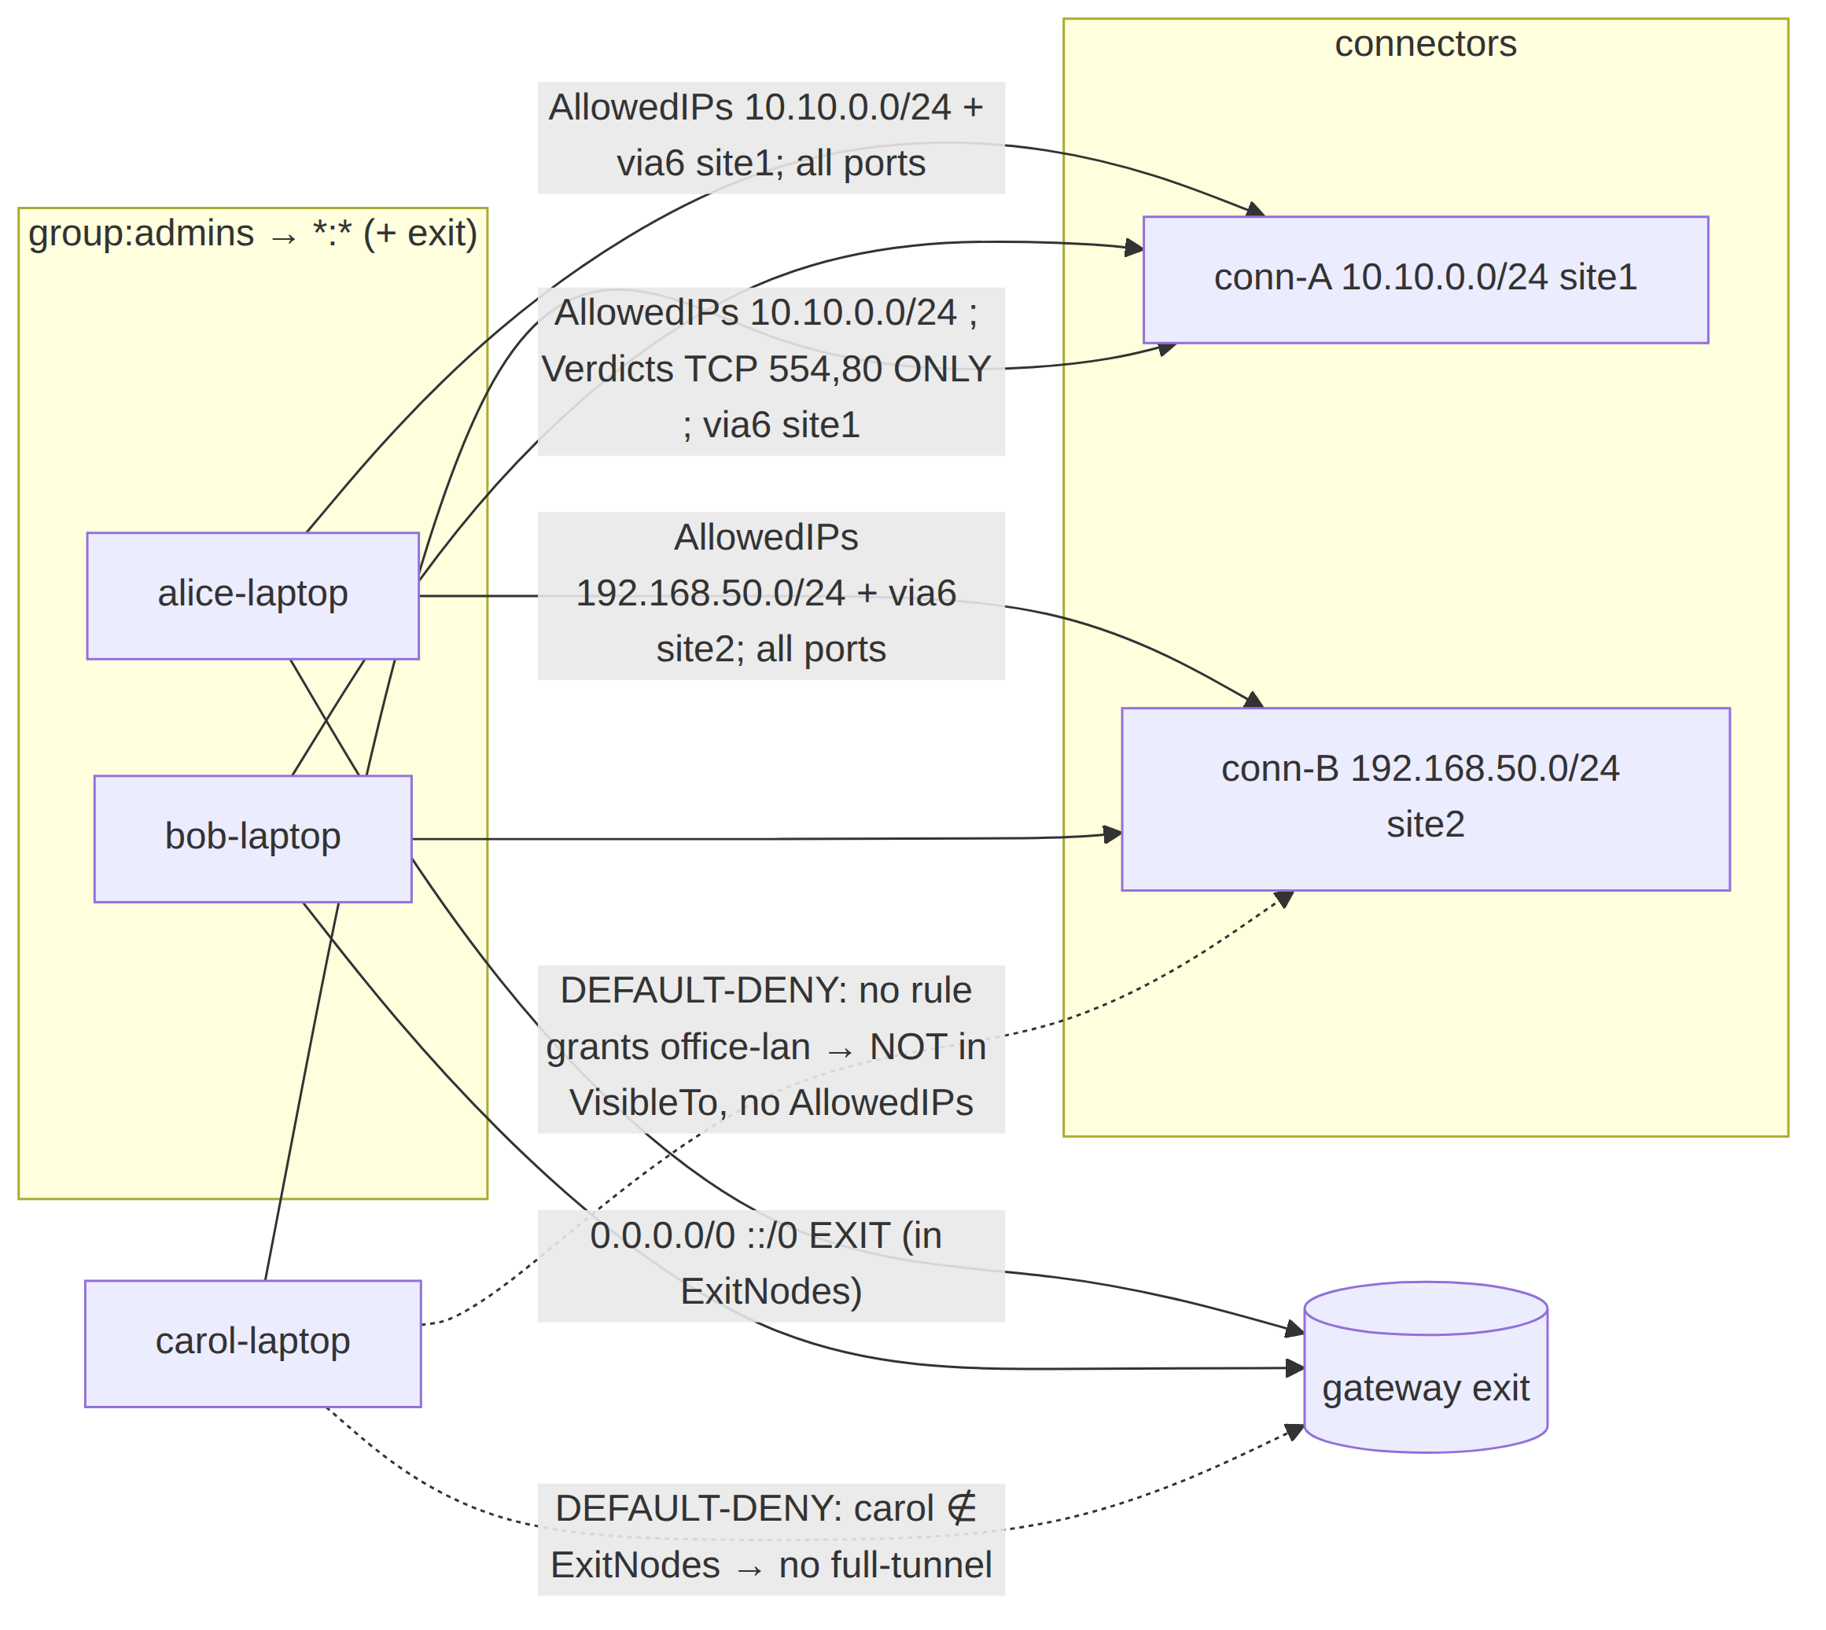

8.2 The precise compiled slice for carol-laptop (least privilege made concrete)
VisibleTo[carol-laptop] = { conn-A } # need-to-know: only conn-A (S3)
AllowedIPs[carol-laptop][conn-A] = [ 10.10.0.0/24 ] # coarse grant (I6)
Verdicts[carol-laptop][conn-A] = [ {10.10.0.0/24, ANY, 554,554}, # fine: ports 554 + 80 ONLY (R3)
{10.10.0.0/24, ANY, 80,80} ]
Via6[carol-laptop][conn-A] = [ {10.10.0.0/24, fd7a:helix:rrrr:0001::/96} ] # 4via6 (D4)
ExitNodes ∌ carol-laptop # no full-tunnel (§4.3)
# carol-laptop has NO entry for conn-B / office-lan → DEFAULT-DENY (S1/P1/I6)

8.3 Runtime enforcement of carol's slice (EP2b, two layers)
A packet from carol-laptop:
Destination attempt | WG AllowedIPs (coarse) | Verdict map (fine) | Result
10.10.0.5:554 (TCP) | match 10.10.0.0/24 ✓ | match 554 ✓ | ALLOW — the granted camera port
10.10.0.5:22 (SSH) | match 10.10.0.0/24 ✓ | no rule → default DROP | DENY — port not granted (least privilege)
192.168.50.5:any | no AllowedIPs → cryptokey-route DROP | (never reached) | DENY — office-lan not granted (S1)
full-tunnel 8.8.8.8 | not in ExitNodes → no 0.0.0.0/0 grant | — | DENY — not an exit node
The two layers are visible: even where the coarse CIDR layer would pass (10.10.0.0/24), the fine verdict map still denies the un-granted port — least privilege is enforced at both the CIDR and the port granularity, and the default at each is deny (I6/R3).

8.4 Need-to-know proven
carol-laptop's NetworkMap contains only conn-A. It does not receive conn-B's pubkey, endpoint, or even its existence (S3/R2). Carol cannot reconnoiter the office LAN, cannot attempt a WG handshake to conn-B (no pubkey), and any packet toward 192.168.50.0/24 is dropped by cryptokey routing (no AllowedIPs). Three independent layers — filtered map, cryptokey routing, verdict map — each default-deny, all agree.

9. Edge cases (defined behavior, no guessing)
Per §11.4.6, every boundary has a defined zero-trust behavior. These extend [v03-control-plane/svc-policy.md §10] with the zero-trust/default-deny lens.
# | Edge case | Defined behavior
Z1 | Newly-enrolled device, no policy grant | Online but isolated: empty AllowedIPs, no verdict entry, in no peer's VisibleTo ([04-security-privacy-pki.md §1.3]). The acceptance criterion "enroll a client; deny an unauthorized host" made concrete.
Z2 | Empty ACL (only groups/hosts) | Compiles to all-empty → everyone denied everything (default-deny floor, E1). Valid, not an error.
Z3 | Device shares the tenant /48 with another | No reach without a rule — overlay adjacency confers nothing (§1.2 #3).
Z4 | Device obtains a peer pubkey out-of-band | Cannot reach it: G4 AllowedIPs + verdict map drop the packet (no compiled grant). Auth ≠ authorization.
Z5 | Control plane unreachable from a device | Fail-static to the last filtered map; cannot widen; kill-switch holds the leak window closed (S9).
Z6 | Edge boots with no compiled policy | policy: None ⇒ drop everything until a policy lands (R3 fail-closed).
Z7 | Policy update fails to compile | Rejected (P4); prior active policy stays live; never allow-all.
Z8 | A granted device is revoked | Removed from every VisibleTo + peer dropped + stream closed in <1 s (S5); re-checked at activation (E5).
Z9 | A wildcard *:* grant to a non-admin group | Honored — the operator explicitly chose broad reach (E2). Zero-trust is "no implicit trust"; an explicit broad grant is the operator's authorized decision, still compiled per-device.
Z10 | Two groups grant overlapping reach to one user | Union — accept rules are additive (no deny to subtract, E6). The broader explicit grant wins; default-deny still governs everything ungranted.
Z11 | Stale delta in flight across edges | Fail-static (each edge enforces last-good); honest sub-second window, never fail-open (§7.2).
Z12 | exitNodes names a connector | Blocking ERR_EXIT_IS_CONNECTOR — a connector cannot be a full-tunnel exit (E7).

10. Test & validation mapping (§11.4.169)
Zero-trust is anti-bluff: each property's PASS is captured evidence that an unauthorized attempt was actually denied, not merely that an authorized one succeeded — a green "allow" test is necessary, never sufficient ([v03-control-plane/svc-policy.md §12 floor], §11.4.5/§11.4.69/§1.1).
Property | Test type | Concrete test point | Captured evidence
Default-deny floor (S1/E1/Z2) | Unit | Compile(emptyACL) → all maps empty; assert no device reaches any other | golden compiled.json byte-compare
New device isolated (Z1) | E2E (§11.4.98) | enroll a client with no grant → assert empty AllowedIPs + cannot reach any LAN host (packet-level) | docs/qa/<run-id>/ transcript + DROP pcap
Least privilege port grant (§8.3) | E2E | carol reaches 10.10.0.0/24:554 and is denied :22 and 192.168.50.0/24 | dual allow/deny pcap
Need-to-know filter (S3/R2/§8.4) | Integration | carol's served map contains only conn-A; conn-B absent | served-map byte-compare
Fail-closed compile (P4/Z7) | Integration + meta-test (§1.1) | spec citing an unadvertised CIDR → Update rejects; assert no policies row inserted; mutate to skip the gate → test FAILs | DB row-count before/after + mutate→FAIL log
Edge fail-closed (R3/Z6) | Integration | start edge with policy: None → every packet dropped | drop-counter trace
Fail-static, not fail-open (§7.2/Z11) | Chaos (§11.4.85) | kill the policy push mid-delta → edges keep enforcing old policy; assert no allow-all window | recovery_trace.log + pcap (no leaked flow)
Server-authoritative identity (§6.1 #1) | Security | a device requests another device's map → served its own slice only | request/response capture
Auth ≠ authorization (Z4/G4) | Security | send a packet to a known-pubkey peer with no compiled grant → dropped | DROP pcap
Revoked-exclusion (S5/Z8) | Integration | revoke a granted device → removed from VisibleTo + peer dropped, timed <1 s | revoke-to-removed timer
Two-layer enforcement (§3/§8.3) | Meta-test (§1.1) | (a) widen verdict default to ACCEPT → least-privilege port test FAILs; (b) skip AllowedIPs filter → CIDR-deny test FAILs | mutate→FAIL→restore→PASS
Determinism of the grant (P2) | Unit/property | compile same intent twice → byte-identical artifact (no nondeterministic widening) | hash-equality log
Anti-bluff floor (the §0.1 covenant): a zero-trust "PASS" requires captured evidence that both an authorized edge succeeded and an unauthorized edge was denied — under the same build, same topology. The §1.1 mutations (skip the dry-run gate; widen the verdict default; drop the need-to-know filter; remove the revoked check) are the runtime signatures (§11.4.108) that S1/S3/P4/I6/R3 are live, not merely promised.

Sources verified
- [04-security-privacy-pki.md] — §0.1 invariants S1 (zero-trust default-deny), S3 (need-to-know map distribution), S4 (two-channel auth), S5 (<1 s revocation), S9 (kill-switch); §1.2 two authentication channels; §1.3 default-deny realisation (empty AllowedIPs + no verdict entry = isolated); §4.6 revocation pipeline. (Read 2026-06-25.)
- [v03-control-plane/svc-policy.md] — §0.1 invariants P1 (default-deny/need-to-know), P4 (fail-closed), P6 (RLS); §2.1 running ACL example; §3 CompiledPolicy {Version, SpecHash, VisibleTo, AllowedIPs, Verdicts, Via6, ExitNodes} + §3 P3 two-artifact model; §4.1 compile algorithm (default-deny base); §4.3 worked carol-laptop slice; §5 blocking/advisory taxonomy; §6 version lifecycle + instant rollback; §7.2 Peer projection; §10 edge cases (E1/E2/E6/E7) + §10.3 honest convergence-race boundary; §11 convergence SLO; §12 test matrix. (Read 2026-06-25.)
- [v02-data-plane/routing-and-addressing.md] — §0.2 invariants I5/I6 (default-deny), R2 (need-to-know delivery), R3 (verdict map fails closed); §1 RouteEngine (policy: Option<CompiledPolicy>, None ⇒ fail-closed); §6 ACL→AllowedIPs + verdict-map compiler. (Read 2026-06-25.)
- [threat-model.md] (this volume) — §5.2/§5.4/§5.5 component STRIDE referenced for the authenticate-vs-authorize separation and the over-share threat. (Authored alongside, 2026-06-25.)
- [04_ARCH] HelixVPN-Architecture-Refined.md §3.4 (overlay/policy, AllowedIPs + nftables/eBPF verdict map, ULA /48 + 4via6), §7 (zero-trust, no-logging) — cited via the sibling specs.
- [04_P1] HelixVPN-Phase1-MVP.md §7 (ACL model, two artifacts, fail-closed), §11 DoD (authorized/denied acceptance criterion) — cited via the sibling specs.
- [research-pki_pq_nat], [SYNTHESIS §1/§3/§7] — trust gradient, D4 4via6, need-to-know. UNVERIFIED items (measured <1 s convergence p99 under 10k streams; the exact stale-delta window distribution) are flagged inline per §11.4.6 and stated as targets, never results.

