Codegen Pipeline (zero-drift contract)

Codegen Pipeline (zero-drift contract)
Revision: 2 Last modified: 2026-07-04T12:00:00Z Rev 2: Reviewed against the Volume-6 enterprise-hardening pass (2026-07-04). The schema- migration/versioning story this document owns (buf breaking-change gate §5, additive Phase-2 forward seams §9) already covers protobuf compatibility; no gap found in scope. Revision bumped for the pass.
Master technical specification — Volume 6 (Deployment, Tooling & Operations), nano-detail document. Scope: the schema-first code generation pipeline — buf → Go/Dart/Rust from the canonical .proto, OpenAPI → Dart/TS/Go from the canonical REST spec, the zero-drift guarantee (generated code is regenerated + diff-gated), the codegen gates wired into the local pre-build (§11.4.156 — NO server CI), and concrete buf.gen.yaml / Makefile / drift-check sketches. This deepens [05-overview §4] and operationalizes the codegen seams declared in [protobuf-spec §6] and [svc-api §12]. It is a SPEC: configs and skeletons are illustrative of the contract, not the shipping implementation (2–3 refinement passes follow).
Evidence cited inline by id: [05_OV §N] = 05-repo-layout-tooling-and-helix-ecosystem.md; [PROTO §N] = v03-control-plane/protobuf-spec.md; [API §N] = v03-control-plane/svc-api.md; [04_ARCH §4.2] = schema-generated clients, no drift; [04_P1 §8] = codegen (buf + OpenAPI); [research-go_cp] = the Go control-plane research digest. Unproven facts are marked UNVERIFIED per §11.4.6 — never fabricated. The proto package is helix.coordinator.v1, unified across the spec set [PROTO §0.2].

0. What this document owns (and does not)
This document owns the codegen mechanics: the two generator families (buf for protobuf, OpenAPI generators for REST), their config files, the offline-reproducibility decision, the make gen / verify-gen contract, the breaking-change gates (buf breaking + oasdiff), the track-vs-gitignore decision for generated code, and how the gates wire into the local pre-build sweep (§11.4.110/.156).
It does not own: the .proto field-by-field semantics (canonical in [PROTO §1]); the REST route table / request schemas (canonical in [API §3/§4]); the FFI bridge surface (Volume 4 ffi-surface.md); the repo layout that places helix-proto/ (that is repo-layout-and-decoupling.md). Those are referenced, never redefined.

1. Why schema-first: the anti-drift thesis
The single most important anti-drift mechanism in HelixVPN is that all Go/Dart/Rust/TS clients are generated from one canonical schema; hand-written clients are forbidden so the four codebases cannot drift apart [04_ARCH §4.2, 04_P1 §8, PROTO §6]. The contract has two canonical sources, each generating its language family:
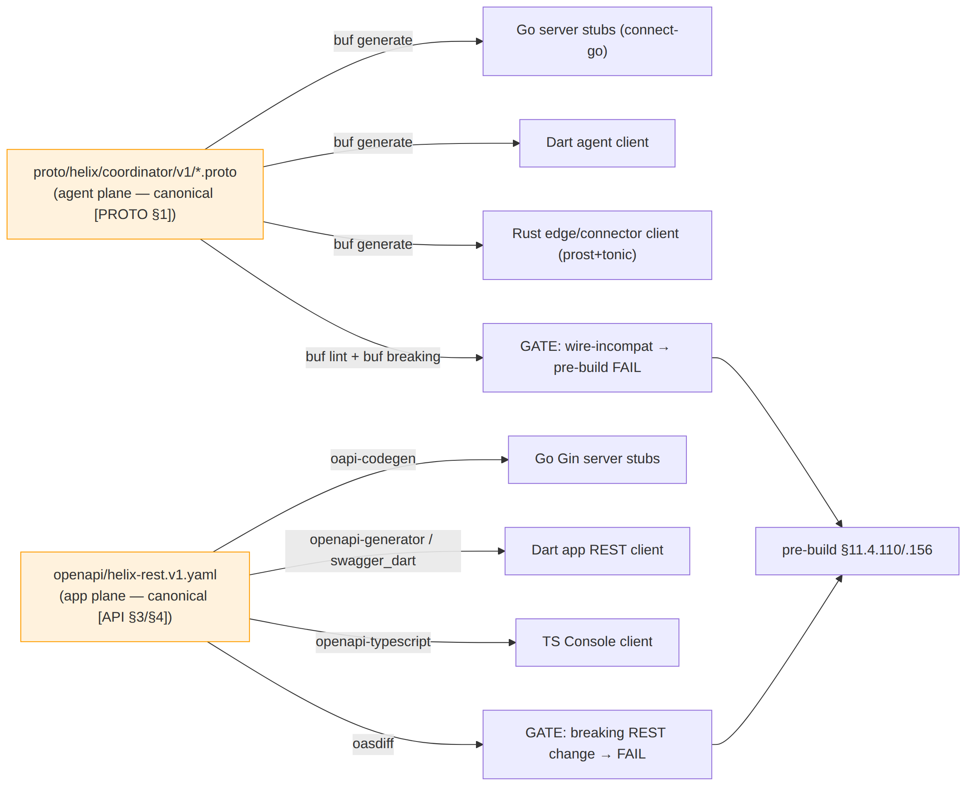
The guarantee is mechanical, not aspirational: regenerate, then git diff --exit-code the generated tree — a stale committed (or stale gitignored-but-required) client FAILs the gate (§11.4.108 runtime-signature). This document specifies exactly that machinery.

2. buf for protobuf (agent plane)
The single Coordinator service .proto lives in helix-proto (proto/helix/coordinator/v1/coordinator.proto) and generates three language stubs over Connect (gRPC + gRPC-Web + Connect on one listener) so native agents and a future WASM Console use the same generated stubs [PROTO §2/§6, 04_P1 §3].

2.1 buf.yaml (module + lint + breaking)
# helix-proto/buf.yaml
version: v2
modules:
- path: proto
lint:
use:
- STANDARD
except:
- PACKAGE_VERSION_SUFFIX # we use helix.coordinator.v1 (suffix present) — documented exception [PROTO §6.1]
breaking:
use:
- FILE # field-number/type changes within v1 are breaking → gate (§5) [PROTO §6.1]

2.2 buf.gen.yaml (three language outputs)
Connect is the binding so ONE service serves native agents over HTTP/2 AND browser clients over gRPC-Web [04_P1 §3, PROTO §6.2]:
# helix-proto/buf.gen.yaml — remote-plugin convenience form
version: v2
plugins:
# ---- Go (server) ----
- remote: buf.build/protocolbuffers/go
out: gen
opt: paths=source_relative
- remote: buf.build/connectrpc/go # Connect Go handlers/clients
out: gen
opt: paths=source_relative
- remote: buf.build/bufbuild/protovalidate-go # buf.validate field constraints [API §5.3]
out: gen
opt: paths=source_relative
# ---- Dart (client core boundary) ----
- remote: buf.build/protocolbuffers/dart
out: gen/dart
- remote: buf.build/connectrpc/dart # connect-dart client (UNVERIFIED plugin coord, §2.4)
out: gen/dart
# ---- Rust (edge / connector) ----
- remote: buf.build/community/neoeinstein-prost # prost messages
out: gen/rust/src
- remote: buf.build/community/neoeinstein-tonic # tonic service stubs
out: gen/rust/src

2.3 protovalidate constraints travel with the schema
Field constraints (wg_pubkey exactly 32 bytes, enroll_token min length, kind defined-only) live in the .proto via buf.validate and are enforced by a validateInterceptor server-side [API §5.3]; they generate into all three languages, so the same constraint cannot drift between client and server. Example, overlaid on the canonical messages [PROTO §1]:
import "buf/validate/validate.proto";
message EnrollRequest {
string enroll_token = 1 [(buf.validate.field).string.min_len = 16];
bytes wg_pubkey = 2 [(buf.validate.field).bytes.len = 32]; // exactly 32B Curve25519 (C6)
string os = 3 [(buf.validate.field).string.max_len = 32];
string name = 4 [(buf.validate.field).string.max_len = 128];
DeviceKind kind = 5 [(buf.validate.field).enum.defined_only = true];
}

2.4 UNVERIFIED plugin coordinates
The remote plugin coordinates/versions above are the conventional buf plugin names; the pinned versions are chosen at implementation time and recorded in buf.gen.yaml + buf.lock then — they are not asserted here as fixed [PROTO §6.2]. The connectrpc/dart plugin coordinate in particular is UNVERIFIED (the Dart Connect ecosystem moved during the spec window); the fallback is plain protocolbuffers/dart messages + a thin hand-checked-but- generated transport shim, which keeps the message types generated even if the service stub is not.

3. OpenAPI for REST (app plane)
The app-facing REST surface is the canonical openapi/helix-rest.v1.yaml [API §4/§12]. Three generated consumers, zero hand-written app clients:
Target | Generator | Consumes
Go server stubs (Gin) | oapi-codegen | helix-go/internal/api handler signatures + request/response models
Dart app REST client | openapi-generator (or swagger_dart_code_generator) | the three Flutter apps (Access/Connector/Console)
TS Console client | openapi-typescript | the Console Web build

3.1 Spec-first vs code-first (decision)
Decision D-OPENAPI-AUTHORING. The OpenAPI spec is authored spec-first (hand-authored contract, handlers validated against it), NOT generated from handler annotations (code-first). Rationale [API §12.2, research-go_cp §1]: Gin is the thin edge; authoring the contract first lets the TS/Dart app clients generate from a stable surface, and a request-validation middleware (kin-openapi) then asserts every request/response conforms — a drift between handler and spec FAILs a test. UNVERIFIED until the validation middleware is wired whether the MVP enforces response-conformance as well as request-conformance; the lean path enforces request-conformance first.
oapi-codegen config (server stubs) is referenced from the Makefile (§5):
# helix-go/internal/api/oapi.cfg.yaml (illustrative)
package: api
generate:
gin-server: true
models: true
embedded-spec: true # embed the spec so /v1 self-describes; never re-authored at runtime
output: internal/api/oapi_gen.go

3.2 The REST breaking-change gate
oasdiff compares the working helix-rest.v1.yaml against the last released git ref; a breaking REST change (removed route, narrowed type, required-field addition) FAILs the gate [API §12]. This is the REST analogue of buf breaking (§5).

4. Track or gitignore the generated code? (the §11.4.77 decision)
Decision D-CODEGEN-TRACK. Generated clients are gitignored, with make gen as the §11.4.77 regeneration mechanism (NOT committed). Rationale: the schema is the single source of truth (§11.4.93 spirit applied to code); a committed generated tree is a second copy that can rot and doubles review noise; make gen from a clean clone reproduces it deterministically. The gitignore entry carries a .gitignore-meta/<slug>.yaml declaring the mechanism (§11.4.77), and scripts/setup.sh runs make gen-tools && make gen post-clone so a fresh checkout builds.
This refines the overview, which kept generated code gitignored (helix-proto/gen/ is gitignored [05_OV §2]) — this document makes that the binding decision and pins the §11.4.77 mechanism. The trade-off: a fresh clone cannot go build until make gen runs once; the post-clone bootstrap (scripts/setup.sh) closes that gap, and the §11.4.77 meta-file makes the regeneration mechanism auditable.
UNVERIFIED: [svc-api §12.1] notes "generated Go/Dart/Rust stubs are committed (regeneratable) so the three codebases cannot drift" — i.e. the control-plane doc leaned track-committed. This is a visible reconciliation (§11.4.35): the binding Volume-6 decision is gitignore + regenerate (D-CODEGEN-TRACK), with the drift gate (§6) providing the no-drift guarantee that committing was meant to provide. Either choice satisfies §11.4.108 (the runtime signature is "regenerate → diff is empty"); gitignore + the §11.4.77 mechanism is chosen for the smaller review surface. The reconciliation is recorded so the two docs do not silently disagree.

5. The breaking-change gates (frozen wire + frozen REST)
Two gates make the contract frozen-by-machine, run in the local pre-build sweep (§11.4.156 — NO server CI; enforcement is the local pre-build + git hooks, §11.4.75):
# agent plane (buf)
buf lint # STANDARD rules
buf breaking --against '.git#branch=main' # field renumber / type-change / reused-number → FAIL
buf generate --template buf.gen.local.yaml # emits gen/ (Go), gen/dart, gen/rust
# app plane (OpenAPI)
oasdiff breaking helix-rest.v1.yaml@main helix-rest.v1.yaml # breaking REST change → FAIL
buf breaking is the mechanical enforcement that the [PROTO §1.1] field-number registry stays frozen: any commit renumbering a v1 field, changing a field type, or reusing a removed number FAILs the gate. Paired §1.1 mutation: a branch that renames Peer.allowed_ips field number 3 → 7 MUST make buf breaking FAIL; reverting MUST make it pass [PROTO §6.3].

6. The make gen / verify-gen contract (the drift gate)

6.1 Offline reproducibility (the §11.4.77 belt)
Decision D-CODEGEN-NET. buf remote plugins need network. Per §11.4.77 the regeneration mechanism MUST work from a clean clone. Recommended: vendor protoc-gen-* plugins as pinned local binaries under tools/ (Go via tools.go + go install, Rust via cargo install --locked) so make gen runs offline after a one-time make gen-tools; buf generate --template buf.gen.local.yaml points at the local binaries. The remote-plugin form (§2.2) stays as the convenience path [05_OV §4.1].
# Makefile — codegen targets (§11.4.156 NO CI)
gen-tools: ## one-time: install pinned local protoc-gen-* + oapi-codegen + openapi gens
go install github.com/bufbuild/buf/cmd/buf@<pin>
go install github.com/oapi-codegen/oapi-codegen/v2/cmd/oapi-codegen@<pin>
cargo install --locked protoc-gen-prost protoc-gen-tonic
# dart/ts generators per their pinned versions
gen: gen-proto gen-openapi gen-ffi ## regenerate ALL clients from schema (run before build)
gen-proto: ; buf generate --template buf.gen.local.yaml
gen-openapi: ; oapi-codegen -config helix-go/internal/api/oapi.cfg.yaml openapi/helix-rest.v1.yaml \
&& openapi-generator generate -i openapi/helix-rest.v1.yaml -g dart -o helix-ui/packages/helix_api_client \
&& npx openapi-typescript openapi/helix-rest.v1.yaml -o helix-ui/packages/app_console/src/gen/api.ts
gen-ffi: ; cd helix-core/crates/helix-ffi && flutter_rust_bridge_codegen generate
<pin> placeholders are resolved to exact versions at implementation time and recorded in buf.lock + go.mod + Cargo.lock — they are not asserted as fixed here (UNVERIFIED exact versions, per §11.4.6).

6.2 verify-gen — the drift gate itself
verify-gen: gen ## §11.4.108 artifact check: regen MUST be a no-op
@git diff --exit-code helix-proto/gen helix-ui/packages/helix_core_ffi helix-ui/packages/helix_api_client \
|| { echo "GENERATED CLIENTS STALE — run make gen and commit the schema change"; exit 1; }
verify-gen is the drift gate (the local equivalent of a CI check, run in the pre-commit hook per §11.4.75): regenerate, then assert the tree is byte-identical. Because generated code is gitignored (D-CODEGEN-TRACK), verify-gen runs against a freshly-generated tree and asserts the generation is deterministic (two runs identical) AND that the schema → code mapping has no manual edits creeping in via the FFI/oapi hand-config. This is the schema-first guarantee made mechanical [05_OV §4.3].

6.3 The full gate wiring into pre-build (§11.4.110)
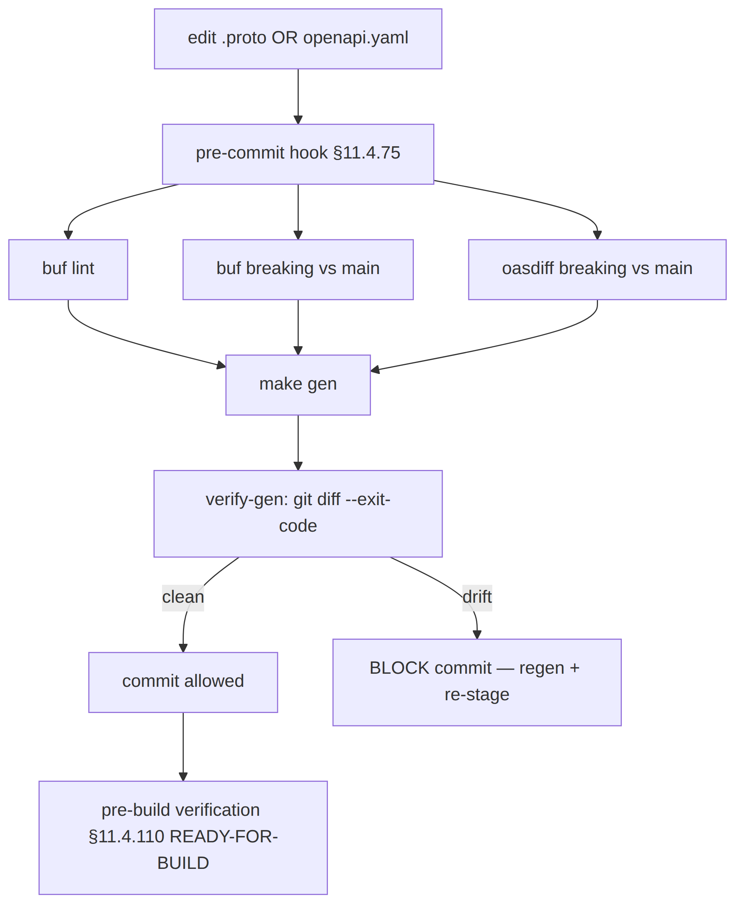
The pre-build READY-FOR-BUILD verdict (§11.4.110) refuses to start the main build unless buf lint, buf breaking, oasdiff, and verify-gen are all green — codegen drift is a build-blocker, not a warning.

7. Cross-language round-trip proof (no-stub-drift)
The strongest anti-bluff for "the stubs actually interoperate" is a cross-language round-trip: a generated Rust tonic client and the generated Go connect-go server complete one real WatchNetworkMap exchange [PROTO §7 T18]. This catches a class of drift that verify-gen cannot — a generation that is internally consistent in each language but semantically divergent across languages (e.g. a oneof mapped differently).
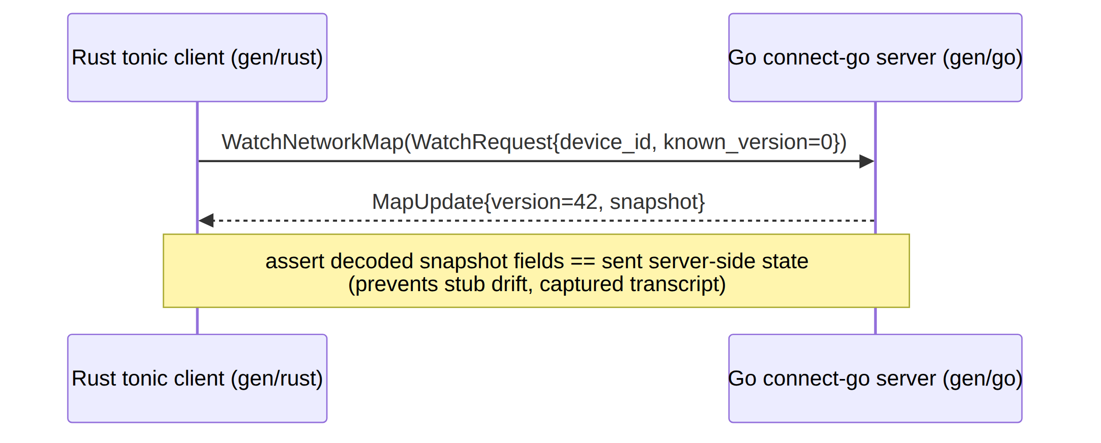
A Dart client variant proves the third language. Infra (Postgres+Redis) is booted on demand via vasic-digital/containers (§11.4.76), never ad-hoc docker run [PROTO §7].

8. Test points (§11.4.169 comprehensive test-type coverage)
Each row is implementation-ready; every PASS cites captured evidence (§11.4.5/.69/.107) — a green test that does not exercise the generated code is a §11.4 PASS-bluff.
# | Test type (§11.4.169) | Target | Concrete assertion + evidence
C1 | unit | generator determinism | make gen twice → byte-identical output (hash compare); evidence under docs/qa/<run-id>/
C2 | unit | protovalidate constraints generated | the generated Go/Dart/Rust validators reject a 31/33-byte wg_pubkey (§2.3)
C3 | contract / compat | buf breaking freeze (§5) | renumber Peer.allowed_ips 3 → 7 → buf breaking FAILs; revert → passes (paired §1.1)
C4 | contract / compat | oasdiff REST freeze (§5) | remove a /v1 route from the spec → oasdiff FAILs
C5 | contract / no-drift | verify-gen (§6.2) | hand-edit a generated stub → verify-gen git diff FAILs; regen restores
C6 | integration | cross-lang round-trip (§7) | Rust tonic client ↔ Go connect-go server complete WatchNetworkMap; captured transcript
C7 | integration | OpenAPI ↔ handler conformance (§3.1) | kin-openapi middleware: a request violating the spec → rejected; a handler diverging from spec → test FAIL
C8 | offline-repro | make gen from clean clone, network off (§6.1) | container clone with no network → make gen-tools && make gen exits 0; transcript captured
C9 | meta-test (§1.1) | every gate has a paired mutation | renumber field / hand-edit stub / remove route / inject volatile codegen → each makes its gate FAIL

9. Phase-2 forward seams (additive, no v1 break)
Codegen seams permit Phase-2 growth without a v1 break [PROTO §8, API §14]: new .proto fields (new field numbers, buf breaking stays green) regenerate into all three languages; new REST routes added spec-first regenerate the app clients; a WASM Console gains the same generated Connect stubs (gRPC-Web already supported [API §5.1]); the PQ pre-shared-key field is a buf-additive field on EnrollResponse/Peer. Each is additive because v1 drew the field-number registry [PROTO §1.1] with room and froze it under buf breaking (§5).

Sources verified
- 05-repo-layout-tooling-and-helix-ecosystem.md §4 (schema-first codegen — buf + OpenAPI, the make gen/verify-gen contract, D-CODEGEN-NET offline reproducibility) — [05_OV].
- v03-control-plane/protobuf-spec.md §1 (canonical .proto + field-number registry), §2 (Connect binding), §6 (buf pipeline + breaking gate), §7 (test points incl. T18 cross-lang), §8 (forward seams) — [PROTO].
- v03-control-plane/svc-api.md §4 (REST schemas), §5.3 (protovalidate), §12 (schema-first no-drift gates — buf + OpenAPI + oasdiff + git-diff runtime signature), §14 (forward seams) — [API].
- 04_VPN_CLD/HelixVPN-Architecture-Refined.md §4.2 (schema-generated clients, no drift), HelixVPN-Phase1-MVP.md §8 (codegen), 02-control-plane.md / research-go_cp §1–§2 (Gin thin edge, connect-go, protovalidate, single-server) — [04_ARCH] [04_P1] [research-go_cp].
- Constitution anchors: §11.4.77 (regeneration mechanism for gitignored content), §11.4.108 (runtime-signature: regen-diff-empty), §11.4.110 (READY-FOR-BUILD pre-build verdict), §11.4.156 (no active CI — local pre-build enforcement), §11.4.76 (containers submodule for test infra), §11.4.35 (visible reconciliation — D-CODEGEN-TRACK vs the control-plane doc's track-committed note), §11.4.6 (no-guessing — UNVERIFIED plugin/version marks), §11.4.169 (test-type coverage), §1.1 (paired meta-test mutations).

