Disaster recovery (RTO/RPO, backup & region-failover runbook)

Disaster recovery (RTO/RPO, backup & region-failover runbook)
Revision: 2 Last modified: 2026-07-04T12:00:00Z Rev 2: Reviewed against the Volume-6 enterprise-hardening pass (2026-07-04); no gaps found in scope (RTO/RPO, backup/restore, region-failover, restore verification are already comprehensive and cross-checked against ha-and-multiregion.md) — revision bumped for the pass, no content change beyond this header.
Master technical specification — Volume 6 (Deployment, Tooling & Operations), nano-detail document disaster-recovery.md. This document CLOSES source-coverage ledger gap G1 (99-source-coverage-ledger.md — [03_ZAI]'s named DR posture: RTO/RPO budget, KMS-encrypted backups, Terraform region-failover runbook, "disaster recovery as a first-class operational section" — was scattered, never consolidated). Scope: the RTO/RPO budget (stated as TARGETS, §11.4.6), exactly what is backed up and what deliberately is not (Postgres = truth, backed up; Redis/NATS = ephemeral, NOT backed up — and why that is safe under the no-logging promise), backup cadence + restore runbook, the step-by-step region-failover runbook, the §9.2 absolute-data-safety discipline, and concrete backup/restore + verification commands. This is a SPEC (describe the procedure; do not run the product). Evidence cited inline: [05 §N], [svc-coordinator §N], [svc-events §N], [svc-telemetry §N], [ha-and-multiregion §N], [kubernetes §N], [03_ZAI] (the DR source), [ledger G1]. Unproven facts are marked UNVERIFIED per §11.4.6.

Table of contents
- 0. DR thesis — back up truth, regenerate the rest
- 1. RTO / RPO budget (TARGETS, not guarantees)
- 2. What is backed up — and what deliberately is NOT
- 3. Backup cadence & mechanism (Postgres + secrets)
- 4. The §9.2 absolute-data-safety discipline applied to DR
- 5. Restore runbook (single-store recovery)
- 6. Region-failover runbook (whole-region loss)
- 7. Restore verification (the anti-bluff gate)
- 8. DR drills & captured evidence
- 9. UNVERIFIED register
- Sources verified

0. DR thesis — back up truth, regenerate the rest
HelixVPN's DR design is shaped by the same architectural decision that makes HA cheap ([ha-and-multiregion §0]): the system has exactly one durable source of truth — Postgres (C2) — and everything else is a regenerable projection of it. From [svc-events §7.4]:
"the bus is a fast-path accelerator over Postgres truth, never a second source of truth."
So DR reduces to a sharp, auditable statement:
- Back up Postgres (truth) + the secrets needed to bring a stack up. That is the entire durable surface.
- Do NOT back up Redis/NATS — they are ephemeral by construction; restoring them would restore stale presence/event state, and (critically) the no-logging promise means there is nothing in them worth persisting. The coordinator graph is rebuilt from Postgres on boot [svc-coordinator §1.4]; the outbox re-relays in-flight events [svc-events §7.4].
- Regenerate the deploy substrate (quadlets/compose/k8s) from the in-code spec via helixvpnctl deploy [05 §6.3(B)] — the manifests are a §11.4.77 build derivative, re-emitted, not restored.
The DR posture is therefore: one thing to back up (Postgres), one thing to protect (the secrets), everything else regenerated. This is both simpler and safer than a "back up everything" posture — there is no risk of restoring a stale connection log because there is no connection log.

1. RTO / RPO budget (TARGETS, not guarantees)
Per §11.4.6 these are stated explicitly as TARGETS the design aims at, to be measured in DR drills (§8) — never asserted as achieved. They consolidate [03_ZAI]'s "RTO < 15 min" framing that [ledger G1] found scattered.
Scenario | RTO target (time to service) | RPO target (data loss window) | Basis
helixd replica loss | seconds (reconnect) | 0 | stateless reconnect [svc-coordinator §3.2]; no data lost
Postgres primary failover (HA standby) | < 60 s (promotion) | 0 for sync-committed | sync standby remote_write [ha-and-multiregion §3]
Redis/NATS loss | seconds–minutes (recovery) | 0 durable (ephemeral) | rehydrate from PG + outbox re-relay [svc-events §7.4]
Postgres total loss → restore from backup | < 15 min ([03_ZAI] target) | ≤ backup-cadence (see §3) | restore latest backup + WAL replay
Whole-region loss → failover to standby region | < 15 min | 0 (sync) or ≤ async-lag | promote cross-region standby [ha-and-multiregion §1] + repoint geoDNS [ha-and-multiregion §5]
RPO precision (the honest number, §11.4.6). RPO is 0 for any transaction that committed against a synchronous standby ([ha-and-multiregion §3]). RPO for a backup-only restore is bounded by the most recent recoverable point = last base backup + last shipped WAL segment (with continuous WAL archiving, RPO ≈ the WAL archive interval, typically seconds–minutes; see §3). The 15-min figure is RTO (time to restore), distinct from RPO (data lost) — conflating them is the bluff this note forbids. The data-plane impact during all of the above is none for live tunnels (C1 fail-static, [ha-and-multiregion §3]): DR pauses control operations, never drops forwarding.

2. What is backed up — and what deliberately is NOT
Asset | Backed up? | Mechanism | Why
Postgres (tenants, devices, connectors, prefixes, policies, certs metadata, audit_events, event_outbox) | YES | base backup + continuous WAL archive (§3) | the only durable truth (C2); losing it loses the system
CA private key / PKI root (doc 04) | YES (separately, stricter) | KMS-encrypted, offline/HSM-class storage | catastrophic if lost (every device cert chains to it); catastrophic if leaked (§4)
Stack secrets (DB password, etc.) | YES (referenced) | external secret store (ESO/Sealed-Secrets, [kubernetes §2]) | needed to bring a stack up; §11.4.10 never plaintext-in-git
Redis stream contents | NO | — | ephemeral (C2); restoring = stale events; outbox re-relays in-flight [svc-events §7.4]
Redis presence keys | NO | — | ephemeral by design — this IS the no-logging mechanism [svc-telemetry §5]; persisting them would create a connection log
NATS JetStream state (Phase 2) | NO (replicated, not backed up) | cluster replication [ha-and-multiregion §4] | same ephemeral logic; HA via replication, not backup
Coordinator in-mem graph | NO | rebuilt on boot [svc-coordinator §1.4] | a projection of PG; not durable
Deploy manifests (quadlet/compose/k8s) | NO (regenerated) | helixvpnctl deploy [05 §6.3B] | §11.4.77 build derivative — re-emitted from in-code spec
The privacy-positive DR property (the thing that makes "don't back up Redis" safe, not reckless). Redis holds presence (who-is-online-now) and in-flight events. Presence is deliberately non-durable — "online/offline state lives only in Redis with a TTL, so the durable store never accumulates a connection log" [svc-telemetry §0/§5]. Backing Redis up would manufacture exactly the durable connection log the no-logging promise (C3) forbids. So the DR design's refusal to back up Redis is not a gap — it is the no-logging invariant extended into the backup layer. A DR plan that snapshotted Redis would be a §11.4 / C3 violation, not a safety improvement.
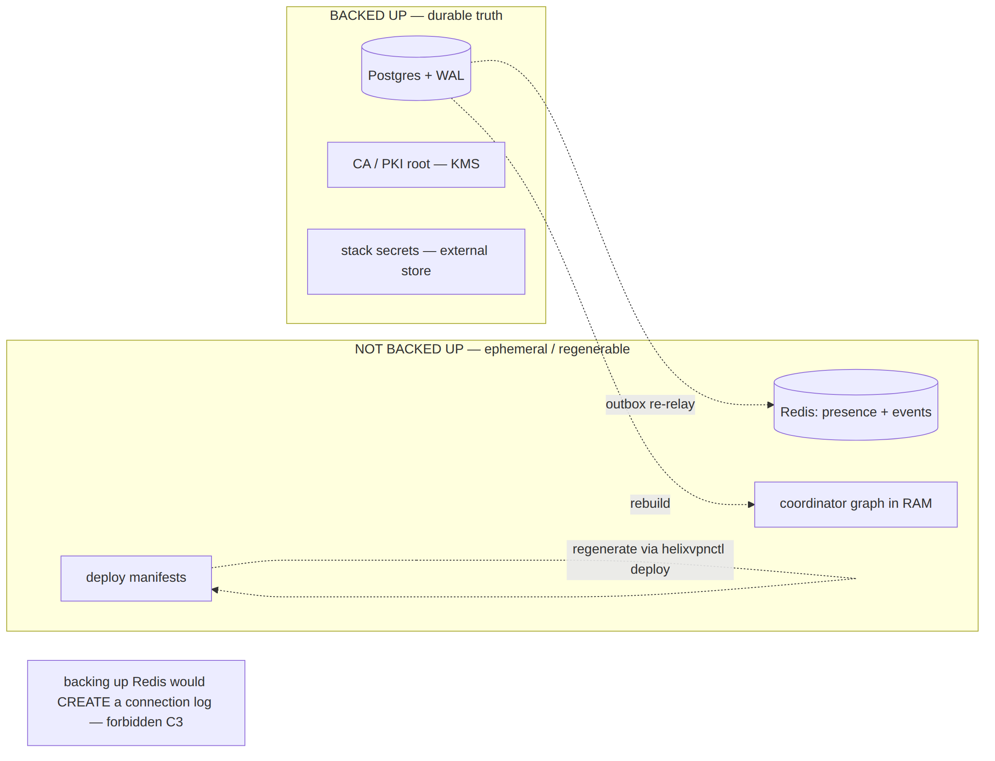

3. Backup cadence & mechanism (Postgres + secrets)
Postgres = base backup + continuous WAL archiving (point-in-time recovery, PITR). This is the mechanism that makes RPO ≈ WAL-archive-interval rather than ≈ backup-interval.
Layer | Cadence (target) | Mechanism | Retention
Base backup | every 24 h | pg_basebackup / CNPG scheduled backup → object store | 30 days (UNVERIFIED — operator policy)
WAL archive | continuous (seconds) | archive_command → object store (S3/GCS) | until next base backup + grace
Logical dump (belt-and-suspenders) | every 24 h | pg_dump --format=custom (portable, cross-version) | 7 days
CA / PKI root | on rotation only | KMS-encrypted export to offline storage | indefinite (the root)
# deploy/scripts/dr/pg-backup.sh (illustrative — KMS-encrypted, §11.4.10/§9.2)
set -euo pipefail
TS="$(date -u +%Y%m%dT%H%M%SZ)"
DEST="s3://helix-dr-backups/pg/${TS}"
# 1) consistent base backup (CNPG does this via its Backup CR; raw form shown for portability)
pg_basebackup -h helix-pg-rw -U helix_owner -D - -Ft -X fetch -z \
| aws s3 cp - "${DEST}/base.tar.gz" --sse aws:kms --sse-kms-key-id "${HELIX_KMS_KEY}" # [03_ZAI] KMS-encrypted
# 2) portable logical dump (cross-version restore safety net)
pg_dump -h helix-pg-rw -U helix_owner -d helix --format=custom \
| aws s3 cp - "${DEST}/helix.dump" --sse aws:kms --sse-kms-key-id "${HELIX_KMS_KEY}"
# 3) record the recoverable point for the §7 verification gate
echo "{\"ts\":\"${TS}\",\"lsn\":\"$(psql -h helix-pg-rw -U helix_owner -tAc 'SELECT pg_current_wal_lsn()')\"}" \
| aws s3 cp - "${DEST}/MANIFEST.json"
WAL archiving is configured on the cluster (CNPG barmanObjectStore, or raw archive_command):
# CNPG continuous WAL archive (the RPO≈seconds mechanism)
spec:
backup:
barmanObjectStore:
destinationPath: "s3://helix-dr-backups/pg"
encryption: aws:kms # [03_ZAI] KMS-encrypted backups
wal: { compression: gzip }
data: { compression: gzip }
retentionPolicy: "30d"
Secrets cadence. Stack secrets are referenced from an external store ([kubernetes §2]); the store's own backup is the operator's responsibility. The CA root is the one secret whose loss is unrecoverable (every device cert chains to it) — it is exported KMS-encrypted on rotation only and stored offline/HSM-class (doc 04). Its handling is the highest-stakes part of DR and is governed by §9.2 (§4) + §11.4.10.

4. The §9.2 absolute-data-safety discipline applied to DR
Every DR operation is a destructive-or-high-stakes operation; §9.2 (absolute data safety, zero risk) applies in full:
- Backup-first, always. Before any restore overwrites a live store, take a fresh backup of the current (even if corrupt) state — a corrupt-but-present DB may still be more recoverable than a botched restore. Hardlinked/cheap snapshot first (§9.2 step 1).
- Record metadata. Capture the pre-restore HEAD/LSN, the target recovery point, the expected post-restore row counts / schema version, and the recoverable-point MANIFEST.json (§3).
- Define expected post-op state. The §7 verification gate's expected values, written down before the restore runs.
- Run the restore — never with --force that skips integrity checks; never auto-retry a failed restore onto the same volume.
- Post-op gate (§7). Schema present, RLS intact, schemalint green against the restored DB (no-logging runtime signature §11.4.108), row-count sanity, a live WatchNetworkMap snapshot matches expectation. If ANY check fails → do NOT promote the restored DB; investigate.
- CA-key handling is operator-gated (§11.4.101/.122). Restoring or rotating the CA root is irreversible + catastrophic-blast-radius → it is NEVER autonomous; it goes through the operator with the exact commands surfaced (§11.4.66), never decided by the agent.
- Audit trail. Every DR action recorded under docs/qa/<run-id>/ (§11.4.83) + a docs/changelogs/ DR-event section.
No-force-push analogue for DR (§11.4.113 spirit). Just as history-rewrite is never autonomous, a destructive restore over a live primary is never autonomous — it is the §11.4.101 block-only-when (irreversible + high-blast-radius) case, surfaced to the operator. The agent prepares the restore (fetches the backup, validates the manifest, stages the commands) but the "overwrite the live primary" step is operator-confirmed.

5. Restore runbook (single-store recovery)
The common case: Postgres is lost/corrupt, the region is intact. Restore from backup + WAL.
# deploy/scripts/dr/pg-restore.sh (illustrative — §9.2 disciplined)
set -euo pipefail
SRC="s3://helix-dr-backups/pg/${RESTORE_TS:?set RESTORE_TS}"
TARGET_PITR="${TARGET_PITR:-latest}" # PITR target time, or 'latest' for end-of-WAL
# §9.2 STEP 1 — backup-first: snapshot whatever is currently there (even if corrupt)
deploy/scripts/dr/pg-backup.sh || echo "WARN: pre-restore backup of current state failed — record + decide (§9.2)"
# §9.2 STEP 2/3 — record metadata + expected state (written to the run dir)
mkdir -p "qa-results/dr/${RESTORE_TS}"
aws s3 cp "${SRC}/MANIFEST.json" "qa-results/dr/${RESTORE_TS}/recoverable-point.json"
# §9.2 STEP 4 — restore to a FRESH volume (never overwrite the live primary in place; operator-gated promote)
# CNPG: create a Cluster with bootstrap.recovery pointing at the barman store + recoveryTarget.
# raw form:
aws s3 cp "${SRC}/base.tar.gz" - | tar -xzf - -C "${RESTORE_DATA_DIR:?}"
cat > "${RESTORE_DATA_DIR}/recovery.signal" <<'EOF'
EOF
# recovery.conf / postgresql.auto.conf: restore_command from the WAL archive + recovery_target_time
# CNPG recovery cluster (the recommended form — restores to a NEW Cluster, not in-place)
apiVersion: postgresql.cnpg.io/v1
kind: Cluster
metadata: { name: helix-pg-restored, namespace: helixvpn }
spec:
instances: 3
bootstrap:
recovery:
source: helix-pg-backup
recoveryTarget: { targetTime: "2026-06-25T11:59:00Z" } # PITR; omit for end-of-WAL
externalClusters:
- name: helix-pg-backup
barmanObjectStore: { destinationPath: "s3://helix-dr-backups/pg", encryption: aws:kms }
After the restored cluster is healthy and §7-verified, the operator repoints helix-pg-rw (the DATABASE_URL host, [kubernetes §2]) to it. The coordinators then rehydrate from the restored truth on their next boot/reconnect [svc-coordinator §1.4] — Redis is untouched (it rebuilds itself), so no Redis restore is needed (§2). Live tunnels never dropped (C1).

6. Region-failover runbook (whole-region loss)
The catastrophic case: region A (primary) is gone. Promote region B's cross-region standby and re-home clients. This consolidates [03_ZAI]'s "Terraform-driven region-failover" [ledger G1] with the HA topology [ha-and-multiregion §1].
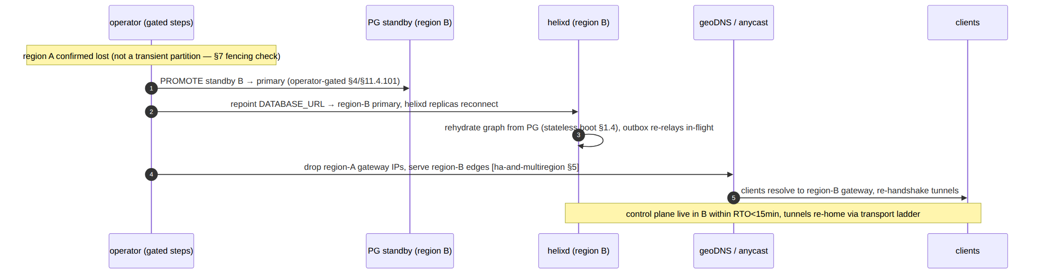
Step-by-step:
- Confirm region loss, not a partition. A transient partition must NOT trigger a promote (split-brain risk, [ha-and-multiregion §7]). The fencing/consensus check (§7) gates this — and per §4, the promote itself is operator-confirmed (irreversible + high-blast-radius).
- Promote the cross-region standby (region B) to primary. RPO = 0 if it was synchronous, ≤ async-lag otherwise [ha-and-multiregion §3, §1].
- Repoint DATABASE_URL to region B's primary; helixd replicas in B reconnect and rehydrate from the (now-promoted) truth [svc-coordinator §1.4]; the outbox drains any staged events [svc-events §7.4].
- Re-home gateway selection — drop region A's edge IPs from geoDNS / withdraw its anycast route [ha-and-multiregion §5]; clients resolve to region B and re-handshake (the re-handshake budget is the data-plane ladder's, NOT the < 1 s control SLO — [ha-and-multiregion §6]).
- Re-establish HA in the surviving region — bring up new standbys in region B (and a new region C if available) so the post-failover topology is not single-point-of-failure.
- Verify (§7) at every step; record evidence (§8).
Terraform's role ([03_ZAI]). The region's infra (gateway VPS, edges, PG nodes) is Terraform-provisioned [05 §2 deploy/terraform]; a region-failover may include terraform apply against the surviving/standby region to scale it up. The infra re-provision is Terraform; the data promote is the PG operator; the traffic re-home is geoDNS/anycast. Three distinct mechanisms, sequenced above.

7. Restore verification (the anti-bluff gate)
A restore is not done when pg_restore exits 0 — it is done when the restored truth is proven correct and serving (§11.4.108 runtime signature, §11.4.123 rock-solid proof). The gate, run before any promote:
# deploy/scripts/dr/verify-restore.sh (illustrative — the §9.2 step-5 post-op gate)
set -euo pipefail
PG="${RESTORED_PG_URL:?}"
# 1) schema + migration version present
psql "$PG" -tAc "SELECT max(version) FROM schema_migrations;" # matches expected (§9.2 step 3)
# 2) RLS intact (C8) — helix_app cannot cross tenants
psql "$PG" -tAc "SELECT relrowsecurity AND relforcerowsecurity FROM pg_class WHERE relname='devices';" # expect t
# 3) no-logging runtime signature (§11.4.108) — schemalint green against the RESTORED db
go run ./tools/schemalint --dsn "$PG" # exit 0 = C3 intact [svc-telemetry §7]
# 4) row-count sanity vs the recoverable-point manifest (no silent truncation)
psql "$PG" -tAc "SELECT count(*) FROM tenants;" # ≥ expected
psql "$PG" -tAc "SELECT count(*) FROM devices WHERE revoked_at IS NULL;"
# 5) live proof: point a throwaway helixd at the restored db, open a WatchNetworkMap, assert a
# sane snapshot (the device sees its authorized peers — C4) — booted via containers (§11.4.76)
deploy/scripts/dr/smoke-watch.sh --dsn "$PG" --expect-peers-for "$KNOWN_DEVICE"
Check | Proves
migration version | restored to the expected schema, no partial restore
RLS forced | C8 multi-tenant isolation survived the restore
schemalint green vs restored DB | no-logging C3 intact (a restore can't smuggle a traffic table)
row-count vs manifest | no silent data loss/truncation
live WatchNetworkMap snapshot | the restored truth actually serves a correct network map (the user-visible proof)
A restore that passes (1)–(4) but fails (5) is NOT recovered — the durable bytes are back but the system doesn't work; only the live snapshot proves end-to-end recovery (§11.4.108 RUNTIME → USER-VISIBLE layers).

8. DR drills & captured evidence
DR is unproven until rehearsed (§11.4.85 chaos / §11.4.123 rock-solid proof). The drills:
Drill | Procedure | Captured evidence (§11.4.5/§11.4.69)
PG restore drill | restore a base backup + WAL to a fresh cluster; run §7 gate; measure RTO | restore transcript + §7 gate output + measured RTO vs the 15-min target
PITR drill | restore to a target time before a known mutation; assert that mutation is absent | before/after row diff at the PITR boundary
Region-failover drill | tabletop → live: promote standby, repoint, re-home geoDNS; measure end-to-end RTO | the §6 sequence with timestamps; client re-handshake recording
"Redis is NOT restored" assertion | kill Redis, restore PG only, confirm presence/events rebuild without any Redis backup | rebuild trace [svc-events §7.4] — proves the §2 design
No-logging-survives-restore | restore PG, run schemalint against it | green lint = C3 intact; paired mutation planting a traffic table in the backup → restore gate FAILs
The drill IS the spec's proof. The RTO/RPO numbers in §1 are TARGETS (§11.4.6) until a drill measures them; a DR plan with no rehearsed restore is a §11.4 bluff (untested recovery is no recovery). Drills are scheduled (e.g. quarterly) and their evidence committed under docs/qa/<run-id>/dr/. The first drill's measured RTO replaces the target as the stated capability — never the design estimate (§11.4.6).

9. UNVERIFIED register
# | UNVERIFIED item | Why / status
U1 | The 15-min RTO target (§1) | [03_ZAI]'s figure; a TARGET until a §8 drill measures it — never asserted as achieved
U2 | Backup retention windows (30d base / 7d dump) (§3) | operator policy, illustrative defaults
U3 | KMS provider + key management exact shape (§3/§4) | [03_ZAI] says KMS-encrypted; the specific KMS (AWS/GCP/HSM) is operator-chosen
U4 | CA-root recovery mechanism (§2/§4) | doc 04 owns PKI; DR only states it is the unrecoverable-if-lost secret, KMS-encrypted, operator-gated
U5 | Cross-region async standby lag → backup-restore RPO (§1) | depends on link/topology; sync standby gives RPO=0, async ≤ measured lag
U6 | Terraform region-failover automation depth (§6) | [03_ZAI]/[05] reference Terraform for infra; the exact apply automation is fleet-specific

Sources verified
- 99-source-coverage-ledger.md G1 (the gap this document closes) + [03_ZAI] (KMS-encrypted automated backups, Terraform-driven region-failover, RTO < 15 min, GitOps — the DR source whose scattered pieces are consolidated here) — [ledger G1].
- 05-repo-layout-tooling-and-helix-ecosystem.md §2 (deploy/terraform, deploy/grafana), §6.3(B) (deploy regeneration via containers/helixvpnctl deploy), §7 (substrates) — [05].
- v03-control-plane/svc-coordinator.md §1.4 (boot rehydration from Postgres — why DR needs only PG), §3.2 (stateless reconnect) — [svc-coordinator].
- v03-control-plane/svc-events.md §5.2 (outbox), §7.4 (cold-boot rehydration / Redis-loss recoverability — the basis for "don't back up Redis") — [svc-events].
- v03-control-plane/svc-telemetry.md §0/§5 (ephemeral Redis presence operationalizes no-logging — why backing it up would CREATE a connection log), §7 (schemalint no-logging runtime signature used in the §7 restore gate) — [svc-telemetry].
- v06-deploy/ha-and-multiregion.md §1 (multi-region topology), §3 (Postgres HA / sync standby / RPO=0), §4 (NATS replicated not backed up), §5 (gateway re-home), §6 (failover convergence semantics), §7 (split-brain fencing — gating the §6 promote) — [ha-and-multiregion] (sibling).
- v06-deploy/kubernetes.md §2 (helix_app DSN + external secret store), §3 (CloudNativePG / Patroni HA + backup CRs) — [kubernetes] (sibling).
Constitution bindings applied: §11.4.44 (revision header), §11.4.6 (no-guessing — RTO/RPO stated as TARGETS, RTO-vs-RPO distinction made explicit, UNVERIFIED register §9), §9.2 (absolute data-safety DR discipline — §4 backup-first/verify/operator-gate), §11.4.10/.30 (KMS-encrypted, never-plaintext secrets), §11.4.101/.122 (CA-root + destructive-restore operator-gated, never autonomous), §11.4.108/.123 (restore verification = runtime signature + rock-solid proof, §7), §11.4.85 (DR drills = chaos rehearsal, §8), §11.4.83 (evidence under docs/qa/). Closes ledger gap G1.

