High availability & multi-region (Phase-2 scale-out)

High availability & multi-region (Phase-2 scale-out)
Revision: 2 Last modified: 2026-07-04T12:00:00Z Rev 2: Added §10 (Resource sizing & cost model — per-tier CPU/RAM/disk estimates from homelab to multi-region fleet); cross-referenced the new §7.5 rate-limiting/DDoS section in 05-repo-layout-tooling-and-helix-ecosystem.md.
Master technical specification — Volume 6 (Deployment, Tooling & Operations), nano-detail document ha-and-multiregion.md. Scope: how HelixVPN goes from the single-node Phase-1 deploy to a horizontally-scalable, multi-region, highly-available topology — and how the < 1 s convergence SLO survives a failover. It deepens the HA hooks already designed into the control plane: stateless coordinators [svc-coordinator §10], the bus-agnostic event seam [svc-events §10], Postgres-as-truth / Redis-as-ephemeral (C2). It is additive, not a rewrite — every Phase-2 mechanism plugs into a seam Phase-1 already drew. This is a SPEC (describe the implementation; do not build the product). Evidence cited inline: [05 §N] (05-repo-layout-tooling-and-helix-ecosystem.md), [svc-coordinator §N], [svc-events §N], [svc-telemetry §N], [kubernetes §N] (sibling), [research-podman_k8s]. The disaster- recovery runbook is its own sibling disaster-recovery.md (closes ledger gap G1); this document owns the steady-state HA topology and the failover convergence story. Unproven facts are marked UNVERIFIED per §11.4.6.

Table of contents
- 0. The HA thesis — stateless coordinators make it cheap
- 1. Reference multi-region topology
- 2. Stateless coordinators behind a load balancer
- 3. Postgres HA — Patroni / synchronous replication
- 4. Event bus HA — Redis replication → NATS JetStream
- 5. Gateway selection — anycast / geoDNS
- 6. Failover semantics — the convergence-during-failover story
- 7. Split-brain handling
- 8. SLOs under failover & anti-bluff evidence
- 9. UNVERIFIED register
- 10. Resource sizing & cost model
- Sources verified

0. The HA thesis — stateless coordinators make it cheap
HelixVPN's HA story is unusually cheap because of one architectural decision made in Phase 1: the coordinator is stateless on disk [svc-coordinator §0/§10(c)]. Its entire runtime state — the per-tenant topology graph + open WatchNetworkMap streams — is a projection of Postgres truth (C2) plus the live event stream, rebuilt from scratch on every boot [svc-coordinator §1.4].
Consequences that define this document:
- Coordinators are cattle. Any helixd replica can serve any agent's stream; killing one loses no state; scaling is a Deployment replicas bump + HPA [kubernetes §5].
- The hard state is exactly two stores. Postgres (truth — MUST be HA) and Redis/NATS (ephemeral — loss is recoverable, HA is a latency/availability nicety, not a correctness need, [svc-events §7.4]).
- Failover is a stream-reconnect, not a resync. An agent whose coordinator dies reconnects to another and resumes by known_version against the version-namespace that survives restarts (version namespace == policy-version namespace, [svc-coordinator §1.4/§3.2]).
So HA = (a) make Postgres HA, (b) front stateless coordinators with a load balancer, (c) pick a gateway-selection mechanism, (d) optionally make the bus HA. Each is below.

1. Reference multi-region topology
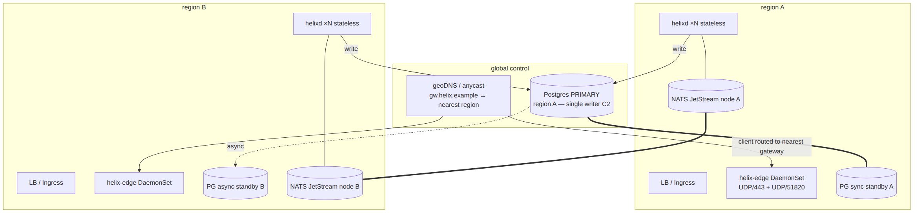
Design rules of the reference topology:
- Single Postgres writer (C2). There is exactly ONE primary at a time (region A here). All helixd replicas — in every region — write to it. Multi-master Postgres is NOT used (it breaks the single-truth invariant). Cross-region write latency is acceptable because control-plane writes are low-rate (enroll/revoke/policy-activate), not packet-path [svc-coordinator §0 C1].
- Regional read scale (Phase-2 optimization). Coordinator boot-hydration reads MAY come from a regional read-replica ([kubernetes §3], helix-pg-ro); UNVERIFIED whether the MVP routes hydration to replicas — Phase-1 reads the primary.
- Per-region edges. Each region runs its own helix-edge DaemonSet so a client connects to the nearest gateway; the coordinator's MapDelta carries the right GatewayInfo.endpoint per node [svc-coordinator §2.1].
- One logical event bus. Phase-2 NATS JetStream clusters across regions behind the same events.Bus interface (D3, §4).

2. Stateless coordinators behind a load balancer
The control-plane API (helixd:8443, Connect-RPC + REST) sits behind a regional L7 LB / Ingress. Because coordinators are stateless [svc-coordinator §10(c)]:
- No sticky sessions required. An agent's long-lived WatchNetworkMap stream is pinned to one pod for the life of the TCP/HTTP-2 connection (normal LB behaviour for a streaming RPC), but on reconnect it may land on any pod and resume by known_version [svc-coordinator §3.2].
- Each replica is a full consumer. Every helixd joins the event-bus consumer groups with a distinct consumer name (pod name = hostID, [svc-events §3.1]); work is partitioned across replicas by the bus (Redis Streams / NATS), not duplicated. The outbox relay uses FOR UPDATE SKIP LOCKED so every replica safely runs the relay loop [svc-events §5.2].
- Fan-out reaches the right replica. An event affecting device D is reacted by whichever replica owns D's open stream — but ALL replicas consume the same streams and recompute, and only the replica holding D's WatchNetworkMap subscription has a subRegistry entry to send to, so a replica with no affected streams simply produces a zero-send no-op [svc-coordinator §5].
UNVERIFIED — cross-replica fan-out. In the single-binary MVP, one coordinator owns every stream, so "the replica that consumed the event also holds the affected stream" is trivially true. In multi-replica Phase 2, an event consumed by replica X may affect a stream held by replica Y. The seam that makes this work is the shared bus: every replica consumes every stream and recomputes its own held streams [svc-coordinator §10(d)]. This is asserted as the design intent, not as validated behaviour — it is flagged for the Phase-2 multi-replica integration test (§8) and MUST NOT be claimed working until that test captures evidence.
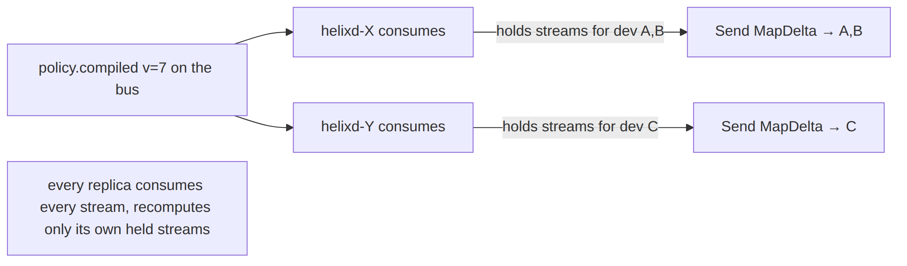

3. Postgres HA — Patroni / synchronous replication
Postgres is the only store whose HA is a correctness requirement (C2). The recommended posture (from [kubernetes §3] D-K8S-PG-HA option a, deepened here):
- Topology: 1 primary + ≥2 standbys. At least one standby is synchronous (synchronous_commit = remote_write or stricter) so an acknowledged control-plane write survives a primary loss with RPO = 0 for committed transactions; additional async standbys (possibly cross-region) serve read scale + DR [03_ZAI] (DR detail in disaster-recovery.md §3).
- Failover: Patroni / CloudNativePG promotes a healthy standby on primary failure, fences the old primary, and re-points the helix-pg-rw Service to the new primary [kubernetes §3].
- What helixd sees: during the promotion window, writes fail (the rw endpoint is briefly unavailable). This is fail-static-correct — existing tunnels keep forwarding (C1, the edge has the WG peers programmed; the Go control plane is not in the packet path), and /readyz goes NOT-READY so the LB stops sending new API traffic until the new primary is up [svc-telemetry §8.2].
- Recovery: when the new primary is rw, coordinators reconnect, the outbox relay drains any staged-but-unrelayed events, and the graph (already in RAM, never lost) keeps serving — only new mutations were paused, never the live topology [svc-events §7.4].
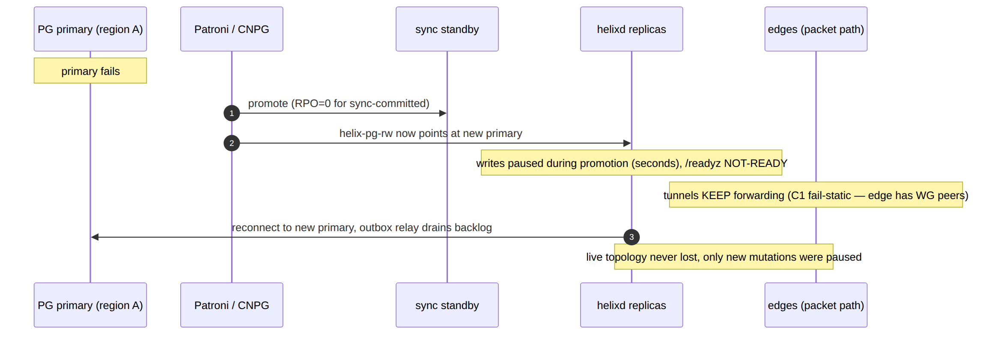
The HA payoff stated plainly: a Postgres failover pauses control operations (you can't enroll/revoke/activate-policy for a few seconds) but NEVER drops data-plane traffic, because the Go control plane is structurally out of the packet path (C1). This is the single most important HA property and it is free — it falls out of the Phase-1 control/data separation.

4. Event bus HA — Redis replication → NATS JetStream
The bus is ephemeral (C2): losing it loses no durable state [svc-events §7.4], so its HA is about availability + latency, not correctness. Two stages:
Phase-1 (Redis): a Redis replica (StatefulSet replicas or Redis Sentinel) reduces the recovery window, but even a total Redis loss is recoverable — the coordinator rehydrates from Postgres and the outbox re-relays [svc-events §7.4]. HA Redis is OPTIONAL in Phase 1.
Phase-2 (NATS JetStream): the D3 swap [svc-events §10]. NATS JetStream gives clustered, replicated, durable streams across regions behind the same events.Bus interface — "the consumer loop is bus-agnostic" [svc-coordinator §10(a)], so this is a transport change, not a rewrite. JetStream consumer groups map onto the same (stream, group, consumer=hostID) topology [svc-events §3.1].
// internal/events/natsbus.go — Phase-2 impl behind the SAME events.Bus interface (§2.1 [svc-events])
// NOTHING above this interface knows Redis vs NATS is live [svc-events §10].
type NatsBus struct {
js nats.JetStreamContext
hostID string
// Publish → js.Publish to the stream subject; Subscribe → durable pull consumer per group;
// Ack/Nack → msg.Ack()/msg.Nak(); XAUTOCLAIM reclaim → JetStream redelivery + MaxDeliver (DLQ).
}
UNVERIFIED — NATS JetStream multi-region replication factor. The exact JetStream cluster sizing (R3/R5, per-region placement, mirror vs cluster) is a Phase-2 capacity decision, not resolved here. What IS asserted: the Bus interface is the seam, the envelope/taxonomy are transport-neutral [svc-events §2.2], and the at-least-once + idempotent-reaction contract [svc-events §6.2] holds identically on JetStream (whose redelivery + MaxDeliver→DLQ map onto the Redis XAUTOCLAIM→DLQ machinery). The replication topology is flagged for Phase-2 design.

5. Gateway selection — anycast / geoDNS
A client must reach the nearest healthy gateway (edge). Two mechanisms, recommendation explicit (§11.4.66):
Decision D-GW-SELECT (options + recommendation). (a) geoDNS — gw.helix.example resolves to the nearest region's edge IP(s) by client geo; health-checked DNS removes a dead region from rotation. Simplest; DNS-TTL-bound failover. (b) Anycast — a single advertised IP announced (BGP) from every region's edge; routing delivers the client to the topologically-nearest PoP; a dead PoP withdraws the route. Fastest failover, requires BGP/anycast capability. (c) Client-side from the network map — GatewayInfo.endpoint in the MapDelta [svc-coordinator §2.1] carries a per-node gateway; the client could be handed a region-specific endpoint by the coordinator at enroll time. Recommended: (a) geoDNS for the Phase-2 MVP (no BGP dependency); (b) anycast for latency-critical fleets that have the network capability; (c) as a complement — the coordinator already knows each node's region, so it can bias GatewayInfo regardless of (a)/(b).
The coordinator's role is consistent across all three: it sets GatewayInfo.endpoint/MasqueSNI per node [svc-coordinator §1.2/§2.1], and on a regional gateway failover it emits gateway.failover {from,to} [svc-events §3.4], which recomputes every affected node's GatewayInfo and pushes a GatewayInfo-only delta [svc-coordinator §4.2].
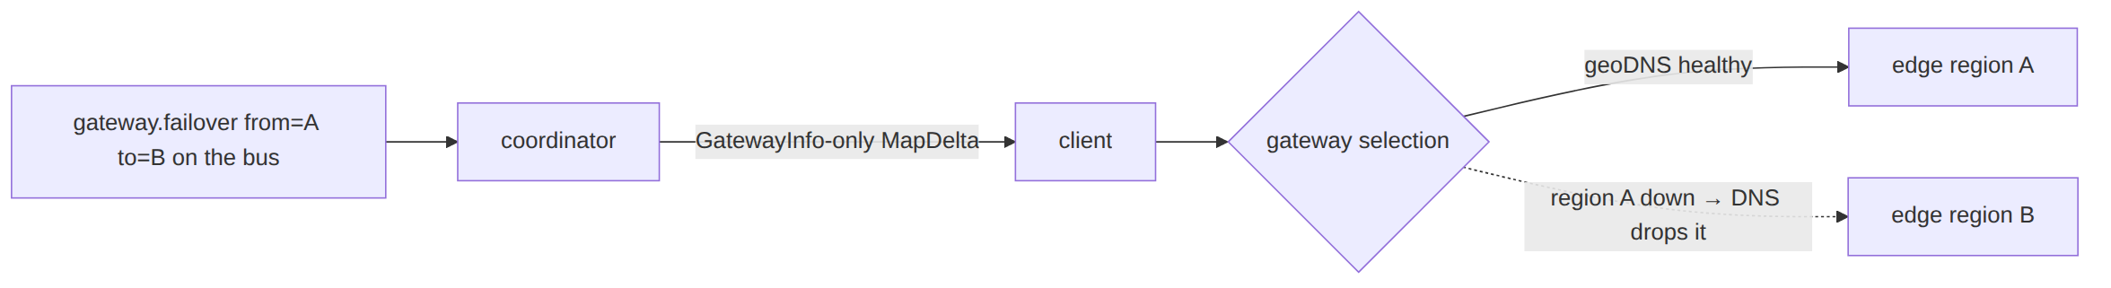

6. Failover semantics — the convergence-during-failover story
This is the heart of the document: what does the < 1 s convergence SLO mean while something is failing over? The answer differs by what fails, and each case is governed by an existing invariant — none is invented here.
Failure | Data-plane effect | Control-plane effect | Convergence semantics
One helixd replica dies | none (C1 — not in packet path) | agents on that pod's streams reconnect to another replica | resume by known_version; deltas, not full snapshot [svc-coordinator §3.2]; SLO clock restarts on reconnect, p99<1s for subsequent events
Postgres primary failover (§3) | none (tunnels keep forwarding) | writes paused seconds; /readyz NOT-READY | new mutations queue/fail-and-retry; the already-pushed topology is intact in every coordinator's RAM; convergence resumes once the new primary is rw
Redis/NATS blip (§4) | none | event delivery paused; presence goes stale | outbox stages writes durably (C2); on bus recovery the relay drains and convergence catches up [svc-events §7.4]; presence reaper reconciles [svc-telemetry §5.4]
Regional gateway (edge) loss (§5) | clients on that gateway drop; reconnect to next-nearest | coordinator emits gateway.failover; re-points GatewayInfo | clients re-handshake against the new gateway; the WG/MASQUE re-handshake is the client's reconnection state machine (data-plane spec), bounded by the transport ladder, NOT by the <1s control SLO
Whole region loss | clients fail over to surviving region's gateways | surviving-region coordinators keep serving from RAM + the (cross-region) primary or its promoted standby | combines the rows above; DR runbook in disaster-recovery.md §6
The crucial honesty (§11.4.6): the < 1 s SLO measures event-receive → MapDelta-on-wire at a healthy coordinator [svc-coordinator §7.1, svc-telemetry §6.1]. It is NOT a promise that a client mid-failover re-handshakes its tunnel in < 1 s — that is the data-plane reconnection ladder's budget, a different and larger number. Conflating the two would be a bluff. What the HA design DOES guarantee: a failover pauses convergence (briefly) and never corrupts it — when the failed component returns, the graph is rebuilt-or-intact and deltas resume; no node ever converges to a wrong map because of a failover (idempotent recompute-from-state, [svc-events §6.2]).
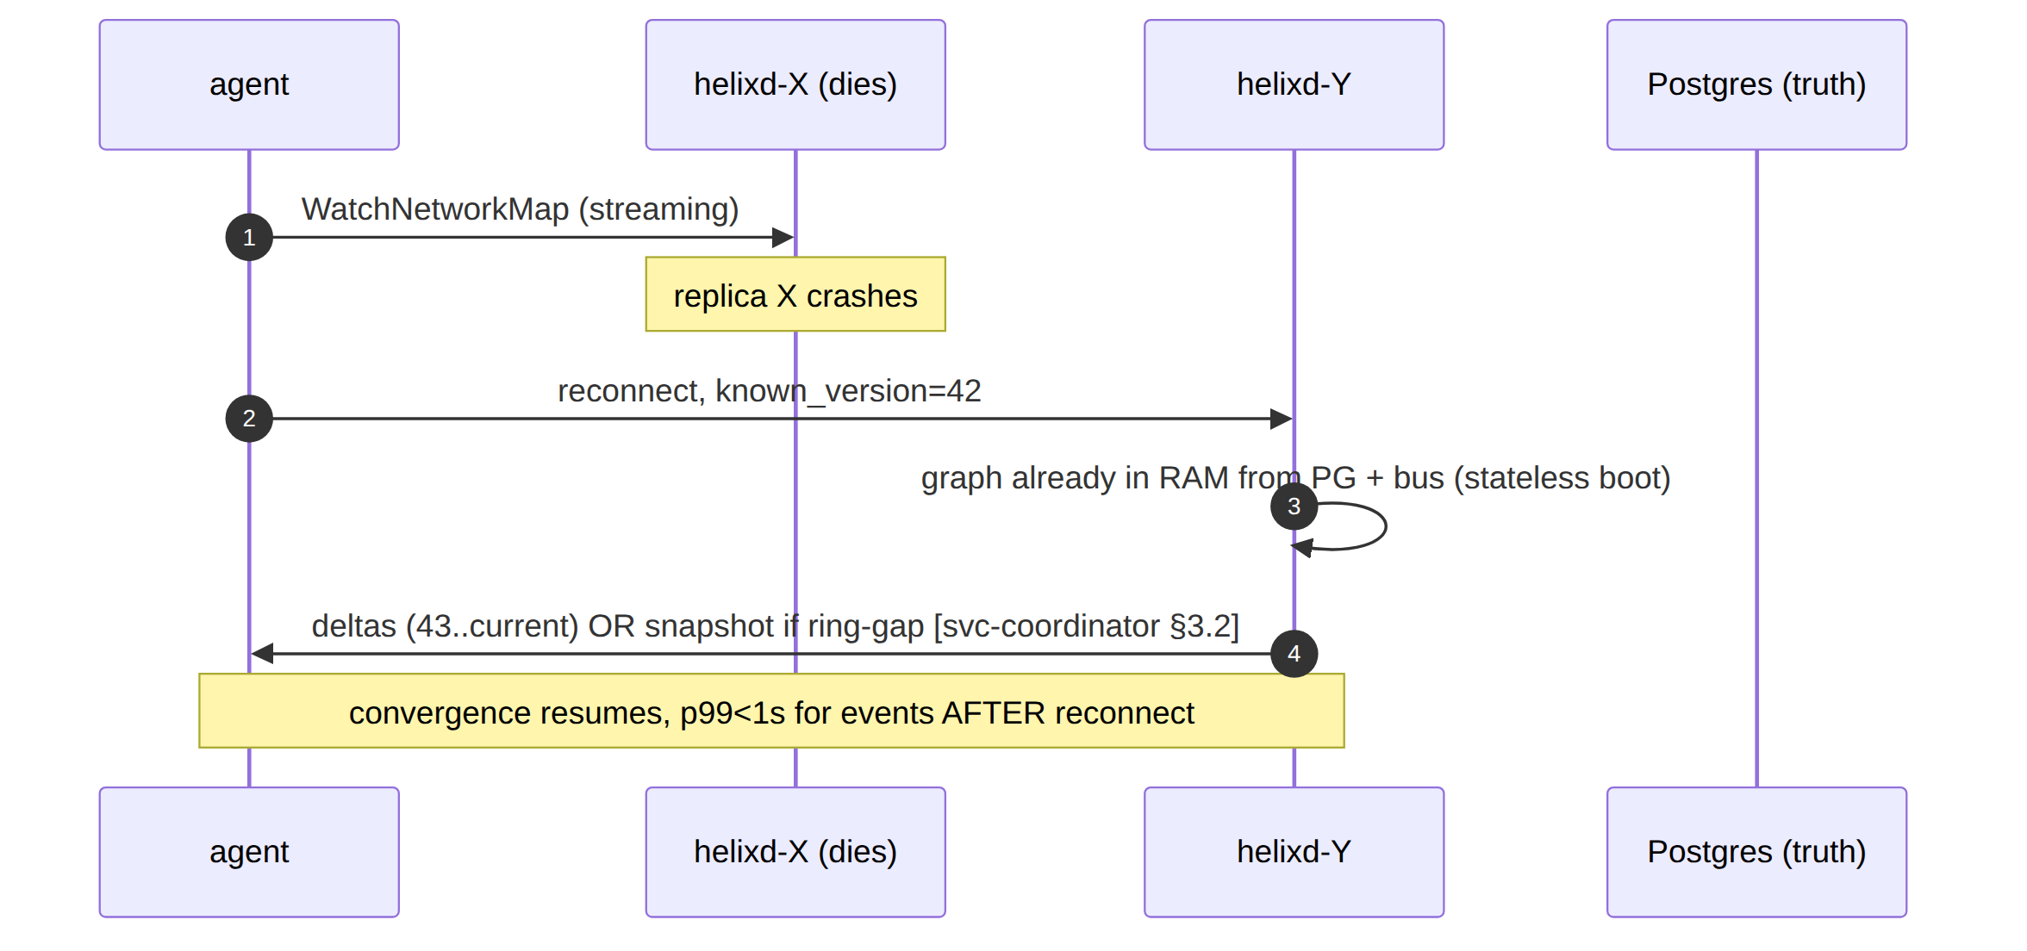

7. Split-brain handling
Split-brain is the classic HA hazard. HelixVPN's exposure is bounded by the single-writer invariant:
- Postgres split-brain (two primaries). Prevented by the HA operator's fencing: Patroni/CNPG uses a distributed-consensus lock (etcd/Kubernetes lease) so at most one node holds the leader key; a partitioned old primary is demoted/fenced before a standby is promoted [research-podman_k8s]. If fencing genuinely fails (UNVERIFIED edge case), the sync-standby's remote_write requirement means an un-fenced old primary cannot acknowledge writes the new primary doesn't have — the damage is bounded, not silent.
- Coordinator "split-brain" is a non-issue. Two helixd replicas serving the same tenant is the normal steady state, not a fault — they are stateless, both read the same Postgres truth, both consume the same bus, and both recompute idempotently [svc-events §6.2]. The presence layer is explicitly split-brain-safe: "two helixd … both write same key — idempotent (SET is last-writer-wins; SADD is a set) — harmless" [svc-telemetry §5.4].
- Bus split-brain (NATS partition). JetStream's RAFT-based clustering elects a single stream leader per partition; a minority partition cannot accept publishes (loses availability, not consistency). Outbox staging means a publish that can't land is retried, not lost [svc-events §5.2]. Exact behaviour is UNVERIFIED pending the Phase-2 NATS topology (§4).
The unifying principle: every stateful component has exactly one writer/leader at a time, chosen by a consensus lock; the stateless components are safe to run N-wide by construction. Split-brain is therefore a bounded-availability event, never a silent-corruption event.

8. SLOs under failover & anti-bluff evidence
SLO / claim | Target | Captured-evidence proof (§11.4.5/§11.4.69/§11.4.85)
helixd replica loss → agent resumes | deltas not snapshot; p99<1s post-reconnect | chaos test: kill a replica mid-stream, capture the reconnect known_version resume transcript [svc-coordinator §8.2-10]
PG primary failover → no tunnel drop | data plane unaffected (C1) | chaos test: trigger CNPG switchover under load; packet capture shows tunnels keep forwarding; /readyz flaps, /healthz stays green [svc-telemetry §8.2]
bus loss → no lost events | RPO=0 for committed mutations | chaos test: kill Redis/NATS mid-flight; assert outbox re-relays every staged event on recovery; before/after event-ID ledger [svc-events §7.4, §11.4.147]
multi-replica cross-stream fan-out (§2, UNVERIFIED) | event on X reaches stream on Y | Phase-2 integration test: 2 replicas, event consumed by X affects a stream held by Y → Y sends the delta; captured MapUpdate transcript
gateway failover → clients re-home | clients reach surviving gateway | chaos test: drop a region's edge; geoDNS health-check drops it; clients re-handshake on the next region's gateway; recorded handshake
split-brain presence safe (§7) | two helixd, same key, no corruption | unit/integration: concurrent MarkOnline from two writers → consistent presence set [svc-telemetry §5.4]
Integration infra (PG + Redis/NATS, multi-replica) booted on-demand via containers (§11.4.76), never ad-hoc. Chaos tests are mandatory per §11.4.85 (process-death, network-fault, state-corruption injection with categorised recovery). A "HA works" claim with no failover chaos evidence is a §11.4 bluff.

9. UNVERIFIED register
# | UNVERIFIED item | Why / status
U1 | Multi-replica cross-stream fan-out (§2) | trivially true single-binary; Phase-2 multi-replica behaviour is design-intent, flagged for the §8 test, NOT claimed working
U2 | Hydration reads routed to regional read-replicas (§1/§3) | Phase-2 optimization; Phase-1 reads the primary
U3 | NATS JetStream replication factor / multi-region placement (§4) | Phase-2 capacity decision; only the Bus-seam neutrality is asserted
U4 | geoDNS vs anycast final pick (§5) | D-GW-SELECT options; recommendation given, not validated against a real fleet
U5 | Postgres fencing under a genuine partition (§7) | bounded by sync-standby remote_write; exact operator fencing behaviour is operator-specific
U6 | Whether the <1s SLO and the client re-handshake budget are ever conflated in tooling (§6) | the doc asserts they are distinct; a test must prove the tooling reports them separately

10. Resource sizing & cost model (TARGET estimates, §11.4.6)
Gap closed (this revision). No document in the corpus previously stated a concrete CPU/RAM/disk sizing envelope per deployment tier — a real operator (the primary buyer, the homelab/small-MSP self-hoster, spine §2) needs a starting point to provision, and an enterprise evaluator needs a cost-scaling story. The table below is an engineering estimate (TARGET) consistent with the chosen stack (Go control plane, Rust edge, Postgres, Redis) — it is explicitly NOT a measured benchmark until a capacity drill produces one (same discipline as the RTO/RPO targets in disaster-recovery.md §1).
Tier | Devices (approx) | helixd (control) | helix-edge (data) | Postgres | Redis | Disk | Notes
Homelab / single VPS | ≤ 50 | 0.25 vCPU / 128 MiB | 0.5 vCPU / 128 MiB | 0.5 vCPU / 256 MiB, 5 GiB disk | 0.1 vCPU / 32 MiB | 10 GiB | Fits a $5–10/mo VPS; one pod, quadlet substrate (§7.4)
Small MSP / multi-tenant homelab | ≤ 500 | 0.5 vCPU / 256 MiB | 1 vCPU / 256 MiB | 1 vCPU / 1 GiB, 20 GiB disk | 0.25 vCPU / 128 MiB | 30 GiB | Still single-node quadlet; watch helix_open_watch_streams (observability.md §2.2) as the load signal
Regional gateway (Phase-2 K8s, single region) | ≤ 5,000 | 2× (0.25 vCPU / 256 MiB) replicas + HPA to 10 (kubernetes.md §5) | 1–2 vCPU / 512 MiB per DaemonSet node | CNPG 3-instance: 2 vCPU / 2 GiB primary, 20 GiB disk per instance | 1 vCPU / 512 MiB (or NATS JetStream equivalent, §4) | 60 GiB (PG) + 10 GiB (bus) | The helixd resource limits in kubernetes.md §5 (cpu:2, memory:1Gi per replica) are the individual-pod ceiling; this row is the aggregate fleet footprint
Multi-region fleet | ≤ 50,000 (10 regions × 5,000) | per-region as above, × N regions | per-region as above, × N regions | 1 global primary (largest region) + ≥1 sync + N async standbys (§3) | 1 JetStream cluster (R3) per region-group (§4) | scales linearly with tenant/device count | Cross-region write latency is acceptable (§1 — control writes are low-rate); dominant cost driver is standby-replica count, not helixd CPU
Basis for the estimates (§11.4.6 — stated, not hidden). helixd is stateless and does no per-packet work (C1) — its footprint scales with open WatchNetworkMap streams and event throughput, not device count directly (svc-coordinator §7.3's 24h-soak assumes RSS slope ≈ 0 at a given stream count, not that RSS is independent of it). helix-edge's footprint scales with concurrent active tunnels + transport-ladder overhead (MASQUE/QUIC costs more per-conn than plain UDP, 01-data-plane.md). Postgres sizing follows the DDL row-count growth (data-model-ddl.md) — dominated by devices/policy_rules/audit_events, all small rows; 20 GiB comfortably covers tens of thousands of rows with headroom. These multipliers are estimates, not measurements — the anti-bluff discipline applied elsewhere in this corpus (RTO/RPO targets, SLO thresholds) applies here too: the first capacity/load drill (§11.4.85 stress test at the target device count) replaces the estimate with a measured number, and the measured number is what future sizing guidance cites — never the design estimate.

10.1 Cost-tier framing (self-host vs managed, non-marketing)
The cost story is deliberately not a marketing tier list — it is the same engineering estimate translated into off-the-shelf cloud pricing shapes so an operator can budget:
Tier | Representative monthly infra cost (2026 pricing, illustrative) | What drives the cost
Homelab | $0 (existing hardware) or ~$5–10/mo (smallest cloud VPS) | one always-on small VM/VPS
Small MSP | ~$20–40/mo (1–2 vCPU / 2–4 GiB VPS) | still one node; disk grows with audit-event retention (audit-and-compliance.md)
Regional K8s | ~$150–400/mo (managed K8s control plane + 3-node worker pool + managed-or-CNPG Postgres) | Postgres HA (3 instances) is the largest single line item, not helixd/edge compute
Multi-region fleet | scales ~linearly per added region (regional cost × N) + cross-region egress | egress + standby-replica storage dominate at this tier, not CPU
UNVERIFIED — exact dollar figures. The representative costs are illustrative, tied to generic 2026 cloud list pricing, not a specific provider quote; an operator's actual bill depends on their chosen provider, region, and reserved-vs-on-demand pricing. This table exists to give a shape (what dominates cost at each tier), not a quote.

Sources verified
- 05-repo-layout-tooling-and-helix-ecosystem.md §7.3 (K8s edge/coordinator/PG shapes the HA topology refines), §7.4 (multi-region-fleet → K8s recommendation), §12 (decision discipline) — [05].
- v03-control-plane/svc-coordinator.md §0 (C1/C2/C5 + stateless-on-disk), §1.4 (boot hydration, version-namespace survives restart), §2.1 (GatewayInfo/relayEndpoint), §3.2 (known_version resume), §4.2 (gateway.failover reaction), §5 (fan-out), §7.1 (the SLO measurement point), §8.2-10 (coordinator-restart-mid-stream edge case), §10 (Phase-2 stateless/bus-agnostic seams) — [svc-coordinator].
- v03-control-plane/svc-events.md §2.2 (transport-neutral envelope), §3.1 (consumer-group partitioning per replica), §5.2 (SKIP LOCKED relay safe on every replica), §6.2 (idempotent recompute-from-state), §7.4 (cold-boot rehydration / Redis-loss correctness), §10 (NATS JetStream swap behind Bus) — [svc-events].
- v03-control-plane/svc-telemetry.md §5.4 (presence split-brain safety, drift reconciliation), §6.1 (convergence measured at a healthy coordinator), §8.2 (liveness/readiness fail-static semantics) — [svc-telemetry].
- v06-deploy/kubernetes.md §3 (D-K8S-PG-HA / CloudNativePG), §5 (stateless Deployment + HPA), §6 (edge DaemonSet) — [kubernetes] (sibling).
- 99-source-coverage-ledger.md G1 + [03_ZAI] (KMS backups, RTO, Terraform DR — the multi-region resilience framing this document operationalizes; DR runbook lives in disaster-recovery.md).
- [research-podman_k8s] — Patroni/CNPG failover + consensus-lock fencing, NATS JetStream clustering, UDP gateway ingress per region; cross-referenced against latest official docs per §11.4.99.
Constitution bindings applied: §11.4.44 (revision header), §11.4.6 (no-guessing — the <1s-SLO vs re-handshake-budget distinction made explicit, UNVERIFIED register in §9), §11.4.66 (D-GW-SELECT, D-K8S-PG-HA referenced as options+recommendation), §11.4.85 (failover chaos evidence mandatory in §8), §11.4.147 (no-work-loss outbox re-relay), §11.4.76 (containers submodule for HA integration infra).

