Podman Quadlets (rootless — the canonical substrate)

Podman Quadlets (rootless — the canonical substrate)
Revision: 3 Last modified: 2026-07-04T12:00:00Z Rev 3: Added §4.1 (rate-limiting/DDoS cross-reference for the rootless single-node case — the transient-ban nftables rule from 05-repo-layout-tooling-and-helix-ecosystem.md §7.5 reuses this document's edge NET_ADMIN capability, no new capability required).
Master technical specification — Volume 6 (Deployment, Tooling & Operations), nano-detail document. [RES] research-backed. Scope: the canonical rootless Podman quadlet deployment of HelixVPN — .pod/.container/.network/.volume systemd-generator units, rootless-MANDATORY (§11.4.161 — NO sudo, NO rootful Docker), the NET_ADMIN/NET_RAW capability set for the data- plane edge, :443/udp MASQUE ingress, the one-pod model, read-only rootfs + seccomp confinement, and the vasic-digital/containers submodule as the sole orchestration layer (§11.4.76). This deepens [05-overview §7.1] with the FACT-grade quadlet semantics from [research-podman_k8s]. It is a SPEC: unit files are illustrative of the contract, not the shipping deployment (2–3 refinement passes follow).
Evidence cited inline by id: [05_OV §N] = 05-repo-layout-tooling-and-helix-ecosystem.md; [RPK §N] = v09-research/research-podman_k8s.md (verified against latest Podman docs 2026-06-25 per §11.4.99); [API §N] = v03-control-plane/svc-api.md (the env/readyz contract). Unproven facts are marked UNVERIFIED per §11.4.6 — never fabricated.

0. What this document owns (and does not)
This document owns the rootless quadlet substrate: the search-path/lifecycle rules, the pod + per-container unit files (edge, control, postgres, redis), the capability/security posture, the :443/udp rootless-bind requirement, the network/volume quadlets, the on-demand-infra invariant, and the rootless-networking caveats that bite a VPN edge.
It does not own: the helixvpnctl deploy quadlet render command (that is helixvpnctl.md); the equivalent Compose stack (docker-compose.md); the K8s manifests (kubernetes.md); the env-contract / readyz semantics (canonical in [API §4.7]); the edge data-plane internals (Volume 2). Quadlets are canonical (§11.4.76/.161); Compose and K8s are equivalents generated from the same OCI images [05_OV §7].

1. Why rootless quadlets are canonical (§11.4.161)
Podman in rootless mode is the MANDATORY container runtime for ALL HelixVPN containerized workloads (§11.4.161): Docker in rootful mode, sudo, or any escalation to root for container management is FORBIDDEN unless the target platform has no rootless option AND that constraint is documented per §11.4.112. The vasic-digital/containers submodule is the sole orchestration layer (§11.4.76) — no ad-hoc docker/podman commands outside its pkg/boot/pkg/compose/ pkg/health primitives [05_OV §7.1]. Rootless quadlets fit the primary buyer (homelab / single VPS, spine §2): no Docker daemon, no root, helixvpnctl init one-shot, systemctl --user start lifecycle.
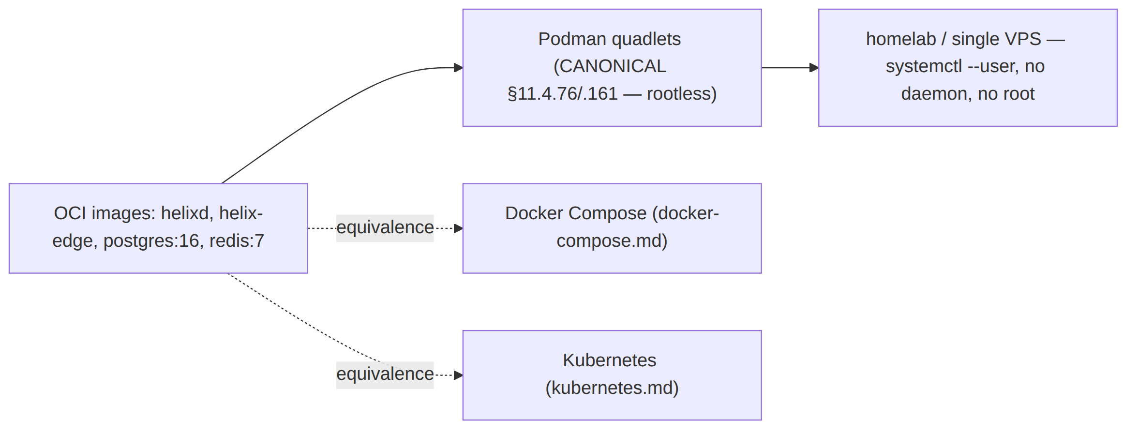

2. Quadlet fundamentals (Podman 5.x, FACT-grade)
Quadlet is a core part of Podman (not a separate project); Podman 5.x added podman quadlet list|print|install|rm and the .pod/.build/.image/.artifact unit types beyond the original .container/.network/.volume/.kube. Quadlet .unit files are read by a systemd generator that emits real .service units at boot / daemon-reload [RPK §1].

2.1 Rootless = file location, NOT User= (the hard constraint)
FACT [RPK §1]. "Quadlet units do not support running as a non-root user by defining the User, Group, or DynamicUser systemd options." Rootless is selected purely by where the file lives. The rootless search paths (verbatim upstream):
- $XDG_RUNTIME_DIR/containers/systemd/
- $XDG_CONFIG_HOME/containers/systemd/ (i.e. ~/.config/containers/systemd/)
- /etc/containers/systemd/users/${UID} and /etc/containers/systemd/users/
- /usr/share/containers/systemd/users/${UID} and /usr/share/containers/systemd/users/
To run rootless with boot-time start (no interactive login), loginctl enable-linger <user> is required [RPK §1]. HelixVPN places its units in ~/.config/containers/systemd/ and enables linger for the gateway service user.
Reconciliation with the overview (§11.4.35). [05_OV §7.1] sketched the units under /etc/containers/systemd/ — that is the rootful system path. Because §11.4.161 mandates rootless, the canonical HelixVPN path is the rootless ~/.config/containers/systemd/ (or /etc/containers/systemd/users/${UID} for a system-managed service user). This is a visible correction, recorded so the two docs do not silently disagree; the unit contents are unchanged.

2.2 Lifecycle
# place units in ~/.config/containers/systemd/, then:
systemctl --user daemon-reload
systemctl --user start helixvpn-pod.service # the .pod generates *-pod.service
loginctl enable-linger "$USER" # boot-start without interactive login (FACT [RPK §1])
The generator guarantees the *-pod.service starts before any member Pod=helixvpn.pod container [RPK §1]; quadlet auto-wires the ordering — no hand-written After=/Requires= between pod and members.

3. The one-pod model (edge + control + postgres + redis)
Containers in a pod share the network namespace, so ports are published at the pod, not the member container, and members reach each other on 127.0.0.1 [RPK §1]. HelixVPN groups the four services into one pod for single-node self-host [05_OV §7.1, 04_P1 §9.2].
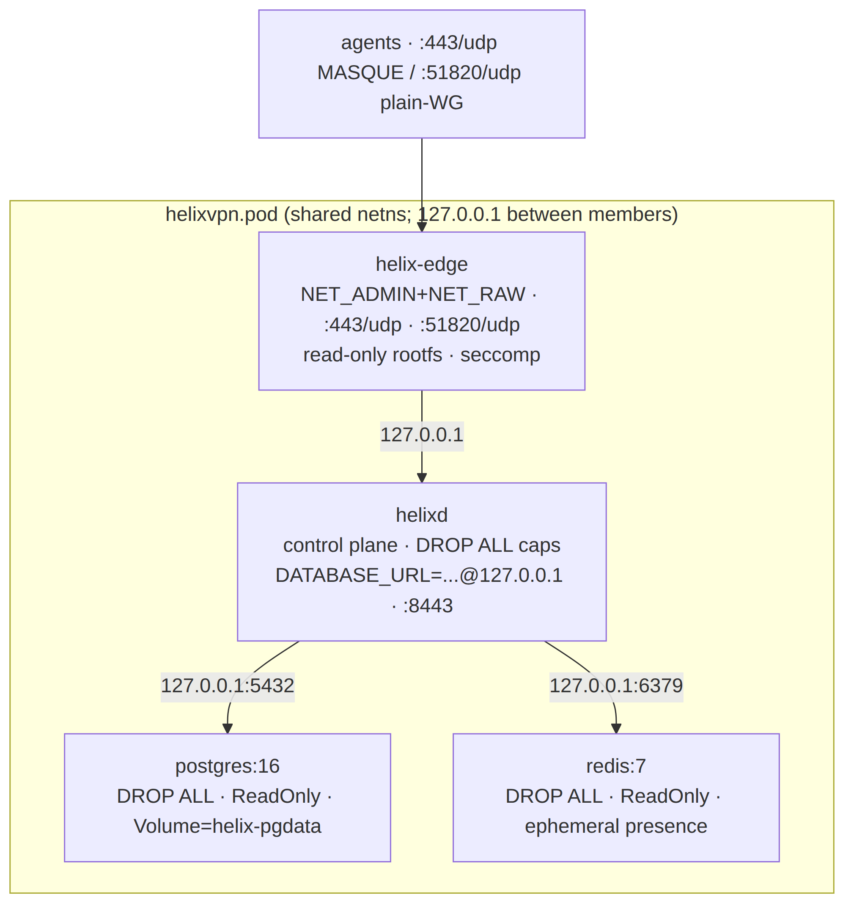

3.1 helixvpn.pod
# ~/.config/containers/systemd/helixvpn.pod
[Pod]
PodName=helixvpn
PublishPort=443:443/udp # MASQUE/QUIC ingress (Volume 2 transport ladder)
PublishPort=51820:51820/udp # plain-WG ingress (auto-ladder base)
[Install]
WantedBy=default.target

3.2 helix-edge.container — the data plane (the ONLY privileged-ish member)
# ~/.config/containers/systemd/helix-edge.container — DATA PLANE
[Unit]
Description=HelixVPN data-plane edge
[Container]
Image=ghcr.io/helixdevelopment/helix-edge:helix_vpn-1.0 # §11.4.151 prefixed tag
Pod=helixvpn.pod
DropCapability=ALL
AddCapability=NET_ADMIN NET_RAW # NET_RAW required for WG/tunnels (FACT [RPK §2]) — NOT just NET_ADMIN
AddDevice=/dev/net/tun:/dev/net/tun # for userspace WG (boringtun) fallback path (FACT [RPK §2])
ReadOnly=true # read-only rootfs
ReadOnlyTmpfs=true # rw tmpfs on /dev /dev/shm /run /tmp /var/tmp (default true when ReadOnly)
SeccompProfile=/etc/containers/seccomp/helix-edge.json
Notify=true # sd_notify readiness passthrough
# no SSH, no shell in this image
[Service]
Restart=always
[Install]
WantedBy=default.target
FACT [RPK §2] — NET_ADMIN alone is insufficient. WireGuard/tunnels need NET_RAW too ("which Docker enables by default but Podman does not" for rootless), the host WG kernel module loaded outside the container (a container cannot modprobe rootlessly; kernels ≥ 5.6 ship it built-in), and /dev/net/tun for the userspace path. The unit above adds all three; the kernel module is a host prerequisite documented in the operator guide.
Reconciled (§11.4.35, 2026-06-26): the canonical edge capability set across all four Volume-6 substrate docs (this doc, docker-compose.md, kubernetes.md) and the security privesc scan is {NET_ADMIN, NET_RAW} + the /dev/net/tun device — no more, no less. This is the FACT the cited research points to (§11.4.6): [research-podman_k8s §2] confirms (3 sources) that the kernel-mode WireGuard fast path — the edge's primary data path — needs both NET_ADMIN and NET_RAW ("WireGuard needs NET_RAW … which Docker enables by default but Podman does not"); /dev/net/tun is added for the userspace boringtun fallback (module-less nodes). The earlier "ONLY NET_ADMIN" reading in the K8s/overview/security drafts was the under-specified side and has been corrected to this set everywhere; the privesc scan asserts no caps beyond this canonical set.
Note — build-org ≠ source-org. Container images are published under ghcr.io/helixdevelopment/* (the GHCR build/registry org) while the source submodules live under vasic-digital/* (the GitHub source org). This is intentional, not an inconsistency: the registry namespace and the source namespace differ. The same ghcr.io/helixdevelopment/* image coordinates are used by every Volume-6 substrate (quadlets, Compose, K8s).

3.3 helixd.container — the control plane (drops all caps)
# ~/.config/containers/systemd/helixd.container — CONTROL PLANE
[Container]
Image=ghcr.io/helixdevelopment/helixd:helix_vpn-1.0
Pod=helixvpn.pod
DropCapability=ALL # control plane needs no extra caps
ReadOnly=true
ReadOnlyTmpfs=true
NoNewPrivileges=true
Environment=DATABASE_URL=postgres://helix_app@127.0.0.1/helix # non-superuser → RLS enforced [API §6.5]
Environment=REDIS_URL=redis://127.0.0.1:6379
Secret=helix_db_pw,type=env,target=PGPASSWORD # podman secret, NEVER in unit text (§11.4.10)
HealthCmd=/helixd healthz # → GET /readyz semantics [API §4.7]
[Service]
Restart=always
[Install]
WantedBy=default.target
The helix_app (non-superuser) DATABASE_URL is load-bearing: it makes Postgres Row-Level Security the floor even if RBAC is mis-wired (C8 [API §6.5]). The DB password is a podman secret injected as an env target, never written into the unit text (§11.4.10).

3.4 helix-pg.container + helix-redis.container
# ~/.config/containers/systemd/helix-pg.container
[Container]
Image=docker.io/library/postgres:16
Pod=helixvpn.pod
DropCapability=ALL
Volume=helix-pgdata.volume:/var/lib/postgresql/data:Z # SELinux relabel; data persists
Environment=POSTGRES_USER=helix_owner POSTGRES_DB=helix # owner role; helixd uses helix_app (§3.3)
Secret=helix_db_pw,type=env,target=POSTGRES_PASSWORD
[Install]
WantedBy=default.target
# ~/.config/containers/systemd/helix-redis.container
[Container]
Image=docker.io/library/redis:7
Pod=helixvpn.pod
DropCapability=ALL
ReadOnly=true
ReadOnlyTmpfs=true
# presence/events are EPHEMERAL (C2: losing Redis loses presence, not identity) — no durable volume
[Install]
WantedBy=default.target
Postgres is not read-only-rootfs in practice (it writes its socket/lock state); it uses DropCapability=ALL + a named volume for PGDATA. Redis is read-only-rootfs because its state is ephemeral (presence TTL keys), so no durable volume is mounted [API §4.2 — Online from Redis].

3.5 helix.network + helix-pgdata.volume
# ~/.config/containers/systemd/helix.network (optional explicit network; the pod also supplies one)
[Network]
NetworkName=helixvpn
# pasta is the Podman 5.x rootless default backend (NAT-free, faster — FACT [RPK §3])
# ~/.config/containers/systemd/helix-pgdata.volume
[Volume]
VolumeName=helix-pgdata
A pod already supplies a shared network namespace, so an explicit .network is optional for the single-pod model; it is included for operators who want a named bridge. The volume quadlet creates the named helix-pgdata referenced by helix-pg.container (§3.4) with an auto-generated dependency [RPK §1].

4. Rootless networking caveats (the load-bearing section for a VPN)
These are the FACT-grade caveats that bite a rootless VPN edge [RPK §3] — each is documented in the operator guide so a fresh init does not hit "connected but nothing loads":
Caveat | FACT | HelixVPN handling
:443 rootless bind | Rootless cannot bind ports < 1024 by default (net.ipv4.ip_unprivileged_port_start=1024) [RPK §3]. | Lower the sysctl: net.ipv4.ip_unprivileged_port_start=443, persisted in /etc/sysctl.d/99-helixvpn-ports.conf. init prints this as a host prerequisite.
pasta backend | Podman 5.x rootless default backend is pasta (NAT-free, faster than slirp4netns); RHEL ≥ 9.5 defaults to it [RPK §3]. | Verify via podman info → host.networkBackend. UNVERIFIED regression: a pasta throughput regression is reported in Podman 5.8 [RPK §3, podman#28219] — the operator guide says benchmark your build, never assume.
No auto firewall/NAT | "Modifying the firewall requires root … rootless Podman does not install iptables rules" [RPK §3]. | A VPN edge that NATs client egress provides host-side forwarding OR runs the masquerade inside the edge's own netns with NET_ADMIN; documented as a host prerequisite.
MTU pitfall | Tunnels frequently break on MTU ("connected but nothing loads") [RPK §3]. | The edge sets the WG/quic MTU (Volume 2 routing-and-addressing.md); the operator guide lists the MTU knob.
Outbound interface pin | slirp4netns offers --outbound-addr to pin the egress interface [RPK §3]. | When the gateway must egress a specific uplink, the operator pins it; UNVERIFIED whether pasta exposes an equivalent on the target build.
# host prerequisite printed by `helixvpnctl init` (rootless :443):
echo 'net.ipv4.ip_unprivileged_port_start=443' | sudo tee /etc/sysctl.d/99-helixvpn-ports.conf
sudo sysctl --system
# (sudo here is a HOST sysctl change, not container management — §11.4.161 forbids rootful CONTAINER ops, not host config)
§11.4.161 boundary (§11.4.6 honesty). Lowering the host sysctl and loading the WG kernel module are host configuration the operator does once, NOT rootful container management. §11.4.161 forbids rootful/sudo container runtime operations; it does not forbid the operator from configuring their own host kernel. The distinction is documented so the rootless mandate is not misread as "the host needs no privileged setup".

4.1 Rate limiting & DDoS (cross-reference)
The edge's transient-ban mechanism for handshake-flood mitigation (§7.5 of 05-repo-layout-tooling-and-helix-ecosystem.md, added this revision) installs short-TTL nftables/eBPF DROP rules for an offending source IP — this is the same verdict-map mechanism the policy compiler already programs into the edge (01-data-plane.md), and it requires no capability beyond the NET_ADMIN/NET_RAW set already granted in §3.2 above. No quadlet change is needed to support it; it is a data-plane software behavior inside the already-privileged edge container, not a new host-facing surface.

5. The on-demand-infra invariant (§11.4.76)
Operators (and tests) are never required to podman machine / systemctl start infra by hand for integration tests — the test entry point boots infra on demand via the containers submodule [05_OV §6.3, §11.4.76(3)]:
// helix-go/internal/store/integration_test.go (illustrative — FACT-grade pattern [05_OV §6.3])
import (
"digital.vasic.containers/pkg/boot"
"digital.vasic.containers/pkg/health"
)
func TestWatchNetworkMapDeltaStream(t *testing.T) {
ctx := context.Background()
infra := boot.Compose(ctx, boot.Spec{ // rootless Podman (§11.4.161)
Services: []boot.Service{
{Name: "pg", Image: "docker.io/library/postgres:16", Port: 5432},
{Name: "redis", Image: "docker.io/library/redis:7", Port: 6379},
},
})
t.Cleanup(func() { infra.Down(ctx) }) // §11.4.14 quiescent teardown
health.WaitReady(ctx, infra, 30*time.Second) // real readiness probe, NOT a sleep
// ... drive enroll → advertise → policy → assert MapDelta
}
This is anti-bluff-critical (§11.4.76(5)): an integration test claiming to exercise the streamed WatchNetworkMap MUST actually boot Postgres+Redis via the submodule — a short-circuit fake that skips boot is a §11.4 violation. The production quadlets and the test infra both go through the containers submodule; no ad-hoc podman run exists in the codebase.

6. helixvpnctl deploy quadlet render (the source of these units)
helixvpnctl deploy quadlet --out ~/.config/containers/systemd/ renders the §3 units from one in-code spec via the containers submodule's pkg/compose primitives (§11.4.81 cross-platform- parity: one source, per-substrate render) [05_OV §6.3, helixvpnctl §10]. The render is parameterized by the init inputs (domain → masque_sni, data-dir → volume host path, image tags → the helix_vpn-<version> release prefix [§11.4.151]). The three substrates (quadlet / compose / kube) derive from the same spec, so a change to the pod shape lands in all three, not three hand-maintained files.

7. Security posture summary
Control | Mechanism | FACT source
Least privilege | DropCapability=ALL on every member; AddCapability=NET_ADMIN NET_RAW ONLY on the edge | [RPK §1/§2]
Read-only rootfs | ReadOnly=true + ReadOnlyTmpfs=true (rw tmpfs on /dev /run /tmp) on edge/control/redis | [RPK §1]
Seccomp | SeccompProfile=/etc/containers/seccomp/helix-edge.json (custom, tighter than default) | [RPK §1]
No privilege escalation | NoNewPrivileges=true on control | [RPK §1]
Secrets | podman Secret= injected as env target; never in unit text | §11.4.10
Rootless | file-location-selected; no User=, no daemon, no sudo for container ops | §11.4.161, [RPK §1]
No shell/SSH in images | edge/control images carry no shell — reduces attack surface | [05_OV §7.1]
SELinux relabel | :Z on the pgdata volume mount | [RPK §1]

8. Test points (§11.4.169 comprehensive test-type coverage)
Every PASS cites captured evidence (§11.4.5/.69/.107); infra is the containers submodule (§11.4.76), rootless Podman (§11.4.161), never ad-hoc podman run.
# | Test type (§11.4.169) | Target | Concrete assertion + evidence
Q1 | unit | render determinism | deploy quadlet twice → byte-identical units; image tag carries helix_vpn- prefix
Q2 | integration | rootless one-pod boot | place units in ~/.config/containers/systemd/, systemctl --user start helixvpn-pod, all 4 members UP; status GREEN
Q3 | integration | :443/udp reachable rootless | with the sysctl set, an agent completes MASQUE handshake to :443/udp; captured
Q4 | security | capability set (§3.2) | podman inspect shows edge has ONLY NET_ADMIN+NET_RAW; control/pg/redis have none; mutation adding a cap → FAIL
Q5 | security | read-only rootfs | a write to the edge rootfs is denied (EROFS); rw tmpfs on /run works
Q6 | security | secret not in unit text | grep the rendered units → no PGPASSWORD value; only Secret= references
Q7 | integration | on-demand-infra invariant (§5) | go test boots infra via boot.Compose; mutation removing boot.Compose → test FAILs (proves it was not a fake)
Q8 | chaos | member restart | kill helix-pg, assert Restart=always recovers + control reconnects; presence (redis) loss degrades gracefully (C2)
Q9 | e2e | three-substrate parity | quadlet + compose + kube boot the same image; helixvpnctl status GREEN on each (recorded per §11.4.159)
Q10 | meta-test (§1.1) | gates paired | add a cap / inline a secret / skip read-only → each makes its gate FAIL

9. Decision callouts (options + recommendation — §11.4.66/.101)
id | Decision | Options | Recommendation
D-SUBSTRATE-DEFAULT | init default substrate | quadlet / compose / k8s | quadlet (§11.4.76/.161 canonical) — flag overrides
D-ROOTLESS-443 | rootless :443 bind | (a) lower ip_unprivileged_port_start; (b) root-side proxy/authbind | (a) the clean path for :443/udp [RPK §3]; documented host prerequisite
D-WG-PATH | edge WG path | (a) kernel WG (NET_ADMIN+NET_RAW + host module); (b) userspace boringtun (+ /dev/net/tun) | (a) primary, (b) fallback where the host module is unavailable (Volume 2)

Sources verified
- v09-research/research-podman_k8s.md §1 (quadlet fundamentals, rootless search paths, User= hard constraint, [Container]/[Pod] directives, example skeleton), §2 (NET_ADMIN insufficient — also NET_RAW + host WG module + /dev/net/tun), §3 (rootless networking caveats: pasta default
  - 5.8 regression, no auto firewall/NAT, MTU, rootless :443 sysctl), §7 (FACT-grade carry-into- spec list) — verified against latest Podman docs 2026-06-25 per §11.4.99 — [RPK].
- 05-repo-layout-tooling-and-helix-ecosystem.md §7.1 (canonical quadlets, the pod/edge/control/pg unit sketches), §6.3 (containers submodule on-demand-infra + deploy render), §7.4 (substrate recommendation) — [05_OV].
- v03-control-plane/svc-api.md §4.7 (/readyz semantics for HealthCmd), §6.5 (helix_app non-superuser → RLS), §4.2 (Redis presence ephemeral, C2) — [API].
- Constitution anchors: §11.4.161 (rootless container runtime mandate — Podman rootless, no sudo/ rootful), §11.4.76 (containers submodule sole orchestration + on-demand-infra invariant), §11.4.10 (secrets as podman Secret, never in unit text), §11.4.81 (one-source three-substrate render), §11.4.112 (honest documented gap if a platform has no rootless option), §11.4.35 (visible reconciliation — rootless path vs the overview's /etc path), §11.4.6 (no-guessing — UNVERIFIED pasta-regression/outbound-pin marks), §11.4.169 (test-type coverage), §1.1 (paired meta-test mutations).

