Repo Layout & Decoupling

Repo Layout & Decoupling
Revision: 2 Last modified: 2026-07-04T12:00:00Z Rev 2: Reviewed against the Volume-6 enterprise-hardening pass (2026-07-04); repo topology, extraction sequencing, and decoupling invariants already comprehensive. No gap found in scope. Revision bumped for the pass.
Master technical specification — Volume 6 (Deployment, Tooling & Operations), nano-detail document. Scope: the physical repository layout of HelixVPN — the Phase-0/1 working monorepo helixvpn/, the planned vasic-digital/* decoupled reusable-component repos, the extraction sequencing, the decoupling invariants (§11.4.28), snake_case naming (§11.4.29), catalogue-first reuse (§11.4.74), the dependency-from-root layout (§11.4.28C), and the overview-level wiring points for the already-incorporated submodules/ members (helix_design/containers/helix_qa/challenges/docs_chain). This deepens [05-overview §1/§2/§3/§6] into an implementation-ready repo spec. It is a SPEC: trees, manifests, and procedures are illustrative of the contract, not the shipping code (2–3 refinement passes follow). Detailed ecosystem wiring lives in helix-ecosystem-integration.md; this doc gives the seam, not the depth.
Evidence cited inline by id: [05_OV §N] = 05-repo-layout-tooling-and-helix-ecosystem.md; [04_ARCH §N] = 04_VPN_CLD/HelixVPN-Architecture-Refined.md §11 (repo layout); [04_P1] = HelixVPN-Phase1-MVP.md §2 (repo skeleton); [04_P0] = HelixVPN-Phase0-Spike.md (surviving Transport trait + FFI seams); [SYNTHESIS §N] = v09-research/_SYNTHESIS.md §6 (reuse pillars). Unproven facts are marked UNVERIFIED per §11.4.6 — never fabricated.

0. What this document owns (and does not)
This document owns the repository topology decisions: the monorepo-now / extract-later strategy, the file-by-file monorepo tree, the six decoupled-repo public-contract definitions, the extraction order + procedure, the per-repo scaffold checklist, the helix-deps.yaml dependency manifests, the release-prefix application to every repo, and the overview-level map of which submodules/ member binds where.
It does not own: the codegen pipeline internals (that is codegen-pipeline.md); the helixvpnctl command spec (that is helixvpnctl.md); the deploy substrates (podman-quadlets.md, docker-compose.md, kubernetes.md); the depth of each submodule's integration (helix-ecosystem-integration.md); the design-system repo's internals (Volume 10, vasic-digital/helix_design). Those are referenced, never redefined.

1. The monorepo-now / extract-later strategy

1.1 The tension and its resolution
The constitution wants decoupled, reusable, project-not-aware components, each in its own repo (§11.4.28/.74). The MVP wants velocity and atomic cross-cutting changes — one PR that touches .proto + Go + Rust + Dart in lock-step. These pull in opposite directions only when treated as simultaneous obligations; they are not. The binding resolution [05_OV §1.1]:
Phase 0 → Phase 1: one working monorepo helixvpn/ whose internal workspace boundaries are already the future repo boundaries. Phase-1 exit gate: extract the stabilized pillars into standalone vasic-digital repos and re-consume them as flat submodules. Nothing is extracted before its public surface stops churning (§11.4.124 — don't split before the seams are known).
This applies, at the repository level, the same discipline the control plane applies at the package level — "one Go binary, many packages; package boundaries == future service boundaries" [04_ARCH §4.1]. It honors §11.4.28 (the boundaries exist from day one, merely co-located) without paying the multi-repo coordination tax during the highest-churn phase.
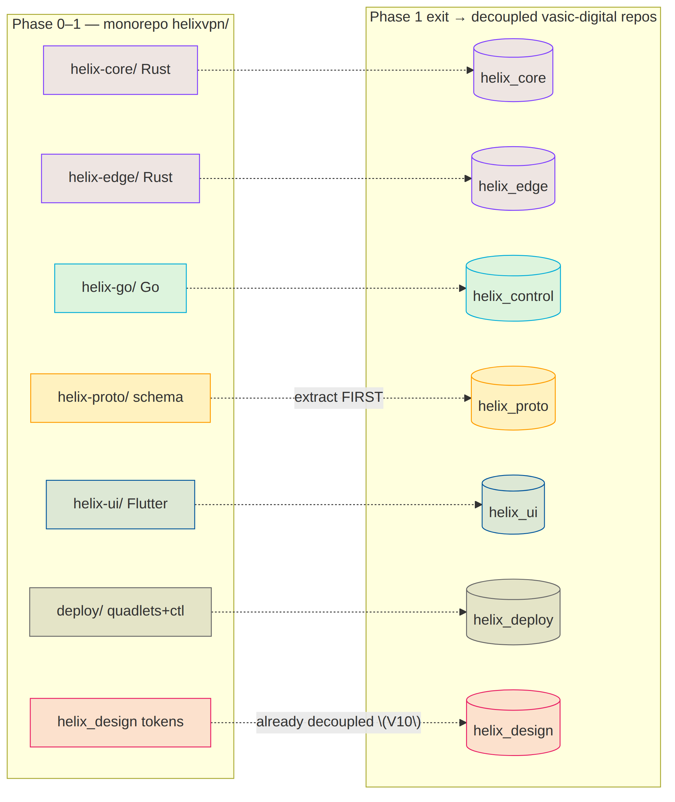
helix_design is the exception (Volume 10, operator mandate 2026-06-25, §11.4.162): the design system is a decoupled vasic-digital/helix_design submodule from day one, not an extract-later pillar, because it is mandated reusable by any future app and its token contract is independent of HelixVPN code churn. The other six follow the extract-later path.

1.2 Extraction order (most-stable-first)
Order | Monorepo dir | Extracted repo (vasic-digital) | Trigger to extract
1 | helix-proto/ | helix_proto | First frozen WatchNetworkMap version [04_P1 §3] — the schema is the contract; it must stop drifting before generated clients can stabilize.
2 | helix-core/ | helix_core | iOS memory gate G3 passes and the helix-ffi C-ABI/UniFFI surface freezes [04_P0].
3 | helix-edge/ | helix_edge | Immediately after helix_core (it path-depends on helix-transport).
4 | helix-ui/ | helix_ui | Riverpod-over-status-stream contract + runHelixApp flavors stable by MVP DoD [04_UI].
5 | helix-go/ | helix_control | Largest churn surface (policy compiler, coordinator) — extract last among code.
6 | deploy/ | helix_deploy | Image names + the env contract freeze (so the quadlet/compose/k8s generators reference stable names).
Each extraction is a visible commit citing §11.4.35 ("Lifted from helixvpn monorepo to vasic-digital/helix_proto per §11.4.28"), preserves history via git filter-repo --path helix-proto/, and immediately re-consumes the new repo as a flat submodule (§4) [05_OV §1.2].

2. Monorepo layout (helixvpn/) — file-by-file
Directory and file names are lowercase snake_case where they are ours to name (§11.4.29); language-mandated layouts (Rust crates/, Dart lib/, Cargo/Go file conventions) follow their ecosystem (the §11.4.29 technology-exception) [05_OV §2].
helixvpn/ # umbrella working repo (this repository's product code)
├── Cargo.toml # Rust workspace root — members: helix-core/crates/*, helix-edge
├── go.work # Go workspace — uses ./helix-go (+ extracted submodules later)
├── melos.yaml # Dart/Flutter monorepo manager (helix-ui packages)
├── buf.yaml buf.gen.yaml buf.lock # schema-first codegen config (codegen-pipeline.md)
├── Makefile # local task runner (gen/build/test/deploy) — NO CI (§11.4.156)
├── .gitignore # build artifacts, .env, *.db-wal/-shm (§11.4.30)
├── .env.example # HELIX_RELEASE_PREFIX, infra creds template (§11.4.77/.151)
├── helix-deps.yaml # submodule dependency manifest (§11.4.31)
│
├── helix-proto/ # ── reuse pillar 1: the contract ──
│ ├── proto/helix/v1/ # coordinator.proto, enrollment.proto, types.proto
│ ├── openapi/helix-rest.v1.yaml # Console/Access/Connector REST surface
│ └── gen/ # GENERATED (gitignored) → go/ dart/ rust/ ts/ (codegen-pipeline.md)
│
├── helix-core/ # ── reuse pillar 2a: Rust client+connector core ──
│ ├── Cargo.toml
│ └── crates/ # helix-transport, helix-wg, helix-reconcile,
│ # helix-netshield, helix-ffi
│
├── helix-edge/ # ── reuse pillar 2b: Rust gateway data-plane edge ──
│ ├── Cargo.toml # path-dep on helix-core/crates/helix-transport (D5)
│ └── src/ # quinn+h3 MASQUE termination + kernel-WG fast path
│
├── helix-go/ # ── the Go control plane (modular monolith) ──
│ ├── go.mod # module helixvpn/helix-go
│ ├── cmd/helixd/ # control-plane binary (all packages wired)
│ ├── cmd/helixvpnctl/ # operator CLI (Cobra) — helixvpnctl.md
│ └── internal/ # identity registry ipam pki policy coordinator events telemetry api store
│
├── helix-ui/ # ── reuse pillar 3: Flutter ──
│ └── packages/ # helix_design(consumes V10), helix_core_ffi, helix_api_client,
│ # app_access, app_connector, app_console
│
├── shims/ # per-platform TunnelPlatform providers (ONLY platform code)
│ ├── apple/ android/ windows/ linux/ # Phase 0–2
│ └── harmonyos/ aurora/ # Phase 3
│
├── deploy/ # ── deployment substrate (→ helix_deploy) ──
│ ├── quadlets/ # *.pod *.container *.network *.volume (CANONICAL, §11.4.76)
│ ├── compose/docker-compose.yaml # Docker-operator equivalence (docker-compose.md)
│ ├── k8s/ # plain manifests + kustomize (kubernetes.md)
│ ├── terraform/ # gateway VPS provisioning
│ └── grafana/ # dashboards-as-code (counters only)
│
├── submodules/ # already-incorporated Helix ecosystem (§5)
│ ├── helix_design/ containers/ docs_chain/ helix_qa/ challenges/ security/
│ ├── vision_engine/ panoptic/ doc_processor/
│ └── llm_orchestrator/ llm_provider/ llms_verifier/ (dev-loop only — §5.2)
└── constitution/ # HelixConstitution submodule (canonical root, §11.4.35)

2.1 Workspace manifests (the boundary-as-config seams)
Three workspace managers keep the internal boundaries crisp so extraction is a git filter-repo
- re-consume, never a refactor [05_OV §2.1]:
- Cargo.toml (Rust) — one resolver, one shared lockfile, path deps so helix-edge reuses the helix-transport crate byte-for-byte (the D5 "shares helix-transport" property [SYNTHESIS §3]). The workspace members ARE the future helix_core crate set + helix_edge.
- go.work (Go) — keeps helixd + helixvpnctl in one module pre-extraction; post- extraction the containers/challenges submodules join via replace directives during dev + pinned SHAs in release (§11.4.76 consumption rule).
- melos.yaml (Dart/Flutter) — governs the helix-ui package tree; runHelixApp(flavor,…) produces all three apps from packages/app_* [04_UI]. The Console is the only Web build and omits helix_core_ffi.
A Cargo member, a Go package, or a Melos package is a future-repo boundary expressed today as a workspace entry — this is the mechanical form of "the seams exist from day one".

3. The decoupled reusable-component repos (the §11.4.28/.29/.74 target)

3.1 The seven repos and their public contracts
Six are created after the spec stabilizes (per §1.2 order); helix_design exists from day one (Volume 10). Each is its own GitHub and GitLab repo (§2.1 multi-mirror), snake_case (§11.4.29), flat under the consumer (no nested own-org .gitmodules chains — §11.4.28C), with an upstreams/ recipe dir + install_upstreams run on clone (§11.4.36) [05_OV §3.1].
Repo | Language | Public surface (the ONLY thing consumers depend on) | Consumed by
helix_proto | proto + OpenAPI | proto/helix/v1/*.proto, openapi/helix-rest.v1.yaml; ships generated Go/Dart/Rust/TS as release artifacts | core, edge, control, ui
helix_core | Rust | Transport trait, helix-wg API, helix-ffi C-ABI/UniFFI surface | edge, Access/Connector apps, shims
helix_edge | Rust | gateway data-plane binary + EdgeConfig (no lib API beyond config) | deploy
helix_control | Go | helixd binary + REST/proto contracts (the internal packages stay private) | deploy, helixvpnctl
helix_ui | Dart/Flutter | helix_design consumption + runHelixApp() entry + Riverpod status-stream contract | the 3 apps
helix_deploy | Go+YAML+HCL | helixvpnctl binary + quadlet/compose/k8s generators | operators
helix_design | tokens + per-platform theme packages | OpenDesign-emitted token bundles (JSON/CSS/Dart/Swift/Kotlin/ArkTS/C-Qt) + component specs (Volume 10, §11.4.162) | helix_ui + any future app

3.2 Decoupling invariant (§11.4.28B) — the load-bearing rule
None of these may hardcode HelixVPN-specific hostnames, asset names, tenant assumptions, or brand strings. helix_core is a generic WG-over-pluggable-transport engine; helix_proto is a generic overlay-coordination schema; helix_design is OpenDesign tokens with brand values injected, not baked. Project specifics enter ONLY via config injection — env var, config struct, constructor parameter — never a hardcoded reach back into HelixVPN [05_OV §3.1].
The gate CM-OWNED-SUBMODULE-DECOUPLING (§11.4.28) greps each submodule diff for parent-project context; a hostname/asset/tenant literal inside a submodule fails it. UNVERIFIED: the exact deny-list of "parent context" tokens is set per-repo at extraction time, not fixed here.

3.3 Per-repo scaffold checklist (applied to all seven)
<repo>/
├── README.md CLAUDE.md AGENTS.md GEMINI.md QWEN.md # inherit constitution (§11.4.35/.157)
├── constitution/ # HelixConstitution submodule (canonical root)
├── upstreams/{github.sh,gitlab.sh} # remote recipes for install_upstreams (§11.4.36)
├── helix-deps.yaml # own-org Git SSH deps (§11.4.31)
├── .gitignore .env.example # §11.4.30/.77
├── docs/ # Status.md + Status_Summary.md + guides (§11.4.45/.56)
│ └── .docs_chain/contexts/<repo>.yaml # docs_chain export + DB sync (§11.4.106)
└── (language tree)

3.4 helix-deps.yaml — the dependency manifest (§11.4.31)
helix_edge is the only code repo with an own-org build-time dependency, so its manifest is the worked example [05_OV §3.2]:
# helix_edge/helix-deps.yaml
schema_version: 1
deps:
- name: helix_core
ssh_url: git@github.com:vasic-digital/helix_core.git
ref: main
why: "helix-edge reuses the helix-transport crate byte-for-byte (D5)"
layout: flat
transitive_handling:
recursive: true
conflict_resolution: operator-required
language_specific_subtree: false
helix_ui's manifest declares helix_design the same way; helix_control's declares containers + challenges. The manifest is what lets a fresh consumer reconstruct the dependency graph at its own root (§11.4.31) without nested own-org chains.

4. Dependency-from-root layout (§11.4.28C) — no nested own-org chains
Every dependency consumed by an owned submodule MUST be reachable from the parent project's root, NOT nested inside the submodule [05_OV §3, §11.4.28C]:
helixvpn/ # parent root
├── submodules/helix_core/ # dependency at the root
├── submodules/helix_edge/ # consumer — reaches helix_core via go.work/Cargo path, NOT a nested submodule
└── submodules/helix_control/ # consumer — reaches containers/challenges via the root, not nested
Forbidden: helix_edge/.gitmodules pulling in helix_core as a nested own-org submodule. Required: helix_core sits at helixvpn/submodules/helix_core, and helix_edge reaches it via the workspace path dep (Cargo) / the documented import resolver — a flat graph the CM-OWNED-SUBMODULE-LAYOUT gate audits (§11.4.28). Third-party submodules (the §11.4.74 no-match → vendor path) are exempt from the flat-only rule because we do not author them.
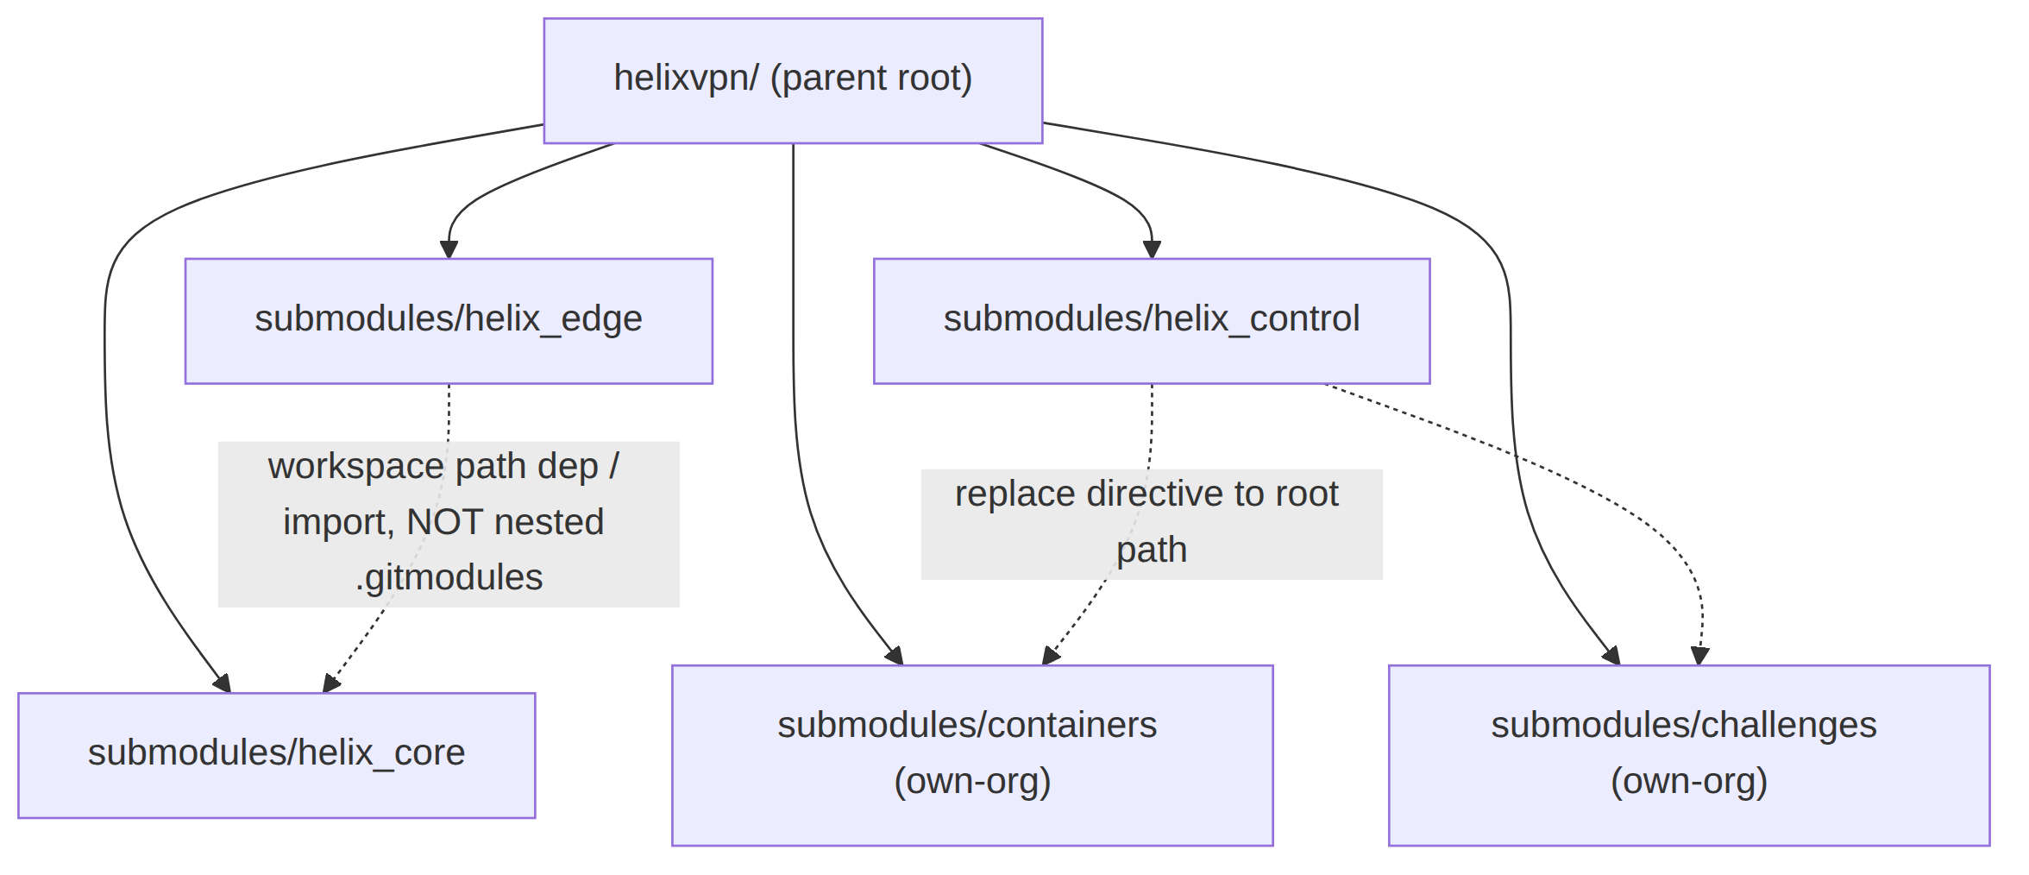

5. Catalogue-first reuse + ecosystem submodule map (overview-level)

5.1 Catalogue-first discipline (§11.4.74)
Before scaffolding ANY new module/helper/utility, the contributor MUST survey the vasic-digital + HelixDevelopment orgs (the canonical inventory is submodules-catalogue.md) and reuse when an existing submodule covers ≥80% of the need, extend upstream when 80%+ matches but features are missing, and record Catalogue-Check: reuse|extend|no-match <org/repo>@<sha> on the relevant tracker row [05_OV §6, §11.4.74]. Concrete applications already made for HelixVPN: containerization → extend vasic-digital/containers (§11.4.76); doc-sync → reuse vasic-digital/docs_chain (§11.4.106); QA → reuse HelixDevelopment/helix_qa (§11.4.27); design system → extend OpenDesign via vasic-digital/helix_design (§11.4.162).

5.2 Ecosystem submodule role map (the seam — depth in the sibling doc)
The 16 source docs predate the submodules/ incorporation, so the spec MUST wire each in or mark it not-applicable with a reason (§11.4.6, no silent drop) [05_OV §6.1]. This is the overview-level binding; the full integration depth (boot/health APIs, on-demand-infra invariant, docs_chain context schema, vision/QA harness wiring) lives in helix-ecosystem-integration.md.
Submodule | HelixVPN role | Binding § | Phase
helix_design | Mandatory OpenDesign design system for all 3 apps × 8 platforms; decoupled reusable submodule (Volume 10) | §11.4.162 | 1+
containers | Sole container-orchestration layer: helixvpnctl deploy boot/health/compose primitives + on-demand integration-test infra | §11.4.76/.161 | 0–1
challenges | Challenge engine under the anti-bluff acceptance Challenges (MVP DoD as executable Challenges) | §11.4.27/.5/.69 | 1
helix_qa | Anti-bluff QA orchestrator: drives the 8 MVP-DoD criteria with captured evidence | §11.4.27/.107/.158 | 1
docs_chain | Mechanical sync of this spec set (final/*.md → HTML/PDF/DOCX) + workable-items SQLite DB ↔ docs | §11.4.106/.65/.93 | 0+
security | Control-plane defensive libs (log PII redaction, security headers, at-rest secrets, SSRF-deny, edge privesc scan) | §11.4 (V5) | 1
vision_engine | Video/screenshot evidence analysis for Flutter UI Challenges | §11.4.107/.158/.159 | 1–2
panoptic | UI automation + screenshot/video capture harness feeding vision_engine | §11.4.107/.154 | 1–2
doc_processor | Feature-map extraction → the per-feature Status ledger coverage cross-check | §11.4.153 | 1
llm_provider | Provider abstraction iff Phase-2 ships LLM-assisted policy authoring; NOT in the packet/control path | §11.4.74 | 2 (opt)
llm_orchestrator | Headless CLI-agent orchestration for the development loop; not a product runtime dependency | §11.4.70 | dev-only
llms_verifier | Verifies any dev-loop LLM ("do you see my code?"); NOT a HelixVPN runtime component | §11.4.78 | dev-only
Honest classification (§11.4.6, no silent drop): llm_orchestrator / llms_verifier are dev-loop only — HelixVPN ships no LLM in its data or control path; they support the autonomous build/QA loop and are correctly present as submodules (the project uses them to build itself) but are not linked into helixd/helix-edge. llm_provider is conditional (binds only if Phase-2 ships LLM-assisted policy authoring — Decision D-LLM-POLICY). Marking these runtime-N/A is the honest classification, never an omission.

6. Repo creation procedure (operator-gated, §11.4.66/.101)
Decision D-REPO-CREATE (operator-gated). Remote repo creation (gh repo create / glab repo create on vasic-digital) is high-blast-radius and cannot be done autonomously (§11.4.101 block-only rule). The extraction PR is prepared autonomously (filtered history, scaffold, submodule pointer staged); the actual repo-create + first push is surfaced to the operator with the exact gh/glab commands [05_OV §3.3]. Recommended: create all six extract-later repos in one batch at the Phase-1 exit gate so the release tags share the helix_vpn- prefix across every repo in one release (§11.4.151).
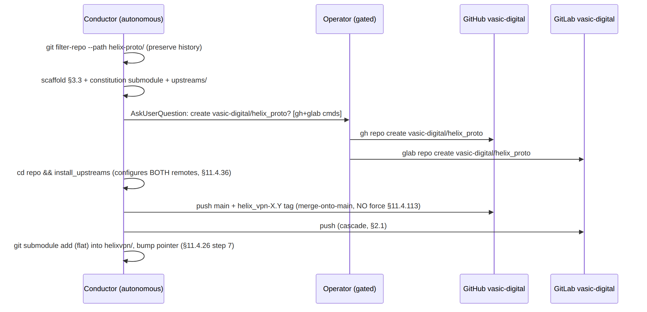
Each push is a fast-forward merge-onto-latest-main (§11.4.113 — no force-push anywhere), fanned out to every upstream (§2.1). After the push lands, install_upstreams is verified by git remote -v | grep -c push reporting the expected remote count (§11.4.36).

7. Release prefixing across every repo (§11.4.151)
Every release tag/version on the monorepo and every extracted reusable repo MUST carry the <PREFIX>- prefix, resolved deterministically as (1) HELIX_RELEASE_PREFIX from .env (authoritative; documented in the tracked .env.example), else (2) the lowercased snake_case root dir name = helix_vpn [05_OV §9, §11.4.151]. One release tags all repos with the same prefix in one batch (§6 recommendation) so a single greppable query enumerates the whole release surface across GitHub + GitLab:
git tag -l 'helix_vpn-*' # enumerates the whole release across every repo
OCI images are tagged <PREFIX>-<version> to match. Version codes increment monotonically within the prefix, never reset, never skipped (§11.4.151).

8. Mapping to workable items (§11.4.93)
This document's deliverables become rows in the git-tracked SQLite SSoT (docs/.workable_items.db, §11.4.95). Representative seed items [05_OV §10]:
ATM-id (illustrative) | Item | Type | Phase | Dep
HVPN-050 | Stand up helixvpn/ monorepo workspaces (Cargo / go.work / melos / buf) | Task | 0 | —
HVPN-056 | Extract 6 reusable repos to vasic-digital (operator-gated, §6) | Task | 1-exit | all code repos
HVPN-057 | helix_design decoupled submodule scaffold + consumption recipe (Volume 10) | Task | 1 | HVPN-050
HVPN-058 | helix-deps.yaml manifests + CM-OWNED-SUBMODULE-LAYOUT flat-graph audit | Task | 1 | HVPN-056
HVPN-059 | Decoupling-invariant gate (CM-OWNED-SUBMODULE-DECOUPLING) per extracted repo | Task | 1 | HVPN-056
Each carries status/type/id on all surfaces (§11.4.148) and a comprehensive description (§11.4.148-D2).

9. Anti-bluff evidence plan (§11.4.5/.69/.107)
Claim | Captured-evidence proof (Phase)
Extraction preserves history (§1.2) | git log --follow on a sample file in the extracted repo shows pre-extraction commits; transcript under docs/qa/<run-id>/
No nested own-org submodule chains (§4) | CM-OWNED-SUBMODULE-LAYOUT audit of the extracted repos GREEN; mutation adding a nested .gitmodules own-org entry → FAIL
Decoupling holds (§3.2) | CM-OWNED-SUBMODULE-DECOUPLING GREEN; mutation injecting a HelixVPN hostname into helix_core → FAIL
Flat dependency-from-root (§4) | each consumer reaches its dep via root path; no submodule has an own-org .gitmodules entry
install_upstreams configured both mirrors (§6) | git remote -v | grep -c push == expected count post-clone; captured
Release prefix uniform (§7) | git tag -l 'helix_vpn-*' across every repo returns the same prefix; mutation creating an unprefixed tag → CM-RELEASE-PREFIX-NAMING FAIL

10. Decision callouts (options + recommendation — §11.4.66/.101)
id | Decision | Options | Recommendation
D-REPO-CREATE | When to extract reusable repos | (a) eager per-pillar; (b) one batch at Phase-1 exit | (b) — shared release prefix, stable seams (§1.2)
D-DESIGN-EXTRACT | When helix_design decouples | (a) extract-later like the six; (b) decoupled day-one | (b) — Volume 10 mandate (§11.4.162); independent of code churn
D-LLM-POLICY | Ship LLM-assisted policy authoring? | (a) yes (binds llm_provider); (b) no (stays dev-only) | Defer to Phase 2; default (b) until product-validated (§5.2)
These compose with the spine's decision register (D1–D8); none is resolved here without the operator where it is irreversible/high-blast-radius (§11.4.101).

Sources verified
- 05-repo-layout-tooling-and-helix-ecosystem.md §1 (monorepo-now/extract-later), §2 (file-by-file tree + workspace manifests), §3 (six decoupled repos + scaffold + deps manifest + creation procedure), §6 (ecosystem submodule role map + N/A justifications), §9 (release prefix), §10 (workable items), §12 (decision callouts) — [05_OV].
- 04_VPN_CLD/HelixVPN-Architecture-Refined.md §11 (repo layout), §4.1 (modular monolith / package-boundary discipline) — [04_ARCH].
- 04_VPN_CLD/HelixVPN-Phase1-MVP.md §2 (repo skeleton), HelixVPN-Phase0-Spike.md (surviving Transport trait + FFI extraction seams), HelixVPN-helix-ui-Flutter.md (runHelixApp flavors, Melos) — [04_P1] [04_P0] [04_UI].
- v09-research/_SYNTHESIS.md §3 (decisions/D5 helix-transport reuse), §6 (repo layout / reuse pillars), §8 (submodule wiring), §9 (constitution bindings) — [SYNTHESIS].
- MASTER_INDEX.md Volume 10 (helix_design decoupled submodule, §11.4.162) — [MASTER_INDEX].
- Constitution anchors: §11.4.28/.29/.31/.36/.74 (decoupled snake_case flat submodules + upstreams
  - deps manifest), §11.4.35 (visible reconciliation / canonical-root), §11.4.66/.101 (decision discipline / operator-gated repo create), §11.4.76/.161 (containers submodule sole orchestration
  - rootless), §11.4.93/.95 (workable items in git-tracked SQLite SSoT), §11.4.113 (no force-push), §11.4.151 (release prefix), §11.4.156 (no active CI), §11.4.162 (OpenDesign decoupled submodule), §11.4.6 (no-guessing — UNVERIFIED marks + N/A justifications), §11.4.5/.69/.107 (captured-evidence proofs in §9).

