Cross-Phase Dependency Graph — the HelixVPN delivery DAG and critical paths

Cross-Phase Dependency Graph — the HelixVPN delivery DAG and critical paths
Revision: 3 Last modified: 2026-07-04T12:00:00Z Rev 3: Corrected §7 master-dependency-table row for HVPN-P0-035 (G2 DPI-survival) — it listed HVPN-P0-039 (Rust edge build) in its blocks column, but 06-phase0-spike-wbs.md shows HVPN-P0-039 depends directly on HVPN-P0-031 (MASQUE framing), not HVPN-P0-035 (the later DPI-block-survival proof); both share the common ancestor 031, so the edge was transitively-plausible but not a cited deps field, violating this doc's own "nothing invented" guarantee (§0). Fixed per gap analysis against 06-… §6 (reconciled against 06-phase0-spike-wbs.md as the authoritative WBS for Phase-0 depends_on fields, per SPECIFICATION.md's spine-wins rule).
Volume 7 (Phase Execution), document 2 of 5. This spec consolidates the dependency edges scattered across the four phase WBS documents into one cross-phase directed acyclic graph (DAG): which Phase-0 spikes gate which Phase-1 epics, the critical path to the MVP tag, the cross-component dependencies that bind data-plane ↔ control-plane ↔ client, and the parallel fan-outs that compress wall-clock. It is spec-only — every edge is cited to a depends_on/deps field in 06-phase0-spike-wbs.md (HVPN-P0-NNN), 07-phase1-mvp-wbs.md (HVPN-P1-NNN), 08-phase2-parity-wbs.md (HVPN-P2-NNN), or 09-phase3-reach-wbs.md (HVPN-P3-NNN); nothing is invented. The DAG is the structure the workable-items loader validates for acyclicity (§11.4.93, see workable-items-model.md §8). All durations are sizing-only TARGETs — never date commitments (§11.4.6, the phase docs' no-commitment caveat).

Table of contents
- 0. Reading the DAG
- 1. Programme-level phase DAG
- 2. Phase 0 → Phase 1 gating (spikes that unblock epics)
- 3. The Phase-1 MVP critical path
- 4. Cross-component dependencies (data ↔ control ↔ client)
- 5. Phase-2 critical path + parallel high-risk tracks
- 6. Phase-3 critical path + device-gated parking
- 7. Master dependency table (item → depends-on → blocks)
- 8. Critical-path call-out + parallelism rules
- Sources verified

0. Reading the DAG
An edge A → B means B depends on A (A must be complete before B starts), sourced from B's depends_on/deps field in its WBS doc. Cross-phase edges cite the full id (08-… §0). The graph is acyclic by construction; workable-items validate (workable-items-model.md §8) fails the build on any cycle.
Risk-ordering (§11.4.132) governs sequencing within the DAG: the irreversible correctness floor (RLS, no-log lint, kill-switch, NAT-traversal honesty, PQ downgrade-safety) leads; convenience UI trails. Red nodes are the critical-path / make-or-break carries each phase doc flags.

1. Programme-level phase DAG
Each phase boundary is a hard gate (07-… §5, 08-… §5, 09-… §2.0): the make-or-break Phase-0 carries (G3 iOS memory, G4 edge language) are resolved before Phase 1 starts (07-… §4); Phase 2 assumes the Phase-1 seams exist (08-… §5 entry gate HVPN-P2-190/191/192); Phase 3 starts only when Phase 2 has graduated (09-… §2.0).

2. Phase 0 → Phase 1 gating (spikes that unblock epics)
The six Phase-0 gates map to Phase-1 entry items HVPN-P1-001..006 (07-… §5), which in turn gate the Phase-1 epics. The dependency-bearing edges (from the Phase-1 deps fields):
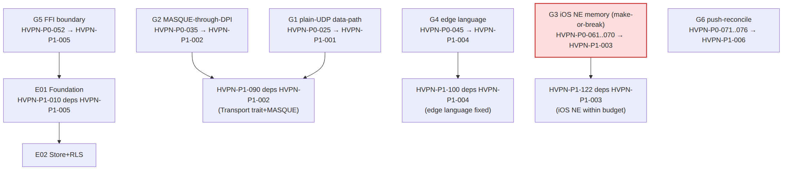
Phase-0 gate | Decides | Phase-1 entry item | Phase-1 epic it unblocks
G1 plain-UDP slice (HVPN-P0-025) | core viability | HVPN-P1-001 | E09 (HVPN-P1-090 Transport)
G2 MASQUE through DPI (HVPN-P0-035) | obfuscation D1 | HVPN-P1-002 | E09 HVPN-P1-090, E10 HVPN-P1-100
G3 iOS NE memory (HVPN-P0-061..070) | Rust-on-every-platform D2 | HVPN-P1-003 | E12 HVPN-P1-122 (iOS shim)
G4 Go-vs-Rust edge (HVPN-P0-045) | edge language D5 | HVPN-P1-004 | E10 HVPN-P1-100 (fixes edge lang)
G5 frb FFI (HVPN-P0-052) | FFI boundary | HVPN-P1-005 | E01 HVPN-P1-010 (monorepo)
G6 push-reconcile (HVPN-P0-071..076) | push model seed | HVPN-P1-006 | E07 WatchNetworkMap seed
G3 fail-path (§11.4.66). If the iOS memory gate fails, HVPN-P1-122 (iOS shim) re-plans against the §6.4 fallback ladder (07-… §5 note) — a decision surfaced, not silently resolved.

3. The Phase-1 MVP critical path
The longest dependency chain to AC certification (07-… §22), with the red critical-path epics E02/E03/E07/E09/E14 (07-… §4):
Critical path: E01(010→011) → E02(020→021→022) → E03(032) → E07(070→071→072→073) → E09(092→093/094) → E10(100→101→102) → E14(140→142→144→145) → E15(151) (07-… §22). The two parallel fan-outs that keep wall-clock down: E04/E05/E06 off E02 (disjoint scope → concurrent PWUs §11.4.58), and E11 UI off E08/E09 in parallel with E10/E12.

4. Cross-component dependencies (data ↔ control ↔ client)
The architecture's three planes (data / control / client) are bound by specific deps edges. The MVP is hub-and-spoke: the coordinator computes per-node maps, the edge enforces them, the client core reconciles them.
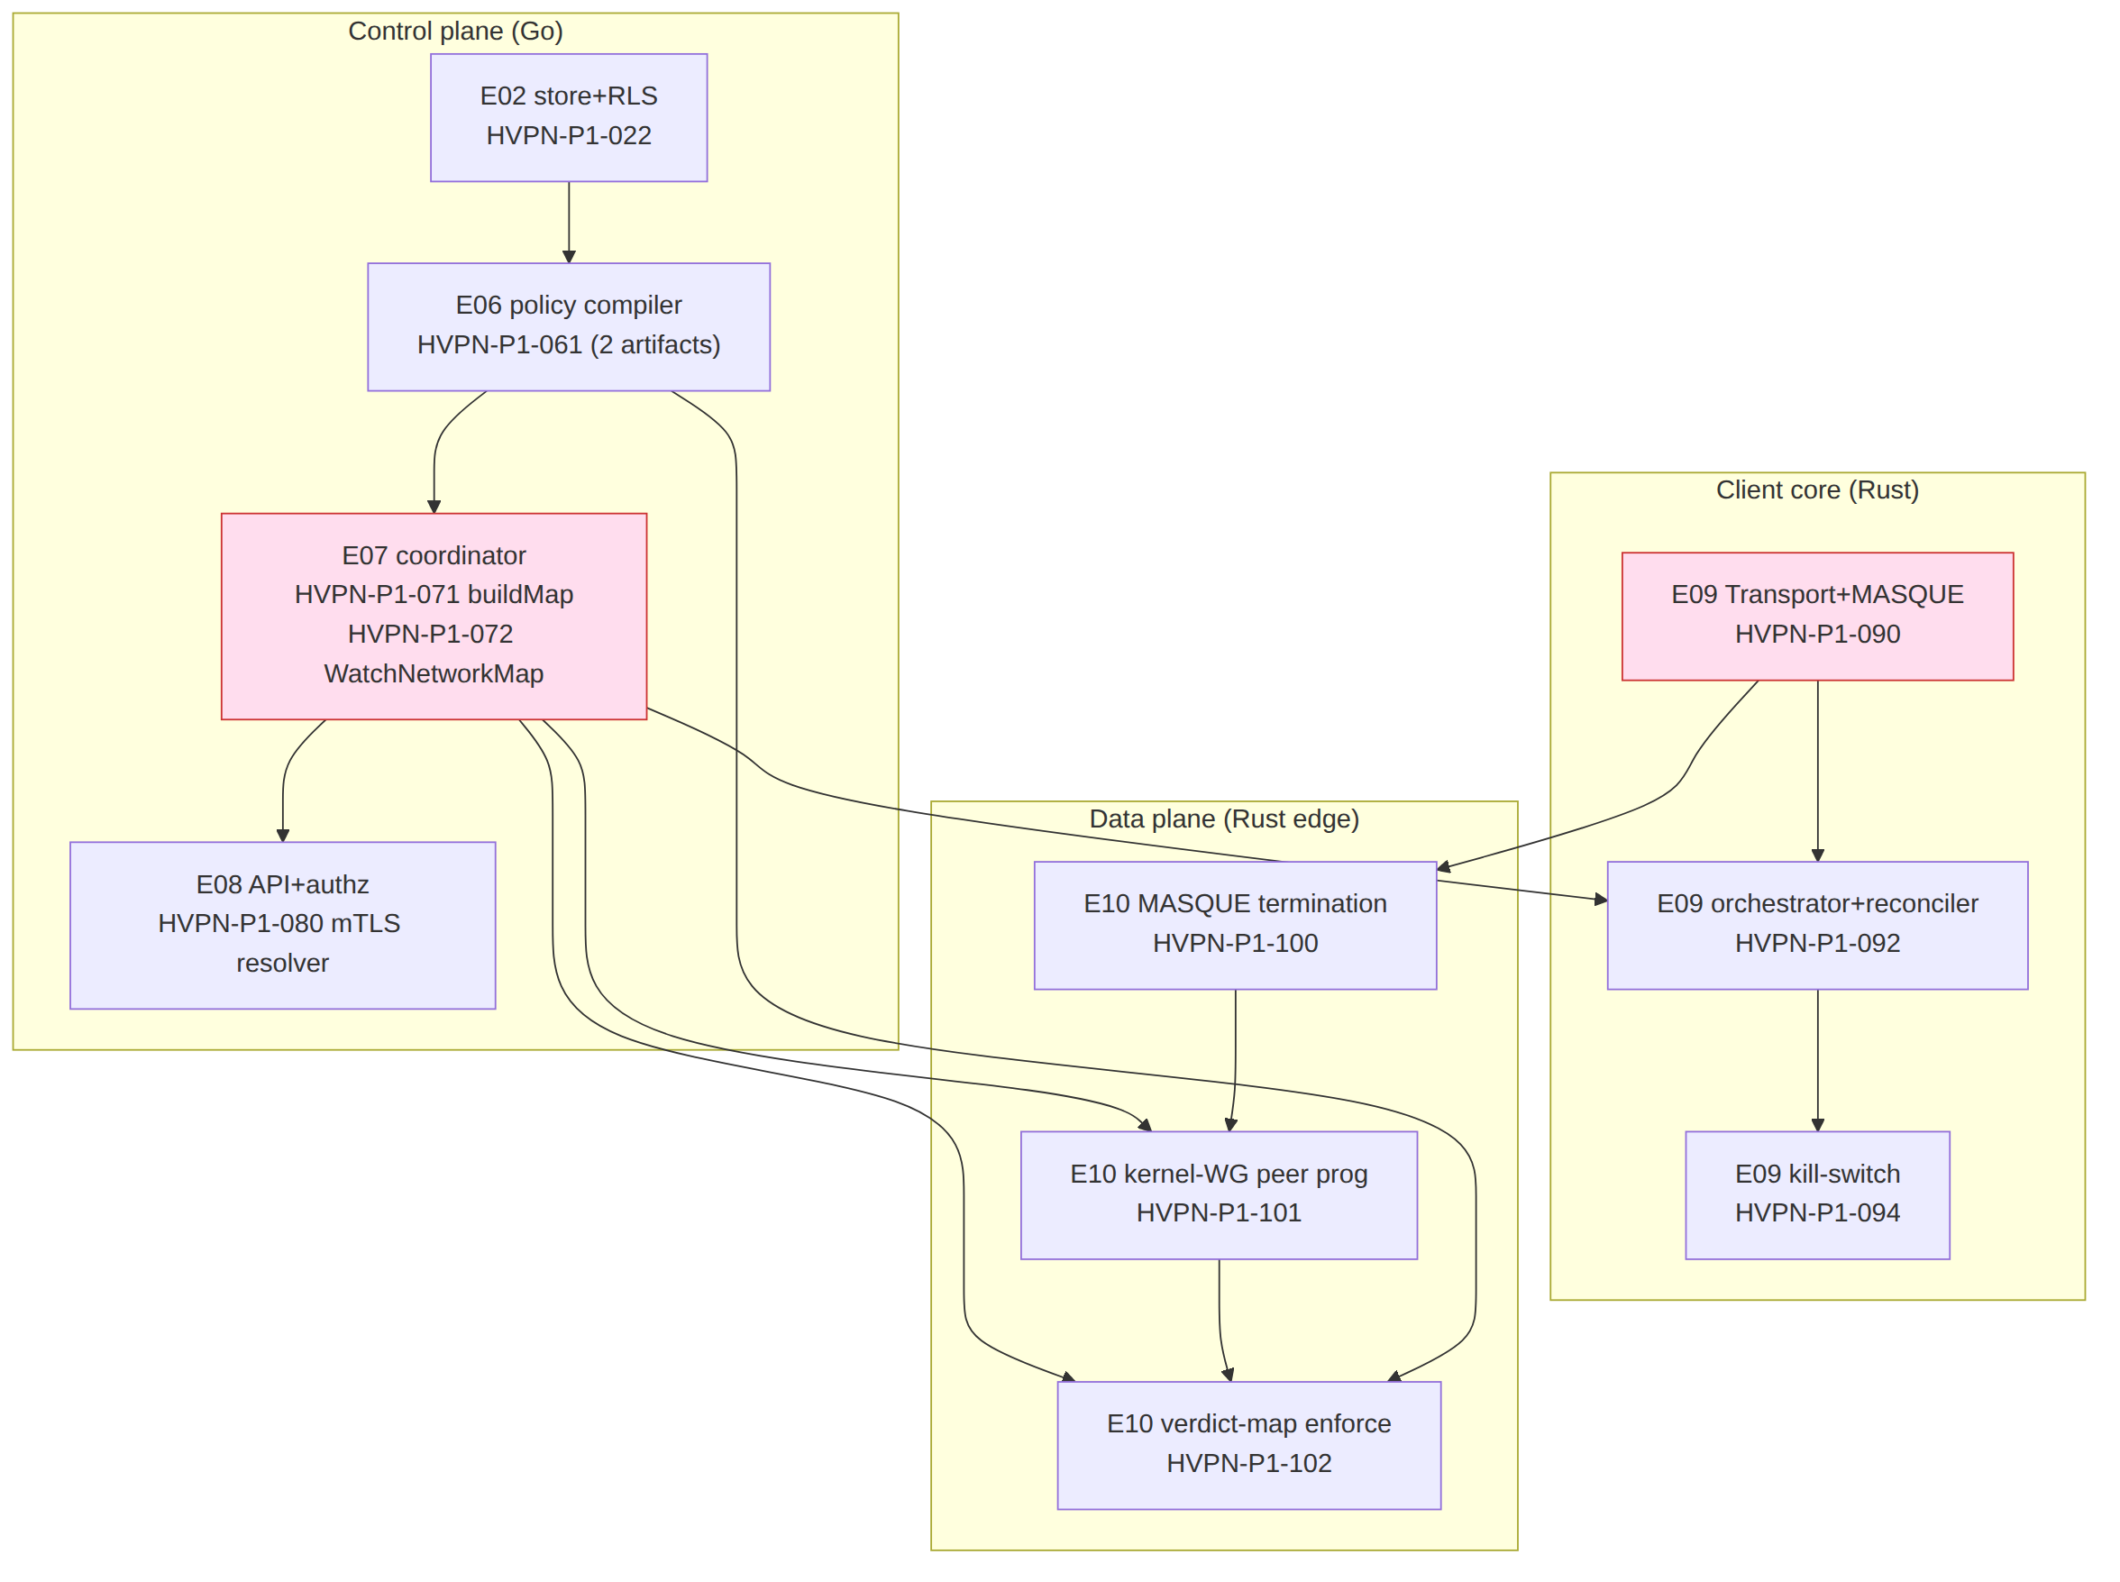
The load-bearing cross-plane edges (from the deps fields):
Edge | Cited dep | Why it binds the planes
policy compiler → coordinator | HVPN-P1-070 deps HVPN-P1-061 | buildMap consumes the compiled {visible,allowedIPs,verdict-map} (07-… §11/§12)
coordinator → client reconciler | HVPN-P1-092 deps HVPN-P1-072 | the client converges to streamed MapUpdate deltas (07-… §14)
Transport trait → edge | HVPN-P1-100 deps HVPN-P1-090,004 | edge reuses helix-transport byte-for-byte; G4 fixes language (07-… §15)
compiler verdict-map → edge | HVPN-P1-102 deps HVPN-P1-061,101,033 | edge applies the port-level verdict map WG AllowedIPs lacks (07-… §15)
PKI cert → API/coordinator authz | HVPN-P1-080 deps HVPN-P1-032; HVPN-P1-072 auth via mTLS | the device cert authenticates the stream (07-… §12/§13)
IPAM → enroll | HVPN-P1-031 deps HVPN-P1-040 | enroll allocates the overlay IP before issuing the map (07-… §8)

5. Phase-2 critical path + parallel high-risk tracks
Phase 2 is additive off the shipped MVP (08-… §4). The networking/reach spine is the critical path; PQ and DAITA are parallel measure-don't-assert tracks.
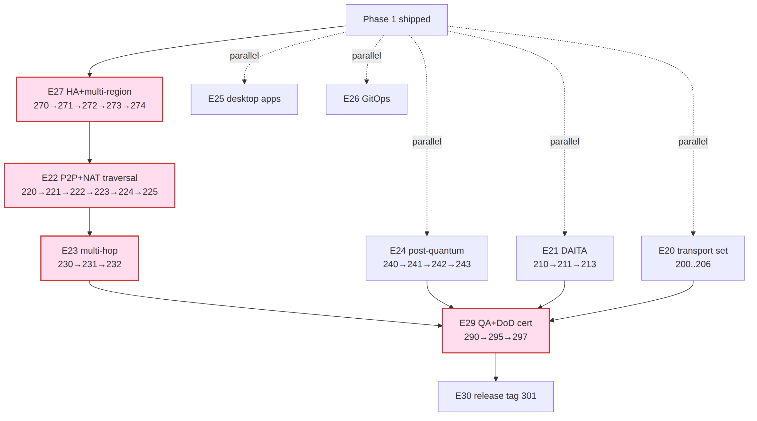
Critical path: E27(270→271→272→273→274) → E22(220→221→222→223→224→225) → E23(230→231→232) → E29(290→295→297) → E30(301) (08-… §19). E27 leads because the STUN endpoints, relay fleet, and NATS mesh that E22/E26/E28 consume are its outputs (08-… §4): HVPN-P2-220 (STUN discovery) deps HVPN-P2-271; HVPN-P2-223 (relay) deps HVPN-P2-273. The two high-risk parallel tracks that converge at E29 but do not sit on the networking critical path: E24 (PQ) and E21 (DAITA) — each a disjoint-scope PWU (§11.4.58). Per §11.4.132 the correctness-and-downgrade-safety floor leads: NAT-traversal honesty (HVPN-P2-222 no-false-direct), PQ never-weaker-than-classical (HVPN-P2-242), DAITA measured efficacy (HVPN-P2-213).

6. Phase-3 critical path + device-gated parking
Phase 3's two native shims (E21 HarmonyOS, E22 Aurora) are the make-or-break carries; they run as disjoint-scope parallel PWUs the moment E20's fork runners exist, and park on PENDING_DEVICE while host-only work proceeds (09-… §4).
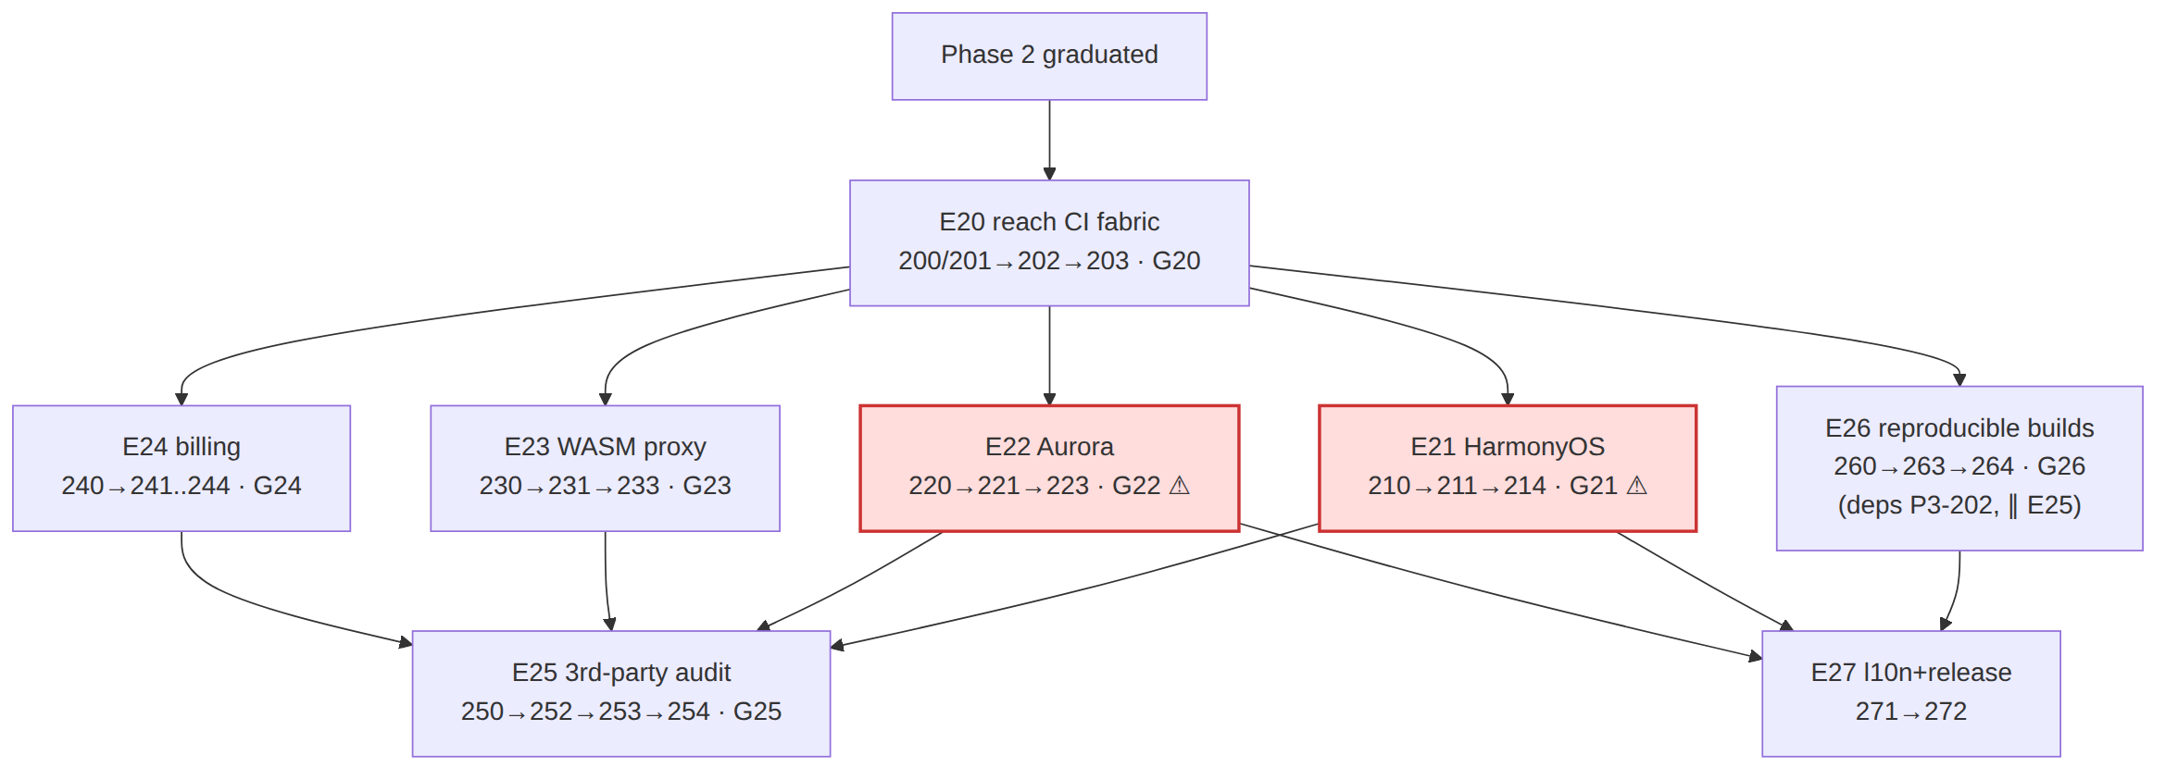
Critical path (risk-ordered §11.4.132): E20(200/201→203) → {E21(210→211→214) ∥ E22(220→221→223)} → E25(250→252→253→254) → E27(271→272). E25 (audit) is a convergence gate — it cannot start until the surfaces it audits (E21–E24) are feature-complete (HVPN-P3-250 deps 214,223,233,244). E26 (reproducible builds, 260→263→264) runs ∥ E25, gated only by E20: HVPN-P3-260 deps HVPN-P3-202 (→ 200/201), not P3-254 (09-… §11). Both E25 (254) and E26 (264) converge into the release set at HVPN-P3-271 (deps …,254,264). The 09-… §14 critical-path note sequences E25→E26; this DAG corrects that to the actual deps edges per §0 (nothing invented). While E21/E22 await device access (PENDING_DEVICE), E23/E24/E26-tooling progress as ≥3 background streams (§11.4.103, 09-… §4).

7. Master dependency table (item → depends-on → blocks)
The load-bearing edges per phase (selected critical/cross-component edges; the full set is every deps/depends_on field in the four WBS docs, which the loader ingests). blocks = the inverse edge (what waits on this item).
Item | Depends on | Blocks (selected) | Source
HVPN-P0-004 Transport trait | HVPN-P0-002 | HVPN-P0-008,028,049 | 06-… §3
HVPN-P0-008 plain-UDP | HVPN-P0-006 | HVPN-P0-018 (orchestrator) | 06-… §3
HVPN-P0-025 G1 reach | HVPN-P0-020,023 | HVPN-P1-001 (G1 entry) | 06-… §5
HVPN-P0-035 G2 MASQUE | HVPN-P0-031,024 | HVPN-P1-002 (G2 entry) | 06-… §6
HVPN-P0-039 Rust edge (helix-edge) | HVPN-P0-031 | HVPN-P0-045 (A/B bench, G4) | 06-… §7
HVPN-P0-045 G4 bench | HVPN-P0-040,043 | HVPN-P1-004 (edge lang) | 06-… §7
HVPN-P1-010 monorepo | HVPN-P1-005 (G5) | HVPN-P1-011,013,110,150 | 07-… §6
HVPN-P1-022 FORCE-RLS | HVPN-P1-021 | HVPN-P1-030,032,040,050,060 | 07-… §7
HVPN-P1-061 policy compiler | HVPN-P1-060 | HVPN-P1-062,070,102 | 07-… §11
HVPN-P1-072 WatchNetworkMap | HVPN-P1-071,080 | HVPN-P1-073,092,101 | 07-… §12
HVPN-P1-090 Transport (prod) | HVPN-P1-002 | HVPN-P1-091,093,100 | 07-… §14
HVPN-P1-100 edge MASQUE term | HVPN-P1-090,004 | HVPN-P1-101,102,261 | 07-… §15
HVPN-P1-145 DoD cert | 140,141,142,143,144 | HVPN-P1-151 (tag) | 07-… §19
HVPN-P2-190 Transport seam | HVPN-P1-090 | HVPN-P2-200,201,202 | 08-… §5
HVPN-P2-220 STUN discovery | HVPN-P2-191,271 | HVPN-P2-221,222,296 | 08-… §8
HVPN-P2-222 hole-punch | HVPN-P2-220,221 | HVPN-P2-223,224,290 | 08-… §8
HVPN-P2-240 ML-KEM PSK | HVPN-P2-192 | HVPN-P2-241,244 | 08-… §10
HVPN-P2-272 NATS mesh | HVPN-P2-270 | HVPN-P2-273,281,295 | 08-… §13
HVPN-P2-297 Phase-2 DoD | 290..296 | HVPN-P2-301 (tag) | 08-… §15
HVPN-P3-200/201 fork runners | — | HVPN-P3-210,220,230,260 | 09-… §5
HVPN-P3-210 OHOS cross-compile | HVPN-P3-200 | HVPN-P3-211 | 09-… §6
HVPN-P3-250 audit scope | 214,223,233,244 | HVPN-P3-252,253 | 09-… §10
HVPN-P3-260 determinize builds | HVPN-P3-202 | HVPN-P3-261,262,263 | 09-… §11

8. Critical-path call-out + parallelism rules
The single longest chain to a published release (programme critical path, concatenating the per-phase critical paths at the gate boundaries):
Phase 0: HVPN-P0-002 → 004 → 008 → 018 → 025(G1) → 031 → 035(G2) → 045(G4)
Phase 1: → P1-010 → 022 → 032 → 070 → 071 → 072 → 092 → 094 → 100 → 102 → 145 → 151(MVP tag)
Phase 2: → P2-270 → 271 → 272 → 220 → 222 → 223 → 224 → 230 → 232 → 295 → 297 → 301(parity tag)
Phase 3: → P3-200 → 203(G20) → 210 → 211 → 214(G21) → 250 → 252 → 253 → 254(G25) → 271 → 272(reach tag) [∥ E26: 260→263→264(G26), gated on P3-202, converges at 271]
→ here is sequence, not necessarily a deps edge. Within each per-phase line above, → denotes execution sequence (risk-ordered §11.4.132), not the §0 dependency relation. Some adjacent steps are ordered by phase/gate sequencing and reach their successor through intermediate deps not shown inline — e.g. P0 018→025, P1 094→100/100→102/102→145, P2 272→220/290→295/232→295. The direct dependency edges (where A → B means B deps A per §0) are those enumerated in §2–§7 and the WBS docs.
Parallelism rules that compress this wall-clock (each cited to a constitution anchor + the WBS note that invokes it):
Rule | Where it applies | Anchor
Disjoint-scope PWUs run fully parallel | P1 E04/E05/E06 off E02; P2 E20/E21/E24/E25; P3 E23/E24 off E20 | §11.4.58
≥3 background streams + auto-backfill | every phase; P3 while shims park on PENDING_DEVICE | §11.4.103
Single-resource-owner for shared hardware | P0 S4 vs S7 must NOT share the bench host at once | §11.4.119 (06-… §2 note)
Risk-ordered sequencing (highest-risk first) | RLS/kill-switch/NAT-honesty/PQ-downgrade-safety lead | §11.4.132
Audio-style top-priority maps to correctness floor | every phase's iteration ordering | §11.4.72→§11.4.132
Honest-uncertainty markers (§11.4.6). Phase-3 device-gated nodes (HVPN-P3-211/221 and downstream) carry the widest error bars and are UNCONFIRMED:/PENDING_DEVICE: until hardware exists (09-… §14 risk register). A gate that cannot be cleared on the real device is the finding — escalate per §11.4.66/.101/.112, never overrun silently. No edge in this DAG implies a calendar date; every duration is a sizing-only TARGET.

Sources verified
- 06-phase0-spike-wbs.md §2 milestone DAG + §2 parallelism note, §3–§11 per-milestone depends_on fields, gates table — read 2026-06-26.
- 07-phase1-mvp-wbs.md §4 epic DAG, §5 entry gates, §21 traceability, §22 critical path + effort caveat — read 2026-06-26.
- 08-phase2-parity-wbs.md §4 epic DAG, §5 entry seams, §18 traceability, §19 critical path — read 2026-06-26.
- 09-phase3-reach-wbs.md §2.1 gate DAG, §4 epic DAG, §13 traceability, §14 critical path + risk register — read 2026-06-26.
- Sibling workable-items-model.md (§8 loader acyclicity validation) — authored this volume.
- Constitution anchors §11.4.58/.66/.72/.101/.103/.112/.119/.132 — read 2026-06-26.
Honest boundary (§11.4.6): every edge is transcribed from a cited WBS deps field; no dependency is inferred or invented. Durations are sizing TARGETs, never commitments; device-gated Phase-3 chains remain PENDING_DEVICE.

