Challenges — HelixVPN nano-detail spec (Volume 8 · §11.4.169 type 5)

Challenges — HelixVPN nano-detail spec (Volume 8 · §11.4.169 type 5)
Revision: 3 Last modified: 2026-07-04T12:00:00Z
Rev 3 (2026-07-04): independently re-verified during a corpus-wide gap-analysis pass. Confirmed honest framing: the challenges engine is described throughout as a planned, owned-by-reference ecosystem submodule (vasic-digital/challenges, per SPECIFICATION.md §6) consumed via replace/pinned-SHA — not as an already-operational tool in this repo today. No contradictions found.
Reconciled (§11.4.35, 2026-06-26): the MVP Definition-of-Done has NINE acceptance criteria (AC1–AC9) per the canonical overview 10-testing-acceptance-and-qa.md §7.2. The earlier "eight … (AC1–AC9)" wording (§1, §6) was a self-contradictory mis-count; a Challenge gate scoring 8/9 ACs is a §11.4.118 coverage bluff. Corrected to NINE.
Nano-detail expansion of §5.5 of the Volume-8 overview. Challenges are the constitution's anti-bluff Challenge layer (§11.4.27(B)) — the vasic-digital/challenges submodule, a Go engine that scores a feature PASS only on captured evidence matching the §11.4.69 shape for that feature class, graded by the engine re-reading the artifact, never by the test's own exit code. This is the structural defence against bluff-classes B1 (config-only), B2 (absence-of-error), and B3 (wrong-plane): the Challenge engine does not trust the harness's claim — it re-reads the pcap / counter / recording itself. The nine MVP Definition-of-Done acceptance criteria (AC1–AC9, overview §7.2) are authored as executable Challenges. This document fixes the bank model, the engine contract, the evidence scoring, the determinism, the gate, the paired §1.1 mutation, and a concrete bank YAML. Spec-only; unproven assumptions marked UNVERIFIED. Siblings: unit.md, integration.md, e2e.md, full-automation.md, helixqa.md.

Table of contents
- 1. Scope — what a Challenge is, and what it covers
- 2. Harness — the challenges submodule engine
- 3. Fixtures — real on-rig drivers, engine-scored evidence
- 4. Evidence taxonomy — engine-re-read, not exit-code
- 5. Determinism — N-iteration identical evidence
- 6. Acceptance gate — when CHAL blocks a release
- 7. The paired §1.1 mutation (anti-bluff proof)
- 8. The MVP-DoD bank (concrete YAML)
- 9. Open decisions surfaced for QA
- Sources verified

1. Scope — what a Challenge is, and what it covers
A Challenge differs from a test in who grades it. A test asserts and exits with a code; a Challenge runs a driver, then the challenges engine independently re-reads the captured evidence artifact and scores PASS only if the artifact's content matches the declared §11.4.69 shape for that feature class. The test's exit code is not the verdict — the re-read is. This is the §11.4.27(B) anti-bluff layer: even a perfectly-written but lying harness cannot fake a Challenge, because the engine never sees the harness's claim, only its artifact.
Challenge | Feature class (§11.4.69) | What the engine re-reads | Bound AC
HVPN-CHAL-AC1-selfhost | boot_service | recorded terminal + helix_up==1 healthcheck | AC1
HVPN-CHAL-AC2-authorized-reach | network_connectivity | pcap: SYN→SYN-ACK from 10.10.0.20 + non-empty body hash | AC2
HVPN-CHAL-AC3-default-deny | network_connectivity (negative) | pcap: SYN out, zero SYN-ACK; edge drop++ | AC3
HVPN-CHAL-AC4-masque-escalate | network_connectivity | tshark: HTTP/3 flow, no WG signature; transport=="masque-h3" | AC4
HVPN-CHAL-AC5-reconcile | counter delta | helix_reconcile_seconds p99 histogram bucket < 1 s | AC5
HVPN-CHAL-AC6-revoke | counter delta | revoke-ts → edge-peer-removed-ts CSV, p99 < 1 s | AC6
HVPN-CHAL-AC7-killswitch-no-leak | killswitch_negative | host pcap: zero plaintext egress, zero :53 DNS | AC7
HVPN-CHAL-AC8-no-log-schema | negative (schema) | schemalint report: zero durable per-flow tables | AC8
HVPN-CHAL-AC9-three-apps | REC | per-app window-scoped MP4 + vision_engine verdict | AC9
Challenges cover the DoD acceptance set — the release-gating proof that the product works for the end user. They sit at the top of the test pyramid below REC (overview §4) and are driven by helix_qa (helixqa.md).

2. Harness — the challenges submodule engine
The challenges submodule (digital.vasic.challenges, Go) is consumed via a replace directive in development and a pinned SHA in release (05 §6.1), per §11.4.27(B)/§11.4.74 (reuse-don't-reimplement) + §11.4.28 (owned submodule, equal-codebase). A bank file (challenges/banks/helixvpn_mvp_dod.yaml) maps each AC to its on-rig driver + the evidence-class assertion the engine scores against.
- Consumed by reference, never copied (§11.4.28) — the engine lives in the submodule; the consumer registers its banks as data (the YAML), keeping the engine project-agnostic.
- Engine-scored, never exit-code — the engine runs the driver, captures the artifact, then re-reads it; score: pass_only_if_evidence_matches is the contract. A driver that exits 0 but produced no matching artifact scores FAIL.
- Self-validated (§11.4.107(10)) — a Challenge with self_validated: true ships a golden-bad artifact (a seeded-leak pcap, a WG flow mislabelled H3) that the engine must score FAIL; if it scores PASS, the analyzer is the bluff and the meta-test FAILs (CM-ANALYZER-SELF-VALIDATED, defeats B5).

3. Fixtures — real on-rig drivers, engine-scored evidence
Fixture | Real or mock | Notes
AC drivers | real rig scripts (e2e.md §8, §5.7 SEC) | rig/test_reach.sh, rig/killswitch_drop.sh, etc. — real packets
captured artifacts | real pcap/CSV/MP4/schemalint report | the engine re-reads these; they are not synthetic
golden-good fixture | real captured-clean artifact | the self-validation positive case
golden-bad fixture | real captured-bad artifact (seeded leak) | the self-validation negative case — must score FAIL
mocks | FORBIDDEN (§11.4.27) | Challenges are above the unit layer; the engine re-reads real evidence
The engine's re-read is the anti-mock guarantee: there is nothing to mock — the verdict is computed from a real pcap/CSV/MP4 captured during a real run. The only out-of-band step is the §11.4.10 credential bootstrap for AC1's init.

4. Evidence taxonomy — engine-re-read, not exit-code
The defining property: the Challenge verdict = the engine's re-read of the artifact, mapped to the §11.4.69 class shape:
Class | Engine assertion | Forbidden bluff it defeats
network_connectivity | tshark/pcap filter matches (SYN-ACK present) and body hash non-empty | B1 config-only — a config check produces no pcap
network_connectivity (negative) | filter matches zero rows (no SYN-ACK) + edge drop++ | B2 absence-of-error — "no error" is not "zero SYN-ACK captured"
killswitch_negative | assert_zero: "ip && not loopback" + assert_zero_dns: "udp.port==53" | B2 — the engine counts plaintext/DNS packets, not "kill-switch enabled"
counter delta | histogram bucket / timing CSV p99 < budget | B3 wrong-plane — a status field is not a measured delta
REC | vision_engine OCR verdict on the MP4 + core-FSM cross-check | B3 — a green shield while the FSM is Blocked FAILs
Per §11.4.83 the engine's per-AC verdict JSON lands under docs/qa/<run-id>/ (the committed evidence trail); per §11.4.69 a PASS without a matching artifact is impossible — the engine has nothing to score. The verdict JSON carries the artifact path (the §11.4.116 verdict-carries-evidence-path rule, helixqa.md §4).

5. Determinism — N-iteration identical evidence
Per §11.4.50 each Challenge runs N=3 (normal) / N=10 (cycle-validation) under the FA wrapper (full-automation.md §5):
- The driver runs on the clean rig per iteration; the engine re-reads each iteration's artifact; the structural hash of the matched-evidence set is compared across runs; a divergence is auto-FAIL.
- The body-hash / drop-count / schemalint-table-set are deterministic by construction (fixed sink page, fixed policy); timing fields are compared to a budget, not hashed.
- A Challenge that scores PASS on run 1 and FAIL on run 2 is not a flake — it is a real defect surfaced (§11.4.50 mechanises §11.4.7); the §11.4.4 STOP fires.

6. Acceptance gate — when CHAL blocks a release
Gate | Bar | Layer
make qa (overview §9) | every DoD Challenge scores PASS via the engine, N=3 | release sweep
CM-DOD-CHALLENGES-GREEN | a release tag is blocked while any DoD Challenge is non-PASS | pre-tag (§11.4.40)
CM-ANALYZER-SELF-VALIDATED (§11.4.107(10)) | every self_validated Challenge's golden-bad artifact scores FAIL | pre-build meta-test
CHAL is a release-gating layer: the MVP ships only when all nine ACs' Challenges score PASS on a clean baseline (§11.4.40 + §11.4.108 runtime-signature on a fresh deploy). This is QA-D5 (overview §10) resolved: challenges-scored, not raw exit codes — the engine re-reads the evidence artifact, structurally defeating B1–B3; exit codes alone are bluffable (§11.4.27).

7. The paired §1.1 mutation (anti-bluff proof)
# §1.1 mutation for CM-ANALYZER-SELF-VALIDATED (the engine's self-validation is real)
- the AC7 kill-switch Challenge has self_validated: true with golden-bad =
fixtures/killswitch_leaked_dns.pcap (a seeded :53 leak)
- MUTATE the engine's assertion: strip `assert_zero_dns: "udp.port==53"`
- assert: the engine now SCORES the leaked-DNS golden-bad pcap as PASS → meta-test FAILs
(the analyzer became a bluff — B5 caught)
- restore the assertion; assert golden-bad scores FAIL again (§11.4.84 quiescence)
# §1.1 mutation for CM-DOD-CHALLENGES-GREEN (engine re-reads, not exit code)
- make rig/test_reach.sh `exit 0` but produce an EMPTY pcap (a lying harness)
- assert: the engine re-reads the empty pcap, finds no SYN-ACK → scores FAIL (not PASS)
→ proves the verdict comes from the artifact, not the exit code (defeats B1)
The second mutation is the structural proof of the Challenge model: a harness that claims success but produced no matching evidence scores FAIL, because the engine grades the artifact, never the claim.

8. The MVP-DoD bank (concrete YAML)
# challenges/banks/helixvpn_mvp_dod.yaml — one entry per DoD AC (§11.4.27(B)/.69/.83)
bank: helixvpn-mvp-dod
engine: digital.vasic.challenges # consumed by-reference, pinned SHA in release (§11.4.28)
score_policy: pass_only_if_evidence_matches # NEVER trust a driver's exit code
evidence_root: docs/qa/${RUN_ID} # §11.4.83 committed trail
challenges:
- id: HVPN-CHAL-AC2-authorized-reach
feature_class: network_connectivity # §11.4.69
driver: rig/test_reach.sh pass
evidence:
kind: pcap
assert: "frame.tcp.flags.syn==1 && frame.tcp.flags.ack==1 from 10.10.0.20"
and_body_hash_nonempty: true # defeats B1 (config-only)
- id: HVPN-CHAL-AC3-default-deny
feature_class: network_connectivity_negative
driver: rig/test_reach.sh deny
evidence:
kind: pcap
assert_zero: "tcp.flags.syn==1 && tcp.flags.ack==1" # ZERO SYN-ACK
and_edge_counter: "drop > 0" # defeats B2 (absence-of-error)
- id: HVPN-CHAL-AC4-masque-escalate
feature_class: network_connectivity
driver: rig/escalate.sh
evidence:
kind: pcap+status
assert: "http3 present && wireguard absent" # tshark classification
and_status: "transport == 'masque-h3'" # defeats B3 (wrong-plane)
- id: HVPN-CHAL-AC6-revoke
feature_class: counter_delta
driver: rig/revoke.sh
evidence:
kind: csv
assert_p99_lt_seconds: 1.0 # revoke→enforcement < 1s (SLO3)
- id: HVPN-CHAL-AC7-killswitch-no-leak
feature_class: killswitch_negative
driver: rig/killswitch_drop.sh
evidence:
kind: pcap
assert_zero: "ip && not loopback" # zero plaintext egress on drop
assert_zero_dns: "udp.port==53" # zero DNS leak
self_validated: true # golden-bad seeded-leak pcap MUST score FAIL (§3.3)
golden_good: fixtures/killswitch_clean.pcap
golden_bad: fixtures/killswitch_leaked_dns.pcap
- id: HVPN-CHAL-AC8-no-log-schema
feature_class: schema_negative
driver: scripts/schemalint.sh
evidence:
kind: report
assert: "forbidden_table_count == 0" # no durable per-flow table
- id: HVPN-CHAL-AC9-three-apps
feature_class: REC # §11.4.153/.159
driver: panoptic drive --app access,connector,console --flow enroll-connect-reach
evidence:
kind: mp4
window_scoped: true # §11.4.154 — app window only, not desktop
filename_prefix: helixvpn--- # §11.4.155 project prefix
vision_verdict: vision_engine # §11.4.163 media-validation re-read
expected_patterns: ["Connect","Connecting","Connected","shield:green"]
cross_check: { core_fsm_at_green_shield: "Connected" } # defeats B3
self_validated: true # golden-bad MP4 (green shield, FSM Blocked) MUST FAIL

8a. Challenge lifecycle (engine internals)
A Challenge moves through a fixed lifecycle inside the engine; understanding it is how the consumer reasons about a verdict:
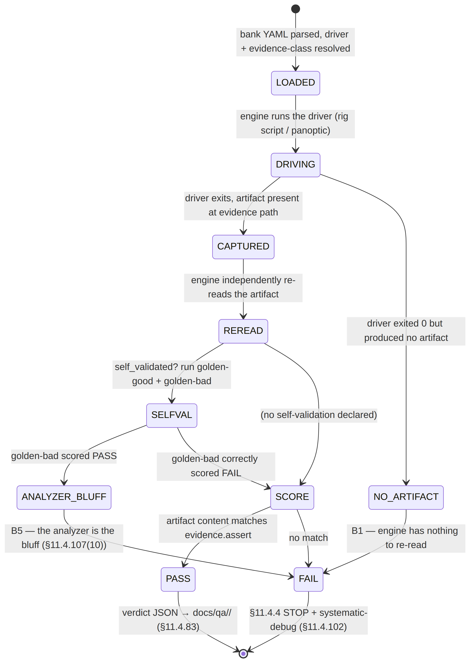
Failure-mode catalog (what scores FAIL, and why that is correct):
Symptom | Engine behaviour | Why it is a FAIL not a flake
driver exits 0, empty pcap | NO_ARTIFACT → FAIL | the verdict is the re-read, not the exit code (B1)
pcap present, no SYN-ACK row | SCORE → FAIL | reach not proven on the wire (§11.4.69)
transport=="masque-h3" but pcap has a WG signature | SCORE → FAIL | wrong-plane lie (B3) — status and wire disagree
golden-bad leaked-DNS pcap scores PASS | ANALYZER_BLUFF → FAIL | the analyzer cannot distinguish leak from clean (B5)
run 1 PASS, run 2 FAIL | §11.4.50 auto-FAIL | a real defect surfaced, never demoted to "flake" (§11.4.7)
The engine never converts an empty/unreachable artifact into a PASS-counting SKIP for a feature class that has a sink-side probe (§11.4.69 CM-NO-FAIL-OPEN-SKIP) — a genuinely-absent topology is an honest §11.4.3 SKIP with a closed-set reason surfaced on the sync channel (helixqa.md §4), never a silent pass.

9. Open decisions surfaced for QA
# | Decision | Options | Recommendation
C-D1 | Challenge engine vs raw exit codes (QA-D5) | exit-code vs challenges-scored | challenges-scored (overview §10) — the engine re-reads the artifact, structurally defeating B1–B3
C-D2 | bank consumption mode | replace (dev) vs pinned SHA (release) | replace in dev, pinned SHA in release (05 §6.1) — reproducible release, fast dev iteration
C-D3 | golden-bad fixture authorship | hand-seed each vs derive from a real failed run | hand-seed the canonical bad artifact + add any real failed-run capture as a second golden-bad — broadens the self-validation surface (§11.4.107(10))

9a. Challenge-vs-test-vs-HelixQA — who owns what
The three top-of-pyramid layers are distinct and composing, not redundant:
Layer | Grades by | Owns | Spec
test (E2E/INT) | its own exit code + an ab_pass_with_evidence call | the assertion | e2e.md, integration.md
Challenge | the challenges engine re-reading the artifact | the DoD AC verdict (B1–B3-proof) | this doc
HelixQA | the orchestrator driving + reconciling all of them, no human | the autonomous session + sync channel + tickets | helixqa.md
A Challenge consumes a test's driver but ignores its verdict; HelixQA consumes a Challenge's verdict and reconciles it into the coverage ledger + the workable-items DB. The chain — test drives, Challenge re-reads, HelixQA orchestrates — is three independent re-reads of the same captured evidence, which is precisely why a bluff must survive all three to ship, and by construction cannot (§11.4.27(B) / §11.4.165).
Why the engine is a submodule, not in-project (§11.4.74/.28). The re-read logic (pcap filters, counter parsers, OCR verdict) is reusable across every Helix project that needs anti-bluff acceptance scoring; reimplementing it in-project would duplicate the 80%+ that challenges already covers (§11.4.74 catalogue-first). The consumer contributes only data (the bank YAML) and any missing assertion kind is added by an upstream PR to vasic-digital/challenges (§11.4.74), never a local fork — keeping the engine project-agnostic and the consumer decoupled (§11.4.28).
UNVERIFIED: the digital.vasic.challenges engine's exact bank-YAML schema (score_policy, assert_zero, self_validated, vision_verdict keys) is the intended shape per the overview skeleton; confirm against the pinned vasic-digital/challenges SHA (§11.4.74 — extend upstream if a key is unsupported).

Sources verified
- Volume-8 overview §2 (taxonomy row CHAL), §5.5 (the bank YAML skeleton + engine-scored model), §5.6 (helix_qa drives banks), §3.3 (self-validated analyzers), §7.2 (AC1–AC9), §10 QA-D5 — read 2026-06-26.
- Sibling specs cross-referenced: e2e.md, helixqa.md, full-automation.md, ../05-repo-layout-tooling-and-helix-ecosystem.md — overview + repo doc read; the [05] ecosystem doc is the [P1] overview present at final/.
- Constitution: §11.4.27(B) (Challenges / no-fakes-beyond-unit), §11.4.69 (sink-side evidence taxonomy), §11.4.107(10) (self-validated analyzer / golden-good+bad), §11.4.83 (docs/qa/<run-id>/ evidence trail), §11.4.116 (verdict-carries-evidence-path), §11.4.28 (owned submodule consumed by reference), §11.4.74 (extend-upstream), §11.4.50 (determinism), §11.4.40 (pre-tag gate), §11.4.108 (runtime-signature on clean deploy), §11.4.153/.154/.155/.159/.163 (REC / window-scope / prefix / media-validation for AC9), §1.1 (paired mutation) — from CLAUDE.md in-context.
- The challenges engine bank-YAML schema is reproduced from the overview skeleton — not independently fetched from vasic-digital/challenges (UNVERIFIED; confirm at the pinned SHA).

