HelixQA Autonomous Sessions — HelixVPN nano-detail spec (Volume 8 · §11.4.169 type 6)

HelixQA Autonomous Sessions — HelixVPN nano-detail spec (Volume 8 · §11.4.169 type 6)
Revision: 3 Last modified: 2026-07-04T12:00:00Z
Rev 3 (2026-07-04): independently re-verified during a corpus-wide gap-analysis pass. Confirmed honest framing: helix_qa is described throughout as a planned, owned-by-reference ecosystem submodule (HelixDevelopment/helix_qa, per SPECIFICATION.md §6) to be incorporated during the build phase — not as an already-operational tool in this repo today. No contradictions found.
Reconciled (§11.4.35, 2026-06-26): the MVP Definition-of-Done set has NINE acceptance criteria (AC1–AC9) per the canonical overview 10-testing-acceptance-and-qa.md §7.2. The earlier "8 ACs" wording (§2, §6) and the §4 status.json counters that totalled 8 (pass:5 + pending:3) were a mis-count that left AC9 uncovered — a §11.4.118 coverage bluff. Corrected to NINE (the snapshot now totals 9: pass:5 + pending:4).
Nano-detail expansion of §5.6 of the Volume-8 overview. HelixQA (HelixDevelopment/helix_qa) is the autonomous QA orchestrator (§11.4.27 / §11.4.107 / §11.4.158): it drives the full MVP-DoD acceptance set end-to-end with no human, consumes the challenges banks (challenges.md), boots infra via containers (integration.md), drives the UI via panoptic and analyses frames via vision_engine, generates tickets for findings into the workable-items DB, respawns crashed sub-runs (§11.4.147), and emits the real-time sync channel (§11.4.116 — append-only JSONL event stream + atomically- rewritten status snapshot) that the conductor tails live. It is the §11.4.165 independent-verification agent for the runtime layer — structurally separate from the code author. This document fixes the harness, the written test banks per app/service/platform, the captured wire-evidence-per-check contract, the sync channel, the determinism, the gate, the paired §1.1 mutation, and skeletons. Spec-only; unproven assumptions marked UNVERIFIED. Siblings: unit.md, integration.md, e2e.md, full-automation.md, challenges.md.

Table of contents
- 1. Scope — what HelixQA orchestrates
- 2. Harness — the helix_qa orchestrator + test banks
- 3. Fixtures — real system, autonomous drive, captured wire evidence
- 4. Evidence taxonomy — the §11.4.116 sync channel + per-check wire evidence
- 5. Determinism — N-iteration identical evidence
- 6. Acceptance gate — when HQA blocks a release
- 7. The paired §1.1 mutation (anti-bluff proof)
- 8. Test skeletons
- 9. Open decisions surfaced for QA
- Sources verified

1. Scope — what HelixQA orchestrates
HelixQA is not a single test type — it is the autonomous QA session orchestrator that drives every other type (CHAL, E2E, INT, SEC, REC) as an end-to-end run with no human, captures wire evidence per check, and reconciles the verdicts into the coverage ledger and the workable-items DB. Per §11.4.27 it must be used with written test banks (suites) for every application, service, and platform plus fully-autonomous QA sessions driving every registered bank with captured wire evidence per check.
HelixQA responsibility | Mechanism | Constitution
drive the DoD acceptance set end-to-end, no human | --suite mvp-dod over the challenges banks | §11.4.27 / §11.4.98
boot infra for the run | containers/pkg/boot (rootless) | §11.4.76 / §11.4.161
drive the UI flows | panoptic (web/desktop/mobile) → window-scoped MP4 | §11.4.154 / §11.4.159
analyse frames for the REC verdict | vision_engine OCR + core-FSM cross-check | §11.4.163 / §11.4.165
emit a real-time sync channel | append-only JSONL events + atomic status snapshot | §11.4.116
respawn crashed sub-runs | durable agent registry, crash≠done | §11.4.147
generate tickets for findings | write into the §11.4.93/.95 workable-items DB | §11.4.148
be the independent verifier | structurally separate from the code author | §11.4.165
The written test banks are organised per surface:
Bank | Surface | Suites it holds
helix_qa/banks/control_plane.yaml | the Go services | enrollment, RLS, reconcile, revoke, events, API authz (drives INT + CHAL)
helix_qa/banks/data_plane.yaml | helix-core + edge | reach, default-deny, escalation, kill-switch, liveness (drives E2E + SEC)
helix_qa/banks/clients_<platform>.yaml | per-platform app | connect flow, status UI, exit picker — one per platform (Access/Connector/Console × iOS/Android/Linux/Windows/macOS/Web; HarmonyOS/Aurora Phase 3) (drives UI + REC)
helix_qa/banks/mvp_dod.yaml | the release gate | the 9 ACs (challenges.md §8)
UNVERIFIED: the exact bank-file naming and the per-platform split granularity are the intended layout; the obligation (a written bank per app/service/platform, §11.4.27) is fixed, the file layout is a Phase-1 instantiation per §11.4.35.

2. Harness — the helix_qa orchestrator + test banks
helix_qa (HelixDevelopment/helix_qa, Go) is consumed as an owned submodule (§11.4.28, equal-codebase, consumed by reference / pinned SHA), invoked as one command (overview §9): go run ./submodules/helix_qa/cmd/orchestrator --suite mvp-dod.
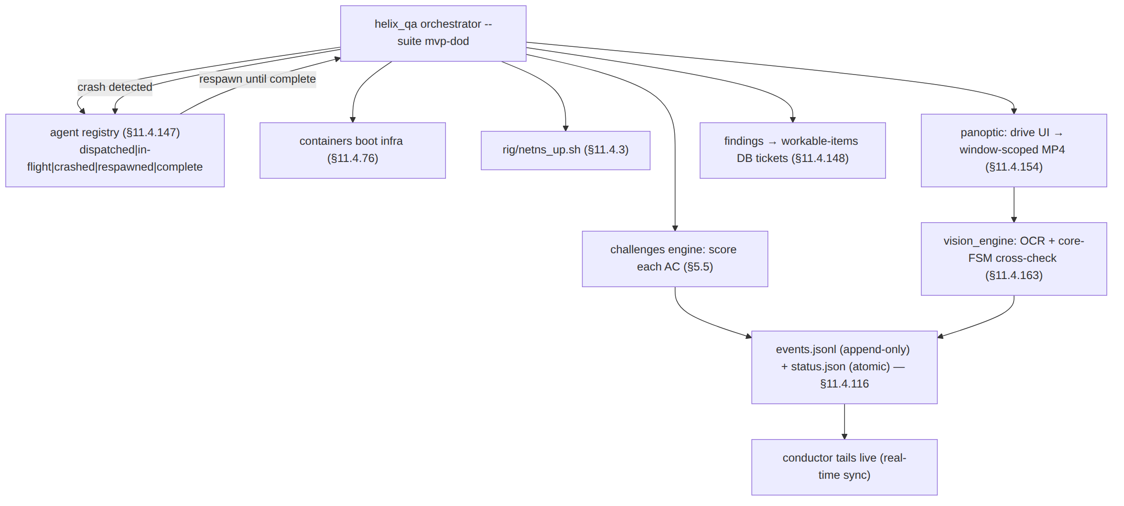
- Independent verifier (§11.4.165): HelixQA is dispatched as a structurally- separate agent from the code author — it re-reads the captured evidence and produces its own verdict; a HelixQA PASS is the runtime-layer independent confirmation, never the author asserting their own work.
- Crash-respawn (§11.4.147): every sub-run (per-AC Challenge, per-platform UI drive) is a registry entry; a transient crash (rate-limit, socket-close, a device drop §11.4.144) flips it to crashed, keeps it OPEN, and respawns until complete. The session's done-condition is not satisfied while any entry is non-complete — a registry showing complete without landed evidence is a §11.4 PASS-bluff at the agent-lifecycle layer.
- Self-meta-test (§11.4.32): HelixQA plants a known-broken AC and asserts the session reports FAIL — proving the orchestrator itself does not bluff.

3. Fixtures — real system, autonomous drive, captured wire evidence
Fixture | Real or mock | Notes
the full stack (control plane + edge + client + apps) | real | HelixQA drives the deployed system, not a mock
infra (PG/Redis) | real, via containers | rootless on-demand boot
netns rig | real | the E2E substrate (e2e.md)
UI drive | real via panoptic | the app's own UI; §11.4.117 pixel oracle for non-introspectable surfaces
frame analysis | real vision_engine OCR | golden-good/bad self-validated (§11.4.107(10))
.env credentials | real token, out-of-band | §11.4.10 — the one permitted human step
mocks / manual steps | FORBIDDEN (§11.4.27 / §11.4.98) | HelixQA is the autonomous-session layer; a human step breaks it
HelixQA's autonomy is the §11.4.98 invariant at the orchestration layer: a session that requires a human to type, click, or trigger anything after startup is a PASS-bluff. A flow genuinely infeasible to drive autonomously is an honest operator_attended SKIP with a tracked migration item (§11.4.52), surfaced on the sync channel — never a faked PASS.

4. Evidence taxonomy — the §11.4.116 sync channel + per-check wire evidence
HelixQA's distinguishing evidence is the real-time sync channel plus a captured wire artifact per check. Per §11.4.116 the channel is two parts:
- an append-only JSONL event stream (qa-results/helix_qa/events.jsonl), one event per line, never rewritten;
- an atomically-rewritten status snapshot (qa-results/helix_qa/status.json, write-temp-then-rename) the conductor tails.
// qa-results/helix_qa/events.jsonl — append-only (§11.4.116)
{"ts":"2026-…","ev":"session_start","suite":"mvp-dod","build":"<artifact-md5>"}
{"ts":"…","ev":"challenge_start","id":"HVPN-CHAL-AC2-authorized-reach"}
{"ts":"…","ev":"evidence","id":"HVPN-CHAL-AC2-…","path":"qa-results/.../reach.pcap"}
{"ts":"…","ev":"verdict","id":"HVPN-CHAL-AC2-…","result":"PASS","evidence":"qa-results/.../reach.pcap"}
{"ts":"…","ev":"agent","id":"ui-drive-ios","state":"crashed","reason":"device_dropped"} // §11.4.147
{"ts":"…","ev":"agent","id":"ui-drive-ios","state":"respawned"}
The verdict-carries-evidence-path invariant (§11.4.116): a verdict event must carry the evidence path that backs it — a PASS event with no evidence path is a channel-layer PASS-bluff; a snapshot reporting PASS while the stream shows no evidence event for that AC is a contradiction → treated as FAIL; an AC with no challenge_start event cannot have a verdict. Verdicts use the closed vocabulary PASS / FAIL / SKIP / OPERATOR-BLOCKED (§11.4.45). The captured artifacts themselves are the §11.4.69 sink-side evidence per check (challenges.md §4).
The status snapshot:
// qa-results/helix_qa/status.json — atomically rewritten (write-temp-then-rename)
{ "session":"mvp-dod","build":"<artifact-md5>","phase":"running",
"counters":{"pass":5,"fail":0,"skip":0,"operator_blocked":0,"pending":4}, // total == 9 ACs (AC1–AC9)
"last_verdict":{"id":"HVPN-CHAL-AC6-revoke","result":"PASS","evidence":"qa-results/.../revoke_timing.csv"},
"open_agents":[{"id":"ui-drive-console","state":"in-flight"}] } // §11.4.147 — not done while open

5. Determinism — N-iteration identical evidence
Per §11.4.50 a HelixQA session over the same artifact MD5 + same rig must produce an identical verdict set with structurally-identical per-check evidence across N=3 (normal) / N=10 (cycle-validation):
- The orchestrator runs under the FA wrapper (full-automation.md §5); each AC's matched-evidence structural hash is compared across runs; a divergence is auto-FAIL.
- The sync-channel event ordering is deterministic per the risk-ordered schedule (§11.4.132 — security-floor ACs first); a reordered run with the same verdicts is acceptable, a divergent verdict is not.
- Crash-respawn does not break determinism: a respawned sub-run must reach the same verdict + same evidence shape as a first-attempt run; the registry proves the work was not lost, the evidence proves it was not corrupted (§11.4.147 honest boundary — durability, not correctness; correctness is the per-check evidence).

6. Acceptance gate — when HQA blocks a release
Gate | Bar | Layer
make qa (overview §9) | the mvp-dod session reports all 9 ACs PASS with per-check evidence | release sweep
CM-AUTONOMOUS-FRAMEWORK-SYNC-CHANNEL (§11.4.116) | the session emits the JSONL stream + atomic snapshot; every verdict carries an evidence path | pre-build + runtime
CM-HQA-NO-COMPLETE-WITHOUT-EVIDENCE (§11.4.147) | the done-condition is unsatisfied while any registry entry is non-complete; no complete without landed evidence | runtime
CM-HQA-SELF-META-TEST (§11.4.32) | the planted known-broken AC makes the session report FAIL | pre-build meta-test
HelixQA's session exit status gates the release — make qa is the §11.4.40 pre-tag full-suite-retest driver at N=10, and the §11.4.165 independent-verification gate (QA-D4: independent re-read, overview §10 — vision_engine re-reads the MP4 and cross-checks the core FSM, the harness's claim is never the verdict). A finding generates a workable-items ticket (§11.4.148); the feature's coverage-ledger cell stays out of AUTONOMOUS_VERIFIED until the session re-runs GREEN.

7. The paired §1.1 mutation (anti-bluff proof)
# §1.1 mutation for CM-AUTONOMOUS-FRAMEWORK-SYNC-CHANNEL (verdict-carries-evidence)
- make the orchestrator emit a verdict event WITHOUT an `evidence` path:
{"ev":"verdict","id":"HVPN-CHAL-AC2-…","result":"PASS"} // no evidence path
- assert: the channel validator flags a PASS-with-no-evidence-path as a contradiction
→ treats it as FAIL → gate FAILs (the bluff is caught)
- restore (evidence path required); assert PASS
# §1.1 mutation for CM-HQA-NO-COMPLETE-WITHOUT-EVIDENCE (§11.4.147)
- mark a `crashed` registry entry as the session's done-condition `complete` WITHOUT
its sub-run landing evidence
- assert: the done-condition checker refuses to read satisfied → session reports
incomplete → gate FAILs (crash≠done enforced)
- restore (respawn-until-real-complete); assert the session completes only with evidence
# §1.1 mutation for CM-HQA-SELF-META-TEST (§11.4.32 — the orchestrator itself doesn't bluff)
- plant a known-broken AC (e.g. force default-deny to fail-open in the test build)
- assert: the mvp-dod session reports AC3 FAIL (the orchestrator detects the break)
- a session that reports AC3 PASS on the broken build is itself the bluff → meta-test FAILs

8. Test skeletons

8.1 The orchestrator invocation + sync-channel consumption
// submodules/helix_qa/cmd/orchestrator/main.go (invocation contract; engine in submodule)
// go run ./submodules/helix_qa/cmd/orchestrator --suite mvp-dod
// 1. boot infra via containers (§11.4.76), bring up the rig (§11.4.3)
// 2. for each AC in the mvp-dod bank, dispatch a sub-run (registry entry §11.4.147)
// 3. score via the challenges engine (§5.5); drive UI via panoptic; analyse via vision_engine
// 4. append every event to events.jsonl; rewrite status.json atomically (§11.4.116)
// 5. on crash → flip registry to `crashed`, respawn until `complete`
// 6. session PASS only when every AC verdict==PASS AND every registry entry==complete-with-evidence
# the conductor's live tail of the sync channel (§11.4.116) — never idle-blind (§11.4.94)
tail -F qa-results/helix_qa/events.jsonl | while read -r ev; do
case "$(jq -r .ev <<<"$ev")" in
verdict)
path=$(jq -r '.evidence // empty' <<<"$ev")
[ -n "$path" ] || ab_fail "§11.4.116: verdict with no evidence path → contradiction (FAIL)"
;;
agent) [ "$(jq -r .state <<<"$ev")" = crashed ] && note_open_workunit "$ev" ;; # §11.4.147
esac
done

8.2 A control-plane bank suite entry (drives INT + CHAL)
# helix_qa/banks/control_plane.yaml — written test bank per service (§11.4.27)
bank: helixvpn-control-plane
suites:
- name: rls-isolation
drives: [ "go test -tags integration -run TestRLSCrossTenantDenial ./helix-go/internal/store/..." ]
evidence_class: rls_rowset # §11.4.69 — captured rowset
capture: qa-results/int/rls_${RUN_ID}.json
- name: revoke-latency
drives: [ "rig/revoke.sh" ]
evidence_class: counter_delta
assert_p99_lt_seconds: 1.0 # SLO3
capture: qa-results/e2e/revoke_timing.csv

8.3 A per-platform client bank suite (drives UI + REC, §11.4.165 independent re-read)
# helix_qa/banks/clients_ios.yaml — written bank per platform (§11.4.27)
bank: helixvpn-client-ios
suites:
- name: connect-flow
drives: [ "panoptic drive --app access --platform ios --flow enroll-connect-reach" ]
evidence_class: REC # §11.4.153/.159
capture:
kind: mp4
window_scoped: true # §11.4.154 — app window only
filename_prefix: helixvpn--- # §11.4.155
vision_verdict: vision_engine # §11.4.163 independent re-read (§11.4.165)
expected_patterns: ["Connect","Connecting","Connected","shield:green"]
cross_check: { core_fsm_at_green_shield: "Connected" } # defeats B3
on_uninstrumentable_ui: pixel_oracle # §11.4.117 fallback, never fake PASS
on_no_device: skip_operator_attended # §11.4.3/.52 honest SKIP (real device required)

8a. The agent-lifecycle registry (§11.4.147 — crash ≠ done)
Every HelixQA sub-run (a per-AC Challenge, a per-platform UI drive, a device session) is a durable registry entry on the §11.4.116 sync substrate, so a crash never loses, forgets, or corrupts its work:
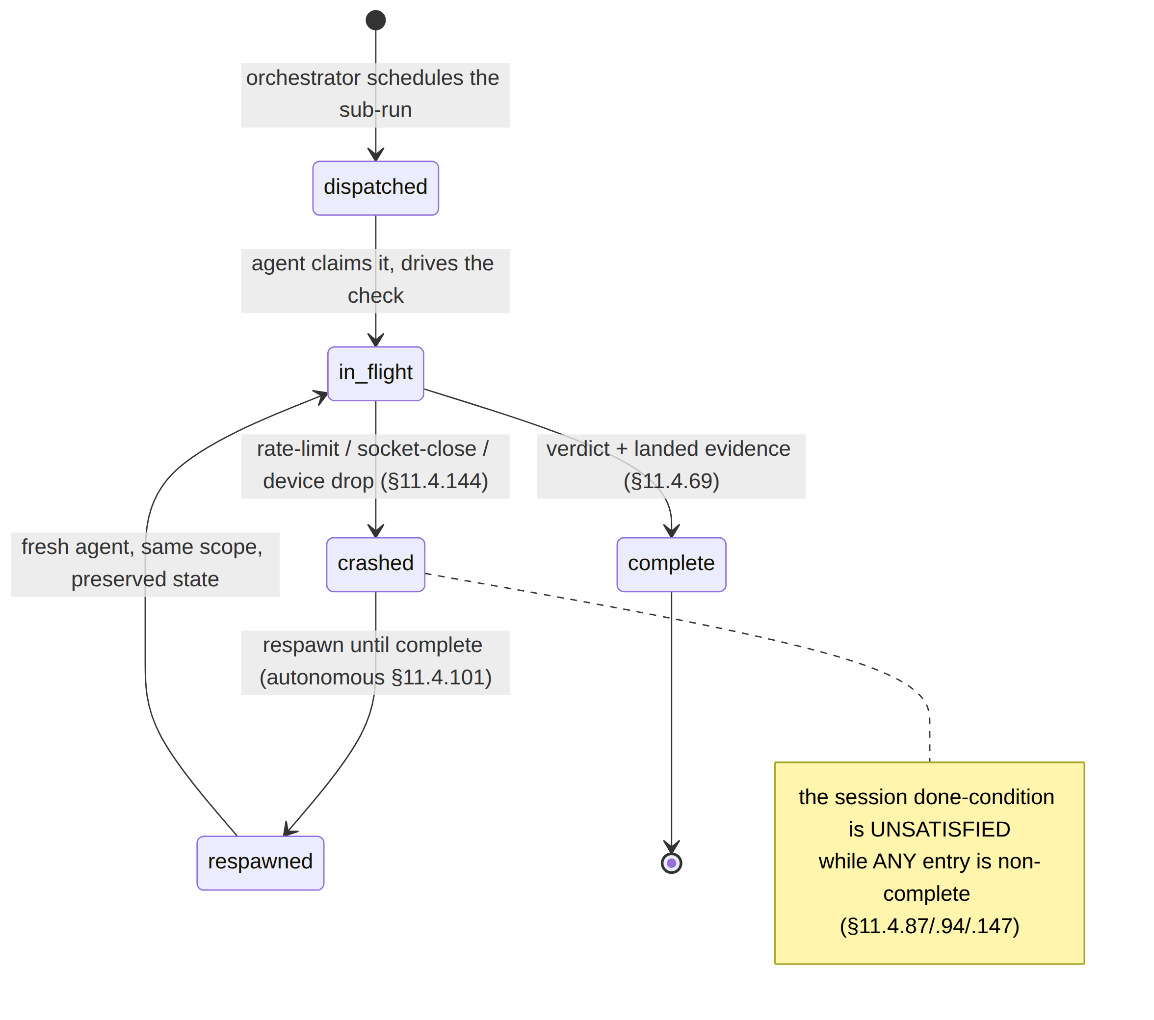
Lifecycle hazard | HelixQA response
transient API rate-limit kills a sub-run | flip to crashed, keep OPEN, respawn with the project's defined backoff (never invented, §11.4.6)
a tracked device drops mid-UI-drive | §11.4.144 availability-following: log an honest offline event, wait the defined reconnect budget, re-attach + resume, escalate on timeout
partial UI-drive state (half a recording) | preserve, §11.4.84 quiescence check, resume-or-clean-restart from a known-good base
a complete entry has no landed evidence | the done-condition refuses to read satisfied (a complete without evidence is a §11.4 PASS-bluff)
The honest boundary (§11.4.147): the registry + respawn guarantee the work is not lost or corrupted, NOT that it is correct — a respawned sub-run's output still crosses the per-check §11.4.69 evidence gate and the §11.4.40 retest; §11.4.147 is the durability layer beneath those.

8b. HelixQA as the independent verifier (§11.4.165) — the structural seam
HelixQA is dispatched as a structurally-separate agent from the code author (§11.4.70 / §11.4.165); §11.4.92 author-side self-evaluation PRECEDES but never satisfies it. The independence is load-bearing:
Verification axis | What HelixQA independently re-reads | The author claim it does NOT trust
reachability | the captured pcap (SYN-ACK present/absent) | "the reach test passed"
escalation | the tshark classification (H3 present, WG absent) | StatusReport.transport=="masque-h3" alone (B3)
UI flow | the window-scoped MP4 via vision_engine + core-FSM cross-check | "the shield went green" (a green shield while the FSM is Blocked FAILs)
no-log | the live-DB introspection report | "the schema is fine"
A HelixQA session that rubber-stamps the harness's claims without re-reading the artifacts is itself the bluff the §11.4.165 + §11.4.32 self-meta-test (§7) catches.

9. Open decisions surfaced for QA
# | Decision | Options | Recommendation
H-D1 | Vision verdict authority (QA-D4) | trust the harness verdict vs independent vision_engine re-read | independent re-read (overview §10) — vision_engine re-reads the MP4 + cross-checks the core FSM (defeats B3); the harness claim is never the verdict (§11.4.165)
H-D2 | crash-respawn backoff | fixed vs project-defined budget | project-defined backoff (§11.4.147) reusing the recovery path's existing budgets — never invented numbers (§11.4.6)
H-D3 | per-platform bank granularity | one bank per platform vs one bank with platform matrix | one bank per platform for clear per-surface coverage (§11.4.27); a matrix view is a derived projection
UNVERIFIED: the helix_qa orchestrator CLI (--suite), the bank-YAML keys (drives, evidence_class, vision_verdict, on_no_device), and the cmd/orchestrator path are the intended shape per the overview skeleton; confirm against the pinned HelixDevelopment/helix_qa SHA (§11.4.74 — extend upstream if unsupported).

Sources verified
- Volume-8 overview §2 (taxonomy row HQA), §5.6 (the orchestrator + the §11.4.116 sync-channel JSONL skeleton), §5.5 (banks it consumes), §7.2 (AC set it scores), §10 QA-D4 — read 2026-06-26.
- Sibling specs cross-referenced: challenges.md, e2e.md, integration.md, full-automation.md — written 2026-06-26 in this same volume.
- Constitution: §11.4.27 (no-fakes / 100% type coverage / HelixQA banks + autonomous sessions), §11.4.116 (real-time sync channel / verdict-carries-evidence-path), §11.4.147 (crashed-agent respawn / crash≠done registry), §11.4.165 (independent verification agent), §11.4.32 (self-meta-test), §11.4.45 (closed verdict vocabulary), §11.4.69 (sink-side evidence per check), §11.4.98 (autonomous / no manual step), §11.4.117 (pixel-oracle fallback), §11.4.52/.3 (honest operator-attended SKIP), §11.4.153/.154/.155/.159/.163 (REC / window-scope / prefix / media-validation), §11.4.148 (ticket integrity), §11.4.93/.95 (workable-items DB), §11.4.50 (determinism), §11.4.40 (pre-tag retest), §11.4.144 (device-availability following), §1.1 (paired mutation) — from CLAUDE.md in-context.
- The helix_qa orchestrator CLI + bank-YAML schema are reproduced from the overview skeleton — not independently fetched from HelixDevelopment/helix_qa (UNVERIFIED; confirm at the pinned SHA).

