Integration Testing — HelixVPN nano-detail spec (Volume 8 · §11.4.169 type 2)

Integration Testing — HelixVPN nano-detail spec (Volume 8 · §11.4.169 type 2)
Revision: 2 Last modified: 2026-07-04T12:00:00Z
Rev 2 (2026-07-04): independently re-verified against SPECIFICATION.md / decision-register.md / 10-testing-acceptance-and-qa.md during a corpus-wide gap-analysis pass; no contradictions or gaps found (the on-demand-infra-via- containers invariant and the no-mocks-below-unit boundary are consistent with the rest of the corpus). Revision bumped for the audit pass itself.
Nano-detail expansion of §5.2 of the Volume-8 overview. Integration (INT) is the first layer where mocks are forbidden (§11.4.27): every seam that touches real infrastructure is exercised against a real Postgres, a real Redis, and a real edge, booted on-demand through the vasic-digital/containers submodule (§11.4.76) running rootless (§11.4.161). This document fixes the INT surface, the on-demand-infra invariant, the no-log schema invariant, the captured evidence, the determinism contract, the acceptance gate, the paired §1.1 mutation, and concrete skeletons. Spec-only; unproven assumptions marked UNVERIFIED. Siblings: unit.md (mocks live there, not here), e2e.md, full-automation.md, challenges.md, helixqa.md.

Table of contents
- 1. Scope — the seams INT covers
- 2. Harness — the containers submodule is the ONLY path
- 3. Fixtures — real services, seeded data, zero mocks
- 4. Evidence taxonomy — what an INT PASS captures
- 5. Determinism — N-iteration identical evidence
- 6. Acceptance gate — when INT blocks a release
- 7. The paired §1.1 mutation (anti-bluff proof)
- 8. Test skeletons
- 9. Open decisions surfaced for QA
- Sources verified

1. Scope — the seams INT covers
INT owns every place where two real components meet over real infrastructure — the seams a unit test cannot reach without a mock (and a mock here is a §11.4.27 violation).
Seam | Components | The invariant proven (real infra) | Spec source
RLS multi-tenant isolation | svc-identity + Postgres | a tenant-B query under tenant-A's RLS role returns zero tenant-B rows | ../v03-control-plane/data-model-ddl.md, ../v05-security/no-logging-as-code.md
Device enrollment end-to-end | svc-identity + svc-registry + svc-pki + Postgres | OIDC/anon token → device-generated WG keypair (private key never persisted server-side) → short-lived mTLS cert issued | ../v05-security/identity-and-enrollment.md, ../v03-control-plane/svc-pki.md
Event backbone round-trip | svc-events + Redis Streams + svc-coordinator | publish on a Redis stream → coordinator consumer-group consume → minimal delta emitted; XAUTOCLAIM DLQ on a stuck consumer | ../v03-control-plane/svc-events.md, ../v03-control-plane/reconciliation-flow.md
WatchNetworkMap server-stream | svc-coordinator + svc-policy + Postgres | snapshot + deltas; peers already policy-filtered (need-to-know); a new enroll appears as a delta | ../v03-control-plane/svc-coordinator.md, ../v03-control-plane/protobuf-spec.md
IPAM persistence (the allocation half) | svc-ipam + Postgres FOR UPDATE | a real allocation is durable, unique, and survives a reconnect (the math half is UNIT, unit.md §8.3) | ../v03-control-plane/svc-ipam.md
No-log schema invariant | Postgres DDL + schema-lint | the live schema contains no durable per-flow / per-connection / per-packet table; only aggregate counters | ../v05-security/no-logging-as-code.md
Policy compile → enforce (control half) | svc-policy + svc-coordinator + edge config | a compiled policy reaches the edge verdict-map config (the packet enforcement is E2E/SEC) | ../v03-control-plane/svc-policy.md
API authz | svc-api (Gin/Connect-RPC) + svc-identity | a token scoped to tenant-A cannot mutate tenant-B; revoked token rejected | ../v03-control-plane/svc-api.md
Boundary with E2E: INT proves the control-plane seams (a delta is emitted, a cert is issued, a row is isolated). The moment the assertion needs a packet on a real tunnel (reach an authorized LAN host, default-deny a SYN) it is E2E and uses the netns rig (e2e.md) — INT does not build tunnels.

2. Harness — the containers submodule is the ONLY path
Per §11.4.76 (containers-submodule mandate) + §11.4.161 (rootless), all containerised infra is booted through vasic-digital/containers (digital.vasic.containers, Go) via its pkg/boot / pkg/compose / pkg/health primitives. There is no docker/podman CLI anywhere in the INT harness; no sudo; no rootful Docker. This is the on-demand-infra invariant: make test (or go test -tags integration) boots Postgres + Redis (+ edge where needed) itself, runs against the real services, and tears them down — the developer never runs podman machine or docker compose up by hand.
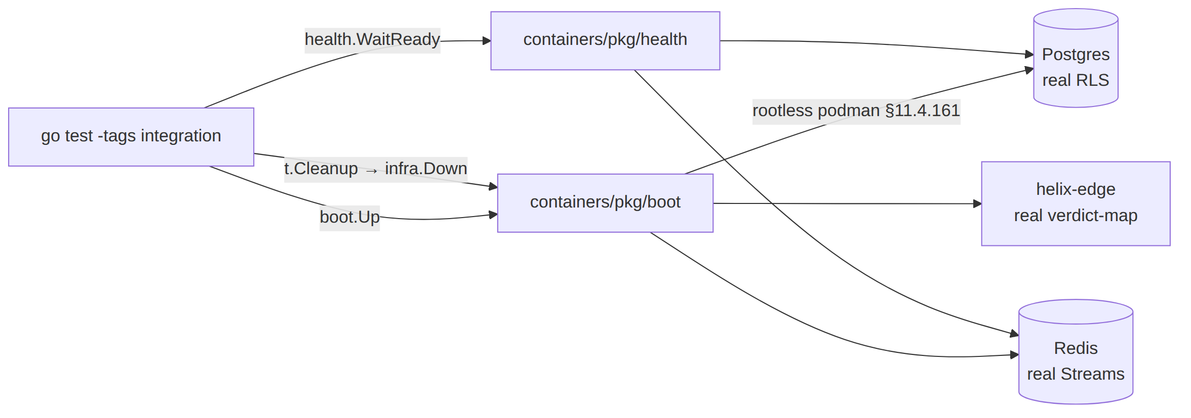
- Boot: boot.Up(ctx, boot.Spec{Postgres:true, Redis:true, Rootless:true}) returns an infra handle exposing DSNs/addresses. The Rootless:true field is the §11.4.161 binding — a rootful spec is rejected by the submodule on a platform that supports rootless.
- Health: health.WaitReady(ctx, infra, health.Postgres) blocks until the service answers a real probe (a SELECT 1, a Redis PING) — never a fixed sleep, which is a §11.4.107(3) loading-vs-ready confusion and a flake source.
- Teardown: t.Cleanup(func(){ infra.Down(ctx) }) guarantees quiescence on every exit path (§11.4.14); an orphaned container after the test is a §11.4.14 violation the post-test sanity check FAILs on.
- Missing capability ⇒ extend upstream: if a needed lifecycle primitive is absent from containers, it is added by an upstream PR (§11.4.74), never reimplemented in-project with a raw podman call.
Invocation seam (Makefile, overview §9): test: cargo test && go test -race ./helix-go/... && melos run test. The integration build tag gates the boot so unit-only runs (pre-commit) do not pay the container cost; INT runs on the pre-push hook (§11.4.75 Layer-2).

3. Fixtures — real services, seeded data, zero mocks
Fixture | Real or mock | Notes
Postgres instance | real (booted via containers) | migrated to the production DDL (../v03-control-plane/data-model-ddl.md); RLS policies enabled
Redis instance | real | Streams + consumer groups; ephemeral (no persistence — the no-log posture)
edge process | real helix-edge build | for policy-enforce-config INT (not packet enforcement)
seed tenants/devices | real rows via the real API/store | seedTenant(db,"tenant-A","device-a1") — inserted through the same code path production uses
OIDC/anon tokens | real-shaped, test-issuer | a real token validation path; the issuer is a test key (a §11.4.10 bootstrap credential, outside test execution)
mocks | FORBIDDEN (§11.4.27) | any mock/stub/fake import in an INT test file FAILs CM-NO-FAKES-BEYOND-UNIT-TESTS
The seed data is inserted through the production store interface, not raw SQL back-doors, so the INT test exercises the real write path. The only permitted out-of-band setup is the §11.4.10 credential bootstrap (a .env test token), which is configuration, not test driving (§11.4.98).

4. Evidence taxonomy — what an INT PASS captures
Per §11.4.5/§11.4.69 an INT PASS cites a captured artifact whose shape the seam fixes — never a config-only / absence-of-error assertion (bluff-class B1/B2).
Seam | §11.4.69 evidence shape | Artifact path
RLS isolation | the captured rowset under each tenant's RLS role (A sees a1, not b1) | qa-results/int/rls_<ts>.json
enrollment | the issued cert chain + a log/DB scan proving zero private-key bytes persisted server-side (§11.4.10) | qa-results/int/enroll_<ts>/
event round-trip | the consumed-event transcript + emitted-delta JSON, with publish-ts→delta-ts timing | qa-results/int/events_<ts>.jsonl
WatchNetworkMap | the server-stream transcript: snapshot frame + the post-enroll delta frame, peers policy-filtered | qa-results/int/watch_<ts>.jsonl
IPAM persistence | the durable allocation rowset + the unique-constraint-violation count (0) | qa-results/int/ipam_<ts>.json
no-log schema | the schemalint report (PASS = zero forbidden tables) | qa-results/int/schemalint_<ts>.txt
The captured rowset/transcript is the evidence — the test re-reads it, the Challenge engine (challenges.md) re-reads it independently. An INT PASS that asserts only "no error returned" without capturing the rowset/transcript is a §11.4.68 absence-of-error bluff and is rejected.

5. Determinism — N-iteration identical evidence
Per §11.4.50 every INT PASS reproduces identically across N=3 (normal) / N=10 (cycle-validation). Container-backed tests are the classic flake source; the mandate is mechanical:
- Health-gate, never sleep. Readiness is health.WaitReady against a real probe; a fixed sleep is forbidden (the loading-vs-ready confusion §11.4.107(3)).
- Fresh infra per run, deterministic seed. Each ab_run_n_times iteration boots a clean Postgres/Redis and seeds identical data, so the captured rowset / transcript hashes identically; a divergent hash is auto-FAIL (no flake escape).
- No wall-clock in assertions. Timing evidence (publish→delta) is captured as a value compared to an SLO budget, not asserted equal across runs; the rowset and delta content are what must hash-match.
- Single-resource ownership (§11.4.119). Parallel INT suites that share an exclusive resource (one edge process, one stream) are partitioned — exactly one owner drives, others read — so cross-contaminated evidence cannot produce a non-deterministic PASS.

6. Acceptance gate — when INT blocks a release
Gate | Bar | Layer
pre-push hook (§11.4.75 Layer-2) | INT subset GREEN (boots PG+Redis via containers) | local, blocks push
make test INT stage | all INT seams GREEN with captured evidence | release sweep
CM-RLS-ENFORCED | RLS isolation INT PASS + its §1.1 mutation FAILs | pre-build + runtime
schemalint / CM-NO-LOG-SCHEMA | zero durable per-flow tables; backs AC8 (overview §7.2) | pre-build + INT
CM-NO-FAKES-BEYOND-UNIT-TESTS | no mock import in any INT file | pre-build
INT is a release gate for AC8 (no durable conn/traffic log) and a contributor to G6 (Phase-0 push-based reconcile, overview §7.1), AC2/AC5/AC6 (the control-plane half of reach/reconcile/revoke). An INT seam in FAIL keeps its feature's coverage-ledger cell out of AUTONOMOUS_VERIFIED (overview §6), blocking the phase release.

7. The paired §1.1 mutation (anti-bluff proof)
The canonical INT mutation — RLS:
# §1.1 mutation for CM-RLS-ENFORCED (meta-test plants, asserts FAIL, restores)
- in data-model-ddl migration: ALTER TABLE devices DISABLE ROW LEVEL SECURITY;
- assert: TestRLSCrossTenantDenial now sees device-b1 under tenant-A → test FAILs
- restore (re-enable RLS); assert PASS again (working-tree quiescence §11.4.84)
The no-log schema mutation:
# §1.1 mutation for CM-NO-LOG-SCHEMA (defeats a "we forgot we log flows" regression)
- seed a forbidden table: CREATE TABLE connections (src_ip inet, dst_ip inet, started_at timestamptz);
- assert: schemalint FAILs (a durable per-flow table appeared)
- restore (drop the table); assert schemalint PASS
Each INT gate's mutation makes it FAIL — proving the gate is not a tautology (the §11.4.120 reconciliation rule applies if a correct schema change later makes a stale schema-lint rule FAIL: rewrite the rule to the new invariant, never weaken it).

8. Test skeletons

8.1 RLS cross-tenant denial (the canonical INT test)
// helix-go/internal/store/rls_integration_test.go
//go:build integration
package store
import (
"context"; "testing"
"digital.vasic.containers/pkg/boot" // §11.4.76 sole container seam
"digital.vasic.containers/pkg/health"
)
func TestRLSCrossTenantDenial(t *testing.T) {
ctx := context.Background()
infra, err := boot.Up(ctx, boot.Spec{Postgres: true, Redis: true, Rootless: true}) // §11.4.161
if err != nil { t.Fatalf("boot infra: %v", err) }
t.Cleanup(func() { _ = infra.Down(ctx) }) // §11.4.14 quiescence
if err := health.WaitReady(ctx, infra, health.Postgres); err != nil { t.Fatal(err) }
db := mustConnect(t, infra.PostgresDSN())
migrateProductionDDL(t, db) // real RLS policies enabled
seedTenant(t, db, "tenant-A", "device-a1") // through the production store path
seedTenant(t, db, "tenant-B", "device-b1")
rows := queryAs(t, db, "tenant-A", `SELECT id FROM devices`) // under tenant-A RLS role
requireContains(t, rows, "device-a1")
requireNotContains(t, rows, "device-b1") // captured rowset = evidence (§11.4.5/.69)
writeEvidence(t, "qa-results/int/rls", rows) // ab_pass_with_evidence cites this
// paired §1.1 mutation: DISABLE ROW LEVEL SECURITY → this test MUST FAIL (CM-RLS-ENFORCED)
}

8.2 Enrollment — key-never-leaves-server (§11.4.10 + S2)
//go:build integration
func TestEnrollmentPrivateKeyNeverPersistedServerSide(t *testing.T) {
infra := mustBoot(t, boot.Spec{Postgres: true, Rootless: true})
api := startAPI(t, infra) // real svc-identity+registry+pki
tok := mintAnonDeviceToken(t) // real token path
resp := api.Enroll(t, tok, devicePubKeyOnly()) // client sends PUBLIC key only
requireValidMTLSCert(t, resp.Cert) // short-lived cert issued (svc-pki)
// SCAN: no private-key bytes anywhere server-side (DB + logs), §11.4.10 / S2
leaks := scanForPrivateKeyBytes(t, infra.PostgresDSN(), infra.LogDir())
requireEmpty(t, leaks) // captured scan report = evidence
// §1.1 mutation: persist the private key → scan finds it → CM-KEY-NEVER-LEAVES FAILs
}

8.3 Event backbone round-trip (Redis Streams → coordinator delta)
//go:build integration
func TestEventPublishToDeltaEmit(t *testing.T) {
infra := mustBoot(t, boot.Spec{Postgres: true, Redis: true, Rootless: true})
coord := startCoordinator(t, infra) // real consumer group
bus := connectRedisStreams(t, infra.RedisAddr())
bus.Publish(t, "device.enrolled", enrollEvent("carol", "10.0.0.3"))
delta := coord.AwaitDelta(t, 1*time.Second) // SLO1 budget < 1 s
requireDeltaAdds(t, delta, "carol") // minimal delta, captured transcript
requirePolicyFiltered(t, delta, forPeer("alice")) // need-to-know peer filtering
// §1.1 mutation: drop the XADD ack path → delta never emitted → test FAILs
}

8.4 No-log schema invariant (DDL + schema-lint)
-- the invariant schemalint enforces against the LIVE booted DB (AC8)
-- ALLOWED: aggregate counters only
CREATE TABLE traffic_counters (
tenant_id uuid NOT NULL,
window_start timestamptz NOT NULL,
rx_bytes bigint NOT NULL, -- SUM over window, NOT per-connection
tx_bytes bigint NOT NULL,
PRIMARY KEY (tenant_id, window_start)
);
-- FORBIDDEN (the §1.1 mutation seeds this → schemalint MUST FAIL):
-- CREATE TABLE connections (src_ip inet, dst_ip inet, started_at timestamptz, ...);
# scripts/schemalint.sh — runs against the containers-booted DB, NOT a static file
psql "$INT_DSN" -Atc "
SELECT table_name FROM information_schema.columns
WHERE column_name IN ('src_ip','dst_ip','src_port','dst_port','packet','flow_id')
AND table_schema='public'" | grep -q . \
&& ab_fail "no-log invariant breached: a per-flow column exists" \
|| ab_pass_with_evidence "no durable conn/traffic log" "qa-results/int/schemalint_$(date +%s).txt"

8a. The on-demand-infra lifecycle (failure modes + cleanup)
The §11.4.76 on-demand-infra invariant has a precise lifecycle whose failure modes are all defects, never flakes:
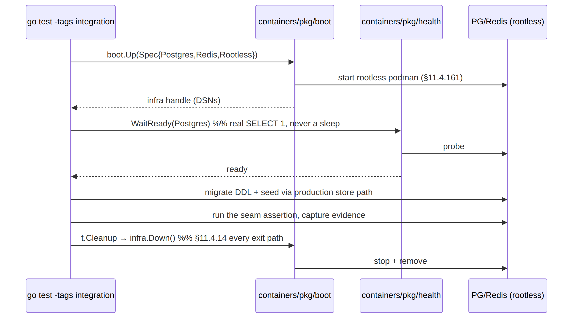
Failure mode | Symptom | Classification
boot times out | boot.Up returns error | infra/host defect — surfaced, not a test FAIL bluff (§11.4.1)
WaitReady replaced by sleep | intermittent "connection refused" | a §11.4.107(3) loading-vs-ready bug → fix the harness, never retry-hope (§11.4.102)
infra.Down skipped | orphan container survives | §11.4.14 violation; post-test sanity check FAILs the run
rootful spec on a rootless platform | boot rejected | §11.4.161 — the spec must be Rootless:true
a needed primitive missing from containers | can't boot the edge | extend upstream (§11.4.74), never a raw podman workaround

8b. Evidence-shape contract per seam (the §11.4.69 binding)
The INT layer's anti-bluff guarantee is that the captured artifact's shape is fixed per seam — a PASS that does not produce the fixed shape is rejected at the gate, not merely flagged:
Seam | Required shape | A bluff that the shape rejects
RLS | a JSON rowset with tenant-A's rows and without tenant-B's | "query returned no error" (B2) — no rowset means no proof
enrollment | issued cert chain + an empty private-key scan report | "enrollment succeeded" (B1) — no scan means the key could have leaked
events | a consumed-event + emitted-delta transcript with timing | "delta emitted" claim with no transcript (B3 wrong-plane)
no-log schema | the live-DB introspection report (zero forbidden columns) | a static-DDL grep (misses a runtime migration, §11.4.108)

9. Open decisions surfaced for QA
# | Decision | Options | Recommendation
I-D1 | Fresh-infra-per-test vs shared-infra-per-suite | clean boot each test (slow, deterministic) vs one boot per package (fast) | clean boot per test for the security floor (RLS, enrollment); shared per-package for read-only seams — balances §11.4.50 determinism against §11.4.82 iteration speed
I-D2 | schema-lint timing | static-DDL grep vs live-DB introspection | live-DB introspection (overview §5.2) — a static grep misses a migration that adds a forbidden table at runtime (the SOURCE→ARTIFACT gap, §11.4.108)
I-D3 | edge-in-INT vs edge-only-in-E2E | boot edge for policy-config INT vs defer all edge to E2E | boot edge for config-reach INT, defer packet-enforce to E2E — keeps the INT/E2E boundary at "packet on a wire"
UNVERIFIED: the exact boot.Spec field names (Postgres, Redis, Rootless, Edge) and health.WaitReady signature are the intended containers submodule API per the overview skeleton; confirm against the pinned digital.vasic.containers SHA at integration time (§11.4.74 — extend upstream if absent).

Sources verified
- Volume-8 overview §2 (taxonomy row INT), §5.2 (the containers-submodule skeleton + no-log DDL), §6 (coverage ledger), §9 (Makefile test: + rootless note) — read 2026-06-26.
- Sibling specs cross-referenced: ../v03-control-plane/data-model-ddl.md, ../v03-control-plane/svc-identity.md, ../v03-control-plane/svc-pki.md, ../v03-control-plane/svc-events.md, ../v03-control-plane/svc-coordinator.md, ../v03-control-plane/svc-ipam.md, ../v05-security/no-logging-as-code.md, ../v05-security/identity-and-enrollment.md — filenames confirmed present 2026-06-26.
- Constitution: §11.4.27 (no-fakes-beyond-unit), §11.4.76 (containers-submodule sole path), §11.4.161 (rootless), §11.4.74 (extend-upstream), §11.4.14 (quiescence cleanup), §11.4.5/.68/.69 (captured / no-absence-of-error / sink-side evidence), §11.4.50 (determinism), §11.4.107(3) (loading-vs-ready), §11.4.108 (SOURCE→ARTIFACT gap), §11.4.119 (single-resource owner), §11.4.120 (gate reconciliation), §11.4.10 (credentials), §1.1 (paired mutation) — from CLAUDE.md in-context.
- The containers submodule API (pkg/boot/pkg/health/pkg/compose) is taken from the overview skeleton — not independently fetched from vasic-digital/containers (UNVERIFIED; confirm at the pinned SHA).

