`helix_design` — the decoupled, reusable HelixVPN design-system submodule

helix_design — the decoupled, reusable HelixVPN design-system submodule
Revision: 1 Last modified: 2026-06-25T12:00:00Z
Master technical specification — Volume 10 (Design System), nano-detail anchor document. This doc specifies vasic-digital/helix_design as a fully decoupled, project-not-aware, reusable design-system submodule: its purpose and scope, why it is a separate submodule (§11.4.28 equal-codebase + decoupling, §11.4.74 catalogue-first reuse), its repository layout, the decoupling invariants (NO HelixVPN-specific context leaks into the submodule — brand values are injected as a token preset per §11.4.28(B)), its semver/versioning policy, the consumption model (how Client / Console / Connector — and any future app — incorporate it), and its relationship to the mandatory OpenDesign design-and-refinement system (§11.4.162, detailed in the sibling [opendesign-foundation.md]). SPEC-ONLY: it describes what to build, not the shipping artifact. No bluff: every external fact about OpenDesign is verified in the sibling doc and cited; anything unproven is tagged UNVERIFIED (§11.4.6).

Table of contents
- 0. Position, ownership, and invariants
- 1. Purpose & scope
- 2. Why a separate submodule (§11.4.28 / §11.4.74)
- 3. The decoupling invariants (no project context leaks)
- 4. Repository layout
- 5. Token tiers, theming, and the brand-preset injection model
- 6. The export forms (one source → every consumable form)
- 7. upstreams/, install_upstreams, and helix-deps.yaml
- 8. Semver & versioning policy
- 9. The consumption model (how ANY app incorporates it)
- 10. Relationship to OpenDesign (§11.4.162)
- 11. Architecture diagram (submodule → exporters → consuming apps)
- 12. Quality, testing, and gates owned here
- 13. Open decisions surfaced by this document
- Sources verified

0. Position, ownership, and invariants
helix_design is the single source of design truth for every HelixVPN user-facing surface. The Flutter helix-ui workspace already names a helix_design package [04_CLIENT §1.1/§2.1] — but per the operator mandate (2026-06-25, §11.4.162) and [MASTER_INDEX Volume 10], the design system is promoted to a standalone, decoupled, reusable submodule at vasic-digital/helix_design (snake_case flat per §11.4.29) that the Flutter helix_design package re-exports for Dart consumers, and that non-Flutter surfaces (native shims, future apps) consume directly via the polyglot token bundle.

0.1 What this document owns vs. consumes
# | Contract | Owned here | Consumed from / by
O-A1 | The submodule's existence, identity, and flat layout at vasic-digital/helix_design | §1, §4 | —
O-A2 | The decoupling invariants — no HelixVPN context inside the submodule | §3 | enforced against the whole submodule tree
O-A3 | The token-tier model (primitive → semantic → component) + brand-preset injection | §5 | deepened in [design-tokens.md], [color-system.md]
O-A4 | The export-form set (JSON source → CSS / Dart / Swift / Compose / ArkTS / C-Qt) | §6 | pipeline deepened in [token-export-pipeline.md]
O-A5 | The consumption recipe (git submodule add, install_upstreams, pull tokens) | §7, §9 | every consuming app + future app
O-A6 | The relationship to OpenDesign | §10 | detailed in [opendesign-foundation.md]
C-B1 | The OpenDesign tool facts (what it is, how it is consumed) | — | [opendesign-foundation.md] (web-verified)
C-B2 | The connection-state palette ↔ TunnelStatus mapping | — | [04_CLIENT §2.1], [02_ORCH §4.1] (5-variant core::TunnelStatus wire enum → 7-variant ffi::TunnelStatus Dart-facing)
C-B3 | The helix-ui package graph that re-exports the Dart bundle | — | [04_CLIENT §1.1/§2.1]

0.2 Non-negotiable invariants
# | Invariant | Source
DS-I1 | helix_design contains NO project-specific HelixVPN context. It ships generic tokens / themes / components; HelixVPN brand values arrive as an injected token preset (config), never hardcoded. | §11.4.28(B)
DS-I2 | OpenDesign is the only design-and-refinement system. No ad-hoc CSS, no one-off design tools. Missing patterns extend OpenDesign upstream (§11.4.74), never reimplemented in-project. | §11.4.162
DS-I3 | Every component & color ships a light AND a dark variant. A token, component, or screen with only one theme is incomplete. | §11.4.162
DS-I4 | Elements MUST NOT overlap; labels MUST NOT be overlaid. The layout-integrity rule is a release blocker, asserted by visual-regression ([visual-regression-and-qa.md]). | §11.4.162
DS-I5 | All UI changes carry visual-regression coverage. Golden screenshots + token-drift assertions gate every design change. | §11.4.162, §11.4.4(b)
DS-I6 | One canonical token source; every consumable form is a derived export. Hand-editing a derived form (e.g. the Dart ThemeData) instead of the source is forbidden — it is a build-derivative per §11.4.30/§11.4.77, regenerated by the pipeline. | §6, §11.4.12
DS-I7 | Honest boundary — helix_design governs design tokens, themes, components, and their visual correctness. It does NOT assert functional correctness (§11.4.27), accessibility behaviour beyond contrast/labels it can statically check, or UI-driven test methodology (§11.4.48/.49). | §11.4.162 honest boundary

1. Purpose & scope

1.1 Purpose
helix_design exists so that every HelixVPN user-facing application — the Client (end-user VPN app on all 8 platforms: iOS, macOS, Android, Windows, Linux, Web, HarmonyOS, Aurora), the Console (admin web app), and the Connector (appliance config UI) — renders from one design source: the same palette (light + dark), the same type ramp, the same spacing/radius/elevation/motion scale, and the same component anatomy, without any of those three apps owning a private copy of the design tokens [SPEC roles]. A change to a brand color, a contrast fix, or a new component variant is made once in helix_design and propagates — through the export pipeline (§6) — to all three apps and all 8 platforms.

1.2 Scope (what the submodule contains)
In scope:
- The canonical token source — primitive → semantic → component tiers, with the light + dark theme model (§5; schema deepened in [design-tokens.md]).
- The HelixVPN brand preset — the one HelixVPN-flavoured config that injects the brand seed color, the connection-state palette, the type face choices, etc., into the generic token tiers (§5.4). This is the only place HelixVPN-specific values live, and it is structured as injectable config, not as inline submodule values (DS-I1).
- The exporters — the generators that emit the token source into every consumable form (JSON / CSS / Dart / Swift / Compose / ArkTS / C-Qt; §6).
- The component library specs + reference implementations — anatomy, states, variants, light+dark, a11y (deepened in [component-library.md]). Reference implementations are per-platform where the component is platform-native; otherwise the spec + tokens are the deliverable and each app composes the widget from tokens.
- The asset corpus — icon set, illustration sources, fonts (or font references), in the asset forms each platform needs (deepened in [assets-and-deliverables.md]).
- The OpenDesign-native design-system folder — the DESIGN.md + tokens.css form OpenDesign consumes/refines (§10; deepened in [opendesign-foundation.md]).
- The visual-regression + token-drift test suite that gates every change (§12).
- Docs — every Volume 10 nano-detail document ships with the submodule (so the design system is self-documenting and reusable by any future project).
Out of scope (lives in the consuming app, not the submodule):
- The Riverpod projectUiState state machine and UiConnectionState projection — that is application logic, owned by helix_domain [04_CLIENT §7]. helix_design provides the colorForUiState-style token map, not the state machine that drives it.
- Per-app navigation / IA / routing — owned by each app.
- FFI, control-plane wire, tunnel lifecycle — Volumes 2/3/4.

2. Why a separate submodule (§11.4.28 / §11.4.74)

2.1 Reuse (§11.4.74 catalogue-first)
The design system is not HelixVPN-specific in its machinery. A palette-tiering model, a polyglot token exporter, a light/dark theming engine, and an icon pipeline are exactly the kind of capability §11.4.74 says must be reusable across ≥3 unrelated projects and therefore must live in the vasic-digital catalogue, not buried in one product. Any future Helix-ecosystem app (a different VPN client, an admin tool, a marketing site, a device dashboard) incorporates helix_design, swaps the brand preset (§5.4), and inherits the entire token/theme/component/export machinery for free. Burying the design system inside helix-ui would force the next project to either re-implement it (a §11.4.74 duplicate-implementation violation) or depend on a VPN app it does not need.

2.2 Equal-codebase + decoupling (§11.4.28)
Per §11.4.28(A), helix_design — once it is an owned submodule — is an equal part of the codebase: same anti-bluff testing, same docs, same multi-upstream push discipline as the main repo. Per §11.4.28(B), it MUST stay project-not-aware and fully testable in isolation — which forces the clean seam this volume specifies: generic tiers in the submodule, HelixVPN values injected as config (DS-I1, §5.4). The decoupling is not a nicety; it is the mechanism that makes the reuse of §2.1 real rather than aspirational.

2.3 Flat-layout requirement (§11.4.28(C) / §11.4.29)
Per §11.4.28(C) nested own-org submodule chains are FORBIDDEN; the dependency is reached from the parent project root at a flat path. helix_design is therefore added at helix_vpn/helix_design/ (or helix_vpn/submodules/helix_design/), snake_case (§11.4.29), and the Flutter helix-ui workspace's helix_design package depends on it via a path/replace directive — it does not nest helix_design inside helix-ui as a sub-submodule.
D-DESIGN-1 (open). Two viable layouts for "the Flutter package vs. the polyglot bundle": (a) a single helix_design submodule that contains BOTH the Flutter package (packages/flutter/) AND the polyglot token/asset bundle (tokens/, export/, assets/), the Flutter helix-ui re-exporting packages/flutter/; or (b) two submodules — helix_design (polyglot source + exporters) and helix_design_flutter (the Dart package that consumes the generated Dart export). §11.4.28(C) forbids nesting but permits sibling flat submodules. This document specifies layout (a) as the default (one submodule, one design truth, fewer moving parts) and flags (b) as the alternative if the Dart package's release cadence must diverge from the token source's. Resolved at the Volume-10 design review. UNVERIFIED until ratified.

3. The decoupling invariants (no project context leaks)
DS-I1 is the load-bearing rule. Concretely, inside the helix_design submodule tree the following are FORBIDDEN (each is a §11.4.28(B) decoupling violation, caught by the pre-commit decoupling grep CM-OWNED-SUBMODULE-DECOUPLING):
Forbidden inside the submodule | Why | Where it goes instead
The literal strings HelixVPN, helix_vpn, helixvpn in token names / component logic / exporter code | project context leak | the brand-preset config file (§5.4) may carry the product name as a value; the machinery may not
A hardcoded brand seed color in a primitive/semantic token | couples the generic tiers to one product | the brand seed is a preset value injected into the semantic tier (§5.4)
A TunnelStatus-shaped enum or any VPN-domain type | VPN domain leak | the connection-state palette is generic "status" tokens (success/warn/danger/neutral/info); the mapping to TunnelStatus lives in helix_domain [04_CLIENT §7.2]
Import of any helix-core / helix_api / control-plane package | inverts the dependency direction | the submodule depends on NOTHING Helix-product-side (it is a leaf)
A hardcoded HelixVPN server list, region name, or asset path | project context | app-side config
What the submodule MAY contain: generic design primitives, a named default brand preset folder (e.g. presets/helix/ — a value, swappable), generic component specs, generic status-token semantics. The test that DS-I1 holds: a throwaway consuming project that injects a different brand preset and builds all export forms green, runs the submodule's own tests against that layout, and contains no reference back to HelixVPN (the §11.4.31 manifest-paired Challenge pattern).
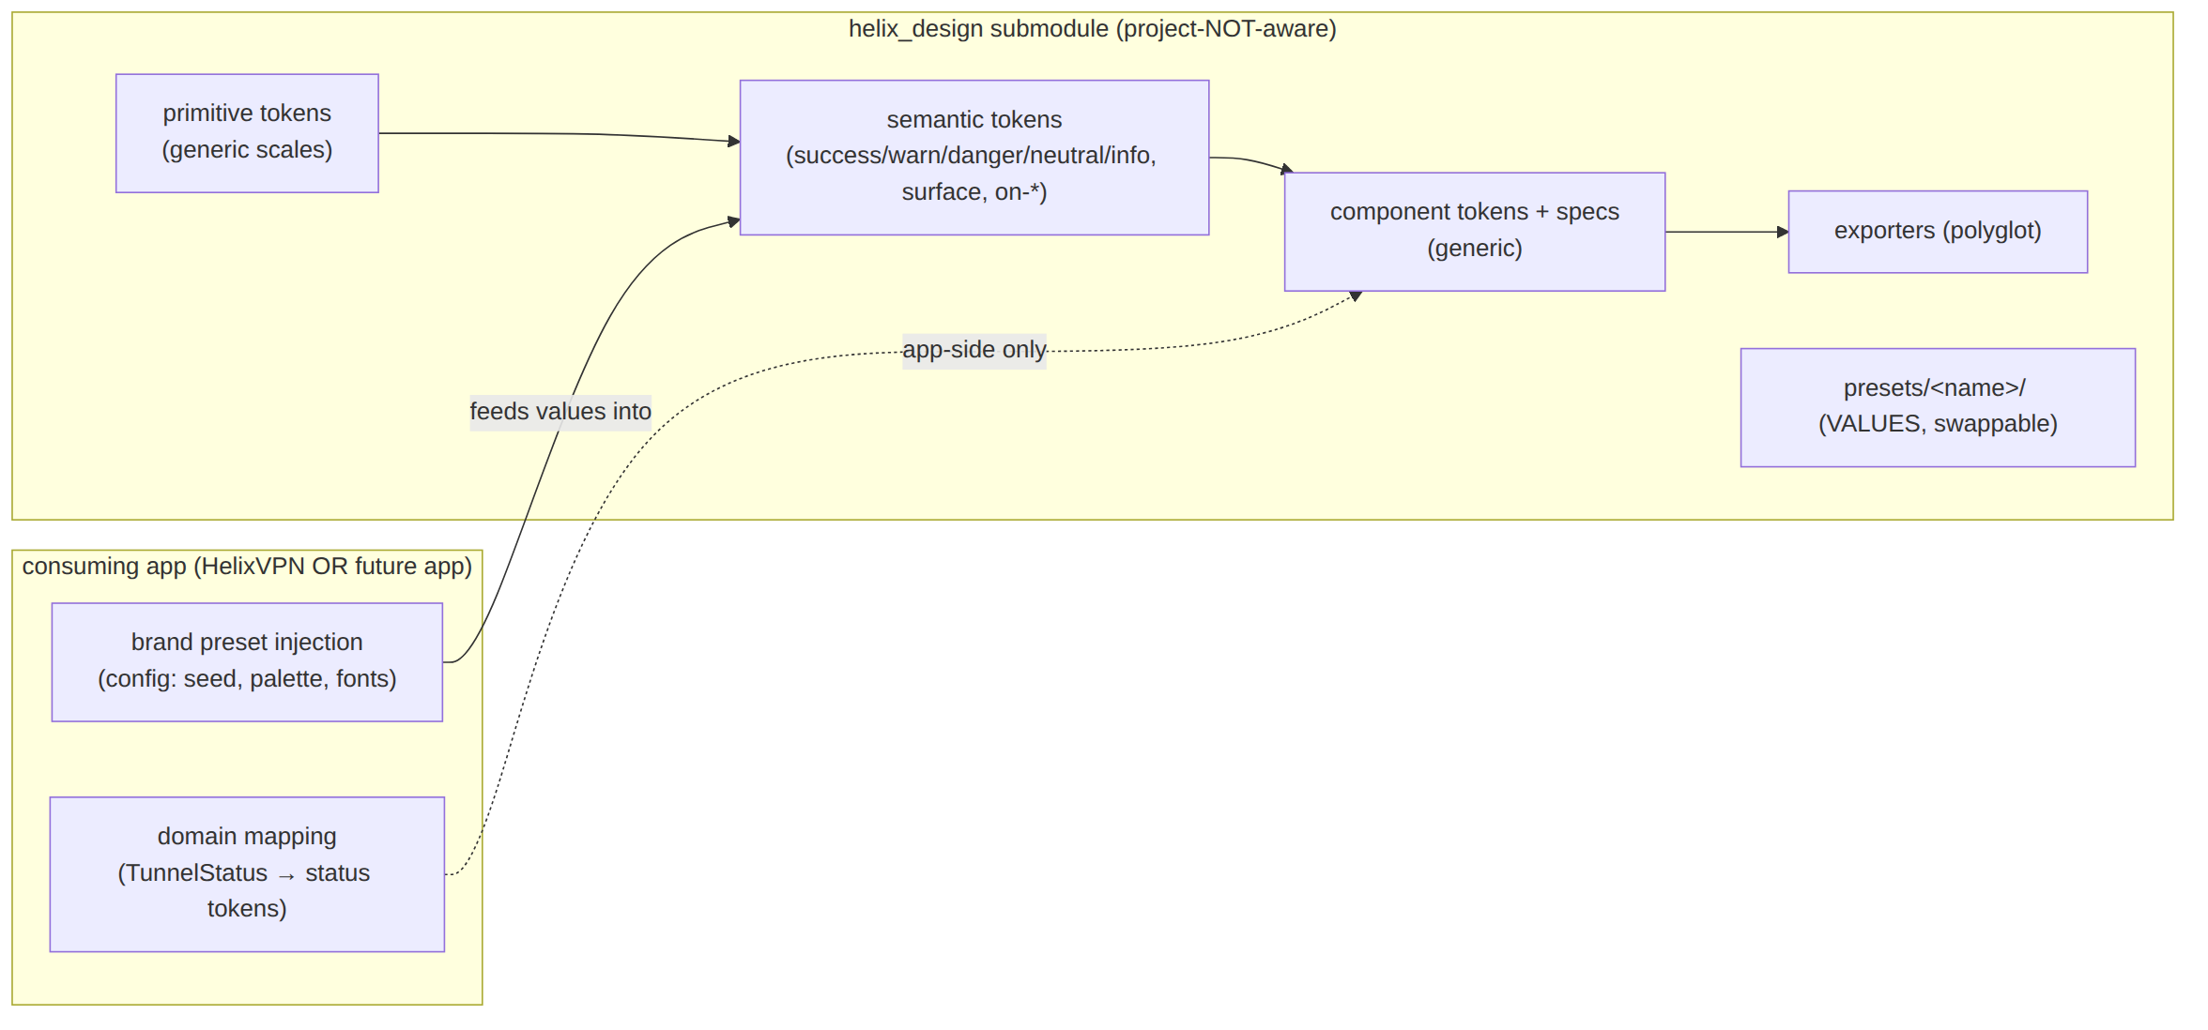

4. Repository layout
Layout (a) of D-DESIGN-1 (single submodule). Every directory is generic-by-default; the presets/helix/ folder holds the only HelixVPN-flavoured values (and even those are structured so a future app drops a sibling presets/<x>/).
helix_design/ # vasic-digital/helix_design (flat submodule)
├── README.md # what it is, install, the per-app pull recipe (§9)
├── CLAUDE.md AGENTS.md QWEN.md GEMINI.md # inherit constitution (§11.4.157)
├── helix-deps.yaml # §11.4.31 dependency manifest (own-org deps, if any)
├── LICENSE CHANGELOG.md VERSION # semver source of truth (§8)
├── upstreams/ # §11.4.36 push-mirror recipes (one .sh per upstream)
│ ├── github.sh gitlab.sh gitflic.sh gitverse.sh
├── tokens/ # ── THE CANONICAL SOURCE OF TRUTH ──
│ ├── primitive/ # raw scales: color ramps, type sizes, space, radius…
│ │ ├── color.json type.json space.json radius.json
│ │ ├── elevation.json motion.json zindex.json breakpoints.json
│ ├── semantic/ # role tokens that reference primitives (light + dark)
│ │ ├── color.light.json color.dark.json
│ │ ├── type.json space.json elevation.json motion.json
│ └── component/ # per-component tokens that reference semantics
│ ├── connect_button.json status_chip.json exit_picker.json …
├── presets/ # brand presets = VALUES injected into semantic tier
│ └── helix/ # the ONLY HelixVPN-flavoured values (swappable)
│ ├── brand.json # seed, accent, logo refs, font family choices
│ └── connection_state.json # the 7-variant status→color map (§5.5)
├── export/ # ── THE EXPORTERS (generators) ──
│ ├── build.ts # orchestrator (Style-Dictionary-class; §6)
│ ├── targets/
│ │ ├── css.ts # → dist/css/helix.css (custom properties, light+dark)
│ │ ├── dart.ts # → dist/dart/helix_tokens.dart (+ ThemeData / ThemeExtension)
│ │ ├── swiftui.ts # → dist/swift/HelixTokens.swift
│ │ ├── compose.ts # → dist/compose/HelixTokens.kt
│ │ ├── arkts.ts # → dist/arkts/helix_tokens.ets
│ │ └── cqt.ts # → dist/cqt/helix_tokens.h (C header + Qt .qml resource)
│ └── schema/ # JSON-schema for tokens/** (drift + validity gate, §12)
├── dist/ # GENERATED export forms (gitignored build-derivative
│ │ # per §11.4.30/§11.4.77; regen = `pnpm export`)
│ ├── css/ dart/ swift/ compose/ arkts/ cqt/ json/
├── packages/
│ └── flutter/ # the Dart package helix-ui re-exports (D-DESIGN-1(a))
│ ├── pubspec.yaml # name: helix_design
│ └── lib/ (re-exports dist/dart + the reference Flutter widgets)
├── components/ # generic component SPECS + reference impls
│ ├── specs/ (one .md per component — anatomy/states/variants/a11y/light+dark)
│ └── reference/ (platform reference implementations where applicable)
├── assets/
│ ├── icons/ (source SVG + per-platform exported forms)
│ ├── illustrations/ fonts/ logo/
├── opendesign/ # ── OpenDesign-native design-system folder (§10) ──
│ └── helix/ # DESIGN.md + tokens.css + manifest.json (§10.3)
├── docs/ # every Volume 10 nano-detail doc travels here
│ └── v10-design/ (00-overview…, opendesign-foundation…, design-tokens…, …)
└── test/ # visual-regression + token-drift + a11y-contrast (§12)
├── golden/ drift/ contrast/ decoupling/
dist/ is a build-derivative. Per DS-I6 + §11.4.30, the dist/** export forms are gitignored and regenerated by pnpm export (the §11.4.77 regeneration mechanism, declared in .gitignore-meta/dist.yaml). The source (tokens/**, presets/**, export/**) is tracked; the outputs are not. A consumer that needs a pinned binary bundle pulls a tagged release artifact (§8), not the git tree's dist/.
D-DESIGN-2 (open). Whether dist/ is gitignored-and-regenerated (above) or committed (so a Dart consumer pulling the submodule gets the generated .dart with no Node toolchain). Trade-off: §11.4.30 forbids versioned build derivatives, but a Dart-only consumer should not need pnpm. Resolution candidate: gitignore dist/, but publish the Flutter package (packages/flutter/lib/ with a checked-in generated helix_tokens.dart) as the pub-consumable form, treating the Flutter package's generated Dart as a source-of-the-package (regenerated in CI-equivalent local pre-tag sweep, §11.4.156). UNVERIFIED until the Volume-10 review ratifies.

5. Token tiers, theming, and the brand-preset injection model

5.1 Three tiers (deepened in [design-tokens.md])
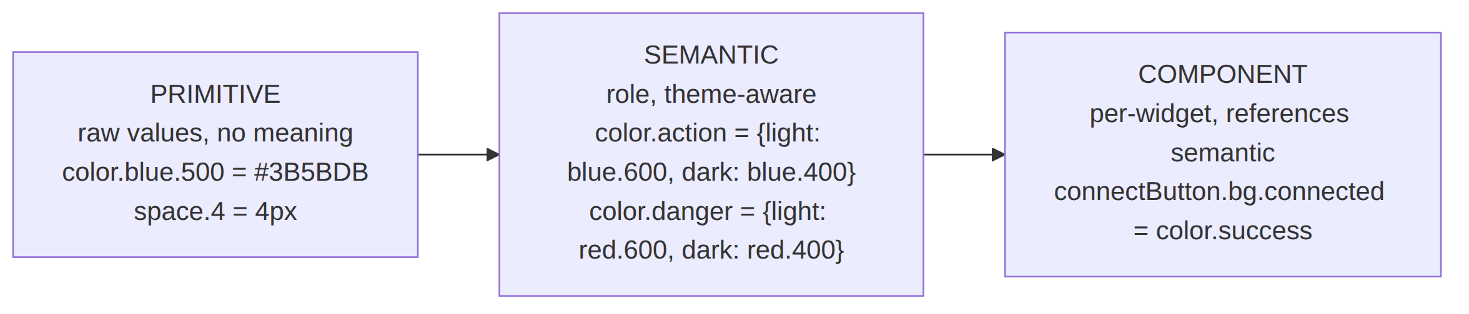
- Primitive — raw, meaningless values: color ramps (e.g. blue.50…900), the type size scale, the 4-base spacing scale {4,8,12,16,24,32,48}, radii {sm8,md12,lg20, pill999}, motion {fast120,base220,slow360}, elevation 0..3. Mirrors the values already sketched in the Flutter helix_design package [04_CLIENT §2.1] but generalised (no brand seed inline — DS-I1).
- Semantic — role tokens that reference primitives and are theme-keyed: a semantic token holds a {light, dark} pair (DS-I3). E.g. color.surface, color.on-surface, color.action, color.success, color.warn, color.danger, color.neutral, color.info.
- Component — per-widget tokens that reference semantic tokens (connectButton.bg, statusChip.fg). A widget reads only component tokens; it never reaches a primitive.

5.2 Light + dark theming (DS-I3)
Theming is a semantic-tier concern: every semantic color token carries both a light and a dark value. The export pipeline (§6) emits two resolved theme tables per target (a light and a dark map) — never a single theme. A component spec that omits the dark value, or an export that emits only one theme, FAILs the §12 drift gate. Example (semantic source):
// tokens/semantic/color.light.json (excerpt) — references primitives by name
{
"color": {
"surface": { "value": "{color.neutral.50}" },
"on-surface": { "value": "{color.neutral.900}" },
"action": { "value": "{color.blue.600}" },
"success": { "value": "{color.green.600}" },
"warn": { "value": "{color.amber.600}" },
"danger": { "value": "{color.red.600}" }
}
}
// tokens/semantic/color.dark.json — same KEYS, dark-resolved values
{
"color": {
"surface": { "value": "{color.neutral.900}" },
"on-surface": { "value": "{color.neutral.50}" },
"action": { "value": "{color.blue.400}" },
"success": { "value": "{color.green.400}" },
"warn": { "value": "{color.amber.400}" },
"danger": { "value": "{color.red.400}" }
}
}

5.3 Light + dark is also a CONTRAST contract
Light/dark is not just two palettes; each (theme, semantic-on-pair) MUST satisfy WCAG contrast (deepened in [color-system.md]). The §12 contrast test asserts every on-X / X pair (e.g. on-surface / surface) clears the AA threshold in both themes — a dark theme that looks fine but fails contrast is a DS-I5 / §11.4.162 failure.

5.4 The brand-preset injection model (DS-I1)
The generic semantic tier references preset tokens for the values a brand chooses. The HelixVPN brand preset supplies them; a future app supplies its own. The submodule ships presets/helix/ as the default value set, but the mechanism is injection — a consuming project can override the preset path at build time:
// presets/helix/brand.json — VALUES (the only HelixVPN-flavoured data; swappable)
{
"brand": {
"seed": "#3B5BDB", // drives the action ramp + M3 ColorScheme
"accent": "#10B981",
"fontFamily": { "sans": "Inter", "mono": "JetBrains Mono" },
"logo": { "light": "assets/logo/helix-light.svg",
"dark": "assets/logo/helix-dark.svg" },
"productName": "HelixVPN" // a VALUE, not machinery (DS-I1 ok)
}
}
Illustrative seed values — the canonical brand/semantic hexes live in [color-system.md] (brand #3D5AF1); a seed need not equal a ramp step.
# build with a DIFFERENT brand preset (proves DS-I1 decoupling) — §12 decoupling test
pnpm export --preset presets/acme/ # → dist/** carries Acme's palette, zero HelixVPN refs

5.5 The connection-state palette (generic status tokens)
The 7-variant connection-state palette the Client renders is expressed as generic status tokens in the preset (presets/helix/connection_state.json), mapped to the FFI TunnelStatus in the app ([04_CLIENT §7.2]), never inside the submodule (DS-I1):
UI state | Status token | Light | Dark | Notes
Disconnected | state.neutral | neutral.600 | neutral.400 | "Not protected" — grey
Connecting / Handshaking | state.warn | amber.600 | amber.400 | in-motion
Connected (direct) | state.success | green.600 | green.400 | safe
Connected (relay) | state.success-alt | green.700 | green.300 | sub-shade for relay path (D-UI-3 in 04_CLIENT)
Reconnecting | state.warn-pulse | amber.600 | amber.400 | animated pulse (motion token)
Down | state.caution | orange.600 | orange.400 | recoverable fault
Danger | state.danger | red.600 | red.400 | leak / kill-switch tripped
These are descriptive labels, not token keys — the canonical token keys are color.semantic.state.<variant>.fill per [design-tokens.md] §8.
The submodule provides the tokens; the projection is layered: the Rust FFI StatusProjector produces the 7-variant ffi::TunnelStatus from the 5-variant core::TunnelStatus (it adds Disconnected and Danger) [ffi-surface.md §3.2/§3.3], and only the Connected{direct|relay} sub-shade is app-side rendering in helix_domain's projectUiState [04_CLIENT §7.2].

6. The export forms (one source → every consumable form)
Per the Volume 10 mandate, the canonical JSON token source is emitted into every consumable form so each platform incorporates tokens directly (no platform re-types a color by hand — DS-I6). Pipeline deepened in [token-export-pipeline.md]; here is the form contract:
Target | Output | Consumed by | Theme handling
JSON (Style-Dictionary-class source) | dist/json/tokens.json | the source-of-truth other exporters read; tooling | both themes as keyed maps
CSS custom properties | dist/css/helix.css | Console Web (Flutter web + any web surface) | :root (light) + [data-theme=dark] (dark)
Dart | dist/dart/helix_tokens.dart + ThemeData/ThemeExtension | helix-ui (Client/Console/Connector Flutter) [04_CLIENT §2.1] | HelixTheme.light() / .dark() ThemeExtension
SwiftUI | dist/swift/HelixTokens.swift | iOS/macOS native shim surfaces (NE config UI, widgets) | Color assets + @Environment(\.colorScheme)
Jetpack Compose | dist/compose/HelixTokens.kt | Android native surfaces (quick-settings tile, notification) | lightColors() / darkColors()
ArkTS | dist/arkts/helix_tokens.ets | HarmonyOS native surfaces | resource qualifiers dark/
C / Qt | dist/cqt/helix_tokens.h + .qml | Aurora Qt/C++ surfaces | C #define + QML Theme singleton
Why polyglot, not Flutter-only. Flutter helix-ui covers the app surfaces, but several surfaces are platform-native and never see Dart: the iOS/macOS Network-Extension config UI and widgets (SwiftUI), the Android quick-settings tile + notification (Compose), the HarmonyOS VPN-ability surfaces (ArkTS), and the Aurora Qt backend's UI (C/Qt) [04_CLIENT §4.4 native shims]. Each must render the same palette as the Flutter app — so the token source must emit a native form for each. A Flutter-only token package would leave those surfaces to hand-copy colors, the exact drift DS-I6 forbids.
Honest boundary on OpenDesign and the polyglot forms. OpenDesign does not itself emit Dart/Swift/Compose/ArkTS/C-Qt (web-verified — see [opendesign-foundation.md] § Sources). OpenDesign's native artifact form is DESIGN.md + tokens.css (CSS custom properties). Therefore the polyglot exporters (export/targets/*.ts) are helix_design's own Style-Dictionary-class pipeline, fed by the canonical JSON source, with tokens.css as one input/round-trip form to/from OpenDesign (§10). If a future requirement is "OpenDesign itself must emit a Compose form", that is an extend-OpenDesign-upstream task per §11.4.74 (§10.4), not an in-helix_design reimplementation. This split is stated plainly so no reader assumes OpenDesign ships a multi-language token compiler it does not (§11.4.6).

7. upstreams/, install_upstreams, and helix-deps.yaml

7.1 upstreams/ + install_upstreams (§11.4.36)
As an owned submodule, helix_design ships an upstreams/ directory with one recipe *.sh per push mirror (GitHub + GitLab + GitFlic + GitVerse per the §11.4.28 owned-org set). On clone/add, install_upstreams is invoked from the submodule root to configure every mirror as a push remote (§11.4.36 mandate). Skipping it silently breaks §2.1 multi-upstream push.
# after the consuming project adds helix_design as a submodule:
cd helix_vpn/helix_design && install_upstreams # configures all push mirrors
git remote -v | grep -c push # expect == number of mirrors

7.2 helix-deps.yaml (§11.4.31)
helix_design declares its own own-org dependencies (if any) in a machine-readable manifest so a consuming project can reconstruct the dependency graph from the parent root (no nested own-org chains — §11.4.28(C)). For a leaf design system this is typically empty of own-org deps (the submodule depends on nothing Helix-product-side, DS-I1) — but the file MUST exist and declare third-party build deps (Node/pnpm toolchain, the Style-Dictionary-class library, weasyprint/pandoc for doc export).
# helix_design/helix-deps.yaml
schema_version: 1
deps: [] # leaf: no own-org runtime deps (DS-I1)
build_toolchain:
- { name: "node", version: "~24" } # OpenDesign + exporter toolchain (verified §10)
- { name: "pnpm", version: "10.x" }
transitive_handling:
recursive: true
conflict_resolution: operator-required
language_specific_subtree: true # packages/flutter/ is a pub package

8. Semver & versioning policy
helix_design is versioned independently of the HelixVPN product (it is reusable; its version tracks design-system change, not VPN-feature change), but its release tags carry the §11.4.151 project prefix when cut as part of a HelixVPN release wave.
Change class | Bump | Examples
MAJOR | breaking token rename/removal, component API break, export-form schema break | rename color.action→color.primary; drop a component; change the Dart ThemeExtension shape
MINOR | additive — new token, new component variant, new export target, new preset | add state.success-alt; add the C-Qt target; add a new icon
PATCH | value-only / fix — recolor within contrast, fix a dark value, doc/asset fix | nudge blue.600; fix a failing dark-contrast pair
- The submodule's VERSION + CHANGELOG.md are the source of truth; the §11.4.65 export pipeline keeps .md/.html/.pdf in sync, the §11.4.44 revision header on each doc.
- A consuming app pins a tag (or a commit), and bumps the pointer deliberately (§11.4.26 step 7 pointer-bump discipline); a pointer bump that changes tokens triggers the app's visual-regression suite (§12, DS-I5).
- Release tags follow §11.4.151: <PREFIX>-helix_design-<semver> when cut in a HelixVPN wave, plain helix_design-<semver> when cut standalone. No force-push, ever (§11.4.113) — every publish is a merge-onto-latest-main fast-forward to all mirrors.

9. The consumption model (how ANY app incorporates it)

9.1 The per-app pull recipe (the same five steps for every app)
# 1. Add the decoupled submodule at the FLAT parent-root path (§11.4.28(C)/.29):
git submodule add git@github.com:vasic-digital/helix_design.git helix_design
# 2. Install upstream push mirrors (§11.4.36):
( cd helix_design && install_upstreams )
# 3. Choose the brand preset (HelixVPN apps use presets/helix/; a future app drops its own):
# (default is presets/helix/ — no flag needed for HelixVPN)
# 4. Generate the export form(s) the app needs (DS-I6 — never hand-copy tokens):
( cd helix_design && pnpm install && pnpm export ) # → dist/<target>/
# 5. Wire the generated form into the app build:
# - Flutter app → depend on helix_design/packages/flutter (path/replace), apply HelixTheme
# - Web surface → import dist/css/helix.css
# - Apple shim → add dist/swift/HelixTokens.swift to the NE-extension target
# - Android shim → add dist/compose/HelixTokens.kt
# - HarmonyOS → add dist/arkts/helix_tokens.ets
# - Aurora → include dist/cqt/helix_tokens.h + the .qml resource

9.2 How the three HelixVPN apps consume it
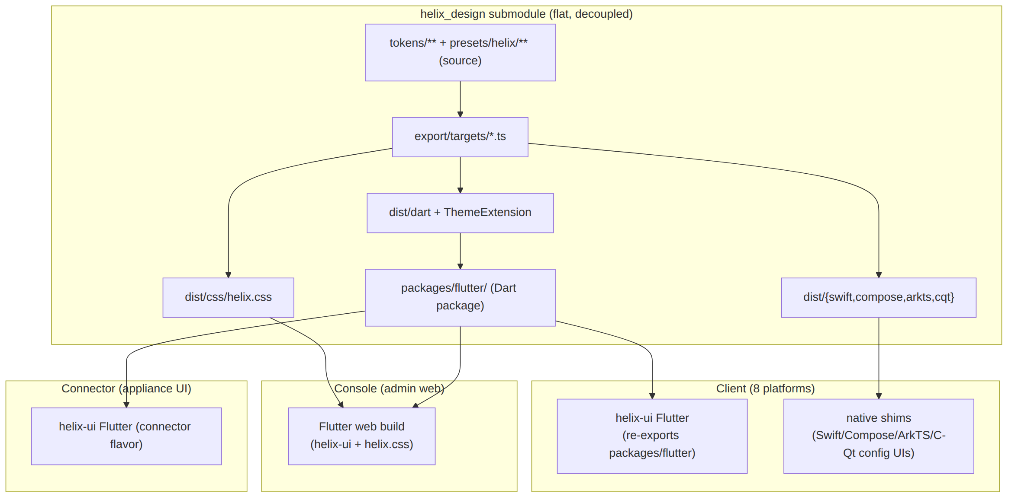
All three apps are built from one Flutter codebase via flavors + capability gating [04_CLIENT §5], so the Flutter package is the primary consumer; the native forms cover the platform-native surfaces the Flutter app cannot reach (§6). The Console Web build adds dist/css/helix.css for any non-Flutter web chrome.

9.3 How a FUTURE app incorporates it
Identical five steps, with step 3 dropping a new presets/<app>/ (its own seed, palette, fonts) — and it inherits the entire token/theme/component/export machinery with zero HelixVPN coupling (DS-I1, the §2.1 reuse payoff). The §12 decoupling test is this scenario, run in CI-equivalent local sweeps.

10. Relationship to OpenDesign (§11.4.162)
Full, web-verified detail is in the sibling [opendesign-foundation.md]. This section states only the relationship helix_design ↔ OpenDesign at the submodule level.

10.1 OpenDesign is the design-and-refinement system; helix_design is the distribution layer
Per §11.4.162, OpenDesign (https://github.com/nexu-io/open-design) is the mandatory system for designing and refining HelixVPN's UI — no ad-hoc CSS, no one-off tools. From the web-verified facts (see sibling doc):
- OpenDesign is a local-first generative design tool — a desktop app + CLI (od) + MCP server — that authors/refines design artifacts and design systems, consumed via CLI/MCP rather than as an npm package dependency (verified 2026-06-25).
- An OpenDesign design system is a folder design-systems/<slug>/ containing DESIGN.md (a 9-section markdown spec), tokens.css (compiled CSS custom properties), components.html, manifest.json, plus assets/ fonts/ preview/ source/ (verified).
So helix_design authors a HelixVPN OpenDesign design system under helix_design/opendesign/helix/ (DESIGN.md + tokens.css + manifest.json), uses OpenDesign to design/refine/preview it, and then helix_design's own exporters (§6) translate the canonical token source into the polyglot forms OpenDesign does not itself produce. OpenDesign owns authoring + refinement + the CSS/markdown design-system form; helix_design owns the canonical JSON source + the polyglot distribution.

10.2 Direction of truth (open decision)
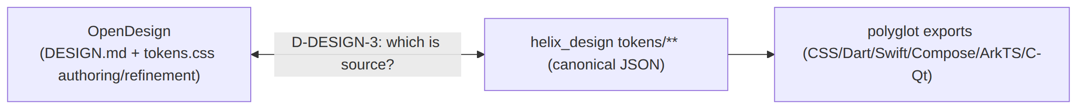
D-DESIGN-3 (open). Two candidate directions: (a) the OpenDesign tokens.css is the human-authored source and helix_design imports it into the canonical JSON (tokens.css → tokens/**), or (b) the JSON tiers are the source and tokens.css is a generated export target (one more export/targets/css.ts output) that OpenDesign then consumes/previews. This document leans (b) — JSON-as-source keeps the three-tier primitive→semantic→component model and light+dark theming first-class (which a flat tokens.css does not natively express), with tokens.css round-tripped for OpenDesign. (a) is simpler if designers live entirely in OpenDesign. Resolved at the Volume-10 review with the design team; UNVERIFIED until ratified.

10.3 The OpenDesign-native folder
helix_design/opendesign/helix/
├── manifest.json # schemaVersion, id, name, category, description, source, files{}
├── DESIGN.md # 9-section: visual theme, color, type, spacing, layout, components,
│ # motion, voice/tone, anti-patterns (verified section model)
├── tokens.css # compiled CSS custom properties (light + dark) — round-trip with §6
├── components.html
└── assets/ fonts/ preview/ source/

10.4 Extend-upstream policy (§11.4.74)
If OpenDesign lacks a pattern HelixVPN needs (e.g. a richer multi-theme token model, a new export form, a VPN-specific component archetype), the fix is a PR to nexu-io/open-design (extend the catalogue tool upstream), recorded with a Catalogue-Check: extend nexu-io/open-design@<sha> tracker line per §11.4.74 — never a private fork-and-diverge inside helix_design. The honest boundary (DS-I7): OpenDesign governs design tokens, themes, and the design-system form — it does not replace functional testing (§11.4.27), the a11y behaviour assertions, or the §11.4.48/.49 UI-driven test methodology; those stay in Volumes 4/8.

11. Architecture diagram (submodule → exporters → consuming apps)
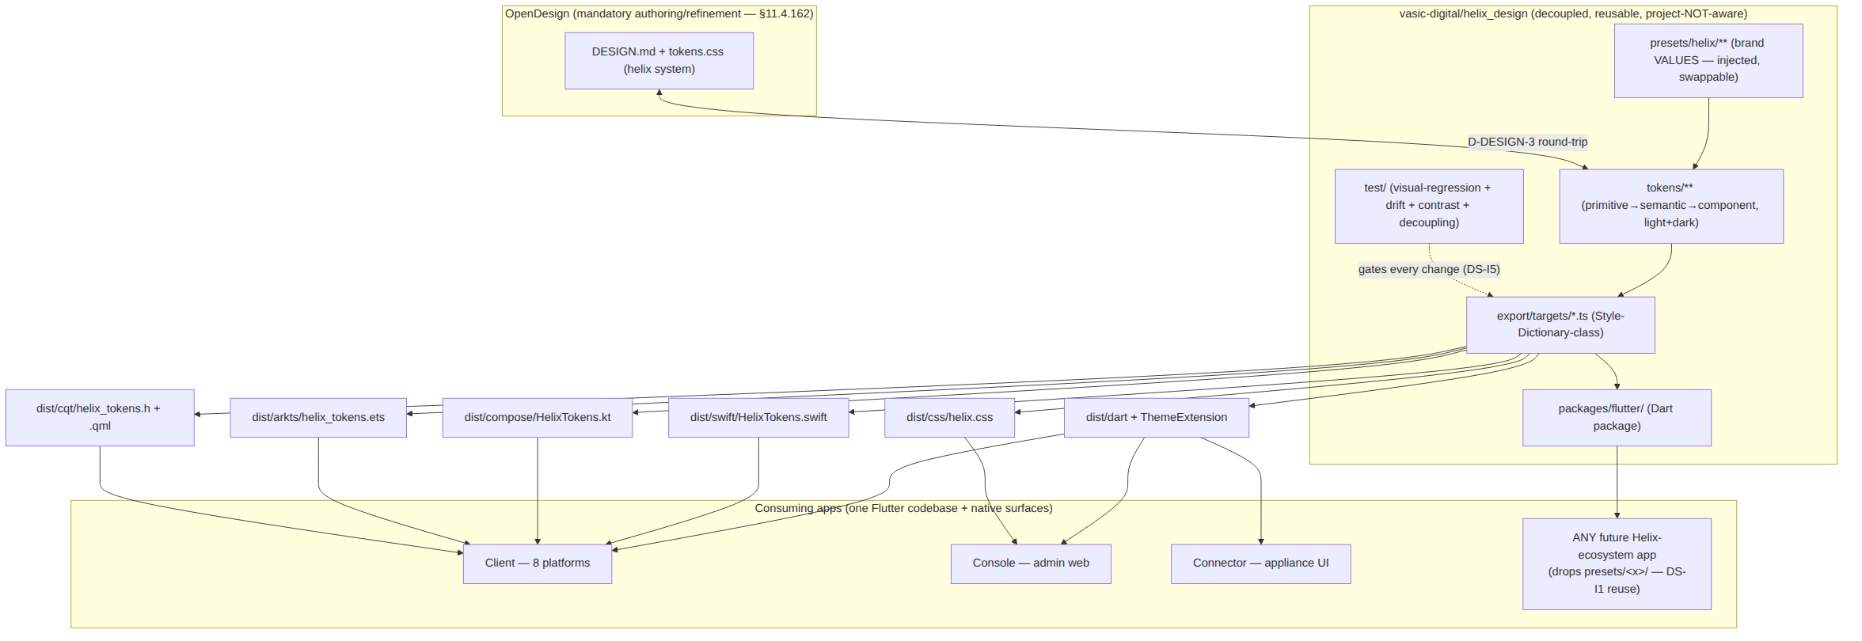

12. Quality, testing, and gates owned here
helix_design is an equal-codebase submodule (§11.4.28(A)), so it carries the full anti-bluff testing floor (§11.4.169) for a design system. Deepened in [visual-regression-and-qa.md]; the gates owned at the submodule level:
Gate | Asserts | Class
DS-DRIFT | dist/** regenerated from tokens/** is byte-identical to a fresh pnpm export; a hand-edited derived form FAILs (DS-I6) | §11.4.12 drift
DS-LIGHT-DARK-COMPLETE | every semantic color token + every component spec defines BOTH light and dark (DS-I3) | §11.4.162
DS-CONTRAST | every on-X / X pair clears WCAG AA in light AND dark (DS-I5) | a11y (static, captured-evidence)
DS-NO-OVERLAP | golden screenshots show no overlapping elements / no label overlay (DS-I4) | §11.4.162 + §11.4.168 visual
DS-VISUAL-REGRESSION | per-component golden screenshots (light+dark) match the baseline within perceptual tolerance | §11.4.162 + §11.4.107(10) self-validated analyzer
DS-DECOUPLING | a build with a non-HelixVPN preset emits all forms green + zero HelixVPN refs in machinery (DS-I1) | §11.4.28(B) CM-OWNED-SUBMODULE-DECOUPLING
DS-EXPORT-FORM-VALID | each emitted form parses in its target toolchain (Dart analyze, swiftc parse, kotlinc, tsc/ArkTS, C compile) | §11.4.110 build-readiness
DS-SCHEMA | tokens/** validate against export/schema/ JSON-schema | §11.4.110
Honest boundary (DS-I7): these gates prove the design system's internal correctness + visual integrity. They do not prove a consuming app's feature works — that is the app's functional/UI-driven testing (Volumes 4/8). A green helix_design is necessary, not sufficient, for a shipped UI.

13. Open decisions surfaced by this document
ID | Decision | Lean | Resolves at
D-DESIGN-1 | One helix_design submodule (Flutter pkg + polyglot bundle together) vs. two sibling submodules | (a) one submodule | Volume-10 review
D-DESIGN-2 | dist/ gitignored-and-regenerated vs. committed (Dart-only consumers want no Node toolchain) | gitignore dist/, check in the Flutter package's generated Dart as package-source | Volume-10 review + §11.4.30 audit
D-DESIGN-3 | Source-of-truth direction: OpenDesign tokens.css → JSON, vs. JSON → tokens.css export | JSON-as-source (keeps tiers + light/dark first-class) | Volume-10 review with design team
D-DESIGN-4 | Whether the polyglot native exporters are helix_design-owned (this doc) vs. contributed upstream to OpenDesign so OpenDesign emits them | helix_design-owned now; upstream-contribute opportunistically per §11.4.74 | post-MVP
D-DESIGN-5 | Font licensing/distribution: bundle font files in assets/fonts/ vs. reference system/Google fonts per platform | per-platform (bundle where license permits; reference otherwise) | Volume-10 assets doc

Sources verified
- OpenDesign tool facts (what it is, how it is consumed, DESIGN.md/tokens.css design-system structure) — verified against https://github.com/nexu-io/open-design and its QUICKSTART.md + design-systems/README.md, accessed 2026-06-25. Full quotes and the per-fact verification table are in the sibling [opendesign-foundation.md] "Sources verified" footer. The critical finding that OpenDesign does not itself emit Dart/Swift/Compose/ArkTS/C-Qt (so the polyglot exporters are helix_design's own) is grounded there, not assumed.
- Constitution clauses §11.4.28 (equal-codebase + decoupling + dependency-layout), §11.4.29 (snake_case naming), §11.4.30/§11.4.77 (no versioned build derivatives + regeneration mechanism), §11.4.31 (submodule-dependency-manifest), §11.4.36 (install_upstreams on clone), §11.4.74 (catalogue-first reuse / extend upstream), §11.4.113 (no force-push), §11.4.151 (release-prefix naming), §11.4.157 (GEMINI.md lockstep), §11.4.162 (OpenDesign UI design-system mandate), §11.4.168 (exported-doc visual validation), §11.4.169 (mandatory test types) — from the constitution submodule text embedded in this repo's constitution/CLAUDE.md, accessed 2026-06-25.
- HelixVPN product context — MASTER_INDEX.md (Volume 10 block + roles), v04-client/helix-ui-flutter.md (the helix_design Flutter package, the 5-variant TunnelStatus, projectUiState, the native-shim languages), SPECIFICATION.md (roles Client/Console/Connector, 8 platforms) — this repo, accessed 2026-06-25.
- All token values, layout shapes, exporter target list, and decisions are HelixVPN's own original design work (NO external source needed) — except where a fact about OpenDesign is cited above; those are web-verified, and every place this document assumes an OpenDesign behaviour it could not verify is tagged UNVERIFIED inline.

