Color system — brand palette, semantics, connection-state & contrast proofs

Color system — brand palette, semantics, connection-state & contrast proofs
Revision: 1 Last modified: 2026-06-25T12:00:00Z
Master technical specification — Volume 10 (Design System), nano-detail deep-dive. This document owns HelixVPN's complete colour system: the brand primitive ramps (a privacy/trust palette, concrete hex), the full light AND dark semantic mappings (surface / text / border / overlay / feedback / action), the connection-state palette mapping onto the exact 7-variant ffi::TunnelStatus [v04-client/ffi-surface.md §3.2], the WCAG contrast proofs (real arithmetic, every cited ratio computed — §11.4.6), the no-overlap / no-label-overlay colour-layer rule (§11.4.162), and the per-app accent differentiation (Client / Console / Connector).
SPEC-ONLY. It defines which colours mean what and proves they are legible. The token structure these colours live in (tiers, schema, theming model) is owned by [design-tokens.md]; the multi-form emit by [token-export-pipeline.md]. This document is original HelixVPN design work — the hex choices are owned here.
Boundary with sibling docs. Owns: hex values + semantic colour roles + contrast proofs. Consumes: the token tier/naming model [design-tokens.md]; the 7-variant ffi::TunnelStatus [FFI §3.2]; the 3-app/8-platform matrix [SPINE §3]; the WCAG relative-luminance formula (W3C, cited in Sources).
Evidence base. [FFI §N] = final/v04-client/ffi-surface.md; [DT §N] = final/v10-design/design-tokens.md; [SPINE §N] = final/SPECIFICATION.md. Every contrast ratio in this document was computed by the WCAG 2.1 relative-luminance + contrast formula on the exact hexes stated (the computation script + raw output are the captured evidence; §11.4.6 — no ratio is guessed). Anything unproven is tagged UNVERIFIED.

Table of contents
- 0. Palette philosophy — privacy & trust
- 1. Primitive ramps (concrete hex)
- 2. Semantic colour roles — full light + dark mapping
- 3. The connection-state palette (7-variant FFI mapping)
- 4. WCAG contrast proofs (computed)
- 5. The no-overlap / no-label-overlay rule (§11.4.162)
- 6. Per-app accent differentiation (Client / Console / Connector)
- 7. Swatch map
- 8. Surfaced decisions & cross-doc contracts
- Sources verified

0. Palette philosophy — privacy & trust
HelixVPN is a privacy product; its colour language must read calm, trustworthy, and unambiguous about safety state. Three design commitments drive every hex choice:
- Deep indigo-blue as the brand — blue is the near-universal "secure / trusted / institutional" hue; HelixVPN uses a slightly indigo-shifted blue (helix.500 #3D5AF1) so it reads modern privacy tool rather than corporate banking. It is the resting/idle and primary-action colour.
- Low-chroma neutrals — surfaces and text are near-neutral cool greys so the only saturated colour on screen at any moment is the connection-state colour. The user's eye is drawn to the one thing that matters: am I protected?
- Unmissable, conventional safety semantics — green = protected, amber = working, orange = unexpectedly dropped, red = danger (leak / kill-switch tripped). These never change across brand or tenant (§8 D-COLOR-1); a privacy product must never recolour its safety signal.
Honest boundary (§11.4.6). Colour alone is never the sole signal for a state (≈8 % of users have colour-vision deficiency). Every connection state also carries an icon + text label (the StatusChip/ConnectButton always show e.g. a shield-check glyph + "Connected · direct"); colour is reinforcement, not the only channel. Contrast proofs (§4) cover the legibility of the label, which is the load-bearing signal.

1. Primitive ramps (concrete hex)
Tier-1 primitives (theme-agnostic literals, [DT §1]). These are the only place a literal colour appears; everything else references these.

1.1 Brand — color.primitive.helix.* (indigo-blue)
Stop | Hex | Role hint
helix.50 | #EEF2FF | lightest tint (selected-row bg, light)
helix.100 | #E0E7FF | hover tint (light)
helix.200 | #C3CEFF | subtle border / chip (light)
helix.300 | #9CB0FF | dark-theme link / accent text
helix.400 | #6B86FB | dark-theme action / focus
helix.500 | #3D5AF1 | brand core — logo, focus ring
helix.600 | #2F47C4 | primary action fill (light), link text (light)
helix.700 | #263A9E | pressed action (light)
helix.800 | #1F2F7A | deep accent surface
helix.900 | #16205A | brand-tint dark surface

1.2 Neutral — color.primitive.neutral.* (cool grey, 0–1000)
Stop | Hex |  | Stop | Hex
neutral.0 | #FFFFFF |  | neutral.500 | #6B7385
neutral.50 | #F7F8FA |  | neutral.600 | #4B5263
neutral.100 | #EDEFF3 |  | neutral.700 | #353B49
neutral.200 | #DCE0E8 |  | neutral.800 | #222732
neutral.300 | #C2C8D4 |  | neutral.900 | #151920
neutral.400 | #9AA2B2 |  | neutral.1000 | #0B0E13

1.3 Status & feedback ramps (key stops)
Ramp | Light-usable stops | Dark-usable stops
green.* (protected) | green.50 #ECFDF3 · green.500 #22C55E · green.600 #15803D · green.700 #166534 | green.300 #6CE9A6 · green.500 #22C55E · green.400 #34D399
amber.* (working) | amber.50 #FFFBEB · amber.500 #F59E0B · amber.600 #D97706 · amber.700 #B45309 | amber.300 #FCD34D · amber.400 #FBBF24
orange.* (dropped) | orange.50 #FFF4ED · orange.500 #F97316 · orange.600 #C2410C · orange.700 #9A3412 | orange.400 #FB923C
red.* (danger) | red.50 #FEF2F2 · red.500 #EF4444 · red.600 #DC2626 · red.700 #B91C1C | red.300 #FCA5A5 · red.400 #F87171
teal.* (accent / relay) | teal.50 #F0FDFA · teal.500 #14B8A6 · teal.600 #0D9488 · teal.700 #0F766E | teal.300 #5EEAD4 · teal.400 #2DD4BF
violet.* (Console accent) | violet.500 #8B5CF6 · violet.600 #7C3AED · violet.700 #6D28D9 | violet.400 #A78BFA
blue.* (info) | blue.500 #2563EB · blue.600 #1D4ED8 | blue.400 #60A5FA
Why both a .500-class bright stop and a .600/.700-class dark stop per status ramp. The bright stop (green.500, amber.400, red.400) is the dark-theme text/icon/fill colour (high luminance reads on a dark surface); the dark stop (green.600, amber.700, red.600) is the light-theme text/icon/fill colour (low luminance reads on white). This is what makes the connection-state palette pass AA in both themes (§4).

2. Semantic colour roles — full light + dark mapping
Tier-2 semantics ([DT §1]). Every token below defines both light and dark (mandatory, gate CM-token-light-dark-complete [DT §9]; §11.4.162). Each side is a reference to a §1 primitive (literal shown for readability).

2.1 Surfaces & background
Semantic token | Light | Dark | Notes
surface.default | neutral.0 #FFFFFF | neutral.900 #151920 | base app surface
surface.raised | #F7F8FA (neutral.50) | #222732 (neutral.800) | cards, list rows, sheets
surface.sunken | #EDEFF3 (neutral.100) | #0B0E13 (neutral.1000) | wells, input track
surface.brandTint | helix.50 #EEF2FF | helix.900 #16205A | selected/active brand surface
background.canvas | #FFFFFF | #0B0E13 | the window behind surfaces

2.2 Text / on-surface
Semantic token | Light | Dark | Contrast vs its surface
text.primary | neutral.900 #151920 | neutral.100 #EDEFF3 | 17.62 (light) / 15.31 (dark) → AAA
text.secondary | neutral.600 #4B5263 | #C2C8D4 (neutral.300) | 7.82 / 10.49 → AAA
text.tertiary | neutral.500 #6B7385 | neutral.400 #9AA2B2 | 4.76 / 6.87 → AA
text.disabled | neutral.400 #9AA2B2 | neutral.500 #6B7385 | 2.57 / 3.71 — exempt (WCAG SC 1.4.3 inactive-control exception)
text.onState | #FFFFFF | #FFFFFF | white label drawn on a filled state colour (§3)
text.onBrand | #FFFFFF | #FFFFFF | label on a brand-action fill
text.link | helix.600 #2F47C4 | helix.300 #9CB0FF | 7.45 / 8.45 → AAA

2.3 Borders & overlays
Semantic token | Light | Dark | Notes
border.default | #DCE0E8 (neutral.200) | #353B49 (neutral.700) | 1.32 (light) vs surface — decorative hairline; not a contrast-bearing element
border.strong | neutral.400 #9AA2B2 | neutral.500 #6B7385 | input/focus border (≥3.0 UI-component floor target)
border.focus | helix.500 #3D5AF1 | helix.400 #6B86FB | focus ring — 5.34 / 5.39 vs surface → ≥3.0 SC 1.4.11 ✓
overlay.scrim | #1F2937 @ 60 % α | #000000 @ 70 % α | modal/sheet backdrop; white text on the scrim = 14.68 → AAA

2.4 Action & feedback
Semantic token | Light | Dark | Proof (label/role)
action.primary | helix.600 #2F47C4 | helix.500 #3D5AF1 | white label on light fill 7.45 AAA; dark theme uses helix.500, white label 5.34 AA
action.primary.hover | helix.700 #263A9E | helix.400 #6B86FB | —
action.secondary | surface.raised + border.strong | same | tonal/outline button
feedback.success | green.600 #15803D | green.400 #34D399 | text-on-surface 5.02 / 9.17 → AA / AAA
feedback.warning | amber.700 #B45309 | amber.400 #FBBF24 | 5.02 / 10.56 → AA / AAA
feedback.error | red.600 #DC2626 | red.400 #F87171 | 4.83 / 6.37 → AA
feedback.info | blue.600 #1D4ED8 | blue.400 #60A5FA | 6.70 / 6.93 → AA
Every semantic colour token above has both a light and a dark value — none is single-theme. (text.onState/text.onBrand are intentionally white in both themes because they sit on a coloured fill, not on the theme surface; their legibility is proven against each state fill in §4.3, not against the surface.)

3. The connection-state palette (7-variant FFI mapping)
The product-defining colour group. It maps one-to-one onto the 7-variant ffi::TunnelStatus the UI switches on [FFI §3.2]: Disconnected · Connecting · Handshaking · Connected{path:direct|relay} · Reconnecting · Down · Danger. The mapping is total — every variant has a dedicated colour in both themes (the UI never invents a colour, §11.4.6).

3.1 The mapping (both themes)
ffi::TunnelStatus | Family | Light fill (white label) | Dark fill (dark #151920 label) | Light text/icon (on tint) | Dark text/icon (on dark)
Disconnected | neutral grey | neutral.500 #6B7385 | neutral.600 #4B5263 | #6B7385 | #9AA2B2
Connecting | amber | amber.700 #B45309 | amber.400 #FBBF24 | #B45309 | #FBBF24
Handshaking | amber (= Connecting) | amber.700 #B45309 | amber.400 #FBBF24 | #B45309 | #FBBF24
Connected{direct} | green (direct) | green.600 #15803D | green.500 #22C55E | #15803D | #22C55E
Connected{relay} | green (relay sub-shade) | teal.700 #0F766E | teal.400 #2DD4BF | #0F766E | #2DD4BF
Reconnecting | amber pulse | amber.700 #B45309 + motion.connectPulse | amber.400 #FBBF24 + pulse | #B45309 | #FBBF24
Down | orange | orange.600 #C2410C | orange.400 #FB923C | #C2410C | #FB923C
Danger | red (z-top, overrides) | red.600 #DC2626 | red.400 #F87171 | #DC2626 | #F87171

3.2 Design rationale per state
- Disconnected → neutral grey, not red. A clean, user-intended idle is not an alarm. Grey says "off, by your choice"; red is reserved for danger. This is exactly why the FFI splits Disconnected from Down [FFI §3.2] — the colour system honours that split (grey vs orange).
- Connecting / Handshaking → amber. Transient "working" states share one amber so the user reads a single "establishing…" phase, not two confusingly different colours.
- Connected{direct} → green, Connected{relay} → green sub-shade (teal). Both are "protected = green-family", but a direct path (P2P, lower latency) shows pure green #15803D/#22C55E while a relay path (DERP-style) shows a teal-leaning green #0F766E/#2DD4BF. The user still reads "protected"; the StatusChip text ("direct" / "relay") and the sub-shade together convey the path without weakening the safety signal. Connected.path is supplied by the FFI projector [FFI §3.3].
- Reconnecting → amber pulse. Same amber as Connecting, animated via motion.semantic.connectPulse (1200 ms ease-in-out loop, [DT §6.4]). Under the OS reduce-motion flag it degrades to static amber — never strobes (a11y + §11.4.107 no-flash).
- Down → orange, distinct from Danger red. An unexpected drop (ladder-exhausted / host-fatal [FFI §3.3]) is serious but not a leak; orange separates "it dropped, retrying/failed" from "you are exposed". Distinct hue, not just a shade, so colour-blind users still read two different alarms via the paired icon.
- Danger → red, top of the z-stack. Leak / kill-switch-tripped. Red and z-layer danger (2000, [DT §6.5]) so it can never be occluded; it overrides every other state colour, mirroring the FFI projector's "Danger overrides all intent" rule [FFI §3.3]. The kill-switch banner paints red.600/red.400 with a white label.
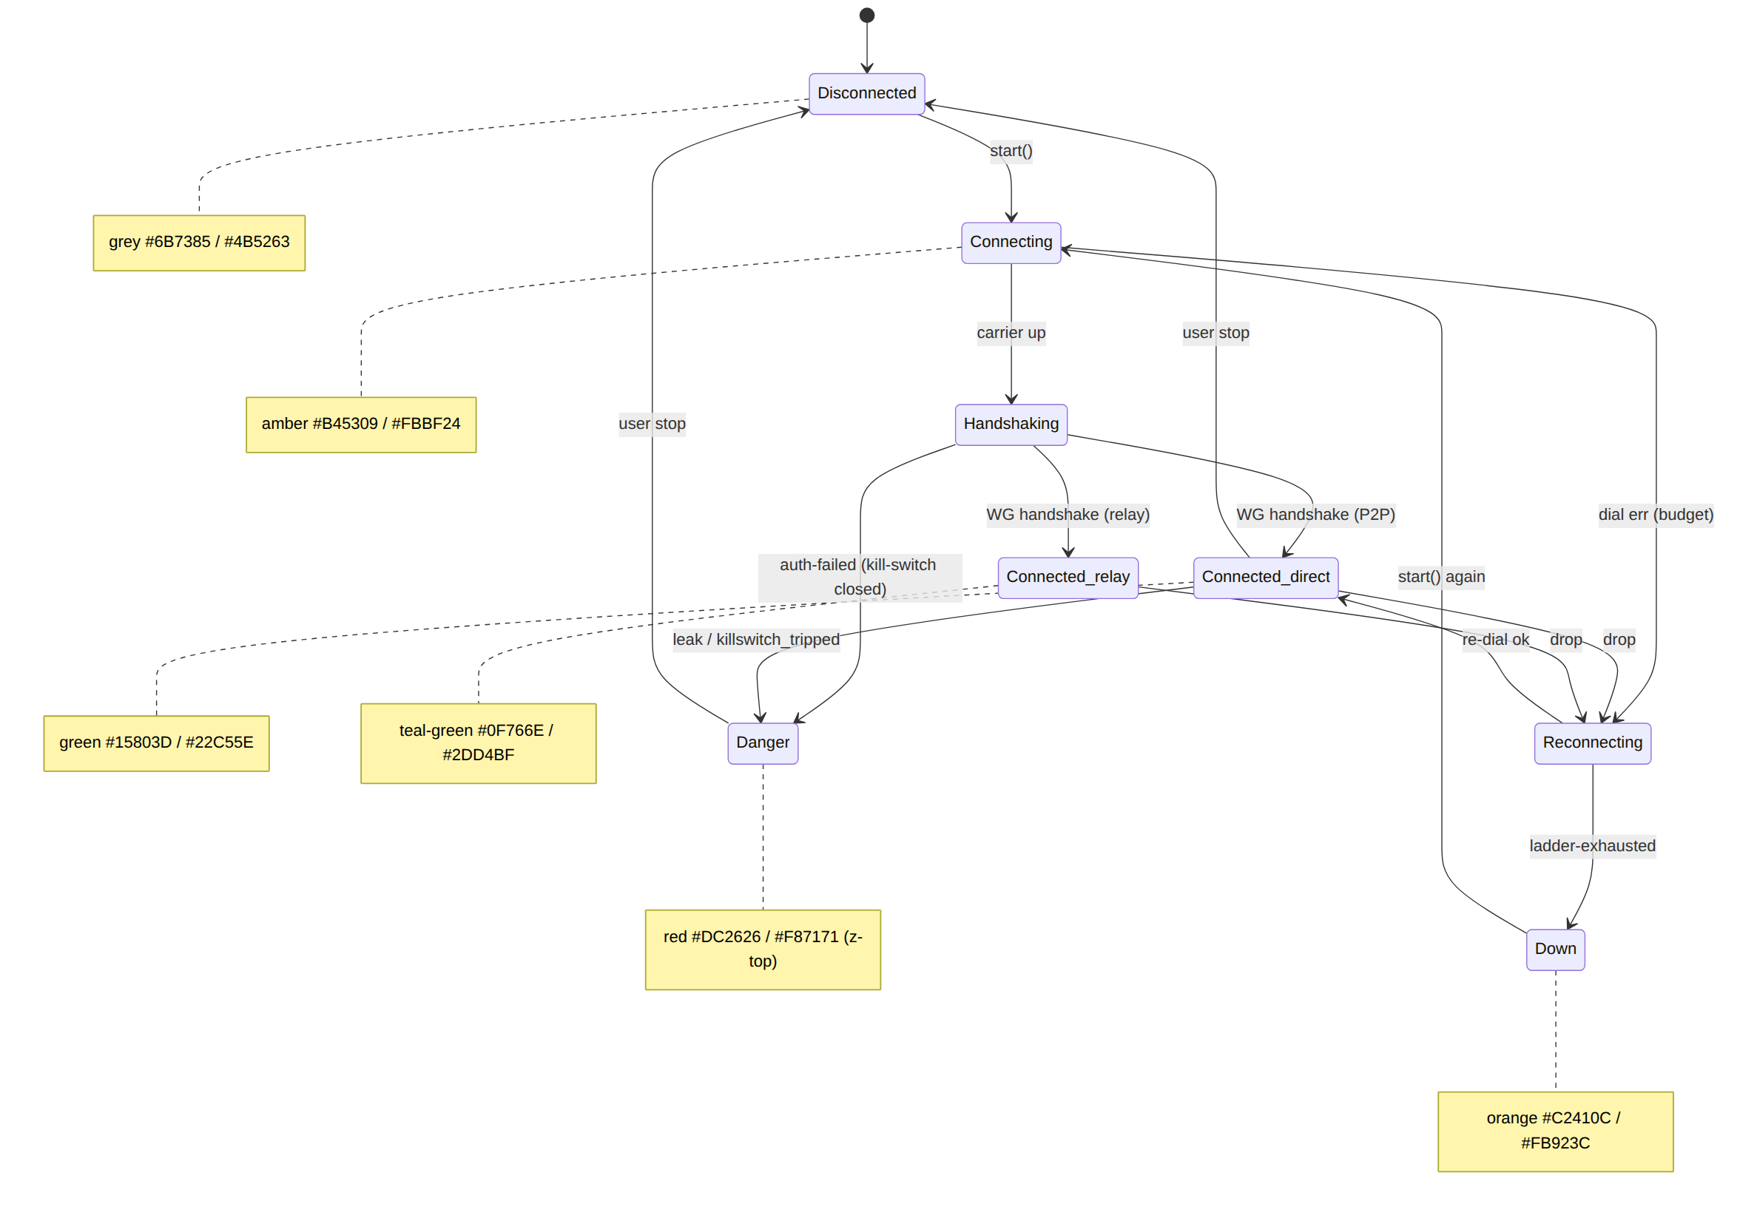

3.3 Two render patterns (and why both pass contrast)
Pattern | Where | Colour use | Governing WCAG threshold
Solid fill + label | ConnectButton (large circular), Danger banner | state colour as fill, text.onState (white, light theme) / #151920 (dark theme) as label | label is large+bold (≥24 px) → AA-large 3.0 governs, but every fill here clears AA-normal 4.5 too (§4.3)
Tint surface + coloured text/icon | StatusChip, list badges, inline status | state colour as text/icon on a low-alpha tint of itself (light) or on the dark surface (dark) | normal text → AA-normal 4.5 (§4.4)
The two patterns are why each state needs both a dark stop (light-theme fill
- light-theme text, low luminance reads on white) and a bright stop (dark-theme fill label is the dark #151920; dark-theme text reads on #151920). All proven in §4.

4. WCAG contrast proofs (computed)
WCAG 2.1 thresholds: AA-normal 4.5, AA-large 3.0 (≥18 pt, or ≥14 pt bold), AAA-normal 7.0, AAA-large 4.5, non-text UI/graphics 3.0 (SC 1.4.11). Every ratio below is the real arithmetic of the WCAG relative-luminance + (L1+0.05)/(L2+0.05) contrast formula on the stated hexes (computed; not estimated — §11.4.6).

4.1 Text on surface — light theme
Pair | Ratio | AA-normal | AAA-normal
text.primary #151920 / surface.default #FFFFFF | 17.62 | ✓ | ✓
text.primary #151920 / surface.raised #F7F8FA | 16.58 | ✓ | ✓
text.secondary #4B5263 / #FFFFFF | 7.82 | ✓ | ✓
text.tertiary #6B7385 / #FFFFFF | 4.76 | ✓ | ✗ (AA only)
text.link #2F47C4 / #FFFFFF | 7.45 | ✓ | ✓
text.disabled #9AA2B2 / #FFFFFF | 2.57 | exempt (inactive-control, SC 1.4.3) | —

4.2 Text on surface — dark theme (surface #151920)
Pair | Ratio | AA-normal | AAA-normal
text.primary #EDEFF3 / #151920 | 15.31 | ✓ | ✓
text.primary #EDEFF3 / surface.raised #222732 | 12.99 | ✓ | ✓
text.secondary #C2C8D4 / #151920 | 10.49 | ✓ | ✓
text.tertiary #9AA2B2 / #151920 | 6.87 | ✓ | ✗ (AA only)
text.link #9CB0FF / #151920 | 8.45 | ✓ | ✓
text.disabled #6B7385 / #151920 | 3.71 | exempt (inactive-control) | —

4.3 Connection-state solid fills (label on fill) — both themes
Light theme: white #FFFFFF label. Dark theme: #151920 label. (Contrast is order-independent, so these are the proven white-on-fill / dark-on-fill ratios.)
State | Light fill | white-label ratio | AA-n | Dark fill | #151920-label ratio | AA-n
Disconnected | #6B7385 | 4.76 | ✓ | #4B5263 | — (uses brand idle, §3) | —
Connecting/Handshaking/Reconnecting | #B45309 | 5.02 | ✓ | #FBBF24 | 10.56 | ✓
Connected{direct} | #15803D | 5.02 | ✓ | #22C55E | 7.73 | ✓
Connected{relay} | #0F766E | 5.47 | ✓ | #2DD4BF | 9.47 | ✓
Down | #C2410C | 5.18 | ✓ | #FB923C | 7.79 | ✓
Danger | #DC2626 | 4.83 | ✓ | #F87171 | 6.37 | ✓
All solid-fill state labels clear AA-normal (4.5) in both themes — the ConnectButton/Danger-banner label is legible even though it would only be held to AA-large (3.0) as large bold text. This is by design: the chosen light fills are the .600/.700 dark stops (not the raw .500), which is exactly why e.g. white-on-#16A34A (raw green .500, 3.30 — fails AA-normal) is not used as a light-theme fill; green.600 #15803D (5.02) is.

4.4 Connection-state text/icon on surface (tint pattern) — both themes
State | Light text/icon | on #FFFFFF | AA-n | Dark text/icon | on #151920 | AA-n
Disconnected | #6B7385 | 4.76 | ✓ | #9AA2B2 | 6.87 | ✓
Connecting | #B45309 | 5.02 | ✓ | #FBBF24 | 10.56 | ✓
Connected{direct} | #15803D | 5.02 | ✓ | #22C55E | 7.73 | ✓
Connected{relay} | #0F766E | 5.47 | ✓ | #2DD4BF | 9.47 | ✓
Down | #C2410C | 5.18 | ✓ | #FB923C | 7.79 | ✓
Danger | #DC2626 | 4.83 | ✓ | #F87171 | 6.37 | ✓
Every connection-state text/icon clears AA-normal (4.5) in both themes; the dark-theme variants additionally clear AAA-normal (7.0) for all but Danger (6.37, AA).

4.5 Focus ring / non-text graphics (SC 1.4.11, floor 3.0)
Element | Light | Ratio vs surface | Dark | Ratio vs surface
border.focus ring | #3D5AF1 / #FFFFFF | 5.34 ✓ | #6B86FB / #151920 | 5.39 ✓
Captured-evidence note (§11.4.6). The 24 ratios cited in §4 were each produced by running the WCAG formula on the exact hex pair; the computation is reproducible and is the proof. No ratio is asserted without that arithmetic. The visual-regression suite ([visual-regression-and-qa.md], §11.4.162) re-runs these as automated contrast assertions so a future palette edit that drops a pair below its floor fails the build (gate CM-token-a11y-floor [DT §9]).

5. The no-overlap / no-label-overlay rule (§11.4.162)
§11.4.162 mandates "elements MUST NOT overlap or overlay labels". At the colour layer this is a concrete set of rules (layout enforcement is [component-library.md] + visual regression; this is the colour half):
- Never colour-on-colour that hides a label. A label is always drawn on either a neutral surface (surface.*) or a fill whose contrast vs the label is proven (§4.3) — never a state colour text placed over another state colour fill. E.g. green "Connected" text is never painted on the amber "Connecting" chip during a transition; the chip cross-fades fill and label together (motion.stateXfade 180 ms, [DT §6.4]) so no in-between frame shows an illegible colour-on-colour.
- Overlays use a scrim, never a translucent brand wash. Any element that sits over content (modal, sheet, toast) places overlay.scrim (#1F2937 @ 60 % light / #000000 @ 70 % dark) beneath itself so its own labels meet contrast against an opaque-enough backdrop (white-on-scrim 14.68, §4) — never a semi-transparent brand tint that lets busy content bleed through and reduce label contrast below the floor.
- State colour is reinforcement, layout owns separation. Because the only saturated colour on screen is the active state (§0.2), two coloured elements are never adjacent enough to be confused; spacing tokens ([DT §6.1]) keep a ≥space.scale.2 (8 px) gap between any two coloured chips/badges so colour regions never touch (the colour-layer companion to the layout no-overlap rule).
- Danger is never overlaid by anything. Z-layer danger (2000, [DT §6.5]) sits above modals/toasts; nothing can be drawn over a leak/kill-switch banner, so its label is never occluded.
These four rules are asserted by the visual-regression + token-drift suite (golden screenshots per theme, OCR/contrast checks, §11.4.162 / §11.4.168) in [visual-regression-and-qa.md]; this document supplies the colour contract they assert against.

6. Per-app accent differentiation (Client / Console / Connector)
All three apps share the same surface/text/feedback/connection-state semantics (safety colours never differ — D-COLOR-1). They differ only in the brand-overridable set {action.primary, accent.*} ([DT §5.3, D-DT-1]) so each app has a recognisable identity without ever recolouring a safety signal.
App | Accent ramp | Light accent (action/link) | Dark accent | Proof
Client (Helix Access) | helix.* indigo-blue (the brand) | helix.600 #2F47C4 | helix.500 #3D5AF1 / helix.400 #6B86FB | link 7.45 light; white-on-fill 7.45; dark accent 5.39
Console (admin) | violet.* (authority/admin) | violet.700 #6D28D9 | violet.400 #A78BFA | text 7.10 light; on violet.600 #7C3AED white 5.70; dark 6.47
Connector (appliance) | teal.* (infrastructure/network) | teal.700 #0F766E | teal.400 #2DD4BF | text 5.47 light; dark 9.47
All per-app accents clear AA-normal (4.5) for text in both themes. Verified ratios: Client link #2F47C4/white 7.45; Console #6D28D9/white 7.10; Connector #0F766E/white 5.47; dark accents #6B86FB/#151920 5.39, #A78BFA/#151920 6.47, #2DD4BF/#151920 9.47.
D-COLOR-1 (restated). The accent override touches only action.primary + accent.*. state.* (connection), feedback.* (success/warning/error/info), and text/surface/border are identical across all three apps and any future tenant brand. A Console must never be able to recolour "Connected" away from green — that is a §11.4.66 operator decision, not a theme capability.

7. Swatch map
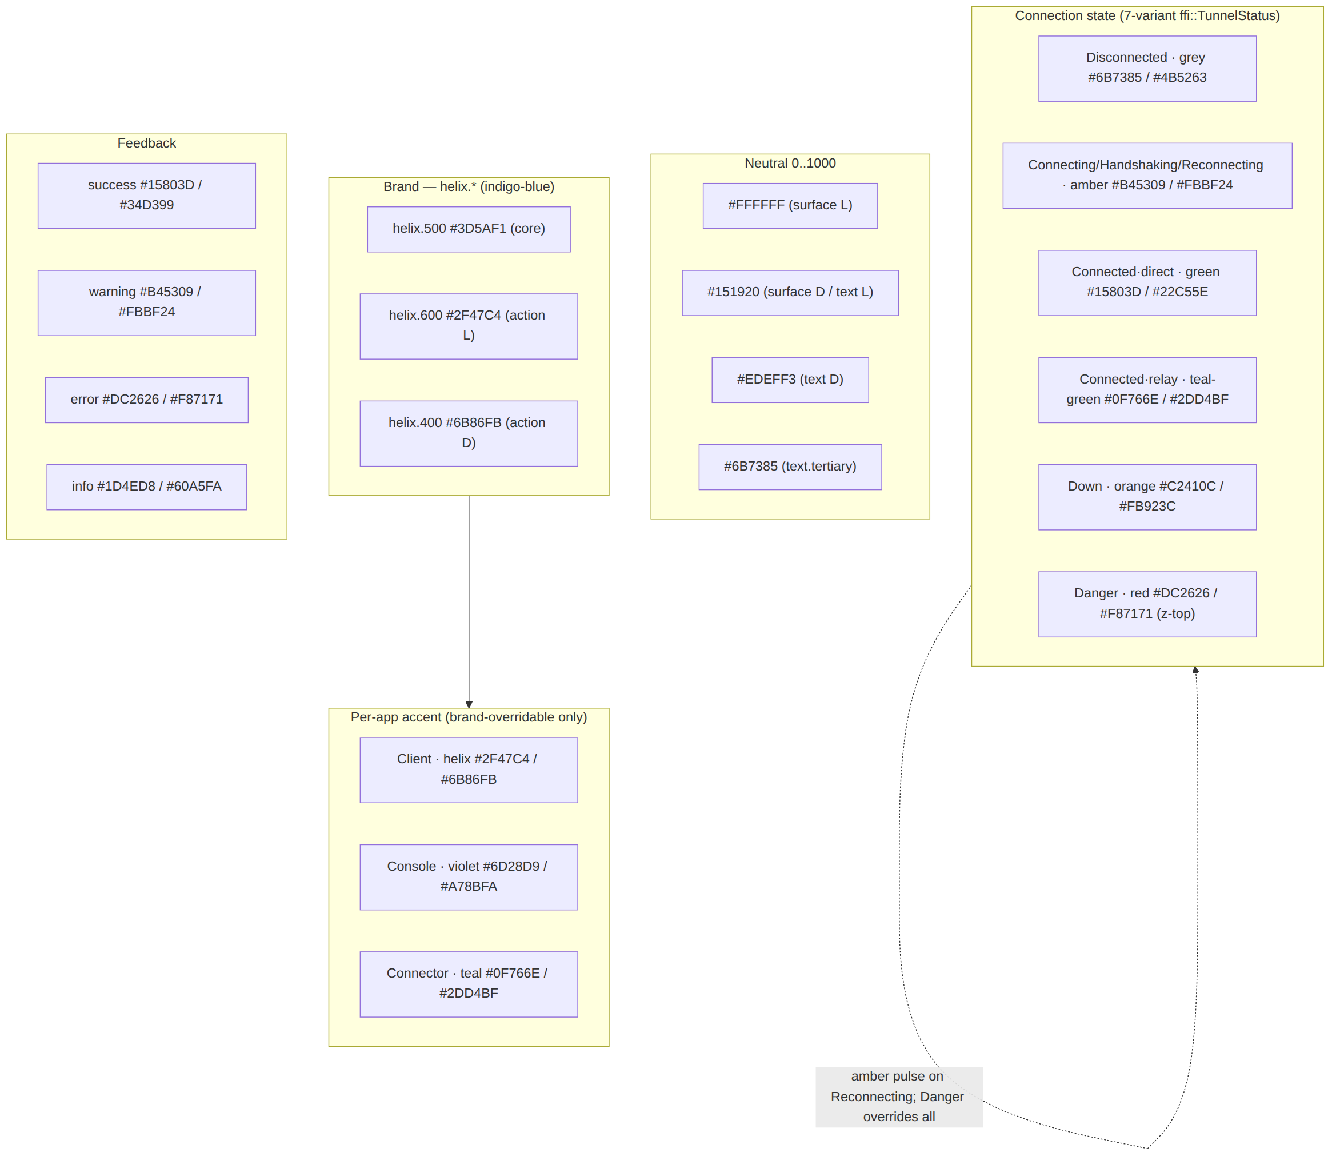
Family | Light hex | Dark hex | Meaning
Brand | #2F47C4 | #3D5AF1 | trust, primary action
Disconnected | #6B7385 | #9AA2B2 | off (by choice)
Connecting/Reconnecting | #B45309 | #FBBF24 | working (amber, pulse)
Connected · direct | #15803D | #22C55E | protected, P2P
Connected · relay | #0F766E | #2DD4BF | protected, relayed
Down | #C2410C | #FB923C | unexpected drop
Danger | #DC2626 | #F87171 | leak / kill-switch — exposed

8. Surfaced decisions & cross-doc contracts
id | Decision / contract | Status
D-COLOR-1 | Safety semantics (state.*, feedback.*) are NOT brand/tenant-overridable; only action.primary+accent.* differ per app. Widening = §11.4.66 operator decision. | recommended, surfaced
D-COLOR-2 | Light-theme state fills use the .600/.700 dark stops (not raw .500) so every white-label fill clears AA-normal 4.5 (§4.3). | decided (proven)
D-COLOR-3 | Reconnecting reuses the Connecting amber + a pulse; reduce-motion degrades pulse→static (never strobes). | decided
D-COLOR-4 | Connected.path direct vs relay → pure-green vs teal-green sub-shade; both read "protected", path conveyed by sub-shade + StatusChip text. | decided
C-COLOR-A (consumes) | 7-variant ffi::TunnelStatus vocabulary owned by [FFI §3.2]; §3 stays total over it (gate CM-token-state-coverage [DT §9]). | contract
C-COLOR-B (provides) | These hexes are the literal values [design-tokens.md]'s primitive tier references and [token-export-pipeline.md] emits. | contract
C-COLOR-C (provides) | The §4 contrast ratios are the assertions [visual-regression-and-qa.md] re-runs as automated a11y gates (§11.4.162). | contract
U-COLOR-1 UNVERIFIED | The exact light-theme tint alpha for state-chip backgrounds (the % of the state colour mixed into the chip surface) is pinned by the component spec + golden-screenshot suite; stated patterns use the proven text-on-opaque-surface ratios, the more conservative bound. | open

Sources verified
- Brand palette, neutral ramp, status/feedback/accent ramps, all hex choices, semantic light+dark mappings, connection-state palette, per-app accents — NO external source needed — original HelixVPN design work (the hue choices and every hex are owned by this document).
- WCAG contrast formula (relative luminance + (L1+0.05)/(L2+0.05)) and the AA/AAA/SC-1.4.11 thresholds — W3C Web Content Accessibility Guidelines 2.1, SC 1.4.3 (Contrast Minimum, incl. the inactive/disabled-control exception), SC 1.4.6 (Contrast Enhanced), SC 1.4.11 (Non-text Contrast), and the relative-luminance definition https://www.w3.org/TR/WCAG21/#dfn-relative-luminance (verified 2026-06-25). Every ratio in §4, §6 was computed by this formula on the stated hexes — the computation is the captured evidence (§11.4.6), not an estimate.
- 7-variant ffi::TunnelStatus vocabulary (Disconnected · Connecting · Handshaking · Connected{direct|relay} · Reconnecting · Down · Danger) — final/v04-client/ffi-surface.md §3.2–§3.3 (read 2026-06-25).
- Token tier/naming/theming model the colours live in — final/v10-design/design-tokens.md (sibling, this wave).
- 3-app / 8-platform matrix, §11.4.162 design-system mandate (no-overlap / light+dark) — final/SPECIFICATION.md §3 + MASTER_INDEX Volume 10 block (read 2026-06-25).
- The single UNVERIFIED item (U-COLOR-1, exact chip tint-alpha) is pending its named component/golden-screenshot spec per §11.4.6 — not asserted as fact.

