Design tokens — taxonomy, schema & theming

Design tokens — taxonomy, schema & theming
Revision: 1 Last modified: 2026-06-25T12:00:00Z
Master technical specification — Volume 10 (Design System), nano-detail deep-dive. This document owns the canonical design-token taxonomy and the JSON source-of-truth schema for HelixVPN's own design system: the three token tiers (primitive → semantic → component), the naming convention, the full token categories (color, typography, spacing, radius, elevation/ shadow, motion, z-index, breakpoints) with light + dark value pairs, the theming-resolution model (theme × platform × brand), and the drift / contract rules that keep every emitted form (JSON / CSS / Dart / SwiftUI / Compose / ArkTS / C-Qt) byte-faithful to this one source.
SPEC-ONLY. It describes what the tokens are and how they resolve — not the shipping helix_design build. The concrete hex values of the color tier are defined and contrast-proven in the sibling color-system.md; this document defines the structure the colors live in (and reproduces the load-bearing hexes so the schema samples are valid, never placeholder).
Position. helix_design is a fully decoupled, reusable submodule (vasic-digital/helix_design, snake_case flat per §11.4.28/.29/.74) that configures OpenDesign (the mandatory token/theme engine, §11.4.162) to emit these tokens. This doc owns the token model; the OpenDesign integration mechanics live in [opendesign-foundation.md], the multi-form emit in [token-export-pipeline.md], the colors in [color-system.md], type/icon/ motion detail in [typography-iconography-motion.md].
Boundary with sibling docs. This doc owns the schema + tier rules + naming. It consumes: the 7-variant connection-state vocabulary from the FFI surface [v04-client/ffi-surface.md §3.2] (the TunnelStatus the component tier's connection tokens map onto); the 3-app / 8-platform matrix from the spine [SPECIFICATION.md §3]; the OpenDesign engine contract [opendesign-foundation.md].
Evidence base. [04_CLIENT §N] = final/03-client-core-and-ui.md; [FFI §N] = final/v04-client/ffi-surface.md; [SPINE §N] = final/SPECIFICATION.md; [COLOR §N] = final/v10-design/color-system.md. Claims not grounded in the evidence base or in this document's own original design choices are tagged UNVERIFIED per constitution §11.4.6 — never fabricated. The token taxonomy itself is original HelixVPN design work (no external source needed), modeled on the well-established primitive/semantic/component three-tier pattern.

Table of contents
- 0. Why tokens, and the one-source rule
- 1. The three tiers
- 2. Naming convention
- 3. The JSON source-of-truth schema
- 4. A concrete, valid token sample (all categories, light+dark)
- 5. The theming-resolution model (theme × platform × brand)
- 6. Scales — spacing, radius, elevation, motion, z-index, breakpoints
- 7. Component tokens — referencing semantic, never primitive
- 8. The connection-state component tokens (the FFI seam)
- 9. Drift, contract & validation rules
- 10. Surfaced decisions & cross-doc contracts
- Sources verified

0. Why tokens, and the one-source rule
A design token is a named, platform-neutral key bound to a design value (a color, a length, a duration, a font axis). HelixVPN ships three apps (Client, Console, Connector) across eight platforms (iOS, macOS, Android, Windows, Linux, Web, HarmonyOS, Aurora) from one Flutter UI core [SPINE §3]. Without a single token source, that surface drifts: the iOS connect button greens one way, the Web one another, and the "connected" colour stops meaning "connected".
The one-source rule. There is exactly one authored source of truth — a set of JSON token files in helix_design/tokens/** — and every consumable form (CSS custom properties, Dart ThemeData, SwiftUI Color/Font, Compose ColorScheme/Typography, ArkTS resource maps, C/Qt .qml/header constants) is generated from it ([token-export-pipeline.md]). A hand-edited platform theme is a drift defect (§9), the visual analogue of the schema-first zero-drift principle the rest of HelixVPN already enforces for proto/OpenAPI [SPINE §4 principle 8].
Honest boundary (§11.4.6). Tokens guarantee consistency and single-sourcing of design values — they do not by themselves guarantee usability, accessibility, or correct layout. Contrast is proven in [color-system.md]; no-overlap / no-label-overlay layout is a component + visual-regression concern ([component-library.md], [visual-regression-and-qa.md], §11.4.162). This doc owns the values' structure, not their fitness.

1. The three tiers
Tokens resolve through exactly three tiers, each referencing only the tier below it. This is the load-bearing rule that lets a single brand or theme swap ripple correctly through every component.
Tier | Purpose | References | May a component use it directly? | Example
Primitive (a.k.a. global / core) | The raw palette + raw scale. Theme-agnostic, brand-agnostic. A flat dictionary of literal values. | nothing (literals only) | No | color.primitive.helix.500 = #3D5AF1
Semantic (a.k.a. alias / system) | Intent. Names a role ("the default surface", "primary text", "the danger colour") and binds it per theme to a primitive. This is the only tier with light/dark forks. | primitive (per theme) | Discouraged — allowed for one-off bespoke surfaces, but components should prefer a component token | color.semantic.surface.default = {light: helix-neutral.0, dark: helix-neutral.900}
Component | A specific UI part's specific slot. Names the exact widget property. | semantic only (never primitive) | Yes — this is what widgets read | comp.connectButton.bg.connected = color.semantic.state.connected.fill
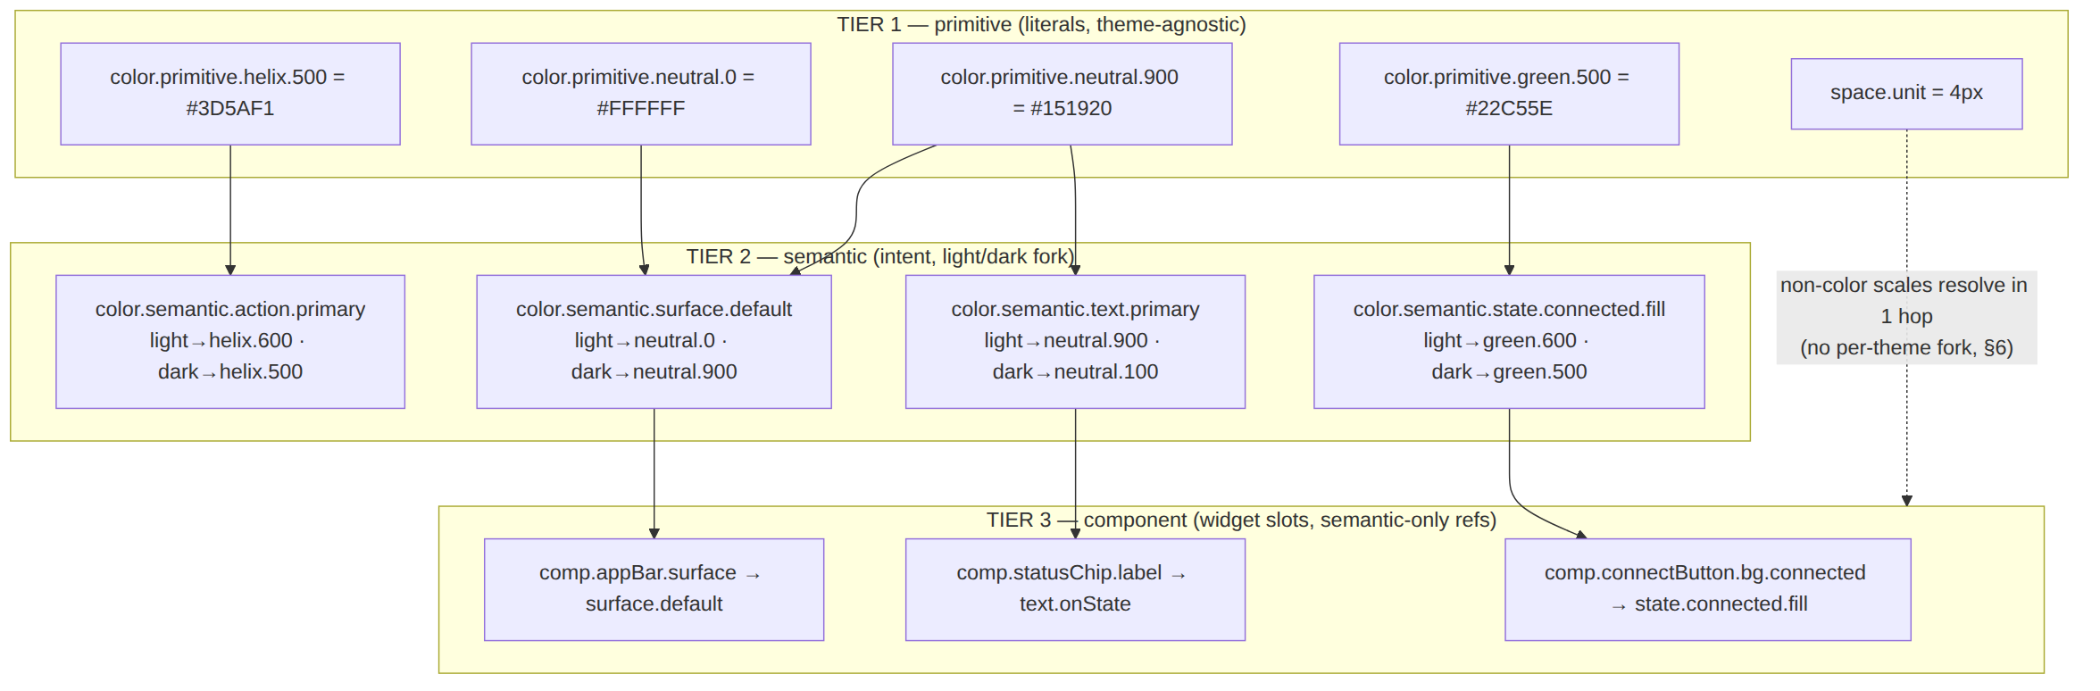
Why component → semantic only (never component → primitive). If comp.connectButton.bg.connected pointed straight at green.500, a brand or theme change would have to rewrite every component token. Routing through state.connected.fill means the theme swap touches one semantic binding and every component that references it updates for free. A component token that references a primitive is a tier violation caught by the lint in §9.

2. Naming convention
Every token id is a dot-delimited, lowercase, snake-free camelCase-segment path. The first segment is the category, the second is the tier, the rest narrows to the leaf. (camelCase within a segment; dots between segments — this survives every target language's identifier rules and the OpenDesign engine input.)
<category>.<tier>.<group>[.<subgroup>...].<leaf>[.<state|variant>]
Part | Closed/open | Values
category | closed | color · font · space · radius · elevation · motion · z · breakpoint · border · opacity · size
tier | closed | primitive · semantic · (component uses the comp. root, below)
group | open | per category (helix, neutral, green for color-primitive; surface, text, state, action, border for color-semantic; …)
leaf | open | the terminal name (500, default, primary, connected)
state/variant | open, optional | hover · pressed · disabled · focus · fill · onFill · subtle
Component tokens use a distinct root, comp, so a grep cleanly separates the widget tier:
comp.<componentName>.<slot>[.<state|variant>]

2.1 Canonical examples
color.primitive.helix.500 # raw brand blue → #3D5AF1
color.primitive.neutral.0 # raw white → #FFFFFF
color.primitive.green.500 # raw connected-green → #22C55E
color.semantic.surface.default # the default surface role (light/dark)
color.semantic.text.primary # primary text role (light/dark)
color.semantic.state.connected.fill# the "connected" fill role (light/dark)
color.semantic.action.primary # primary action role (light/dark)
comp.connectButton.bg.connected # the connect button's bg when Connected
comp.connectButton.bg.disconnected # …when Disconnected
comp.statusChip.label # the status-chip text slot
comp.exitPicker.row.selected.bg # selected exit row background
font.semantic.body.md # body medium type role
space.scale.4 # 4 × base = 16px
radius.scale.md # medium corner radius
elevation.semantic.menu # the elevated-menu shadow role
motion.semantic.connectPulse.dur # the connecting-pulse duration
z.semantic.modal # modal stacking layer
breakpoint.scale.md # the medium responsive breakpoint
Naming invariants (lint-enforced, §9). (a) every id starts with a closed category; (b) every non-comp id has a closed tier second segment; (c) comp.* ids reference only *.semantic.* values; (d) ids are unique across the whole tree; (e) ids never collide with a target-language reserved word after the JSON→identifier transform (the transform replaces .→_/- per form; see [token-export-pipeline.md]).

3. The JSON source-of-truth schema
The source is a tree of JSON files (one file per category is the recommended layout; the loader merges them). Every leaf token object has a fixed shape — a Style-Dictionary-class $value/$type envelope extended with HelixVPN's per-theme fork for color-and-other-themed categories.

3.1 The leaf-token envelope
// the shape of EVERY leaf token (primitive or semantic or component)
{
"$type": "color", // closed: color|dimension|fontFamily|fontWeight|
// number|duration|cubicBezier|shadow|zIndex
"$value": <literal | { "light": <ref|literal>, "dark": <ref|literal> } | <ref>>,
"$description": "human-readable intent (REQUIRED on every semantic token)",
"$extensions": { // optional engine/consumer hints
"helix.deprecated": false,
"helix.a11yMin": "AA", // contrast floor this token is contractually held to (§COLOR)
"helix.platforms": ["*"] // or a subset; "*" = all 8
}
}
- Reference syntax — a $value of the form "{color.primitive.helix.500}" is a reference to another token (curly-brace, dotted path). The resolver (OpenDesign / the export pipeline) dereferences it. A reference MUST resolve to a token of the same $type.
- Per-theme fork — only the themed categories (color, elevation/ shadow, and the small set of border/opacity tokens that differ by theme) carry a { "light": …, "dark": … } object in $value. Non-themed categories (space, radius, font metrics, motion, z, breakpoint) carry a single literal/reference — they are identical across themes (§6).
- Primitive $value is always a literal (never a reference) — primitives are the leaves the references terminate at.
- Semantic $value is the per-theme fork, each side a reference to a primitive.
- Component $value is a single reference to a semantic token (no fork — the fork already happened one tier down, so a component token is theme-correct by construction).

3.2 $type closed vocabulary → target-form mapping
$type | JSON literal form | CSS | Dart | SwiftUI | Compose | ArkTS | C/Qt
color | "#RRGGBB" / "#RRGGBBAA" | --c: #… | Color(0xAARRGGBB) | Color(red:…) | Color(0x…) | $rrggbb | QColor("#…")
dimension | "16px" / "1.5rem" | 16px | 16.0 (logical px) | 16 (pt) | 16.dp | 16vp | 16
fontFamily | "Inter" | font-family | fontFamily | Font.custom | FontFamily | fontFamily | QFont
fontWeight | 400/600 | 400 | FontWeight.w400 | .regular | W400 | FontWeight.Regular | QFont::Normal
number | 1.5 | unitless | double | CGFloat | Float | number | qreal
duration | "180ms" | 180ms | Duration(ms:180) | 0.18 | 180 | 180 | 180
cubicBezier | [0.2,0,0,1] | cubic-bezier(…) | Cubic(…) | .timingCurve | CubicBezierEasing | bezier | QEasingCurve
shadow | {offsetX,offsetY,blur,spread,color} | box-shadow | BoxShadow | .shadow | Modifier.shadow | shadow | QGraphicsDropShadow
zIndex | integer | z-index | int | zIndex | zIndex | zIndex | stack order
UNVERIFIED — the exact ArkTS resource-map key syntax and the C/Qt .qml/header emit shapes are pinned by the export-pipeline contract test ([token-export-pipeline.md] §drift-gate); the column above states the intended mapping, frozen there. Marked UNVERIFIED until that contract test exists per §11.4.6.

4. A concrete, valid token sample (all categories, light+dark)
The following is a valid, self-consistent slice of the source tree (not a placeholder) covering every category. Color literals match [color-system.md]; non-color scales are defined in §6 of this doc.
// helix_design/tokens/primitive.json — TIER 1 (literals, theme-agnostic)
{
"color": { "primitive": {
"helix": { "500": { "$type": "color", "$value": "#3D5AF1" },
"600": { "$type": "color", "$value": "#2F47C4" },
"400": { "$type": "color", "$value": "#6B86FB" } },
"neutral": { "0": { "$type": "color", "$value": "#FFFFFF" },
"100": { "$type": "color", "$value": "#EDEFF3" },
"500": { "$type": "color", "$value": "#6B7385" },
"600": { "$type": "color", "$value": "#4B5263" },
"900": { "$type": "color", "$value": "#151920" } },
"green": { "500": { "$type": "color", "$value": "#22C55E" },
"600": { "$type": "color", "$value": "#15803D" } },
"amber": { "500": { "$type": "color", "$value": "#F59E0B" },
"700": { "$type": "color", "$value": "#B45309" } },
"orange": { "600": { "$type": "color", "$value": "#C2410C" } },
"red": { "600": { "$type": "color", "$value": "#DC2626" } },
"teal": { "500": { "$type": "color", "$value": "#14B8A6" },
"700": { "$type": "color", "$value": "#0F766E" } }
} },
"space": { "primitive": { "unit": { "$type": "dimension", "$value": "4px" } } },
"font": { "primitive": {
"family": { "sans": { "$type": "fontFamily", "$value": "Inter" },
"mono": { "$type": "fontFamily", "$value": "JetBrains Mono" } },
"weight": { "regular": { "$type": "fontWeight", "$value": 400 },
"medium": { "$type": "fontWeight", "$value": 500 },
"semibold":{ "$type": "fontWeight", "$value": 600 } }
} }
}
// helix_design/tokens/semantic.json — TIER 2 (intent, light/dark fork)
{
"color": { "semantic": {
"surface": {
"default": { "$type": "color", "$description": "the base app surface",
"$value": { "light": "{color.primitive.neutral.0}",
"dark": "{color.primitive.neutral.900}" },
"$extensions": { "helix.a11yMin": "AAA" } },
"raised": { "$type": "color", "$description": "cards/sheets above the base",
"$value": { "light": "#F7F8FA", "dark": "#222732" } }
},
"text": {
"primary": { "$type": "color", "$description": "default body/heading text",
"$value": { "light": "{color.primitive.neutral.900}",
"dark": "{color.primitive.neutral.100}" },
"$extensions": { "helix.a11yMin": "AAA" } },
"secondary": { "$type": "color", "$description": "supporting text",
"$value": { "light": "{color.primitive.neutral.600}", "dark": "#C2C8D4" } },
"onState": { "$type": "color", "$description": "label drawn ON a filled state colour",
"$value": { "light": "#FFFFFF", "dark": "#FFFFFF" } }
},
"action": {
"primary": { "$type": "color", "$description": "primary action/brand fill",
"$value": { "light": "{color.primitive.helix.600}",
"dark": "{color.primitive.helix.500}" },
"$extensions": { "helix.a11yMin": "AA" } }
},
"state": {
"connected": { "fill": { "$type": "color", "$description": "the Connected state colour",
"$value": { "light": "{color.primitive.green.600}", "dark": "{color.primitive.green.500}" } } },
"connecting":{ "fill": { "$type": "color", "$description": "Connecting/Handshaking/Reconnecting",
"$value": { "light": "{color.primitive.amber.700}", "dark": "#FBBF24" } } },
"danger": { "fill": { "$type": "color", "$description": "Danger (leak/killswitch)",
"$value": { "light": "{color.primitive.red.600}", "dark": "#F87171" } } }
},
"border": {
"default": { "$type": "color", "$value": { "light": "#DCE0E8", "dark": "#353B49" } }
}
} },
"font": { "semantic": {
"body": { "md": { "$type": "number", "$description": "body medium size (px)",
"$value": 14 } },
"heading": { "lg": { "$type": "number", "$value": 22 } }
} }
}
// helix_design/tokens/component.json — TIER 3 (widget slots, semantic-only refs)
{
"comp": {
"connectButton": {
"bg": {
"connected": { "$type": "color", "$value": "{color.semantic.state.connected.fill}" },
"connecting": { "$type": "color", "$value": "{color.semantic.state.connecting.fill}" },
"disconnected": { "$type": "color", "$value": "{color.semantic.action.primary}" },
"danger": { "$type": "color", "$value": "{color.semantic.state.danger.fill}" }
},
"label": { "$type": "color", "$value": "{color.semantic.text.onState}" },
"radius":{ "$type": "dimension", "$value": "{radius.scale.full}" }
},
"statusChip": {
"label": { "$type": "color", "$value": "{color.semantic.text.onState}" },
"padX": { "$type": "dimension", "$value": "{space.scale.3}" }
},
"appBar": { "surface": { "$type": "color", "$value": "{color.semantic.surface.default}" } }
}
}
// helix_design/tokens/scale.json — non-themed scales (single literal, §6)
{
"space": { "scale": { "1": {"$type":"dimension","$value":"4px"}, "2": {"$type":"dimension","$value":"8px"},
"3": {"$type":"dimension","$value":"12px"}, "4": {"$type":"dimension","$value":"16px"},
"5": {"$type":"dimension","$value":"24px"}, "6": {"$type":"dimension","$value":"32px"} } },
"radius": { "scale": { "sm": {"$type":"dimension","$value":"4px"}, "md": {"$type":"dimension","$value":"8px"},
"lg": {"$type":"dimension","$value":"16px"},"full":{"$type":"dimension","$value":"9999px"} } },
"elevation": { "semantic": {
"card": { "$type": "shadow", "$value": {
"light": { "offsetX":"0px","offsetY":"1px","blur":"3px","spread":"0px","color":"#1519201A" },
"dark": { "offsetX":"0px","offsetY":"1px","blur":"3px","spread":"0px","color":"#00000066" } } },
"menu": { "$type": "shadow", "$value": {
"light": { "offsetX":"0px","offsetY":"8px","blur":"24px","spread":"-4px","color":"#15192026" },
"dark": { "offsetX":"0px","offsetY":"8px","blur":"24px","spread":"-4px","color":"#00000080" } } } } },
"motion": { "semantic": {
"connectPulse": { "dur": {"$type":"duration","$value":"1200ms"},
"ease": {"$type":"cubicBezier","$value":[0.4,0,0.6,1]} },
"stateXfade": { "dur": {"$type":"duration","$value":"180ms"},
"ease": {"$type":"cubicBezier","$value":[0.2,0,0,1]} } } },
"z": { "semantic": { "base":{"$type":"zIndex","$value":0}, "nav":{"$type":"zIndex","$value":100},
"overlay":{"$type":"zIndex","$value":1000}, "modal":{"$type":"zIndex","$value":1100},
"toast":{"$type":"zIndex","$value":1200}, "danger":{"$type":"zIndex","$value":2000} } },
"breakpoint": { "scale": { "sm":{"$type":"dimension","$value":"360px"},
"md":{"$type":"dimension","$value":"600px"},
"lg":{"$type":"dimension","$value":"1024px"},
"xl":{"$type":"dimension","$value":"1440px"} } }
}
Every $value above is a real, resolvable value or a real reference into the primitive/semantic trees in this same sample — no placeholders, no TODO (§11.4.6). The 8-hex colors (e.g. #1519201A) are #RRGGBBAA — neutral.900 at ~10 % alpha for the light-card shadow.

5. The theming-resolution model (theme × platform × brand)
A token id resolves to a concrete value along three axes. Resolution is deterministic and total (every (id, theme, platform, brand) yields exactly one value or a build error — never a silent default, §11.4.6).

5.1 Axis 1 — theme (light / dark) — mandatory both
Every semantic color/elevation token MUST define both light and dark (§9 gate CM-token-light-dark-complete). A semantic token missing a theme side is a build-blocking defect (§11.4.162 mandates light+dark for every component). Because components reference semantics, every component token is dual-theme by construction — no component ever declares a theme fork itself.
The active theme is chosen at runtime by the app (system setting → user override → forced-by-context, e.g. Danger never changes theme but always paints from the danger semantic). The Flutter helix-ui builds two ThemeData (light + dark) from the emitted Dart and hands both to MaterialApp(theme:, darkTheme:) [04_CLIENT §7].

5.2 Axis 2 — platform (emit target) — form, not value
Platform does not change a token's value; it changes its emitted form (§3.2 table) and, rarely, its adaptation (e.g. a platform that lacks a shadow primitive renders elevation as a hairline border). A token may opt out of a platform via $extensions.helix.platforms; the export pipeline omits it from that form's output. Platform never forks $value — that would re-introduce drift. Per-platform look-and-feel adaptation (Material vs Cupertino vs desktop vs TV-leanback vs HarmonyOS vs Aurora) is a component-mapping concern owned by [platform-adaptation.md], built on top of these identical token values.

5.3 Axis 3 — brand (tenant / app accent) — override map
The default brand is HelixVPN (the helix.* ramp). The model supports a brand-override layer: a thin JSON that re-points a small, closed set of semantic tokens (chiefly action.primary and the app-accent) to a different primitive ramp, leaving the connection-state and feedback semantics fixed (state colours MUST stay stable across brands — "connected" is always green, a multi-tenant Console must not recolour safety semantics). The per-app accent differentiation (Client vs Console vs Connector) is one such override and is specified in [color-system.md §per-app accent]. Resolution order: brand-override (if present) → semantic default → primitive.
D-DT-1 (surfaced, §10). The closed set of brand-overridable semantic tokens is {action.primary, accent.*, surface.brandTint}. Allowing a tenant to override state.* or feedback.* is rejected (safety-colour drift). If a future product needs per-tenant state colours, that is a §11.4.66 operator decision, not a silent capability.

6. Scales — spacing, radius, elevation, motion, z-index, breakpoints
The non-color scales are theme-agnostic (one value, no light/dark fork) — except elevation/shadow, whose color differs by theme (a shadow is darker and more opaque on dark surfaces, §4 sample).

6.1 Spacing — 4-pt base scale
space.primitive.unit = 4px. The scale is integer multiples; component padding/ gaps reference scale steps, never raw px.
token | multiplier | value | typical use
space.scale.0 | 0 | 0px | reset
space.scale.1 | 1× | 4px | icon-to-label gap
space.scale.2 | 2× | 8px | tight intra-component
space.scale.3 | 3× | 12px | chip padding
space.scale.4 | 4× | 16px | default content padding
space.scale.5 | 6× | 24px | section gap
space.scale.6 | 8× | 32px | screen margin (phone)
space.scale.7 | 12× | 48px | hero / connect-button ring
space.scale.8 | 16× | 64px | large desktop gutter
The 4-pt base is the original HelixVPN choice; it aligns with the 8 platforms' common density grids (Material 4dp/8dp, Cupertino 8pt) so one scale maps cleanly everywhere.

6.2 Radius scale
token | value | use
radius.scale.none | 0px | data tables
radius.scale.sm | 4px | inputs, chips
radius.scale.md | 8px | cards, sheets
radius.scale.lg | 16px | dialogs, the connect panel
radius.scale.full | 9999px | the circular ConnectButton, status dots, pills

6.3 Elevation / shadow scale (themed color)
token | light shadow | dark shadow | use
elevation.semantic.flat | none | none | base surface
elevation.semantic.card | 0 1px 3px #1519201A | 0 1px 3px #00000066 | cards, list rows
elevation.semantic.menu | 0 8px 24px #15192026 | 0 8px 24px #00000080 | menus, popovers
elevation.semantic.modal | 0 16px 48px #15192033 | 0 16px 48px #000000A6 | dialogs, sheets
The shape (offset/blur/spread) is theme-invariant; only the shadow color + alpha forks — darker, more opaque on dark (a soft light-grey shadow is invisible on a dark surface). This is the only non-color category that forks by theme.

6.4 Motion tokens
token | value | use
motion.semantic.stateXfade.dur | 180ms | cross-fade between two TunnelStatus colours
motion.semantic.stateXfade.ease | cubic-bezier(0.2,0,0,1) | (decelerate)
motion.semantic.connectPulse.dur | 1200ms | the Connecting/Reconnecting amber pulse loop
motion.semantic.connectPulse.ease | cubic-bezier(0.4,0,0.6,1) | (ease-in-out, symmetric loop)
motion.semantic.press.dur | 100ms | button press scale/ink
motion.semantic.sheet.dur | 240ms | sheet/dialog enter
motion.semantic.reducedMotion | 0ms | the value all *.dur collapse to when the OS "reduce motion" flag is set (a11y; the Reconnecting "pulse" becomes a static amber, never a flash)
Reduce-motion contract. When the platform reports reduced-motion, the export/runtime substitutes motion.semantic.reducedMotion for animation durations. The Reconnecting state therefore degrades from pulse to static amber — it never strobes (a11y + the §11.4.107 no-flash discipline).

6.5 Z-index scale
base 0 → nav 100 → overlay 1000 → modal 1100 → toast 1200 → danger 2000. The danger layer (2000) sits above everything so a Danger banner (leak / kill-switch tripped) is never occluded by a modal or toast — the safety state always wins the stacking order (mirrors the FFI rule that Danger overrides all intent [FFI §3.2/§3.3]).

6.6 Breakpoints
token | min-width | layout class
breakpoint.scale.sm | 360px | compact phone
breakpoint.scale.md | 600px | large phone / small tablet — two-pane begins
breakpoint.scale.lg | 1024px | tablet / desktop — Console master-detail
breakpoint.scale.xl | 1440px | wide desktop — Console three-pane
The Client app is primarily sm/md; the Console (web + desktop) uses lg/xl; the same tokens serve TV-leanback (treated as xl with larger touch/ focus targets). Responsive screen specs live in [screens-client.md] / [screens-console.md].

7. Component tokens — referencing semantic, never primitive
A component token names one widget's one slot in one state. It is the only tier widgets read. Example: the ConnectButton's background across its states maps one-to-one onto the connection-state semantics (the FFI seam, §8).
"comp": { "connectButton": {
"bg": {
"disconnected": { "$value": "{color.semantic.action.primary}" }, // brand idle
"connecting": { "$value": "{color.semantic.state.connecting.fill}" },
"handshaking": { "$value": "{color.semantic.state.connecting.fill}" },
"connected": { "$value": "{color.semantic.state.connected.fill}" },
"reconnecting": { "$value": "{color.semantic.state.connecting.fill}" },
"down": { "$value": "{color.semantic.state.down.fill}" },
"danger": { "$value": "{color.semantic.state.danger.fill}" }
},
"label": { "$value": "{color.semantic.text.onState}" }, // white on every fill
"ring": { "$value": "{color.semantic.state.connected.glow}" }, // the "connected" halo
"radius": { "$value": "{radius.scale.full}" },
"size": { "$value": "{size.connectButton.diameter}" }
} }
The rule restated: every comp.* $value is a single reference into *.semantic.* (color/elevation) or into a non-themed *.scale.*. A comp.* token that references a *.primitive.* value or hard-codes a literal is a tier violation (§9 lint). This is what makes a brand or theme swap a one-tier edit.

8. The connection-state component tokens (the FFI seam)
The single most product-specific token group: the connection-state colours map exactly onto the 7-variant ffi::TunnelStatus the UI switches on [FFI §3.2]. This document owns the token structure; [color-system.md] owns the hex values + contrast proofs. The mapping is total — every one of the seven variants has a dedicated semantic + component token, so the UI never invents a colour for a state (§11.4.6).
ffi::TunnelStatus variant | semantic token | component token (ConnectButton bg) | family
Disconnected | color.semantic.state.disconnected.fill | comp.connectButton.bg.disconnected (= action.primary brand, idle) | neutral / brand
Connecting | color.semantic.state.connecting.fill | comp.connectButton.bg.connecting | amber
Handshaking | color.semantic.state.connecting.fill (shared with Connecting) | …bg.handshaking | amber
Connected { path:"direct" } | color.semantic.state.connected.fill | …bg.connected | green (direct sub-shade)
Connected { path:"relay" } | color.semantic.state.connectedRelay.fill | …bg.connectedRelay | green (relay sub-shade, teal-leaning)
Reconnecting | color.semantic.state.connecting.fill (amber, pulsing via motion.connectPulse) | …bg.reconnecting | amber (animated)
Down { reason } | color.semantic.state.down.fill | …bg.down | orange
Danger { kind } | color.semantic.state.danger.fill | …bg.danger | red (z-layer danger, overrides intent)
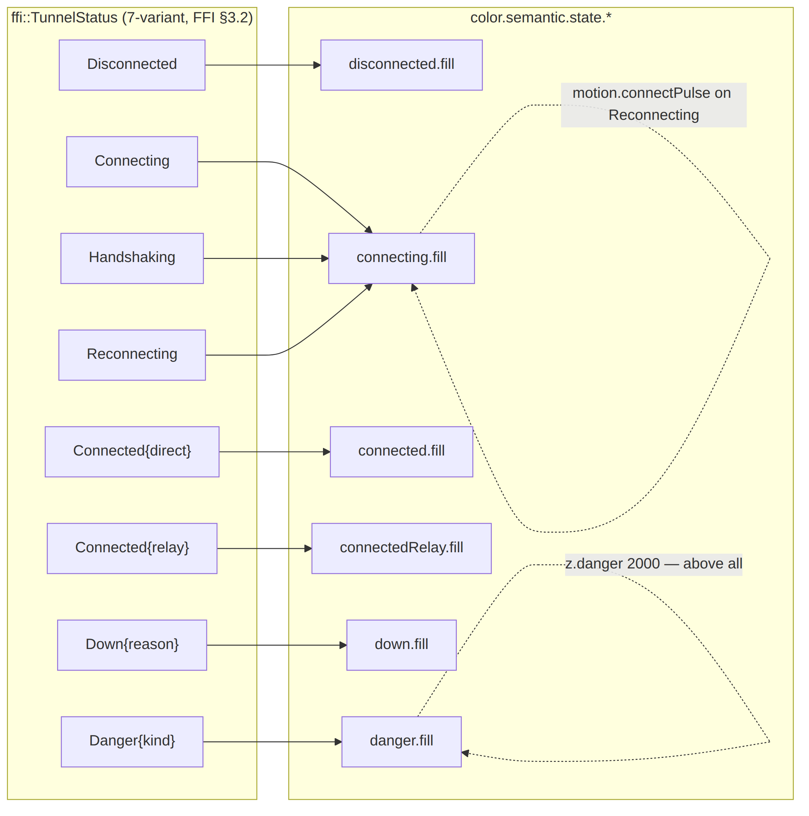
- Direct vs relay sub-shade. Connected.path is "direct" (P2P) or "relay" (DERP-style) [FFI §3.2]. Two distinct green semantics (connected.fill vs connectedRelay.fill) let the StatusChip show the path without changing the "I am protected = green" signal. Hexes in [color-system.md].
- Reconnecting = amber pulse, not a new colour. It reuses connecting.fill + motion.connectPulse; reduce-motion degrades it to static amber (§6.4).
- Danger overrides intent. The Danger family is red and sits on z-layer danger (2000) — it can never be hidden, mirroring the FFI projector rule that Danger overrides every other state [FFI §3.3].

9. Drift, contract & validation rules
Tokens are only single-source if machine-checked. The following gates run in helix_design CI and the consuming helix-ui pre-build (paired §1.1 mutation each):
Gate | Asserts | Mutation that must FAIL it
CM-token-tiers-valid | every id starts with a closed category; non-comp ids carry a closed tier; comp.* ids reference only *.semantic.*/*.scale.* (never primitive, never literal) | point a comp.* $value at color.primitive.*
CM-token-light-dark-complete | every semantic color/elevation token defines both light and dark | delete the dark side of surface.default
CM-token-refs-resolve | every {…} reference resolves to an existing token of the same $type | reference a non-existent / wrong-type token
CM-token-ids-unique | no duplicate id across the whole tree | duplicate color.primitive.helix.500
CM-token-a11y-floor | every token carrying helix.a11yMin meets its floor against its paired surface (computed, [COLOR §contrast]) | drop text.primary to a value below its AAA floor
CM-token-no-drift | every emitted form (CSS/Dart/Swift/Compose/ArkTS/C-Qt) re-generates byte-identically from the JSON source; a hand-edited emitted file is a finding ([token-export-pipeline.md]) | hand-edit helix_tokens.dart
CM-token-state-coverage | all 7 ffi::TunnelStatus variants (§8) have a semantic + component token | remove state.danger.fill
The drift gate is the load-bearing one. It is the visual analogue of HelixVPN's proto/OpenAPI zero-drift principle [SPINE §4.8]: the only way a platform theme can diverge from the source is a hand-edit, and the gate catches that hand-edit. Emitted forms are never authored, only generated ([token-export-pipeline.md]); exported docs of the token reference carry the §11.4.65/.168 visual-validation per [visual-regression-and-qa.md].

10. Surfaced decisions & cross-doc contracts
id | Decision / contract | Status
D-DT-1 | Closed brand-overridable semantic set = {action.primary, accent.*, surface.brandTint}; state.*/feedback.* are NOT brand-overridable (safety-colour stability). Widening requires a §11.4.66 operator decision. | recommended, surfaced
D-DT-2 | Per-theme fork lives only on color, elevation (+ a tiny border/opacity set). All other categories are theme-invariant single values. | decided
D-DT-3 | Component tokens reference semantic only; the lint (CM-token-tiers-valid) enforces it. | decided
C-DT-A (consumes) | The 7-variant ffi::TunnelStatus vocabulary is owned by [FFI §3.2]; §8's token set MUST stay total over it (gate CM-token-state-coverage). A new FFI variant is a contract change here. | contract
C-DT-B (provides) | This schema (§3) is the input contract for [token-export-pipeline.md] (the emit) and [color-system.md] (the color values + contrast). | contract
C-DT-C (provides) | The naming convention (§2) is the identifier contract every emitted form's transform must honor. | contract
U-DT-1 UNVERIFIED | Exact ArkTS resource-map key syntax + C/Qt emit shapes (§3.2) — pinned by the export-pipeline contract test; UNVERIFIED until that test exists. | open

Sources verified
- Token taxonomy, tier model, naming, theming model, scales, drift rules — NO external source needed — original HelixVPN design work, modeled on the well-established primitive→semantic→component three-tier token pattern and the Style-Dictionary $value/$type envelope convention (engine-neutral; the concrete engine is OpenDesign per §11.4.162, integration in [opendesign-foundation.md]).
- 7-variant ffi::TunnelStatus vocabulary (§8) — final/v04-client/ffi-surface.md §3.2 (read 2026-06-25). The token set is held total over it by gate CM-token-state-coverage.
- 3-app / 8-platform matrix, schema-first zero-drift principle (§0, §5) — final/SPECIFICATION.md §3, §4 (read 2026-06-25).
- Color hex values reproduced in the JSON samples (§4) — defined + contrast-proven in final/v10-design/color-system.md (this doc reproduces only the load-bearing subset to keep the samples valid).
- WCAG contrast floors referenced by helix.a11yMin — W3C WCAG 2.1 SC 1.4.3 / 1.4.6 and the relative-luminance formula (https://www.w3.org/TR/WCAG21/#dfn-relative-luminance); the arithmetic is performed in [color-system.md].
- Items explicitly marked UNVERIFIED (U-DT-1) are pending their named contract test per §11.4.6 — not asserted as fact.

