Token export pipeline — one JSON source → every consumable form

Token export pipeline — one JSON source → every consumable form
Revision: 1 Last modified: 2026-06-25T12:00:00Z
Master technical specification — Volume 10 (Design System), nano-detail deep-dive. This document owns the build pipeline that turns helix_design's one canonical JSON token source into every consumable platform form: the transform tool (a Style-Dictionary-class generator — role named, exact tool choice surfaced as a decision), the per-target emit (CSS custom properties light+dark, Dart ThemeExtension + ThemeData, SwiftUI, Jetpack Compose Material3 ColorScheme, ArkTS HarmonyOS resources, C/Qt header
- QML singleton), each with a concrete output sample, the drift gate (generated output MUST match a fresh regenerate — a hand-edited derived form fails the build, §11.4.108-style), the §11.4.65 / §11.4.168 export + visual- validation hook, and how OpenDesign's tokens.css feeds in as one authoring input (D-DESIGN-3 round-trip).
SPEC-ONLY. It describes the pipeline contract — the transforms, the output shapes, the gates — not the shipping helix_design build. The token model (tiers, $value/$type envelope, naming, theming axes) is owned by [design-tokens.md]; the colour values + contrast by [color-system.md]; the type/icon/motion token families by [typography-iconography-motion.md]; the submodule layout + the export/targets/*.ts placement + OpenDesign relationship by [00-overview-and-submodule.md] (§4, §6, §10) and [opendesign-foundation.md]. This document is original HelixVPN design work (the pipeline architecture is owned here, layered on the verified OpenDesign facts).
Boundary with sibling docs. Owns: the transform stages, the per-target output samples, the drift gate, the round-trip-with-OpenDesign mechanics, the §11.4.65/.168 export hook. Consumes: the JSON schema + the $type→target mapping table [design-tokens.md §3.2]; the 8-platform target list + dist/**-is-a-build-derivative rule [00-overview-and-submodule.md §4/§6, DS-I6]; the verified fact that OpenDesign does not emit Dart/Swift/Compose/ ArkTS/C-Qt (so these exporters are helix_design's own) [opendesign-foundation.md §0/§1.2].
Evidence base. [DT §N] = final/v10-design/design-tokens.md; [COLOR §N] = final/v10-design/color-system.md; [TIM §N] = final/v10-design/typography-iconography-motion.md; [OV §N] = final/v10-design/00-overview-and-submodule.md; [OD §N] = final/v10-design/opendesign-foundation.md; [SPINE §N] = final/SPECIFICATION.md. Claims not grounded in the evidence base or in this document's own original design choices are tagged UNVERIFIED per constitution §11.4.6 — never fabricated. The exact transform-library API shapes (the precise dist/** byte forms) are pinned by the pipeline's own contract test and tagged UNVERIFIED until that test exists.

Table of contents
- 0. The pipeline at a glance
- 1. Inputs — JSON source + the OpenDesign round-trip
- 2. The transform tool (Style-Dictionary-class) — role & decision
- 3. The transform stages (resolve → theme-split → per-target format)
- 4. Per-target output samples (concrete)
  - 4.1 CSS custom properties (light + dark)
  - 4.2 Dart — ThemeExtension + ThemeData
  - 4.3 SwiftUI — generated tokens + asset catalog
  - 4.4 Jetpack Compose — Material3 ColorScheme + Typography
  - 4.5 ArkTS — HarmonyOS resources / AppStorage
  - 4.6 C / Qt — header + QML singleton
- 5. The drift gate (generated MUST match source)
- 6. The §11.4.65 / §11.4.168 export + visual-validation hook
- 7. How OpenDesign's tokens.css feeds in
- 8. The full pipeline diagram
- 9. Surfaced decisions & cross-doc contracts
- Sources verified

0. The pipeline at a glance
helix_design holds one authored source of truth — the tiered JSON token tree (tokens/** + presets/**, [DT §3], [OV §4]). The export pipeline (export/) is the machine that turns that one source into the seven forms the 3 apps × 8 platforms consume, so no platform ever re-types a token by hand (DS-I6, [OV §0.2]). The pipeline is the enforcement of the one-source / zero-drift rule: the only way a platform theme can diverge from source is a hand-edit of a generated file, and the drift gate (§5) catches that hand-edit.
# | Stage | Input | Output
1 | Load + merge | tokens/** JSON files + active presets/<brand>/ | one in-memory token dictionary
2 | Resolve references | the dictionary | every {ref} dereferenced to a literal (same-$type-checked)
3 | Theme-split | the resolved dictionary | a light table + a dark table per [DT §5.1]
4 | Per-target format | the two theme tables | dist/{css,dart,swift,compose,arkts,cqt,json}/**
5 | Drift gate | a fresh re-run | byte-compare vs the committed package-source forms (§5)
6 | Export + visual-validate | the docs + the emitted forms | §11.4.65 .html/.pdf siblings + §11.4.168 visual validation
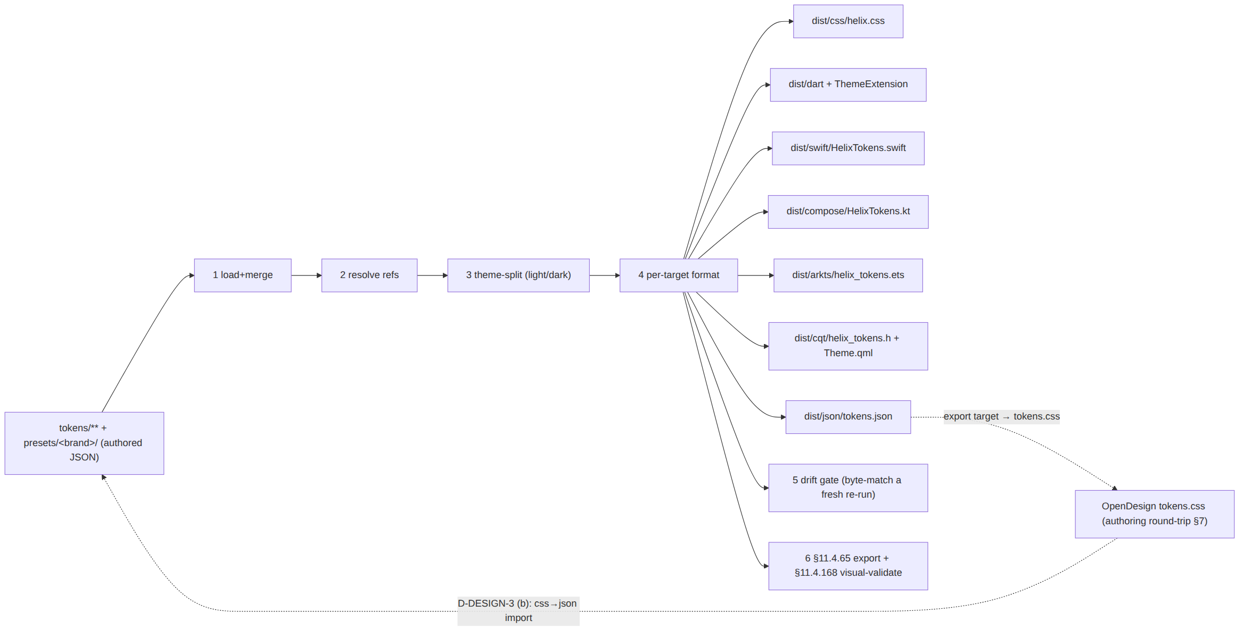

1. Inputs — JSON source + the OpenDesign round-trip

1.1 The primary input — the tiered JSON source
The authored input is the three-tier JSON tree [DT §3, OV §4]:
helix_design/tokens/
├── primitive/ color.json type.json space.json radius.json elevation.json
│ motion.json zindex.json breakpoints.json icon.json
├── semantic/ color.light.json color.dark.json type.json space.json
│ elevation.json motion.json border.json
└── component/ connect_button.json status_chip.json exit_picker.json …
helix_design/presets/<brand>/ brand.json connection_state.json
The active brand preset ([OV §5.4]) is selected at build time (--preset presets/helix/, default HelixVPN; a future app drops presets/<x>/). The preset supplies the values the semantic tier references — the only place brand-specific values live (DS-I1, [OV §3]).

1.2 The secondary input — OpenDesign tokens.css (round-trip)
OpenDesign authoring/refinement [OD §6] edits the HelixVPN design system's tokens.css. Per D-DESIGN-3 ([OV §10.2]) the project leans (b) — JSON is the source, tokens.css is a generated export target that OpenDesign consumes/previews; refinement edits made in OpenDesign are reconciled back into tokens/** (a css→json import diff). The round-trip touches only the verified OpenDesign surface (CSS custom properties, [OD §4]) — never an unverified OpenDesign API. §7 details the mechanics.

2. The transform tool (Style-Dictionary-class) — role & decision

2.1 The role
The transform tool is a token-build engine that: loads a tiered token tree, resolves {ref} references, applies per-platform transforms (e.g. #RRGGBB → Dart Color(0xAARRGGBB), 16px → Compose 16.dp), and runs per-platform formatters that emit a file in the target language. This is exactly the Style-Dictionary category of tool (Amazon's open-source design-token build system is the canonical example; the W3C Design-Tokens Community Group format the ecosystem converges on is the $value/$type envelope [DT §3.1] this project already authors in).

2.2 The decision
D-EXP-1 (open, §9) — exact transform engine. The pipeline is specified against the Style-Dictionary-class role (§2.1), not hard-bound to one library, so the choice is surfaced, not silently made (§11.4.6):
Candidate | Note
Style Dictionary (amzn, v4) | the reference implementation; native W3C-DTCG $type/$value support, custom transforms/formats in TS; the lean default
Terrazzo (formerly cobalt-ui) | W3C-DTCG-native, TS-first, plugin per target
a bespoke TS generator in export/build.ts | full control, no dep; more code to own/test
Lean: Style Dictionary v4 (mature, DTCG-native, custom-format API covers all 6 non-JSON targets), with bespoke formatters for the targets it lacks built-in (ArkTS, C/Qt). The engine is a build-time dev dependency declared in helix-deps.yaml build_toolchain ([OV §7.2]) — never a runtime dependency of the consuming apps. UNVERIFIED until the Volume-10 review ratifies the exact library + pins its version per §11.4.99; the pipeline contract (stages §3, outputs §4, drift gate §5) holds regardless of which engine fills the role.
Honest boundary (§11.4.6 / [OD §0]). OpenDesign does NOT itself emit Dart/Swift/Compose/ArkTS/C-Qt (verified, [OD §1.2]). These exporters are therefore helix_design's own Style-Dictionary-class pipeline — not an OpenDesign feature. If a future requirement is "OpenDesign itself emits a Compose form", that is an extend-OpenDesign-upstream task per §11.4.74 ([OD §7], D-DESIGN-4) — not assumed here.

3. The transform stages (resolve → theme-split → per-target format)

3.1 Stage 1–2 — load, merge, resolve
The loader merges every tokens/** file + the active preset into one dictionary, then resolves references depth-first. Resolution is total and type-checked ([DT §3.1]): a {ref} MUST resolve to an existing token of the same $type, else the build fails (never a silent default, §11.4.6 + [DT §9 CM-token-refs-resolve]).

3.2 Stage 3 — theme-split
Only themed categories (color, elevation, a small border/opacity set [DT §3.1/§6]) carry a {light, dark} fork. Stage 3 produces two fully-resolved flat tables — a light table and a dark table — where every themed token has collapsed to its theme-specific literal and every non-themed token (space, radius, type metrics, motion, z, breakpoints, [DT §6]) appears identically in both. The two tables are the input to every formatter, so every target emits a light and a dark form (a target emitting one theme fails [OV §12 DS-LIGHT-DARK-COMPLETE]).

3.3 Stage 4 — per-target format
Each target is a transform-set + a formatter:
Target | Transform highlights ($type → form, [DT §3.2]) | Formatter emits
CSS | color→#RRGGBB[AA], dim→px/rem, dur→ms, bezier→cubic-bezier() | :root (light) + [data-theme=dark] (dark) custom-property blocks
Dart | color→Color(0xAARRGGBB), dim→double logical px, weight→FontWeight.wNNN, dur→Duration | a tokens file + a ThemeExtension<HelixTokens> with .light()/.dark()
SwiftUI | color→Color(.sRGB,…)/asset-catalog entry, dim→CGFloat, weight→Font.Weight | a HelixTokens.swift + a .xcassets colorset per themed colour
Compose | color→Color(0x…), dim→.dp/.sp, weight→FontWeight.WNNN | a HelixTokens.kt with lightColors/darkColors + an M3 ColorScheme builder
ArkTS | color→$rrggbb/resource, dim→vp/fp | a helix_tokens.ets + resources/base + resources/dark qualifier sets
C/Qt | color→QColor("#…"), dim→int px | a helix_tokens.h (#define) + a Theme.qml singleton (light/dark property sets)
JSON | identity (resolved) | dist/json/tokens.json — the flattened resolved source (other tooling + the §7 css round-trip read it)

4. Per-target output samples (concrete)
Every sample below is a valid, self-consistent emit of the same small token slice — color.semantic.surface.default, text.primary, action.primary, state.connected.fill, state.danger.fill, font.semantic.title.lg, space.scale.4, radius.scale.full, motion.semantic.connectPulse — in both themes. Colour literals match [COLOR §2/§3]; type metrics match [TIM §1.1]; scales match [DT §6]. No placeholders, no TODO (§11.4.6).

4.1 CSS custom properties (light + dark)
dist/css/helix.css — light on :root, dark on [data-theme="dark"] (consumed by the Console Web build + any web chrome, [OV §6]). A @media (prefers-color-scheme: dark) block mirrors the attribute so OS dark works without an explicit data-theme.
/* dist/css/helix.css — GENERATED, do not edit (drift gate §5) */
:root {
/* color — light */
--hx-color-surface-default: #FFFFFF;
--hx-color-text-primary: #151920;
--hx-color-action-primary: #2F47C4;
--hx-color-state-connected-fill: #15803D;
--hx-color-state-danger-fill: #DC2626;
/* type (theme-invariant) */
--hx-font-title-lg-family: 'Inter', system-ui, sans-serif;
--hx-font-title-lg-size: 20px;
--hx-font-title-lg-line: 1.30;
--hx-font-title-lg-weight: 600;
/* scales (theme-invariant) */
--hx-space-4: 16px;
--hx-radius-full: 9999px;
--hx-motion-connect-pulse-dur: 1200ms;
--hx-motion-connect-pulse-ease: cubic-bezier(0.4, 0, 0.6, 1);
}
[data-theme="dark"] {
--hx-color-surface-default: #151920;
--hx-color-text-primary: #EDEFF3;
--hx-color-action-primary: #3D5AF1;
--hx-color-state-connected-fill: #22C55E;
--hx-color-state-danger-fill: #F87171;
}
@media (prefers-color-scheme: dark) {
:root:not([data-theme="light"]) {
--hx-color-surface-default: #151920;
--hx-color-text-primary: #EDEFF3;
--hx-color-action-primary: #3D5AF1;
--hx-color-state-connected-fill: #22C55E;
--hx-color-state-danger-fill: #F87171;
}
}
@media (prefers-reduced-motion: reduce) {
:root { --hx-motion-connect-pulse-dur: 0ms; } /* [TIM §8.1] */
}

4.2 Dart — ThemeExtension + ThemeData
dist/dart/helix_tokens.dart — a ThemeExtension carrying every token so a widget reads Theme.of(context).extension<HelixTokens>()!; plus a ThemeData light/dark pair the helix-ui MaterialApp(theme:, darkTheme:) consumes ([DT §5.1], [OV §6]).
// dist/dart/helix_tokens.dart — GENERATED, do not edit (drift gate §5)
import 'package:flutter/material.dart';
@immutable
class HelixTokens extends ThemeExtension<HelixTokens> {
final Color surfaceDefault, textPrimary, actionPrimary, stateConnected, stateDanger;
final Duration connectPulseDur;
const HelixTokens({
required this.surfaceDefault, required this.textPrimary, required this.actionPrimary,
required this.stateConnected, required this.stateDanger, required this.connectPulseDur,
});
static const light = HelixTokens(
surfaceDefault: Color(0xFFFFFFFF), textPrimary: Color(0xFF151920),
actionPrimary: Color(0xFF2F47C4), stateConnected: Color(0xFF15803D),
stateDanger: Color(0xFFDC2626), connectPulseDur: Duration(milliseconds: 1200));
static const dark = HelixTokens(
surfaceDefault: Color(0xFF151920), textPrimary: Color(0xFFEDEFF3),
actionPrimary: Color(0xFF3D5AF1), stateConnected: Color(0xFF22C55E),
stateDanger: Color(0xFFF87171), connectPulseDur: Duration(milliseconds: 1200));
@override
HelixTokens copyWith({Color? surfaceDefault, Color? textPrimary, Color? actionPrimary,
Color? stateConnected, Color? stateDanger, Duration? connectPulseDur}) => HelixTokens(
surfaceDefault: surfaceDefault ?? this.surfaceDefault,
textPrimary: textPrimary ?? this.textPrimary,
actionPrimary: actionPrimary ?? this.actionPrimary,
stateConnected: stateConnected ?? this.stateConnected,
stateDanger: stateDanger ?? this.stateDanger,
connectPulseDur: connectPulseDur ?? this.connectPulseDur);
@override
HelixTokens lerp(ThemeExtension<HelixTokens>? other, double t) {
if (other is! HelixTokens) return this;
return HelixTokens(
surfaceDefault: Color.lerp(surfaceDefault, other.surfaceDefault, t)!,
textPrimary: Color.lerp(textPrimary, other.textPrimary, t)!,
actionPrimary: Color.lerp(actionPrimary, other.actionPrimary, t)!,
stateConnected: Color.lerp(stateConnected, other.stateConnected, t)!,
stateDanger: Color.lerp(stateDanger, other.stateDanger, t)!,
connectPulseDur: t < 0.5 ? connectPulseDur : other.connectPulseDur);
}
}
const _titleLg = TextStyle(fontFamily: 'Inter', fontSize: 20, height: 1.30, fontWeight: FontWeight.w600);
ThemeData helixLight() => ThemeData(
useMaterial3: true, brightness: Brightness.light,
scaffoldBackgroundColor: const Color(0xFFFFFFFF),
colorScheme: const ColorScheme.light(
primary: Color(0xFF2F47C4), surface: Color(0xFFFFFFFF), onSurface: Color(0xFF151920)),
textTheme: const TextTheme(titleLarge: _titleLg),
extensions: const [HelixTokens.light]);
ThemeData helixDark() => ThemeData(
useMaterial3: true, brightness: Brightness.dark,
scaffoldBackgroundColor: const Color(0xFF151920),
colorScheme: const ColorScheme.dark(
primary: Color(0xFF3D5AF1), surface: Color(0xFF151920), onSurface: Color(0xFFEDEFF3)),
textTheme: const TextTheme(titleLarge: _titleLg),
extensions: const [HelixTokens.dark]);
Dart colour is Color(0xAARRGGBB) — the leading FF is full alpha; an 8-hex token like #1519201A ([DT §4] light-card shadow) emits Color(0x1A151920).

4.3 SwiftUI — generated tokens + asset catalog
dist/swift/HelixTokens.swift — a generated Swift file referencing asset-catalog colorsets (the idiomatic SwiftUI way to carry light+dark: one named colorset holds both appearances, resolved by @Environment(\.colorScheme) automatically). The exporter emits both the .swift accessor and the .xcassets colorset JSON.
// dist/swift/HelixTokens.swift — GENERATED, do not edit (drift gate §5)
import SwiftUI
public enum HelixTokens {
// colours resolve light/dark automatically via the asset catalog (below)
public static let surfaceDefault = Color("HXSurfaceDefault", bundle: .module)
public static let textPrimary = Color("HXTextPrimary", bundle: .module)
public static let actionPrimary = Color("HXActionPrimary", bundle: .module)
public static let stateConnected = Color("HXStateConnected", bundle: .module)
public static let stateDanger = Color("HXStateDanger", bundle: .module)
// type (theme-invariant)
public static let titleLg = Font.custom("Inter", size: 20).weight(.semibold)
// scale / motion (theme-invariant)
public static let space4: CGFloat = 16
public static let radiusFull: CGFloat = 9999
public static let connectPulse: Double = 1.200 // seconds
}
// dist/swift/Resources/HelixColors.xcassets/HXStateConnected.colorset/Contents.json
// GENERATED — one colorset per themed colour, light + dark appearance
{
"colors": [
{ "idiom": "universal",
"color": { "color-space": "srgb",
"components": { "red": "0x15", "green": "0x80", "blue": "0x3D", "alpha": "1.000" } } },
{ "idiom": "universal",
"appearances": [ { "appearance": "luminosity", "value": "dark" } ],
"color": { "color-space": "srgb",
"components": { "red": "0x22", "green": "0xC5", "blue": "0x5E", "alpha": "1.000" } } }
],
"info": { "author": "helix_design exporter", "version": 1 }
}
The native shim's font is the system font for the tiny NE-extension surface ([TIM §2.2 D-TYPE-1]) — Font.custom("Inter",…) above is for any iOS/macOS surface that does bundle the brand font; the colorset (palette) reaches all native surfaces regardless of font.

4.4 Jetpack Compose — Material3 ColorScheme + Typography
dist/compose/HelixTokens.kt — a Compose object plus lightColorScheme() / darkColorScheme() Material3 builders the Android quick-settings tile / notification surfaces consume ([OV §6]).
// dist/compose/HelixTokens.kt — GENERATED, do not edit (drift gate §5)
package com.helixvpn.design
import androidx.compose.material3.*
import androidx.compose.ui.graphics.Color
import androidx.compose.ui.text.TextStyle
import androidx.compose.ui.text.font.FontWeight
import androidx.compose.ui.unit.dp
import androidx.compose.ui.unit.sp
object HelixColors { // raw tokens (both themes)
val SurfaceLight = Color(0xFFFFFFFF); val SurfaceDark = Color(0xFF151920)
val OnSurfaceLight = Color(0xFF151920); val OnSurfaceDark = Color(0xFFEDEFF3)
val ActionLight = Color(0xFF2F47C4); val ActionDark = Color(0xFF3D5AF1)
val ConnectedLight = Color(0xFF15803D); val ConnectedDark = Color(0xFF22C55E)
val DangerLight = Color(0xFFDC2626); val DangerDark = Color(0xFFF87171)
}
val HelixLightColorScheme: ColorScheme = lightColorScheme(
primary = HelixColors.ActionLight, surface = HelixColors.SurfaceLight,
onSurface = HelixColors.OnSurfaceLight, error = HelixColors.DangerLight)
val HelixDarkColorScheme: ColorScheme = darkColorScheme(
primary = HelixColors.ActionDark, surface = HelixColors.SurfaceDark,
onSurface = HelixColors.OnSurfaceDark, error = HelixColors.DangerDark)
object HelixType {
val TitleLg = TextStyle(fontSize = 20.sp, lineHeight = 26.sp, fontWeight = FontWeight.W600)
}
object HelixScale { val Space4 = 16.dp; val RadiusFull = 9999.dp }
object HelixMotion { const val ConnectPulseMs = 1200L }
// "connected" is not an M3 slot → exposed as a HelixColors token the StatusChip reads.
Material3's ColorScheme has no "connected/danger-state" slot, so the connection-state colours ([COLOR §3]) are exposed as HelixColors tokens the StatusChip/ConnectButton read directly (the [DT §8] component-token seam), while the M3 slots (primary/surface/error) carry the brand + error mapping for stock M3 widgets.

4.5 ArkTS — HarmonyOS resources / AppStorage
dist/arkts/helix_tokens.ets + the HarmonyOS resource qualifier tree — light in resources/base/element/, dark in resources/dark/element/ (HarmonyOS resolves the qualifier by system theme), consumed by the HarmonyOS VPN-ability surfaces ([OV §6]).
// dist/arkts/helix_tokens.ets — GENERATED, do not edit (drift gate §5)
export class HelixTokens {
// colour tokens resolve light/dark via the resource qualifier tree (below)
static readonly surfaceDefault: Resource = $r('app.color.hx_surface_default');
static readonly textPrimary: Resource = $r('app.color.hx_text_primary');
static readonly actionPrimary: Resource = $r('app.color.hx_action_primary');
static readonly stateConnected: Resource = $r('app.color.hx_state_connected');
static readonly stateDanger: Resource = $r('app.color.hx_state_danger');
// type / scale / motion (theme-invariant)
static readonly titleLgSize: number = 20; // fp
static readonly titleLgWeight: number = 600;
static readonly space4: number = 16; // vp
static readonly radiusFull: number = 9999; // vp
static readonly connectPulseMs: number = 1200;
}
// dist/arkts/resources/base/element/color.json (LIGHT — system default)
{ "color": [
{ "name": "hx_surface_default", "value": "#FFFFFF" },
{ "name": "hx_text_primary", "value": "#151920" },
{ "name": "hx_action_primary", "value": "#2F47C4" },
{ "name": "hx_state_connected", "value": "#15803D" },
{ "name": "hx_state_danger", "value": "#DC2626" }
] }
// dist/arkts/resources/dark/element/color.json (DARK — resolved when system dark)
{ "color": [
{ "name": "hx_surface_default", "value": "#151920" },
{ "name": "hx_text_primary", "value": "#EDEFF3" },
{ "name": "hx_action_primary", "value": "#3D5AF1" },
{ "name": "hx_state_connected", "value": "#22C55E" },
{ "name": "hx_state_danger", "value": "#F87171" }
] }
UNVERIFIED (U-EXP-1). The exact ArkTS $r('app.color.…') resolver key form + the resources/dark/ qualifier directory name are HarmonyOS-SDK-version dependent; stated as the intended mapping per [DT §3.2 U-DT-1], pinned + re-verified per §11.4.99 against the live HarmonyOS docs before the ArkTS exporter ships. Not asserted as fact (§11.4.6).

4.6 C / Qt — header + QML singleton
dist/cqt/helix_tokens.h (#define constants for C/C++) + dist/cqt/Theme.qml (a QML singleton exposing a light/dark property set, switched by a theme property) — consumed by the Aurora Qt/C++ surfaces ([OV §6]).
// dist/cqt/helix_tokens.h — GENERATED, do not edit (drift gate §5)
#ifndef HELIX_TOKENS_H
#define HELIX_TOKENS_H
/* light */
#define HX_LIGHT_SURFACE_DEFAULT "#FFFFFF"
#define HX_LIGHT_TEXT_PRIMARY "#151920"
#define HX_LIGHT_ACTION_PRIMARY "#2F47C4"
#define HX_LIGHT_STATE_CONNECTED "#15803D"
#define HX_LIGHT_STATE_DANGER "#DC2626"
/* dark */
#define HX_DARK_SURFACE_DEFAULT "#151920"
#define HX_DARK_TEXT_PRIMARY "#EDEFF3"
#define HX_DARK_ACTION_PRIMARY "#3D5AF1"
#define HX_DARK_STATE_CONNECTED "#22C55E"
#define HX_DARK_STATE_DANGER "#F87171"
/* type / scale / motion (theme-invariant) */
#define HX_FONT_TITLE_LG_SIZE_PX 20
#define HX_FONT_TITLE_LG_WEIGHT 600
#define HX_SPACE_4_PX 16
#define HX_RADIUS_FULL_PX 9999
#define HX_MOTION_CONNECT_PULSE_MS 1200
#endif /* HELIX_TOKENS_H */
// dist/cqt/Theme.qml — GENERATED QML singleton, do not edit (drift gate §5)
pragma Singleton
import QtQuick 2.15
QtObject {
property bool dark: false
readonly property color surfaceDefault: dark ? "#151920" : "#FFFFFF"
readonly property color textPrimary: dark ? "#EDEFF3" : "#151920"
readonly property color actionPrimary: dark ? "#3D5AF1" : "#2F47C4"
readonly property color stateConnected: dark ? "#22C55E" : "#15803D"
readonly property color stateDanger: dark ? "#F87171" : "#DC2626"
readonly property int titleLgSize: 20
readonly property int titleLgWeight: 600
readonly property int space4: 16
readonly property int radiusFull: 9999
readonly property int connectPulseMs: 1200
}
UNVERIFIED (U-EXP-2). The exact QML singleton registration form (qmldir singleton Theme 1.0 Theme.qml) and whether Aurora's Qt build uses a resource (.qrc) vs. a module import is Aurora-Qt-version dependent; pinned + re-verified per §11.4.99 before the C/Qt exporter ships ([DT §3.2 U-DT-1]).

5. The drift gate (generated MUST match source)
The drift gate is the load-bearing §11.4.108-class mechanism: it makes a hand-edit of a generated form a build failure, so the only way to change a platform's tokens is to change the JSON source + regenerate.

5.1 What it asserts
DS-DRIFT (the §11.4.108 SOURCE→ARTIFACT equality gate for tokens):
1. run `pnpm export` into a CLEAN temp dir
2. byte-compare each freshly-generated form against the committed package-source form
3. ANY difference ⇒ FAIL (the committed form was hand-edited or the source drifted)
The comparison is byte-for-byte (after a deterministic format pass, so formatter non-determinism — map ordering, trailing newline — is normalised at generation, never papered over at compare time). A generated file carries a GENERATED, do not edit banner + a content hash header; the gate also asserts the hash matches the file body (a hand-edit that forgets to update the banner is still caught by the byte-compare).

5.2 Why byte-compare, not "looks equivalent"
Per §11.4.108 (runtime-signature / artifact-byte equality) and §11.4.6 (no-guessing): "the Dart and the CSS look like the same colour" is not a proof the source and the artifact agree. The byte-compare against a fresh re-run is the captured evidence that dist/** (and the checked-in package-source Dart, [OV §4 D-DESIGN-2]) is exactly what the current tokens/** produces — no drift, no stale form from a previous source state.

5.3 The paired mutation (§1.1)
Gate | Mutation that MUST make it FAIL
DS-DRIFT | hand-edit one hex in helix_tokens.dart (e.g. 0xFF2F47C4 → 0xFF000000) without touching tokens/** → the fresh re-run differs → FAIL
DS-DRIFT (source side) | change a tokens/** value but commit the old dist/** → fresh re-run differs → FAIL (forces regenerate-on-source-change)
DS-EXPORT-FORM-VALID ([OV §12]) | emit syntactically-broken Dart (drop a ;) → dart analyze fails → FAIL (the form must also parse in its toolchain, §11.4.110 build-readiness)
DS-LIGHT-DARK-COMPLETE ([OV §12]) | delete the dark colorset appearance / the [data-theme=dark] block → a theme is missing → FAIL ([TIM]/[COLOR] light+dark mandate)

5.4 Where the gate runs
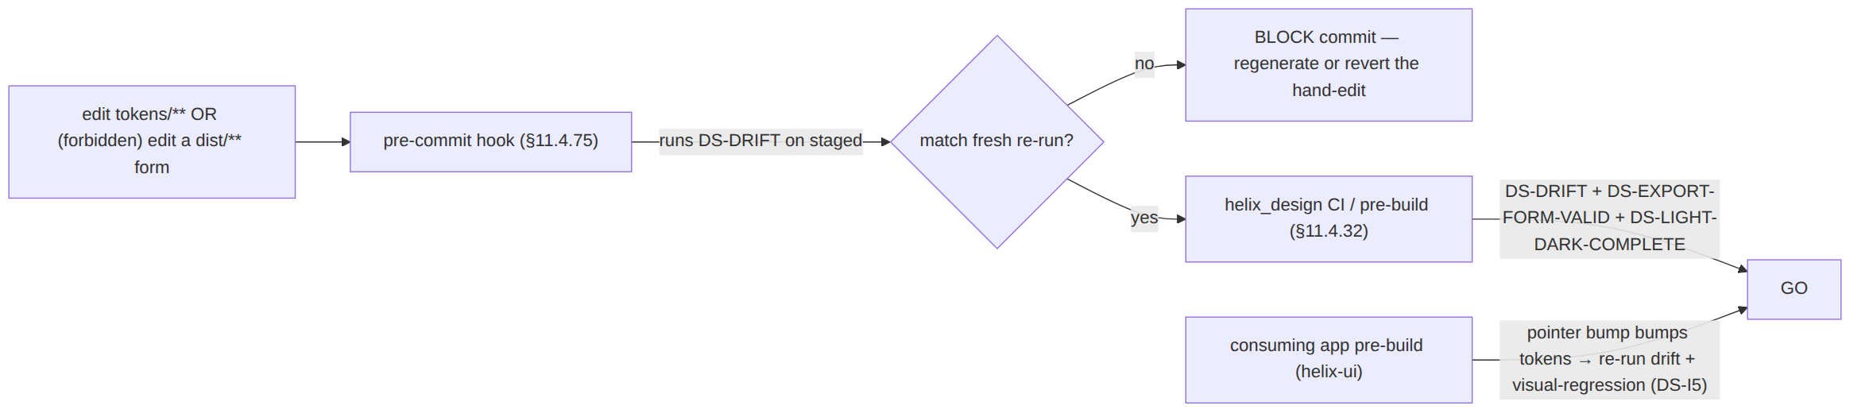
The gate runs at three seams: the pre-commit hook (§11.4.75, blocks a hand-edit landing), helix_design CI/pre-build (§11.4.32 post-pull sweep), and the consuming app's pre-build when a submodule-pointer bump changes tokens ([OV §8] — a token change triggers the app's visual-regression suite, DS-I5).

6. The §11.4.65 / §11.4.168 export + visual-validation hook

6.1 §11.4.65 — Markdown export of the pipeline + token docs
Every Volume-10 doc (this one included) travels in the submodule (helix_design/docs/v10-design/, [OV §4]) and is a §11.4.65-scope Markdown doc: each edit regenerates synchronized .html + .pdf siblings, and (for the §11.4.153 feature-status class) .docx. The pipeline's own run produces a machine-readable export manifest (dist/.export-manifest.json — every emitted form + its content hash + the source-commit it was generated from) that the docs reference, so a reader of the rendered token reference sees exactly which source produced it.

6.2 §11.4.168 — visual validation of the rendered token reference
Because the token reference docs contain rendered swatches + Mermaid diagrams (this doc's pipeline diagram, the [COLOR] swatch map, the [TIM] type-scale diagram), the §11.4.168 exported-document validation applies: an independent check confirms the exported .pdf/.html (a) carries the content faithfully, (b) shows no raw Mermaid/diagram source as body text (the §11.4.168 forensic failure), and (c) renders every diagram as an image + every swatch as a visible colour block. pdftotext catches raw source leaking as text; pdfimages confirms the diagrams rasterised; the self-validated golden-good/golden-bad analyzer ([§11.4.107(10)]) is seeded with a known-bad export (raw flowchart source in the body) that MUST FAIL the gate.

6.3 The combined hook
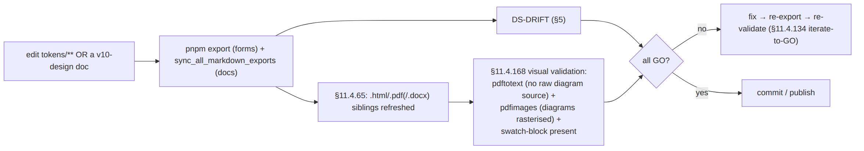
A token-doc PDF that ships raw flowchart TD … as readable text, or a swatch table with no rendered colour blocks, is a §11.4.168 violation — a release blocker — caught here, never shipped (the [COLOR §5]/[TIM §4] no-overlay rule extended to the documentation of the design system).

7. How OpenDesign's tokens.css feeds in

7.1 The round-trip (D-DESIGN-3, lean (b))
Per [OV §10.2] / [OD §4–§5] the project leans JSON-as-source: tokens.css is a generated export target (one more formatter, export/targets/css.ts → opendesign/helix/tokens.css) that OpenDesign consumes as the active design system; refinement edits a designer makes in OpenDesign land in that tokens.css, and a css→json reconciliation imports the diff back into tokens/** so the polyglot exports stay in sync (DS-I6).
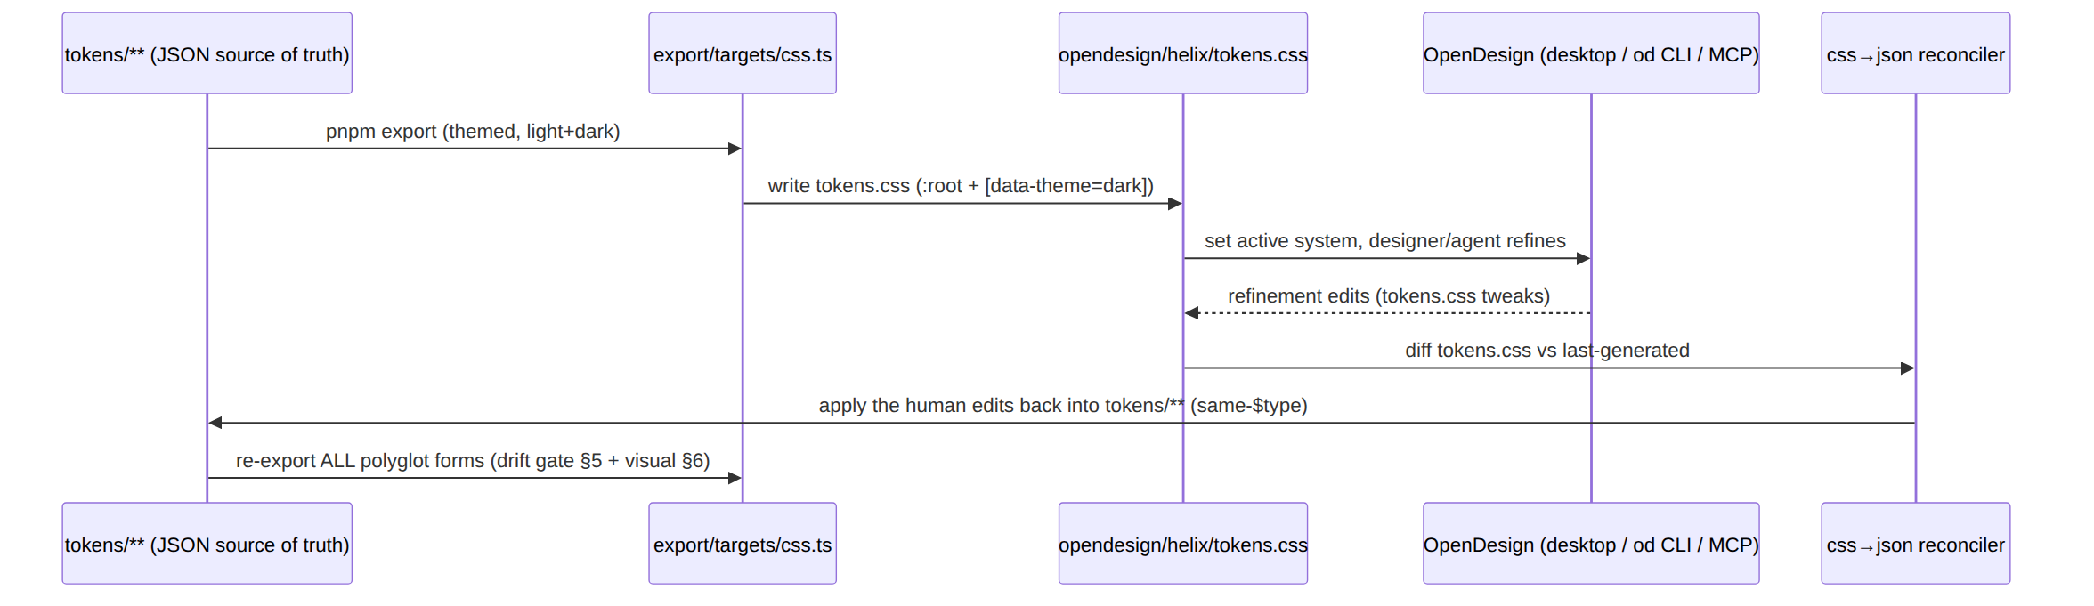

7.2 Why the round-trip is safe (only verified OpenDesign surface)
The round-trip touches only tokens.css — CSS custom properties, the verified OpenDesign token form ([OD §3.3/§4]). It does not depend on any UNVERIFIED OpenDesign API (no theme-engine knobs, no multi-language export OD lacks, [OD §1.2]). The css→json reconciler is helix_design-owned (a CSS parser → token-path mapper); it maps --hx-color-state-connected-fill ↔ color.semantic.state.connected.fill by the [DT §2] naming convention (--hx- prefix + - for .). A tokens.css edit that does not map cleanly to a known token path is surfaced to the operator (§11.4.6 — never silently dropped or guessed), not auto-merged.
UNVERIFIED (U-EXP-3). Whether OpenDesign's renderer honours the [data-theme="dark"] block the css exporter emits, or expects a different dark-mode convention (twin "HelixVPN Light"/"HelixVPN Dark" systems, prefers-color-scheme) is [OD §5.2 U4] — confirmed against a live built-in OpenDesign tokens.css in the refinement pass. If twin systems are required, the css exporter emits opendesign/helix-light/tokens.css + opendesign/helix-dark/tokens.css from the same JSON source — a formatter option, not a token-source change (the JSON stays the single source). Not asserted as fact (§11.4.6).

8. The full pipeline diagram
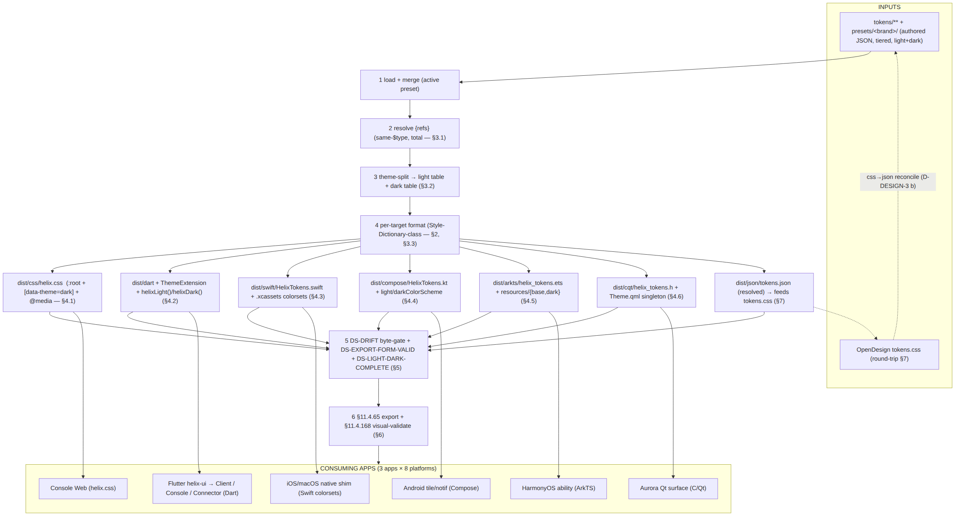

9. Surfaced decisions & cross-doc contracts
id | Decision / contract | Status
D-EXP-1 UNVERIFIED | Transform engine = a Style-Dictionary-class tool; lean Style Dictionary v4 (DTCG-native) + bespoke formatters for ArkTS/C-Qt. Build-time dev dep only. Exact library + pinned version ratified at Volume-10 review per §11.4.99. | open
D-EXP-2 | Theme is handled by theme-split (Stage 3) into two resolved tables, so every target emits light and dark; no target emits one theme ([OV §12 DS-LIGHT-DARK-COMPLETE]). | decided
D-EXP-3 | tokens.css is a generated export target (D-DESIGN-3 (b)), OpenDesign consumes it; refinement round-trips back via the css→json reconciler (§7) — JSON stays the single source. | recommended (leans (b))
D-EXP-4 | SwiftUI light/dark via asset-catalog colorsets (idiomatic), not runtime colorScheme branching; Compose via light/darkColorScheme; ArkTS via resources/{base,dark}; CSS via [data-theme]+@media; C/Qt via a dark-property QML singleton. | decided (per §4)
C-EXP-A (consumes) | The JSON schema + the $type→target mapping table [DT §3.2] is this pipeline's input contract; a $type added there is a new transform here. | contract
C-EXP-B (consumes) | The 8-platform target list + the dist/**-is-a-build-derivative + checked-in-package-Dart rule [OV §4/§6, D-DESIGN-2]. | contract
C-EXP-C (consumes) | The verified fact OpenDesign does not emit Dart/Swift/Compose/ArkTS/C-Qt [OD §1.2] — so these exporters are helix_design-owned, not an OpenDesign feature. | contract
C-EXP-D (provides) | The drift gate (§5) is the §11.4.108 SOURCE→ARTIFACT equality proof the whole design system rests on; the §6 visual-validation is the §11.4.168 proof for the rendered token docs. | contract
U-EXP-1 UNVERIFIED | Exact ArkTS $r('app.color.…') resolver + resources/dark/ qualifier form (HarmonyOS-SDK-version dependent) — pinned + re-verified per §11.4.99 before the ArkTS exporter ships. | open
U-EXP-2 UNVERIFIED | Exact QML singleton registration (qmldir/.qrc) + Aurora-Qt module form — pinned + re-verified per §11.4.99 before the C/Qt exporter ships. | open
U-EXP-3 UNVERIFIED | OpenDesign's canonical dark-mode tokens.css convention ([data-theme] vs prefers-color-scheme vs twin systems, [OD §5.2 U4]) — confirmed against a live built-in system in the refinement pass; css exporter has a twin-systems formatter option ready. | open

Sources verified
- The pipeline architecture (stages, theme-split, per-target transforms + formatters, the drift gate, the round-trip mechanics, the §11.4.65/.168 export hook) and every per-target output sample (§4) — NO external source needed — original HelixVPN design work, layered on the well-established Style-Dictionary-class token-build pattern and each platform's idiomatic theme carrier (CSS custom properties + [data-theme]; Flutter ThemeExtension/ ThemeData; SwiftUI asset-catalog colorsets; Compose Material3 ColorScheme; HarmonyOS resources/{base,dark} qualifiers; Qt QML singleton). The exact per-platform idioms are the documented conventions of each framework; the pipeline that emits them is HelixVPN's own design.
- The W3C Design-Tokens Community-Group $value/$type envelope + the Style-Dictionary build-engine category (Stage transforms/formatters) — the DTCG format the token source [DT §3.1] already authors in, and the Style-Dictionary (amzn) reference implementation of a token-build engine; the exact engine + version is D-EXP-1 UNVERIFIED, ratified + pinned per §11.4.99 at the Volume-10 review (not asserted as a settled fact here).
- The token model (tiers, $value/$type envelope, naming, theming axes, the $type→target mapping), the colour hexes, the type metrics, the scales — final/v10-design/design-tokens.md §3/§5/§6, final/v10-design/color-system.md §2/§3, final/v10-design/typography-iconography-motion.md §1/§6 (siblings, this wave, read 2026-06-25). Every literal in the §4 samples is reproduced from those documents to keep the samples valid (no placeholders).
- The submodule layout (export/targets/*.ts, dist/**-is-a-build-derivative, the checked-in package-Dart D-DESIGN-2), the 8-platform target list, the OpenDesign relationship + the verified absence of OpenDesign multi-language export — final/v10-design/00-overview-and-submodule.md §4/§6/§10 + final/v10-design/opendesign-foundation.md §0/§1.2/§3.3/§4/§5.2 (siblings, read 2026-06-25). The "OpenDesign does not emit Dart/Swift/Compose/ArkTS/C-Qt" finding is grounded there (web-verified 2026-06-25), not assumed.
- Constitution clauses §11.4.6 (no-guessing), §11.4.32 (post-pull validation sweep), §11.4.65 (universal Markdown export), §11.4.75 (mechanical enforcement / pre-commit), §11.4.99 (latest-source cross-reference), §11.4.107(10) (self-validated analyzer), §11.4.108 (SOURCE→ARTIFACT equality — the drift gate's class), §11.4.110 (build-readiness / form-must-parse), §11.4.134 (iterate-to-GO), §11.4.162 (OpenDesign mandate), §11.4.168 (exported-doc visual validation) — constitution submodule text embedded in this repo's constitution/CLAUDE.md, accessed 2026-06-25.
- Items explicitly marked UNVERIFIED (U-EXP-1 ArkTS resolver, U-EXP-2 QML registration, U-EXP-3 OpenDesign dark-mode convention, D-EXP-1 exact engine) are pending their named contract test / §11.4.99 verification pass per §11.4.6 — not asserted as fact.

