UX flows & interaction patterns — the end-to-end behaviour of every HelixVPN surface

UX flows & interaction patterns — the end-to-end behaviour of every HelixVPN surface
Revision: 2 Last modified: 2026-07-04T12:00:00Z
Master technical specification — Volume 10 (Design System), nano-detail deep-dive. This document owns HelixVPN's end-to-end UX flows and the universal interaction patterns that bind the three apps (Client, Console, Connector) across eight platforms and four form factors into one coherent product. It is the behavioural half of the design system: where [screens-client.md] / [screens-console.md] / [screens-connector.md] own each screen and [component-library.md] owns each component, this doc owns the journeys between them — the step-by-step sequences, the per-app information architecture + navigation model, the universal interaction grammar (gestures, keyboard, TV-remote D-pad, long-press, pull-to-refresh), the reusable loading / empty / error / success state contract, the motion choreography, the full accessibility spec (WCAG 2.1 AA target), and the i18n / RTL / localization patterns.
The product's emotional centre of gravity is one question — "am I protected right now?" [04_CLIENT §7]. Every flow below is designed so that question is answered instantly and unambiguously, and so the loading / connecting state is never mistaken for the connected state (§11.4.107 — a spinner is not proof of connection; the connected state is reached only on an actual Connected{...} FFI event, never on a timer or an optimistic guess).
SPEC-ONLY. It describes what each flow is and how each interaction behaves — not the shipping Flutter navigator, gesture recognisers, or focus-traversal code. Screen layouts are owned by the three screens-* docs; component internals by [component-library.md]; colours by [color-system.md]; token scales (spacing / motion / breakpoints) by [design-tokens.md]; the type/icon/motion catalog by [typography-iconography-motion.md].
Boundary with sibling docs. Owns: the cross-screen journeys, the per-app navigation model, the interaction grammar, the state-pattern contract, motion choreography, the a11y flow, and i18n/RTL. Consumes: the 7-variant ffi::TunnelStatus state machine + its Dart-facing state diagram [FFI §3.2, §3.4]; the connection-state palette [COLOR §3]; the motion tokens [DT §6.4]; the screen inventories + nav maps of the three screens-* docs; the components each flow drives [component-library.md].
Evidence base. [04_CLIENT §N] = final/03-client-core-and-ui.md; [FFI §N] = final/v04-client/ffi-surface.md; [SC §N] = final/v10-design/screens-client.md; [SK §N] = final/v10-design/screens-console.md; [SN §N] = final/v10-design/screens-connector.md; [CL §N] = final/v10-design/component-library.md; [COLOR §N] = final/v10-design/color-system.md; [DT §N] = final/v10-design/design-tokens.md; [CP §N] = final/02-control-plane.md; [POL §N]/[REG §N]/[IPAM §N]/[COORD §N] = the matching final/v03-control-plane/svc-*.md. Claims not grounded in the evidence base or in this document's own original UX design choices are tagged UNVERIFIED per constitution §11.4.6 — never fabricated. The flow and interaction designs are original HelixVPN UX design work (modelled on well-established WAI-ARIA Authoring-Practices, Material/Apple-HIG, and TV-leanback focus patterns, cited in Sources).

Table of contents
- 0. Scope & the principles that shape every flow
- 1. Information architecture & navigation model (per app, per form factor)
  - 1.1 The navigation-affordance ladder
  - 1.2 Client IA
  - 1.3 Console IA
  - 1.4 Connector IA
- 2. The state-machine spine every flow rides
- 3. Flow 1 — first-run onboarding → first connect
- 4. Flow 2 — connect → established → graceful disconnect
- 5. Flow 3 — reconnect / drop recovery
- 6. Flow 4 — leak / kill-switch-tripped Danger (intent-override)
- 7. Flow 5 — exit switch + multi-hop build
- 8. Flow 6 — Console: enroll a device → author a policy → see it converge
- 9. Flow 7 — Connector: enroll → advertise a subnet → resolve a CIDR conflict
- 10. Universal interaction patterns
  - 10.1 Gestures (touch)
  - 10.2 Keyboard navigation (desktop / web-less native)
  - 10.3 TV-leanback D-pad / remote
  - 10.4 Long-press / context actions
  - 10.5 Pull-to-refresh & live-vs-pull
- 11. The loading / empty / error / success state contract
- 12. Motion choreography
- 13. Accessibility (WCAG 2.1 AA)
- 14. Internationalization, RTL & localization
- 15. Surfaced decisions & cross-doc contracts
- Sources verified

0. Scope & the principles that shape every flow
This document specifies the dynamic behaviour of HelixVPN: the ordered sequences a user moves through, and the grammar of interaction those sequences share. Six principles govern every flow:
- The status stream is the single source of truth. Every connection-bearing screen is a pure function of the ffi::TunnelStatus stream [FFI §3.4]; no flow ever paints "Protected" off a timer, an optimistic local guess, or a button-press it merely initiated. Only an actual Connected{...} event paints green (§11.4.107, [04_CLIENT §8.2]).
- Danger overrides intent. A Danger{kind} event interrupts whatever the user is doing and pushes the red surface to the top of the stack [FFI §3.3, SC §11]. No flow can suppress it; every flow yields to it.
- No dead ends. Every error, empty, denied, or blocked state offers a next action (retry, re-explain, deep-link, alternative path). A flow never strands the user (§11.4.66 — closed-set choices use the interactive question mechanism, never a silent wait).
- Honesty over optimism (§11.4.6). A flow shows cached + stale-labelled data rather than a fake-fresh value; a "loading" spinner is visually + semantically distinct from a "connected" success; a partial result is shown as partial, never rounded up to done.
- One decision per step. Onboarding and destructive flows present a single decision per screen (the §11.4.162 no-overlap covenant applied to time, not just space) so the path is unambiguous on every form factor.
- Reachable on every input model. Each flow is fully operable by touch, keyboard, screen reader, and TV-remote D-pad — the canonical path is never gesture-only or hover-only (§13).
Honest boundary (§11.4.6). This doc owns flow + interaction behaviour. The exact router config is deferred to a Volume-10 navigation refinement pass (see MASTER_INDEX; not yet authored); the gesture-recogniser thresholds and focus-traversal matrices are pinned by [platform-adaptation.md]; where a concrete numeric threshold or per-platform focus order is named without a grounding citation it is tagged UNVERIFIED.

1. Information architecture & navigation model (per app, per form factor)

1.1 The navigation-affordance ladder
All three apps share one responsive law: the navigation affordance is chosen by width size-class, never by Platform.isX [04_CLIENT §7.3, SC §0, SK §1, SN §1], so a resized desktop window degrades to a phone layout and Web/desktop "just work". The shared ladder:
Size class | Width [DT §6.6] | Nav affordance | Body | Archetype
compact | < 600 px | BottomNavigationBar | single pane | phone (portrait)
medium | 600–1024 px | NavigationRail (icon-only) | master / detail | tablet / landscape phone
expanded | > 1024 px | extended NavigationRail (icon + label) | multi-pane | desktop
tv | ≥ 1440 px + leanback input | extended rail, enlarged focus targets, D-pad traversal | multi-pane | Android TV / leanback
Drawer is not a primary HelixVPN nav affordance: the destination count per app is small (Client 5, Console 10, Connector 3), so a bottom-nav (compact) or rail (medium+) holds them all without a hamburger-hidden menu. A drawer is used only for secondary overflow where a screen genuinely needs it (Console's "More" sheet on compact for destinations beyond the bottom-nav's 5 [SK §1]). This is D-UX-1.
TV-leanback is a size class + an input model, not a separate platform tree [SC §0]. It renders the expanded layout with focus targets enlarged to a ~64 px hit area, a visible focus ring (border.focus [COLOR §4.5]) on every focusable, and a per-screen declared D-pad traversal order (§10.3). The Console and Connector also render on TV via the same ladder, but the Client is the only flavor whose hero (the ConnectButton) is designed as the default-focused TV control [SC §5].

1.2 Client IA
The Client is a hub-and-spoke from Home [SC §2]. Home (/) is the root of the post-onboarding AdaptiveScaffold; Exits, Shields, Account, Settings are its peer destinations.
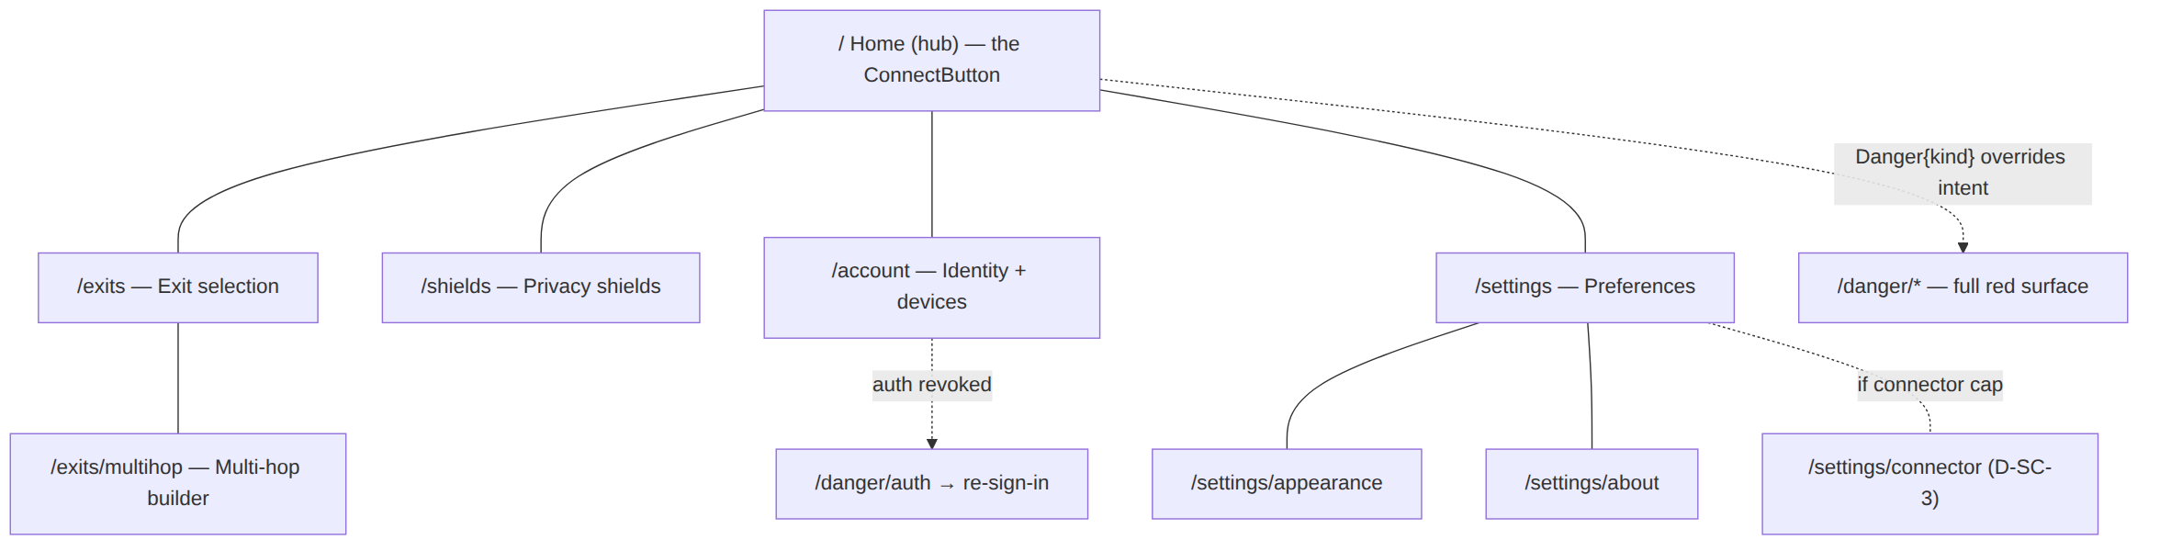
- compact: bottom-nav with 5 destinations (Home · Exits · Shields · Account · Settings); Home shows the full-width ConnectButton [SC §3].
- medium: icon-only rail; Exits and Settings become master/detail (list left, selected detail right) without leaving the destination.
- expanded: extended rail; Home gains a right pane (live status detail), Exits gains a wide detail pane.
- tv: extended rail; ConnectButton is the default-focused control; D-pad down reaches the exit summary then the shields row [SC §5].

1.3 Console IA
The Console is a hub-and-spoke from the Dashboard with cross-links that follow the data [SK §2] (a policy compile error naming an un-advertised host CIDR links to IPAM; a topology connector node links to its prefixes; an audit policy.activate row links to that policy version). It adds a ⌘K command palette [SK §1] as a keyboard-first jump-to-anything affordance orthogonal to the rail, and a live-events rail (expanded only) folding the WS/SSE stream.
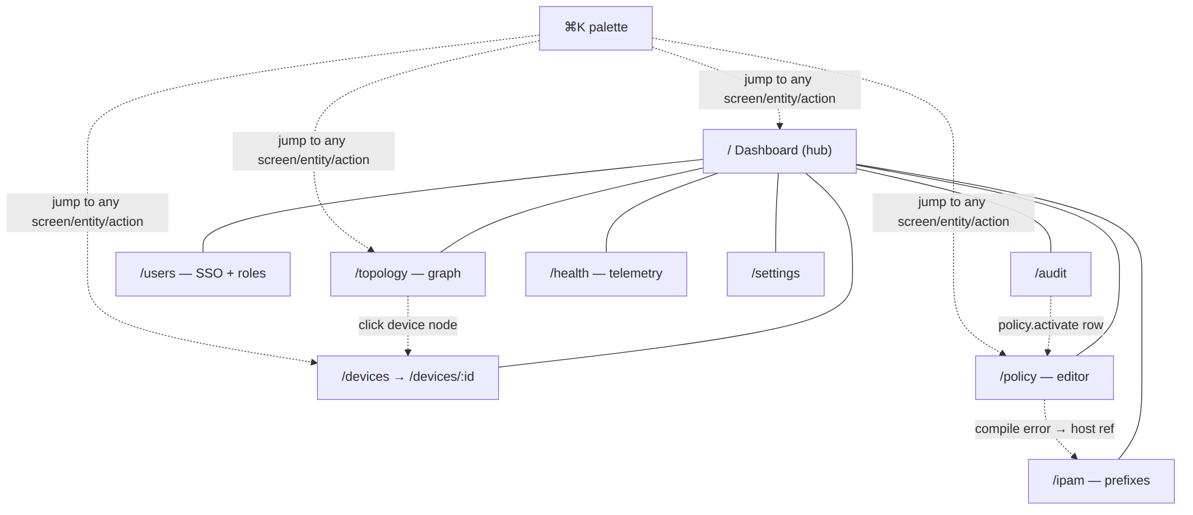

1.4 Connector IA
The Connector is a near-linear flow [SN §2] with a deliberately narrow IA: get enrolled, prove healthy, declare subnets, surface conflicts. Three primary destinations only (Status · Routes · Settings); Enroll precedes the shell.
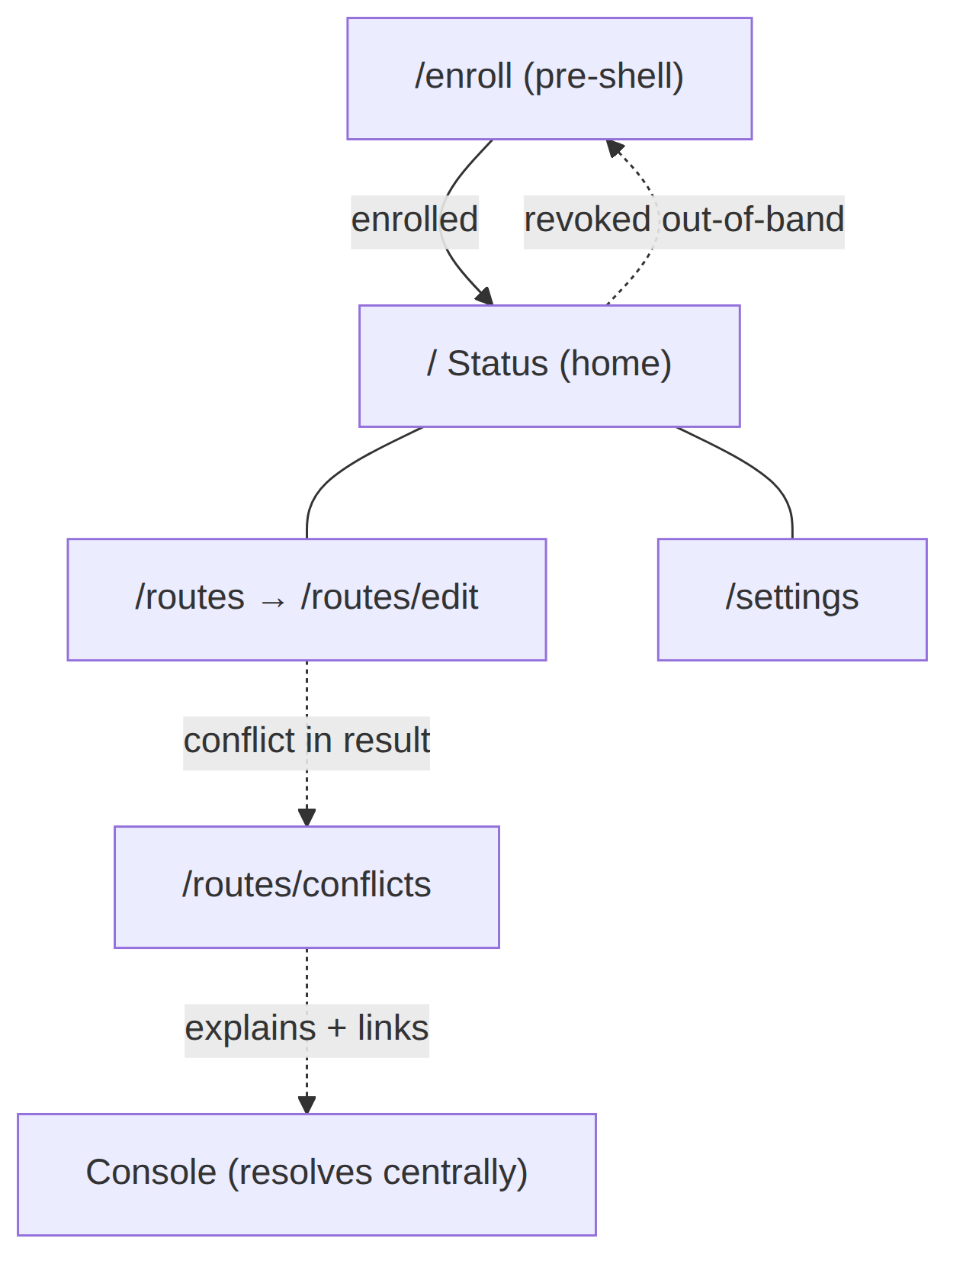

2. The state-machine spine every flow rides
Every connection-bearing flow (Client Home, Connector Status) switches on the 7-variant ffi::TunnelStatus [FFI §3.2] via the Dart-facing state diagram [FFI §3.4]. This is the spine the flows in §4–§6 map onto; it is reproduced here as the canonical reference (owned by [FFI §3.4], consumed here):
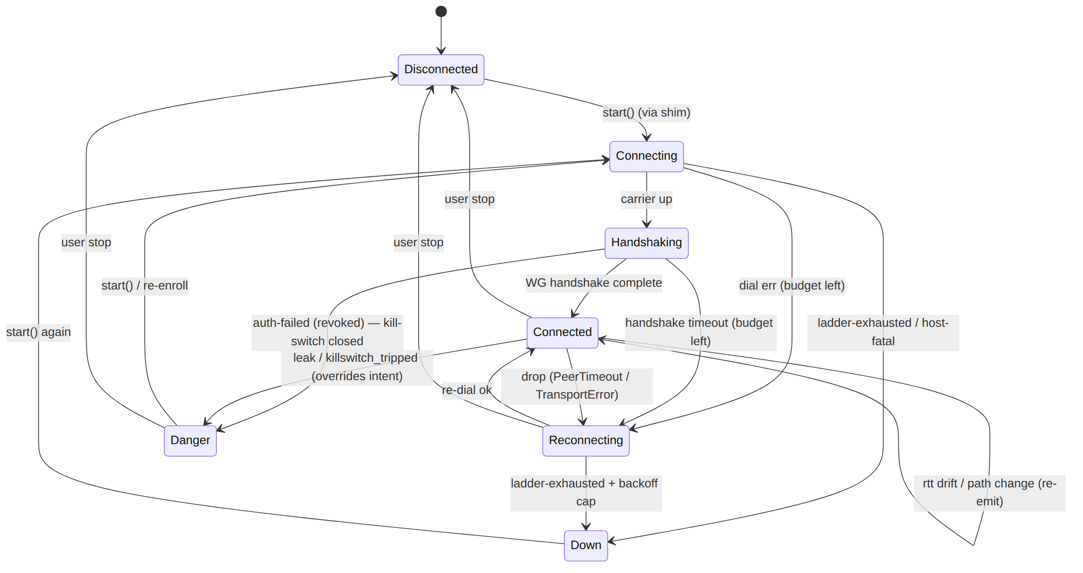
The UI mapping of each state (fill colour / icon / label / motion) is owned by the Home render matrix [SC §5] and the ConnectButton state table [CL §2]; the flows below reference state names, not colours, so they stay valid regardless of theme.

3. Flow 1 — first-run onboarding → first connect
Goal. A brand-new install reaches its first Connected{...} with the minimum decisions, never dead-ending, honouring the OS-mediated VPN-consent step.
Entry. App launch with no persisted device token / session [04_CLIENT §8] → the launch gate routes to /welcome [SC §2]. (A present token skips straight to Home — Flow 2.)
Step-by-step.
- Welcome (/welcome, SC §4.1). Static value-promise; one decision: Get started (→ sign-in) or "I already have an account / device". No async.
- Sign-in (/welcome/sign-in, SC §4.2). The user picks one of two enrolment paths the spine supports [04_CLIENT §6]:
  - OIDC (managed identity / SSO) — opens the issuer in an OidcWebView / system browser; success returns a code exchanged for a session.
  - Anonymous device token (self-hostable, privacy-max) — generates + registers a per-device token against the configured server (server URL entered here on first run). No email, no personal identity. While the chosen path runs, the other card disables (no double-enrol); on failure an InlineError gives a typed, human reason (unreachable server, bad URL, issuer rejected, token bound elsewhere) and returns to idle for retry — never a silent fail (§11.4.6).
- VPN permission grant (/welcome/grant, SC §4.3). A pre-consent explainer ("Helix needs permission to create a VPN tunnel; we never see your traffic") then Allow VPN triggers the OS-owned consent dialog the TunnelPlatform shim requires (NEPacketTunnelProvider saveToPreferences / VpnService.prepare() / privileged-service install, per platform [SC §4.3]).
  - granted → brief success tick → Home.
  - denied → a calm re-explain + "Try again" + a "How to enable in Settings" deep-link; if the OS won't re-show the dialog (denied-permanently), the Settings deep-link is the path. Never a dead end.
- Home, Disconnected (/, SC §5). First post-onboarding frame. The ConnectButton renders Disconnected (the safe default — never a fake "connected" first frame) with chip "Tap to connect".
- First connect. The user taps the ConnectButton → connectController.toggle(Disconnected) calls start() via the shim [04_CLIENT §8.2]. The status stream now drives the UI through Connecting → Handshaking → Connected{...} (Flow 2). The first Connected{...} event paints green — and only that event does (§11.4.107).
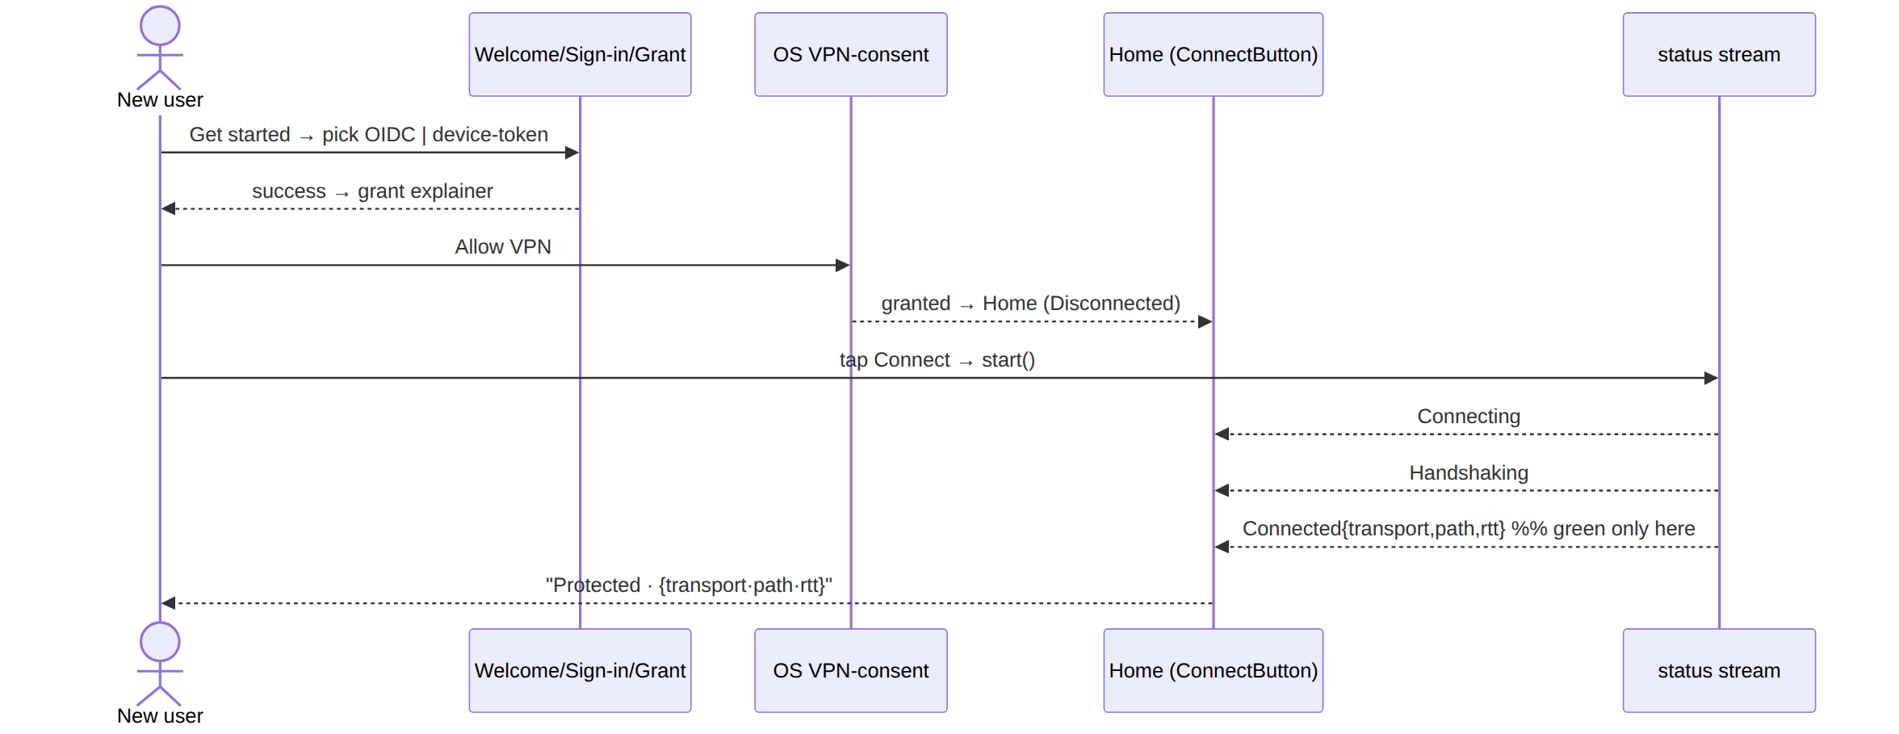
a11y. Each onboarding step is its own route (sane OS back; partial enrolment resumes at the right step); the actionable button is focused per step; success / denied results are announced via a polite live-region; the headline is an h1 heading node [SC §4]. Resume: a half-finished enrolment (token saved, consent not granted) resumes at step 3, not step 1.

4. Flow 2 — connect → established → graceful disconnect
Goal. The everyday happy path: connect, observe the established connection honestly (the §11.4.107 loading-vs-connected distinction), then disconnect cleanly.
The state transitions this flow maps to UI (the spine, §2):
Transition | UI on Home [SC §5] | Why it is honest
Disconnected → Connecting | amber fill, spinner-ring, "Connecting…", chip "Contacting exit…", connectPulse | animated + "…"-suffixed + non-committal chip ⇒ not "connected"
Connecting → Handshaking | amber (= Connecting), key-exchange glyph, "Securing…", chip "Handshaking…" | still amber, still busy (aria-busy)
Handshaking → Connected{direct} | green fill, shield-check, "Protected", chip transport·direct·{rtt}ms, one-shot settle | green painted only on the real Connected{...} event
Handshaking → Connected{relay} | teal-green, shield-check-relay, "Protected · relayed", chip transport·relay·{rtt}ms | relay path surfaced honestly (not hidden as "direct")
Connected → Connected (rtt drift / path change) | chip updates in place; fill steady | re-emit coalesced [FFI §4.4]; no flicker
Connected → Disconnected (user stop) | grey, power-off glyph, "Not connected" | clean idle, distinct from a drop
Step-by-step.
- Tap ConnectButton from Disconnected → start() [04_CLIENT §8.2].
- Connecting — amber + connectPulse; the chip shows the in-flight phase; the button announces "Connecting" with aria-busy=true [CL §2].
- Handshaking — "Securing…"; still amber, still busy. The user cannot mistake this for connected: colour (amber) + icon (spinner/key) + text ("…"-suffixed) + the non-committal chip are four independent signals that say "not yet" (§11.4.107, §13 colour-independence).
- Connected{...} — green/teal settle (a one-shot, non-looping motion, §12); the chip now shows the live transport · path · rtt; the button announces "Connected, direct path, 28 milliseconds" via a polite live-region. This is the only state painted as protected, and it is reached only from a real FFI Connected{...} event — never from the tap, a timeout, or an optimistic guess.
- Established steady state. rtt drift / path change re-emit Connected, updating the chip without re-animating the fill (coalesced [FFI §4.4]). The shields row + exit summary reflect the live session.
- Graceful disconnect. The user taps the ConnectButton (now in Connected) → toggle(Connected) calls stop(). The orchestrator emits Down{reason:"stopped"}, which the projector maps to Disconnected [FFI §3.3] (a user stop is clean idle, not a Down drop). The button cross-fades grey → "Not connected"; no Danger, no banner.
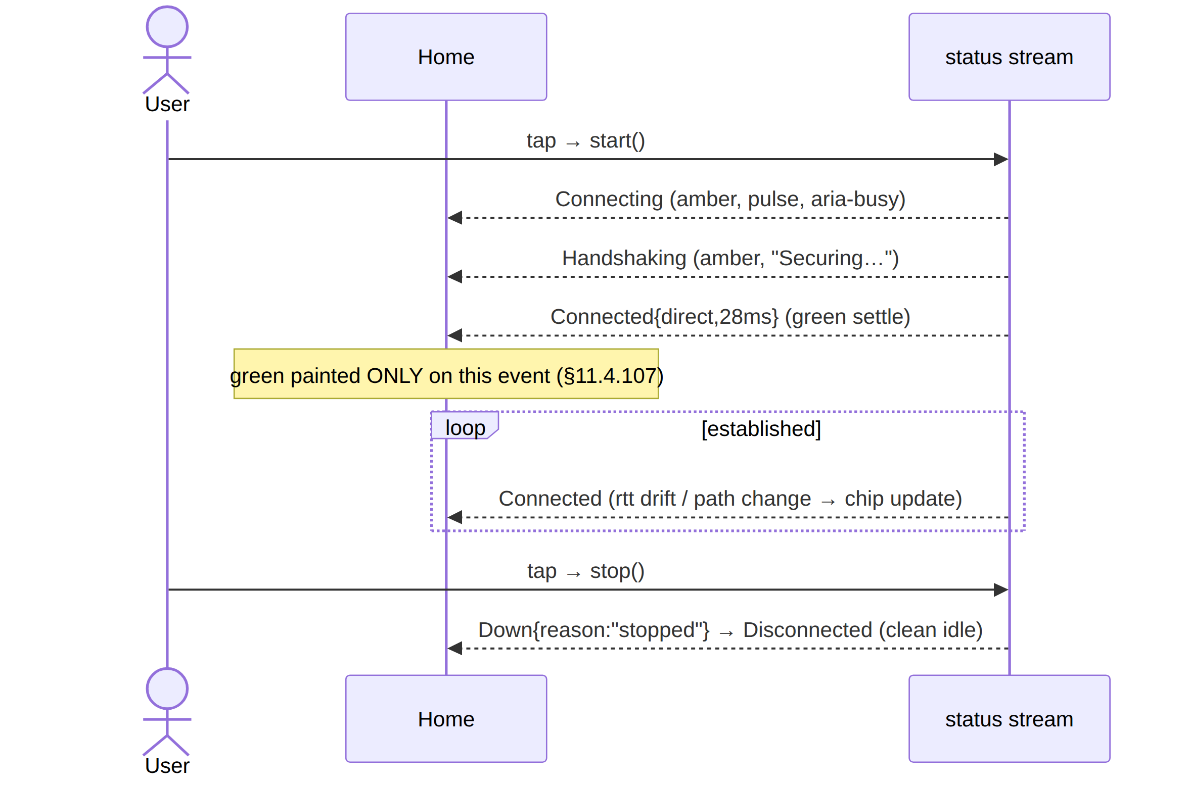
a11y. State changes fire polite live-region announcements; Connected adds the composed transport·path·rtt to the accessible name; the loading states set aria-busy; the disconnect tap is announced as a protection-reducing action only when a shield (kill-switch) would be lowered (it isn't here — a clean stop is neutral). Connector parity: the Connector Status home rides the same spine (its hero answers "am I up and serving my subnets?" [SN §0]) but with no user "connect" tap — an appliance is connected by config, so its home shows the live state read-only and surfaces re-enroll only on revoke (Flow 7).

5. Flow 3 — reconnect / drop recovery
Goal. An unexpected link loss recovers automatically without alarming the user as if they were exposed — distinct from both a clean stop (Flow 2) and a Danger exposure (Flow 4).
The distinction (load-bearing, §11.4.6). Three different "not fully connected" situations get three different visual languages so the user is never misled:
Situation | FFI state | Home language | Severity
User stopped | Disconnected | grey, "Not connected" | neutral
Link dropped, retrying | Reconnecting | amber pulse, "Reconnecting…", chip "Lost link, retrying…" | transient (no exposure)
Retry budget exhausted | Down{reason} | orange + inline DownBanner on Home, "Disconnected — dropped", reason (stable-prefix) | failed (no exposure)
Traffic may be escaping | Danger{kind} | red full surface (Flow 4) | exposure
Step-by-step.
- From Connected, the carrier drops (PeerTimeout / TransportError) → the orchestrator's re-dial driver begins; the FFI emits Reconnecting.
- Reconnecting — amber pulsing fill, rotating glyph, "Reconnecting…", chip "Lost link, retrying…"; aria-busy=true. This is an inline state on Home — not a full red surface — because a retrying drop is not an exposure.
- Recovery path A — Reconnecting → Connected. Re-dial succeeds → green settle; the chip returns to live transport·path·rtt. A polite announcement: "Reconnected, direct path, 31 milliseconds".
- Recovery path B — Reconnecting → Down{reason}. The re-dial ladder is exhausted + the backoff cap is hit → Down{reason}: an orange button + the inline DownBanner on Home (z below Danger, never full-screen-red), label "Disconnected — dropped", the reason shown by stable prefix (ladder-exhausted / host-fatal) not parsed prose (§11.4.6). The banner offers Reconnect (→ start() again, back to Connecting).
- The kill-switch interaction. If the kill-switch shield is on, traffic is blocked while Reconnecting/Down (the protection is working) — the shields row shows kill-switch active to reassure; this is coordinated by the screen, not an overlap [CL §5]. (If kill-switch is off, a drop may expose traffic → that path is a Danger{kind:"leak"}, Flow 4.)
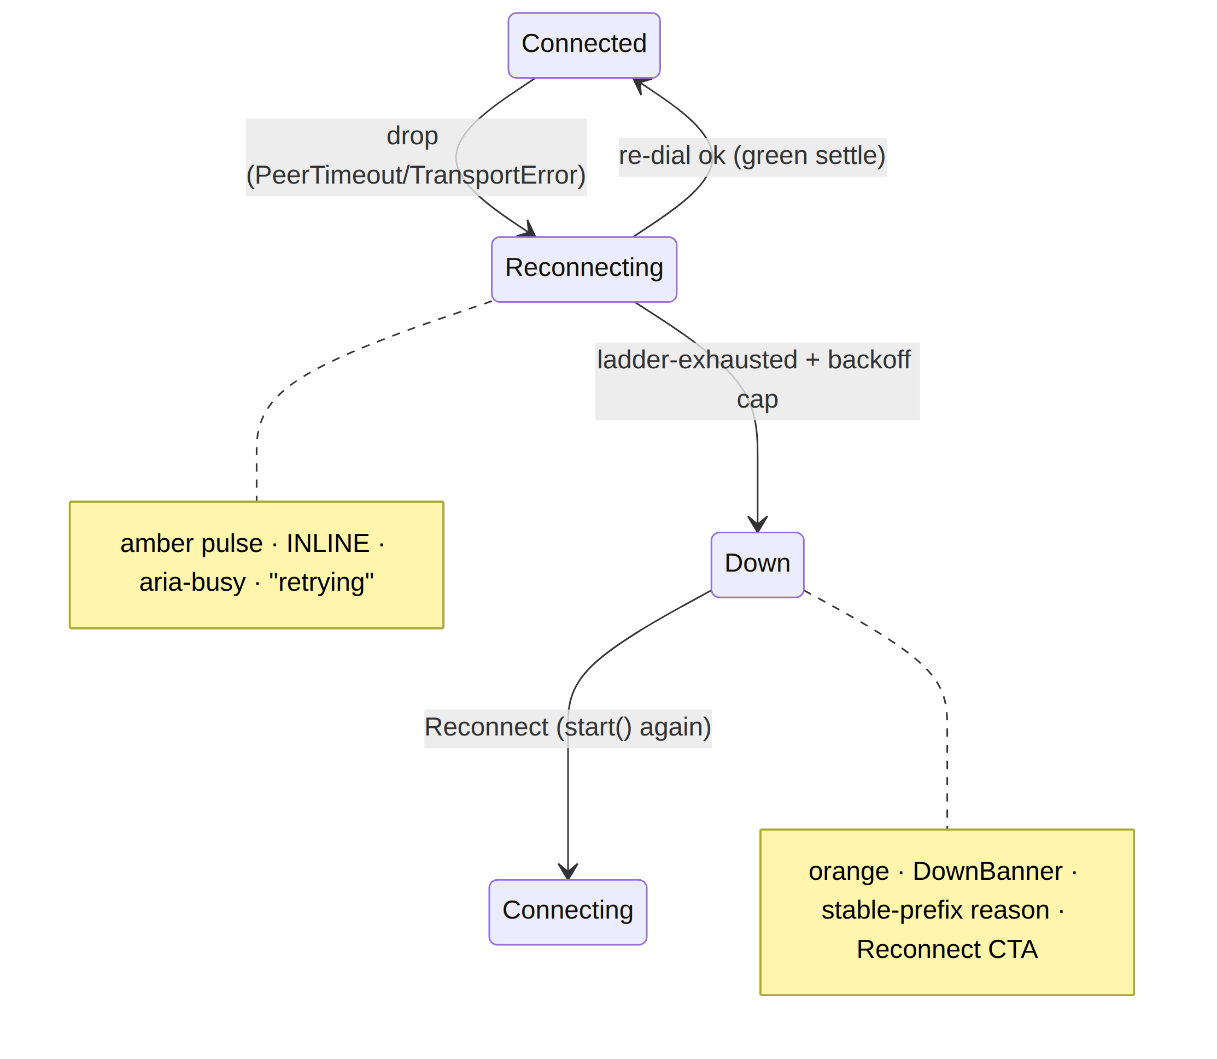
a11y. Reconnecting announces politely (not assertively — it is not an emergency); Down announces the typed reason and moves focus to the DownBanner's Reconnect action. The pulse degrades to a static amber ring under reduce-motion (§12) — it never strobes (§11.4.107 no-flash).

6. Flow 4 — leak / kill-switch-tripped Danger (intent-override)
Goal. Make "you may be exposed" impossible to miss and impossible to suppress, and give exactly one safe action — without strobing or panicking.
The override rule. A Danger{kind} from the stream paints red regardless of where the user is [FFI §3.3, §3.2]: the projector returns Danger before matching any other state ("Danger overrides everything"). The UI honours this by pushing the Danger surface over the entire stack — over Home, over Exits, over Settings, even over a modal or a toast (the DangerBanner is z-top, z.semantic.danger 2000, and can never be occluded [SC §0]). This is D-UX-2: the Danger surface is the only input-overriding navigation event in the product.
The two kinds.
Danger.kind | Source | Surface [SC §11] | Safe action
"leak" | shields_tripped = "leak" (DNS/IPv6/route escape) [FFI §3.3] | /danger/leak — full red DangerScreen + LeakDetail (what leaked, plain language) | Reconnect securely
"killswitch_tripped" | auth-failed (revoked) → kill-switch closed [FFI §3.3] | /danger/killswitch — full red + KillSwitchDetail | resolve (re-sign-in / re-enroll)
Step-by-step.
- The core detects an exposure (a shield trips, or auth fails and the kill-switch closes) → the FFI emits Danger{kind}.
- Immediate, anywhere. Wherever the user is, the DangerBanner appears z-top (red, "EXPOSED — leak detected" / "Kill-switch engaged") and the full DangerScreen is pushed. An assertive screen-reader announcement interrupts (this is the one place an assertive announcement is correct, §13) because the user must know now [CL §2].
- No strobe. The red is a static fill — there is no flashing (§11.4.107 no-flash; a strobing exposure warning would be both an a11y hazard and a panic trigger). Colour + the alert glyph + the "Exposed" text are three independent signals so colour-blind and screen-reader users get it too (§13).
- One safe action.
  - leak → Reconnect securely re-establishes the tunnel (→ Connecting); a secondary "See what happened" expands the LeakDetail.
  - killswitch_tripped (auth revoked) → resolve by re-sign-in / re-enroll (→ /welcome/sign-in, Flow 1 step 2); the kill-switch stays closed (blocking traffic) until resolved — the block is the protection working.
- Exit. Danger → Connecting (reconnect / re-enroll) or Danger → Disconnected (user stop). The red surface is dismissed only by an actual state transition off Danger — never by a back-gesture that would merely hide an active exposure.
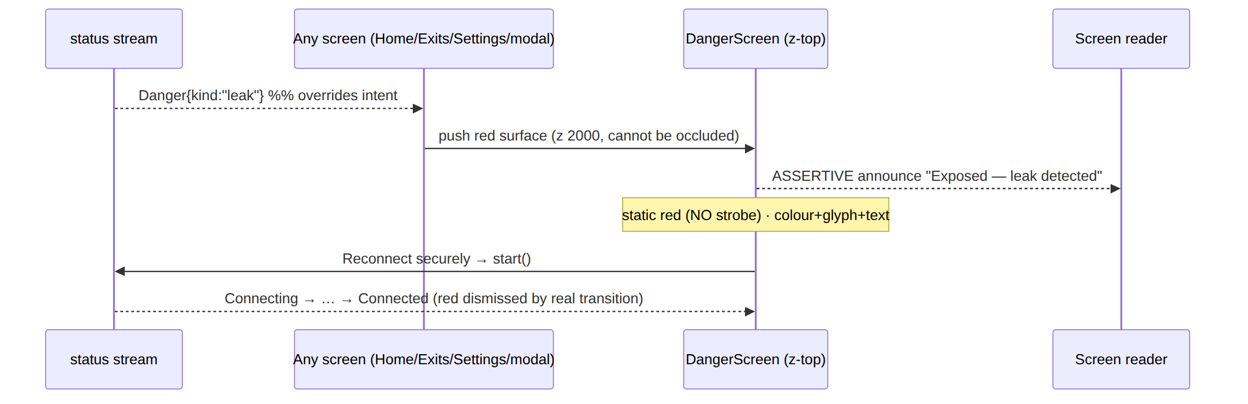
a11y. Assertive announcement (the only one in the product); focus moves to the single safe action; the red surface traps focus until a real state transition dismisses it; the static red clears the §11.4.107 no-flash rule. Connector note: an appliance with kill-switch off by default [SN §0 principle 4] does not enter Danger{leak} on a drop the way a Client does — its exposure model is different (it serves a LAN); the Connector surfaces a drop as a health-degraded state, and a revoke as a re-enroll-required state, not a red consumer-exposure surface. This is D-UX-3.

7. Flow 5 — exit switch + multi-hop build
Goal. Change where traffic exits (single exit) or compose an ordered multi-hop chain — applied live, with honest validation, without dropping protection.
Sub-flow A — single exit switch.
- From Home, tap the ExitSummaryCard → /exits (SC §6).
- The ExitPicker list loads (core.exits()): loading = skeleton rows; empty = "No exits available" + a CTA (self-host with none configured) — never a blank screen; error = "Couldn't load exits" + retry + the last cached list shown stale-labelled [SC §6, §11.4.6]; populated = RTT-sorted ascending, favourites pinned.
- The user filters (SearchField), optionally stars a favourite, taps a row.
- Apply live. Selecting an exit while Connected triggers a seamless re-route (apply_map / set_exit [FFI §2]) — the orchestrator switches the active path without a full drop where possible; Home's ExitSummaryCard updates and the chip re-emits the new transport·path·rtt. The user returns to Home with the new exit active.
Sub-flow B — multi-hop build (SC §7, CL §6).
- From Exits, tap "Build a multi-hop chain" → /exits/multihop.
- The HopChainEditor opens with one entry hop (= the current exit). The user adds a second hop (an ExitPicker sub-sheet), then more (entry → middle → … → exit).
- Live validation. As hops are added/reordered, the summed estimated latency (Σ hop RTTs) recomputes in the sticky ChainSummaryBar. An invalid chain (duplicate hop, a non-relaying exit, overlapping-CIDR if a network hop) flags the offending row (feedback.error) and disables Apply with a typed reason — never silently accepted (§11.4.6).
- Reorder is keyboard/remote-operable, not drag-only: focus a hop, Space to lift, arrow to move, Space to drop, with a live-region announcing "Hop 2 moved to position 1" (WAI APG reorder pattern [CL §6]).
- Apply (enabled only when valid) calls apply_map/set_exit [FFI §2]; the chain becomes the active route; Home reflects it.
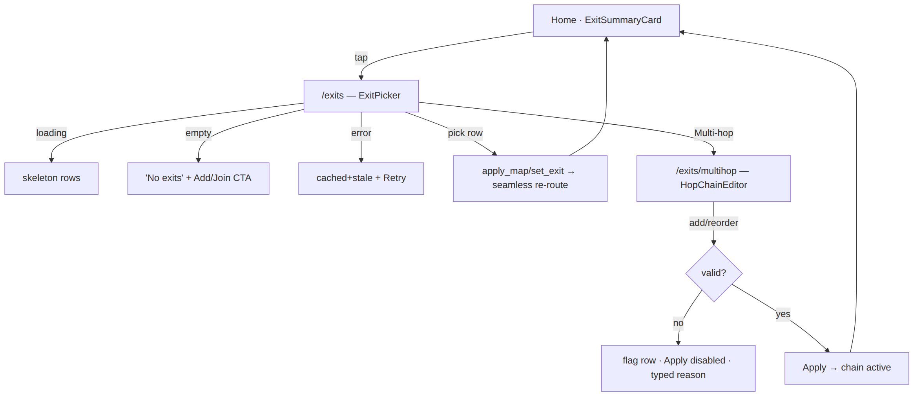
a11y. Each exit row announces name + jurisdiction + RTT + selected + favourite (RTT colour is paired with the numeric value — never colour-only [SC §6]); the favourite star is a nested button with its own 44 px target; each hop announces its ordinal + role ("Hop 1 of 3, entry, Sweden"); the chain summary announces total latency + validity.

8. Flow 6 — Console: enroll a device → author a policy → see it converge
Goal. An admin admits a new device, writes an access rule for it, and watches the change propagate — fail-closed, preview-before-apply, live-not-polled [SK §0].
Step-by-step.
- Enroll / approve a device. A new device appears in Devices (/devices, SK §5) as pending-approval (a PeerCard with primary Approve / Deny [CL §7]). The admin Approves → the control plane admits it; the live-events rail shows device.online [SK §1]. (Token minting for the device itself is the Console operator action in [CP §9.2]; the device-side enroll is Flow 7 / Flow 1.)
- Author a policy (/policy, SK §7). The admin adds a RuleRow in the PolicyEditor: an AllowDenyToggle (allow/deny), a TargetPicker source (e.g. group:eng), a destination (tag:prod), a port (:443) [CL §8]. Order matters (first-match ACL) — rows are keyboard-reorderable.
- Compile dry-run first (fail-closed). The editor compiles the spec dry-run and shows an effect-diff before anything activates [POL §4/§5, SK §0]: what access this rule grants/revokes, and any conflict (a rule shadowed by an earlier one → amber conflictMark + a tooltip naming the shadowing rule [CL §8]). A compile error that names an un-advertised host CIDR links to IPAM (S6) — cross-links follow the data [SK §2].
- Activate. Only after the admin reviews the diff and confirms (§11.4.66 confirmation for a high-stakes change) does the policy version activate; the live-events rail shows policy.compiled / version-activated.
- See it converge. The admin watches convergence live: the topology graph (/topology, SK §8) and telemetry (/health) fold the WS/SSE stream so edges / device state update without a manual refresh [SK §0 principle 3]; the convergence/event-lag SLOs show the change landing. The stream-health chip is the §11.4.6-honest signal that "live" is real — amber when reconnecting, red
  - a "may be stale" notice when down, rather than lying [SK §1].
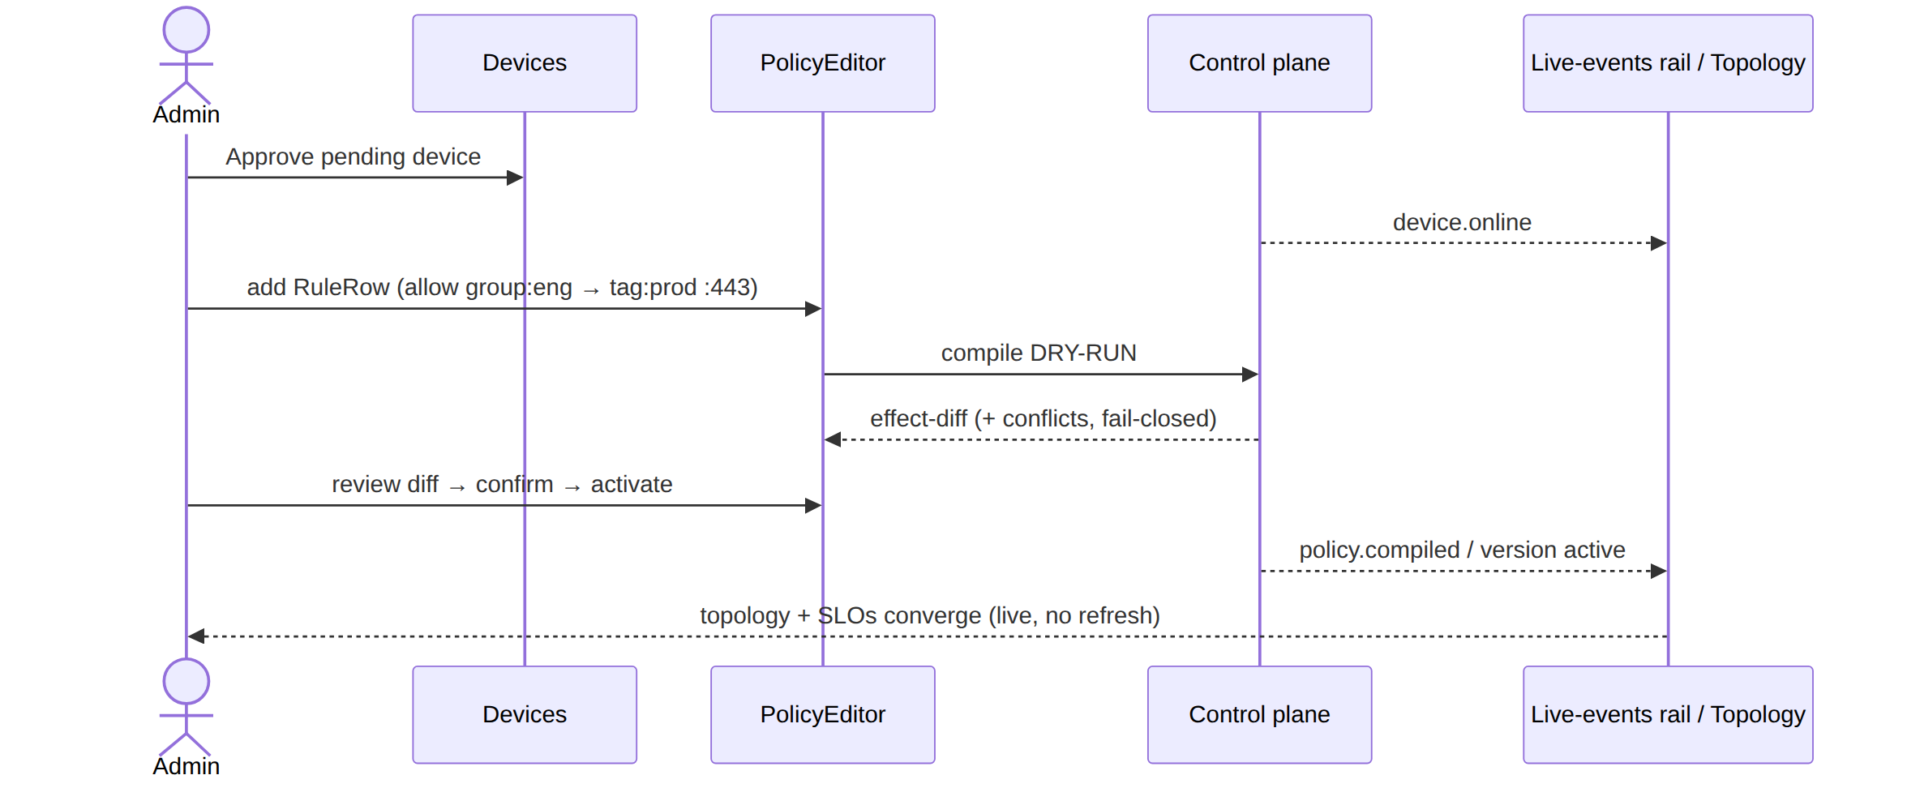
a11y. The policy is an ordered list of RuleRow listitems (order = precedence, announced "rule 3 of 8" [CL §8]); the allow/deny verb is colour + glyph (check / block), never colour alone; the effect-diff is a reviewable region; destructive control actions (revoke, deactivate) carry confirm dialogs [SK §0]. The topology graph ships a dual representation — the visual canvas plus an always-available navigable treegrid of the same nodes+edges — so a screen-reader / keyboard admin has a non-visual path (§11.4.117, [CL §9]).

9. Flow 7 — Connector: enroll → advertise a subnet → resolve a CIDR conflict
Goal. Stand up an appliance: turn an enroll token into an identity, declare the LAN subnet it exposes, and handle an overlapping-CIDR conflict honestly [SN §0].
Step-by-step.
- Enroll (/enroll, SN §3). A first-run stepper (token → keys → name → done). The operator pastes the single-use enroll token (minted in the Console [CP §9.2]) or scans its QR. The device generates its WG keypair locally — the private key never leaves it (C6 [CP §9.2]); only the 32-byte public key registers. Steps show honest progress; on success → the Status home.
- Status home (/, SN §4). The connector proves it is up and serving its subnets — the home is a pure function of the statusStream [FFI §3.2], never "up" on intent alone [SN §0 principle 1]. (Kill-switch is Off by default on an appliance — turning it on would sever the LAN it serves; that is a deliberate, explained choice [SN §0 principle 4, §7].)
- Advertise a subnet (/routes → /routes/edit, SN §5). The operator adds a CIDR (e.g. 10.20.0.0/24) and enables it. The core advertise() call returns AdvertiseResult { accepted, conflicts } [FFI §3.1]; the UI shows accepted vs conflicting CIDRs honestly and never claims a conflicting prefix is live [SN §0 principle 3].
- Resolve a conflict (/routes/conflicts, SN §6). If the result carries a conflict (another site already advertises an overlapping CIDR), the conflict view explains it (with the 4via6 / overlapping-prefix explanation [REG §6.2, IPAM §6]) and links to the Console, which resolves IPAM/policy centrally — the Connector view explains + guides, it does not resolve centrally itself [SN §0, SN §2]. The operator either changes the local CIDR or coordinates the central fix.
- Out-of-band revoke. A device.revoke from the Console [CP §9.3] drops the Connector back to an enroll-required state (→ /enroll), surfaced honestly on the Status home, not as a silent failure.
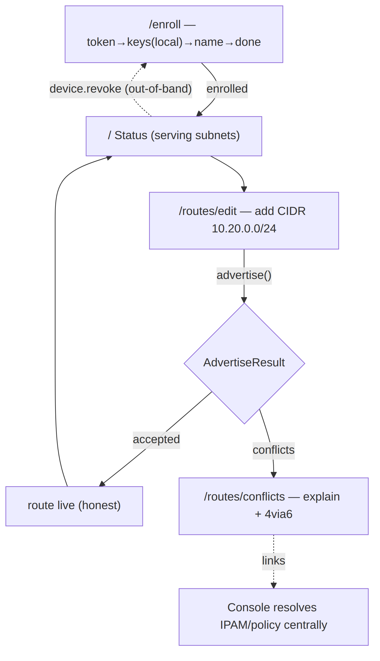
a11y. The enroll stepper announces "step N of M" + the current step's purpose; the keygen step states the private key never leaves the device (privacy-honest); each route row announces its CIDR + accepted/conflict state (never colour-only); the conflict view's explanation is body text + a link, focus-ordered. The appliance form factor is compact-first, so the bottom-nav (Status · Routes · Settings) is the default affordance [SN §1].

10. Universal interaction patterns
These patterns are shared by all three apps; a flow above composes them.

10.1 Gestures (touch)
Gesture | Meaning | Where | Reduce-/no-touch fallback
tap | activate the primary action | everywhere | keyboard Enter/Space; D-pad OK
long-press | reveal context actions (§10.4) | list rows, ConnectButton (transport-override sheet UNVERIFIED) | keyboard menu key / a visible ⋯ button
swipe (horizontal) | onboarding carousel; reveal row actions (favourite/remove) where used | Welcome pager [SC §4.1]; list rows | arrow keys; visible inline action buttons
drag | reorder (hops, policy rules) — sugar only | multi-hop, PolicyEditor | keyboard lift/move/drop is the canonical path [CL §6]
pull-to-refresh | re-probe live data (RTT, devices) | Exits list, Console tables | a visible Refresh button; live stream where present (§10.5)
pinch / pan | zoom the topology graph | Console topology | zoom/fit controls + keyboard pan [CL §9]
Every gesture has a non-gesture equivalent (§13) — the canonical path is never gesture-only. Gesture thresholds are UNVERIFIED (owned by [platform-adaptation.md]).

10.2 Keyboard navigation (desktop / web-less native)
- Tab order follows reading order (top→bottom, leading→trailing); modals trap focus; Esc closes dismissibles and restores focus to the trigger (e.g. ExitPicker trigger [CL §4.3]); tab order never jumps [CL §1.3].
- Activation: Enter / Space on buttons + the ConnectButton toggle; arrow keys traverse lists/rails/segmented controls; Home/End jump list ends; PageUp/Down page long lists [CL §4.2].
- Reorder: focus → Space lift → arrows move → Space drop, with live-region feedback (multi-hop, policy rules) [CL §6].
- Console command palette: ⌘K / Ctrl-K jumps to any screen / entity / action; keyboard-first, but every action it lists is also mouse-reachable [SK §1].
- Focus is never colour-only: a 2 px border.focus ring, offset from the container, visible against any state fill (≥3.0 non-text contrast both themes [COLOR §4.5]) [CL §1.2].

10.3 TV-leanback D-pad / remote
- Default focus is declared per screen (Client Home → ConnectButton; Welcome → "Get started"; Appearance → the current theme choice) so the remote lands on the right control [SC §4, §5, §10.a].
- Traversal: D-pad up/down/left/right moves focus along the per-screen declared order; OK/center activates; Back pops. No hover-only affordances; no gesture-only paths.
- Enlarged targets + ring: focus targets are enlarged to ~64 px hit area with an always-visible focus ring (border.focus); the rail is reachable by D-pad (no bottom-nav on TV) [SC §0, §3].
- The exact per-screen D-pad focus-order matrices are UNVERIFIED — pinned by [platform-adaptation.md] + the leanback golden-screenshot suite; this doc and the screens-* docs state the focus intent per screen [SC §0].

10.4 Long-press / context actions
Long-press (touch) / menu-key (keyboard) / long-OK (remote) reveals secondary actions that are never the only path to a capability:
- Client: long-press the ConnectButton → a quick transport-override sheet (auto / specific) [SC §5] (UNVERIFIED — the override UX is pinned by [CL §2]); long-press an exit row → favourite/details (also reachable by the visible star + row tap).
- Console: a PeerCard / AuditLogRow exposes its actions via a visible ⋯-menu button and the high-priority actions inline (Approve / Revoke), so the menu is an accelerator, not a requirement [CL §7, §10].
Every long-press target also exposes a visible affordance (a ⋯ button, a star, an inline action) so the capability is discoverable without knowing the gesture (§13).

10.5 Pull-to-refresh & live-vs-pull
HelixVPN distinguishes live surfaces (folding a stream) from pull surfaces (on-demand re-probe). This is D-UX-4:
- Live surfaces (Client Home status, Console device list / topology / audit / live-events rail, Connector Status) fold the FFI status stream or the control plane's WS/SSE /v1/stream and update without a manual refresh [SK §0, FFI §4]. A stream-health chip honestly signals stream state (green / amber reconnecting / red down + "may be stale" notice) — the live claim is never a lie [SK §1].
- Pull surfaces (Exit-list RTT re-probe, Console tables on a non-stream view) support pull-to-refresh + a visible Refresh button; a pull shows a determinate-where-possible progress, then the fresh (or cached+stale-labelled on failure) data [SC §6].
A surface is never both lying-fresh and stale: if a live stream is down, the data is shown with an explicit stale label, not silently frozen as fresh (§11.4.6).

11. The loading / empty / error / success state contract
Every async surface in every app renders one of four states, each a reusable contract (composed from [CL §11.15] ProgressIndicator, [CL §11.16] EmptyState, [CL §11.17] Skeleton, [CL §11.8] Banner). This is D-UX-5 — the single state grammar all three apps share.
State | What it MUST do | What it MUST NOT do
loading | show a skeleton (list/table) or an indeterminate spinner (action), aria-busy=true, distinct colour/motion from any success state | never look like the connected/success state (§11.4.107); never block forever with no timeout path
empty | state the empty reason + offer a next action (CTA: "Add a server" / "Join a network" / "Clear filter") | never a blank screen; never imply data exists
error | a typed, human reason + retry + show the last cached value stale-labelled if available (§11.4.6) | never a silent fail; never a raw stack/error code as the only message; never fake-fresh cached data
success | render the real data; for the connection hero, paint the protected/connected language only on a real Connected{...} event | never paint success off a timer, a tap, or an optimistic guess (§11.4.107)
The §11.4.107 loading-vs-connected rule is the contract's keystone. On the connection hero (Client Home, Connector Status), "loading/connecting" and "connected" are kept distinct by four independent signals — colour (amber vs green/teal), icon (spinner/key vs shield-check), text ("…"-suffixed vs "Protected"), and the chip (non-committal vs live transport·path·rtt) — so the distinction survives colour-blindness, a muted screen, and a screen reader (§11.4.107, §13). A spinner is never proof of connection.
State transitions cross-fade fill and label together (motion.semantic.stateXfade, 180 ms [DT §6.4]) so no in-between frame is illegible (§12, [SC §0]).
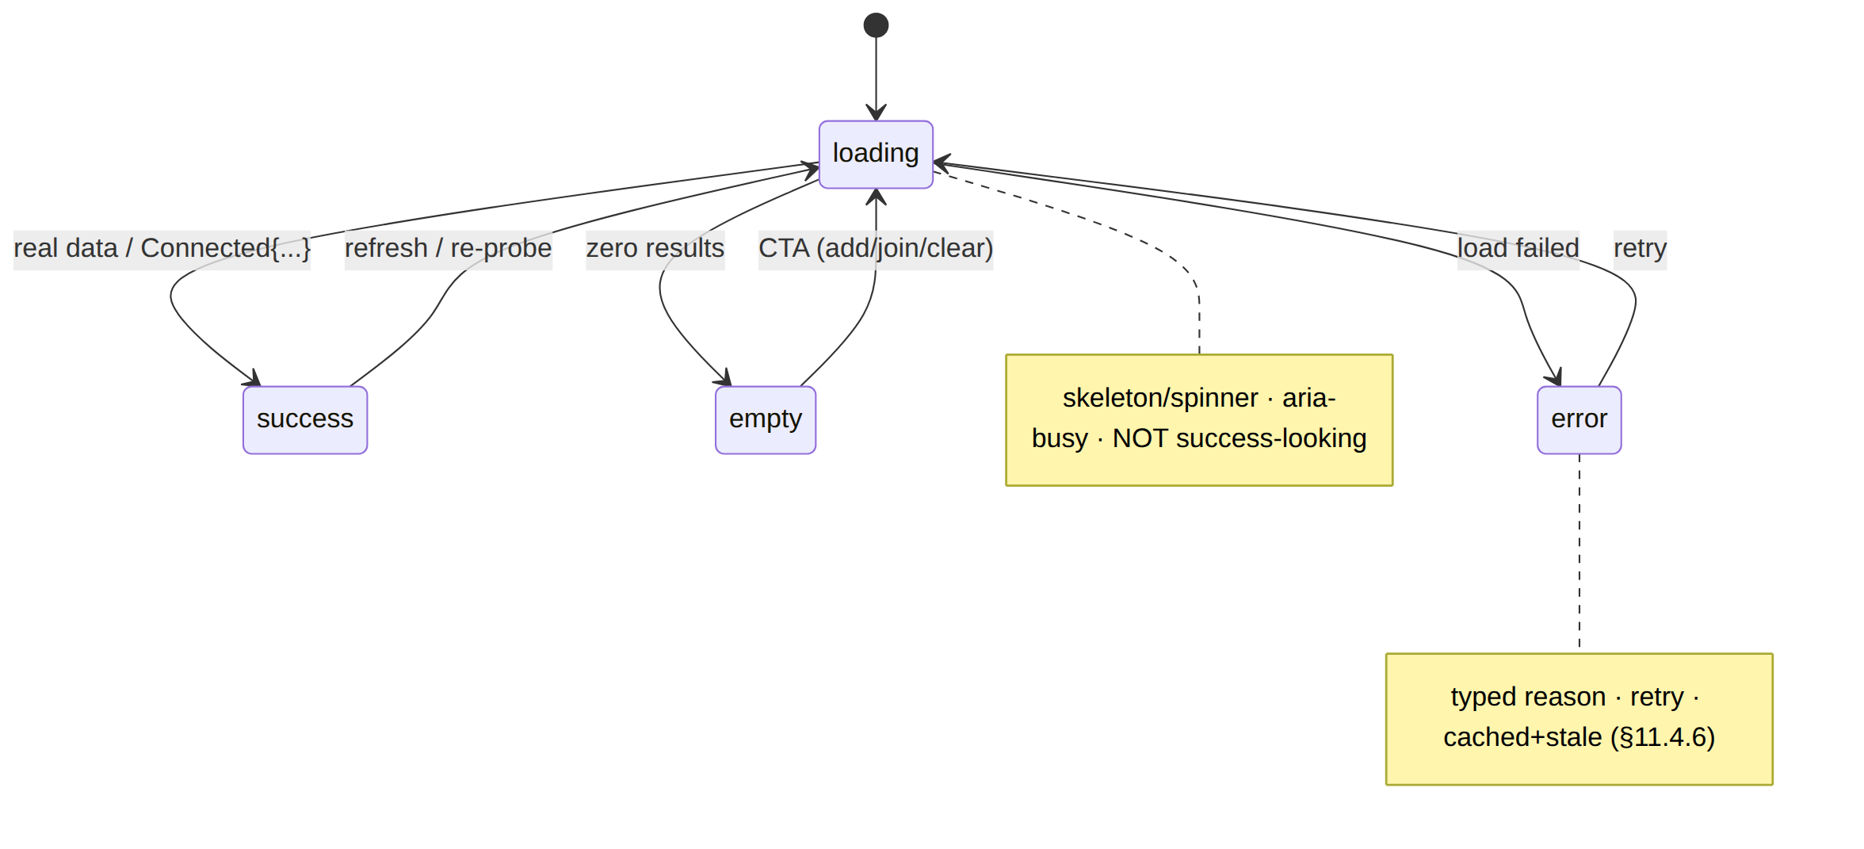

12. Motion choreography
Motion is functional, not decorative — it communicates state change, spatial relationship, and busy-ness, and it always degrades to a static end-state under reduce-motion. All durations/curves are tokens [DT §6.4]; this doc names the choreography, the values live in tokens.
Moment | Motion token | Behaviour | Reduce-motion fallback
state cross-fade (any state→state on the hero) | motion.semantic.stateXfade (180 ms) | fill and label cross-fade together; no illegible mid-frame | instant swap to the end-state
connecting / reconnecting | motion.semantic.connectPulse (looping aura) | amber pulse aura while Connecting/Handshaking/Reconnecting | static amber ring (no loop, no strobe)
connected settle | one-shot settle | a single, non-looping "lock-in" on reaching Connected{...} | static green/teal end-state
press feedback | motion.semantic.press (≈100 ms) | a brief scale/overlay on tap | overlay only, no scale
danger | none | static red — no strobe, no flash (§11.4.107) | already static
skeleton shimmer | comp.skeleton shimmer | a low-contrast sweep while loading | static skeleton (motion.semantic.reducedMotion)
route/sheet transitions | motion.semantic.* page/sheet | enter/exit slide+fade | fade only / instant
Hard rules. (1) Nothing strobes — the Danger surface and every pulse are static or sub-flash-threshold (§11.4.107 no-flash; the connecting pulse is a slow aura, not a flash). (2) Every looping/transition animation degrades to its static end-state via motion.semantic.reducedMotion [DT §6.4, CL §1.3] when the OS reduce-motion setting is on. (3) Motion never conveys state alone — it reinforces a colour+icon+text signal, never replaces it (a reduce-motion user loses no information).

13. Accessibility (WCAG 2.1 AA)
HelixVPN targets WCAG 2.1 Level AA across all three apps and eight platforms. This is D-UX-6. The baseline (every component) is owned by [CL §1.3]; this section owns the flow-level a11y guarantees.
Screen-reader flow.
- Every flow above is fully operable by screen reader (VoiceOver / TalkBack / Narrator / Orca / the HarmonyOS+Aurora a11y trees [CL §1.3]); the canonical path is never gesture- or hover-only.
- Connection state is announced on every change: the ConnectButton announces a stateful name ("Connecting" / "Connected, direct path, 28 milliseconds" / "Not protected, leak detected") via a polite live-region — except Danger, which fires an assertive announcement (the one place interruption is correct, §6) [CL §2].
- Loading states set aria-busy; the StatusChip is a polite status live-region [CL §3]; error states move focus to the error/retry control.
Focus order. Logical (reading order); modals + the Danger surface trap focus; Esc closes dismissibles and restores focus to the trigger; the multi-hop and policy reorders are keyboard lift/move/drop with live-region feedback [CL §1.3, §6].
Contrast. Text vs background ≥ 4.5 AA-normal (or 3.0 AA-large for ≥24 px); non-text UI parts ≥ 3.0; every state fill is proven against its white/dark label in both themes [COLOR §4]. The focus ring clears the 3.0 non-text floor in both themes [COLOR §4.5].
Reduced motion. Every looping/transition animation degrades to its static end-state (§12); nothing strobes (§11.4.107 no-flash).
Hit targets. Every interactive target is ≥ 44 × 44 px (touch floor); a visually-smaller control keeps a 44 px transparent tap area centred on the glyph; TV-leanback enlarges to ~64 px (a hard gate CM-hit-target-44 [CL §1.3, visual-regression-and-qa.md]).
Colour-independent state (the load-bearing a11y rule for a VPN product). State is never conveyed by colour alone — every coloured state also carries an icon and text: connecting (amber + spinner + "Connecting…"), connected (green
- shield-check + "Protected"), reconnecting (amber-pulse + rotate + "Reconnecting…"), down (orange + alert + "dropped"), danger (red + alert + "Exposed"). A colour-blind user reads "Protected" vs "Exposed" from the glyph + label, not the green/red [COLOR §0, CL §2, §11.4.107]. RTT, presence dots, allow/deny verbs, and audit severities are all icon/text-reinforced too.
Graph fallback. The Console topology ships a dual representation — the visual canvas plus an always-available navigable treegrid of the same nodes+edges — so a non-visual user has a structured path (§11.4.117, [CL §9]).
The §11.4.162 covenant. Every screen ships light AND dark, no element overlaps another, no element overlays a label, and visual-regression goldens (per theme, per size, per app) OCR-/overlap-check every surface [CL §1.5, SC §0].

14. Internationalization, RTL & localization
HelixVPN is multi-region (the spine targets self-host + managed worldwide), so every flow is i18n-ready by construction. This is D-UX-7.
String externalization. No user-visible string is hard-coded; all copy is in ARB/.arb-class resource bundles resolved at runtime (UNVERIFIED exact l10n toolchain — owned by [platform-adaptation.md]). Status labels ("Connecting…", "Protected", "Exposed"), error reasons, and CTAs are localized; the stable reason prefixes the FFI carries (ladder-exhausted, auth-failed, killswitch_tripped [FFI §3.3]) are keys, mapped to localized human strings in the UI layer — never the raw key shown to a user, never the localized string parsed back (§11.4.6).
RTL (right-to-left). Every layout mirrors for Arabic / Hebrew / Persian: leading/trailing swap (the favourite star, chevrons, the → policy arrow, the multi-hop chain direction all mirror); the bottom-nav / rail order mirrors; text aligns to the start edge. Directional glyphs (chevron, arrow, reorder) use start/end semantics, not fixed left/right, so they flip correctly. The multi-hop chain renders entry → … → exit start-to-end, mirroring in RTL so the meaning (entry first) is preserved [CL §6].
Text expansion. Layouts tolerate ~+30–40 % string growth (German / Finnish): the no-overlap covenant (§11.4.162) means a label grows within its own box and ellipsises + tooltips rather than colliding with a neighbour [CL §1.5]; the ConnectButton label wraps (never truncates) under large accessibility text sizes
- long localizations, never overlaying the icon or sub-label [SC §5].
Numerals, dates, units. RTT ("28 ms"), latency sums ("+71 ms"), timestamps (audit UTC), and counts use locale-aware formatting; the audit log keeps UTC for forensic precision but announces a locale-readable form [CL §10]. Country/flag labels in the exit list are localized country names, not only flags (the flag is decorative; the name carries meaning, §13).
Bi-di safety. Mixed-direction content (an LTR server URL or CIDR inside an RTL sentence) uses bidi isolation so a CIDR like 10.20.0.0/24 or a URL renders correctly within RTL copy.

15. Surfaced decisions & cross-doc contracts
ID | Decision | Status
D-UX-1 | Bottom-nav (compact) / rail (medium+) are the primary nav affordances; drawer is secondary-overflow only (Console "More" sheet on compact). | Asserted (this doc)
D-UX-2 | The Danger{kind} surface is the only input-overriding navigation event; it pushes z-top over everything, dismissed only by a real state transition off Danger. | Grounded [FFI §3.3, SC §11]
D-UX-3 | The Connector's exposure model differs from the Client's (kill-switch Off by default; a drop is health-degraded, a revoke is re-enroll-required — not a red consumer-exposure surface). | Grounded [SN §0, CP §9.3]
D-UX-4 | Live surfaces (status / device list / topology / audit) fold a stream + a stream-health chip; pull surfaces (RTT re-probe, non-stream tables) use pull-to-refresh; a surface is never lying-fresh while stale. | Asserted (this doc); grounded [SK §0, FFI §4]
D-UX-5 | One loading / empty / error / success state grammar shared by all three apps; the §11.4.107 loading-vs-connected distinction is its keystone. | Asserted (this doc)
D-UX-6 | WCAG 2.1 AA is the accessibility target across all apps/platforms; colour-independent state (icon+text) is the load-bearing rule for a VPN product. | Asserted (this doc)
D-UX-7 | Every flow is i18n-ready by construction: externalized strings, full RTL mirroring (start/end semantics), +30–40 % expansion tolerance, locale-aware numerals/dates, bidi isolation. | Asserted (this doc)
Cross-doc contracts this doc depends on.
- The 7-variant ffi::TunnelStatus state machine + Dart-facing state diagram [FFI §3.2, §3.4] — the spine §2–§6 ride; if the FFI enum changes, the flows here re-map.
- The Home render matrix [SC §5] + ConnectButton state table [CL §2] — the per-state colour/icon/label/motion this doc references by state name.
- The connection-state palette + contrast proofs [COLOR §3, §4] and motion tokens [DT §6.4] — every colour/motion reference resolves there.
- The three screen inventories + nav maps [SC §2, SK §2, SN §2] — the per-app IA §1 consumes.
- The component a11y baseline [CL §1.3] + topology dual-representation [CL §9] — the §13 flow-level a11y builds on.
- The §11.4.162 no-overlap / light+dark / visual-regression covenant [CL §1.5, SC §0] — enforced on every surface a flow renders.
UNVERIFIED surfaces in this doc (flagged inline, never fabricated): exact gesture thresholds + per-screen TV D-pad focus-order matrices ([platform-adaptation.md]); the ConnectButton transport-override long-press UX ([CL §2]); the l10n toolchain ([platform-adaptation.md]); the exact router config (deferred to a Volume-10 navigation refinement pass — see MASTER_INDEX; not yet authored).

Sources verified
- HelixVPN sibling specs (same wave, on disk, read for consistency): final/v10-design/screens-client.md (Client screen inventory, nav map, AdaptiveScaffold ladder, Home 7-state render matrix, Danger surfaces) · final/v10-design/screens-console.md (Console IA, command palette, live-events rail, policy fail-closed, stream-health chip) · final/v10-design/screens-connector.md (Connector near-linear IA, enroll, advertise, conflict, appliance defaults) · final/v10-design/component-library.md (ConnectButton/StatusChip state sets, reorder pattern, topology dual-representation, a11y baseline, no-overlap guarantee) · final/v10-design/color-system.md (connection-state palette, contrast proofs, focus-ring contrast) · final/v04-client/ffi-surface.md §3 (the 7-variant ffi::TunnelStatus, projector, §3.4 Dart-facing state diagram, §4 StreamSink delivery + current-truth guarantee). Verified 2026-06-25 against the files at the cited paths.
- External interaction/accessibility precedent (pattern grounding, not copied): W3C WAI-ARIA Authoring Practices Guide (listbox, dialog focus-trap + restoration, keyboard reorder, treegrid) — https://www.w3.org/WAI/ARIA/apg/ · WCAG 2.1 Level AA success criteria (1.4.3 contrast, 1.4.11 non-text contrast, 2.1.1 keyboard, 2.3.1 no-flash, 2.5.5 target size, 1.4.10 reflow, 1.3.4 orientation) — https://www.w3.org/TR/WCAG21/ · Material Design 3 adaptive navigation (bottom-nav / rail / drawer by window-size class) — https://m3.material.io/foundations/layout/understanding-layout/overview · Apple HIG — Designing for tvOS (focus + parallax, remote interaction) — https://developer.apple.com/design/human-interface-guidelines/designing-for-tvos · Android TV leanback / D-pad focus guidance — https://developer.android.com/training/tv/start/navigation . Verified 2026-06-25 (latest-source check per §11.4.99; these are stable W3C/ vendor references used for pattern grounding only — no HelixVPN behaviour is asserted from them).
- Constitution anchors applied: §11.4.6 (no-guessing — UNVERIFIED tags, no fabrication), §11.4.107 (loading ≠ connected — the keystone of §4, §11, §12), §11.4.117 (pixel-only graph → structured fallback, §13), §11.4.162 (OpenDesign: light+dark, no overlap / no label overlay, visual regression — §11, §13).

