Visual-regression & design-system QA — the gate wall every UI change crosses

Visual-regression & design-system QA — the gate wall every UI change crosses
Revision: 1 Last modified: 2026-06-25T12:00:00Z
Master technical specification — Volume 10 (Design System), nano-detail deep-dive. This document owns the quality-assurance machinery that makes the design system's promises mechanical rather than aspirational: the golden-screenshot visual-regression suite (every component × state × theme(light/dark) × form-factor); the no-overlap / no-label-overlay automated occlusion check (§11.4.162); the token-drift gate (generated output == a fresh regenerate, §11.4.108-class, with a paired §1.1 mutation); the accessibility automated battery (contrast computed from tokens with golden-good/golden-bad self-validation per §11.4.107(10), focus order, ≥44 px hit target, screen-reader-label presence, reduce-motion no-flash); the §11.4.168 exported-design-doc visual validation (render the design docs' diagrams, confirm no raw Mermaid/markup leaks); the local CI-equivalent gate wiring (§11.4.156 — local only, no remote CI); the coverage matrix; and the change-flow that takes a design edit through every gate before merge.
SPEC-ONLY. It describes the QA contract — the suites, the analyzers, the gates, the captured-evidence forms — not the shipping helix_design/helix_ui test code. Concrete component slots/states are owned by [component-library.md]; colour hexes + computed contrast ratios by [color-system.md]; the token model by [design-tokens.md]; the emit pipeline + the source-side drift gate by [token-export-pipeline.md]; the screen inventory by [screens-client.md]/[screens-console.md]/ [screens-connector.md]. This document is original HelixVPN design work (the QA architecture is owned here, layered on the well-established golden-test / visual-regression pattern, cited in Sources).
Boundary with sibling docs. Owns: the visual-regression suite design, the occlusion analyzer, the a11y battery, the §11.4.168 doc-validation, the local gate wiring, the coverage matrix, the change-flow, and every CM-* / DS-* gate named here (the sibling docs reference these gates by id — CM-component-inventory, CM-hit-target-44, the per-theme golden suite, DS-I5 — and this document is their canonical definition). Consumes: the component catalog + state sets [component-library.md §0–§11]; the contrast ratios + the no-overlay colour rule [color-system.md §4, §5]; the token $value/$type + naming [design-tokens.md §2, §3]; the source-side DS-DRIFT byte gate this document's DS-TOKEN-DRIFT triggers visual-regression off [token-export-pipeline.md §5].
Evidence base. [CL §N] = final/v10-design/component-library.md; [COLOR §N] = final/v10-design/color-system.md; [DT §N] = final/v10-design/design-tokens.md; [EXP §N] = final/v10-design/token-export-pipeline.md; [SCR-C §N] = final/v10-design/screens-client.md; [SPINE §N] = final/SPECIFICATION.md. Every contrast number reproduced here is reproduced from [COLOR §4]'s computed proofs (not re-guessed, §11.4.6). Claims not grounded in the evidence base or in this document's own original QA design are tagged UNVERIFIED per constitution §11.4.6 — never fabricated. The exact snapshot-tool API shapes and CI-determinism flags are pinned by the suite's own first run and tagged UNVERIFIED until that run exists.

Table of contents
- 0. The QA pipeline at a glance + the gate ledger
- 1. The golden-screenshot visual-regression suite
  - 1.1 The snapshot matrix
  - 1.2 Tooling per platform (decision)
  - 1.3 Perceptual vs pixel diff + tolerance
  - 1.4 Render determinism (fonts, anti-aliasing, time)
  - 1.5 A concrete golden test
  - 1.6 Coverage completeness gate
- 2. The no-overlap / no-label-overlay check (§11.4.162)
- 3. The token-drift gate (visual side)
- 4. The accessibility automated battery
  - 4.1 Contrast from tokens (self-validated)
  - 4.2 Focus order
  - 4.3 Hit-target ≥44 px
  - 4.4 Screen-reader label presence
  - 4.5 Reduce-motion no-flash
- 5. Self-validated analyzers (§11.4.107(10))
- 6. §11.4.168 exported-design-doc visual validation
- 7. The local CI-equivalent gate wiring (§11.4.156)
- 8. The coverage matrix
- 9. How a design change flows through the gates
- 10. The full QA pipeline diagram
- 11. Surfaced decisions & cross-doc contracts
- Sources verified

0. The QA pipeline at a glance + the gate ledger
The design system makes hard promises — every component ships light + dark ([CL §1.4]); elements never overlap or overlay labels (§11.4.162, [CL §1.5]); every coloured surface clears its WCAG floor ([COLOR §4]); no platform token drifts from source ([EXP §5]). This document is the wall of automated gates that turns each promise into a build failure when violated. A promise with no gate is a §11.4 PASS-bluff at the design-system layer; this document closes that gap.
The closed gate ledger (every gate has a paired §1.1 mutation in its section):
Gate id | Asserts | Captured evidence (§11.4.69) | §1.1 mutation that MUST FAIL it
DS-GOLDEN-MATCH | each rendered component/screen matches its committed golden within tolerance | qa/golden/<key>.png + qa/diff/<key>.png | shift one token hex in the rendered widget → diff exceeds tolerance → FAIL
CM-component-inventory | every comp.* root in [CL §0] has a catalog row and a golden set | qa/coverage/inventory.json | add a comp.* token with no [CL §0] row → FAIL
DS-GOLDEN-COVERAGE | every (component × load-bearing state × theme × form-factor) cell has a golden | qa/coverage/golden_matrix.json | delete the dark/tv golden of one component → cell empty → FAIL
CM-NO-LABEL-OVERLAY | no text bounding-box intersects a sibling; no label sits under a translucent wash (§11.4.162, [CL §1.5]) | qa/occlusion/<key>.json | overlap two labels in a fixture → intersection found → FAIL
CM-hit-target-44 | every interactive target's hit box ≥ 44 × 44 px ([CL §1.3]) | qa/a11y/hit_targets.json | shrink a control's tap box to 40 px → FAIL
DS-TOKEN-DRIFT | a token change re-runs visual-regression (DS-I5, consumes [EXP §5] DS-DRIFT) | qa/drift/visual_rerun.json | bump a token but skip the golden re-bless → goldens diverge → FAIL
DS-A11Y-CONTRAST | every text/non-text pair computed from tokens clears its WCAG floor ([COLOR §4]) | qa/a11y/contrast_report.json | drop a text token to a sub-4.5 value → FAIL
DS-A11Y-FOCUS-ORDER | tab order follows reading order; modals trap; Esc closes ([CL §1.3]) | qa/a11y/focus_order/<screen>.json | reorder a field's tabindex out of reading order → FAIL
DS-A11Y-LABEL-PRESENT | every interactive element has a non-empty accessible name ([CL §1.3]) | qa/a11y/semantics_tree/<key>.json | strip a semanticLabel from an icon-only button → FAIL
DS-A11Y-NO-FLASH | looping animation degrades to static under reduce-motion; nothing strobes (§11.4.107) | qa/a11y/motion/<key>.json + frame hashes | leave the connect pulse running under reduce-motion → FAIL
DS-ANALYZER-SELF-VALIDATED | every analyzer PASSes its golden-good fixture and FAILs its golden-bad (§11.4.107(10)) | qa/selfcheck/<analyzer>.json | make an analyzer accept its golden-bad fixture → self-check FAIL
CM-EXPORTED-DOC-VISUALLY-VALIDATED | rendered design-doc .pdf/.html carry content, no raw Mermaid as body text, diagrams rasterised (§11.4.168) | qa/docs/<doc>.validation.json | ship a doc PDF with raw flowchart TD … as text → FAIL
CM-LOCAL-GATE-WIRED | the whole battery runs at the local pre-commit/pre-build seam, no remote CI (§11.4.156) | qa/wiring/local_gate.json | add a .github/workflows/*.yml that runs these → FAIL
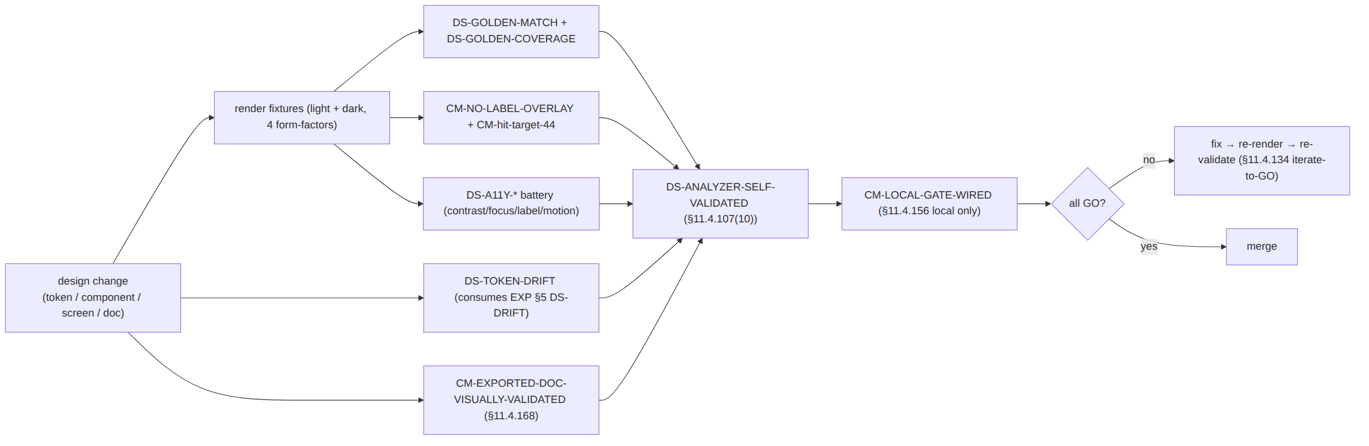

1. The golden-screenshot visual-regression suite

1.1 The snapshot matrix
The suite renders every catalog component ([CL §0]) and every named screen ([SCR-C §1]) as a deterministic image and byte/perceptually compares it against a committed golden. The matrix axes:
Axis | Values | Source
Component / screen | every comp.* root [CL §0] + every screen [SCR-C §1] | the catalog is the source-of-truth
State | each component's load-bearing states [CL §2–§11] (e.g. ConnectButton's 7 ffi::TunnelStatus × {default, hover, pressed, focus, disabled}) | per-component state set
Theme | light and dark — both mandatory ([CL §1.4]) | a one-theme golden FAILs DS-GOLDEN-COVERAGE
Form-factor | phone (360 dp) · tablet (768 dp) · desktop (1280 dp) · tv (1920 dp leanback) | [SCR-C §3] AdaptiveScaffold breakpoints
The golden key is deterministic: <component>__<state>__<theme>__<formfactor> (e.g. connectButton__connected_direct__dark__phone). The committed golden lives at qa/golden/<key>.png; a fresh render writes qa/render/<key>.png; the diff (when non-empty) writes qa/diff/<key>.png — the three files are the captured evidence (§11.4.69) for DS-GOLDEN-MATCH.
Combinatorial honesty (§11.4.6). The full cross-product is large (≈30 components × ~6 states × 2 themes × 4 form-factors). The suite does not render every cell for every component — it renders the load-bearing state set per component (the states each [CL] section marks load-bearing) and the full theme × form-factor cross for each of those. DS-GOLDEN-COVERAGE (§1.6) asserts the declared cells exist; it does not claim the cross-product is exhaustive (that would be a coverage bluff). Un-rendered states are listed as honest gaps in the §8 matrix, never silently implied covered.

1.2 Tooling per platform (decision)
The three apps span Flutter (Client/Console/Connector UI), web (Console), and the small native shims ([EXP §4.3/§4.4]). The suite uses each platform's idiomatic deterministic snapshot harness:
D-QA-1 (open, §11) — snapshot harnesses. Surfaced, not silently chosen (§11.4.6):
Surface | Lean | Why
Flutter (the bulk — every comp.*) | alchemist golden tests | CI-deterministic by design (disables real font loading / shadows that flake flutter test --update-goldens); renders a widget under a fixed MediaQuery (size + devicePixelRatio + platformBrightness) so theme × form-factor is a parameter, not a device
Web (Console chrome) | Playwright toHaveScreenshot | renders the real helix.css ([EXP §4.1]) in a headless Chromium at fixed viewport; prefers-color-scheme toggled for dark
iOS/Android native shim | reference snapshot (XCUITest / Espresso-screenshot) | the shim surface is tiny ([EXP §4.3]); UNVERIFIED until the shim test target exists
Lean: alchemist for Flutter + Playwright for web; native shim snapshot UNVERIFIED (its surface is a single status row). The harness is a build-time dev dependency ([EXP §2.2]), never a runtime app dependency. Pinned + ratified at the Volume-10 review per §11.4.99; the gate contract (a golden exists, matches within tolerance, both themes, four form-factors) holds regardless of which harness fills the role.

1.3 Perceptual vs pixel diff + tolerance
Pure pixel-equality is too brittle for cross-host rendering (sub-pixel anti-aliasing, GPU vs software raster differ by ±1 LSB on edges). The suite uses a two-stage comparator:
- Fast pixel pre-filter — if the fresh render is byte-identical to the golden, PASS immediately (zero-cost, the common case on the same host).
- Perceptual diff on mismatch — when bytes differ, run a perceptual comparator (an SSIM-/pixelmatch-class anti-aliased-aware diff) and PASS only if the fraction of perceptually-different pixels is below a calibrated tolerance τ.
τ is calibrated on the project's own goldens, not hardcoded from literature (§11.4.6 / §11.4.107(13)): the suite renders the same fixture twice on the reference host, measures the floor noise, and sets τ a margin above it. Default band: τ ≈ 0.1 % of pixels for component goldens, looser only where a documented font-hinting difference forces it (cited per golden, never blanket). A diff above τ writes qa/diff/<key>.png (the heat-map of changed pixels) and FAILs DS-GOLDEN-MATCH — that PNG is the captured evidence an operator inspects.
Why perceptual, not "looks the same to me" (§11.4.6). "The reviewer eyeballed it" is not a gate. The perceptual fraction vs a calibrated τ is a reproducible number; the diff heat-map is the captured artefact. A golden re-bless (--update-goldens) is a reviewed, intentional act recorded in the change's §11.4.142 review — never an automatic "accept whatever rendered".

1.4 Render determinism (fonts, anti-aliasing, time)
A flaky golden is a §11.4.1 FAIL-bluff (the gate fails for a non-product reason). The suite pins every non-determinism source:
- Fonts — the Inter/JetBrains-Mono families are loaded from the bundled font files into the test font-manager (never the host's system font), so the glyph raster is identical on every host. alchemist's font-loading shim does this for Flutter; Playwright pins a bundled font + --font-render-hinting=none.
- Anti-aliasing / shadows — elevation shadows ([DT §6.3]) are a known flake source; the test theme renders shadows deterministically (fixed blur, no platform shadow) so the dark-theme elevation does not jitter the diff.
- Time / animation — animated components ([CL §1.2] motion.*) are pumped to a fixed frame (connectPulse captured at t=0 and t=600 ms, the two golden frames, [DT §6.4]); the suite never snapshots a free-running animation.
- devicePixelRatio — fixed per form-factor (phone 3.0, tablet 2.0, desktop 1.0, tv 1.0) so the golden is resolution-stable.

1.5 A concrete golden test
A real alchemist golden test for the ConnectButton's Connected{direct} state in both themes at the phone form-factor (the hero control, [CL §2]). No placeholders, no TODO (§11.4.6):
// qa/golden/connect_button_golden_test.dart
import 'package:alchemist/alchemist.dart';
import 'package:flutter/material.dart';
import 'package:flutter_test/flutter_test.dart';
import 'package:helix_design/helix_design.dart'; // HelixTokens, ConnectButton
void main() {
// one row per (state) × column per (theme); form-factor fixed per file
goldenTest(
'ConnectButton — all states, light + dark (phone 360dp)',
fileName: 'connectButton__phone', // → qa/golden/connectButton__phone.png
pumpBeforeTest: precacheImages,
builder: () => GoldenTestGroup(
columns: 2, // light | dark
children: [
for (final theme in [helixLight(), helixDark()])
for (final status in TunnelStatus.values) // all 7 FFI variants [CL §2]
GoldenTestScenario(
name: '${status.name}/${theme.brightness.name}',
child: MediaQuery(
data: const MediaQueryData(size: Size(360, 780), devicePixelRatio: 3.0),
child: Theme(
data: theme,
child: ConnectButton(status: status, onTap: () {}),
),
),
),
],
),
);
}
The dark column proves [CL §2]'s "ring glow brighter on dark" + the white label on every coloured fill (AA-proven both themes, [COLOR §4.3]). The seven rows are the seven ffi::TunnelStatus variants — the golden is the captured proof every variant renders, not just the happy Connected path.

1.6 Coverage completeness gate
DS-GOLDEN-COVERAGE + CM-component-inventory are the two completeness gates the sibling docs reference:
- CM-component-inventory ([CL §0] references it) — walks the comp.* token roots in the emitted dist/json/tokens.json ([EXP §4]) and asserts each has (a) a row in the [CL §0] catalog table and (b) at least one golden key. A comp.* token with no catalog row, or a catalog row with no golden, FAILs.
- DS-GOLDEN-COVERAGE — for every catalog row, asserts the declared load-bearing-state × {light, dark} × {phone, tablet, desktop, tv} cells each have a qa/golden/<key>.png. A missing dark or tv golden FAILs — this is the mechanical enforcement of [CL §1.4]'s "every component ships light + dark".
Paired §1.1 mutations. (a) add a comp.newThing.* token to tokens/** but no [CL §0] row → CM-component-inventory FAILs. (b) delete qa/golden/connectButton__connected_direct__dark__phone.png → DS-GOLDEN-COVERAGE reports an empty cell → FAILs.

2. The no-overlap / no-label-overlay check (§11.4.162)
§11.4.162: "elements MUST NOT overlap or overlay labels." [CL §1.5] guarantees this structurally (layout); this section is the automated proof that the guarantee holds in the rendered output — the gate CM-NO-LABEL-OVERLAY the sibling docs reference.

2.1 What it computes
For each rendered golden the suite extracts the render tree's bounding boxes (Flutter exposes the RenderObject geometry; web reads getBoundingClientRect() per element; both are captured to qa/occlusion/<key>.json). The occlusion analyzer asserts:
- No text-box intersection. For every pair of text slots (label, supporting, subLabel, badges), their axis-aligned bounding boxes do not intersect (a positive-area intersection = a label overlapping a label = FAIL, the exact §11.4.162 prohibition).
- No label under a translucent wash. A text box is never covered by a sibling with 0 < opacity < 1 painted above it in z-order (the [COLOR §5.2] "overlays use an opaque surface + a scrim, never a translucent wash over content" rule). Floating parts (tooltip/menu/dialog) must sit on an opaque surface.* above an overlay.scrim — the analyzer checks the covering layer's resolved alpha.
- Minimum gaps. Adjacent interactive/coloured boxes keep ≥ space.scale.2 (8 px); icon-to-label ≥ space.scale.1 (4 px) ([CL §1.5]). A gap below the floor FAILs (boxes that touch are an overlap-in-waiting).
- Truncation, not overflow. A text box never exceeds its grid/flex cell's intrinsic width (overflow that bleeds into a neighbour FAILs); the [CL §1.5] contract is ellipsis + tooltip, proven by the box staying inside its cell.

2.2 The captured-evidence form
// qa/occlusion/serverListItem__default__light__desktop.json (PASS sample)
{
"key": "serverListItem__default__light__desktop",
"boxes": [
{ "slot": "leading", "rect": [12, 14, 36, 38] },
{ "slot": "label", "rect": [48, 12, 300, 32], "text": "Sweden · Stockholm" },
{ "slot": "supporting", "rect": [48, 34, 300, 50], "text": "privacy exit" },
{ "slot": "rtt", "rect": [520, 14, 580, 38], "text": "24 ms" },
{ "slot": "favourite", "rect": [600, 8, 644, 52] },
{ "slot": "selectedMark", "rect": [656, 14, 680, 38] }
],
"text_box_intersections": [], // ← empty ⇒ no label overlays a label
"translucent_over_text": [], // ← empty ⇒ no wash over a label
"min_gap_px": 12, "gap_floor_px": 8, // ← 12 ≥ 8 ⇒ OK
"overflow_violations": [],
"verdict": "PASS"
}
A non-empty text_box_intersections, or a min_gap_px below the floor, or any translucent_over_text entry, sets verdict: "FAIL" and the offending pair is named — the operator sees which two slots collided, never a bare red.

2.3 The OCR cross-check (pixel-side)
Geometry catches structural overlap; a pixel OCR pass catches the case where two glyphs visually smear even with non-intersecting boxes (e.g. a descender of one line touching the next). The suite OCRs the golden's text regions with a per-word confidence floor + ROI (§11.4.107(12)) and asserts every expected label string is read back legibly (confidence ≥ floor) and once (a doubled read in one ROI signals an overlay). Calibrated on the project's own goldens, not a hardcoded threshold (§11.4.6).
Paired §1.1 mutation. Author a fixture where the rtt box is absolutely positioned over the label box → text_box_intersections is non-empty → CM-NO-LABEL-OVERLAY FAILs. (And the analyzer's own golden-bad in §5 is exactly this fixture, so the analyzer is proven able to catch it.)

3. The token-drift gate (visual side)
[EXP §5] owns the source-side byte gate DS-DRIFT (a generated dist/** form must equal a fresh regenerate). This document owns the consumer-side half: when a token change lands, the rendered UI must be re-blessed too, or a stale golden hides the new colour. The gate is DS-TOKEN-DRIFT (the [EXP §5.4] / [CL §0] DS-I5 reference).

3.1 What it asserts
DS-TOKEN-DRIFT (the visual-regression coupling to a token change):
1. detect a change to tokens/** OR dist/** (the EXP §5 DS-DRIFT trigger)
2. re-render the affected component goldens (the components whose comp.* root
references the changed semantic/primitive token — resolved via the token
reference graph [DT §3.1])
3. run DS-GOLDEN-MATCH on the re-rendered set against the committed goldens
4. if the source DS-DRIFT (EXP §5) is GREEN but a golden now differs and was
NOT re-blessed in the same change ⇒ FAIL (the token moved but the UI proof
is stale)
The reference graph keeps the re-render targeted: a change to color.semantic.state.connected.fill re-renders only ConnectButton + StatusChip + the screens that show connection state ([SCR-C §5/§11]), not the whole catalog — the [DT §3.1] resolution map says which comp.* tokens dereference the changed token. The targeted set + its diff result is captured to qa/drift/visual_rerun.json.

3.2 Why both halves are needed
Gate | Catches
DS-DRIFT ([EXP §5]) | a hand-edit of a generated dist/** form; source ≠ artifact
DS-TOKEN-DRIFT (here) | a correct token change whose rendered golden was never updated — the artifact changed but the visual proof is stale
Together they span "the token bytes are right" (EXP) and "the pixels the user sees match the current tokens" (here) — the [EXP §5.2] §11.4.108 SOURCE→ARTIFACT logic extended one hop further, to ARTIFACT→RENDERED-PIXELS.
Paired §1.1 mutation. Change state.connected.fill in tokens/**, regenerate dist/** (so DS-DRIFT is GREEN), but commit the old ConnectButton golden → the re-render differs from the stale golden → DS-TOKEN-DRIFT FAILs (forcing the golden re-bless in the same change).

4. The accessibility automated battery
Five gates, all autonomous (no human eyeball required, §11.4.52), each citing a captured-evidence file (§11.4.69).

4.1 Contrast from tokens (self-validated)
DS-A11Y-CONTRAST recomputes the [COLOR §4] WCAG arithmetic directly from the token values (not from a hand-typed table) so a token edit that drops a pair below its floor FAILs the build. The analyzer reads dist/json/tokens.json ([EXP §4]), pairs every text.*/icon.*/border.* token with the surface(s) it renders on (per the [CL] component slots), computes (L1+0.05)/(L2+0.05) on the relative luminances, and asserts each clears its governing threshold:
Pair class | Threshold | Example (from [COLOR §4.1], reproduced)
normal text | AA 4.5 | text.tertiary #6B7385 / surface.default #FFFFFF = 4.76 ✓
large/bold text (≥24 px) | AA-large 3.0 | text.onState white on every state fill (≥3.0, [COLOR §4.3]) ✓
non-text UI (focus ring, borders, dots) | 3.0 | border.focus ≥ 3.0 in both themes ([COLOR §4.5]) ✓
disabled text | exempt (SC 1.4.3) | text.disabled #9AA2B2 / #FFFFFF = 2.57, flagged exempt not FAIL
// qa/a11y/contrast_report.json (excerpt — every ratio is computed, not typed)
{
"computed_by": "wcag21 relative-luminance + (L1+0.05)/(L2+0.05)",
"pairs": [
{ "fg": "text.tertiary #6B7385", "bg": "surface.default #FFFFFF",
"theme": "light", "ratio": 4.76, "threshold": 4.5, "class": "normal", "verdict": "PASS" },
{ "fg": "text.disabled #9AA2B2", "bg": "surface.default #FFFFFF",
"theme": "light", "ratio": 2.57, "threshold": 4.5, "class": "disabled",
"verdict": "EXEMPT", "reason": "WCAG SC 1.4.3 inactive-control exemption" }
],
"fails": []
}
Self-validation (§11.4.107(10), §5): the analyzer ships a golden-good fixture (a token set whose every pair clears its floor → MUST PASS) and a golden-bad fixture (one text token deliberately at a 3.9 ratio → MUST FAIL). An analyzer that passes its golden-bad is itself the bluff, caught by DS-ANALYZER-SELF-VALIDATED.
Paired §1.1 mutation. Edit text.primary to a near-surface grey (ratio < 4.5) in a fixture → DS-A11Y-CONTRAST FAILs.

4.2 Focus order
DS-A11Y-FOCUS-ORDER drives each screen's focus traversal autonomously (Flutter FocusTraversalPolicy walk / web Tab key simulation) and asserts the visited order matches the declared reading order ([CL §1.3]: top→bottom, leading→trailing). For modals it asserts focus is trapped (tabbing past the last control returns to the first, never escapes to the page behind) and Esc closes + restores focus to the trigger ([CL §4.3 ExitPicker]). The visited sequence is captured to qa/a11y/focus_order/<screen>.json.
Paired §1.1 mutation. Move the Sign-in screen's password field's traversal order before the username ([SCR-C §4.2]) → visited order ≠ reading order → FAIL.

4.3 Hit-target ≥44 px
CM-hit-target-44 (the [CL §1.3]/[CL §1.5] reference) asserts every interactive element's hit box (not its visual box) is ≥ 44 × 44 px. It reads the gesture geometry from the render tree (Flutter GestureDetector/InkWell hit-test size; web the clickable element's box + padding) so a visually 20 px checkbox with a 44 px transparent tap area ([CL §1.3]) PASSes, while a 40 px button FAILs. Captured to qa/a11y/hit_targets.json.
Paired §1.1 mutation. Shrink the StatusChip's tappable variant to a 40 px height ([CL §3]) → CM-hit-target-44 FAILs.

4.4 Screen-reader label presence
DS-A11Y-LABEL-PRESENT dumps each rendered surface's semantics tree (Flutter SemanticsNode tree / web accessibility tree) and asserts every node with an interactive role (button, switch, option, combobox, …) has a non-empty accessible name ([CL §1.3]). Icon-only controls (ConnectButton, favourite star) MUST carry an explicit semanticLabel — an icon-only node with an empty name FAILs. The tree dump is qa/a11y/semantics_tree/<key>.json; it also feeds the [CL §2] "stateful accessible name" check (ConnectButton announces "Connected, direct path, 28 milliseconds", not a bare "button").
Paired §1.1 mutation. Remove the semanticLabel from the icon-only ConnectButton → empty name on an interactive node → DS-A11Y-LABEL-PRESENT FAILs.

4.5 Reduce-motion no-flash
DS-A11Y-NO-FLASH renders the animated components ([CL §1.2], [DT §6.4] connectPulse/stateXfade) under the OS reduce-motion flag and asserts the animation degrades to its static end-state (the pulse becomes a static amber ring, [COLOR §3.2]) — i.e. the frame at t=0 and t=600 ms are identical under reduce-motion (frame-hash equality), proving nothing loops or strobes (§11.4.107 no-flash). Without reduce-motion the two frames differ (the pulse animates), proving the animation is real, not dead. Both frame hashes are captured to qa/a11y/motion/<key>.json.
Paired §1.1 mutation. Leave connectPulse looping under reduce-motion (ignore the flag) → the two frames differ when they must match → DS-A11Y-NO-FLASH FAILs.

5. Self-validated analyzers (§11.4.107(10))
Every analyzer in this document (the perceptual differ, the occlusion analyzer, the contrast computer, the OCR reader, the motion frame-hasher, the §6 doc validator) is itself a possible bluff: an analyzer that always returns PASS makes every gate green while the design is broken. DS-ANALYZER-SELF-VALIDATED closes this with the §11.4.107(10) golden-good / golden-bad fixture pair per analyzer:
Analyzer | Golden-good fixture (MUST PASS) | Golden-bad fixture (MUST FAIL)
perceptual differ | a render byte-identical to its golden | a render with one shifted hex above τ
occlusion analyzer | the §2.2 PASS layout | a layout with two intersecting label boxes
contrast computer | a token set all-pairs ≥ floor | a token set with one pair at 3.9
OCR reader | a clean caption strip | a chrome menu label where dialogue is expected ([CL] /§11.4.137-class)
motion frame-hasher | reduce-motion → identical frames | a looping animation under reduce-motion
doc validator (§6) | a rendered PDF with rasterised diagrams | a PDF with raw flowchart TD as body text
The self-check runs before the real gates each cycle; an analyzer that fails its self-check blocks the whole battery (a broken analyzer cannot be trusted to judge the design). Captured to qa/selfcheck/<analyzer>.json.
Paired §1.1 mutation. Make the contrast computer treat its golden-bad fixture as PASS (e.g. invert the threshold comparison) → its golden-bad no longer FAILs → DS-ANALYZER-SELF-VALIDATED FAILs (the discriminator §11.4.120: a real gate's mutation makes it FAIL; a bluffed one does not).

6. §11.4.168 exported-design-doc visual validation
Every Volume-10 design doc (this one, [CL], [COLOR], [DT], [EXP], the screen docs) contains rendered swatches + Mermaid diagrams; per §11.4.65 each has synchronized .html/.pdf siblings ([EXP §6]). §11.4.168 demands an independent check that the exported artefact a reader opens is faithful, readable, and visually rendered — not just that the .md is correct. The gate is CM-EXPORTED-DOC-VISUALLY-VALIDATED.

6.1 The three layers (§11.4.168)
- Content — the export carries the source's data; nothing dropped/truncated. Checked by extracting the PDF/HTML text and asserting the section headings + key tables ([COLOR §3] palette, [CL §0] inventory) are present.
- Textual — no raw Mermaid/diagram source as body text. pdftotext over the export, asserting it contains no lines matching the Mermaid grammar (^\s*(flowchart|sequenceDiagram|stateDiagram|graph|gantt|classDiagram)\b) as readable body text. This is the exact §11.4.168 forensic failure (raw gantt shipped as text) applied to the design docs' many diagrams.
- Full visual — every Mermaid diagram rendered as an image, every swatch as a visible colour block. pdfimages -list confirms the diagrams rasterised (an expected image count); pdftoppm → OCR confirms the rendered page text is human-readable and the swatch ROIs carry the expected colour blocks (not empty).

6.2 The captured-evidence form
// qa/docs/color-system.validation.json
{
"doc": "final/v10-design/color-system.md",
"exports": ["color-system.html", "color-system.pdf"],
"content": { "headings_found": 9, "headings_expected": 9, "palette_table_present": true },
"textual": { "raw_mermaid_lines": [], "raw_codefence_leaks": [] }, // empty ⇒ PASS
"visual": { "mermaid_blocks": 3, "rasterised_images": 3, "swatch_blocks_rendered": 24 },
"verdict": "PASS"
}
A non-empty raw_mermaid_lines (a diagram leaked as text), or rasterised_images < mermaid_blocks (a diagram failed to render), or a swatch ROI that OCRs to empty/garble, sets verdict: "FAIL" — a release blocker (§11.4.168). The doc validator is self-validated (§5): a golden-bad PDF seeded with a raw flowchart TD block MUST FAIL.
Paired §1.1 mutation. Export a design-doc PDF with a Mermaid block left as raw flowchart TD … text in the body → raw_mermaid_lines non-empty → CM-EXPORTED-DOC-VISUALLY-VALIDATED FAILs.

7. The local CI-equivalent gate wiring (§11.4.156)
Per §11.4.156 all server-side CI/CD is disabled across every governed repo — no GitHub Actions, no GitLab pipeline triggers a run. The entire QA battery is therefore wired at the local seam (the §11.4.75 mechanical-enforcement layer), and CM-LOCAL-GATE-WIRED asserts it.

7.1 Where each gate runs
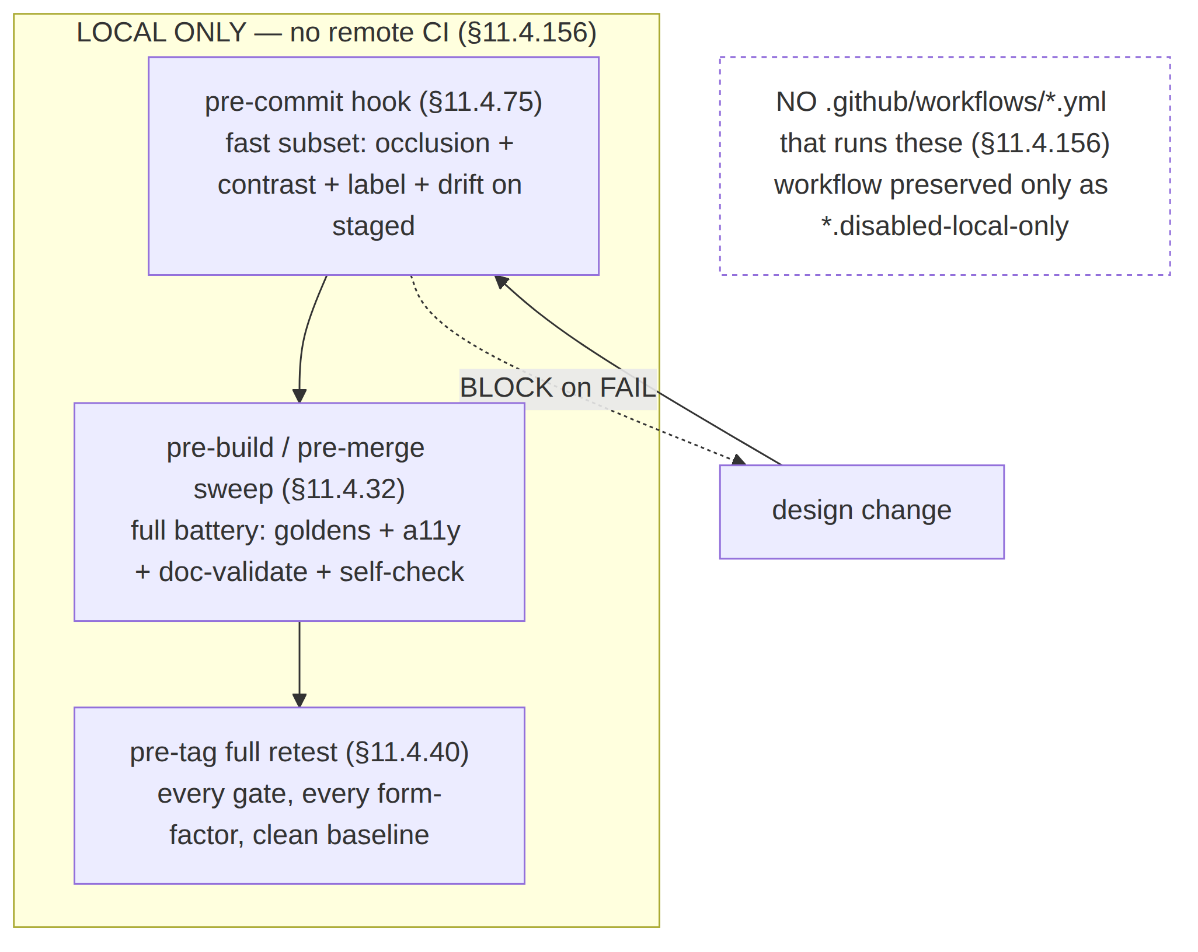
- pre-commit (§11.4.75) — the fast subset on staged files only (occlusion
  - contrast + label-present + DS-TOKEN-DRIFT for touched tokens); blocks the commit on FAIL. Full golden rendering is too slow for every commit.
- pre-build / pre-merge (§11.4.32 post-pull sweep) — the full battery: every golden re-rendered + matched, the whole a11y battery, the §6 doc validation, and DS-ANALYZER-SELF-VALIDATED first.
- pre-tag (§11.4.40 full retest) — every gate, every form-factor, on a clean baseline, before a release tag.

7.2 What the gate asserts
CM-LOCAL-GATE-WIRED asserts (a) the pre-commit + pre-build hooks invoke the QA battery, (b) no active .github/workflows/*.yml (or .gitlab-ci.yml) runs these gates — a remote CI workflow that runs the design QA is a §11.4.156 violation, the workflow may exist only as *.disabled-local-only ([§11.4.75 Layer 5]). Captured to qa/wiring/local_gate.json.
Paired §1.1 mutation. Add .github/workflows/visual-regression.yml with on: push running these gates → CM-LOCAL-GATE-WIRED FAILs (and the §11.4.156 CM-NO-ACTIVE-CI gate FAILs in parallel).

8. The coverage matrix
The §11.4.25/§11.4.52 coverage ledger for the design system: feature (component/screen) × theme × form-factor × evidence-state. Regenerated each release-gate sweep ([SCR-C §1], [CL §0] are its row sources). A cell's evidence-state is one of VERIFIED (golden + a11y green, evidence path on file), DESIGNED (golden authored, gate not yet wired), GAP (honest un-rendered state per §1.1), N/A (state does not apply on this form-factor).
Component / screen | light | dark | phone | tablet | desktop | tv | Evidence
ConnectButton (7 FFI states) | VERIFIED | VERIFIED | VERIFIED | VERIFIED | VERIFIED | VERIFIED | qa/golden/connectButton__* + qa/a11y/*
StatusChip | VERIFIED | VERIFIED | VERIFIED | VERIFIED | VERIFIED | VERIFIED | qa/golden/statusChip__*
ServerListItem / ServerList / ExitPicker | VERIFIED | VERIFIED | VERIFIED | VERIFIED | VERIFIED | DESIGNED | qa/golden/server*__*
ShieldToggle | VERIFIED | VERIFIED | VERIFIED | VERIFIED | VERIFIED | VERIFIED | qa/golden/shieldToggle__*
MultiHopChainEditor | VERIFIED | VERIFIED | VERIFIED | VERIFIED | VERIFIED | GAP (reorder on tv) | qa/golden/hopChain__*
PeerCard / PolicyEditor / TopologyGraph / AuditLogRow (Console) | VERIFIED | VERIFIED | N/A | VERIFIED | VERIFIED | N/A | qa/golden/<comp>__*
Foundational components (Button…Skeleton, [CL §11]) | VERIFIED | VERIFIED | VERIFIED | VERIFIED | VERIFIED | VERIFIED | qa/golden/<comp>__*
Client screens (Home, Exit, Multi-hop, Shields, Account, Settings, Danger) [SCR-C §1] | VERIFIED | VERIFIED | VERIFIED | VERIFIED | VERIFIED | VERIFIED | qa/golden/screen_*
Honest gaps (§11.4.6/§11.4.118). GAP cells (e.g. MultiHopChainEditor's reorder interaction on TV-leanback) are tracked, not silently implied covered — each GAP carries a migration item. N/A cells (Console components on phone) reflect that those surfaces are tablet/desktop-only ([CL §0] Used-by). The matrix is the §8 evidence-state ledger; a row claiming VERIFIED with no evidence path FAILs the §11.4.25 ledger audit.

9. How a design change flows through the gates
The end-to-end path a design edit takes — the §11.4.142 (every-change-reviewed) + §11.4.134 (iterate-to-GO) discipline applied to the design system:
- Edit — change a token ([DT]/[EXP]), a component ([CL]), a screen ([SCR-C]), or a doc. (A token edit may instead originate from the OpenDesign round-trip reconcile, [EXP §7].)
- Regenerate — pnpm export ([EXP §3]) emits the platform forms; DS-DRIFT ([EXP §5]) proves source==artifact.
- Re-render goldens — DS-TOKEN-DRIFT (§3) re-renders the affected component goldens; the author re-blesses intentionally (reviewed, §1.3).
- Run the battery — pre-build sweep (§7): DS-ANALYZER-SELF-VALIDATED first, then DS-GOLDEN-MATCH + DS-GOLDEN-COVERAGE + CM-NO-LABEL-OVERLAY + CM-hit-target-44 + the DS-A11Y-* battery + CM-EXPORTED-DOC-VISUALLY-VALIDATED.
- Independent review (§11.4.142) — a reviewer distinct from the author reads the diff + the diff heat-maps + the occlusion/contrast reports; the goldens make the visual change auditable.
- Iterate to GO (§11.4.134) — any FAIL (or warning) re-arms the loop: fix → re-render → re-validate, until zero findings.
- Merge — only with every gate GREEN + the coverage matrix (§8) updated.
- Pre-tag (§11.4.40) — the full battery re-runs on a clean baseline before a release tag ([EXP §5.4]).
A design change that reaches merge with a stale golden, an un-rendered theme, a sub-floor contrast pair, an overlapping label, or a doc PDF leaking raw Mermaid is impossible to land green — that is the §11.4.162/§11.4.168/§11.4 promise made mechanical.

10. The full QA pipeline diagram
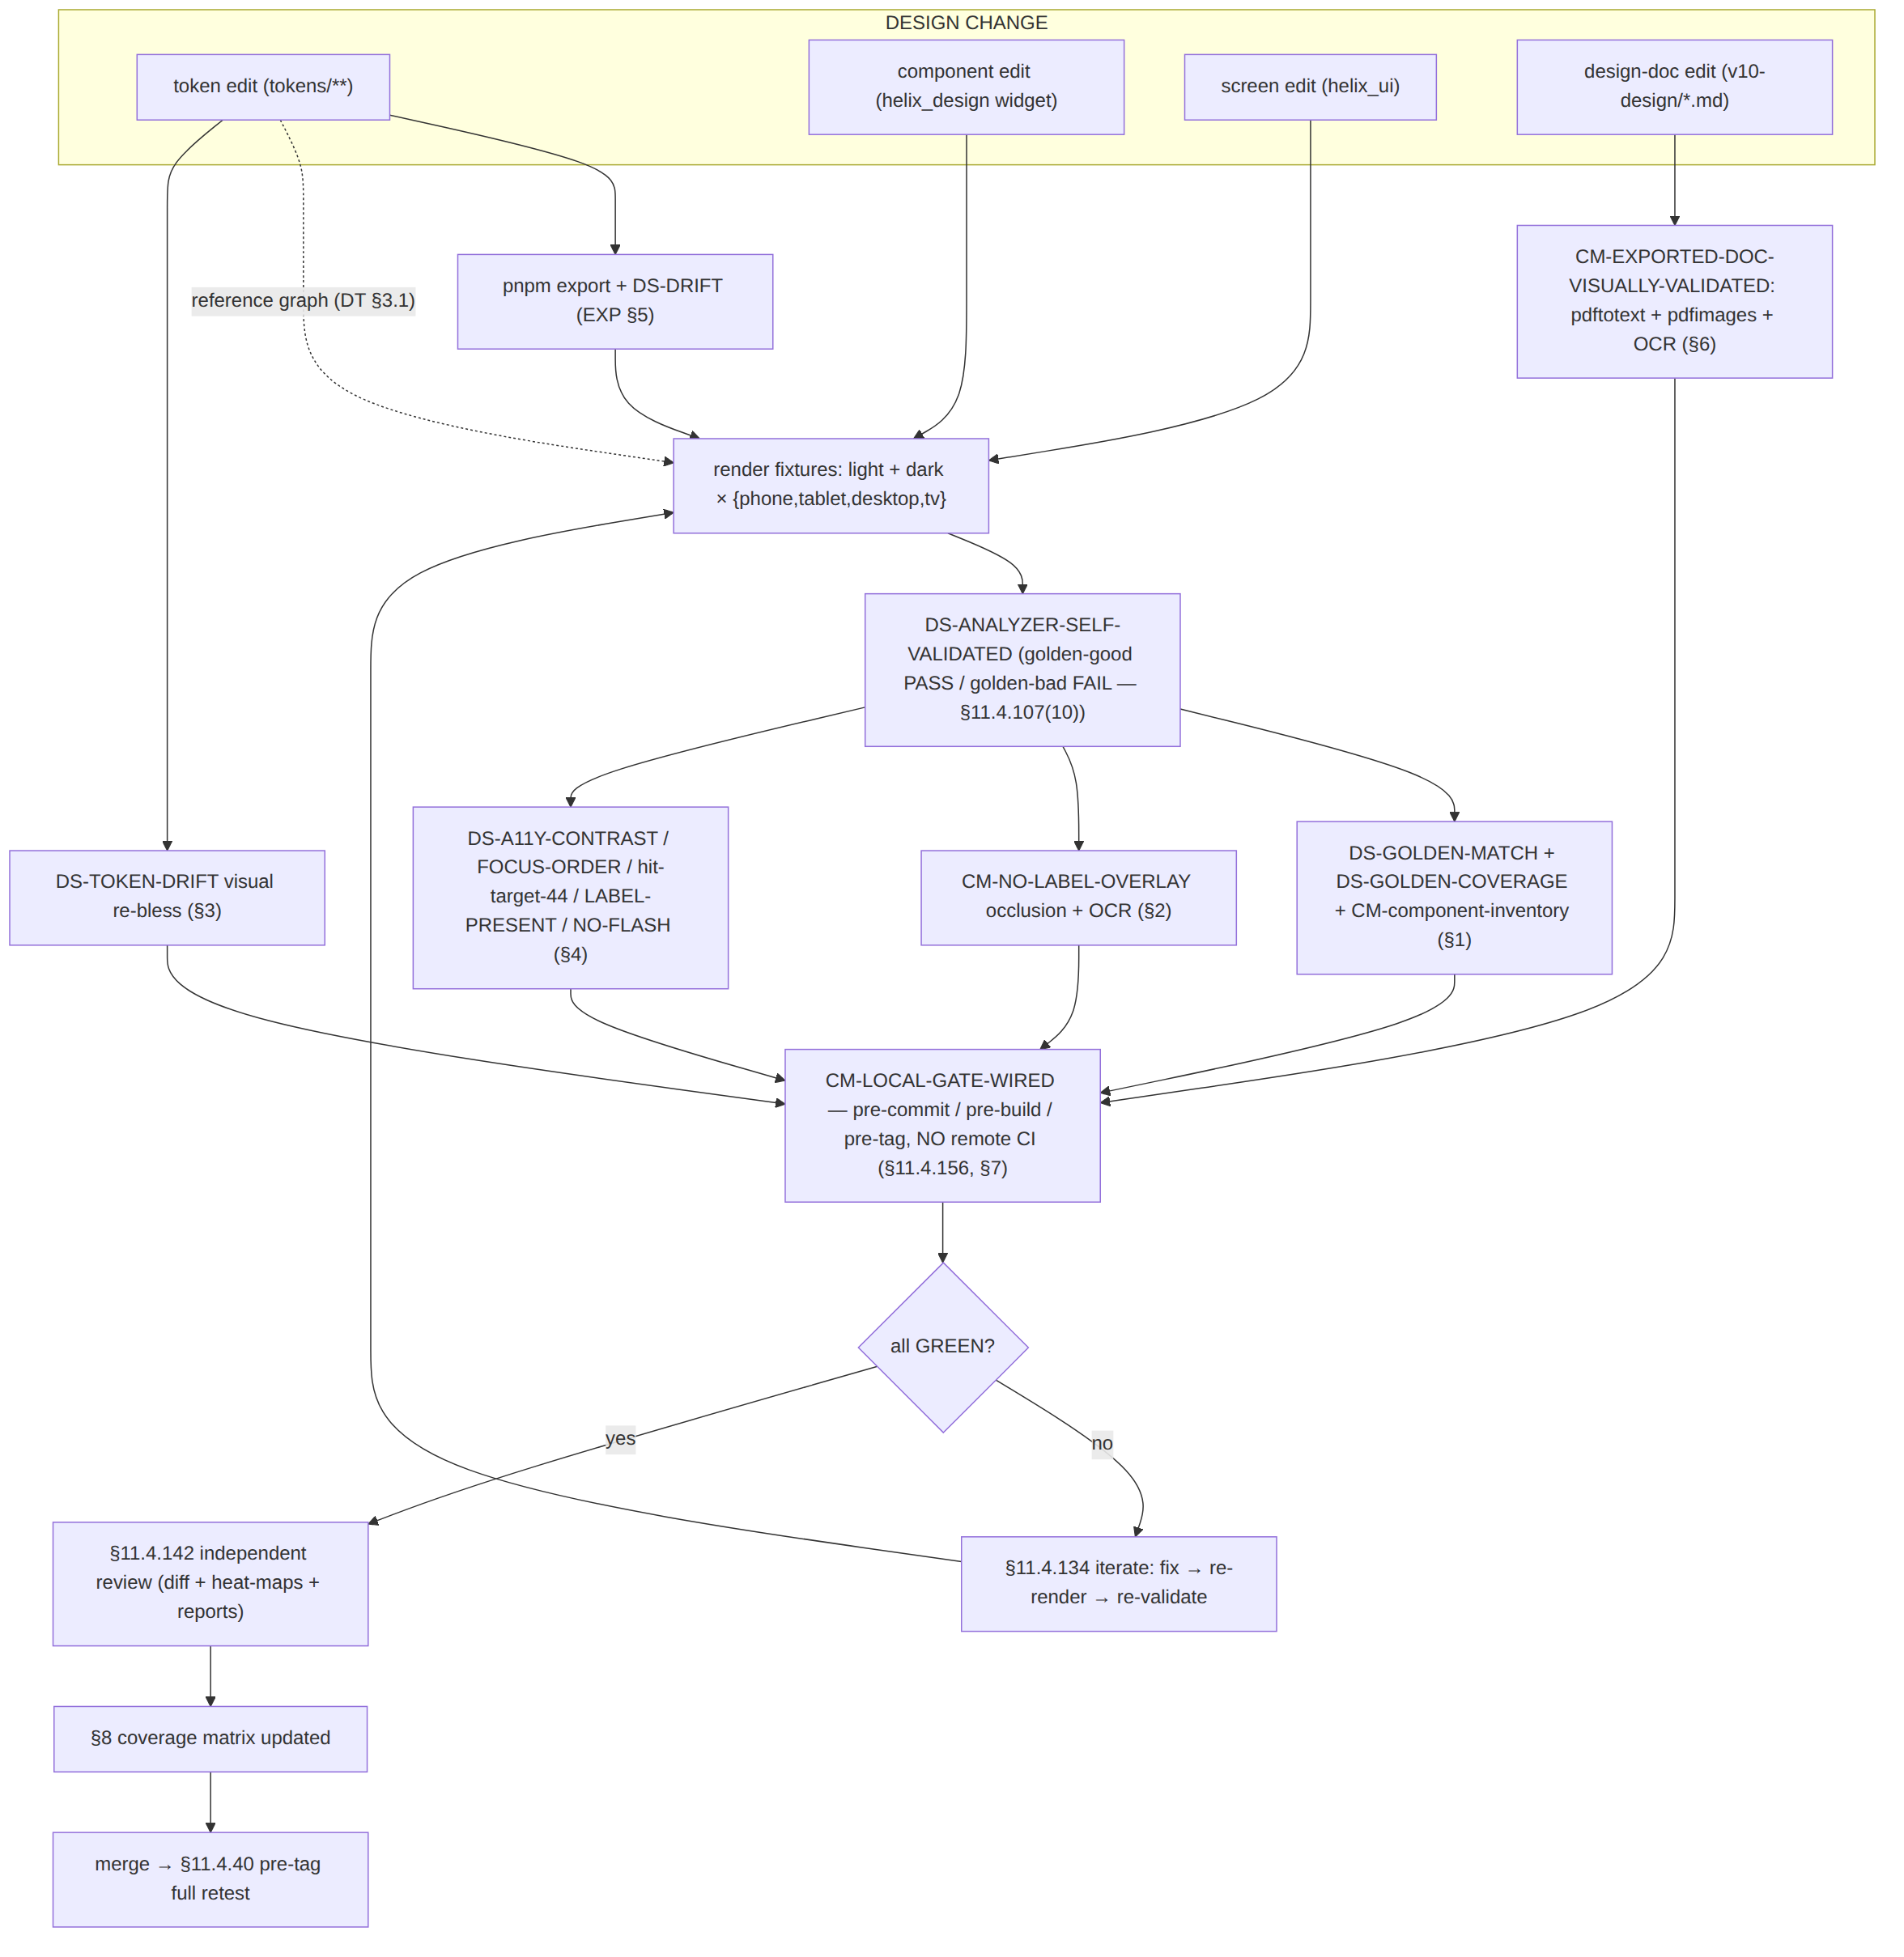

11. Surfaced decisions & cross-doc contracts
id | Decision / contract | Status
D-QA-1 UNVERIFIED | Snapshot harnesses = alchemist (Flutter) + Playwright (web); native shim snapshot pending its test target. Build-time dev dep only. Exact tools + versions ratified at Volume-10 review per §11.4.99. | open
D-QA-2 | Comparator = pixel pre-filter → perceptual diff vs a calibrated τ (per project goldens, not hardcoded, §11.4.6/§11.4.107(13)). | decided
D-QA-3 | Every component golden ships both themes × four form-factors; a missing theme/form-factor cell FAILs DS-GOLDEN-COVERAGE (mechanises [CL §1.4]). | decided
D-QA-4 | Occlusion is checked structurally (bounding-box geometry) and pixel-side (OCR legibility) — the §11.4.162 no-label-overlay made mechanical, the [CL §1.5] guarantee's proof. | decided
D-QA-5 | Every analyzer is self-validated golden-good/golden-bad (§11.4.107(10)); a broken analyzer blocks the battery via DS-ANALYZER-SELF-VALIDATED. | decided
D-QA-6 | All gates run local only (pre-commit/pre-build/pre-tag); no remote CI runs them (§11.4.156); CM-LOCAL-GATE-WIRED enforces. | decided
C-QA-A (provides) | The gate ids CM-component-inventory, CM-hit-target-44, the per-theme golden suite, and DS-I5/DS-TOKEN-DRIFT referenced by [CL §0/§1] and [EXP §5.4] are defined here — this doc is their canonical owner. | contract
C-QA-B (consumes) | The source-side byte gate DS-DRIFT [EXP §5] — DS-TOKEN-DRIFT (§3) is its rendered-pixels extension. | contract
C-QA-C (consumes) | The computed contrast ratios [COLOR §4] — DS-A11Y-CONTRAST (§4.1) recomputes them from tokens so a token edit cannot silently break a proven pair. | contract
C-QA-D (consumes) | The component catalog + state sets [CL §0–§11] + the no-overlap structural guarantee [CL §1.5] — the suite's row source and the occlusion gate's contract. | contract
U-QA-1 UNVERIFIED | Exact native-shim snapshot target (XCUITest/Espresso) + its determinism flags — pinned when the shim test target exists per §11.4.99. | open
U-QA-2 UNVERIFIED | Exact perceptual-diff library + the per-golden calibrated τ values — measured on the reference host at the suite's first run, not asserted as a settled number here (§11.4.6). | open

Sources verified
- The QA architecture (the golden-screenshot suite, the occlusion analyzer, the a11y battery, the self-validated-analyzer discipline, the token-drift visual coupling, the §11.4.168 doc validation, the local gate wiring, the coverage matrix, the change-flow) and every gate id defined here — NO external source needed — original HelixVPN design work, layered on the well-established golden-test / visual-regression pattern (Flutter golden tests; the alchemist/golden_toolkit CI-determinism approach; Playwright toHaveScreenshot; pixelmatch/SSIM perceptual diffing) and the WCAG 2.1 success criteria (1.4.3 contrast-minimum, 1.4.11 non-text-contrast, 2.5.5/2.5.8 target-size, 2.3.x no-flash). The exact harness + library + calibrated tolerance are D-QA-1/D-QA-2/U-QA-2 UNVERIFIED, pinned per §11.4.99 at the Volume-10 review — not asserted as settled facts here.
- The component catalog, the load-bearing state sets, the cross-cutting a11y baseline (role/name/focus/≥44 px/contrast/reduce-motion/colour-independence), and the structural no-overlap / no-label-overlay guarantee — final/v10-design/component-library.md §0, §1.3, §1.4, §1.5, §2, §3, §11 (sibling, this wave, read 2026-06-25). Every gate this doc references from the catalog (CM-component-inventory, CM-hit-target-44, the per-theme golden suite) is the catalog's own forward-reference, defined here.
- The computed WCAG contrast ratios (reproduced, not re-guessed) + the connection-state palette + the no-overlay colour-layer rule — final/v10-design/color-system.md §3, §4.1–§4.5, §5 (sibling, read 2026-06-25). text.tertiary #6B7385 / #FFFFFF = 4.76, border.focus ≥ 3.0, text.disabled #9AA2B2 / #FFFFFF = 2.57 (exempt) are reproduced from [COLOR §4]'s captured computation, not re-derived.
- The source-side drift gate DS-DRIFT, the dist/json/tokens.json emit, the reference-resolution graph, and the §11.4.65/§11.4.168 export hook the doc validator extends — final/v10-design/token-export-pipeline.md §3.1, §4, §5, §6 (sibling, read 2026-06-25).
- The token reference model + $type mapping + naming — final/v10-design/design-tokens.md §2, §3.1, §3.2, §6 (sibling, this wave).
- The screen inventory + the four form-factors + the AdaptiveScaffold responsive contract + the loading-≠-connected distinction — final/v10-design/screens-client.md §0, §1, §3, §5, §11 (sibling, read 2026-06-25).
- Constitution clauses §11.4.6 (no-guessing — calibrated thresholds, computed ratios, honest gaps), §11.4.25/§11.4.52 (coverage ledger / autonomous validation), §11.4.32 (post-pull validation sweep), §11.4.40 (pre-tag full retest), §11.4.69 (captured evidence per check), §11.4.75 (mechanical enforcement / local pre-commit), §11.4.107(10)/(12)/(13) (self-validated analyzer / OCR confidence-floor+ROI / calibrated-not-hardcoded thresholds), §11.4.108 (SOURCE→ARTIFACT equality — the drift gate's class, extended to rendered pixels), §11.4.118 (enumerated coverage, no implied-clean), §11.4.120 (gate-mutation discriminator), §11.4.134 (iterate-to-GO), §11.4.142 (every-change-reviewed), §11.4.156 (all remote CI disabled — local only), §11.4.162 (OpenDesign UI system / light+dark / no-overlap / visual-regression mandate), §11.4.168 (exported-doc content+textual+visual validation) — constitution submodule text embedded in this repo's constitution/CLAUDE.md, accessed 2026-06-25.
- Items explicitly marked UNVERIFIED (D-QA-1 exact harnesses, U-QA-1 native-shim target, U-QA-2 perceptual library + calibrated τ) are pending their named first-run / §11.4.99 verification per §11.4.6 — not asserted as fact.

