HelixVPN — Phase 3: Enterprise & Scale (MVP3)

HelixVPN — Phase 3: Enterprise & Scale (MVP3)
Revision: 1 Last modified: 2026-07-04T12:00:00Z Status: draft specification — describes what to build, not the shipping product.
Scope of this document. Phase 0 (spike) and Phase 1 (self-hostable control-plane MVP) — Go control plane (helixd), Postgres+RLS, Redis Streams, the Rust helix-core data plane, WireGuard/MASQUE/Shadowsocks/LWO transports, the policy compiler, helixvpnctl, Podman quadlets — are specified end-to-end under docs/research/mvp/ (spine: docs/research/mvp/final/SPECIFICATION.md; architecture: docs/research/mvp/04_VPN_CLD/HelixVPN-Architecture-Refined.md). Phase 2 — the 8-platform client-application suite (Tauri v2 desktop, Flutter mobile/HarmonyOS, Qt6/QML Aurora, browser extension/PWA, all on the shared helix-core Rust library) — is specified under docs/research/mvp2/ (entry point: docs/research/mvp2/README.md). This document defines Phase 3: the step that takes a working, single-tenant-capable MVP to an enterprise-ready, horizontally-scalable, commercially deployable platform — multi-tenant organizations, enterprise SSO/SCIM/device-trust, multi-region HA, an advanced policy engine, compliance-grade observability, marketplace/billing, and hardened advanced networking.
A pre-existing naming collision, disclosed honestly (constitution §11.4.6 no-guessing). docs/research/mvp/final/09-phase3-reach-wbs.md already exists and is already titled "Phase 3 — Extended Reach & Hardening." That document's Phase 3 covers a different scope: HarmonyOS NEXT + Aurora OS native tunnel shims (epics E21/E22), an in-browser WASM MASQUE proxy (E23), a billing-optional multi-tenant foundation (E24 — plans, subscriptions, aggregate-only usage counters, RLS), a third-party security audit (E25), and reproducible builds (E26). Those are genuinely Phase-2-adjacent platform-completion and hardening items, not organizational/enterprise-scale items. This document does not duplicate or contradict that work — it explicitly extends E24's billing schema (§8) and cross-references E25's audit epic (§7.3, §10) rather than re-specifying them. The full reconciliation of the two "Phase 3" labels, and the recommended resolution, is documented in docs/research/UNIFIED_PHASE_ROADMAP.md §4 — read it alongside this file. Until the operator makes a naming decision, this document's workable items use a distinct ID namespace (HVPN-ENT-NNN, epics E30+, gates G30+) so they never collide with the existing HVPN-P3-NNN / G20–G26 rows if both land in the same docs/workable_items.db (§11.4.93).
Entry condition. Phase 3 (this document) starts once Phase 2's 8-platform client suite has a working build on at least the Tier-1 platforms (macOS/Windows/Linux/Android per docs/research/mvp2/MVP2_OVERVIEW.md §4.2) and the Phase 0/1 control-plane Definition of Done (docs/research/mvp/final/07-phase1-mvp-wbs.md) is green on a clean baseline. Everything below is additive to that baseline — no invariant from the constitution's non-negotiable principles (04_VPN_CLD/HelixVPN-Architecture-Refined.md §2; restated in mvp/final/SPECIFICATION.md §4) is relaxed. In particular: no-logging-as-code stays absolute — every enterprise feature below that touches auditing, DLP, or QoS is designed to add metadata-level, aggregate, or control-plane observability, never a per-connection or per-content traffic log. Where a feature request would require breaking that invariant (full deep-packet-content DLP is the clearest example, §6.3), this document says so explicitly rather than hand-waving it.

Table of contents
- 1. Executive summary
- 2. Architectural principles for Phase 3
- 3. Multi-tenancy & organizations
- 4. Enterprise identity
- 5. Global scale & HA
- 6. Advanced policy engine
- 7. Observability & compliance
- 8. Marketplace/billing
- 9. Advanced networking
- 10. Phased task/subtask WBS
- 11. Decision register (operator input needed)
- Sources

1. Executive summary
Phase 3 does not add new cryptography, new transports, or new client platforms — those are Phase 0/1/2 concerns and stay untouched. Phase 3 adds the organizational, identity, scale, and commercial machinery an MSP, a mid-size company, or a regulated enterprise needs before they will run HelixVPN for hundreds or thousands of users across many sites. Concretely, that machinery is:
- An organization layer above the existing tenant (§3) so an MSP/reseller can operate several isolated tenants under one billing/reporting umbrella without weakening per-tenant RLS isolation.
- Enterprise SSO (SAML, alongside the OIDC already specified) + SCIM user-lifecycle provisioning + device-trust/posture checks + conditional access (§4).
- Multi-region HA hardening of the control plane already designed to be stateless (§5) — this section resolves the UNVERIFIED items left open in mvp/final/v06-deploy/ha-and-multiregion.md §9 (read-replica routing, NATS JetStream replication factor).
- An advanced policy engine — time/context-aware conditions, per-app split-tunnel templates, destination/category-based egress controls, and SIEM export — built as an additive extension of the existing pure/deterministic policy compiler (§6).
- Compliance-grade observability — tracing, tamper-evident audit retention, and an explicit SOC2/ISO27001/GDPR control-mapping table that is honest about what is mechanically enforced today versus what requires an external audit engagement (§7).
- A marketplace/billing layer built directly on the existing aggregate-only usage-metering schema (§8).
- Advanced networking — site-to-site mesh, dual-stack IPv6, QoS, and enterprise-grade DPI-resistance hardening of the already-specified transport ladder (§9).
None of this is aspirational marketing language: every subsection below cites the concrete Go interface, Postgres table, protobuf message, or event name it extends, and every WBS task in §10 carries a falsifiable, evidence-based acceptance criterion in the same style as mvp/final/06-phase0-spike-wbs.md / 07-phase1-mvp-wbs.md.

2. Architectural principles for Phase 3
Phase 3 inherits all 9 non-negotiable principles from 04_VPN_CLD/HelixVPN-Architecture-Refined.md §2 / mvp/final/SPECIFICATION.md §4 unchanged, and adds three enterprise-specific ones:
- Enterprise features are additive and optional. A single self-hoster running one tenant with no organization, no SSO, no billing must see zero behavioral change. Every mechanism in this document is opt-in per tenant/organization (mirrors the existing "billing OFF by default" invariant from mvp/final/09-phase3-reach-wbs.md HVPN-P3-E24).
- Organizational hierarchy never weakens tenant isolation. RLS stays keyed on tenant_id (unchanged, §3.1). An organization or a reseller admin gets rollup visibility (aggregate usage, billing, compliance posture) across the tenants it owns — never row-level access to another tenant's devices, policy, or audit log, unless a tenant's own admin explicitly grants a cross-tenant policy relationship (site-to-site mesh, §9.1).
- No-logging-as-code is a ceiling, not a starting point. Every new observability, audit-retention, DLP-style, or QoS mechanism in this document adds only control-plane metadata or aggregate counters — the S6/S7 invariants (mvp/final/v05-security/audit-and-compliance.md §0) are never relaxed to accommodate an enterprise ask. Where an ask structurally requires per-flow content data, this document states that plainly instead of quietly designing around the conflict (§6.3).

3. Multi-tenancy & organizations

3.1 Data model — organizations above tenants, teams refining groups
The Phase-1 schema already has tenant-level multi-tenancy with RLS (mvp/final/04_VPN_CLD/HelixVPN-Architecture-Refined.md §4.5; deepened in v03-control-plane/data-model-ddl.md):
tenants(id, name, created_at)
users(id, tenant_id, email, oidc_sub, role)
devices(id, tenant_id, user_id, kind, pubkey, overlay_ip, last_seen, enrolled_at, revoked_at)
groups(id, tenant_id, name) group_members(group_id, device_id)
tenant is, and remains, the RLS isolation boundary — that does not change. What Phase 3 adds is a purely organizational/billing grouping layer above it, for the MSP/reseller and multi-brand-enterprise case where one commercial entity legitimately owns several isolated tenants (e.g. one tenant per client network, or per business unit, that must never share a policy or device graph):
-- Phase-3 addition. Additive: no existing column changes type or meaning.
CREATE TABLE organizations (
id uuid PRIMARY KEY DEFAULT gen_random_uuid(),
name text NOT NULL,
parent_org_id uuid REFERENCES organizations(id), -- reseller/MSP hierarchy (§8.4)
kind text NOT NULL DEFAULT 'direct'
CHECK (kind IN ('direct','reseller','sub_org')),
created_at timestamptz NOT NULL DEFAULT now()
);
-- tenants gain an optional owning organization. NULL org_id == today's behaviour
-- (a lone self-hosted tenant with no org layer at all) -- principle 10.
ALTER TABLE tenants ADD COLUMN org_id uuid REFERENCES organizations(id);
-- teams promote `groups` to a first-class, nestable structure used by both
-- policy `src_group` resolution (unchanged, group_members still authoritative)
-- and the new permission-scoped RBAC (§3.5).
CREATE TABLE teams (
id uuid PRIMARY KEY DEFAULT gen_random_uuid(),
tenant_id uuid NOT NULL REFERENCES tenants(id),
parent_team_id uuid REFERENCES teams(id), -- nesting, e.g. "Engineering" > "SRE"
name text NOT NULL
);
CREATE TABLE team_members (
team_id uuid NOT NULL REFERENCES teams(id),
user_id uuid NOT NULL REFERENCES users(id),
PRIMARY KEY (team_id, user_id)
);
-- `groups`/`group_members` (device-reachability grouping, consumed by the policy
-- compiler's TopologySnapshot) are UNCHANGED and remain the policy-graph primitive;
-- `teams` is the human-org-chart primitive RBAC binds to. A migration MAY populate
-- one team per existing group 1:1 for tenants that want them to track, but the
-- compiler never reads `teams` directly (P6/P8 of svc-policy.md are preserved).
ALTER TABLE organizations ENABLE ROW LEVEL SECURITY;
ALTER TABLE organizations FORCE ROW LEVEL SECURITY; -- org-scoped visibility, not tenant RLS
ALTER TABLE teams ENABLE ROW LEVEL SECURITY;
ALTER TABLE teams FORCE ROW LEVEL SECURITY; -- tenant_id-keyed, same policy as `groups`
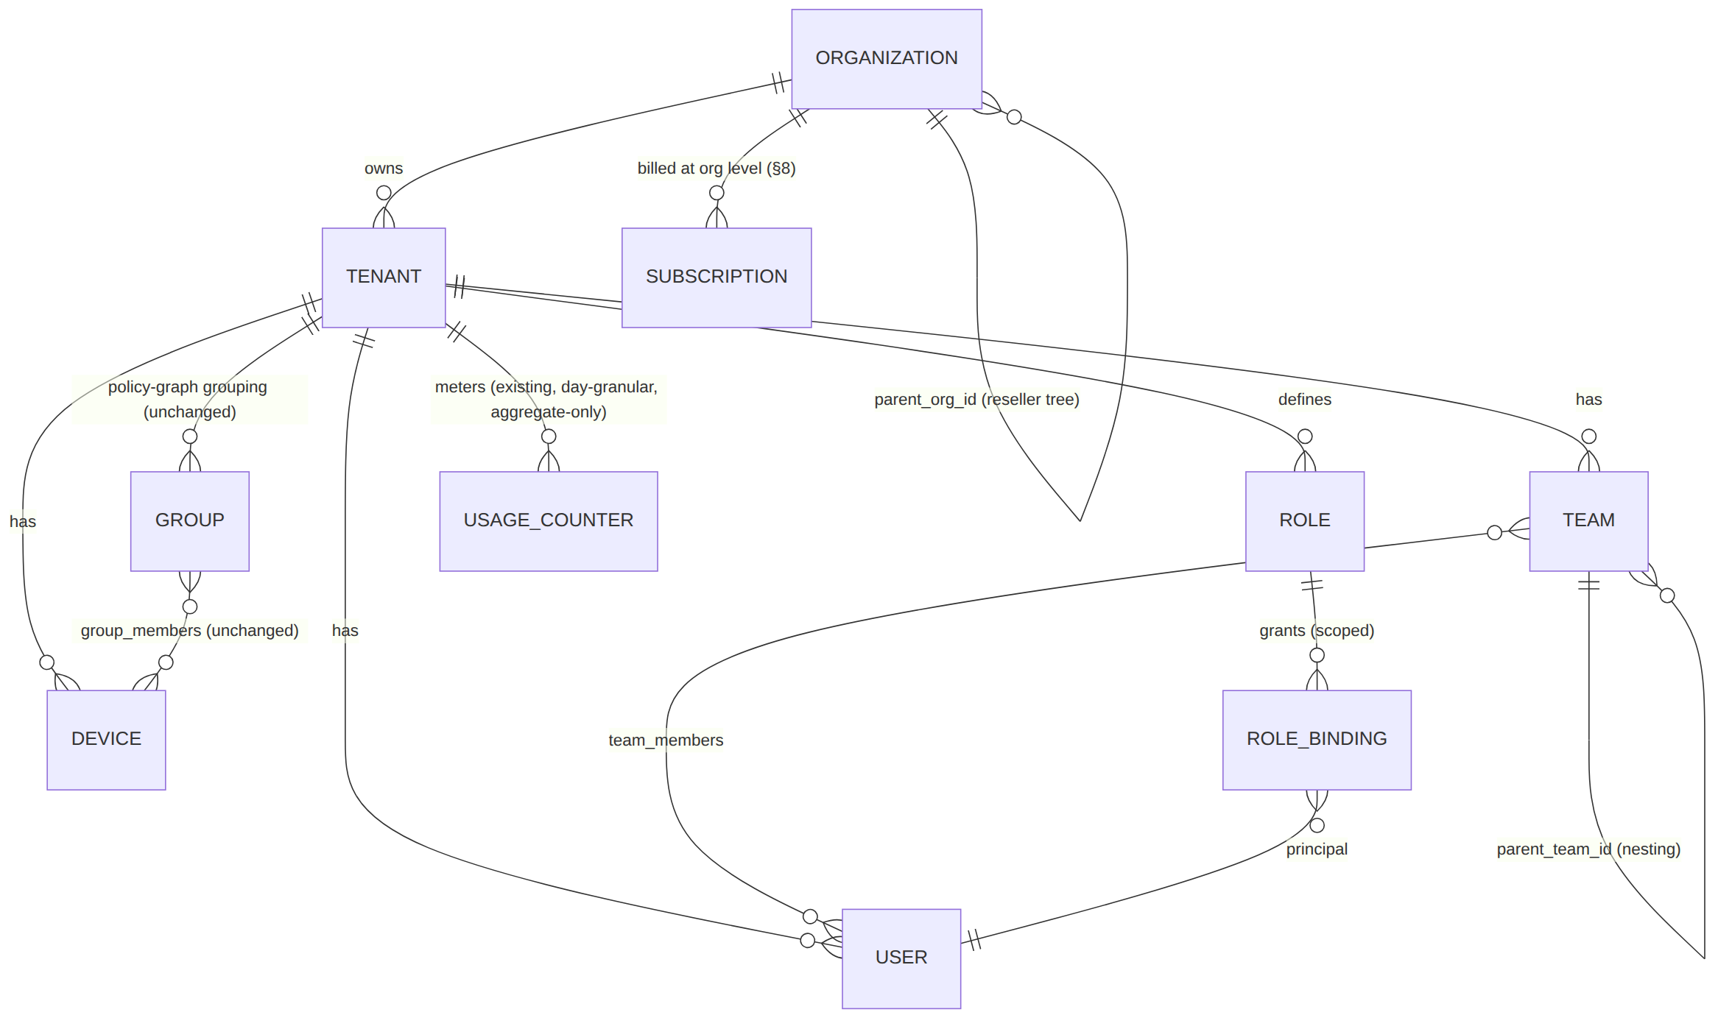

3.2 Per-org policy isolation
The policy compiler's governing invariant P6 (v03-control-plane/svc-policy.md §0.1 — "every DB touch runs through store.WithTenant under FORCE ROW LEVEL SECURITY") is unchanged and is the mechanism that makes cross-tenant policy leakage structurally impossible even for an organization-level admin. An org-admin's Console session carries an org_id claim used only to compute rollup views (§3.4, §8); every policy read/write still runs through the existing Principal{TenantID, Role} path (v03-control-plane/svc-identity.md §1.2) unmodified. Explicit cross-tenant reachability (two tenants under one org wanting to talk to each other) is not an organization feature — it is the site-to-site mesh in §9.1, which is an explicit, auditable, per-policy grant between two named tenants, never an implicit consequence of shared org_id.

3.3 Delegated admin roles (RBAC)
The Phase-1 Role enum (member | operator | admin, v03-control-plane/svc-identity.md §1.2) is too coarse for enterprise delegation (a billing contact should not be able to revoke devices; a security auditor should read audit logs but change nothing). Phase 3 replaces the fixed enum with a permission-based RBAC that keeps the old 3 roles as seeded defaults so nothing already built breaks:
CREATE TABLE roles (
id uuid PRIMARY KEY DEFAULT gen_random_uuid(),
tenant_id uuid REFERENCES tenants(id), -- NULL == system-defined built-in role
name text NOT NULL, -- 'owner','admin','operator','member','auditor','billing_admin', or custom
permissions jsonb NOT NULL DEFAULT '[]', -- e.g. ["device.revoke","policy.write","audit.read","billing.read"]
is_builtin boolean NOT NULL DEFAULT false
);
CREATE TABLE role_bindings (
id uuid PRIMARY KEY DEFAULT gen_random_uuid(),
tenant_id uuid NOT NULL REFERENCES tenants(id),
principal_id uuid NOT NULL, -- users.id (device principals keep using policy, not RBAC)
role_id uuid NOT NULL REFERENCES roles(id),
scope_type text NOT NULL CHECK (scope_type IN ('tenant','team','network')),
scope_id uuid, -- team_id or a network/connector-group id; NULL for scope_type='tenant'
granted_by uuid NOT NULL,
granted_at timestamptz NOT NULL DEFAULT now()
);
ALTER TABLE roles ENABLE ROW LEVEL SECURITY; ALTER TABLE roles FORCE ROW LEVEL SECURITY;
ALTER TABLE role_bindings ENABLE ROW LEVEL SECURITY; ALTER TABLE role_bindings FORCE ROW LEVEL SECURITY;
// internal/identity/rbac.go — extends identity.Authorize (svc-identity.md §1.1), pure, no I/O
// beyond the pre-loaded binding set already fetched at Authenticate() time.
type Permission string // "device.revoke", "policy.write", "audit.read", "billing.read", ...
func (p Principal) HasPermission(perm Permission, scope Scope) bool {
// Union of every role_binding whose scope covers `scope` (tenant-wide binding
// covers every team/network scope beneath it). Built-in roles pre-seed the
// OLD 3-value enum's exact permission sets so a Phase-1 tenant with no RBAC
// rows configured behaves byte-identically to before (principle 10).
}
Seeded built-in roles preserve backward compatibility exactly: admin = every permission, operator = every permission except user.role.change and org.*, member = read-only on own devices. New enterprise-only built-ins: auditor (audit.read + billing.read only, no write permission of any kind — the compliance-review persona) and billing_admin (billing.read + billing.write, no device/policy permission).

3.4 Per-org billing/usage metering
Builds directly on the existing aggregate-only usage_counter table (mvp/final/09-phase3-reach-wbs.md HVPN-P3-240 — day-granular, (tenant_id, device_id, day), rx_bytes/tx_bytes only, no src/dst/port/flow columns, the no-log CI lint already rejects any table shaped like a traffic log). Phase 3 adds a pure rollup view, no new traffic-adjacent column:
-- Read-only aggregation across every tenant an org owns. Never joins to anything
-- finer-grained than the existing day-bucket; still no per-connection data exists
-- anywhere in the chain (S6 preserved).
CREATE VIEW org_usage_rollup AS
SELECT t.org_id, uc.day, SUM(uc.rx_bytes) AS rx_bytes, SUM(uc.tx_bytes) AS tx_bytes,
COUNT(DISTINCT uc.device_id) AS active_devices
FROM usage_counter uc JOIN tenants t ON t.id = uc.tenant_id
WHERE t.org_id IS NOT NULL
GROUP BY t.org_id, uc.day;

3.5 SCIM provisioning
A SCIM 2.0 server (/scim/v2/Users, /scim/v2/Groups) is a thin adapter in front of the existing identity.Identity interface — it introduces no new identity model, only a standards-compliant lifecycle wire format:
// internal/identity/scim/handler.go — SCIM 2.0 (RFC 7643/7644) adapter.
// Every SCIM operation maps 1:1 onto an EXISTING identity.Identity method; SCIM never
// bypasses Authorize() or the audit path.
// POST /scim/v2/Users -> identity.CompleteOIDC-equivalent JIT-provision path,
// but IdP-push rather than user-initiated login
// PATCH /scim/v2/Users/{id} -> identity.SuspendUser (active:false) / role change
// DELETE /scim/v2/Users/{id} -> identity.SuspendUser (SCIM "deprovision" = suspend,
// never a hard delete -- preserves audit trail, S7)
// POST /scim/v2/Groups -> teams.Create + team_members sync from SCIM group members
Every SCIM-driven mutation emits the same user.created/user.suspended/user.role.changed events already in the taxonomy (04_VPN_CLD/HelixVPN-Architecture-Refined.md §4.3), so the coordinator's revoke-cascade (Phase-1 MVP DoD criterion 6: revoke enforced < 1 s) applies to a SCIM-deactivated user identically to a Console-driven suspend — enterprise IdP-triggered offboarding gets the same sub-second edge enforcement as a manual admin action, for free.

4. Enterprise identity

4.1 SAML 2.0 SSO alongside existing OIDC
identity already speaks OIDC to any IdP (Keycloak, Authentik, or a generic OIDC provider) via BeginOIDC/CompleteOIDC with JIT (just-in-time) user provisioning (v03-control-plane/svc-identity.md §1.1). Many enterprise IdPs (Okta, Azure AD/Entra ID, Ping, ADFS) are SAML-first for VPN/SSO integrations. Phase 3 adds a second provider type using the identical JIT-provisioning shape:
// internal/identity/iface.go — additive methods, same package, same Principal/User types.
BeginSAML(ctx context.Context, tenantID uuid.UUID, providerID uuid.UUID) (SAMLAuthnRequest, error)
CompleteSAML(ctx context.Context, in SAMLResponse) (Session, User, error) // validates signed
// assertion, maps NameID + attribute statements -> User (JIT, same as CompleteOIDC),
// reuses the SAME `providers` table with `protocol='saml'|'oidc'` discriminator.
ALTER TABLE identity_providers ADD COLUMN protocol text NOT NULL DEFAULT 'oidc'
CHECK (protocol IN ('oidc','saml'));
ALTER TABLE identity_providers ADD COLUMN saml_metadata_xml text; -- IdP metadata (cert, ACS binding)

4.2 Device-trust / posture checks before connect
Extends the existing Enroll RPC (svc-identity.md §1.1) and the periodic status the client core already reports. A device posture attestation is collected at enroll time and refreshed on every WatchNetworkMap reconnect:
// helix.coordinator.v1 — additive field on the existing WatchRequest (02-control-plane.md §4, "Agent contract — protobuf" — corrected 2026-07-04, was mis-cited as §7.2 which is the policy-compiler section)
message DevicePosture {
bool disk_encrypted = 1;
bool screen_lock_enabled = 2;
string os_patch_level = 3; // free-form per-OS version string, compared to a tenant policy
bool edac_agent_present = 4; // EDR/MDM agent heartbeat present (platform-specific check)
bool jailbroken_or_rooted = 5; // best-effort per-platform detection
}
message WatchRequest {
string device_id = 1;
uint64 known_version = 2;
DevicePosture posture = 3; // Phase-3 addition; absent (zero-value) on Phase-1/2 agents
}
A tenant-configured posture policy (a new, small, tenant-scoped table, evaluated by the coordinator before it grants a network map) classifies posture into compliant / remediation_only / denied. A remediation_only device receives a network map restricted to a single remediation host (e.g. an internal patch-management portal) rather than the full authorized set — the compiler's existing need-to-know graph (svc-policy.md P1) already supports "this device may reach exactly one host," so posture gating is a policy input, not a new enforcement mechanism.

4.3 Conditional access policies
Conditional access combines identity context (IdP group membership, which SSO session, geo-IP of the enrollment/connect attempt) with device posture (§4.2) as additional inputs to the policy compiler's Spec (extended in §6.1). This section supplies the identity-side inputs; §6.1 is the compiler mechanism that evaluates them.
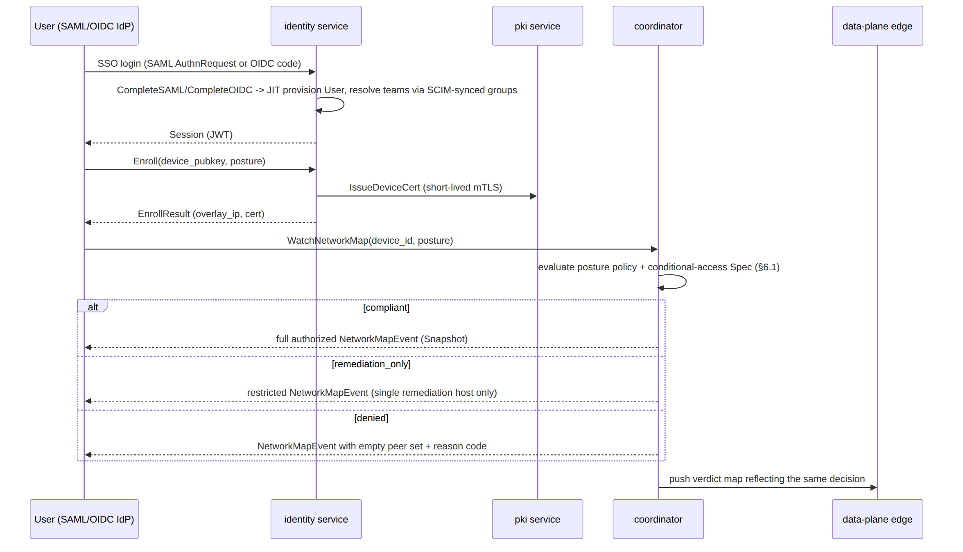

5. Global scale & HA
Phase 2 already establishes the HA thesis that makes this section cheap: coordinators are stateless on disk (v06-deploy/ha-and-multiregion.md §0 — "coordinators are cattle"), Postgres is the one store whose HA is a correctness requirement, and the event bus is ephemeral by design. Phase 3 resolves the UNVERIFIED items that document left open (its §9) and formalizes "region" and "organization-aware routing" as first-class control-plane concepts.

5.1 Multi-region Gateway/Connector mesh as a first-class concept
-- Phase-3 addition: regions become addressable rows, not just deployment topology.
CREATE TABLE regions (
id text PRIMARY KEY, -- 'us-east', 'eu-west', 'ap-south', ...
display_name text NOT NULL,
edge_endpoint text NOT NULL -- the region's public gateway endpoint (host:443/udp)
);
ALTER TABLE devices ADD COLUMN home_region text REFERENCES regions(id); -- connectors: where they're deployed
The coordinator's existing GatewayInfo field (svc-coordinator.md §1.2 "Graph data structures" — corrected 2026-07-04, was mis-cited as §2.1 which is the buildMap snapshot section — already used for per-node gateway selection, D-GW-SELECT) now resolves against this table instead of static config, so adding a region is a data change (INSERT INTO regions ... + deploy an edge DaemonSet there), not a code change.

5.2 Geo-routing / latency-based server selection
Resolves mvp/final/v06-deploy/ha-and-multiregion.md decision D-GW-SELECT for the enterprise tier: Phase 3 ships (a) geoDNS as the default (as recommended there) plus (c) client-side override from the network map — the coordinator now actively measures inter-region RTT from each connector's advertised prefixes (a lightweight periodic probe, metadata only) and biases GatewayInfo.endpoint toward the lowest-latency region for that device's typical peers, not just the device's own geo-IP. Anycast (option b) remains available for fleets with BGP capability but is not required for GA.

5.3 Horizontal autoscaling of the control plane
helixd replicas are already HPA-ready (stateless, v06-deploy/kubernetes.md §5). Phase 3 pins the concrete scaling signal: HPA on (a) open WatchNetworkMap stream count per replica and (b) event-consumer lag (svc-events.md §7), not raw CPU — CPU is a poor proxy for a mostly-I/O-bound streaming server. Target: scale out when a replica holds > N streams (N tenant-tunable, default 5,000) or consumer lag exceeds the convergence SLO budget.

5.4 Postgres HA — resolving the read-replica question
ha-and-multiregion.md §9 flags U2 ("hydration reads routed to regional read-replicas") as UNVERIFIED/Phase-2-optimization. Phase 3 resolves it: coordinator boot hydration and all reporting/billing rollup queries (§3.4, §8) read from a regional async standby; every write and every policy-compile snapshot read (TopologySnapshot, svc-policy.md §1.1 — must be read-consistent within one transaction) still goes to the single primary (C2 invariant unchanged). This split is safe specifically because hydration and billing reads are tolerant of a few seconds of replication lag; policy compilation is not, and never reads from a replica.

5.5 Redis Streams clustering → NATS JetStream at defined replication factor
Resolves U3 (ha-and-multiregion.md §9 — "NATS JetStream replication factor / multi-region placement... a Phase-2 capacity decision, not resolved"). Phase 3's concrete answer: R3 JetStream clustering per region, with cross-region stream mirroring (not a single cross-region cluster — WAN RAFT consensus latency would blow the < 1 s convergence budget). Each region's helixd replicas publish/consume against their local R3 cluster; a lightweight mirror relay forwards policy.*/device.* events cross-region for global consistency of the Postgres-backed truth, while presence.* (ephemeral, region-local by nature — a device is connected to one region's edge) never crosses regions at all.

5.6 Disaster recovery — concrete RPO/RTO targets
Building on v06-deploy/disaster-recovery.md's existing runbook (RPO≈0 via sync-committed Postgres + Git-tracked policy-as-code, RTO 15–30 min for a single-node self-host):
Scenario | RPO target | RTO target | Mechanism
Single helixd replica loss | 0 (stateless) | seconds | agent reconnect + known_version resume (§6, ha-and-multiregion.md)
Postgres primary loss (single region) | 0 for sync-committed txns | < 60 s | Patroni/CNPG promotion (already spec'd)
Whole-region loss (Phase 3 new) | 0 for the surviving region's data; up to the async-replication lag (target < 30 s) for the lost region's very-latest writes | < 15 min automated (geoDNS health-check removes the region; surviving regions' coordinators already serve from the cross-region-replicated primary/promoted-standby) | automated region-failover runbook (§10 HVPN-ENT-5xx), replacing the Phase-2 manual DR drill for the enterprise tier

5.7 Zero-downtime rolling upgrades
Because coordinators are stateless and the WatchNetworkMap protocol already carries a monotonic version field (02-control-plane.md §4, "Agent contract — protobuf" — corrected 2026-07-04, was mis-cited as §7.2), a rolling upgrade adds one field to negotiate protocol compatibility during the rollout window:
message WatchRequest {
string device_id = 1;
uint64 known_version = 2;
DevicePosture posture = 3;
uint32 client_protocol_version = 4; // Phase-3: coordinator refuses only on a KNOWN-breaking bump
}
A standard Kubernetes rolling Deployment update mixes old/new helixd pods during rollout; because both understand the currently-shipping wire contract (protocol version bumps are additive-only within a phase per the existing schema-first/zero-drift principle, §4 clause 8 of SPECIFICATION.md), an agent reconnecting mid-rollout to either an old or a new pod gets a correct network map — no maintenance window, no forced client disconnect.
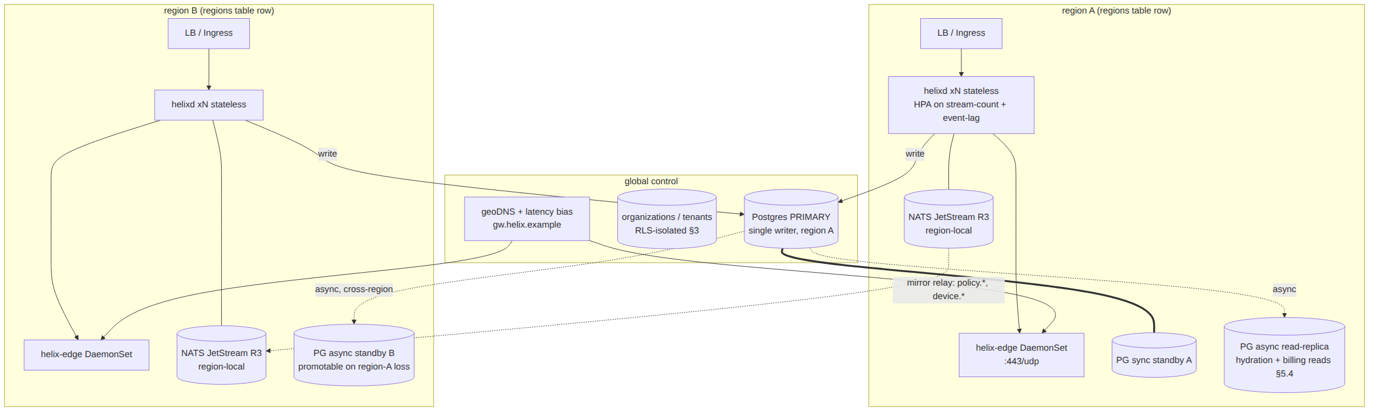

6. Advanced policy engine
The Phase-1 compiler (v03-control-plane/svc-policy.md) is a pure, deterministic, versioned function Compile(tenant, spec, graph) → (AllowedIPs, VerdictMap, Advisories) (invariant P2). Every extension below adds an explicit input parameter to that function rather than a hidden side effect, which is the only way to add context-awareness without breaking purity/determinism/testability.

6.1 Time-based / context-aware access policies
// internal/policy/spec.go — additive Spec fields. The compiler signature becomes
// Compile(ctx, tenant, spec, graph, evalTime) — evalTime is an EXPLICIT parameter,
// never time.Now() read inside Compile, preserving P2 (pure + deterministic: identical
// (tenant, spec, graph, evalTime) still yields a byte-identical CompiledPolicy).
type Condition struct {
TimeWindow *TimeWindow // e.g. Mon-Fri 08:00-18:00 in a named tz
GeoCountries []string // ISO-3166 allow-list, sourced from enrollment/connect geo-IP
PostureTier *string // "compliant" | "remediation_only" (§4.2)
IdPGroup *string // SAML/OIDC group claim, synced via SCIM (§3.5)
}
type Rule struct {
SrcGroup string
DstSelector string
Ports []PortRange
Action string // "accept" (P1: absence is denial, unchanged)
Conditions []Condition // Phase-3 addition; empty == unconditional (Phase-1/2 behaviour, unchanged)
}
A background scheduler emits a policy.recompile event at every condition boundary a tenant's active policy has (e.g. at 08:00 and 18:00 local time for a time-window rule) so the existing policy.compiled → coordinator-recompute → push-delta pipeline (04_ARCH §8, the "policy change propagation" sequence) handles the transition with zero new mechanism — a time-boundary firing looks, to the coordinator, exactly like an admin editing the policy at that moment. This is the concrete reason evalTime is passed explicitly: Compile at 07:59 and Compile at 08:00 with the identical stored spec legitimately produce different CompiledPolicy artifacts, and that difference is driven by one auditable scheduler tick, never by an ambient clock read buried in the compiler.

6.2 Per-app split-tunneling policy templates
Rule gains an optional AppSelector (bundle ID / package name / process name, platform capability already noted for Android/desktop in mvp2/MVP2_SECURITY_PERFORMANCE.md's per-app kill-switch scoping). A template is a named, reusable []Rule an org can apply across many tenants/teams (e.g. "Finance app must always route through the tunnel; general browsing may split-tunnel") — templates are stored once at the org level and referenced by tenant policy Specs, so updating a template and re-activating cascades through the existing monotonic-version
- instant-rollback machinery (P5) unchanged.

6.3 DLP-style egress controls — and the honest boundary
An enterprise buyer's first ask here is usually "block egress to categories of destinations" or "stop sensitive data leaving via the tunnel." HelixVPN can honestly deliver the first without touching the no-logging invariant; it explicitly cannot deliver the second at the platform level without contradicting the entire product's privacy architecture, and this document says so rather than hand-waving a feature that would not survive the S6 CI schema-lint:
- In scope (metadata/destination-level, S6-compatible): destination category and reputation allow/deny lists (malware, known-C2, adult-content categories, etc., sourced from a pluggable feed), evaluated at the same compile step as any other DstSelector match — this is structurally identical to an existing policy rule, just with a category-to-CIDR/FQDN-set resolver feeding Resolve() (svc-policy.md §1). SNI/FQDN-based matching for MASQUE/TLS traffic uses the unencrypted ClientHello SNI only (metadata, never decrypted payload) — enforced at the edge verdict-map layer, counted (aggregate only, §7.4), never logged per-connection.
- Explicitly out of scope, with reason (§11.4.112-class structural boundary): payload-level content inspection (scanning file contents, matching regex against decrypted traffic, keyword/PII detection inside the tunnel) is structurally incompatible with invariant S6 (audit-and-compliance.md §0 — "no durable connection/traffic log... by construction") and with the WireGuard-encrypted, zero-trust data-plane architecture (04_ARCH §2 principle 7 — "no-logging by construction... a build property, not a config toggle"). Implementing it would require either terminating and inspecting decrypted traffic at the gateway (a MITM the architecture explicitly does not do — the gateway relays encrypted WireGuard datagrams, it does not decrypt user payloads) or an on-device content scanner outside helix-core's scope entirely (a separate, customer-deployed DLP/CASB product, not a HelixVPN feature). This boundary is a decision register item (§11) for the operator to confirm as final product positioning, not an engineering gap to be silently closed later.

6.4 SIEM / audit export hooks
Extends the existing export path already scoped in v05-security/audit-and-compliance.md §9: policy.compiled, policy.activated, and the new Advisory stream (route conflicts, unreachable/shadowed rules) are shipped to an external SIEM in CEF (Common Event Format) or as a Syslog stream, in addition to the existing webhook export. No new data is invented for export — it is the same audit/advisory events the Console already renders, reformatted for ingestion by Splunk/Elastic/QRadar-class tooling.
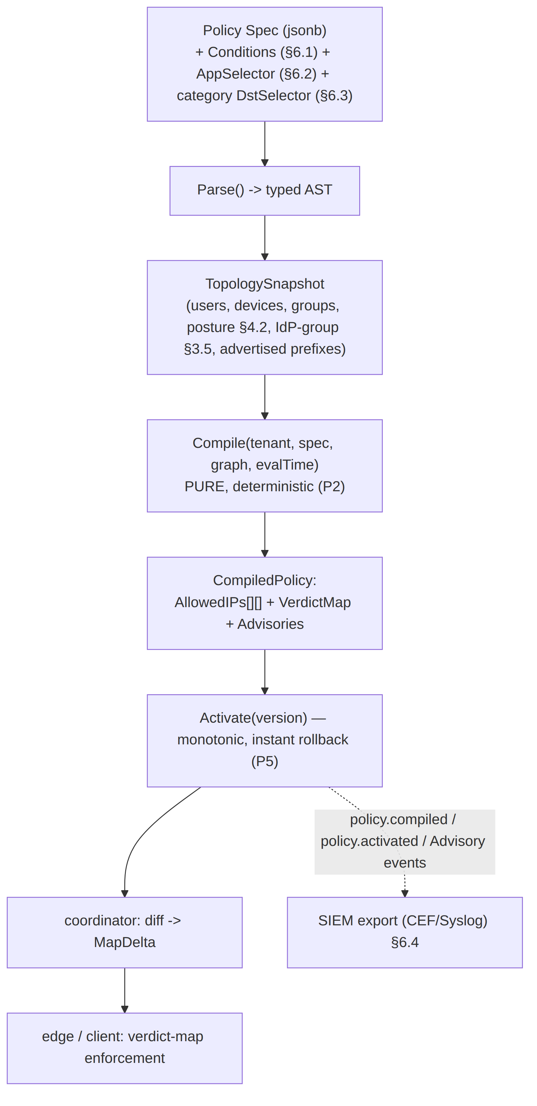

7. Observability & compliance

7.1 Centralized structured logging / metrics / tracing
Extends the existing Prometheus exposition (svc-telemetry.md, 04_ARCH §9) with OpenTelemetry distributed tracing across control-plane operations only: WatchNetworkMap open→snapshot→ delta round-trips, policy compile latency, enroll-flow spans, SSO login spans. Trace spans carry tenant_id/org_id/device_id as attributes for filtering — never a destination, byte count, or any data shaped like a flow record (the same shape-based CI schema-lint from audit-and-compliance.md §1.2 applies to trace-attribute schemas too, extended in this phase).

7.2 Audit-log retention & tamper-evidence
audit_events (v05-security/audit-and-compliance.md §3) is already append-only and RLS-scoped. Phase 3 adds:
- Per-org configurable retention (default 400 days, enterprise tiers may configure longer) enforced by a scheduled partition-drop, never a row-level DELETE (preserves append-only semantics up to the retention boundary).
- Hash-chain tamper evidence: each audit_events row stores prev_hash = SHA-256 of the previous row's canonical serialization for that tenant; a verification job periodically re-walks the chain and raises an alert (itself an audited, SIEM-exported event) on any mismatch. This is a genuinely new mechanism (not present in Phase 1/2) and is the concrete answer to "how do we prove the audit log wasn't edited after the fact."
ALTER TABLE audit_events ADD COLUMN prev_hash bytea; -- sha256(canonical(previous row)), per tenant chain
ALTER TABLE audit_events ADD COLUMN row_hash bytea; -- sha256(canonical(this row) || prev_hash)

7.3 SOC2 / ISO27001 / GDPR control mapping
An honest mapping table — column 4 states plainly which controls are mechanically enforced today by the architecture versus which require an external audit/certification engagement (cross-referenced to the GA-readiness security-audit item, docs/research/mvp_final/MVP_FINAL_GA_READINESS.md §2, so this document does not duplicate that gate):
Control family | Example control | HelixVPN mechanism | Status
SOC2 CC6 (logical access) | least-privilege access to production data | RBAC (§3.3), RLS-forced tenant isolation | Mechanically enforced
SOC2 CC7 (monitoring) | detect and respond to anomalies | audit_events + tamper-evidence (§7.2) + SIEM export (§6.4) | Mechanically enforced
ISO 27001 A.8 (asset mgmt) | device inventory + lifecycle | registry service device table + revoke-cascade | Mechanically enforced
ISO 27001 A.9 (access control) | joiner/mover/leaver process | SCIM lifecycle (§3.5) | Mechanically enforced
GDPR Art. 5(1)(c) data minimisation | collect no more than necessary | no-logging-as-code (S6) — architecturally the strongest claim in this table | Mechanically enforced by construction
GDPR Art. 17 (erasure) | user can request data deletion | anonymous-account model (no PII by default); OIDC/SAML-linked accounts require an erasure runbook (Console "purge user" removes users/audit_events PII fields, retains anonymized audit skeleton) | Partially mechanized — erasure runbook is a GA-readiness deliverable, not yet built
SOC2 / ISO27001 (certification itself) | an accredited third party attests to the above | — | Not mechanically achievable by code. Requires an actual auditor engagement — tracked as a decision item (§11) and as a GA-readiness gate, never claimed here as "done."

7.4 Usage/billing analytics
Reporting views over usage_counter (§3.4) and subscription/plan (§8.1), exposed in Console for org-admins and billing-admins (§3.3): daily/monthly bandwidth per tenant/device, active-device counts vs. plan entitlement, near-limit alerts. All derived from data that already exists; no new metering mechanism.

7.5 SLA definitions & status-page tooling
Concrete, measurable SLA targets (final numbers are a business decision, §11):
Tier | Control-plane API availability | Data-plane (gateway) availability | Measured via
Self-host (no SLA) | best-effort | best-effort | operator's own monitoring
Managed — Team | 99.5% monthly | 99.5% per-region | /readyz//healthz uptime (svc-telemetry.md §8.2)
Managed — Enterprise | 99.9% monthly | 99.9% per-region, multi-region failover counted | same, + region-failover chaos-test evidence (§5.6, §10)
A public status page (self-hosted Upptime/Cachet-class static page, or a hosted status-page provider) surfaces the same /healthz signal already emitted by every helixd replica — no new health-check mechanism, just a public-facing aggregation of an existing one.

8. Marketplace/billing

8.1 Subscription tiers on the existing plan schema
Directly extends HVPN-P3-240's plan/subscription tables (mvp/final/09-phase3-reach-wbs.md §9) — this document does not re-define billing schema, it adds organization-level rollup and tier examples:
Tier | max_devices | max_networks | max_bytes_mo | Positioning
Self-Host (Free) | unlimited (operator's own hardware) | unlimited | NULL (unlimited) | homelab / single self-hoster, billing OFF
Team | 25 | 5 | 500 GB | small company, self-serve
Business | 250 | 25 | 5 TB | mid-size, self-serve or sales-assisted
Enterprise | negotiated | negotiated | negotiated | sales-assisted, multi-region, SLA-backed
Exact price points are explicitly not specified here — that is a go-to-market decision, not an engineering one (§11, and cross-referenced in MVP_FINAL_GA_READINESS.md §3.1).

8.2 Usage-based billing hooks
// internal/billing/report.go — a daily rollup job over the EXISTING usage_counter table
// (no new per-flow data). Emits one event per tenant per day; the payment-processor
// adapter is pluggable and OFF by default (preserves E24's "billing OFF by default").
type UsageReporter interface {
// ReportDaily reads yesterday's usage_counter rows, aggregates per subscription,
// and emits billing.usage.reported{tenant_id, day, rx_bytes, tx_bytes, device_count}.
ReportDaily(ctx context.Context, day time.Time) error
}
type PaymentAdapter interface { // Stripe-class adapter; swappable, never mandatory
ReportUsage(ctx context.Context, subscriptionID string, ev UsageEvent) error
}

8.3 Self-serve vs. enterprise-sales-assisted signup
- Self-serve: Console signup flow, SAML/OIDC or anonymous-account creation, payment adapter charges a card on file for Team/Business tiers — same enrollment path already specified (CreateAccount/LoginAccount, svc-identity.md §1.1), with a plan_id selected at signup.
- Enterprise-sales-assisted: helixvpnctl org create --plan enterprise --contract-ref <id> provisions the organizations row + tenant(s) + a negotiated subscription row with no self-serve payment step; identical schema underneath, different provisioning entry point.

8.4 Partner/reseller model
organizations.parent_org_id (§3.1) lets a reseller org own several sub_org-kind organizations, each with its own tenants. A reseller admin's RBAC scope (§3.3) is bound to scope_type='tenant' rows only within tenants belonging to its own sub-orgs' billing rollup — it sees org_usage_rollup and subscription rows for its sub-orgs, never those sub-orgs' device/policy/audit data (principle 11, §2). This mirrors exactly how a real MSP contract works: the reseller is accountable for billing and provisioning, the end-customer keeps operational control and privacy of their own network.

9. Advanced networking

9.1 Site-to-site mesh
The policy compiler already resolves arbitrary src_group → dst_selector grants across the topology graph (svc-policy.md §1, P1 "default-deny, need-to-know"), and connectors are already just devices in that graph that advertise prefixes. Site-to-site mesh requires no new compiler mechanism — it is the Console UX + a policy Rule whose SrcGroup resolves to Connector-A's device set and whose DstSelector resolves to Connector-B's advertised prefixes (and the symmetric rule the other direction), which the existing engine already compiles into AllowedIPs/VerdictMap unchanged. Phase 3's actual deliverable here is the Console workflow that makes cross-network access grants a first-class, auditable, two-click operation instead of requiring hand-written policy JSON — and, where the two sites are in an org's different tenants (§3.2), an explicit cross-tenant grant object that both tenant admins must approve (never an implicit consequence of shared org_id).

9.2 IPv6 / dual-stack support
The overlay is already IPv6-native (ULA /48 per tenant, 04_ARCH §3.4). Phase 3 adds: (a) dual-stack privacy-exit egress — a client using the gateway as a full-tunnel internet exit gets both an IPv6 and an IPv4 egress path (today's spec is silent on whether the exit itself is dual-stack; Phase 3 makes it explicit and required for the enterprise tier); (b) native (non-4via6) IPv6 LAN advertisement for connectors whose private network is already IPv6-addressed — advertised_prefixes.cidr already accepts any CIDR, so this is a validation-and-UX change (don't force a v6-native LAN through the 4via6 v4-collision-avoidance path meant for overlapping RFC1918 ranges), not a schema change.

9.3 QoS / traffic shaping
Per-plan bandwidth ceilings (plan.max_bytes_mo, already in the schema) are complemented by per-tenant rate limiting at the edge (token-bucket shaping in the Rust data-plane edge, consistent with the existing "counters only, never content" telemetry stance) so tenants sharing a gateway get fair queueing rather than one noisy tenant starving others. This is a rate/metadata mechanism only — no packet content is inspected to classify traffic; shaping is per-tenant and optionally per-connector, never per-application-content.

9.4 DPI-resistance hardening
Extends the existing obfuscation ladder (plain UDP → LWO → MASQUE/QUIC → Shadowsocks → UDP-over-TCP, 04_ARCH §3.2) with enterprise-specific hardening: (a) per-org custom MASQUE SNI / domain-fronting profiles so an enterprise's traffic can mimic a specific, operator-chosen web property rather than a generic default; (b) scheduled automatic rotation of the edge's MASQUE TLS fingerprint/SNI set, reducing the window a censor's DPI signature has to become effective; (c) DAITA (already specified for Phase 2, v02-data-plane/daita.md) becomes default-on for the enterprise tier rather than opt-in, since enterprise buyers in censorship-affected regions are exactly the customers most likely to need constant-size/cover-traffic shaping.

9.5 Redundant transport failover, hardened
The existing auto-escalation ladder already handles automatic MASQUE↔WireGuard↔Shadowsocks fallback (04_ARCH §3.2, and mvp/final/08-phase2-parity-wbs.md's "per-network memory + regional priors" enhancement). Phase 3 adds enterprise-configurable fallback policy: a compliance-sensitive org can pin a specific transport (e.g. "MASQUE only, never silently fall back to a less-obfuscated transport") and receive an alert instead of a silent escalation — because for some regulated enterprises a loud failure that gets a human's attention is strictly preferable to a silent downgrade in obfuscation posture.

10. Phased task/subtask WBS

10.1 ID namespace and field dictionary
Mirrors the schema used in mvp/final/06-phase0-spike-wbs.md / 07-phase1-mvp-wbs.md / 09-phase3-reach-wbs.md, with a distinct ID prefix (HVPN-ENT-NNN, epics HVPN-ENT-E3n, gates G30–G39) to avoid collision with the existing HVPN-P3-NNN/G20–G26 rows from the "Extended Reach" WBS (see the naming-collision note at the top of this document). Every row is §11.4.93-DB-ready (same items/gates table shape as the existing WBS documents — not repeated here for brevity; see 06-phase0-spike-wbs.md §3 for the canonical DDL).
Field | Meaning
id | HVPN-ENT-NNN[.k], stable, monotonic, never reused
parent | owning epic HVPN-ENT-E3n
gate | which of G30–G39 this advances
depends_on | upstream ids that must be complete first
acceptance | falsifiable, evidence-based PASS condition
est_effort | engineer-days, wide error bars, not a calendar commitment
test_types | §11.4.169 closed-set codes (UNIT/INT/E2E/FA/SEC/PERF/CHAOS/STRESS/UI/UX/REC/CHAL, as in the existing WBS docs)

10.2 Gates G30–G39
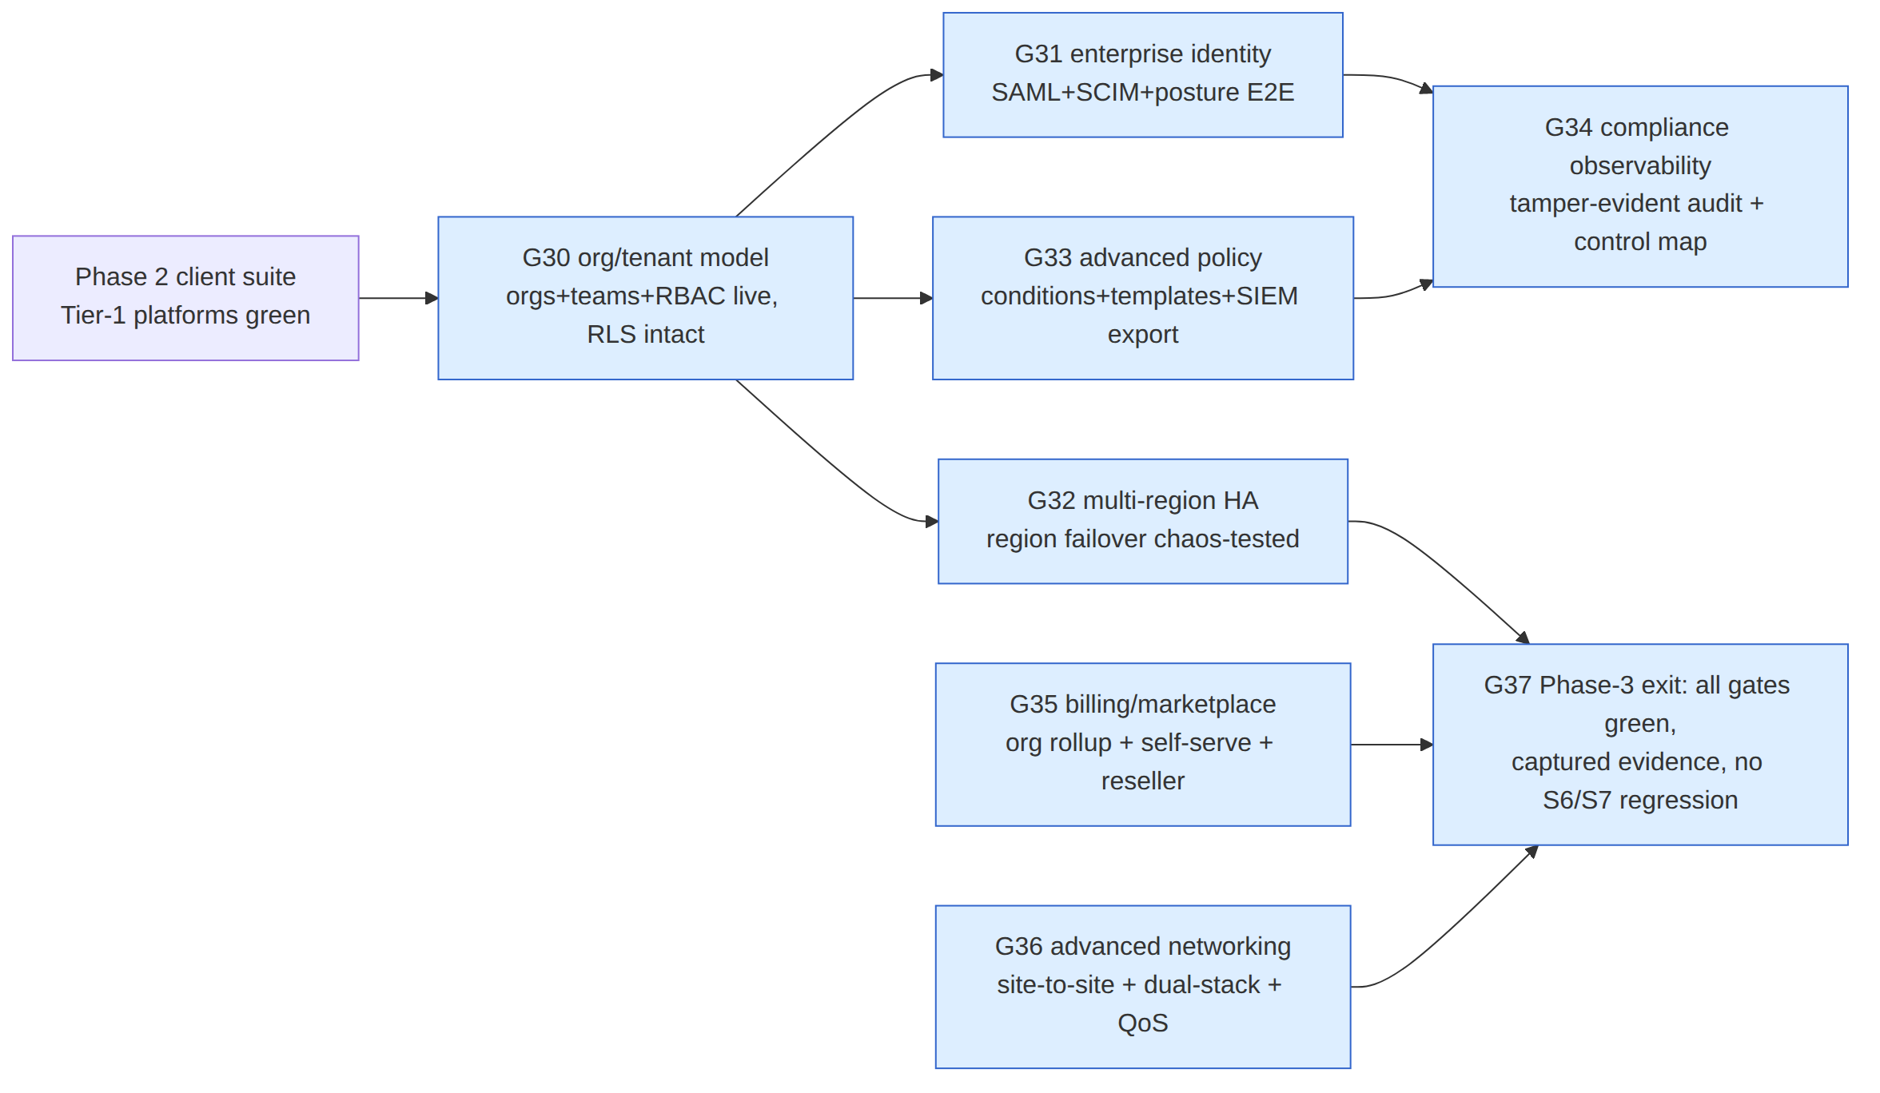

10.3 Epics
HVPN-ENT-E30 — Organizations, teams, and permission-based RBAC epic · module: helix-go/identity,store Gate G30. Delivers §3 in full.
- HVPN-ENT-300 — organizations/teams DDL + RLS + migration from groups. M(5) · deps: — · tests: UNIT,INT,SEC Acceptance: existing tenants with org_id IS NULL behave byte-identically (regression suite from Phase 1 still green); a new org with 2 tenants shows correct rollup isolation (cross-tenant read denied by RLS, proven by a planted cross-org read attempt that must fail).
- HVPN-ENT-301 — roles/role_bindings + built-in-role seed matching the old 3-value enum. L(7) · deps: HVPN-ENT-300 · tests: UNIT,INT,SEC Acceptance: a Phase-1 tenant with zero RBAC configuration authorizes identically to the pre-Phase-3 Role enum (parity test suite diffing old vs. new Authorize() decisions across the full Phase-1 permission matrix).
- HVPN-ENT-302 — SCIM 2.0 server (/Users, /Groups). L(8) · deps: HVPN-ENT-301 · tests: UNIT,INT,E2E,SEC Acceptance: an IdP-driven SCIM deprovision reaches device revoke-cascade in < 1 s (reuses the existing Phase-1 revoke SLO test harness against a SCIM-triggered suspend).
- HVPN-ENT-303 — G30 certification. S(3) · deps: HVPN-ENT-300..302 · tests: FA,CHAL
HVPN-ENT-E31 — Enterprise identity: SAML, device posture, conditional access epic · module: helix-go/identity,helix-core Gate G31.
- HVPN-ENT-310 — SAML 2.0 provider type + JIT provisioning parity with OIDC. L(8) · deps: HVPN-ENT-301 · tests: UNIT,INT,E2E,SEC Acceptance: a SAML login against a test IdP (e.g. a self-hosted SimpleSAMLphp/Keycloak-SAML instance) JIT-provisions a user with the correct team/role mapping; captured login transcript.
- HVPN-ENT-311 — DevicePosture protobuf field + posture-policy evaluation in the coordinator. M(6) · deps: HVPN-ENT-310 · tests: UNIT,INT,E2E Acceptance: a device reporting jailbroken_or_rooted=true against a tenant policy denying that posture receives a restricted/denied network map, proven by a captured NetworkMapEvent diff vs. a compliant device.
- HVPN-ENT-312 — Conditional-access Spec extension (IdP-group + geo + posture as Condition). M(5) · deps: HVPN-ENT-311,HVPN-ENT-E33-300 · tests: UNIT,INT
- HVPN-ENT-313 — G31 certification. S(3) · deps: HVPN-ENT-310..312 · tests: E2E,FA,CHAL
HVPN-ENT-E32 — Multi-region HA hardening epic · module: helix-go/coordinator,deploy Gate G32.
- HVPN-ENT-320 — regions table + GatewayInfo resolution from region data. M(5) · deps: — · tests: UNIT,INT
- HVPN-ENT-321 — Latency-biased gateway selection (resolves D-GW-SELECT option c for enterprise). L(7) · deps: HVPN-ENT-320 · tests: UNIT,INT,PERF
- HVPN-ENT-322 — Postgres read-replica routing for hydration + billing reads (resolves U2). M(6) · deps: HVPN-ENT-320 · tests: UNIT,INT,PERF Acceptance: policy-compile snapshot reads are proven (via a query-source assertion in the integration test) to NEVER hit a replica; hydration/billing reads are proven to use the replica under normal operation.
- HVPN-ENT-323 — NATS JetStream R3 clustering + cross-region mirror relay (resolves U3). L(8) · deps: HVPN-ENT-320 · tests: UNIT,INT,CHAOS
- HVPN-ENT-324 — Automated region-failover runbook + chaos test. L(8) · deps: HVPN-ENT-321,HVPN-ENT-322,HVPN-ENT-323 · tests: CHAOS,STRESS,REC Acceptance: a chaos test kills region A's edge + coordinator replicas entirely; clients re-home to region B within the target RTO (§5.6 table); captured before/after connectivity transcript, zero data-plane packet-content loss claim (only convergence-pause per the honest §6 semantics in ha-and-multiregion.md).
- HVPN-ENT-325 — Zero-downtime rolling upgrade proof (protocol-version field). M(5) · deps: HVPN-ENT-320 · tests: INT,E2E,CHAOS Acceptance: a rolling Deployment update runs while agents are connected; zero forced disconnects, captured connection-continuity transcript across the rollout window.
- HVPN-ENT-326 — G32 certification. S(3) · deps: HVPN-ENT-320..325 · tests: FA,CHAL
HVPN-ENT-E33 — Advanced policy engine epic · module: helix-go/policy Gate G33.
- HVPN-ENT-330 — Condition/evalTime compiler extension, purity-preserving. L(8) · deps: — · tests: UNIT,PERF Acceptance: a property test asserts Compile(t, spec, graph, evalTime) is byte-identical across repeated calls with identical inputs (P2 preserved) and differs ONLY when evalTime crosses a declared window boundary.
- HVPN-ENT-331 — AppSelector + org-level policy templates. M(6) · deps: HVPN-ENT-330 · tests: UNIT,INT
- HVPN-ENT-332 — Destination-category egress lists (DLP-lite, S6-compatible). M(6) · deps: HVPN-ENT-330 · tests: UNIT,INT,SEC Acceptance: a category-blocked destination is denied; the schema-lint from audit-and-compliance.md still passes (no new flow-shaped table introduced) — proven by re-running that lint against this feature's migration.
- HVPN-ENT-333 — SIEM export (CEF/Syslog) for policy + advisory events. M(5) · deps: HVPN-ENT-330 · tests: UNIT,INT,SEC
- HVPN-ENT-334 — G33 certification. S(3) · deps: HVPN-ENT-330..333 · tests: FA,CHAL
HVPN-ENT-E34 — Compliance-grade observability epic · module: helix-go/telemetry Gate G34.
- HVPN-ENT-340 — OpenTelemetry tracing across control-plane operations. M(6) · deps: — · tests: UNIT,INT,PERF
- HVPN-ENT-341 — Hash-chain tamper-evidence on audit_events + verification job. M(6) · deps: — · tests: UNIT,INT,SEC Acceptance: a planted out-of-band row edit is detected by the verification job on its next run; captured alert + SIEM-exported tamper event.
- HVPN-ENT-342 — SOC2/ISO27001/GDPR control-mapping doc + erasure runbook. M(5) · deps: HVPN-ENT-341 · tests: UNIT,FA
- HVPN-ENT-343 — G34 certification. S(3) · deps: HVPN-ENT-340..342 · tests: FA,CHAL
HVPN-ENT-E35 — Marketplace / billing epic · module: helix-go/billing Gate G35.
- HVPN-ENT-350 — org_usage_rollup view + Console billing dashboard. M(5) · deps: HVPN-ENT-300 · tests: UNIT,INT
- HVPN-ENT-351 — UsageReporter daily job + pluggable PaymentAdapter. L(7) · deps: HVPN-ENT-350 · tests: UNIT,INT,SEC Acceptance: billing stays OFF (zero adapter calls, zero behavioral change) when a tenant has no subscription row — regression-tested against the Phase-1/2 self-host baseline.
- HVPN-ENT-352 — Reseller (parent_org_id) provisioning + scoped RBAC. M(6) · deps: HVPN-ENT-301,HVPN-ENT-350 · tests: UNIT,INT,SEC
- HVPN-ENT-353 — G35 certification. S(3) · deps: HVPN-ENT-350..352 · tests: FA,CHAL
HVPN-ENT-E36 — Advanced networking epic · module: helix-go/policy,helix-edge Gate G36.
- HVPN-ENT-360 — Site-to-site Console workflow + cross-tenant grant object. M(6) · deps: HVPN-ENT-300 · tests: UNIT,INT,E2E
- HVPN-ENT-361 — Dual-stack privacy-exit egress + native IPv6 LAN advertisement. M(6) · deps: — · tests: UNIT,INT,E2E
- HVPN-ENT-362 — Per-tenant token-bucket QoS shaping at the edge. M(6) · deps: — · tests: UNIT,INT,PERF,STRESS
- HVPN-ENT-363 — Per-org MASQUE SNI/fingerprint rotation + DAITA-default-on enterprise tier. L(7) · deps: — · tests: UNIT,INT,SEC
- HVPN-ENT-364 — Pin-and-alert transport-fallback policy. M(5) · deps: — · tests: UNIT,INT,CHAOS
- HVPN-ENT-365 — G36 certification. S(3) · deps: HVPN-ENT-360..364 · tests: FA,CHAL
HVPN-ENT-E37 — Phase-3 exit certification epic · module: — Gate G37. All prior gates green + a full-suite retest from the Phase-2 baseline (constitution §11.4.40) + no S6/S7 (no-logging-as-code) regression proven by re-running the existing schema-lint against the entire Phase-3 migration set in one pass.

11. Decision register (operator input needed)
# | Decision | Options | Recommendation | Resolved by
D-ENT-1 | Reconcile the two "Phase 3" labels (this doc vs. mvp/final/09-phase3-reach-wbs.md) | (a) rename the existing platform-reach WBS to "Phase 2.5" or "Phase 2c"; (b) rename this document's scope to "Phase 4"; (c) keep both labeled "Phase 3" as parallel sub-tracks, cross-referenced (current state) | (c) for now — see UNIFIED_PHASE_ROADMAP.md §4 — but this is a genuine naming decision, not silently resolved | operator, before the numbering is used in external communication
D-ENT-2 | Pricing for the tiers in §8.1 | exact $/tier, usage overage pricing | not specified — business decision | operator + go-to-market (cross-ref MVP_FINAL_GA_READINESS.md §3.1)
D-ENT-3 | Which compliance certification to pursue first (§7.3) | SOC2 Type II first (common enterprise-buyer gate) vs. ISO 27001 first (common EU-buyer gate) vs. neither until customer-demanded | not specified — depends on target market | operator
D-ENT-4 | Whether an organization layer above tenant is needed at all for the initial enterprise launch, or whether it can be deferred (many enterprise buyers are a single tenant) | ship §3.1's org layer in the first Phase-3 release vs. defer to a later Phase-3 increment, shipping RBAC/SSO/HA first | ship RBAC+SSO+HA first (G31/G32/G33 have no dependency on G30's org layer beyond the shared roles table); org/reseller layer (G30, G35) can trail if it de-risks the critical path | operator, informs WBS sequencing in §10
D-ENT-5 | DLP posture (§6.3) — confirm the "no payload inspection" boundary as final product positioning | accept the metadata/category-only boundary vs. explicitly scope a separate, clearly-labeled non-HelixVPN-core CASB/DLP integration product | recommend accepting the boundary — payload inspection contradicts the product's core privacy promise | operator
D-ENT-6 | SLA numbers in §7.5 | exact percentages, credit/refund policy on breach | not specified — business/legal decision | operator (cross-ref MVP_FINAL_GA_READINESS.md §2)

Sources
- docs/research/mvp/final/SPECIFICATION.md — architectural spine, non-negotiable principles, phase roadmap, decision register.
- docs/research/mvp/04_VPN_CLD/HelixVPN-Architecture-Refined.md — refined architecture (transports, control plane, security, deployment).
- docs/research/mvp/final/09-phase3-reach-wbs.md — the pre-existing "Phase 3 — Extended Reach" WBS (HarmonyOS/Aurora/WASM/billing-optional/audit/reproducible-builds); source of the naming-collision disclosure and the E24 billing schema this document extends.
- docs/research/mvp/final/v06-deploy/ha-and-multiregion.md — HA thesis, reference multi-region topology, UNVERIFIED register (U2, U3) resolved in §5 above.
- docs/research/mvp/final/v03-control-plane/svc-identity.md — identity service interface, Role enum, OIDC JIT-provisioning, extended in §3.3/§4.
- docs/research/mvp/final/v03-control-plane/svc-policy.md — policy compiler invariants P1–P8, extended in §6.
- docs/research/mvp/final/v05-security/audit-and-compliance.md — S6/S7 no-logging-as-code invariants, audit_events schema, extended in §7.
- docs/research/mvp2/README.md, docs/research/mvp2/MVP2_OVERVIEW.md — Phase 2 client-suite platform matrix and scope (entry condition for this document).
- docs/research/UNIFIED_PHASE_ROADMAP.md — full phase reconciliation, read alongside this document.
End of Phase 3 (Enterprise & Scale) specification.

