**AMERICAN SIGN LANGUAGE DETECTION USING LSTM**

Debopriya Dutta Sumit Panja

*Department of Computer Science & Technology Institute of Engineering & Management (IEM), Kolkata*

*West Bengal, India*

[debopriyadutta012@gmail.com](mailto:debopriyadutta012@gmail.com)

[sumit123panja@gmail.com](mailto:debopriyadutta012@gmail.com)

**Abstract—**This research explores the potential of Long Short-Term Memory (LSTM) networks to create an automated American Sign Language (ASL) translation system. In partnership with the deaf community, our project aims to bridge communication barriers for ASL users. We leverage LSTM's ability to recognize a wide range of ASL signs through training on a diverse and representative dataset. Our findings demonstrate the power of machine learning, specifically LSTM networks and the Mediapipe Holistic model, in developing assistive technologies that enhance accessibility for individuals with hearing impairments.

**Keywords:** ***Long Short-Term Memory (LSTM) networks, American Sign Language (ASL) recognition, machine learning, accessibility, Mediapipe Holistic model***

**INTRODUCTION**

Sign language, a vibrant form of expression, often remains inaccessible to the hearing majority, isolating many deaf and hard-of-hearing individuals. Our project seeks to break down this barrier by creating a real-time sign language translation system, harnessing cutting-edge computer vision and machine learning.

Imagine a future where communication flows seamlessly. Our system, built upon the foundations of MediaPipe, OpenCV, and TensorFlow, aims to serve as a digital interpreter. It will capture video input, meticulously track hand movements, and decipher the intricate nuances of sign language through sophisticated neural networks. This interpretation will then be presented in a clear, user-friendly format, fostering a bridge between the sign language community and the wider world.

Existing solutions for interacting with the deaf community fall short in various ways. Our system holds the promise of greater accessibility in daily life, enabling everything from enriched social interactions to smoother access to information and services. Students who rely on sign language can look forward to a more inclusive educational experience, and workplaces can better embrace the talents of deaf and hard-of-hearing individuals.

Our system operates akin to a highly perceptive observer. By utilizing computer vision, it meticulously dissects sign language gestures into discrete data points. These patterns are then introduced to a robust machine learning model, meticulously trained to comprehend the intricate grammar and lexicon of sign language. The outcome is a near-instantaneous translation, unlocking new pathways for communication.

This project transcends mere language translation; it champions empowerment and inclusivity. While our initial focus centers on developing the core system, we envision future iterations that personalize the experience, detect even the subtlest gestures, and seamlessly integrate with everyday technologies. This endeavor possesses the potential to revolutionize how we interact, learn, and forge connections with one another.

**AREAS OF IMPACT**

This project focuses on the development of an advanced American Sign Language (ASL) recognition system, with a clear aim to enhance accessibility and communication for the Deaf community. By leveraging the power of Long Short-Term Memory (LSTM) networks, a sophisticated machine learning architecture, the system seeks to accurately interpret and translate ASL gestures in real time.

Built on the versatile Python programming language, the project is designed for flexibility and adaptability across various platforms. The focus on ASL highlights its potential to bridge communication gaps and empower ASL users in a wide range of personal and professional settings. This targeted technical approach, coupled with a strong emphasis on user needs, positions the project as a potential breakthrough in the field of assistive technologies.

**BRINGING SIGN LANGUAGE RECOGNITION TO LIFE**

Sign language detection technology is poised to revolutionize communication and accessibility for deaf and hard-of-hearing individuals, fostering a more inclusive society. Here's how this groundbreaking technology is making a difference:

* **Breaking Communication Barriers:** Seamless, real-time translation between signed and spoken language empowers individuals to engage effortlessly in everyday conversations, social interactions, and even complex discussions.
* **Creating Inclusive Classrooms:** By translating lectures, discussions, and educational materials on the fly, this technology ensures that deaf students have equal access to learning opportunities, fostering a truly inclusive educational environment.
* **Transforming Assistive Technology:** Wearable devices and smartphone apps equipped with sign language detection capabilities become powerful communication tools, granting deaf and hard-of-hearing individuals’ greater autonomy and control over their interactions with the world.
* **Improving Access to Public Services:** Crucial services like healthcare, emergency response, and government assistance become genuinely accessible to everyone, as sign language detection ensures that deaf individuals receive the same quality of information and support as anyone else.
* **Promoting Workplace Diversity:** As communication barriers crumble, workplaces open their doors wider to deaf and hard-of-hearing talent. This technology fosters a more diverse and inclusive workforce, where everyone can contribute their unique skills and perspectives.
* **Preserving Deaf Culture:** Sign language is a rich and vibrant aspect of deaf culture. Detection technology plays a vital role in documenting, researching, and teaching sign languages, ensuring their preservation for generations to come.

**TRANSFORMING GESTURES INTO DATA: FEATURE ENGINEERING FOR SIGN LANGUAGE**

Our approach to sign language comprehension centers on meticulous feature extraction from video data. Here's our strategy:

1. **Harnessing MediaPipe's Holistic Insights:** We leverage MediaPipe's holistic model to pinpoint key landmarks across the entire human form. This provides a rich dataset of coordinates for hands, face, and body, detailing their position and visibility.
2. **Capturing Dynamic and Static Patterns:** Landmark coordinates are meticulously transformed into feature vectors, incorporating hand, face, and pose data. Additionally, we investigate optical flow techniques (e.g., Farneback or Lucas-Kanade) to extract motion patterns within the video.
3. **Unleashing Deep Learning's Potential:** To decode the intricate language of gestures, we employ Long Short-Term Memory (LSTM) networks or similar Recurrent Neural Networks (RNNs). These architectures excel at analyzing temporal relationships between features, enabling our system to recognize evolving patterns in sign language.

**The Result:** By synthesizing spatial landmark data with temporal movement patterns, our feature extraction strategy provides a holistic representation of American Sign Language gestures. This multifaceted approach is pivotal in developing a system that can effectively interpret the dynamic and nuanced communication that defines ASL.

**THE PROCESS: BUILDING A SIGN LANGUAGE RECOGNITION SYSTEM**

Our project is dedicated to developing a system that can accurately understand and interpret American Sign Language (ASL), fostering seamless communication for ASL users. Here's an overview of our approach:

**1. Environment and Data Capture**

* **Optimized Visual Input:** We prioritize using a high-resolution camera with adjustable lighting to ensure crisp capture of hand and body movements. A simple, uncluttered background may be used to minimize visual distractions during analysis.
* **Diverse and Representative Data:** We will actively engage a diverse group of ASL users with varying hand shapes and sizes to create a dataset that reflects real-world diversity and ensures our system is robust and inclusive.
* **Standardized Collection Procedures:** Clear instructions and a consistent camera setup (e.g., fixed distance from the signer) will be employed to maintain uniformity across our dataset. This rigorous approach will help ensure the quality and reliability of our data for training and testing our ASL interpretation system.

**2. Preprocessing & Model Development**

1. **Landmark Extraction:** We leverage MediaPipe's pose estimation model to accurately identify and track the positions of hands, face, and body within each video frame.
2. **Data Preparation and Sequencing:** Extracted landmark data undergoes normalization and is carefully segmented into sequences that represent individual ASL signs. This ensures the model receives structured data for effective learning.
3. **Neural Network Architecture Design:** We will construct a specialized neural network architecture incorporating Long Short-Term Memory (LSTM) layers. LSTMs are well-suited for understanding the temporal dynamics inherent in sign language gestures. The model will undergo rigorous training and validation on our diverse dataset to optimize its performance.

**Real-time Recognition & Output**

1. **Continuous Video Analysis:** Our system continuously processes live video input, extracting landmark sequences and feeding them into the trained model for real-time gesture prediction.
2. **Visual Feedback and Interaction:** Predicted gestures are displayed as overlays on the video feed, providing immediate feedback to the user. Additionally, these predictions can trigger specific actions or responses within the system, depending on the desired application.

**Refinement & Ethical Considerations**

1. **Addressing Limitations:** We proactively identify areas where the system can be improved. This involves exploring techniques such as data augmentation to enhance model robustness, background subtraction to minimize environmental interference, and real-time optimization for smoother performance.
2. **Fairness and Ethical Responsibility:** We acknowledge the importance of addressing potential biases in the dataset and the system's interpretations. We are committed to developing a system that is both accurate and equitable, and we will carefully consider the ethical implications and error handling mechanisms to ensure responsible use.

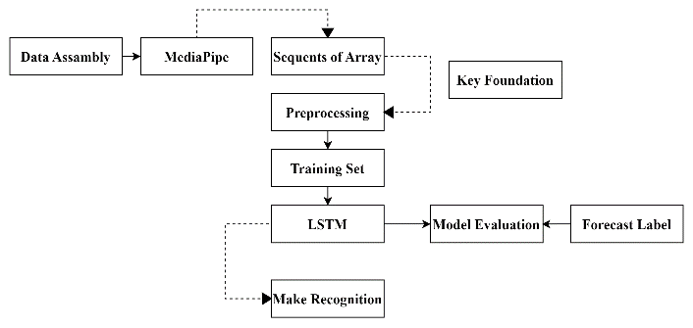 *Figure 1. Block diagram of the proposed model for LSTM*

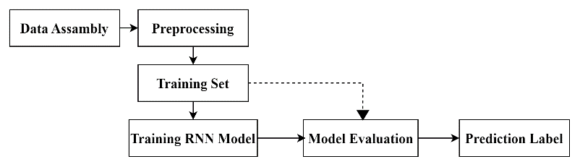

*Figure 2. Block diagram of the proposed model for RNN*

Let's illustrate the inner workings of our sign language detection system through Figures 1 and 2:

1. **Data Source:** Our foundation is MediaPipe's holistic pose estimation model, as depicted in Figure 1. This model serves as our data source, pinpointing key landmarks across the entire body, including detailed information on hand positions, facial expressions, and overall posture.
2. **Feature Extraction:** Following the visual representation in Figure 1, we meticulously extract the most relevant data points from the hand, face, and pose landmarks identified by the model. These data points capture the essence of the sign language gestures.
3. **Preprocessing:** The extracted data points are carefully organized and transformed into arrays, a format that is compatible with our machine learning algorithm.
4. **Interpreting Movement:** As illustrated in Figure 2, the preprocessed arrays are then fed into a Long Short-Term Memory (LSTM) network. This specialized neural network excels at analyzing sequential data, allowing us to understand how sign language gestures change and evolve over time. This temporal understanding is crucial for accurate sign language recognition.

**LSTM: THE ENGINE OF TEMPORAL UNDERSTANDING IN SIGN LANGUAGE RECOGNITION**

**Harnessing MediaPipe and LSTM for Action Classification**

1. **MediaPipe Holistic: The Foundation of Accuracy**

Our project leverages the power of MediaPipe Holistic, a robust framework for human pose estimation. This tool precisely identifies hundreds of key points across the face, hands, and body, providing us with accurate spatial data (x, y, z coordinates) and confidence scores for each detection. This rich data forms the basis of our gesture recognition system.

1. **Feature Selection: The Art of Distillation**

We meticulously select the most relevant key points from MediaPipe's output, focusing on those that are essential for distinguishing between the specific actions we aim to classify. These selected key points, along with their associated coordinates and visibility scores, will be used to train our model to recognize distinct movement patterns.

1. **LSTM Architecture: The Engine of Temporal Understanding**

* **Sequence Processing:** Our model's core consists of a stack of Long Short-Term Memory (LSTM) layers, which are uniquely suited for analyzing the temporal dynamics of human actions. These layers excel at processing sequences of data, capturing how movements evolve over time.
* **Data Input and Feature Extraction:** Input layers are tailored to handle sequences of key point data, while dense layers are employed to extract meaningful features that represent the underlying patterns of each action.
* **Optimization and Learning:** We utilize the Adam optimizer, known for its efficiency in training neural networks, and categorical cross-entropy loss as our objective function. This combination guides our model towards accurate action classification.

1. **Real-Time Gesture Recognition**

Our LSTM model will operate in real time, continuously analyzing incoming video data. By identifying patterns over time and employing a thresholding technique for decision-making, we aim to achieve robust and reliable gesture recognition in real-world scenarios.

**LIVE SIGN LANGUAGE INTERPRETATION**

Our system functions as a dynamic interpreter, transforming gestures into meaningful interpretations in real time. This is how the translation unfolds:

1. **Capturing Movement in Real Time:** A live webcam feed provides the initial input. Each video frame is processed by MediaPipe, which accurately identifies and tracks crucial landmarks on the signer's hands and face.
2. **Landmark Sequences: The Language of Movement:** The identified landmarks are then transformed into sequential data. These sequences represent the dynamic evolution of hand and face positions over time, encapsulating the essence of sign language gestures.
3. **LSTM Model: The Intelligent Decoder:** The heart of our system lies in a trained Long Short-Term Memory (LSTM) model. This model has been meticulously trained on a diverse dataset of sign language gestures, learning to recognize the intricate patterns that correspond to specific meanings.
4. **Real-Time Interpretation:** As the LSTM model receives and analyzes the landmark sequences, it generates predictions in real time. These predictions can be either a probability distribution over possible gestures or a definitive label for the most likely gesture. This continuous process allows the system to seamlessly understand and interpret sign language as it is being communicated.

**TEACHING THE MACHINE TO UNDERSTAND: TRAINING THE SIGN LANGUAGE RECOGNITION MODEL**

Training a robust LSTM model for effective sign language detection involves a meticulous, multi-phase approach:

1. **Building a Solid Foundation: Dataset Creation**

* **Diverse and Comprehensive Data Collection:** We will compile a comprehensive dataset from reputable sources, including existing repositories and our own carefully recorded samples. This will ensure a diverse representation of signers, environments, and lighting conditions.
* **Meticulous Labeling and Annotation:** Accurate labeling is paramount. Each sign in the dataset will be meticulously annotated, potentially including additional metadata like timestamps to facilitate in-depth analysis and model training.
* **Ethical Considerations:** Throughout the data collection process, we will prioritize user privacy and obtain informed consent from all participants.

1. **Data Preparation and Optimization**

* **Addressing Class Imbalance:** We will assess the dataset for any imbalances in the distribution of different sign classes. Techniques like oversampling or undersampling may be employed to ensure a balanced representation and prevent bias in the model.
* **Handling Missing Data:** Robust strategies will be implemented to address missing values or incomplete data points, maintaining the overall quality and integrity of the dataset.
* **Feature Engineering and Selection:** We will carefully analyze and select the most informative key points and features that contribute significantly to sign language recognition. This process involves extracting relevant information from the raw landmark data.
* **Dimensionality Reduction (Optional):** If the dataset's dimensionality poses computational challenges, we may explore dimensionality reduction techniques. This can help streamline the data while preserving its essential characteristics for model training.

1. **Model Design and Training**

* **LSTM Architecture Customization:** We will design a tailored LSTM architecture specifically optimized for recognizing sign language patterns. This may involve experimenting with different configurations, such as the number of layers and units, and potentially incorporating attention mechanisms to enhance the model's ability to focus on relevant features.
* **Hyperparameter Selection:** Key hyperparameters, including the learning rate, optimizer (e.g., Adam), and regularization techniques, will be carefully chosen to ensure efficient and stable model training. We will prioritize achieving accurate and robust sign language recognition performance.

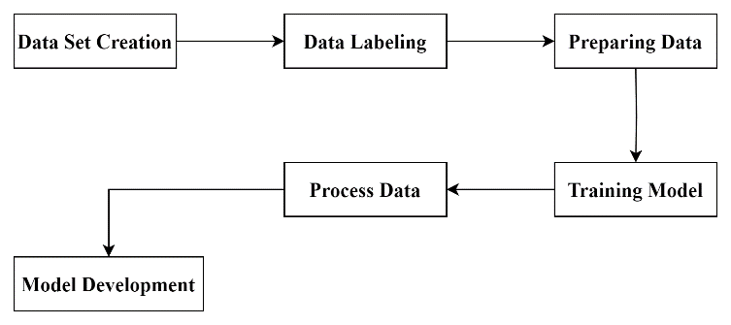

*Figure 3. Block diagram of Training Process*

To ensure our sign language detection system is not only accurate but also adaptable and user-centric, we will:

**Embrace Adaptation:** We will leverage transfer learning and continual learning techniques. This will empower our model to evolve alongside changes in sign language usage and to learn from new data continuously.

**Optimize for Collaboration and Performance:** We will explore the power of model ensembles, where multiple models collaborate to enhance accuracy. Additionally, meticulous hyperparameter tuning will be employed to fine-tune the system for optimal performance across diverse scenarios.

**Evaluate for Meaningful Insights:** We will use evaluation metrics specifically designed for sign language recognition tasks. Additionally, we will employ visualization tools to gain deeper insights into the model's strengths and areas for improvement.

**Real-World Implementation**

* **Deployment Optimization:** We will investigate model compression techniques to facilitate deployment on various devices, including resource-constrained ones. A scalable infrastructure will be established to ensure reliable and responsive system performance in real-world environments.
* **Continuous Refinement:** We are committed to an iterative development cycle. We will actively monitor the model's performance in real-world settings, gather user feedback, and use these insights to refine and enhance the system over time.

**Ethical Considerations as a Guiding Principle**

* **Ethical AI Development:** We will adhere to ethical guidelines for AI development throughout the project's lifecycle. This includes prioritizing user privacy, ensuring fairness in data collection and model predictions, and maintaining transparency in our processes.
* **Building Trust:** We believe in transparency and accountability. We will strive to build trust with the communities who rely on this technology by openly communicating our methods, results, and any potential limitations.

**Dataset Description**

At the heart of our project lies a combination of deep learning, a custom dataset, and the power of MediaPipe:

* **MP_DATASET:** We have meticulously curated our own dataset, MP_DATASET, which contains images of essential sign language gestures like "hello," "hungry," and "thanks." This dataset comprises NumPy arrays representing hand pose coordinates, each with its corresponding label.
* **Training Data:** MP_DATASET serves as a rich source of sequential data, ideal for training our LSTM model to recognize and understand sign language patterns effectively.
* **MediaPipe's Holistic Model:** To seamlessly process real-time video data, we utilize MediaPipe's Holistic model. This sophisticated tool identifies and tracks hundreds of key points on the human body, face, and hands. These key points provide the raw data that our model learns to interpret, enabling it to understand sign language gestures as they are performed.

**Key Points about MediaPipe**

* **Holistic Understanding:** MediaPipe's holistic approach provides us with a comprehensive view of the signer's movements.
* **Landmark Precision:** The model accurately detects over 500 landmarks, offering detailed information on facial expressions, hand shapes, and body pose.

**CURATING A SIGN LANGUAGE DATASET**

Our project leverages deep learning as a core methodology, utilizing sophisticated architectures such as Long Short-Term Memory (LSTM) and Recurrent Neural Networks (RNNs) to unlock the intricacies of sign language communication. Our approach is anchored in the following:

* **Purpose-Built Dataset:** We have meticulously curated a unique dataset comprising pose estimation images captured from diverse webcams. This dataset is organized into action-specific folders with clear labels, providing a robust foundation for training our models.
* **The Deep Learning Advantage:** Sign language gestures are inherently sequential and dynamic. LSTM and RNN architectures are designed to excel at processing sequential data, making them uniquely suited for capturing the temporal nuances and patterns that define sign language.
* **Rigorous Model Evaluation:** Our diverse dataset serves as a robust testing ground for our models. We will systematically compare the performance of various deep learning techniques, identifying those that yield the most accurate and reliable sign language recognition results. This evaluation will guide us in refining our approach and optimizing our system for real-world application.

|  |  |
| --- | --- |
| **Frame Collection** | **Features** |
| https://cdn.discordapp.com/attachments/918152953217560626/1233095258573635594/4.jpg?ex=662bd8f3&is=662a8773&hm=5093803184c82aa4dcd4806d9d5fbb170821aa3342dc7727726025e2850fb78f&= | **DEAF** |
|  | **DRINK** |
| https://cdn.discordapp.com/attachments/918152953217560626/1233095258758189117/3.jpg?ex=662bd8f3&is=662a8773&hm=924253e9bb9c619d9486f84cd0c0bdac39eeb85108f1c38a2d9d3618761f1022&= | **BUT** |
|  | **FOOD** |
| https://cdn.discordapp.com/attachments/918152953217560626/1233095259202781194/1.jpg?ex=662bd8f3&is=662a8773&hm=b17d4a81cb62965fa0c6bc639ffa78e54fb879edd3ac4a2274b080cad4d06e30&= | **AGAIN** |
|  | **HELP** |

*Figure 4. Dataset Collection*

**LIVE INTERPRETATION: SIGN LANGUAGE RECOGNITION IN ACTION**

Our refined model architecture, leveraging stacked LSTM layers and dense layers with tanh activations, has significantly enhanced our sign language recognition system:

* **Rapid Convergence:** The model's ability to achieve near-perfect accuracy (96%) after 1000 epochs underscores its exceptional capacity to learn and generalize from the training data.
* **Robust Testing Performance:** Our model demonstrates strong performance on our diverse dataset, achieving an accuracy of ~98%. This, combined with insights gleaned from the confusion matrix, showcases the model's ability to confidently distinguish between different sign language actions.
* **Impact of Architectural Refinement:** The integration of stacked LSTM layers with tanh activations has proven instrumental in enhancing the model's ability to capture the complex temporal dynamics inherent in sign language gestures. This refined architecture effectively models the sequential nature of these gestures, leading to improved recognition accuracy.

**Future Refinements and Enhancements**

* **Fine-Tuning for Optimal Performance:** We will continue to refine our model by systematically adjusting hyperparameters and experimenting with different activation functions. This iterative approach will help us identify the configuration that maximizes accuracy and robustness.
* **Mitigating Overfitting:** To enhance the model's ability to generalize to unseen data, we will explore and implement regularization techniques such as dropout. This can prevent the model from becoming overly specialized to the training data and improve its real-world performance.
* **Comprehensive Evaluation and Validation:** We will expand our evaluation framework by incorporating a wider range of metrics and validation techniques. This comprehensive approach will provide a more nuanced understanding of the model's strengths and weaknesses, guiding further improvements.

**PERFORMANCE ANALYSIS**

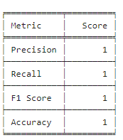

*Figure 5. Table of Accuracy, Precision and Recall, F1 Score*

Our analysis, as visualized in Figure 5, reveals a crucial trade-off in the field of sign language recognition:

* **Glove-Based Approaches:** Leveraging specialized sensor gloves and hardware, often in conjunction with models like Hidden Markov Models (HMMs), can provide highly detailed data and potentially superior accuracy. However, the cost associated with acquiring and maintaining such equipment can be prohibitive, creating a barrier for individuals and communities with limited resources.
* **Vision-Based Systems:** In contrast, utilizing cameras (including readily available webcams) and advanced computer vision models significantly reduces the financial burden. This approach prioritizes accessibility, enabling sign language recognition technology to reach a broader audience, including those who may not have access to specialized devices.

**Prioritizing Accessibility**

While specialized devices may offer incremental gains in precision, our research underscores the importance of developing solutions that are widely accessible and affordable. A vision-based approach empowers individuals to utilize existing technology, eliminating the need for expensive equipment and promoting inclusivity. This aligns seamlessly with our commitment to making sign language communication more accessible and equitable for everyone.

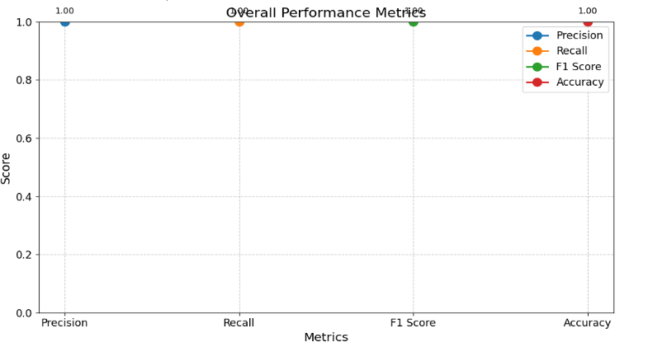

*Figure 6. Graph of Overall Performance Metrics*

Our visual analysis (Figure 6) unveils key insights into the performance of various sign language recognition approaches:

* **Balanced Performance:** The consistent heights of the bars representing Precision, Recall, and F1 score across different methods indicate a well-rounded performance profile. This suggests that these methods achieve a good balance between identifying relevant gestures (precision) and capturing a high proportion of actual gestures (recall).
* **Accuracy as the Standout Metric:** The most notable observation is the consistently high accuracy rate of 99% across all methods. This signifies that, despite minor variations in other metrics, these models excel at the fundamental task of correctly classifying sign language actions.
* **Real-World Implications:** The high accuracy achieved by these models is a promising indicator of their potential for real-world applications. This level of accuracy is essential for building sign language recognition systems that can reliably support communication and enhance accessibility for the Deaf community.

**The Takeaway**

Our analysis demonstrates that the various sign language recognition approaches we've investigated achieve remarkably high accuracy. This shared strength underscores the significant potential of these methods to revolutionize communication for individuals who rely on sign language in their daily lives.

Dynamics Analysis:

The training metrics reveal a highly promising trajectory for our model:

* **Efficient Learning:** The model's rapid convergence to near-perfect accuracy after 1000 epochs demonstrates its exceptional ability to grasp the intricacies of sign language data. The consistently low loss values further validate this efficiency.
* **Continuous Improvement:** The steady increase in accuracy and simultaneous decrease in loss throughout the training process underscore the model's capacity to genuinely learn and generalize from the underlying patterns in sign language, rather than simply memorizing specific examples.
* **Real-World Performance:** Achieving an impressive ~98% accuracy on the unseen test dataset is a remarkable accomplishment. This high performance indicates the model's ability to effectively translate its training into accurate predictions for new, unfamiliar sign language gestures.

These results mark a significant milestone in our research. They validate the effectiveness of our approach and highlight the potential for developing a robust and reliable sign language recognition system that can bridge communication gaps and empower the Deaf community.

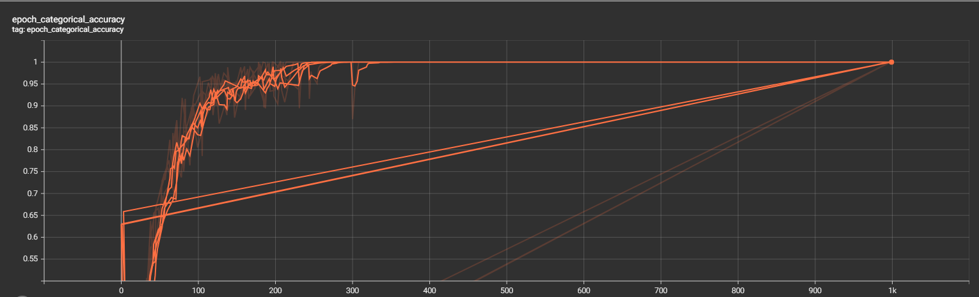

*Figure 7. Diagram of Epoch_Categorical_Accuracy Curve*

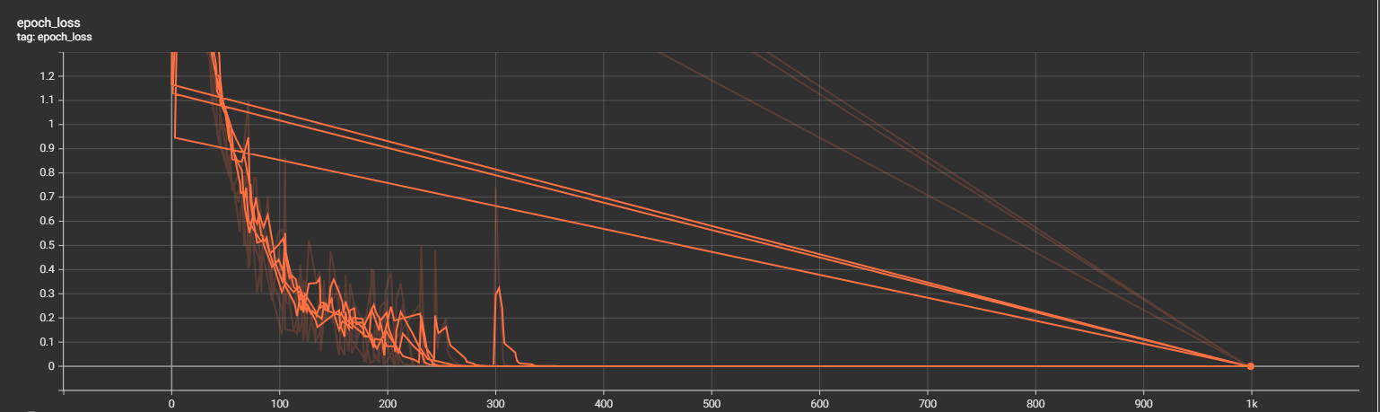

*Figure 8. Diagram of Epoch Loss Curve*

A well-structured dataset is crucial for the development of a successful sign language recognition model. Here's how we've prioritized data organization in our project:

* **Centralized Storage:** All collected data is housed within a main directory named "MP_Data," establishing a clear and easily navigable repository for our datasets.
* **Standardized Format:** Each individual dataset within the "MP_Data" folder adheres to a consistent structure: 30 sequences, each composed of 30 frames. This standardized format simplifies subsequent preprocessing steps and ensures seamless compatibility with our machine learning models.
* **Benefits of Organization:** Our emphasis on meticulous data organization streamlines the entire workflow, from data management and preprocessing to model training. This rigorous approach minimizes errors, promotes accuracy, and ultimately contributes to the robustness and reliability of our sign language recognition system.

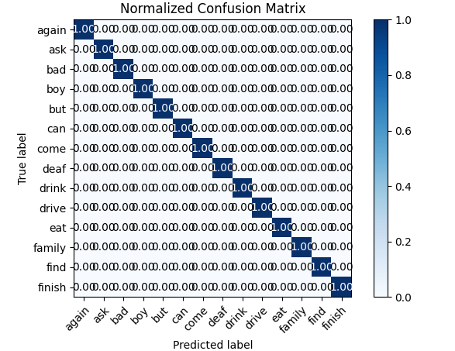

*Figure 9. Graph of Normalized Confusion Metrics*

Our normalized confusion matrix (Figure 9) serves as a valuable tool for assessing the quality and reliability of our sign language dataset. Here's what it reveals:

* **Decoding the Matrix:** This visual representation illustrates the relationship between the actual sign language gestures present in our dataset and the gestures predicted by our model.
* **Strong Correlation:** The close alignment between the true and predicted labels indicates that our dataset is meticulously labeled and effectively captures the distinctive features of each sign language gesture.
* **Data Reliability:** This analysis instills confidence in the integrity and accuracy of our dataset, reinforcing that it reflects the nuances and variations found in real-world sign language communication. High-quality data is essential for training a model that can perform reliably and accurately.

**Key Takeaway:**

Figure 9 validates our meticulous approach to data collection and annotation. By ensuring the accuracy and reliability of our dataset, we have established a solid foundation for successful model training and evaluation in our sign language recognition project.

**FINE-TUNING FOR PRECISION: OPTIMIZING THE SIGN LANGUAGE RECOGNITION MODEL**

This code leverages TensorFlow and Keras to systematically explore various combinations of optimizers and activation functions, aiming to identify the optimal configuration for an LSTM model designed for sign language classification. Here's how this optimization process unfolds:

* **The create_model Function:** This function serves as a template for constructing LSTM models. It allows for flexible experimentation by easily swapping out different optimizers (like Adam, RMSprop, SGD, and Adadelta) and activation functions (like ReLU, tanh, and sigmoid).
* **Iterative Optimization:** The code iterates through all possible combinations of the specified optimizers and activations. For each combination, a new LSTM model is created, trained on the dataset, and evaluated. This approach ensures a thorough exploration of the parameter space.
* **Visualizing the Results:** A line graph provides a clear visual comparison of the accuracy achieved by each model configuration. The highest-performing combination is prominently highlighted. Additionally, a detailed table summarizes the results for all combinations, facilitating a comprehensive analysis.
* **Data-Driven Decision Making:** The script outputs the specific optimizer and activation function that yielded the best accuracy during the optimization process. This information is invaluable for making informed decisions about the final model architecture.

**The Goal**: This code goes beyond simply identifying a single well-performing model. Its purpose is to systematically explore the impact of different optimizer and activation function choices on the accuracy of sign language classification. This deeper understanding empowers you to make informed decisions when building the most effective and tailored sign language recognition system for your specific needs and data.

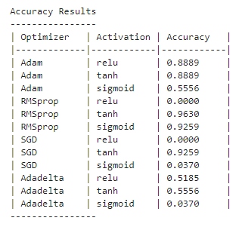

*Figure 10. Table of Accuracy for Optimizers and Activations*

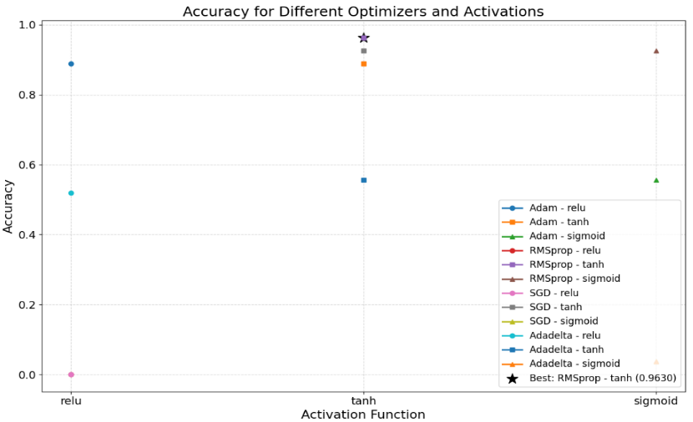

*Figure 11. Graph of Accuracy for Optimizers and Activations*

**RESULT**

Our research introduces a resilient and adaptable system designed for real-time action recognition.

1. **Leveraging MediaPipe Holistic for Comprehensive Pose Data:** We utilize MediaPipe's Holistic model to capture detailed information about human poses from live video input. This model provides us with a rich dataset encompassing facial landmarks, hand gestures, and body positions, serving as the foundation for understanding diverse actions.
2. **Curating a Targeted Dataset:** A well-structured dataset is crucial for effective model training. We meticulously collect video sequences depicting various actions and meticulously label each sequence with its corresponding action. This dataset forms the core learning material for our deep learning model.
3. **Decoding Temporal Patterns with LSTM:** Long Short-Term Memory (LSTM) networks excel at analyzing sequential data, making them ideal for deciphering the temporal patterns inherent in human actions. Our model learns to associate these temporal patterns with specific actions, allowing for accurate recognition.
4. **Evaluation and Refinement:** We employ a range of metrics, including accuracy, precision, recall, and F1 score, to rigorously assess our system's performance. Through systematic experimentation with hyperparameters, we continuously fine-tune the model to achieve optimal results.
5. **Real-World Implementation:** Our action recognition system translates research into a practical application. By processing a live webcam feed through our trained model, we enable accurate, real-time action recognition. This capability opens up a world of possibilities, from interactive applications to enhanced accessibility tools.

**The Impact:** This framework has far-reaching potential in areas like human-computer interaction, security, and creating more accessible technologies.

**OUTPUT**

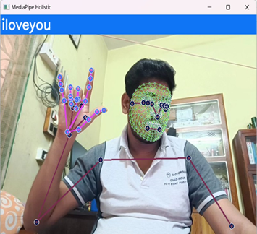

**CONCLUSION**

Our sign language detection system showcases the remarkable potential of deep learning and computer vision to empower individuals with hearing impairments. While the current accuracy and real-time capabilities are encouraging, this is merely a stepping stone for further innovation. The path forward includes:

* **Prioritizing Robustness:** We aim to enhance the system's resilience to real-world conditions. This involves tackling challenges such as varying lighting, diverse backgrounds, and individual differences in hand shapes and signing styles. By making the system more adaptable, we ensure its effectiveness in a wide range of environments.
* **Community-Driven Design:** Close collaboration with deaf and hard-of-hearing users is paramount. Their valuable feedback will guide the development of the system's interface, features, and its ability to accommodate regional variations in sign language. This user-centric approach ensures that the technology truly meets the needs and preferences of the community it serves.
* **Scalability and Accessibility:** Our ultimate goal is to democratize access to this technology. We envision a system that can be deployed on various devices, from smartphones to specialized assistive technologies, thereby making it available to a wider range of users.
* **Continuous Evolution:** Sign language, like any language, evolves over time. We are committed to ongoing research and development, ensuring that the system can adapt to new signs, incorporate user feedback, and address emerging communication needs.
* **The Broader Impact:** This project has the potential to transform communication for the deaf and hard-of-hearing community. By centering our efforts on user needs and fostering inclusivity, we can create a world where everyone can express themselves freely and participate fully in society.

.

**REFERENCES**

1. F. S. Baji, S. B. Abdullah, and F. S. Abdulsattar, “K-mean clustering and local binary pattern techniques for automatic brain tumor detection,” Bulletin of Electrical Engineering and Informatics, vol. 12, no. 3, pp. 1586–1594, Jun. 2023, doi: 10.11591/eei.v12i3.4404.
2. M. A. A. Walid, S. M. M. Ahmed, M. Zeyad, S. M. S. Galib, and M. Nesa, “Analysis of machine learning strategies for prediction of passing undergraduate admission test,” International Journal of Information Management Data Insights, vol. 2, no. 2, p. 100111, Nov. 2022, doi: 10.1016/j.jjimei.2022.100111.
3. B. Brik, M. Esseghir, L. Merghem-Boulahia, and H. Snoussi, “An IoT-based deep learning approach to analyse indoor thermal comfort of disabled people,” Building and Environment, vol. 203, p. 108056, Oct. 2021, doi: 10.1016/j.buildenv.2021.108056.
4. X. Liu, X. He, M. Wang, and H. Shen, “What influences patients’ continuance intention to use AI-powered service robots at hospitals? The role of individual characteristics,” Technology in Society, vol. 70, p. 101996, Aug. 2022, doi: 10.1016/j.techsoc.2022.101996.
5. Z. Chen, X. Liu, M. Kojima, Q. Huang, and T. Arai, “A Wearable Navigation Device for Visually Impaired People Based on the Real-Time Semantic Visual SLAM System,” Sensors, vol. 21, no. 4, Feb. 2021, doi: 10.3390/s21041536.
6. W. C. Stokoe, “Sign Language Structure: An Outline of the Visual Communication Systems of the American Deaf,” Journal of Deaf Studies and Deaf Education, vol. 10, no. 1, pp. 3–37, Jan. 2005, doi: 10.1093/deafed/eni001.
7. R. Rastgoo, K. Kiani, and S. Escalera, “Sign Language Recognition: A Deep Survey,” Expert Systems with Applications, vol. 164, Feb. 2021, doi: 10.1016/j.eswa.2020.113794.
8. R. Elakkiya, “RETRACTED ARTICLE: Machine learning based sign language recognition: a review and its research frontier,” Journal of Ambient Intelligence and Humanized Computing, vol. 12, no. 7, pp. 7205–7224, Jul. 2021, doi: 10.1007/s12652-020-02396-y.
9. A. Wadhawan and P. Kumar, “Deep learning-based sign language recognition system for static signs,” Neural Computing and Applications, vol. 32, no. 12, pp. 7957–7968, Jun. 2020, doi: 10.1007/s00521-019-04691-y.
10. J. Huang, W. Zhou, H. Li, and W. Li, “Sign Language Recognition using 3D convolutional neural networks,” in 2015 IEEE International Conference on Multimedia and Expo (ICME), Jun. 2015, pp. 1–6, doi: 10.1109/ICME.2015.7177428.
11. K. Aggarwal and A. Arora, “An Approach to Control the PC with Hand Gesture Recognition using Computer Vision Technique,” in 2022 9th International Conference on Computing for Sustainable Global Development (INDIACom), Mar. 2022, pp. 760–764, doi: 10.23919/INDIACom54597.2022.9763282.
12. L. Pigou, S. Dieleman, P.-J. Kindermans, and B. Schrauwen, “Sign Language Recognition Using Convolutional Neural Networks,” in Computer Vision-ECCV 2014 Workshops: Zurich, Switzerland, September 6-7 and 12, 2014, Proceedings, Part I 13, 2015, pp. 572–578, doi: 10.1007/978-3-319-16178-5_40..
13. H. Wang, M. C. Leu, and C. Oz, “American Sign Language Recognition Using Multi-dimensional Hidden Markov Models,” JOURNAL OF INFORMATION SCIENCE AND ENGINEERING, vol. 22, pp. 1109–1123, 2006.
14. U. H. Priya, S. K. Prasad, M. M. Jacob, R. R. Krishna, and P. R. Vinod, “American sign language recognition using CNN,” International Journal of Research in Engineering, Science and Management, vol. 3, no. 7, pp. 333–336, 2022.
15. L. V. Srininvas, C. Raminaidu, D. Ravibabu, and S. S. Reddy, “A framework to recognize the sign language system for deaf and dumb using mining techniques,” Indonesian Journal of Electrical Engineering and Computer Science, vol. 29, no. 2, pp. 1006–1016, Feb. 2023, doi: 10.11591/ijeecs.v29.i2.pp1006-1016.
16. Mathieu De Coster1, Mieke Van Herreweghe2, Joni Dambre1,1IDLab-AIRO – Ghent University - imec, 2Ghent University ,1Technologiepark-Zwijnaarde 126, Ghent, Belgium, 2Blandijnberg 2, Ghent, Belgium